Make sure PyCharm Community Edition 2023 is installed, if not download and install it in your system.

After Installation:

1: OPEN PY CHARM

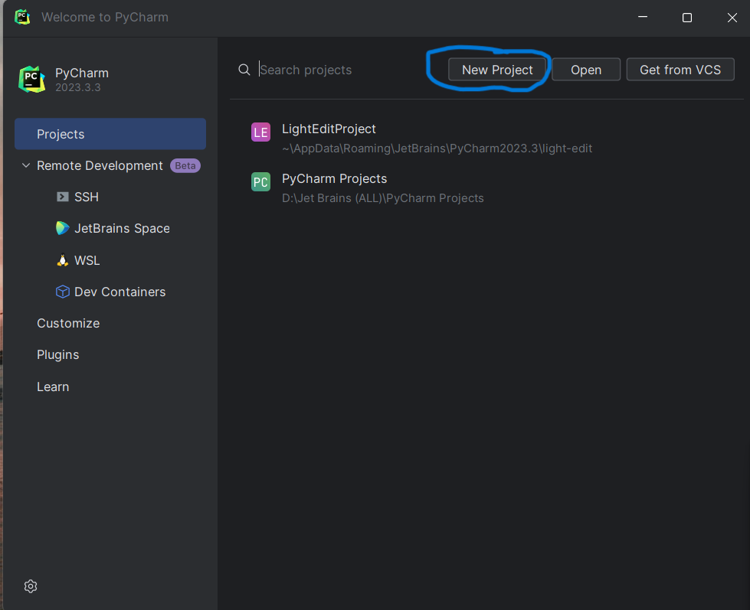

2: CLICK ON NEW PROJECT

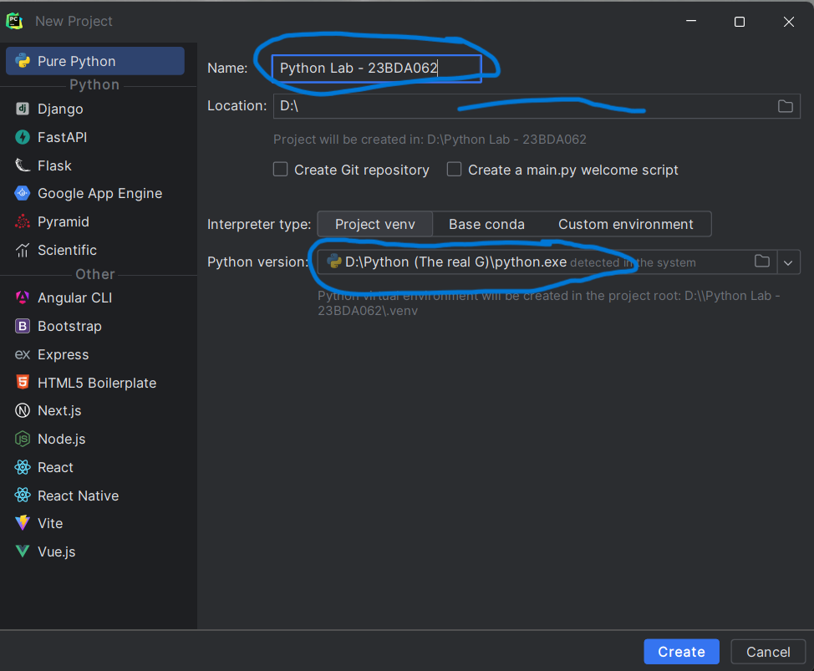

3: CREATE A PROJECT WITH THE NAMING FORMAT “PYTHON LAB – [YOUR ROLL NUMBER]

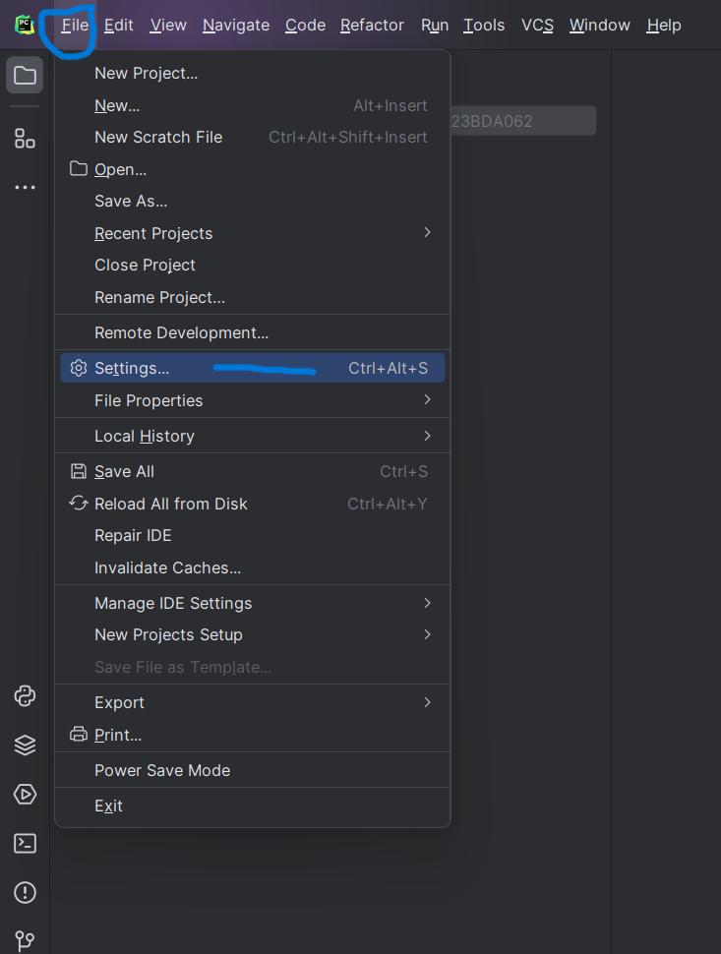

4: ON THE TOP LEFT CORNER, GO TO FILE – SETTINGS

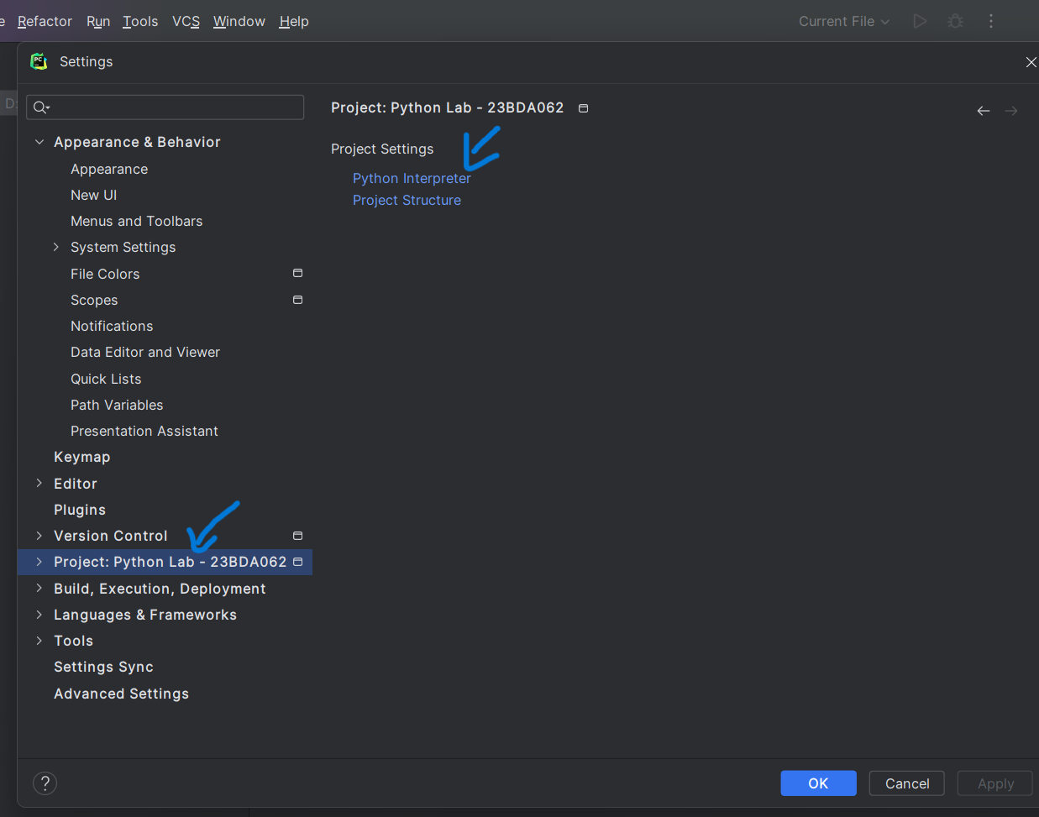

5: GO TO YOUR PROJECT AND SELECT PYTHON INTERPRETER

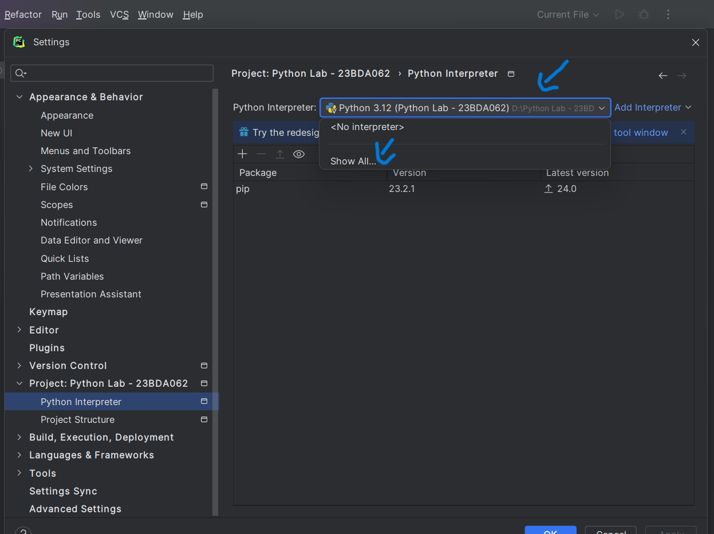

6: FROM THE PYTHON INTERPRETER DROP DOWN MENU, CLICK ON SHOW ALL

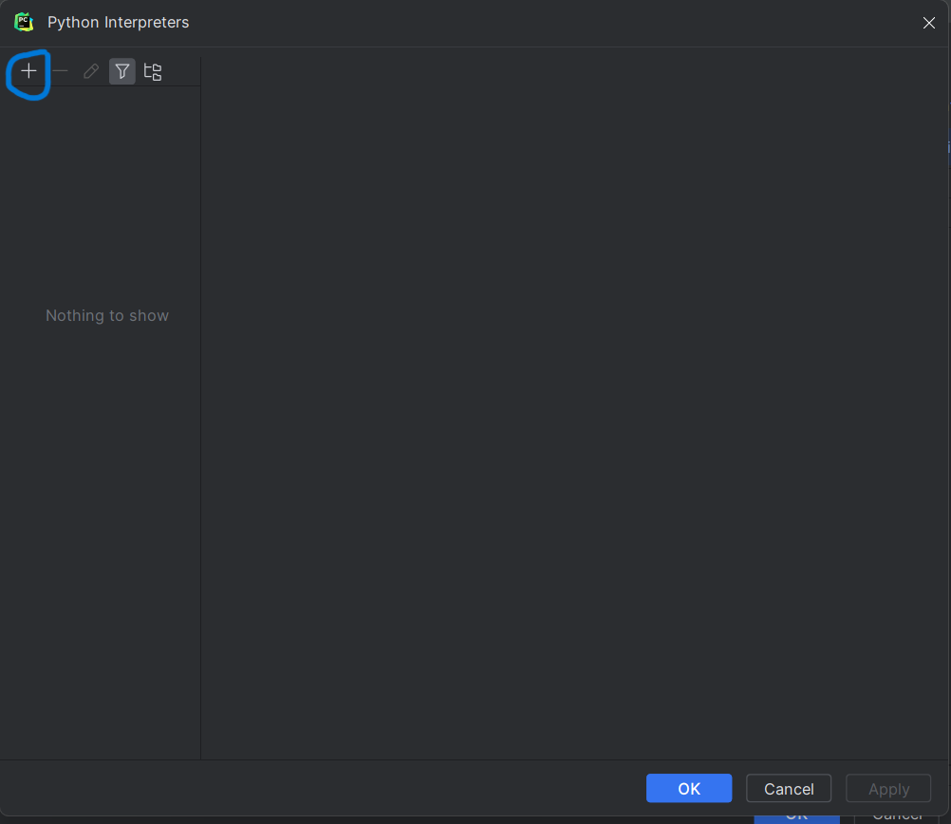

7: CLICK ON THE + ICON

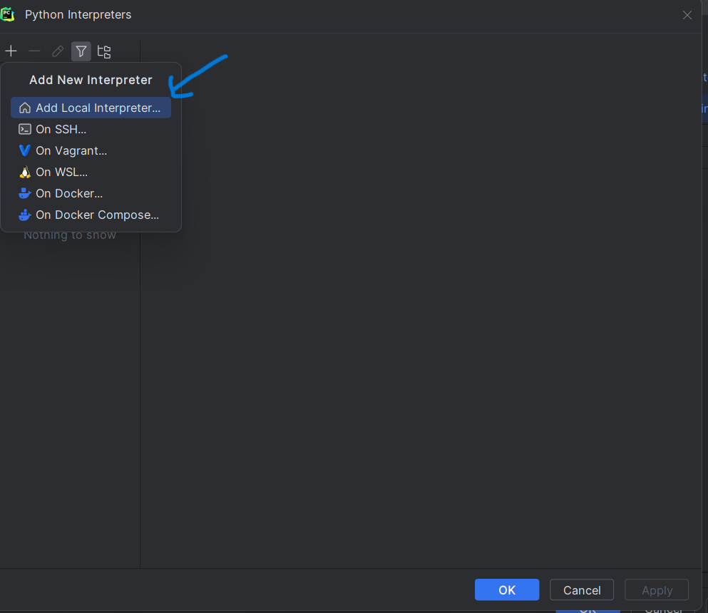

8: SELECT ADD LOCAL INTERPRETER

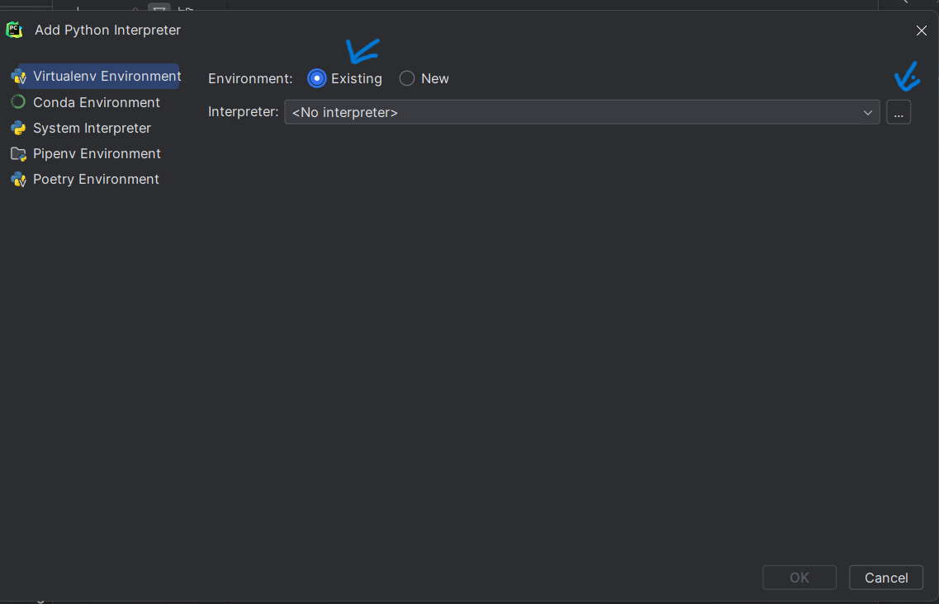

9: SELECT THE “EXISTING” OPTION AND CLICK ON THE THREE DOT ICON TO THE RIGHT CORNER

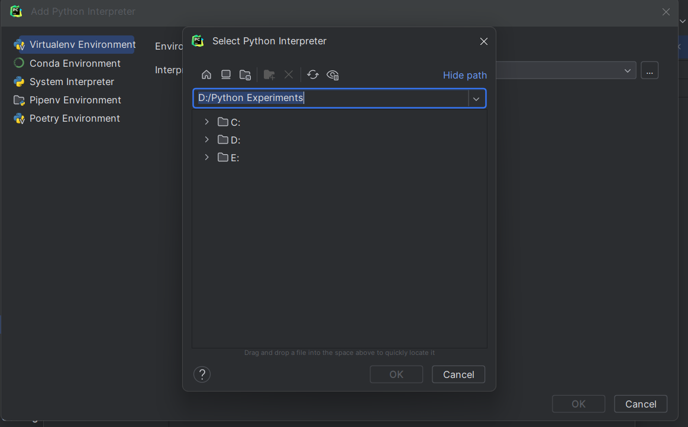

IN YOUR COMPUTER – GO TO Z: DRIVE AND FIND A FOLDER NAME “PYCHARM VENV”

IN THAT FOLDER , GO TO THE SCRIPTS SUBFOLDER AND CLICK ON THE FILE NAMED “PYTHON.EXE” AND CLICK OK

AFTER SELECTING THE INTERPRETER CLICK OK AND APPLY AND CHECK IF YOU HAVE THE FOLLOWING LIBRARIES

\*PANDAS

\*NUMPY

\*OPENPYXL

\*PYARROW

10: CLOSE ALL THE INNER WINDOWS AND GO TO FILE – NEW

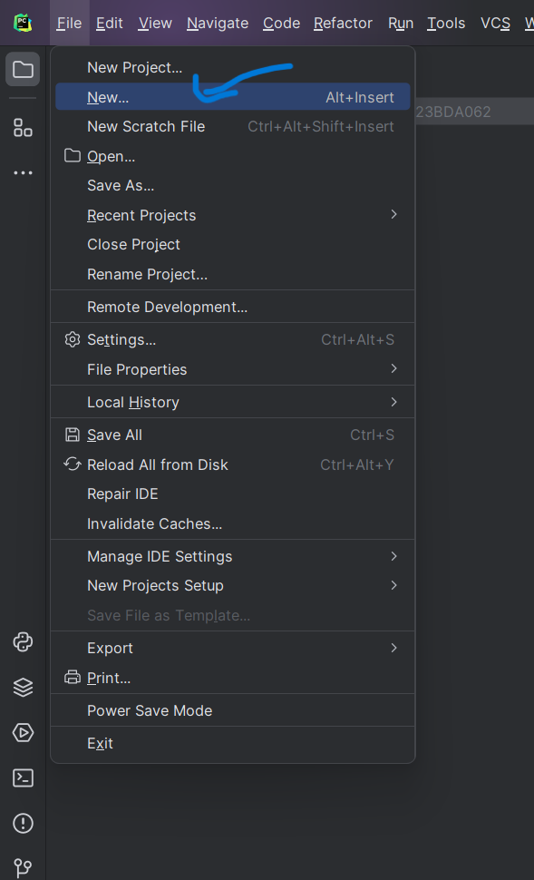

11: SELECT THE PYTHON FILE OPTION

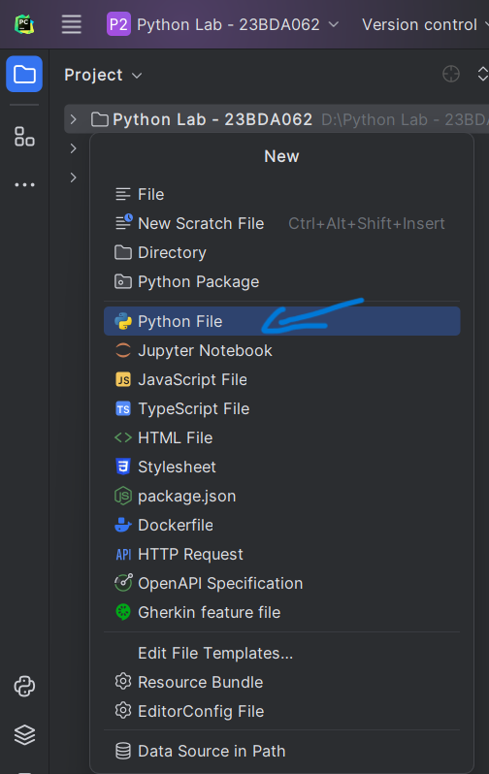

12: NAME YOUR FILE AS GIVEN IN THE SYLLABUS EXPERIMENT

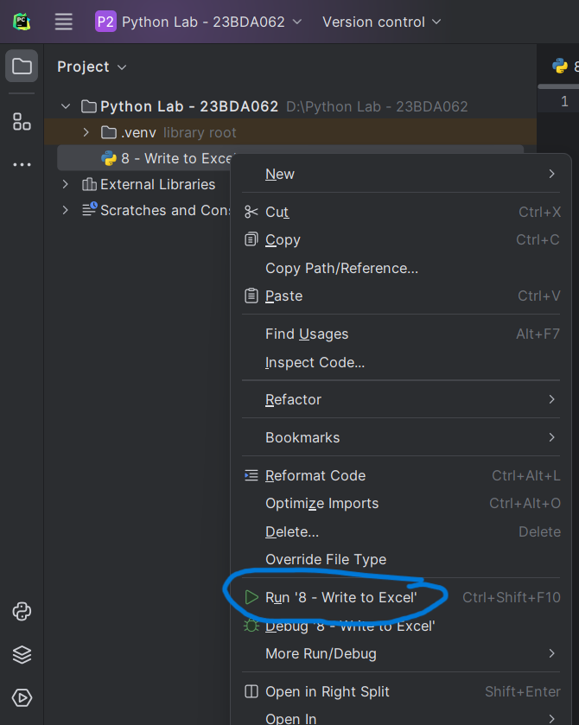

TO RUN THE PYTHON FILE , RIGHT CLICK ON IT AND SELECT RUN

NOTE:

* EVERYTIME YOU OPEN PYCHARM, ALL YOUR FILES WILL BE LOADED INTO IT
* IT IS NOT NEEDED TO CREATE A NEW PROJECT EVERYTIME FOR ALL THE EXPERIMENTS
* TO PERFORM A NEW EXPERIMENT, GO TO FILE – NEW – PYTHON FILE AND THEN NAME YOUR NEW FILE AS GIVEN IN THE SYLLABUS AND START WORKING ON IT
* WHEN YOU CREATE A NEW PYTHON FILE, RUN THE FILE BY RIGHT CLICKING ON IT AND SELECTING RUN
* OUTPUT WILL BE DISPLAYED AT THE BOTTOM OF THE SCREEN
* PYCHARM AUTOMATICALLY SAVES ALL YOUR CODE
* YOUR CSV AND EXCEL FILES WILL APPEAR TO THE LEFT SIDE OF YOUR SCREEN ONCE AFTER YOU CREATE IT