We are creating an AI powered social media platform designed for North American university students and research industry partners. This platform will be completely free and accessible across multiple devices, including desktops, laptops, tablets, and smartphones.
The purpose of this social media platform is to foster social connections and content sharing among students and industry professionals. Users will also gain access to free courses, paid or unpaid mentorship opportunities, and research support. Additionally, the platform will provide up-to-date information on academic conferences. The platform is equipped with a machine leaning model. The model will recommend free courses, reading materials, and video tutorials tailored to your needs.
In this survey, you will review and interpret data security and use of machine learning model terms and conditions similar to those presented when signing up for popular social media platforms such as Facebook or Instagram. This study aims to examine whether the way these terms and conditions are presented affects users’ understanding of data use for machine learning development.
Question 1: You are a
- UNB Undergraduate Student
- UNB Graduate Student
- UNB Industry Partner Employee
- Other
Question 2: My background is
- Science
- Engineering
- Social Science
- Business
- Arts
- Other
Question 3: Do you use computer or smart phone for internet browsing daily?
- Yes
- No
Question 4: Do you use search engines? Example: Google, Bing, Yahoo, Baidu, etc.
- Yes
- No
Question 5: Do you use any social media platform? Example: Facebook, X, Reddit, Instagram, etc.
- Yes
- No
Question 6: Have you ever used ChatGPT, Grammarly, Co-Pilot, or any similar AI enabled services?
- Yes
- No

Please review the Terms & Conditions for this social media platform before continuing to the next question.
Question 7: Do you know what data the platform will be collecting from you while you use the social media platform?
- Yes, I do
- May be I know
- No, I do not
Question 8: Do you understand how the platform will be processing your data that were collected before?
- Yes, I understand
- I am not sure
- No, I do not understand
Question 9: Do you know that the platform will be selling your data that were collected before?
- Yes, I do
- May be I know
- No, I do not
Question 10: Do you think the platform’s machine learning model will be making and unbiased and fair recommendation?
- Yes, I think so
- I am not sure
- No, I do not think so
Question 8: What is your understanding of the Terms & Conditions (select all that applies)?
- All items are clearly defined
- The document is easy to read
- The document is too long
- The document is concise
- Hard to understand
- Essy to understand
Question 11: Would you consider using our free social media platform?
- Yes, I will
- No, I won’t
- I will consider
Question 12: If you responded ‘No’ or ‘Maybe,’ please provide the reasons for your decision (select all that applies)?
- I do not agree with the Terms & Conditions
- Terms & Conditions are vague
- Other reasons

Please review the information below before proceeding to the next section. The details provided will be required to continue with the remaining of this survey.

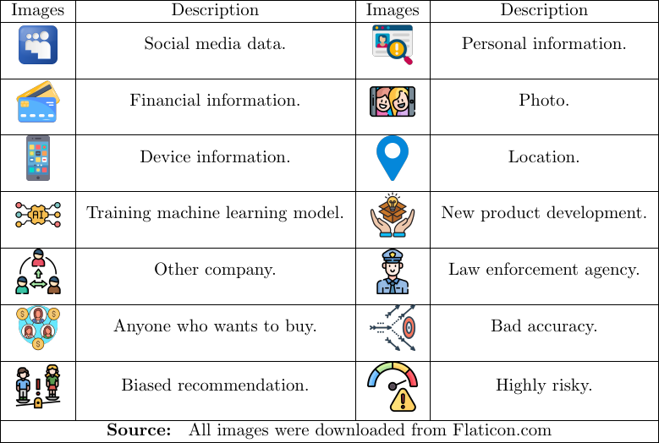

Please review the visually presented Terms & Conditions for this social media platform before proceeding to the next question.

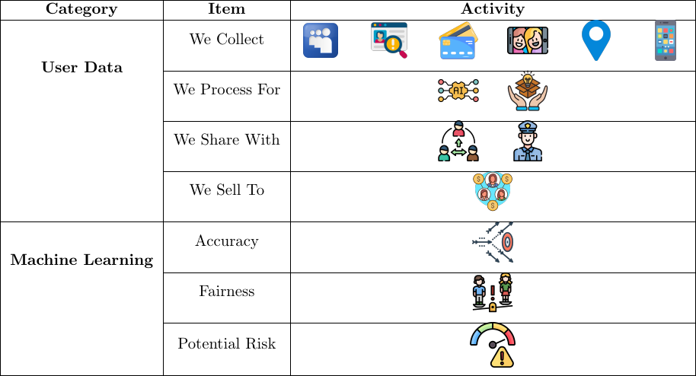
Figure 1: Terms & Conditions for the Social Media Platform

Question 13: Do you know what data the platform will be collecting from you while you use the social media platform?
- Yes, I do
- May be I know
- No, I do not
Question 14: Do you understand how the platform will be processing your data that were collected before?
- Yes, I understand
- I am not sure
- No, I do not understand
Question 15: Do you know that the platform will be selling your data that were collected before?
- Yes, I do
- May be I know
- No, I do not
Question 16: Do you think the platform’s machine learning model will be making and unbiased and fair recommendation?
- Yes, I think so
- I am not sure
- No, I do not think so
Question 8: What is your understanding of the visually presented Terms & Conditions (select all that applies)?
- All items are clearly defined
- The document is easy to read
- The document is too long
- The document is concise
- Hard to understand
- Essy to understand
Question 17: After reviewing the visually presented Terms & Conditions, would you consider using the free social media platform?
- Yes, I will
- No, I won’t
- I will consider
Question 18: If you responded ‘No’ or ‘Maybe,’ please provide the reasons for your decision (select all that applies).?
- I do not agree with the Terms & Conditions
- Terms & Conditions are vague
- Other reasons
Question 19: How did the visual presentation of the Terms & Conditions help you understand the data collection, processing, sharing policy of the free social media platform (select all that applies)?
- More informative
- Impacted my decision
- Did not help
Question 20: How did the visual presentation of the Terms & Conditions help you understand the use of machining learning into the free social media platform (select all that applies)?
- More informative
- Impacted my decision
- Did not help
Question 20: How did the visual presentation of the Terms & Conditions help you understand the use of machining learning into the free social media platform (select all that applies)?
Question 21: Do you have any observations or suggestions?

