We are creating an AI powered social media platform designed for North American university students and research industry partners. This platform will be completely free and accessible across multiple devices, including desktops, laptops, tablets, and smartphones.
The purpose of this social media platform is to foster social connections and content sharing among students and industry professionals. Users will also gain access to free courses, paid or unpaid mentorship opportunities, and research support. Additionally, the platform will provide up-to-date information on academic conferences. The platform is equipped with a machine leaning model. The model will recommend free courses, reading materials, and video tutorials tailored to your needs.
In this survey, you will review and interpret data security and use of machine learning model terms and conditions similar to those presented when signing up for popular social media platforms such as Facebook or Instagram. This study aims to examine whether the way these terms and conditions are presented affects users’ understanding of data use for machine learning development.
Question 1: You are a
- UNB Undergraduate Student
- UNB Graduate Student
- UNB Industry Partner Employee
- Other
Question 2: My background is
- Science
- Engineering
- Social Science
- Business
- Arts
- Other
Question 3: Do you use computer or smart phone for internet browsing daily?
- Yes
- No
Question 4: Do you use search engines? Example: Google, Bing, Yahoo, Baidu, etc.
- Yes
- No
Question 5: Do you use any social media platform? Example: Facebook, X, Reddit, Instagram, etc.
- Yes
- No
Question 6: Have you ever used ChatGPT, Grammarly, Co-Pilot, or any similar AI enabled services?
- Yes
- No

Please review the Terms & Conditions for this social media platform before continuing to the next question.
Question 7: I am aware that the platform will collect my personal data while I use the social media platform?
- Strongly Agree
- Agree
- Somewhat Agree
- Neither Agree nor Disagree
- Somewhat Disagree
- Disagree
- Strongly Disagree

Question 8: I am aware that the platform will be processing my personal data that were collected before?
- Strongly Agree
- Agree
- Somewhat Agree
- Neither Agree nor Disagree
- Somewhat Disagree
- Disagree
- Strongly Disagree
Question 9: I am aware that the platform will be selling my personal data that were collected before?
- Strongly Agree
- Agree
- Somewhat Agree
- Neither Agree nor Disagree
- Somewhat Disagree
- Disagree
- Strongly Disagree
Question 10: I am aware that the platform’s machine learning model will be making and unbiased and fair recommendation?
- Strongly Agree
- Agree
- Somewhat Agree
- Neither Agree nor Disagree
- Somewhat Disagree
- Disagree
- Strongly Disagree
Question 11: What is your understanding of the Terms & Conditions (select all that applies)?
- All items are clearly defined
- The document is easy to read
- The document is too long
- The document is concise
- Hard to understand
- Essy to understand
Question 12: I will use the free social media platform?
- Strongly Agree
- Agree
- Somewhat Agree
- Neither Agree nor Disagree
- Somewhat Disagree
- Disagree
- Strongly Disagree
Question 13: If you responded ‘Disagree’ or ‘Strongly Disagree’ or ‘Neither Agree nor Disagree0’, please provide the reasons for your decision (select all that applies).?
- I do not agree with the Terms & Conditions
- Terms & Conditions are vague
- Other reasons

Please review the information below before proceeding to the next section. The details provided will be required to continue with the remaining of this survey.

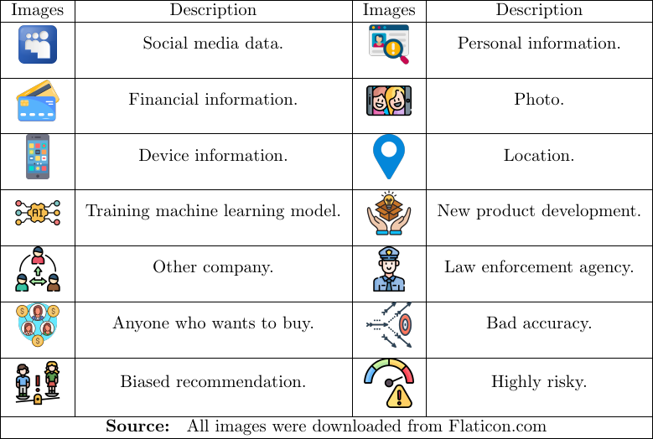

Please review the visually presented Terms & Conditions for this social media platform before proceeding to the next question.

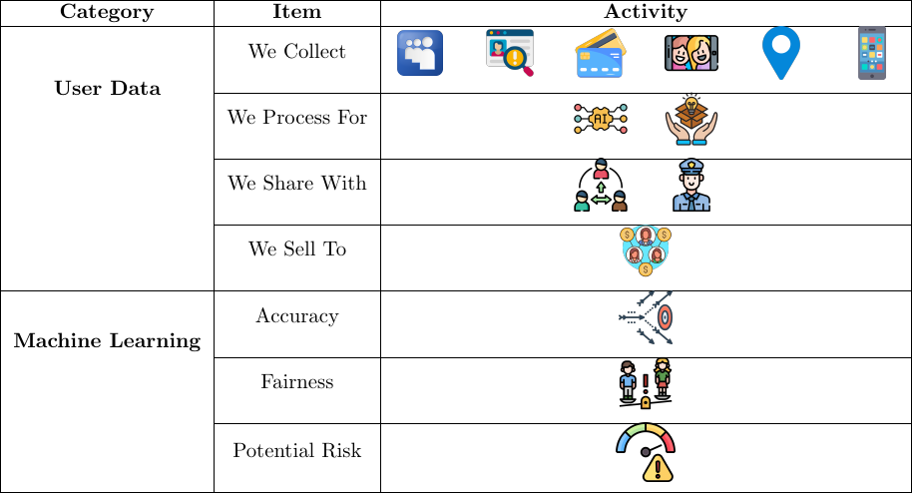
Figure 1: Terms & Conditions for the Social Media Platform

Question 14: I am aware that the platform will collect my personal data while I use the social media platform?
- Strongly Agree
- Agree
- Somewhat Agree
- Neither Agree nor Disagree
- Somewhat Disagree
- Disagree
- Strongly Disagree
Question 15: I am aware that the platform will be processing my personal data that were collected before?
- Strongly Agree
- Agree
- Somewhat Agree
- Neither Agree nor Disagree
- Somewhat Disagree
- Disagree
- Strongly Disagree
Question 16: I am aware that the platform will be selling my personal data that were collected before?
- Strongly Agree
- Agree
- Somewhat Agree
- Neither Agree nor Disagree
- Somewhat Disagree
- Disagree
- Strongly Disagree
Question 17: I am aware that the platform’s machine learning model will be making and unbiased and fair recommendation?
- Strongly Agree
- Agree
- Somewhat Agree
- Neither Agree nor Disagree
- Somewhat Disagree
- Disagree
- Strongly Disagree
Question 18: What is your understanding of the visually presented Terms & Conditions (select all that applies)?
- All items are clearly defined
- The document is easy to read
- The document is too long
- The document is concise
- Hard to understand
- Essy to understand
Question 19: After reviewing the visually presented Terms & Conditions, I will use the free social media platform?
- Strongly Agree
- Agree
- Somewhat Agree
- Neither Agree nor Disagree
- Somewhat Disagree
- Disagree
- Strongly Disagree
Question 20: If you responded ‘Disagree’ or ‘Strongly Disagree’ or ‘Neither Agree nor Disagree0’, please provide the reasons for your decision (select all that applies).?
- I do not agree with the Terms & Conditions
- Terms & Conditions are vague
- Other reasons
Question 21: How did the visual presentation of the Terms & Conditions help you understand the data collection, processing, sharing policy of the free social media platform (select all that applies)?
- More informative
- Impacted my decision
- Did not help
Question 22: How did the visual presentation of the Terms & Conditions help you understand the use of machining learning into the free social media platform (select all that applies)?
- More informative
- Impacted my decision
- Did not help
Question 23: How did the visual presentation of the Terms & Conditions help you understand the use of machining learning into the free social media platform (select all that applies)?
Question 24: Do you have any observations or suggestions?

