NabtaTech Solutions – Internal Network & File Server Deployment Report

1. Project Overview
This report documents the internal network infrastructure and the configuration of the Ubuntu File Server deployed for NabtaTech Solutions. The setup aims to provide a segmented, VLAN-based network supporting multiple departments, inter-VLAN routing, and centralized file services. The report includes network topology, switch and VLAN configurations, server deployment details, and verification steps to ensure full operational readiness.

2. Network Topology
Logical Network Layout
Device/Segment | IP Range | VLAN | Purpose
HR Workstations | 192.168.10.0/24 | 10 | Human Resources department
Reception Workstations | 192.168.20.0/24 | 20 | Front desk and visitor management
Finance Workstations | 192.168.30.0/24 | 30 | Financial operations
IT Support Workstations | 192.168.40.0/24 | 40 | IT maintenance and support
DevOps Workstations | 192.168.50.0/24 | 50 | Development & operations
File Server (Ubuntu) | 192.168.100.10 | 100 | Centralized file storage
Web Server (Ubuntu) | 192.168.100.11 | 100 | Internal and external web services
Database Server (Ubuntu) | 192.168.100.12 | 100 | Centralized database services

Connectivity Diagram:
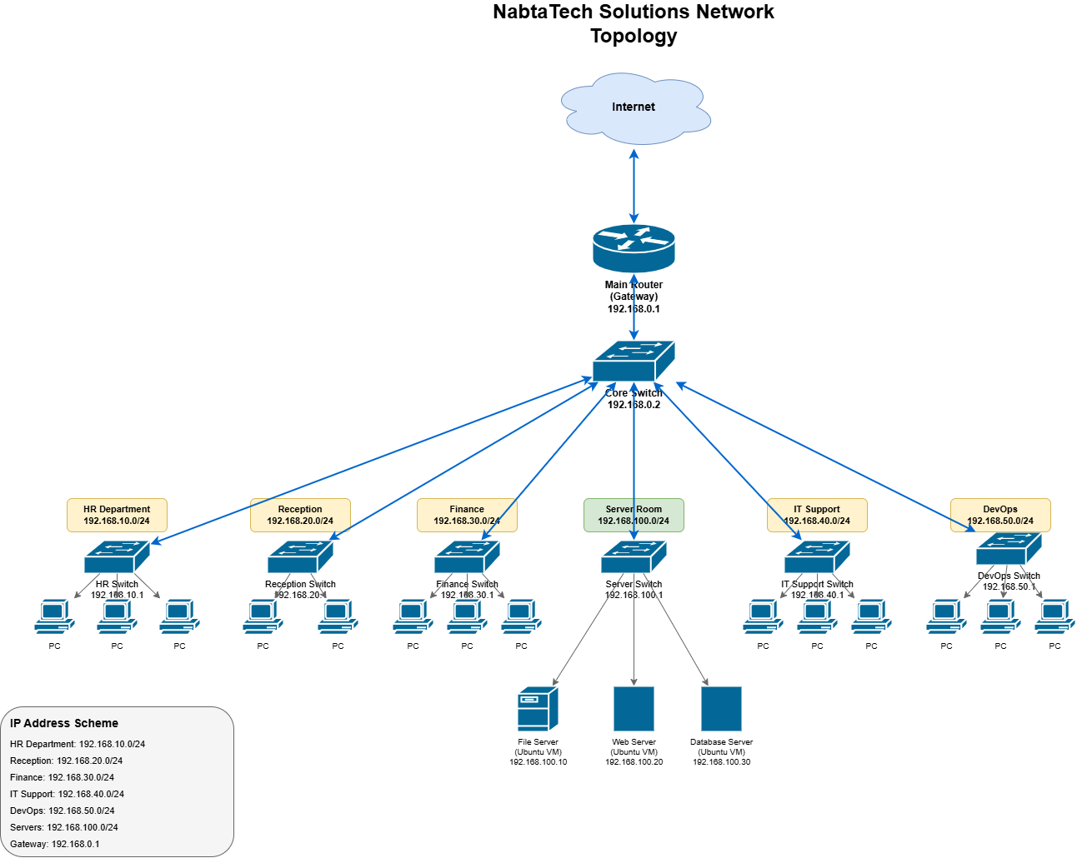

3. Switch Configuration
Main Switch – VLAN and Trunk Setup
Interface | Mode | VLAN Assigned/Allowed | Description
Fa0/1 | Trunk | 10,20,30,40,50,100 | Trunk to Core/Main Switch
Fa0/2 | Access | 20 | Reception
Fa0/3 | Access | 30 | Finance
Fa0/4-6 | Access | 10 | HR
Fa0/7-8 | Access | 40 | IT Support
Fa0/10 | Access | 50 | DevOps
Fa0/23 | Trunk | 10,20,30,40,50,100 | Trunk to File Server Switch
Configuration Notes:
# Example trunk setup on main switch
interface fa0/1
switchport mode trunk
switchport trunk native vlan 100
switchport trunk allowed vlan 10,20,30,40,50,100
no shutdown
- Access ports are assigned to the corresponding VLAN for each department.
- Trunks carry multiple VLANs to the server switch and core router.
Spanning Tree & Connectivity Verification
- All VLANs are in forwarding state except VLANs not assigned locally.
- show spanning-tree vlan 100 confirms root bridge and port roles.
- CDP shows connectivity to other switches and router interfaces.

4. Ubuntu File Server Deployment
Server Specifications
Parameter | Value
VM Name | File-Server
OS | Ubuntu 24.04 LTS
CPU | 2 cores
RAM | 4 GB
Storage | 40 GB VDI
Network Adapter | Bridged Adapter
VLAN | 100
Installation Steps
- Mount the Ubuntu Server ISO in VirtualBox under storage.
- Boot the VM and select Install Ubuntu Server.
- Configure language, location, and keyboard layout.
- Create an administrative user (mozan) and password.
- Choose default installation with standard utilities.
- Set hostname as File-Server.
- Configure network with static IP: 192.168.100.10/24, gateway: 192.168.100.1.
- Complete installation and reboot the VM.
Post-Installation Configuration
sudo apt update
sudo apt upgrade -y
sudo apt install build-essential dkms linux-headers-$(uname -r)
- Installed essential build tools and kernel headers for future services.
- Enabled network services for file sharing (NFS/Samba) in preparation for production use.
Network Verification
# Ping other VLAN gateways and servers
ping 192.168.10.1
ping 192.168.50.1
ping 192.168.100.11
- All pings successful, confirming inter-VLAN routing through the router.

5. Connectivity Tests
- Switch to Server: Verified trunk connectivity using show interfaces trunk.
- Ping Tests: Conducted from each VLAN to the File Server, all successful.
- Service Verification: SSH enabled and accessible from management workstation.
- Spanning Tree: All trunk links in forwarding state, no loops detected.

6. Troubleshooting Notes
- Native VLAN mismatches observed in CDP logs during initial testing; resolved by aligning trunk configurations on both switches.
- System services (systemd-resolved, systemd-networkd) initially failed during installation; reboot resolved service startup issues.
- Future installations should monitor ISO integrity and ensure proper VM network adapter type (bridged or host-only).

7. Next Steps
- Deploy Web Server and Database Server in VLAN 100.
- Configure NFS or Samba file sharing services on File Server.
- Perform additional connectivity and user access tests.
- Backup VM snapshots for all production servers.

Prepared by: Mozan Ahmed
Position: IT Network Engineer
Date: 15-Feb-2026

