HTML Evidence Exam-4

- Create an html file named product_entry.html which contains product entry form with
The following fields:
Product name (text),
Description (textarea),
Categories (dropdown list: Man, Women, Kids),
Features (checkbox: Cotton, Woolen, Polyester, Full Sleeves),
Product Photo,
Stock (number)

Q2. Create an html document named student_records.html to show the following information:

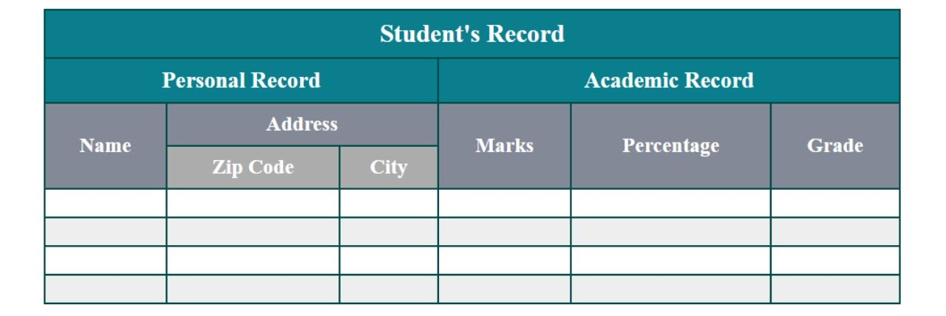

Q3. Create an html page index.html which contains two link items:
a. Product Entry
c. Student Records
Using iframe show above pages in one iframe. Use div and make the menu in left side and content will be right side.

