**Laboratory work 8**

**We continue to work with the database from the previous laboratory works.**

**Take a full-page screenshot that covers the code and results of each task.**

VIEW.

1. Create a view to show details of all flights that are departing on a specific date. 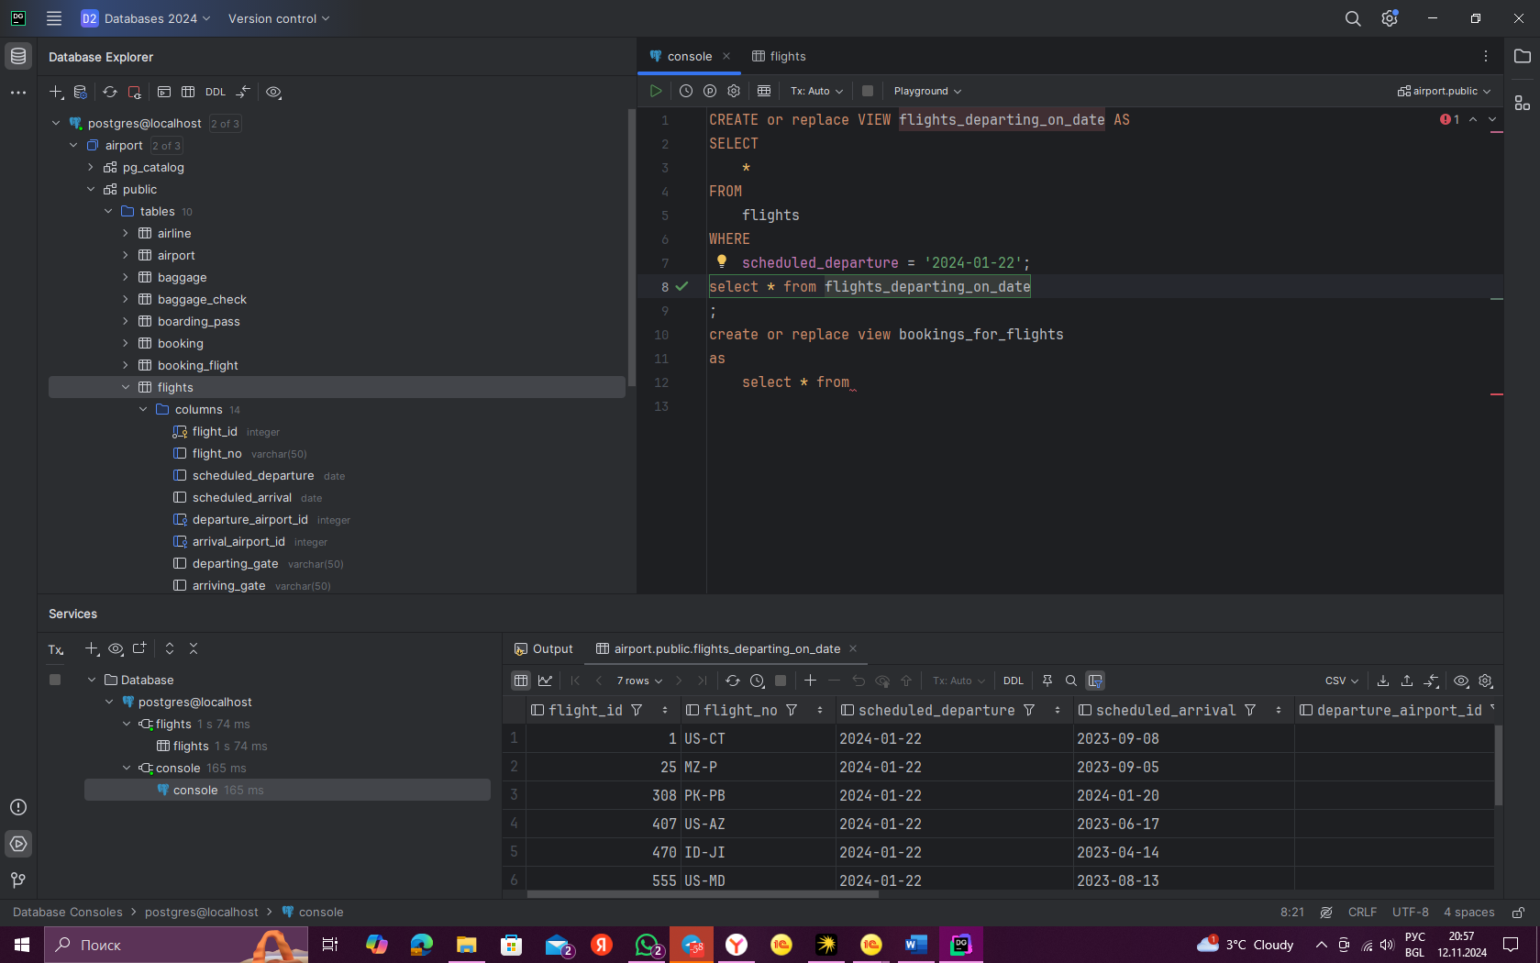
2. Create a view that shows bookings for flights scheduled to depart within the next week. 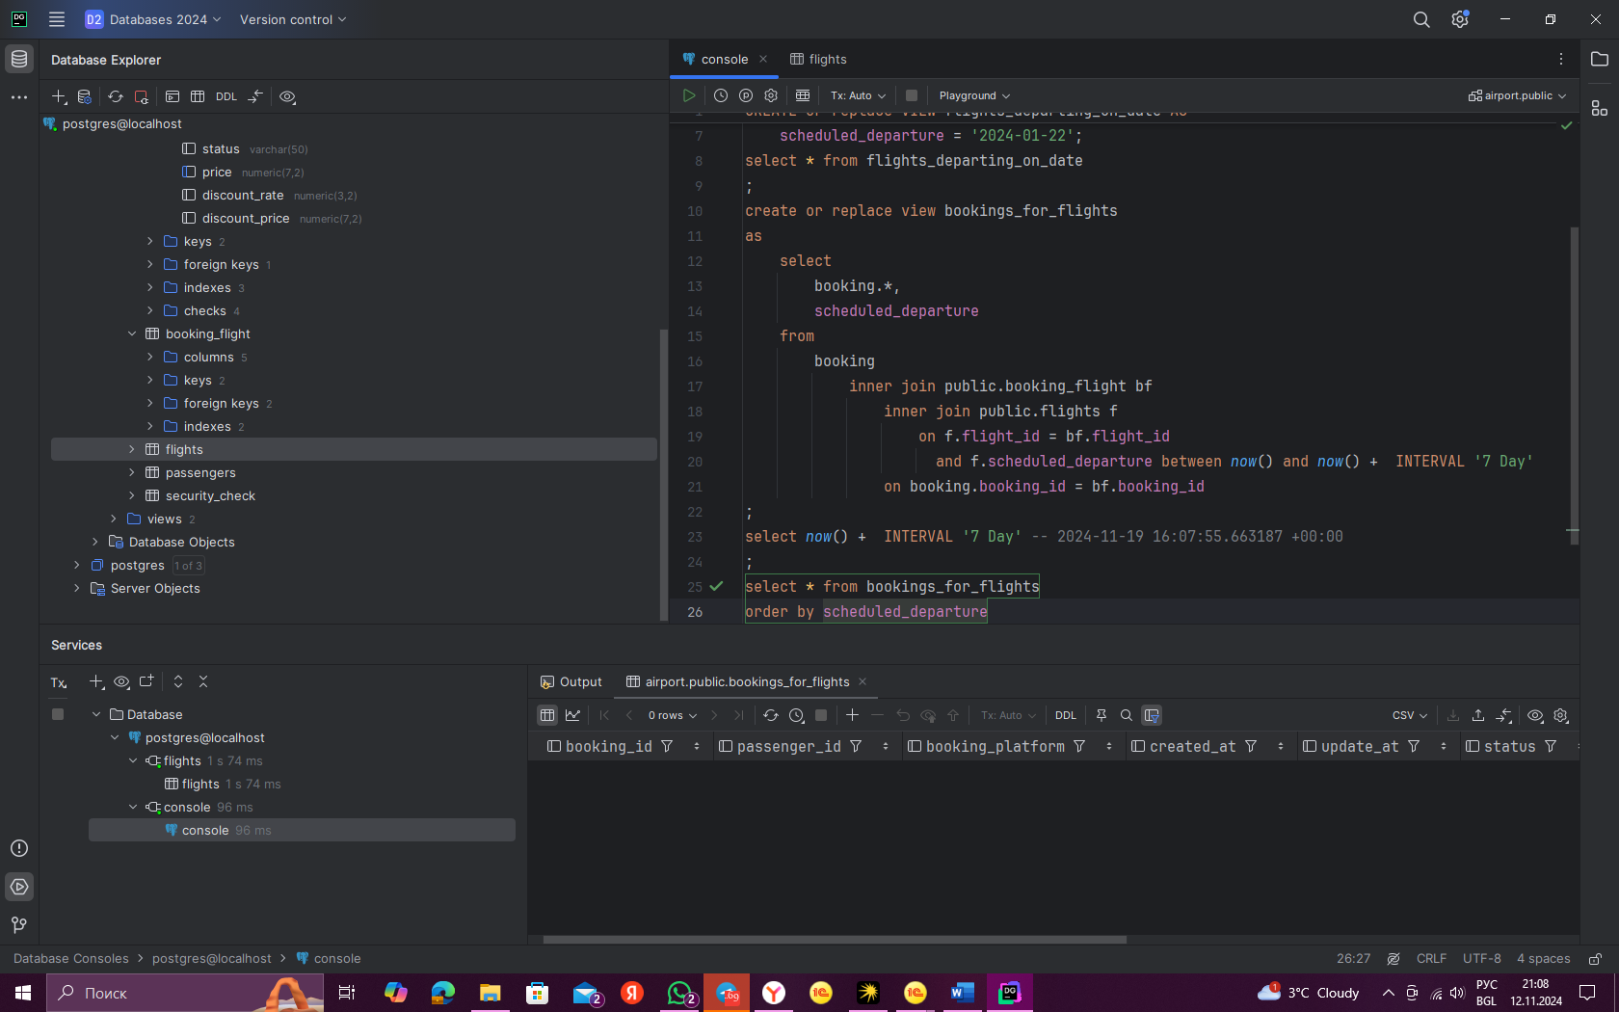
3. Create a view to show the top 5 most popular flight routes based on the number of bookings. 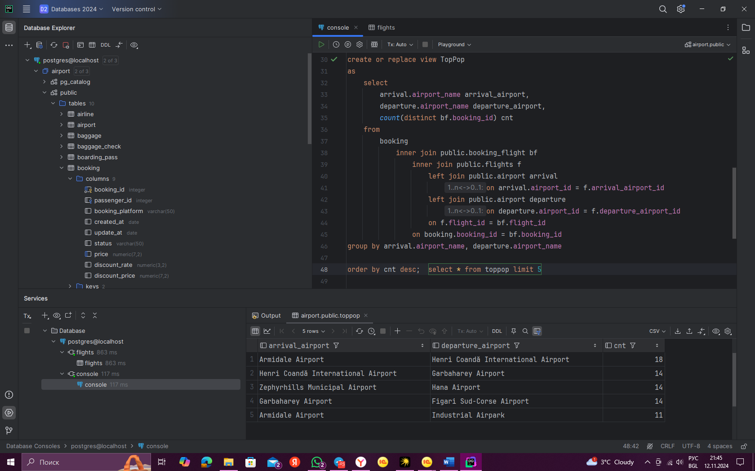
4. Create a view that lists all flights for a specific airline. 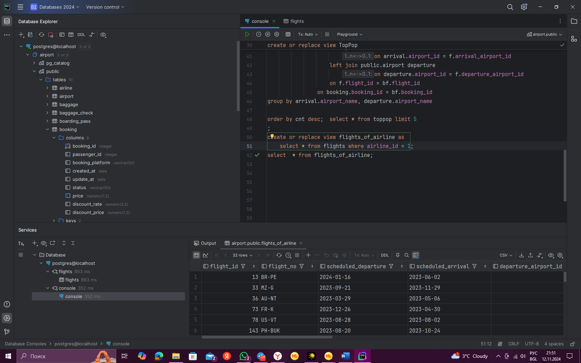
5. Modify the view created in task 4 to show only flights departing within the next 7 days for a specific airline. Изображение выглядит как текст, снимок экрана, программное обеспечение, Мультимедийное программное обеспечение

   Автоматически созданное описание
6. Create a view to show flights that are delayed by more than 24 hours. 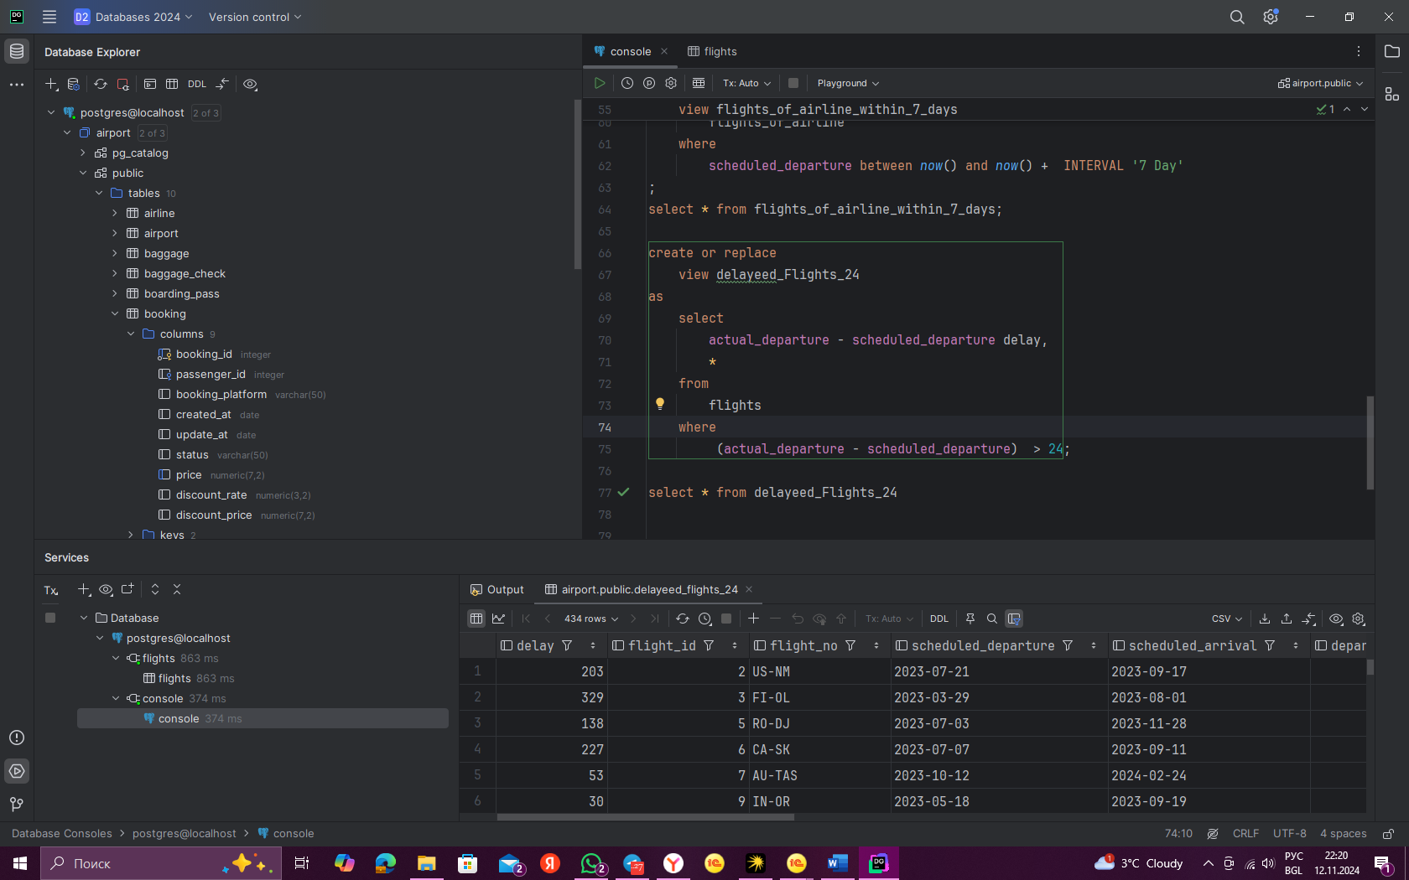
7. Create a view in which you can display the full name and country of origin of passengers who made bookings on Leffler-Thompson platform. Then show the list of that passengers. 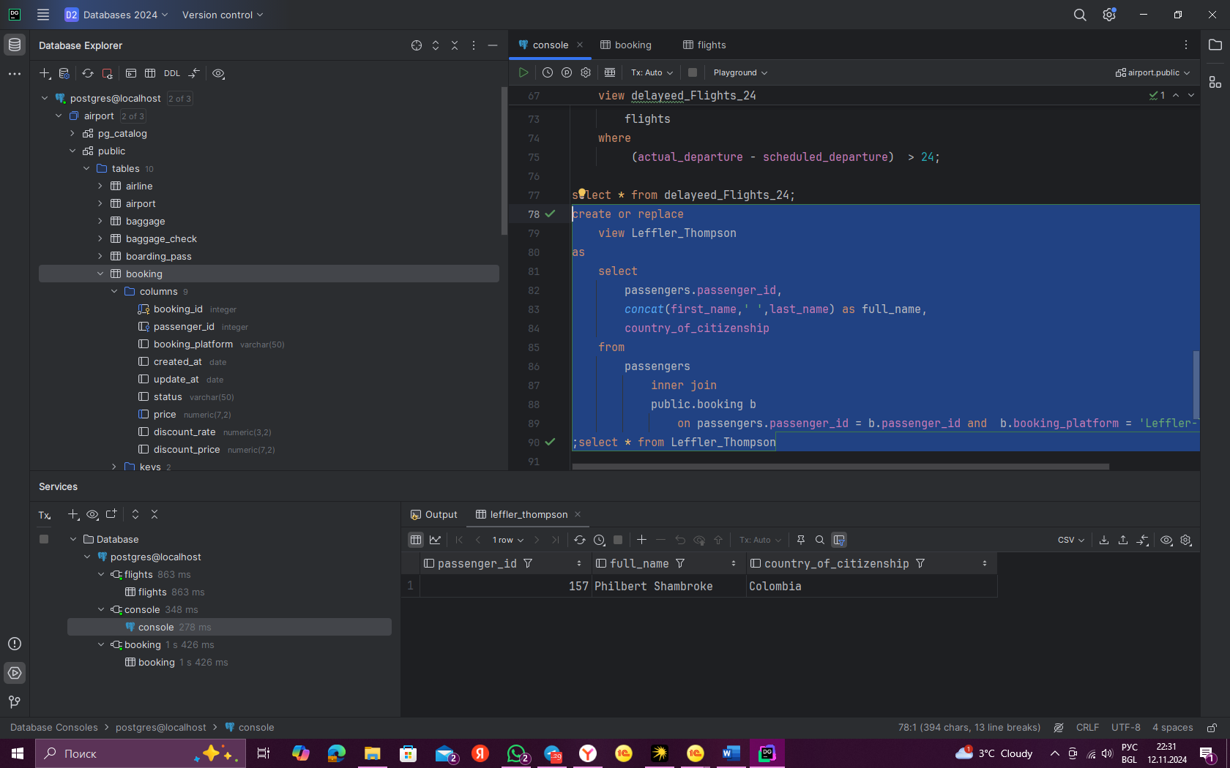
8. Create a view that shows top 10 most visited countries. 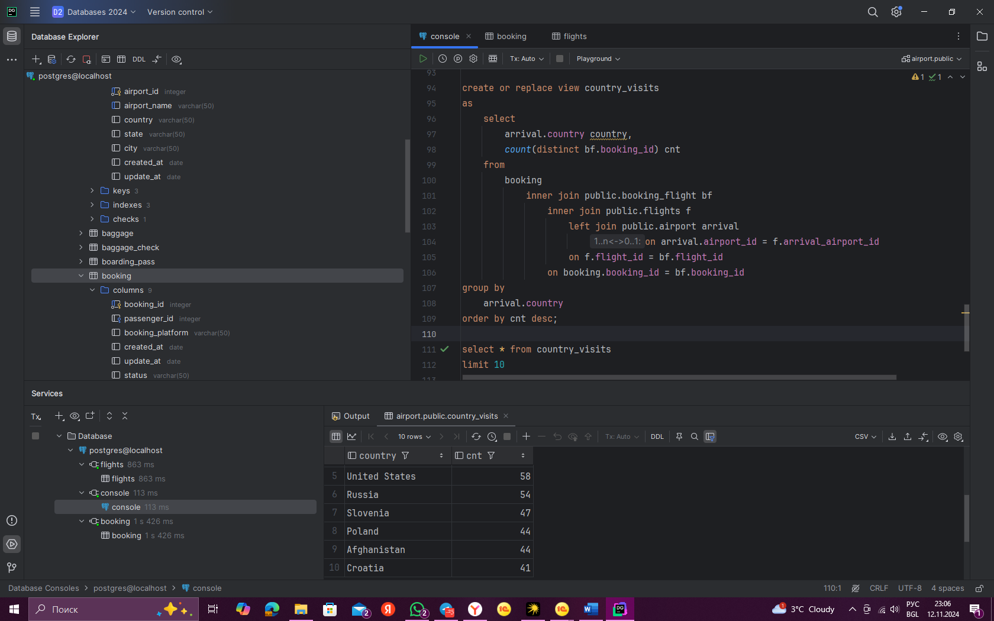
9. Update any of the created views by adding new information in the view table. Show results. Изображение выглядит как текст, снимок экрана, программное обеспечение, Мультимедийное программное обеспечение

   Автоматически созданное описание
10. Drop all existing views. 