Chapter 2
Thinking Like an Economist
Multiple Choice
1. Which of the following terms are most closely associated with the study of economics?
a. force and acceleration
b. torts and venues
c. ego and cognitive dissonance
d. comparative advantage and deadweight loss
ANS: D PTS: 1 DIF: 2 REF: 2-0
TOP: Economists MSC: Interpretive
2. Economists, like mathematicians, physicists, and psychologists,
a. make use of the scientific method.
b. make use of their own language.
c. devise theories, and collect and analyze data.
d. All of the above are correct.
ANS: D PTS: 1 DIF: 1 REF: 2-1
TOP: Economists | Scientific method MSC: Interpretive
3. With respect to how economists study the economy, which of the following statements is most accurate?
a. Economists study the past, but they do not try to predict the future.
b. Economists use “rules of thumb” to predict the future.
c. Economists devise theories, collect data, and analyze the data to test the theories.
d. Economists use controlled experiments in much the same way that biologists and physicists do.
ANS: C PTS: 1 DIF: 2 REF: 2-1
TOP: Economists MSC: Interpretive
4. By scientific method we mean
a. the use of modern electronic testing equipment to understand the world.
b. the dispassionate development and testing of theories about how the world works.
c. the use of controlled laboratory experiments to understand the way the world works.
d. finding evidence to support preconceived theories about how the world works.
ANS: B PTS: 1 DIF: 2 REF: 2-1
TOP: Scientific method MSC: Definitional
5. Who said, "The whole of science is nothing more than the refinement of everyday thinking?"
a. Isaac Newton
b. Albert Einstein
c. Sigmund Freud
d. Benjamin Franklin
ANS: B PTS: 1 DIF: 1 REF: 2-1
TOP: Scientific method MSC: Definitional
6. Albert Einstein once made the following observation about science:
a. "The whole of science is nothing more than the refinement of everyday thinking."
b. "The whole of science is nothing more than an interesting intellectual exercise."
c. "In order to understand science, one must rely solely on abstraction."
d. "In order to understand science, one must transcend everyday thinking."
ANS: A PTS: 1 DIF: 1 REF: 2-1
TOP: Scientific method MSC: Definitional
7. Sir Isaac Newton's development of the theory of gravity after observing an apple fall from a tree is an example of
a. controlled experiments that lead to the formulation of scientific theories.
b. being in the right place at the right time.
c. an idea whose time had come.
d. the interplay between observation and theory in science.
ANS: D PTS: 1 DIF: 2 REF: 2-1
TOP: Scientific method MSC: Interpretive
8. Which of the following statements applies to economics, as well as to other sciences such as physics?
a. Experiments are considered valid only when they are conducted in a laboratory.
b. Good theories do not need to be tested.
c. Real-world observations often lead to theories.
d. Economics, as well as other sciences, are concerned primarily with abstract concepts.
ANS: C PTS: 1 DIF: 2 REF: 2-1
TOP: Scientific method MSC: Interpretive
9. The use of theory and observation is more difficult in economics than in sciences such as physics due to the difficulty in
a. performing an experiment in an economic system.
b. applying mathematical methods to economic analysis.
c. analyzing available data.
d. formulating theories about economic events.
ANS: A PTS: 1 DIF: 2 REF: 2-1
TOP: Scientific method MSC: Interpretive
10. Which of the following statements is true?
a. Economists almost always find it easy to conduct experiments in order to test their theories.
b. Economics is not a true science because economists are not usually allowed to conduct experiments to test their theories.
c. Economics is a social science rather than a true science because it cannot employ the scientific method.
d. Economists are usually not allowed to conduct experiments, and so they must rely on natural experiments offered by history.
ANS: D PTS: 1 DIF: 2 REF: 2-1
TOP: Scientific method MSC: Interpretive
11. Because it is difficult for economists to use experiments to generate data, they generally must
a. do without data.
b. substitute assumptions for data when data are unavailable.
c. rely upon hypothetical data that were previously concocted by other economists.
d. use whatever data the world gives them.
ANS: D PTS: 1 DIF: 2 REF: 2-1
TOP: Scientific method MSC: Interpretive
12. Economists regard events from the past as
a. irrelevant, since history is unlikely to repeat itself.
b. of limited interest, since those events seldom provide any useful economic data.
c. interesting but not particularly valuable, since those events cannot be used to evaluate present-day economic theories.
d. interesting and valuable, because those events are capable of helping us to understand the past, the present, and the future.
ANS: D PTS: 1 DIF: 2 REF: 2-1
TOP: Economists | Scientific method MSC: Interpretive
13. Which of the following statements is (are) correct?
a. Relative to other scientists, economists find it more difficult to generate useful data.
b. Theory and observation are important in economics as well as in other sciences.
c. To obtain data, economists often rely upon the natural experiments offered by history.
d. All of the above are correct.
ANS: D PTS: 1 DIF: 1 REF: 2-1
TOP: Scientific method MSC: Interpretive
14. The most common data for testing economic theories come from
a. carefully controlled and conducted laboratory experiments.
b. traditional economies.
c. historical episodes of economic change.
d. centrally planned economies.
ANS: C PTS: 1 DIF: 1 REF: 2-1
TOP: Scientific method MSC: Interpretive
15. In conducting their research, economists face an obstacle that not all scientists face; specifically, in economics, it is difficult to
a. make use of theory and observation.
b. rely upon the scientific method.
c. conduct laboratory experiments.
d. find articles or books that were written before 1900.
ANS: C PTS: 1 DIF: 1 REF: 2-1
TOP: Scientific method MSC: Definitional
16. In conducting their research, economists often substitute historical events and historical episodes for
a. theories and observations.
b. laboratory experiments.
c. models.
d. assumptions.
ANS: B PTS: 1 DIF: 1 REF: 2-1
TOP: Scientific method MSC: Definitional
17. For economists, substitutes for laboratory experiments often come in the form of
a. natural experiments offered by history.
b. untested theories.
c. “rules of thumb” and other such conveniences.
d. reliance upon the wisdom of elders in the economics profession.
ANS: A PTS: 1 DIF: 1 REF: 2-1
TOP: Scientific method MSC: Interpretive
18. Economists make assumptions in order to
a. mimic the methodologies employed by other scientists.
b. minimize the number of experiments that yield no useful data.
c. minimize the likelihood that some aspect of the problem at hand is being overlooked.
d. focus their thinking on the essence of the problem at hand.
ANS: D PTS: 1 DIF: 2 REF: 2-1
TOP: Assumptions MSC: Interpretive
19. The art in scientific thinking—whether in chemistry, economics, or psychology—is
a. the design and implementation of laboratory experiments.
b. knowing when to stop collecting data and when to start analyzing the data.
c. deciding which assumptions to make.
d. being able to mathematically model natural phenomena.
ANS: C PTS: 1 DIF: 2 REF: 2-1
TOP: Assumptions | Scientific method MSC: Interpretive
20. An economic theory about international trade that is based on the assumption that there are only two countries and two goods
a. can be useful in helping economists understand the complex world of international trade involving many countries and many goods.
b. is useless, since the real world has many countries trading many goods.
c. can be useful only in situations involving two countries and two goods.
d. can be useful in the classroom, but is useless in the real world.
ANS: A PTS: 1 DIF: 2 REF: 2-1
TOP: Assumptions MSC: Interpretive
21. The 1973 war in the Middle East provided economists with the opportunity to observe the negative relationship between
a. oil prices and living standards.
b. military buildups and government spending.
c. the flow of crude oil and living standards.
d. the flow of crude oil and political power.
ANS: A PTS: 1 DIF: 2 REF: 2-1
TOP: Scientific method MSC: Interpretive
22. Historical episodes are
a. valuable to economists, primarily because they allow economists to see how the science of economics has evolved.
b. valuable to economists, primarily because they allow economists to evaluate economic theories of the present.
c. not of concern to economists, since economics is about predicting the future; economics is not about dwelling on the past.
d. not of concern to economists, since the exact circumstances of historical episodes are unlikely to be observed again.
ANS: B PTS: 1 DIF: 2 REF: 2-1
TOP: Scientific method MSC: Interpretive
23. The goal of an economist who formulates new theories is to
a. provide an interesting framework of analysis, whether or not the framework turns out to be of much use in understanding how the world works.
b. provoke stimulating debate in scientific journals.
c. demonstrate that economists, like other scientists, can formulate testable theories.
d. contribute to an understanding of how the world works.
ANS: D PTS: 1 DIF: 2 REF: 2-1
TOP: Scientific method MSC: Interpretive
24. One thing economists do to help them understand how the real world works is as follows:
a. They make assumptions.
b. They ignore the past.
c. They try to capture every aspect of the real world in the models they construct.
d. All of the above are correct.
ANS: A PTS: 1 DIF: 2 REF: 2-1
TOP: Assumptions | Scientific method MSC: Interpretive
25. For an economist, the idea of making assumptions is regarded generally as a
a. bad idea, since doing so leads to the omission of important ideas and variables from economic models.
b. bad idea, since doing so invariably leads to data-collection problems.
c. good idea, since doing so helps to simplify the complex world and make it easier to understand.
d. good idea, since economic analysis without assumptions leads to complicated results that the general public finds hard to understand.
ANS: C PTS: 1 DIF: 2 REF: 2-1
TOP: Assumptions MSC: Interpretive
26. Which of the following statements is true?
a. Few economic models incorporate assumptions.
b. Different economic models employ different sets of assumptions.
c. Good economic models should attempt to mimic reality as closely as possible.
d. Economic models, to be accepted, must be tested by conducting experiments.
ANS: B PTS: 1 DIF: 2 REF: 2-1
TOP: Economic models | Assumptions MSC: Interpretive
27. The decision of which assumptions to make is
a. an easy decision for an economist, but a difficult decision for a physicist or a chemist.
b. not a particularly important decision for an economist.
c. usually regarded as an art in scientific thinking.
d. usually regarded as the easiest part of the scientific method.
ANS: C PTS: 1 DIF: 2 REF: 2-1
TOP: Assumptions MSC: Interpretive
28. The art in scientific thinking is
a. finding the right problem to study.
b. deciding which assumptions to make.
c. the ability to make an abstract subject easy to understand.
d. not something in which economists have to be skilled.
ANS: B PTS: 1 DIF: 1 REF: 2-1
TOP: Assumptions | Scientific method MSC: Interpretive
29. Economists make use of assumptions, some of which are unrealistic, for the purpose of
a. teaching economics to people who have never before studied economics.
b. advancing their political agendas.
c. developing models when the scientific method cannot be used.
d. focusing their thinking.
ANS: D PTS: 1 DIF: 2 REF: 2-1
TOP: Assumptions MSC: Interpretive
30. An example of a price that changes only infrequently is the price of
a. stocks on the New York Stock Exchange.
b. crude oil.
c. residential real estate.
d. magazines sold at newsstands.
ANS: D PTS: 1 DIF: 1 REF: 2-1
TOP: Assumptions | Prices MSC: Definitional
31. When studying the effects of changes in public policy, economists believe that
a. it is important to distinguish between the short run and the long run.
b. the assumptions used in studying those effects should be the same for the short run as for the long run.
c. the short-run effects of those changes are always more beneficial to society than are the long-run effects.
d. the long-run effects of those changes are always more beneficial to society than are the short-run effects.
ANS: A PTS: 1 DIF: 2 REF: 2-1
TOP: Public policy | Short run | Long run MSC: Interpretive
32. When studying the effects of public policy changes, economists
a. always refrain from making assumptions.
b. sometimes make different assumptions about the short run and the long run.
c. consider only the direct effects of those policy changes and not the indirect effects.
d. consider only the short-run effects of those policy changes and not the long-run effects.
ANS: B PTS: 1 DIF: 2 REF: 2-1
TOP: Public policy | Assumptions | Short run | Long run MSC: Interpretive
33. Economic models
a. cannot be useful if they are based on false assumptions.
b. were once thought to be useful, but that is no longer true.
c. must incorporate all aspects of the economy if those models are to be useful.
d. can be useful, even if they are not particularly realistic.
ANS: D PTS: 1 DIF: 3 REF: 2-1
TOP: Economic models MSC: Applicative
34. Just like models constructed in other areas of science, economic models
a. incorporate assumptions that contradict reality.
b. incorporate all details about the real world.
c. complicate reality.
d. All of the above are correct.
ANS: A PTS: 1 DIF: 2 REF: 2-1
TOP: Economic models MSC: Interpretive
35. In building economic models, economists often omit
a. assumptions.
b. theories.
c. details.
d. equations.
ANS: C PTS: 1 DIF: 1 REF: 2-1
TOP: Economic models MSC: Interpretive
36. Which types of models are built with assumptions?
a. economic models, but not models in other disciplines such as physics and sociology
b. economic models as well as models in other disciplines such as physics and sociology
c. models that are built for teaching purposes but not for research purposes
d. No models are built with assumptions.
ANS: B PTS: 1 DIF: 2 REF: 2-1
TOP: Economic models | Assumptions MSC: Interpretive
37. Economists build economic models by
a. generating data.
b. conducting controlled experiments in a lab.
c. making assumptions.
d. reviewing statistical forecasts.
ANS: C PTS: 1 DIF: 2 REF: 2-1
TOP: Economic models | Assumptions MSC: Interpretive
38. A model can be accurately described as a
a. theoretical abstraction with very little value.
b. device that is useful only to the persons who created it.
c. realistic and carefully constructed theory.
d. simplification of reality.
ANS: D PTS: 1 DIF: 2 REF: 2-1
TOP: Economic models MSC: Interpretive
39. Which of the following statements about models is correct?
a. The more details a model includes, the better the model.
b. Models assume away irrelevant details.
c. Models cannot be used to explain how the economy functions.
d. Models cannot be used to make predictions.
ANS: B PTS: 1 DIF: 1 REF: 2-1
TOP: Economic models MSC: Interpretive
40. Which of the following is not true about most economic models?
a. They are composed of equations and diagrams.
b. They contribute very little to economists’ understanding of the real world.
c. They omit many features of the real-world economy.
d. In constructing models, economists make assumptions.
ANS: B PTS: 1 DIF: 2 REF: 2-1
TOP: Economic models MSC: Interpretive
41. Which of the following statements about economic models is valid?
a. Economic models are built to mirror reality exactly.
b. Economic models are useful, but they should not be used for the purpose of improving public policies.
c. Because economic models omit many details, they allow us to see what is truly important.
d. Economic models seldom incorporate equations or diagrams.
ANS: C PTS: 1 DIF: 2 REF: 2-1
TOP: Economic models MSC: Interpretive
42. Which of these statements about economic models is correct?
a. For economists, economic models provide insights about the world.
b. Economic models are built with assumptions.
c. Economic models are often composed of equations and diagrams.
d. All of the above are correct.
ANS: D PTS: 1 DIF: 1 REF: 2-1
TOP: Economic models MSC: Definitional
43. In constructing models, economists
a. leave out equations, since equations and models tend to contradict one another.
b. ignore the long run, since models are useful only for short-run analysis.
c. make assumptions that are contrary to features of the real world.
d. try to include every feature of the economy.
ANS: C PTS: 1 DIF: 2 REF: 2-1
TOP: Economic models MSC: Interpretive
44. Economic models are built with
a. recommendations concerning public policies.
b. facts about the legal system.
c. assumptions.
d. statistical forecasts.
ANS: C PTS: 1 DIF: 1 REF: 2-1
TOP: Economic models MSC: Definitional
45. The circular-flow diagram is a
a. visual model of how the economy is organized.
b. visual model of the relationships among money, prices, and businesses.
c. model that shows the effects of government on the economy.
d. mathematical model of how the economy works.
ANS: A PTS: 1 DIF: 1 REF: 2-1
TOP: Circular-flow diagram MSC: Definitional
46. A circular-flow diagram is a model that
a. helps to explain how participants in the economy interact with one another.
b. helps to explain how the economy is organized.
c. incorporates the markets for the factors of production.
d. All of the above are correct.
ANS: D PTS: 1 DIF: 1 REF: 2-1
TOP: Circular-flow diagram MSC: Definitional
47. Factors of production are
a. the mathematical calculations firms make in determining their optimal production levels.
b. social and political conditions that affect production.
c. the physical relationships between economic inputs and outputs.
d. inputs into the production process.
ANS: D PTS: 1 DIF: 1 REF: 2-1
TOP: Factors of production MSC: Definitional
48. In the simple circular-flow diagram, the participants in the economy are
a. firms and government.
b. households and firms.
c. households and government.
d. elected officials and ordinary citizens.
ANS: B PTS: 1 DIF: 1 REF: 2-1
TOP: Circular-flow diagram MSC: Definitional
49. The two loops in the circular-flow diagram represent
a. (i) the flow of goods and (ii) the flow of services.
b. (i) the flow of dollars and (ii) other financial flows.
c. (i) inputs into production processes and (ii) outputs from production processes.
d. (i) the flows of inputs and outputs and (ii) the flow of dollars.
ANS: D PTS: 1 DIF: 2 REF: 2-1
TOP: Circular-flow diagram MSC: Interpretive
50. In a circular-flow diagram,
a. taxes flow from households to firms, and transfer payments flow from firms to households.
b. income payments flow from firms to households, and sales revenue flows from households to firms.
c. resources flow from firms to households, and goods and services flow from households to firms.
d. inputs and outputs flow in the same direction as the flow of dollars, from firms to households.
ANS: B PTS: 1 DIF: 3 REF: 2-1
TOP: Circular-flow diagram MSC: Applicative
51. In the circular-flow diagram,
a. firms are buyers in the markets for goods and services.
b. households are sellers in the markets for the factors of production.
c. firms are sellers in the markets for factors of production and in the markets for goods and services.
d. dollars that are spent on goods and services flow directly from firms to households.
ANS: B PTS: 1 DIF: 2 REF: 2-1
TOP: Circular-flow diagram MSC: Interpretive
52. In the circular-flow diagram,
a. factors of production flow from government to firms.
b. goods and services flow from households to firms.
c. income paid to the factors of production flows from firms to households.
d. spending on goods and services flows from firms to households.
ANS: C PTS: 1 DIF: 2 REF: 2-1
TOP: Circular-flow diagram MSC: Interpretive
53. Which of the following items is not a factor of production?
a. labor
b. land
c. capital
d. money
ANS: D PTS: 1 DIF: 1 REF: 2-1
TOP: Factors of production MSC: Definitional
54. Another name for goods and services produced by firms is
a. factors of production.
b. output.
c. inputs.
d. resources.
ANS: B PTS: 1 DIF: 1 REF: 2-1
TOP: Output MSC: Definitional
55. Factors of production are
a. used to produce goods and services.
b. also called output.
c. abundant in most economies.
d. assumed to be owned by firms in the circular-flow diagram.
ANS: A PTS: 1 DIF: 2 REF: 2-1
TOP: Factors of production MSC: Interpretive
56. Which of these terms are used interchangeably?
a. "goods and services" and "inputs"
b. "goods and services" and "factors of production"
c. "inputs" and "factors of production"
d. "land, labor and capital" and "goods and services"
ANS: C PTS: 1 DIF: 1 REF: 2-1
TOP: Factors of production | Goods and services | Circular-flow diagram MSC: Definitional
57. Another term for factors of production is
a. inputs.
b. output.
c. goods.
d. services.
ANS: A PTS: 1 DIF: 1 REF: 2-1
TOP: Factors of production MSC: Definitional
58. In the simple circular-flow diagram, households
a. are represented, but firms are not represented.
b. own the factors of production.
c. are buyers of inputs.
d. directly receive revenue from the sale of goods and services.
ANS: B PTS: 1 DIF: 2 REF: 2-1
TOP: Circular-flow diagram MSC: Interpretive
59. Which two groups of decisionmakers are included in the simple circular-flow diagram?
a. markets and government
b. households and government
c. firms and government
d. households and firms
ANS: D PTS: 1 DIF: 1 REF: 2-1
TOP: Circular-flow diagram MSC: Definitional
60. In the simple circular-flow diagram,
a. households own the factors of production.
b. households buy all the goods and services that firms produce.
c. land, labor, and capital flow from households to firms.
d. All of the above are correct.
ANS: D PTS: 1 DIF: 2 REF: 2-1
TOP: Circular-flow diagram MSC: Interpretive
61. Which of the following statements about the circular-flow diagram is correct?
a. One must imagine that the economy operates without money in order to make sense of the diagram.
b. The diagram leaves out details that are not essential for understanding the economic transactions that occur between households and firms.
c. In the diagram, households use the factors of production to produce goods and services.
d. All of the above are correct.
ANS: B PTS: 1 DIF: 2 REF: 2-1
TOP: Circular-flow diagram MSC: Interpretive
62. Which markets are represented in the simple circular-flow diagram?
a. markets for goods and services and markets for financial assets
b. markets for factors of production and markets for financial assets
c. markets for goods and services and markets for factors of production
d. markets for goods and services and markets for imports and exports
ANS: C PTS: 1 DIF: 1 REF: 2-1
TOP: Circular-flow diagram MSC: Definitional
63. In the markets for goods and services,
a. households and firms are both buyers.
b. households and firms are both sellers.
c. households are buyers and firms are sellers.
d. households are sellers and firms are buyers.
ANS: C PTS: 1 DIF: 2 REF: 2-1
TOP: Circular-flow diagram MSC: Interpretive
64. In the markets for the factors of production,
a. households are sellers and firms are buyers.
b. households are buyers and firms are sellers.
c. households and firms are both buyers.
d. households and firms are both sellers.
ANS: A PTS: 1 DIF: 2 REF: 2-1
TOP: Circular-flow diagram MSC: Interpretive
Figure 2-1
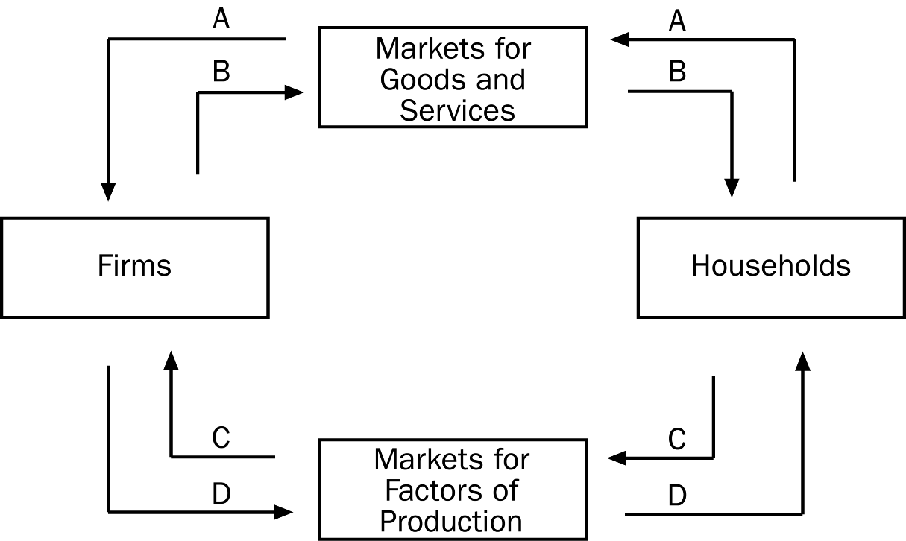
65. Refer to Figure 2-1. Which arrow represents the flow of goods and services?
a. A
b. B
c. C
d. D
ANS: B PTS: 1 DIF: 2 REF: 2-1
TOP: Circular-flow diagram MSC: Interpretive
66. Refer to Figure 2-1. Which arrow represents the flow of spending by households?
a. A
b. B
c. C
d. D
ANS: A PTS: 1 DIF: 2 REF: 2-1
TOP: Circular-flow diagram MSC: Interpretive
67. Refer to Figure 2-1. Which arrow shows the flow of land, labor, and capital?
a. A
b. B
c. C
d. D
ANS: C PTS: 1 DIF: 2 REF: 2-1
TOP: Circular-flow diagram MSC: Interpretive
68. Refer to Figure 2-1. Which arrow shows the flow of income payments?
a. A
b. B
c. C
d. D
ANS: D PTS: 1 DIF: 2 REF: 2-1
TOP: Circular-flow diagram MSC: Interpretive
69. Refer to Figure 2-1. Juan buys a new pair of shoes at a shoe store. To which of the arrows does this purchase directly contribute?
a. A only
b. A and B
c. C only
d. C and D
ANS: B PTS: 1 DIF: 2 REF: 2-1
TOP: Circular-flow diagram MSC: Applicative
70. Refer to Figure 2-1. Michelle completes her first week of employment working as a hairdresser at a salon. On Friday of that week she receives her first paycheck. To which of the arrows does this activity contribute directly?
a. B only
b. A and B
c. C only
d. C and D
ANS: D PTS: 1 DIF: 2 REF: 2-1
TOP: Circular-flow diagram MSC: Applicative
71. Among economic models, the circular-flow diagram is unusual in that it
a. drastically simplifies the real world.
b. features more than one type of market.
c. features flows of dollars.
d. does not involve mathematics.
ANS: D PTS: 1 DIF: 2 REF: 2-1
TOP: Circular-flow diagram | Economic models MSC: Interpretive
Figure 2-2
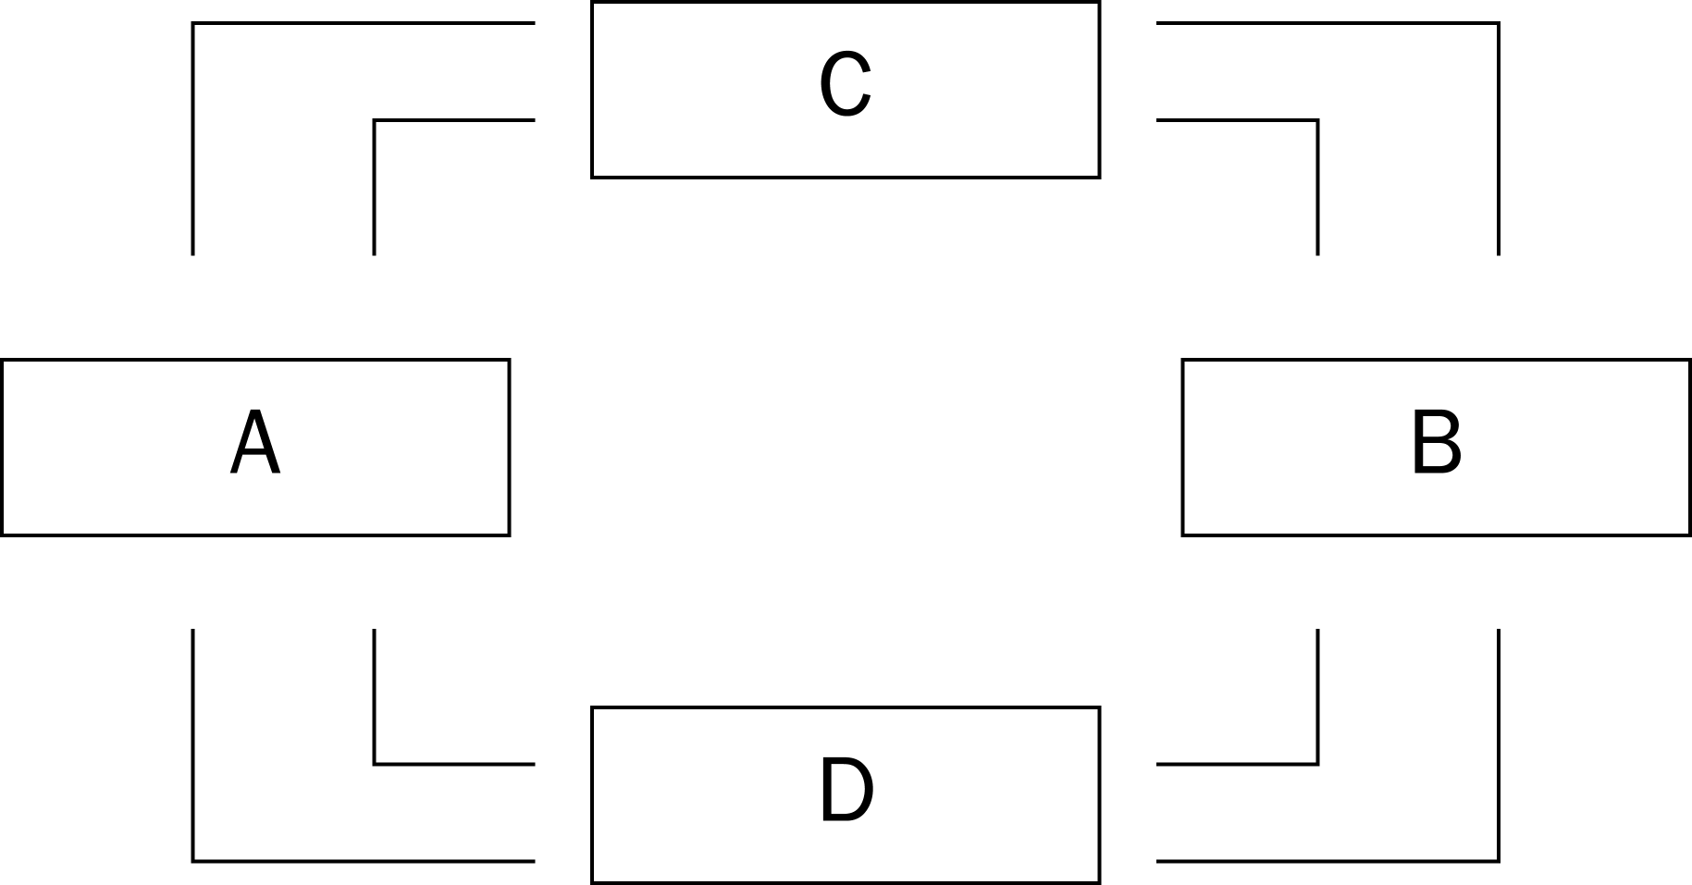
72. Refer to Figure 2-2. The figure represents a circular-flow diagram. Boxes A and B represent
a. firms and households.
b. households and government.
c. the markets for goods and services and the financial markets.
d. the markets for goods and the markets for services.
ANS: A PTS: 1 DIF: 2 REF: 2-1
TOP: Circular-flow diagram MSC: Interpretive
73. Refer to Figure 2-2. The figure represents a circular-flow diagram. Boxes C and D represent
a. households and government.
b. firms and government.
c. the markets for goods and services and the financial markets.
d. None of the above are correct.
ANS: D PTS: 1 DIF: 2 REF: 2-1
TOP: Circular-flow diagram MSC: Interpretive
74. Refer to Figure 2-2. The figure represents a circular-flow diagram. If Box A represents firms, then which box represents households?
a. Box B
b. Box C
c. Box D
d. Any one of the other boxes (B, C, or D) could represent households.
ANS: A PTS: 1 DIF: 2 REF: 2-1
TOP: Circular-flow diagram MSC: Interpretive
75. Refer to Figure 2-2. The figure represents a circular-flow diagram. If households are sellers in the markets represented by Box D, then
a. Box D must represent the markets for factors of production.
b. Box C must represent the markets for goods and services.
c. firms are buyers in the markets represented by Box D.
d. All of the above are correct.
ANS: D PTS: 1 DIF: 3 REF: 2-1
TOP: Circular-flow diagram MSC: Applicative
76. Refer to Figure 2-2. The figure represents a circular-flow diagram. If households are buyers in the markets represented by Box C, then
a. Box C must represent the markets for the factors of production.
b. Box D must represent the markets for goods and services.
c. firms are sellers in the markets represented by Box C.
d. All of the above are correct.
ANS: C PTS: 1 DIF: 3 REF: 2-1
TOP: Circular-flow diagram MSC: Applicative
77. Refer to Figure 2-2. The figure represents a circular-flow diagram. If the owners of land, labor, and capital are represented by Box B, then
a. the government is represented by Box A.
b. firms are represented by Box C.
c. firms are represented by Box A.
d. firms are sellers in Box B.
ANS: C PTS: 1 DIF: 3 REF: 2-1
TOP: Circular-flow diagram MSC: Applicative
78. Refer to Figure 2-2. The figure represents a circular-flow diagram. If the outer loop represents flows of dollars, then the inner loop includes
a. flows of goods and services, of which households are sellers.
b. flows of inputs, of which firms are buyers.
c. flows of rent payments paid to owners of land.
d. flows of wages and salaries paid to workers.
ANS: B PTS: 1 DIF: 2 REF: 2-1
TOP: Circular-flow diagram MSC: Applicative
79. Refer to Figure 2-2. The figure represents a circular-flow diagram. If the flow of goods and services is part of what is represented by the inner loop, then
a. the flow of factors of production is also part of what is represented by the inner loop.
b. the flow of income paid to households is also part of what is represented by the inner loop.
c. Box C must represent households and Box D must represent firms.
d. households must be sellers of output.
ANS: A PTS: 1 DIF: 2 REF: 2-1
TOP: Circular-flow diagram MSC: Applicative
80. Refer to Figure 2-2. The figure represents a circular-flow diagram. Marsha works as an attorney for a corporation and is paid a salary in exchange for the legal services she performs. James owns office buildings and rents his buildings to companies in exchange for rent payments. If Marsha’s income is represented by a flow of dollars from Box D to Box B, then James’s income is represented by a flow of dollars
a. from Box A to Box C.
b. from Box C to Box A.
c. from Box C to Box B.
d. from Box D to Box B.
ANS: D PTS: 1 DIF: 2 REF: 2-1
TOP: Circular-flow diagram MSC: Applicative
81. Refer to Figure 2-2. The figure represents a circular-flow diagram. Andrea regularly buys fruits and vegetables at a grocery store. Michael regularly pays a lawn-care company to mow his lawn. If the flow of fruits and vegetables from the grocery store to Andrea is represented by an arrow from Box C to Box B, then the money paid by Michael to the lawn-care company is represented by an arrow
a. from Box A to Box C.
b. from Box B to Box C.
c. from Box C to Box B.
d. from Box D to Box B.
ANS: B PTS: 1 DIF: 2 REF: 2-1
TOP: Circular-flow diagram MSC: Applicative
82. In the markets for factors of production,
a. households provide firms with labor, land, and capital.
b. households provide firms with savings for investment.
c. firms provide households with goods and services.
d. the government provides firms with inputs for the production process.
ANS: A PTS: 1 DIF: 2 REF: 2-1
TOP: Factor markets MSC: Interpretive
83. In the markets for goods and services,
a. households provide firms with savings for investment.
b. households provide firms with labor, land, and capital.
c. firms provide households with output.
d. the government provides firms with inputs for the production process.
ANS: C PTS: 1 DIF: 2 REF: 2-1
TOP: Output MSC: Interpretive
84. Which of the following transactions does not take place in a market for a factor of production?
a. Karl provides plumbing services for a plumbing company and receives an hourly wage from the company for his services.
b. Juanita works as a marriage counselor and her clients pay her on a per-hour basis for her services.
c. Trish owns several shopping malls and receives rent payments from the companies that operate those malls.
d. Ben sells advertising for a newspaper and receives a commission from the newspaper company for each advertisement that he sells.
ANS: B PTS: 1 DIF: 3 REF: 2-1
TOP: Factor markets MSC: Applicative
85. In economics, capital refers to
a. the finances necessary for firms to produce their products.
b. buildings and machines used in the production process.
c. the money households use to purchase firms' output.
d. goods, but not to services.
ANS: B PTS: 1 DIF: 2 REF: 2-1
TOP: Capital MSC: Definitional
86. The amount by which firms’ sales revenue exceeds their payments to factors of production is called
a. rent.
b. capital.
c. profit.
d. interest.
ANS: C PTS: 1 DIF: 2 REF: 2-1
TOP: Profit MSC: Definitional
87. Any point on a country's production possibilities frontier represents a combination of two goods that an economy
a. will never be able to produce.
b. can produce using all available resources and technology.
c. can produce using some portion, but not all, of its resources and technology.
d. may be able to produce in the future with more resources and/or superior technology.
ANS: B PTS: 1 DIF: 2 REF: 2-1
TOP: Production possibilities frontier MSC: Interpretive
88. Which of the following is the most accurate statement about production possibilities?
a. An economy can produce only on the production possibilities frontier.
b. An economy can produce at any point inside or outside a production possibilities frontier.
c. An economy can produce at any point on or inside the production possibilities frontier, but not outside the frontier.
d. An economy can produce at any point inside the production possibilities frontier, but not on or outside the frontier.
ANS: C PTS: 1 DIF: 2 REF: 2-1
TOP: Production possibilities frontier MSC: Interpretive
89. An economic outcome is said to be efficient if the economy is
a. using all of the resources it has available.
b. conserving on resources, rather than using all available resources.
c. getting all it can get from the scarce resources it has available.
d. able to produce more than what is currently being produced without additional resources.
ANS: C PTS: 1 DIF: 2 REF: 2-1
TOP: Efficiency MSC: Definitional
90. When constructing a production possibilities frontier, which of the following assumptions is not made?
a. The economy produces only two goods or two types of goods.
b. Firms produce goods using factors of production.
c. The technology available to firms is given.
d. The quantities of the factors of production that are available are increasing over the relevant time period.
ANS: D PTS: 1 DIF: 2 REF: 2-1
TOP: Production possibilities frontier MSC: Interpretive
91. Production is efficient if the economy is producing at a point
a. on the production possibilities frontier.
b. outside the production possibilities frontier.
c. on or inside the production possibilities frontier.
d. inside the production possibilities frontier.
ANS: A PTS: 1 DIF: 1 REF: 2-1
TOP: Production possibilities frontier MSC: Interpretive
92. If an economy is producing efficiently, then
a. there is no way to produce more of one good without producing less of another good.
b. it is possible to produce more of both goods without increasing the quantities of inputs that are being used.
c. it is possible to produce more of one good without producing less of the other.
d. it is not possible to produce more of any good at any cost.
ANS: A PTS: 1 DIF: 2 REF: 2-1
TOP: Efficiency MSC: Interpretive
93. Which of the following concepts can not be illustrated by the production possibilities frontier?
a. efficiency
b. opportunity cost
c. equity
d. tradeoffs
ANS: C PTS: 1 DIF: 2 REF: 2-1
TOP: Production possibilities frontier MSC: Interpretive
94. The bowed-out shape of the production possibilities frontier can be explained by the fact that
a. scarcity is a fact of life.
b. economic growth is always occurring.
c. the opportunity cost of one good in terms of the other depends on how much of each good the economy is producing.
d. an assumption that is made in constructing a production possibilities frontier is that tradeoffs are unimportant.
ANS: C PTS: 1 DIF: 2 REF: 2-1
TOP: Production possibilities frontier MSC: Interpretive
95. Production possibilities frontiers are usually bowed outward. This is because
a. the more resources a society uses to produce one good, the fewer resources it has available to produce another good.
b. it reflects the fact that the opportunity cost of producing a good decreases as more and more of that good is produced.
c. of the effects of technological change.
d. resources are specialized, that is, some are better at producing particular goods rather than other goods.
ANS: D PTS: 1 DIF: 2 REF: 2-1
TOP: Production possibilities frontier MSC: Interpretive
96. A production possibilities frontier that is a straight line shows
a. a truer picture of the real world than does a bowed-out production possibilities frontier.
b. that resources can be shifted easily and seamlessly from the production of one good to the production of a different good.
c. that the opportunity cost of one good in terms of another good depends on the quantities of the two goods that the economy is producing.
d. All of the above are correct.
ANS: B PTS: 1 DIF: 2 REF: 2-1
TOP: Production possibilities frontier MSC: Interpretive
97. Here are some production possibilities for an imaginary economy for a given year.

Cars | Newspapers
10 | 400
12 | 360
14 | ?

If the production possibilities frontier is bowed outward, then in place of "?" we might have
a. 340.
b. 330.
c. 320.
d. 310.
ANS: D PTS: 1 DIF: 2 REF: 2-1
TOP: Production possibilities frontier MSC: Applicative
98. A certain production possibilities frontier shows production possibilities for two goods: wheat and shirts. Which of the following concepts can not be illustrated in this model?
a. the flow of dollars between (i) sellers of wheat and shirts and (ii) buyers of wheat and shirts
b. the tradeoff between production of wheat and production of shirts
c. the opportunity cost of shirts in terms of wheat
d. the effect of economic growth on production possibilities involving wheat and shirts
ANS: A PTS: 1 DIF: 2 REF: 2-1
TOP: Production possibilities frontier MSC: Interpretive
99. Suppose a nation is currently producing at a point inside its production possibilities frontier. We know that
a. the nation is producing beyond its capacity, and inflation will occur.
b. the nation is not using all available resources or is using inferior technology or both.
c. the nation is producing an efficient combination of goods.
d. there will be a large opportunity cost if the nation tries to increase production of any good.
ANS: B PTS: 1 DIF: 2 REF: 2-1
TOP: Production possibilities frontier MSC: Interpretive
Figure 2-3
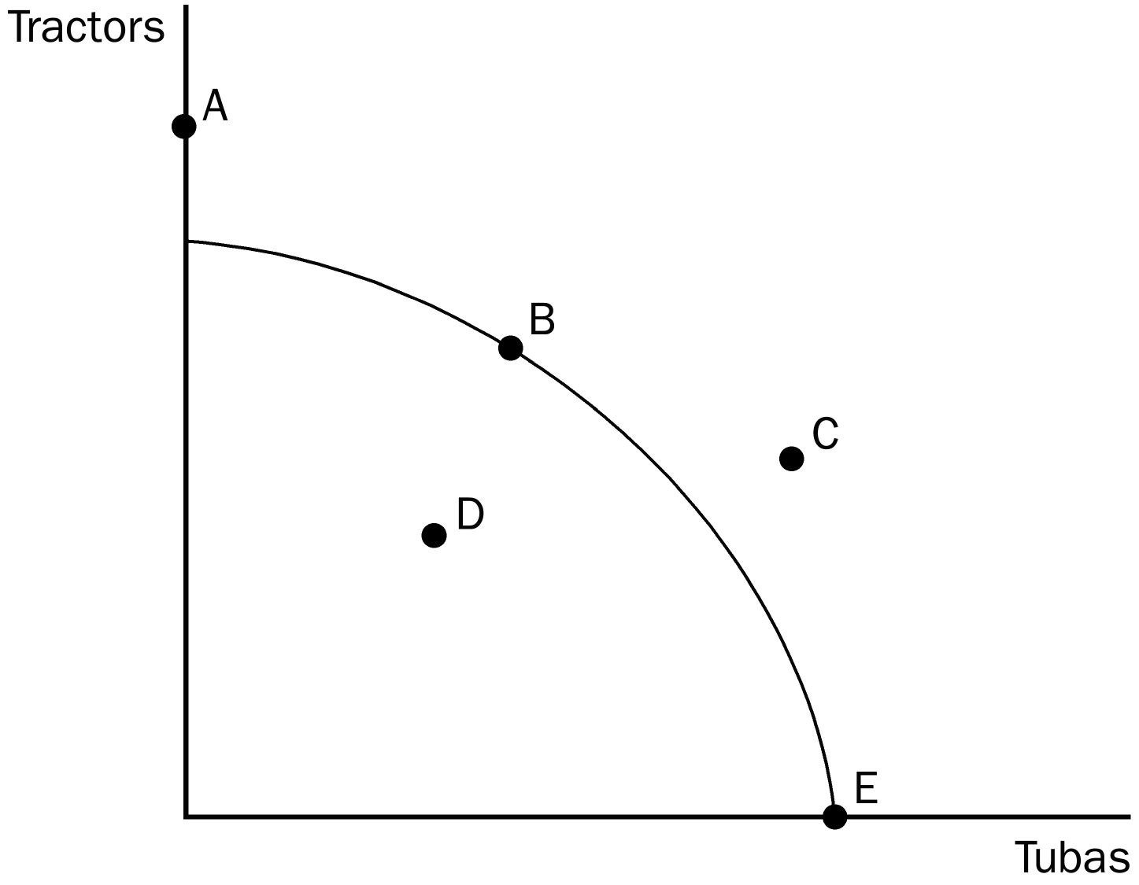
100. Refer to Figure 2-3. The economy has the ability to produce at which point or points?
a. B, D, E
b. A, B, D, E
c. D, C
d. D
ANS: A PTS: 1 DIF: 2 REF: 2-1
TOP: Production possibilities frontier MSC: Interpretive
101. Refer to Figure 2-3. Which point represents the situation in which the economy is producing its maximum possible quantity of tubas?
a. A
b. B
c. D
d. E
ANS: D PTS: 1 DIF: 1 REF: 2-1
TOP: Production possibilities frontier MSC: Interpretive
102. Refer to Figure 2-3. At which point or points can the economy not currently produce?
a. A
b. C
c. A, C
d. A, C, D
ANS: C PTS: 1 DIF: 2 REF: 2-1
TOP: Production possibilities frontier MSC: Interpretive
103. Refer to Figure 2-3. Efficient production is represented by which point or points?
a. B, E
b. A, B, E
c. D
d. C
ANS: A PTS: 1 DIF: 2 REF: 2-1
TOP: Production possibilities frontier MSC: Interpretive
104. Refer to Figure 2-3. Inefficient production is represented by which point or points?
a. D
b. D, E
c. A, C
d. A, B
ANS: A PTS: 1 DIF: 2 REF: 2-1
TOP: Production possibilities frontier MSC: Interpretive
105. The opportunity cost of obtaining more of one good is shown on the production possibilities frontier as the
a. amount of the other good that must be given up.
b. market price of the additional amount produced.
c. amount of resources that must be devoted to its production.
d. number of dollars that must be spent to produce it.
ANS: A PTS: 1 DIF: 2 REF: 2-1
TOP: Production possibilities frontier | Opportunity cost MSC: Interpretive
Figure 2-4
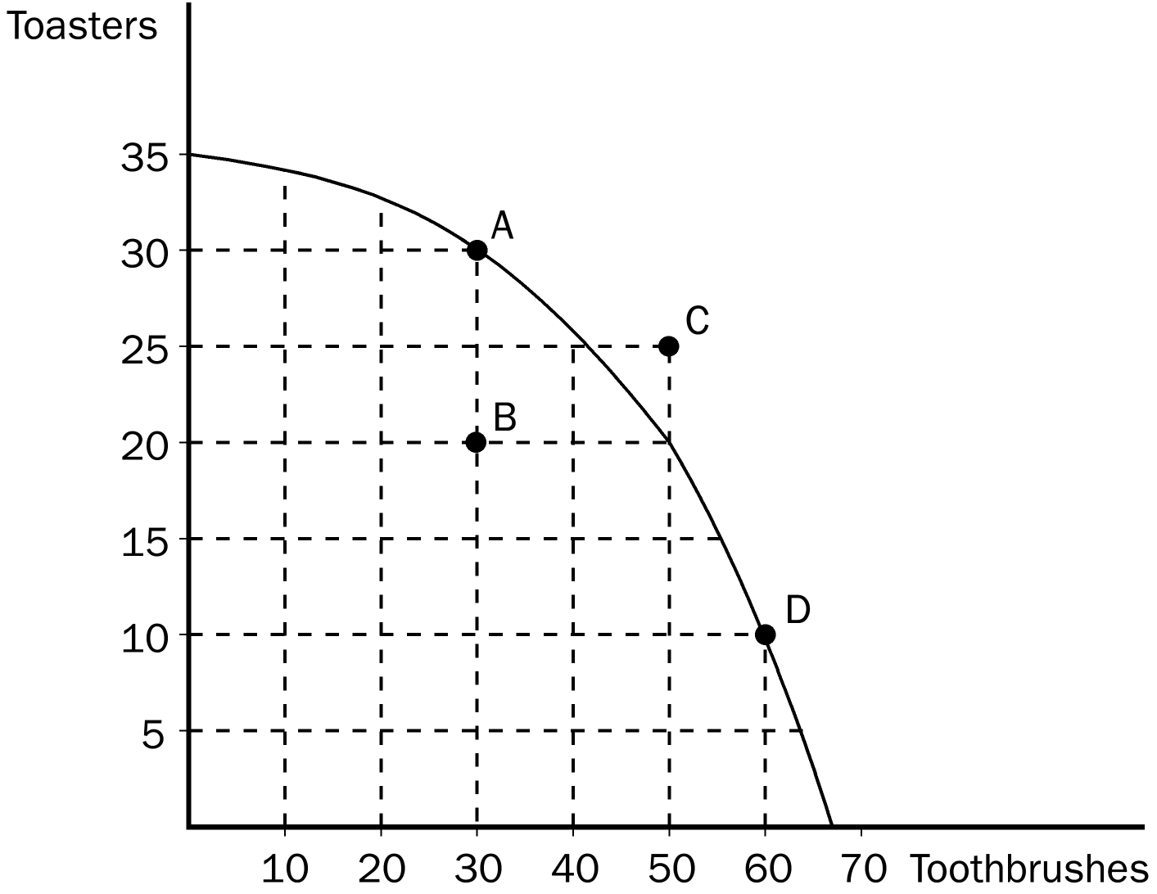
106. Refer to Figure 2-4. If the economy moves from point A to point D, the opportunity cost is
a. 10 toasters.
b. 20 toasters.
c. 30 toasters.
d. 30 toothbrushes.
ANS: B PTS: 1 DIF: 2 REF: 2-1
TOP: Production possibilities frontier | Opportunity cost MSC: Interpretive
107. Refer to Figure 2-4. The opportunity cost of obtaining 15 additional toasters by moving from point D to point C is
a. 10 toothbrushes.
b. 20 toothbrushes.
c. 30 toothbrushes.
d. none of the above; the economy cannot move from point D to point C.
ANS: D PTS: 1 DIF: 2 REF: 2-1
TOP: Production possibilities frontier | Opportunity cost MSC: Interpretive
108. Refer to Figure 2-4. The opportunity cost of obtaining 10 additional toasters by moving from point B to point A is
a. 10 toothbrushes.
b. 20 toothbrushes.
c. 30 toothbrushes.
d. zero, since the economy has the additional resources to produce 10 additional toasters.
ANS: D PTS: 1 DIF: 2 REF: 2-1
TOP: Production possibilities frontier | Opportunity cost MSC: Interpretive
109. Refer to Figure 2-4. Suppose the economy is producing at point B. Which of the following statements would best explain this situation?
a. The economy lacks the resources to produce at a more desirable point.
b. The economy’s available technology prevents it from producing at a more desirable point.
c. There is widespread unemployment in the economy.
d. Any of the above statements would be a legitimate explanation for this situation.
ANS: C PTS: 1 DIF: 3 REF: 2-1
TOP: Production possibilities frontier MSC: Analytical
Figure 2-5
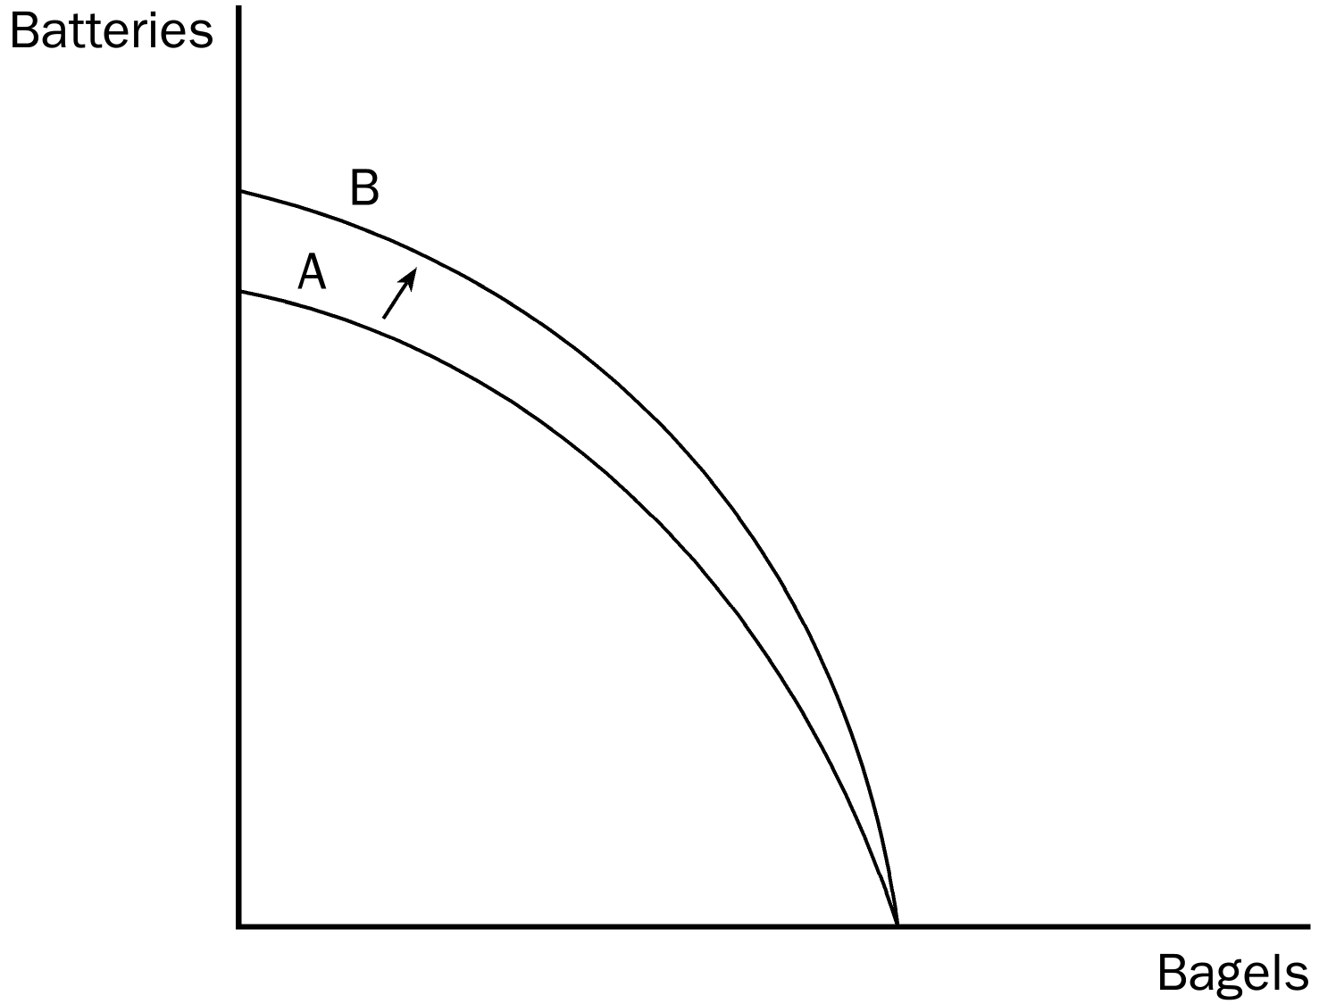
110. Refer to Figure 2-5. Which of the following events would explain the shift of the production possibilities frontier from A to B?
a. The economy experienced a technological advance in the production of batteries.
b. The economy’s citizens developed an enhanced taste for batteries.
c. More capital became available in the economy.
d. More labor became available in the economy.
ANS: A PTS: 1 DIF: 2 REF: 2-1
TOP: Production possibilities frontier MSC: Interpretive
111. Refer to Figure 2-5. The shift of the production possibilities frontier from A to B illustrates
a. simultaneous technological advances in the battery and bagel industries.
b. a reallocation of resources away from the production of bagels and toward the production of batteries.
c. economic growth.
d. All of the above are correct.
ANS: C PTS: 1 DIF: 3 REF: 2-1
TOP: Production possibilities frontier MSC: Applicative
Figure 2-6
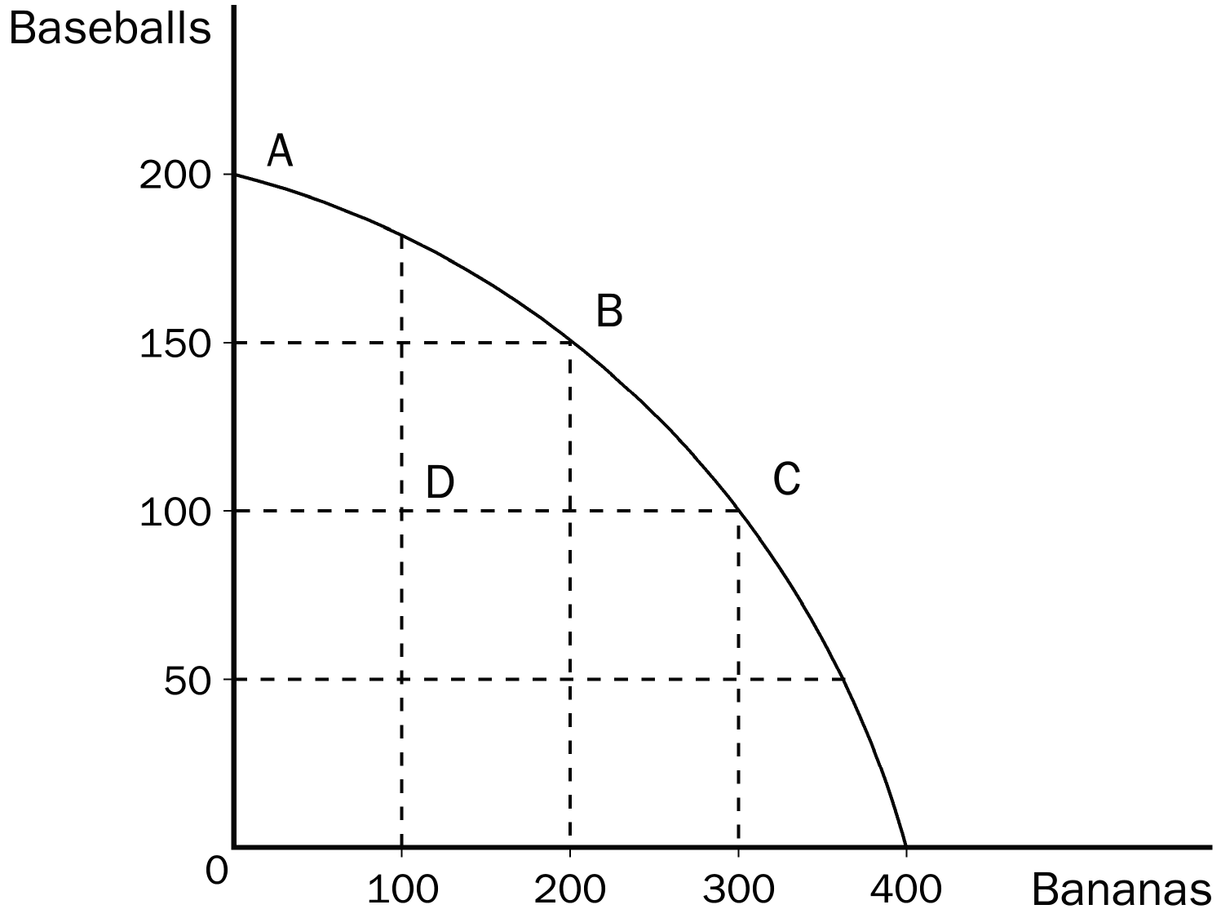
112. Refer to Figure 2-6. What is the opportunity cost to society of the movement from point A to point C?
a. 50 baseballs
b. 100 baseballs
c. 100 bananas
d. 300 bananas
ANS: B PTS: 1 DIF: 2 REF: 2-1
TOP: Production possibilities frontier | Opportunity cost MSC: Interpretive
113. Refer to Figure 2-6. A movement from point C to point D could be caused by
a. unemployment.
b. a decrease in society's preference for bananas.
c. fewer resources available for production of bananas.
d. All of the above are correct.
ANS: A PTS: 1 DIF: 2 REF: 2-1
TOP: Production possibilities frontier MSC: Interpretive
114. Refer to Figure 2-6. If this economy put all available resources into the production of bananas, it could produce
a. 200 bananas and also 150 baseballs.
b. 300 bananas and also 100 baseballs.
c. 400 bananas and no baseballs.
d. It is impossible to know unless we know the quantity of resources available.
ANS: C PTS: 1 DIF: 2 REF: 2-1
TOP: Production possibilities frontier MSC: Interpretive
115. Refer to Figure 2-6. If this economy put one-half of its available resources into the production of baseballs and the other half into the production of bananas, it could produce
a. 100 baseballs and 200 bananas.
b. 100 baseballs and 300 bananas.
c. 150 baseballs and 200 bananas.
d. We would have to know the details of the economy’s technology in order to determine this.
ANS: D PTS: 1 DIF: 3 REF: 2-1
TOP: Production possibilities frontier MSC: Analytical
116. Refer to Figure 2-6. If the economy moves from point C to point B, then which of the following statements is correct?
a. The economy benefited from a technological advance in the production of baseballs.
b. The opportunity cost of each additional baseball is 2 bananas.
c. The opportunity cost of each additional banana is 2 baseballs.
d. The move involves no opportunity cost; it simply reflects the desires of the economy’s citizens.
ANS: B PTS: 1 DIF: 3 REF: 2-1
TOP: Production possibilities frontier MSC: Applicative
117. Refer to Figure 2-6. If the economy moves from point A to point B, then which of the following statements is correct?
a. The economy has moved from a point of inefficient production to a point of efficient production.
b. The economy has experienced economic growth.
c. The opportunity cost of each additional banana produced is 50 baseballs.
d. None of the above is correct.
ANS: D PTS: 1 DIF: 3 REF: 2-1
TOP: Production possibilities frontier MSC: Applicative
118. Unemployment would cause an economy to
a. produce inside its production possibilities frontier.
b. produce on its production possibilities frontier.
c. produce outside its production possibilities frontier.
d. experience an inward shift of its production possibilities frontier.
ANS: A PTS: 1 DIF: 2 REF: 2-1
TOP: Production possibilities frontier MSC: Interpretive
119. When an economy is operating at a point on (rather than inside) its production possibilities frontier, then
a. consumers are content with the mix of goods and services that is being produced.
b. there is no way to produce more of one good without producing less of the other.
c. equal amounts of the two goods (measured along the two axes) are being produced.
d. All of the above are correct.
ANS: B PTS: 1 DIF: 3 REF: 2-1
TOP: Production possibilities frontier MSC: Analytical
120. It is possible for an economy to increase its production of computers and, at the same time, to increase its production of cars if the economy
a. moves downward and to the right along its production possibilities frontier and the frontier is bowed outward.
b. moves upward and to the left along its production possibilities frontier and the frontier is bowed outward.
c. moves in either direction along its production possibilities frontier and the frontier is a straight line.
d. moves from a situation of inefficient production to a situation of efficient production.
ANS: D PTS: 1 DIF: 2 REF: 2-1
TOP: Production possibilities frontier MSC: Applicative
121. A production possibilities frontier can shift outward if
a. government increases the amount of money in the economy.
b. there is a technological improvement.
c. resources are shifted from the production of one good to the production of the other good.
d. the economy abandons inefficient production methods in favor of efficient production methods.
ANS: B PTS: 1 DIF: 2 REF: 2-1
TOP: Production possibilities frontier MSC: Interpretive
122. A production possibilities frontier shifts outward when
a. the economy experiences economic growth.
b. the desires of the economy’s citizens change.
c. at least one of the basic principles of economics is violated.
d. opportunity costs are lessened.
ANS: A PTS: 1 DIF: 2 REF: 2-1
TOP: Production possibilities frontier MSC: Interpretive
123. When an economy is operating inside its production possibilities frontier we know that
a. there are unused resources or inefficiencies in the economy.
b. all of the economy’s resources are fully employed.
c. economic growth would have to occur in order for the economy to move to a point on the frontier.
d. in order to produce more of one good, the economy would have to give up some of the other good.
ANS: A PTS: 1 DIF: 2 REF: 2-1
TOP: Production possibilities frontier MSC: Interpretive
124. In a certain economy, peanuts and books are produced, and the economy currently operates on its production possibilities frontier. Which of the following events would allow the economy to produce more peanuts and more books, relative to the quantities of those goods that are being produced now?
a. Unemployed labor is put to work producing peanuts and books.
b. The economy puts its idle capital to work producing peanuts and books.
c. The economy experiences economic growth.
d. All of the above are correct.
ANS: C PTS: 1 DIF: 3 REF: 2-1
TOP: Production possibilities frontier MSC: Applicative
125. In a certain economy, brooms and radios are produced, and the economy currently operates on its production possibilities frontier. Which of the following events would allow the economy to produce more brooms and more radios, relative to the quantities of those goods that are being produced now?
a. The economy experiences economic growth.
b. There is a technological advance in the broom industry, but the radio industry experiences no such advance.
c. There is a technological advance in the radio industry, but the broom industry experiences no such advance.
d. All of the above are correct.
ANS: D PTS: 1 DIF: 3 REF: 2-1
TOP: Production possibilities frontier MSC: Applicative
126. Which of the following is an example of an economic model?
a. the production possibilities frontier
b. the concept of opportunity cost
c. the concept of capital
d. All of the above are economic models.
ANS: A PTS: 1 DIF: 1 REF: 2-1
TOP: Economic models | Production possibilities frontier MSC: Interpretive
Figure 2-7
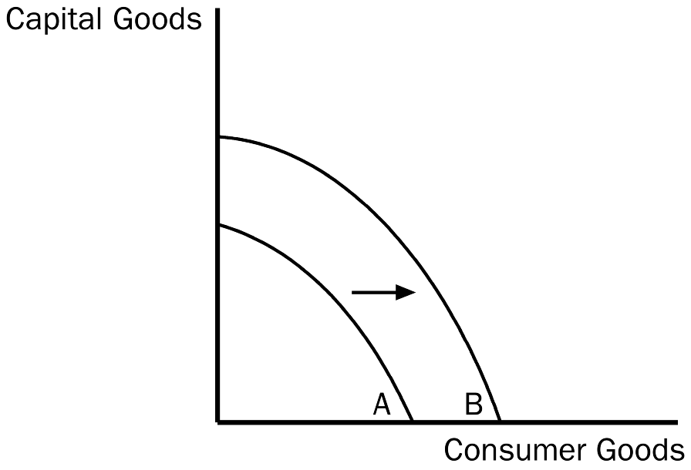
127. Refer to Figure 2-7. Which of the following would most likely have caused the production possibilities frontier to shift outward from A to B?
a. an increase in the availability of capital-producing resources
b. a technological advance in the consumer-goods industries
c. a general technological advance
d. a decrease in unemployment
ANS: C PTS: 1 DIF: 2 REF: 2-1
TOP: Production possibilities frontier | Technology MSC: Applicative
128. Refer to Figure 2-7. The shift of the production possibilities frontier from A to B can best be described as
a. a downturn in the economy.
b. economic growth.
c. an enhancement of equity.
d. an improvement in the allocation of resources.
ANS: B PTS: 1 DIF: 2 REF: 2-1
TOP: Production possibilities frontier MSC: Interpretive
Table 2-1. Production Possibilities for Toyland

Dolls | Fire Trucks
400 | 0
300 | 200
200 | 350
100 | 450
0 | 500

129. Refer to Table 2-1. What is the opportunity cost to Toyland of increasing the production of dolls from 200 to 300?
a. 200 fire trucks
b. 150 fire trucks
c. 100 fire trucks
d. It is impossible to tell what the opportunity cost is since in this example costs are not constant.
ANS: B PTS: 1 DIF: 2 REF: 2-1
TOP: Opportunity cost MSC: Interpretive
130. Refer to Table 2-1. Which of the following statements accurately describes the production possibilities for Toyland?
a. The opportunity cost of an additional 100 dolls is 50 fire trucks.
b. The opportunity cost of an additional 100 dolls is 100 fire trucks.
c. Toyland’s production possibilities frontier is a straight, downward-sloping line.
d. The opportunity cost of an additional 100 dolls increases as more dolls are produced.
ANS: D PTS: 1 DIF: 2 REF: 2-1
TOP: Opportunity cost | Production possibilities frontier MSC: Applicative
Figure 2-8
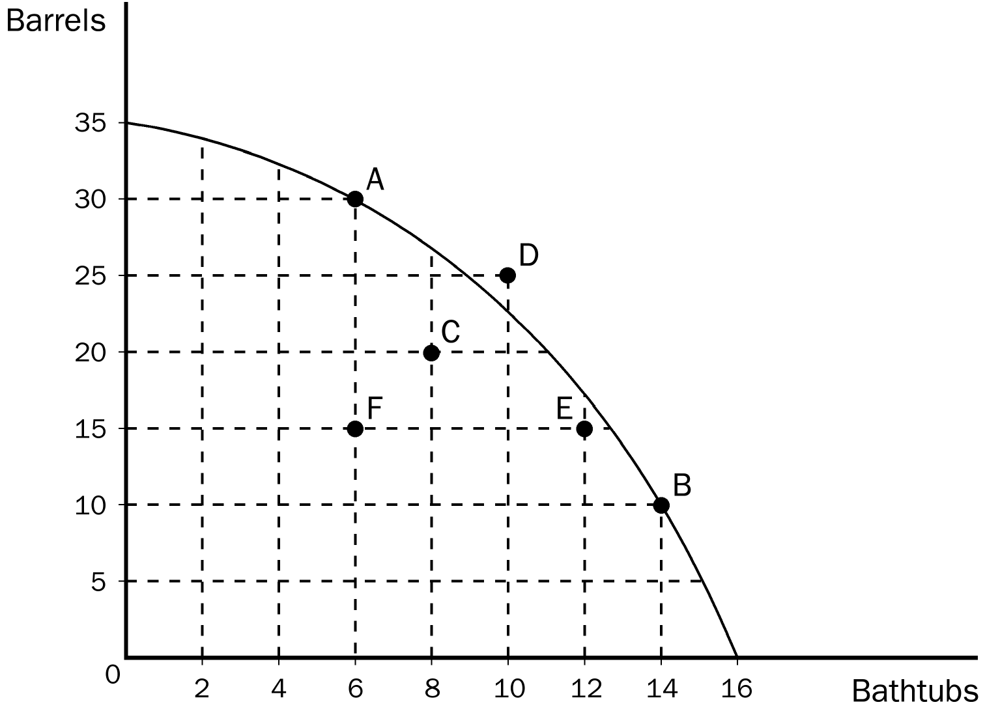
131. Refer to Figure 2-8. Production is efficient if the economy is producing
a. 30 barrels and 6 bathtubs.
b. 20 barrels and 8 bathtubs.
c. 25 barrels and 12 bathtubs.
d. 15 barrels and 12 bathtubs.
ANS: A PTS: 1 DIF: 2 REF: 2-1
TOP: Production possibilities frontier MSC: Interpretive
132. Refer to Figure 2-8. What is the opportunity cost of moving from point A to point B?
a. 8 bathtubs
b. 20 barrels
c. the gain in well-being that the society experiences as a result of the move
d. the loss of well-being that the society experiences as a result of the move
ANS: B PTS: 1 DIF: 2 REF: 2-1
TOP: Production possibilities frontier | Opportunity cost MSC: Interpretive
133. Refer to Figure 2-8. If this economy puts all of its resources into the production of bathtubs it could produce
a. 20 barrels and 12 bathtubs.
b. no barrels and 14 bathtubs.
c. no barrels and 16 bathtubs.
d. More information is required in order to make this determination.
ANS: C PTS: 1 DIF: 2 REF: 2-1
TOP: Production possibilities frontier MSC: Interpretive
134. Refer to Figure 2-8. Which of the following combinations can this economy not produce?
a. 30 barrels and 6 bathtubs
b. 25 barrels and 12 bathtubs
c. 20 barrels and 8 bathtubs
d. 10 barrels and 14 bathtubs
ANS: B PTS: 1 DIF: 2 REF: 2-1
TOP: Production possibilities frontier MSC: Interpretive
135. Refer to Figure 2-8. If this economy moved from point C to point E,
a. it still would not be producing efficiently.
b. there would be no gain in either bathtubs or barrels.
c. it would be producing more barrels and more bathtubs than at point C.
d. It is not possible for this economy to move from point C to point E without additional resources.
ANS: A PTS: 1 DIF: 2 REF: 2-1
TOP: Production possibilities frontier MSC: Interpretive
136. Suppose an economy produces two goods, food and machines. This economy always operates on its production possibilities frontier. Last year, it produced 50 units of food and 30 machines. This year, it is producing 55 units of food and 33 machines. Which of the following events could not explain the increase in output?
a. a reduction in unemployment
b. an increase in available labor
c. an improvement in technology
d. Any of these events could explain the increase in output.
ANS: A PTS: 1 DIF: 3 REF: 2-1
TOP: Production possibilities frontier MSC: Applicative
137. Suppose an economy produces two goods, food and machines. This economy always operates on its production possibilities frontier. Last year, it produced 50 units of food and 30 machines. This year it experienced a technological advance in its machine-making industry. As a result, this year the society wants to produce 55 units of food and 30 machines. Which of the following statements is true?
a. Because the technological advance occurred in the machine-making industry, it will not be possible to increase food production without reducing machine production below 30.
b. Because the technological advance occurred in the machine-making industry, increases in output can only occur in the machine industry.
c. In order to increase food production in these circumstances without reducing machine production, the economy must reduce inefficiencies.
d. The technological advance reduced the amount of resources needed to produce 30 machines. These resources could be used to produce more food.
ANS: D PTS: 1 DIF: 3 REF: 2-1
TOP: Production possibilities frontier MSC: Analytical
138. The country of Econoland produces two goods, textbooks and widgets. Last year it produced 200 textbooks and 500 widgets. This year it produced 250 textbooks and 600 widgets. Given no other information, which of the following events could not explain this change?
a. Econoland experienced a reduction in unemployment.
b. Econoland experienced an improvement in widget-making technology.
c. Econoland acquired more resources.
d. Any of these events could, in fact, explain the change.
ANS: D PTS: 1 DIF: 2 REF: 2-1
TOP: Production possibilities frontier MSC: Applicative
139. The field of economics is traditionally divided into two broad subfields,
a. national economics and international economics.
b. consumer economics and producer economics.
c. private sector economics and public sector economics.
d. microeconomics and macroeconomics.
ANS: D PTS: 1 DIF: 1 REF: 2-1
TOP: Microeconomics | Macroeconomics MSC: Definitional
140. Microeconomics is the study of
a. the behavior of consumers.
b. how individual households and firms make decisions.
c. how government affects the economy.
d. how the economy as a whole works.
ANS: B PTS: 1 DIF: 1 REF: 2-1
TOP: Microeconomics | Macroeconomics MSC: Definitional
141. Macroeconomics is the study of
a. individual decisionmakers.
b. international trade.
c. economy-wide phenomena.
d. markets for large products.
ANS: C PTS: 1 DIF: 1 REF: 2-1
TOP: Microeconomics | Macroeconomics MSC: Definitional
142. Which of the following would be considered a topic of study in macroeconomics?
a. the effect of agricultural price support programs on the cotton industry
b. the effect on U.S. steel producers of an import quota imposed on foreign steel
c. the effect of an increasing inflation rate on national living standards
d. the effect of an increase in the price of imported coffee beans on the U.S. coffee industry
ANS: C PTS: 1 DIF: 2 REF: 2-1
TOP: Microeconomics | Macroeconomics MSC: Interpretive
143. Which of the following statements best captures the relationship between microeconomics and macroeconomics?
a. For the most part, microeconomists are unconcerned with macroeconomics, and macroeconomists are unconcerned with microeconomics.
b. Microeconomists study markets for small products, whereas macroeconomists study markets for large products.
c. Microeconomics and macroeconomics are distinct from one another, yet they are closely related.
d. Microeconomics is oriented toward policy studies, whereas macroeconomics is oriented toward theoretical studies.
ANS: C PTS: 1 DIF: 1 REF: 2-1
TOP: Microeconomics | Macroeconomics MSC: Definitional
144. Microeconomics is best described as the study of
a. economy-wide phenomena.
b. how households and firms make decisions and how they interact in specific markets.
c. the flows of dollars between households and firms.
d. markets for land, labor, and capital.
ANS: B PTS: 1 DIF: 1 REF: 2-1
TOP: Microeconomics MSC: Definitional
145. Which of the following areas of study typifies macroeconomics as opposed to microeconomics?
a. the effects of rent control on the availability of housing in New York City
b. the economic impact of tornadoes on cities and towns in Oklahoma
c. how tariffs on shoes affects the shoe industry
d. the effect on the economy of changes in the nation’s unemployment rate
ANS: D PTS: 1 DIF: 2 REF: 2-1
TOP: Microeconomics | Macroeconomics MSC: Interpretive
146. Which of the following areas of study typifies microeconomics as opposed to macroeconomics?
a. the impact of minimum-wage laws on employment in the fast food industry
b. the effect of changes in household saving rates on the growth rate of national income
c. the impact of faster money growth on the rate of inflation
d. a comparison of alternative tax policies and their respective impacts on the rate of the nation’s economic growth
ANS: A PTS: 1 DIF: 2 REF: 2-1
TOP: Microeconomics | Macroeconomics MSC: Interpretive
147. Which of the following statements is correct?
a. Microeconomics and macroeconomics are two separate divisions of economics, completely independent of each other.
b. Microeconomists focus their attention on markets for small products, while macroeconomics focus their attention on markets for large products.
c. Microeconomics and macroeconomics are two distinct but closely intertwined fields of economics.
d. It is possible to understand macroeconomics without understanding microeconomics, but not vice versa.
ANS: C PTS: 1 DIF: 2 REF: 2-1
TOP: Microeconomics | Macroeconomics MSC: Interpretive
148. When economists are trying to explain the world, they are
a. scientists.
b. policy advisers.
c. in the realm of microeconomics rather than macroeconomics.
d. in the realm of normative economics rather than positive economics.
ANS: A PTS: 1 DIF: 1 REF: 2-2
TOP: Economists MSC: Interpretive
149. When economists are trying to help improve the world they are
a. concerned with positive economics rather than normative economics.
b. concerned with macroeconomics rather than microeconomics.
c. scientists.
d. policy advisers.
ANS: D PTS: 1 DIF: 1 REF: 2-2
TOP: Economists MSC: Interpretive
150. Which is the best statement about the roles of economists?
a. Economists are best viewed as policymakers.
b. Economists are best viewed as scientists.
c. In trying to explain the world, economists are policymakers; in trying to improve the world, they are scientists.
d. In trying to explain the world, economists are scientists; in trying to improve the world, they are policymakers.
ANS: D PTS: 1 DIF: 2 REF: 2-2
TOP: Economists MSC: Interpretive
151. Who among the following individuals majored in economics as a college student?
a. Arnold Schwartzenegger, governor of California
b. Ronald Reagan, president of the United States
c. Tiger Woods, golfer
d. All of the above are correct.
ANS: D PTS: 1 DIF: 2 REF: 2-2
TOP: Economists MSC: Definitional
152. Who among the following individuals majored in economics as a college student?
a. Mick Jagger, singer
b. John Elway, National Football League quarterback
c. Kofi Annan, United Nations Secretary General
d. All of the above are correct.
ANS: D PTS: 1 DIF: 2 REF: 2-2
TOP: Economists MSC: Definitional
153. For economists, statements about the world are of two types:
a. assumptions and theories.
b. true statements and false statements.
c. specific statements and general statements.
d. positive statements and normative statements.
ANS: D PTS: 1 DIF: 1 REF: 2-2
TOP: Positive statements | Normative statements MSC: Definitional
154. Economists view positive statements as
a. affirmative, justifying existing economic policy.
b. optimistic, putting the best possible interpretation on things.
c. descriptive, making a claim about how the world is.
d. prescriptive, making a claim about how the world ought to be.
ANS: C PTS: 1 DIF: 1 REF: 2-2
TOP: Positive statements MSC: Definitional
155. Economists consider normative statements to be
a. descriptive, making a claim about how the world is.
b. statements about the normal condition of the world.
c. prescriptive, making a claim about how the world ought to be.
d. statements which establish production goals for the economy.
ANS: C PTS: 1 DIF: 1 REF: 2-2
TOP: Normative statements MSC: Definitional
156. Which of the following is an example of a positive statement?
a. Prices rise when the government prints too much money.
b. If welfare payments increase, the world will be a better place.
c. Inflation is more harmful to the economy than is unemployment.
d. When public policies are evaluated, the benefits to the economy of improved equity should be considered more important than the costs of reduced efficiency.
ANS: A PTS: 1 DIF: 2 REF: 2-2
TOP: Positive statements | Normative statements MSC: Applicative
157. Which of these statements is a normative statement (as opposed to a positive statement)?
a. Gasoline prices ought to be lower than they are now.
b. The federal government should raise taxes on wealthy people.
c. The social security system is a good system and it deserves to be preserved as it is.
d. All of the above are normative statements.
ANS: D PTS: 1 DIF: 2 REF: 2-2
TOP: Normative statements | Positive statements MSC: Interpretive
158. Which of the following is not a positive statement?
a. Higher gasoline prices will reduce gasoline consumption.
b. Equity is more important than efficiency.
c. Trade restrictions lower our standard of living.
d. If a nation wants to avoid inflation, it will restrict the growth rate of the quantity of money.
ANS: B PTS: 1 DIF: 2 REF: 2-2
TOP: Positive statements MSC: Interpretive
159. A normative statement describes how the world
a. was in the past.
b. is in the present.
c. will be in the future.
d. ought to be.
ANS: D PTS: 1 DIF: 1 REF: 2-2
TOP: Normative statements MSC: Definitional
160. Which of the following is an example of a normative statement?
a. If the price of a product decreases, people’s willingness to buy that product will increase.
b. Reducing tax rates on the wealthy would benefit the nation.
c. If the national saving rate were to increase, so would the rate of economic growth.
d. All of the above are correct.
ANS: B PTS: 1 DIF: 2 REF: 2-2
TOP: Normative statements MSC: Applicative
161. Which of these statements is a positive statement (as opposed to a normative statement)?
a. Income tax rates should not have been cut as they were a few years ago.
b. The quantity of money has grown too slowly in recent years.
c. When the quantity of money grows rapidly, inflation is a predictable consequence.
d. All of the above are positive statements.
ANS: C PTS: 1 DIF: 2 REF: 2-2
TOP: Normative statements | Positive statements MSC: Interpretive
162. “Prices rise when the quantity of money rises rapidly” is an example of a
a. negative economic statement.
b. positive economic statement.
c. normative economic statement.
d. statement that contradicts one of the basic principles of economics.
ANS: B PTS: 1 DIF: 2 REF: 2-2
TOP: Positive statements | Normative statements MSC: Applicative
163. In principle, we can
a. ignore positive statements when choosing among various public-policy alternatives.
b. ignore normative statements when choosing among various public-policy alternatives.
c. confirm or refute positive statements by examining evidence.
d. confirm or refute normative statements by examining evidence.
ANS: C PTS: 1 DIF: 2 REF: 2-2
TOP: Positive statements | Normative statements MSC: Interpretive
164. When economists make normative statements, they are
a. speaking as scientists.
b. speaking as policy advisers.
c. adhering very strictly to basic economic principles.
d. revealing that they are very conservative in their views of how the world works.
ANS: B PTS: 1 DIF: 2 REF: 2-2
TOP: Normative statements MSC: Interpretive
165. One way to characterize the difference between positive statements and normative statements is as follows:
a. Positive statements tend to reflect optimism about the economy and its future, whereas normative statements tend to reflect pessimism about the economy and its future.
b. Positive statements offer descriptions of the way things are, whereas normative statements offer opinions on how things ought to be.
c. Positive statements involve advice on policy matters, whereas normative statements are supported by scientific theory and observation.
d. Economists outside of government tend to make normative statements, whereas government-employed economists tend to make positive statements.
ANS: B PTS: 1 DIF: 2 REF: 2-2
TOP: Normative statements | Positive statements MSC: Definitional
166. When an economist evaluates a positive statement, he or she is primarily
a. examining evidence.
b. evaluating values as well as facts.
c. acting as a policy adviser.
d. concerned with making a sound decision on how the world ought to be.
ANS: A PTS: 1 DIF: 2 REF: 2-2
TOP: Positive statements MSC: Interpretive
167. Normative conclusions
a. are derived directly from positive analysis.
b. are based on ignorance of positive analysis.
c. involve value judgments.
d. reflect the economist’s role as scientist.
ANS: C PTS: 1 DIF: 2 REF: 2-2
TOP: Positive statements | Normative statements MSC: Interpretive
168. You know an economist has crossed the line from scientist to policy adviser when he or she
a. claims that the problem at hand is widely misunderstood by non-economists.
b. talks about the evidence.
c. makes normative statements.
d. makes positive statements.
ANS: C PTS: 1 DIF: 1 REF: 2-2
TOP: Positive statements | Normative statements MSC: Interpretive
169. A few years ago, economist David Romer wrote a paper in which he analyzed whether professional football teams
a. should be exempt from antitrust laws.
b. earned higher profits than those earned by professional baseball or basketball teams.
c. priced their admission tickets in a rational manner.
d. punted more often than is rational.
ANS: D PTS: 1 DIF: 2 REF: 2-2
TOP: Economists MSC: Interpretive
170. A few years ago, Bill Belichick, the coach of the New England Patriots football team, acknowledged that he had recently read an article written by a professional economist concerning
a. the tendency of professional football teams to pass more often than is rational.
b. the tendency of professional football teams to punt more often than is rational.
c. the tendency of professional football team owners to fire their coaches more often than is rational.
d. the overinflated salaries of professional athletes in all sports, including football.
ANS: B PTS: 1 DIF: 2 REF: 2-2
TOP: Economists MSC: Interpretive
171. Bill Belichick, coach of the New England Patriots football team,
a. majored in sports management when he was a college student.
b. has been credited with adapting the methods of a social scientist to the coaching of football.
c. has been described as a coach who uses his knowledge of business to keep the salaries of his players artificially low.
d. All of the above are correct.
ANS: B PTS: 1 DIF: 2 REF: 2-2
TOP: Economists MSC: Interpretive
172. Economists at the Treasury Department
a. write the annual Economic Report of the President.
b. provide Congress with the annual budget.
c. enforce the U.S. antitrust laws.
d. provide advice on tax policy to the President.
ANS: D PTS: 1 DIF: 2 REF: 2-2
TOP: Economists MSC: Definitional
173. In addition to advising the president, one duty of the Council of Economic Advisors is to
a. prepare the federal budget.
b. write government regulations.
c. advise Congress on economic matters.
d. write the annual Economic Report of the President.
ANS: D PTS: 1 DIF: 2 REF: 2-2
TOP: Council of Economic Advisers MSC: Definitional
174. The Council of Economic Advisors
a. was created in 1913 and consists of three members and a staff of several dozen economists.
b. was created in 1913 and consists of three members and a staff of six economists.
c. was created in 1946 and consists of three members and a staff of several dozen economists.
d. was created in 1946 and consists of several dozen members and a staff of several hundred economists.
ANS: C PTS: 1 DIF: 2 REF: 2-2
TOP: Council of Economic Advisers MSC: Definitional
175. The President of the United States receives tax policy advice from economists in the
a. Federal Reserve.
b. Department of Justice.
c. Department of Treasury.
d. Congressional Budget Office.
ANS: C PTS: 1 DIF: 2 REF: 2-2
TOP: Economists MSC: Interpretive
176. Economists in which cabinet-level department help enforce antitrust laws?
a. Department of Labor
b. Department of Justice
c. Department of Treasury
d. Department of Commerce
ANS: B PTS: 1 DIF: 2 REF: 2-2
TOP: Economists MSC: Interpretive
177. Economists who are primarily responsible for advising Congress on economic matters work in which agency?
a. the Federal Reserve
b. the Congressional Budget Office
c. the Department of Treasury
d. the Department of Commerce
ANS: B PTS: 1 DIF: 1 REF: 2-2
TOP: Economists MSC: Interpretive
178. The Council of Economic Advisers
a. was created in 1946.
b. advises the president of the United States on economic policy matters.
c. writes the annual Economic Report of the President.
d. All of the above are correct.
ANS: D PTS: 1 DIF: 1 REF: 2-2
TOP: Economists MSC: Definitional
179. The Council of Economic Advisers has
a. three members and a staff of economists.
b. five members and a staff of economists.
c. seven members and a staff of economists.
d. nine members and no staff of economists.
ANS: A PTS: 1 DIF: 1 REF: 2-2
TOP: Council of Economic Advisers MSC: Definitional
180. Duties of the Council of Economic Advisers include
a. advising the president and writing the annual Economic Report of the President.
b. implementing the president’s tax policies.
c. tracking the behavior of the nation’s money supply.
d. All of the above are correct.
ANS: A PTS: 1 DIF: 2 REF: 2-2
TOP: Council of Economic Advisers MSC: Interpretive
181. The design of tax policy is one of the responsibilities of economists who work at the
a. Council of Economic Advisers.
b. Federal Reserve.
c. Department of Treasury.
d. Department of Labor.
ANS: C PTS: 1 DIF: 2 REF: 2-2
TOP: Economists MSC: Interpretive
182. The nation's antitrust laws are enforced by the Department of
a. Labor.
b. Health and Human Services.
c. Justice.
d. Treasury.
ANS: C PTS: 1 DIF: 2 REF: 2-2
TOP: Antitrust MSC: Interpretive
183. A duty of economists at the Department of Labor is to
a. analyze data on workers.
b. schedule federal holidays.
c. enforce the nation's antitrust laws.
d. All of the above are correct.
ANS: A PTS: 1 DIF: 1 REF: 2-2
TOP: Economists MSC: Interpretive
184. The Federal Reserve
a. designs tax policy.
b. enforces the nation's antitrust laws.
c. sets the nation's monetary policy.
d. analyzes data on workers.
ANS: C PTS: 1 DIF: 1 REF: 2-2
TOP: Federal Reserve system MSC: Definitional
185. Congress relies on economists at the Congressional Budget Office to
a. enforce the nation's antitrust laws.
b. set the nation’s monetary policy.
c. provide evidence that incumbent members of Congress are performing well in their jobs.
d. provide independent evaluations of policy proposals.
ANS: D PTS: 1 DIF: 2 REF: 2-2
TOP: Economists MSC: Interpretive
186. Some, but not all, government economists are employed within the administrative branch of government. Which of the following government agencies employs economists outside of the administrative branch?
a. the U.S. Department of Labor
b. the U.S. Department of Treasury
c. the Congressional Budget Office
d. All of the above agencies employ economists outside of the administrative branch.
ANS: C PTS: 1 DIF: 1 REF: 2-2
TOP: Economists MSC: Definitional
187. The author of your textbook for this course, N. Gregory Mankiw, worked in the administration of President George W. Bush from 2003 to 2005. Specifically, he served as the
a. Secretary of Commerce.
b. Secretary of the Treasury.
c. Chairman of the Council of Economic Advisers.
d. Chairman of the Federal Reserve System.
ANS: C PTS: 1 DIF: 2 REF: 2-2
TOP: Economists MSC: Definitional
188. John Maynard Keynes believed the ideas of economists to be
a. generally incorrect.
b. powerful.
c. pie-in-the-sky ideals.
d. rantings of madmen.
ANS: B PTS: 1 DIF: 1 REF: 2-2
TOP: Economists MSC: Interpretive
189. “If all economists were laid end to end, they would not reach a conclusion.” Who made this whimsical observation?
a. Harry Truman
b. George Bernard Shaw
c. John Maynard Keynes
d. Ronald Reagan
ANS: B PTS: 1 DIF: 1 REF: 2-3
TOP: Economists MSC: Interpretive
190. President Ronald Reagan once joked that a Trivial Pursuit game for economists would
a. have no questions but hundreds of answers.
b. have 100 questions and 3,000 answers.
c. have 1,000 questions but no answers.
d. never produce a winner.
ANS: B PTS: 1 DIF: 1 REF: 2-3
TOP: Economists MSC: Interpretive
191. The two basic reasons why economists often appear to give conflicting advice to policymakers are differences in
a. opinions and education.
b. opinions and values.
c. scientific judgments and education.
d. scientific judgments and values.
ANS: D PTS: 1 DIF: 2 REF: 2-3
TOP: Economists MSC: Interpretive
192. In 2002, the Bush administration imposed temporary tariffs to protect domestic
a. steel producers.
b. shoe producers.
c. wine producers.
d. clothing producers.
ANS: A PTS: 1 DIF: 1 REF: 2-3
TOP: Tariffs MSC: Definitional
193. A survey which sought the opinion of academic, business, and government economists on ten propositions about economic policy found that
a. the respondents were almost equally divided on the propositions.
b. the respondents favored the propositions by a slight margin.
c. the respondents disagreed with the propositions by a slight margin.
d. there was overwhelming endorsement of the propositions among the respondents.
ANS: D PTS: 1 DIF: 1 REF: 2-3
TOP: Economists MSC: Interpretive
194. Almost all economists agree that rent control
a. has no effect on the rental income of landlords.
b. allows the market for housing to work more efficiently.
c. adversely affects the availability and quality of housing.
d. is a very inexpensive way to help the most needy members of society.
ANS: C PTS: 1 DIF: 2 REF: 2-3
TOP: Rent control MSC: Interpretive
195. A survey of economists revealed that more than three-fourths of them agreed with a number of statements, including which of the following?
a. Tariffs and import quotas usually reduce general economic well-being.
b. A large federal budget deficit has an adverse effect on the economy.
c. A minimum wage increases unemployment among young and unskilled workers.
d. All of the above are correct.
ANS: D PTS: 1 DIF: 1 REF: 2-3
TOP: Economists MSC: Definitional
196. Sometimes economists disagree because their scientific judgments differ. Which of the following instances best reflects this source of disagreement?
a. One economist believes income tax cuts are unfair to those with low incomes; another economist believes income tax cuts are not unfair to those with low incomes.
b. One economist believes unemployment causes more human suffering than does inflation; another economist believes inflation causes more human suffering than does unemployment.
c. One economist believes the policies of the Democratic party offer the best hope for America's future; another economist believes the policies of the Republican party offer the best hope for America's future.
d. One economist believes increases in the minimum wage increase unemployment; another economist believes increases in the minimum wage do not increase unemployment.
ANS: D PTS: 1 DIF: 2 REF: 2-3
TOP: Economists MSC: Interpretive
197. Sometimes economists disagree because their values differ. Which of the following instances best reflects this source of disagreement?
a. One economist believes the North American Free Trade Agreement (NAFTA) has led to a loss of American jobs; another economist disputes this claim.
b. One economist believes that, when income taxes are cut, people will increase their spending; another economist believes that, when income taxes are cut, people will increase their saving.
c. One economist advises against increases in sales taxes because she thinks such increases are unfair to low-income people; another economist disputes the idea that increases in sales taxes are unfair to low-income people.
d. One economist believes that, prior to the Civil War, slavery contributed to economic growth in the South; another economist believes that slavery held back the South's economic growth.
ANS: C PTS: 1 DIF: 2 REF: 2-3
TOP: Economists MSC: Interpretive
198. Which of the following statements is correct about the extent of disagreement among economists?
a. There is a great deal of agreement among economists on virtually every economic issue.
b. There is a great deal of agreement among economists on many important economic issues.
c. All disagreements among economists are attributable to differences in their values.
d. All disagreements among economists are attributable to the fact that different economists have different degrees of faith in the validity of alternative economic theories.
ANS: B PTS: 1 DIF: 2 REF: 2-3
TOP: Economists MSC: Interpretive
199. Policies such as rent control and import quotas persist in spite of the fact that economists are virtually united in their opposition to such policies, probably because
a. economists have not yet convinced the general public that the policies are undesirable.
b. economists engage in positive analysis, not normative analysis.
c. economists have values that are different from the values of most non-economists.
d. economists’ theories are not easily confirmed or refuted in laboratory analysis.
ANS: A PTS: 1 DIF: 2 REF: 2-3
TOP: Economists | Public policy MSC: Interpretive
200. Robert McTeer, the former President of the Federal Reserve Bank of Dallas, asserted in a commencement address that the study of economics
a. is more beneficial to those who are just starting their careers than to those who have moved up the career ladder.
b. helps students understand fallacies and unintended consequences.
c. has an unintended consequence itself, and it is that even serious students of economics usually fall for the broken window fallacy.
d. All of the above are correct.
ANS: B PTS: 1 DIF: 2 REF: 2-3
TOP: Economists MSC: Interpretive
201. A person who has fallen for the broken window fallacy might make which of the following claims?
a. To break a window is to ask for seven years of bad luck.
b. Scientific thinking would never advance if it were not for the inadvertent breaking down of old ways of thinking.
c. Any activity which entails an unintended consequence is not worth pursuing.
d. The construction boom in the Gulf Coast states following the catastrophic Hurricane Katrina of 2005 proves that hurricanes eventually increase incomes in affected regions.
ANS: D PTS: 1 DIF: 3 REF: 2-3
TOP: Economists | Income MSC: Applicative
202. How did the influential economist John Maynard Keynes explain his remark that although economics is an easy subject compared with the higher branches of philosophy or pure science, it is a subject at which few excel?
a. Most people who study economics are not very bright.
b. Good economists must possess a rare combination of gifts.
c. Economics is quite boring; hence, people tend to lose interest in it before mastering it.
d. Good thinkers become frustrated with economics because it does not make use of the scientific method.
ANS: B PTS: 1 DIF: 2 REF: 2-4
TOP: Economists MSC: Interpretive
203. John Maynard Keynes referred to economics as an easy subject,
a. at which very few excel.
b. but not as easy as philosophy or the pure sciences.
c. which very few can enjoy.
d. which deals primarily with common sense.
ANS: A PTS: 1 DIF: 1 REF: 2-4
TOP: Economists MSC: Interpretive
204. A type of graph that can be used to display the relationship between two variables is
a. a pie chart.
b. a bar graph.
c. a time-series graph.
d. the coordinate system.
ANS: D PTS: 1 DIF: 1 REF: 2-5
TOP: Graphs MSC: Interpretive
205. The use of the coordinate system allows
a. for the display of the flows of income, goods, and factors of production in an economic system.
b. for the display of how labor and other resources are organized in the production process.
c. economists to show two variables on a single graph.
d. students of economics to become proficient with pie charts and bar graphs.
ANS: C PTS: 1 DIF: 2 REF: 2-5
TOP: Graphs MSC: Interpretive
206. An ordered pair is
a. the process of checking calculations twice before placing them on a graph.
b. two numbers that can be represented by a single point on a graph.
c. two numbers that are represented by side-by-side points on a graph.
d. two points on a graph that are of equal distance from the origin.
ANS: B PTS: 1 DIF: 2 REF: 2-5
TOP: Graphs MSC: Interpretive
207. The ordered pair that represents the origin on a graph is
a. (1, 1).
b. (0, 0).
c. (0, 1).
d. (1, 0).
ANS: B PTS: 1 DIF: 1 REF: 2-5
TOP: Graphs MSC: Interpretive
208. The x-coordinate is the
a. first number of an ordered pair and represents the point's horizontal location.
b. second number of an ordered pair and represents the point's horizontal location.
c. first number of an ordered pair and represents the point's vertical location.
d. second number of an ordered pair and represents the point's vertical location.
ANS: A PTS: 1 DIF: 2 REF: 2-5
TOP: Graphs MSC: Interpretive
209. The y-coordinate is the
a. first number of an ordered pair and represents the point's horizontal location.
b. second number of an ordered pair and represents the point's horizontal location.
c. first number of an ordered pair and represents the point's vertical location.
d. second number of an ordered pair and represents the point's vertical location.
ANS: D PTS: 1 DIF: 2 REF: 2-5
TOP: Graphs MSC: Interpretive
Figure 2-9
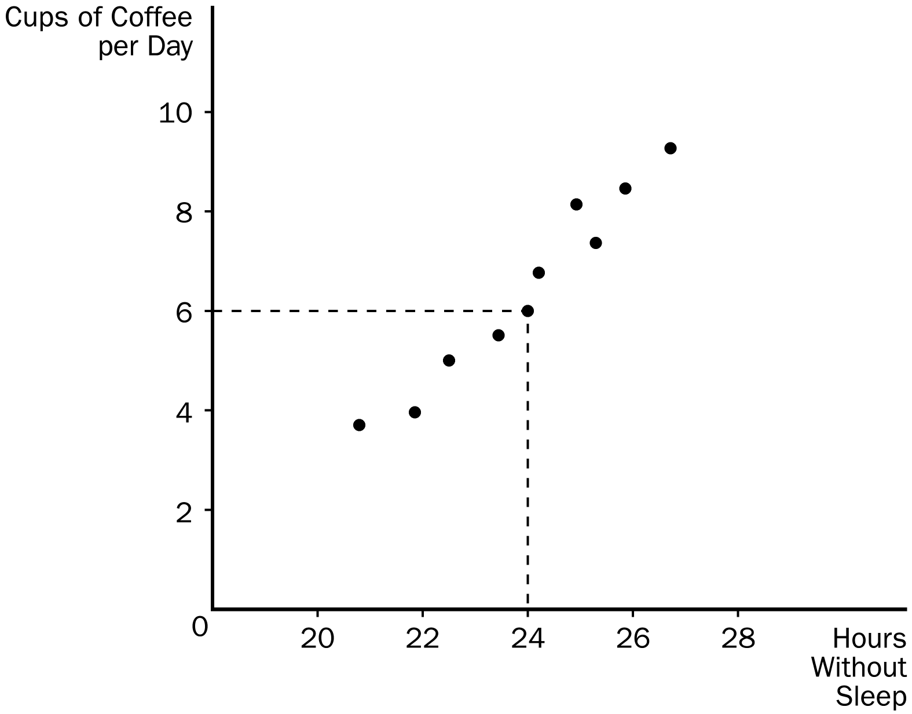
210. Refer to Figure 2-9. The graph shown is known as a
a. time series.
b. bar graph.
c. scatterplot.
d. pie chart.
ANS: C PTS: 1 DIF: 1 REF: 2-5
TOP: Graphs MSC: Definitional
211. Refer to Figure 2-9. Cups of coffee per day and the hours that someone can go without sleep appear to have
a. a positive correlation.
b. a negative correlation.
c. a random correlation.
d. no correlation.
ANS: A PTS: 1 DIF: 2 REF: 2-5
TOP: Graphs MSC: Interpretive
212. Refer to Figure 2-9. Taking cause and effect into account, which of the following interpretations would be most reasonable regarding the relationship between coffee and hours without sleep?
a. The less coffee a person drinks per day, the more time he can go without sleep.
b. There is no relationship between how much coffee per day a person drinks and how long he can go without sleep.
c. The more coffee a person drinks per day, the longer he can go without sleep.
d. The relationship between cups of coffee per day and time without sleep is too unpredictable to consider.
ANS: C PTS: 1 DIF: 3 REF: 2-5
TOP: Graphs MSC: Applicative
Figure 2-10
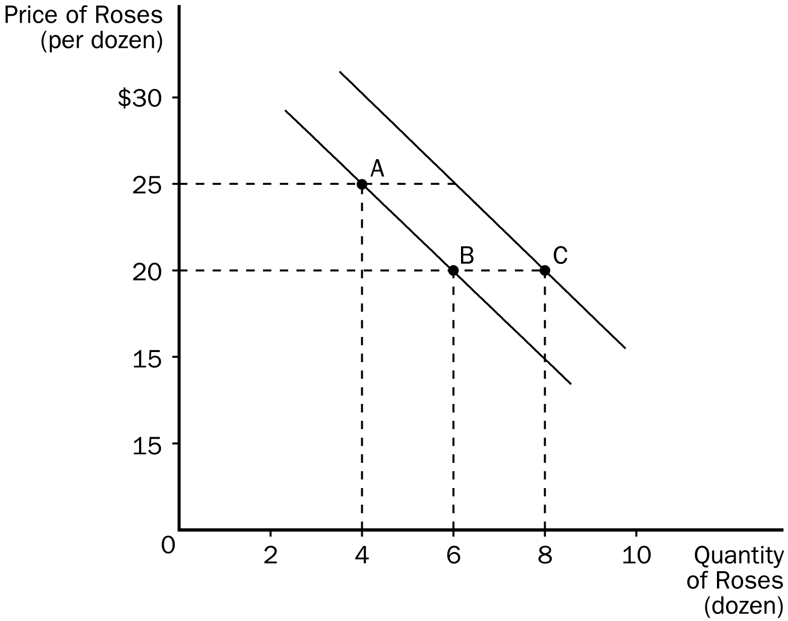
213. Refer to Figure 2-10. The movement from point A to point B is a(n)
a. shift of the curve.
b. indication of a change in preferences for roses.
c. movement along the curve.
d. All of the above are correct.
ANS: C PTS: 1 DIF: 2 REF: 2-5
TOP: Graphs MSC: Definitional
214. Refer to Figure 2-10. The movement from point B to point C is a(n)
a. shift of the curve.
b. movement along the curve.
c. indication that the price of roses has changed.
d. indication that the costs incurred by firms that produce roses have changed.
ANS: A PTS: 1 DIF: 2 REF: 2-5
TOP: Graphs MSC: Interpretive
215. Refer to Figure 2-10. The slope of the curve between points A and B is
a. 5/2
b. 2/5
c. -2/5
d. -5/2
ANS: D PTS: 1 DIF: 2 REF: 2-5
TOP: Graphs MSC: Interpretive
216. Refer to Figure 2-10. The movement from point B to point C could have been caused by
a. inflation.
b. a change in income.
c. a change in the price of roses.
d. a change in the cost of producing roses.
ANS: B PTS: 1 DIF: 3 REF: 2-5
TOP: Graphs MSC: Applicative
217. Refer to Figure 2-10. The curves shown are
a. supply curves.
b. demand curves.
c. preference curves.
d. income-consumption curves.
ANS: B PTS: 1 DIF: 2 REF: 2-5
TOP: Graphs MSC: Interpretive
218. The slope of a straight line is calculated by
a. rise divided by run.
b. run divided by rise.
c. rise minus run.
d. rise plus run.
ANS: A PTS: 1 DIF: 2 REF: 2-5
TOP: Graphs MSC: Interpretive
219. The slope of a line is calculated by the
a. change in the value of x divided by the change in the value of y.
b. change in the value of y divided by the change in the value of x.
c. horizontal distance divided by the vertical distance.
d. value of y divided by value of x.
ANS: B PTS: 1 DIF: 2 REF: 2-5
TOP: Graphs MSC: Interpretive
220. Which of the following is a correct statement about slope?
a. A horizontal line has an infinite slope, and a vertical line has a zero slope.
b. A horizontal line has a slope of 1, and a vertical line has a slope of -1.
c. A horizontal line has a zero slope, and a vertical line has an infinite slope.
d. None of the above are correct.
ANS: C PTS: 1 DIF: 2 REF: 2-5
TOP: Graphs MSC: Interpretive
221. The slope of a fairly flat, upward-sloping line will be a
a. small positive number.
b. large positive number.
c. small negative number.
d. large negative number.
ANS: A PTS: 1 DIF: 2 REF: 2-5
TOP: Graphs MSC: Interpretive
222. Graphs such as bar graphs are limited in that they
a. can only show variables that are positively related.
b. can only show variables that have a negative correlation.
c. provide information on only one variable.
d. provide information on no more than two variables.
ANS: C PTS: 1 DIF: 2 REF: 2-5
TOP: Graphs MSC: Interpretive
223. In order to provide information on two variables, an economist must use
a. a bar graph.
b. pie chart.
c. the coordinate system.
d. a time-series graph.
ANS: C PTS: 1 DIF: 1 REF: 2-5
TOP: Graphs MSC: Interpretive
224. The second number in any ordered pair is
a. the x-coordinate.
b. the y-coordinate.
c. quantity demanded.
d. price.
ANS: B PTS: 1 DIF: 1 REF: 2-5
TOP: Graphs MSC: Definitional
225. The x-coordinate in an ordered pair specifies the
a. diagonal location of the point.
b. vertical location of the point.
c. horizontal location of the point.
d. quadrant location in which the point is located.
ANS: C PTS: 1 DIF: 1 REF: 2-5
TOP: Graphs MSC: Interpretive
226. The point where both x and y are zero is known as the
a. origin.
b. null.
c. zero coordinate.
d. center.
ANS: A PTS: 1 DIF: 1 REF: 2-5
TOP: Graphs MSC: Definitional
227. When two variables have a negative correlation,
a. they tend to move in opposite directions.
b. they tend to move in the same direction.
c. one variable will move while the other remains constant.
d. the movement of the two variables is unpredictable.
ANS: A PTS: 1 DIF: 1 REF: 2-5
TOP: Graphs MSC: Definitional
228. A demand curve shows the relationship
a. between income and quantity demanded.
b. between price and income.
c. between price and quantity demanded.
d. among income, price, and quantity demanded.
ANS: C PTS: 1 DIF: 2 REF: 2-5
TOP: Graphs MSC: Interpretive
229. If Steven’s income decreases and, as a result, he chooses to buy fewer bagels per month at each price his demand curve will
a. shift inward.
b. shift outward.
c. not shift; instead, Steven will move along his demand curve downward and to the right.
d. not shift; instead, Steven will move along his demand curve upward and to the left.
ANS: A PTS: 1 DIF: 3 REF: 2-5
TOP: Graphs MSC: Applicative
230. A relatively steep demand curve indicates that
a. quantity demanded will adjust only slightly to a price change.
b. quantity demanded will adjust significantly to a price change.
c. quantity demanded will not adjust to a price change.
d. the change in quantity demanded will exactly equal a change in price.
ANS: A PTS: 1 DIF: 3 REF: 2-5
TOP: Graphs MSC: Applicative
231. When a relevant variable that is not named on either axis changes,
a. there will be a movement along the curve.
b. the curve will rotate clockwise about the original point.
c. the curve will be unaffected since only the variables on the axis affect the curve.
d. the curve will shift.
ANS: D PTS: 1 DIF: 2 REF: 2-5
TOP: Graphs MSC: Interpretive
232. Suppose the variable y is measured along the vertical axis on a graph. When the value of y changes, the curve will
a. rotate.
b. shift.
c. become irrelevant.
d. None of the above is correct.
ANS: D PTS: 1 DIF: 2 REF: 2-5
TOP: Graphs MSC: Interpretive
233. Suppose that someone makes the argument that because empty alcohol containers are found at many accidents, the containers cause accidents. This would be an example of
a. sound logic.
b. reverse causality.
c. omitted variables.
d. slope.
ANS: C PTS: 1 DIF: 2 REF: 2-5
TOP: Graphs MSC: Applicative
234. In the early 19th century, the Russian government sent doctors to southern Russian villages to provide assistance during a cholera epidemic. The villagers noticed that wherever doctors appeared, people died. Therefore, many doctors were chased away from villages, and some were even killed. This reaction to the correlation between doctors and deaths is most likely a problem of
a. omitted variables.
b. reverse causality.
c. government propaganda.
d. medical incompetence.
ANS: B PTS: 1 DIF: 2 REF: 2-5
TOP: Reverse causality MSC: Applicative
235. When examining two variables, one way to determine the direction of causality is to
a. assume the two variables move in the same direction.
b. assume the two variables move in opposite directions.
c. determine which variable moves first.
d. determine which variable should be omitted.
ANS: C PTS: 1 DIF: 2 REF: 2-5
TOP: Cause and effect MSC: Interpretive
236. Bill has noticed that increases in unemployment insurance claims are associated with recessions, and therefore he advocates limits on unemployment insurance so as to prevent recessions. Martha has noticed that most drug addicts once attended schools, and therefore she advocates getting rid of schools so as to prevent drug addiction.
a. The reasoning of both Bill and Martha suffers from the omitted variable problem.
b. The reasoning of both Bill and Martha suffers from the reverse causality problem.
c. Bill's reasoning suffers from the reverse causality problem and Martha's reasoning suffers from the omitted variable problem.
d. Martha's reasoning suffers from the reverse causality problem and Bill's reasoning suffers from the omitted variable problem.
ANS: A PTS: 1 DIF: 3 REF: 2-5
TOP: Graphs MSC: Applicative
True/False
1. While the scientific method is applicable to studying natural sciences, it is not useful in studying an economic system.
ANS: F PTS: 1 DIF: 1 REF: 2-1
TOP: Scientific method MSC: Interpretive
2. Since natural experiments offered by history cannot be used in economics, carefully constructed laboratory experiments must be used.
ANS: F PTS: 1 DIF: 1 REF: 2-1
TOP: Scientific method MSC: Interpretive
3. An economic model can accurately explain how the economy is organized because it is designed to include, to the extent possible, all features of the real world.
ANS: F PTS: 1 DIF: 1 REF: 2-1
TOP: Economic models MSC: Interpretive
4. All scientific models, including economic models, simplify reality in order to improve our understanding of it.
ANS: T PTS: 1 DIF: 1 REF: 2-1
TOP: Economic models MSC: Interpretive
5. A circular-flow diagram is a visual model of how an economy is organized.
ANS: T PTS: 1 DIF: 1 REF: 2-1
TOP: Economic models MSC: Interpretive
6. In a simple circular-flow diagram, firms own the factors of production and use them to produce goods and services.
ANS: F PTS: 1 DIF: 2 REF: 2-1
TOP: Economic models MSC: Interpretive
7. In a simple circular-flow diagram, the two types of markets in which households and firms interact are the markets for goods and services and the markets for factors of production.
ANS: T PTS: 1 DIF: 1 REF: 2-1
TOP: Circular-flow diagram MSC: Interpretive
8. In the markets for goods and services, as in the markets for the factors of production, households are buyers and firms are sellers.
ANS: F PTS: 1 DIF: 2 REF: 2-1
TOP: Circular-flow diagram MSC: Interpretive
9. In a circular-flow diagram, one loop shows the flow of goods, services and factors of production, and the other loop shows the corresponding flow of dollars.
ANS: T PTS: 1 DIF: 1 REF: 2-1
TOP: Circular-flow diagram MSC: Interpretive
10. A production possibilities frontier is a graph that shows the various combinations of outputs the economy can produce given its factors of production and its technology.
ANS: T PTS: 1 DIF: 1 REF: 2-1
TOP: Production possibilities frontier MSC: Interpretive
11. An economy can produce at any point on or outside the production possibilities frontier, but it cannot produce at points inside the frontier.
ANS: F PTS: 1 DIF: 2 REF: 2-1
TOP: Production possibilities frontier MSC: Interpretive
12. An efficient outcome is one in which the economy is conserving the largest possible amount of resources, while still meeting the basic needs of society.
ANS: F PTS: 1 DIF: 2 REF: 2-1
TOP: Efficiency MSC: Definitional
13. An economy is being efficient if it is impossible to produce more of one good without producing less of another.
ANS: T PTS: 1 DIF: 2 REF: 2-1
TOP: Efficiency MSC: Definitional
Figure 2-11
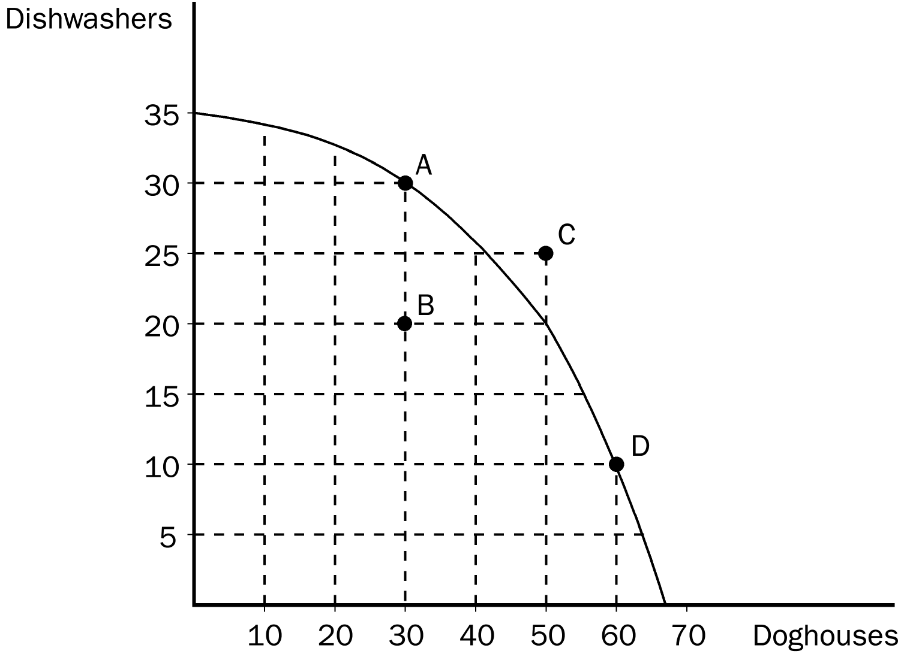
14. Refer to Figure 2-11. Points A, B, and D represent feasible or attainable outcomes for society.
ANS: T PTS: 1 DIF: 2 REF: 2-1
TOP: Production possibilities frontier MSC: Interpretive
15. Refer to Figure 2-11. The opportunity cost of more doghouses increases as more doghouses are produced.
ANS: T PTS: 1 DIF: 2 REF: 2-1
TOP: Production possibilities frontier | Opportunity cost MSC: Applicative
16. The extent of the tradeoff between the production of one good and the production of another good can change because of technological advances over time.
ANS: T PTS: 1 DIF: 3 REF: 2-1
TOP: Production possibilities frontier | Tradeoffs MSC: Analytical
17. Economic growth causes a production possibilities frontier to shift outward.
ANS: T PTS: 1 DIF: 2 REF: 2-1
TOP: Production possibilities frontier | Economic growth MSC: Interpretive
18. If government regulations designed to protect wetlands removed very productive farmland from production, the production possibilities would shift inward.
ANS: T PTS: 1 DIF: 2 REF: 2-1
TOP: Production possibilities frontier MSC: Applicative
19. The field of economics is divided into two subfields: microeconomics and macroeconomics.
ANS: T PTS: 1 DIF: 1 REF: 2-1
TOP: Microeconomics | Macroeconomics MSC: Definitional
20. Normative statements describe how the world is, while positive statements prescribe how the world should be.
ANS: F PTS: 1 DIF: 1 REF: 2-2
TOP: Positive statements | Normative statements MSC: Definitional
21. "Society would be better if the welfare system were abolished" is a normative statement, not a positive statement.
ANS: T PTS: 1 DIF: 2 REF: 2-2
TOP: Positive statements | Normative statements MSC: Applicative
22. When economists are trying to explain the world they are acting as scientists, and when they are trying to improve it, they are policymakers.
ANS: T PTS: 1 DIF: 1 REF: 2-2
TOP: Economists MSC: Interpretive
23. The Council of Economic Advisors has as its duties both advising the President of the United States and formulating monetary policy.
ANS: F PTS: 1 DIF: 2 REF: 2-2
TOP: Economists MSC: Definitional
24. A survey of business, government, and academic economists revealed widespread disagreement on ten propositions about economic policy.
ANS: F PTS: 1 DIF: 2 REF: 2-3
TOP: Economists MSC: Interpretive
25. Two variables that are negatively related will move in opposite directions.
ANS: T PTS: 1 DIF: 1 REF: 2-5
TOP: Graphs MSC: Interpretive
Short Answer
1. Using this outline, draw a circular-flow diagram representing the interactions between households and firms in a simple economy. Explain briefly the various parts of the diagram.



ANS:
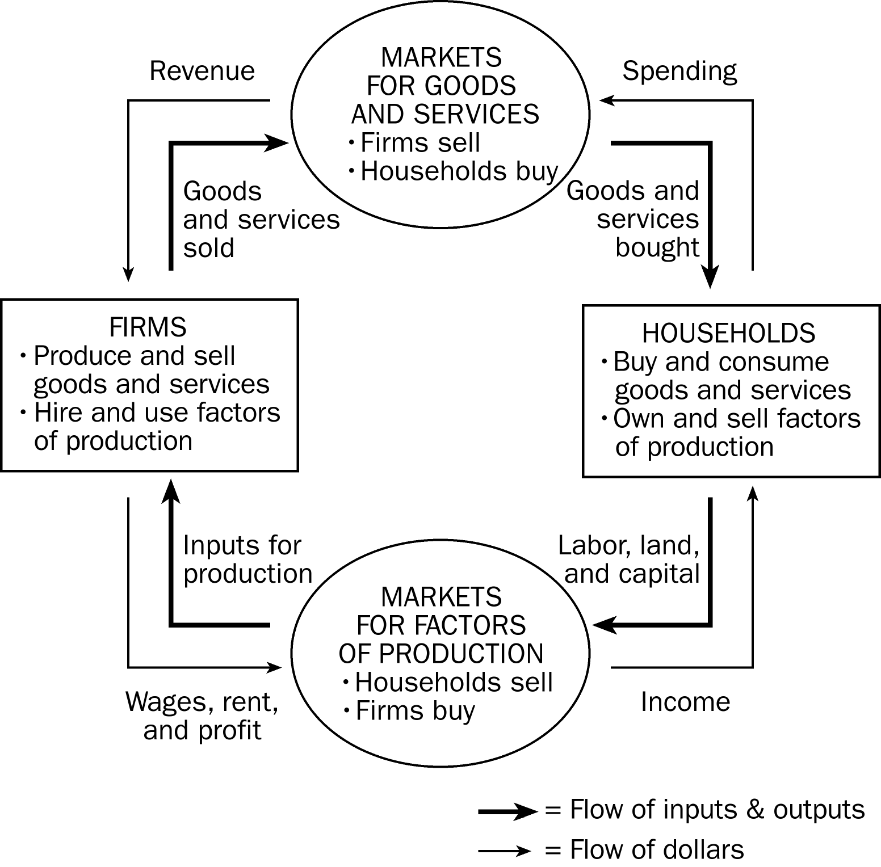

This diagram should duplicate the essential characteristics of the diagram in the text, with an explanation of the meaning of each flow and each market. It is important that the student understands that the inner loop represents the flow of real goods and services and that the outer loop represents the corresponding flow of payments.
PTS: 1 DIF: 2 REF: 2-1
TOP: Circular-flow diagram MSC: Interpretive
2. Draw a production possibilities frontier showing increasing opportunity cost for hammers in terms of horseshoes.
a. On the graph, identify the area of feasible outcomes and the area of infeasible outcomes.
b. On the graph, label a point that is efficient as point "E" and a point that is inefficient as point "I".
c. On the graph, illustrate the effect of the discovery of a new vein of iron ore, a resource needed to make both horseshoes and hammers, on this economy.
d. On a second graph, illustrate the effect of a new computerized assembly line in the production of hammers on this economy.
ANS:
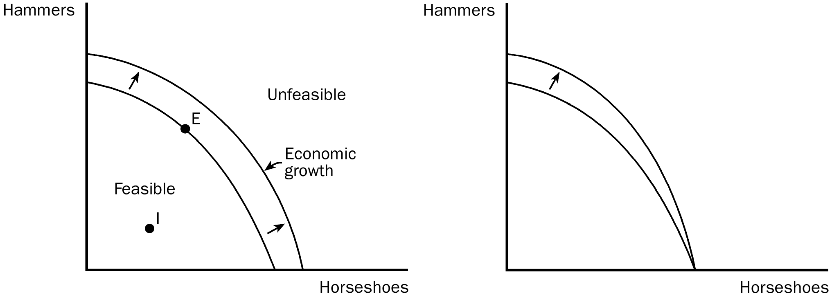
PTS: 1 DIF: 3 REF: 2-1
TOP: Production possibilities frontier MSC: Applicative
3. The prairie dog has always been considered a problem for American cattle ranchers. They dig holes that cattle and horses can step in and they eat grass necessary for cattle. Recently, ranchers have discovered that there is a demand for prairie dogs as pets. In some areas prairie dogs can sell for as high as $150. Cattlemen are now fencing off prairie dog towns on their land so these towns will not be disturbed by their cattle.
Draw a production possibilities frontier showing a rancher's production option between cattle production and prairie dog production showing increasing opportunity cost and show what would happen in each of the following situations. (Use a separate graph for each situation.)
a. The outcome is efficient, with ranchers choosing to produce equal numbers of cattle and prairie dogs.
b. As a protest against the government introducing the gray wolf back into the wild in their state, ranchers decide to withhold 25 percent of the available grassland for grazing.
c. The price of prairie dogs increases to $200 each, so ranchers decide to allot additional land for prairie dogs.
d. The government grants new leases to ranchers, giving them 10,000 new acres of grassland each for grazing.
e. A drought destroys most of the available grass for grazing of cattle, but not for prairie dogs since they also eat plant roots.
ANS:
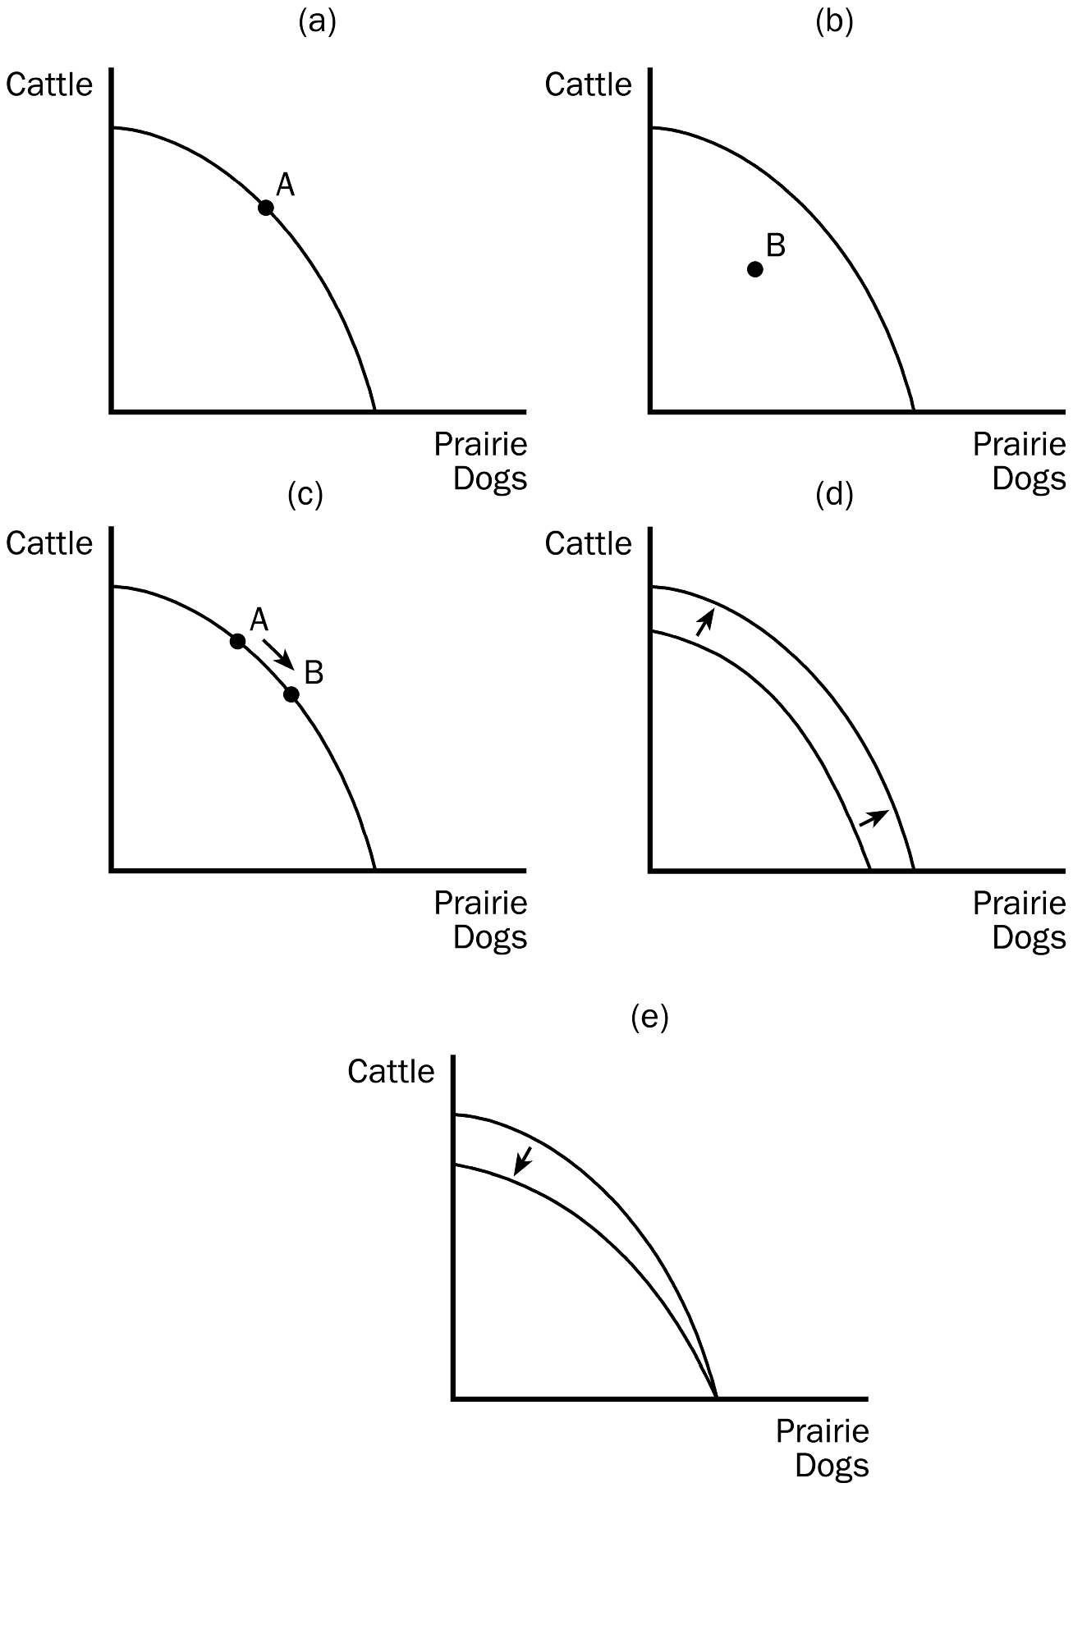
PTS: 1 DIF: 3 REF: 2-1
TOP: Production possibilities frontier MSC: Analytical
4. Identify each of the following topics as being part of microeconomics or macroeconomics:
a. the impact of a change in consumer income on the purchase of luxury automobiles
b. the effect of a change in the price of Coke on the purchase of Pepsi
c. the impact of a war in the Middle East on the rate of inflation in the United States
d. factors influencing the rate of economic growth
e. factors influencing the demand for tractors
f. the impact of tax policy on national saving
g. the effect of pollution taxes on the U.S. copper industry
h. the degree of competition in the cable television industry
i. the effect of a balanced-budget amendment on economic stability
j. the impact of deregulation on the savings and loan industry
ANS:
a, b, e, g, h, and j are microeconomic topics. c, d, f, and i are macroeconomic topics.
PTS: 1 DIF: 2 REF: 2-1
TOP: Microeconomics | Macroeconomics MSC: Applicative
5. Which of the following statements are positive, and which are normative?
a. The minimum wage creates unemployment among young and unskilled workers.
b. The minimum wage ought to be abolished.
c. If the price of a product in a market decreases, other things equal, quantity demanded will increase.
d. A little bit of inflation is worse for society than a little bit of unemployment.
e. There is a tradeoff between inflation and unemployment in the short run.
f. If consumer income increases, other things equal, the demand for automobiles will increase.
g. The U.S. income distribution is not equitable.
h. U.S. workers deserve more liberal unemployment benefits.
i. If interest rates increase, investment will decrease.
j. If welfare benefits were reduced, the country would be better off.
ANS:
a, c, e, f, and i are positive statements. b, d, g, h, and j are normative statements.
PTS: 1 DIF: 2 REF: 2-1
TOP: Positive statements | Normative statements MSC: Interpretive
6. Use the following demand curve to answer the following questions.
a. How would point A be represented as an ordered pair?
b. What type of curve is this?
c. Does this curve show a positive or negative correlation between price and quantity?
d. Compute the slope of D₁ between points A and C.
e. What is the slope of D₁ between points C and E? Why would you not have to calculate this answer?
f. What is it called if we move from D₁ to D₂?
- How do you know that the slope of D₂ is the same as the slope of D₁?

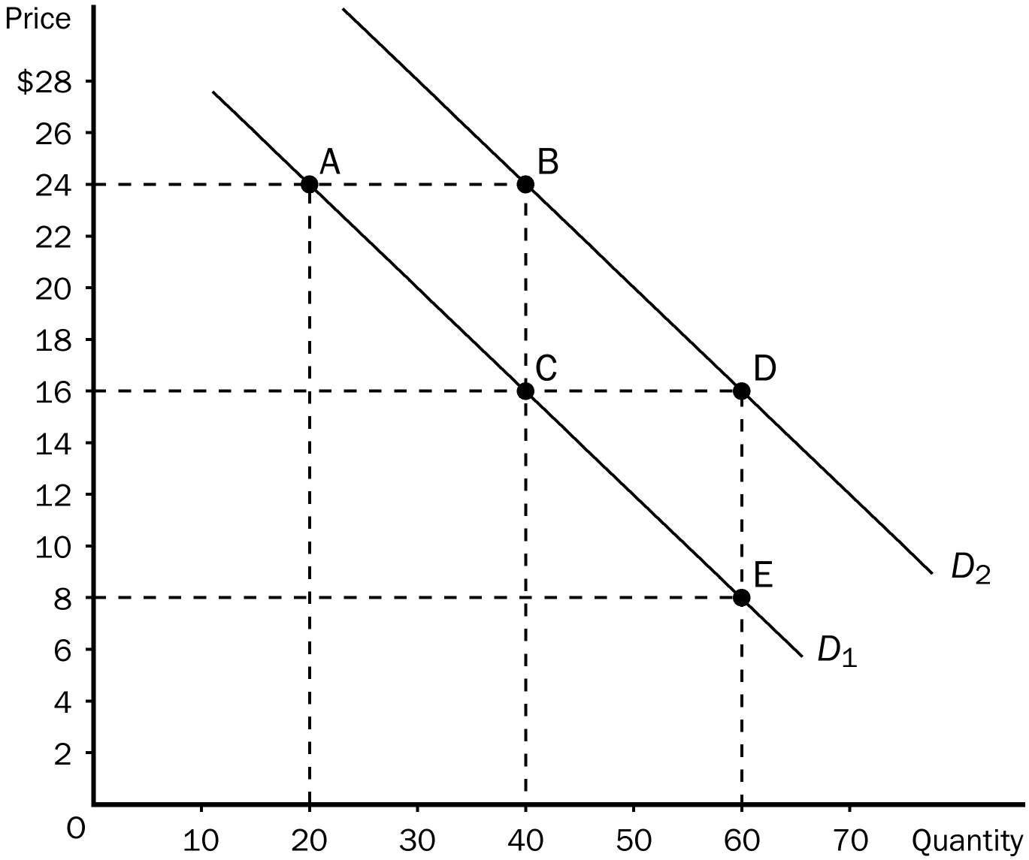
ANS:
a. (20, 24)
b. a demand curve
c. a negative correlation between price and quantity
d. –8/20 or –2/5.
e. –2/5; because the slope of a straight line is constant.
f. an increase in demand.
g. The 2 lines are parallel.
PTS: 1 DIF: 3 REF: 2-5
TOP: Graphs MSC: Applicative

