Chapter 3
Interdependence and the Gains from Trade
Multiple Choice
1. People who provide you with goods and services
a. are acting out of generosity.
b. do so because they have no other choice.
c. do so because they get something in return.
d. are required to do so by government.
ANS: C PTS: 1 DIF: 1 REF: 3-0
TOP: Trade MSC: Interpretive
2. When an economist points out that you and millions of other people are interdependent, he or she is referring to the fact that we all
a. rely upon government to provide us with the basic necessities of life.
b. rely upon one another for the goods and services we all consume.
c. have similar tastes and abilities.
d. are concerned about one another’s well-being.
ANS: B PTS: 1 DIF: 1 REF: 3-0
TOP: Trade MSC: Interpretive
3. People generally choose to depend upon others for goods and services. Economists view this interdependence as
a. a good thing, since it fosters friendships and bonds that otherwise would never develop.
b. a good thing, since it allows people to consume more goods and services than they would otherwise be able to consume.
c. a bad thing, since self-sufficiency may become necessary in the future.
d. a bad thing, since interdependence reduces people’s self-esteem and causes various social problems.
ANS: B PTS: 1 DIF: 1 REF: 3-1
TOP: Trade MSC: Interpretive
4. Regan grows flowers and makes ceramic vases. Jayson also grows flowers and makes vases, but Regan is better at producing both. In this case, trade could
a. benefit both Jayson and Regan.
b. benefit Jayson, but not Regan.
c. benefit Regan, but not Jayson.
d. benefit neither Jayson nor Regan.
ANS: A PTS: 1 DIF: 2 REF: 3-1
TOP: Trade MSC: Interpretive
5. Ben bakes bread and Shawna knits sweaters. Ben likes to eat bread and wear sweaters, and the same is true for Shawna. In which of the following cases is it impossible for both Ben and Shawna to benefit from trade?
a. Ben cannot knit sweaters and Shawna cannot bake bread.
b. Ben is better than Shawna at baking bread and Shawna is better than Ben at knitting sweaters.
c. Ben is better than Shawna at baking bread and at knitting sweaters.
d. None of the above is correct.
ANS: D PTS: 1 DIF: 2 REF: 3-1
TOP: Trade MSC: Applicative
6. Shannon bakes cookies and Justin grows vegetables. In which of the following cases is it impossible for both Shannon and Justin to benefit from trade?
a. Shannon does not like vegetables and Justin does not like cookies.
b. Shannon is better than Justin at baking cookies and Justin is better than Shannon at growing vegetables.
c. Justin is better than Shannon at baking cookies and at growing vegetables.
d. All of the above are correct.
ANS: A PTS: 1 DIF: 2 REF: 3-1
TOP: Trade MSC: Applicative
7. Consider a shoemaker and a vegetable farmer. Potentially, trade could benefit both individuals if
a. the shoemaker can produce only shoes and the vegetable farmer can produce only vegetables.
b. the shoemaker is capable of growing vegetables, but he is not very good at it.
c. the vegetable farmer is better at growing vegetables and better at making shoes than the shoemaker.
d. All of the above are correct.
ANS: D PTS: 1 DIF: 2 REF: 3-1
TOP: Trade MSC: Interpretive
8. Without trade,
a. a country is better off because it will have to learn to be self-sufficient without trade.
b. a country's production possibilities frontier is also its consumption possibilities frontier.
c. a country can still benefit from international specialization.
d. interdependence is more extensive than it would be with trade.
ANS: B PTS: 1 DIF: 2 REF: 3-1
TOP: Trade MSC: Interpretive
9. A country's consumption possibilities frontier can be outside its production possibilities frontier if
a. the country’s technology is superior to the technologies of other countries.
b. the citizens of the country have a greater desire to consume goods and services than do the citizens of other countries.
c. the country engages in trade.
d. All of the above are correct.
ANS: C PTS: 1 DIF: 2 REF: 3-1
TOP: Trade | Production possibilities frontier MSC: Interpretive
10. A production possibilities frontier will be a straight line if
a. increasing the production of one good by x units entails no opportunity cost in terms of the other good.
b. increasing the production of one good by x units entails a constant opportunity cost in terms of the other good.
c. the economy is producing efficiently.
d. the economy is engaged in trade with at least one other economy.
ANS: B PTS: 1 DIF: 3 REF: 3-1
TOP: Production possibilities frontier MSC: Applicative
11. The difference between production possibilities frontiers that are bowed out and those that are straight lines is that
a. bowed-out production possibilities frontiers apply to economies that face tradeoffs, whereas straight-line production possibilities frontiers apply to economies that do not face tradeoffs.
b. bowed-out production possibilities frontiers apply to economies in which resources are not specialized, whereas straight-line production possibilities frontiers apply to economies in which resources are specialized.
c. bowed-out production possibilities frontiers illustrate increasing opportunity cost, whereas straight-line production possibilities frontiers illustrate constant opportunity cost.
d. straight-line production possibilities frontiers illustrate real-world conditions, whereas bowed-out production possibilities frontiers illustrate more simplistic assumptions.
ANS: C PTS: 1 DIF: 3 REF: 3-1
TOP: Production possibilities frontier | Opportunity cost MSC: Applicative
12. Which of the following statements is not correct?
a. Trade allows for specialization.
b. Trade has the potential to benefit all nations.
c. Trade allows nations to consume outside of their production possibilities curves.
d. Absolute advantage is the driving force of specialization.
ANS: D PTS: 1 DIF: 2 REF: 3-2
TOP: Specialization | Trade MSC: Interpretive
13. If labor in Mexico is less productive than labor in the United States in all areas of production,
a. neither nation can benefit from trade.
b. Mexico can benefit from trade but the United States cannot.
c. the United States will have a comparative advantage relative to Mexico in the production of all goods.
d. both Mexico and the United States still can benefit from trade.
ANS: D PTS: 1 DIF: 2 REF: 3-2
TOP: Comparative advantage | Trade MSC: Interpretive
14. The production possibilities frontier is a downward-sloping straight line when
a. it is possible to switch between one good and the other good at a constant rate.
b. there is no tradeoff involved in switching between one good and the other good.
c. the same amount of time is required to produce a unit of one good as is required to produce a unit of the other good.
d. the person for whom the frontier is drawn wishes to consume equal amounts of the two goods.
ANS: A PTS: 1 DIF: 2 REF: 3-1
TOP: Production possibilities frontier MSC: Interpretive
Table 3-1
 | Labor Hours Needed to Make 1 Pound of: |  | Pounds produced in 40 hours:
 | Meat | Potatoes | Meat | Potatoes
Farmer | 8 | 2 | 5 | 20
Rancher | 4 | 5 | 10 | 8

15. Refer to Table 3-1. The opportunity cost of 1 pound of meat for the farmer is
a. 1/4 hour of labor.
b. 4 hours of labor.
c. 4 pounds of potatoes.
d. 1/4 pound of potatoes.
ANS: C PTS: 1 DIF: 2 REF: 3-2
TOP: Opportunity cost MSC: Applicative
16. Refer to Table 3-1. The opportunity cost of 1 pound of meat for the rancher is
a. 4 hours of labor.
b. 5 hours of labor.
c. 4/5 pounds of potatoes.
d. 5/4 pounds of potatoes.
ANS: C PTS: 1 DIF: 2 REF: 3-2
TOP: Opportunity cost MSC: Applicative
17. Refer to Table 3-1. The opportunity cost of 1 pound of potatoes for the farmer is
a. 8 hours of labor.
b. 2 hours of labor.
c. 4 pounds of meat.
d. 1/4 pound of meat.
ANS: D PTS: 1 DIF: 2 REF: 3-2
TOP: Opportunity cost MSC: Applicative
18. Refer to Table 3-1. The opportunity cost of 1 pound of potatoes for the rancher is
a. 5 hours of labor.
b. 4 hours of labor.
c. 5/4 pounds of meat.
d. 4/5 pound of meat.
ANS: C PTS: 1 DIF: 2 REF: 3-2
TOP: Opportunity cost MSC: Applicative
19. Refer to Table 3-1. The farmer has an absolute advantage in
a. meat, and the rancher has an absolute advantage in potatoes.
b. potatoes, and the rancher has an absolute advantage in meat.
c. meat, and the rancher has an absolute advantage in meat.
d. neither good, and the rancher has an absolute advantage in both goods.
ANS: B PTS: 1 DIF: 2 REF: 3-2
TOP: Absolute advantage MSC: Applicative
20. Refer to Table 3-1. The rancher has an absolute advantage in
a. both goods, and the farmer has a comparative advantage in meat.
b. both goods, and the farmer has a comparative advantage in potatoes.
c. meat, and the farmer has a comparative advantage in potatoes.
d. meat, and the farmer has a comparative advantage in neither good.
ANS: C PTS: 1 DIF: 3 REF: 3-2
TOP: Absolute advantage | Comparative advantage MSC: Applicative
21. Refer to Table 3-1. The farmer has an absolute advantage in
a. potatoes, and the rancher has a comparative advantage in meat.
b. meat, and the rancher has a comparative advantage in potatoes.
c. neither good, and the rancher has a comparative advantage in potatoes.
d. neither good, and the rancher has a comparative advantage in meat.
ANS: A PTS: 1 DIF: 3 REF: 3-2
TOP: Absolute advantage | Comparative advantage MSC: Applicative
22. Refer to Table 3-1. The rancher has a comparative advantage in
a. neither good, and the farmer has a comparative advantage in both goods.
b. both goods, and the farmer has a comparative advantage in neither good.
c. potatoes, and the farmer has a comparative advantage in meat.
d. meat, and the farmer has a comparative advantage in potatoes.
ANS: D PTS: 1 DIF: 2 REF: 3-2
TOP: Comparative advantage MSC: Applicative
23. Refer to Table 3-1. The farmer and the rancher both could benefit if the farmer were to specialize in
a. meat and the rancher were to specialize in potatoes.
b. potatoes and the rancher were to specialize in meat.
c. neither good and the rancher were to specialize in both goods.
d. none of the above; they cannot both benefit by specialization and trade.
ANS: B PTS: 1 DIF: 2 REF: 3-2
TOP: Specialization | Trade MSC: Applicative
Figure 3-1
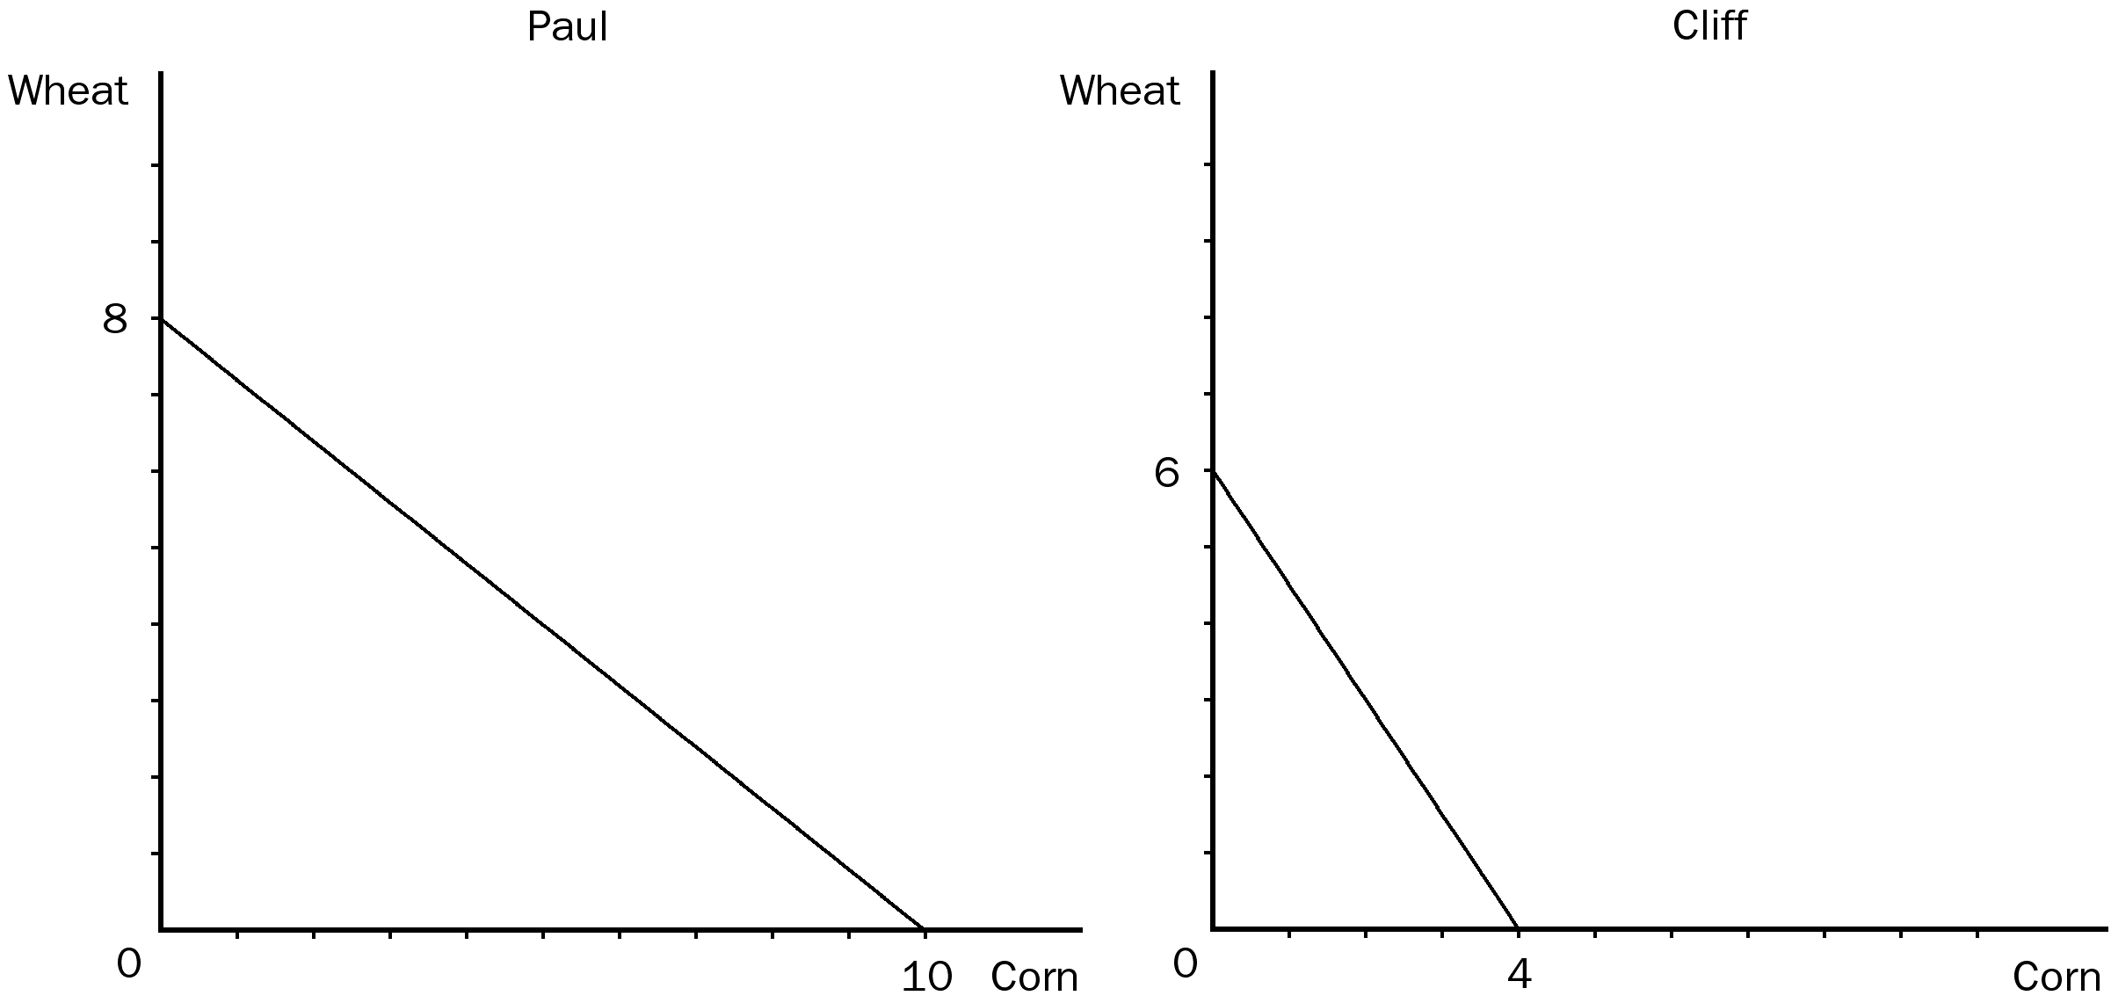
24. Refer to Figure 3-1. If Paul divides his time equally between corn and wheat, he will be able to produce
a. 2 bushels of wheat and 2 bushels of corn.
b. 3 bushels of wheat and 3 bushels of corn.
c. 4 bushels of wheat and 5 bushels of corn.
d. 4 bushels of wheat and 6 bushels of corn.
ANS: C PTS: 1 DIF: 2 REF: 3-2
TOP: Production possibilities frontier MSC: Applicative
25. Refer to Figure 3-1. The opportunity cost of 1 bushel of wheat for Cliff is
a. 1/3 bushel of corn.
b. 2/3 bushel of corn.
c. 1 bushel of corn.
d. 3/2 bushels of corn.
ANS: B PTS: 1 DIF: 2 REF: 3-2
TOP: Opportunity cost MSC: Applicative
26. Refer to Figure 3-1. The opportunity cost of 2 bushels of corn for Cliff is
a. 2 bushels of wheat.
b. 3 bushels of wheat.
c. 6 bushels of wheat.
d. 12 bushels of wheat.
ANS: B PTS: 1 DIF: 2 REF: 3-2
TOP: Opportunity cost MSC: Applicative
27. Refer to Figure 3-1. The opportunity cost of 1 bushel of corn is
a. 4/5 bushel of wheat for Paul and 3/2 bushels of wheat for Cliff; thus, Paul has the comparative advantage in growing corn.
b. 4/5 bushel of wheat for Paul and 3/2 bushels of wheat for Cliff; thus, Cliff has the comparative advantage in growing corn.
c. 5/4 bushels of wheat for Paul and 2/3 bushel of wheat for Cliff; thus, Paul has the comparative advantage in growing corn.
d. 5/4 bushels of wheat for Paul and 2/3 bushel of wheat for Cliff; thus, Cliff has the comparative advantage in growing corn.
ANS: A PTS: 1 DIF: 3 REF: 3-2
TOP: Opportunity cost | Comparative advantage MSC: Applicative
28. Refer to Figure 3-1. Assume both Paul and Cliff divide their time equally between the production of corn and wheat, and they do not trade. If they are the only producers of wheat and corn, then total production of wheat and corn is
a. 8 bushels of wheat and 7 bushels of corn.
b. 7 bushels of wheat and 6 bushels of corn.
c. 6 bushels of wheat and 8 bushels of corn.
d. 7 bushels of wheat and 7 bushels of corn.
ANS: D PTS: 1 DIF: 2 REF: 3-2
TOP: Production possibilities frontier MSC: Applicative
29. Refer to Figure 3-1. Assume Cliff and Paul were both producing wheat and corn, and each person was dividing his time equally between the two. Then each decides to specialize in the product in which he has a comparative advantage. As a result of this change, total production of corn would
a. increase by 1 bushel.
b. increase by 3 bushels.
c. increase by 5 bushels.
d. decrease by 2 bushels.
ANS: B PTS: 1 DIF: 3 REF: 3-2
TOP: Comparative advantage MSC: Applicative
30. Refer to Figure 3-1. Assume Cliff and Paul were both producing wheat and corn, and each person was dividing his time equally between the two. Then each decides to specialize in the product in which he has a comparative advantage. Furthermore, they agree to trade 3 bushels of wheat for 3 bushels of corn. As a result of these new arrangements, Cliff is able to consume
a. 4 bushels of wheat and 3 bushels of corn, and this point lies on Cliff’s production possibilities frontier.
b. 3 bushels of wheat and 3 bushels of corn, and this point lies outside of Cliff’s production possibilities frontier.
c. 3 bushels of wheat and 2 bushels of corn, and this point lies on Cliff’s production possibilities frontier.
d. 4 bushels of wheat and 3 bushels of corn, and this point lies outside of Cliff’s production possibilities frontier.
ANS: B PTS: 1 DIF: 3 REF: 3-2
TOP: Comparative advantage | Specialization | Trade MSC: Analytical
31. Refer to Figure 3-1. Which of the following statements is correct?
a. Paul has an absolute advantage in both wheat and corn.
b. Paul has an absolute advantage in wheat and Cliff has an absolute advantage in corn.
c. Cliff has an absolute advantage in wheat and Paul has an absolute advantage in corn.
d. Cliff has an absolute advantage in both wheat and corn.
ANS: A PTS: 1 DIF: 2 REF: 3-2
TOP: Absolute advantage MSC: Applicative
32. Refer to Figure 3-1. Which of the following statements is correct?
a. Paul has a comparative advantage in both wheat and corn.
b. Paul has a comparative advantage in wheat and Cliff has a comparative advantage in corn.
c. Cliff has a comparative advantage in wheat and Paul has a comparative advantage in corn.
d. Cliff has a comparative advantage in both wheat and corn.
ANS: C PTS: 1 DIF: 2 REF: 3-2
TOP: Comparative advantage MSC: Applicative
33. Refer to Figure 3-1. Suppose Paul must work 2 hours to produce each bushel of corn. Then Paul’s production possibilities frontier is based on how many hours of work?
a. 0.2 hours
b. 5 hours
c. 10 hours
d. 20 hours
ANS: D PTS: 1 DIF: 2 REF: 3-2
TOP: Production possibilities frontier MSC: Applicative
34. Refer to Figure 3-1. Suppose Paul must work 2 hours to produce each bushel of corn. Then Paul
a. must work 0.4 hours to produce each bushel of wheat, and his opportunity cost of a bushel of corn is 0.8 bushels of wheat.
b. must work 0.4 hours to produce each bushel of wheat, and his opportunity cost of a bushel of corn is 1.25 bushels of wheat.
c. must work 2.5 hours to produce each bushel of wheat, and his opportunity cost of a bushel of corn is 0.8 bushels of wheat.
d. must work 2.5 hours to produce each bushel of wheat, and his opportunity cost of a bushel of corn is 1.25 bushels of wheat.
ANS: C PTS: 1 DIF: 3 REF: 3-2
TOP: Production possibilities frontier | Opportunity cost MSC: Analytical
35. Refer to Figure 3-1. Suppose Cliff must work 5 hours to produce each bushel of corn. Then Cliff’s production possibilities frontier is based on how many hours of work?
a. 0.2 hours
b. 2.5 hours
c. 15 hours
d. 20 hours
ANS: D PTS: 1 DIF: 2 REF: 3-2
TOP: Production possibilities frontier MSC: Applicative
36. Refer to Figure 3-1. Suppose Cliff must work 5 hours to produce each bushel of corn. Then Cliff
a. must work 3 1/3 hours to produce each bushel of wheat, and his opportunity cost of a bushel of corn is 2/3 bushel of wheat.
b. must work 3 1/3 hours to produce each bushel of wheat, and his opportunity cost of a bushel of corn is 1.5 bushels of wheat.
c. must work 7.5 to produce each bushel of wheat, and his opportunity cost of a bushel of corn is approximately 2/3 bushel of wheat.
d. must work 7.5 hours to produce each bushel of wheat, and his opportunity cost of a bushel of corn is 1.5 bushels of wheat.
ANS: B PTS: 1 DIF: 3 REF: 3-2
TOP: Production possibilities frontier | Opportunity cost MSC: Analytical
Figure 3-2
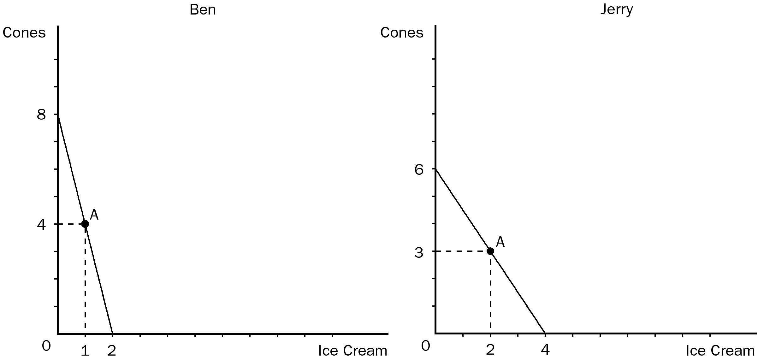
37. Refer to Figure 3-2. For Ben, the opportunity cost of 1 pound of ice cream is
a. 1/14 pound of cones.
b. 1/2 pound of cones.
c. 2 pounds of cones.
d. 4 pound of cones.
ANS: D PTS: 1 DIF: 2 REF: 3-2
TOP: Opportunity cost MSC: Applicative
38. Refer to Figure 3-2. For Jerry, the opportunity cost of 1 pound of ice cream is
a. 1/3 pound of cones.
b. 2/3 pound of cones.
c. 3/2 pounds of cones.
d. 2 pounds of cones.
ANS: C PTS: 1 DIF: 2 REF: 3-2
TOP: Opportunity cost MSC: Applicative
39. Refer to Figure 3-2. For Ben, the opportunity cost of 1 pound of cones is
a. 1/4 pound of ice cream.
b. 1/2 pound of ice cream.
c. 2 pounds of ice cream.
d. 4 pounds of ice cream.
ANS: A PTS: 1 DIF: 2 REF: 3-2
TOP: Opportunity cost MSC: Applicative
40. Refer to Figure 3-2. For Jerry, the opportunity cost of 1 pound of cones is
a. 1/3 pound of ice cream.
b. 2/3 pound of ice cream.
c. 3/2 pounds of ice cream.
d. 2 pounds of ice cream.
ANS: B PTS: 1 DIF: 2 REF: 3-2
TOP: Opportunity cost MSC: Applicative
41. Refer to Figure 3-2. Ben has a comparative advantage in
a. cones and Jerry has a comparative advantage in ice cream.
b. ice cream and Jerry has a comparative advantage in cones.
c. neither good and Jerry has a comparative advantage in both goods.
d. both goods and Jerry has a comparative advantage in neither good.
ANS: A PTS: 1 DIF: 2 REF: 3-2
TOP: Comparative advantage MSC: Applicative
42. Refer to Figure 3-2. Ben has an absolute advantage in
a. ice cream and Jerry has an absolute advantage in cones.
b. cones and Jerry has an absolute advantage in ice cream.
c. neither good and Jerry has an absolute advantage in both goods.
d. both goods and Jerry has an absolute advantage in neither good.
ANS: B PTS: 1 DIF: 2 REF: 3-2
TOP: Absolute advantage MSC: Applicative
43. Refer to Figure 3-2. Ben has an absolute advantage in
a. neither good and he has a comparative advantage in neither good.
b. neither good and he has a comparative advantage in cones.
c. cones and he has a comparative advantage in cones.
d. ice cream and he has a comparative advantage in ice cream.
ANS: C PTS: 1 DIF: 3 REF: 3-2
TOP: Absolute advantage | Comparative advantage MSC: Applicative
44. Refer to Figure 3-2. Jerry has an absolute advantage in
a. both goods and Ben has a comparative advantage in ice cream.
b. neither good and Ben has a comparative advantage in cones.
c. ice cream and Ben has a comparative advantage in ice cream.
d. ice cream and Ben has a comparative advantage in cones.
ANS: D PTS: 1 DIF: 3 REF: 3-2
TOP: Absolute advantage | Comparative advantage MSC: Applicative
45. Refer to Figure 3-2. Suppose Ben and Jerry have both decided to produce at point A on their respective production possibilities frontiers. We know that
a. neither Ben’s well-being nor Jerry’s well-being could be improved as a result of trade between the two.
b. trade between the two could benefit Ben but not Jerry.
c. trade between the two could benefit Jerry but not Ben.
d. Ben and Jerry are both allocating 1/2 of their time to the production of each good.
ANS: D PTS: 1 DIF: 2 REF: 3-2
TOP: Production possibilities frontier MSC: Applicative
46. Refer to Figure 3-2. Originally, Ben was producing at his point A and Jerry was producing at his point A. Then, each person decided to specialize in the product in which he has a comparative advantage. Furthermore, they agreed to trade 4 pounds of cones for 2 pounds of ice cream. As a result of these new arrangements, the gains from trade relative to the original situation are as follows:
a. 1 additional pound of cones for Ben and 1 additional pound of ice cream for Jerry.
b. 1 additional pound of ice cream for Ben and 1 additional pound of cones for Jerry.
c. 2 additional pounds of ice cream for Ben and 2 additional pounds of cones for Jerry.
d. 2 additional pounds of ice cream for Ben and 1 additional pound of cones for Jerry.
ANS: B PTS: 1 DIF: 3 REF: 3-2
TOP: Production possibilities frontier | Specialization | Trade MSC: Analytical
47. Refer to Figure 3-2. Suppose Ben’s production possibilities frontier is based on 4 hours of work. How much time does Ben require to produce 1 pound of ice cream?
a. 1/2 hour
b. 1 hour
c. 2 hours
d. The answer cannot be determined from the given information.
ANS: C PTS: 1 DIF: 2 REF: 3-2
TOP: Production possibilities frontier MSC: Applicative
48. Refer to Figure 3-2. Suppose Jerry’s production possibilities frontier is based on 4 hours of work. Jerry requires
a. 1/4 hour to produce 1 pound of ice cream and 3/8 hour to produce 1 pound of cones.
b. 1/2 hour to produce 1 pound of ice cream and 3/4 hour to produce 1 pound of cones.
c. 1 hour to produce 1 pound of ice cream and 2/3 hour to produce 1 pound of cones.
d. 1 hour to produce 1 pound of ice cream and 3/2 hours to produce 1 pound of cones.
ANS: C PTS: 1 DIF: 2 REF: 3-2
TOP: Production possibilities frontier MSC: Applicative
49. Refer to Figure 3-2. Suppose Ben’s production possibilities frontier is based on 4 hours of work and the same true is for Jerry’s. Then
a. Ben requires 2 hours to produce a pound of ice cream and Jerry requires 40 minutes to produce a pound of cones.
b. if Ben worked 1 hour producing ice cream and 3 hours producing cones, and if Jerry worked 3 hours producing ice cream and 1 hour producing cones, total output would be 3.5 pounds of ice cream and 7.5 pounds of cones.
c. if each person worked 4 hours, specializing in the activity in which he has a comparative advantage, total output would be 4 pounds of ice cream and 8 pounds of cones.
d. All of the above are correct.
ANS: D PTS: 1 DIF: 3 REF: 3-2
TOP: Production possibilities frontier | Specialization MSC: Applicative

For the following question(s), use the accompanying table.
Table 3-2
Labor Hours needed to make one |  |  | Amount produced in 90 hours:
 | Quilt | Dress | Quilts | Dresses
Helen | 50 | 10 | 1.8 | 9
Carolyn | 90 | 45 | 1 | 2

50. Refer to Table 3-2. For Helen, the opportunity cost of 1 quilt is
a. 0.2 dresses.
b. 2 dresses.
c. 3.5 dresses.
d. 5 dresses.
ANS: D PTS: 1 DIF: 2 REF: 3-2
TOP: Opportunity cost MSC: Applicative
51. Refer to Table 3-2. For Carolyn, the opportunity cost of 1 quilt is
a. 0.5 dresses.
b. 1 dress.
c. 2 dresses.
d. 3 dresses.
ANS: C PTS: 1 DIF: 2 REF: 3-2
TOP: Opportunity cost MSC: Applicative
52. Refer to Table 3-2. For Helen, the opportunity cost of 1 dress is
a. 1/5 quilt.
b. 1/4 quilt.
c. 2 quilts.
d. 5 quilts.
ANS: A PTS: 1 DIF: 2 REF: 3-2
TOP: Opportunity cost MSC: Applicative
53. Refer to Table 3-2. For Carolyn, the opportunity cost of 1 dress is
a. 5 quilts.
b. 4 quilts.
c. 1/2 quilt.
d. 1/10 quilt.
ANS: C PTS: 1 DIF: 2 REF: 3-2
TOP: Opportunity cost MSC: Applicative
54. Refer to Table 3-2. Helen has a comparative advantage in
a. quilts and Carolyn has an absolute advantage in neither good.
b. dresses and Carolyn has an absolute advantage in quilts.
c. quilts and Carolyn has an absolute advantage in dresses.
d. dresses and Carolyn has an absolute advantage in neither good.
ANS: D PTS: 1 DIF: 3 REF: 3-2
TOP: Absolute advantage | Comparative advantage MSC: Applicative
55. Refer to Table 3-2. Helen has an absolute advantage in
a. dresses and Carolyn has an absolute advantage in quilts.
b. quilts and Carolyn has a comparative advantage in dresses.
c. both goods and Carolyn has a comparative advantage in quilts.
d. neither good and Carolyn has a comparative advantage in dresses.
ANS: C PTS: 1 DIF: 3 REF: 3-2
TOP: Absolute advantage | Comparative advantage MSC: Applicative
56. Refer to Table 3-2. Helen has a comparative advantage in
a. dresses and Carolyn has a comparative advantage in quilts.
b. quilts and Carolyn has a comparative advantage in dresses.
c. neither good and Carolyn has a comparative advantage in both goods.
d. both goods and Carolyn has a comparative advantage in neither good.
ANS: A PTS: 1 DIF: 2 REF: 3-2
TOP: Comparative advantage MSC: Applicative
57. Refer to Table 3-2. We could use the information in the table to draw a production possibilities frontier for Helen and a second production possibilities frontier for Carolyn. If we were to do this, measuring quilts along the horizontal axis, then
a. the slope of Helen’s production possibilities frontier would be -0.2 and the slope of Carolyn’s production possibilities frontier would be -0.5.
b. the slope of Helen’s production possibilities frontier would be -5 and the slope of Carolyn’s production possibilities frontier would be -2.
c. the slope of Helen’s production possibilities frontier would be 0.2 and the slope of Carolyn’s production possibilities frontier would be 0.5.
d. the slope of Helen’s production possibilities frontier would be 5 and the slope of Carolyn’s production possibilities frontier would be 2.
ANS: B PTS: 1 DIF: 3 REF: 3-2
TOP: Production possibilities frontier MSC: Applicative
58. Refer to Table 3-2. We could use the information in the table to draw a production possibilities frontier for Helen and a second production possibilities frontier for Carolyn. If we were to do this, measuring dresses along the horizontal axis, then
a. the slope of Helen’s production possibilities frontier would be -0.2 and the slope of Carolyn’s production possibilities frontier would be -0.5.
b. the slope of Helen’s production possibilities frontier would be -5 and the slope of Carolyn’s production possibilities frontier would be -2.
c. the slope of Helen’s production possibilities frontier would be 0.2 and the slope of Carolyn’s production possibilities frontier would be 0.5.
d. the slope of Helen’s production possibilities frontier would be 5 and the slope of Carolyn’s production possibilities frontier would be 2.
ANS: A PTS: 1 DIF: 3 REF: 3-2
TOP: Production possibilities frontier MSC: Applicative
These graphs illustrate the production possibilities available to Fred and Ginger with each person working 40 hours.
Figure 3-3
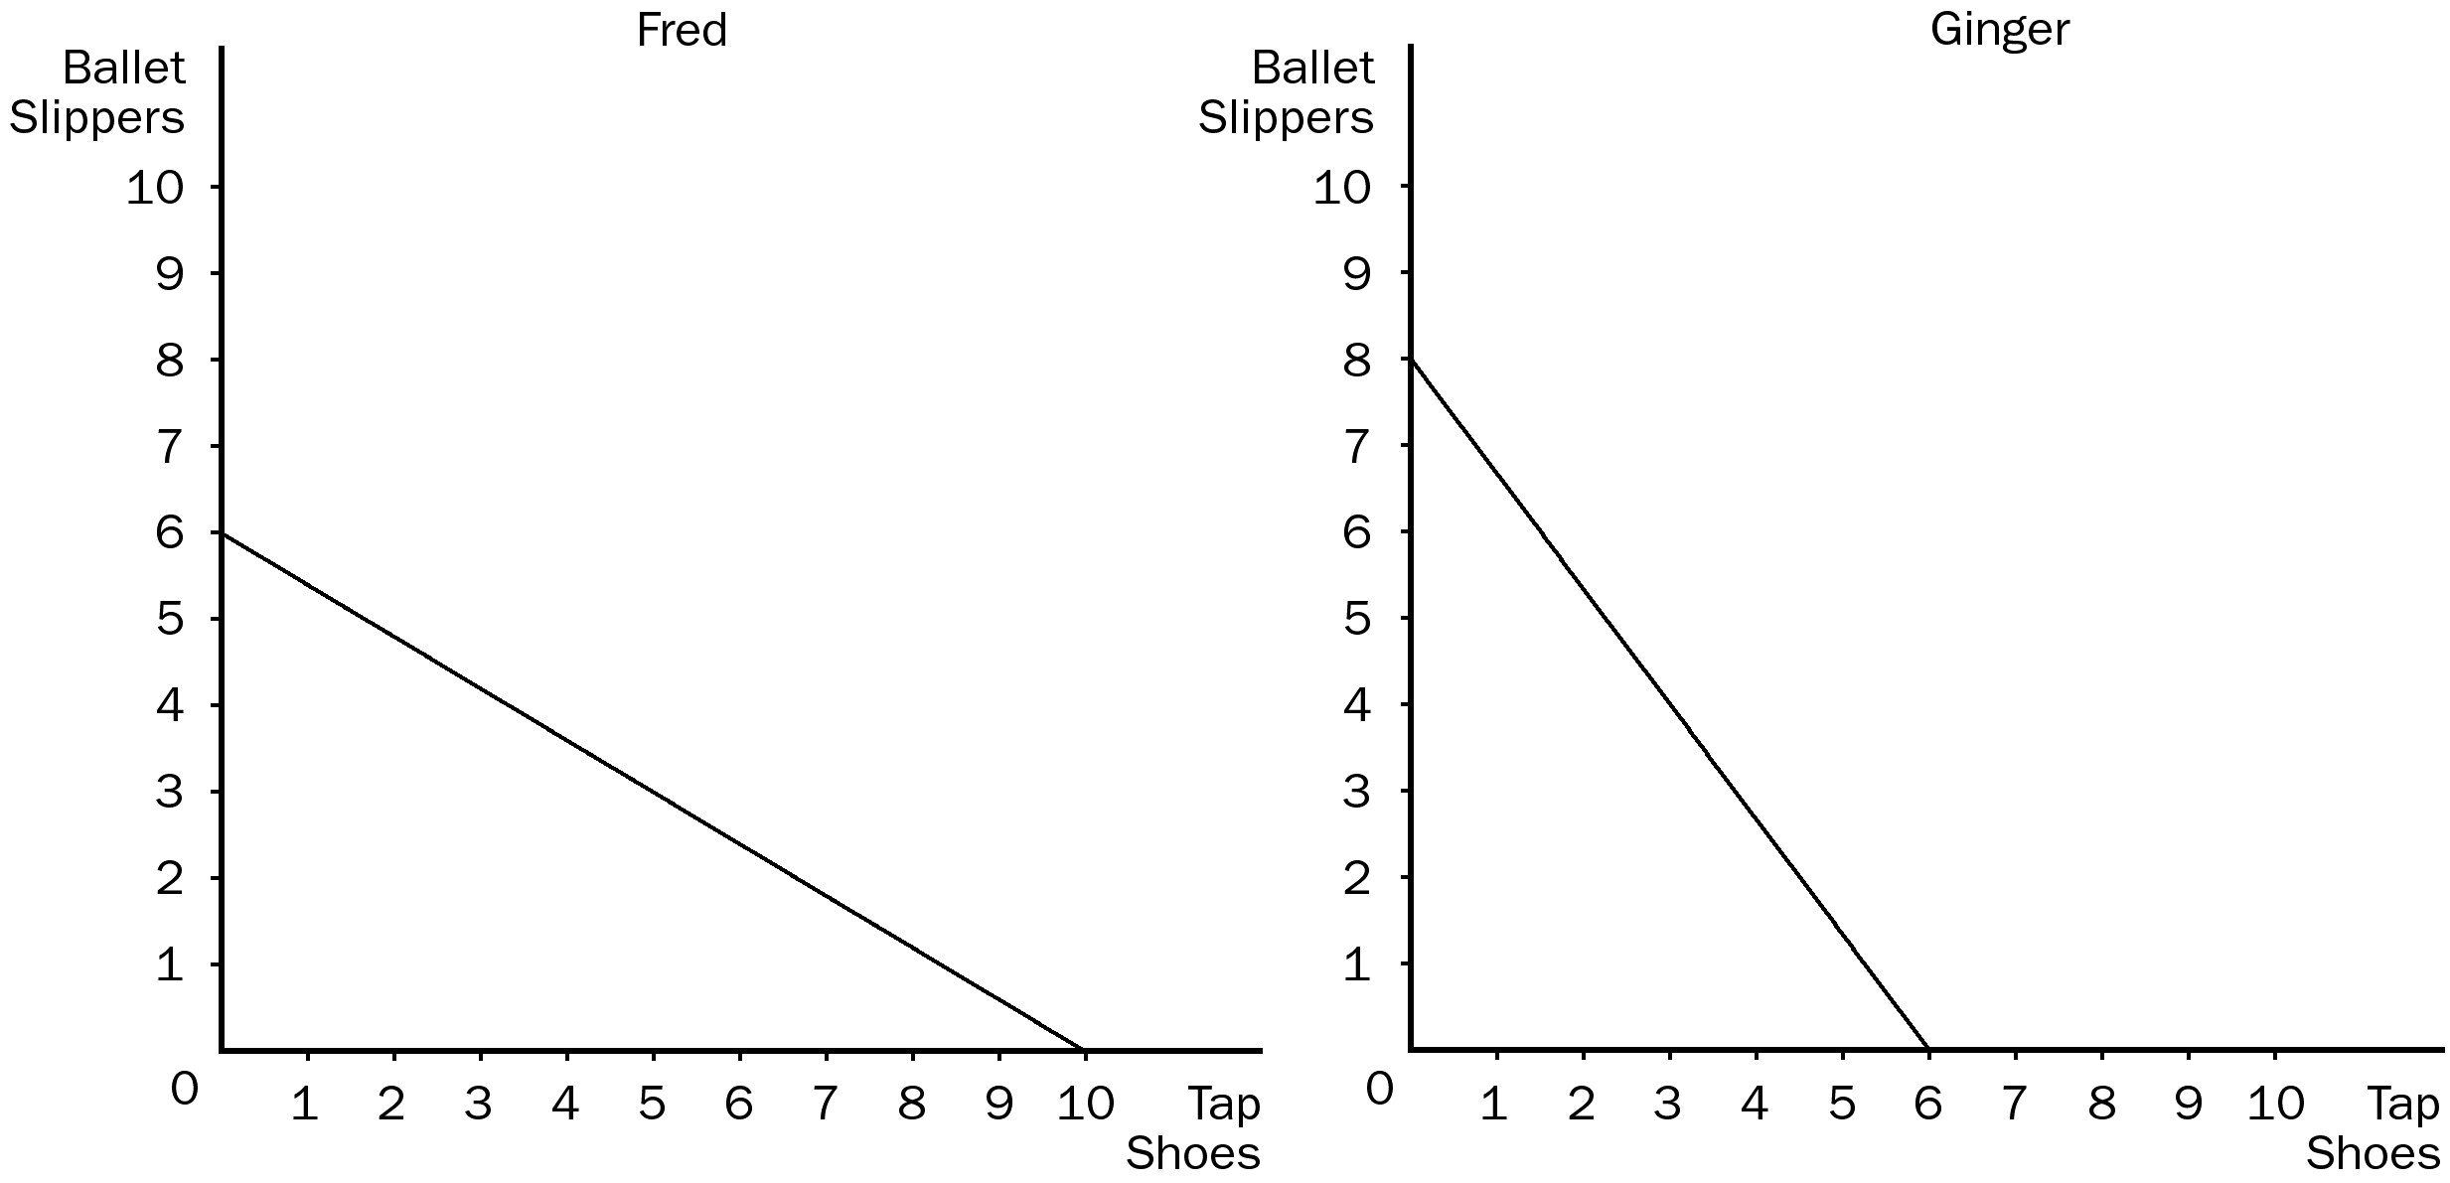
59. Refer to Figure 3-3. The opportunity cost of 1 pair of tap shoes for Fred is
a. 1/3 pair of ballet slippers.
b. 1/5 pair of ballet slippers.
c. 3/5 pair of ballet slippers.
d. 5/3 pairs of ballet slippers.
ANS: C PTS: 1 DIF: 2 REF: 3-2
TOP: Opportunity cost MSC: Applicative
60. Refer to Figure 3-3. The opportunity cost of 1 pair of tap shoes for Ginger is
a. 1/4 pair of ballet slippers.
b. 1/3 pair of ballet slippers.
c. 3/4 pair of ballet slippers.
d. 4/3 pairs of ballet slippers.
ANS: D PTS: 1 DIF: 2 REF: 3-2
TOP: Opportunity cost MSC: Applicative
61. Refer to Figure 3-3. The opportunity cost of 1 pair of ballet slippers for Ginger is
a. 1/4 pair of tap shoes.
b. 1/3 pair of tap shoes.
c. 3/4 pair of tap shoes.
d. 4/3 pairs of tap shoes.
ANS: C PTS: 1 DIF: 2 REF: 3-2
TOP: Opportunity cost MSC: Applicative
62. Refer to Figure 3-3. The opportunity cost of 1 pair of ballet slippers for Fred is
a. 1/3 pair of tap shoes.
b. 1/5 pair of tap shoes.
c. 3/5 pair of tap shoes.
d. 5/3 pairs of tap shoes.
ANS: D PTS: 1 DIF: 2 REF: 3-2
TOP: Opportunity cost MSC: Applicative
63. Refer to Figure 3-3. Fred would incur an opportunity cost of 3 ballet slippers if he
a. increased his production of tap shoes by 4.
b. increased his production of tap shoes by 5.
c. decreased his production of tap shoes by 4.
d. increased the time he spends on the two activities from 40 hours to 50 hours.
ANS: B PTS: 1 DIF: 2 REF: 3-2
TOP: Opportunity cost MSC: Applicative
64. Refer to Figure 3-3. How long does it take Fred to make one ballet slipper?
a. 4 hours
b. 6 hours
c. 6 2/3 hours
d. 7 1/2 hours
ANS: C PTS: 1 DIF: 2 REF: 3-2
TOP: Production possibilities frontier MSC: Applicative
65. Refer to Figure 3-3. Ginger has an absolute advantage in
a. ballet slippers and Fred has an absolute advantage in tap shoes.
b. tap shoes and Fred has an absolute advantage in ballet slippers.
c. neither good and Fred has an absolute advantage in both goods.
d. both goods and Fred has an absolute advantage in neither good.
ANS: A PTS: 1 DIF: 2 REF: 3-2
TOP: Absolute advantage MSC: Applicative
66. Refer to Figure 3-3. Ginger has a comparative advantage in
a. tap shoes and Fred has a comparative advantage in ballet slippers.
b. both goods and Fred has a comparative advantage in neither good.
c. ballet slippers and Fred has a comparative advantage in tap shoes.
d. neither good and Fred has a comparative advantage in both goods.
ANS: C PTS: 1 DIF: 2 REF: 3-2
TOP: Comparative advantage MSC: Applicative
67. Refer to Figure 3-3. Ginger has an absolute advantage in
a. tap shoes and Fred has a comparative advantage in ballet slippers.
b. both goods and Fred has a comparative advantage in neither good.
c. ballet slippers and Fred has a comparative advantage in tap shoes.
d. neither good and Fred has a comparative advantage in both goods.
ANS: C PTS: 1 DIF: 3 REF: 3-2
TOP: Absolute advantage | Comparative advantage MSC: Applicative
68. Refer to Figure 3-3. Which of the following statements is correct?
a. Fred sacrifices 1 2/3 ballet slippers to produce 1 tap shoe; Ginger sacrifices 3/4 of a ballet slipper to produce 1 tap shoe; therefore, Fred has a comparative advantage in producing tap shoes.
b. Fred sacrifices 3/5 of a ballet slipper to produce 1 tap shoe; Ginger sacrifices 1 1/3 ballet slippers to produce 1 tap shoe; therefore, Fred has an absolute advantage in producing tap shoes.
c. Fred requires 4 hours to produce a tap shoe; Ginger requires 6 2/3 hours to produce a tap shoe; therefore, Fred has a comparative advantage in producing tap shoes.
d. Fred requires 4 hours to produce a tap shoe; Ginger requires 6 2/3 hours to produce a tap shoe; therefore, Fred has an absolute advantage in producing tap shoes.
ANS: D PTS: 1 DIF: 3 REF: 3-2
TOP: Absolute advantage | Comparative advantage MSC: Applicative
69. Refer to Figure 3-3. In order to maximize total output,
a. Ginger should specialize in tap shoes and Fred should specialize in ballet slippers.
b. Ginger should specialize in both goods and Fred should specialize in neither good.
c. Ginger should specialize in ballet slippers and Fred should specialize in tap shoes.
d. Ginger should specialize in neither good and Fred should specialize in both goods.
ANS: C PTS: 1 DIF: 2 REF: 3-2
TOP: Specialization MSC: Applicative
70. Refer to Figure 3-3. Suppose Fred spends half of his time producing ballet slippers and the other half of his time producing tap shoes. Ginger divides her time the same way. Then
a. total production of ballet slippers would be 7 and total production of tap shoes would be 8.
b. total production of ballet slippers would be 8 and total production of tap shoes would be 8.
c. total production of ballet slippers would be 9 and total production of tap shoes would be 6.
d. total production of ballet slippers would be 10 and total production of tap shoes would be 8.
ANS: A PTS: 1 DIF: 2 REF: 3-2
TOP: Production possibilities frontier MSC: Applicative
71. Refer to Figure 3-3. Suppose Fred specializes in the good in which he has a comparative advantage, and Ginger specializes in the good in which she has a comparative advantage. Then
a. total production of ballet slippers would be 6 and total production of tap shoes would be 6.
b. total production of ballet slippers would be 8 and total production of tap shoes would be 6.
c. total production of ballet slippers would be 8 and total production of tap shoes would be 8.
d. total production of ballet slippers would be 8 and total production of tap shoes would be 10.
ANS: D PTS: 1 DIF: 2 REF: 3-2
TOP: Comparative advantage | Specialization MSC: Applicative
72. Refer to Figure 3-3. Originally, Fred was spending half of his time producing tap shoes and the other half of his time producing ballet slippers; Ginger was dividing her time the same way. Then, Fred began spending all of his time producing the good in which he has a comparative advantage, and Ginger began spending all of her time producing the good in which she has a comparative advantage. As a result,
a. total output of ballet slippers decreases by 1 and total output of tap shoes increases by 3.
b. total output of ballet slippers increases by 1 and total output of tap shoes increases by 2.
c. total output of ballet slippers increases by 2 and total output of tap shoes increases by 1.
d. total output of ballet slippers remains constant and total output of tap shoes increases by 2.
ANS: B PTS: 1 DIF: 2 REF: 3-2
TOP: Comparative advantage | Specialization MSC: Applicative
73. Suppose a gardener produces both green beans and corn in her garden. If she must give up 14 bushels of corn to get 5 bushels of green beans, then her opportunity cost of 1 bushel of green beans is
a. 0.36 bushel of corn.
b. 2.4 bushels of corn.
c. 2.8 bushels of corn.
d. 70 bushels of corn.
ANS: C PTS: 1 DIF: 2 REF: 3-2
TOP: Opportunity cost MSC: Interpretive
74. Suppose a gardener produces both green beans and corn in her garden. If the opportunity cost of one bushel of corn is 3/5 bushel of green beans, then the opportunity cost of 1 bushel of green beans is
a. 5/3 bushels of corn.
b. 2/5 bushel of corn.
c. 5/2 bushels of corn.
d. 8/5 bushels of corn.
ANS: A PTS: 1 DIF: 2 REF: 3-2
TOP: Opportunity cost MSC: Interpretive
75. If he devotes all of his available resources to cantaloupe production, a farmer can produce 120 cantaloupes. If he sacrifices 1.5 watermelons for each cantaloupe that he produces, it follows that
a. if he devotes all of his available resources to watermelon production he can produce 80 watermelons.
b. he cannot have a comparative advantage over other farmers in producing cantaloupes.
c. his opportunity cost of one watermelon is 2/3 of a cantaloupe.
d. All of the above are correct.
ANS: C PTS: 1 DIF: 3 REF: 3-2
TOP: Comparative advantage | Opportunity cost MSC: Analytical
76. A farmer has the ability to grow either corn or cotton or some combination of the two. Given no other information, it follows that the farmer’s opportunity cost of a bushel of corn multiplied by his opportunity cost of a bushel of cotton
a. is equal to 1.
b. is greater than 1 but less than 2.
c. is equal to 2.
d. Not enough information is given to make this determination.
ANS: A PTS: 1 DIF: 2 REF: 3-2
TOP: Opportunity cost MSC: Interpretive
77. If Shawn can produce donuts at a lower opportunity cost than Sue, then
a. Shawn has a comparative advantage in the production of donuts.
b. Sue has a comparative advantage in the production of donuts.
c. Shawn should not produce donuts.
d. Shawn is capable of producing more donuts than Sue in a given amount of time.
ANS: A PTS: 1 DIF: 2 REF: 3-2
TOP: Comparative advantage MSC: Definitional
78. If Shawn can produce more donuts in one day than Sue can produce in one day, then
a. Shawn has a comparative advantage in the production of donuts.
b. Sue has a comparative advantage in the production of donuts.
c. Shawn has an absolute advantage in the production of donuts.
d. Shawn should produce donuts and Sue should spend her time on a different activity.
ANS: C PTS: 1 DIF: 2 REF: 3-2
TOP: Absolute advantage MSC: Definitional
Table 3-3
 | Labor Hours Needed to Make One: |  | Amount Produced in 24 Hours:
 | Basket | Birdhouse | Baskets | Birdhouses
Montana | 6 | 2 | 4 | 12
Missouri | 3 | 1.5 | 8 | 16

79. Refer to Table 3-3. The opportunity cost of 1 basket for Montana is
a. 1/3 birdhouse.
b. 1 birdhouse.
c. 3 birdhouses.
d. 4 birdhouses.
ANS: C PTS: 1 DIF: 2 REF: 3-2
TOP: Opportunity cost MSC: Applicative
80. Refer to Table 3-3. The opportunity cost of 1 basket for Missouri is
a. 1/4 birdhouse.
b. 1/2 birdhouse.
c. 2 birdhouses.
d. 2 2/3 birdhouses.
ANS: C PTS: 1 DIF: 2 REF: 3-2
TOP: Opportunity cost MSC: Applicative
81. Refer to Table 3-3. The opportunity cost of 1 birdhouse for Montana is
a. 1/3 basket.
b. 1 basket.
c. 4/3 baskets.
d. 3 baskets.
ANS: A PTS: 1 DIF: 2 REF: 3-2
TOP: Opportunity cost MSC: Applicative
82. Refer to Table 3-3. The opportunity cost of 1 birdhouse for Missouri is
a. 1/2 basket.
b. 1 basket.
c. 1 1/2 baskets.
d. 2 baskets.
ANS: A PTS: 1 DIF: 2 REF: 3-2
TOP: Opportunity cost MSC: Applicative
83. Refer to Table 3-3. Montana has an absolute advantage in
a. birdhouses and Missouri has an absolute advantage in baskets.
b. baskets and Missouri has an absolute advantage in birdhouses.
c. neither good and Missouri has an absolute advantage in both goods.
d. both goods and Missouri has an absolute advantage in neither good.
ANS: C PTS: 1 DIF: 2 REF: 3-2
TOP: Absolute advantage MSC: Applicative
84. Refer to Table 3-3. Montana has a comparative advantage in
a. baskets and Missouri has a comparative advantage in birdhouses.
b. birdhouses and Missouri has a comparative advantage in baskets.
c. neither good and Missouri has a comparative advantage in both goods.
d. both goods and Missouri has a comparative advantage in neither good.
ANS: B PTS: 1 DIF: 2 REF: 3-2
TOP: Comparative advantage MSC: Applicative
85. Refer to Table 3-3. If Montana and Missouri trade based on the principle of comparative advantage, Montana will export
a. baskets and Missouri will export birdhouses.
b. birdhouses and Missouri will export baskets.
c. neither good and Missouri will export both goods.
d. both goods and Missouri will export neither good.
ANS: B PTS: 1 DIF: 2 REF: 3-2
TOP: Comparative advantage | Trade MSC: Applicative
86. Refer to Table 3-3. If Montana and Missouri were to specialize and engage in trade that would benefit both states, they would most likely base their decisions on the principle of
a. absolute advantage.
b. comparative advantage.
c. maximum opportunity cost.
d. zero-sum trade.
ANS: B PTS: 1 DIF: 1 REF: 3-2
TOP: Comparative advantage | Trade MSC: Interpretive
87. Specialization and trade are closely linked to
a. absolute advantage.
b. comparative advantage.
c. gains to some traders that exactly offset losses to other traders.
d. shrinkage of the economic pie.
ANS: B PTS: 1 DIF: 1 REF: 3-2
TOP: Specialization | Trade MSC: Interpretive
88. For two individuals who engage in the same two productive activities, it is impossible for one of the two individuals to
a. have a comparative advantage in both activities.
b. have an absolute advantage in both activities.
c. be more productive per unit of time in both activities.
d. All of the above are correct.
ANS: A PTS: 1 DIF: 2 REF: 3-2
TOP: Absolute advantage | Comparative advantage MSC: Interpretive
89. Two individuals engage in the same two productive activities. In which of the following circumstances would neither individual have a comparative advantage in either activity?
a. One individual’s production possibilities frontier is steeper than the other individual’s production possibilities frontier.
b. One individual is faster at both activities than the other individual.
c. One individual’s opportunity costs are the same as the other individual’s opportunity costs.
d. None of the above is correct; one of the two individuals always will have a comparative advantage in at least one of the two activities.
ANS: C PTS: 1 DIF: 2 REF: 3-2
TOP: Opportunity cost | Comparative advantage MSC: Interpretive
90. Comparative advantage is related most closely to which of the following?
a. output per hour
b. opportunity cost
c. efficiency
d. bargaining strength in international trade
ANS: B PTS: 1 DIF: 2 REF: 3-2
TOP: Comparative advantage MSC: Interpretive
91. Which of the following statements about comparative advantage is not true?
a. Comparative advantage is determined by which person or group of persons can produce a given quantity of a good using the fewest resources.
b. The principle of comparative advantage applies to countries as well as to individuals.
c. Economists use the principle of comparative advantage to emphasize the potential benefits of free trade.
d. A country may have a comparative advantage in producing a good, even though it lacks an absolute advantage in producing that good.
ANS: A PTS: 1 DIF: 2 REF: 3-2
TOP: Comparative advantage MSC: Interpretive
92. The producer that requires a smaller quantity of inputs to produce a certain amount of a good, relative to the quantities of inputs required by other producers to produce the same amount of that good,
a. has a low opportunity cost of producing that good, relative to the opportunity costs of other producers.
b. has a comparative advantage in the production of that good.
c. has an absolute advantage in the production of that good.
d. has an artificial advantage in the production of that good.
ANS: C PTS: 1 DIF: 1 REF: 3-2
TOP: Absolute advantage MSC: Definitional
93. If Iowa’s opportunity cost of corn is lower than Oklahoma’s opportunity cost of corn, then
a. Iowa has a comparative advantage in the production of corn.
b. Iowa has an absolute advantage in the production of corn.
c. Iowa should import corn from Oklahoma.
d. Oklahoma should produce just enough corn to satisfy its own residents’ demands.
ANS: A PTS: 1 DIF: 2 REF: 3-2
TOP: Opportunity cost | Comparative advantage MSC: Interpretive
94. The opportunity cost of an item is
a. the number of hours that one must work in order to buy one unit of the item.
b. what you give up to get that item.
c. always less than the dollar value of the item.
d. always greater than the cost of producing the item.
ANS: B PTS: 1 DIF: 1 REF: 3-2
TOP: Opportunity cost MSC: Definitional
95. What must be given up to obtain an item is called
a. out-of-pocket cost.
b. comparative worth.
c. opportunity cost.
d. absolute value.
ANS: C PTS: 1 DIF: 1 REF: 3-2
TOP: Opportunity cost MSC: Definitional
96. Absolute advantage is found by comparing different producers’
a. opportunity costs.
b. payments to land, labor, and capital.
c. input requirements per unit of output.
d. locational and logistical circumstances.
ANS: C PTS: 1 DIF: 2 REF: 3-2
TOP: Absolute advantage MSC: Interpretive
97. Total output in an economy increases when each person specializes because
a. there is less competition for the same resources.
b. each person spends more time producing that product in which he or she has a comparative advantage.
c. a wider variety of products will be produced within each country due to specialization.
d. government necessarily plays a larger role in the economy due to specialization.
ANS: B PTS: 1 DIF: 2 REF: 3-2
TOP: Specialization MSC: Interpretive
98. The gains from trade are
a. evident in economic models, but seldom observed in the real world.
b. evident in the real world, but impossible to capture in economic models.
c. a result of more efficient resource allocation than would be observed in the absence of trade.
d. based on the principle of absolute advantage.
ANS: C PTS: 1 DIF: 2 REF: 3-2
TOP: Gains from trade MSC: Interpretive
99. The fact that economists are generally united in their support of free trade is traceable to
a. the principle of absolute advantage.
b. the arguments made by Adam Smith and David Ricardo.
c. the decline in the power of labor unions during the 20th century.
d. All of the above are correct.
ANS: B PTS: 1 DIF: 2 REF: 3-2
TOP: Economists | Trade MSC: Interpretive
100. Mike and Sandy are two woodworkers who both make tables and chairs. In one month, Mike can make 4 tables or 20 chairs, while Sandy can make 6 tables or 18 chairs. Given this, we know that
a. Mike has an absolute advantage in chairs.
b. Mike has a comparative advantage in tables.
c. Sandy has an absolute advantage in chairs.
d. Sandy has a comparative advantage in chairs.
ANS: A PTS: 1 DIF: 3 REF: 3-2
TOP: Absolute advantage | Comparative advantage MSC: Applicative
101. Mike and Sandy are two woodworkers who both make tables and chairs. In one month, Mike can make 4 tables or 20 chairs, while Sandy can make 6 tables or 18 chairs. Given this, we know that
a. Mike has a comparative advantage in tables.
b. Sandy has an absolute advantage in chairs.
c. Mike has an absolute advantage in tables.
d. Sandy has a comparative advantage in tables.
ANS: D PTS: 1 DIF: 3 REF: 3-2
TOP: Absolute advantage | Comparative advantage MSC: Applicative
102. Mike and Sandy are two woodworkers who both make tables and chairs. In one month, Mike can make 4 tables or 20 chairs, where Sandy can make 6 tables or 18 chairs. Given this, we know that the opportunity cost of 1 chair is
a. 1/5 table for Mike and 1/3 table for Sandy.
b. 5 tables for Mike and 3 tables for Sandy.
c. 1/3 table for Mike and 1/5 table for Sandy.
d. 3 tables for Mike and 5 tables for Sandy.
ANS: A PTS: 1 DIF: 2 REF: 3-2
TOP: Opportunity cost MSC: Applicative
103. Mike and Sandy are two woodworkers who both make tables and chairs. In one month, Mike can make 4 tables or 20 chairs, where Sandy can make 6 tables or 18 chairs. Given this, we know that the opportunity cost of 1 table is
a. 1/5 chair for Mike and 1/3 chair for Sandy.
b. 5 chairs for Mike and 3 chairs for Sandy.
c. 1/3 chair for Mike and 1/5 chair for Sandy.
d. 3 chairs for Mike and 5 chairs for Sandy.
ANS: B PTS: 1 DIF: 2 REF: 3-2
TOP: Opportunity cost MSC: Applicative
104. Suppose Susan can wash three windows per hour or she can iron six shirts per hour. Paul can wash two windows per hour or he can iron five shirts per hour.
a. Susan has an absolute advantage over Paul in washing windows.
b. Susan has a comparative advantage over Paul in washing windows.
c. Paul has a comparative advantage over Susan in ironing shirts.
d. All of the above are correct.
ANS: D PTS: 1 DIF: 2 REF: 3-2
TOP: Absolute advantage | Comparative advantage MSC: Applicative
105. Travis can mow a lawn in two hours or he can trim a tree in one hour. Ricardo can mow a lawn in three hours or he can trim a tree in two hours.
a. Travis has an absolute advantage over Ricardo in trimming trees.
b. Travis has a comparative advantage over Ricardo in mowing lawns.
c. Ricardo has a comparative advantage over Travis in trimming trees.
d. All of the above are correct.
ANS: A PTS: 1 DIF: 2 REF: 3-2
TOP: Absolute advantage | Comparative advantage MSC: Applicative
106. Kelly and David are both capable of repairing cars and cooking meals. Which of the following scenarios is not possible?
a. Kelly has a comparative advantage in repairing cars and David has a comparative advantage in cooking meals.
b. Kelly has an absolute advantage in repairing cars and David has an absolute advantage in cooking meals.
c. Kelly has a comparative advantage in repairing cars and in cooking meals.
d. Kelly has an absolute advantage in repairing cars and in cooking meals.
ANS: C PTS: 1 DIF: 1 REF: 3-2
TOP: Absolute advantage | Comparative advantage MSC: Interpretive
These figures illustrate the production possibilities available to Barney and Betty with 8 hours of labor in their bakery.
Figure 3-4
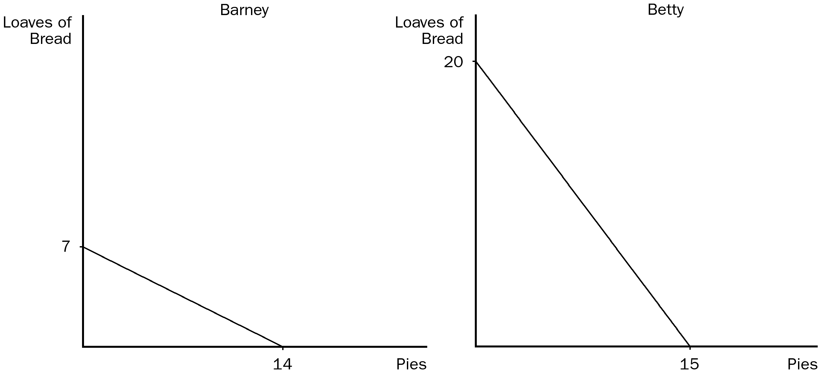
107. Refer to Figure 3-4. The opportunity cost of 1 loaf of bread for Barney is
a. 1/4 pie.
b. 1/2 pie.
c. 1 pie.
d. 2 pies.
ANS: D PTS: 1 DIF: 2 REF: 3-2
TOP: Opportunity cost MSC: Applicative
108. Refer to Figure 3-4. The opportunity cost of 1 pie for Betty is
a. 1/4 loaf of bread.
b. 3/4 loaf of bread.
c. 1 loaf of bread.
d. 4/3 loaves of bread.
ANS: D PTS: 1 DIF: 2 REF: 3-2
TOP: Opportunity cost MSC: Applicative
109. Refer to Figure 3-4. Barney has an absolute advantage in
a. both goods and Betty has an absolute advantage in neither good.
b. loaves of bread and Betty has an absolute advantage in pies.
c. pies and Betty has an absolute advantage in loaves of bread.
d. neither good and Betty has an absolute advantage in both goods.
ANS: D PTS: 1 DIF: 2 REF: 3-2
TOP: Absolute advantage MSC: Applicative
110. Refer to Figure 3-4. Barney has a comparative advantage in
a. both goods and Betty has a comparative advantage in neither good.
b. loaves of bread and Betty has a comparative advantage in pies.
c. neither good and Betty has a comparative advantage in both goods.
d. pies and Betty has a comparative advantage in loaves of bread.
ANS: D PTS: 1 DIF: 2 REF: 3-2
TOP: Comparative advantage MSC: Applicative
111. Refer to Figure 3-4. If Barney and Betty both specialize in the good in which they have a comparative advantage,
a. total production of bread will be 7 and total production of pies will be 15.
b. total production of bread will be 20 and total production of pies will be 14.
c. total production of bread will be 27 and total production of pies will be 29.
d. total production of bread will be 40 and total production of pies will be 22.
ANS: B PTS: 1 DIF: 2 REF: 3-2
TOP: Comparative advantage MSC: Applicative
112. Refer to Figure 3-4. Initially, Barney is spending one-half of his time making pies and the other one-half of his time making bread, and Betty is doing the same. Relative to this initial situation, Barney and Betty could specialize according to the principle of comparative advantage, and both could benefit from this new arrangement, provided they agree that one loaf of bread will trade for somewhere between
a. 1/2 pie and 3/4 pie.
b. 3/4 pie and 1 pie.
c. 3/4 pie and 2 pies.
d. 1 pie and 1 1/2 pies.
ANS: C PTS: 1 DIF: 3 REF: 3-2
TOP: Comparative advantage | Specialization | Trade MSC: Analytical
113. Refer to Figure 3-4. Initially, Barney is spending one-half of his time making pies and the other one-half of his time making bread, and Betty is doing the same. Relative to this initial situation, Barney and Betty could specialize according to the principle of comparative advantage, and both could benefit from this new arrangement, provided they agree that one pie will trade for somewhere between
a. 1/2 loaf of bread and 4/3 loaves of bread.
b. 2/3 loaf of bread and 2 loaves of bread.
c. 3/4 loaf of bread and 2 loaves of bread.
d. 3/4 loaf of bread and 5/2 loaves of bread.
ANS: A PTS: 1 DIF: 3 REF: 3-2
TOP: Comparative advantage | Specialization | Trade MSC: Analytical
Table 3-4
Brenda and Eric run a business that involves setting up and testing computers. The following table applies.

 | Minutes Needed to |  | Number of Computers Set Up or Tested in a 40-Hour Week
 | Set Up | Test | Computers | Computers
 | a Computer | a Computer | Set Up | Tested
Brenda | 30 | 40 | 80 | 60
Eric | 48 | ? | 50 | 40

114. Refer to Table 3-4. The number of minutes needed by Eric to test a computer is
a. 36.
b. 48.
c. 60.
d. 64.
ANS: C PTS: 1 DIF: 2 REF: 3-2
TOP: Production MSC: Interpretive
115. Refer to Table 3-4. For Brenda, the opportunity cost of testing a computer is
a. setting up 2/3 of a computer.
b. setting up 3/4 of a computer.
c. setting up 1 1/3 computers.
d. setting up 1 1/2 computers
ANS: C PTS: 1 DIF: 2 REF: 3-2
TOP: Opportunity cost MSC: Interpretive
116. Refer to Table 3-4. Which of the following statements is correct?
a. Brenda has an absolute advantage, and Eric has a comparative advantage, in testing computers.
b. Eric has an absolute advantage, and Brenda has a comparative advantage, in testing computers.
c. Brenda has an absolute advantage and a comparative advantage in testing computers.
d. Eric has an absolute advantage and a comparative advantage in testing computers.
ANS: A PTS: 1 DIF: 3 REF: 3-2
TOP: Absolute advantage | Comparative advantage MSC: Applicative
117. Refer to Table 3-4. For Eric, the opportunity cost of setting up a computer is
a. testing 0.75 computers.
b. testing 0.8 computers.
c. testing 1.25 computers.
d. testing 1.5 computers.
ANS: B PTS: 1 DIF: 2 REF: 3-2
TOP: Opportunity cost MSC: Interpretive
118. Refer to Table 3-4. Which of the following statements is correct?
a. Brenda has an absolute advantage, and Eric has a comparative advantage, in setting up computers.
b. Eric has an absolute advantage, and Brenda has a comparative advantage, in setting up computers.
c. Brenda has an absolute advantage and a comparative advantage in setting up computers.
d. Eric has an absolute advantage and a comparative advantage in setting up computers.
ANS: C PTS: 1 DIF: 3 REF: 3-2
TOP: Absolute advantage | Comparative advantage MSC: Applicative
119. Refer to Table 3-4. Which of these points would not be on Brenda's production possibilities frontier, based on a 40-hour week and assuming Brenda can switch between setting up and testing computers at a constant rate?
a. (60 computers tested, 0 computers set-up)
b. (30 computers tested, 40 computers set-up)
c. (12 computers tested, 60 computers set-up)
d. (6 computers tested, 72 computers set-up)
ANS: C PTS: 1 DIF: 2 REF: 3-2
TOP: Production possibilities frontier MSC: Applicative
120. Refer to Table 3-4. Which of these points would not be on Eric's production possibilities frontier, based on a 40-hour week and assuming Eric can switch between setting up and testing computers at a constant rate?
a. (0 computers set-up, 40 computers tested)
b. (30 computers set-up, 16 computers tested)
c. (25 computers set-up, 20 computers tested)
d. (8 computers set-up, 32 computers tested)
ANS: D PTS: 1 DIF: 2 REF: 3-2
TOP: Production possibilities frontier MSC: Applicative
121. Adam Smith
a. wrote An Inquiry into the Nature and Causes of the Wealth of Nations.
b. opposed free trade.
c. wrote The General Theory of Economics.
d. All of the above are correct.
ANS: A PTS: 1 DIF: 1 REF: 3-2
TOP: Economists MSC: Definitional
122. Adam Smith asserted that a person should never attempt to make at home
a. what it will cost him more to make than to buy.
b. any good in which that person does not have an absolute advantage.
c. any luxury good.
d. any necessity.
ANS: A PTS: 1 DIF: 2 REF: 3-2
TOP: Economists MSC: Interpretive
123. The principle of comparative advantage as we know it today was developed by
a. Aristotle.
b. David Ricardo.
c. John Maynard Keynes.
d. Adam Smith.
ANS: B PTS: 1 DIF: 1 REF: 3-2
TOP: Economists MSC: Definitional
124. Which economist developed the theory of comparative advantage as we know it today?
a. Plato
b. Thomas Malthus
c. Karl Marx
d. David Ricardo
ANS: D PTS: 1 DIF: 1 REF: 3-2
TOP: Comparative advantage MSC: Definitional
125. David Ricardo
a. wrote a famous book in which he attacked the ideas of Adam Smith.
b. was the founder of modern economics.
c. argued that Britain should not restrict imports of grain.
d. wrote An Inquiry into the Nature and Causes of the Wealth of Nations in 1776.
ANS: C PTS: 1 DIF: 1 REF: 3-2
TOP: Economists MSC: Definitional
126. David Ricardo, a millionaire stockbroker and economist,
a. opposed the Corn Laws as a member of the British Parliament.
b. disputed Adam Smith's theory of specialization and trade in the early 1800s.
c. developed the principle of absolute advantage.
d. was an early supporter of trade restrictions.
ANS: A PTS: 1 DIF: 1 REF: 3-2
TOP: Economists MSC: Definitional
127. David Ricardo was the author of
a. An Inquiry into the Nature and Causes of the Wealth of Nations.
b. Principles of Political Economy and Taxation.
c. The General Theory of Employment, Interest, and Money.
d. Why Homo Sapiens Dominated Neanderthals.
ANS: B PTS: 1 DIF: 1 REF: 3-2
TOP: Economists MSC: Definitional
128. The principle of comparative advantage does not provide answers to certain questions. One of those questions is as follows:
a. Do specialization and trade benefit more than one party to a trade?
b. Is it absolute advantage or comparative advantage that really matters?
c. How are the gains from trade shared among the parties to a trade?
d. Is it possible for specialization and trade to increase total output of traded goods?
ANS: C PTS: 1 DIF: 2 REF: 3-2
TOP: Comparative advantage | Trade MSC: Interpretive
129. The principle of comparative advantage does not provide answers to certain questions. One of those questions is as follows:
a. Is it possible for specialization and trade to benefit more than one party to a trade?
b. Is it possible for specialization and trade to increase total output of traded goods?
c. Do opportunity costs play a role in people’s decisions to specialize in certain activities?
d. What determines the price at which trade takes place?
ANS: D PTS: 1 DIF: 2 REF: 3-2
TOP: Comparative advantage | Trade MSC: Interpretive
130. If Korea is capable of producing either shoes or soccer balls or some combination of those two products, then
a. Korea should specialize in the product in which it has an absolute advantage.
b. it would be impossible for Korea to have an absolute advantage over another country in both products.
c. it would be difficult for Korea to benefit from trade with another country if Korea is efficient in the production of both goods.
d. Korea’s opportunity cost of shoes is the inverse of its opportunity cost of soccer balls.
ANS: D PTS: 1 DIF: 2 REF: 3-3
TOP: Opportunity cost MSC: Interpretive
131. Assume that Greece has a comparative advantage in fish and Germany has a comparative advantage in cars. Also assume that Germany has an absolute advantage in both fish and cars. If these two countries specialize and trade so as to maximize the benefits of specialization and trade,
a. the two countries’ combined output of both goods will be higher than it would be in the absence of trade.
b. Greece will produce more fish than it would produce in the absence of trade.
c. Germany will produce more cars than it would produce in the absence of trade.
d. All of the above are correct.
ANS: D PTS: 1 DIF: 2 REF: 3-3
TOP: Specialization | Trade MSC: Interpretive
132. Belarus has a comparative advantage in the production of linen, but Russia has an absolute advantage in the production of linen. If these two countries decide to trade,
a. Belarus should export linen to Russia.
b. Russia should export linen to Belarus.
c. trading linen would provide no net advantage to either country.
d. Without additional information about opportunity costs, this question cannot be answered.
ANS: A PTS: 1 DIF: 2 REF: 3-3
TOP: Absolute advantage | Comparative advantage | Trade MSC: Interpretive
133. Canada and the U.S. both produce wheat and computer software. Canada is said to have the comparative advantage in producing wheat if
a. Canada requires fewer resources than the U.S. to produce a bushel of wheat.
b. the opportunity cost of producing a bushel of wheat is lower for Canada than it is for the U.S.
c. the opportunity cost of producing a bushel of wheat is lower for the U.S. than it is for Canada.
d. the U.S. has an absolute advantage over Canada in producing computer software.
ANS: B PTS: 1 DIF: 1 REF: 3-2
TOP: Opportunity cost | Comparative advantage MSC: Definitional
134. Assume for the United States that the opportunity cost of each airplane is 100 cars. Then which of these pairs of points could be on the United States' production possibilities frontier?
a. (200 airplanes, 5,000 cars) and (150 airplanes, 4,000 cars)
b. (200 airplanes, 10,000 cars) and (150 airplanes, 20,000 cars)
c. (300 airplanes, 15,000 cars) and (200 airplanes, 25,000 cars)
d. (300 airplanes, 25,000 cars) and (200 airplanes, 40,000 cars)
ANS: C PTS: 1 DIF: 2 REF: 3-2
TOP: Opportunity cost | Production possibilities frontier MSC: Applicative
135. When a country has a comparative advantage in producing a certain good,
a. the country should import that good.
b. the country should produce just enough of that good for its own consumption.
c. the country’s opportunity cost of that good is high relative to other countries’ opportunity costs of that same good.
d. None of the above is correct.
ANS: D PTS: 1 DIF: 2 REF: 3-3
TOP: Comparative advantage MSC: Interpretive
136. Trade between countries
a. allows each country to consume at a point outside its production possibilities frontier.
b. limits a country’s ability to produce goods and services on its own.
c. must benefit both countries equally; otherwise, trade is not mutually beneficial.
d. can best be understood by examining the countries’ absolute advantages.
ANS: A PTS: 1 DIF: 2 REF: 3-3
TOP: Trade MSC: Interpretive
137. Which of the following would not result from all countries specializing according to the principle of comparative advantage?
a. Each country’s production possibilities frontier will shift outward.
b. Worldwide production of goods and services will increase.
c. The well-being of citizens in each country will be enhanced.
d. The size of the economic pie will increase.
ANS: A PTS: 1 DIF: 2 REF: 3-3
TOP: Specialization | Trade MSC: Interpretive
Table 3-5
 | Hours needed to make one: |  | Amount produced in 2400 hours:
 | Car | Airplane | Cars | Airplanes
Japan | 30 | 150 | 80 | 16
U.S. | 50 | 200 | 48 | 12

138. Refer to Table 3-5. The opportunity cost of 1 car for Japan is
a. 5 airplanes.
b. 4 airplanes.
c. 1/4 airplane.
d. 1/5 airplane.
ANS: D PTS: 1 DIF: 2 REF: 3-3
TOP: Opportunity cost MSC: Applicative
139. Refer to Table 3-5. The opportunity cost of 1 airplane for Japan is
a. 5 cars.
b. 4 cars.
c. 1/4 car.
d. 1/5 car.
ANS: A PTS: 1 DIF: 2 REF: 3-3
TOP: Opportunity cost MSC: Applicative
140. Refer to Table 3-5. The opportunity cost of 1 car for the United States is
a. 4 airplanes.
b. 3 airplanes.
c. 1/3 airplane.
d. 1/4 airplane.
ANS: D PTS: 1 DIF: 2 REF: 3-3
TOP: Opportunity cost MSC: Applicative
141. Refer to Table 3-5. The opportunity cost of 1 airplane for the United States is
a. 4 cars.
b. 3 cars.
c. 1/3 car.
d. 1/4 car.
ANS: A PTS: 1 DIF: 2 REF: 3-3
TOP: Opportunity cost MSC: Applicative
142. Refer to Table 3-5. Japan has a comparative advantage in
a. airplanes and the United States has an absolute advantage in cars.
b. cars and the United States has an absolute advantage in airplanes.
c. cars and the United States has an absolute advantage in neither good.
d. airplanes and the United States has an absolute advantage in both goods.
ANS: C PTS: 1 DIF: 3 REF: 3-3
TOP: Absolute advantage | Comparative advantage MSC: Applicative
143. Refer to Table 3-5. Japan has an absolute advantage in
a. both goods and the United States has a comparative advantage in cars.
b. both goods and the United States has a comparative advantage in airplanes.
c. cars (but not airplanes) and the United States has a comparative advantage in airplanes.
d. airplanes (but not cars) and the United States has a comparative advantage in cars.
ANS: B PTS: 1 DIF: 3 REF: 3-3
TOP: Absolute advantage | Comparative advantage MSC: Applicative
144. Refer to Table 3-5. The United States has an absolute advantage in
a. airplanes and Japan has an absolute advantage in cars.
b. cars and Japan has an absolute advantage in airplanes.
c. both cars and airplanes.
d. neither cars nor airplanes.
ANS: D PTS: 1 DIF: 2 REF: 3-3
TOP: Absolute advantage MSC: Applicative
145. Refer to Table 3-5. The United States has a comparative advantage in
a. airplanes and Japan has a comparative advantage in airplanes.
b. cars and Japan has a comparative advantage in airplanes.
c. airplanes and Japan has a comparative advantage in cars.
d. neither good and Japan has a comparative advantage in both goods.
ANS: C PTS: 1 DIF: 2 REF: 3-3
TOP: Comparative advantage MSC: Applicative
146. Refer to Table 3-5. The United States and Japan could benefit by the United States specializing in
a. airplanes and Japan specializing in airplanes.
b. cars and Japan specializing in airplanes.
c. airplanes and Japan specializing in cars.
d. neither good and Japan specializing in cars.
ANS: C PTS: 1 DIF: 2 REF: 3-3
TOP: Specialization MSC: Applicative
147. Refer to Table 3-5. If the United States and Japan trade based on the principle of comparative advantage, the United States will
a. export cars (but not airplanes) to Japan.
b. export airplanes (but not cars) to Japan.
c. export cars and airplanes to Japan.
d. import cars and airplanes from Japan.
ANS: B PTS: 1 DIF: 2 REF: 3-3
TOP: Comparative advantage | Trade MSC: Applicative
148. Refer to Table 3-5. If the United States and Japan trade based on the principle of comparative advantage, Japan will
a. export cars (but not airplanes) to the U.S.
b. export airplanes (but not cars) to the U.S.
c. export cars and airplanes to the U.S.
d. import cars and airplanes from the U.S.
ANS: A PTS: 1 DIF: 2 REF: 3-3
TOP: Comparative advantage | Trade MSC: Applicative
149. Refer to Table 3-5. If the United States and Japan specialize and trade based on the principle of comparative advantage, the United States will
a. export cars and Japan will export airplanes.
b. export airplanes and Japan will export cars.
c. export cars and Japan will export cars.
d. export airplanes and Japan will export airplanes.
ANS: B PTS: 1 DIF: 2 REF: 3-3
TOP: Comparative advantage | Trade MSC: Applicative
150. Refer to Table 3-5. If Japan and the United States trade based on the principle of comparative advantage,
a. both countries can consume outside of their respective production possibilities frontiers.
b. both countries can have more airplanes and cars than they would have without trade.
c. Japan will specialize in cars and the United States will specialize in airplanes.
d. All of the above are correct.
ANS: D PTS: 1 DIF: 2 REF: 3-3
TOP: Comparative advantage | Trade MSC: Applicative
Figure 3-5 The graph below represents the various combinations of cars and corn that Country A could produce in a given month. (On the vertical axis, corn is measured in bushels.)
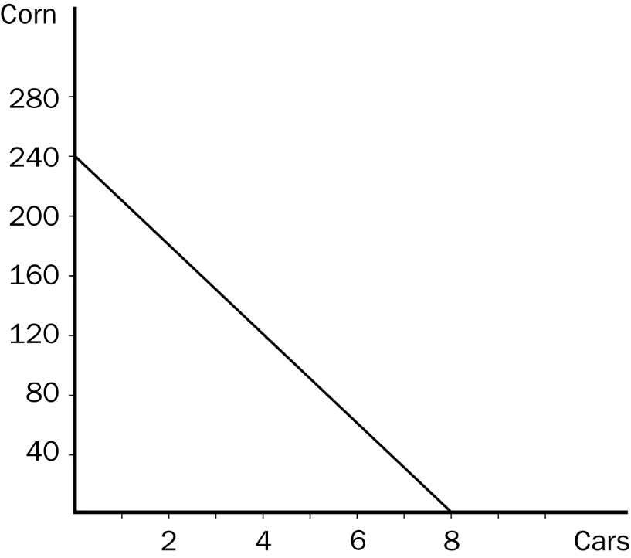
151. Refer to Figure 3-5. The graph that is shown is called a
a. supply line.
b. opportunity line.
c. production possibilities frontier.
d. consumption possibilities frontier.
ANS: C PTS: 1 DIF: 1 REF: 3-3
TOP: Production possibilities frontier MSC: Definitional
152. Refer to Figure 3-5. The fact that the line slopes downward reflects the fact that
a. for Country A, it is more costly to produce a car than it is to produce a bushel of corn.
b. Country A will produce more cars and fewer bushels of corn as time goes by.
c. Country A faces a tradeoff between producing cars and producing corn.
d. Country A should specialize in producing corn.
ANS: C PTS: 1 DIF: 1 REF: 3-3
TOP: Production possibilities frontier MSC: Interpretive
153. Refer to Figure 3-5. Which of the following combinations of cars and corn could Country A produce in a given month?
a. 7 cars and 40 bushels of corn
b. 5 cars and 92 bushels of corn
c. 3 cars and 165 bushels of corn
d. 2 cars and 180 bushels of corn
ANS: D PTS: 1 DIF: 2 REF: 3-3
TOP: Production possibilities frontier MSC: Applicative
154. Refer to Figure 3-5. Which of the following combinations of cars and corn could Country A not produce in a given month?
a. 6 cars and 60 bushels of corn
b. 4 cars and 120 bushels of corn
c. 3 cars and 160 bushels of corn
d. 1 car and 210 bushels of corn
ANS: C PTS: 1 DIF: 2 REF: 3-3
TOP: Production possibilities frontier MSC: Applicative
155. Refer to Figure 3-5. Suppose Country B is willing to trade 40 bushels of corn to Country A for each car that Country A produces and sends to Country B. Which of the following combinations of cars and corn could Country A then consume, assuming Country A specializes in car production?
a. 2 cars and 240 bushels of corn
b. 3 cars and 220 bushels of corn
c. 4 cars and 200 bushels of corn
d. 5 cars and 140 bushels of corn
ANS: A PTS: 1 DIF: 3 REF: 3-3
TOP: Production possibilities frontier | Trade MSC: Applicative
156. Refer to Figure 3-5. For Country A, what is the opportunity cost of each additional car that it decides to produce?
a. 25 bushels of corn
b. 30 bushels of corn
c. 35 bushels of corn
d. 40 bushels of corn
ANS: B PTS: 1 DIF: 2 REF: 3-3
TOP: Opportunity cost | Production possibilities frontier MSC: Applicative
157. Refer to Figure 3-5. Suppose Country A decides to increase its production of corn by three bushels. What is the opportunity cost of this decision?
a. one-sixth of a car
b. one-eighth of a car
c. one-tenth of a car
d. one-twelfth of a car
ANS: C PTS: 1 DIF: 2 REF: 3-3
TOP: Opportunity cost | Production possibilities frontier MSC: Applicative
158. Refer to Figure 3-5. Country A would most likely find itself specializing in corn production if it began trading with Country B and
a. Country A had an absolute advantage over Country B in producing corn.
b. Country B had a comparative advantage over Country A in producing corn.
c. Country B faced an opportunity cost of 20 bushels of corn for every additional car that it produced.
d. Country B faced an opportunity cost of 40 bushels of corn for every additional car that it produced.
ANS: D PTS: 1 DIF: 3 REF: 3-3
TOP: Opportunity cost | Production possibilities frontier | Trade MSC: Analytical
159. Refer to Figure 3-5. Under which of the following circumstances would Country A be able to consume outside of its production possibilities frontier?
a. Under no circumstances is that possible.
b. Country A trades with Country B; Country A has a comparative advantage over Country B in producing corn; and Country A specializes in car production.
c. Country A trades with Country B; Country A has a comparative advantage over Country B in producing cars; and Country A specializes in car production.
d. Country A trades with Country B; Country A has an absolute advantage over Country B in producing cars; and Country A specializes in car production.
ANS: C PTS: 1 DIF: 2 REF: 3-3
TOP: Absolute advantage | Comparative advantage MSC: Applicative
160. A good that is produced abroad and sold domestically is called
a. a quota.
b. a tariff.
c. an import.
d. an export.
ANS: C PTS: 1 DIF: 1 REF: 3-3
TOP: Imports MSC: Definitional
161. By definition, imports are
a. people who work in foreign countries.
b. goods in which a country has an absolute advantage.
c. whatever is given up to obtain some item.
d. goods produced abroad and sold domestically.
ANS: D PTS: 1 DIF: 1 REF: 3-3
TOP: Imports MSC: Definitional
162. By definition, exports are
a. a limit placed on the quantity of goods brought into a country.
b. opportunity benefits (as opposed to opportunity costs).
c. goods produced abroad and sold domestically.
d. goods produced domestically and sold abroad.
ANS: D PTS: 1 DIF: 1 REF: 3-3
TOP: Exports MSC: Definitional
163. Economists generally support
a. trade restrictions.
b. government management of trade.
c. export subsidies.
d. free international trade.
ANS: D PTS: 1 DIF: 1 REF: 3-3
TOP: Economists | Trade MSC: Interpretive
164. A country that currently does not trade with other countries could benefit by
a. restricting imports and promoting exports.
b. promoting imports and restricting exports.
c. restricting both imports and exports.
d. not restricting trade.
ANS: D PTS: 1 DIF: 2 REF: 3-3
TOP: Gains from trade MSC: Interpretive
165. Trade can make everybody better off because it
a. increases cooperation among nations.
b. allows people to specialize according to comparative advantage.
c. requires some workers in an economy to be retrained.
d. reduces competition among domestic companies.
ANS: B PTS: 1 DIF: 2 REF: 3-3
TOP: Gains from trade MSC: Interpretive
Use the accompanying table to answer the following questions:
Table 3-6
 | Labor hours needed to make one unit of |  | Amount produced in 40 hours
 | Cheese | Bread | Cheese | Bread
England | 1 | 2 | 40 | 20
Spain | 2 | 8 | 20 | 5

166. Refer to Table 3-6. The opportunity cost of 1 unit of cheese in England is
a. 4 units of bread.
b. 2 units of bread.
c. 1/2 unit of bread.
d. 1/4 unit of bread.
ANS: C PTS: 1 DIF: 2 REF: 3-3
TOP: Opportunity cost MSC: Applicative
167. Refer to Table 3-6. The opportunity cost of 1 unit of bread in England is
a. 4 units of cheese.
b. 2 units of cheese.
c. 1 unit of cheese.
d. 1/2 unit of cheese.
ANS: B PTS: 1 DIF: 2 REF: 3-3
TOP: Opportunity cost MSC: Applicative
168. Refer to Table 3-6. The opportunity cost of 1 unit of cheese in Spain is
a. 2 unit of bread.
b. 1 unit of bread.
c. 1/2 unit of bread.
d. 1/4 unit of bread.
ANS: D PTS: 1 DIF: 2 REF: 3-3
TOP: Opportunity cost MSC: Applicative
169. Refer to Table 3-6. The opportunity cost of 1 unit of bread in Spain is
a. 4 units of cheese.
b. 2 units of cheese.
c. 1 unit of cheese.
d. 1/4 unit of cheese.
ANS: A PTS: 1 DIF: 2 REF: 3-3
TOP: Opportunity cost MSC: Applicative
170. Refer to Table 3-6. England has a comparative advantage in
a. bread and Spain has a comparative advantage in cheese.
b. cheese and Spain has a comparative advantage in bread.
c. both goods and Spain has a comparative advantage in neither good.
d. neither good and Spain has a comparative advantage in both goods.
ANS: A PTS: 1 DIF: 2 REF: 3-3
TOP: Comparative advantage MSC: Applicative
171. Refer to Table 3-6. England has an absolute advantage in
a. bread and Spain has an absolute advantage in cheese.
b. cheese and Spain has an absolute advantage in bread.
c. neither good and Spain has an absolute advantage in both goods.
d. both goods and Spain has an absolute advantage in neither good.
ANS: D PTS: 1 DIF: 2 REF: 3-3
TOP: Absolute advantage MSC: Applicative
172. Refer to Table 3-6. England has a comparative advantage in
a. bread and Spain has an absolute advantage in cheese.
b. bread and Spain has an absolute advantage in neither good.
c. cheese and Spain has an absolute advantage in both goods.
d. both goods and Spain has an absolute advantage in cheese.
ANS: B PTS: 1 DIF: 3 REF: 3-3
TOP: Absolute advantage | Comparative advantage MSC: Applicative
173. Refer to Table 3-6. England has an absolute advantage in
a. bread and Spain has a comparative advantage in cheese.
b. bread and Spain has a comparative advantage in neither good.
c. cheese and Spain has a comparative advantage in both goods.
d. both goods and Spain has a comparative advantage in cheese.
ANS: D PTS: 1 DIF: 3 REF: 3-3
TOP: Absolute advantage | Comparative advantage MSC: Applicative
174. Refer to Table 3-6. England and Spain both could benefit, relative to a situation in which neither country is specializing, by England specializing in
a. bread and Spain specializing in cheese.
b. cheese and Spain specializing in bread.
c. both goods and Spain specializing in neither good.
d. neither good and Spain specializing in both goods.
ANS: A PTS: 1 DIF: 2 REF: 3-3
TOP: Specialization MSC: Applicative
175. Refer to Table 3-6. If England and Spain specialize and trade based on the principle of comparative advantage, England will export which product to Spain?
a. cheese
b. bread
c. both cheese and bread
d. England cannot benefit from trade with Spain.
ANS: B PTS: 1 DIF: 2 REF: 3-3
TOP: Comparative advantage | Trade MSC: Applicative
176. Refer to Table 3-6. If England and Spain specialize and trade based on the principle of comparative advantage, Spain will export which product to England?
a. bread
b. cheese
c. both bread and cheese
d. Spain cannot benefit from trade with England.
ANS: B PTS: 1 DIF: 2 REF: 3-3
TOP: Comparative advantage | Trade MSC: Applicative
177. Refer to Table 3-6. If England and Spain specialize and trade based on the principle of comparative advantage, England will export
a. bread and Spain will export cheese.
b. bread and Spain will export bread.
c. cheese and Spain will export cheese.
d. cheese and Spain will export bread.
ANS: A PTS: 1 DIF: 2 REF: 3-3
TOP: Comparative advantage | Trade MSC: Applicative
178. Refer to Table 3-6. If England and Spain trade based on the principle of comparative advantage, England will import
a. bread and Spain will import cheese.
b. bread and Spain will import bread.
c. cheese and Spain will import bread.
d. cheese and Spain will import cheese.
ANS: C PTS: 1 DIF: 2 REF: 3-3
TOP: Comparative advantage | Trade MSC: Applicative
179. Refer to Table 3-6. If England and Spain specialize and trade according to their respective comparative advantages,
a. all individuals in both countries will benefit.
b. Spain will specialize in and export bread.
c. Spain will produce more bread than in the absence of trade.
d. Spain will produce more cheese than in the absence of trade.
ANS: D PTS: 1 DIF: 2 REF: 3-3
TOP: Comparative advantage | Trade MSC: Applicative
180. Suppose that a worker in Freedonia can produce either 6 units of corn or 2 units of wheat per year, and a worker in Sylvania can produce either 2 units of corn or 6 units of wheat per year. Each nation has 10 workers. Without trade, Freedonia produces and consumes 30 units of corn and 10 units of wheat per year. Sylvania produces and consumes 10 units of corn and 30 units of wheat. Suppose that trade is then initiated between the two countries, and Freedonia sends 30 units of corn to Sylvania in exchange for 30 units of wheat. Freedonia will now be able to consume a maximum of
a. 30 units of corn and 30 units of wheat.
b. 40 units of corn and 30 units of wheat.
c. 40 units of corn and 20 units of wheat.
d. 10 units of corn and 40 units of wheat.
ANS: A PTS: 1 DIF: 3 REF: 3-3
TOP: Specialization | Trade MSC: Applicative
181. Suppose that a worker in Freedonia can produce either 6 units of corn or 2 units of wheat per year, and a worker in Sylvania can produce either 2 units of corn or 6 units of wheat per year. Each nation has 10 workers. For many years the two countries traded, each completely specializing according to their respective comparative advantages. Now, however, war has broken out between them and all trade has stopped. Without trade, Freedonia produces and consumes 30 units of corn and 10 units of wheat per year. Sylvania produces and consumes 10 units of corn and 30 units of wheat. The war has caused the combined yearly output of the two countries to decline by
a. 10 units of corn and 10 units of wheat.
b. 20 units of corn and 20 units of wheat.
c. 30 units of corn and 30 units of wheat.
d. 40 units of corn and 40 units of wheat.
ANS: B PTS: 1 DIF: 3 REF: 3-3
TOP: Specialization | Trade MSC: Applicative
182. Suppose that a worker in Radioland can produce either 4 radios or 1 television per year, and a worker in Teeveeland can produce either 2 radios or 4 televisions per year. Each nation has 100 workers. Also suppose that each country completely specializes in producing the good for which it has a comparative advantage. If Radioland trades 100 radios to Teeveeland in exchange for 100 televisions each year, then each country's maximum consumption of new radios and televisions per year will be
a. 100 radios, 300 televisions in Radioland and 300 radios, 100 televisions in Teeveeland.
b. 300 radios, 100 televisions in Radioland and 100 radios, 300 televisions in Teeveeland.
c. 200 radios, 100 televisions in Radioland and 100 radios, 200 televisions in Teeveeland.
d. 300 radios, 100 televisions in Radioland and 100 radios, 400 televisions in Teeveeland.
ANS: B PTS: 1 DIF: 3 REF: 3-3
TOP: Specialization | Trade MSC: Applicative
183. Suppose that a worker in Radioland can produce either 4 radios or 1 television per year, and a worker in Teeveeland can produce either 2 radios or 5 televisions per year. Each nation has 100 workers, and each country specializes according to the principle of comparative advantage. If Radioland trades 100 televisions to Teeveeland in exchange for 100 radios each year, then each country's maximum consumption of new radios and televisions per year will be
a. higher than it would be in the absence of trade because of the gains from trade.
b. the same as it would be in the absence of trade.
c. less than it would be in the absence of trade because neither country is specializing in the product for which it has a comparative advantage.
d. less than it would be in the absence of trade because Teeveeland has an absolute advantage in both goods and so it cannot benefit by trading with Radioland.
ANS: C PTS: 1 DIF: 2 REF: 3-3
TOP: Specialization | Trade MSC: Applicative
184. Suppose that a worker in Agland can produce either 10 units of organic grain or 2 units of incense per year, and a worker in Zenland can produce either 5 units of organic grain or 15 units of incense per year. There are 20 workers in Agland and 10 workers in Zenland. Currently the two countries do not trade. Agland produces and consumes 100 units of grain and 20 units of incense per year. Zenland produces and consumes 50 units of grain and no incense per year. If each country made the decision to specialize in producing the good for which it has a comparative advantage, then the combined yearly output of the two countries would increase by
a. 30 units of grain and 100 units of incense.
b. 30 units of grain and 150 units of incense.
c. 50 units of grain and 90 units of incense.
d. 50 units of grain and 130 units of incense.
ANS: D PTS: 1 DIF: 3 REF: 3-3
TOP: Comparative advantage | Specialization MSC: Applicative
185. Suppose that a worker in Cornland can grow either 40 bushels of corn or 10 bushels of oats per year, and a worker in Oatland can grow either 5 bushels of corn or 50 bushels of oats per year. There are 20 workers in Cornland and 20 workers in Oatland. If the two countries do not trade, Cornland will produce and consume 400 bushels of corn and 100 bushels of oats, while Oatland will produce and consume 60 bushels of corn and 400 bushels of oats. If each country made the decision to specialize in producing the good for which it has a comparative advantage, then the combined yearly output of the two countries would increase by
a. 280 bushels of corn and 450 bushels of oats.
b. 340 bushels of corn and 500 bushels of oats.
c. 360 bushels of corn and 520 bushels of oats.
d. 360 bushels of corn and 640 bushels of oats.
ANS: B PTS: 1 DIF: 3 REF: 3-3
TOP: Comparative advantage | Specialization MSC: Applicative
186. Suppose that a worker in Cornland can grow either 40 bushels of corn or 10 bushels of oats per year, and a worker in Oatland can grow either 20 bushels of corn or 5 bushels of oats per year. There are 20 workers in Cornland and 20 workers in Oatland. Which of the following statements is true?
a. Both countries could gain from trade with each other.
b. Neither country could gain from trade with each other because Cornland has an absolute advantage in both goods.
c. Neither country could gain from trade with each other because neither one has a comparative advantage.
d. Oatland could gain from trade between the two countries, but Cornland definitively would lose.
ANS: C PTS: 1 DIF: 3 REF: 3-3
TOP: Comparative advantage | Trade MSC: Applicative
187. Suppose that a worker in Boatland can produce either 5 units of wheat or 25 units of fish per year, and a worker in Farmland can produce either 25 units of wheat or 5 units of fish per year. There are 10 workers in each country. Political pressure from the fish lobby in Farmland and from the wheat lobby in Boatland has prevented trade between the two countries on the grounds that cheap imports would kill the fish industry in Farmland and the wheat industry in Boatland. As a result, Boatland produces and consumes 25 units of wheat and 125 units of fish per year while Farmland produces and consumes 125 units of wheat and 25 units of fish per year. If the political pressure were overcome and trade were to occur, each country would completely specialize in the product for which it has a comparative advantage. If trade were to occur, the combined output of the two countries would increase by
a. 25 units of wheat and 25 units of fish.
b. 50 units of wheat and 50 units of fish.
c. 75 units of wheat and 75 units of fish.
d. 100 units of wheat and 100 units of fish.
ANS: D PTS: 1 DIF: 3 REF: 3-3
TOP: Comparative advantage | Specialization MSC: Applicative
188. Suppose that a worker in Boatland can produce either 5 units of wheat or 25 units of fish per year, and a worker in Farmland can produce either 25 units of wheat or 5 units of fish per year. There are 30 workers in each country. No trade occurs between the two countries. Boatland produces and consumes 75 units of wheat and 375 units of fish per year while Farmland produces and consumes 375 units of wheat and 75 units of fish per year. If trade were to occur, Boatland would trade 90 units of fish to Farmland in exchange for 80 units of wheat. If Boatland now completely specializes in fish production, how many units of fish could it now consume along with the 80 units of imported wheat?
a. 490 units
b. 500 units
c. 610 units
d. 660 units
ANS: D PTS: 1 DIF: 3 REF: 3-3
TOP: Specialization MSC: Applicative
189. Suppose that the country of Xenophobia chose to isolate itself from the rest of the world. Its ruler proclaimed that Xenophobia should become self-sufficient, so it would not engage in foreign trade. From an economic perspective, this idea would
a. make sense if Xenophobia had an absolute advantage in all goods.
b. make sense if Xenophobia had no absolute advantages in any good.
c. not make sense as long as Xenophobia had a comparative advantage in some good.
d. not make sense as long as Xenophobia had an absolute advantage in at least half the goods that could be traded.
ANS: C PTS: 1 DIF: 2 REF: 3-3
TOP: Comparative advantage | Trade MSC: Interpretive
190. Recently, it has been suggested by researchers that the theory of comparative advantage may explain the fact that
a. Tiger Woods mows his own lawn.
b. brilliant scholars write textbooks.
c. Homo sapiens displaced Neanderthals.
d. many countries impose tariffs.
ANS: C PTS: 1 DIF: 2 REF: 3-3
TOP: Comparative advantage MSC: Interpretive
191. A recently-developed theory asserts that Homo sapiens dominated Neanderthals because
a. tools developed by Homo sapiens were superior to tools developed by Neanderthals.
b. Homo sapiens engaged in specialization and trade to a greater extent than did the Neanderthals.
c. Homo sapiens produced more children than did Neanderthals and eventually the Homo sapiens dominated because of their larger population.
d. Homo sapiens adopted methods of production that were efficient, while Neanderthals tended to waste their valuable resources.
ANS: B PTS: 1 DIF: 2 REF: 3-3
TOP: Specialization | Trade MSC: Interpretive
192. Suppose the United States has a comparative advantage over Mexico in producing pork. The principle of comparative advantage asserts that
a. the United States should produce more pork than what it requires and export some of it to Mexico.
b. the United States should produce a moderate quantity of pork and import the remainder of what it requires from Mexico.
c. the United States should refrain altogether from producing pork and import all of what it requires from Mexico.
d. Mexico has nothing to gain from importing United States pork.
ANS: A PTS: 1 DIF: 1 REF: 3-3
TOP: Trade | Comparative advantage MSC: Interpretive
True/False
1. Trade allows a country to consume outside its production possibilities frontier.
ANS: T PTS: 1 DIF: 2 REF: 3-1
TOP: Production possibilities frontier | Trade MSC: Interpretive
2. It takes Barbara 3 hours to make a pie and 4 hours to make a shirt. It takes Gary 2 hours to make a pie and 5 hours to make a shirt. Barbara should specialize in making shirts and Gary should specialize in making pies, and they should trade.
ANS: T PTS: 1 DIF: 2 REF: 3-2
TOP: Comparative advantage | Specialization MSC: Applicative
3. It takes Russell 6 hours to produce a bushel of corn and 2 hours to wash and polish a car. It takes Wilma 6 hours to produce a bushel of corn and 1 hour to wash and polish a car. Wilma and Russell cannot gain from specialization and trade, since it takes each of them 6 hours to produce 1 bushel of corn.
ANS: F PTS: 1 DIF: 2 REF: 3-2
TOP: Comparative advantage | Specialization MSC: Applicative
4. For a country producing two goods, the opportunity cost of one good will be the inverse of the opportunity cost of the other good.
ANS: T PTS: 1 DIF: 2 REF: 3-2
TOP: Opportunity cost MSC: Interpretive
5. The producer who has the smaller opportunity cost of producing a good is said to have an absolute advantage in producing that good.
ANS: F PTS: 1 DIF: 1 REF: 3-2
TOP: Absolute advantage MSC: Definitional
6. Trade is based on absolute advantage.
ANS: F PTS: 1 DIF: 1 REF: 3-2
TOP: Trade MSC: Interpretive
7. Rusty can edit 2 pages in one minute, and he can type 80 words in one minute. Emily can edit 1 page in one minute, and she can type 100 words in one minute. Rusty has an absolute advantage and a comparative advantage in editing, and Emily has an absolute advantage and a comparative advantage in typing.
ANS: T PTS: 1 DIF: 3 REF: 3-2
TOP: Absolute advantage | Comparative advantage MSC: Applicative
8. Two countries can achieve gains from trade even if one country has an absolute advantage in the production of both goods.
ANS: T PTS: 1 DIF: 2 REF: 3-2
TOP: Absolute advantage | Gains from trade MSC: Interpretive
9. Differences in opportunity cost allow for gains from trade.
ANS: T PTS: 1 DIF: 2 REF: 3-2
TOP: Gains from trade | Opportunity cost MSC: Interpretive
10. When each person specializes in producing the good for which he or she has a comparative advantage, each person can gain from trade but total production in the economy is unchanged.
ANS: F PTS: 1 DIF: 2 REF: 3-2
TOP: Gains from trade MSC: Interpretive
11. Unless two people who are producing two goods have exactly the same opportunity costs, then one person will have a comparative advantage in one good, and the other person will have a comparative advantage in the other good.
ANS: T PTS: 1 DIF: 2 REF: 3-2
TOP: Opportunity cost MSC: Interpretive
12. As long as two people have different opportunity costs, each can gain from trade, since trade allows each person to obtain a good at a price lower than his or her opportunity cost.
ANS: T PTS: 1 DIF: 2 REF: 3-2
TOP: Gains from trade | Opportunity cost MSC: Interpretive
13. Trade allows a person to obtain goods at prices that are less than that person's opportunity cost because each person specializes in the activity for which he or she has the lower opportunity cost.
ANS: T PTS: 1 DIF: 2 REF: 3-2
TOP: Gains from trade | Opportunity cost MSC: Interpretive
14. Jonathan can make a bird house in 3 hours. He can make a bird feeder in 1 hour. The opportunity cost to Jonathan of making a bird house is 1/3 bird feeder.
ANS: F PTS: 1 DIF: 2 REF: 3-2
TOP: Opportunity cost MSC: Applicative
15. Mark is a computer company executive, earning $200 per hour managing the company and promoting its products. His daughter Regan is a high school student, earning $6 per hour helping her grandmother on the farm. Mark's computer is broken. He can repair it himself in one hour. Regan can repair it in 10 hours. Mark’s opportunity cost of repairing the computer is lower than Regan’s.
ANS: F PTS: 1 DIF: 2 REF: 3-2
TOP: Opportunity cost MSC: Applicative
16. Suppose it takes a Chinese worker 2 hours to produce a ceramic pot, and 20 hours to produce a tablecloth. Suppose, also, that it takes an American worker 2 hours to produce a ceramic pot and 10 hours to produce a tablecloth. It will be worthwhile for China to produce extra pots and export them to the United States in return for imported U.S. tablecloths.
ANS: T PTS: 1 DIF: 2 REF: 3-2
TOP: Opportunity cost MSC: Applicative
17. If it takes U.S. workers fewer hours to produce every good than it takes German workers, the United States cannot gain from trade with Germany.
ANS: F PTS: 1 DIF: 2 REF: 3-2
TOP: Absolute advantage MSC: Interpretive
18. Adam Smith developed the theory of comparative advantage as we know it today.
ANS: F PTS: 1 DIF: 2 REF: 3-2
TOP: Economists | Comparative advantage MSC: Definitional
19. Goods produced abroad and sold domestically are called exports and goods produced domestically and sold abroad are called imports.
ANS: F PTS: 1 DIF: 1 REF: 3-3
TOP: Exports | Imports MSC: Definitional
20. International trade may make some individuals in a nation better off, while other individuals are made worse off.
ANS: T PTS: 1 DIF: 2 REF: 3-3
TOP: Trade MSC: Interpretive
21. Some countries win in international trade, while other countries lose.
ANS: F PTS: 1 DIF: 2 REF: 3-3
TOP: Trade MSC: Interpretive
Short Answer
1. Explain the difference between absolute advantage and comparative advantage. Which is more important in determining trade patterns, absolute advantage or comparative advantage? Why?
ANS:
Absolute advantage refers to productivity, as in the producer who can produce a product at a lower cost in terms of the resources used in production. Comparative advantage refers to the producer who can produce a product at a lower opportunity cost. Comparative advantage is the principle upon which trade patterns are based. Comparative advantage is based on opportunity cost, and opportunity cost measures the real cost to an individual or country of producing a particular product. Opportunity cost is therefore the information necessary for an individual or nation to determine whether to produce a good or buy it from someone else.
PTS: 1 DIF: 2 REF: 3-2
TOP: Absolute advantage | Comparative advantage | Trade MSC: Applicative
2. The only two countries in the world, Alpha and Omega, face the following production possibilities frontiers.
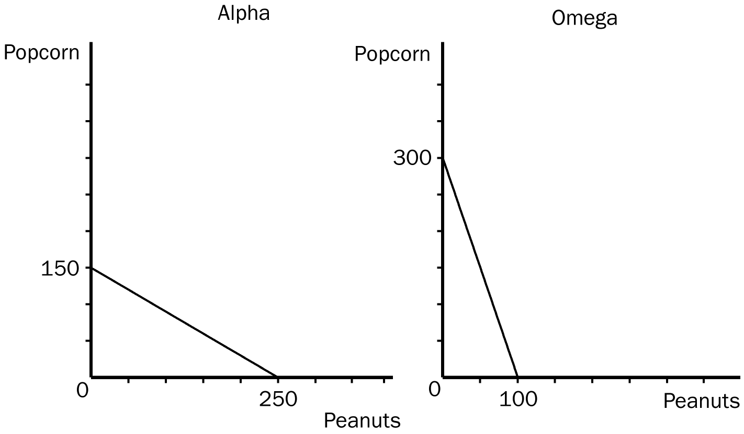
a. Assume that each country decides to use half of its resources in the production of each good. Show these points on the graphs for each country as point A.
b. If these countries choose not to trade, what would be the total world production of popcorn and peanuts?
c. Now suppose that each country decides to specialize in the good in which each has a comparative advantage. By specializing, what is the total world production of each product now?
d. If each country decides to trade 100 units of popcorn for 100 units of peanuts, show on the graphs the gain each country would receive from trade. Label these points B.
ANS:
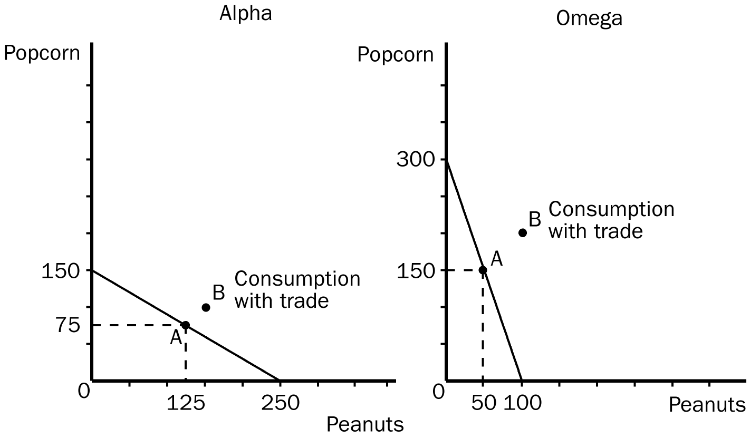
a. Alpha would be producing 125 units of peanuts and 75 units of popcorn (point A on its production possibilities frontier) and Omega would be producing 50 units of peanuts and 150 units of popcorn (point A on its production possibilities frontier).
b. The total world production of peanuts would be 175 units and the total world production of popcorn would be 225 units.
c. The total world production of peanuts would now be 250 units and the total world production of popcorn would now be 300 units.
d. Alpha would be producing 250 units of peanuts and would trade 100 of them to Omega, leaving Alpha with 150 units of peanuts. Alpha would then receive 100 units of popcorn from Omega. Omega would be producing 300 units of popcorn and would trade 100 of them to Alpha, leaving Omega with 200 units of popcorn. Omega would then receive 100 units of peanuts from Alpha.
PTS: 1 DIF: 2 REF: 3-2
TOP: Production possibilities frontier | Trade MSC: Applicative
3. Julia can fix a meal in 1 hour, and her opportunity cost of one hour is $50. Jacque can fix the same kind of meal in 2 hours, and his opportunity cost of one hour is $20. Will both Julia and Jacque be better off if she pays him $45 per meal to fix her meals? Explain.
ANS:
Since Julia's opportunity cost of preparing a meal is $50, and Jacque's opportunity cost of preparing a meal is $40, each of them will be better off by $5 per meal if this arrangement is made.
PTS: 1 DIF: 2 REF: 3-2
TOP: Opportunity cost MSC: Applicative
4. Gary and Diane must prepare a presentation for their marketing class. As part of their presentation, they must do a series of calculations and prepare 50 PowerPoint slides. It would take Gary 10 hours to do the required calculation and 10 hours to prepare the slides. It would take Diane 12 hours to do the calculations and 20 hours to prepare the slides.
a. How much time would it take the two to complete the project if they divide the calculations equally and the slides equally?
b. How much time would it take the two to complete the project if they use comparative advantage and specialize in calculating or preparing slides?
c. If Diane and Gary have the same opportunity cost of $5 per hour, is there a better solution than for each to specialize in calculating or preparing slides?
ANS:
a. If both tasks are divided equally, it will take 11 hours for the calculations and 15 hours for the writing, for a total of 26 hours.
b. If Diane specializes in calculating and Gary specializes in preparing slides, it will take 22 hours to complete the project.
c. If Diane specializes in calculating, her opportunity cost will be $60; hence, Diane would be better off if she paid Gary any amount less than $60 to do the calculating. Since Gary's opportunity cost of doing the calculations is only $50, he would be better off if Diane paid him between $50 and $60 dollars to do the calculations. In this case, the total time spent on the project would be 20 hours.
PTS: 1 DIF: 2 REF: 3-2
TOP: Opportunity cost | Comparative advantage MSC: Applicative

