Chapter 13
The Costs of Production
Multiple Choice
1. According to the law of supply,
a. firms’ production levels are not correlated with the price of a good.
b. the supply curve will slope downward when demand decreases.
c. firms are willing to produce a greater quantity of a good when the price of the good is higher.
d. the supply curve identifies the points where the firm minimizes its marginal costs.
ANS: C PTS: 1 DIF: 2 REF: 13-1
TOP: Law of supply MSC: Definitional
2. Industrial organization is the study of how
a. labor unions organize workers in industries.
b. profitable firms are in organized industries.
c. industries organize for political advantage.
d. firms’ decisions regarding prices and quantities depend on the market conditions they face.
ANS: D PTS: 1 DIF: 1 REF: 13-1
TOP: Industrial organization MSC: Definitional
3. Economists normally assume that the goal of a firm is to
(i) sell as much of their product as possible.
(ii) set the price of their product as high as possible.
(iii) maximize profit.
a. (i) and (ii) are true.
b. (ii) and (iii) are true.
c. (iii) is true.
d. (i) and (iii) are true.
ANS: C PTS: 1 DIF: 2 REF: 13-1
TOP: Profit maximization MSC: Interpretive
4. The amount of money that a firm receives from the sale of its output is called
a. total gross profit.
b. total net profit.
c. total revenue.
d. net revenue.
ANS: C PTS: 1 DIF: 1 REF: 13-1
TOP: Total revenue MSC: Definitional
5. The amount of money that a firm pays to buy inputs is called
a. total cost.
b. variable cost.
c. marginal cost.
d. fixed cost.
ANS: A PTS: 1 DIF: 2 REF: 13-1
TOP: Total cost MSC: Definitional
6. Profit is defined as
a. net revenue minus depreciation.
b. total revenue minus total cost.
c. average revenue minus average total cost.
d. marginal revenue minus marginal cost.
ANS: B PTS: 1 DIF: 1 REF: 13-1
TOP: Profit MSC: Definitional
7. Which of the following can be added to profit to obtain total revenue?
a. net profit
b. capital profit
c. operational profit
d. total cost
ANS: D PTS: 1 DIF: 2 REF: 13-1
TOP: Total revenue MSC: Analytical
8. Economists normally assume that the goal of a firm is to
(i) make profit as large as possible even if it means reducing output.
(ii) make profit as large as possible even if it means incurring a higher total cost.
(iii) make revenue as large as possible.
a. (i) and (ii) are true.
b. (i) and (iii) are true.
c. (ii) and (iii) are true.
d. (i), (ii), and (iii) are true.
ANS: A PTS: 1 DIF: 2 REF: 13-1
TOP: Profit maximization MSC: Interpretive
9. Those things that must be forgone to acquire a good are called
a. substitutes.
b. opportunity costs.
c. explicit costs.
d. competitors.
ANS: B PTS: 1 DIF: 1 REF: 13-1
TOP: Opportunity cost MSC: Definitional
10. XYZ corporation produced 300 units of output but sold only 275 of the units it produced. The average cost of production for each unit of output produced was $100. Each of the 275 units sold was sold for a price of $95. Total profit for the XYZ corporation would be
a. -$3,875.
b. $26,125.
c. $28,500.
d. $30,000.
ANS: A PTS: 1 DIF: 2 REF: 13-1
TOP: Profit MSC: Applicative
11. Explicit costs
a. require an outlay of money by the firm.
b. include all of the firm’s opportunity costs.
c. include income that is forgone by the firm’s owners.
d. Both b and c are correct.
ANS: A PTS: 1 DIF: 1 REF: 13-1
TOP: Explicit costs MSC: Definitional
12. Which of the following would be categorized as an implicit cost?
(i) forgone investment opportunities
(ii) wages of workers
(iii) raw materials costs
a. (i)
b. (ii)
c. (ii) and (iii)
d. (i) and (iii).
ANS: A PTS: 1 DIF: 2 REF: 13-1
TOP: Implicit costs MSC: Interpretive
13. An example of an explicit cost of production would be
a. the cost of forgone labor earnings for an entrepreneur.
b. the lost opportunity to invest in capital markets when the money is invested in one’s business.
c. lease payments for the land on which a firm’s factory stands.
d. Both a and c are correct.
ANS: C PTS: 1 DIF: 2 REF: 13-1
TOP: Explicit costs MSC: Interpretive
14. Which of the following is an implicit cost?
(i) the owner of a firm forgoing an opportunity to earn a large salary working for a Wall Street brokerage firm
(ii) interest paid on the firm’s debt
(iii) rent paid by the firm to lease office space
a. (ii) and (iii)
b. (i) and (iii)
c. (i) only
d. (iii) only
ANS: C PTS: 1 DIF: 2 REF: 13-1
TOP: Implicit costs MSC: Interpretive
15. To an economist, the field of industrial organization answers which of the following questions?
a. Why are consumers subject to the law of demand?
b. Why do firms experience falling marginal product of labor?
c. How does the difference in the number of firms affect prices and the efficiency of market outcomes?
d. Why do firms consider production costs when determining product supply?
ANS: C PTS: 1 DIF: 2 REF: 13-1
TOP: Industrial organization MSC: Interpretive
16. John owns a shoe-shine business. His accountant most likely includes which of the following costs on his financial statements?
a. wages John could earn washing windows
b. dividends John’s money was earning in the stock market before John sold his stock and bought a shoe-shine booth
c. the cost of shoe polish
d. Both b and c are correct.
ANS: C PTS: 1 DIF: 2 REF: 13-1
TOP: Accounting profit MSC: Interpretive
17. The amount of money that a wheat farmer could have earned if he had planted barley instead of wheat is
a. an explicit cost.
b. an accounting cost
c. an implicit cost.
d. forgone accounting profit.
ANS: C PTS: 1 DIF: 2 REF: 13-1
TOP: Implicit costs MSC: Interpretive
Scenario 13-1
Joe wants to start his own business. The business he wants to start will require that he purchase a factory that costs $400,000. Joe currently has $500,000 in the bank earning 3 percent interest per year.
18. Refer to Scenario 13-1. If Joe purchases the factory with his own money, what is the annual implicit opportunity cost of purchasing the factory?
a. $0
b. $3,000
c. $12,000
d. $15,000
ANS: C PTS: 1 DIF: 2 REF: 13-1
TOP: Implicit costs MSC: Applicative
19. Refer to Scenario 13-1. Suppose Joe purchases the factory using $200,000 of his own money and $200,000 borrowed from a bank at an interest rate of 6 percent. What is Joe’s annual opportunity cost of purchasing the factory?
a. $3,000
b. $6,000
c. $15,000
d. $18,000
ANS: D PTS: 1 DIF: 2 REF: 13-1
TOP: Opportunity cost MSC: Applicative
20. Economic profit is equal to
a. total revenue minus the explicit cost of producing goods and services.
b. total revenue minus the opportunity cost of producing goods and services.
c. total revenue minus the accounting cost of producing goods and services.
d. average revenue minus the average cost of producing the last unit of a good or service.
ANS: B PTS: 1 DIF: 1 REF: 13-1
TOP: Economic profit MSC: Definitional
21. Accounting profit is equal to
a. marginal revenue minus marginal cost.
b. total revenue minus the explicit cost of producing goods and services.
c. total revenue minus the opportunity cost of producing goods and services.
d. average revenue minus the average cost of producing the last unit of a good or service.
ANS: B PTS: 1 DIF: 1 REF: 13-1
TOP: Accounting profit MSC: Definitional
22. Economic profit
a. will never exceed accounting profit.
b. is most often equal to accounting profit.
c. is always at least as large as accounting profit.
d. is a less complete measure of profitability than accounting profit.
ANS: A PTS: 1 DIF: 2 REF: 13-1
TOP: Economic profit MSC: Interpretive
23. To an economist, it is conceivable that the objective that motivates an individual entrepreneur to start a business arises from
a. an innate love for the type of business that he or she starts.
b. a desire to earn a profit.
c. an altruistic desire to provide the world with a good product.
d. All of the above are correct.
ANS: D PTS: 1 DIF: 2 REF: 13-1
TOP: Profit maximization MSC: Interpretive
24. When a firm is making a profit-maximizing production decision, which of the following principles of economics is likely to be most important to the firm’s decision?
a. The cost of something is what you give up to get it.
b. A country’s standard of living depends on its ability to produce goods and services.
c. Prices rise when the government prints too much money.
d. Governments can sometimes improve market outcomes.
ANS: A PTS: 1 DIF: 2 REF: 13-1
TOP: Profit maximization MSC: Interpretive
25. Gordon is a senior majoring in computer network development at Smart State University. While he has been attending college, Gordon started a computer consulting business to help senior citizens set up their network connections and teach them how to use e-mail. Gordon charges $25 per hour for his consulting services. Gordon also works 5 hours a week for the Economics Department to maintain that department’s Web page. The Economics Department pays Gordon $20 per hour. From this information we can conclude:
a. Gordon should increase the number of hours he works for the Economics Department to make it comparable to his consulting business income.
b. Gordon is obviously not maximizing his well-being if he continues to work for the Economics Department.
c. If Gordon chooses one hour at the beach with his friends rather than spend one more hour with a consulting client, the forgone income of $25 is considered a cost of the choice to go to the beach.
d. Both b and c are correct
ANS: C PTS: 1 DIF: 2 REF: 13-1
TOP: Opportunity cost MSC: Analytical
26. Economists normally assume that the goal of a firm is to
a. maximize its total revenue.
b. maximize its profit.
c. minimize its explicit costs.
d. minimize its total cost.
ANS: B PTS: 1 DIF: 1 REF: 13-1
TOP: Profit maximization MSC: Definitional
27. Explicit costs
a. do not require an outlay of money by the firm.
b. enter into the accountant’s measurement of a firm’s profit.
c. enter into the economist’s measurement of a firm’s profit.
d. Both b and c are correct.
ANS: D PTS: 1 DIF: 1 REF: 13-1
TOP: Explicit costs MSC: Interpretive
28. A certain firm manufactures and sells computer chips. Last year it sold 2 million chips at a price of $10 per chip. For last year, the firm’s
a. accounting profit amounted to $20 million.
b. economic profit amounted to $20 million.
c. total revenue amounted to $20 million.
d. explicit costs amounted to $20 million.
ANS: C PTS: 1 DIF: 1 REF: 13-1
TOP: Total revenue MSC: Applicative
29. A firm’s opportunity costs of production amount to its
a. explicit costs only.
b. implicit costs only.
c. explicit costs + implicit costs.
d. explicit costs + implicit costs + total revenue.
ANS: C PTS: 1 DIF: 1 REF: 13-1
TOP: Opportunity cost MSC: Definitional
30. Which of the following expressions is correct?
a. accounting profit = total revenue - explicit costs
b. economic profit = total revenue - implicit costs
c. economic profit = total revenue - explicit costs
d. Both a and b are correct.
ANS: A PTS: 1 DIF: 2 REF: 13-1
TOP: Accounting profit MSC: Interpretive
31. Which of the following expressions is correct?
a. accounting profit = economic profit + implicit costs
b. accounting profit = total revenue - implicit costs
c. economic profit = accounting profit + explicit costs
d. economic profit = total revenue - implicit costs
ANS: A PTS: 1 DIF: 2 REF: 13-1
TOP: Accounting profit MSC: Analytical
32. Susan used to work as a telemarketer, earning $25,000 per year. She gave up that job to start a catering business. In calculating the economic profit of her catering business, the $25,000 income that she gave up is counted as part of the catering firm’s
a. total revenue.
b. opportunity costs.
c. explicit costs.
d. marginal costs.
ANS: B PTS: 1 DIF: 1 REF: 13-1
TOP: Opportunity cost MSC: Interpretive
Scenario 13-2
Zach took $400,000 out of the bank and used it to start his new cookie business. The bank account pays 3 percent interest per year. During the first year of his business, Zach sold 6,000 boxes of cookies for $2.50 per box. Also, during the first year, the cookie business incurred costs that required outlays of money amounting to $9,000.
33. Refer to Scenario 13-2. Zach’s accounting profit for the year was
a. $-494,000.
b. $-6,000.
c. $6,000.
d. $12,000.
ANS: C PTS: 1 DIF: 2 REF: 13-1
TOP: Accounting profit MSC: Applicative
34. Refer to Scenario 13-2. Zach’s economic profit for the year was
a. $-506,000.
b. $-6,000.
c. $3,000.
d. $6,000.
ANS: B PTS: 1 DIF: 2 REF: 13-1
TOP: Economic profit MSC: Applicative
Scenario 13-3
Tony is a wheat farmer, but he also spends part of his day teaching guitar lessons. Due to the popularity of his local country western band, Farmer Tony has more students requesting lessons than he has time for if he is to also maintain his farming business. Farmer Tony charges $25 an hour for his guitar lessons. One spring day, he spends 10 hours in his fields planting $130 worth of seeds on his farm. He expects that the seeds he planted will yield $300 worth of wheat.
35. Refer to Scenario 13-3. What is the total opportunity cost of the day that Farmer Tony incurred for his spring day in the field planting wheat?
a. $130
b. $250
c. $300
d. $380
ANS: D PTS: 1 DIF: 2 REF: 13-1
TOP: Opportunity cost MSC: Analytical
36. Refer to Scenario 13-3. Tony’s accountant would most likely figure the total cost of his wheat planting to equal
a. $25
b. $130
c. $300
d. $380
ANS: B PTS: 1 DIF: 2 REF: 13-1
TOP: Explicit costs MSC: Analytical
37. Refer to Scenario 13-3. Tony’s accounting profit equals
a. $-80
b. $130
c. $170
d. $260
ANS: C PTS: 1 DIF: 2 REF: 13-1
TOP: Accounting profit MSC: Applicative
38. Refer to Scenario 13-3. Tony’s economic profit equals
a. $-130
b. $-80
c. $130
d. $170
ANS: B PTS: 1 DIF: 2 REF: 13-1
TOP: Economic profit MSC: Applicative
39. Dolores used to work as a high school teacher for $40,000 per year but quit in order to start her own catering business. To buy the necessary equipment, she withdrew $20,000 from her savings, (which paid 3 percent interest) and borrowed $30,000 from her uncle, whom she pays 3 percent interest per year. Last year she paid $25,000 for ingredients and had revenue of $60,000. She asked Louis the accountant and Greg the economist to calculate her profit for her.
a. Louis says her profit is $34,100 and Greg says her profit is $6,500.
b. Louis says her profit is $34,100 and Greg says she lost $6,500.
c. Louis says her profit is $35,000 and Greg says she lost $5,000.
d. Louis says her profit is $33,500 and Greg says her profit is 33,500.
ANS: B PTS: 1 DIF: 3 REF: 13-1
TOP: Economic profit MSC: Applicative
40. When calculating a firm’s profit, an economist
a. will subtract only explicit costs from total revenue since these are the only costs that can be measured explicitly.
b. will subtract only implicit costs from total revenue since these include both the costs that can be directly measured as well as the costs that can be indirectly measured.
c. will subtract only the opportunity costs from total revenue since these include both the implicit and explicit costs of the firm.
d. will subtract only the marginal cost since the cost of the next unit is the only relevant cost.
ANS: C PTS: 1 DIF: 2 REF: 13-1
TOP: Profit MSC: Definitional
41. John has decided to start his own lawn-mowing business. To purchase the mowers and the trailer to transport the mowers, John withdrew $1,000 from his savings account, which was earning 3% interest, and borrowed an additional $2,000 from the bank at an interest rate of 7%. What is John’s annual opportunity cost of the financial capital that has been invested in the business?
a. $30.00
b. $140.00
c. $170.00
d. $3,000.00
ANS: C PTS: 1 DIF: 3 REF: 13-1
TOP: Opportunity cost MSC: Analytical
42. Jane decides to open her own business and earns $50,000 in accounting profit the first year. When deciding to open her own business she turned down three separate job offers with annual salaries of $30,000, $40,000, and $45,000. What is Jane’s economic profit from running her own business?
a. $-65,000
b. $5,000
c. $10,000
d. $20,000
ANS: B PTS: 1 DIF: 2 REF: 13-1
TOP: Opportunity cost MSC: Analytical
43. Suppose that for a particular business there are no implicit opportunity costs. Then
a. accounting profit will be greater than economic profit.
b. accounting profit will be the same as economic profit.
c. accounting profit will be less than economic profit.
d. the relationship between accounting profit and economic profit cannot be determined since the amount of explicit opportunity costs is not given.
ANS: B PTS: 1 DIF: 2 REF: 13-1
TOP: Profit MSC: Analytical
44. Total revenue minus explicit and implicit costs is called
a. accounting profit
b. economic profit
c. average total cost
d. fixed expenses
ANS: B PTS: 1 DIF: 1 REF: 13-1
TOP: Economic profit MSC: Definitional
45. The value of a business owner’s time is an example of
a. an opportunity cost.
b. a fixed cost.
c. an explicit cost.
d. total revenue.
ANS: A PTS: 1 DIF: 1 REF: 13-1
TOP: Opportunity cost MSC: Interpretive
46. Kevin quit his $65,000 a year corporate lawyer job to open up his own law practice. In Kevin’s first year in business his total revenue equaled $150,000. Kevin’s explicit cost during the year totaled $85,000. Using the information from Kevin’s first year in business, what is his economic profit?
a. $0
b. $20,000
c. $65,000
d. $85,000
ANS: A PTS: 1 DIF: 2 REF: 13-1
TOP: Economic profit MSC: Applicative
47. Which of the following is an implicit cost?
a. Salaries paid to owners who work for the firm
b. Interest on money borrowed to finance equipment purchases
c. Cash payments for raw materials
d. Foregone rent on office space owned and used by the firm
ANS: D PTS: 1 DIF: 1 REF: 13-1
TOP: Implicit costs MSC: Interpretive
48. Samantha has been working for a law firm and earning an annual salary of $80,000. She decides to open her own practice. Her annual expenses will include $15,000 for office rent, $3,000 for equipment rental, $1,000 for supplies, $1,200 for utilities, and a $35,000 salary for a secretary/bookkeeper. Samantha will cover her start-up expenses by cashing in a $20,000 certificate of deposit on which she was earning annual interest of $500. Assuming that there are no additional expenses, Samantha’s annual implicit costs will equal
a. $55,200.
b. $75,200.
c. $80,500.
d. $165,700.
ANS: C PTS: 1 DIF: 2 REF: 13-1
TOP: Implicit costs MSC: Analytical
49. Economists assume that the goal of the firm is to maximize
a. total revenue.
b. total profits.
c. total costs.
d. total satisfaction.
ANS: B PTS: 1 DIF: 1 REF: 13-1
TOP: Profit maximization MSC: Interpretive
50. The difference between accounting profit and economic profit relates to
a. the manner in which revenues are defined.
b. how total revenue is calculated.
c. the manner in which costs are defined.
d. the price of the good in the market.
ANS: C PTS: 1 DIF: 2 REF: 13-1
TOP: Economic profit MSC: Definitional
51. A production function is a relationship between
a. inputs and quantity of output.
b. inputs and revenue.
c. inputs and costs.
d. inputs and profit.
ANS: A PTS: 1 DIF: 1 REF: 13-2
TOP: Production function MSC: Definitional
52. The marginal product of labor is equal to the
a. incremental cost associated with a one unit increase in labor.
b. incremental profit associated with a one unit increase in labor.
c. increase in labor necessary to generate a one unit increase in output.
d. increase in output obtained from a one unit increase in labor.
ANS: D PTS: 1 DIF: 1 REF: 13-2
TOP: Marginal product of labor MSC: Definitional
53. The marginal product of labor can be defined as
a. change in profit/change in labor.
b. change in output/change in labor.
c. change in labor/change in output.
d. change in labor/change in total cost.
ANS: B PTS: 1 DIF: 1 REF: 13-2
TOP: Marginal product of labor MSC: Definitional
54. When adding another unit of labor leads to an increase in output that is smaller than the increases in output that resulted from adding previous units of labor, we have the property of
a. diminishing labor.
b. diminishing output.
c. diminishing marginal product.
d. negative marginal product.
ANS: C PTS: 1 DIF: 1 REF: 13-2
TOP: Diminishing marginal product MSC: Definitional
Figure 13-1
The figure below depicts a production function for a firm that produces cookies.

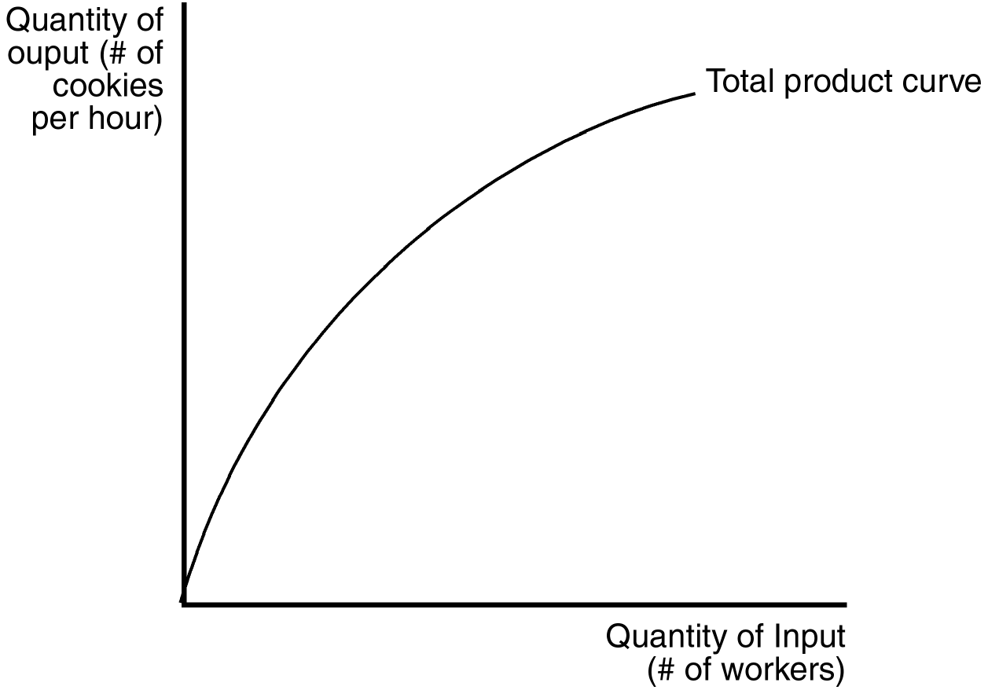
55. Refer to Figure 13-1. As the number of workers increases,
a. total output increases, but at a decreasing rate.
b. marginal product increases, but at a decreasing rate.
c. marginal product increases at an increasing rate.
d. total output decreases.
ANS: A PTS: 1 DIF: 2 REF: 13-2
TOP: Production function MSC: Analytical
56. Refer to Figure 13-1. With regard to cookie production, the figure implies
a. diminishing marginal product of workers.
b. diminishing marginal cost of cookie production.
c. decreasing cost of cookie production.
d. increasing marginal product of workers.
ANS: A PTS: 1 DIF: 2 REF: 13-2
TOP: Marginal product of labor MSC: Analytical
57. Which of the following statements about a production function is correct for a firm that uses labor to produce output?
a. The production function depicts the relationship between the quantity of labor and the quantity of output.
b. The slope of the production function measures marginal cost.
c. The quantity of output determines the maximum amount of labor the firm will hire.
d. All of the above are correct.
ANS: A PTS: 1 DIF: 2 REF: 13-2
TOP: Production function MSC: Interpretive
Figure 13-2
The figure below depicts a total cost function for a firm that produces cookies.
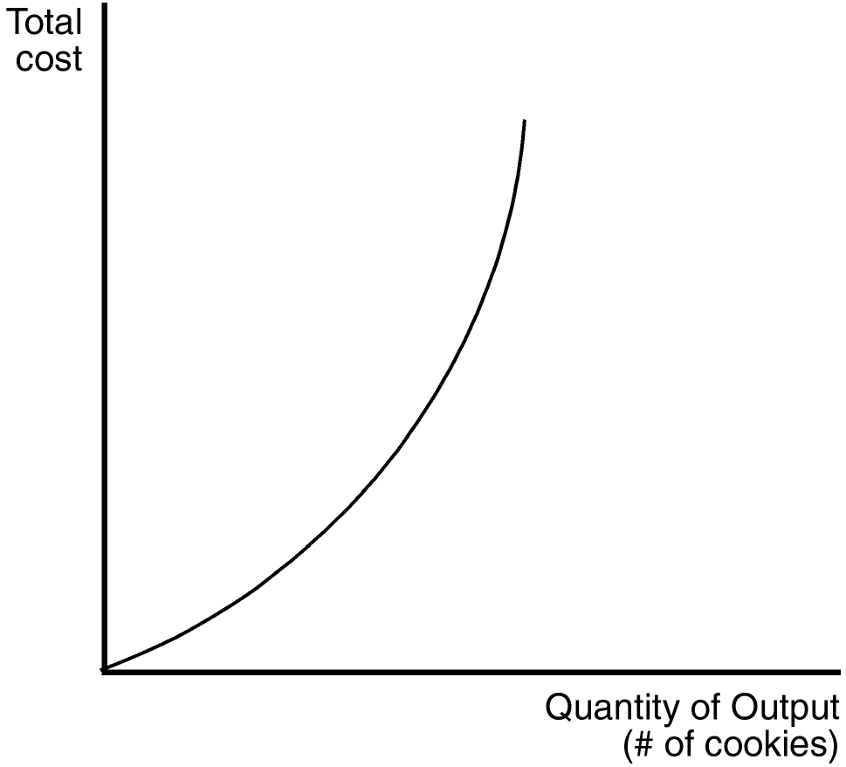
58. Refer to Figure 13-2. Which of the following is true of the production function (not pictured) that underlies this total cost function?
(i) Total output increases as the quantity of inputs increases, but at a decreasing rate.
(ii) Marginal product is diminishing for all levels of input usage.
(iii) The slope of the production function decreases as the quantity of inputs increases.
a. (i) only
b. (ii) and (iii)
c. (i) and (iii)
d. All of the above are correct.
ANS: D PTS: 1 DIF: 3 REF: 13-2
TOP: Production function MSC: Interpretive
59. Refer to Figure 13-2. The changing slope of the total cost curve reflects
a. decreasing average variable cost.
b. decreasing average total cost.
c. decreasing marginal product.
d. increasing fixed cost.
ANS: C PTS: 1 DIF: 2 REF: 13-2
TOP: Marginal product MSC: Interpretive
60. Refer to Figure 13-2. Which of the following statements best captures the nature of the underlying production function?
a. Output increases at a decreasing rate with additional units of input.
b. Output increases at an increasing rate with additional units of input.
c. Output decreases at a decreasing rate with additional units of input.
d. Output decreases at an increasing rate with additional units of input.
ANS: A PTS: 1 DIF: 2 REF: 13-2
TOP: Production function MSC: Interpretive
61. Refer to Figure 13-2. Which of the statements below is most consistent with the shape of the total cost curve?
a. Producing an additional cookie is always more costly than producing the previous cookie.
b. Total production of cookies decreases with additional units of input.
c. Producing additional cookies is equally costly, regardless of how many cookies are already being produced.
d. Producing additional cookies becomes increasingly costly only when the number of cookies already being produced is large.
ANS: A PTS: 1 DIF: 2 REF: 13-2
TOP: Production function MSC: Interpretive
62. Which of these assumptions is often realistic for a firm in the short run?
a. The firm can vary both the size of its factory and the number of workers it employs.
b. The firm can vary the size of its factory, but not the number of workers it employs.
c. The firm can vary the number of workers it employs, but not the size of its factory.
d. The firm can vary neither the size of its factory nor the number of workers it employs.
ANS: C PTS: 1 DIF: 1 REF: 13-2
TOP: Short run MSC: Definitional
63. Assume a certain firm regards the number of workers it employs as variable, and that it regards the size of its factory as fixed. This assumption is often realistic
a. in the short run, but not in the long run.
b. in the long run, but not in the short run.
c. both in the short run and in the long run.
d. neither in the short run nor in the long run.
ANS: A PTS: 1 DIF: 1 REF: 13-2
TOP: Short run MSC: Interpretive
64. For a firm, the production function represents the relationship between
a. implicit costs and explicit costs.
b. quantity of inputs and total cost.
c. quantity of inputs and quantity of output.
d. quantity of output and total cost.
ANS: C PTS: 1 DIF: 1 REF: 13-2
TOP: Production function MSC: Definitional
65. For a firm, the relationship between the quantity of inputs and quantity of output is called the
a. profit function.
b. production function.
c. total-cost function.
d. quantity function.
ANS: B PTS: 1 DIF: 1 REF: 13-2
TOP: Production function MSC: Definitional
66. The marginal product of an input in the production process is the increase in
a. total revenue obtained from an additional unit of that input.
b. profit obtained from an additional unit of that input.
c. total revenue obtained from an additional unit of that input.
d. quantity of output obtained from an additional unit of that input.
ANS: D PTS: 1 DIF: 1 REF: 13-2
TOP: Marginal product MSC: Definitional
67. When a firm’s only variable input is labor, then the slope of the production function measures the
a. quantity of labor.
b. quantity of output.
c. total cost.
d. marginal product of labor.
ANS: D PTS: 1 DIF: 1 REF: 13-2
TOP: Marginal product of labor MSC: Definitional
68. Let L represent the number of workers hired by a firm and let Q represent that firm’s quantity of output. Assume two points on the firm’s production function are (L = 12, Q = 122) and (L = 13, Q = 132). Then the marginal product of the 13th worker is
a. 8 units of output.
b. 10 units of output.
c. 122 units of output.
d. 132 units of output.
ANS: B PTS: 1 DIF: 2 REF: 13-2
TOP: Marginal product of labor MSC: Applicative
69. On a 100-acre farm, a farmer is able to produce 3,000 bushels of wheat when he hires 2 workers. He is able to produce 4,400 bushels of wheat when he hires 3 workers. Which of the following possibilities is consistent with the property of diminishing marginal product?
a. The farmer is able to produce 5,600 bushels of wheat when he hires 4 workers.
b. The farmer is able to produce 5,800 bushels of wheat when he hires 4 workers.
c. The farmer is able to produce 6,000 bushels of wheat when he hires 4 workers.
d. All of the above are correct.
ANS: A PTS: 1 DIF: 2 REF: 13-2
TOP: Diminishing marginal product MSC: Analytical
70. Suppose a certain firm is able to produce 165 units of output per day when 15 workers are hired. The firm is able to produce 176 units of output per day when 16 workers are hired (holding other inputs fixed). Then the marginal product of the 16th worker is
a. 10 units of output.
b. 11 units of output.
c. 16 units of output.
d. 176 units of output.
ANS: B PTS: 1 DIF: 1 REF: 13-2
TOP: Marginal product of labor MSC: Applicative
71. A total-cost curve shows the relationship between the
a. quantity of an input used and the total cost of production.
b. quantity of output produced and the total cost of production.
c. total cost of production and profit.
d. total cost of production and total revenue.
ANS: B PTS: 1 DIF: 1 REF: 13-2
TOP: Total-cost curve MSC: Definitional
72. The marginal product of any input
a. is the increase in total cost associated with a one-unit increase in production.
b. is the change in total output associated with a $1.00 increase in total cost.
c. is the increase in total cost resulting from the hiring of an additional worker.
d. is the increase in total output obtained from one additional unit of that input.
ANS: D PTS: 1 DIF: 1 REF: 13-2
TOP: Marginal product MSC: Definitional
Table 13-1

Number of Workers | Total Output | Marginal Product
0 | 0 | --
1 |  | 30
2 |  | 40
3 |  | 50
4 |  | 40
5 |  | 30

73. Refer to Table 13-1. What is total output when 4 workers are hired?
a. 30
b. 40
c. 120
d. 160
ANS: D PTS: 1 DIF: 2 REF: 13-2
TOP: Marginal product MSC: Analytical
Table 13-2

Number of Workers | Output
0 | 0
1 | 50
2 | 110
3 | 180
4 | 260
5 | 330

74. Refer to Table 13-2. What is the marginal product of the fourth worker?
a. 65
b. 70
c. 75
d. 80
ANS: D PTS: 1 DIF: 2 REF: 13-2
TOP: Marginal product MSC: Analytical
75. Refer to Table 13-2. At which number of workers does diminishing marginal product begin?
a. 2
b. 3
c. 4
d. 5
ANS: D PTS: 1 DIF: 1 REF: 13-2
TOP: Marginal product MSC: Analytical
76. When the marginal product of an input declines as the quantity of that input increases, the production function exhibits
a. increasing returns to scale.
b. decreasing returns to scale.
c. diminishing total product.
d. diminishing marginal product.
ANS: D PTS: 1 DIF: 1 REF: 13-2
TOP: Diminishing marginal product MSC: Definitional
77. The total cost curve gets steeper as output increases due to
a. diseconomies of scale.
b. economies of scale.
c. diminishing marginal product.
d. increasing returns to scale.
ANS: C PTS: 1 DIF: 2 REF: 13-2
TOP: Total-cost curve MSC: Interpretive
Table 13-3

Number  of  Workers | Number  of  Machines | Output  (corks produced  per hour) | Marginal Product of Labor | Cost of Workers | Cost of Machines | Total  Cost
1 | 2 | 5
2 | 2 | 10
3 | 2 | 20
4 | 2 | 35
5 | 2 | 55
6 | 2 | 70
7 | 2 | 80

78. Refer to Table 13-3. Each worker at Gallo’s cork factory costs $12 per hour. The cost of each machine is $20 per day regardless of the number of corks produced. If Gallo’s produces at a rate of 70 corks per hour and operates 8 hours per day, what is Gallo’s total labor cost per day?
a. $72
b. $96
c. $480
d. $576
ANS: D PTS: 1 DIF: 2 REF: 13-2
TOP: Variable costs MSC: Applicative
79. Refer to Table 13-3. Each worker at Gallo’s cork factory costs $12 per hour. The cost of each machine is $20 per day regardless of the number of corks produced. What is the total daily cost of producing at a rate of 55 units per hour if Gallo’s operates 8 hours per day?
a. $480
b. $576
c. $520
d. $616
ANS: C PTS: 1 DIF: 2 REF: 13-2
TOP: Total cost MSC: Applicative
80. Refer to Table 13-3. Each worker at Gallo’s cork factory costs $12 per hour. The cost of each machine is $20 per day regardless of the number of corks produced. Assume the number of machines does not change. If Gallo’s produces at a rate of 78 corks per hour, what is the total machine cost per day?
a. $20
b. $40
c. $72
d. $320
ANS: B PTS: 1 DIF: 2 REF: 13-2
TOP: Fixed costs MSC: Applicative
81. Refer to Table 13-3. Each worker at Gallo’s cork factory costs $12 per hour. The cost of each machine is $20 per day regardless of the number of corks produced. If Gallo’s produces at a rate of 35 corks per hour, what is the total labor cost per hour?
a. $40
b. $48
c. $384
d. $424
ANS: B PTS: 1 DIF: 2 REF: 13-2
TOP: Variable costs MSC: Applicative
82. Refer to Table 13-3. Assume Gallo’s currently employs 5 workers. What is the marginal product of labor when Gallo’s adds a 6th worker?
a. 5 corks per hour
b. 15 corks per hour
c. 25 corks per hour
d. 70 corks per hour
ANS: B PTS: 1 DIF: 2 REF: 13-2
TOP: Marginal product of labor MSC: Applicative
83. Refer to Table 13-3. Assume Gallo’s currently employs 2 workers. What is the marginal product of labor when Gallo’s adds a 3rd worker?
a. 5 corks
b. 10 corks
c. 20 corks
d. 25 corks
ANS: B PTS: 1 DIF: 2 REF: 13-2
TOP: Marginal product of labor MSC: Applicative
84. Refer to Table 13-3. Gallo’s cork factory experiences diminishing marginal product of labor with the addition of which worker?
a. The third worker.
b. The fourth worker.
c. The fifth worker.
d. The sixth worker.
ANS: D PTS: 1 DIF: 2 REF: 13-2
TOP: Marginal product of labor MSC: Applicative
Figure 13-3
85. Refer to Figure 13-3. In this diagram, the shift in the total product curve represents an increase in the firm’s
a. costs of production.
b. productivity.
c. diseconomies.
d. market share.
ANS: B PTS: 1 DIF: 2 REF: 13-2
TOP: Production function MSC: Analytical
86. Refer to Figure 13-3. Which of the following could explain why the total product curve shifted in this diagram?
a. A reduction in capital equipment available to the firm.
b. Labor skills have become rusty and outdated in the firm.
c. The firm has developed new technology in its production facility.
d. The firm is now receiving a higher price for its product.
ANS: C PTS: 1 DIF: 2 REF: 13-2
TOP: Production function MSC: Interpretive
87. As Al’s Radiator Company adds workers while keeping the same amount of machinery, some workers may be underutilized because they have little work to do while waiting in line to use the machinery. When this occurs, Al’s Radiator Company encounters
a. economies of scale.
b. diseconomies of scale.
c. increasing marginal returns.
d. diminishing marginal returns.
ANS: D PTS: 1 DIF: 2 REF: 13-2
TOP: Diminishing marginal product MSC: Interpretive
88. Which of the following costs do not vary with the amount of output a firm produces?
a. average fixed costs
b. fixed costs and average fixed costs
c. marginal costs and average fixed costs
d. fixed costs
ANS: D PTS: 1 DIF: 1 REF: 13-3
TOP: Fixed costs MSC: Definitional
89. Fixed costs can be defined as costs that
a. vary inversely with production.
b. vary in proportion with production.
c. are incurred only when production is large enough.
d. are incurred even if nothing is produced.
ANS: D PTS: 1 DIF: 1 REF: 13-3
TOP: Fixed costs MSC: Interpretive
90. Suppose Jan started up a small lemonade stand business last month. Variable costs for Jan’s lemonade stand now include the cost of
a. building the lemonade stand.
b. hiring an artist to design a logo for her sign.
c. lemonade mix.
d. All of the above are correct.
ANS: C PTS: 1 DIF: 2 REF: 13-3
TOP: Variable costs MSC: Interpretive
91. If a firm produces nothing, which of the following costs will be zero?
a. total cost
b. fixed cost
c. opportunity cost
d. variable cost
ANS: D PTS: 1 DIF: 1 REF: 13-3
TOP: Variable costs MSC: Interpretive
92. One assumption that distinguishes short-run cost analysis from long-run cost analysis for a profit-maximizing firm is that in the short run,
a. output is not variable.
b. the number of workers used to produce the firm’s product is fixed.
c. the size of the factory is fixed.
d. there are no fixed costs.
ANS: C PTS: 1 DIF: 2 REF: 13-3
TOP: Long run MSC: Interpretive
93. The cost of producing the typical unit of output is the firm’s
a. average total cost.
b. opportunity cost.
c. variable cost.
d. marginal cost.
ANS: A PTS: 1 DIF: 2 REF: 13-3
TOP: Average total cost MSC: Definitional
94. Average total cost is equal to
a. output/total cost.
b. total cost - total quantity of output.
c. average variable cost + total fixed cost.
d. total cost/output.
ANS: D PTS: 1 DIF: 1 REF: 13-3
TOP: Average total cost MSC: Definitional
95. The amount by which total cost rises when the firm produces one additional unit of output is called
a. average cost.
b. marginal cost.
c. fixed cost.
d. variable cost.
ANS: B PTS: 1 DIF: 1 REF: 13-3
TOP: Marginal cost MSC: Definitional
96. The cost of producing an additional unit of output is the firm’s
a. marginal cost.
b. productivity offset.
c. variable cost.
d. average variable cost.
ANS: A PTS: 1 DIF: 1 REF: 13-3
TOP: Marginal cost MSC: Definitional
97. Average total cost equals
a. change in total costs divided by quantity produced.
b. change in total costs divided by change in quantity produced.
c. (fixed costs + variable costs) divided by quantity produced.
d. (fixed costs + variable costs) divided by change in quantity produced.
ANS: C PTS: 1 DIF: 2 REF: 13-3
TOP: Average total cost MSC: Definitional
98. Variable cost divided by quantity produced is
a. average total cost.
b. marginal cost.
c. profit.
d. None of the above is correct.
ANS: D PTS: 1 DIF: 2 REF: 13-3
TOP: Average variable cost MSC: Definitional
99. Marginal cost equals
(i) change in total cost divided by change in quantity produced.
(ii) change in variable cost divided by change in quantity produced.
(iii) the average fixed cost of the current unit.
a. (i) and (ii)
b. (ii) and (iii)
c. (i) only
d. All of the above are correct.
ANS: A PTS: 1 DIF: 2 REF: 13-3
TOP: Marginal cost MSC: Definitional
100. Variable cost divided by change in quantity produced is
a. average variable cost.
b. marginal cost.
c. average total cost.
d. None of the above is correct.
ANS: D PTS: 1 DIF: 2 REF: 13-3
TOP: Average variable cost MSC: Definitional
101. Marginal cost equals
a. total cost divided by quantity of output produced.
b. total output divided by the change in total cost.
c. the slope of the total cost curve.
d. the slope of the line drawn from the origin to the total cost curve.
ANS: C PTS: 1 DIF: 2 REF: 13-3
TOP: Marginal cost MSC: Definitional
102. Average total cost tells us the
a. total cost of the first unit of output, if total cost is divided evenly over all the units produced.
b. cost of a typical unit of output, if total cost is divided evenly over all the units produced.
c. cost of the last unit of output, if total cost does not include a fixed cost component.
d. variable cost of a firm that is producing at least one unit of output.
ANS: B PTS: 1 DIF: 2 REF: 13-3
TOP: Average total cost MSC: Interpretive
103. Marginal cost tells us the
a. value of all resources used in a production process.
b. marginal increment to profitability when price is constant.
c. amount by which total cost rises when output is increased by one unit.
d. amount by which output rises when labor is increased by one unit.
ANS: C PTS: 1 DIF: 2 REF: 13-3
TOP: Marginal cost MSC: Interpretive
Scenario 13-4
Suppose that a given firm experiences decreasing marginal product of labor with the addition of each worker regardless of the current output level.
104. Refer to Scenario 13-4. Average total cost will be
a. rising at all points.
b. falling at all points.
c. constant.
d. U-shaped.
ANS: D PTS: 1 DIF: 2 REF: 13-3
TOP: Average total cost MSC: Analytical
105. Refer to Scenario 13-4. Average fixed cost will be
a. rising at all points.
b. falling at all points.
c. U-shaped.
d. constant.
ANS: B PTS: 1 DIF: 2 REF: 13-3
TOP: Average fixed cost MSC: Analytical
106. Refer to Scenario 13-4. Average variable cost will be
a. rising at all points.
b. falling at all points.
c. U-shaped.
d. constant.
ANS: A PTS: 1 DIF: 2 REF: 13-3
TOP: Average variable cost MSC: Analytical
107. Refer to Scenario 13-4. Marginal cost will be
a. rising at all points.
b. falling at all points.
c. U-shaped.
d. constant.
ANS: A PTS: 1 DIF: 2 REF: 13-3
TOP: Marginal cost MSC: Analytical
Figure 13-4
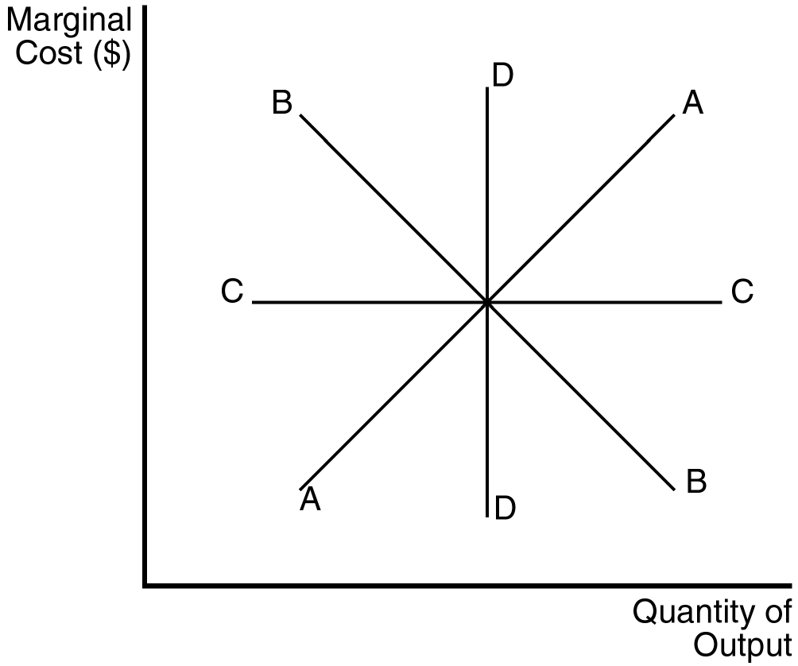
108. Refer to Figure 13-4. Which of the above marginal cost curves reflects the existence of diminishing marginal product?
a. A
b. B
c. C
d. D
ANS: A PTS: 1 DIF: 2 REF: 13-3
TOP: Diminishing marginal product MSC: Analytical
109. If marginal cost is rising,
a. average variable cost must be falling.
b. average fixed cost must be rising.
c. marginal product must be falling.
d. marginal product must be rising.
ANS: C PTS: 1 DIF: 2 REF: 13-3
TOP: Diminishing marginal product MSC: Interpretive
110. Diminishing marginal product suggests that the marginal
a. cost of an extra worker is unchanged.
b. cost of an extra worker is less than the previous worker’s marginal cost.
c. product of an extra worker is less than the previous worker’s marginal product.
d. product of an extra worker is greater than the previous worker’s marginal product.
ANS: C PTS: 1 DIF: 2 REF: 13-3
TOP: Diminishing marginal product MSC: Interpretive
111. Diminishing marginal product suggests that
a. additional units of output become less costly as more output is produced.
b. marginal cost is upward sloping.
c. the firm is at full capacity.
d. adding additional workers will lower total cost.
ANS: B PTS: 1 DIF: 2 REF: 13-3
TOP: Diminishing marginal product MSC: Interpretive
112. The average fixed cost curve
a. always declines with increased levels of output.
b. always rises with increased levels of output.
c. declines as long as it is above marginal cost.
d. declines as long as it is below marginal cost.
ANS: A PTS: 1 DIF: 2 REF: 13-3
TOP: Average fixed cost MSC: Interpretive
113. Average total cost is very high when a small amount of output is produced because
a. average variable cost is high.
b. average fixed cost is high.
c. marginal cost is high.
d. marginal product is high.
ANS: B PTS: 1 DIF: 2 REF: 13-3
TOP: Average total cost MSC: Interpretive
114. The efficient scale of the firm is the quantity of output that
a. maximizes marginal product.
b. maximizes profit.
c. minimizes average total cost.
d. minimizes average variable cost.
ANS: C PTS: 1 DIF: 1 REF: 13-3
TOP: Efficient scale MSC: Definitional
115. When marginal cost is less than average total cost,
a. marginal cost must be falling.
b. average variable cost must be falling.
c. average total cost is falling.
d. average total cost is rising.
ANS: C PTS: 1 DIF: 2 REF: 13-3
TOP: Average total cost MSC: Interpretive
116. When marginal cost exceeds average total cost,
a. average fixed cost must be rising.
b. average total cost must be rising.
c. average total cost must be falling.
d. marginal cost must be falling.
ANS: B PTS: 1 DIF: 2 REF: 13-3
TOP: Average total cost MSC: Interpretive
117. Average total cost is increasing whenever
a. total cost is increasing.
b. marginal cost is increasing.
c. marginal cost is less than average total cost.
d. marginal cost is greater than average total cost.
ANS: D PTS: 1 DIF: 2 REF: 13-3
TOP: Average total cost MSC: Interpretive
118. Johnny is a sophomore in college and has a 1.5 cumulative grade point average (GPA). Johnny’s cumulative GPA will fall even further next semester if he performs worse than
(i) his cumulative GPA.
(ii) he ever performed before.
(iii) he did last semester.
a. (i) and (ii)
b. (i) and (iii)
c. (ii) and (iii)
d. All of the above are correct.
ANS: A PTS: 1 DIF: 3 REF: 13-3
TOP: Average total cost MSC: Analytical
119. Johnny is a sophomore in college and has a 1.5 cumulative grade point average (GPA). Johnny’s cumulative GPA will be better next semester if he
(i) performs better than he did last semester.
(ii) performs better than his cumulative GPA.
(iii) gives an average performance.
a. (ii) only
b. (iii) only
c. (i) and (ii)
d. (ii) and (iii)
ANS: A PTS: 1 DIF: 3 REF: 13-3
TOP: Average total cost MSC: Analytical
120. Marginal cost is equal to average total cost when
a. average variable cost is falling.
b. average fixed cost is rising.
c. marginal cost is at its minimum.
d. average total cost is at its minimum.
ANS: D PTS: 1 DIF: 2 REF: 13-3
TOP: Average total cost MSC: Interpretive
121. The marginal cost curve crosses the average total cost curve at
a. the efficient scale.
b. the minimum point on the average total cost curve.
c. a point where the marginal cost curve is rising.
d. All of the above are correct.
ANS: D PTS: 1 DIF: 2 REF: 13-3
TOP: Average total cost MSC: Interpretive
122. If marginal cost is below average total cost, then average total cost
a. is constant.
b. is falling.
c. is rising.
d. may rise or fall depending on the size of fixed costs.
ANS: B PTS: 1 DIF: 2 REF: 13-3
TOP: Average total cost MSC: Interpretive
123. At all levels of production beyond the point where the marginal cost curve crosses the average variable cost curve, average variable cost
a. rises.
b. remains unaffected.
c. falls.
d. All of the above are possible depending on the shape of the marginal cost curve.
ANS: A PTS: 1 DIF: 2 REF: 13-3
TOP: Average variable cost MSC: Interpretive
Figure 13-5
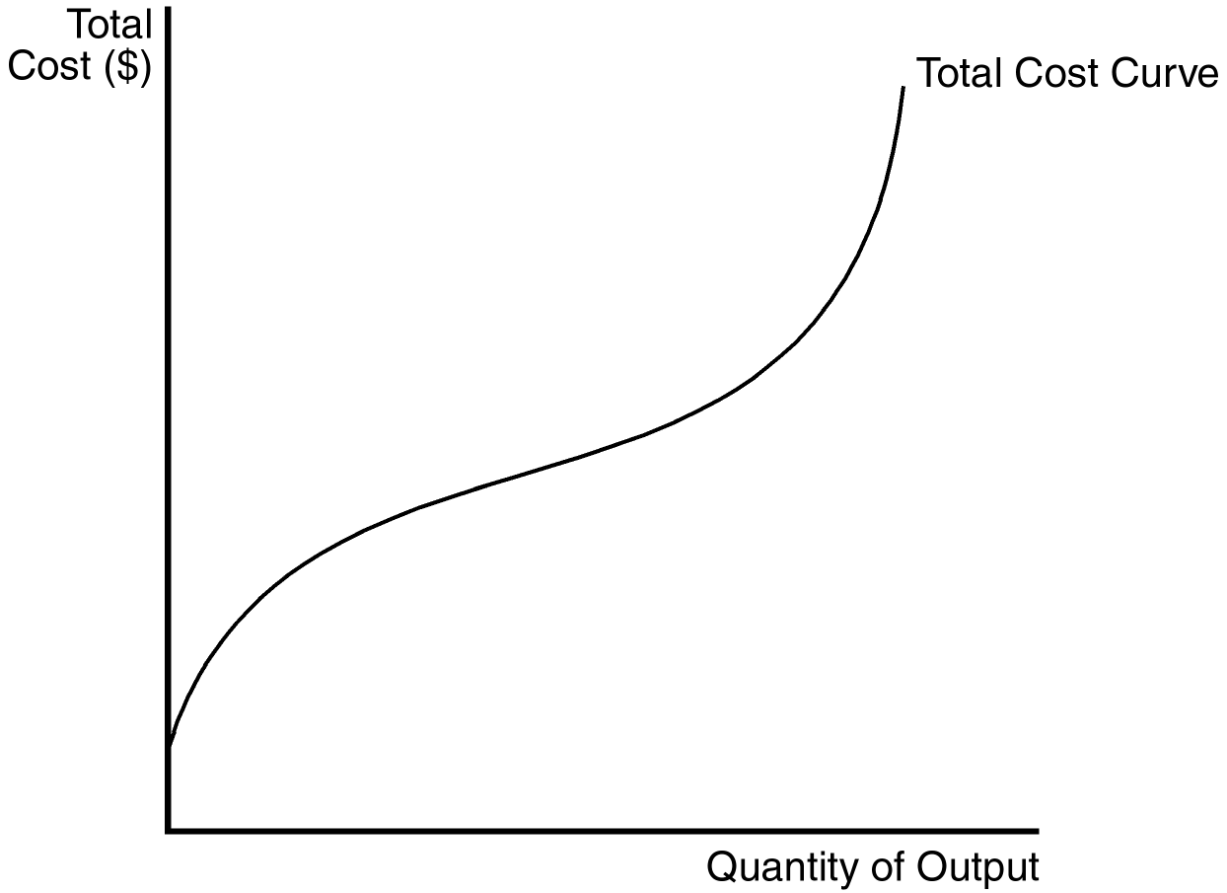
124. Refer to Figure 13-5. Which of the following can be inferred from the figure above?
(i) Marginal cost is increasing at all levels of output.
(ii) Marginal product is increasing at low levels of output.
(iii) Marginal product is decreasing at high levels of output.
a. (i) and (ii)
b. (ii) and (iii)
c. (i) and (iii)
d. (ii) only
ANS: B PTS: 1 DIF: 3 REF: 13-3
TOP: Marginal cost MSC: Analytical
Figure 13-6
The curves below reflect information about the cost structure of a firm.

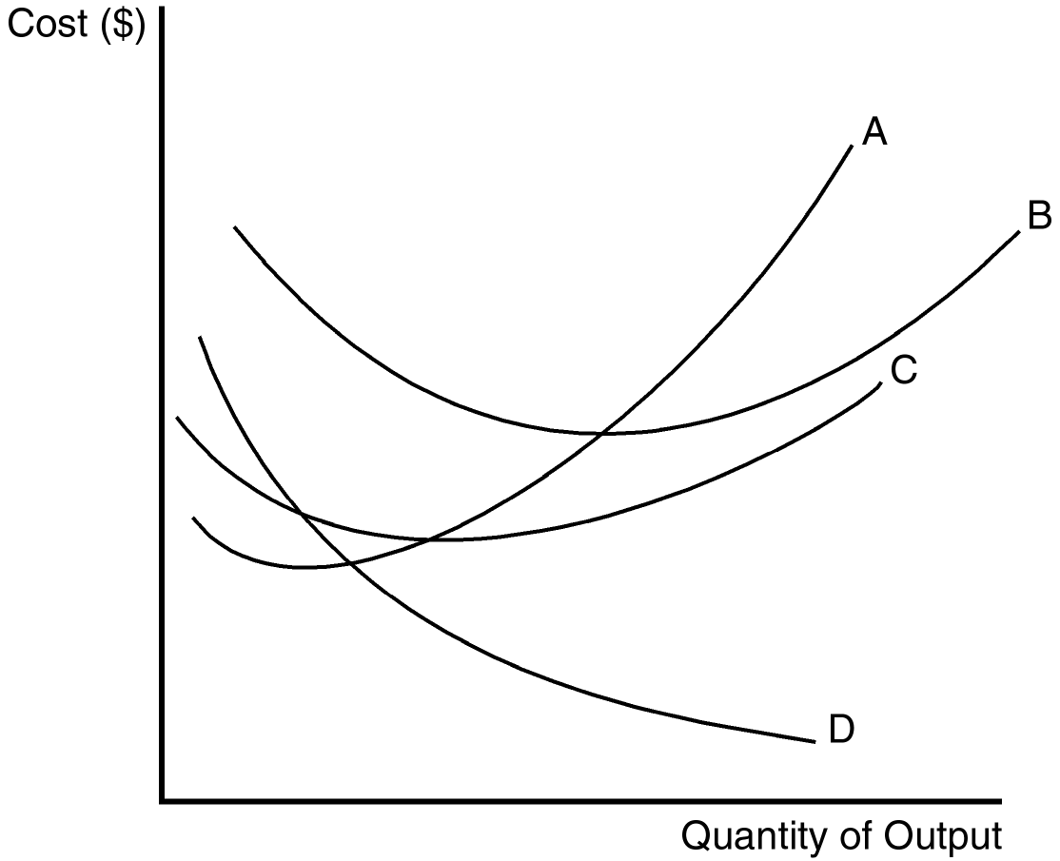
125. Refer to Figure 13-6. Which of the curves is most likely to represent average total cost?
a. A
b. B
c. C
d. D
ANS: B PTS: 1 DIF: 2 REF: 13-3
TOP: Average total cost MSC: Analytical
126. Refer to Figure 13-6. Which of the curves is most likely to represent average fixed cost?
a. A
b. B
c. C
d. D
ANS: D PTS: 1 DIF: 2 REF: 13-3
TOP: Average fixed cost MSC: Analytical
127. Refer to Figure 13-6. Which of the curves is most likely to represent average variable cost?
a. A
b. B
c. C
d. D
ANS: C PTS: 1 DIF: 2 REF: 13-3
TOP: Average variable cost MSC: Analytical
128. Refer to Figure 13-6. Which of the curves is most likely to represent marginal cost?
a. A
b. B
c. C
d. D
ANS: A PTS: 1 DIF: 2 REF: 13-3
TOP: Marginal cost MSC: Analytical
129. Refer to Figure 13-6. Curve A is U-shaped because of
a. diminishing marginal product.
b. increasing marginal product.
c. the fact that increasing marginal product follows decreasing marginal product.
d. the fact that decreasing marginal product follows increasing marginal product.
ANS: D PTS: 1 DIF: 3 REF: 13-3
TOP: Marginal product MSC: Analytical
130. Total cost can be divided into two types of costs. Those two types are
a. fixed costs and variable costs.
b. fixed costs and marginal costs.
c. variable costs and marginal costs.
d. average costs and marginal costs.
ANS: A PTS: 1 DIF: 1 REF: 13-3
TOP: Total cost MSC: Definitional
131. Some costs do not vary with the quantity of output produced. Those costs are called
a. marginal costs.
b. average costs.
c. fixed costs.
d. incurred costs.
ANS: C PTS: 1 DIF: 1 REF: 13-3
TOP: Fixed costs MSC: Definitional
132. For a construction company that builds houses, which of the following costs would be a fixed cost?
a. The $50,000 per year salary paid to a construction foreman
b. The $30,000 per year salary paid to the company’s bookkeeper
c. The $10,000 per year premium paid to an insurance company
d. All of the above are correct.
ANS: D PTS: 1 DIF: 1 REF: 13-3
TOP: Fixed costs MSC: Interpretive
133. For a large firm that produces and sells automobiles, which of the following costs would be a variable cost?
a. The $20 million payment that the firm pays each year for accounting services
b. The cost of the steel that is used in producing automobiles
c. The rent that the firm pays for office space in a suburb of St. Louis
d. All of the above are correct.
ANS: B PTS: 1 DIF: 2 REF: 13-3
TOP: Variable costs MSC: Interpretive
134. Which of the following expressions is correct?
a. marginal cost = (change in quantity of output)/(change in total cost)
b. average total cost = total cost/quantity of output
c. total cost = variable cost + marginal cost
d. average variable cost = quantity of output/total variable cost
ANS: B PTS: 1 DIF: 2 REF: 13-3
TOP: Average total cost MSC: Interpretive
135. Average total cost (ATC) is calculated as follows:
a. ATC = (change in total cost)/(change in quantity of output).
b. ATC = (change in total cost)/(change in quantity of input).
c. ATC = total cost/quantity of output.
d. ATC = total cost/quantity of input.
ANS: C PTS: 1 DIF: 1 REF: 13-3
TOP: Average total cost MSC: Definitional
136. Implicit costs
a. do not require an outlay of money by the firm.
b. do not enter into the economist’s measurement of a firm’s profit.
c. are also known as variable costs.
d. are not part of an economist’s measurement of opportunity cost.
ANS: A PTS: 1 DIF: 2 REF: 13-3
TOP: Implicit costs MSC: Interpretive
137. Which of the following measures of cost is best described as “the increase in total cost that arises from an extra unit of production?”
a. Variable cost
b. Average variable cost
c. Average total cost
d. Marginal cost
ANS: D PTS: 1 DIF: 1 REF: 13-3
TOP: Marginal cost MSC: Definitional
138. Which of the following measures of cost is best described as “the cost of a typical unit of output if total cost is divided evenly over all the units produced?”
a. Average fixed cost
b. Average variable cost
c. Average total cost
d. Marginal cost
ANS: C PTS: 1 DIF: 1 REF: 13-3
TOP: Average total cost MSC: Definitional
139. Marginal cost increases as the quantity of output increases. This reflects the property of
a. increasing total cost.
b. diminishing total cost.
c. increasing marginal product.
d. diminishing marginal product.
ANS: D PTS: 1 DIF: 2 REF: 13-3
TOP: Diminishing marginal product MSC: Interpretive
140. In the short run, a firm incurs fixed costs
a. only if it incurs variable costs.
b. only if it produces no output.
c. only if it produces a positive quantity of output.
d. whether it produces output or not.
ANS: D PTS: 1 DIF: 1 REF: 13-3
TOP: Short run MSC: Interpretive
Scenario 13-5
A certain firm produces and sells staplers. Last year, it produced 7,000 staplers and sold each stapler for $6. In producing the 7,000 staplers, it incurred variable costs of $28,000 and a total cost of $45,000.
141. Refer to Scenario 13-5. The firm’s fixed costs amounted to
a. $7,000.
b. $17,000.
c. $28,000.
d. $42,000.
ANS: B PTS: 1 DIF: 1 REF: 13-3
TOP: Fixed costs MSC: Applicative
142. Refer to Scenario 13-5. In producing the 7,000 staplers, the firm’s average fixed cost was
a. $1.00
b. $1.32
c. $2.21
d. $2.43
ANS: D PTS: 1 DIF: 2 REF: 13-3
TOP: Average fixed cost MSC: Applicative
143. Refer to Scenario 13-5. In producing the 7,000 staplers, the firm’s average variable cost was
a. $2.
b. $4.
c. $6.
d. $8.
ANS: B PTS: 1 DIF: 1 REF: 13-3
TOP: Average variable cost MSC: Applicative
144. Refer to Scenario 13-5. In producing the 7,000 staplers, the firm’s average total cost was
a. $5.00
b. $5.42
c. $6.21
d. $6.43
ANS: D PTS: 1 DIF: 1 REF: 13-3
TOP: Average total cost MSC: Applicative
145. Refer to Scenario 13-5. The firm’s accounting profit for the year was
a. $-3,000.
b. $-5,000
c. $7,000.
d. $17,000.
ANS: A PTS: 1 DIF: 2 REF: 13-3
TOP: Accounting profit MSC: Applicative
Figure 13-7
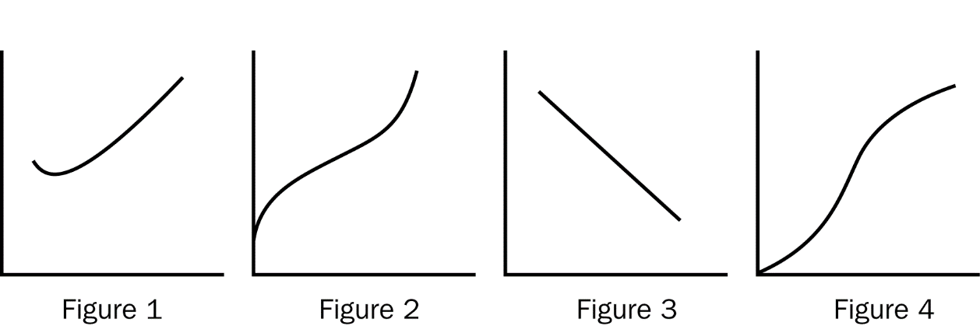
146. Refer to Figure 13-7. Which of the figures represents the total cost curve for a firm?
a. Figure 1
b. Figure 2
c. Figure 3
d. Figure 4
ANS: B PTS: 1 DIF: 1 REF: 13-3
TOP: Total-cost curve MSC: Analytical
147. Refer to Figure 13-7. Which of the figures represents the marginal cost curve for a firm?
a. Figure 1
b. Figure 2
c. Figure 3
d. Figure 4
ANS: A PTS: 1 DIF: 1 REF: 13-3
TOP: Marginal cost MSC: Analytical
148. Refer to Figure 13-7. Which of the figures represents the production function for a firm?
a. Figure 1
b. Figure 2
c. Figure 3
d. Figure 4
ANS: D PTS: 1 DIF: 1 REF: 13-3
TOP: Production function MSC: Analytical
149. Which of the following statements about costs is correct?
a. When marginal cost is less than average total cost, average total cost is rising.
b. The total cost curve is U-shaped.
c. As the quantity of output increases, marginal cost eventually rises.
d. All of the above are correct.
ANS: C PTS: 1 DIF: 2 REF: 13-3
TOP: Marginal cost MSC: Interpretive
150. Whenever marginal cost is greater than average total cost,
a. marginal cost is rising.
b. marginal cost is falling.
c. average total cost is rising.
d. average total cost is falling.
ANS: C PTS: 1 DIF: 2 REF: 13-3
TOP: Average total cost MSC: Interpretive
151. The firm’s efficient scale is the quantity of output that minimizes
a. average total cost.
b. average fixed cost.
c. average variable cost.
d. marginal cost.
ANS: A PTS: 1 DIF: 1 REF: 13-3
TOP: Efficient scale MSC: Definitional
Table 13-5

Measures of Cost for ABC Inc. Widget Factory
Quantity  of Widgets | Variable  Costs | Total  Costs | Fixed  Costs
0 |  |  | $10
1 | $ 1
2 | $ 3 | $13
3 | $ 6 | $16
4 | $10
5 |  | $25
6 | $21 |  | $10

152. Refer to Table 13-5. The average fixed cost of producing five widgets is
a. $1.00
b. $2.00
c. $3.00
d. $5.00
ANS: B PTS: 1 DIF: 2 REF: 13-3
TOP: Average fixed cost MSC: Applicative
153. Refer to Table 13-5. The average variable cost of producing four widgets is
a. $2.00
b. $2.50
c. $3.33
d. $5.00
ANS: B PTS: 1 DIF: 2 REF: 13-3
TOP: Average variable cost MSC: Applicative
154. Refer to Table 13-5. The average total cost of producing one widget is
a. $1.00.
b. $10.00.
c. $11.00.
d. $22.00.
ANS: C PTS: 1 DIF: 2 REF: 13-3
TOP: Average total cost MSC: Applicative
155. Refer to Table 13-5. The marginal cost of producing the sixth widget is
a. $1.00.
b. $3.50.
c. $5.00.
d. $6.00.
ANS: D PTS: 1 DIF: 2 REF: 13-3
TOP: Marginal cost MSC: Applicative
156. Refer to Table 13-5. What is the variable cost of producing zero widgets?
a. $0.00
b. $1.00
c. $10.00
d. $10.00
ANS: A PTS: 1 DIF: 2 REF: 13-3
TOP: Variable costs MSC: Applicative
157. Refer to Table 13-5. What is the marginal cost of producing the first widget?
a. $1.00
b. $10.00
c. $11.00
d. It can’t be determined from the information given.
ANS: A PTS: 1 DIF: 2 REF: 13-3
TOP: Marginal cost MSC: Applicative
158. Refer to Table 13-5. What is the variable cost of producing five widgets?
a. $13.00
b. $14.00
c. $15.00
d. It can’t be determined from the information given.
ANS: C PTS: 1 DIF: 2 REF: 13-3
TOP: Variable costs MSC: Applicative
Table 13-6
Adrian’s Premium Chocolates produces boxes of chocolates for its mail order catalogue business. She rents a small room for $150 a week in the downtown business district that serves as her factory. She can hire workers for $275 a week. There are no implicit costs.

Number of Workers | Boxes of  Chocolates Produced per Week | Marginal Product  of Labor | Cost of  Factory | Cost  of  Workers | Total Cost  of  Inputs
0 | 0
1 |  | 330 | 150 | 275 | 425
2 | 630
3 |  | 150 |  | 825 | 975
4 | 890
5 | 950 | 60 |  | 1,375
6 |  | 10 |  |  | 1,800

159. Refer to Table 13-6. What is the marginal product of the second worker?
a. 110
b. 200
c. 260
d. 300
ANS: D PTS: 1 DIF: 2 REF: 13-3
TOP: Marginal product of labor MSC: Applicative
160. Refer to Table 13-6. What is the total cost associated with making 890 boxes of premium chocolates per week?
a. $1,250
b. $1,325
c. $1,400
d. $1,575
ANS: A PTS: 1 DIF: 2 REF: 13-3
TOP: Total cost MSC: Applicative
161. Refer to Table 13-6. During the week of July 4th, Adrian doesn’t box any chocolates. What are her costs during the week?
a. $0
b. $150
c. $275
d. $425
ANS: B PTS: 1 DIF: 2 REF: 13-3
TOP: Fixed costs MSC: Applicative
162. Refer to Table 13-6. One week, Adrian earns a profit of $125. If her revenue for the week is $1100, how many boxes of chocolate did she produce?
a. 140
b. 330
c. 780
d. 950
ANS: C PTS: 1 DIF: 2 REF: 13-3
TOP: Accounting profit MSC: Applicative
163. Refer to Table 13-6. Adrian has received an order for 3,000 boxes of chocolates for next week. If she expects that the trend in the marginal product of labor will continue in the same direction, it is most likely that her best decision will be to
a. not commit to meeting the order until she can move to a larger room and hire more workers to box the chocolates.
b. close her business until she is able to hire more productive workers.
c. hire about 12 new workers and hope she can satisfy the order.
d. commit to meeting the order and then take three weeks to complete the job.
ANS: A PTS: 1 DIF: 2 REF: 13-3
TOP: Marginal product of labor MSC: Interpretive
Table 13-7
Teacher’s Helper is a small company that has a subcontract to produce instructional materials for disabled children in public school districts. The owner rents several small rooms in an office building in the suburbs for $600 a month and has leased computer equipment that costs $480 a month.

Output (Instructional  Modules per Month) | Fixed  Costs | Variable  Costs | Total  Cost | Average  Fixed  Cost | Average  Variable  Cost | Average  Total  Cost | Marginal  Cost
0 | 1,080
1 | 1,080 | 400 | 1,480 |  |  |  | 400
2 |  |  |  |  |  | 965 | 450
3 |  | 1,350 | 2,430
4 |  | 1,900 |  |  | 475
5 |  | 2,500 |  | 216
6 |  |  | 4,280 |  |  |  | 700
7 |  | 4,100
8 |  | 5,400 |  | 135
9 |  | 7,300
10 |  |  | 10,880 |  | 980

164. Refer to Table 13-7. What is the marginal cost of creating the tenth instructional module in a given month?
a. $900
b. $1,250
c. $2,500
d. $3,060
ANS: C PTS: 1 DIF: 2 REF: 13-3
TOP: Marginal cost MSC: Applicative
165. Refer to Table 13-7. What is the average variable cost for the month if six instructional modules are produced?
a. $180.00
b. $533.33
c. $700.00
d. $713.33
ANS: B PTS: 1 DIF: 2 REF: 13-3
TOP: Average variable cost MSC: Applicative
166. Refer to Table 13-7. What is the average fixed cost for the month if nine instructional modules are produced?
a. $108.00
b. $120.00
c. $150.00
d. $811.11
ANS: B PTS: 1 DIF: 2 REF: 13-3
TOP: Average fixed cost MSC: Applicative
167. Refer to Table 13-7. How many instructional modules are produced when marginal cost is $1,300?
a. 4
b. 5
c. 7
d. 8
ANS: D PTS: 1 DIF: 2 REF: 13-3
TOP: Marginal cost MSC: Applicative
168. Refer to Table 13-7. One month, Teacher’s Helper produced 18 instructional modules. What was the average fixed cost for that month?
a. $60
b. $108
c. $811
d. It can’t be determined from the information given.
ANS: A PTS: 1 DIF: 2 REF: 13-3
TOP: Average fixed cost MSC: Applicative
169. At what level of output will average variable cost equal average total cost?
a. When marginal cost equals average total cost
b. For all levels of output in which average variable cost is falling
c. When marginal cost equals average variable cost
d. There is no level of output where this occurs, as long as fixed costs are positive.
ANS: D PTS: 1 DIF: 2 REF: 13-3
TOP: Average total cost MSC: Interpretive
Scenario 13-6
Farmer Jack is a watermelon farmer. If Jack plants no seeds on his farm, he gets no harvest. If he plants 1 bag of seeds, he gets 30 watermelons. If he plants 2 bags of seeds, he gets 50 watermelons. If he plants 3 bags of seeds he gets 60 watermelons. A bag of seeds costs $100, and the costs of seeds are his only costs.
170. Refer to Scenario 13-6. Which of the following statements is (are) true?
(i) Farmer Jack experiences decreasing marginal product.
(ii) Farmer Jack’s production function is nonlinear.
(iii) Farmer Jack’s total cost curve is linear.
a. (i) only
b. (i) and (ii)
c. (ii) only
d. (i) and (iii)
ANS: B PTS: 1 DIF: 2 REF: 13-3
TOP: Production function MSC: Interpretive
171. Refer to Scenario 13-6. Which of the following statements is(are) true of Jack’s marginal cost?
(i) His marginal cost curve is U-shaped.
(ii) His marginal cost decreases with increased watermelon output.
(iii) His marginal cost reflects diminishing marginal product.
a. (ii) only
b. (iii) only
c. (i) and (iii)
d. (i) and (ii)
ANS: B PTS: 1 DIF: 2 REF: 13-3
TOP: Marginal cost MSC: Applicative
172. Refer to Scenario 13-6. Jack’s production function will
a. Decrease at a decreasing rate.
b. Decrease at an increasing rate.
c. Increase at a decreasing rate.
d. Increase at an increasing rate.
ANS: C PTS: 1 DIF: 2 REF: 13-3
TOP: Production function MSC: Applicative
173. Harry’s Hotdogs is a small street vendor business owned by Harry Huggins. Harry is trying to get a better understanding of his costs by categorizing them as fixed or variable. Which of the following costs are most likely to be considered fixed costs?
a. The cost of mustard
b. The cost of hotdog buns
c. Wages paid to workers that sell hotdogs
d. The cost of bookkeeping services
ANS: D PTS: 1 DIF: 2 REF: 13-3
TOP: Fixed costs MSC: Interpretive
174. Harry’s Hotdogs is a small street vendor business owned by Harry Huggins. If Harry makes 15 hotdogs in his first hour of business and incurs a total cost of $16.50, his average total cost per hotdog is
a. $1.10
b. $6.50
c. $15.00
d. $16.50
ANS: A PTS: 1 DIF: 2 REF: 13-3
TOP: Average total cost MSC: Applicative
175. When a firm is able to put idle equipment to use by hiring another worker,
a. variable costs will rise.
b. variable costs will fall.
c. fixed costs will fall.
d. fixed costs and variable costs will rise.
ANS: A PTS: 1 DIF: 2 REF: 13-3
TOP: Variable costs MSC: Interpretive
176. Thirsty Thelma owns and operates a small lemonade stand. When Thelma is producing a low quantity of lemonade she has few workers and her equipment is not being fully utilized. Because she can easily put her idle resources to use,
a. the marginal cost of an extra worker is large.
b. the marginal cost of one more glass of lemonade is smaller than if output were high.
c. the marginal product of an extra worker is small.
d. her lemonade stand is likely to be crowded with workers.
ANS: B PTS: 1 DIF: 2 REF: 13-3
TOP: Marginal cost MSC: Interpretive
177. When a firm is operating at an efficient scale,
a. average variable cost is minimized.
b. average fixed cost is minimized.
c. average total cost is minimized.
d. marginal cost is minimized.
ANS: C PTS: 1 DIF: 2 REF: 13-3
TOP: Efficient scale MSC: Interpretive
178. Which of the following must always be true as the quantity of output increases?
a. Marginal cost must rise.
b. Average total cost must rise.
c. Average variable cost must rise.
d. Average fixed cost must fall.
ANS: D PTS: 1 DIF: 2 REF: 13-3
TOP: Average fixed cost MSC: Interpretive
179. Which of the following statements is false?
a. The marginal cost of the fifth unit of output equals the total cost of five units minus the total cost of four units.
b. The total variable cost of seven units equals the average variable cost of seven units times seven.
c. If marginal cost is rising, then average variable cost must be rising.
d. The marginal cost of the fifth unit of output equals the total variable cost of five units minus the total variable cost of four units.
ANS: C PTS: 1 DIF: 2 REF: 13-3
TOP: Average variable cost MSC: Interpretive
180. When marginal cost is rising, average variable cost
a. must be rising.
b. must be falling.
c. must be constant.
d. could be rising or falling.
ANS: D PTS: 1 DIF: 3 REF: 13-3
TOP: Average variable cost MSC: Interpretive
181. Consider the following information about bread production at Beth’s Bakery:

Worker | Marginal Product
1 | 5
2 | 7
3 | 10
4 | 11
5 | 8
6 | 6
7 | 4

Beth pays all her workers the same wage and labor is her only variable cost. From this information we can conclude that Beth’s marginal cost
a. declines as output increases from 0 to 33, but increases after that.
b. declines as output increases from 0 to 11, but increases after that.
c. increases as output increases from 0 to 11, but declines after that.
d. is constant.
ANS: A PTS: 1 DIF: 3 REF: 13-3
TOP: Marginal cost MSC: Applicative
182. Consider the following information about baseball production at Bob’s Baseball Factory:

Worker | Marginal Product
1 | 3
2 | 5
3 | 8
4 | 10
5 | 7
6 | 4
7 | 2

Bob pays all his workers the same wage and labor is his only variable cost. From this information we can conclude that Bob’s average variable cost decreases
a. as output rises from 0 to 10, but rises after that.
b. as output rises from 0 to 26, but rises after that.
c. as output rises from 0 to 33, but increases after that.
d. continually as output rises.
ANS: C PTS: 1 DIF: 3 REF: 13-3
TOP: Average variable cost MSC: Applicative
183. At Bert’s Bootery, the total cost of producing twenty pairs of boots is $400. The marginal cost of producing the twenty-first pair of boots is $83. We can conclude that the average
a. variable cost of 21 pairs of boots is $23.
b. total cost of 21 pairs of boots is $23.
c. total cost of 21 pairs of boots is $15.09.
d. total cost of 21 pairs of boots cannot be calculated from the information given.
ANS: B PTS: 1 DIF: 3 REF: 13-3
TOP: Average total cost MSC: Applicative
184. One of the most important properties of cost curves is that
a. for most producers, the average total cost curve never crosses the marginal cost curve.
b. the average fixed cost curve must eventually rise.
c. the average total cost curve first rises, then falls with increased output.
d. the marginal cost curve eventually rises with the quantity of output.
ANS: D PTS: 1 DIF: 2 REF: 13-3
TOP: Marginal cost MSC: Interpretive
185. Suppose that for a particular firm the only variable input into the production process is labor and that output equals zero when no workers are hired. In addition, suppose that marginal cost when three workers are hired is $40 and the average total cost when three workers are hired is $50. What is the total cost of production when three workers are hired?
a. $50
b. $90
c. $120
d. $150
ANS: D PTS: 1 DIF: 2 REF: 13-3
TOP: Average total cost MSC: Analytical
186. For Firm A, when four units of output are produced, the total cost is $175 and the average variable cost is $33.75. What would the average fixed cost be if ten units were produced?
a. $4
b. $10
c. $40
d. $135
ANS: A PTS: 1 DIF: 3 REF: 13-3
TOP: Average fixed cost MSC: Analytical
187. For Firm A, when 4 units of labor, the only variable input into the production process, are hired, the firm produces 50 units of output. If the fixed cost of production is $4, the variable cost per unit of labor is $20, and the marginal product of labor for the fifth unit of labor is 2, what is the average total cost of production when labor is 5 units?
a. $2.00
b. $20.00
c. $20.80
d. $22.80
ANS: A PTS: 1 DIF: 3 REF: 13-3
TOP: Average total cost MSC: Applicative
188. Suppose that when 2 units of labor, the only variable input into the production process, are hired, the total cost of production is $100 and that when 3 units of labor are hired the total cost of production is $120. In addition, assume that the variable cost per unit of labor is the same regardless of the number of units of labor that are hired. What is the firm’s fixed cost?
a. $40
b. $60
c. $80
d. $100
ANS: B PTS: 1 DIF: 3 REF: 13-3
TOP: Fixed costs MSC: Analytical
189. The average total cost when 5 units of output are produced is $30, and the marginal cost of the sixth unit of output is $60. What is the average total cost when six units are produced?
a. $10
b. $25
c. $30
d. $35
ANS: D PTS: 1 DIF: 3 REF: 13-3
TOP: Average total cost MSC: Analytical
190. When marginal cost is greater than average cost, average cost is
a. rising.
b. falling.
c. constant.
d. either rising or falling depending on the economies of scale.
ANS: A PTS: 1 DIF: 1 REF: 13-3
TOP: Marginal cost | Average total cost MSC: Applicative
191. When average cost is greater than marginal cost, marginal cost must be
a. rising.
b. falling.
c. constant.
d. The direction of change in marginal cost cannot be determined from this information.
ANS: D PTS: 1 DIF: 2 REF: 13-3
TOP: Marginal cost | Average total cost MSC: Analytical
192. Which of the following is not a property of a firm’s cost curves?
a. Marginal cost must eventually rise as a result of diminishing marginal product.
b. Average total cost is U-shaped.
c. Economies of scale will exist when average total cost falls as output rises.
d. Average total cost will cross marginal cost at the minimum of marginal cost.
ANS: D PTS: 1 DIF: 2 REF: 13-3
TOP: Cost curves MSC: Definitional
Table 13-8

Quantity  of  gigaplots | Fixed  Cost | Variable Cost | Total  Cost | Average Fixed  Cost | Average Variable Cost | Average  Total  Cost | Marginal Cost
1 |  | $13 | $38
2 |  | $28
3 |  |  | $70
4 |  | $64
5 |  |  | $110
6 |  | $108
7 |  | $133
8 |  |  | $185

193. Refer to Table 13-8. What is the fixed cost of production at Jimmy’s Gigaplot factory?
a. $12
b. $20
c. $25
d. More information is needed.
ANS: C PTS: 1 DIF: 2 REF: 13-3
TOP: Fixed costs MSC: Applicative
194. Refer to Table 13-8. What is the variable cost of producing 5 gigaplots at Jimmy’s Gigaplot factory?
a. $64
b. $85
c. $90
d. $100
ANS: B PTS: 1 DIF: 2 REF: 13-3
TOP: Variable costs MSC: Applicative
195. Refer to Table 13-8. What is the variable cost of producing 8 gigaplots at Jimmy’s Gigaplot factory?
a. $120
b. $140
c. $155
d. $160
ANS: D PTS: 1 DIF: 2 REF: 13-3
TOP: Variable costs MSC: Applicative
196. Refer to Table 13-8. What is the total cost of producing 7 gigaplots at Jimmy’s Gigaplot factory?
a. $140
b. $150
c. $153
d. $158
ANS: D PTS: 1 DIF: 2 REF: 13-3
TOP: Total cost MSC: Applicative
197. Refer to Table 13-8. What is the total cost of producing 2 gigaplots at Jimmy’s Gigaplot factory?
a. $48
b. $53
c. $58
d. $62
ANS: B PTS: 1 DIF: 2 REF: 13-3
TOP: Total cost MSC: Applicative
198. Refer to Table 13-8. What is the average variable cost of producing 3 gigaplots at Jimmy’s Gigaplot factory?
a. $14
b. $15
c. $16
d. $17
ANS: B PTS: 1 DIF: 2 REF: 13-3
TOP: Average variable cost MSC: Applicative
199. Refer to Table 13-8. What is the average variable cost of producing 6 gigaplots at Jimmy’s Gigaplot factory?
a. $16
b. $17
c. $18
d. $19
ANS: C PTS: 1 DIF: 2 REF: 13-3
TOP: Average variable cost MSC: Applicative
200. Refer to Table 13-8. What is the average fixed cost of producing 8 gigaplots at Jimmy’s Gigaplot factory?
a. $2.12
b. $3.13
c. $20.00
d. $24.37
ANS: B PTS: 1 DIF: 2 REF: 13-3
TOP: Average fixed cost MSC: Applicative
201. Refer to Table 13-8. What is the average fixed cost of producing 3 gigaplots at Jimmy’s Gigaplot factory?
a. $1.67
b. $2.67
c. $5.33
d. $8.33
ANS: D PTS: 1 DIF: 2 REF: 13-3
TOP: Average fixed cost MSC: Applicative
202. Refer to Table 13-8. What is the average total cost of producing 6 gigaplots at Jimmy’s Gigaplot factory?
a. $16.34
b. $22.00
c. $22.17
d. $22.57
ANS: C PTS: 1 DIF: 3 REF: 13-3
TOP: Average total cost MSC: Applicative
203. Refer to Table 13-8. What is the average total cost of producing 2 gigaplots at Jimmy’s Gigaplot factory?
a. $14.00
b. $18.50
c. $22.50
d. $26.50
ANS: D PTS: 1 DIF: 3 REF: 13-3
TOP: Average total cost MSC: Applicative
204. Refer to Table 13-8. What is the marginal cost of the 4th gigaplot at Jimmy’s Gigaplot factory?
a. $13
b. $15
c. $19
d. $64
ANS: C PTS: 1 DIF: 2 REF: 13-3
TOP: Marginal cost MSC: Applicative
205. Refer to Table 13-8. What is the marginal cost of the 8th gigaplot at Jimmy’s Gigaplot factory?
a. $20
b. $27
c. $160
d. $185
ANS: B PTS: 1 DIF: 2 REF: 13-3
TOP: Marginal cost MSC: Applicative
206. Refer to Table 13-8. What is the marginal cost of the 2nd gigaplot at Jimmy’s Gigaplot factory?
a. $14
b. $15
c. $28
d. $34
ANS: B PTS: 1 DIF: 2 REF: 13-3
TOP: Marginal cost MSC: Applicative
207. Which of the following costs of publishing a book is a fixed cost?
a. Author royalties of 5% per book.
b. The costs of paper and binding.
c. Shipping and postage expenses.
d. Composition, typesetting, and jacket design for the book.
ANS: D PTS: 1 DIF: 2 REF: 13-3
TOP: Fixed costs MSC: Interpretive
208. Which of the following is the best example of a variable cost?
a. Monthly wage payments for hired labor.
b. Annual property tax payments for a building.
c. Monthly rent payments for a warehouse.
d. Annual insurance payments for a warehouse.
ANS: A PTS: 1 DIF: 2 REF: 13-3
TOP: Variable costs MSC: Interpretive
209. Smith Tire Company has total fixed costs of $300,000 per year. The firm’s average variable cost is $80 for 10,000 tires. At that level of output, the firm’s average total costs equal
a. $80
b. $90
c. $100
d. $110
ANS: D PTS: 1 DIF: 2 REF: 13-3
TOP: Average total cost MSC: Applicative
210. Miller Technologies has average variable costs of $1 and average total costs of $3 when it produces 500 units of output. The firm’s total fixed costs equal
a. $500
b. $1,000
c. $1,500
d. $2,000
ANS: B PTS: 1 DIF: 2 REF: 13-3
TOP: Average fixed cost MSC: Applicative
211. If marginal cost is greater than average total cost then
a. profits are increasing.
b. economies of scale are becoming greater.
c. average total cost remains constant.
d. average total cost is increasing.
ANS: D PTS: 1 DIF: 1 REF: 13-3
TOP: Average total cost MSC: Interpretive
212. The minimum points of the average variable cost and average total cost curves occur where
a. the marginal cost curve lies below the average variable cost and average total cost curves.
b. the marginal cost curve intersects those curves.
c. the average variable cost and average total cost curves intersect.
d. the slope of total cost is the smallest.
ANS: B PTS: 1 DIF: 2 REF: 13-3
TOP: Average total cost MSC: Interpretive
213. If Franco’s Pizza Parlor knows that the marginal cost of the 500th pizza is $3.50 and that the average total cost of making 499 pizzas is $3.30, then
a. average costs are rising at Q = 500.
b. average costs are falling at Q = 500.
c. total costs are falling at Q = 500.
d. average variable costs must be falling.
ANS: A PTS: 1 DIF: 2 REF: 13-3
TOP: Average total cost MSC: Interpretive
214. Which of the following factors is most likely to shift IBM’s total cost and marginal cost curves downward?
a. A technological advance resulting in increased productivity.
b. Higher property taxes charged by the municipal government.
c. Increased wages to attract additional computer operators.
d. A reduction in subsidies from the state government.
ANS: A PTS: 1 DIF: 2 REF: 13-3
TOP: Total cost MSC: Analytical
215. Given the cost curves shown in the diagram below, the efficient scale of production occurs at point
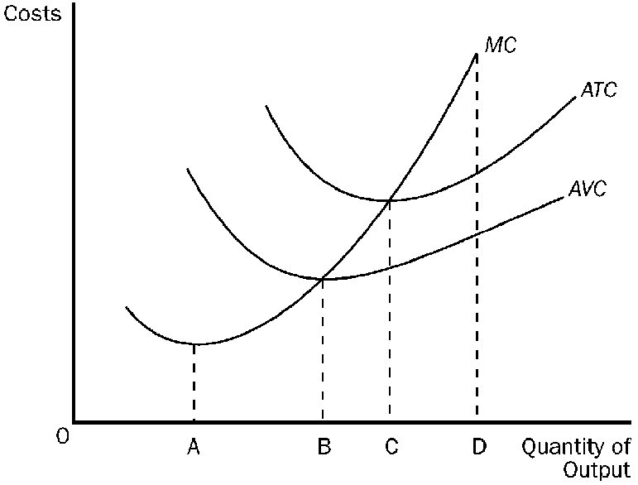
a. A.
b. B.
c. C.
d. D.
ANS: C PTS: 1 DIF: 2 REF: 13-3
TOP: Efficient scale MSC: Analytical
1. When a factory is operating in the short run,
a. it cannot alter variable costs.
b. total cost and variable cost are usually the same.
c. average fixed cost rises as output increases.
d. it cannot adjust the quantity of fixed inputs.
ANS: D PTS: 1 DIF: 2 REF: 13-4
TOP: Short run MSC: Interpretive
2. In the long run,
a. inputs that were fixed in the short run remain fixed.
b. inputs that were fixed in the short run become variable.
c. inputs that were variable in the short run become fixed.
d. variable inputs are rarely used.
ANS: B PTS: 1 DIF: 2 REF: 13-4
TOP: Long run MSC: Interpretive
Figure 13-8
The figure below depicts average total cost functions for a firm that produces automobiles.

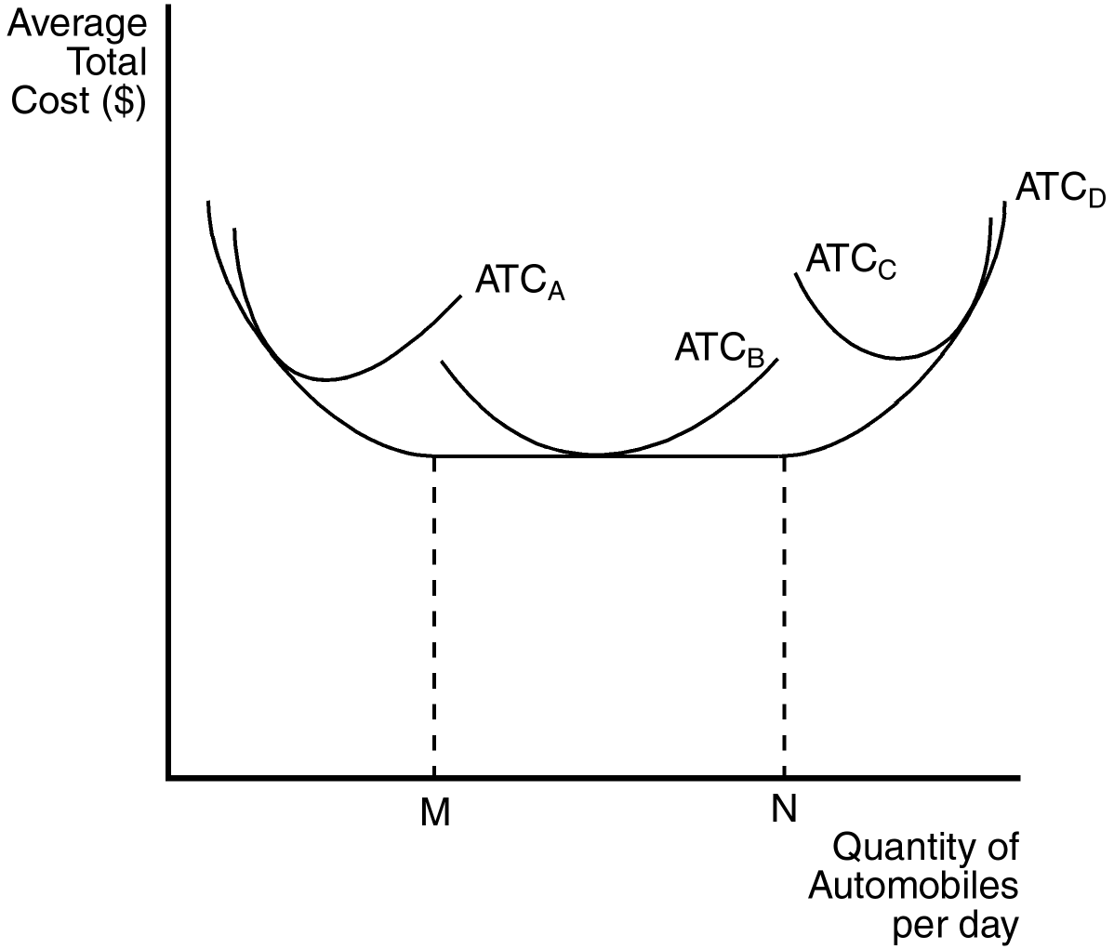
3. Refer to Figure 13-8. Which of the curves is most likely to characterize the short-run average total cost curve of the smallest factory?
a. ATC_{A}
b. ATC_{B}
c. ATC_{C}
d. ATC_{D}
ANS: A PTS: 1 DIF: 1 REF: 13-4
TOP: Average total cost MSC: Analytical
4. Refer to Figure 13-8. Which curve represents the long-run average total cost?
a. ATC_{A}
b. ATC_{B}
c. ATC_{C}
d. ATC_{D}
ANS: D PTS: 1 DIF: 1 REF: 13-4
TOP: Average total cost MSC: Analytical
5. Refer to Figure 13-8. In the long run, the firm can operate on which of the following average total cost curves?
a. ATC_{A}
b. ATC_{B}
c. ATC_{C}
d. All of the above are correct.
ANS: D PTS: 1 DIF: 1 REF: 13-4
TOP: Average total cost MSC: Analytical
6. Refer to Figure 13-8. This firm experiences diseconomies of scale at what output levels?
a. output levels above N
b. output levels between M and N
c. output levels below M
d. All of the above are correct, if the firm is operating in the long run.
ANS: A PTS: 1 DIF: 2 REF: 13-4
TOP: Diseconomies of scale MSC: Analytical
7. Refer to Figure 13-8. At levels of output below M the firm experiences
a. economies of scale.
b. diseconomies of scale.
c. economic profit.
d. accounting profit.
ANS: A PTS: 1 DIF: 2 REF: 13-4
TOP: Economies of scale MSC: Analytical
8. The long-run average total cost curve is always
a. flatter than the short-run average total cost curve, but not necessarily horizontal.
b. horizontal.
c. falling as output increases.
d. rising as output increases.
ANS: A PTS: 1 DIF: 2 REF: 13-4
TOP: Average total cost MSC: Interpretive
9. The length of the short run
a. is different for different types of firms.
b. can never exceed 3 years.
c. can never exceed 1 year.
d. is always less than 6 months.
ANS: A PTS: 1 DIF: 1 REF: 13-4
TOP: Short run MSC: Interpretive
10. Economies of scale occur when
a. long-run average total costs rise as output increases.
b. long-run average total costs fall as output increases.
c. average fixed costs are falling.
d. average fixed costs are constant.
ANS: B PTS: 1 DIF: 2 REF: 13-4
TOP: Economies of scale MSC: Definitional
11. Diseconomies of scale occur when
a. average fixed costs are falling.
b. average fixed costs are constant.
c. long-run average total costs rise as output increases.
d. long-run average total costs fall as output increases.
ANS: C PTS: 1 DIF: 2 REF: 13-4
TOP: Diseconomies of scale MSC: Definitional
12. Constant returns to scale occur when
a. long-run total costs are constant as output increases.
b. long-run average total costs are constant as output increases.
c. the firm’s long-run average cost curve is falling as output increases.
d. the firm’s long-run average cost curve is rising as output increases.
ANS: B PTS: 1 DIF: 2 REF: 13-4
TOP: Constant returns to scale MSC: Definitional
13. If a firm wants to capitalize on economies of scale, it may be able to do so by
a. assigning limited tasks to its employees, so they can master those tasks.
b. employing a smaller number of workers.
c. producing a smaller quantity of output.
d. producing an output level higher than the efficient scale.
ANS: A PTS: 1 DIF: 2 REF: 13-4
TOP: Economies of scale MSC: Interpretive
14. In setting the production level, a firm’s cost curves
a. by themselves do not tell us what decisions the firm will make.
b. dictate what decisions the firm will make.
c. have no bearing on what decisions the firm will make.
d. None of the above is correct.
ANS: A PTS: 1 DIF: 2 REF: 13-4
TOP: Cost curves MSC: Interpretive
15. Economies of scale arise when
a. an economy is self-sufficient in production.
b. individuals in a society are self-sufficient.
c. fixed costs are large relative to variable costs.
d. workers are able to specialize in a particular task.
ANS: D PTS: 1 DIF: 2 REF: 13-4
TOP: Economies of scale MSC: Interpretive
16. How long does it take a firm to go from the short run to the long run?
a. six months
b. one year
c. two years
d. It depends on the nature of the firm.
ANS: D PTS: 1 DIF: 1 REF: 13-4
TOP: Short run MSC: Interpretive
17. In the long run, a firm that produces and sells computers gets to choose
a. how many workers to hire.
b. the size of its factories.
c. which short-run average-total-cost curve to use.
d. All of the above are correct.
ANS: D PTS: 1 DIF: 2 REF: 13-4
TOP: Long run MSC: Interpretive
18. When, for a firm, long-run average total cost decreases as the quantity of output increases, we have a situation of
a. economies of scale.
b. diseconomies of scale.
c. coordination problems arising from the large size of the firm.
d. fixed costs greatly exceeding variable costs.
ANS: A PTS: 1 DIF: 1 REF: 13-4
TOP: Economies of scale MSC: Interpretive
Figure 13-9
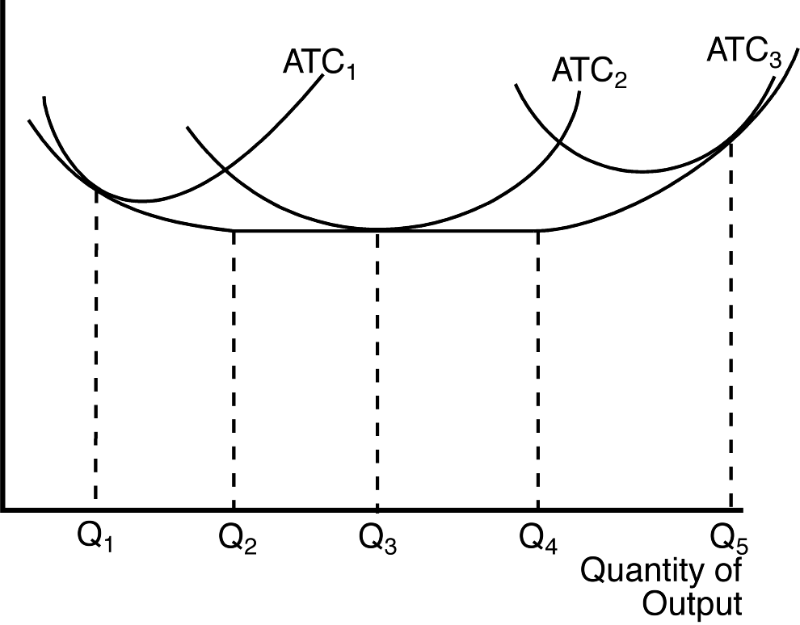
19. Refer to Figure 13-9. The three average total cost curves on the diagram correspond to three different
a. time horizons.
b. products.
c. firms.
d. factory sizes.
ANS: D PTS: 1 DIF: 2 REF: 13-4
TOP: Average total cost MSC: Analytical
20. Refer to Figure 13-9. The firm experiences economies of scale if it changes its level of output
a. from Q₁ to Q₂.
b. from Q₂ to Q₃.
c. from Q₃ to Q₄.
d. from Q₄ to Q₅.
ANS: A PTS: 1 DIF: 2 REF: 13-4
TOP: Economies of scale MSC: Analytical
21. Refer to Figure 13-9. The firm experiences diseconomies of scale if it changes its level of output
a. from Q₁ to Q₂.
b. from Q₂ to Q₃.
c. from Q₃ to Q₄.
d. from Q₄ to Q₅.
ANS: D PTS: 1 DIF: 2 REF: 13-4
TOP: Diseconomies of scale MSC: Analytical
22. The fundamental reason that marginal cost eventually rises as output increases is because of
a. economies of scale.
b. diseconomies of scale.
c. diminishing marginal product.
d. rising average fixed cost.
ANS: C PTS: 1 DIF: 2 REF: 13-4
TOP: Diminishing marginal product MSC: Interpretive
23. Which of the following statements is false?
a. In the long run, there are no fixed costs.
b. Marginal cost is independent of fixed costs.
c. Economies of scale is a short-run concept.
d. Diminishing marginal product explains increasing marginal cost.
ANS: C PTS: 1 DIF: 2 REF: 13-4
TOP: Economies of scale MSC: Interpretive
24. In the long run, when marginal cost is above average total cost, the average total cost curve exhibits
a. economies of scale.
b. diseconomies of scale.
c. constant returns to scale.
d. efficient scale.
ANS: B PTS: 1 DIF: 2 REF: 13-4
TOP: Diseconomies of scale MSC: Applicative
25. When comparing short-run average total cost with long-run average total cost at a given level of output,
a. short-run average total cost is typically above long-run average total cost.
b. short-run average total cost is typically the same as long-run average total cost.
c. short-run average total cost is typically below long-run average total cost.
d. the relationship between short-run and long-run average total cost follows no clear pattern.
ANS: A PTS: 1 DIF: 2 REF: 13-4
TOP: Average total cost MSC: Analytical
Table 13-9

Output | Total Cost
0 | 40
10 | 60
20 | 90
30 | 130
40 | 180
50 | 240

26. Refer to Table 13-9. What is the total fixed cost for this firm?
a. $20
b. $30
c. $40
d. $50
ANS: C PTS: 1 DIF: 2 REF: 13-4
TOP: Fixed costs MSC: Analytical
27. Refer to Table 13-9. What is average fixed cost when output is 40 units?
a. $1.00
b. $3.32
c. $5.00
d. $8.00
ANS: A PTS: 1 DIF: 3 REF: 13-4
TOP: Average fixed cost MSC: Analytical
28. Refer to Table 13-9. What is average variable cost when output is 50 units?
a. $3.60
b. $4.00
c. $4.40
d. $4.80
ANS: B PTS: 1 DIF: 3 REF: 13-4
TOP: Average variable cost MSC: Analytical
29. Refer to Table 13-9. What is variable cost when output equals 30 units?
a. $4.00
b. $4.33
c. $40.00
d. $90.00
ANS: D PTS: 1 DIF: 2 REF: 13-4
TOP: Variable costs MSC: Analytical
30. In the long run for Firm A, total cost is $105 when output is 3 units and $120 when output is 4 units. Does Firm A exhibit economies or diseconomies of scale?
a. Diseconomies of scale, since total cost is rising as output rises.
b. Diseconomies of scale, since average total cost is falling as output rises.
c. Economies of scale, since total cost is rising as output rises.
d. Economies of scale, since average total cost is falling as output rises.
ANS: D PTS: 1 DIF: 2 REF: 13-4
TOP: Economies of scale MSC: Analytical
Table 13-10
Consider the following table of long-run total cost for four different firms

Quantity | 1 | 2 | 3 | 4 | 5 | 6 | 7
Firm 1 | $210 | $340 | $490 | $660 | $850 | $1,060 | $1,290
Firm 2 | $180 | $350 | $510 | $660 | $800 | $930 | $1,050
Firm 3 | $120 | $250 | $390 | $540 | $700 | $870 | $1,050
Firm 4 | $150 | $300 | $450 | $600 | $750 | $900 | $1,050

31. Refer to Table 13-10. Which firm has constant returns to scale over the entire range of output?
a. Firm 1
b. Firm 2
c. Firm 3
d. Firm 4
ANS: D PTS: 1 DIF: 2 REF: 13-4
TOP: Constant returns to scale MSC: Applicative
32. Refer to Table 13-10. Which firm has diseconomies of scale over the entire range of output?
a. Firm 1
b. Firm 2
c. Firm 3
d. Firm 4
ANS: C PTS: 1 DIF: 3 REF: 13-4
TOP: Diseconomies of scale MSC: Applicative
33. Refer to Table 13-10. Which firm has economies of scale over the entire range of output?
a. Firm 1
b. Firm 2
c. Firm 3
d. Firm 4
ANS: B PTS: 1 DIF: 3 REF: 13-4
TOP: Economies of scale MSC: Applicative
34. Refer to Table 13-10. Which firm has economies of scale and then diseconomies of scale as output increases from 1 to 7?
a. Firm 1
b. Firm 2
c. Firm 3
d. Firm 4
ANS: A PTS: 1 DIF: 3 REF: 13-4
TOP: Economies of scale MSC: Applicative
35. Refer to Table 13-10. Which firm’s long-run marginal cost decreases as output increases?
a. Firm 1
b. Firm 2
c. Firm 3
d. Firm 4
ANS: B PTS: 1 DIF: 3 REF: 13-4
TOP: Marginal cost MSC: Applicative
36. Refer to Table 13-10. Firm 1’s efficient scale occurs at what quantity?
a. 2
b. 3
c. 4
d. 5
ANS: B PTS: 1 DIF: 3 REF: 13-4
TOP: Efficient scale MSC: Applicative
37. Since the 1980s, Wal-Mart stores have appeared in almost every community in America. Wal-Mart buys its goods in large quantities and, therefore, at cheaper prices. Wal-Mart also locates its stores where land prices are low, usually outside of the community business district. Many customers shop at Wal-Mart because of low prices. Local retailers, like the neighborhood drug store, often go out of business because they lose customers. This story demonstrates that
a. consumers are boycotting local retailers whose prices are relatively higher.
b. there are diseconomies of scale in retail sales.
c. there are economies of scale in retail sales.
d. there are diminishing returns to producing and selling retail goods.
ANS: C PTS: 1 DIF: 2 REF: 13-4
TOP: Economies of scale MSC: Interpretive
38. Some reasons that firms may experience diseconomies of scale include that
a. the firm is too small to take advantage of specialization.
b. large management structures may be bureaucratic and inefficient.
c. if there are too many employees, the work place becomes crowded and people become less productive.
d. average fixed costs begin to rise again.
ANS: B PTS: 1 DIF: 2 REF: 13-4
TOP: Diseconomies of scale MSC: Interpretive
39. A local potato chip company plans to keep and maintain its chip factory, which is estimated to last 25 years. All cost decisions it makes during the 25-year period
a. are short-run decisions.
b. are long-run decisions.
c. involve only maintenance of the factory.
d. are zero, since the cost decisions were made at the beginning of the business.
ANS: A PTS: 1 DIF: 2 REF: 13-4
TOP: Short run MSC: Interpretive
40. If a firm experiences constant returns to scale at all output levels, then its long-run average total cost curve would
a. slope downward.
b. be horizontal.
c. slope upward.
d. slope downward for low output levels and upward for high output levels.
ANS: B PTS: 1 DIF: 2 REF: 13-4
TOP: Constant returns to scale MSC: Interpretive
41. Which of the following explains why long-run average cost at first decreases as output increases?
a. diseconomies of scale
b. less-efficient use of inputs
c. fixed costs becoming spread out over more units of output
d. gains from specialization of inputs
ANS: D PTS: 1 DIF: 2 REF: 13-4
TOP: Average total cost MSC: Interpretive
42. The total cost to the firm of producing zero units of output is
a. zero in both the short run and the long run.
b. its fixed cost in the short run and zero in the long run.
c. its fixed cost in both the short run and the long run.
d. its variable cost in both the short run and the long run.
ANS: B PTS: 1 DIF: 2 REF: 13-4
TOP: Total cost MSC: Interpretive
True/False
1. Examination of the costs of production is unnecessary to the field of industrial organization.
ANS: F PTS: 1 DIF: 2 REF: 13-1
TOP: Industrial organization MSC: Interpretive
2. When economists speak of a firm’s costs, they are usually excluding the opportunity costs.
ANS: F PTS: 1 DIF: 2 REF: 13-1
TOP: Opportunity costs MSC: Interpretive
3. Economists and accountants usually disagree on the inclusion of implicit costs into the cost analysis of a firm.
ANS: T PTS: 1 DIF: 1 REF: 13-1
TOP: Implicit costs MSC: Interpretive
4. Implicit costs are costs that do not require an outlay of money by the firm.
ANS: T PTS: 1 DIF: 1 REF: 13-1
TOP: Implicit costs MSC: Definitional
5. Accountants keep track of the money that flows into and out of firms.
ANS: T PTS: 1 DIF: 1 REF: 13-1
TOP: Accounting profit MSC: Interpretive
6. Accountants often ignore implicit costs.
ANS: T PTS: 1 DIF: 1 REF: 13-1
TOP: Implicit costs MSC: Interpretive
7. Economists and accountants both include forgone income as a cost to a small business owner.
ANS: F PTS: 1 DIF: 2 REF: 13-1
TOP: Opportunity costs MSC: Interpretive
8. Although economists and accountants treat many costs differently, they both treat the cost of capital the same.
ANS: F PTS: 1 DIF: 2 REF: 13-1
TOP: Economic profit MSC: Interpretive
9. In the long run, a factory is usually considered a fixed input.
ANS: F PTS: 1 DIF: 2 REF: 13-2
TOP: Long run MSC: Interpretive
10. When trying to understand the decision making process of different firms, economists assume that people think at the margin.
ANS: T PTS: 1 DIF: 2 REF: 13-2
TOP: Marginal analysis MSC: Interpretive
11. The shape of the total cost curve is unrelated to the shape of the production function.
ANS: F PTS: 1 DIF: 2 REF: 13-2
TOP: Total-cost curve MSC: Interpretive
12. Diminishing marginal product exists when the total cost curve becomes flatter as outputs increases.
ANS: F PTS: 1 DIF: 2 REF: 13-3
TOP: Diminishing marginal product MSC: Interpretive
13. Diminishing marginal product exists when the production function becomes flatter as inputs increase.
ANS: T PTS: 1 DIF: 2 REF: 13-3
TOP: Diminishing marginal product MSC: Interpretive
14. Several related measures of cost can be derived from a firm’s total cost.
ANS: T PTS: 1 DIF: 2 REF: 13-3
TOP: Cost curves MSC: Interpretive
15. Fixed costs are incurred even when a firm does not produce anything.
ANS: T PTS: 1 DIF: 2 REF: 13-3
TOP: Fixed costs MSC: Definitional
16. Variable costs usually change as the firm alters the quantity of output produced.
ANS: T PTS: 1 DIF: 2 REF: 13-3
TOP: Variable costs MSC: Definitional
17. Variable costs equal fixed costs when nothing is produced.
ANS: F PTS: 1 DIF: 2 REF: 13-3
TOP: Variable costs MSC: Interpretive
18. The cost of producing an additional unit of a good is not the same as the average cost of the good.
ANS: T PTS: 1 DIF: 2 REF: 13-3
TOP: Average total cost MSC: Interpretive
19. Average variable cost is equal to total variable cost divided by quantity of output.
ANS: T PTS: 1 DIF: 2 REF: 13-3
TOP: Average variable cost MSC: Definitional
20. The average total cost curve is unaffected by diminishing marginal product.
ANS: F PTS: 1 DIF: 2 REF: 13-3
TOP: Diminishing marginal product MSC: Interpretive
21. The average total cost curve reflects the shape of both the average fixed cost and average variable cost curves.
ANS: T PTS: 1 DIF: 2 REF: 13-3
TOP: Average total cost MSC: Interpretive
22. If the marginal cost curve is rising, then so is the average total cost curve.
ANS: F PTS: 1 DIF: 2 REF: 13-3
TOP: Average total cost MSC: Interpretive
23. The marginal cost curve intersects the average total cost curve at the minimum point of the average total cost curve.
ANS: T PTS: 1 DIF: 2 REF: 13-3
TOP: Average total cost MSC: Interpretive
24. A second or third worker may have a higher marginal product than the first worker in certain circumstances.
ANS: T PTS: 1 DIF: 2 REF: 13-3
TOP: Marginal product of labor MSC: Interpretive
25. Assume Jack received all A’s in his classes last semester. If Jack gets all B’s in his classes this semester, his GPA may or may not fall.
ANS: T PTS: 1 DIF: 3 REF: 13-3
TOP: Average total cost MSC: Interpretive
26. Average total cost and marginal cost are merely ways to express information that is already contained in a firm’s total cost.
ANS: T PTS: 1 DIF: 2 REF: 13-3
TOP: Average total cost MSC: Interpretive
27. Average total cost reveals how much total cost will change as the firm alters its level of production.
ANS: F PTS: 1 DIF: 2 REF: 13-3
TOP: Average total cost MSC: Interpretive
28. The shape of the marginal cost curve tells a producer something about the marginal product of her workers.
ANS: T PTS: 1 DIF: 2 REF: 13-3
TOP: Marginal cost MSC: Interpretive
29. When average total cost rises if a producer either increases or decreases production, then the firm is said to be operating at efficient scale.
ANS: T PTS: 1 DIF: 2 REF: 13-3
TOP: Efficient scale MSC: Interpretive
30. Fixed costs are those costs that remain fixed no matter how long the time horizon is.
ANS: F PTS: 1 DIF: 2 REF: 13-4
TOP: Fixed costs MSC: Interpretive
31. Diseconomies of scale often arise because higher production levels allow specialization among workers.
ANS: F PTS: 1 DIF: 2 REF: 13-4
TOP: Diseconomies of scale MSC: Interpretive
32. The fact that many inputs are fixed in the short run but variable in the long run has little impact on the firm’s cost curves.
ANS: F PTS: 1 DIF: 2 REF: 13-4
TOP: Long run MSC: Interpretive
33. In some cases, specialization allows larger factories to produce goods at a lower average cost than smaller factories.
ANS: T PTS: 1 DIF: 2 REF: 13-4
TOP: Specialization MSC: Interpretive
34. The use of specialization to achieve economies of scale is one reason modern societies are as prosperous as they are.
ANS: T PTS: 1 DIF: 2 REF: 13-4
TOP: Specialization MSC: Interpretive
35. As a firm moves along its long-run average cost curve, it is adjusting the size of its factory to the quantity of production.
ANS: T PTS: 1 DIF: 2 REF: 13-4
TOP: Average total cost MSC: Interpretive
36. Because of the greater flexibility that firms have in the long run, all short-run cost curves lie on or above the long-run curve.
ANS: T PTS: 1 DIF: 2 REF: 13-4
TOP: Average total cost MSC: Interpretive
37. There is general agreement among economists that the long-run time period exceeds one year.
ANS: F PTS: 1 DIF: 2 REF: 13-4
TOP: Long run MSC: Interpretive
38. Adam Smith’s example of the pin factory demonstrates that economies of scale result from specialization.
ANS: T PTS: 1 DIF: 2 REF: 13-4
TOP: Economies of scale MSC: Interpretive
Short Answer
1. What are opportunity costs? How do explicit and implicit costs relate to opportunity costs?
ANS:
The opportunity cost of an item refers to all those things that must be forgone to acquire that item. Both explicit and implicit costs are included as opportunity costs.
PTS: 1 DIF: 2 REF: 13-1
TOP: Opportunity costs MSC: Definitional
2. A key difference between accountants and economists is their different treatment of the cost of capital. Does this cause an accountant’s estimate of total costs to be higher or lower than an economist’s estimate? Explain.
ANS:
An accountant would not include the forgone interest income that the money could have earned elsewhere if it had not been invested in the business. Therefore, an accountant’s estimate of total cost will be less than an economist’s.
PTS: 1 DIF: 2 REF: 13-1
TOP: Accounting profit MSC: Analytical
3. The production function depicts a relationship between which two variables? Also, draw a production function that exhibits diminishing marginal product.
ANS:
It depicts a relationship between output and a given input. The graph should show output increasing, but at a decreasing rate as inputs increase.
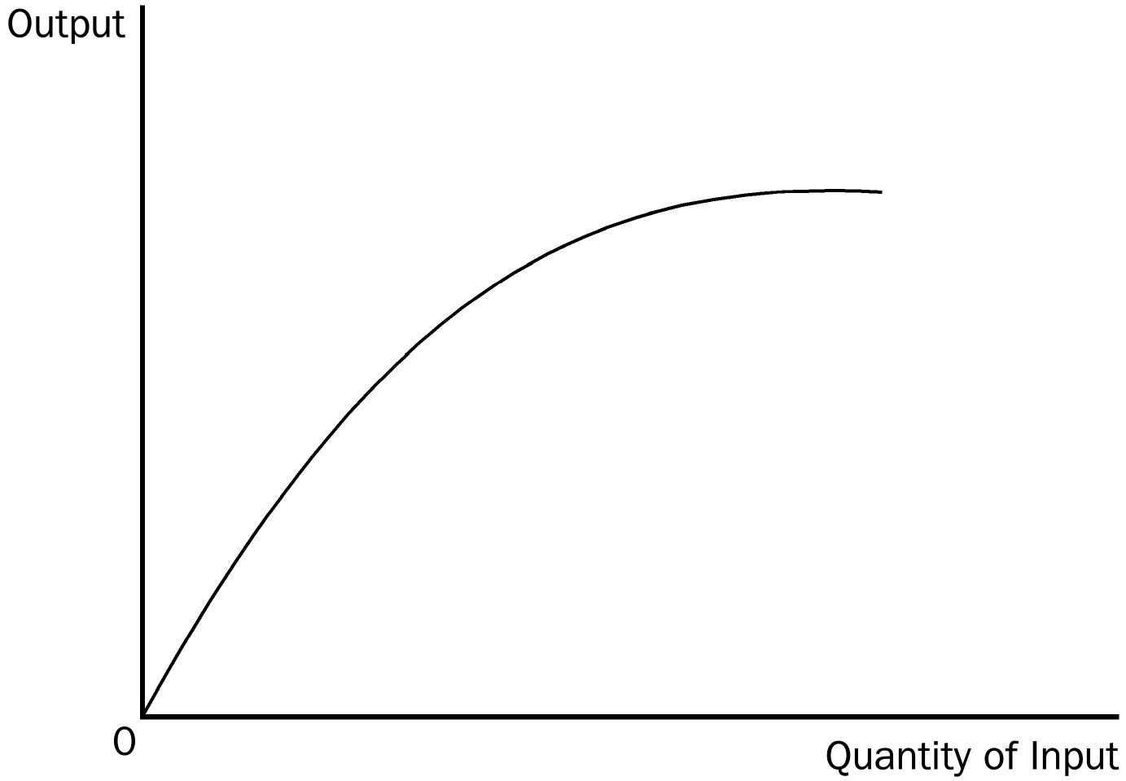
PTS: 1 DIF: 2 REF: 13-2
TOP: Production function MSC: Applicative
4. How would a production function that exhibits decreasing marginal product affect the shape of the total cost curve? Explain or draw a graph.
ANS:
The total cost curve will increase at an increasing rate, or in other words, the total cost curve gets steeper as the amount produced rises.
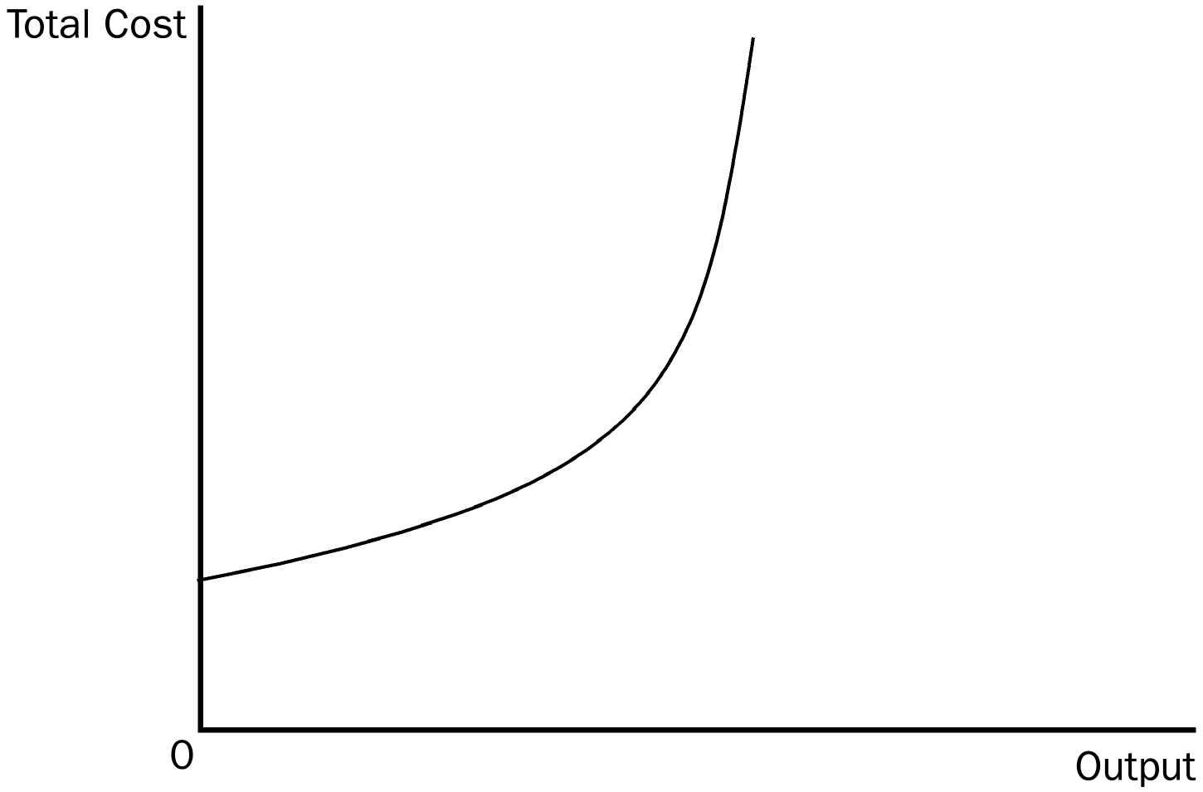
PTS: 1 DIF: 2 REF: 13-3
TOP: Diminishing marginal product MSC: Analytical
5. What effect, if any, does diminishing marginal product have on the shape of the marginal cost curve?
ANS:
Diminishing marginal product causes the marginal cost curve to rise.
PTS: 1 DIF: 2 REF: 13-3
TOP: Diminishing marginal product MSC: Analytical
6. Bob Edwards owns a bagel shop. Bob hires an economist who assesses the shape of the bagel shop’s average total cost (ATC) curve as a function of the number of bagels produced. The results indicate a U-shaped average total cost curve. Bob’s economist explains that ATC is U-shaped for two reasons. The first is the existence of diminishing marginal product, which causes it to rise. What would be the second reason? Assume that the marginal cost curve is linear. (Hint: The second reason relates to average fixed cost)
ANS:
Average fixed cost always declines as output rises because fixed cost is being spread over a larger number of units, thus causing the average total cost curve to fall.
PTS: 1 DIF: 3 REF: 13-3
TOP: Average fixed cost MSC: Analytical
7. If the average total cost curve is falling, what is necessarily true of the marginal cost curve? If the average total cost curve is rising, what is necessarily true of the marginal cost curve?
ANS:
When average total cost curve is falling it is necessarily above the marginal cost curve. If the average total cost curve is rising, it is necessarily below the marginal cost curve.
PTS: 1 DIF: 2 REF: 13-3
TOP: Average total cost MSC: Analytical
8. According to the mathematical laws that govern the relationship between average total cost and marginal cost, where must these two curves intersect?
ANS:
The two curves will cross at the minimum point on the average total cost curve.
PTS: 1 DIF: 2 REF: 13-3
TOP: Average total cost MSC: Analytical

