Chapter 14
Firms in Competitive Markets
Multiple Choice
1. A market is competitive if
(i) firms have the flexibility to price their own product.
(ii) each buyer is small compared to the market.
(iii) each seller is small compared to the market.
a. (i) and (ii) only
b. (i) and (iii) only
c. (ii) and (iii) only
d. All of the above are correct.
ANS: C PTS: 1 DIF: 1 REF: 14-1
TOP: Competitive markets MSC: Definitional
2. When a firm has little ability to influence market prices it is said to be in
a. a competitive market.
b. a strategic market.
c. a thin market.
d. a power market.
ANS: A PTS: 1 DIF: 1 REF: 14-1
TOP: Competitive markets MSC: Definitional
3. In a competitive market, the actions of any single buyer or seller will
a. have a negligible impact on the market price.
b. have little effect on overall production but will ultimately change final product price.
c. cause a noticeable change in overall production and a change in final product price.
d. adversely affect the profitability of more than one firm in the market.
ANS: A PTS: 1 DIF: 2 REF: 14-1
TOP: Competitive markets MSC: Interpretive
Table 14-1

Quantity | Price
1 | 13
2 | 13
3 | 13
4 | 13
5 | 13
6 | 13
7 | 13
8 | 13
9 | 13

4. Refer to Table 14-1. The price and quantity relationship in the table is most likely that faced by a firm in a
a. monopoly.
b. concentrated market.
c. competitive market.
d. strategic market.
ANS: C PTS: 1 DIF: 1 REF: 14-1
TOP: Competitive markets MSC: Analytical
5. Refer to Table 14-1. Over which range of output is average revenue equal to price?
a. 1 to 5
b. 3 to 7
c. 5 to 9
d. Average revenue is equal to price over the whole range of output.
ANS: D PTS: 1 DIF: 1 REF: 14-1
TOP: Average revenue MSC: Analytical
6. Refer to Table 14-1. Over what range of output is marginal revenue declining?
a. 1 to 6
b. 3 to 7
c. 7 to 9
d. None; marginal revenue is constant over the whole range of output.
ANS: D PTS: 1 DIF: 2 REF: 14-1
TOP: Marginal revenue MSC: Analytical
7. Refer to Table 14-1. If the firm doubles its output from 3 to 6 units, total revenue will
a. increase by less than $39.
b. increase by exactly $39.
c. increase by more than $39.
d. It cannot be determined from the information provided.
ANS: B PTS: 1 DIF: 1 REF: 14-1
TOP: Total revenue MSC: Applicative
8. For a firm in a perfectly competitive market, the price of the good is always
a. equal to marginal revenue.
b. equal to total revenue.
c. greater than average revenue.
d. equal to the firm’s efficient scale of output.
ANS: A PTS: 1 DIF: 1 REF: 14-1
TOP: Marginal revenue MSC: Interpretive
9. If a firm in a perfectly competitive market triples the number of units of output sold, then total revenue will
a. more than triple.
b. less than triple.
c. exactly triple.
d. Any of the above may be true depending on the firm’s labor productivity.
ANS: C PTS: 1 DIF: 1 REF: 14-1
TOP: Total revenue MSC: Analytical
10. Because the goods offered for sale in a competitive market are largely the same,
a. there will be few sellers in the market.
b. there will be few buyers in the market.
c. buyers will have market power.
d. sellers will have little reason to charge less than the going market price.
ANS: D PTS: 1 DIF: 1 REF: 14-1
TOP: Competitive markets MSC: Interpretive
11. Which of the following is NOT a characteristic of a perfectly competitive market?
a. Firms are price takers.
b. Firms have difficulty entering the market.
c. There are many sellers in the market.
d. Goods offered for sale are largely the same.
ANS: B PTS: 1 DIF: 1 REF: 14-1
TOP: Competitive markets MSC: Interpretive
12. When buyers in a competitive market take the selling price as given, they are said to be
a. market entrants.
b. monopolists.
c. free riders.
d. price takers.
ANS: D PTS: 1 DIF: 1 REF: 14-1
TOP: Competitive markets MSC: Definitional
13. When firms are said to be price takers, it implies that if a firm raises its price,
a. buyers will go elsewhere.
b. buyers will pay the higher price in the short run.
c. competitors will also raise their prices.
d. firms in the industry will exercise market power.
ANS: A PTS: 1 DIF: 2 REF: 14-1
TOP: Competitive markets MSC: Interpretive
14. Which of the following statements best reflects a price-taking firm?
a. If the firm were to charge more than the going price, it would sell none of its goods.
b. The firm has an incentive to charge less than the market price to earn higher revenue.
c. The firm can sell only a limited amount of output at the market price before the market price will fall.
d. Price-taking firms maximize profits by charging a price above marginal cost.
ANS: A PTS: 1 DIF: 2 REF: 14-1
TOP: Competitive markets MSC: Interpretive
15. In a competitive market, no single producer can influence the market price because
a. many other sellers are offering a product that is essentially identical.
b. consumers have more influence over the market price than producers do.
c. government intervention prevents firms from influencing price.
d. producers agree not to change the price.
ANS: A PTS: 1 DIF: 2 REF: 14-1
TOP: Competitive markets MSC: Interpretive
16. A competitive firm might choose to set its price below the market price, because
a. this would result in higher average revenue.
b. this would result in higher profits.
c. this would result in lower total costs.
d. None of the above is correct.
ANS: D PTS: 1 DIF: 2 REF: 14-1
TOP: Competitive markets MSC: Interpretive
17. Of the following characteristics of competitive markets, which are necessary for firms to be price takers?
(i) There are many sellers.
(ii) Firms can freely enter or exit the market.
(iii) Goods offered for sale are largely the same.
a. (i) and (ii) only
b. (i) and (iii) only
c. (ii) only
d. All are necessary.
ANS: B PTS: 1 DIF: 2 REF: 14-1
TOP: Competitive markets MSC: Interpretive
18. Suppose a firm in a competitive market produces and sells 8 units of output and has a marginal revenue of $8.00. What would be the firm’s total revenue if it instead produced and sold 4 units of output?
a. $4.00
b. $8.00
c. $32.00
d. $64.00
ANS: C PTS: 1 DIF: 2 REF: 14-1
TOP: Marginal revenue MSC: Applicative
19. Suppose a firm in a competitive market received $1,000 in total revenue and had a marginal revenue of $10 for the last unit produced and sold. What is the average revenue per unit, and how many units were sold?
a. $5 and 50
b. $5 and 100
c. $10 and 50
d. $10 and 100
ANS: D PTS: 1 DIF: 2 REF: 14-1
TOP: Average revenue MSC: Applicative
20. Whenever a perfectly competitive firm chooses to change its level of output, holding the price of the product constant, its marginal revenue
a. increases if MR < ATC and decreases if MR > ATC.
b. does not change.
c. increases.
d. decreases.
ANS: B PTS: 1 DIF: 1 REF: 14-1
TOP: Competitive firms MSC: Interpretive
21. Suppose a firm in a competitive market reduces its output by 20 percent. As a result, the price of its output is likely to
a. increase.
b. remain unchanged.
c. decrease by less than 20 percent.
d. decrease by more than 20 percent.
ANS: B PTS: 1 DIF: 1 REF: 14-1
TOP: Competitive markets MSC: Analytical
22. Changes in the output of a perfectly competitive firm, without any change in the price of the product, will change the firm’s
a. total revenue.
b. marginal revenue.
c. average revenue.
d. All of the above are correct.
ANS: A PTS: 1 DIF: 2 REF: 14-1
TOP: Total revenue MSC: Analytical
23. When a profit-maximizing firm in a competitive market has zero economic profit, accounting profit
a. is negative (accounting losses).
b. is positive.
c. is also zero.
d. could be positive, negative or zero.
ANS: B PTS: 1 DIF: 2 REF: 14-1
TOP: Economic profit MSC: Interpretive
24. As a general rule, when accountants calculate profit they account for explicit costs but usually ignore
a. certain outlays of money by the firm.
b. implicit costs.
c. operating costs.
d. fixed costs.
ANS: B PTS: 1 DIF: 1 REF: 14-1
TOP: Implicit costs MSC: Interpretive
25. In calculating accounting profit, accountants typically don’t include
a. long-run costs.
b. sunk costs.
c. explicit costs of production.
d. opportunity costs that do not involve an outflow of money.
ANS: D PTS: 1 DIF: 1 REF: 14-1
TOP: Accounting profit MSC: Interpretive
Scenario 14-1
As part of an estate settlement Mary received $1 million. She decided to use the money to purchase a small business in Anywhere, USA. If Mary would have invested the $1 million in a risk-free bond fund she could have made $100,000 each year. She also quit her job with Lucky.Com Inc. to devote all of her time to her new business; her salary at Lucky.Com Inc. was $75,000 per year.
26. Refer to Scenario 14-1. At the end of the first year of operating her new business, Mary’s accountant reported an accounting profit of $150,000. What was Mary’s economic profit?
a. $25,000 loss
b. $50,000 loss
c. $25,000 profit
d. $150,000 profit
ANS: A PTS: 1 DIF: 2 REF: 14-1
TOP: Economic profit MSC: Applicative
27. Refer to Scenario 14-1. What are Mary’s opportunity costs of operating her new business?
a. $25,000
b. $75,000
c. $100,000
d. $175,000
ANS: D PTS: 1 DIF: 2 REF: 14-1
TOP: Opportunity cost MSC: Applicative
28. Refer to Scenario 14-1. How large would Mary’s accounting profits need to be to allow her to attain zero economic profit?
a. $100,000
b. $125,000
c. $175,000
d. $225,000
ANS: C PTS: 1 DIF: 2 REF: 14-1
TOP: Economic profit MSC: Applicative
29. The Wheeler Wheat Farm sells wheat to a grain broker in Seattle, Washington. Since the market for wheat is generally considered to be competitive, the Wheeler Farm does not
a. choose the quantity of wheat to produce.
b. choose the price at which it sells its wheat.
c. have any fixed costs of production.
d. set marginal revenue equal to marginal cost to maximize profit.
ANS: B PTS: 1 DIF: 1 REF: 14-1
TOP: Competitive markets MSC: Interpretive
30. In a competitive market,
a. no single buyer or seller can influence the price of the product.
b. there is a small number of sellers.
c. the goods offered by the different sellers are markedly different.
d. accounting profit is driven to zero as firms freely enter and exit the market.
ANS: A PTS: 1 DIF: 1 REF: 14-1
TOP: Competitive markets MSC: Interpretive
31. If ABC Company sells its product in a competitive market, then
a. the price of that product depends on the quantity of the product that ABC Company produces and sells since ABC Company’s demand curve is downward sloping.
b. ABC Company’s total revenue must be proportional to its quantity of output.
c. ABC Company’s total cost must be proportional to its quantity of output.
d. ABC Company’s total revenue must be equal to its average revenue.
ANS: B PTS: 1 DIF: 2 REF: 14-1
TOP: Total revenue MSC: Analytical
32. Which of the following expressions is correct for a competitive firm?
a. Profit = (Quantity of output) x (Price - Average total cost)
b. Marginal revenue = (Change in total revenue)/(Quantity of output)
c. Average cost = Total variable cost/Quantity of output
d. Average revenue = (Marginal revenue) x (Quantity of output)
ANS: A PTS: 1 DIF: 2 REF: 14-1
TOP: Profit MSC: Definitional
33. For a competitive firm,
a. Total revenue = Average revenue.
b. Total revenue = Marginal revenue.
c. Total cost = Marginal revenue.
d. Average revenue = Marginal revenue.
ANS: D PTS: 1 DIF: 1 REF: 14-1
TOP: Competitive firms MSC: Definitional
34. If a competitive firm is (i) selling 1,000 units of its product at a price of $9 per unit and (ii) earning a positive profit, then
a. its total cost is less than $9,000.
b. its marginal revenue is less than $9.
c. its average revenue is greater than $9.
d. the firm cannot be a competitive firm since competitive firms can only earn zero profit.
ANS: A PTS: 1 DIF: 2 REF: 14-1
TOP: Profit MSC: Analytical
35. When a competitive firm triples the amount of output it sells,
a. its total revenue triples.
b. its average revenue triples.
c. its marginal revenue triples.
d. its profit must increase.
ANS: A PTS: 1 DIF: 2 REF: 14-1
TOP: Total revenue MSC: Analytical
36. Which of the following statements regarding a competitive market is false?
a. There are many buyers and many sellers in the market.
b. Because of firm location or product differences, some firms can charge a higher price than other firms and still maintain their sales volume.
c. Price and average revenue are equal.
d. Price and marginal revenue are equal.
ANS: B PTS: 1 DIF: 1 REF: 14-1
TOP: Perfect competition MSC: Interpretive
37. Suppose that in a competitive market the market price is $2.50. What is marginal revenue for the last unit sold by the typical firm in this market?
a. Less than $2.50.
b. More than $2.50.
c. $2.50.
d. The marginal revenue cannot be determined without knowing the actual quantity sold by the typical firm.
ANS: C PTS: 1 DIF: 1 REF: 14-1
TOP: Marginal revenue MSC: Interpretive
38. Which of the following statements regarding a competitive firm is true?
a. Since demand is downward sloping, if a firm increases its level of output, the firm will have to charge a lower price to sell the additional output.
b. If a firm raises its price, the firm may be able to increase its total revenue even though it will sell fewer units.
c. By lowering its price below the market price, the firm will benefit from being able to sell more units at the lower price than it could have sold by charging the market price.
d. For all firms, average revenue equals the price of the good.
ANS: D PTS: 1 DIF: 2 REF: 14-1
TOP: Average revenue MSC: Analytical
Table 14-2
The following table presents cost and revenue information for Soper’s Port Vineyard.

COSTS |  |  | REVENUES
Quantity Produced | Total  Cost | Marginal  Cost | Quantity Demanded | Price | Total  Revenue | Marginal Revenue
0 | 100 | -- | 0 | 120 |  | --
1 | 150 |  | 1 | 120
2 | 202 |  | 2 | 120
3 | 257 |  | 3 | 120
4 | 317 |  | 4 | 120
5 | 385 |  | 5 | 120
6 | 465 |  | 6 | 120
7 | 562 |  | 7 | 120
8 | 682 |  | 8 | 120

39. Refer to Table 14-2. Consumers are willing to pay $120 per unit of port wine. What is the total revenue from selling 7 units?
a. $120
b. $700
c. $820
d. $840
ANS: D PTS: 1 DIF: 2 REF: 14-1
TOP: Total revenue MSC: Applicative
40. Refer to Table 14-2. Consumers are willing to pay $120 per unit of port wine. What is the total revenue from selling 4 units?
a. $120
b. $217
c. $263
d. $480
ANS: D PTS: 1 DIF: 2 REF: 14-1
TOP: Total revenue MSC: Applicative
41. Refer to Table 14-2. Consumers are willing to pay $120 per unit of port wine. What is the marginal revenue from selling the 3rd unit?
a. $50
b. $80
c. $120
d. $140
ANS: C PTS: 1 DIF: 2 REF: 14-1
TOP: Marginal revenue MSC: Applicative
42. Refer to Table 14-2. Consumers are willing to pay $120 per unit of port wine. What is the average revenue when 4 units are sold?
a. $50
b. $120
c. $125
d. $130
ANS: B PTS: 1 DIF: 2 REF: 14-1
TOP: Average revenue MSC: Applicative
43. Refer to Table 14-2. Consumers are willing to pay $120 per unit of port wine. What is the marginal cost of the 1st unit?
a. $50
b. $75
c. $80
d. $150
ANS: A PTS: 1 DIF: 2 REF: 14-2
TOP: Marginal cost MSC: Applicative
44. Refer to Table 14-2. Consumers are willing to pay $120 per unit of port wine. What is the marginal cost of the 8th unit?
a. $0
b. $100
c. $120
d. $140
ANS: C PTS: 1 DIF: 2 REF: 14-2
TOP: Marginal cost MSC: Applicative
45. Refer to Table 14-2. Consumers are willing to pay $120 per unit of port wine. What is Soper’s Port Vineyard’s economic profit at their profit maximizing point?
a. $78
b. $243
c. $278
d. $375
ANS: C PTS: 1 DIF: 2 REF: 14-2
TOP: Economic profit MSC: Applicative
46. One of the defining characteristics of a perfectly competitive market is
a. a small number of sellers.
b. a large number of buyers and a small number of sellers.
c. a standardized product.
d. significant advertising by firms to promote their products.
ANS: C PTS: 1 DIF: 1 REF: 14-1
TOP: Perfect competition MSC: Definitional
47. Which of the following firms is the closest to being a perfectly competitive firm?
a. A hot dog vendor in New York
b. Microsoft Corporation
c. Ford Motor Company
d. The campus bookstore
ANS: A PTS: 1 DIF: 1 REF: 14-1
TOP: Perfect competition MSC: Interpretive
48. If the market elasticity of demand for potatoes is -0.3 in a perfectly competitive market, then the individual farmer’s elasticity of demand
a. will also be -0.3.
b. depends on how large a crop the farmer produces.
c. will range between -0.3 and -1.0.
d. will be infinite.
ANS: D PTS: 1 DIF: 3 REF: 14-1
TOP: Elasticity MSC: Analytical
49. Free entry means that
a. there are no costs of entering into an industry.
b. no legal barriers prevent a firm from entering an industry.
c. a firm’s marginal cost is zero.
d. a firm has no fixed costs in the short run.
ANS: B PTS: 1 DIF: 2 REF: 14-1
TOP: Entry into industry MSC: Interpretive
50. Total profit for a firm is calculated as
a. (marginal revenue) minus (average cost).
b. (average revenue) minus (average cost).
c. (marginal revenue) minus (marginal cost).
d. (price minus average cost) times (quantity of output).
ANS: D PTS: 1 DIF: 1 REF: 14-2
TOP: Profit MSC: Definitional
Table 14-3
Use the information for a competitive firm in the table below to answer the following questions.

Quantity | Total Revenue | Total Cost
0 | $0 | $10
1 | 9 | 14
2 | 18 | 19
3 | 27 | 25
4 | 36 | 32
5 | 45 | 40
6 | 54 | 49
7 | 63 | 59
8 | 72 | 70
9 | 81 | 82

51. Refer to Table 14-3. At a production level of 4 units which of the following is true?
a. Marginal cost is $6.
b. Total revenue is greater than variable cost.
c. Marginal revenue is less than marginal cost.
d. The firm is maximizing profit.
ANS: B PTS: 1 DIF: 2 REF: 14-2
TOP: Competitive firms MSC: Analytical
52. Refer to Table 14-3. At which quantity of output is marginal revenue equal to marginal cost?
a. 3
b. 6
c. 8
d. 9
ANS: B PTS: 1 DIF: 2 REF: 14-2
TOP: Profit maximization MSC: Applicative
53. Refer to Table 14-3. If this firm chooses to maximize profit it will choose a level of output where marginal revenue is equal to
a. 6
b. 7
c. 8
d. 9
ANS: D PTS: 1 DIF: 2 REF: 14-2
TOP: Profit maximization MSC: Applicative
54. Refer to Table 14-3. The maximum profit available to this firm is
a. $2
b. $3
c. $4
d. $5
ANS: D PTS: 1 DIF: 1 REF: 14-2
TOP: Profit MSC: Applicative
55. Refer to Table 14-3. If the firm finds that its marginal cost is $11, it should
a. increase production to maximize profit.
b. increase the price of the product to maximize profit.
c. advertise to attract additional buyers to maximize profit.
d. reduce production to increase profit.
ANS: D PTS: 1 DIF: 2 REF: 14-2
TOP: Profit maximization MSC: Analytical
56. Refer to Table 14-3. If the firm finds that its marginal cost is $5, it should
a. reduce fixed costs by lowering production.
b. increase production to maximize profit.
c. decrease production to maximize profit.
d. maintain its current level of production to maximize profit.
ANS: B PTS: 1 DIF: 2 REF: 14-2
TOP: Profit maximization MSC: Analytical
57. The Wheeler Wheat Farm sells wheat to a grain broker in Seattle, Washington. Since the market for wheat is generally considered to be competitive, the Wheeler Wheat Farm maximizes its profit by choosing
a. to produce the quantity at which average variable cost is minimized.
b. to produce the quantity at which average fixed cost is minimized.
c. to sell its wheat at a price where marginal cost is equal to average total cost.
d. the quantity at which market price is equal to the farm’s marginal cost of production.
ANS: D PTS: 1 DIF: 2 REF: 14-2
TOP: Profit maximization MSC: Analytical
58. Comparison of marginal revenue to marginal cost
(i) reveals the contribution of the last unit of production to total profit.
(ii) is helpful in making profit-maximizing production decisions.
(iii) tells a firm whether its fixed costs are too high.
a. (i) only
b. (i) and (ii) only
c. (ii) and (iii) only
d. (i) and (iii) only
ANS: B PTS: 1 DIF: 2 REF: 14-2
TOP: Profit maximization MSC: Interpretive
59. If marginal cost exceeds marginal revenue, the firm
a. is most likely to be at a profit-maximizing level of output.
b. should increase the level of production to maximize its profit.
c. must be experiencing losses.
d. may still be earning a positive accounting profit.
ANS: D PTS: 1 DIF: 2 REF: 14-2
TOP: Profit maximization MSC: Analytical
60. When marginal revenue equals marginal cost, the firm
a. should increase the level of production to maximize its profit.
b. may be minimizing its losses, rather than maximizing its profit.
c. must be generating positive economic profits.
d. must be generating positive accounting profits.
ANS: B PTS: 1 DIF: 2 REF: 14-2
TOP: Profit maximization MSC: Analytical
61. As a general rule, profit-maximizing producers in a competitive market produce output at a point where
a. marginal cost is increasing.
b. marginal cost is decreasing.
c. marginal revenue is increasing.
d. price is less than marginal revenue.
ANS: A PTS: 1 DIF: 2 REF: 14-2
TOP: Profit maximization MSC: Analytical
62. When calculating marginal cost, what must the firm know?
a. Sunk cost
b. Variable cost
c. Fixed cost
d. Price
ANS: B PTS: 1 DIF: 2 REF: 14-2
TOP: Marginal cost MSC: Interpretive
Figure 14-1
The graph below depicts the cost structure for a firm in a competitive market.
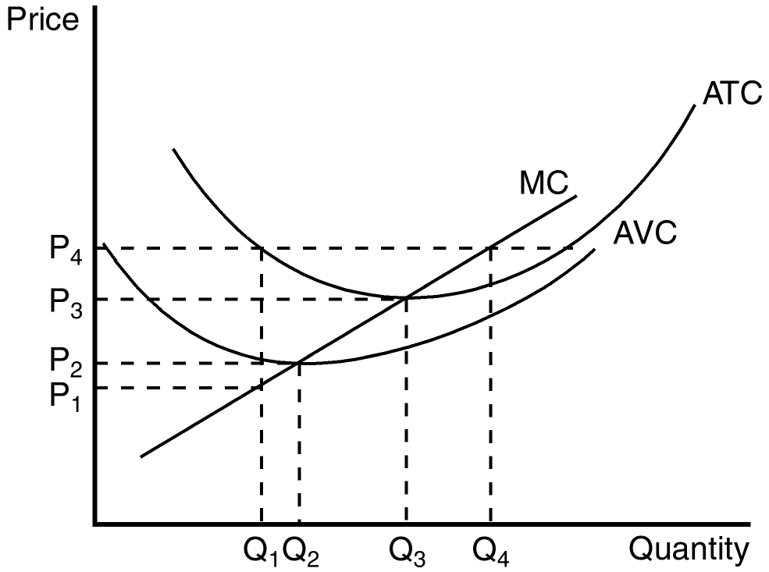
63. Refer to Figure 14-1. When price rises from P₂ to P₃, the firm finds that
a. marginal cost exceeds marginal revenue at a production level of Q₂.
b. if it produces at output level Q₃ it will earn a positive profit.
c. expanding output to Q₄ would leave the firm with losses.
d. it could increase profits by lowering output from Q₃ to Q₂.
ANS: C PTS: 1 DIF: 2 REF: 14-2
TOP: Profit maximization MSC: Analytical
64. Refer to Figure 14-1. When price falls from P₃ to P₁, the firm finds that
a. fixed cost is higher at a production level of Q₁ than it is at Q₃.
b. it should produce Q₁ units of output.
c. it should produce Q₃ units of output.
d. it should shut down immediately.
ANS: D PTS: 1 DIF: 2 REF: 14-2
TOP: Profit maximization MSC: Analytical
65. Refer to Figure 14-1. When price rises from P₃ to P₄, the firm finds that
a. fixed costs are lower at a production level of Q₄.
b. it can earn a positive profit by increasing production to Q₄.
c. profit is still maximized at a production level of Q₃.
d. average revenue exceeds marginal revenue at a production level of Q₄.
ANS: B PTS: 1 DIF: 2 REF: 14-2
TOP: Profit maximization MSC: Analytical
66. A profit-maximizing firm in a competitive market will always make marginal adjustments to production as long as
a. average revenue is greater than average total cost.
b. average revenue is equal to marginal cost.
c. marginal cost is greater than average total cost.
d. price is above or below marginal cost.
ANS: D PTS: 1 DIF: 2 REF: 14-2
TOP: Profit maximization MSC: Interpretive
67. When price is greater than marginal cost for a firm in a competitive market,
a. marginal cost must be falling.
b. the firm must be minimizing its losses.
c. there are opportunities to increase profit by increasing production.
d. the firm should decrease output to maximize profit.
ANS: C PTS: 1 DIF: 2 REF: 14-2
TOP: Profit maximization MSC: Analytical
68. The short-run supply curve for a firm in a perfectly competitive market is
a. horizontal.
b. likely to slope downward.
c. determined by forces external to the firm.
d. the portion of its marginal cost curve that lies above its average variable cost.
ANS: D PTS: 1 DIF: 2 REF: 14-2
TOP: Supply curve MSC: Interpretive
69. When a perfectly competitive firm decides to shut down, it is most likely that
a. marginal cost is above average variable cost.
b. marginal cost is above average total cost.
c. price is below the firm’s average variable cost.
d. fixed costs exceed variable costs.
ANS: C PTS: 1 DIF: 2 REF: 14-2
TOP: Profit maximization MSC: Interpretive
70. When total revenue is less than variable costs, a firm in a competitive market will
a. continue to operate as long as average revenue exceeds marginal cost.
b. continue to operate as long as average revenue exceeds average fixed cost.
c. shut down.
d. raise its price.
ANS: C PTS: 1 DIF: 2 REF: 14-2
TOP: Profit maximization MSC: Analytical
71. When price is below average variable cost, a firm in a competitive market will
a. shut down and incur fixed costs.
b. shut down and incur both variable and fixed costs.
c. continue to operate as long as average revenue exceeds marginal cost.
d. continue to operate as long as average revenue exceeds average fixed cost.
ANS: A PTS: 1 DIF: 2 REF: 14-2
TOP: Profit maximization MSC: Interpretive
Figure 14-2
The figure below depicts the cost structure of a profit-maximizing firm in a competitive market.

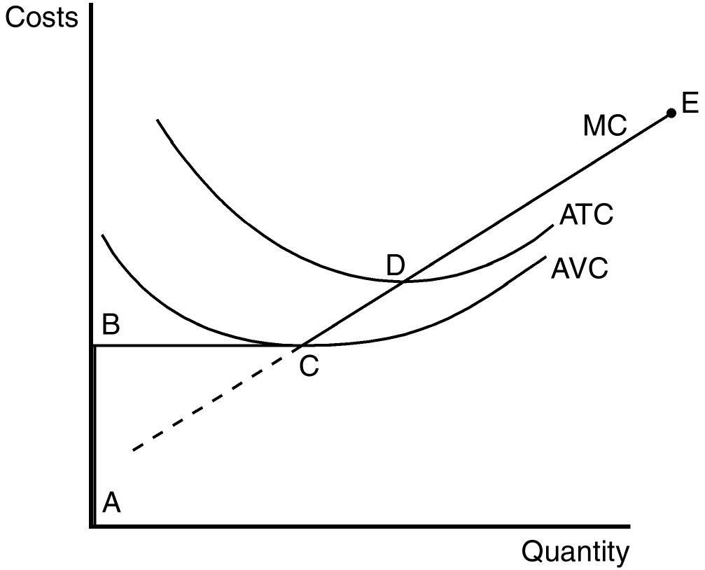
72. Refer to Figure 14-2. Which line segment best reflects the short-run supply curve for this firm?
a. ABCE
b. CD
c. DE
d. BCD
ANS: A PTS: 1 DIF: 2 REF: 14-2
TOP: Supply curve MSC: Interpretive
73. Refer to Figure 14-2. If the firm is in a short-run position where P < AVC, it is most likely to be on what segment of its supply curve?
a. BC
b. CD
c. DE
d. AB
ANS: D PTS: 1 DIF: 2 REF: 14-2
TOP: Supply curve MSC: Interpretive
Figure 14-3
The figure below depicts the cost structure of a profit-maximizing firm in a competitive market.

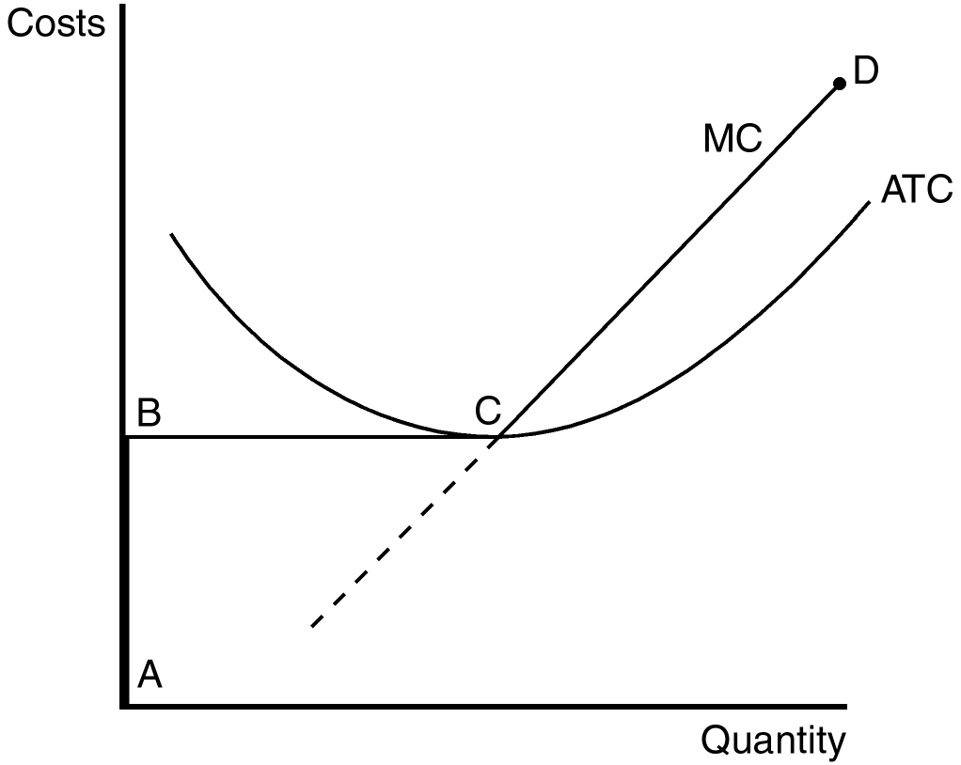
74. Refer to Figure 14-3. Which line segment best reflects the long-run supply curve for this firm?
a. ABCD
b. BC
c. ABC
d. None of the above, the long-run supply curve requires knowledge of the average variable cost structure.
ANS: A PTS: 1 DIF: 2 REF: 14-2
TOP: Supply curve MSC: Interpretive
75. Refer to Figure 14-3. This firm will exit the market for any price on the line segment
a. AB
b. BC
c. CD
d. None of the above
ANS: A PTS: 1 DIF: 2 REF: 14-2
TOP: Supply curve MSC: Interpretive
76. When economists refer to a production cost that has already been committed and cannot be recovered, they use the term
a. implicit cost.
b. explicit cost.
c. variable cost.
d. sunk cost.
ANS: D PTS: 1 DIF: 1 REF: 14-2
TOP: Sunk costs MSC: Definitional
77. Suppose a profit-maximizing firm in a competitive market produces rubber bands. When the market price for rubber bands falls below the minimum of its average total cost, but still lies above the minimum of average variable cost, the firm
a. will experience losses but will continue to produce rubber bands.
b. will shut down.
c. will be earning both economic and accounting profits.
d. should raise the price of its product.
ANS: A PTS: 1 DIF: 2 REF: 14-2
TOP: Profit maximization MSC: Analytical
78. Which of the following statements best reflects the production decision of a profit-maximizing firm in a competitive market when price falls below the minimum of average variable cost?
a. The firm will continue to produce to attempt to pay fixed costs.
b. The firm will immediately stop production to minimize its losses.
c. The firm will stop production as soon as it is able to pay its sunk costs.
d. The firm will continue to produce in the short run but will likely exit the market in the long run.
ANS: B PTS: 1 DIF: 2 REF: 14-2
TOP: Profit maximization MSC: Interpretive
79. When fixed costs are ignored because they are irrelevant to a business’s production decision, they are called
a. explicit costs.
b. implicit costs.
c. sunk costs.
d. opportunity costs.
ANS: C PTS: 1 DIF: 1 REF: 14-2
TOP: Sunk costs MSC: Interpretive
80. Shrimp Galore, a shrimp harvesting business in the Pacific Northwest, has a 30-year loan on its shrimp harvesting boat. The annual loan payment is $25,000 and the boat has a market (salvage) value that exceeds its outstanding loan balance. Prior to the 2001 shrimp harvesting season, Shrimp Galore’s accountant predicted that at expected market prices for shrimp, Shrimp Galore would have a net loss of $75,000 dollars after paying all 2001 expenses (including the annual loan payment). In this case, Shrimp Galore should
a. produce nothing and experience a loss of $25,000.
b. produce nothing and experience a loss of $75,000.
c. continue to operate because expected profits will rise in the future.
d. continue to operate even though it predicts a loss of $75,000.
ANS: A PTS: 1 DIF: 2 REF: 14-2
TOP: Profit maximization MSC: Analytical
81. A profit-maximizing firm will shut down in the short run when
a. price is less than average variable cost.
b. price is less than average total cost.
c. average revenue is greater marginal cost.
d. average revenue is greater than average fixed cost.
ANS: A PTS: 1 DIF: 2 REF: 14-2
TOP: Profit maximization MSC: Interpretive
82. In the long run, all of a firm’s costs are variable. In this case the exit criterion for a profit-maximizing firm is to
a. shutdown if price is less than average total cost.
b. shutdown if price is greater than average total cost.
c. shutdown if average revenue is greater than average fixed cost.
d. shutdown if average revenue is greater than marginal cost.
ANS: A PTS: 1 DIF: 2 REF: 14-2
TOP: Profit maximization MSC: Interpretive
83. When profit-maximizing firms in competitive markets are earning profits,
a. market demand must exceed market supply at the market equilibrium price.
b. market supply must exceed market demand at the market equilibrium price.
c. new firms will enter the market.
d. the most inefficient firms will be encouraged to leave the market.
ANS: C PTS: 1 DIF: 2 REF: 14-2
TOP: Competitive markets MSC: Interpretive
84. Profit-maximizing firms enter a competitive market when, for existing firms in that market,
a. total revenue exceeds fixed costs.
b. total revenue exceeds total variable costs.
c. average total cost exceeds average revenue.
d. price exceeds average total cost.
ANS: D PTS: 1 DIF: 2 REF: 14-2
TOP: Profit maximization MSC: Interpretive
Figure 14-4
The figure below depicts the cost structure of a firm in a competitive market.

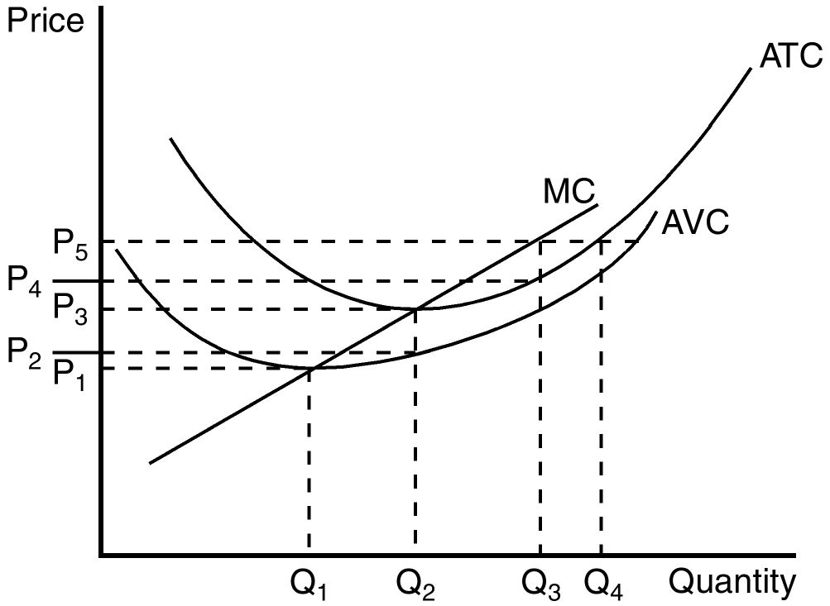

85. Refer to Figure 14-4. When market price is P₅, a profit-maximizing firm’s profits can be represented by the area
a. P₅ Q₃.
b. (P₅ - P₃) Q₂.
c. (P₅ - P₄) Q₃.
d. When market price is P₅ there are no profits.
ANS: C PTS: 1 DIF: 2 REF: 14-2
TOP: Profit MSC: Analytical
86. Refer to Figure 14-4. Firms would be encouraged to enter this market for all prices that exceed
a. P₁.
b. P₂.
c. P₃.
d. None of the above is correct.
ANS: C PTS: 1 DIF: 2 REF: 14-2
TOP: Profit MSC: Analytical
87. Refer to Figure 14-4. When market price is P₂, a profit-maximizing firm’s losses can be represented by the area
a. (P₃ - P₂) Q₂.
b. (P₂ - P₁) Q₂.
c. At a market price of P₂, the firm does not have losses.
d. At a market price of P₂ the firm has losses, but the reference points in the figure don’t identify the losses.
ANS: D PTS: 1 DIF: 2 REF: 14-2
TOP: Profit MSC: Analytical
Figure 14-5
The figure below depicts the cost structure of a firm in a competitive market.
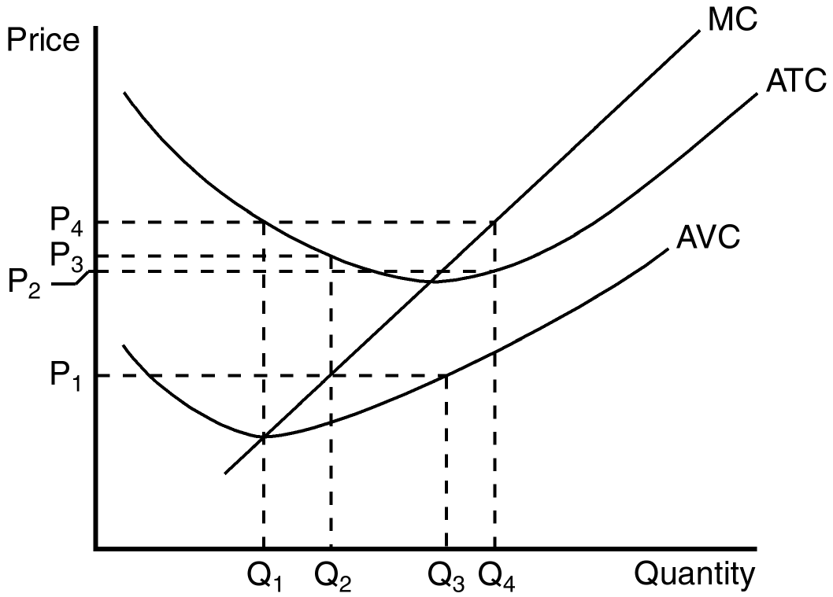
88. Refer to Figure 14-5. When market price is P₁, a profit-maximizing firm’s total revenue can be represented by the area
a. P₁ × Q₂.
b. P₂ × Q₂.
c. P₃ × Q₂.
d. P₁ × Q₃.
ANS: A PTS: 1 DIF: 2 REF: 14-2
TOP: Total revenue MSC: Analytical
89. Refer to Figure 14-5. When market price is P₄, a profit-maximizing firm’s total cost can be represented by the area
a. P₄ × Q₁
b. P₄ × Q₄
c. P₂ × Q₄
d. Total costs cannot be determined from the information in the figure.
ANS: C PTS: 1 DIF: 2 REF: 14-2
TOP: Total cost MSC: Analytical
90. Refer to Figure 14-5. When market price is P₁, a profit-maximizing firm’s total profit or loss can be represented by which area?
a. P₁ × Q₃; profit
b. (P₃ – P₁) × Q₂ ; loss
c. (P₂ – P₁) × Q₁; loss
d. We can’t tell because we don’t know fixed costs.
ANS: B PTS: 1 DIF: 2 REF: 14-2
TOP: Profit MSC: Analytical
91. When a profit-maximizing firm is earning profits, those profits can be identified by
a. P × Q.
b. (MC – AVC) × Q.
c. (P – ATC) × Q.
d. (P – AVC) × Q.
ANS: C PTS: 1 DIF: 2 REF: 14-2
TOP: Profit MSC: Interpretive
92. When a profit-maximizing competitive firm finds itself minimizing losses because it is unable to earn a positive profit, this task is accomplished by producing the quantity at which price is equal to
a. sunk cost.
b. average fixed cost.
c. average variable cost.
d. marginal cost.
ANS: D PTS: 1 DIF: 2 REF: 14-2
TOP: Profit maximization MSC: Interpretive
93. When a profit-maximizing firm’s fixed costs are considered sunk in the short run, then the firm
a. can set price above marginal cost.
b. must set price below average total cost.
c. will never show losses.
d. can safely ignore fixed costs when deciding how much output to produce.
ANS: D PTS: 1 DIF: 2 REF: 14-2
TOP: Sunk costs MSC: Interpretive
94. A competitive firm’s short-run supply curve is part of which of the following curves?
a. Marginal revenue
b. Average variable cost
c. Average total cost
d. Marginal cost
ANS: D PTS: 1 DIF: 2 REF: 14-2
TOP: Supply curve MSC: Definitional
95. If a profit-maximizing firm in a competitive market discovers that, at its current level of production, price is greater than marginal cost, it should
a. shut down.
b. reduce its output, but continue operating.
c. keep output the same.
d. increase its output.
ANS: D PTS: 1 DIF: 2 REF: 14-2
TOP: Profit maximization MSC: Interpretive
96. For any given price, a firm in a competitive market will maximize profit by selecting the level of output at which price intersects the
a. average total cost curve.
b. average variable cost curve.
c. marginal cost curve.
d. marginal revenue curve.
ANS: C PTS: 1 DIF: 2 REF: 14-2
TOP: Profit maximization MSC: Interpretive
97. By comparing marginal revenue and marginal cost, a firm in a competitive market is able to adjust production to the level that achieves its objective, which we assume to be
a. maximization of total revenue.
b. maximization of profit.
c. minimization of variable cost.
d. minimization of average total cost.
ANS: B PTS: 1 DIF: 2 REF: 14-2
TOP: Profit maximization MSC: Interpretive
98. When a restaurant stays open for lunch service even though few customers patronize the restaurant for lunch, which of the following principles is (are) best demonstrated?
(i) Fixed costs are sunk in the short run.
(ii) In the short run, only fixed costs are important to the decision to stay open for lunch.
(iii) If revenue exceeds variable cost, the restaurant owner is making a profitable strategic decision to remain open for lunch.
a. (i) and (ii) only
b. (ii) and (iii) only
c. (i) and (iii) only
d. All are demonstrated.
ANS: C PTS: 1 DIF: 2 REF: 14-2
TOP: Profit maximization MSC: Interpretive
99. In the long run, a profit-maximizing firm will choose to exit a market when
a. average fixed cost is falling.
b. variable costs exceed sunk costs.
c. marginal cost exceeds marginal revenue at the current level of production.
d. total revenue is less than total cost.
ANS: D PTS: 1 DIF: 2 REF: 14-2
TOP: Profit maximization MSC: Analytical
100. One of the most important determinants of the success of free-market capitalism is
a. enlightened governments selecting firms that should not be allowed to exit a market.
b. free entry and exit in markets.
c. government regulation of market participants.
d. having a few large firms rather than thousands of small ones.
ANS: B PTS: 1 DIF: 2 REF: 14-2
TOP: Competitive markets MSC: Interpretive
101. A profit-maximizing firm in a competitive market is currently producing 200 units of output. It has average revenue of $9 and average total cost of $7. It follows that the firm’s
a. average total cost curve intersects the marginal cost curve at an output level of less than 200 units.
b. average variable cost curve intersects the marginal cost curve at an output level of less than 200 units.
c. profit is $400.
d. All of the above are correct.
ANS: D PTS: 1 DIF: 3 REF: 14-2
TOP: Profit maximization MSC: Applicative
102. A profit-maximizing firm in a competitive market is able to sell its product for $7. At its current level of output, the firm’s average total cost is $10. The firm’s marginal cost curve crosses its marginal revenue curve at an output level of 9 units. The firm experiences a
a. profit of more than $27.
b. profit of exactly $27.
c. loss of more than $27.
d. loss of exactly $27.
ANS: D PTS: 1 DIF: 3 REF: 14-2
TOP: Profit MSC: Applicative
103. If a competitive firm is currently producing a level of output at which marginal revenue exceeds marginal cost, then
a. a one-unit increase in output will increase the firm’s profit.
b. a one-unit decrease in output will increase the firm’s profit.
c. total revenue exceeds total cost.
d. total cost exceeds total revenue.
ANS: A PTS: 1 DIF: 2 REF: 14-2
TOP: Competitive firms MSC: Analytical
104. If a competitive firm is currently producing a level of output at which marginal cost exceeds marginal revenue, then
a. average revenue exceeds marginal cost.
b. the firm is earning a positive profit.
c. a one-unit decrease in output would increase the firm’s profit.
d. All of the above are correct.
ANS: C PTS: 1 DIF: 2 REF: 14-2
TOP: Competitive firms MSC: Analytical
105. If a competitive firm is currently producing a level of output at which profit is not maximized, then it must be true that
a. marginal revenue exceeds marginal cost.
b. marginal cost exceeds marginal revenue.
c. total cost exceeds total revenue.
d. None of the above is correct.
ANS: D PTS: 1 DIF: 2 REF: 14-2
TOP: Profit maximization MSC: Interpretive
106. At the profit-maximizing level of output,
a. marginal revenue equals average total cost.
b. marginal revenue equals average variable cost.
c. marginal revenue equals marginal cost.
d. average revenue equals average total cost.
ANS: C PTS: 1 DIF: 2 REF: 14-2
TOP: Profit maximization MSC: Interpretive
107. The intersection of a firm’s marginal revenue and marginal cost curves determines the level of output at which
a. total revenue is equal to variable cost.
b. total revenue is equal to fixed cost.
c. total revenue is equal to total cost.
d. profit is maximized.
ANS: D PTS: 1 DIF: 2 REF: 14-2
TOP: Profit maximization MSC: Interpretive
108. For a certain firm, the 100th unit of output that the firm produces has a marginal revenue of $10 and a marginal cost of $7. It follows that
a. the production of the 100th unit of output increases the firm’s profit by $3.
b. the production of the 100th unit of output increases the firm’s average total cost by $7.
c. the firm’s profit-maximizing level of output is less than 100 units.
d. the production of the 110th unit of output must increase the firm’s profit by less than $3.
ANS: A PTS: 1 DIF: 2 REF: 14-2
TOP: Profit maximization MSC: Analytical
109. A certain competitive firm sells its output for $20 per unit. The 50th unit of output that the firm produces has a marginal cost of $22. Which of following is not necessarily true?
a. Production of the 50th unit of output increases the firm’s total revenue by $20.
b. Production of the 50th unit of output increases the firm’s total cost by $22.
c. Production of the 50th unit of output decreases the firm’s profit by $2.
d. Production of the 50th unit of output increases the firm’s average variable cost.
ANS: D PTS: 1 DIF: 2 REF: 14-2
TOP: Competitive firms MSC: Analytical
Scenario 14-2
Assume a certain firm is producing Q = 1,000 units of output. At Q = 1,000, the firm’s marginal cost equals $15 and its average total cost equals $11. The firm sells its output for $12 per unit.
110. Refer to Scenario 14-2. At Q = 1,000, the firm’s profit amounts to
a. $-200.
b. $1,000.
c. $3,000.
d. $4,000.
ANS: B PTS: 1 DIF: 2 REF: 14-2
TOP: Profit MSC: Applicative
111. Refer to Scenario 14-2. At Q = 999, the firm’s total cost amounts to
a. $10,985.
b. $10,990.
c. $10,995.
d. $10,999.
ANS: A PTS: 1 DIF: 3 REF: 14-2
TOP: Total cost MSC: Applicative
112. Refer to Scenario 14-2. At Q = 999, the firm’s profit amounts to
a. $993.
b. $997.
c. $1,003.
d. $1,007.
ANS: C PTS: 1 DIF: 3 REF: 14-2
TOP: Profit MSC: Applicative
113. Refer to Scenario 14-2. To maximize its profit, the firm should
a. increase its output.
b. continue to produce 1,000 units.
c. decrease its output, but continue to produce.
d. shut down.
ANS: C PTS: 1 DIF: 2 REF: 14-2
TOP: Profit maximization MSC: Analytical
114. Which of these curves is the competitive firm’s short-run supply curve?
a. The average variable cost curve above marginal cost.
b. The average total cost curve above marginal cost.
c. The marginal cost curve above average variable cost.
d. The average fixed cost curve.
ANS: C PTS: 1 DIF: 2 REF: 14-2
TOP: Supply curve MSC: Definitional
115. A competitive firm’s marginal cost curve is regarded as its supply curve because
a. the position of the marginal cost curve determines the price for which the firm should sell its product.
b. among the various cost curves, the marginal cost curve is the only one that slopes upward.
c. the marginal cost curve determines the quantity of output the firm is willing to supply at any price.
d. the firm is aware that marginal revenue must exceed marginal cost in order for profit to be maximized.
ANS: C PTS: 1 DIF: 2 REF: 14-2
TOP: Supply curve MSC: Interpretive
116. A competitive firm has been selling its output for $20 per unit and has been maximizing its profit, which is positive. Then, the price rises to $25 and the firm makes whatever adjustments are necessary to maximize its profit at the now-higher price. Once the firm has adjusted, which of the following statements is correct?
a. The firm’s quantity of output is higher than it was previously.
b. The firm’s average total cost is higher than it was previously.
c. The firm’s marginal revenue is higher than it was previously.
d. All of the above are correct.
ANS: D PTS: 1 DIF: 2 REF: 14-2
TOP: Competitive firms MSC: Interpretive
117. A competitive firm has been selling its output for $10 per unit and has been maximizing its profit. Then, the price rises to $14 and the firm makes whatever adjustments are necessary to maximize its profit at the now-higher price. Once the firm has adjusted, which of the following statements is correct?
a. The firm’s marginal revenue is lower than it was previously.
b. The firm’s marginal cost is lower than it was previously.
c. The firm’s quantity of output is higher than it was previously.
d. All of the above are correct.
ANS: C PTS: 1 DIF: 2 REF: 14-2
TOP: Competitive firms MSC: Interpretive
118. Which of the following statements is correct regarding a firm’s decision-making?
a. The decision to shutdown and the decision to exit are both short-run decisions.
b. The decision to shutdown and the decision to exit are both long-run decisions.
c. The decision to shutdown is a short-run decision, whereas the decision to exit is a long-run decision.
d. The decision to exit is a short-run decision, whereas the decision to shutdown is a long-run decision.
ANS: C PTS: 1 DIF: 2 REF: 14-2
TOP: Profit maximization MSC: Interpretive
119. A firm that shuts down temporarily
a. still has to pay its variable costs, but not its fixed costs.
b. still has to pay its fixed costs, but not its variable costs.
c. still has to pay both its variable costs and its fixed costs.
d. has to pay neither its variable costs nor its fixed costs.
ANS: B PTS: 1 DIF: 2 REF: 14-2
TOP: Fixed costs MSC: Interpretive
120. A firm that exits its market
a. still has to pay its variable costs, but not its fixed costs.
b. still has to pay its fixed costs, but not its variable costs.
c. still has to pay both its variable costs and its fixed costs.
d. has to pay neither its variable costs nor its fixed costs.
ANS: D PTS: 1 DIF: 2 REF: 14-2
TOP: Fixed costs MSC: Interpretive
121. A firm will shut down in the short run if the total revenue that it would get from producing and selling its output is less than its
a. opportunity costs.
b. fixed costs.
c. variable costs.
d. total costs.
ANS: C PTS: 1 DIF: 2 REF: 14-2
TOP: Profit maximization MSC: Interpretive
122. A firm will shutdown in the short run if, for all positive levels of output,
a. its loss exceeds its fixed costs.
b. its total revenue is less than its variable costs.
c. the price of its product is less than its average variable cost.
d. All of the above are correct.
ANS: D PTS: 1 DIF: 2 REF: 14-2
TOP: Profit maximization MSC: Interpretive
123. A firm’s marginal cost has a minimum value of $2, its average variable cost has a minimum value of $4, and its average total cost has a minimum value of $5. Then the firm will shut down if the price of its product falls below
a. $2.
b. $4.
c. $5.
d. There is not enough information given to answer the question.
ANS: B PTS: 1 DIF: 2 REF: 14-2
TOP: Profit maximization MSC: Analytical
124. The complete description of a competitive firm’s supply curve is as follows: The competitive firm’s short-run supply curve is that portion of the
a. average variable cost curve that lies above marginal cost.
b. average total cost curve that lies above marginal cost.
c. marginal cost curve that lies above average variable cost.
d. marginal cost curve that lies above average total cost.
ANS: C PTS: 1 DIF: 2 REF: 14-2
TOP: Supply curve MSC: Definitional
125. Which of these types of costs can be ignored when an individual or a firm is making decisions?
a. Sunk costs
b. Marginal costs
c. Variable costs
d. Information costs
ANS: A PTS: 1 DIF: 1 REF: 14-2
TOP: Sunk costs MSC: Interpretive
126. Suppose you bought a ticket to a football game for $30, and that you place a $35 value on seeing the game. If you lose the ticket, then what is the maximum price you should pay for another ticket?
a. $5
b. $30
c. $35
d. $65
ANS: C PTS: 1 DIF: 2 REF: 14-2
TOP: Sunk costs MSC: Interpretive
127. The competitive firm’s long-run supply curve is that portion of the marginal cost curve that lies above average
a. fixed cost.
b. variable cost.
c. total cost.
d. revenue.
ANS: C PTS: 1 DIF: 2 REF: 14-2
TOP: Supply curve MSC: Definitional
128. Assume a firm is producing 800 units of output, and it sells each unit for $6. Its average total cost is $4. Its profit is
a. $-1,600.
b. $1,600.
c. $3,200.
d. $8,000.
ANS: B PTS: 1 DIF: 2 REF: 14-2
TOP: Profit MSC: Applicative
129. Susan quit her job as a teacher, which paid her $36,000 per year, in order to start her own catering business. She spent $12,000 of her savings, which had been earning 10 percent interest per year, on equipment for her business. She also borrowed $12,000 from her bank at 10 percent interest, which she also spent on equipment. For the past several months she has spent $1,000 per month on ingredients and other variable costs. Also for the past several months she has taken in $3,500 in monthly revenue.
a. In the short run, Susan should shut down her business and in the long run she should exit the industry.
b. In the short run, Susan should continue to operate her business, but in the long run she should exit the industry.
c. In the short run, Susan should continue to operate her business, but in the long run she will probably face competition from newly entering firms.
d. In the short run, Susan should continue to operate her business, and she is also in long-run equilibrium.
ANS: B PTS: 1 DIF: 3 REF: 14-2
TOP: Profit maximization MSC: Analytical
130. A firm in a competitive market has the following cost structure:

Output | Total Cost
0 | $5
1 | $10
2 | $12
3 | $15
4 | $24
5 | $40

If the market price is $4, this firm will
a. produce two units in the short run and exit in the long run.
b. produce three units in the short run and exit in the long run.
c. produce four units in the short run and exit in the long run.
d. shut down in the short run and exit in the long run.
ANS: B PTS: 1 DIF: 3 REF: 14-2
TOP: Profit maximization MSC: Applicative
131. A competitive market is in long-run equilibrium. If demand decreases, we can be certain that price will
a. fall in the short run. All firms will shut down and some of them will exit the industry. Price will then rise to reach the new long-run equilibrium.
b. fall in the short run. No firms will shut down, but some of them will exit the industry. Price will then rise to reach the new long-run equilibrium.
c. fall in the short run. All, some, or no firms will shut down, and some of them will exit the industry. Price will then rise to reach the new long-run equilibrium.
d. not fall in the short run because firms will exit to maintain the price.
ANS: C PTS: 1 DIF: 3 REF: 14-2
TOP: Competitive markets MSC: Analytical
132. Starting from a situation in which a firm in a competitive market produces and sells 500 doorknobs for a price of $10 per doorknob, which of the following events would decrease the firm’s average revenue?
a. The firm increases its output above 500 doorknobs.
b. The firm decreases its output below 500 doorknobs.
c. The market price of doorknobs rises above $10.
d. The market price of doorknobs falls below $10.
ANS: D PTS: 1 DIF: 1 REF: 14-2
TOP: Average revenue MSC: Interpretive
133. Suppose the total cost for various levels of output for a competitive firm are given in the table below:

Q | TC
0 | 10
1 | 12
2 | 15
3 | 19
4 | 24
5 | 30
6 | 37
7 | 46
8 | 55
9 | 65

If the market price is $8, how many units should the firm produce to maximize profit?
a. 5
b. 6
c. 7
d. 8
ANS: B PTS: 1 DIF: 2 REF: 14-2
TOP: Profit maximization MSC: Analytical
134. The following table gives the average total cost of production for various levels of output for a competitive firm:

Q | ATC
0 | --
1 | 10
2 | 8
3 | 7
4 | 8
5 | 10

If the firm’s fixed cost of production is $3 and the market price is $10, how many units should the firm produce to maximize its profit?
a. 1
b. 2
c. 3
d. 4
ANS: C PTS: 1 DIF: 3 REF: 14-2
TOP: Profit maximization MSC: Analytical
135. The following table presents the total cost of production for various levels of output for a competitive firm:

Q | TC
0 | 4
1 | 9
2 | 12
3 | 13
4 | 20
5 | 29

What is the lowest price at which this firm might choose to operate?
a. $2.00
b. $3.00
c. $4.00
d. $5.00
ANS: B PTS: 1 DIF: 3 REF: 14-2
TOP: Profit maximization MSC: Analytical
136. The competitive firm’s short-run supply curve
a. is its marginal revenue curve, but only the portion where marginal revenue exceeds marginal cost.
b. is its marginal cost curve.
c. is its marginal cost curve, but only the portion above the minimum of average total cost.
d. is its marginal cost curve, but only the portion above the minimum of average variable cost.
ANS: D PTS: 1 DIF: 2 REF: 14-2
TOP: Supply curve MSC: Interpretive
137. Which of the following could be used to calculate the profit for a firm?
a. Profit = MR - MC
b. Profit = MR - TC
c. Profit = (P - MC)Q
d. Profit = (P - AC)Q
ANS: D PTS: 1 DIF: 2 REF: 14-2
TOP: Profit MSC: Definitional
138. Suppose that a firm is currently maximizing its short-run profit at an output of 50 units. If the current price is $9, the marginal cost of the 50th unit is $9, and the average cost of producing 50 units is $4, what is the firm’s profit?
a. $0
b. $200
c. $250
d. $450
ANS: C PTS: 1 DIF: 2 REF: 14-2
TOP: Profit MSC: Analytical
139. Which of the following represents the firm’s short-run condition for shutting down?
a. Shut down if TR < TC
b. Shut down if TR < FC
c. Shut down if P < ATC
d. Shut down if TR < VC
ANS: D PTS: 1 DIF: 2 REF: 14-2
TOP: Profit maximization MSC: Definitional
140. Which of the following represents the firm’s long-run condition for exiting a market?
a. Exit if P < MC
b. Exit if P < FC
c. Exit if P < ATC
d. Exit if MR < MC
ANS: C PTS: 1 DIF: 2 REF: 14-2
TOP: Profit maximization MSC: Definitional
141. Consider a competitive market with 50 identical firms. Suppose the market demand is given by the equation Q^{D} = 200 - 10P and the market supply is given by the equation Q^{S} = 10P. In addition, suppose the following table shows the marginal cost of production for various levels of output for firms in this market.

Q | MC
0 | --
1 | 5
2 | 10
3 | 15
4 | 20
5 | 25

How many units should a firm in this market produce to maximize profit?
a. 1
b. 2
c. 3
d. 4
ANS: B PTS: 1 DIF: 3 REF: 14-2
TOP: Profit maximization MSC: Analytical
142. When determining whether to shutdown in the short run, a competitive firm should
a. ignore fixed costs.
b. ignore variable costs.
c. ignore sunk costs.
d. Both a and c are correct
ANS: D PTS: 1 DIF: 2 REF: 14-2
TOP: Profit maximization MSC: Analytical
143. Competitive firms that earn a loss in the short run should
a. shut down if P < AVC.
b. raise their price.
c. lower their output.
d. All of the above
ANS: A PTS: 1 DIF: 1 REF: 14-2
TOP: Profit maximization MSC: Interpretive
144. Mrs. Smith is operating a firm in a competitive market. The market price is $6.50. At her profit-maximizing level of output, her average total cost of production is $7.00 and her average variable cost of production is $6.00.
a. Mrs. Smith is earning a loss and should shutdown in the short run.
b. Mrs. Smith is earning a loss but should continue to operate in the short run.
c. Mrs. Smith is earning a profit since the price is above the average variable cost.
d. Without knowing Mrs. Smith’s marginal cost we cannot determine whether she should stay in business or shut down.
ANS: B PTS: 1 DIF: 2 REF: 14-2
TOP: Profit maximization MSC: Applicative
145. Mrs. Smith operates a business in a competitive market. The current market price is $8.50, and at her profit-maximizing level of production, the average variable cost is $8.00 and the average total cost is $8.25.
a. Mrs. Smith should shut down her business in the short run but continue to operate in the long run..
b. Mrs. Smith should continue to operate in the short run but shut down in the long run.
c. Mrs. Smith should continue to operate in both the short run and long run.
d. Mrs. Smith should shut down in both the short run and long run.
ANS: C PTS: 1 DIF: 2 REF: 14-2
TOP: Profit maximization MSC: Applicative
146. Suppose a firm operates in the short run at a price above its average total cost of production. In the long run the firm should expect
a. new firms to enter the market.
b. the market price to fall.
c. its profits to fall.
d. All of the above
ANS: D PTS: 1 DIF: 1 REF: 14-2
TOP: Profit maximization MSC: Applicative
147. In a competitive market the current price is $7, and the typical firm in the market has ATC = $7.50 and AVC = $7.15.
a. In the short run firms will shut down, and in the long run firms will leave the market.
b. In the short run firms will continue to operate, but in the long run firms will leave the market.
c. New firms will likely enter this market to capture any remaining economic profits.
d. In the long run the market will cease to exist.
ANS: A PTS: 1 DIF: 2 REF: 14-2
TOP: Profit maximization MSC: Applicative
148. In a competitive market the price is $8. A typical firm in the market has ATC = $6, AVC = $5, and MC = $8. How much economic profit is the firm earning in the short run?
a. $0 per unit
b. $1 per unit
c. $2 per unit
d. $3 per unit
ANS: C PTS: 1 DIF: 2 REF: 14-2
TOP: Profit MSC: Analytical
149. Consider a firm operating in a competitive market. The firm is producing 40 units of output, has an average cost of production equal to $5, and is earning $240 economic profit in the short run. What is the current market price?
a. $9
b. $10
c. $11
d. $12
ANS: C PTS: 1 DIF: 3 REF: 14-2
TOP: Profit MSC: Analytical
150. You purchase a $30, nonrefundable ticket to a play at a local theater. Ten minutes into the show you realize that it is not a very good show and place only a $10 value on seeing the remainder of the show. Alternatively you could leave the theater and go home and watch TV or read a book. You place an $8 value on watching TV and a $6 value on reading a book.
a. You should leave the theater since the net benefit from seeing the remainder of the show is -$20, while going home will earn you at least $8 of satisfaction.
b. You should stay and watch the remainder of the show.
c. You should go home and watch TV.
d. You should go home and read a book.
ANS: B PTS: 1 DIF: 2 REF: 14-2
TOP: Sunk costs MSC: Applicative
151. The accountants hired by Davis Golf Course have determined total fixed cost to be $75,000, total variable cost to be $130,000, and total revenue to be $145,000. Because of this information, in the short run, Davis Golf Course should
a. decide to shut-down.
b. decide to exit the industry.
c. decide to stay open because shutting down would be more expensive.
d. decide to stay open because they are making an economic profit.
ANS: C PTS: 1 DIF: 2 REF: 14-2
TOP: Profit maximization MSC: Analytical
Table 14-4
The following table presents cost and revenue information for John’s Vineyard.

COSTS |  |  | REVENUES
Quantity Produced | Total  Cost | Marginal  Cost | Quantity Demanded | Price | Total  Revenue | Marginal Revenue
0 | 0 | -- | 0 | 80 |  | --
1 | 50 |  | 1 | 80
2 | 102 |  | 2 | 80
3 | 157 |  | 3 | 80
4 | 217 |  | 4 | 80
5 | 285 |  | 5 | 80
6 | 365 |  | 6 | 80
7 | 462 |  | 7 | 80
8 | 582 |  | 8 | 80

152. Refer to Table 14-4. What is the marginal cost of the 5th unit?
a. $55
b. $60
c. $68
d. $80
ANS: C PTS: 1 DIF: 2 REF: 14-2
TOP: Marginal cost MSC: Applicative
153. Refer to Table 14-4. What is the marginal cost of the 8th unit?
a. $0
b. $68
c. $120
d. $242
ANS: C PTS: 1 DIF: 2 REF: 14-2
TOP: Marginal cost MSC: Applicative
154. Refer to Table 14-4. What is the total revenue from selling 4 units?
a. $80
b. $320
c. $360
d. $480
ANS: B PTS: 1 DIF: 2 REF: 14-2
TOP: Total revenue MSC: Applicative
155. Refer to Table 14-4. What is the total revenue from selling 7 units?
a. $80
b. $210
c. $540
d. $560
ANS: D PTS: 1 DIF: 2 REF: 14-2
TOP: Total revenue MSC: Applicative
156. Refer to Table 14-4. What is the marginal revenue from selling the 1st unit?
a. $50
b. $80
c. $160
d. $170
ANS: B PTS: 1 DIF: 2 REF: 14-2
TOP: Marginal revenue MSC: Applicative
157. Refer to Table 14-4. What is the marginal revenue from selling the 5th unit?
a. $12
b. $68
c. $80
d. $480
ANS: C PTS: 1 DIF: 2 REF: 14-2
TOP: Marginal revenue MSC: Applicative
158. Refer to Table 14-4. What is the average revenue when 4 units are sold?
a. $0
b. $80
c. $90
d. $320
ANS: B PTS: 1 DIF: 2 REF: 14-2
TOP: Average revenue MSC: Applicative
159. Refer to Table 14-4. At what quantity does John’s Vineyard maximize profits?
a. 3
b. 6
c. 7
d. 8
ANS: B PTS: 1 DIF: 3 REF: 14-2
TOP: Profit maximization MSC: Applicative
160. Refer to Table 14-4. What is John’s Vineyard’s economic profit at its profit-maximizing output level?
a. $25
b. $75
c. $115
d. $225
ANS: C PTS: 1 DIF: 3 REF: 14-2
TOP: Economic profit MSC: Applicative
Table 14-5

 | Marginal | Marginal
Quantity | Cost | Revenue
12 | $5.00 | $9.00
13 | $6.00 | $9.00
14 | $7.00 | $9.00
15 | $8.00 | $9.00
16 | $9.00 | $9.00
17 | $10.00 | $9.00

161. Refer to Table 14-5. This table provides information on a firm’s output, marginal revenue, and marginal cost. If the firm is currently producing 14 units, what would you advise them to do?
a. Decrease quantity to 13 units.
b. Increase quantity to 17 units.
c. Continue to operate at 14 units.
d. Increase quantity to 16 units.
ANS: D PTS: 1 DIF: 1 REF: 14-2
TOP: Profit maximization MSC: Applicative
162. Refer to Table 14-5. This table provides information on a firm’s output, marginal revenue, and marginal cost for a firm. If the firm is maximizing profit, how much profit is it earning?
a. $0.00
b. $1.00
c. $10.00
d. There is insufficient data to determine the firms profit.
ANS: D PTS: 1 DIF: 2 REF: 14-2
TOP: Profit MSC: Applicative
163. Cold Duck Airlines flies between Tacoma and Portland. The company leases planes on a year-long contract at a cost that averages $600 per flight. Other costs (fuel, flight attendants, etc.) amount to $550 per flight. Currently, Cold Duck’s revenues are $1,000 per flight. All prices and costs are expected to continue at their present levels. If it wants to maximize profit, Cold Duck Airlines should
a. drop the flight immediately.
b. continue the flight.
c. continue flying until the lease expires and then drop the run.
d. drop the flight now but renew the lease if conditions improve.
ANS: C PTS: 1 DIF: 2 REF: 14-2
TOP: Profit maximization MSC: Analytical
164. Raiman’s Shoe Repair also produces custom-made shoes. When Mr. Raiman produces 12 pairs a week, the marginal cost of the twelfth pair is $84, and the MR of that unit is $70. What would you advise Mr. Raiman to do?
a. Shut down the business.
b. Produce more custom-made shoes.
c. Decrease the price.
d. Produce fewer custom-made shoes.
ANS: D PTS: 1 DIF: 2 REF: 14-2
TOP: Profit maximization MSC: Analytical
165. Carla’s Candy Store is maximizing profits by producing 1,000 pounds of candy per day. If Carla’s fixed costs unexpectedly increase and the market price remains constant, then the short run profit-maximizing level of output
a. is less than 1,000 pounds.
b. is still 1,000 pounds.
c. is more than 1,000 pounds.
d. becomes zero.
ANS: B PTS: 1 DIF: 2 REF: 14-2
TOP: Profit maximization MSC: Analytical
166. The firm will make the most profits if it produces the quantity of output at which
a. marginal cost equals average cost.
b. profit per unit is greatest.
c. marginal revenue equals total revenue.
d. marginal revenue equals marginal cost.
ANS: D PTS: 1 DIF: 2 REF: 14-2
TOP: Profit maximization MSC: Interpretive
167. Joe’s Garage operates in a perfectly competitive market. At the point where marginal cost equals marginal revenue, ATC = $20, AVC = $15, and the price per unit is $10. In this situation,
a. Joe’s Garage is earning a positive economic profit.
b. Joe’s Garage should shut down immediately.
c. Joe’s is losing money in the short run, but should continue to operate.
d. the market price will rise in the short run to increase profits.
ANS: B PTS: 1 DIF: 2 REF: 14-2
TOP: Profit maximization MSC: Analytical
168. If there is an increase in market demand in a perfectly competitive market, then in the short run
a. there will be no change in the demand curves faced by individual firms in the market.
b. the demand curves for firms will shift downward.
c. the demand curves for firms will become more elastic.
d. profits will rise.
ANS: D PTS: 1 DIF: 2 REF: 14-2
TOP: Profit maximization MSC: Analytical
169. A sunk cost is one that
a. changes as the level of output changes in the short run.
b. was paid in the past and will not change regardless of the present decision.
c. should determine the rational course of action in the future.
d. has the most impact on profit-making decisions.
ANS: B PTS: 1 DIF: 2 REF: 14-2
TOP: Sunk costs MSC: Definitional
170. A corporation has been steadily losing money on one of its product lines. The factory used to produce that product cost $20 million to build 10 years ago. The firm is now considering an offer to buy that factory for $15 million. Which of the following statements about the decision to sell or not to sell is correct?
a. The firm should turn down the purchase offer because the factory cost more than $15 million to build.
b. The $20 million spent on the factory is a sunk cost, and that should not affect the decision.
c. The $20 million spent on the factory is an implicit cost, which should be included in the decision.
d. The firm should sell the factory only if it can reduce its costs elsewhere by $5 million.
ANS: B PTS: 1 DIF: 2 REF: 14-2
TOP: Sunk costs MSC: Analytical
171. In a market with 1,000 identical firms, the short-run market supply is the
a. marginal cost curve (above average variable cost) for a typical firm in the market.
b. quantity supplied by the typical firm in the market.
c. sum of the prices charged by each of the 1,000 individual firms.
d. sum of the quantities supplied by each of the 1,000 individual firms.
ANS: D PTS: 1 DIF: 2 REF: 14-3
TOP: Supply curve MSC: Interpretive
Figure 14-6
In the figure below, panel (a) depicts the linear marginal cost of a firm in a competitive market, and panel (b) depicts the linear market supply curve for a market with a fixed number of identical firms.
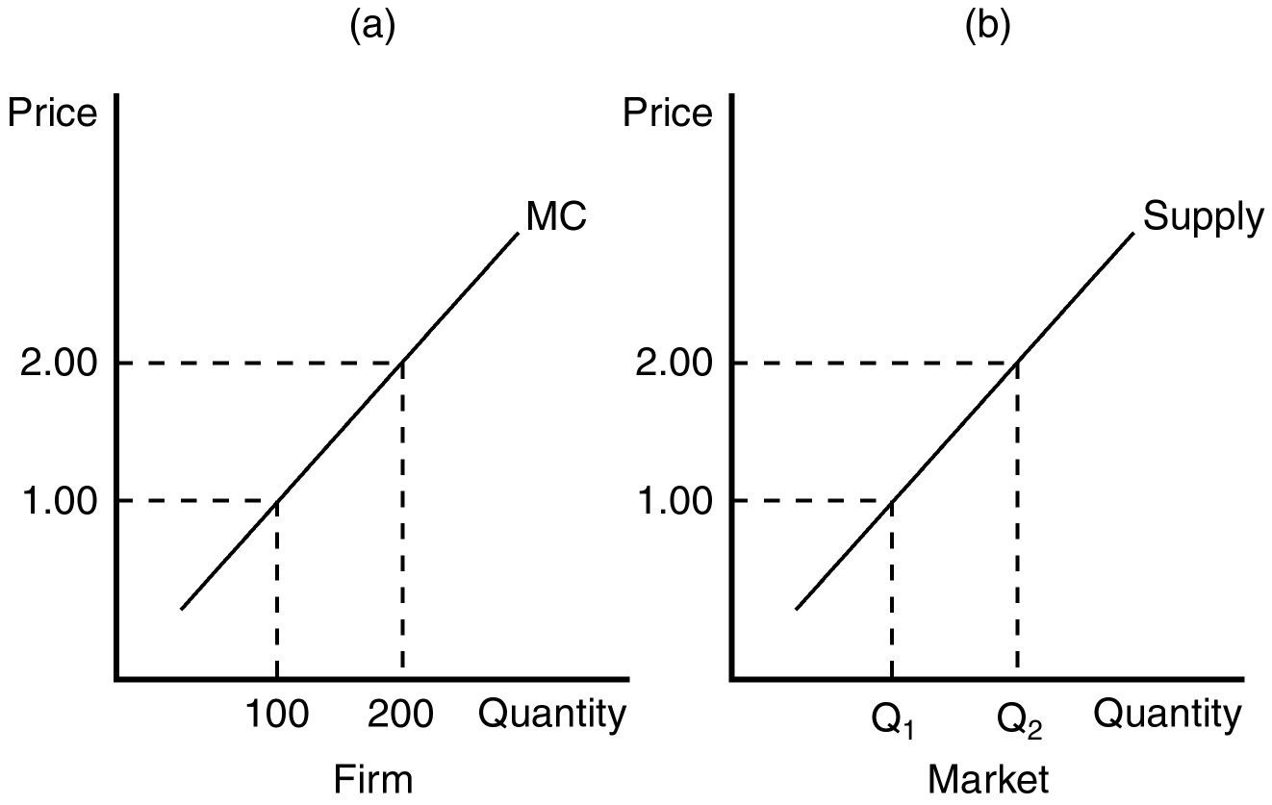
172. Refer to Figure 14-6. If there are 200 identical firms in this market, what level of output will be supplied to the market when price is $1.00?
a. 2,000
b. 5,000
c. 10,000
d. 20,000
ANS: D PTS: 1 DIF: 2 REF: 14-3
TOP: Supply curve MSC: Applicative
173. Refer to Figure 14-6. When 100 identical firms participate in this market, at what price will 15,000 units be supplied to this market?
a. $1.00
b. $1.50
c. $2.00
d. It cannot be determined from the information provided.
ANS: B PTS: 1 DIF: 2 REF: 14-3
TOP: Supply curve MSC: Applicative
174. Refer to Figure 14-6. If at a market price of $1.75, 52,500 units of output are supplied to this market, how many identical firms are participating in this market?
a. 75
b. 100
c. 250
d. 300
ANS: D PTS: 1 DIF: 3 REF: 14-3
TOP: Supply curve MSC: Applicative
175. When existing firms in a competitive market are profitable, an incentive exists for
a. new firms to seek government subsidies that would allow them to enter the market.
b. new firms to enter the market, even without government subsidies.
c. existing firms to raise prices.
d. existing firms to increase production.
ANS: B PTS: 1 DIF: 2 REF: 14-3
TOP: Competitive markets MSC: Interpretive
176. When new firms have an incentive to enter a competitive market, their entry will
a. increase the price of the product.
b. drive down profits of existing firms in the market.
c. shift the market supply curve to the left.
d. increase demand for the product.
ANS: B PTS: 1 DIF: 2 REF: 14-3
TOP: Competitive markets MSC: Interpretive
177. When firms have an incentive to exit a competitive market, their exit will
a. lower market price.
b. necessarily raise the costs of firms that remain in the market.
c. raise profits for firms that remain in the market.
d. reduce demand for the product.
ANS: C PTS: 1 DIF: 2 REF: 14-3
TOP: Competitive markets MSC: Interpretive
178. In a perfectly competitive market, the process of entry and exit will end when, for firms in the market,
a. price is equal to average variable cost.
b. marginal revenue is equal to average variable cost.
c. economic profits are zero.
d. accounting profits are zero.
ANS: C PTS: 1 DIF: 2 REF: 14-3
TOP: Competitive markets MSC: Interpretive
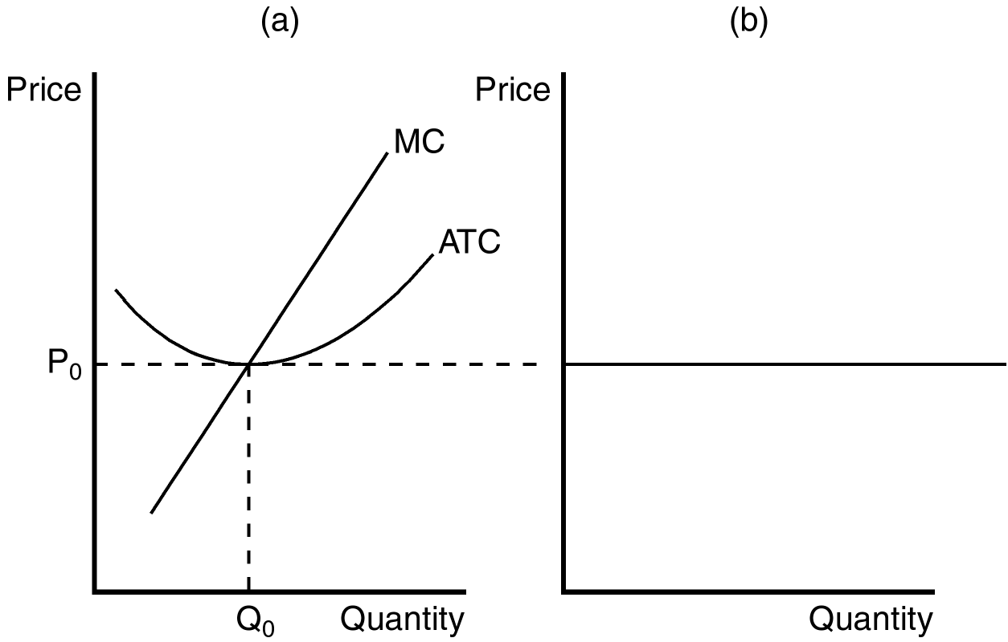
179. If the figure in panel (a) reflects the long-run equilibrium of a profit-maximizing firm in a competitive market, the figure in panel (b) most likely reflects
a. perfectly inelastic long-run market supply.
b. the idea that free entry and exit of firms in the market lead to only one market price in the long run.
c. the product of the individual supply curves of all firms in the market.
d. the fact that zero profits cannot be sustained in the long run.
ANS: B PTS: 1 DIF: 2 REF: 14-3
TOP: Supply curve MSC: Interpretive
180. In a competitive market with free entry and exit, the process of entry and exit ends when, for the typical firm in the market,
a. marginal revenue is equal to long-run average total cost.
b. total revenue is equal to average total cost.
c. average revenue exceeds marginal cost.
d. accounting profit is driven to zero.
ANS: A PTS: 1 DIF: 2 REF: 14-3
TOP: Competitive markets MSC: Analytical
181. When new firms enter a perfectly competitive market,
a. demand increases.
b. the short-run market supply curve shifts right.
c. the short-run market supply curve shifts left.
d. existing firms will increase prices to keep the new firms from entering.
ANS: B PTS: 1 DIF: 2 REF: 14-3
TOP: Supply curve MSC: Interpretive
182. When new firms enter a perfectly competitive market,
a. economic profits of existing firms will continue to be zero.
b. entering firms will earn zero economic profit upon entry into the market.
c. existing firms may see their costs rise as more firms compete for limited resources.
d. prices will rise as existing firms raise prices to keep new firms out of the market.
ANS: C PTS: 1 DIF: 2 REF: 14-3
TOP: Competitive markets MSC: Interpretive
183. In a competitive market with free entry and exit, if all firms have the same cost structure, then
a. all firms will operate at efficient scale in the short run.
b. all firms will operate at efficient scale in the long run.
c. the price of the product will differ across firms.
d. the number of sellers in the market will steadily decrease over time.
ANS: B PTS: 1 DIF: 2 REF: 14-3
TOP: Competitive markets MSC: Interpretive
184. If all existing firms and all potential firms have the same cost curves, there are no inputs in limited quantities, and the market is characterized by free entry and exit, then the long-run
a. market supply curve is equal to the sum of marginal cost.
b. supply curve for the market must slope downward.
c. market supply curve must slope upward.
d. supply curve for the market is horizontal and equal to the minimum of long-run average cost for each firm.
ANS: D PTS: 1 DIF: 2 REF: 14-3
TOP: Supply curve MSC: Interpretive
185. When all firms and potential firms in a market have the same cost curves, the long-run equilibrium of a competitive market with free entry and exit will be characterized by firms
a. earning small levels of economic profit.
b. facing the prospect of future losses.
c. operating at efficient scale.
d. that band together to raise market prices.
ANS: C PTS: 1 DIF: 2 REF: 14-3
TOP: Competitive markets MSC: Interpretive
Scenario 14-3
In March of 2000 a study sponsored by the Food Consumer Safety Board found that consumption of irradiated grapefruit increased the health of laboratory rats. As a result of national press coverage of the report, the demand for irradiated grapefruit increased dramatically. Organic farmers were able to switch from organic production of grapefruit to irradiated production with no additional cost. Assume that the grapefruit market satisfies all of the attributes of perfect competition.
186. Refer to Scenario 14-3. As a result of the increase in the demand for grapefruit, we would predict that in the short run that the
a. production of grapefruit would be at efficient scale.
b. price of grapefruit would rise.
c. total cost for existing irradiated grapefruit producers must rise.
d. number of firms in the market would fall as prices fall and firms exit the market.
ANS: B PTS: 1 DIF: 2 REF: 14-3
TOP: Competitive markets MSC: Analytical
187. Refer to Scenario 14-3. If the increased production of irradiated grapefruit caused a rise in the marginal transportation costs of moving irradiated grapefruit to market, the
a. short-run market supply curve for irradiated grapefruit would be affected, but not the long-run market supply.
b. long-run market supply curve for irradiated grapefruit would be perfectly elastic.
c. long-run market supply of irradiated grapefruit would be downward sloping.
d. long-run market supply of irradiated grapefruit would be upward sloping.
ANS: D PTS: 1 DIF: 2 REF: 14-3
TOP: Supply curve MSC: Analytical
188. In the long-run equilibrium of a competitive market, the number of firms in the market adjusts until the market demand is satisfied at a price equal to
a. average fixed cost for the marginal firm.
b. the maximum of marginal cost of the marginal firm.
c. the minimum of average total cost of the marginal firm.
d. the minimum of average variable cost of the marginal firm.
ANS: C PTS: 1 DIF: 2 REF: 14-3
TOP: Competitive markets MSC: Interpretive
189. The entry of new firms into a competitive market will
a. increase market supply and increase market prices.
b. increase market supply and decrease market prices.
c. decrease market supply and increase market prices.
d. decrease market supply and decrease market prices.
ANS: B PTS: 1 DIF: 2 REF: 14-3
TOP: Competitive markets MSC: Interpretive
190. The exit of existing firms from a competitive market will
a. increase market supply and increase market prices.
b. increase market supply and decrease market prices.
c. decrease market supply and increase market prices.
d. decrease market supply and decrease market prices.
ANS: C PTS: 1 DIF: 2 REF: 14-3
TOP: Competitive markets MSC: Interpretive
191. When firms are neither entering nor exiting a perfectly competitive market,
a. total revenue must equal total variable cost for each firm.
b. economic profits must be zero.
c. price must equal average variable cost for each firm.
d. Both a and c are correct.
ANS: B PTS: 1 DIF: 2 REF: 14-3
TOP: Competitive markets MSC: Interpretive
192. When entry and exit behavior of firms in an industry does not affect a firm’s cost structure,
a. the long-run market supply curve must be horizontal.
b. the long-run market supply curve must be upward-sloping.
c. the long-run market supply curve must be downward-sloping.
d. we can’t tell anything about the shape of the long-run market supply curve.
ANS: A PTS: 1 DIF: 2 REF: 14-3
TOP: Supply curve MSC: Interpretive
Figure 14-7
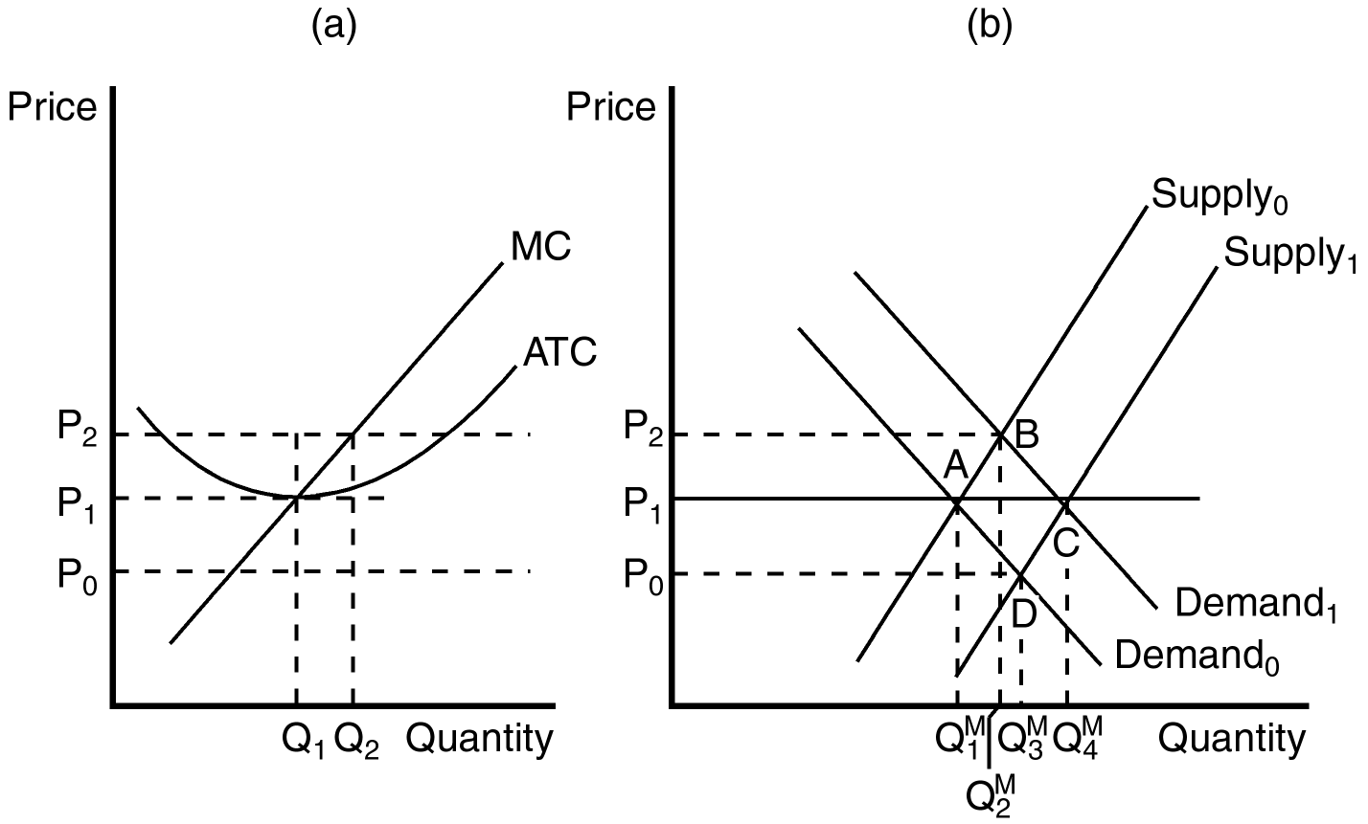
193. Refer to Figure 14-7. When the market is in long-run equilibrium at point A in panel (b), the firm represented in panel (a) will
a. have a zero economic profit.
b. have a negative accounting profit.
c. exit the market.
d. choose to increase production to increase profit.
ANS: A PTS: 1 DIF: 2 REF: 14-3
TOP: Profit maximization MSC: Analytical
194. Refer to Figure 14-7. Assume that the market starts in equilibrium at point A in panel (b). An increase in demand from Demand₀ to Demand₁ will result in
a. a new market equilibrium at point D.
b. an eventual increase in the number of firms in the market and a new long-run equilibrium at point C.
c. rising prices and falling profits for existing firms in the market.
d. falling prices and falling profits for existing firms in the market.
ANS: B PTS: 1 DIF: 2 REF: 14-3
TOP: Competitive markets MSC: Analytical
195. Refer to Figure 14-7. If the market starts in equilibrium at point C in panel (b), a decrease in demand will ultimately lead to
a. more firms in the industry, but lower levels of production for each firm.
b. fewer firms in the market.
c. a new long-run equilibrium at point D in panel (b).
d. lower prices once the new long-run equilibrium is reached.
ANS: B PTS: 1 DIF: 2 REF: 14-3
TOP: Competitive markets MSC: Analytical
196. Refer to Figure 14-7. Suppose a firm in a competitive market, like the one depicted in panel (a), observes market price rising from P₁ to P₂. Which of the following could explain this observation?
a. The entry of new firms into the market.
b. The exit of existing consumers from the market.
c. An increase in market supply from Supply₀ to Supply₁.
d. An increase in market demand from Demand₀ to Demand₁.
ANS: D PTS: 1 DIF: 2 REF: 14-3
TOP: Competitive markets MSC: Analytical
197. When managers of firms in a competitive market observe falling profits, they are likely to infer that the market is characterized by
a. a violation of conventional market forces.
b. over-investment.
c. the entry of new firms.
d. too few firms in the market.
ANS: C PTS: 1 DIF: 2 REF: 14-3
TOP: Competitive markets MSC: Interpretive
198. Suppose a competitive market is comprised of firms that face identical cost curves. The firms experience an increase in demand that results in positive profits for the firms. Which of the following events are then most likely to occur?
(i) New firms will enter the market.
(ii) In the short run, price will rise; in the long run, price will rise further.
(iii) In the long run, all firms will be producing at their efficient scale.

a. (i) and (ii) only
b. (i) and (iii) only
c. (ii) and (iii) only
d. (i), (ii) and (iii)
ANS: B PTS: 1 DIF: 2 REF: 14-3
TOP: Competitive markets MSC: Interpretive
199. When firms in a perfectly competitive market face the same costs, in the long run they must be operating
a. under diseconomies of scale.
b. with small, but positive, levels of profit.
c. at their efficient scale.
d. where price is equal to average fixed cost.
ANS: C PTS: 1 DIF: 2 REF: 14-3
TOP: Competitive markets MSC: Interpretive
200. When some resources used in production are only available in limited quantities, it is likely that the long-run supply curve in a competitive market is
a. downward sloping.
b. upward sloping.
c. horizontal.
d. vertical.
ANS: B PTS: 1 DIF: 2 REF: 14-3
TOP: Supply curve MSC: Interpretive
201. When a competitive market experiences an increase in demand that induces an increase in production costs, which of the following is most likely to arise?
a. The long-run market supply curve will be upward sloping.
b. The condition of free entry into the market will be violated.
c. Producer profits will fall in the long run.
d. The long-run market supply curve will be horizontal as new firms enter and drive the price downward.
ANS: A PTS: 1 DIF: 2 REF: 14-3
TOP: Supply curve MSC: Interpretive
202. When firms in a competitive market have different costs, it is likely that
a. free entry and exit in the market will be violated.
b. the market will no longer be considered competitive.
c. long-run market supply will be downward sloping.
d. some firms will earn positive economic profits in the long run.
ANS: D PTS: 1 DIF: 2 REF: 14-3
TOP: Competitive markets MSC: Interpretive
203. Regardless of the cost structure of firms in a competitive market, in the long run
a. firms will experience rising demand for their products.
b. the marginal firm will earn zero economic profit.
c. firms will experience a less competitive market environment.
d. exit and entry is likely to lead to a horizontal long-run supply curve.
ANS: B PTS: 1 DIF: 2 REF: 14-3
TOP: Competitive markets MSC: Interpretive
204. A long-run supply curve is flatter than a short-run supply curve because
a. firms can enter and exit a market more easily in the long run than in the short run.
b. long-run supply curves are sometimes downward sloping.
c. competitive firms have more control over demand in the long run.
d. firms in a competitive market face identical cost structures.
ANS: A PTS: 1 DIF: 2 REF: 14-3
TOP: Supply curve MSC: Interpretive
205. A market might have an upward-sloping long-run supply curve if
a. firms have different costs.
b. consumers exercise market power over producers.
c. all factors of production are essentially available in unlimited supply.
d. the entry of new firms into the market has no effect on the cost structure of firms in the market.
ANS: A PTS: 1 DIF: 2 REF: 14-3
TOP: Supply curve MSC: Interpretive
206. When new entrants into a competitive market have higher costs than existing firms,
a. accounting profits will be the primary determinant of entry into the market.
b. sunk costs become an important determinant of the short-run entry strategy.
c. market price must be rising.
d. all firms will earn zero economic profit once the new equilibrium is reached.
ANS: C PTS: 1 DIF: 2 REF: 14-3
TOP: Competitive markets MSC: Interpretive
207. The assumption of a fixed number of firms is appropriate for analysis of
a. the short run, but not the long run.
b. the long run, but not the short run.
c. both the short run and the long run.
d. neither the short run nor the long run.
ANS: A PTS: 1 DIF: 1 REF: 14-3
TOP: Competitive markets MSC: Interpretive
208. In a particular market, there are 500 firms. Each firm has a marginal cost of $30 when it produces 200 units of output. One point on the market supply curve is
a. Quantity = 200, Price = $30
b. Quantity = 500, Price = $30
c. Quantity = 100,000, Price = $30
d. Quantity = 100,000, Price = $15,000
ANS: C PTS: 1 DIF: 2 REF: 14-3
TOP: Supply curve MSC: Applicative
209. Entry into a market by new firms will
a. increase the supply of the good.
b. increase profits of existing firms.
c. increase the price of the good.
d. raise the marginal cost of producing the good.
ANS: A PTS: 1 DIF: 2 REF: 14-3
TOP: Competitive markets MSC: Interpretive
210. In a long-run equilibrium, the marginal firm has
a. price equal to average total cost.
b. total revenue equal to total cost.
c. economic profit equal to zero.
d. All of the above are correct.
ANS: D PTS: 1 DIF: 2 REF: 14-3
TOP: Competitive firms MSC: Interpretive
211. In the long-run equilibrium of a market with free entry and exit, if all firms have the same cost structure, then
a. marginal cost exceeds average total cost.
b. the price of the good exceeds average total cost.
c. average total cost exceeds the price of the good.
d. firms are operating at their efficient scale.
ANS: D PTS: 1 DIF: 2 REF: 14-3
TOP: Profit maximization MSC: Interpretive
212. In the long-run equilibrium of a market with free entry and exit, marginal firms are operating
a. at the point where average variable cost equals marginal cost.
b. at the minimum point on their marginal cost curves.
c. at their efficient scale.
d. where accounting profit is zero.
ANS: D PTS: 1 DIF: 2 REF: 14-3
TOP: Competitive firms MSC: Interpretive
213. Suppose a competitive market has a horizontal long-run supply curve and is in long-run equilibrium. If demand decreases, we can be certain that in the short-run,
a. at least some firms will shut down.
b. price will fall below marginal cost for some firms.
c. price will fall below average total cost for some firms.
d. at least some firms will exit the industry.
ANS: C PTS: 1 DIF: 2 REF: 14-3
TOP: Competitive markets MSC: Analytical
214. There are 500 identical firms in a competitive market. The firms do not use any resources that are available in limited quantities, and all of them have the following long-run cost structure:

Output | Total Cost
0 | $0
1 | $10
2 | $12
3 | $15
4 | $24
5 | $40

The long-run supply curve for this market is
a. positively sloped.
b. horizontal at a price of $3.33.
c. horizontal at a price of $5.
d. horizontal at a price of $7.
ANS: C PTS: 1 DIF: 3 REF: 14-3
TOP: Profit maximization MSC: Analytical
215. Consider a competitive market with a large number of identical firms. The firms in this market do not use any resources that are available only in limited quantities. In long-run equilibrium, market price
a. is determined by demand.
b. is determined by the minimum point on the firms’ average total cost curve.
c. is determined by the minimum point on the firms’ average variable cost curve.
d. depends on how many firms exist in the industry.
ANS: B PTS: 1 DIF: 2 REF: 14-3
TOP: Supply curve MSC: Interpretive
216. Consider a competitive market with a large number of identical firms. The firms in this market do not use any resources that are available only in limited quantities. In this market, an increase in demand will
a. increase price in the short run, but not in the long run.
b. increase price in the long run, but not in the short run.
c. increase price both in the short and the long run.
d. not affect price in either the short or the long run.
ANS: A PTS: 1 DIF: 2 REF: 14-3
TOP: Competitive markets MSC: Interpretive
217. Which of the following statements is false?
a. In a long-run equilibrium, marginal firms make zero economic profit.
b. To maximize profit, firms should produce at a level of output where price equals average variable cost.
c. The amount of gold in the world is limited. Therefore, the gold jewelry market probably has a long-run supply curve that is upward sloping.
d. Long-run supply curves are typically more elastic than short-run supply curves.
ANS: B PTS: 1 DIF: 2 REF: 14-3
TOP: Competitive markets MSC: Interpretive
218. In the short run, a market consists of 100 identical firms. The market price is $8, and the total cost to each firm of producing various levels of output is given in the table below. What will total quantity supplied be in the market?

Q | TC
0 | 1
1 | 7
2 | 14
3 | 22
4 | 31
5 | 41

a. 200 units
b. 300 units
c. 400 units
d. 500 units
ANS: B PTS: 1 DIF: 2 REF: 14-3
TOP: Market supply MSC: Analytical
219. The long-run market supply curve in a competitive market will
a. always be horizontal.
b. be the portion of the MC that lies above the minimum of AVC.
c. typically be more elastic than the short-run supply curve.
d. be above the competitive firm’s efficient scale.
ANS: C PTS: 1 DIF: 2 REF: 14-3
TOP: Market supply MSC: Interpretive
220. In a competitive market with identical firms,
a. an increase in demand in the short run will result in a new price above the minimum of average total cost allowing firms to earn a positive economic profit in the long run.
b. firms cannot earn positive economic profit in either the short run or long run.
c. firms can earn positive economic profit in the long run if the long-run market supply curve is upward sloping.
d. free entry and exit into the market requires that firms earn zero economic profit in the long run even though they may be able to earn positive economic profit in the short run.
ANS: D PTS: 1 DIF: 2 REF: 14-3
TOP: Profit MSC: Analytical
221. In the long run the market supply
a. must always be horizontal.
b. could be upward sloping if the cost of production falls as new firms enter the market.
c. could be upward sloping if the cost of production rises as new firms enter the market.
d. could be upward sloping if technological improvements lower the cost of producing in the market.
ANS: C PTS: 1 DIF: 2 REF: 14-3
TOP: Market supply MSC: Interpretive
222. In the short-run, a firm’s supply curve is equal to
a. the marginal cost curve above its average variable cost curve.
b. the marginal cost curve above its average total cost curve.
c. the average variable cost curve above its marginal cost curve.
d. the average total cost curve above its marginal cost curve.
ANS: A PTS: 1 DIF: 1 REF: 14-3
TOP: Supply curve MSC: Definitional
223. The short-run market supply curve in a perfectly competitive industry
a. shows the total quantity supplied by all firms at each possible price.
b. is perfectly inelastic at the market price.
c. is perfectly elastic at the market price.
d. is usually downward-sloping.
ANS: A PTS: 1 DIF: 1 REF: 14-3
TOP: Market supply MSC: Definitional
224. Tommy’s Tires operates in a perfectly competitive market. If tires sell for $50 each and average total cost per tire is $40 at the profit-maximizing output level, then in the long run
a. more firms will enter the market.
b. some firms will exit from the market.
c. the equilibrium price per tire will rise.
d. average total costs will fall.
ANS: A PTS: 1 DIF: 2 REF: 14-3
TOP: Perfect competition MSC: Analytical
225. If all firms have the same costs of production, then in long-run equilibrium,
a. price exceeds average total cost for all firms.
b. price exceeds marginal cost for all firms.
c. some firms may earn positive economic profits.
d. all firms have zero economic profits and just cover their opportunity costs.
ANS: D PTS: 1 DIF: 2 REF: 14-3
TOP: Profit maximization MSC: Interpretive
226. When market conditions in a competitive industry are such that firms cannot cover their production costs, then
a. the firms will suffer long-run economic losses.
b. the firms will suffer short-run economic losses that will be exactly offset by long-run economic profits.
c. some firms will exit the market, causing prices to rise until the remaining firms can cover their production costs.
d. all firms will go out of business, since consumers will not pay prices that enable firms to cover their production costs.
ANS: C PTS: 1 DIF: 2 REF: 14-3
TOP: Profit maximization MSC: Interpretive
227. If occupational safety laws were changed so that firms no longer had to take expensive steps to meet regulatory requirements, we would expect that
a. the demand for products in this industry would increase.
b. the market price of products in this industry would decrease in the short run but not in the long run.
c. the firms in the industry would make a long-run economic profit.
d. competition would force producers to pass the lower production costs on to consumers in the long run.
ANS: D PTS: 1 DIF: 2 REF: 14-3
TOP: Profit maximization MSC: Analytical
228. The textile industry is composed of a large number of small firms. In recent years, these firms have suffered economic losses and many sellers have left the industry. Economic theory suggests that these conditions will
a. shift the demand curve outward so that price will rise to the level of production cost.
b. cause the remaining firms to collude so that they can produce more efficiently.
c. cause the market supply to decline and the price of textiles to rise.
d. cause firms in the textile industry to suffer long-run economic losses.
ANS: C PTS: 1 DIF: 2 REF: 14-3
TOP: Profit maximization MSC: Analytical
229. In a perfectly competitive market, the horizontal sum of all the individual firms’ supply curves is
a. zero.
b. equal to the industry profits.
c. the market supply curve.
d. a horizontal line.
ANS: C PTS: 1 DIF: 1 REF: 14-3
TOP: Market supply MSC: Definitional
230. The production decisions of perfectly competitive firms follow one of the Ten Principles of Economics, which states that rational people
a. consider sunk costs.
b. equate prices to the average costs of production.
c. will eventually leave markets that experience zero profit.
d. think at the margin.
ANS: D PTS: 1 DIF: 2 REF: 14-4
TOP: Marginal changes MSC: Definitional
True/False
1. In competitive markets, firms that raise their prices are typically rewarded with larger profits.
ANS: F PTS: 1 DIF: 2 REF: 14-1
TOP: Competitive markets MSC: Interpretive
2. When an individual firm in a competitive market increases its production, it is likely that the market price will fall.
ANS: F PTS: 1 DIF: 2 REF: 14-1
TOP: Competitive markets MSC: Interpretive
3. In a competitive market, firms are unable to differentiate their product from that of other producers.
ANS: T PTS: 1 DIF: 1 REF: 14-1
TOP: Competitive markets MSC: Interpretive
4. Firms in competitive markets are said to be price takers.
ANS: T PTS: 1 DIF: 1 REF: 14-1
TOP: Competitive markets MSC: Interpretive
5. For a firm in a competitive market, marginal revenue is always equal to average revenue.
ANS: T PTS: 1 DIF: 2 REF: 14-1
TOP: Marginal revenue MSC: Interpretive
6. The assumption of free entry and exit is necessary for firms in a competitive market to be price takers.
ANS: F PTS: 1 DIF: 2 REF: 14-1
TOP: Competitive markets MSC: Interpretive
7. To answer the question, “How much revenue does the farm receive for the typical gallon of milk?” a dairy farmer must be able to calculate sunk cost.
ANS: F PTS: 1 DIF: 1 REF: 14-1
TOP: Sunk cost MSC: Interpretive
8. A firm must be participating in a competitive market for average revenue to equal price.
ANS: F PTS: 1 DIF: 2 REF: 14-1
TOP: Average revenue MSC: Interpretive
9. A profit-maximizing firm in a competitive market will increase production when average revenue exceeds marginal cost.
ANS: T PTS: 1 DIF: 2 REF: 14-2
TOP: Profit maximization MSC: Interpretive
10. In making a short-run profit-maximizing production decision, the firm must consider both fixed and variable cost.
ANS: F PTS: 1 DIF: 2 REF: 14-2
TOP: Profit maximization MSC: Interpretive
11. The marginal firm in a competitive market will earn zero economic profit in the long run.
ANS: T PTS: 1 DIF: 2 REF: 14-2
TOP: Economic profit MSC: Interpretive
12. A profit-maximizing firm in a competitive market will earn zero accounting profits in the long run.
ANS: F PTS: 1 DIF: 2 REF: 14-2
TOP: Accounting profit MSC: Interpretive
13. A firm will shut down in the short run if revenue is not sufficient to cover its variable costs of production.
ANS: T PTS: 1 DIF: 2 REF: 14-2
TOP: Profit maximization MSC: Interpretive
14. A firm will shut down in the short run if revenue is not sufficient to cover all of its fixed costs of production.
ANS: F PTS: 1 DIF: 2 REF: 14-2
TOP: Profit maximization MSC: Interpretive
15. The supply curve of a firm in a competitive market is the average variable cost curve, above the minimum of marginal cost.
ANS: F PTS: 1 DIF: 2 REF: 14-2
TOP: Supply curve MSC: Interpretive
16. A firm in a competitive market will maximize profit when the level of production is such that marginal cost equals price.
ANS: T PTS: 1 DIF: 2 REF: 14-2
TOP: Profit maximization MSC: Interpretive
17. By comparing the marginal revenue and marginal cost from each unit produced, a firm in a competitive market can determine the profit-maximizing level of production.
ANS: T PTS: 1 DIF: 2 REF: 14-2
TOP: Profit maximization MSC: Interpretive
18. A firm’s incentive to compare marginal revenue and marginal cost is an application of the principle that rational people think at the margin.
ANS: T PTS: 1 DIF: 1 REF: 14-2
TOP: Profit maximization MSC: Interpretive
19. A distinctive feature of the average total cost curve is that it is upward sloping at every point.
ANS: F PTS: 1 DIF: 1 REF: 14-2
TOP: Average total cost MSC: Interpretive
20. Marginal adjustments to production end when firms in competitive markets experience a price equal to marginal revenue.
ANS: F PTS: 1 DIF: 2 REF: 14-2
TOP: Profit maximization MSC: Interpretive
21. When a profit-maximizing firm in a competitive market experiences rising prices, it will respond with an increase in production.
ANS: T PTS: 1 DIF: 2 REF: 14-2
TOP: Profit maximization MSC: Interpretive
22. Because nothing can be done about sunk costs, they are irrelevant to decisions about business strategy.
ANS: T PTS: 1 DIF: 2 REF: 14-2
TOP: Sunk cost MSC: Interpretive
23. A miniature golf course is a good example of where fixed costs become relevant to the decision of when to open and when to close for the season.
ANS: F PTS: 1 DIF: 2 REF: 14-2
TOP: Sunk cost MSC: Interpretive
24. In the long run, when price is less than average total cost for all possible levels of production, a firm in a competitive market will choose to exit (or not enter) the market.
ANS: T PTS: 1 DIF: 2 REF: 14-2
TOP: Profit maximization MSC: Interpretive
25. The long-run equilibrium in a competitive market characterized by firms with identical costs is generally characterized by firms operating at efficient scale.
ANS: T PTS: 1 DIF: 2 REF: 14-3
TOP: Competitive markets MSC: Interpretive
26. When a resource used in the production of a good sold in a competitive market is available in only limited quantities, the long-run supply curve is likely to be upward sloping.
ANS: T PTS: 1 DIF: 2 REF: 14-3
TOP: Supply curve MSC: Interpretive
27. A competitive market will typically experience entry and exit until accounting profits are zero.
ANS: F PTS: 1 DIF: 2 REF: 14-3
TOP: Competitive markets MSC: Interpretive
28. In the long run, a competitive market with 1,000 identical firms will experience an equilibrium price equal to the minimum of each firm’s average total cost.
ANS: T PTS: 1 DIF: 2 REF: 14-3
TOP: Competitive markets MSC: Interpretive
29. In a long-run equilibrium, it is possible that some firms in a competitive market are making a positive economic profit.
ANS: T PTS: 1 DIF: 2 REF: 14-3
TOP: Competitive markets MSC: Interpretive
30. The short-run supply curve in a competitive market must be more elastic than the long-run supply curve.
ANS: F PTS: 1 DIF: 2 REF: 14-3
TOP: Supply curve MSC: Interpretive
31. When economic profits are zero in equilibrium, the firm’s revenue must be sufficient to cover all opportunity costs.
ANS: T PTS: 1 DIF: 2 REF: 14-3
TOP: Competitive markets MSC: Interpretive
Short Answer
1. Describe the difference between average revenue and marginal revenue. Why are both of these revenue measures important to a profit-maximizing firm?
ANS:
Average revenue is total revenue divided by the amount of output. Marginal revenue is the change in total revenue from the sale of each additional unit of output. Marginal revenue is used to determine the profit-maximizing level of production and average revenue is used to help determine the level of profits.
PTS: 1 DIF: 2 REF: 14-1
TOP: Price MSC: Definitional
2. List and describe the characteristics of a perfectly competitive market.
ANS:
There are many buyers and sellers in the market. The goods offered by the various sellers are largely the same. Firms can freely enter or exit the market.
PTS: 1 DIF: 2 REF: 14-1
TOP: Competitive markets MSC: Definitional
3. Why would a firm in a perfectly competitive market always choose to set its price equal to the current market price? If a firm set its price below the current market price, what effect would this have on the market?
ANS:
The firm could not sell any more of its product at a lower price than it could sell at the market price. As a result, it would needlessly forgo revenue if it set a price below the market price. If the firm set a higher price, it would not sell anything at all.
PTS: 1 DIF: 2 REF: 14-1
TOP: Profit maximization MSC: Analytical
4. Use a graph to demonstrate the circumstances that would prevail in a competitive market where firms are earning economic profits. Can this scenario be maintained in the long run? Carefully explain your answer.
ANS:
In a competitive market where firms are earning economic profits, new firms will have an incentive to enter the market. This entry will expand the number of firms, increase the quantity of the good supplied, and drive down prices and profits.
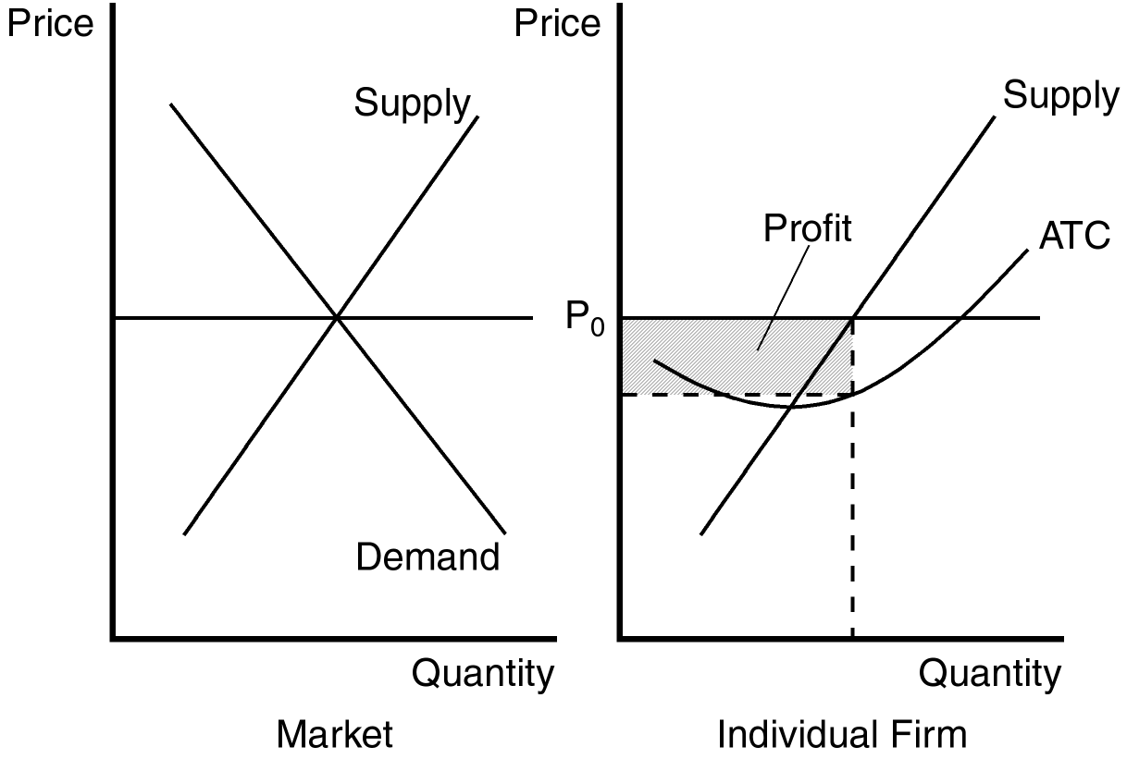
PTS: 1 DIF: 2 REF: 14-2
TOP: Profit maximization MSC: Analytical
5. Explain how a firm in a competitive market identifies the profit-maximizing level of production. When should the firm raise production, and when should the firm lower production?
ANS:
By selecting the level of output at which marginal revenue is equal to marginal cost. If MR > MC, profit will increase if the firm increases Q. If MR < MC, profit will increase if the firm decreases Q.
PTS: 1 DIF: 2 REF: 14-2
TOP: Profit maximization MSC: Analytical
6. News reports from the western United States occasionally report incidents of cattle ranchers slaughtering a large number of newborn calves and burying them in mass graves rather than transporting them to markets. Assuming that this is rational behavior by profit-maximizing “firms,” explain what economic factors may influence such behavior.
ANS:
If the selling price is not sufficient to cover the variable cost of sending them to market this behavior would make sense.
PTS: 1 DIF: 2 REF: 14-2
TOP: Profit maximization MSC: Analytical
7. Use a graph to demonstrate the circumstances that would prevail in a perfectly competitive market where firms are experiencing economic losses. Identify costs, revenue, and the economic losses on your graph. Using your graph, determine whether this firm will shut down in the short run, or choose to remain in the market. Explain your answer.
ANS:
The loss and revenue are identified on the individual firm’s graph. Total cost is equal to the sum of the losses and revenue. The decision about whether this firm shuts down or remains in the market depends upon the position of average variable cost. If average variable cost is below P₀ at output level Q₀, the firm will remain in the market. If average variable cost is above P₀ at output level Q₀ the firm will shut down in the short run.
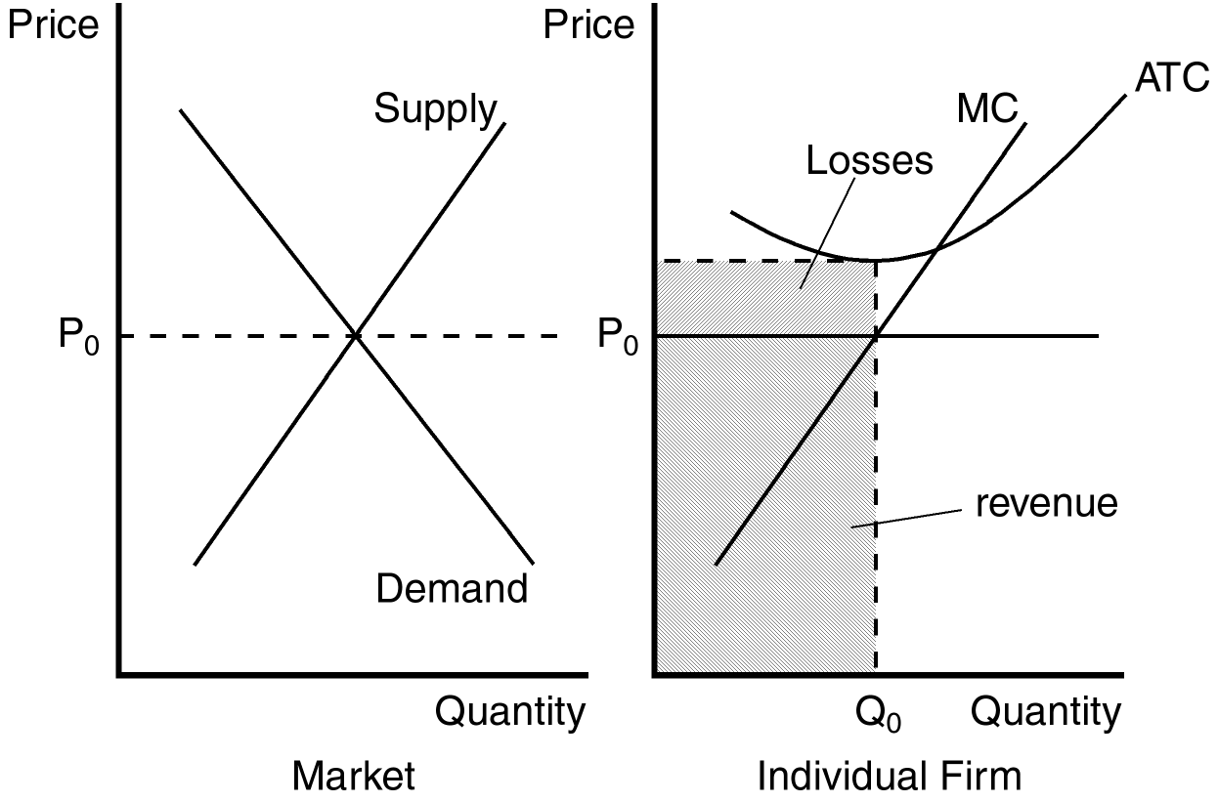
PTS: 1 DIF: 2 REF: 14-2
TOP: Profit maximization MSC: Analytical
8. At its current level of production a profit-maximizing firm in a competitive market receives $12.50 for each unit it produces and faces an average total cost of $10. At the market price of $12.50 per unit, the firm’s marginal cost curve crosses the marginal revenue curve at an output level of 1,000 units. What is the firm’s current profit? What is likely to occur in this market and why?
ANS:
$2,500; firms are likely to enter this market since existing firms are earning economic profits.
PTS: 1 DIF: 2 REF: 14-2
TOP: Profit MSC: Analytical
9. Give two reasons why the long-run industry supply curve may slope upward. Use an example to demonstrate your reasons.
ANS:
Some resource used in production may be available only in limited quantities and firms may have different cost structures. The example provided in the text for the first reason is the market for farm products. As more people become farmers, the price of land is bid up since its supply is limited. As the price of farm land is bid up, the costs of all farmers in the market rise. The example used to support the second reason is the market for painters. Anyone can enter the market for painting services, but not everyone has the same costs because some painters work faster than others.
PTS: 1 DIF: 3 REF: 14-3
TOP: Supply curve MSC: Interpretive
10. If identical firms that remain in a competitive market over the long run make zero economic profit, why do these firms choose to remain in the market?
ANS:
Because a normal rate of return on their investment is included as part of the opportunity cost of production.
PTS: 1 DIF: 2 REF: 14-3
TOP: Economic profit MSC: Interpretive

