Chapter 15
Monopoly
Multiple Choice
1. Which of the following statements is correct?
a. A competitive firm is a price maker and a monopoly is a price taker.
b. A competitive firm is a price taker and a monopoly is a price maker.
c. Both competitive firms and monopolies are price takers.
d. Both competitive firms and monopolies are price makers.
ANS: B PTS: 1 DIF: 1 REF: 14-1
TOP: Monopoly MSC: Interpretive
2. Angelo is a wholesale meatball distributor. He sells his meatballs to all the finest Italian restaurants in town. Nobody can make meatballs like Angelo. As a result, his is the only business in town that sells meatballs to restaurants. Assuming that Angelo is maximizing his profit, which of the following statements is true?
a. Meatball prices will be less than marginal cost.
b. Meatball prices will equal marginal cost.
c. Meatball prices will exceed marginal cost.
d. Meatball prices will be a function of supply and demand and will therefore oscillate around marginal costs.
ANS: C PTS: 1 DIF: 2 REF: 14-1
TOP: Pricing MSC: Interpretive
3. A monopoly's marginal cost will
a. be less than its average fixed cost.
b. be less than the price per unit of its product.
c. exceed its marginal revenue.
d. equal its average total cost.
ANS: B PTS: 1 DIF: 2 REF: 14-1
TOP: Marginal cost MSC: Interpretive
4. Which of the following statements is (are) true of a monopoly?
(i) A monopoly has the ability to set the price of its product at whatever level it desires.
(ii) A monopoly's total revenue will always increase when it increases the price of its product.
(iii) A monopoly can earn unlimited profits.
a. (i) only
b. (ii) only
c. (i) and (ii)
d. (ii) and (iii)
ANS: A PTS: 1 DIF: 2 REF: 14-1
TOP: Monopoly MSC: Interpretive
5. Young Johnny inherited the only local cable TV company in town after his father passed away. The company is completely unregulated by the government and is therefore free to operate as it wishes. Assuming that Johnny understands the true power of his new monopoly, he is probably most excited about which of the following statements?
(i) He will be able to set the price of cable TV service at whatever level he wishes.
(ii) The customers will be forced to purchase cable TV service at whatever price he wants to set.
(iii) He will be able to achieve any profit level that he desires.
a. (i) only
b. (ii) only
c. (i) and (iii)
d. All of the above are correct.
ANS: A PTS: 1 DIF: 2 REF: 14-1
TOP: Monopoly MSC: Interpretive
6. Which of the following is an example of a barrier to entry?
(i) A key resource is owned by a single firm.
(ii) The costs of production make a single producer more efficient than a large number of producers.
(iii) The government has given the existing monopoly the exclusive right to produce the good.
a. (i) and (ii)
b. (ii) and (iii)
c. (i) only
d. All of the above are examples of barriers to entry.
ANS: D PTS: 1 DIF: 1 REF: 14-1
TOP: Barriers to entry MSC: Interpretive
7. Which of the following are necessary characteristics of a monopoly?
(i) The firm is the sole seller of its product.
(ii) The firm's product does not have close substitutes.
(iii) The firm generates a large economic profit.
(iv) The firm is located in a small geographic market.
a. (i) and (ii)
b. (i) and (iii)
c. (ii) and (iv)
d. (i), (ii), and (iii)
ANS: A PTS: 1 DIF: 2 REF: 14-1
TOP: Monopoly MSC: Interpretive
8. A fundamental source of monopoly market power arises from
a. perfectly elastic demand.
b. perfectly inelastic demand.
c. barriers to entry.
d. availability of "free" natural resources, such as water or air.
ANS: C PTS: 1 DIF: 2 REF: 14-1
TOP: Barriers to entry MSC: Interpretive
9. Because monopoly firms do not have to compete with other firms, the outcome in a market with a monopoly is often
a. not in the best interest of society.
b. one that fails to maximize total economic well-being.
c. inefficient.
d. All of the above are correct.
ANS: D PTS: 1 DIF: 2 REF: 14-1
TOP: Welfare MSC: Interpretive
10. A natural monopoly occurs when
a. the product is sold in its natural state (such as water or diamonds).
b. there are economies of scale over the relevant range of output.
c. the firm is characterized by a rising marginal cost curve.
d. production requires the use of free natural resources, such as water or air.
ANS: B PTS: 1 DIF: 2 REF: 14-1
TOP: Natural monopoly MSC: Interpretive
11. An industry is a natural monopoly when
(i) the government assists the firm in maintaining the monopoly.
(ii) a single firm owns a key resource.
(iii) a single firm can supply a good or service to an entire market at a smaller cost than could two or more firms.
a. (ii) only
b. (iii) only
c. (i) and (ii)
d. (ii) and (iii)
ANS: B PTS: 1 DIF: 2 REF: 14-1
TOP: Natural monopoly MSC: Interpretive
12. When a natural monopoly exists, it is
a. always cost effective for government-owned firms to produce the product.
b. never cost effective for one firm to produce the product.
c. always cost effective for two or more private firms to produce the product.
d. never cost effective for two or more private firms to produce the product.
ANS: D PTS: 1 DIF: 2 REF: 14-1
TOP: Natural monopoly MSC: Definitional
13. The defining characteristic of a natural monopoly is
a. constant marginal cost over the relevant range of output.
b. economies of scale over the relevant range of output.
c. constant returns to scale over the relevant range of output.
d. diseconomies of scale over the relevant range of output.
ANS: B PTS: 1 DIF: 2 REF: 14-1
TOP: Natural monopoly MSC: Definitional
14. Natural monopolies differ from other forms of monopoly because they
a. are not subject to barriers to entry.
b. are not regulated by government.
c. generally don't make a profit.
d. are generally not worried about competition eroding their monopoly position in the market.
ANS: D PTS: 1 DIF: 2 REF: 14-1
TOP: Natural monopoly MSC: Interpretive
15. Patent and copyright laws are major sources of
a. natural monopolies.
b. government-created monopolies.
c. resource monopolies.
d. antitrust regulation.
ANS: B PTS: 1 DIF: 1 REF: 14-1
TOP: Patents MSC: Interpretive
16. Encouraging firms to invest in research and development and individuals to engage in creative endeavors such as writing novels is one justification for
a. resource monopolies.
b. natural monopolies.
c. government-created monopolies.
d. breaking up monopolies into smaller firms.
ANS: C PTS: 1 DIF: 1 REF: 14-1
TOP: Patents MSC: Interpretive
17. When a firm's average total cost curve continually declines, the firm is a
a. government-created monopoly.
b. natural monopoly.
c. revenue monopoly.
d. All of the above are correct.
ANS: B PTS: 1 DIF: 1 REF: 14-1
TOP: Natural monopoly MSC: Definitional
18. The simplest way for a monopoly to arise is for a single firm to
a. decrease its price below its competitors’ prices.
b. decrease production to increase demand for its product.
c. make pricing decisions jointly with other firms.
d. own a key resource.
ANS: D PTS: 1 DIF: 1 REF: 14-1
TOP: Monopoly MSC: Interpretive
19. A government-created monopoly arises when
a. government spending in a certain industry gives rise to monopoly power.
b. the government exercises its market control by encouraging competition among sellers.
c. the government gives a firm the exclusive right to sell some good or service.
d. Both a and c are correct.
ANS: C PTS: 1 DIF: 2 REF: 14-1
TOP: Patents MSC: Interpretive
20. Allowing an inventor to have the exclusive rights to market her new invention will lead to
(i) a product that is priced higher than it would be without the exclusive rights.
(ii) desirable behavior in the sense that inventors are encouraged to invent.
(iii) higher profits for the inventor.

a. (i) and (ii)
b. (ii) and (iii)
c. (i) and (iii)
d. (i), (ii), and (iii)
ANS: D PTS: 1 DIF: 2 REF: 14-1
TOP: Patents MSC: Interpretive
21. Drug companies are allowed to be monopolists in the drugs they discover in order to
a. allow drug companies to charge a price that is equal to their marginal cost.
b. discourage new firms from entering the drug market.
c. encourage research.
d. allow the government to earn patent revenue.
ANS: C PTS: 1 DIF: 2 REF: 14-1
TOP: Patents MSC: Interpretive
22. Authors are allowed to be monopolists in the sale of their books in order to
a. encourage authors to write more and better books.
b. correct for the negative externalities that the internet and television impose.
c. satisfy literary advocacy groups that exercise their lobbying power.
d. promote a society in which people think for themselves and learn from whichever books they please.
ANS: A PTS: 1 DIF: 2 REF: 14-1
TOP: Copyrights MSC: Interpretive
23. Which of the following statements is true about patents and copyrights?
(i) They both have benefits and costs.
(ii) They lead to higher prices.
(iii) They enhance the ability of monopolists to earn above-average profits.
a. (i) and (ii)
b. (ii) and (iii)
c. (ii) only
d. (i), (ii), and (iii)
ANS: D PTS: 1 DIF: 2 REF: 14-1
TOP: Patents MSC: Interpretive
Figure 14-1
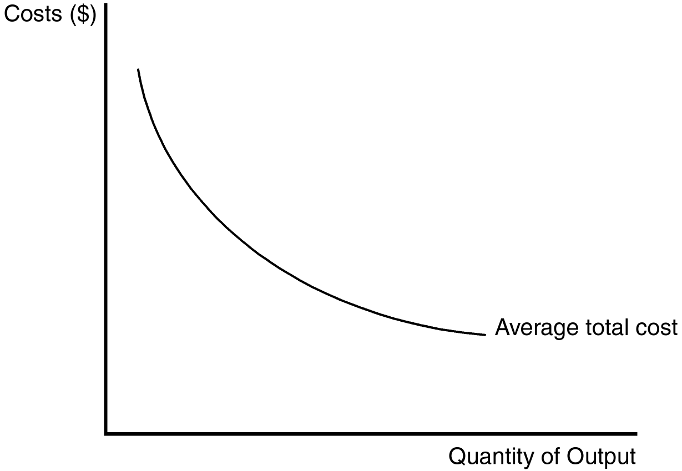
24. Refer to Figure 14-1. The shape of the average total cost curve reveals information about the nature of the barrier to entry that might exist in a monopoly market. Which of the following monopoly types best coincides with the figure?
a. Ownership of a key resource by a single firm
b. Natural monopoly
c. Government-created monopoly
d. A patent or copyright monopoly
ANS: B PTS: 1 DIF: 2 REF: 14-1
TOP: Natural monopoly MSC: Analytical
25. Refer to Figure 14-1. The shape of the average total cost curve in the figure suggests an opportunity for a profit-maximizing monopolist to take advantage of
a. economies of scale.
b. diseconomies of scale.
c. diminishing marginal product.
d. increasing marginal cost.
ANS: A PTS: 1 DIF: 1 REF: 14-1
TOP: Economies of scale MSC: Analytical
26. Refer to Figure 14-1. Considering the relationship between average total cost and marginal cost, the marginal cost curve for this firm
a. must lie entirely above the average total cost curve.
b. must lie entirely below the average total cost curve.
c. must be upward sloping.
d. does not exist.
ANS: B PTS: 1 DIF: 3 REF: 14-1
TOP: Marginal cost MSC: Analytical
27. When an industry is a natural monopoly,
a. it is characterized by constant returns to scale.
b. it is characterized by diseconomies of scale.
c. a larger number of firms may lead to a lower average cost.
d. a larger number of firms will lead to a higher average cost.
ANS: D PTS: 1 DIF: 2 REF: 14-1
TOP: Natural monopoly MSC: Definitional
28. If the distribution of water is a natural monopoly, then
(i) multiple firms will each have to pay large fixed costs to develop their own network of pipes.
(ii) allowing for competition among different firms in the water-distribution industry is efficient.
(iii) a single firm can serve the market at the lowest possible average total cost.
a. (i) and (ii)
b. (ii) and (iii)
c. (i) and (iii)
d. (iii) only
ANS: C PTS: 1 DIF: 2 REF: 14-1
TOP: Natural monopoly MSC: Interpretive
29. A firm that is a natural monopoly
a. is not likely to be concerned about new entrants eroding its monopoly power.
b. is taking advantage of economies of scale.
c. would experience a higher average total cost if more firms entered the market.
d. All of the above are correct.
ANS: D PTS: 1 DIF: 2 REF: 14-1
TOP: Natural monopoly MSC: Interpretive
30. Additional firms often do not try to compete with a natural monopoly because
a. they fear retaliation in the form of pricing wars from the natural monopolist.
b. they are unsure of the size of the market in general.
c. they know they cannot achieve the same low costs that the monopolist enjoys.
d. the natural monopoly doesn't make a huge profit.
ANS: C PTS: 1 DIF: 2 REF: 14-1
TOP: Natural monopoly MSC: Interpretive
31. The laws governing patents and copyrights
a. can lead to monopolies.
b. are intended to serve private interests, not the public interest.
c. have costs, but no benefits.
d. eliminate the need for firms to engage in research and development.
ANS: A PTS: 1 DIF: 2 REF: 14-1
TOP: Patents MSC: Interpretive
Scenario 14-1
Consider a transportation corporation named C.R. Evans that has just completed the development of a new subway system in a medium-sized town in the Northwest. Currently, there are plenty of seats on the subway, and it is never crowded. Its capacity far exceeds the needs of the city. After just a few years of operation, the shareholders of C.R. Evans experienced incredible rates of return on their investment, due to the profitability of the corporation.
32. Refer to Scenario 14-1. Which of the following statements are most likely to be true?
(i) New entrants to the market know they will earn a smaller piece of the market than C.R. Evans currently has.
(ii) C.R. Evans is most likely experiencing increasing average total cost.
(iii) C.R. Evans is a natural monopoly.
a. (i) and (ii)
b. (ii) and (iii)
c. (i) and (iii)
d. (i), (ii), and (iii)
ANS: C PTS: 1 DIF: 2 REF: 14-1
TOP: Natural monopoly MSC: Interpretive
33. Refer to Scenario 14-1. C.R. Evans will continue to be a monopolist in the subway transportation industry only if
a. population growth leads to an overcrowding of the subway cars.
b. there are no new entrants to the market.
c. demand for transportation services decreases.
d. All of the above are correct.
ANS: B PTS: 1 DIF: 2 REF: 14-1
TOP: Monopoly MSC: Interpretive
34. The fundamental cause of monopoly is
a. incompetent management in competitive firms.
b. the zero-profit feature of long-run equilibrium in competitive markets.
c. advertising.
d. barriers to entry.
ANS: D PTS: 1 DIF: 1 REF: 14-1
TOP: Barriers to entry MSC: Interpretive
35. Which of the following items is a primary source of barriers to entry?
a. The costs of production make a single firm more efficient than a large number of firms.
b. A single firm hires all the people who have the management skills that are important in the industry.
c. Contracts among firms prohibit them from competing with one another in the production and sale of certain products.
d. All of the above are correct.
ANS: A PTS: 1 DIF: 2 REF: 14-1
TOP: Barriers to entry MSC: Interpretive
36. Suppose most people regard emeralds, rubies, and sapphires as close substitutes for diamonds. Then DeBeers, a large diamond company, has
a. less incentive to advertise than it would otherwise have.
b. less market power than it would otherwise have.
c. more control over the price of diamonds than it would otherwise have.
d. higher profits than it would otherwise have.
ANS: B PTS: 1 DIF: 2 REF: 14-1
TOP: Monopoly MSC: Interpretive
37. A benefit to society of the patent and copyright laws is that those laws
a. help to keep prices down.
b. help to prevent a single firm from acquiring ownership of a key resource.
c. encourage creative activity.
d. discourage excessive amounts of output of certain products.
ANS: C PTS: 1 DIF: 1 REF: 14-1
TOP: Patents MSC: Interpretive
38. When a single firm can supply a product to an entire market at a smaller cost than could two or more firms, the industry is called a
a. resource industry.
b. exclusive industry.
c. government monopoly.
d. natural monopoly.
ANS: D PTS: 1 DIF: 1 REF: 14-1
TOP: Natural monopoly MSC: Definitional
39. A natural monopoly arises when
a. there are constant returns to scale over the relevant range of output.
b. there are economies of scale over the relevant range of output.
c. one firm owns a key natural resource.
d. the government gives a single firm the exclusive right to produce a particular good or service.
ANS: B PTS: 1 DIF: 1 REF: 14-1
TOP: Natural monopoly MSC: Definitional
40. When a firm has a natural monopoly, the firm's
a. marginal cost always exceeds its average total cost.
b. total cost curve is horizontal.
c. average total cost curve is downward sloping.
d. marginal cost curve must lie above the firm’s average total cost curve.
ANS: C PTS: 1 DIF: 2 REF: 14-1
TOP: Natural monopoly MSC: Interpretive
41. Which of the following is not a reason for the existence of a monopoly?
a. Sole ownership of a key resource
b. Patents
c. Copyrights
d. Diseconomies of scale
ANS: D PTS: 1 DIF: 1 REF: 14-1
TOP: Monopoly MSC: Interpretive
42. Which of the following would be most likely to have monopoly power?
a. A long-distance telephone service provider
b. A local cable TV provider
c. A large department store
d. A gas station
ANS: B PTS: 1 DIF: 2 REF: 14-1
TOP: Monopoly MSC: Applicative
43. A firm that is the sole seller of a product without close substitutes is
a. perfectly competitive.
b. monopolistically competitive.
c. an oligopolist
d. a monopolist
ANS: D PTS: 1 DIF: 1 REF: 14-1
TOP: Monopoly MSC: Definitional
44. If government officials break a natural monopoly up into several smaller firms, then
a. competition will force firms to attain economic profits rather than accounting profits.
b. competition will force firms to produce surplus output, which drives up price.
c. the average costs of production will increase.
d. the average costs of production will decrease.
ANS: C PTS: 1 DIF: 2 REF: 14-1
TOP: Natural monopoly MSC: Interpretive
45. Sizable economic profits can persist over time under monopoly if the monopolist
a. produces that output where average total cost is at a maximum.
b. is protected by barriers to entry.
c. operates as a price taker rather than a price maker.
d. realizes revenues that exceed variable costs.
ANS: B PTS: 1 DIF: 1 REF: 14-1
TOP: Barriers to entry MSC: Interpretive
46. Most markets are not monopolies in the real world because
a. firms usually face downward-sloping demand curves.
b. supply curves slope upward.
c. price is usually set equal to marginal cost by firms.
d. there are reasonable substitutes for most goods.
ANS: D PTS: 1 DIF: 1 REF: 14-1
TOP: Monopoly MSC: Interpretive
47. Patents grant
a. permanent monopoly status to creators of scientific inventions.
b. permanent monopoly status to creators of any intellectual property.
c. temporary monopoly status to creators of scientific inventions.
d. temporary monopoly status to creators of any intellectual property.
ANS: C PTS: 1 DIF: 2 REF: 14-1
TOP: Patents MSC: Definitional
48. The key difference between a competitive firm and a monopoly firm is the ability to select
a. the level of competition in the market.
b. the level of production.
c. inputs in the production process.
d. the price of its output.
ANS: D PTS: 1 DIF: 2 REF: 14-2
TOP: Monopoly MSC: Interpretive
49. The market demand curve for a monopolist is typically
a. unitary elastic at the point of profit maximization.
b. downward sloping.
c. horizontal.
d. vertical.
ANS: B PTS: 1 DIF: 2 REF: 14-2
TOP: Demand curve MSC: Interpretive
50. When a firm operates under conditions of monopoly, its price is
a. not constrained.
b. constrained by marginal cost.
c. constrained by demand.
d. constrained only by its social agenda.
ANS: C PTS: 1 DIF: 2 REF: 14-2
TOP: Pricing MSC: Interpretive
51. In order to sell more of its product, a monopolist must
a. sell to the government.
b. sell in international markets.
c. lower its price.
d. use its market power to force up the price of complementary products.
ANS: C PTS: 1 DIF: 2 REF: 14-2
TOP: Pricing MSC: Interpretive
52. A natural monopolist's ability to price its product is
a. constrained by the market demand curve.
b. constrained by market supply.
c. not affected by market demand.
d. enhanced by regulatory control of the government.
ANS: A PTS: 1 DIF: 2 REF: 14-2
TOP: Pricing MSC: Interpretive
53. Economists assume that monopolists behave as
a. cost minimizers.
b. profit maximizers.
c. price maximizers.
d. maximizers of social welfare.
ANS: B PTS: 1 DIF: 2 REF: 14-2
TOP: Profit maximization MSC: Interpretive
54. A monopolist's average revenue is always
a. equal to marginal revenue.
b. greater than the price of its product.
c. equal to the price of its product.
d. less than the price of its product.
ANS: C PTS: 1 DIF: 2 REF: 14-2
TOP: Average revenue MSC: Definitional
55. If a profit-maximizing monopolist faces a downward-sloping market demand curve, its
a. average revenue is less than the price of the product.
b. average revenue is less than marginal revenue.
c. marginal revenue is less than the price of the product.
d. marginal revenue is greater than the price of the product.
ANS: C PTS: 1 DIF: 2 REF: 14-2
TOP: Average revenue MSC: Analytical
56. When a monopolist increases the number of units it sells, there are two effects on revenue. They are the
a. demand effect and the supply effect.
b. competition effect and the cost effect.
c. competitive effect and the monopoly effect.
d. output effect and the price effect.
ANS: D PTS: 1 DIF: 2 REF: 14-2
TOP: Marginal revenue MSC: Interpretive
57. For a monopolist, marginal revenue is
a. positive when the demand effect is greater than the supply effect.
b. positive when the monopoly effect is greater than the competitive effect.
c. negative when the price effect is greater than the output effect.
d. negative when the output effect is greater than the price effect.
ANS: C PTS: 1 DIF: 3 REF: 14-2
TOP: Marginal revenue MSC: Analytical
58. A profit-maximizing monopolist will produce the level of output at which
a. average revenue is equal to average total cost.
b. average revenue is equal to marginal cost.
c. marginal revenue is equal to marginal cost.
d. total revenue is equal to opportunity cost.
ANS: C PTS: 1 DIF: 2 REF: 14-2
TOP: Profit maximization MSC: Interpretive
59. For a profit-maximizing monopolist,
a. P > MR = MC.
b. P = MR = MC.
c. P > MR > MC.
d. MR < MC < P.
ANS: A PTS: 1 DIF: 2 REF: 14-2
TOP: Profit maximization MSC: Analytical
60. Because a monopolist is the sole producer in its market, it can necessarily alter the price of its good
(i) without affecting the quantity sold.
(ii) without affecting its average total cost.
(iii) by adjusting the quantity it supplies to the market.
a. (ii) only
b. (iii) only
c. (i) and (ii)
d. (ii) and (iii)
ANS: B PTS: 1 DIF: 2 REF: 14-2
TOP: Pricing MSC: Interpretive
61. Competitive firms have
a. downward-sloping demand curves and they can sell as much output as they desire at the market price.
b. downward-sloping demand curves and they can sell only a limited quantity of output at each price.
c. horizontal demand curves and they can sell as much output as they desire at the market price.
d. horizontal demand curves and they can sell only a limited quantity of output at each price.
ANS: C PTS: 1 DIF: 2 REF: 14-2
TOP: Competitive markets MSC: Interpretive
62. Monopoly firms have
a. downward-sloping demand curves and they can sell as much output as they desire at the market price.
b. downward-sloping demand curves and they can sell only a limited quantity of output at each price.
c. horizontal demand curves and they can sell as much output as they desire at the market price.
d. horizontal demand curves and they can sell only a limited quantity of output at each price.
ANS: B PTS: 1 DIF: 2 REF: 14-2
TOP: Pricing MSC: Interpretive
63. Because many good substitutes exist for a competitive firm's product, the demand curve that it faces is
a. unit-elastic.
b. perfectly inelastic.
c. perfectly elastic.
d. inelastic only over a certain region.
ANS: C PTS: 1 DIF: 2 REF: 14-2
TOP: Competitive markets MSC: Analytical
64. When a monopolist decreases the price of its good, consumers
a. continue to buy the same amount.
b. buy more.
c. buy less.
d. may buy more or less, depending on the price elasticity of demand.
ANS: B PTS: 1 DIF: 1 REF: 14-2
TOP: Demand curve MSC: Analytical
65. When a monopolist increases the amount of output that it produces and sells, the price of its output
a. stays the same.
b. increases.
c. decreases.
d. may increase or decrease depending on the price elasticity of demand.
ANS: C PTS: 1 DIF: 2 REF: 14-2
TOP: Demand curve MSC: Analytical
66. When a monopolist increases the amount of output that it produces and sells, its average revenue
a. increases and its marginal revenue increases.
b. increases and its marginal revenue decreases.
c. decreases and its marginal revenue increases.
d. decreases and its marginal revenue decreases.
ANS: D PTS: 1 DIF: 2 REF: 14-2
TOP: Demand curve MSC: Analytical
Table 14-1

Quantity | Price | Total  Revenue | Average  Revenue | Marginal  Revenue
1 | 35 | 35
2 |  | 64 | 32 | 29
3 | 29
4 |  |  |  | 17
5 | 23 |  |  | 11
6 |  | 120
7 | 17 |  |  | -1
8 |  |  |  | -7
9 |  | 99 | 11 | -13
10 |  | 80 | 8

67. Refer to Table 14-1. If the monopolist sells 8 units of its product, how much total revenue will it receive from the sale?
a. 14
b. 40
c. 112
d. 164
ANS: C PTS: 1 DIF: 2 REF: 14-2
TOP: Total revenue MSC: Applicative
68. Refer to Table 14-1. If the monopolist wants to maximize its revenue, how many units of its product should it sell?
a. 4
b. 5
c. 6
d. 8
ANS: C PTS: 1 DIF: 2 REF: 14-2
TOP: Total revenue MSC: Applicative
69. Refer to Table 14-1. When 4 units of output are produced and sold, what is average revenue?
a. 17
b. 21
c. 23
d. 26
ANS: D PTS: 1 DIF: 2 REF: 14-2
TOP: Average revenue MSC: Applicative
70. Refer to Table 14-1. What is the marginal revenue for the monopolist for the sixth unit sold?
a. 3
b. 5
c. 11
d. 17
ANS: B PTS: 1 DIF: 2 REF: 14-2
TOP: Marginal revenue MSC: Applicative
71. Refer to Table 14-1. Assume this monopolist's marginal cost is constant at $12. What quantity of output (Q) will it produce and what price (P) will it charge?
a. Q = 4, P = $29
b. Q = 4, P = $26
c. Q = 5, P = $23
d. Q = 7, P = $17
ANS: B PTS: 1 DIF: 2 REF: 14-2
TOP: Profit maximization MSC: Applicative
72. Marginal revenue for a monopolist is computed as
a. average revenue divided by quantity sold.
b. average revenue times quantity divided by price.
c. total revenue divided by quantity sold.
d. change in total revenue per one unit increase in quantity sold.
ANS: D PTS: 1 DIF: 2 REF: 14-2
TOP: Marginal revenue MSC: Definitional
73. Which of the following statements is true?
(i) When a competitive firm sells an additional unit of output, its revenue increases by an amount less than the price.
(ii) When a monopoly firm sells an additional unit of output, its revenue increases by an amount less than the price.
(iii) Average revenue is the same as price for both competitive and monopoly firms.
a. (ii) only
b. (iii) only
c. (i) and (ii)
d. (ii) and (iii)
ANS: D PTS: 1 DIF: 3 REF: 14-2
TOP: Marginal revenue MSC: Interpretive
74. For a monopoly firm, which of the following equalities is always true?
a. price = marginal revenue
b. price = average revenue
c. price = total revenue
d. marginal revenue = marginal cost
ANS: B PTS: 1 DIF: 2 REF: 14-2
TOP: Average revenue MSC: Interpretive
75. The marginal revenue curve for a monopoly firm starts at the same point on the vertical axis as the
(i) average revenue curve.
(ii) marginal cost curve.
(iii) demand curve.
a. (i) only
b. (i) and (ii)
c. (i) and (iii)
d. (iii) only
ANS: C PTS: 1 DIF: 2 REF: 14-2
TOP: Marginal revenue MSC: Analytical
76. Marginal revenue can become negative for
a. both competitive and monopoly firms.
b. competitive firms, but not for monopoly firms.
c. monopoly firms, but not for competitive firms.
d. neither competitive nor monopoly firms.
ANS: C PTS: 1 DIF: 2 REF: 14-2
TOP: Marginal revenue MSC: Interpretive
Figure 14-2
The figure below illustrates the cost and revenue structure for a monopoly firm.
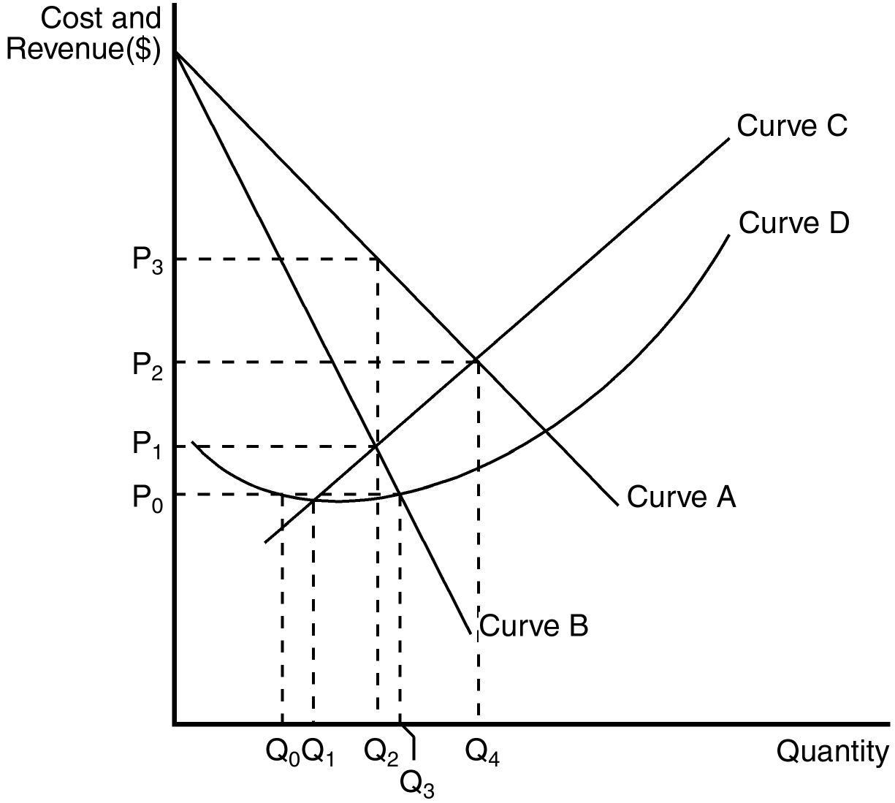
77. Refer to Figure 14-2. The demand curve for a monopoly firm is depicted by curve
a. A.
b. B.
c. C.
d. D.
ANS: A PTS: 1 DIF: 1 REF: 14-2
TOP: Demand curve MSC: Interpretive
78. Refer to Figure 14-2. The marginal revenue curve for a monopoly firm is depicted by curve
a. A.
b. B.
c. C.
d. D.
ANS: B PTS: 1 DIF: 2 REF: 14-2
TOP: Marginal revenue MSC: Interpretive
79. Refer to Figure 14-2. The marginal cost curve for a monopoly firm is depicted by curve
a. A.
b. B.
c. C.
d. D.
ANS: C PTS: 1 DIF: 2 REF: 14-2
TOP: Marginal cost MSC: Interpretive
80. Refer to Figure 14-2. The average total cost curve for a monopoly firm is depicted by curve
a. A.
b. B.
c. C.
d. D.
ANS: D PTS: 1 DIF: 2 REF: 14-2
TOP: Average total cost MSC: Interpretive
81. Refer to Figure 14-2. If the monopoly firm is currently producing Q₃ units of output, then a decrease in output will necessarily cause profit to
a. remain unchanged.
b. decrease.
c. increase as long as the new level of output is at least Q₂.
d. increase as long as the new level of output is at least Q₁.
ANS: C PTS: 1 DIF: 2 REF: 14-2
TOP: Profit maximization MSC: Analytical
82. Refer to Figure 14-2. Profit can always be increased by increasing the level of output by one unit if the monopolist is currently operating at
(i) Q₀.
(ii) Q₁.
(iii) Q₂.
(iv) Q₃.
a. (i) or (ii)
b. (i), (ii) or (iii)
c. (iii) or (iv)
d. (iv) only
ANS: A PTS: 1 DIF: 2 REF: 14-2
TOP: Profit maximization MSC: Analytical
83. Refer to Figure 14-2. If the monopoly firm wants to maximize its profit, it should operate at a level of output equal to
a. Q₁.
b. Q₂.
c. Q₃.
d. Q₄.
ANS: B PTS: 1 DIF: 2 REF: 14-2
TOP: Profit maximization MSC: Analytical
84. Refer to Figure 14-2. Profit will be maximized by charging a price equal to
a. P₀.
b. P₁.
c. P₂.
d. P₃.
ANS: D PTS: 1 DIF: 2 REF: 14-2
TOP: Profit maximization MSC: Analytical
85. Which of the following statements is true of a monopoly firm?
a. A monopoly firm is a price taker and has no supply curve.
b. A monopoly firm is a price maker and has no supply curve
c. A monopoly firm is a price maker and has a downward-sloping supply curve.
d. A monopoly firm is a price maker and has an upward-sloping supply curve.
ANS: B PTS: 1 DIF: 2 REF: 14-2
TOP: Monopoly MSC: Interpretive
86. For a monopoly firm, the shape and position of the demand curve play a role in determining
(i) the profit-maximizing price.
(ii) the shape and position of the marginal cost curve.
(iii) the shape and position of the marginal revenue curve.
a. (i) and (ii)
b. (ii) and (iii)
c. (i) and (iii)
d. (i), (ii), and (iii)
ANS: C PTS: 1 DIF: 2 REF: 14-2
TOP: Demand curve MSC: Interpretive
87. In a competitive market, a firm's supply curve dictates the amount it will supply. In a monopoly market the
a. same is true.
b. supply curve conceptually makes sense, but in practice is never used.
c. supply curve will have limited predictive capacity.
d. decision about how much to supply is impossible to separate from the demand curve it faces.
ANS: D PTS: 1 DIF: 2 REF: 14-2
TOP: Supply curve MSC: Interpretive
Figure 14-3
The figure below illustrates the cost and revenue structure for a monopoly firm.

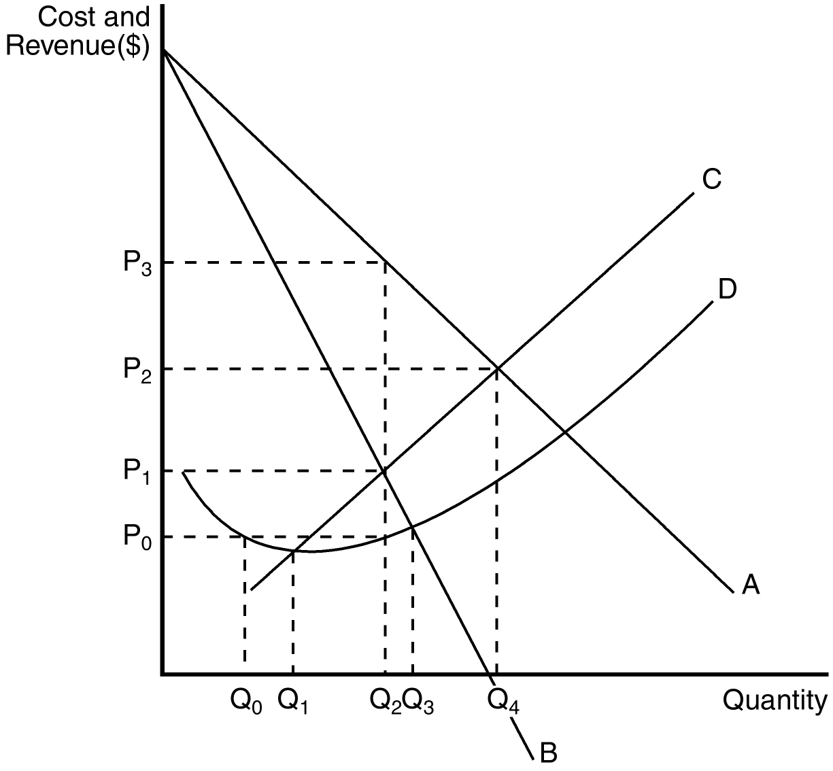
88. Refer to Figure 14-3. A profit-maximizing monopoly's total revenue is equal to
a. P₃ × Q₂.
b. P₂ × Q₄.
c. (P₃ – P₀) × Q₂.
d. (P₃ – P₀) × Q₄.
ANS: A PTS: 1 DIF: 2 REF: 14-2
TOP: Total revenue MSC: Analytical
89. Refer to Figure 14-3. A profit-maximizing monopoly's total cost is equal to
a. (P₁ – P₀) × Q₂.
b. P₀ × Q₁.
c. P₀ × Q₂.
d. P₀ × Q₃.
ANS: C PTS: 1 DIF: 2 REF: 14-2
TOP: Total cost MSC: Analytical
90. Refer to Figure 14-3. A profit-maximizing monopoly's profit is equal to
a. P₃ × Q₂.
b. P₂ × Q₄.
c. (P₃ – P₀) × Q₂.
d. (P₃ – P₀) × Q₄.
ANS: C PTS: 1 DIF: 2 REF: 14-2
TOP: Profit MSC: Analytical
91. Refer to Figure 14-3. Profit on a typical unit sold for a profit-maximizing monopoly would equal
a. P₂ – P₁.
b. P₂ – P₀.
c. P₃ – P₂.
d. P₃ – P₀.
ANS: D PTS: 1 DIF: 2 REF: 14-2
TOP: Profit MSC: Analytical
92. Refer to Figure 14-3. At the profit-maximizing level of output,
a. marginal revenue is equal to P₃.
b. marginal cost is equal to P₃.
c. average revenue is equal to P₃.
d. average total cost is equal to P₁.
ANS: C PTS: 1 DIF: 2 REF: 14-2
TOP: Average revenue MSC: Interpretive
93. When a pharmaceutical company discovers a new drug, patent law gives the monopoly
a. partial ownership of the right to sell the drug for a limited number of years.
b. partial ownership of the right to sell the drug for an unlimited number of years.
c. sole ownership of the right to sell the drug for a limited number of years.
d. sole ownership of the right to sell the drug for an unlimited number of years.
ANS: C PTS: 1 DIF: 1 REF: 14-2
TOP: Patents MSC: Definitional
94. Due to the nature of the patent laws on pharmaceuticals, the market for such drugs
a. always remains a competitive market.
b. always remains a monopolistic market.
c. switches from competitive to monopolistic once the firm's patent runs out.
d. switches from monopolistic to competitive once the firm's patent runs out.
ANS: D PTS: 1 DIF: 2 REF: 14-2
TOP: Patents MSC: Interpretive
95. What happens to the price and quantity sold of a drug when its patent runs out?
(i) The price will fall.
(ii) The quantity sold will fall.
(iii) The marginal cost of producing the drug will rise.
a. (i) only
b. (i) and (ii)
c. (ii) and (iii)
d. (i), (ii), and (iii)
ANS: A PTS: 1 DIF: 2 REF: 14-2
TOP: Patents MSC: Interpretive
96. Generic drugs enter the pharmaceutical drug market once
a. the ingredients to the name brand drug have been discovered.
b. 10 years have passed.
c. they are patented.
d. the patent on the name brand drug expires.
ANS: D PTS: 1 DIF: 2 REF: 14-2
TOP: Patents MSC: Interpretive
97. Name brand drugs are able to continue capitalizing on their market power even after generic drugs enter the market because
(i) almost all people fear the generic drug companies are devoting too few resources to research and development.
(ii) some people fear that generic drugs are inferior.
(iii) some people are loyal to the name brand.
a. (i) and (ii)
b. (ii) and (iii)
c. (i) and (iii)
d. (i), (ii), and (iii)
ANS: B PTS: 1 DIF: 2 REF: 14-2
TOP: Patents MSC: Interpretive
98. In a market characterized by monopoly, the market demand curve is
a. upward sloping.
b. horizontal.
c. downward sloping.
d. vertical.
ANS: C PTS: 1 DIF: 1 REF: 14-2
TOP: Demand curve MSC: Definitional
99. As a monopolist increases the quantity of output it sells, the price consumers are willing to pay for the good
a. is unaffected.
b. decreases.
c. increases.
d. There is not enough information given in answer the question.
ANS: B PTS: 1 DIF: 1 REF: 14-2
TOP: Demand curve MSC: Interpretive
100. Competitive firms differ from monopolies in which of the following ways?
(i) Competitive firms do not have to worry about the price effect lowering their total revenue.
(ii) Marginal revenue for a competitive firm equals price, while marginal revenue for a monopoly is less than the price it is able to charge.
(iii) Monopolies must lower their price in order to sell more of their product, while competitive firms do not.
a. (i) and (ii)
b. (ii) and (iii)
c. (i) and (iii)
d. (i), (ii), and (iii)
ANS: D PTS: 1 DIF: 3 REF: 14-2
TOP: Monopoly MSC: Interpretive
101. The monopolist's profit-maximizing quantity of output is determined by the intersection of which of the following two curves?
a. Marginal cost and demand
b. Marginal cost and marginal revenue
c. Average total cost and marginal revenue
d. Average variable cost and average revenue
ANS: B PTS: 1 DIF: 2 REF: 14-2
TOP: Profit maximization MSC: Interpretive
102. What is the monopolist's profit under the following conditions? The profit-maximizing price charged for goods produced is $12. The intersection of the marginal revenue and marginal cost curves occurs where output is 10 units and marginal cost is $6. Average total cost for 10 units of output is $5.
a. $60
b. $70
c. $100
d. $120
ANS: B PTS: 1 DIF: 2 REF: 14-2
TOP: Profit MSC: Applicative
103. What is the monopolist's profit under the following conditions? The profit-maximizing price charged for goods produced is $14. The intersection of the marginal revenue curve and the marginal cost curve occurs where output is 15 units and marginal cost is $7.
a. $90
b. $105
c. $180
d. Not enough information is given to determine the answer.
ANS: D PTS: 1 DIF: 2 REF: 14-2
TOP: Profit MSC: Applicative
104. A monopolist will choose to increase output when
a. market price increases.
b. at all levels of output, marginal cost increases.
c. at the present level of output, marginal revenue exceeds marginal cost.
d. the demand curve shifts to the left.
ANS: C PTS: 1 DIF: 2 REF: 14-2
TOP: Profit maximization MSC: Analytical
105. For a monopolist, when does marginal revenue exceed average revenue?
a. Never
b. When output is less than the profit-maximizing level of output
c. When output is greater than the profit-maximizing level of output
d. For all levels of output greater than zero.
ANS: A PTS: 1 DIF: 2 REF: 14-2
TOP: Marginal revenue MSC: Analytical
106. If a monopolist sells 100 units at $8 per unit and realizes an average total cost of $6 per unit, what is the monopolist's profit?
a. $200
b. $400
c. $600
d. $800
ANS: A PTS: 1 DIF: 1 REF: 14-2
TOP: Profit MSC: Applicative
107. Suppose a firm has a monopoly on the sale of widgets and faces a downward-sloping demand curve. When selling the 100th widget, the firm will always receive
a. less marginal revenue on the 100th widget than it received on the 99th widget.
b. more average revenue on the 100th widget than it received on the 99th widget.
c. more total revenue on the 100 widgets than it received on the first 99 widgets.
d. a lower average cost per unit at 100 units output than at 99 units of output.
ANS: A PTS: 1 DIF: 2 REF: 14-2
TOP: Demand curve MSC: Analytical
108. For a monopoly, the level of output at which marginal revenue equals zero is also the level of output at which
a. average revenue is zero.
b. profit is maximized.
c. total revenue is maximized.
d. marginal cost is zero.
ANS: C PTS: 1 DIF: 3 REF: 14-2
TOP: Total revenue MSC: Analytical
109. For a monopolist,
a. average revenue is always greater than the price of the good.
b. marginal revenue is always less than the price of the good.
c. marginal cost is always greater than average total cost.
d. marginal revenue equals marginal cost at the point where total revenue is maximized.
ANS: B PTS: 1 DIF: 2 REF: 14-2
TOP: Marginal revenue MSC: Interpretive
110. The profit-maximization problem for a monopolist differs from that of a competitive firm in which of the following ways?
a. A competitive firm maximizes profit at the point where marginal revenue equals marginal cost; a monopolist maximizes profit at the point where marginal revenue exceeds marginal cost.
b. A competitive firm maximizes profit at the point where average revenue equals marginal cost; a monopolist maximizes profit at the point where average revenue exceeds marginal cost.
c. For a competitive firm, marginal revenue at the profit-maximizing level of output is equal to marginal revenue at all other levels of output; for a monopolist, marginal revenue at the profit-maximizing level of output is smaller than it is for larger levels of output.
d. For a profit-maximizing competitive firm, thinking at the margin is much more important than it is for a profit-maximizing monopolist.
ANS: B PTS: 1 DIF: 3 REF: 14-2
TOP: Profit maximization MSC: Interpretive
111. When a monopoly increases its output and sales,
a. both the output effect and the price effect work to increase total revenue.
b. the output effect works to increase total revenue and the price effect works to decrease total revenue.
c. the output effect works to decrease total revenue and the price effect works to increase total revenue.
d. both the output effect and the price effect work to decrease total revenue.
ANS: B PTS: 1 DIF: 2 REF: 14-2
TOP: Marginal revenue MSC: Interpretive
112. A monopolist can sell 200 units of output for $36.00 per unit. Alternatively, it can sell 201 units of output for $35.80 per unit. The marginal revenue of the 201st unit of output is
a. $-4.20.
b. $-0.20.
c. $4.20.
d. $35.80.
ANS: A PTS: 1 DIF: 2 REF: 14-2
TOP: Marginal revenue MSC: Applicative
113. A monopoly firm can sell 150 units of output for $10.00 per unit. Alternatively, it can sell 151 units of output for $9.95 per unit. The marginal revenue of the 151st unit of output is
a. $-2.45.
b. $-0.05.
c. $2.45.
d. $9.95.
ANS: C PTS: 1 DIF: 2 REF: 14-2
TOP: Marginal revenue MSC: Applicative
Scenario 14-2
A monopoly firm maximizes its profit by producing Q = 500 units of output. At that level of output, its marginal revenue is $30, its average revenue is $60, and its average total cost is $34.
114. Refer to Scenario 14-2. The firm's profit-maximizing price is
a. $30.
b. between $30 and $34.
c. between $34 and $60.
d. $60.
ANS: D PTS: 1 DIF: 2 REF: 14-2
TOP: Pricing MSC: Analytical
115. Refer to Scenario 14-2. At Q = 500, the firm's total revenue is
a. $13,000.
b. $15,000.
c. $17,000.
d. $30,000.
ANS: D PTS: 1 DIF: 2 REF: 14-2
TOP: Total revenue MSC: Applicative
116. Refer to Scenario 14-2. The firm's maximum profit is
a. $13,000.
b. $15,000.
c. $17,000.
d. $30,000.
ANS: A PTS: 1 DIF: 2 REF: 14-2
TOP: Profit MSC: Applicative
117. Refer to Scenario 14-2. At Q = 500, the firm's marginal cost is
a. less than $30.
b. $30.
c. $34.
d. greater than $34.
ANS: B PTS: 1 DIF: 2 REF: 14-2
TOP: Marginal cost MSC: Analytical
118. A monopolist faces the following demand curve:

Price | Quantity Demanded
$51 | 1
$47 | 2
$42 | 3
$36 | 4
$29 | 5
$21 | 6
$12 | 7

The monopolist has total fixed costs of $60 and has a constant marginal cost of $15. What is the profit-maximizing level of production?
a. 2 units
b. 3 units
c. 4 units
d. 5 units
ANS: C PTS: 1 DIF: 3 REF: 14-2
TOP: Profit maximization MSC: Applicative
119. A monopolist faces the following demand curve:

Price | Quantity Demanded
$10 | 5
$9 | 10
$8 | 16
$7 | 23
$6 | 31
$5 | 45
$4 | 52
$3 | 60

The monopolist has total fixed costs of $40 and a constant marginal cost of $5. At the profit-maximizing level of output, the monopolist's average total cost is
a. $9.00
b. $7.50
c. $6.74
d. $5.82
ANS: B PTS: 1 DIF: 3 REF: 14-2
TOP: Average total cost MSC: Applicative
120. A reduction in a monopolist's fixed costs would
a. decrease the profit-maximizing price and increase the profit-maximizing quantity produced.
b. increase the profit-maximizing price and decrease the profit-maximizing quantity produced.
c. not effect the profit-maximizing price or quantity.
d. possibly increase, decrease or not effect profit-maximizing price and quantity, depending on the elasticity of demand.
ANS: C PTS: 1 DIF: 3 REF: 14-2
TOP: Fixed cost MSC: Interpretive
121. For a monopoly,
a. average revenue exceeds marginal revenue.
b. average revenue equals marginal revenue.
c. average revenue is less than marginal revenue.
d. price equals marginal revenue.
ANS: A PTS: 1 DIF: 1 REF: 14-2
TOP: Marginal revenue MSC: Definitional
122. If a monopoly lowers its price, its
a. total revenue must increase.
b. total revenue must decrease.
c. marginal revenue must increase.
d. marginal revenue must decrease.
ANS: D PTS: 1 DIF: 2 REF: 14-2
TOP: Marginal revenue MSC: Interpretive
123. When a certain monopoly sets its price at $8 it sells 64 units. When the monopoly sets its price at $10 it sells 60 units. The marginal revenue for the firm over this range is
a. $11.
b. $22.
c. $33.
d. $44.
ANS: B PTS: 1 DIF: 2 REF: 14-2
TOP: Marginal revenue MSC: Analytical
124. The following table shows quantity, price, and marginal cost information for a monopoly. What price should the firm charge to maximize its profit?

Q | P | MC
0 | 10 | --
1 | 9 | 3
2 | 8 | 4
3 | 7 | 5
4 | 6 | 6
5 | 5 | 7
6 | 4 | 8

a. $4
b. $5
c. $6
d. $7
ANS: D PTS: 1 DIF: 2 REF: 14-2
TOP: Profit maximization MSC: Analytical
125. The following table provides information on the price, quantity, and average cost for a monopoly. At what price will the firm maximize its profit?

P | Q | ATC
5 | 0 | --
4 | 4 | 1.00
3 | 8 | 0.75
2 | 12 | 0.75
1 | 16 | 0.81
0 | 20 | 0.90

a. $1
b. $2
c. $3
d. $4
ANS: C PTS: 1 DIF: 3 REF: 14-2
TOP: Profit maximization MSC: Analytical
126. The following table gives information on the price, quantity, and total cost of production for a monopolist. How much profit will the firm earn at the profit-maximizing price?

P | Q | TC
5 | 0 | 3
4 | 5 | 8
3 | 10 | 18
2 | 15 | 33
1 | 20 | 53
0 | 25 | 78

a. $9
b. $12
c. $15
d. $18
ANS: B PTS: 1 DIF: 2 REF: 14-2
TOP: Profit maximization MSC: Analytical
127. Which of the following statements is false?
a. The competitive firm produces where P = MC.
b. The monopolist produces where P = MC.
c. The competitive firm produces where MR = MC.
d. The monopolist produces where MR = MC.
ANS: B PTS: 1 DIF: 2 REF: 14-2
TOP: Profit maximization MSC: Definitional
128. Suppose when a monopolist produces 50 units its average revenue is $8 per unit, its marginal revenue is $4 per unit, its marginal cost is $4 per unit, and its average total cost is $3 per unit. What can we conclude about this monopolist?
a. The monopolist is currently maximizing profits and its total profits are $200.
b. The monopolist is currently maximizing profits and its total profits are $250.
c. The monopolist is not currently maximizing its profits; it should produce more units and charge a lower price to maximize profit.
d. The monopolist is not currently maximizing its profits; it should produce fewer units and charger a higher price to maximize profit.
ANS: B PTS: 1 DIF: 2 REF: 14-2
TOP: Profit maximization MSC: Analytical
129. Suppose when a monopolist produces 75 units its average revenue is $10 per unit, its marginal revenue is $5 per unit, its marginal cost is $6 per unit, and its average total cost is $5 per unit. What can we conclude about this monopolist?
a. The monopolist is currently maximizing profits and its total profits are $375.
b. The monopolist is currently maximizing profits and its total profits are $300.
c. The monopolist is not currently maximizing profits; it should produce more units and charge a lower price to maximize profits.
d. The monopolist is not currently maximizing profits; it should produce fewer units and charge a higher price to maximize profits.
ANS: D PTS: 1 DIF: 3 REF: 14-2
TOP: Profit maximization MSC: Analytical
130. With no price discrimination, the monopolist sells every unit at the same price. Therefore
a. marginal revenue is equal to price.
b. marginal revenue is equal to average revenue.
c. price is greater than marginal revenue.
d. Both a and b are correct.
ANS: C PTS: 1 DIF: 2 REF: 14-2
TOP: Marginal revenue MSC: Interpretive
131. Which of the following statements is true?
a. If the monopolist's marginal revenue is greater than its marginal cost, the monopolist can increase profit by selling more units at a lower price per unit.
b. If the monopolist's marginal revenue is greater than its marginal cost, the monopolist can increase profit by selling fewer units at a higher price per unit.
c. When a monopolist produces where MR = MC it must earn a positive economic profit.
d. If the monopolist is earning a positive economic profit, it must be producing where MR = MC.
ANS: A PTS: 1 DIF: 2 REF: 14-2
TOP: Profit maximization MSC: Interpretive
Table 14-2
Dreher's Designer Shirt Company, a monopolist, has the following cost and revenue information.

COSTS |  |  | REVENUES
Quantity  Produced | Total Cost  ($) | Marginal  Cost | Quantity  Demanded | Price  ($/unit) | Total  Revenue | Marginal  Revenue
0 | 100 | -- | 0 | 170 |  | --
1 | 140 |  | 1 | 160
2 | 184 |  | 2 | 150
3 | 230 |  | 3 | 140
4 | 280 |  | 4 | 130
5 | 335 |  | 5 | 120
6 | 395 |  | 6 | 110
7 | 475 |  | 7 | 100
8 | 565 |  | 8 | 90

132. Refer to Table 14-2. What is the marginal cost of the 6th shirt?
a. $44
b. $46
c. $55
d. $60
ANS: D PTS: 1 DIF: 2 REF: 14-2
TOP: Marginal cost MSC: Applicative
133. Refer to Table 14-2. What is the marginal cost of the 8th shirt?
a. $50
b. $60
c. $90
d. $110
ANS: C PTS: 1 DIF: 2 REF: 14-2
TOP: Marginal cost MSC: Applicative
134. Refer to Table 14-2. What is the total revenue from selling 6 shirts?
a. $100
b. $600
c. $625
d. $660
ANS: D PTS: 1 DIF: 2 REF: 14-2
TOP: Total revenue MSC: Applicative
135. Refer to Table 14-2. What is the total revenue from selling 8 shirts?
a. $90
b. $695
c. $720
d. $800
ANS: C PTS: 1 DIF: 2 REF: 14-2
TOP: Total revenue MSC: Applicative
136. Refer to Table 14-2. What is the marginal revenue from selling the 2nd shirt?
a. $140
b. $150
c. $160
d. $170
ANS: A PTS: 1 DIF: 2 REF: 14-2
TOP: Marginal revenue MSC: Applicative
137. Refer to Table 14-2. What is the marginal revenue from selling the 8th shirt?
a. $10
b. $20
c. $40
d. $90
ANS: B PTS: 1 DIF: 2 REF: 14-2
TOP: Marginal revenue MSC: Applicative
138. Refer to Table 14-2. What is the average revenue when 7 shirts are sold?
a. $40
b. $90
c. $100
d. $700
ANS: C PTS: 1 DIF: 2 REF: 14-2
TOP: Average revenue MSC: Applicative
139. Refer to Table 14-2. Which of the following quantities will achieve the maximum profit?
a. 3
b. 4
c. 6
d. 7
ANS: C PTS: 1 DIF: 2 REF: 14-2
TOP: Profit maximization MSC: Applicative
140. Refer to Table 14-2. What is total profit at the profit-maximizing quantity?
a. $100
b. $245
c. $265
d. $395
ANS: C PTS: 1 DIF: 2 REF: 14-2
TOP: Profit MSC: Applicative
141. Refer to Table 14-2. What are Dreher's Designer Shirt Company's fixed costs?
a. $0
b. $100
c. $600
d. $745
ANS: B PTS: 1 DIF: 2 REF: 14-2
TOP: Fixed cost MSC: Applicative
142. Refer to Table 14-2. What is the total variable cost of production when six units are produced?
a. $100
b. $295
c. $600
d. $620
ANS: B PTS: 1 DIF: 2 REF: 14-2
TOP: Variable costs MSC: Applicative
143. After the patent runs out on a brand name drug, generic drugs, which have the same effect as the branded drug, enter the market. Because of this
a. the price increases and total surplus decreases.
b. the price decreases and total surplus decreases.
c. the price decreases and total surplus increases.
d. the price increases and total surplus increases.
ANS: C PTS: 1 DIF: 2 REF: 14-2
TOP: Patents MSC: Interpretive
144. Monopolies use their market power to
a. charge prices that equal minimum average total cost.
b. attain normal profits in the long run.
c. charge a price that is higher than marginal cost.
d. dump excess supplies of their product on the market.
ANS: C PTS: 1 DIF: 2 REF: 14-2
TOP: Pricing MSC: Interpretive
145. If a monopolist can sell 7 units when the price is $4 and 8 units when the price is $3, then marginal revenue of selling the eighth unit is equal to
a. $3.
b. $4.
c. $24.
d. -$4.
ANS: D PTS: 1 DIF: 2 REF: 14-2
TOP: Marginal revenue MSC: Applicative
Table 14-3
George has the following demand curve for selling vegemite:

Price | Quantity
$10.00 | 1
$8.00 | 2
$6.00 | 3
$4.00 | 4
$2.00 | 5

In addition, George has a marginal cost of $3.00 per unit.
146. Refer to Table 14-3. What is George's profit-maximizing level of output?
a. 1
b. 2
c. 3
d. 4
ANS: B PTS: 1 DIF: 2 REF: 14-2
TOP: Profit maximization MSC: Applicative
147. Refer to Table 14-3. What is George's profit-maximizing price?
a. $2
b. $4
c. $6
d. $8
ANS: B PTS: 1 DIF: 2 REF: 14-2
TOP: Profit maximization MSC: Applicative
148. If a monopolist's marginal costs shift up by $1.00, then
a. the monopoly price will rise by $1.
b. the monopoly price will rise by more than $1.
c. the monopoly price will rise by less than $1.
d. there is no change in the monopoly price and profits fall.
ANS: C PTS: 1 DIF: 2 REF: 14-2
TOP: Pricing MSC: Interpretive
149. If a monopolist has zero marginal costs it will produce
a. the output at which total revenue is maximized.
b. in the range in which marginal revenue is still increasing.
c. at the point at which marginal revenue is at a maximum.
d. in the range in which marginal revenue is negative.
ANS: A PTS: 1 DIF: 3 REF: 14-2
TOP: Pricing MSC: Analytical
150. The supply curve for the monopolist
a. is horizontal.
b. is vertical.
c. is upward sloping.
d. does not exist.
ANS: D PTS: 1 DIF: 1 REF: 14-2
TOP: Supply curve MSC: Interpretive
Table 14-4
Consider the following demand and cost information for a monopoly.

Quantity | Price | Total Cost
0 | $30 | $3
1 | $25 | $7
2 | $20 | $12
3 | $15 | $18
4 | $10 | $25

151. Refer to Table 14-4. The marginal revenue of the second unit is
a. $10
b. $15
c. $20
d. $25
ANS: B PTS: 1 DIF: 2 REF: 14-2
TOP: Marginal revenue MSC: Applicative
152. Refer to Table 14-4. The marginal cost of the fourth unit is
a. $7.
b. $12.
c. $25.
d. $60.
ANS: A PTS: 1 DIF: 2 REF: 14-2
TOP: Marginal cost MSC: Applicative
153. Refer to Table 14-4. The maximum profit this monopolist can earn is
a. $5.
b. $15.
c. $16
d. $28
ANS: D PTS: 1 DIF: 2 REF: 14-2
TOP: Profit MSC: Applicative
154. Refer to Table 14-4. To maximize profit, the monopolist sets price at
a. $10
b. $15
c. $20
d. $25
ANS: C PTS: 1 DIF: 2 REF: 14-2
TOP: Profit maximization MSC: Applicative
155. A monopoly market
a. always maximizes total economic well-being.
b. always minimizes consumer surplus.
c. generally fails to maximize total economic well-being.
d. generally fails to maximize producer surplus.
ANS: C PTS: 1 DIF: 2 REF: 14-3
TOP: Welfare MSC: Interpretive
156. Suppose a monopolist chooses the price and production level which maximizes its profit. From that point, to increase society’s economic welfare, output would need to be increased as long as
a. average revenue exceeds marginal cost.
b. average revenue exceeds average total cost.
c. marginal revenue exceeds marginal cost.
d. marginal revenue exceeds average total cost.
ANS: A PTS: 1 DIF: 2 REF: 14-3
TOP: Welfare MSC: Analytical
157. The economic inefficiency of a monopolist can be measured by the
a. number of consumers who are unable to purchase the product because of its high price.
b. excess profit generated by monopoly firms.
c. poor quality of service offered by monopoly firms.
d. deadweight loss.
ANS: D PTS: 1 DIF: 2 REF: 14-3
TOP: Deadweight loss MSC: Interpretive
158. The problem with monopolies is their ability
(i) to do away with barriers to entry.
(ii) to price their product at a level that exceeds marginal cost.
(iii) to restrict output below the socially efficient level of production.
a. (i) and (ii)
b. (ii) and (iii)
c. (iii) only
d. (i), (ii), and (iii)
ANS: B PTS: 1 DIF: 2 REF: 14-3
TOP: Monopoly MSC: Interpretive
159. The socially efficient level of production occurs where the marginal cost curve intersects which of the following curves?
a. Average variable cost
b. Average total cost
c. Demand
d. Marginal revenue
ANS: C PTS: 1 DIF: 2 REF: 14-3
TOP: Welfare MSC: Analytical
160. Monopoly pricing prevents some mutually beneficial trades from taking place. These unrealized mutually beneficial trades are
a. of little concern to society.
b. a deadweight loss to society.
c. a sunk cost to society.
d. also observed in competitive markets.
ANS: B PTS: 1 DIF: 2 REF: 14-3
TOP: Deadweight loss MSC: Interpretive
161. The difference in total surplus between the socially efficient level of production and the monopolist's level of production is
a. offset by regulatory revenues.
b. called a deadweight loss.
c. equal to the monopolist’s profit.
d. Both b and c are correct.
ANS: B PTS: 1 DIF: 2 REF: 14-3
TOP: Total surplus MSC: Definitional
162. Consider a profit-maximizing monopoly pricing under the following conditions. The profit-maximizing price charged for goods produced is $12.The intersection of the marginal revenue and marginal cost curves occurs where output is 10 units and marginal cost is $6. The socially efficient level of production is 12 units. The demand curve and marginal cost curves are linear. What is the deadweight loss?
a. $4
b. $6
c. $12
d. $16
ANS: B PTS: 1 DIF: 3 REF: 14-3
TOP: Deadweight loss MSC: Applicative
163. Economic welfare is generally measured by
(i) profit.
(ii) total surplus.
(iii) the price consumer’s pay for the product.
a. (i) and (ii)
b. (ii) and (iii)
c. (i) and (iii)
d. (ii) only
ANS: D PTS: 1 DIF: 2 REF: 14-3
TOP: Total surplus MSC: Interpretive
164. Consumers' willingness to pay for a good minus the amount they actually pay for it equals
a. consumer surplus.
b. consumer benefit.
c. price discriminant.
d. quantity demanded.
ANS: A PTS: 1 DIF: 2 REF: 14-3
TOP: Consumer surplus MSC: Definitional
165. The amount that producers receive for a good minus their costs of producing it equals
a. quantity supplied.
b. supply price.
c. producer gain.
d. producer surplus.
ANS: D PTS: 1 DIF: 2 REF: 14-3
TOP: Producer surplus MSC: Definitional
166. For a monopoly market, total surplus can be defined as the value of the good to
a. producers minus the cost incurred by consumers.
b. producers plus the cost incurred by consumers.
c. consumers minus the costs of producing the good.
d. consumers plus the cost of producing the good.
ANS: C PTS: 1 DIF: 2 REF: 14-3
TOP: Total surplus MSC: Definitional
Figure 14-4
The figure below depicts the demand and marginal cost curves of a profit-maximizing monopolist.

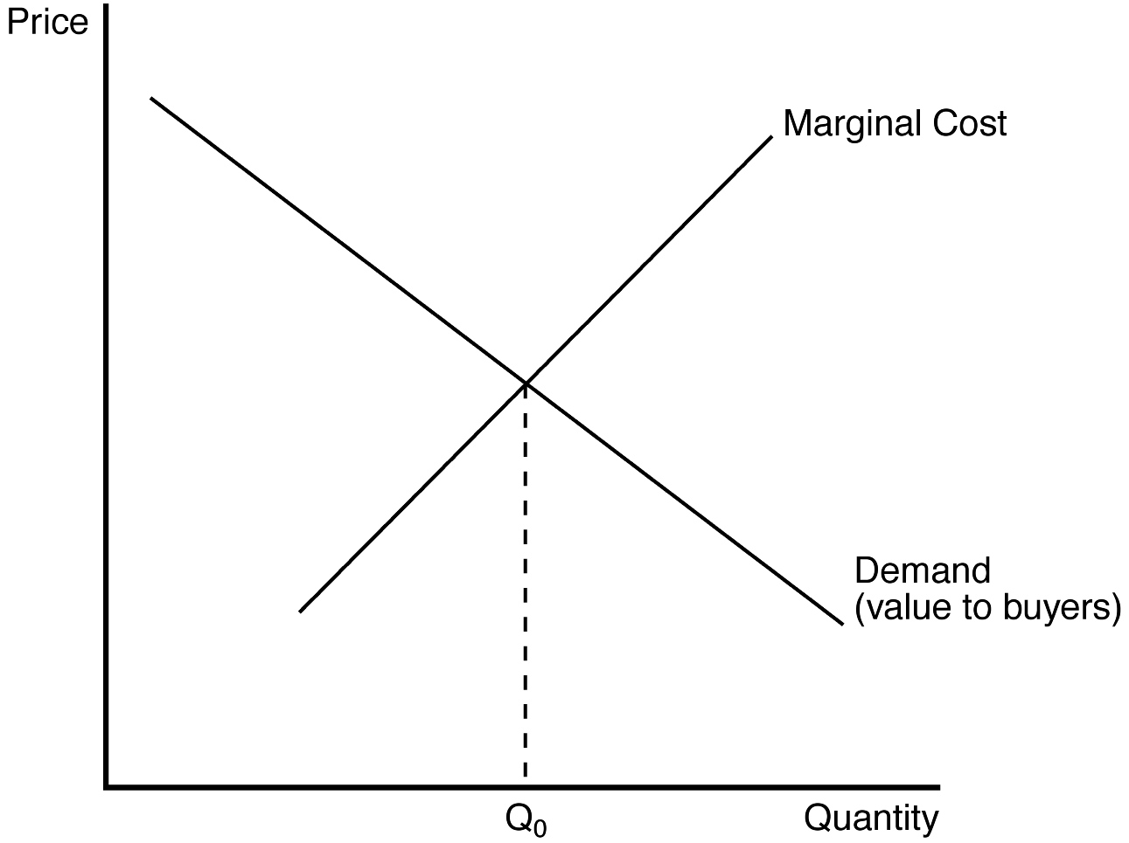
167. Refer to Figure 14-4. A benevolent social planner would have the monopoly operate at an output level
a. below Q₀.
b. above Q₀.
c. equal to Q₀.
d. equal to zero.
ANS: C PTS: 1 DIF: 2 REF: 14-3
TOP: Welfare MSC: Analytical
168. Refer to Figure 14-4. If the monopoly operates at an output level below Q₀, then an increase in output toward Q₀ (but not so large an increase as to exceed Q₀) would
a. raise the price and raise total surplus.
b. lower the price and raise total surplus.
c. raise the price and lower total surplus.
d. lower the price and lower total surplus.
ANS: B PTS: 1 DIF: 2 REF: 14-3
TOP: Total surplus MSC: Analytical
169. Selling a good at a price determined by the intersection of the demand curve and the marginal cost curve is consistent with
(i) the socially-optimal level of output.
(ii) the market solution for profit-maximizing competitive firms.
(iii) the market solution for a profit-maximizing monopoly.
a. (i) and (ii)
b. (ii) and (iii)
c. (i) and (iii)
d. (i), (ii), and (iii)
ANS: A PTS: 1 DIF: 2 REF: 14-3
TOP: Welfare MSC: Interpretive
170. A monopoly chooses to supply the market with a quantity of goods that is determined by the intersection of the
a. marginal cost and demand curves.
b. average total cost and demand curves.
c. marginal revenue and average total cost curves.
d. marginal revenue and marginal cost curves.
ANS: D PTS: 1 DIF: 1 REF: 14-3
TOP: Profit maximization MSC: Interpretive
Figure 14-5
The figure below depicts the demand, marginal revenue and marginal cost curves of a profit-maximizing monopolist.
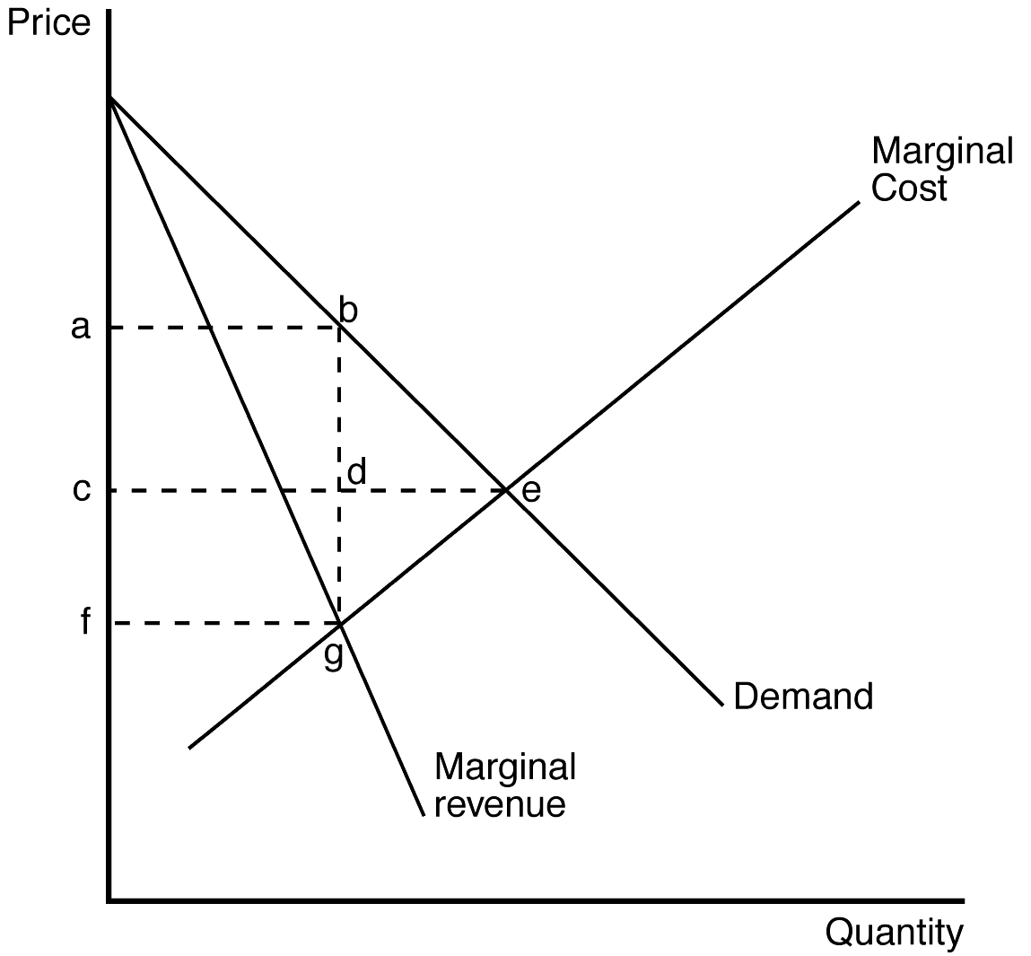
171. Refer to Figure 14-5. Which of the following areas represents the deadweight loss due to monopoly pricing?
a. Triangle bde
b. Triangle bge
c. Rectangle acdb
d. Rectangle cfgd
ANS: B PTS: 1 DIF: 2 REF: 14-3
TOP: Deadweight loss MSC: Analytical
172. Refer to Figure 14-5. Which area represents the total surplus lost due to monopoly pricing?
a. Triangle bde.
b. Triangle bge.
c. Rectangle acdb.
d. Rectangle cfgd.
ANS: B PTS: 1 DIF: 2 REF: 14-3
TOP: Deadweight loss MSC: Analytical
173. When the government creates a monopoly, the social loss may include
a. declining marginal costs.
b. the cost of lawyers and lobbyists hired to convince lawmakers to continue the monopoly.
c. excessive monopoly profits.
d. diminishing marginal revenue.
ANS: B PTS: 1 DIF: 2 REF: 14-3
TOP: Welfare MSC: Interpretive
174. If a social planner were running a monopoly, that planner could achieve an efficient outcome by charging the price that is determined by the
a. minimum point on the average total cost curve.
b. intersection of the average total cost curve and the demand curve.
c. intersection of the marginal cost curve and the demand curve.
d. intersection of the marginal cost curve and the marginal revenue curve.
ANS: C PTS: 1 DIF: 2 REF: 14-3
TOP: Welfare MSC: Analytical
175. The deadweight loss that arises from a monopoly is a consequence of the fact that the monopoly
a. price is higher than the socially-optimal price.
b. price equals marginal revenue.
c. price is the same as average revenue.
d. maximizes profit where marginal revenue equals marginal cost.
ANS: A PTS: 1 DIF: 2 REF: 14-3
TOP: Deadweight loss MSC: Interpretive
176. Which of the following statements is correct?
a. The benefits that accrue to a monopoly’s owners are equal to the costs that are incurred by consumers of that firm's product.
b. The deadweight loss that arises in monopoly stems from the fact that the profit-maximizing monopoly firm produces a quantity of output that exceeds the socially efficient quantity.
c. The deadweight loss caused by monopoly is similar to the deadweight loss caused by a tax on a product.
d. The primary social problem caused by monopoly is monopoly profit.
ANS: C PTS: 1 DIF: 3 REF: 14-3
TOP: Deadweight loss MSC: Interpretive
Figure 14-6
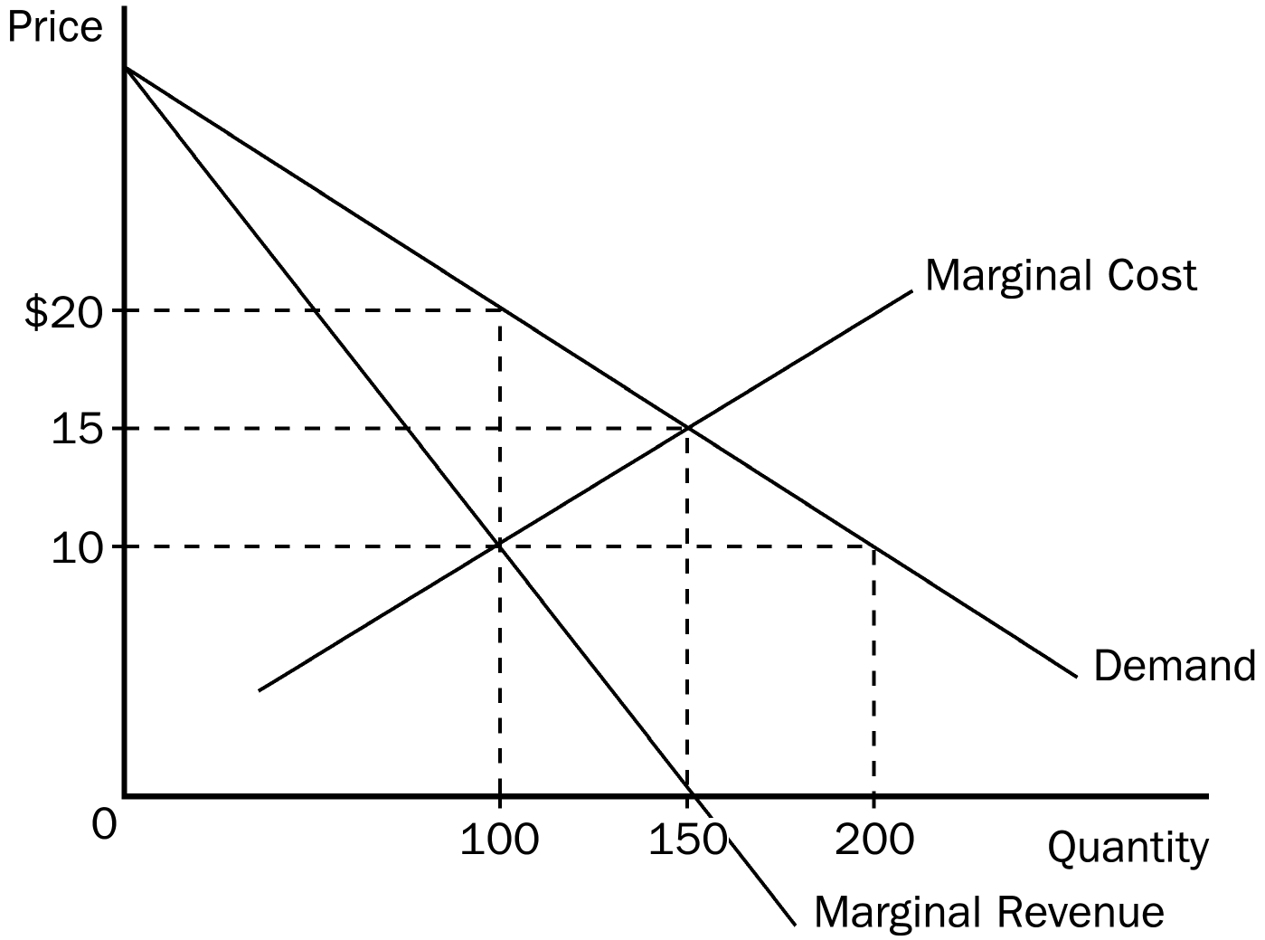
177. Refer to Figure 14-6. To maximize total surplus, a benevolent social planner would choose which of the following outcomes?
a. 100 units of output and a price of $10 per unit
b. 150 units of output and a price of $10 per unit
c. 150 units of output and a price of $15 per unit
d. 200 units of output and a price of $10 per unit
ANS: C PTS: 1 DIF: 2 REF: 14-3
TOP: Total surplus MSC: Analytical
178. Refer to Figure 14-6. To maximize its profit, a monopolist would choose which of the following outcomes?
a. 100 units of output and a price of $10 per unit
b. 100 units of output and a price of $20 per unit
c. 150 units of output and a price of $15 per unit
d. 200 units of output and a price of $20 per unit
ANS: B PTS: 1 DIF: 2 REF: 14-3
TOP: Profit maximization MSC: Analytical
179. Refer to Figure 14-6. The monopolist's maximum profit
a. is $800.
b. is $1,000.
c. is $1,250.
d. cannot be determined from the diagram.
ANS: D PTS: 1 DIF: 2 REF: 14-3
TOP: Profit MSC: Analytical
180. Refer to Figure 14-6. The deadweight loss caused by a profit-maximizing monopoly amounts to
a. $150.
b. $200.
c. $250.
d. $300.
ANS: C PTS: 1 DIF: 2 REF: 14-3
TOP: Deadweight loss MSC: Applicative
181. Which of the following statements is false?
a. Part of the deadweight loss associated with monopoly is measured by the monopolist's economic profit.
b. Marginal cost is always less than average total cost in a natural monopoly.
c. Discount coupons available free to the public are a type of price discrimination.
d. Anti-trust laws make it harder for firms to create synergies.
ANS: A PTS: 1 DIF: 2 REF: 14-3
TOP: Deadweight loss MSC: Interpretive
182. To maximize total surplus with a monopoly firm, a benevolent social planner would
a. choose the level of output where MR = MC.
b. choose the level of output where MR intersects the demand curve.
c. choose the level of output where MC intersects the demand curve.
d. allow the free market system to determine the level of output.
ANS: C PTS: 1 DIF: 2 REF: 14-3
TOP: Total surplus MSC: Interpretive
183. A monopolist produces
a. more than the socially efficient quantity of output, but at a higher price than in a competitive market.
b. less than the socially efficient quantity of output, but at a higher price than in a competitive market.
c. the socially efficient quantity of output, but at a higher price than in a competitive market.
d. possibly more or possibly less than the socially efficient quantity of output, but definitely at a higher price than in a competitive market.
ANS: B PTS: 1 DIF: 2 REF: 14-3
TOP: Monopoly MSC: Interpretive
184. In the diagram below, which area represents the deadweight loss from monopoly?
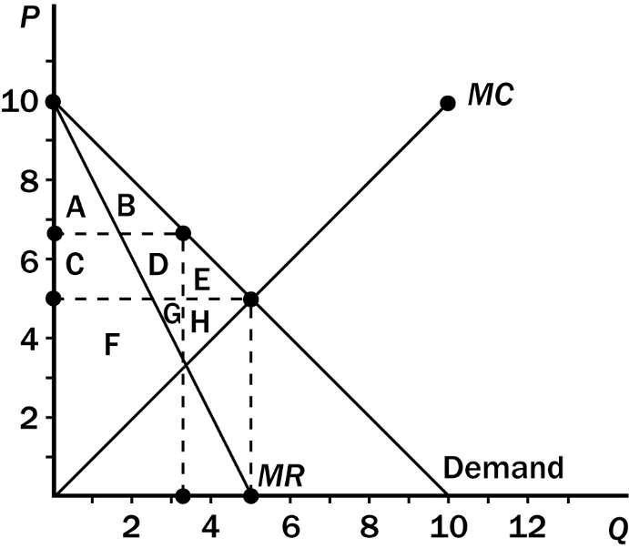
a. E
b. H
c. C+D+E
d. E+H
ANS: D PTS: 1 DIF: 2 REF: 14-3
TOP: Deadweight loss MSC: Interpretive
185. For a monopoly, the socially efficient level of output occurs where
a. marginal revenue equals marginal cost.
b. average revenue equals marginal cost.
c. marginal revenue equals average total cost.
d. average revenue equals average total cost.
ANS: B PTS: 1 DIF: 2 REF: 14-3
TOP: Welfare MSC: Interpretive
186. The social cost of a single-price monopoly is equal to its
a. economic profit.
b. fixed cost.
c. dead weight loss.
d. variable cost.
ANS: C PTS: 1 DIF: 1 REF: 14-3
TOP: Deadweight loss MSC: Interpretive
187. "Monopolists do not worry about efficient production and minimizing costs since they can just pass along any increase in costs to their consumers." This statement is
a. false; price increases will mean fewer sales, and lower costs will mean higher profits (or smaller losses).
b. true; this is the primary reason why economists believe that monopolies result in economic inefficiency.
c. false; the monopolist is a price taker.
d. true; consumers in a monopoly market have no substitutes to turn to when the monopolist raises prices.
ANS: A PTS: 1 DIF: 2 REF: 14-3
TOP: Monopoly MSC: Interpretive
188. Many economists criticize monopolists because they produce at output levels that are not efficient. In other words, monopolists
a. charge a price that equals marginal cost rather than a price that equals average cost.
b. don't innovate.
c. produce a large quantity of waste.
d. have no incentive to produce at their minimum ATC.
ANS: D PTS: 1 DIF: 2 REF: 14-3
TOP: Inefficiency MSC: Interpretive
1. One method used to control the ability of firms to capture monopoly profit in the United States is through
a. government purchase of products produced by monopolists.
b. government distribution of a monopolist's excess production.
c. enforcement of antitrust laws.
d. regulation of firms in highly competitive markets.
ANS: C PTS: 1 DIF: 2 REF: 14-4
TOP: Antitrust MSC: Interpretive
2. Antitrust laws may
a. enhance the ability of firms to capture profits from a concentration of market power.
b. enhance the ability of firms to reduce economic losses.
c. restrict the ability of firms to operate at the socially efficient level of production.
d. restrict the ability of firms to merge.
ANS: D PTS: 1 DIF: 2 REF: 14-4
TOP: Antitrust MSC: Interpretive
3. One problem with government operation of monopolies is that
a. a benevolent government is likely to be interested in generating profits for political gain.
b. monopolies typically have rising average costs.
c. the government typically has little incentive to reduce costs.
d. a government-regulated outcome will increase the profitability of the monopoly.
ANS: C PTS: 1 DIF: 2 REF: 14-4
TOP: Regulation MSC: Interpretive
4. For a typical natural monopoly, average total cost is
a. falling and marginal cost is above average total cost.
b. falling and marginal cost is below average total cost.
c. rising and marginal cost is below average total cost.
d. rising and marginal cost is above average total cost.
ANS: B PTS: 1 DIF: 2 REF: 14-4
TOP: Natural monopoly MSC: Analytical
5. One problem with regulating a monopolist on the basis of cost is that
a. regulators are unable to effectively control prices and/or production.
b. it does not provide an incentive for the monopolist to reduce its cost.
c. a monopolist's costs, by definition, are higher than costs of perfectly competitive firms.
d. a monopolist is still able to generate excessive economic profits.
ANS: B PTS: 1 DIF: 2 REF: 14-4
TOP: Regulation MSC: Interpretive
6. When regulators use a marginal-cost pricing strategy to regulate a natural monopoly, the regulated monopoly
a. will experience a loss.
b. will experience a price below average total cost.
c. may rely on a government subsidy to remain in business.
d. All of the above are correct.
ANS: D PTS: 1 DIF: 2 REF: 14-4
TOP: Regulation MSC: Interpretive
7. The key issue in determining the efficiency of public versus private ownership of a monopoly is
a. the tendency for efficient management of publicly owned enterprises.
b. the inability of private monopolies to get rid of managers that are doing a bad job.
c. the propensity of private monopolies to generate excessive profits.
d. how ownership of the firm affects the cost of production.
ANS: D PTS: 1 DIF: 2 REF: 14-4
TOP: Welfare MSC: Interpretive
8. The collection of statutes aimed at curbing monopoly power is called
a. the 14th amendment.
b. the Clayton Act.
c. the Sherman Act.
d. antitrust law.
ANS: D PTS: 1 DIF: 2 REF: 14-4
TOP: Antitrust MSC: Interpretive
9. The legislation passed by Congress in 1890 to reduce the market power of large and powerful "trusts" is called the
a. Morgan Act.
b. Sherman Act.
c. Clayton Act.
d. 14th Amendment.
ANS: B PTS: 1 DIF: 2 REF: 14-4
TOP: Antitrust MSC: Definitional
10. Antitrust laws allow the government to
a. prevent mergers.
b. break up companies.
c. promote competition.
d. All of the above are correct.
ANS: D PTS: 1 DIF: 2 REF: 14-4
TOP: Antitrust MSC: Interpretive
11. Since natural monopolies have a declining average cost curve, regulating natural monopolies by setting price equal to marginal cost would
a. cause the monopolist to operate at a loss.
b. result in a less than optimal total surplus.
c. maximize producer surplus.
d. result in higher profits for the monopoly.
ANS: A PTS: 1 DIF: 2 REF: 14-4
TOP: Natural monopoly MSC: Interpretive
12. The assessment by George Stigler concerning the tradeoffs between "market failure" and "political failure" in the American economy provides support for which of the following solutions to the problems of monopolies?
a. Public ownership of monopolies
b. Government regulation of monopolies
c. Government incentives to promote competition in monopolized industries
d. Doing nothing at all
ANS: D PTS: 1 DIF: 2 REF: 14-4
TOP: Regulation MSC: Interpretive
13. In order for antitrust laws to raise social welfare, the government must
a. disallow synergy benefits from accruing to monopolists.
b. disallow any mergers from taking place.
c. be able to determine which mergers are desirable and which are not.
d. always attempt to keep markets in their most competitive form.
ANS: C PTS: 1 DIF: 2 REF: 14-4
TOP: Antitrust MSC: Interpretive
14. Reduced competition through merging of companies will raise social welfare
a. if the cost from the synergies exceeds the benefit of increased market power.
b. if the benefit from the synergies exceeds the social cost of increased market power.
c. always.
d. never.
ANS: B PTS: 1 DIF: 2 REF: 14-4
TOP: Antitrust MSC: Interpretive
15. In the majority of cases where there is a natural monopoly, the U. S. government usually deals with the problem
a. by splitting the natural monopoly into smaller companies.
b. through regulation.
c. by turning the natural monopoly into a public enterprise.
d. by doing nothing.
ANS: B PTS: 1 DIF: 2 REF: 14-4
TOP: Natural monopoly MSC: Interpretive
16. Private ownership of a monopoly may benefit society because the monopoly will have an incentive to
a. charge a price that is consistent with that of a benevolent social planner.
b. charge a price that prevents some people from buying.
c. price its good according to the intersection of marginal cost and average revenue.
d. lower its costs to earn a higher profit.
ANS: D PTS: 1 DIF: 2 REF: 14-4
TOP: Welfare MSC: Interpretive
17. Policymakers are discussing various proposals regarding how to deal with natural monopolies. Senator Huff wants to regulate natural monopolies by equating price with average total cost. Huff contends that such a policy will ensure that monopolies make every effort to reduce costs. Senator Puff wants the government to own natural monopolies. Puff argues that government-owned monopolies usually do a better job of holding down costs than privately owned monopolies. Which senator's argument is correct?
a. Senator Huff
b. Senator Puff
c. Both Senators
d. Neither Senator
ANS: D PTS: 1 DIF: 2 REF: 14-4
TOP: Regulation MSC: Interpretive
18. Which of the following is the most likely reason the city council in New York City consistently denies licenses to independent van drivers selling rides to the public?
a. Allowing the vans to operate would reduce social welfare.
b. The van drivers engage in price discrimination.
c. Allowing the vans to operate would allow them to unfairly take advantage of poor residents.
d. The vans are a threat to the public transit monopoly, which makes campaign contributions to the city council members.
ANS: D PTS: 1 DIF: 2 REF: 14-4
TOP: Monopoly MSC: Interpretive
19. In a natural monopoly,
a. society would be better off if antitrust laws were used to create many different firms in the market.
b. the marginal cost curve is positively sloped.
c. if the government requires marginal cost pricing, it must pay the monopolist a subsidy.
d. the marginal revenue curve is horizontal.
ANS: C PTS: 1 DIF: 2 REF: 14-4
TOP: Natural monopoly MSC: Interpretive
20. Which of the following is not a way the government can respond to the inefficient allocation of resources associated with monopolies?
a. Preventing mergers through antitrust laws.
b. Regulating the prices that monopolies can charge.
c. Requiring the monopolies to produce more than their profit-maximizing level of output.
d. Running the monopoly itself.
ANS: C PTS: 1 DIF: 2 REF: 14-4
TOP: Monopoly MSC: Applicative
21. Which of the following statements comparing monopoly with competition is correct?
a. A monopolist produces a higher level of output and charges a lower price than a competitive firm would.
b. With perfect price discrimination, the total surplus under monopoly can be the same as under competition.
c. With or without price discrimination, the consumer surplus under monopoly is at least as large as it would be under competition.
d. The deadweight loss associated with monopoly is caused by the positive economic profits of the monopolist; competitive firms do not earn a positive economic profit so there is no deadweight loss under competition.
ANS: B PTS: 1 DIF: 2 REF: 14-4
TOP: Welfare MSC: Interpretive
22. For a long while, electricity producers were thought to be a classic example of a natural monopoly. People held this view because
a. the average cost of producing units of electricity by one producer in a specific region was lower than if the same quantity were produced by two or more producers in the same region.
b. the average cost of producing units of electricity by one producer in a specific region was higher than if the same quantity were produced by two or more produced in the same region.
c. the marginal cost of producing units of electricity by one producer in a specific region was higher than if the same quantity were produced by two or more producers in the same region.
d. electricity is a special non-excludable good that could never be sold in a competitive market.
ANS: A PTS: 1 DIF: 2 REF: 14-4
TOP: Natural monopoly MSC: Interpretive
23. Concerning public utilities, the stated reason for resorting to regulation of a monopoly, rather than promoting competition through antitrust, is that the industry in question is believed to be a
a. profit-maximizing monopoly.
b. producer of externalities.
c. revenue-maximizing monopoly.
d. natural monopoly.
ANS: D PTS: 1 DIF: 2 REF: 14-4
TOP: Natural monopoly MSC: Interpretive
24. Splitting up a monopoly is often justified on the grounds that
a. consumers prefer dealing with small firms.
b. small firms have lower costs.
c. competition is inherently efficient.
d. nationalization is a less-preferred option.
ANS: C PTS: 1 DIF: 1 REF: 14-4
TOP: Monopoly MSC: Interpretive
25. The first major piece of antitrust legislation was the
a. Clayton Act.
b. Celler-Kefauver Act.
c. Sherman Act.
d. Robinson-Patman Act.
ANS: C PTS: 1 DIF: 1 REF: 14-4
TOP: Antitrust MSC: Interpretive
26. The task of economic regulation is to
a. protect monopoly profits.
b. approximate the results of the competitive market.
c. replace competition with government ownership.
d. increase competition within the market.
ANS: B PTS: 1 DIF: 1 REF: 14-4
TOP: Regulation MSC: Interpretive
27. A perfectly price-discriminating monopolist is able to
a. maximize profit and produce a socially-optimal level of output.
b. maximize profit, but not produce a socially-optimal level of output.
c. produce a socially-optimal level of output, but not maximize profit.
d. exercise illegal preferences regarding the race and/or gender of its employees.
ANS: A PTS: 1 DIF: 2 REF: 14-5
TOP: Perfect price discrimination MSC: Interpretive
28. When a monopolist is able to sell its product at different prices, it is engaging in
a. distribution pricing.
b. quality-adjusted pricing.
c. price differentiation.
d. price discrimination.
ANS: D PTS: 1 DIF: 1 REF: 14-5
TOP: Price discrimination MSC: Definitional
Scenario 14-3
Black Box Cable TV is able to purchase an exclusive right to sell a premium movie channel (PMC) in its market area. Let's assume that Black Box Cable pays $150,000 a year for the exclusive marketing rights to PMC. Since Black Box has already installed cable to all of the homes in its market area, the marginal cost of delivering PMC to subscribers is zero. The manager of Black Box needs to know what price to charge for the PMC service to maximize her profit. Before setting price, she hires an economist to estimate demand for the PMC service. The economist discovers that there are two types of subscribers who value premium movie channels. First are the 4,000 die-hard TV viewers who will pay as much as $150 a year for the new PMC premium channel. Second, the PMC channel will appeal to about 20,000 occasional TV viewers who will pay as much as $20 a year for a subscription to PMC.
29. Refer to Scenario 14-3. If Black Box Cable TV is unable to price discriminate, what price will it choose to maximize its profit, and what is the amount of the profit?
a. price = $20; profit = $400,000
b. price = $20; profit = $330,000
c. price = $150; profit = $450,000
d. price = $150; profit = $600,000
ANS: C PTS: 1 DIF: 2 REF: 14-5
TOP: Price discrimination MSC: Applicative
30. Refer to Scenario 14-3. If Black Box Cable TV is able to price discriminate, what would be the maximum amount of profit it could generate?
a. $500,000
b. $600,000
c. $850,000
d. $925,000
ANS: C PTS: 1 DIF: 2 REF: 14-5
TOP: Price discrimination MSC: Applicative
31. Refer to Scenario 14-3. What is the deadweight loss associated with the nondiscriminating pricing policy compared to the price discriminating policy?
a. $375,000
b. $400,000
c. $475,000
d. It cannot be determined from the information provided.
ANS: B PTS: 1 DIF: 3 REF: 14-5
TOP: Deadweight loss MSC: Applicative
32. Price discrimination is a rational strategy for a profit-maximizing monopolist when
a. the monopolist finds itself able to produce only limited amounts of output.
b. consumers are unable to be segmented into identifiable markets.
c. the monopolist wishes to increase the deadweight loss that results from profit-maximizing behavior.
d. there is no opportunity for arbitrage across market segments.
ANS: D PTS: 1 DIF: 2 REF: 14-5
TOP: Arbitrage MSC: Interpretive
33. If a monopolist is able to perfectly price discriminate,
a. consumer surplus is always increased.
b. total surplus is always decreased.
c. consumer surplus and deadweight losses are transformed into monopoly profits.
d. the price effect dominates the output effect on monopoly revenue.
ANS: C PTS: 1 DIF: 2 REF: 14-5
TOP: Perfect price discrimination MSC: Interpretive
34. The practice of selling the same goods to different customers at different prices, but with the same marginal cost, is known as
a. price segregation.
b. price discrimination.
c. arbitrage.
d. monopoly pricing.
ANS: B PTS: 1 DIF: 2 REF: 14-5
TOP: Price discrimination MSC: Definitional
35. In theory, perfect price discrimination
a. decreases the monopolist's profits.
b. decreases consumer surplus.
c. increases deadweight loss.
d. reduces the number of consumers who purchase the monopoly’s product.
ANS: B PTS: 1 DIF: 2 REF: 14-5
TOP: Perfect price discrimination MSC: Interpretive
36. For a firm to price discriminate,
a. it must be a natural monopoly.
b. it must be regulated by the government.
c. it must have some market power.
d. consumers must tell the firm what they are willing to pay for the product.
ANS: C PTS: 1 DIF: 2 REF: 14-5
TOP: Price discrimination MSC: Interpretive
37. A rational pricing strategy for a profit-maximizing monopolist is
a. price discrimination.
b. price segregation.
c. synergy pricing.
d. average cost pricing.
ANS: A PTS: 1 DIF: 2 REF: 14-5
TOP: Price discrimination MSC: Interpretive
38. Price discrimination requires the firm to
a. separate customers according to their willingness to pay.
b. differentiate between different units of its product.
c. engage in arbitrage.
d. use coupons.
ANS: A PTS: 1 DIF: 2 REF: 14-5
TOP: Price discrimination MSC: Interpretive
39. When deciding what price to charge consumers, the monopolist may choose to charge them different prices based on the customers'
a. geographical location.
b. age.
c. income.
d. All of the above are correct.
ANS: D PTS: 1 DIF: 2 REF: 14-5
TOP: Price discrimination MSC: Interpretive
40. A market force that can prevent firms from price discriminating is
a. fluctuating resource prices.
b. arbitrage.
c. high fixed costs.
d. marginal-cost pricing.
ANS: B PTS: 1 DIF: 2 REF: 14-5
TOP: Arbitrage MSC: Interpretive
41. Which of the following can eliminate the inefficiency inherent in monopoly pricing?
a. Arbitrage
b. Cost-plus pricing
c. Price discrimination
d. Regulations that force monopolies to reduce their levels of output
ANS: C PTS: 1 DIF: 2 REF: 14-5
TOP: Price discrimination MSC: Interpretive
42. A firm cannot price discriminate if it
a. has perfect information about consumer demand.
b. operates in a competitive market.
c. faces a downward-sloping demand curve.
d. is regulated by the government.
ANS: B PTS: 1 DIF: 2 REF: 14-5
TOP: Price discrimination MSC: Interpretive
43. A firm cannot price discriminate if
a. its marginal revenue curve is linear for all levels of output.
b. it operates in a competitive market.
c. buyers only reveal the price they are willing to pay for the product.
d. it has a constant marginal cost.
ANS: B PTS: 1 DIF: 2 REF: 14-5
TOP: Price discrimination MSC: Interpretive
44. The process of buying a good in one market at a low price and selling the good in another market for a higher price in order to profit from the price difference is known as
a. sabotage.
b. conspiracy.
c. arbitrage.
d. collusion.
ANS: C PTS: 1 DIF: 1 REF: 14-5
TOP: Arbitrage MSC: Definitional
45. Which of the following may eliminate some or all of the inefficiency that results from monopoly pricing?
a. The government can regulate the monopoly.
b. The monopoly can be prohibited from price discriminating.
c. The monopoly can be forced to operate at a point where its marginal revenue is equal to its marginal cost.
d. None of the above would eliminate any inefficiency associated with a monopoly.
ANS: A PTS: 1 DIF: 2 REF: 14-5
TOP: Regulation MSC: Interpretive
46. Price discrimination adds to social welfare in the form of
(i) increased total surplus.
(ii) reduced costs of production.
(iii) increased consumer surplus.

a. (i) only
b. (i) and (ii)
c. (i) and (iii)
d. (i), (ii), and (iii)
ANS: A PTS: 1 DIF: 2 REF: 14-5
TOP: Welfare MSC: Interpretive
47. Perfect price discrimination describes a situation in which the monopolist
a. knows the exact willingness to pay of each of its customers.
b. charges exactly two different prices to exactly two different groups of customers.
c. maximizes consumer surplus.
d. experiences a zero economic profit.
ANS: A PTS: 1 DIF: 2 REF: 14-5
TOP: Perfect price discrimination MSC: Interpretive
Figure 14-7
The figure below depicts the demand, marginal revenue, and marginal cost curves of a profit-maximizing monopolist.
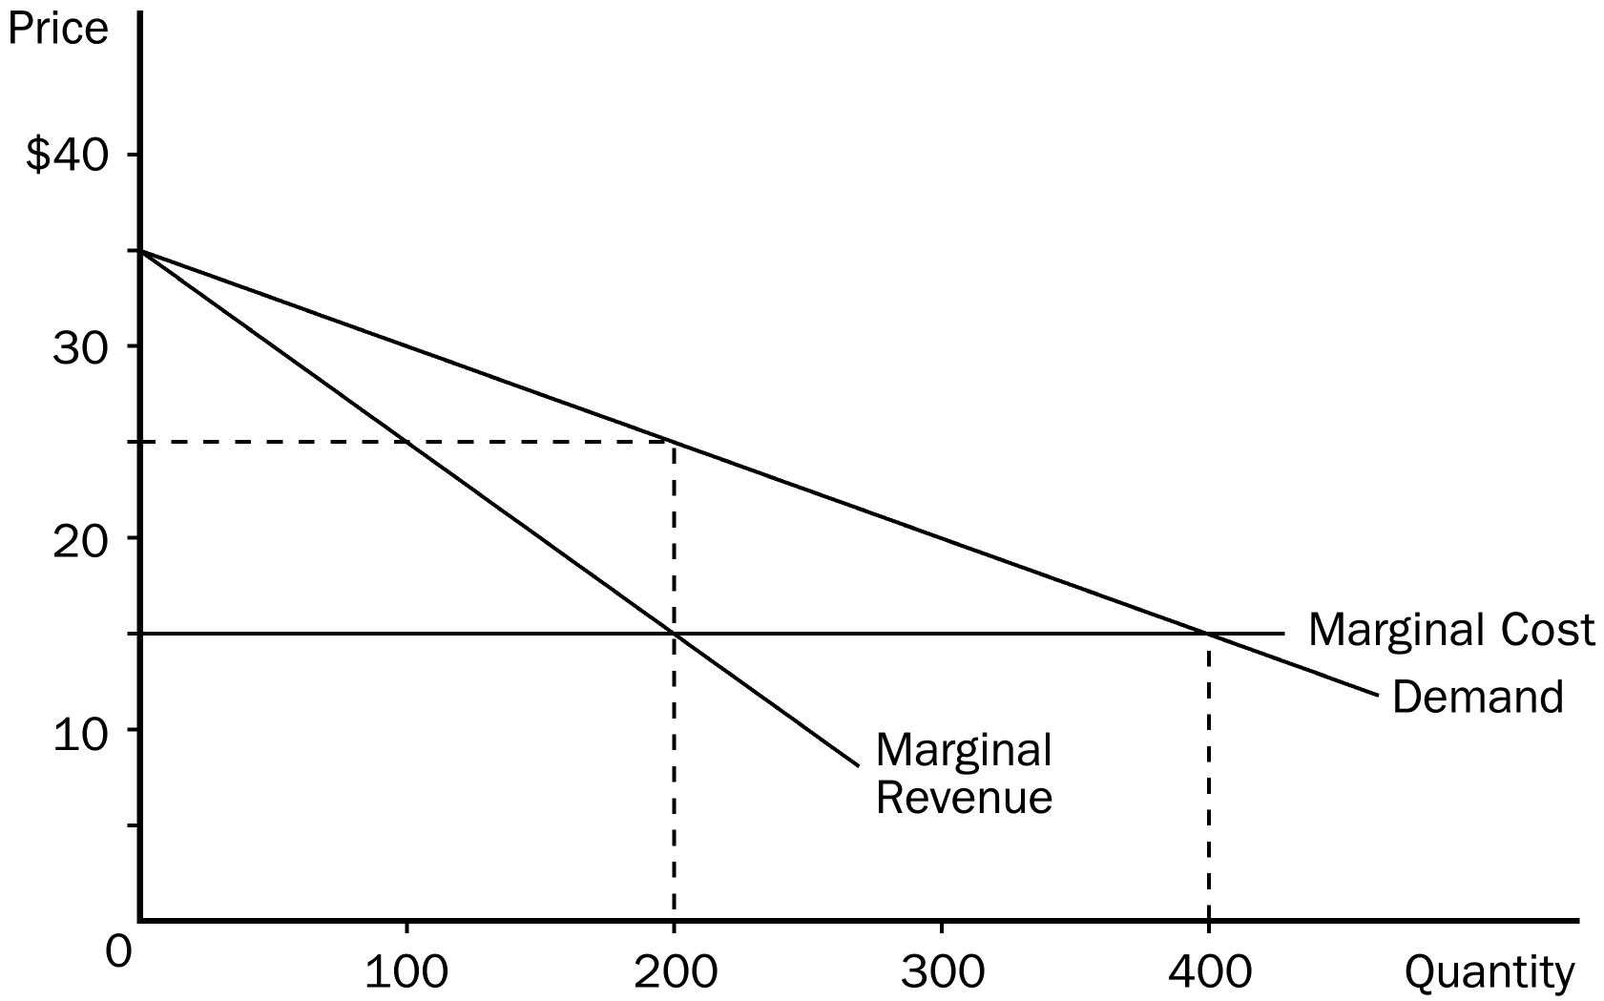
48. Refer to Figure 14-7. If the monopoly firm is NOT allowed to price discriminate, then consumer surplus amounts to
a. $0.
b. $500.
c. $1,000.
d. $2,000.
ANS: C PTS: 1 DIF: 2 REF: 14-5
TOP: Consumer surplus MSC: Applicative
49. Refer to Figure 14-7. If the monopoly firm perfectly price discriminates, then consumer surplus amounts to
a. $0.
b. $250.
c. $500.
d. $1,000.
ANS: A PTS: 1 DIF: 2 REF: 14-5
TOP: Perfect price discrimination MSC: Analytical
50. Refer to Figure 14-7. If the monopoly firm is NOT allowed to price discriminate, then the deadweight loss amounts to
a. $50.
b. $100.
c. $500.
d. $1,000.
ANS: D PTS: 1 DIF: 3 REF: 14-5
TOP: Deadweight loss MSC: Applicative
51. Refer to Figure 14-7. If the monopoly firm perfectly price discriminates, then the deadweight loss amounts to
a. $0.
b. $100.
c. $200.
d. $500.
ANS: A PTS: 1 DIF: 2 REF: 14-5
TOP: Perfect price discrimination MSC: Analytical
52. Refer to Figure 14-7. If there are no fixed costs of production, monopoly profit without price discrimination equals
a. $500.
b. $1,000.
c. $2,000.
d. $4,000.
ANS: C PTS: 1 DIF: 3 REF: 14-5
TOP: Profit MSC: Applicative
53. Refer to Figure 14-7. If there are no fixed costs of production, monopoly profit with perfect price discrimination equals
a. $500.
b. $1,000.
c. $2,000.
d. $4,000.
ANS: D PTS: 1 DIF: 3 REF: 14-5
TOP: Profit MSC: Applicative
54. In reality, perfect price discrimination is
a. used by about 75 percent of all monopolies.
b. used by about 50 percent of all monopolies.
c. seldom used by monopolies because it leads to lower profits.
d. not possible.
ANS: D PTS: 1 DIF: 2 REF: 14-5
TOP: Perfect price discrimination MSC: Interpretive
55. Compared to the monopoly outcome with a single price, imperfect price discrimination
(i) sometimes raises total surplus.
(ii) sometimes lowers total surplus.
(iii) always leads to a lower quantity of output.
a. (i) and (ii)
b. (ii) and (iii)
c. (i) and (iii)
d. Any of these outcomes is possible.
ANS: A PTS: 1 DIF: 2 REF: 14-5
TOP: Welfare MSC: Interpretive
56. Many movie theaters allow discount tickets to be sold to senior citizens because
a. senior-citizen laws mandate such discounts.
b. efforts of goodwill show community respect and win loyal patrons.
c. the theaters are profit maximizers.
d. senior citizens usually comprise a solid portion of those who voice their opinions.
ANS: C PTS: 1 DIF: 2 REF: 14-5
TOP: Price discrimination MSC: Interpretive
57. Round-trip airline tickets are usually cheaper if you stay over a Saturday night before you fly back. What is the reason for this price discrepancy?
a. Airlines are practicing imperfect price discrimination to raise their profits.
b. Airlines charge a different rate based on the different nature of peoples' travel needs.
c. Airlines are attempting to charge people based on their willingness to pay.
d. All of the above are correct.
ANS: D PTS: 1 DIF: 2 REF: 14-5
TOP: Price discrimination MSC: Interpretive
58. When a local grocery store offers discount coupons in the Sunday paper it is most likely trying to
a. reduce prices for all customers.
b. offer their customers a reward for reading the paper.
c. gain some pricing power over the other grocery stores in town.
d. price discriminate.
ANS: D PTS: 1 DIF: 2 REF: 14-5
TOP: Price discrimination MSC: Interpretive
59. Price discrimination explains why Ivy League universities often set rules that determine prices of admission based on students'
a. age.
b. financial resources.
c. high school GPA.
d. gender.
ANS: B PTS: 1 DIF: 2 REF: 14-5
TOP: Price discrimination MSC: Analytical
60. A monopolist faces the following demand curve:

Price | Quantity Demanded
$8 | 300
$7 | 400
$6 | 500
$5 | 600
$4 | 700
$3 | 800
$2 | 900
$1 | 1,000

The monopolist has fixed costs of $1,000 and has a constant marginal cost of $2 per unit. If the monopolist were able to perfectly price discriminate, how many units would it sell?
a. 400
b. 500
c. 900
d. 4,200
ANS: C PTS: 1 DIF: 3 REF: 14-5
TOP: Perfect price discrimination MSC: Analytical
61. It is not uncommon to find that prescription drugs sell for more in the United States than they do in other countries. Which of the following statements about this issue is most likely to be true?
a. Drug companies are engaging in price discrimination, and this practice certainly reduces global social welfare.
b. Global social welfare could be improved if the price in the United States were reduced to the price charged in other countries.
c. Global social welfare could be improved if the price in the other countries were increased to the price charged in the United States.
d. Drug companies are engaging in price discrimination, but this might improve global social welfare if it gives more people access to the drugs.
ANS: D PTS: 1 DIF: 2 REF: 14-5
TOP: Price discrimination MSC: Interpretive
62. If one were to compare a competitive market to a monopoly that engages in perfect price discrimination, one could say that
a. in both cases, total social welfare is the same.
b. total social welfare is higher in the competitive market than with the perfectly price discriminating monopoly.
c. in both cases, some potentially mutually beneficial trades do not occur.
d. consumer surplus is the same in both cases.
ANS: A PTS: 1 DIF: 3 REF: 14-5
TOP: Perfect price discrimination MSC: Analytical
63. Price discrimination
a. forces monopolies to charge a lower price as a result of government regulation.
b. is an attempt by a monopoly to prevent some customers from purchasing its product by charging a high price.
c. is an attempt by a monopoly to increases its profit by selling the same good to different customers at different prices.
d. increases the consumer surplus associated with a monopolistic market.
ANS: C PTS: 1 DIF: 2 REF: 14-5
TOP: Price discrimination MSC: Applicative
64. Which of the following is not an example of price discrimination by a firm?
a. Children's meals at a restaurant.
b. A natural gas company charging customers a higher rate in the winter than in the summer.
c. A senior citizens' discount.
d. Coupons in the Sunday newspaper.
ANS: B PTS: 1 DIF: 2 REF: 14-5
TOP: Price discrimination MSC: Applicative
65. With perfect price discrimination
a. the monopoly eliminates all price discrimination by charging each customer the same price.
b. the monopoly charges each customer an amount equal to the monopolist's marginal cost of production.
c. the deadweight loss from monopoly is eliminated.
d. consumer surplus is gained as monopoly profits are eliminated.
ANS: C PTS: 1 DIF: 2 REF: 14-5
TOP: Price discrimination MSC: Applicative
66. An airline knows that there are two types of travelers: business travelers and vacationers. For a particular flight, there are 100 business travelers who will pay $600 for a ticket while there are 50 vacationers who will pay $300 for a ticket. There are 150 seats available on the plane. Suppose the cost to the airline of providing the flight is $20,000, which includes the cost of the pilots, flight attendants, fuel, etc. How much profit will the airline earn if it sets the price of a ticket at $600?
a. -$5,000
b. $15,000
c. $40,000
d. $70,000
ANS: C PTS: 1 DIF: 2 REF: 14-5
TOP: Price discrimination MSC: Analytical
67. An airline knows that there are two types of travelers: business travelers and vacationers. For a particular flight, there are 100 business travelers who will pay $600 for a ticket while there are 50 vacationers who will pay $300 for a ticket. There are 150 seats available on the plane. Suppose the cost to the airline of providing the flight is $20,000, which includes the cost of the pilots, flight attendants, fuel, etc. How much additional profit can the firm earn by charging each customer their willingness to pay relative to charging a flat price of $600 per ticket?
a. $15,000
b. $25,000
c. $40,000
d. $70,000
ANS: A PTS: 1 DIF: 3 REF: 14-5
TOP: Price discrimination MSC: Analytical
68. Customers who purchase a book from Dave's Bookstore are charged 20% more than customers who purchase the same book from the Dave's Bookstore website. This is an example of
a. perfect price discrimination.
b. price discrimination.
c. deadweight loss.
d. socially inefficient output.
ANS: B PTS: 1 DIF: 2 REF: 14-5
TOP: Price discrimination MSC: Applicative
Table 14-5
Dreher's Designer Shirt Company, a monopolist, has the following cost and revenue information. Assume that Dreher’s is able to engage in perfect price discrimination.

COSTS |  |  |  | REVENUES
Quantity  Produced | Total Cost  ($) | Marginal  Cost | Quantity  Demanded |  | Price  ($) | Total  Revenue | Marginal  Revenue
0 | 100 | -- | 0 |  | 170 |  | --
1 | 140 |  | 1 |  | 160
2 | 184 |  | 2 |  | 150
3 | 230 |  | 3 |  | 140
4 | 280 |  | 4 |  | 130
5 | 335 |  | 5 |  | 120
6 | 395 |  | 6 |  | 110
7 | 475 |  | 7 |  | 100
8 | 575 |  | 8 |  | 95

69. Refer to Table 14-5. What is the marginal revenue from selling the 5th shirt?
a. $80
b. $100
c. $110
d. $120
ANS: D PTS: 1 DIF: 2 REF: 14-5
TOP: Marginal revenue MSC: Applicative
70. Refer to Table 14-5. What is the marginal revenue from selling the 8th shirt?
a. $45
b. $60
c. $80
d. $95
ANS: D PTS: 1 DIF: 2 REF: 14-5
TOP: Marginal revenue MSC: Applicative
71. Refer to Table 14-5. What is the total revenue when 3 shirts are sold?
a. $140
b. $420
c. $450
d. $620
ANS: C PTS: 1 DIF: 3 REF: 14-5
TOP: Total revenue MSC: Applicative
72. Refer to Table 14-5. What is the total revenue when 7 shirts are sold?
a. $650
b. $700
c. $910
d. $1080
ANS: C PTS: 1 DIF: 3 REF: 14-5
TOP: Total revenue MSC: Applicative
73. Refer to Table 14-5. What is the average revenue when 7 shirts are sold?
a. $90
b. $100
c. $110
d. $130
ANS: D PTS: 1 DIF: 3 REF: 14-5
TOP: Average revenue MSC: Applicative
74. Refer to Table 14-5. What is the quantity that maximizes economic profit?
a. 5
b. 6
c. 7
d. 8
ANS: C PTS: 1 DIF: 3 REF: 14-5
TOP: Profit maximization MSC: Applicative
75. Refer to Table 14-5. What is total profit at the profit-maximizing quantity?
a. $325
b. $435
c. $565
d. $1000
ANS: B PTS: 1 DIF: 3 REF: 14-5
TOP: Profit MSC: Applicative
76. Refer to Table 14-5. What are Dreher's Designer Shirt Company's fixed costs?
a. $100
b. $150
c. $354
d. $654
ANS: A PTS: 1 DIF: 2 REF: 14-5
TOP: Fixed cost MSC: Applicative
77. What do economists call the business practice of selling the same good at difference prices to different customers?
a. Price discrimination
b. Collusion
c. Compensating differential
d. Both a and b are correct
ANS: A PTS: 1 DIF: 1 REF: 14-5
TOP: Price discrimination MSC: Definitional
78. During the holiday season, high-end retailers frequently place a high price on merchandise on weekends and discount the price during the week. They do this because they believe that two groups of customers exist: shoppers with little free time and bargain hunters. Bargain hunters have time to shop around and frequently shop during the week. What do economists call this price strategy used by high-end retailers?
a. Oligopoly
b. Price discrimination
c. Compensating differential
d. In-kind transfers
ANS: B PTS: 1 DIF: 2 REF: 14-5
TOP: Price discrimination MSC: Interpretive
79. Which of the following is an example of price discrimination?
a. Nabisco provides cents-off coupons for its products.
b. Amtrak offers a lower price for weekend travel compared to weekday rates on the same routes.
c. Hotel rates for AAA members are lower than for nonmembers.
d. All of the above are correct.
ANS: D PTS: 1 DIF: 1 REF: 14-5
TOP: Price discrimination MSC: Analytical
80. A monopolist that practices perfect price discrimination
a. creates no deadweight loss.
b. charges one group of buyers a higher price than another group, such as offering a student discount.
c. produces the same monopoly level of output as when a single price is charged.
d. charges some customers a price below marginal cost because costs are covered by the high-priced buyers.
ANS: A PTS: 1 DIF: 2 REF: 14-5
TOP: Perfect price discrimination MSC: Interpretive
81. A monopolist's profits with price discrimination will be
a. lower than if the firm charged a single, profit-maximizing price
b. the same as if the firm charged a single, profit-maximizing price.
c. higher than if the firm charged just one price because the firm will capture more consumer surplus.
d. higher than if the firm charged a single price because the costs of selling the good will be lower.
ANS: C PTS: 1 DIF: 1 REF: 14-5
TOP: Price discrimination MSC: Interpretive
True/False
1. When a monopoly charges a higher price, fewer of its goods are sold.
ANS: T DIF: 1 REF: 14-1
TOP: Demand curve MSC: Interpretive
2. The De Beers Diamond company advertises heavily to promote the sale of all diamonds, not just its own. This is evidence that it has a monopoly position to some degree.
ANS: T DIF: 1 REF: 14-1
TOP: Monopoly MSC: Interpretive
3. The De Beers Diamond company is not worried about differentiating its product from all other gemstones.
ANS: F DIF: 1 REF: 14-1
TOP: Monopoly MSC: Interpretive
4. The amount of power that a monopoly has depends on whether there are close substitutes for its product.
ANS: T DIF: 1 REF: 14-1
TOP: Monopoly MSC: Interpretive
5. If the government deems a newly invented drug to be truly original, the pharmaceutical company is given the exclusive right to manufacture and sell the drug for 50 years.
ANS: F DIF: 1 REF: 14-1
TOP: Patents MSC: Interpretive
6. Declining average total cost with increased production is one of the defining characteristics of a natural monopoly.
ANS: T DIF: 1 REF: 14-1
TOP: Natural monopoly MSC: Definitional
7. Average revenue for a monopoly is the total revenue divided by the quantity produced.
ANS: T DIF: 1 REF: 14-2
TOP: Average revenue MSC: Definitional
8. For a monopoly, marginal revenue is often greater than the price they charge for their good.
ANS: F DIF: 1 REF: 14-2
TOP: Marginal revenue MSC: Interpretive
9. Like monopolies, competitive firms choose to produce a quantity in which marginal revenue equals marginal cost.
ANS: T DIF: 1 REF: 14-2
TOP: Profit maximization MSC: Interpretive
10. It doesn't make sense to talk about a monopolist's supply curve.
ANS: T DIF: 1 REF: 14-2
TOP: Monopoly MSC: Interpretive
11. During the life of a drug patent, the monopoly pharmaceutical firm maximizes profit by producing the quantity at which marginal revenue equals marginal cost.
ANS: T DIF: 1 REF: 14-2
TOP: Profit maximization MSC: Interpretive
12. Antitrust laws give the Justice Department the authority to challenge potential mergers between companies in an effort to safeguard society from monopoly power.
ANS: T DIF: 1 REF: 14-4
TOP: Antitrust MSC: Interpretive
13. Some companies merge in order to lower costs through efficient joint production.
ANS: T DIF: 1 REF: 14-4
TOP: Antitrust MSC: Interpretive
14. A common solution to monopoly in European countries is public ownership.
ANS: T DIF: 1 REF: 14-4
TOP: Monopoly MSC: Interpretive
15. The proper level of government intervention is ambiguous when dealing with a monopoly.
ANS: T DIF: 1 REF: 14-4
TOP: Regulation MSC: Interpretive
16. Firms with substantial monopoly power are quite common, because many goods are truly unique.
ANS: F DIF: 1 REF: 14-4
TOP: Monopoly MSC: Interpretive
17. By selling hardcover books to die-hard fans and paperback books to less enthusiastic readers, the publisher is able to price discriminate and raise its profit.
ANS: T DIF: 1 REF: 14-5
TOP: Price discrimination MSC: Interpretive
18. Movie theatres charge different prices to different groups of people based on the differing marginal costs that exist from group to group.
ANS: F DIF: 1 REF: 14-5
TOP: Price discrimination MSC: Interpretive
19. Airlines often separate their customers into business travelers and personal travelers by giving a discount to those travelers who stay over a Saturday night.
ANS: T DIF: 1 REF: 14-5
TOP: Price discrimination MSC: Interpretive
20. University financial aid can be viewed as a type of price discrimination.
ANS: T DIF: 1 REF: 14-5
TOP: Price discrimination MSC: Interpretive
21. By offering lower prices to customers who buy a large quantity, a monopoly is price discriminating.
ANS: T DIF: 1 REF: 14-5
TOP: Price discrimination MSC: Interpretive
22. Goods that do not have close substitutes have downward-sloping demand curves.
ANS: T DIF: 1 REF: 14-5
TOP: Demand curve MSC: Interpretive
Short Answer
1. Describe how government is involved in creating a monopoly. Why might the government create one? Give an example.
ANS:
The government can create a monopoly by giving a single firm the exclusive right to produce some good. Monopolies are created for many reasons; one important one is the recognition that a single firm in industries characterized by high fixed costs can usually supply the entire market at a lower cost than having multiple firms in the industry. Examples include most utility companies. The government also grants sole ownership of inventions through patent laws in order to help eliminate the market failure that is likely to otherwise occur in the markets for those goods.
DIF: 2 REF: 14-1
TOP: Government MSC: Applicative
2. What is the defining characteristic of a natural monopoly? Give an example of a natural monopoly.
ANS:
The defining characteristic of a natural monopoly is when a firm can supply a good or service to an entire market at a smaller cost than could two or more firms. It may also be defined when goods are excludable, but non rival (see Chapter 11). The examples provided in the text include a water distribution system and a bridge.
DIF: 2 REF: 14-1
TOP: Natural monopoly MSC: Definitional
3. In the market for "home heating" consumers typically have several options (e.g., electricity, heating fuel, natural gas, propane, etc.) yet we often think of firms in this industry as behaving like monopolists. Using your understanding of monopoly, discuss the context in which your electricity provider is a monopolist. Is this characterization universally applicable? Carefully explain your answer.
ANS:
In this case, the firms are monopolists in the short run when consumers are unable to change their "home heating" systems. In the long run, consumers can change from electric appliances to natural gas appliances, and thus lessen the monopoly power of utility providers. As long as consumers are able to substitute, in the long run the monopoly power is reduced.
DIF: 3 REF: 14-2
TOP: Monopoly MSC: Analytical
4. There has been much discussion of deregulating electricity and natural gas delivery companies in the United States. Using your understanding of monopolies, discuss the likely effect of deregulation on prices in these two industries.
ANS:
If deregulation leads to increased competition then production and prices should move toward the competitive equilibrium. If deregulation does not lead to increased competition then the monopoly production and price outcome is likely. The success of deregulation movements hinges on their ability to use markets to promote competitive market outcomes.
DIF: 2 REF: 14-2
TOP: Regulation MSC: Analytical
5. Explain how a profit-maximizing monopolist chooses its level of output and the price of its goods.
ANS:
A profit-maximizing monopolist chooses the output level where MR = MC and chooses the corresponding price off of the market demand curve.
DIF: 2 REF: 14-2
TOP: Profit maximization MSC: Analytical
6. Graphically depict the deadweight loss caused by a monopoly. How is this similar to the deadweight loss from taxation?
ANS:
A profit-maximizing monopolist will choose to produce Q₀ units of output and sell at price P₀. However, marginal cost is MC₀. This is identical to the deadweight loss of taxation when the tax forces a wedge between market price and marginal cost.

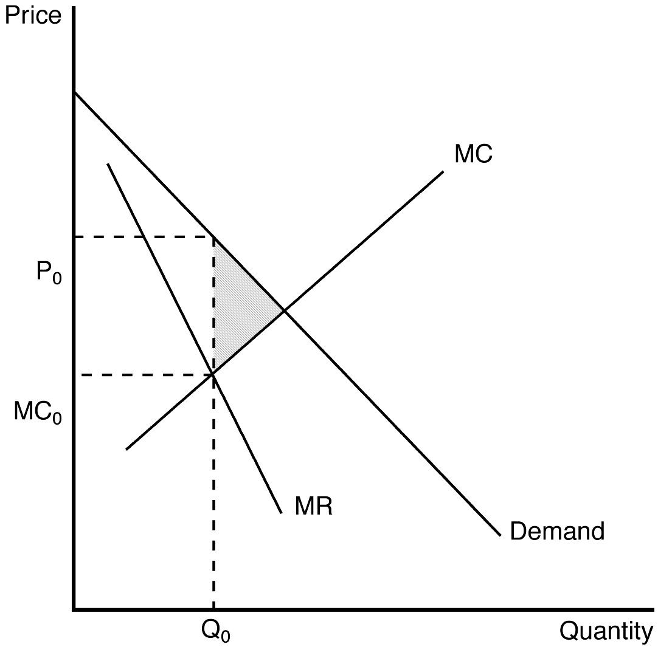
DIF: 2 REF: 14-3
TOP: Deadweight loss MSC: Analytical
7. What is the deadweight loss due to profit-maximizing monopoly pricing under the following conditions: The price charged for goods produced is $10. The intersection of the marginal revenue and marginal cost curves occurs where output is 100 units and marginal revenue is $5. The socially efficient level of production is 110 units. The demand curve is linear and downward sloping and the marginal cost curve is linear and upward sloping.
ANS:
$25
DIF: 2 REF: 14-3
TOP: Deadweight loss MSC: Applicative
8. In many countries, the government chooses to "internalize" the monopoly by owning monopoly providers of goods and services. (In some cases these firms are "nationalized" and the government actually buys or confiscates firms that operate in monopoly markets). What would be the advantages and disadvantages of such an approach to ensuring the "best interest of society" is promoted in these markets? Carefully explain your answer.
ANS:
As long as the government "owner" pursues a production and pricing policy that approaches a competitive outcome, social well-being can be enhanced. In this case the government ownership would benefit society. However, in most cases, government owners operate much like private sector monopolists. The political economy of government institutions does not ensure that government owners will pursue socially optimal policy. Also, governments have no incentive to reduce costs or innovate.
DIF: 3 REF: 14-3
TOP: Government MSC: Analytical
9. Let's assume that a monopolist decides to maximize revenue, rather than profit. How does this operating objective change the size of the deadweight loss? If you are a "benevolent" manager of a monopoly firm and are interested in reducing the deadweight loss of monopoly, should you maximize profits or maximize revenue? Carefully explain your answer.
ANS:
A revenue maximizer operates where MR = 0. This solution moves the monopolist closer to the socially optimal competitive outcome, and reduces deadweight loss. Revenue maximization is potentially a more "socially" optimal objective for monopoly markets than profit maximization.
DIF: 3 REF: 14-3
TOP: Total revenue MSC: Analytical
10. Why might economists prefer private ownership of monopolies over public ownership of monopolies?
ANS:
The private monopolist is governed by the market. Even though the market solution is sub-optimal, it may be better than outcomes generated by publicly owned monopolies. Publicly owned monopolies may restrict output to levels below the private market outcome and thus generate an even lower level of social surplus than a private profit-maximizing monopolist. They also may not work to reduce costs.
DIF: 2 REF: 14-4
TOP: Monopoly MSC: Analytical
11. One solution to the problems of marginal-cost pricing of a regulated monopolist is average cost pricing. In this model, the monopolist is allowed to price its production at average total cost. How does average-cost pricing differ from marginal-cost pricing? Does this solution maximize social well-being?
ANS:
Average-cost pricing always guarantees that the monopolist earns zero economic profits, but does not ensure a socially optimal market solution.
DIF: 3 REF: 14-4
TOP: Regulation MSC: Interpretive
12. What are the four ways that government policymakers can respond to the problem of monopoly?
ANS:
Trying to make monopolized industries more competitive. Regulating the behavior of monopolies. Turning some private monopolies into public enterprises. Do nothing.
DIF: 2 REF: 14-4
TOP: Government MSC: Interpretive
13. Explain the benefits and costs of antitrust laws.
ANS:
Benefits: Promote competition by preventing mergers and breaking-up companies. Costs: May increase cost of operating by restricting synergy mergers.
DIF: 2 REF: 14-4
TOP: Antitrust MSC: Interpretive
14. Why do economists usually prefer private ownership to public ownership of natural monopolies?
ANS:
Private owners have an incentive to minimize cost as long as they reap part of the benefit in the form of higher profit. By contrast, government bureaucrats have no incentive to reduce costs and the losers are customers and taxpayers, whose only recourse is the political system.
DIF: 2 REF: 14-4
TOP: Natural monopoly MSC: Interpretive
15. One example of price discrimination occurs in the publishing industry when a publisher initially releases an expensive hardcover edition of a popular novel, and later releases a cheaper paperback edition. Use this example to demonstrate the benefits and potential pitfalls of a price discrimination pricing strategy.
ANS:
The answer should address the three basic lessons of price discrimination. First, price discrimination is a rational strategy that can lead to higher monopoly profits. Second, price discrimination requires an ability to separate customers according to their willingness to pay. Third, price discrimination can raise economic welfare.
DIF: 2 REF: 14-5
TOP: Price discrimination MSC: Analytical

