Chapter 17
Monopolistic Competition
Multiple Choice
1. Which of the following is not a characteristic of monopolistic competition?
a. A large number of sellers.
b. Firms are price takers.
c. There is free entry into the market.
d. Sellers offer products that are, in some way, different from their competitors’ products.
ANS: B PTS: 1 DIF: 1 REF: 17-0
TOP: Monopolistic competition MSC: Definitional
2. Which of the following markets would most likely be represented by monopolistic competition?
a. The market for corn.
b. The market for cable television service.
c. The market for #2 wooden pencils.
d. The market for clothing.
ANS: D PTS: 1 DIF: 2 REF: 17-0
TOP: Monopolistic competition MSC: Interpretive
3. Monopolistic competition is characterized by which of the following attributes?
(i) Free entry
(ii) Product differentiation
(iii) Many sellers
a. (i) and (iii) only
b. (i) and (ii) only
c. (ii) and (iii) only
d. (i), (ii), and (iii)
ANS: D PTS: 1 DIF: 1 REF: 17-1
TOP: Monopolistic competition MSC: Definitional
4. In a monopolistically competitive industry, firms set price
a. equal to marginal cost since each firm is a price taker.
b. below marginal cost since each firm is a price taker.
c. above marginal cost since each firm is a price setter.
d. always a fraction of marginal cost since each firm is a price setter.
ANS: C PTS: 1 DIF: 2 REF: 17-1
TOP: Price MSC: Interpretive
5. In which of the following market structures are there a large number of sellers?
(i) Monopolistic competition
(ii) Perfect competition
(iii) Oligopoly
a. (i) and (ii) only
b. (ii) and (iii) only
c. (ii) only
d. (i), (ii), and (iii)
ANS: A PTS: 1 DIF: 1 REF: 17-1
TOP: Markets MSC: Definitional
6. In which of the following market structures does free entry and exit play an important role in the long-run equilibrium outcome?
(i) Perfect competition
(ii) Monopolistic competition
(iii) Monopoly
a. (i) only
b. (i) and (ii) only
c. (ii) and (iii) only
d. (i), (ii), and (iii)
ANS: B PTS: 1 DIF: 2 REF: 17-1
TOP: Markets MSC: Interpretive
7. Monopolistic competition differs from perfect competition because in monopolistically competitive markets
a. there are barriers to entry.
b. all firms can eventually earn economic profits.
c. each of the sellers offers a somewhat different product.
d. strategic interactions between firms is vitally important.
ANS: C PTS: 1 DIF: 2 REF: 17-1
TOP: Markets MSC: Interpretive
8. One way in which monopolistic competition differs from oligopoly is that
a. there are no barriers to entry in oligopolies.
b. in oligopoly markets there are only a few sellers.
c. all firms in an oligopoly eventually earn zero economic profits.
d. strategic interactions between firms are rarely evident in oligopolies.
ANS: B PTS: 1 DIF: 2 REF: 17-1
TOP: Markets MSC: Interpretive
9. A similarity between monopoly and monopolistic competition is that, in both market structures,
a. strategic interactions among sellers are important.
b. there are a small number of sellers.
c. sellers are price makers rather than price takers.
d. product differentiation is important.
ANS: C PTS: 1 DIF: 2 REF: 17-1
TOP: Markets MSC: Interpretive
10. A profit-maximizing firm in a monopolistically competitive market differs from a firm in a perfectly competitive market because the firm in the monopolistically competitive market
a. is characterized by market-share maximization.
b. has no barriers to entry.
c. faces a downward-sloping demand curve for its product.
d. faces a horizontal demand curve at the market clearing price.
ANS: C PTS: 1 DIF: 2 REF: 17-1
TOP: Markets MSC: Interpretive
11. The profit-maximizing rule for a firm in a monopolistically competitive market is to always select the quantity at which
a. marginal revenue is equal to marginal cost.
b. average total cost is equal to marginal revenue.
c. average total cost is equal to price.
d. average revenue exceeds average total cost.
ANS: A PTS: 1 DIF: 2 REF: 17-1
TOP: Profit maximization MSC: Interpretive
12. A profit-maximizing firm in a monopolistically competitive market is characterized by which of the following?
a. Average revenue exceeds marginal revenue
b. Marginal revenue exceeds average revenue
c. Average revenue is equal to marginal revenue
d. Revenue is always maximized along with profit
ANS: A PTS: 1 DIF: 2 REF: 17-1
TOP: Price MSC: Interpretive
Figure 17-1
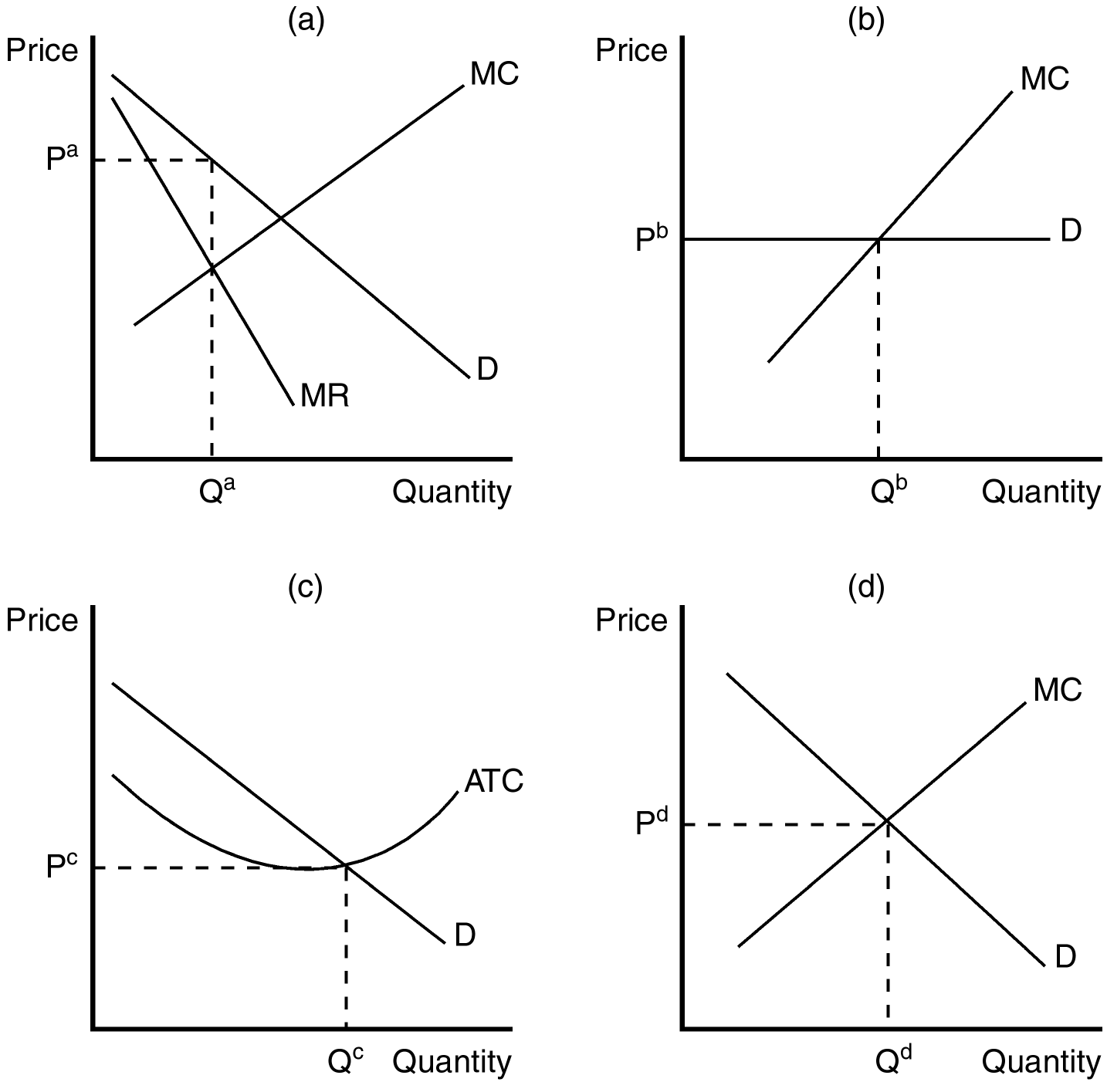
13. Refer to Figure 17-1. Which of the graphs depicts the situation for a profit-maximizing firm in a monopolistically competitive market?
a. Panel a
b. Panel b
c. Panel c
d. Panel d
ANS: A PTS: 1 DIF: 2 REF: 17-1
TOP: Monopolistic competition MSC: Interpretive
14. Refer to Figure 17-1. If a firm in a monopolistically competitive market was producing the level of output depicted as Q_{d} in panel (d), it would
a. not be maximizing its profit.
b. be minimizing its losses.
c. be losing market share to other firms in the market.
d. be operating at excess capacity.
ANS: A PTS: 1 DIF: 2 REF: 17-1
TOP: Profit maximization MSC: Analytical
15. Refer to Figure 17-1. The firm depicted in panel b faces a horizontal demand curve. If panel b depicts a profit-maximizing firm,
a. it could be operating in either a perfectly competitive market or in a monopolistically competitive market.
b. it would not have excess capacity in its production as long as it is earning zero economic profit.
c. it is able to choose the price at which it sells its product.
d. the firm can always raise its profit by increasing production since consumers will buy as much as the firm can produce.
ANS: B PTS: 1 DIF: 2 REF: 17-1
TOP: Profit maximization MSC: Interpretive
16. Product differentiation causes the seller of a good to face what type of demand curve?
a. Downward sloping
b. Vertical
c. Horizontal
d. Any of the above could be correct since product differentiation does not affect the shape of the demand curve.
ANS: A PTS: 1 DIF: 2 REF: 17-1
TOP: Demand curve MSC: Interpretive
Figure 17-2
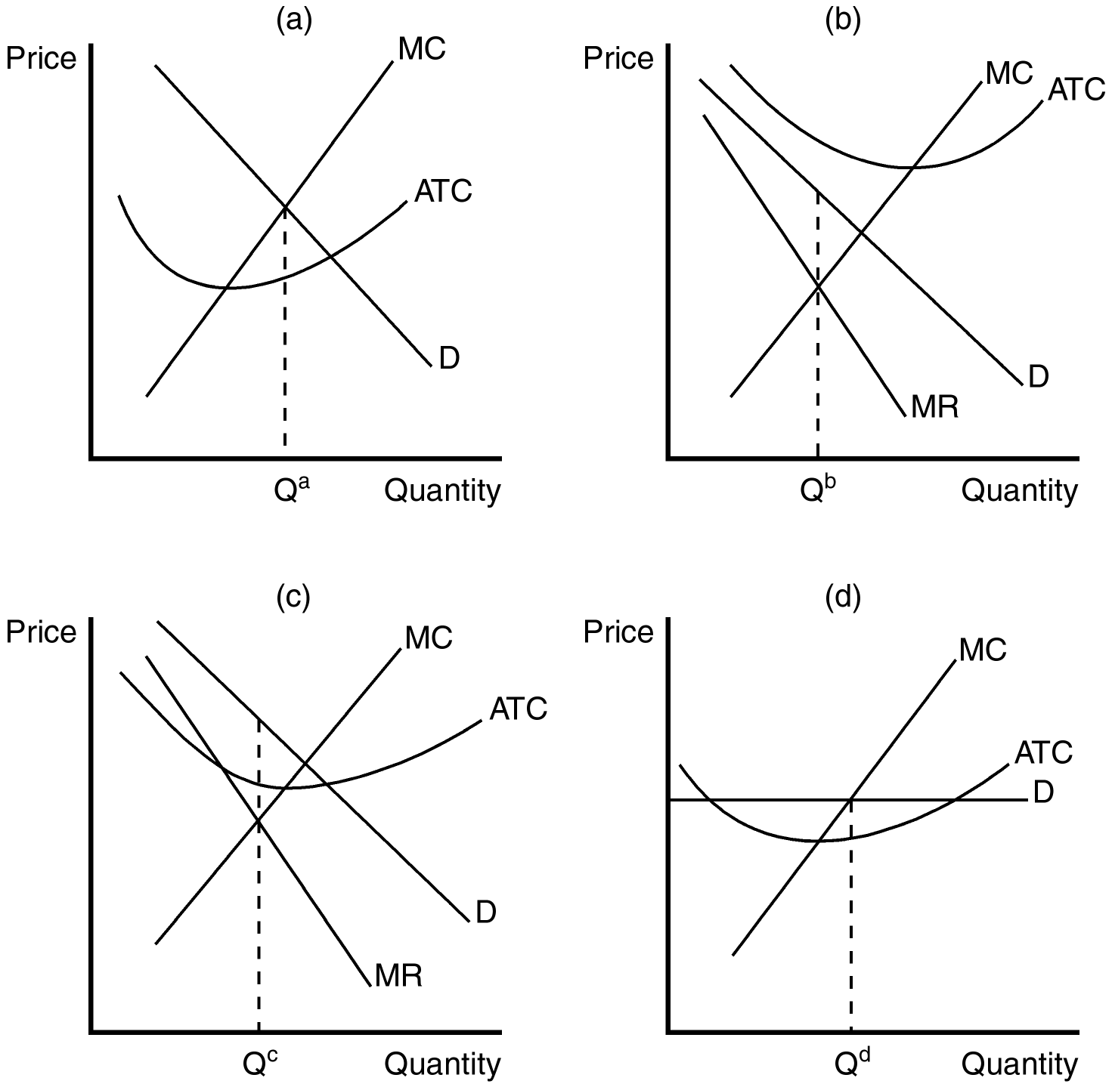
17. Refer to Figure 17-2. Which of the graphs shown would be consistent with a firm in a monopolistically competitive market that is earning a positive profit?
a. Panel a
b. Panel b
c. Panel c
d. Panel d
ANS: C PTS: 1 DIF: 2 REF: 17-1
TOP: Monopolistic competition MSC: Interpretive
18. Refer to Figure 17-2. Which of the graphs shown would be consistent with a firm in a monopolistically competitive market that is doing its best but still losing money?
a. Panel a
b. Panel b
c. Panel c
d. Panel d
ANS: B PTS: 1 DIF: 2 REF: 17-1
TOP: Monopolistic competition MSC: Interpretive
19. Refer to Figure 17-2. Which of the graphs depicts a monopolistically competitive firm in long-run equilibrium?
a. Panel a
b. Panel b
c. Panel c
d. None of the above is correct.
ANS: D PTS: 1 DIF: 2 REF: 17-1
TOP: Long-run equilibrium MSC: Interpretive
20. In the short run, a firm in a monopolistically competitive market operates much like a
a. firm in a perfectly competitive market.
b. firm in an oligopoly.
c. monopolist.
d. monopsonist.
ANS: C PTS: 1 DIF: 2 REF: 17-1
TOP: Monopolistic competition MSC: Interpretive
21. A monopolistically competitive firm chooses
a. the quantity of output to produce, but the market determines price.
b. the price, but competition in the market determines the quantity.
c. price, but output is determined by a cartel production quota.
d. the quantity of output to produce and the price at which it will sell its output.
ANS: D PTS: 1 DIF: 2 REF: 17-1
TOP: Monopolistic competition MSC: Interpretive
22. If firms in a monopolistically competitive market are earning positive profits, then
a. firms will likely be subject to regulation.
b. barriers to entry will be strengthened.
c. some firms must exit the market.
d. new firms will enter the market.
ANS: D PTS: 1 DIF: 2 REF: 17-1
TOP: Long-run equilibrium MSC: Interpretive
23. If firms in a monopolistically competitive market are earning economic profits, which of the following scenarios would best describe the change existing firms would face as the market adjusts to the long-run equilibrium?
a. An increase in demand for each firm
b. A decrease in demand for each firm
c. A downward shift in the marginal cost curve for each firm
d. An upward shift in the marginal cost curve for each firm
ANS: B PTS: 1 DIF: 2 REF: 17-1
TOP: Long-run equilibrium MSC: Interpretive
24. If firms in a monopolistically competitive market are incurring economic losses, which of the following scenarios would best describe the change existing firms (who are able to stay in the market) would face as the market adjusts to the long-run equilibrium?
a. A downward shift in the marginal cost curve for each firm
b. An upward shift in the marginal cost curve for each firm
c. A decrease in demand for each firm
d. An increase in demand for each firm
ANS: D PTS: 1 DIF: 2 REF: 17-1
TOP: Long-run equilibrium MSC: Interpretive
Figure 17-3
The lines in the figures below illustrate the potential effect of entry and exit in a monopolistically competitive market on either the demand curve or the marginal cost curve of existing firms.
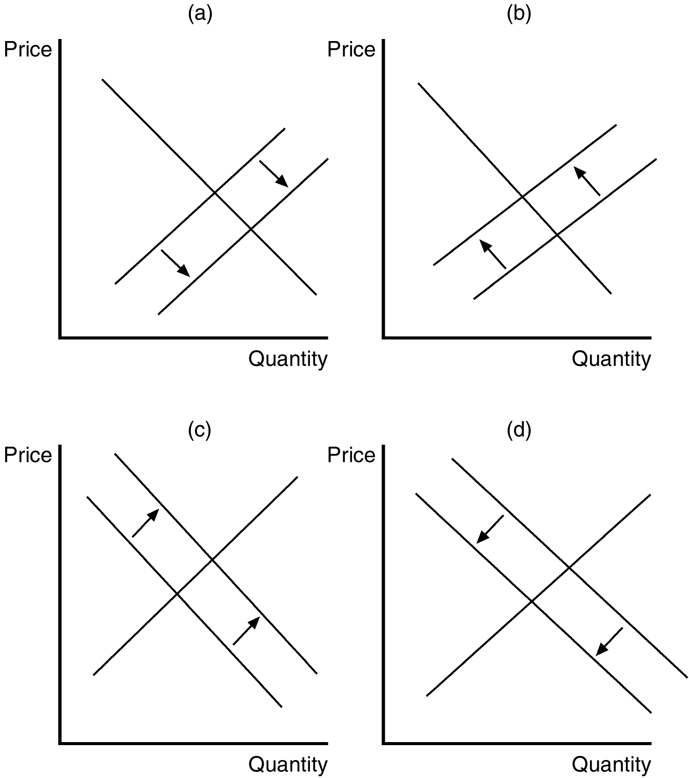
25. Refer to Figure 17-3. Panel (d) illustrates the change that would occur if existing firms faced
a. long-run economic losses.
b. a decrease in the diversity of products offered in the market.
c. new entrants in the market.
d. firms exiting the market.
ANS: C PTS: 1 DIF: 2 REF: 17-1
TOP: Long-run equilibrium MSC: Interpretive
26. Refer to Figure 17-3. Which of the diagrams illustrates the impact of some existing firms leaving the market?
a. Panel a
b. Panel b
c. Panel c
d. Panel d
ANS: C PTS: 1 DIF: 2 REF: 17-1
TOP: Long-run equilibrium MSC: Interpretive
27. In monopolistically competitive markets, positive economic profits
a. suggest that some existing firms will exit the market.
b. suggest that new firms will enter the market.
c. are sustained through government-imposed barriers to entry.
d. are never possible.
ANS: B PTS: 1 DIF: 1 REF: 17-1
TOP: Long-run equilibrium MSC: Interpretive
28. In monopolistically competitive markets, economic losses
a. suggest that some existing firms will exit the market.
b. suggest that new firms will enter the market.
c. are minimized through government-imposed barriers to entry.
d. are never possible.
ANS: A PTS: 1 DIF: 1 REF: 17-1
TOP: Long-run equilibrium MSC: Interpretive
29. As new firms enter a monopolistically competitive market, profits of existing firms
a. rise and product diversity in the market increases.
b. rise and product diversity in the market decreases.
c. decline and product diversity in the market increases.
d. decline and product diversity in the market decreases.
ANS: C PTS: 1 DIF: 2 REF: 17-1
TOP: Long-run equilibrium MSC: Analytical
30. As firms exit a monopolistically competitive market, profits of remaining firms
a. decline and product diversity in the market decreases.
b. decline and product diversity in the market increases.
c. rise and product diversity in the market decreases.
d. rise and product diversity in the market increases.
ANS: C PTS: 1 DIF: 2 REF: 17-1
TOP: Long-run equilibrium MSC: Analytical
31. The free entry and exit of firms in a monopolistically competitive market guarantees that
a. both economic profits and economic losses can persist in the long run.
b. both economic profits and economic losses disappear in the long run.
c. economic profits, but not economic losses, can persist in the long run.
d. economic losses, but not economic profits, can persist in the long run.
ANS: B PTS: 1 DIF: 2 REF: 17-1
TOP: Long-run equilibrium MSC: Interpretive
32. In monopolistically competitive markets, free entry and exit suggests that
a. the market structure will eventually be characterized by perfect competition in the long run.
b. all firms earn zero economic profits in the long run.
c. some firms will be able to earn economic profits in the long run.
d. some firms will be forced to incur economic losses in the long run.
ANS: B PTS: 1 DIF: 2 REF: 17-1
TOP: Long-run equilibrium MSC: Interpretive
33. When a profit-maximizing firm in a monopolistically competitive market is producing the long-run equilibrium quantity,
a. its average revenue will equal its marginal cost.
b. its marginal revenue will exceed its marginal cost.
c. it will be earning positive economic profits.
d. its demand curve will be tangent to its average-total-cost curve.
ANS: D PTS: 1 DIF: 2 REF: 17-1
TOP: Long-run equilibrium MSC: Interpretive
34. When a firm’s demand curve is tangent to its average total cost curve, the
a. firm’s economic profit is zero.
b. firm must be earning economic profits.
c. firm must be incurring economic losses.
d. firm must be operating at its efficient scale.
ANS: A PTS: 1 DIF: 2 REF: 17-1
TOP: Long-run equilibrium MSC: Interpretive
Figure 17-4
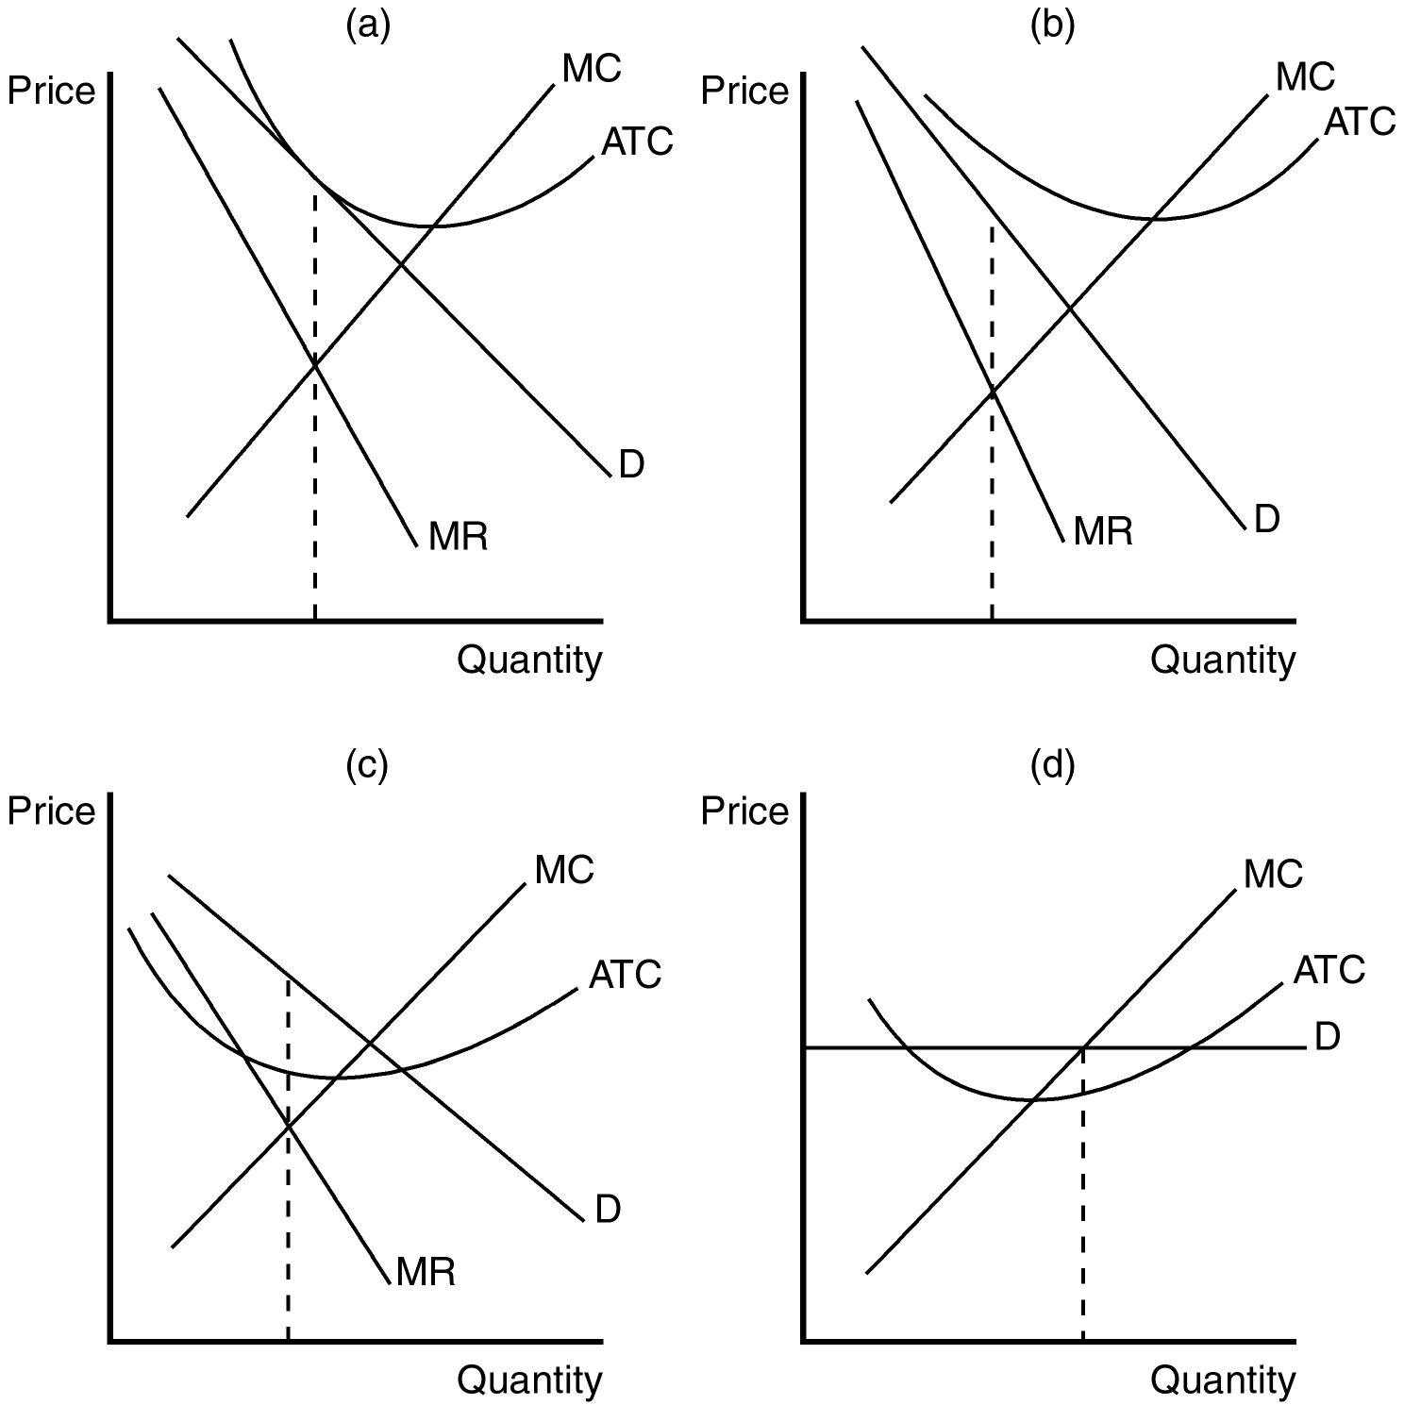
35. Refer to Figure 17-4. Panel (a) shows a profit-maximizing monopolistically competitive firm that is
a. earning zero economic profit.
b. likely to exit the market in the long run.
c. producing its efficient scale of output.
d. not maximizing its profit.
ANS: A PTS: 1 DIF: 2 REF: 17-1
TOP: Profit maximization MSC: Interpretive
36. Refer to Figure 17-4. Which of the panels shown could illustrate the short-run situation for a monopolistically competitive firm?
a. Panel a
b. Panel b
c. Panel c
d. All of the above are correct.
ANS: D PTS: 1 DIF: 2 REF: 17-1
TOP: Monopolistic competition MSC: Interpretive
37. Refer to Figure 17-4. Panel (b) is consistent with a firm in a monopolistically competitive market that is
a. not in long-run equilibrium.
b. in long-run equilibrium.
c. producing its efficient scale of output.
d. earning a positive economic profit.
ANS: A PTS: 1 DIF: 2 REF: 17-1
TOP: Long-run equilibrium MSC: Interpretive
38. Refer to Figure 17-4. Which of the panels depicts a firm in a monopolistically competitive market earning positive economic profits?
a. Panel a
b. Panel b
c. Panel c
d. Panel d
ANS: C PTS: 1 DIF: 2 REF: 17-1
TOP: Monopolistic competition MSC: Interpretive
39. When a profit-maximizing firm in a monopolistically competitive market is in long-run equilibrium,
a. the demand curve will be perfectly elastic.
b. price exceeds marginal cost.
c. marginal cost must be falling.
d. marginal revenue exceeds marginal cost.
ANS: B PTS: 1 DIF: 2 REF: 17-1
TOP: Long-run equilibrium MSC: Interpretive
40. A profit-maximizing firm operating in a monopolistically competitive market that is in a long-run equilibrium has
a. minimized average total cost.
b. chosen to produce where demand is unitary elastic.
c. produced the efficient scale of output.
d. chosen a quantity of output where average revenue equals average total cost.
ANS: D PTS: 1 DIF: 2 REF: 17-1
TOP: Long-run equilibrium MSC: Interpretive
41. Since a firm in a monopolistically competitive market faces a
a. downward-sloping demand curve, it will always operate with excess capacity.
b. downward-sloping demand curve, it will always operate at its efficient scale.
c. perfectly elastic demand curve, it will always operate with excess capacity.
d. perfectly inelastic demand curve, it will always operate at efficient scale.
ANS: A PTS: 1 DIF: 2 REF: 17-1
TOP: Demand curve MSC: Interpretive
42. When a firm operates with excess capacity,
a. additional production would lower the average total cost.
b. additional production would increase the average total cost.
c. it must be a perfectly competitive firm.
d. it must be a monopolistically competitive firm.
ANS: A PTS: 1 DIF: 2 REF: 17-1
TOP: Average total cost MSC: Interpretive
43. In the long run, a firm in a perfectly competitive market operates
a. at its efficient scale and a monopolistically competitive firm operates at efficient scale.
b. at its efficient scale and a monopolistically competitive firm operates with excess capacity.
c. with excess capacity and a monopolistically competitive firm operates with excess capacity.
d. with excess capacity and a monopolistically competitive firm operates at its efficient scale.
ANS: B PTS: 1 DIF: 2 REF: 17-1
TOP: Markets MSC: Interpretive
44. In the long run, a profit-maximizing firm in a monopolistically competitive market operates at
a. efficient scale.
b. a level of output at which average total cost is rising.
c. a level of output at which average total cost is falling.
d. the level of output at which total revenue is maximized.
ANS: C PTS: 1 DIF: 2 REF: 17-1
TOP: Average total cost MSC: Interpretive
45. Product differentiation in monopolistically competitive markets ensures that, for profit-maximizing firms,
a. marginal revenue will equal average total cost.
b. price will exceed marginal cost.
c. marginal cost will exceed average revenue.
d. average variable cost will be declining.
ANS: B PTS: 1 DIF: 2 REF: 17-1
TOP: Profit maximization MSC: Interpretive
46. In a long-run equilibrium, a firm in a monopolistically competitive market operates
a. where marginal revenue is zero.
b. where marginal revenue is negative.
c. on the rising portion of its average total cost curve.
d. on the declining portion of its average total cost curve.
ANS: D PTS: 1 DIF: 2 REF: 17-1
TOP: Long-run equilibrium MSC: Interpretive
47. Hotels in New York City frequently experience an average vacancy rate of about 20 percent (i.e., on an average night, 80 percent of the hotel rooms are full). This kind of excess capacity is indicative of what kind of market?
a. Monopoly
b. Perfect competition
c. Monopolistic competition
d. Oligopoly
ANS: C PTS: 1 DIF: 2 REF: 17-1
TOP: Markets MSC: Interpretive
48. A monopolistically competitive market could be considered inefficient because
a. marginal revenue exceeds average revenue.
b. price exceeds marginal cost.
c. the efficient scale of production is only achieved in the long run, but not in the short run.
d. markup pricing does not occur in any other market structure.
ANS: B PTS: 1 DIF: 2 REF: 17-1
TOP: Welfare MSC: Interpretive
49. When a profit-maximizing firm in a monopolistically competitive market charges a price higher than marginal cost,
a. the firm must be earning a positive economic profit.
b. the firm may be incurring economic losses
c. there is a deadweight loss to society, but it is exactly offset by the benefit of excess capacity.
d. new firms will necessarily wish to enter the market in the long run.
ANS: B PTS: 1 DIF: 2 REF: 17-1
TOP: Profit MSC: Analytical
50. The deadweight loss that is associated with a monopolistically competitive market is a result of
a. price falling short of marginal cost in order to increase market share.
b. price exceeding marginal cost.
c. the firm operating in a regulated industry.
d. excessive advertising costs.
ANS: B PTS: 1 DIF: 2 REF: 17-1
TOP: Welfare MSC: Interpretive
51. Regulation of a firm in a monopolistically competitive market
a. usually implies a very small administrative burden.
b. will lower the firm’s costs.
c. is commonly used to enhance market efficiency.
d. is unlikely to improve market efficiency.
ANS: D PTS: 1 DIF: 2 REF: 17-1
TOP: Regulation MSC: Interpretive
52. The administrative burden of regulating price in a monopolistically competitive market is
a. small due to economies of scale.
b. large because price is usually below marginal cost.
c. large because of the large number of firms that produce differentiated products.
d. small because firms produce with excess capacity.
ANS: C PTS: 1 DIF: 2 REF: 17-1
TOP: Regulation MSC: Interpretive
53. If regulators required firms in monopolistically competitive markets to set price equal to marginal cost,
a. firms would most likely experience economic losses.
b. firms would also operate at their efficient scale.
c. new firms would likely to enter the market.
d. the most efficient firms would not likely to be affected.
ANS: A PTS: 1 DIF: 2 REF: 17-1
TOP: Regulation MSC: Interpretive
54. If regulators required firms in monopolistically competitive markets to set price equal to marginal cost,
a. firms would respond by lowering their costs.
b. firms would require a subsidy to stay in business
c. new firms that enter the market would operate at efficient scale.
d. the most efficient firms would not be affected.
ANS: B PTS: 1 DIF: 2 REF: 17-1
TOP: Regulation MSC: Interpretive
55. Monopolistically competitive markets may be socially inefficient because
a. most firms produce inferior products.
b. government programs cannot effectively regulate price.
c. firms earn zero economic profit.
d. the market may have too much or too little entry by new firms.
ANS: D PTS: 1 DIF: 2 REF: 17-1
TOP: Welfare MSC: Interpretive
56. Before a new firm enters a monopolistically competitive market with a new product, it considers
a. the profit opportunities.
b. the business-stealing externality.
c. the product-variety externality.
d. Both b and c are correct.
ANS: A PTS: 1 DIF: 2 REF: 17-1
TOP: Welfare MSC: Interpretive
57. The product-variety externality is associated with
a. the producer surplus that accrues to incumbent firms in a monopolistically competitive industry.
b. loss of consumer surplus from exposure to additional advertising.
c. the consumer surplus that is generated from the introduction of a new product.
d. the opportunity cost of firms exiting a monopolistically competitive industry.
ANS: C PTS: 1 DIF: 2 REF: 17-1
TOP: Externalities MSC: Interpretive
58. When consumers are exposed to additional choices that result from the introduction of a new product,
a. their satisfaction is likely to be lowered as a result of their having to make additional choices.
b. a product-variety externality is said to occur.
c. an advertising externality is said to occur.
d. consumers are likely to experience negative consumption externalities.
ANS: B PTS: 1 DIF: 2 REF: 17-1
TOP: Externalities MSC: Interpretive
59. A business-stealing externality
a. is an externality that is likely to be punished under antitrust laws.
b. is the negative externality that occurs when one firm attempts to duplicate exactly the product of a different firm.
c. is an externality that is considered to be an explicit cost of business in monopolistically competitive markets.
d. is the negative externality associated with entry of new firms in a monopolistically competitive market.
ANS: D PTS: 1 DIF: 2 REF: 17-1
TOP: Externalities MSC: Interpretive
60. When existing firms lose customers and profits due to entry of a new competitor, a
a. predatory-pricing externality occurs.
b. consumption externality occurs.
c. business-stealing externality occurs.
d. product-variety externality occurs.
ANS: C PTS: 1 DIF: 2 REF: 17-1
TOP: Externalities MSC: Interpretive
61. When the loss from a business-stealing externality exceeds the gain from a product-variety externality,
a. firms are more likely to operate at efficient scale.
b. there are likely to be too many firms in a monopolistically competitive market.
c. market efficiency is likely to be enhanced by the entry of new firms.
d. the market structure is likely to be in transition.
ANS: B PTS: 1 DIF: 2 REF: 17-1
TOP: Externalities MSC: Interpretive
62. The entry of new firms into a monopolistically competitive market is accompanied by
a. both positive and negative externalities.
b. only positive externalities.
c. only negative externalities.
d. only private profit opportunities (no externalities).
ANS: A PTS: 1 DIF: 2 REF: 17-1
TOP: Externalities MSC: Interpretive
63. The product-variety externality associated with monopolistic competition arises because in monopolistically competitive markets,
a. firms produce with excess capacity.
b. firms try to differentiate their products.
c. firms would like to produce homogeneous products, but the large number of firms prohibits it.
d. entry and exit is not restricted.
ANS: B PTS: 1 DIF: 2 REF: 17-1
TOP: Externalities MSC: Interpretive
Scenario 17-1
Vacation Inns of America (VIA) has recently announced intentions of building a new hotel/resort complex in Myrtle Beach, South Carolina. Assume that the hotel/resort market in Myrtle Beach is characterized by monopolistic competition.
64. Refer to Scenario 17-1. As a result of the new VIA hotel/resort, tourists who stay in Myrtle Beach are likely to experience a
a. product-variety externality, which harms consumers.
b. product-variety externality, which benefits consumers.
c. business-stealing externality, which harms consumers.
d. business-stealing externality, which benefits consumers.
ANS: B PTS: 1 DIF: 2 REF: 17-1
TOP: Externalities MSC: Applicative
65. Refer to Scenario 17-1. Existing hotels, motels, and lodging facilities in Myrtle Beach are likely to experience what kind of externality as a result of the new VIA hotel/resort?
a. Product-variety
b. Business-stealing
c. Competitive
d. Advertising
ANS: B PTS: 1 DIF: 2 REF: 17-1
TOP: Externalities MSC: Applicative
66. In a monopolistically competitive industry, firms’ demand curves also represent
a. marginal revenue.
b. marginal cost.
c. average revenue.
d. profit.
ANS: C PTS: 1 DIF: 1 REF: 17-1
TOP: Average revenue MSC: Definitional
67. When a new firm enters a monopolistically competitive market, the individual demand curves faced by all existing firms in that market will
a. shift to the left.
b. shift to the right.
c. shift in a direction that is unpredictable without further information.
d. remain unchanged. It is the supply curve that will shift.
ANS: A PTS: 1 DIF: 2 REF: 17-1
TOP: Demand curve MSC: Analytical
68. When a firm exits a monopolistically competitive market, the individual demand curves faced by all remaining firms in that market will
a. shift in a direction that is unpredictable without further information.
b. shift to the right.
c. shift to the left.
d. remain unchanged. It is the supply curve that will shift.
ANS: B PTS: 1 DIF: 2 REF: 17-1
TOP: Demand curve MSC: Analytical
69. Long-run profit earned by a monopolistically competitive firm is driven to the competitive level due to
a. a change in the technology that the firm utilizes.
b. a shift of its demand curve.
c. a shift of its supply curve.
d. an increase in the firm’s average cost of production.
ANS: B PTS: 1 DIF: 2 REF: 17-1
TOP: Long-run equilibrium MSC: Interpretive
70. In the long run, a monopolistically competitive firm produces a quantity that is
a. equal to the efficient scale.
b. less than the efficient scale.
c. greater than the efficient scale.
d. consistent with diseconomies of scale.
ANS: B PTS: 1 DIF: 2 REF: 17-1
TOP: Long-run equilibrium MSC: Interpretive
71. Because a monopolistically competitive firm has some market power, in the long-run the price of its good exceeds its
a. average revenue.
b. average total cost.
c. marginal cost.
d. profit per unit.
ANS: C PTS: 1 DIF: 2 REF: 17-1
TOP: Long-run equilibrium MSC: Interpretive
72. Which of the following markets impose deadweight losses on society?
(i) Perfect competition
(ii) Monopolistic competition
(iii) Monopoly

a. (i) and (ii)
b. (ii) and (iii)
c. (i) and (iii)
d. (i) only
ANS: B PTS: 1 DIF: 2 REF: 17-1
TOP: Markets MSC: Interpretive
73. Which of the following goods are likely to be sold in a monopolistically competitive market?
a. Compact discs
b. Wheat
c. Corn
d. Postage stamps
ANS: A PTS: 1 DIF: 1 REF: 17-1
TOP: Monopolistic competition MSC: Applicative
74. Which of the following goods are not likely to be sold in monopolistically competitive markets?
a. Compact discs
b. Books
c. Cookies
d. Wheat
ANS: D PTS: 1 DIF: 1 REF: 17-1
TOP: Monopolistic competition MSC: Applicative
75. Monopolistically competitive markets differ from perfectly competitive markets due to
(i) the number of sellers.
(ii) the barriers to entry.
(iii) the product differentiation among the sellers.

a. (i) only
b. (iii) only
c. (i) and (iii)
d. (ii) and (iii)
ANS: B PTS: 1 DIF: 1 REF: 17-1
TOP: Markets MSC: Interpretive
76. A firm in a monopolistically competitive market is similar to a monopoly in the sense that
(i) they both face downward-sloping demand curves.
(ii) they both charge a price that exceeds marginal cost.
(iii) free entry and exit determines the long-run equilibrium.

a. (i) only
b. (ii) only
c. (i) and (ii)
d. (i), (ii), and (iii)
ANS: C PTS: 1 DIF: 2 REF: 17-1
TOP: Markets MSC: Interpretive
77. A monopolistically competitive firm’s choice of output level is virtually identical to the choice made by
a. a perfectly competitive firm.
b. a duopolist.
c. a monopolist.
d. an oligopolist.
ANS: C PTS: 1 DIF: 2 REF: 17-1
TOP: Markets MSC: Interpretive
78. New firms will likely enter a monopolistically competitive market when price exceeds
a. marginal revenue.
b. average revenue.
c. marginal cost.
d. average total cost.
ANS: D PTS: 1 DIF: 2 REF: 17-1
TOP: Long-run equilibrium MSC: Interpretive
79. Which two curves are tangent to each other in a monopolistically competitive market with zero economic profit?
a. Demand and average variable cost
b. Demand and average total cost
c. Marginal revenue and average variable cost
d. Marginal revenue and average total cost
ANS: B PTS: 1 DIF: 2 REF: 17-1
TOP: Long-run equilibrium MSC: Interpretive
80. A downward-sloping demand curve
a. is a feature of all monopolistically competitive firms.
b. means that the firm in question will never experience a zero profit.
c. causes marginal revenue to exceed price.
d. prohibits firms from earning positive economic profits in the long run.
ANS: A PTS: 1 DIF: 2 REF: 17-1
TOP: Demand curve MSC: Interpretive
81. Excess capacity
a. tells economists little about the desirability of a market outcome.
b. is the primary source of market inefficiency in monopolistically competitive markets.
c. is a characteristic of rising average total cost curves.
d. implies that the quantity demanded exceeds the quantity produced.
ANS: A PTS: 1 DIF: 2 REF: 17-1
TOP: Excess capacity MSC: Interpretive
82. In a monopolistically competitive market,
a. there are only a few sellers.
b. each firm takes the price of its product as given.
c. firms can enter or exit the market without restriction.
d. each firm produces a product that is essentially identical to the products of other firms in the market.
ANS: C PTS: 1 DIF: 1 REF: 17-1
TOP: Monopolistic competition MSC: Definitional
83. A monopolistically competitive market
a. has some features of monopoly and some features of competition.
b. has one large, dominant firm and many other smaller firms.
c. is difficult to enter.
d. whenever firms earn zero economic profit.
ANS: A PTS: 1 DIF: 1 REF: 17-1
TOP: Monopolistic competition MSC: Definitional
84. In both perfect competition and monopolistic competition,
a. each firm is, in many ways, like a monopoly.
b. each firm sells a product that is at least slightly different from those of other firms.
c. each firm faces a downward-sloping demand curve.
d. each firm has many competitors.
ANS: D PTS: 1 DIF: 1 REF: 17-1
TOP: Monopolistic competition MSC: Definitional
85. Examples of monopolistically competitive markets include the markets for
a. restaurants and furniture.
b. wheat and corn.
c. postage stamps and wooden pencils.
d. All of the above are correct.
ANS: A PTS: 1 DIF: 1 REF: 17-1
TOP: Monopolistic competition MSC: Applicative
86. Which of the following markets is not likely characterized by a monopolistically competitive market?
a. The market for piano lessons
b. The market for corn
c. The market for cookies
d. The market for clothing
ANS: B PTS: 1 DIF: 1 REF: 17-1
TOP: Monopolistic competition MSC: Applicative
87. In a monopolistically competitive market,
a. strategic interactions among the firms are very important.
b. the threat of entry by new firms is not an important consideration.
c. the attainment of a Nash equilibrium is an important objective.
d. firms may enter even though they will earn zero economic profit in the long run.
ANS: D PTS: 1 DIF: 2 REF: 17-1
TOP: Long-run equilibrium MSC: Interpretive
88. Each firm in a monopolistically competitive firm faces a downward-sloping demand curve because
a. there are many other sellers in the market.
b. there are very few other sellers in the market.
c. the firm’s product is different from those offered by other firms in the market.
d. that firm faces the threat of entry into the market by new firms.
ANS: C PTS: 1 DIF: 2 REF: 17-1
TOP: Demand curve MSC: Interpretive
89. Both monopolistic competition and oligopoly are market structures
a. that fail to achieve the total surplus achieved by perfect competition.
b. that feature only a few firms in each market.
c. to which the concept of Nash equilibrium is frequently applied by economists.
d. in which firms earn zero economic profit in the long run.
ANS: A PTS: 1 DIF: 2 REF: 17-1
TOP: Markets MSC: Interpretive
90. When a market is monopolistically competitive, the typical firm in the market is likely to experience a
a. positive profit in the short run and in the long run.
b. positive or negative profit in the short run and a zero profit in the long run.
c. zero profit in the short run and a positive or negative profit in the long run.
d. zero profit in the short run and in the long run.
ANS: B PTS: 1 DIF: 2 REF: 17-1
TOP: Profit MSC: Analytical
91. Among the following situations, the one that is least likely to apply to a monopolistically competitive firm is that in which
a. profit is positive in the short run.
b. total cost exceeds total revenue in the short run.
c. profit is positive in the long run.
d. total revenue equals total cost in the long run.
ANS: C PTS: 1 DIF: 2 REF: 17-1
TOP: Monopolistic competition MSC: Interpretive
92. To maximize its profit, a monopolistically competitive firm
a. takes the price as given and chooses its quantity, just as a competitive firm does.
b. takes the price as given and chooses its quantity, just as a colluding oligopolist does.
c. chooses its quantity and price, just as a competitive firm does.
d. chooses its quantity and price, just as a monopoly does.
ANS: D PTS: 1 DIF: 2 REF: 17-1
TOP: Markets MSC: Interpretive
93. To maximize its profit, a monopolistically competitive firm chooses its level of output by looking for the
a. level of output at which price equals marginal cost.
b. level of output at which marginal revenue equals marginal cost.
c. level of output at which marginal revenue equals zero.
d. level of output at which average total cost is minimized.
ANS: B PTS: 1 DIF: 2 REF: 17-1
TOP: Profit maximization MSC: Interpretive
94. For a monopolistically competitive firm,
a. marginal revenue and price are the same.
b. average revenue and price are the same.
c. at the profit-maximizing quantity of output, price equals marginal cost.
d. at the profit-maximizing quantity of output, marginal revenue exceeds price.
ANS: B PTS: 1 DIF: 2 REF: 17-1
TOP: Average revenue MSC: Interpretive
95. For a monopolistically competitive firm, at the profit-maximizing quantity of output,
a. price exceeds marginal cost.
b. marginal revenue exceeds marginal cost.
c. marginal cost exceeds average revenue.
d. price equals marginal revenue.
ANS: A PTS: 1 DIF: 2 REF: 17-1
TOP: Profit maximization MSC: Interpretive
96. Ignoring oligopoly and focusing on the other three market structures, in which of those market structures does a profit-maximizing firm charge a price that exceeds marginal cost?
a. Monopoly only
b. Monopoly and monopolistic competition only
c. Monopoly, monopolistic competition, and perfect competition
d. The answer cannot be determined without knowing whether the market is in the long run or short run.
ANS: B PTS: 1 DIF: 2 REF: 17-1
TOP: Markets MSC: Interpretive
97. Ignoring oligopoly and focusing on the other three market structures, in which of those market structures does a profit-maximizing firm experience zero economic profit?
a. Perfect competition only
b. Perfect competition and monopolistic competition only
c. Perfect competition, monopolistic competition, and monopoly
d. The answer cannot be determined without knowing whether the market is in the long run or short run.
ANS: D PTS: 1 DIF: 2 REF: 17-1
TOP: Markets MSC: Interpretive
98. An important difference between the situation faced by a profit-maximizing monopolistically competitive firm in the short run and the situation faced by that same firm in the long run is that in the short run,
a. price may exceed marginal revenue, but in the long run, price equals marginal revenue.
b. price may exceed marginal cost, but in the long run, price equals marginal cost.
c. price may exceed average total cost, but in the long run, price equals average total cost.
d. there are many firms in the market, but in the long run, there are only a few firms in the market.
ANS: C PTS: 1 DIF: 2 REF: 17-1
TOP: Monopolistic competition MSC: Interpretive
99. Suppose that monopolistically competitive firms in a certain market are earning positive profits. In the transition from this initial situation to a long-run equilibrium,
a. the number of firms in the market decreases.
b. each existing firm experiences a decrease in demand for its product.
c. each existing firm experiences a rightward shift of its marginal revenue curve.
d. each existing firm experiences an upward shift in its average total cost curve.
ANS: B PTS: 1 DIF: 2 REF: 17-1
TOP: Long-run equilibrium MSC: Interpretive
100. Suppose that monopolistically competitive firms in a certain market are experiencing losses. In the transition from this initial situation to a long-run equilibrium,
a. the number of firms in the market decreases.
b. each existing firm experiences a decrease in demand for its product.
c. each firm experiences an upward shift to its marginal cost and average total cost curves.
d. each existing firm’s average total cost falls to bring economic profit back to zero.
ANS: A PTS: 1 DIF: 2 REF: 17-1
TOP: Long-run equilibrium MSC: Interpretive
101. When a monopolistically competitive firm is in long-run equilibrium,
a. marginal revenue is equal to marginal cost.
b. marginal revenue is equal to average total cost.
c. marginal revenue is equal to price.
d. price is equal to marginal cost.
ANS: A PTS: 1 DIF: 2 REF: 17-1
TOP: Long-run equilibrium MSC: Interpretive
102. When a monopolistically competitive firm is in long-run equilibrium,
a. price is equal to average total cost.
b. price is equal to marginal cost.
c. price is equal to marginal revenue.
d. the firm operates at its efficient scale.
ANS: A PTS: 1 DIF: 2 REF: 17-1
TOP: Long-run equilibrium MSC: Interpretive
103. Which of these types of firms can earn a positive economic profit in the long run?
a. Monopolies, but not competitive firms or monopolistically competitive firms
b. Monopolies and monopolistically competitive firms, but not competitive firms
c. Monopolies, monopolistically competitive firms, and monopolies
d. No firms earn positive economic profit in the long run. Entry will reduce all firms’ economic profit to zero in the long run.
ANS: A PTS: 1 DIF: 2 REF: 17-1
TOP: Markets MSC: Interpretive
104. “In a long-run equilibrium, price is equal to average total cost.” This statement applies to
a. competitive markets, but not to monopolistically competitive markets or monopolies.
b. competitive and monopolistically competitive markets, but not to monopolies.
c. competitive markets, monopolistically competitive markets, and monopolies.
d. None of the above is correct.
ANS: B PTS: 1 DIF: 2 REF: 17-1
TOP: Markets MSC: Interpretive
105. For a profit-maximizing monopolistically competitive firm, price exceeds marginal cost
a. in the short run but not in the long run.
b. in the long run but not in the short run.
c. in both the short run and the long run.
d. in neither the short run nor the long run.
ANS: C PTS: 1 DIF: 2 REF: 17-1
TOP: Profit maximization MSC: Interpretive
106. Entry and exit drive each firm in a monopolistically competitive market to a point of tangency between its
a. marginal revenue curve and its total cost curve.
b. marginal revenue curve and its average total cost curve.
c. demand curve and its total cost curve.
d. demand curve and its average total cost curve.
ANS: D PTS: 1 DIF: 2 REF: 17-1
TOP: Long-run equilibrium MSC: Interpretive
107. Suppose the point of tangency that characterizes long-run equilibrium for a monopolistically competitive firm occurs at Q₁ units of output. This level of output, Q₁,
a. exceeds the level of output at which marginal revenue equals marginal cost.
b. exceeds the level of output at which marginal cost equals average total cost.
c. falls short of the level of output at which price equals marginal cost.
d. exceeds the firm’s efficient scale of output.
ANS: C PTS: 1 DIF: 3 REF: 17-1
TOP: Long-run equilibrium MSC: Analytical
108. Suppose for some firm that average total cost is minimized at Q₁ units of output. For a monopolistically competitive firm in long-run equilibrium, Q₁
a. is also the level of output at which marginal cost equals average total cost.
b. exceeds the level of output at which there is a point of tangency between the demand curve and the average total cost curve.
c. exceeds the level of output at which marginal revenue equals marginal cost.
d. All of the above are correct.
ANS: D PTS: 1 DIF: 3 REF: 17-1
TOP: Long-run equilibrium MSC: Analytical
109. In a long-run equilibrium,
a. only a perfectly competitive firm operates at its efficient scale.
b. only a monopolistically competitive firm operates at its efficient scale.
c. neither a competitive firm nor a monopolistically competitive firm charges a markup over marginal cost.
d. both a perfectly competitive firm and a monopolistically competitive firm operate at their efficient scale of production.
ANS: A PTS: 1 DIF: 2 REF: 17-1
TOP: Long-run equilibrium MSC: Interpretive
110. In a long-run equilibrium,
a. “excess capacity” applies to monopolistically competitive firms, but not to competitive firms.
b. “zero economic profit” applies to competitive firms, but not to monopolistically competitive firms.
c. “markup over marginal cost” applies to both monopolistically competitive and competitive firms.
d. “product variety externalities” apply to both perfectly competitive firms and monopolistically competitive firms.
ANS: A PTS: 1 DIF: 2 REF: 17-1
TOP: Markets MSC: Interpretive
111. Firm A is a perfectly competitive firm. Firm B is a monopolistically competitive firm. Both firms are currently maximizing their respective profits. Which of the following statements is correct?
a. Both Firm A and Firm B would be eager to make an additional sale.
b. Firm A would be eager to make an additional sale, but Firm B would not care whether it made an additional sale or not.
c. Firm B would be eager to make an additional sale, but Firm A would not care whether it made an additional sale or not.
d. Neither Firm A nor Firm B would care whether they made an additional sale or not.
ANS: C PTS: 1 DIF: 2 REF: 17-1
TOP: Markets MSC: Interpretive
112. In a monopolistically competitive market,
a. the entry of new firms creates externalities.
b. the absence of restrictions on entry by new firms ensures that there will be no deadweight loss.
c. there are always too many firms in the market relative to the socially-optimal number of firms.
d. firms cannot earn positive economic profits in the short run.
ANS: A PTS: 1 DIF: 2 REF: 17-1
TOP: Externalities MSC: Interpretive
113. Entry by new firms into a monopolistically competitive market
a. creates additional consumer surplus.
b. imposes a positive externality on existing firms.
c. leads to the same externalities that are observed when new firms enter a perfectly competitive market.
d. increases the demand for existing firms’ products.
ANS: A PTS: 1 DIF: 3 REF: 17-1
TOP: Externalities MSC: Interpretive
114. A monopolistically competitive firm faces the following demand schedule for its product:
Price ($) | 10 | 9 | 8 | 7 | 6 | 5 | 4 | 3 | 2 | 1
Quantity | 2 | 4 | 6 | 9 | 11 | 13 | 15 | 17 | 19 | 21
The firm has total fixed costs of $20 and a constant marginal cost of $2 per unit. The firm will maximize profit with
a. 6 units of output.
b. 9 units of output.
c. 11 units of output.
d. 13 units of output.
ANS: B PTS: 1 DIF: 2 REF: 17-1
TOP: Profit maximization MSC: Applicative
115. A monopolistically competitive firm faces the following demand curve for its product:
Price ($) | 10 | 9 | 8 | 7 | 6 | 5 | 4 | 3 | 2 | 1
Quantity | 2 | 4 | 6 | 8 | 10 | 12 | 14 | 16 | 18 | 20
The firm has total fixed costs of $20 and a constant marginal cost of $5 per unit. The firm will maximize profit with the production of
a. 6 units of output.
b. 8 units of output.
c. 10 units of output.
d. 12 units of output.
ANS: A PTS: 1 DIF: 2 REF: 17-1
TOP: Profit maximization MSC: Applicative
116. A monopolistically competitive firm faces the following demand curve for its product:
Price ($) | 10 | 9 | 8 | 7 | 6 | 5 | 4 | 3 | 2 | 1
Quantity | 2 | 4 | 6 | 8 | 10 | 12 | 14 | 16 | 18 | 20
The firm has total fixed costs of $40 and a constant marginal cost of $2 per unit. We can conclude that
a. firms will exit this market.
b. firms will enter this market.
c. this market is in long-run equilibrium.
d. this firm is operating at efficient scale.
ANS: C PTS: 1 DIF: 3 REF: 17-1
TOP: Long-run equilibrium MSC: Analytical
117. A firm has the following cost structure:
Output | 1 | 2 | 3 | 4 | 5 | 6 | 7
Total Cost($) | 30 | 32 | 36 | 42 | 50 | 63 | 77
If this firm is in a typical monopolistically competitive market, it will likely produce
a. four or fewer units of output.
b. five units of output.
c. more than five units of output.
d. None of the above are necessarily correct because there is not enough information to tell.
ANS: A PTS: 1 DIF: 3 REF: 17-1
TOP: Profit maximization MSC: Analytical
118. A firm has the following cost structure:
Output | 1 | 2 | 3 | 4 | 5 | 6 | 7
Total Cost($) | 30 | 32 | 36 | 42 | 50 | 63 | 77
If this firm is in a typical perfectly competitive market, in the long run it will likely produce
a. 4 or fewer units of output.
b. 5 units of output.
c. more than 5 units of output.
d. None of the above are necessarily correct because there is not enough information to tell.
ANS: B PTS: 1 DIF: 3 REF: 17-1
TOP: Long-run equilibrium MSC: Interpretive
119. A monopolistically competitive firm has the following cost structure:
Output | 1 | 2 | 3 | 4 | 5 | 6 | 7
Total Cost($) | 30 | 32 | 36 | 42 | 50 | 63 | 77
The firm faces the following demand curve:
Price ($) | 20 | 18 | 15 | 12 | 9 | 7 | 4
Quantity | 1 | 2 | 3 | 4 | 5 | 6 | 7
To maximize profit (or minimize losses), the firm will produce
a. 2 units.
b. 3 units.
c. 4 units.
d. 5 units.
ANS: B PTS: 1 DIF: 3 REF: 17-1
TOP: Profit maximization MSC: Applicative
120. A monopolistically competitive firm has the following cost structure:
Output | 1 | 2 | 3 | 4 | 5 | 6 | 7
Total Cost($) | 30 | 32 | 36 | 42 | 50 | 63 | 77
The firm faces the following demand curve:
Price ($) | 20 | 18 | 15 | 12 | 9 | 7 | 4
Quantity | 1 | 2 | 3 | 4 | 5 | 6 | 7
If the government forces this firm to produce at its efficient scale, it will
a. produce 3 units and make $9.
b. produce 4 units and make $6.
c. produce 5 units and lose $5.
d. produce 7 units and lose $49.
ANS: C PTS: 1 DIF: 3 REF: 17-1
TOP: Regulation MSC: Applicative
121. A monopolistically competitive firm is currently earning a positive economic profit. If other firms enter the market, we would expect that the added competition will cause this firm to adjust its
a. output so that it will operate closer to its efficient scale.
b. output so that it will operate further from its efficient scale.
c. output so that it will no longer be at its efficient scale.
d. output, but it might move either closer to or further from its efficient scale.
ANS: B PTS: 1 DIF: 3 REF: 17-1
TOP: Long-run equilibrium MSC: Analytical
122. Senator Hubris wants to pass a law that would require all monopolistically competitive firms to operate at their efficient scale. If this law were to pass and be enforced, we would expect that monopolistically competitive firms would
a. see their profits increase.
b. break even.
c. lose money.
d. not really be affected by the law.
ANS: C PTS: 1 DIF: 3 REF: 17-1
TOP: Regulation MSC: Interpretive
Figure 17-5
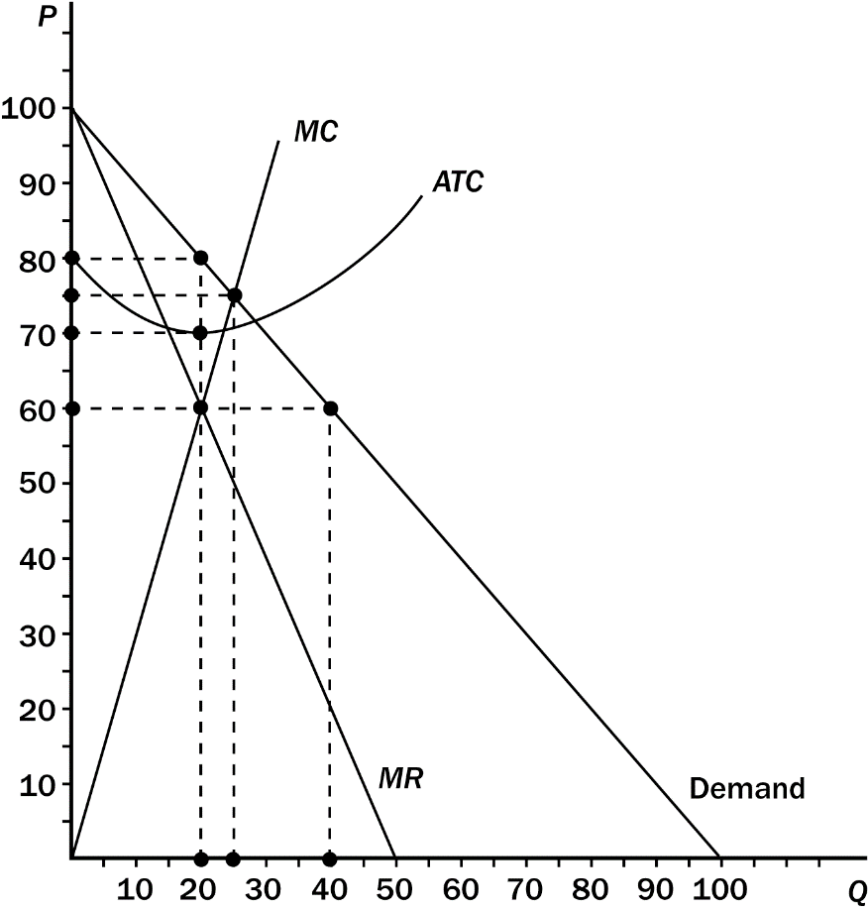
123. Refer to Figure 17-5. This figure depicts a situation in a monopolistically competitive market. What price will the monopolistically competitive firm charge in this market?
a. $60
b. $70
c. $75
d. $80
ANS: D PTS: 1 DIF: 2 REF: 17-1
TOP: Price MSC: Analytical
124. Refer to Figure 17-5. This figure depicts a situation in a monopolistically competitive market. How much consumer surplus will be derived from the purchase of this product at the monopolistically competitive price?
a. $200.00
b. $312.50
c. $400.00
d. $800.00
ANS: A PTS: 1 DIF: 3 REF: 17-1
TOP: Consumer surplus MSC: Analytical
125. Refer to Figure 17-5. This figure depicts a situation in a monopolistically competitive market. How much profit will the monopolistically competitive firm earn in this situation?
a. A $10 profit.
b. A $20 profit.
c. A $200 profit.
d. No profit, since monopolistically competitive firms never earn economic profit.
ANS: C PTS: 1 DIF: 2 REF: 17-1
TOP: Profit MSC: Analytical
126. Refer to Figure 17-5. This figure depicts a situation in a monopolistically competitive market. How much output will the monopolistically competitive firm produce in this situation?
a. 20 units
b. 25 units
c. 40 units
d. No output, since producing in this situation will result in a loss for the firm.
ANS: A PTS: 1 DIF: 2 REF: 17-1
TOP: Output MSC: Analytical
127. In the long run,
a. monopolistically competitive firms earn a higher profit than perfectly competitive firms because monopolistically competitive firms have some monopoly power.
b. monopolistically competitive firms produce a higher output than perfectly competitive firms because competition drives the perfectly competitive firm’s output down.
c. both monopolistically competitive and perfectly competitive firms produce where P = MC.
d. both monopolistically competitive and perfectly competitive firms produce where P = ATC.
ANS: D PTS: 1 DIF: 2 REF: 17-1
TOP: Profit MSC: Interpretive
Table 17-1

Quantity | Price | Marginal Cost | Average Total Cost
0 | 10 | -- | --
1 | 9 | 3 | 14
2 | 8 | 6 | 10
3 | 7 | 9 | 9
4 | 6 | 12 | 10
5 | 5 | 15 | 12
6 | 4 | 18 | 14
7 | 3 | 21 | 17
8 | 2 | 24 | 21
9 | 1 | 27 | 25
10 | 0 | 30 | 29

128. Refer to Table 17-1. This table shows the demand schedule, marginal cost, and average total cost for a monopolistically competitive firm. What price will this firm charge to maximize profit?
a. $6
b. $7
c. $8
d. $9
ANS: C PTS: 1 DIF: 2 REF: 17-1
TOP: Price MSC: Applicative
129. Refer to Table 17-1. This table shows the demand schedule, marginal cost, and average total cost for a monopolistically competitive market. Which of the following is likely to happen in the long run in this market?
a. The market is currently in a long-run equilibrium.
b. The market price is likely to fall.
c. Firms are likely to enter the market since firms are earning a positive economic profit.
d. Firms are likely to leave the market since firms are earning a negative economic profit.
ANS: D PTS: 1 DIF: 2 REF: 17-1
TOP: Long-run equilibrium MSC: Applicative
130. Refer to Table 17-1. This table shows the demand schedule, marginal cost, and average total cost for a monopolistically competitive firm. How much profit will this firm earn when it chooses its output to maximize profit?
a. A $4 loss.
b. A $2 loss.
c. A $6 profit.
d. A $16 profit.
ANS: A PTS: 1 DIF: 2 REF: 17-1
TOP: Profit MSC: Applicative
Table 17-2

Quantity | Price | Marginal  Cost | Average  Total Cost
0 | 20 | -- | --
1 | 16 | 2 | 21.00
2 | 12 | 4 | 12.00
3 | 8 | 6 | 9.67
4 | 4 | 8 | 9.00
5 | 0 | 10 | 9.00

131. Refer to Table 17-2. This table shows the demand schedule, marginal cost, and average cost for a monopolistically competitive firm. What price should this firm charge to maximize profit?
a. $4
b. $8
c. $12
d. $16
ANS: C PTS: 1 DIF: 2 REF: 17-1
TOP: Price MSC: Applicative
132. Refer to Table 17-2. This table shows the demand schedule, marginal cost, and average cost for a monopolistically competitive firm. How much profit will this firm earn at the monopolistically competitive price?
a. $0
b. $5
c. $12
d. $16
ANS: A PTS: 1 DIF: 2 REF: 17-1
TOP: Profit MSC: Applicative
133. Refer to Table 17-2. Which of the following statements regarding this monopolistically competitive firm is true?
a. New firms will enter this market in the long run since firm profits are greater than zero.
b. Firms will leave this market in the long run since firm profits are less than zero.
c. This firm is currently in long-run equilibrium.
d. This firm is currently in long-run equilibrium, and the firm is producing its efficient scale of output.
ANS: C PTS: 1 DIF: 2 REF: 17-1
TOP: Long-run equilibrium MSC: Applicative
134. A monopolistically competitive firm is currently producing 10 units of output. At this level of output the firm is charging a price equal to $10, has marginal revenue equal to $6, has marginal cost equal to $6, and has average total cost equal to $12. From this information we can infer that
a. the firm is currently maximizing its profit.
b. the profits of the firm are negative.
c. firms are likely to leave this market in the long run.
d. All of the above
ANS: D PTS: 1 DIF: 2 REF: 17-1
TOP: Profit MSC: Analytical
135. Which of the following statements regarding monopolistic competition is false?
a. In the long-run equilibrium, price equals average total cost.
b. In the long-run equilibrium, firms earn zero economic profit.
c. In the long-run equilibrium, firms charge a price above marginal cost.
d. In the long-run equilibrium, firms produce a quantity in excess of their efficient scale.
ANS: D PTS: 1 DIF: 2 REF: 17-1
TOP: Long-run equilibrium MSC: Interpretive
136. Consider a monopolistically competitive firm in a market in long-run equilibrium. This firm is likely
a. earning a positive economic profit since it is charging a price above marginal cost.
b. earning no economic profit since it is charging a price equal to its marginal cost.
c. earning a positive economic profit since it is charging a price above its average total cost.
d. earning no economic profit since it is charging a price equal to it average total cost.
ANS: D PTS: 1 DIF: 2 REF: 17-1
TOP: Profit MSC: Interpretive
137. A monopolistically competitive market
a. usually has too many firms, reducing the economic profit of each firm to zero.
b. usually has too few firms, reducing the product variety for consumers.
c. may have too many or too few firms, and the government can intervene to achieve the optimal number of firms.
d. may have too many or too few firms, but the government can do little to rectify the situation.
ANS: D PTS: 1 DIF: 2 REF: 17-1
TOP: Monopolistic competition MSC: Interpretive
138. Under which of the following market structures would consumers likely pay the highest price for a product?
a. Perfect competition
b. Monopolistic competition
c. Oligopoly
d. Monopoly
ANS: D PTS: 1 DIF: 2 REF: 17-1
TOP: Markets MSC: Analytical
139. Under which of the following market structures would the highest output of a particular good be produced?
a. Perfect competition
b. Monopolistic competition
c. Oligopoly
d. Monopoly
ANS: A PTS: 1 DIF: 2 REF: 17-1
TOP: Markets MSC: Analytical
140. Under which of the following market structures would consumers likely receive the most product variety?
a. Perfect competition
b. Monopolistic competition
c. Oligopoly
d. Monopoly
ANS: B PTS: 1 DIF: 2 REF: 17-1
TOP: Markets MSC: Analytical
141. Monopolistically competitive firms have excess capacity. To maximize profits, firms will
a. increase their output to lower their average total cost of production and eliminate the excess capacity.
b. produce where price equals marginal cost to eliminate the excess capacity.
c. produce where average revenue equals marginal cost to eliminate the excess capacity.
d. maintain the excess capacity.
ANS: D PTS: 1 DIF: 2 REF: 17-1
TOP: Profit MSC: Interpretive
142. In which of the following market structures can firms earn economic profits in the long run?
a. Perfect competition
b. Monopolistic competition
c. Monopoly
d. Both b and c
ANS: C PTS: 1 DIF: 2 REF: 17-1
TOP: Profit MSC: Analytical
143. In which of the following market structures do firms produce the welfare-maximizing level of output?
a. Perfect competition
b. Monopolistic competition
c. Monopoly
d. Both a and b
ANS: A PTS: 1 DIF: 2 REF: 17-1
TOP: Welfare MSC: Analytical
Table 17-3
Traci’s Hairstyling is one salon among many in the market for hairstyling. The following table presents cost and revenue data for Traci’s Hairstyling.

COSTS |  |  | REVENUES
Quantity  Produced | Total  Cost | Marginal  Cost | Quantity  Demanded | Price | Total  Revenue | Marginal  Revenue
0 | $10 | -- | 0 | $50 |  | --
1 | $15 |  | 1 | $45
2 | $21 |  | 2 | $40
3 | $28 |  | 3 | $35
4 | $36 |  | 4 | $30
5 | $45 |  | 5 | $25
6 | $55 |  | 6 | $20
7 | $66 |  | 7 | $15
8 | $78 |  | 8 | $10

144. Refer to Table 17-3. What is the profit-maximizing output for Traci’s Hairstyling?
a. 3 hair treatments
b. 4 hair treatments
c. 5 hair treatments
d. 6 hair treatments
ANS: B PTS: 1 DIF: 2 REF: 17-1
TOP: Profit maximization MSC: Applicative
145. Refer to Table 17-3. When maximizing profit, what price does Traci’s charge for hairstyling?
a. $20
b. $25
c. $30
d. $35
ANS: C PTS: 1 DIF: 2 REF: 17-1
TOP: Profit maximization MSC: Applicative
146. Refer to Table 17-3. At the profit-maximizing quantity, what is Traci’s total profit?
a. $30
b. $59
c. $77
d. $84
ANS: D PTS: 1 DIF: 2 REF: 17-1
TOP: Profit MSC: Applicative
147. Refer to Table 17-3. Given the cost and revenue data, Traci’s is
a. not in a long-run equilibrium. More businesses will enter the hair treatment market in the long-run.
b. not in a short-run equilibrium.
c. not in a long-run equilibrium. Some businesses currently in the hair treatment market will exit the market in the long-run.
d. in a long-run equilibrium.
ANS: A PTS: 1 DIF: 2 REF: 17-1
TOP: Long-run equilibrium MSC: Interpretive
148. Refer to Table 17-3. If the government required Traci’s to produce at the efficient scale of output, how many hair treatments would Traci’s sell?
a. Either 3 or 4
b. Either 4 or 5
c. Either 5 or 6
d. Either 6 or 7
ANS: B PTS: 1 DIF: 2 REF: 17-1
TOP: Efficient scale MSC: Analytical
149. Refer to Table 17-3. If the government forced Traci’s to produce at the efficient scale of output, what is the maximum profit Traci’s could earn?
a. $77
b. $80
c. $84
d. $96
ANS: C PTS: 1 DIF: 2 REF: 17-1
TOP: Profit MSC: Applicative
150. Refer to Table 17-3. Suppose the government forced Traci’s to produce at the efficient scale of output. Who would be better off as a result of this policy? Who would be worse off as a result of this policy?
a. Traci’s; Consumers
b. Consumers; Traci’s
c. No one; Consumers
d. No one; No one
ANS: D PTS: 1 DIF: 2 REF: 17-1
TOP: Welfare MSC: Interpretive
151. Select the type of market that is described by the following attributes: many firms, differentiated products, and free entry.
a. Natural monopoly
b. Perfectly competition
c. Monopolistic competition
d. Monopoly
ANS: C PTS: 1 DIF: 1 REF: 17-1
TOP: Monopolistic competition MSC: Definitional
152. Because monopolistically competitive firms produce differentiated products, each firm
a. faces a demand curve that is horizontal.
b. faces a demand curve that is vertical.
c. has no control over product price.
d. has some control over product price.
ANS: D PTS: 1 DIF: 1 REF: 17-1
TOP: Price MSC: Interpretive
153. Which of the following conditions distinguishes monopolistic competition from perfect competition?
a. The number of sellers in the market
b. The freedom of entry and exit by firms in the market
c. The size of firms in the market
d. Product differentiation
ANS: D PTS: 1 DIF: 1 REF: 17-1
TOP: Monopolistic competition MSC: Interpretive
154. When a monopolistically competitive firm raises its price,
a. quantity demanded falls to zero.
b. quantity demanded declines, but not to zero.
c. the market supply curve shifts outward.
d. quantity demanded remains constant.
ANS: B PTS: 1 DIF: 2 REF: 17-1
TOP: Monopolistic competition MSC: Analytical
155. Which of the following is a characteristic of oligopoly or monopolistic competition, but not perfect competition?
a. Advertising and sales promotion
b. Profit maximization according to the MR = MC rule
c. Firms being price takers rather than price makers
d. Horizontal demand and marginal revenue curves
ANS: A PTS: 1 DIF: 2 REF: 17-1
TOP: Monopolistic competition MSC: Interpretive
Figure 17-6
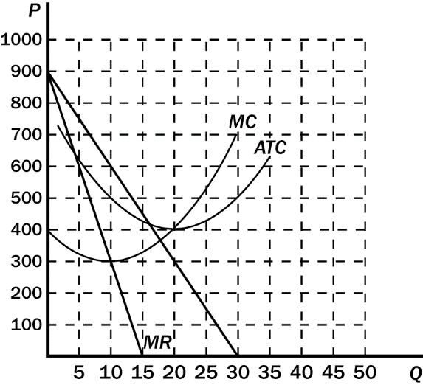
156. Refer to Figure 17-6. The firm in this figure is monopolistically competitive. It illustrates
a. the shut-down case.
b. a long-run economic profit.
c. a short-run economic profit.
d. a short-run loss.
ANS: C PTS: 1 DIF: 2 REF: 17-1
TOP: Monopolistic competition MSC: Interpretive
157. Refer to Figure 17-6. At the profit-maximizing, or loss-minimizing, output level, the firm in this figure has total costs of approximately
a. $2,000.
b. $3,000.
c. $4,000
d. $5,000
ANS: D PTS: 1 DIF: 2 REF: 17-1
TOP: Total cost MSC: Applicative
158. Refer to Figure 17-6.. Assume the firm in the figure is currently producing 8 units of output and charging $400. The firm
a. will increase its profits if it raises its price and reduces its production level.
b. will increase its profits if it lowers its price and expands its production level.
c. is maximizing profits.
d. will increase its profits if it raises its prices and expands its production level.
ANS: D PTS: 1 DIF: 2 REF: 17-1
TOP: Profit maximization MSC: Analytical
159. Refer to Figure 17-6. The maximum total short-run economic profit for the monopolistically competitive firm in this figure is
a. $1,000.
b. $2,000.
c. $3,000
d. $5,000.
ANS: A PTS: 1 DIF: 2 REF: 17-1
TOP: Profit MSC: Applicative
160. Cecilia’s Café is in a monopolistically competitive market. Cecilia’s is currently producing where average total cost is at its minimum, and Cecilia’s is earning a positive economic profit. In the long run we would expect Cecilia’s output to
a. decrease and average total cost to increase.
b. decrease and average total cost to decrease.
c. remain unchanged as Cecilia’s is doing the best it can.
d. increase and average total costs to decrease.
ANS: A PTS: 1 DIF: 2 REF: 17-1
TOP: Monopolistic competition MSC: Analytical
161. Which of the following best describes the idea of excess capacity in monopolistic competition?
a. Firms produce more output than is socially desirable.
b. The output produced by a typical firm is less than what would occur at the minimum point on its ATC curve.
c. Due to product differentiation, firms choose output levels where P > ATC.
d. Firms keep some surplus output on hand in case there is a shift in the demand for their product.
ANS: B PTS: 1 DIF: 2 REF: 17-1
TOP: Excess capacity MSC: Interpretive
162. The traditional view of monopolistic competition holds that this type of industrial structure is inefficient because
a. there are too few firms to reach an efficient level of production.
b. firms do not operate at the output that minimizes average costs.
c. advertising is not used extensively enough to yield an efficient differentiation of the products.
d. consumers do not have enough choice among the product varieties available.
ANS: B PTS: 1 DIF: 2 REF: 17-1
TOP: Welfare MSC: Interpretive
163. Monopolistic competition is considered by some to be inefficient because
a. price exceeds marginal cost.
b. output exceeds capacity output.
c. long-run profits are positive.
d. barriers to entry limit the number of firms in the market.
ANS: A PTS: 1 DIF: 2 REF: 17-1
TOP: Welfare MSC: Interpretive
164. Perhaps it’s not a problem at all, but if “too much choice” is a problem for consumers, it would occur in which market structure(s)?
a. Perfect competition
b. Monopoly
c. Monopolistic competition
d. Perfect competition and monopolistic competition
ANS: C PTS: 1 DIF: 2 REF: 17-1
TOP: Monopolistic competition MSC: Interpretive
165. When firms sell highly differentiated consumer goods, it is likely that a significant cost to the firms will be
a. associated with advertising.
b. associated with the product-variety externality.
c. associated with intermediate materials.
d. associated with taxes and regulation.
ANS: A PTS: 1 DIF: 2 REF: 17-2
TOP: Advertising MSC: Interpretive
166. Professional organizations and producer groups have an incentive to
a. restrict advertising in order to enhance competition on the basis of price.
b. restrict advertising in order to reduce competition on the basis of price.
c. encourage advertising in order to reduce competition on the basis of price.
d. encourage advertising in order to enhance competition on the basis of price.
ANS: B PTS: 1 DIF: 2 REF: 17-2
TOP: Advertising MSC: Interpretive
167. When firms in a monopolistically competitive market engage in price-related advertising, defenders of advertising argue that
a. the quality of products sold in the market always increases.
b. customers are less likely to be informed about other characteristics of the product.
c. new firms are discouraged from entering the market.
d. each firm has less market power.
ANS: D PTS: 1 DIF: 2 REF: 17-2
TOP: Advertising MSC: Interpretive
168. Critics of advertising argue that in some markets advertising may
a. attract products of lower quality into the market.
b. attract less informed buyers into the market.
c. decrease elasticity of demand allowing firms to charge a larger markup over marginal cost.
d. enhance competition in markets to an unnecessary degree.
ANS: C PTS: 1 DIF: 2 REF: 17-2
TOP: Advertising MSC: Interpretive
169. In the study done by Lee Benham on advertising for eyeglasses,
a. advertising increased the average price.
b. advertising decreased the average price.
c. there was no difference in price, but quality was better in the states that didn’t allow advertising.
d. advertising appeared to have no effect whatsoever in the states that permitted advertising.
ANS: B PTS: 1 DIF: 1 REF: 17-2
TOP: Advertising MSC: Applicative
170. Results of the study done by Lee Benham on advertising for eyeglasses would suggest that
a. brand loyalty and market power in the eyeglass market was likely to be more pervasive in states that allowed advertising.
b. eyeglass sales were more profitable in states that allowed advertising.
c. optometrists would not be supportive of advertising restrictions.
d. optometrists would enthusiastically endorse advertising restrictions.
ANS: D PTS: 1 DIF: 2 REF: 17-2
TOP: Advertising MSC: Applicative
171. Advertising that uses celebrity endorsements is most likely intended to
a. increase elasticity of demand for the advertised product.
b. reduce the ability of markets to allocate resources efficiently.
c. provide a signal of product quality.
d. be useful only for psychological effects.
ANS: C PTS: 1 DIF: 2 REF: 17-2
TOP: Advertising MSC: Interpretive
172. Firms that spend a large amount of money on advertising a particular product are likely to be providing consumers with
a. information about the availability of the product.
b. information about product price.
c. a signal of product quality.
d. a good example of wasted resources.
ANS: C PTS: 1 DIF: 2 REF: 17-2
TOP: Advertising MSC: Interpretive
173. Defenders of advertising argue that it is not rational for profit-maximizing firms to spend money on advertising for products that have
a. superior quality.
b. inferior or mediocre quality.
c. low prices.
d. limited availability.
ANS: B PTS: 1 DIF: 2 REF: 17-2
TOP: Advertising MSC: Interpretive
174. One theory of advertising suggests that
a. information on price is always a necessary ingredient of effective advertising.
b. the content of advertising may be irrelevant to product success in the market.
c. celebrity advertising is not effective in retail food markets.
d. Post and Kellogg should not advertise new cereals.
ANS: B PTS: 1 DIF: 2 REF: 17-2
TOP: Advertising MSC: Interpretive
175. Advertisements that appear to convey no information at all
a. are usually associated with “infomercials.”
b. are mostly useless to consumers, but valuable to firms.
c. are mostly useless to firms, but valuable to consumers for their entertainment quality alone.
d. may convey information to consumers by providing them with a signal that firms are willing to spend significant amounts of money to advertise.
ANS: D PTS: 1 DIF: 2 REF: 17-2
TOP: Advertising MSC: Interpretive
176. Critics of markets that are characterized by firms that sell “brand” name products argue that brand names encourage consumers to pay more for branded products that
a. have elastic demand curves.
b. are very different from generic products.
c. are indistinguishable from generic products.
d. consumer-advocate groups have found to be inferior.
ANS: C PTS: 1 DIF: 1 REF: 17-2
TOP: Advertising MSC: Interpretive
177. Edward Chamberlin argued that brand names
a. hampered market efficiency.
b. were instrumental in enhancing market efficiency.
c. were useful in enhancing market efficiency when the government enforced the use of exclusive trademarks.
d. were likely to be more socially efficient when used in conjunction with advertising.
ANS: A PTS: 1 DIF: 1 REF: 17-2
TOP: Advertising MSC: Interpretive
178. The debate over the efficiency of markets in which products with brand names are sold
a. is framed by the role of regulation in advertising.
b. is likely to be resolved by reference to anecdotal evidence.
c. hinges on whether consumers are rational in their choices.
d. hinges on the effectiveness of advertising which identifies price differences.
ANS: C PTS: 1 DIF: 2 REF: 17-2
TOP: Advertising MSC: Interpretive
179. A recent outbreak of hepatitis was linked to a national fast-food restaurant chain. This is an example of a case in which
a. brand name identity increases the effectiveness of markets.
b. brand name identity can be detrimental to the profitability of a firm.
c. advertising is ineffective in salvaging perceptions of product quality.
d. advertising cannot be used to establish brand loyalty.
ANS: B PTS: 1 DIF: 1 REF: 17-2
TOP: Advertising MSC: Analytical
180. If advertising reduces a consumer’s price sensitivity between identical goods, it is likely to
a. increase the elasticity of demand for differentiated products.
b. enhance competition, and encourage more product diversity.
c. reduce competition and reduce social welfare.
d. encourage the consumption of all homogenous goods.
ANS: C PTS: 1 DIF: 2 REF: 17-2
TOP: Advertising MSC: Interpretive
181. If a firm in a monopolistically competitive market successfully uses advertising to decrease elasticity of demand for its product,
a. the firm will be able to increase its markup over marginal cost.
b. the firm will eventually have to lower price to remain competitive.
c. it will increase the welfare of society.
d. it will reduce average total cost.
ANS: A PTS: 1 DIF: 2 REF: 17-2
TOP: Advertising MSC: Interpretive
182. The primary claim of defenders of advertising is that it
a. conveys information about firm profitability.
b. is psychological rather than informational.
c. enhances the information available to consumers.
d. reduces the elasticity of demand for a firm’s product.
ANS: C PTS: 1 DIF: 2 REF: 17-2
TOP: Advertising MSC: Interpretive
183. Evidence suggests that, in markets with differentiated products but little advertising,
a. consumers are not confused by conflicting signals.
b. in general, firms are less profitable.
c. markets are less efficient.
d. consumers make better choices.
ANS: C PTS: 1 DIF: 2 REF: 17-2
TOP: Advertising MSC: Interpretive
184. In markets where restrictions on advertising have been used to curtail competition, the U.S. courts have generally
a. referred the matters of advertising restrictions to executive regulators.
b. enforced industry-wide agreements to restrict advertising.
c. been silent on the effect of explicit advertising restrictions.
d. overturned laws that prohibit advertising.
ANS: D PTS: 1 DIF: 1 REF: 17-2
TOP: Advertising MSC: Interpretive
185. A law that restricts the ability of hotels/motels to advertise on billboards outside of a resort community would likely lead to
a. a decrease in profits for all hotels/motels.
b. reduced efficiency of local lodging markets.
c. a request by consumers to increase the number of billboards.
d. increased price competition among hotels/motels in the community.
ANS: B PTS: 1 DIF: 2 REF: 17-2
TOP: Advertising MSC: Interpretive
Scenario 17-2
Consider the problem facing two firms, Firm A and Firm B, in the fast-food restaurant market. Each firm has just come up with an idea for a new fast-food menu item which it would sell for $4. Assume that the marginal cost for each new menu item is a constant $2, and the only fixed cost is for advertising. Each company knows that if it spends $12 million on advertising it will get 2 million consumers to try its new product. Firm A has done market research which suggests that its product does not have any “staying” power in the market. Even though it could get 2 million consumers to buy the product once, it is unlikely that they will continue to buy the product in the future. Firm B’s market research suggests that its product is very good, and consumers who try the product will continue to be consumers over the ensuing year. On the basis of its market research, Firm B estimates that its initial 2 million customers will buy one unit of the product each month in the coming year, for a total of 24 million units.
186. Refer to Scenario 17-2. If Firm A decides to advertise its product it can expect to
a. get repeat sales above and beyond the initial 2 million consumers.
b. increase its market power.
c. incur a loss of $8 million.
d. have a profit of $4 million.
ANS: C PTS: 1 DIF: 2 REF: 17-2
TOP: Advertising MSC: Applicative
187. Refer to Scenario 17-2. If firm B decides to advertise its product it can expect to
a. have a profit of $48 million per year.
b. have a profit of $36 million per year.
c. incur a loss of $12 million per year.
d. exit the industry.
ANS: B PTS: 1 DIF: 2 REF: 17-2
TOP: Advertising MSC: Applicative
188. Refer to Scenario 17-2. By its willingness to spend money on advertising, Firm B
a. signals the quality of its new product to consumers.
b. signals that it is not a profit maximizer.
c. is detracting from the efficiency of markets.
d. will drive Firm A out of the market.
ANS: A PTS: 1 DIF: 2 REF: 17-2
TOP: Advertising MSC: Interpretive
189. Refer to Scenario 17-2. On the basis of a theory that people buy a product because it is advertised, the content of advertisements for Firm B’s product
a. should focus on quality comparisons in order to be successful.
b. should definitely include celebrity endorsements in order to be successful.
c. is critical to the success of the product in the market.
d. is irrelevant to the success of the advertisement.
ANS: D PTS: 1 DIF: 2 REF: 17-2
TOP: Advertising MSC: Interpretive
190. It is a well-publicized fact that television advertisements aired during major sporting events are very expensive. A theory asserting that people buy a product simply because it is advertised would suggest that information on the high cost of advertising
a. enhances the effectiveness of the advertisement.
b. reduces people’s willingness to purchase advertised products.
c. is leaked to discredit the firms that spend so much on advertising.
d. reduces the effective staying power of a product.
ANS: A PTS: 1 DIF: 2 REF: 17-2
TOP: Advertising MSC: Interpretive
191. In some countries, brand name fast-food restaurants are not allowed to operate. Such restrictions are likely to
a. enhance the social welfare of society.
b. increase the number of local fast-food restaurants.
c. reduce barriers to entry in imperfect markets.
d. reduce the competitive nature of local fast-food markets.
ANS: D PTS: 1 DIF: 2 REF: 17-2
TOP: Advertising MSC: Interpretive
192. Eunice consumes Coke exclusively. She claims that there is a clear taste difference and that competing brands of cola leave an unsavory residual taste in her mouth. However, in a blind taste test, Eunice is found to prefer generic store-brand cola to Coke eight out of ten times. The results of Eunice’s taste test would reinforce claims by critics of brand names that
a. consumers are always willing to pay more for brand names.
b. brand names cause consumers to perceive differences that do not really exist.
c. brand names cause consumers to be more sensitive to product differences.
d. brand names are a form of socially efficient advertising.
ANS: B PTS: 1 DIF: 1 REF: 17-2
TOP: Advertising MSC: Interpretive
193. Your company has recently requested that you travel to Dhaka, Bangladesh, to work on negotiations for a new factory to be located in one of the port cities. Your travel agent provides a list of several hundred local hotels, and a Sheraton. In this case, the Sheraton brand-name is likely to be used as a signal of
a. perceived differences that are not likely to exist among your various options.
b. quality when quality cannot be easily judged.
c. inefficiency in markets characterized by recognizable brand names.
d. the quality of general lodging accommodations in Dhaka.
ANS: B PTS: 1 DIF: 1 REF: 17-2
TOP: Advertising MSC: Interpretive
194. On a vacation to Cancun, Mexico, you find yourself eating every meal at the local McDonald’s rather than having a hamburger from one of the street vendors. Your traveling companion claims that you are irrational, since you never eat McDonald’s hamburgers when you are home and McDonald’s hamburgers cost more than those prepared and sold by Cancun’s street vendors. An economist would most likely explain your behavior by suggesting that
a. your behavior is rational, but your friend’s behavior is clearly irrational.
b. you are clearly irrational.
c. the McDonald’s brand name suggests consistent quality.
d. the advertising by McDonalds in Cancun is more persuasive than the advertising by McDonalds in your home town.
ANS: C PTS: 1 DIF: 2 REF: 17-2
TOP: Advertising MSC: Interpretive
195. Which of the following is unique to a monopolistically competitive firm when compared to an oligopoly?
a. The monopolistically competitive firm advertises.
b. The monopolistically competitive firm produces a quantity of output that falls short of the socially optimal level.
c. Monopolistic competition features many buyers.
d. Monopolistic competition features many sellers.
ANS: D PTS: 1 DIF: 2 REF: 17-2
TOP: Markets MSC: Interpretive
196. Firm A produces and sells in a market that is characterized by highly differentiated consumer goods. Firm B produces and sells industrial products. Firm C produces and sells an agricultural commodity. Which firm is likely to spend the greatest portion of its total revenue on advertising?
a. Firm A
b. Firm B
c. Firm C
d. There is no reason to believe that any one of the three firms would spend a greater portion of its total revenue on advertising than the other two firms.
ANS: A PTS: 1 DIF: 1 REF: 17-2
TOP: Advertising MSC: Analytical
197. The fact that there is a great deal of advertising of men’s shaving products indicates that
a. the market for those products is perfectly competitive.
b. it costs firms very little to produce those products.
c. those products are highly differentiated.
d. firms are irrational in their decision to advertise.
ANS: C PTS: 1 DIF: 2 REF: 17-2
TOP: Advertising MSC: Interpretive
198. In which of the following product markets are we likely to observe the largest amount of advertising?
a. Markets with highly differentiated products
b. Perfectly competitive markets
c. Markets in which industrial products are sold
d. Markets in which there is very little difference between different firms’ products
ANS: A PTS: 1 DIF: 2 REF: 17-2
TOP: Advertising MSC: Interpretive
199. Critics of advertising argue that advertising
a. creates desires that otherwise might not exist.
b. hinders competition.
c. often fails to convey substantive information.
d. All of the above are correct.
ANS: D PTS: 1 DIF: 1 REF: 17-2
TOP: Advertising MSC: Interpretive
200. A study of the market for optometrists’ services in the 1960s showed that
a. all states in the United States prohibited advertising by optometrists.
b. almost all professional optometrists opposed legal restrictions on their rights to advertise.
c. the average price of eyeglasses would be reduced by the removal of legal restrictions on advertising by optometrists.
d. advertising on eyeglasses limited competition among optometrists.
ANS: C PTS: 1 DIF: 2 REF: 17-2
TOP: Advertising MSC: Interpretive
201. Which of the following statements is correct? Among arguments for and against advertising, both sides agree that advertising leads to
a. higher prices and less competitive markets.
b. higher prices and more competitive markets.
c. lower prices and more competitive markets.
d. None of the above is correct. The debate fails to resolve the question of advertising’s effect on prices and competition.
ANS: D PTS: 1 DIF: 2 REF: 17-2
TOP: Advertising MSC: Interpretive
202. According to the “signaling theory” of advertising, consumers
a. pay little or no attention to which firms advertise and which firms do not advertise.
b. are often more impressed by a firm’s willingness to spend money on advertising than they are by the content of the advertisement.
c. are often more impressed by low-cost advertisements than they are by high-cost advertisements.
d. gain little or no information about product quality from advertisements.
ANS: B PTS: 1 DIF: 2 REF: 17-2
TOP: Advertising MSC: Interpretive
203. ABC Company knows that it produces and sells a very good mouse trap. XYZ Company knows that it produces and sells a lousy mouse trap. According to the “signaling theory” of advertising, the quality difference likely produces the result that
a. both ABC and XYZ have incentives to spend large amounts of money on advertising their mouse traps.
b. ABC has an incentive to spend a large amount of money on advertising its mouse trap, but XYZ does not.
c. XYZ has an incentive to spend a large amount of money on advertising its mouse trap, but ABC does not.
d. neither ABC nor XYZ has an incentive to spend a large amount of money on advertising their mouse traps.
ANS: B PTS: 1 DIF: 2 REF: 17-2
TOP: Advertising MSC: Analytical
204. Two soft drinks sit side-by-side in a grocery store: A six-pack of Coca-Cola (a brand name) sells for $3.00, while a six-pack of Uncle Don’s cola (not a brand name) sells for $1.50. Even defenders of brand names would have to admit that
a. no rational consumer would spend twice as much for Coca-Cola as he would for Uncle Don’s cola.
b. the side-by-side presence of these two colas conveys no useful information to consumers.
c. Coca-Cola has no incentive to maintain the quality of its product just because of the Coca-Cola brand name.
d. None of the above is correct.
ANS: D PTS: 1 DIF: 2 REF: 17-2
TOP: Advertising MSC: Interpretive
205. Which of the following statements is false?
a. The typical monopolistically competitive firm could reduce its average total cost if it produced more output.
b. Monopolistically competitive firms advertise in order to increase the elasticity of the demand curve they face.
c. Expensive advertising might help consumers if it is a signal that the product is good.
d. Brand names acquired at great cost might help consumers by assuring quality.
ANS: B PTS: 1 DIF: 2 REF: 17-2
TOP: Advertising MSC: Interpretive
206. How does advertising signal to consumers that the product is a good one?
a. By seeing famous people using the product, consumers infer that they too can be famous.
b. By being willing to spend money on advertising, firms let consumers know the product is likely a good one since firms would not likely advertise a poor product.
c. By making consumers laugh during commercials, firms are associating positive experiences with the product.
d. It is not possible, without allowing consumers to actually use the product, for firms to signal to consumers the product’s quality.
ANS: B PTS: 1 DIF: 2 REF: 17-2
TOP: Advertising MSC: Interpretive
207. Which of the following statements regarding brand names in advertising is false?
a. Brand names provide consumers with information about quality when quality cannot be easily judged in advance of purchase.
b. Brand names give firms an incentive to maintain high quality to maintain the reputation of the firm.
c. Brand names allow firms to produce and sell inferior products in the long run since people will continue to purchase the brand-name product.
d. Brand names can cause consumers to perceive differences in products that do not actually exist.
ANS: C PTS: 1 DIF: 1 REF: 17-2
TOP: Advertising MSC: Definitional
208. Most businesses advertise their products and services. Some business use SPAM emails to advertise because the cost of a mass e-mail is close to zero. Other business spend millions of dollars to advertise in a 30-second spot during the super bowl. Having observed this real world data, economists argue that the amount of money that a business spends on advertising is a proxy for a good or service’s
a. size.
b. quality.
c. newness.
d. cost of production.
ANS: B PTS: 1 DIF: 2 REF: 17-2
TOP: Advertising MSC: Interpretive
209. When quality cannot be easily judged in advance, what provides consumers with information about the quality of a product?
a. A brand name
b. A tie-in
c. The quantity available for sale
d. The amount of deadweight loss
ANS: A PTS: 1 DIF: 1 REF: 17-2
TOP: Advertising MSC: Interpretive
210. When monopolistically competitive firms advertise, in the long run
a. they will still earn zero economic profit.
b. they can earn positive economic profit by increasing market share.
c. the market price must fall.
d. the market price must rise.
ANS: A PTS: 1 DIF: 2 REF: 17-2
TOP: Advertising MSC: Interpretive
211. Advertising
a. provides information about products, including prices and seller locations.
b. has been proven to increase competition and reduce prices compared to markets without advertising.
c. signals quality to consumers, since advertising is expensive.
d. All of the above are correct.
ANS: D PTS: 1 DIF: 2 REF: 17-2
TOP: Advertising MSC: Interpretive
212. Critics of advertising argue that advertising
a. creates demand for products that people otherwise do not want or need.
b. lowers barriers to entry into an industry because new firms can more easily establish themselves as competitors.
c. increases competition by providing information about prices.
d. encourages monopolization of markets by raising entry barriers too high.
ANS: A PTS: 1 DIF: 2 REF: 17-2
TOP: Advertising MSC: Interpretive
True/False
1. For a profit-maximizing firm in a monopolistically competitive market, when price is equal to average total cost, price must lie above marginal cost.
ANS: T PTS: 1 DIF: 2 REF: 17-1
TOP: Profit maximization MSC: Interpretive
2. Product differentiation always leads to some measure of market power.
ANS: T PTS: 1 DIF: 2 REF: 17-1
TOP: Monopolistic competition MSC: Interpretive
3. A monopolistically competitive market is characterized by barriers to entry.
ANS: F PTS: 1 DIF: 1 REF: 17-1
TOP: Monopolistic competition MSC: Interpretive
4. A profit-maximizing firm in a monopolistically competitive market always prices its product at some markup over marginal cost.
ANS: T PTS: 1 DIF: 2 REF: 17-1
TOP: Profit maximization MSC: Interpretive
5. Monopolistic competition is the only market structure that features “many sellers.”
ANS: F PTS: 1 DIF: 1 REF: 17-1
TOP: Markets MSC: Interpretive
6. Excess capacity characterizes firms in monopolistically competitive markets, even in situations of long-run equilibrium.
ANS: T PTS: 1 DIF: 2 REF: 17-1
TOP: Excess capacity MSC: Interpretive
7. When a firm operates with excess capacity, it must be in a monopolistically competitive market.
ANS: F PTS: 1 DIF: 2 REF: 17-1
TOP: Excess capacity MSC: Interpretive
8. When a firm operates at efficient scale, it is producing at the minimum point on its average total cost curve.
ANS: T PTS: 1 DIF: 1 REF: 17-1
TOP: Efficient scale MSC: Interpretive
9. A firm that would experience higher average total cost by increasing production is operating with excess capacity.
ANS: F PTS: 1 DIF: 2 REF: 17-1
TOP: Excess capacity MSC: Interpretive
10. A profit-maximizing firm in a monopolistically competitive market always operates on the downward-sloping portion of its marginal cost curve.
ANS: F PTS: 1 DIF: 2 REF: 17-1
TOP: Profit maximization MSC: Interpretive
11. A markup of price over marginal cost is inconsistent with free entry and zero profit.
ANS: F PTS: 1 DIF: 2 REF: 17-1
TOP: Profit maximization MSC: Interpretive
12. When a firm in a monopolistically competitive market earns zero economic profit, its product price must equal marginal cost.
ANS: F PTS: 1 DIF: 2 REF: 17-1
TOP: Profit maximization MSC: Interpretive
13. When a profit-maximizing firm in a monopolistically competitive market is in long-run equilibrium, marginal cost must lie below average total cost.
ANS: T PTS: 1 DIF: 2 REF: 17-1
TOP: Long-run equilibrium MSC: Interpretive
14. A firm in a monopolistically competitive market is usually indifferent to an additional customer walking through the door, since a sale to that customer will not increase the firm’s profit.
ANS: F PTS: 1 DIF: 2 REF: 17-1
TOP: Profit maximization MSC: Interpretive
15. The “competition” in monopolistically competitive markets is most likely a result of having many sellers in the market.
ANS: T PTS: 1 DIF: 1 REF: 17-1
TOP: Monopolistic competition MSC: Interpretive
16. When advertising is used to relay information about price, each firm is able to enhance market power.
ANS: F PTS: 1 DIF: 2 REF: 17-2
TOP: Advertising MSC: Interpretive
17. Policymakers have generally come to accept the view that advertising enhances the efficiency of markets.
ANS: T PTS: 1 DIF: 2 REF: 17-2
TOP: Advertising MSC: Interpretive
18. Critics of advertising argue that advertising leads to less elastic demand for products and a larger markup of price over marginal cost.
ANS: T PTS: 1 DIF: 2 REF: 17-2
TOP: Advertising MSC: Interpretive
19. Economists who argue that advertising enhances market efficiency suggest that celebrity advertising signals inferior product quality.
ANS: F PTS: 1 DIF: 2 REF: 17-2
TOP: Advertising MSC: Interpretive
20. When McDonalds opens a store in Dhaka, Bangladesh, it has a strong incentive to enforce product quality consistent with stores in the United States.
ANS: T PTS: 1 DIF: 2 REF: 17-2
TOP: Advertising MSC: Interpretive
21. The Mikati Philippines Hard Rock Cafe has the exact same menu as the Hard Rock Cafe in New York. This is an example of a brand name enhancing market efficiency for U.S. tourists visiting the Philippines.
ANS: T PTS: 1 DIF: 2 REF: 17-2
TOP: Advertising MSC: Interpretive
22. Empirical evidence suggests that advertising usually leads to an increase in the price for advertised products.
ANS: F PTS: 1 DIF: 2 REF: 17-2
TOP: Advertising MSC: Interpretive
23. Advertising during the Super Bowl is an example of information about quality contained primarily in the existence and expense of the advertising.
ANS: T PTS: 1 DIF: 2 REF: 17-2
TOP: Advertising MSC: Interpretive
24. Brand names are rarely used to convey information about product quality.
ANS: F PTS: 1 DIF: 2 REF: 17-2
TOP: Advertising MSC: Interpretive
25. There is general disagreement among economists about the role of advertising but there is widespread agreement about the role of brand names on market efficiency.
ANS: F PTS: 1 DIF: 2 REF: 17-2
TOP: Advertising MSC: Interpretive
26. The government of Italy will not allow any Hard Rock Cafe restaurants to open in Italy. Defenders of the efficiency of brand-name markets would argue that this has hindered restaurant market efficiency in Italy.
ANS: T PTS: 1 DIF: 2 REF: 17-2
TOP: Advertising MSC: Interpretive
27. The debate over whether advertising serves a valuable purpose in society is definitively answered by economists who study the tastes and preferences of individuals.
ANS: F PTS: 1 DIF: 2 REF: 17-2
TOP: Advertising MSC: Interpretive
28. The claim that advertising reduces the elasticity of demand is likely to be made by a defender of advertising.
ANS: F PTS: 1 DIF: 2 REF: 17-2
TOP: Advertising MSC: Interpretive
29. If advertising decreases the elasticity of demand for specific brand names of hard liquor, we would expect firms to be able to charge a larger markup over marginal cost.
ANS: T PTS: 1 DIF: 2 REF: 17-2
TOP: Advertising MSC: Interpretive
30. When poor-quality products are advertised using cheap advertising, consumers learn to ignore such cheap advertising.
ANS: T PTS: 1 DIF: 2 REF: 17-2
TOP: Advertising MSC: Interpretive
Short Answer
1. Entry of firms in a monopolistically competitive industry is characterized by two externalities. List these externalities and briefly describe how consumers and existing firms are influenced by these externalities.
ANS:
Business-stealing effect: incumbent firms are affected through the loss of sales, consumers are affected by lower price.
Product-variety effect: incumbent firms face a market with more substitutes, consumers have more product variety from which to choose.
PTS: 1 DIF: 2 REF: 17-1
TOP: Externalities MSC: Interpretive
2. Evaluate the following statement in the context of business-stealing and product-variety externalities: “We have too many student apartments in this town already. Statistics show that vacancy rates average 15 percent during any given semester.”
ANS:
Business-stealing effect: if new entrants into the market can be profitable, then average vacancy rates are likely to rise above 15 percent.
Product-variety effect: if new entrants to the market are able to identify niche markets which are profitable (i.e., offer club rooms, pools, athletic facilities, etc.) then product variety will increase, and average vacancy rates are likely to rise above 15 percent.
PTS: 1 DIF: 2 REF: 17-1
TOP: Externalities MSC: Interpretive
3. Use a graph to demonstrate why a profit-maximizing monopolistically competitive firm must operate at excess capacity. Explain why a perfectly competitive firm is not subject to the same constraint.
ANS:
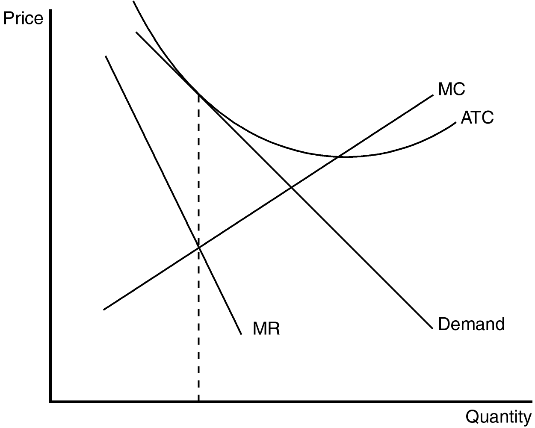
Competitive firms do not face downward-sloping demand. The graph shows the firm choosing a level of production in which the intersection of marginal revenue and marginal cost occurs at an output level where average total cost is decreasing. This profit-maximizing output level is less than the efficient scale (minimum of average total cost) and therefore the firm is said to be operating with excess capacity.
PTS: 1 DIF: 2 REF: 17-1
TOP: Excess capacity MSC: Analytical
4. In a small college town, four microbreweries have opened in the last two years. Demonstrate the effect of these new market entrants on demand for existing firms (microbreweries) that already served this market. Assume that the local community now places a moratorium on new liquor licenses for microbreweries. How will this moratorium affect the long-run profitability of incumbent firms?
ANS:
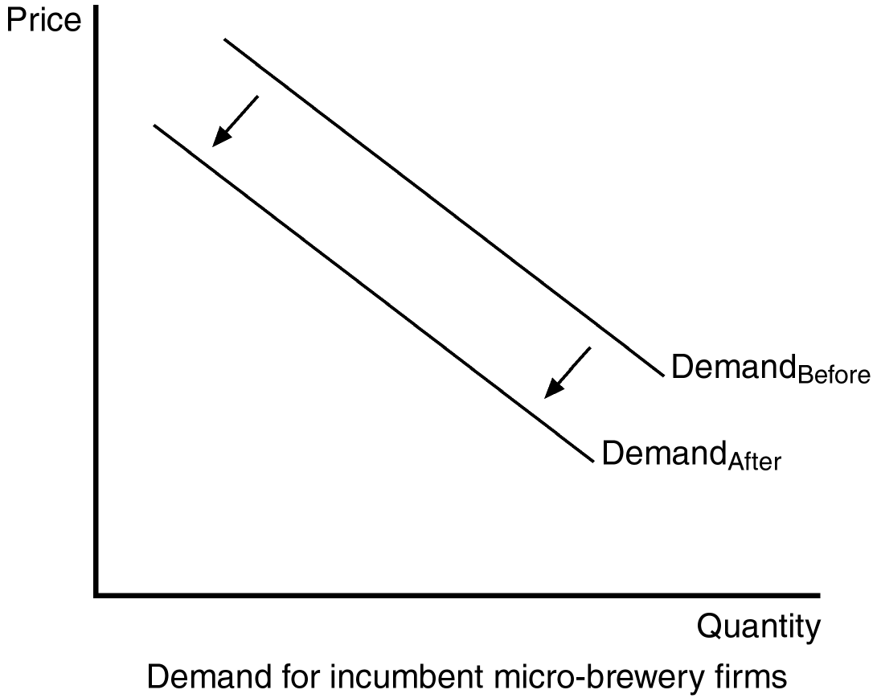
The arrival of a new entrant should be graphically depicted by a leftward shift in the demand curves faced by all incumbent firms. If firms are able to make economic profits, these will be able to be maintained in the long run if new entrants are not allowed.
PTS: 1 DIF: 2 REF: 17-1
TOP: Long-run equilibrium MSC: Analytical
5. In many college towns, private independent bookstores typically locate on the periphery of the college campus. However, in some college towns, the University has used political power to restrict private bookstores near campus through community zoning laws. Use your knowledge of markets to predict the price and quality of service difference in the market for college textbooks under these two different market regimes.
ANS:
In monopoly markets, price will be higher and the quality of service will be lower than in monopolistically competitive markets.
PTS: 1 DIF: 2 REF: 17-1
TOP: Markets MSC: Analytical
6. List five goods that are likely sold in a monopolistically competitive market.
ANS:
Books, CDs, movies, computer games, and piano lessons are some examples.
PTS: 1 DIF: 1 REF: 17-1
TOP: Monopolistic competition MSC: Interpretive
7. Why does a typical monopolistically competitive firm face a downward-sloping demand curve?
ANS:
Because its product is different from those offered by other firms.
PTS: 1 DIF: 1 REF: 17-1
TOP: Demand curve MSC: Interpretive
8. What is meant by the term “excess capacity” as it relates to monopolistically competitive firms?
ANS:
Monopolistically competitive firms produce a level of output lower than the efficient scale of output and are therefore said to have excess capacity.
PTS: 1 DIF: 2 REF: 17-1
TOP: Excess capacity MSC: Interpretive
9. Assume the role of a critic of advertising. Describe the characteristics of advertising that reduce the effectiveness of markets and decrease the social welfare of society.
ANS:
Advertising manipulates people’s tastes and is psychological rather than informational. As a result, advertising creates a desire that might not otherwise exist. Advertising may also impede competition by convincing consumers that products that are identical have significant differences.
PTS: 1 DIF: 2 REF: 17-2
TOP: Advertising MSC: Interpretive
10. Assume the role of a defender of advertising. Describe the characteristics of advertising that enhance the effectiveness of markets and increase the social welfare of society.
ANS:
Advertising provides information to consumers and thus allows consumers to make more informed (and, therefore, better) choices. Advertising fosters competition by making consumers more aware of prices and product characteristics in a market.
PTS: 1 DIF: 2 REF: 17-2
TOP: Advertising MSC: Interpretive
11. Evaluate the following statement: “Advertisements that use celebrity endorsements are devoid of any value and do not enhance the efficient functioning of markets.”
ANS:
Some people argue that celebrity endorsements are a signal of quality due to the high cost of the advertisement. If so, then these advertisements relay information about product quality and enhance the effective functioning of markets.
PTS: 1 DIF: 2 REF: 17-2
TOP: Advertising MSC: Interpretive
12. Discuss how “brand names” may enhance the efficiency of markets in a less developed country.
ANS:
Recognizable brand names signal quality products. In the tourist and business services market this signal can be critical at the early stages of development to ensure visitors have a quality experience when other information is unavailable or unreliable.
PTS: 1 DIF: 2 REF: 17-2
TOP: Advertising MSC: Interpretive
13. Professional organizations (for example, the American Medical Association and the American Bar Association) have been active advocates for regulation to restrict the right of professionals to advertise. Describe what economic incentives might exist for existing professionals to restrict advertising.
ANS:
If advertising increases information about prices and services, then providers of professional services will be required to compete with each other on the basis of price and service. As such, existing professionals will be subject to more competitive pressure in the markets they service, and individual profits are likely to fall.
PTS: 1 DIF: 2 REF: 17-2
TOP: Advertising MSC: Analytical
14. In markets where the government imposes an excise tax on unit sales, it also has a tendency to dabble with restrictions on advertising (for example, cigarettes and hard liquor). Do potential (or actual) restrictions on advertising in these markets serve the interest of a government that is interested in maximizing its tax revenue from the sale of these products? Explain your answer.
ANS:
In the case of the examples given, demand is quite inelastic, so restrictions on advertising are not likely to have a large impact on total sales, but may have an impact on the distribution of sales across brand names. As such, government revenue is largely unaffected if the tax is on unit sales.
PTS: 1 DIF: 3 REF: 17-2
TOP: Advertising MSC: Analytical
15. As developing countries make a transition to market-based economies, one of the first major capital investments is in “Western-quality” hotels. Explain why “brand-name” hotel accommodations are a critical step in attracting foreign investment.
ANS:
Brand-name hotels are a critical first step to economic development because their recognized signal of quality reduces the barriers of facilitating foreign visitors (and their money).
PTS: 1 DIF: 2 REF: 17-2
TOP: Advertising MSC: Analytical

