Chapter 6
Supply, Demand, and Government Policies
Multiple Choice
1. Price controls are usually enacted
a. as a means of raising revenue for public purposes.
b. when policymakers believe that the market price of a good or service is unfair to buyers or sellers.
c. when policymakers detect inefficiencies in a market.
d. All of the above are correct.
ANS: B PTS: 1 DIF: 1 REF: 6-0
TOP: Price ceilings | Price floors MSC: Interpretive
2. The presence of price controls in a market usually is an indication that
a. an insufficient quantity of a good or service was being produced in that market to meet the public’s need.
b. the usual forces of supply and demand were not able to establish an equilibrium price in that market.
c. policymakers believed that the price that prevailed in that market in the absence of price controls was unfair to buyers or sellers.
d. policymakers correctly believed that, in that market, price controls would generate no inequities of their own.
ANS: C PTS: 1 DIF: 2 REF: 6-0
TOP: Price ceilings | Price floors MSC: Interpretive
3. Policymakers sometimes are attracted to price controls because
a. they view the market's outcome as inefficient.
b. they view the market's outcome as unfair.
c. it is politically popular to impose price controls in markets in which the demand for the good or service is inelastic.
d. they are required to do so under the Employment Act of 1946.
ANS: B PTS: 1 DIF: 2 REF: 6-0
TOP: Price ceilings | Price floors MSC: Interpretive
4. Price controls
a. always produce an equitable outcome.
b. always produce an efficient outcome.
c. can generate inequities of their own.
d. produce revenue for the government.
ANS: C PTS: 1 DIF: 2 REF: 6-0
TOP: Price ceilings | Price floors MSC: Interpretive
5. Policymakers use taxes
a. to raise revenue for public purposes, but not to influence market outcomes.
b. both to raise revenue for public purposes and to influence market outcomes.
c. when they realize that price controls alone are insufficient to correct market inequities.
d. only in those markets in which the burden of the tax falls clearly on the sellers.
ANS: B PTS: 1 DIF: 2 REF: 6-0
TOP: Taxes MSC: Interpretive
6. A legal maximum price at which a good can be sold is a price
a. floor.
b. stabilization.
c. support.
d. ceiling.
ANS: D PTS: 1 DIF: 1 REF: 6-1
TOP: Price ceilings MSC: Definitional
7. A price ceiling
a. is a legal maximum on the price at which a good can be sold.
b. is often imposed in markets in which “cutthroat competition” would prevail without a price ceiling.
c. is often imposed when sellers of a good are successful in their attempts to convince the government that the market outcome is unfair without a price ceiling.
d. All of the above are correct.
ANS: A PTS: 1 DIF: 2 REF: 6-1
TOP: Price ceilings MSC: Interpretive
8. A legal minimum price at which a good can be sold is
a. exemplified by rent-control laws.
b. usually intended to enhance efficiency in a market.
c. called a price ceiling.
d. called a price floor.
ANS: D PTS: 1 DIF: 1 REF: 6-1
TOP: Price floors MSC: Definitional
9. A price floor
a. is a legal minimum on the price at which a good can be sold.
b. can result when sellers of a good are successful in their attempts to convince the government that the market outcome without a price floor is unfair to them.
c. can create inequities in a market.
d. All of the above are correct.
ANS: D PTS: 1 DIF: 1 REF: 6-1
TOP: Price floors MSC: Definitional
10. Which of the following is the most likely explanation for the imposition of a price floor in the market for corn?
a. Policymakers have studied the effects of the price floor carefully and they recognize that the price floor is advantageous for society as a whole.
b. Buyers and sellers of corn have agreed that the price floor is good for both of them and have therefore pressured policy makers into enacting the price floor.
c. Buyers of corn, recognizing that the price floor is good for them, have pressured policy makers into enacting the price floor.
d. Sellers of corn, recognizing that the price floor is good for them, have pressured policy makers into enacting the price floor.
ANS: D PTS: 1 DIF: 2 REF: 6-1
TOP: Price floors MSC: Interpretive
11. A price ceiling will be binding only if it is set
a. equal to equilibrium price.
b. above equilibrium price.
c. below equilibrium price.
d. none of the above; a price ceiling is never binding.
ANS: C PTS: 1 DIF: 2 REF: 6-1
TOP: Price ceilings MSC: Interpretive
12. A price ceiling is binding when it is set
a. above the equilibrium price, causing a shortage.
b. above the equilibrium price, causing a surplus.
c. below the equilibrium price, causing a shortage.
d. below the equilibrium price, causing a surplus.
ANS: C PTS: 1 DIF: 2 REF: 6-1
TOP: Price ceilings | Shortages MSC: Interpretive
13. Suppose a price ceiling is not binding; this means that
a. the equilibrium price is above the price ceiling.
b. the equilibrium price is below the price ceiling.
c. it has no legal enforcement mechanism.
d. people are finding a way to circumvent the law.
ANS: B PTS: 1 DIF: 2 REF: 6-1
TOP: Price ceilings MSC: Interpretive
14. A price ceiling that is not binding will
a. cause a surplus in the market.
b. cause a shortage in the market.
c. cause the market to be less efficient than it would be without the price ceiling.
d. have no effect on the market price.
ANS: D PTS: 1 DIF: 2 REF: 6-1
TOP: Price ceilings MSC: Interpretive
15. A shortage results when
a. a binding price ceiling is imposed.
b. a binding price floor is imposed.
c. a price ceiling is imposed but it is not binding.
d. a price floor is imposed but it is not binding.
ANS: A PTS: 1 DIF: 2 REF: 6-1
TOP: Price ceilings MSC: Interpretive
16. When, in a particular market, the law of demand and the law of supply both apply, the imposition of a binding price ceiling in that market causes quantity demanded to be
a. greater than quantity supplied.
b. less than quantity supplied.
c. equal to quantity supplied.
d. Any of the above is possible.
ANS: A PTS: 1 DIF: 2 REF: 6-1
TOP: Price ceilings | Shortages MSC: Interpretive
17. To say that a price ceiling is binding is to say that the price ceiling
a. results in a scarcity.
b. is set above the equilibrium price.
c. results in excess demand.
d. All of the above are correct.
ANS: C PTS: 1 DIF: 2 REF: 6-1
TOP: Price ceilings | Shortages MSC: Interpretive
Figure 6-1
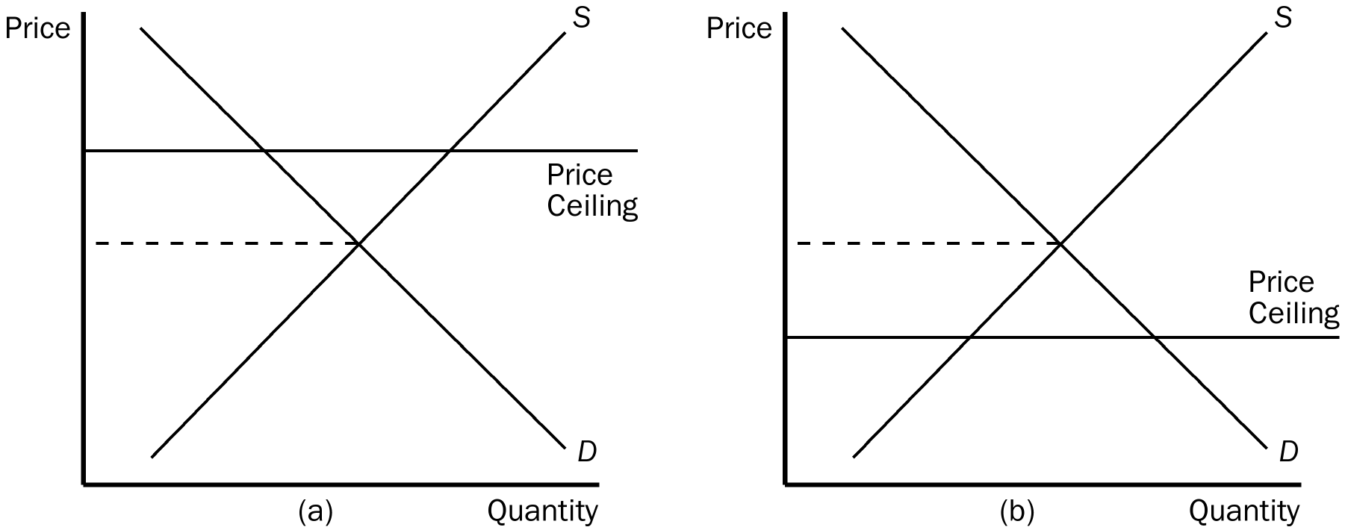
18. Refer to Figure 6-1. A binding price ceiling is shown in
a. panel (a) but not panel (b).
b. panel (b) but not panel (a).
c. both panel (a) and panel (b).
d. neither panel (a) nor panel (b).
ANS: B PTS: 1 DIF: 2 REF: 6-1
TOP: Price ceilings MSC: Applicative
19. Refer to Figure 6-1. In which panel(s) of the figure would there be a shortage of the good at the ceiling price?
a. panel (a) but not panel (b)
b. panel (b) but not panel (a)
c. panel (a) and panel (b)
d. neither panel (a) nor panel (b)
ANS: B PTS: 1 DIF: 2 REF: 6-1
TOP: Price ceilings | Shortages MSC: Applicative
20. Refer to Figure 6-1. The situation in panel (a) may be described as one in which
a. the price ceiling is not binding.
b. the price “ceiling” really functions as a price floor.
c. a surplus of the good will be observed.
d. All of the above are correct.
ANS: A PTS: 1 DIF: 2 REF: 6-1
TOP: Price ceilings MSC: Applicative
Figure 6-2
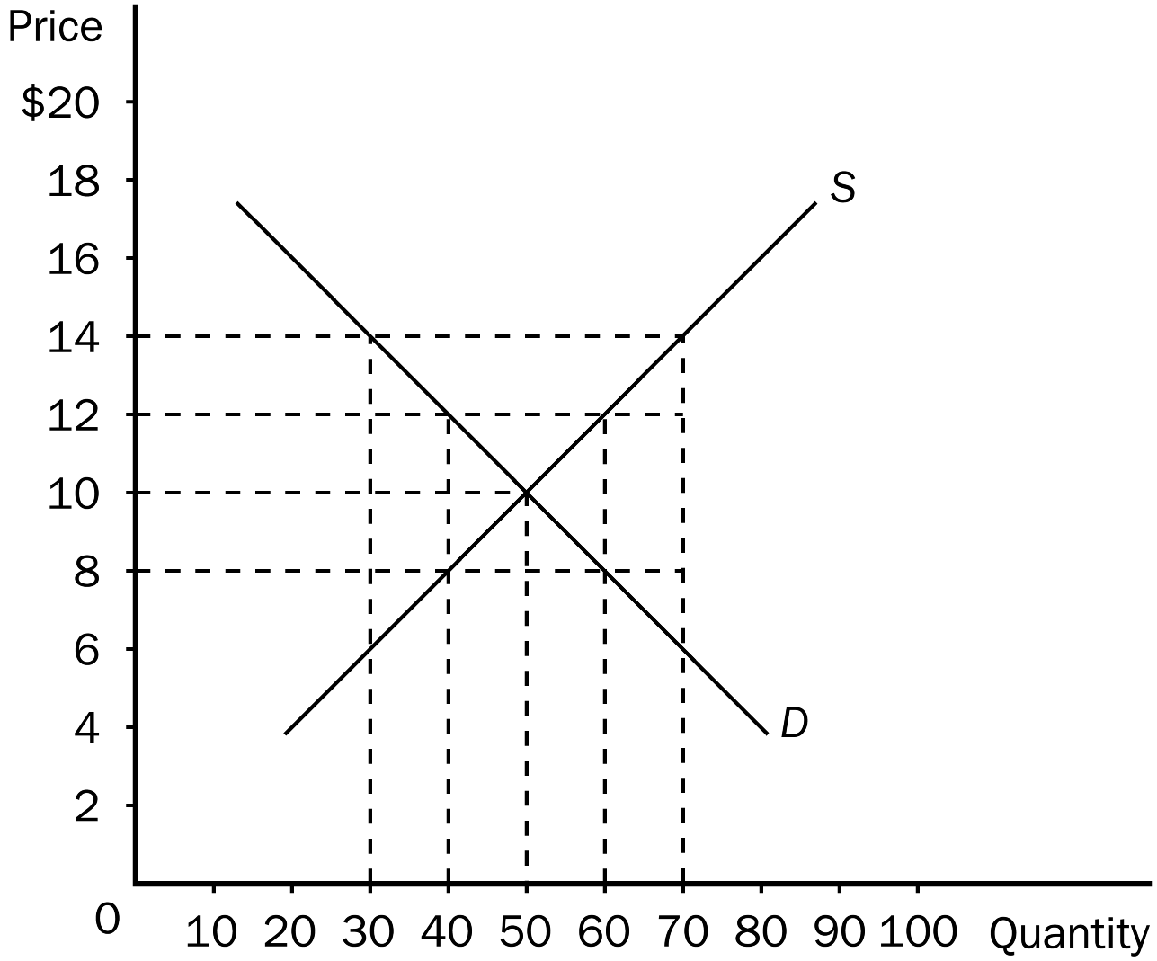
21. Refer to Figure 6-2. A binding price ceiling would be the result if the price ceiling were set at
a. $14.
b. $12.
c. $10.
d. $8.
ANS: D PTS: 1 DIF: 2 REF: 6-1
TOP: Price ceilings MSC: Applicative
22. Refer to Figure 6-2. Which of the following statements is correct?
a. A price ceiling set at $12 would be binding, but a price ceiling set at $8 would not be binding.
b. A price floor set at $8 would be binding, but a price ceiling set at $8 would not be binding.
c. A price ceiling set at $9 would result in an excess supply.
d. A price floor set at $11 would result in a surplus.
ANS: D PTS: 1 DIF: 2 REF: 6-1
TOP: Price ceilings | Price floors MSC: Applicative
23. Refer to Figure 6-2. If the government imposes a price floor of $14 in this market, the result would be a
a. surplus of 20.
b. surplus of 40.
c. shortage of 20.
d. shortage of 40.
ANS: B PTS: 1 DIF: 2 REF: 6-1
TOP: Price floors | Surpluses MSC: Applicative
24. Refer to Figure 6-2. If the government imposes a price ceiling of $8 in this market, the result would be a
a. surplus of 10.
b. surplus of 20.
c. shortage of 10.
d. shortage of 20.
ANS: D PTS: 1 DIF: 2 REF: 6-1
TOP: Price ceilings | Shortages MSC: Applicative
25. Refer to Figure 6-2. If the government imposes a price ceiling of $12 in this market, the result would be
a. a surplus of 10.
b. a surplus of 20.
c. a shortage of 20.
d. neither a surplus nor a shortage.
ANS: D PTS: 1 DIF: 3 REF: 6-1
TOP: Price ceilings MSC: Applicative
26. Refer to Figure 6-2. In which of the following cases would sellers have to develop a rationing mechanism?
a. A price ceiling is set at $8.
b. A price ceiling is set at $12.
c. A price floor is set at $8.
d. A price floor is set at $10.
ANS: A PTS: 1 DIF: 3 REF: 6-1
TOP: Price ceilings | Price floors MSC: Applicative
27. A price floor is binding if it
a. is set lower than the equilibrium market price.
b. results in an observed price that is the same as the equilibrium price.
c. leads to a surplus.
d. is strictly enforced by the government.
ANS: C PTS: 1 DIF: 2 REF: 6-1
TOP: Price floors | Surpluses MSC: Interpretive
28. An example of a price floor is
a. the regulation of gasoline prices in the U.S. in the 1970s.
b. rent control.
c. the minimum wage.
d. any restriction on price that leads to a shortage.
ANS: C PTS: 1 DIF: 1 REF: 6-1
TOP: Price ceilings | Price floors MSC: Definitional
29. When a price floor is binding, the equilibrium price is
a. lower than the price floor.
b. higher than the price floor.
c. equal to the price floor.
d. It is impossible to compare the equilibrium price with the price floor.
ANS: A PTS: 1 DIF: 2 REF: 6-1
TOP: Price floors MSC: Interpretive
30. A binding price floor in a market is set
a. above equilibrium price and causes a shortage.
b. above equilibrium price and causes a surplus.
c. below equilibrium price and causes a surplus.
d. below equilibrium price and causes a shortage.
ANS: B PTS: 1 DIF: 2 REF: 6-1
TOP: Price floors | Surpluses MSC: Interpretive
31. A price floor is not binding if
a. the price floor is higher than the equilibrium price of the good.
b. the quantity of the good demanded with the price floor is less than the quantity demanded of the good without the price floor.
c. the quantity of the good supplied with the price floor is less than the quantity supplied of the good without the price floor.
d. All of the above are correct.
ANS: C PTS: 1 DIF: 3 REF: 6-1
TOP: Price floors | Quantity demanded | Quantity supplied MSC: Analytical
32. A binding price floor causes
a. excess demand.
b. a shortage.
c. a surplus.
d. quantity demanded to exceed quantity supplied.
ANS: C PTS: 1 DIF: 2 REF: 6-1
TOP: Price floors | Surpluses MSC: Interpretive
Figure 6-3
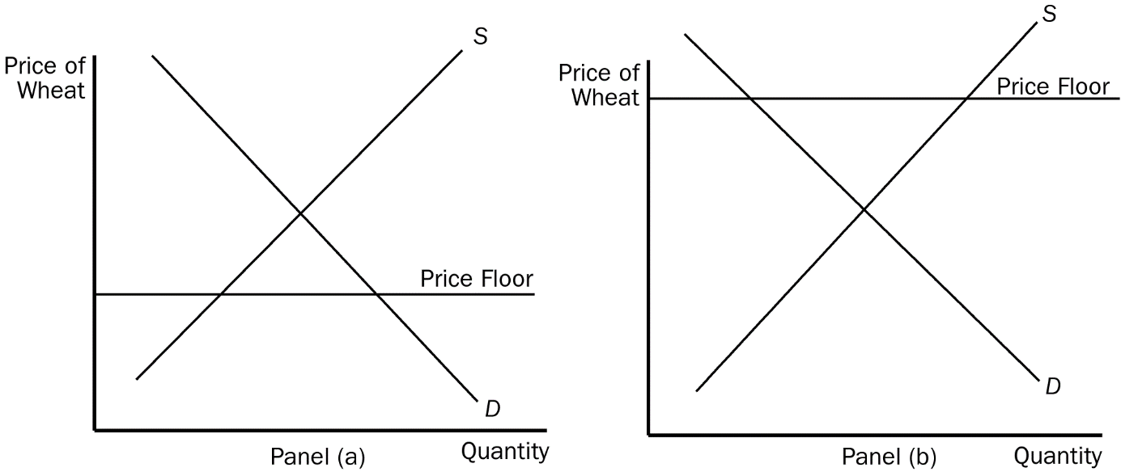
33. Refer to Figure 6-3. Which of the panels represents a binding price floor?
a. panel (a) but not panel (b)
b. panel (b) but not panel (a)
c. panel (a) and panel (b)
d. neither panel (a) nor panel (b)
ANS: B PTS: 1 DIF: 2 REF: 6-1
TOP: Price floors MSC: Applicative
34. Refer to Figure 6-3. In panel (b), with the price floor in effect, there will be
a. a shortage of wheat.
b. equilibrium in the market.
c. a surplus of wheat.
d. an excess demand for wheat.
ANS: C PTS: 1 DIF: 2 REF: 6-1
TOP: Price floors | Surpluses MSC: Applicative
35. If a price ceiling is a binding constraint on the market,
a. the equilibrium price must be below the price ceiling.
b. there is excess supply.
c. sellers cannot sell all they want to sell at the price ceiling.
d. buyers cannot buy all they want to buy at the price ceiling.
ANS: D PTS: 1 DIF: 2 REF: 6-1
TOP: Price ceilings MSC: Interpretive
36. When a price ceiling is imposed in a market and the ceiling is binding,
a. price no longer serves as a rationing device.
b. the quantity supplied at the price ceiling exceeds the quantity that would have been supplied without the price ceiling.
c. buyers and sellers both benefit in equal measure.
d. buyers and sellers both are harmed in equal measure.
ANS: A PTS: 1 DIF: 2 REF: 6-1
TOP: Price ceilings MSC: Interpretive
37. Suppose the government has imposed a price ceiling on televisions. Which of the following events could transform the price ceiling from one that is not binding into one that is binding?
a. Firms take advantage of an advance in technology that reduces the amount of labor necessary to produce televisions.
b. The number of firms selling televisions decreases.
c. Consumers' income decreases, and televisions are a normal good.
d. All of the above are correct.
ANS: B PTS: 1 DIF: 2 REF: 6-1
TOP: Price ceilings MSC: Applicative
38. When a binding price ceiling is imposed to benefit buyers, a result is that
a. every buyer in the market benefits.
b. every seller in the market benefits, but the overall benefit to sellers is smaller than the overall benefit to buyers.
c. every buyer in the market benefits and every seller in the market is harmed.
d. some buyers will not be able to buy any amount of the good.
ANS: D PTS: 1 DIF: 2 REF: 6-1
TOP: Price ceilings MSC: Interpretive
39. Which of the following statements is correct?
a. A price ceiling is not binding when the price ceiling is set above the equilibrium price.
b. A price floor is not binding when the price floor is set below the equilibrium price.
c. A binding price ceiling causes a shortage and a binding price floor causes a surplus.
d. All of the above are correct.
ANS: D PTS: 1 DIF: 2 REF: 6-1
TOP: Price ceilings | Price floors MSC: Interpretive
40. Which of the following observations would be consistent with a binding price ceiling in a market?
a. A smaller quantity of the good is bought and sold after the price ceiling becomes effective than before the price ceiling became effective.
b. A smaller quantity of the good is demanded after the price ceiling becomes effective than before the price ceiling became effective.
c. A larger quantity of the good is supplied after the price ceiling becomes effective than before the price ceiling became effective.
d. All of the above are correct.
ANS: A PTS: 1 DIF: 2 REF: 6-1
TOP: Price ceilings MSC: Interpretive
41. Which of the following observations would be consistent with a binding price floor in a market?
a. A smaller quantity of the good is bought and sold after the price floor becomes effective than before the price floor became effective.
b. A smaller quantity of the good is demanded after the price floor becomes effective than before the price floor became effective.
c. A larger quantity of the good is supplied after the price floor becomes effective than before the price floor became effective.
d. All of the above are correct.
ANS: D PTS: 1 DIF: 2 REF: 6-1
TOP: Price floors MSC: Interpretive
42. If a binding price ceiling were imposed in the computer market,
a. the demand for computers would increase.
b. the supply of computers would decrease.
c. a shortage of computers would develop.
d. All of the above are correct.
ANS: C PTS: 1 DIF: 2 REF: 6-1
TOP: Price ceilings MSC: Interpretive
43. If a binding price ceiling were imposed in the computer market,
a. the quantity of computers demanded would increase.
b. the quantity of computers supplied would decrease.
c. a shortage of computers would develop.
d. All of the above are correct.
ANS: D PTS: 1 DIF: 2 REF: 6-1
TOP: Price ceilings MSC: Interpretive
44. Suppose the equilibrium price of a physical examination ("physical") by a doctor is $200, and the government imposes a price ceiling of $150 per physical. As a result of the price ceiling,
a. the demand curve for physicals shifts to the right.
b. the supply curve for physicals shifts to the left.
c. the quantity demanded of physicals increases and the quantity supplied of physicals decreases.
d. the number of physicals performed will increase.
ANS: C PTS: 1 DIF: 2 REF: 6-1
TOP: Price ceilings MSC: Applicative
45. When policymakers set prices by legal decree, they
a. are usually following the advice of mainstream economists.
b. are usually improving the organization of economic activity.
c. are obscuring the signals that normally guide the allocation of society’s resources.
d. are demonstrating a willingness to sacrifice equity for the sake of a gain in efficiency.
ANS: C PTS: 1 DIF: 2 REF: 6-1
TOP: Price ceilings | Price floors MSC: Interpretive
46. An outcome that can result from either a price ceiling or a price floor is
a. a surplus in the market.
b. a shortage in the market.
c. a nonbinding price control.
d. long lines of frustrated buyers.
ANS: C PTS: 1 DIF: 2 REF: 6-1
TOP: Price ceilings | Price floors MSC: Applicative
47. An outcome that can result from either a price ceiling or a price floor is
a. an enhancement of efficiency.
b. undesirable rationing mechanisms.
c. excess supply.
d. excess demand.
ANS: B PTS: 1 DIF: 2 REF: 6-1
TOP: Price ceilings | Price floors MSC: Applicative
Figure 6-4
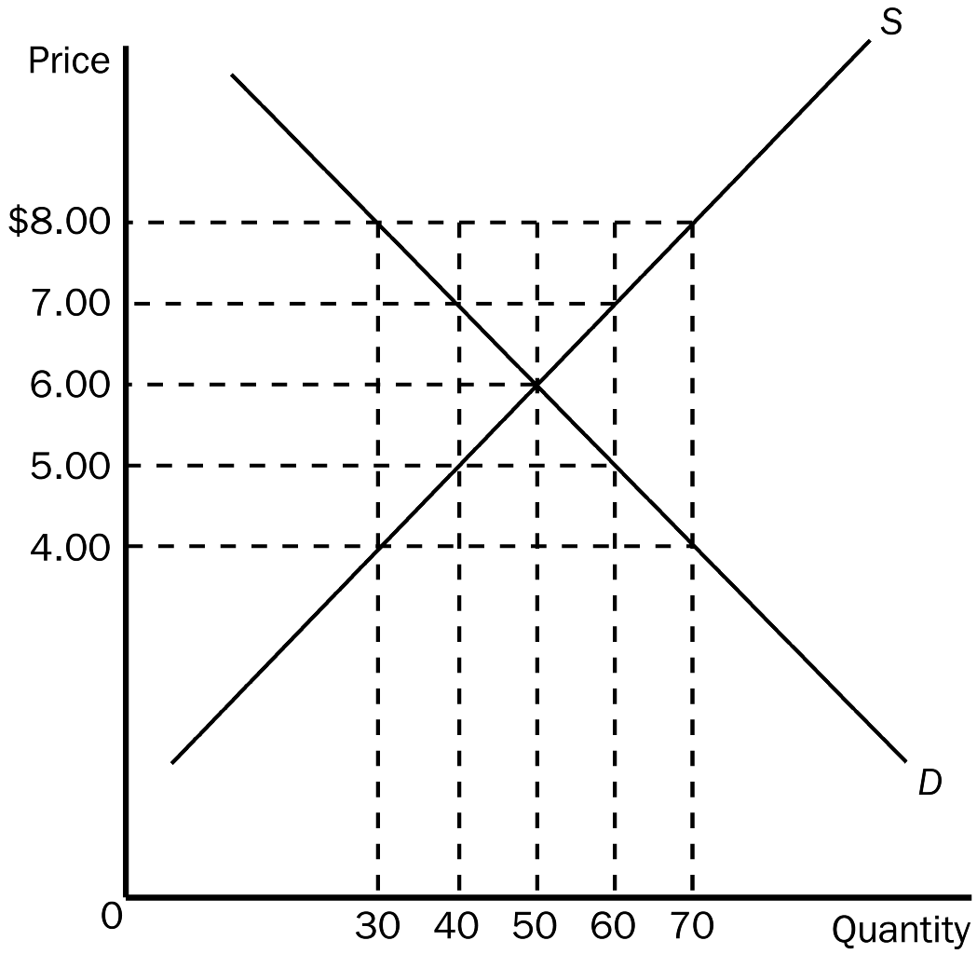
48. Refer to Figure 6-4. If the government imposes a price ceiling in this market at a price of $5.00, the result would be a
a. shortage of 20 units.
b. shortage of 10 units.
c. surplus of 20 units.
d. surplus of 10 units.
ANS: A PTS: 1 DIF: 2 REF: 6-1
TOP: Price ceilings | Shortages MSC: Applicative
49. Refer to Figure 6-4. For a price ceiling to be binding, it would have to be set at
a. any price below $6.00.
b. a price between $4.00 and $6.00.
c. a price between $6.00 and $8.00.
d. any price above $6.00.
ANS: A PTS: 1 DIF: 2 REF: 6-1
TOP: Price ceilings MSC: Applicative
50. Refer to Figure 6-4. Which of the following price controls would cause a shortage of 10 units of the good?
a. a price ceiling of $5.50
b. a price floor of $5.50
c. a price ceiling of $6.50
d. a price floor of $6.50
ANS: A PTS: 1 DIF: 2 REF: 6-1
TOP: Price ceilings MSC: Applicative
51. Refer to Figure 6-4. Suppose a price floor of $7.00 is imposed. As a result,
a. buyers’ total expenditure on the good decreases by $20.00.
b. the supply curve will shift to the left so as to now pass through the point (Q = 40, P = $7.00).
c. the quantity of the good demanded decreases by 20 units.
d. the price of the good continues to serve as the rationing mechanism.
ANS: A PTS: 1 DIF: 3 REF: 6-1
TOP: Price floors MSC: Analytical
52. Refer to Figure 6-4. Suppose a price ceiling of $4.50 is imposed. As a result,
a. there is a shortage of 15 units of the good.
b. the demand curve will shift to the left so as to now pass through the point (Q = 35, P = $4.50).
c. the situation is very much like the one created by a binding minimum wage.
d. the quantity of the good that is bought and sold is the same as it would have been had a price floor of $7.50 been imposed.
ANS: D PTS: 1 DIF: 3 REF: 6-1
TOP: Price ceilings MSC: Analytical
Figure 6-5
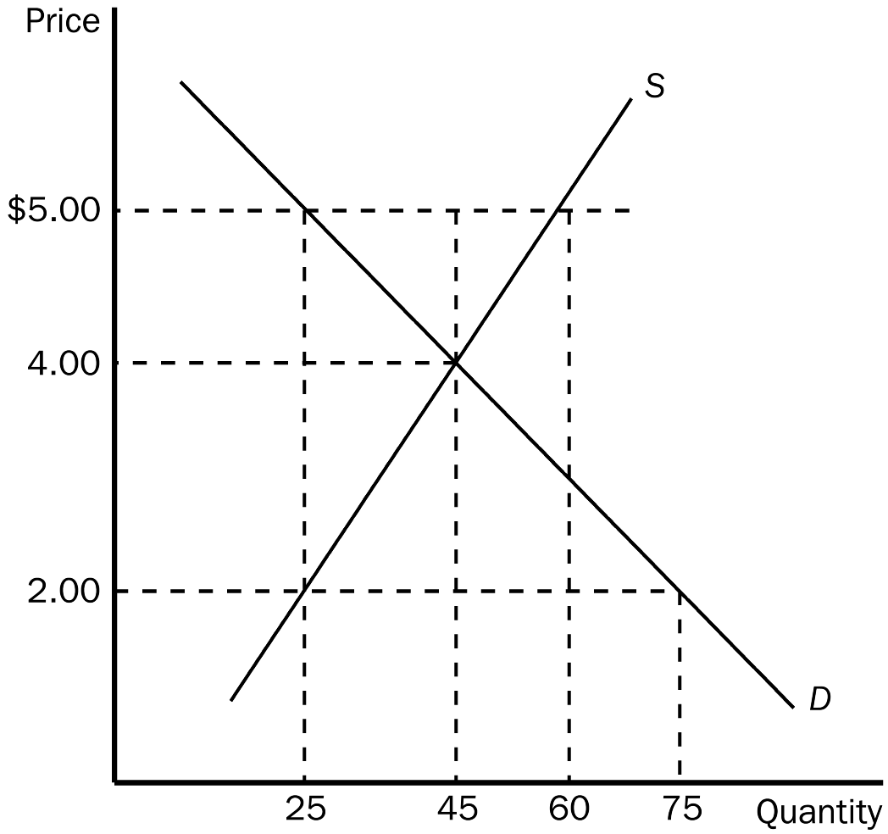
53. Refer to Figure 6-5. If the government imposes a price ceiling of $2.00 in this market, the result is a
a. surplus of 30 units of the good.
b. shortage of 20 units of the good.
c. shortage of 30 units of the good.
d. shortage of 50 units of the good.
ANS: D PTS: 1 DIF: 2 REF: 6-1
TOP: Price ceilings | Shortages MSC: Applicative
54. Refer to Figure 6-5. In this market, which of the following price controls would be binding?
a. a price ceiling of $2.00, and it would cause a shortage
b. a price ceiling of $5.00, and it would cause a surplus
c. a price floor of $2.00, and it would cause a shortage
d. All of the above are correct.
ANS: A PTS: 1 DIF: 2 REF: 6-1
TOP: Price ceilings | Shortages MSC: Applicative
55. Refer to Figure 6-5. The price of the good would continue to serve as the rationing mechanism if
a. a price ceiling of $4.00 were imposed.
b. a price ceiling of $5.00 were imposed.
c. a price floor of $3.00 were imposed.
d. All of the above are correct.
ANS: D PTS: 1 DIF: 2 REF: 6-1
TOP: Price ceilings | Price floors MSC: Applicative
56. Refer to Figure 6-5. When a certain price control is imposed in this market, the resulting quantity of the good that is actually bought and sold is such that buyers are willing and able to pay a maximum of P₁ dollars per unit for that quantity and sellers are willing and able to accept a minimum of P₂ dollars per unit for that quantity.
If P₁ – P₂ = $3.00, then the price control in question is
a. a price ceiling of $2.00.
b. a price ceiling of $5.00.
c. a price floor of $5.00.
d. either a price ceiling of $2.00 or a price floor of $5.00.
ANS: D PTS: 1 DIF: 3 REF: 6-1
TOP: Price ceilings | Price floors MSC: Analytical
57. Rationing by long lines is
a. inefficient, because it wastes buyers' time.
b. efficient, because those who are willing to wait the longest get the goods.
c. the only way scarce goods can be rationed.
d. only necessary if price ceilings are not binding.
ANS: A PTS: 1 DIF: 1 REF: 6-1
TOP: Shortages MSC: Interpretive
58. Price ceilings and price floors that are binding
a. are desirable because they make markets more efficient and more equitable.
b. cause surpluses and shortages to persist since price cannot adjust to the market equilibrium price.
c. can have the effect of restoring a market to equilibrium.
d. are imposed because they can make the poor in the economy better off without causing adverse effects.
ANS: B PTS: 1 DIF: 2 REF: 6-1
TOP: Price ceilings | Price floors MSC: Interpretive
59. In the 1970s, long lines at gas stations in the United States were primarily a result of the fact that
a. OPEC raised the price of crude oil in world markets.
b. U.S. gasoline producers raised the price of gasoline.
c. the U.S. government maintained a price ceiling on gasoline.
d. Americans typically commute long distances.
ANS: C PTS: 1 DIF: 2 REF: 6-1
TOP: Price ceilings | Shortages MSC: Interpretive
60. Other than OPEC, the shortage of gasoline in the U.S. in the 1970s could also be blamed on
a. a sharp increase in the demand for gasoline that was brought on by the Vietnam War.
b. the government’s policy of maintaining a price ceiling on gasoline.
c. an indifference among U.S. consumers toward conservation.
d. the lack of substitutes for crude oil.
ANS: B PTS: 1 DIF: 2 REF: 6-1
TOP: OPEC | Price ceilings | Shortages MSC: Interpretive
61. When OPEC raised the price of crude oil in the 1970s, it caused the
a. demand for gasoline to increase.
b. demand for gasoline to decrease.
c. supply of gasoline to increase.
d. supply of gasoline to decrease.
ANS: D PTS: 1 DIF: 2 REF: 6-1
TOP: OPEC | Supply MSC: Interpretive
62. When OPEC raised the price of crude oil in the 1970s, it caused the
a. supply of gasoline to decrease.
b. quantity of gasoline demanded to decrease.
c. equilibrium price of gasoline to increase.
d. All of the above are correct.
ANS: D PTS: 1 DIF: 2 REF: 6-1
TOP: OPEC | Supply | Quantity demanded MSC: Interpretive
63. In the United States, before OPEC increased the price of crude oil in 1973, there was
a. no price ceiling on gasoline.
b. a price ceiling on gasoline but it was not binding.
c. a price ceiling on gasoline and it was binding.
d. a price floor on gasoline but it was not binding.
ANS: B PTS: 1 DIF: 2 REF: 6-1
TOP: Price ceilings MSC: Definitional
64. Economists blame the long lines at gasoline stations in the U.S. in the 1970s on
a. U.S. government regulations pertaining to the price of gasoline.
b. the Organization of Petroleum Exporting Countries (OPEC).
c. major oil companies operating in the U.S.
d. consumers who bought gasoline frequently, even when their cars' gasoline tanks were nearly full.
ANS: A PTS: 1 DIF: 1 REF: 6-1
TOP: Price ceilings MSC: Interpretive
Figure 6-6
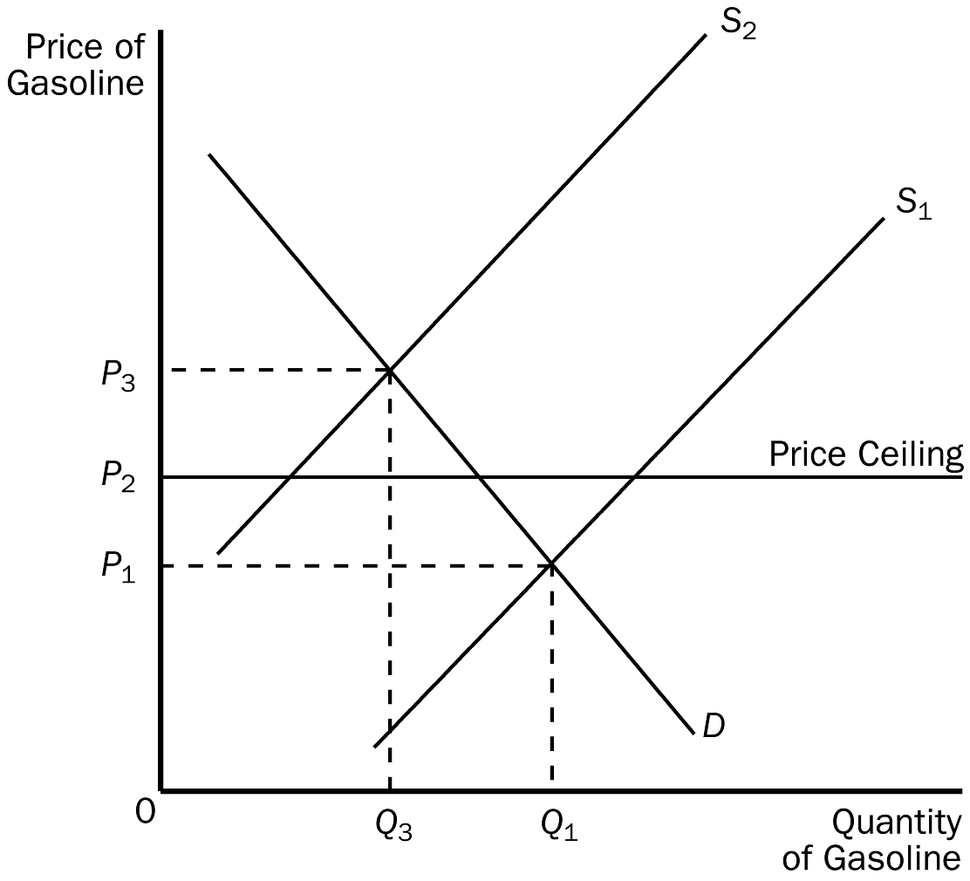
65. Refer to Figure 6-6. When the price ceiling applies in this market and the supply curve for gasoline shifts from S₁ to S₂,
a. the price will increase to P₃.
b. a surplus will occur at the new market price of P₂.
c. the market price will stay at P₁ due to the price ceiling.
d. a shortage will occur at the price ceiling of P₂.
ANS: D PTS: 1 DIF: 2 REF: 6-1
TOP: Price ceilings | Shortages MSC: Applicative
66. Refer to Figure 6-6. When the price ceiling applies in this market and the supply curve for gasoline shifts from S₁ to S₂, the resulting quantity of gasoline that is bought and sold is
a. less than Q₃.
b. Q₃
c. between Q₁ and Q_{3.}
d. at least Q₁.
ANS: A PTS: 1 DIF: 2 REF: 6-1
TOP: Price ceilings MSC: Applicative
67. Refer to Figure 6-6. Which of the following statements best relates the figure to the events of the 1970s?
a. Buyers of gasoline paid a price of P₁ before 1973; they paid a price of P₂ after OPEC increased the price of crude oil in 1973, and there was a shortage of gasoline at that price.
b. Buyers of gasoline paid a price of P₁ before 1973; they paid a price of P₃ after OPEC increased the price of crude oil in 1973, and there was a shortage of gasoline at that price.
c. Buyers of gasoline paid a price of P₂ before 1973; they paid a price of P₃ after OPEC increased the price of crude oil in 1973, with no shortage of gasoline at that price.
d. The price ceiling was binding before 1973; the price ceiling was no longer binding after OPEC increased the price of crude oil in 1973.
ANS: A PTS: 1 DIF: 2 REF: 6-1
TOP: OPEC | Price ceilings MSC: Applicative
68. Rent control
a. serves as an example of how a social problem can be alleviated or even solved by government policies.
b. serves as an example of a price floor.
c. is regarded by most economists as an inefficient way of helping the poor.
d. is the most efficient way to allocate scarce housing resources.
ANS: C PTS: 1 DIF: 2 REF: 6-1
TOP: Rent control MSC: Interpretive
69. The long-run effects of rent controls are a good illustration of the principle that
a. society faces a short-run tradeoff between unemployment and inflation.
b. the cost of something is what you give up to get it.
c. people respond to incentives.
d. government can sometimes improve on market outcomes.
ANS: C PTS: 1 DIF: 2 REF: 6-1
TOP: Rent control | Long run MSC: Interpretive
70. Which of the following statements about the effects of rent control is correct?
a. The short-run effect of rent control is a surplus of apartments, and the long-run effect of rent control is a shortage of apartments.
b. The short-run effect of rent control is a relatively small shortage of apartments, and the long-run effect of rent control is a larger shortage of apartments.
c. In the long run, rent control leads to a shortage of apartments, and the quality of available apartments is improved by rent control.
d. The effects of rent control are very noticeable to the public in the short run, because the primary effects of rent control occur very quickly.
ANS: B PTS: 1 DIF: 2 REF: 6-1
TOP: Rent control MSC: Interpretive
71. Over time, housing shortages caused by rent control
a. increase, because the demand for, and supply of, housing are less elastic in the long run.
b. increase, because the demand for, and supply of, housing are more elastic in the long run.
c. decrease, because the demand for, and supply of, housing are less elastic in the long run.
d. decrease, because the demand for, and supply of, housing are more elastic in the long run.
ANS: B PTS: 1 DIF: 2 REF: 6-1
TOP: Rent control | Long run MSC: Interpretive
72. Economists generally believe that rent control is
a. an efficient and equitable way to help the poor.
b. not efficient, but the best available means of solving a serious social problem.
c. a highly inefficient way to help the poor raise their standard of living.
d. an efficient way to allocate housing, but not a good way to help the poor.
ANS: C PTS: 1 DIF: 2 REF: 6-1
TOP: Rent control MSC: Interpretive
73. In the housing market, rent control causes
a. quantity supplied to fall and quantity demanded to fall.
b. quantity supplied to fall and quantity demanded to rise.
c. quantity supplied to rise and quantity demanded to fall.
d. quantity supplied to rise and quantity demanded to rise.
ANS: B PTS: 1 DIF: 2 REF: 6-1
TOP: Rent control | Quantity demanded | Quantity supplied MSC: Interpretive
Figure 6-7
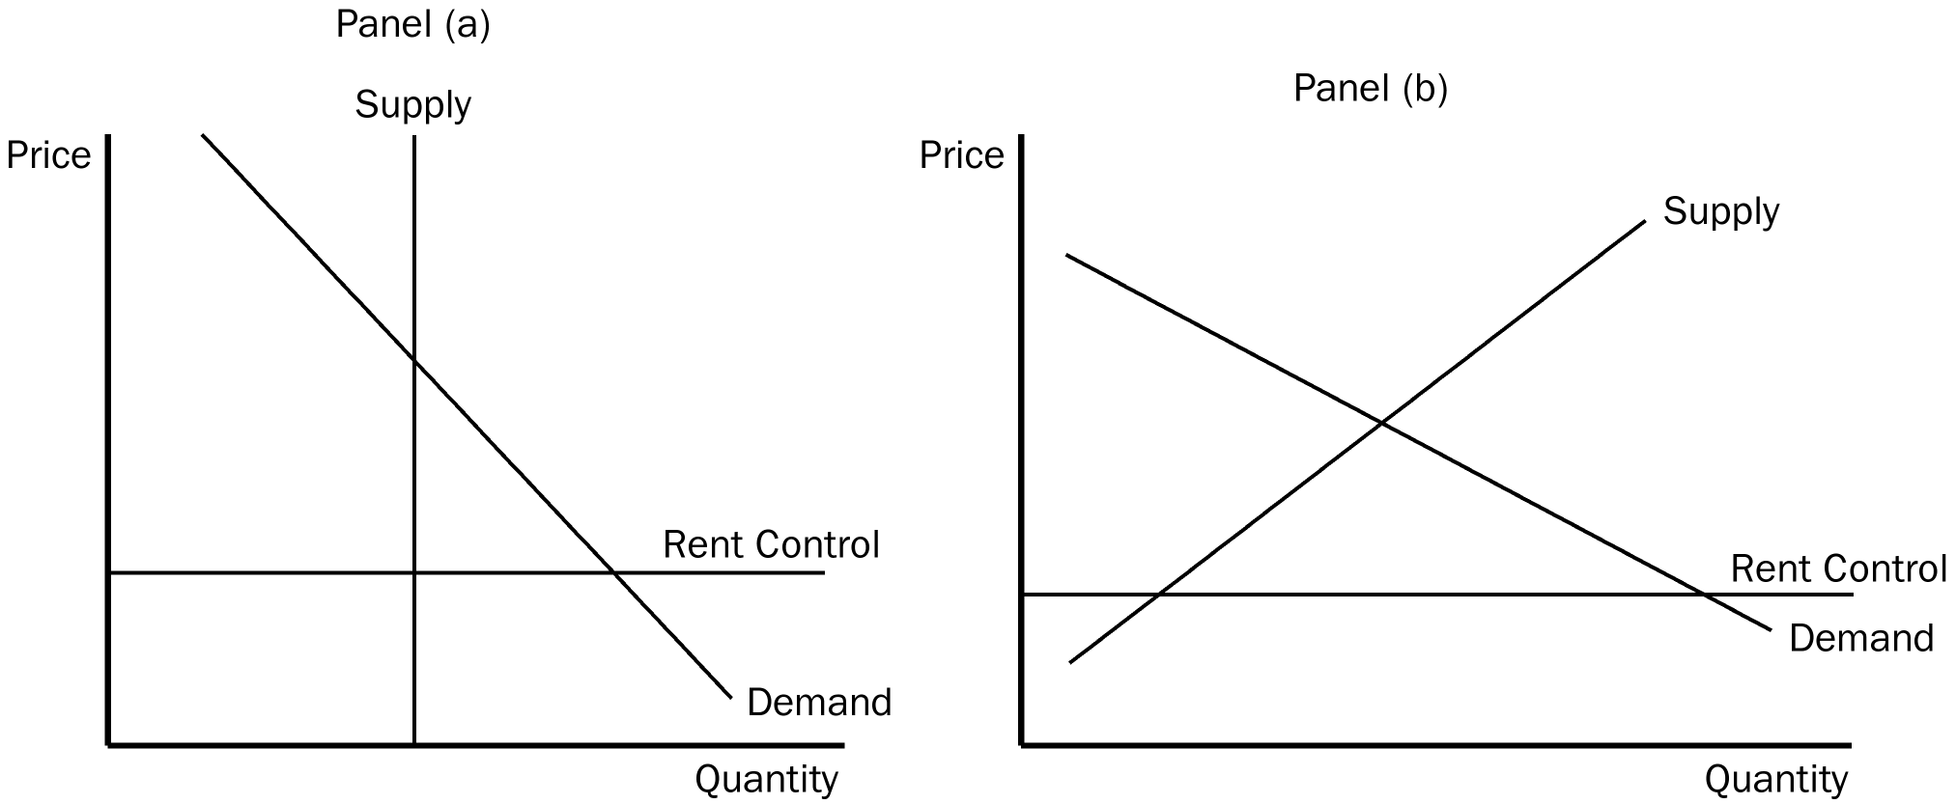
74. Refer to Figure 6-7. Which panel best represents a binding rent control in the short run?
a. panel (a)
b. panel (b)
c. neither panel
d. either panel (a) or panel (b), depending upon local housing conditions
ANS: A PTS: 1 DIF: 1 REF: 6-1
TOP: Rent control MSC: Interpretive
75. Refer to Figure 6-7. Which panel(s) best represent(s) a non-binding rent control in the long run?
a. panel (a)
b. panel (b)
c. neither panel
d. either panel (a) or panel (b), depending upon local housing conditions
ANS: C PTS: 1 DIF: 2 REF: 6-1
TOP: Rent control MSC: Interpretive
76. Which of the following is not a rationing mechanism used by landlords in cities with rent control?
a. waiting lists
b. race
c. price
d. bribes
ANS: C PTS: 1 DIF: 1 REF: 6-1
TOP: Rent control MSC: Interpretive
77. Under rent control, bribery is a mechanism to
a. bring the total price of an apartment (including the bribe) closer to the equilibrium price.
b. allocate housing to the poorest individuals in the market.
c. force the total price of an apartment (including the bribe) to be less than the market price.
d. allocate housing to the most deserving tenants.
ANS: A PTS: 1 DIF: 2 REF: 6-1
TOP: Rent control MSC: Interpretive
78. One economist has argued that rent control is "the best way to destroy a city, other than bombing." Why would an economist say this?
a. He fears that low rents will cause low-income people to move into the city, reducing the quality of life for other people.
b. He fears that rent control will benefit landlords at the expense of tenants, increasing inequality in the city.
c. He fears that rent controls will cause a construction boom, which will make the city crowded and more polluted.
d. He fears that rent control will eliminate the incentive to maintain buildings, leading to a deterioration of the city.
ANS: D PTS: 1 DIF: 2 REF: 6-1
TOP: Rent control MSC: Interpretive
79. Under rent control, tenants can expect
a. lower rent and higher quality housing.
b. lower rent and lower quality housing.
c. higher rent and a shortage of rental housing.
d. higher rent and a surplus of rental housing.
ANS: B PTS: 1 DIF: 2 REF: 6-1
TOP: Rent control MSC: Interpretive
80. Under rent control, landlords cease to be responsive to tenants' concerns about the quality of the housing because
a. with shortages and waiting lists, they have no incentive to maintain and improve their property.
b. they become resigned to the fact that many of their apartments are going to be vacant at any given time.
c. with rent control the government guarantees landlords a minimal level of profit.
d. with rent control it becomes the government's responsibility to maintain rental housing.
ANS: A PTS: 1 DIF: 2 REF: 6-1
TOP: Rent control MSC: Interpretive
81. The goal of a rent-control policy is to
a. facilitate controlled economic experiments in urban areas.
b. help landlords by assuring them a low vacancy rate for their apartments.
c. help the poor by assuring them an adequate supply of apartments.
d. help the poor by making housing more affordable.
ANS: D PTS: 1 DIF: 1 REF: 6-1
TOP: Rent control MSC: Interpretive
82. Which of the following is not a result of government-imposed rent control?
a. fewer new apartments offered for rent
b. less maintenance provided by landlords
c. bribery
d. higher quality housing
ANS: D PTS: 1 DIF: 2 REF: 6-1
TOP: Rent control MSC: Interpretive
83. Which of the following statements about rent control in New York City is accurate?
a. Rent control has proven successful in providing low-cost housing for poor people.
b. Rent control has produced an increase in available rental units.
c. Many well-to-do people live in rent-controlled apartments.
d. All of the above are accurate statements.
ANS: C PTS: 1 DIF: 2 REF: 6-1
TOP: Rent control MSC: Definitional
84. Approximately what proportion of rental apartments in New York City are subject to some sort of rent control?
a. 10 percent
b. 33 percent
c. 67 percent
d. 90 percent
ANS: C PTS: 1 DIF: 2 REF: 6-1
TOP: Rent control MSC: Definitional
85. In New York City, rent-control laws have resulted in
a. substantial benefits to people who are relatively wealthy and few, if any, benefits to the poor.
b. the passage of other laws that make it almost impossible for landlords to evict tenants.
c. a very slow rate of growth of the housing supply.
d. All of the above are correct.
ANS: D PTS: 1 DIF: 2 REF: 6-1
TOP: Rent control MSC: Interpretive
86. In the United States, rent-control policies were first adopted during
a. the Civil War.
b. the Great Depression.
c. World War II.
d. the 1960s.
ANS: C PTS: 1 DIF: 2 REF: 6-1
TOP: Rent control MSC: Definitional
87. The minimum wage is an example of
a. a price ceiling.
b. a price floor.
c. a wage subsidy.
d. a price control that is not binding.
ANS: B PTS: 1 DIF: 1 REF: 6-1
TOP: Minimum wage MSC: Interpretive
88. Which of the following characterizations is correct?
a. Rent control and the minimum wage are both examples of price ceilings.
b. Rent control is an example of a price ceiling and the minimum wage is an example of a price floor.
c. Rent control is an example of a price floor and the minimum wage is an example of a price ceiling.
d. Rent control and the minimum wage are both examples of price floors.
ANS: B PTS: 1 DIF: 2 REF: 6-1
TOP: Rent control | Minimum wage MSC: Interpretive
89. Minimum wage laws dictate the
a. average price employers must pay for labor.
b. highest price employers may pay for labor.
c. lowest price employers may pay for labor.
d. quality of labor which must be supplied.
ANS: C PTS: 1 DIF: 1 REF: 6-1
TOP: Minimum wage MSC: Definitional
90. The U.S. Congress first instituted a minimum wage in
a. 1890.
b. 1914.
c. 1938.
d. 1974.
ANS: C PTS: 1 DIF: 1 REF: 6-1
TOP: Minimum wage MSC: Definitional
91. The minimum wage was instituted in order to ensure workers
a. a middle-class standard of living.
b. employment.
c. a minimally adequate standard of living.
d. unemployment compensation.
ANS: C PTS: 1 DIF: 1 REF: 6-1
TOP: Minimum wage MSC: Definitional
92. As of 2005, the U.S. minimum wage according to federal law was
a. $4.25 per hour.
b. $4.85 per hour.
c. $5.15 per hour.
d. $5.45 per hour.
ANS: C PTS: 1 DIF: 1 REF: 6-1
TOP: Minimum wage MSC: Definitional
93. Which of the following is a correct statement about the labor market?
a. Workers determine the supply of labor, and firms determine the demand for labor.
b. Workers determine the demand for labor, and firms determine the supply of labor.
c. Workers determine the supply of labor, and government determines the demand for labor.
d. The forces of supply and demand, while present in the labor market, have nothing to balance in that market.
ANS: A PTS: 1 DIF: 1 REF: 6-1
TOP: Labor demand | Labor supply MSC: Interpretive
94. Which of the following is a correct statement about the labor market?
a. Price controls are absent from the labor market, just as they are absent from many markets in the economy.
b. “The labor market” really consists of a multitude of labor markets for different types of workers.
c. Workers determine the demand for labor, and firms determine the supply of labor.
d. The forces of supply and demand, while present in the labor market, have nothing to balance in that market.
ANS: B PTS: 1 DIF: 2 REF: 6-1
TOP: Labor demand | Labor supply MSC: Interpretive
95. A binding minimum wage
a. alters both the quantity demanded and quantity supplied of labor.
b. affects only the quantity of labor demanded; it does not affect the quantity of labor supplied.
c. has no effect on the quantity of labor demanded or the quantity of labor supplied.
d. causes only temporary unemployment, since the market will adjust and eliminate any temporary surplus of workers.
ANS: A PTS: 1 DIF: 2 REF: 6-1
TOP: Minimum wage | Quantity demanded | Quantity supplied MSC: Interpretive
96. At a minimum wage that exceeds the equilibrium wage,
a. the quantity demanded of labor will exceed the quantity supplied.
b. the quantity supplied of labor will exceed the quantity demanded.
c. the minimum wage will not be binding.
d. the market for skilled workers is affected, but the market for unskilled workers remains unaffected.
ANS: B PTS: 1 DIF: 2 REF: 6-1
TOP: Minimum wage | Surpluses MSC: Interpretive
97. A minimum wage that is set above a market's equilibrium wage will result in
a. an excess demand for labor, that is, unemployment.
b. an excess demand for labor, that is, a shortage of workers.
c. an excess supply of labor, that is, unemployment.
d. an excess supply of labor, that is, a shortage of workers.
ANS: C PTS: 1 DIF: 2 REF: 6-1
TOP: Minimum wage | Unemployment MSC: Interpretive
98. A minimum wage that is set below a market's equilibrium wage will result in
a. an excess demand for labor, that is, unemployment.
b. an excess demand for labor, that is, a shortage of workers.
c. an excess supply of labor, that is, unemployment.
d. None of the above is correct.
ANS: D PTS: 1 DIF: 2 REF: 6-1
TOP: Minimum wage MSC: Interpretive
99. The minimum wage, if it is binding, lowers the incomes of
a. no workers.
b. only those workers who cannot find jobs.
c. only those workers who have jobs.
d. all workers.
ANS: B PTS: 1 DIF: 2 REF: 6-1
TOP: Minimum wage | Income MSC: Interpretive
100. The minimum wage has its greatest impact on the market for
a. female workers.
b. older workers.
c. black workers.
d. teenage workers.
ANS: D PTS: 1 DIF: 1 REF: 6-1
TOP: Minimum wage | Labor force MSC: Interpretive
101. To which of the following types of jobs does the minimum wage not apply?
a. jobs for teenagers
b. jobs for members of minority groups
c. internships
d. All of the above are correct.
ANS: C PTS: 1 DIF: 1 REF: 6-1
TOP: Minimum wage MSC: Definitional
102. Studies of the effects of the minimum wage typically find that a 10 percent increase in the minimum wage depresses teenage employment by about
a. 1 percent to 3 percent.
b. 2 percent to 6 percent.
c. 5 percent to 9 percent.
d. none of the above; the typical finding is that a 10 percent increase in the minimum wage has no measurable effect on teenage employment.
ANS: A PTS: 1 DIF: 2 REF: 6-1
TOP: Minimum wage MSC: Interpretive
103. The typical study on the effect of the minimum wage on teenage employment finds that a 10 percent increase in the minimum wage
a. depresses teenage employment by 1 to 3 percent.
b. depresses teenage employment by 10 to 13 percent.
c. has no effect on teenage employment.
d. raises wages of teenagers by 10 percent.
ANS: A PTS: 1 DIF: 1 REF: 6-1
TOP: Minimum wage MSC: Definitional
104. If we were to construct an elasticity of teenage employment with respect to the minimum wage, the value of that elasticity would be about
a. –1.0 to –0.4.
b. –0.3 to –0.1.
c. 0.2 to 0.7.
d. 0.5 to 1.0.
ANS: B PTS: 1 DIF: 3 REF: 6-1
TOP: Minimum wage | Elasticity MSC: Applicative
105. Advocates of the minimum wage
a. deny that the minimum wage produces any adverse effects.
b. emphasize the benefits to teenagers of increases in the minimum wage.
c. emphasize the low annual incomes of those who work for the minimum wage.
d. All of the above are correct.
ANS: C PTS: 1 DIF: 2 REF: 6-1
TOP: Minimum wage MSC: Interpretive
106. The minimum wage
a. alters the quantity of labor demanded, but not the quantity of labor supplied.
b. is binding for all workers, regardless of their levels of experience and skills.
c. has its greatest impact on the market for teenage labor.
d. All of the above are correct.
ANS: C PTS: 1 DIF: 1 REF: 6-1
TOP: Minimum wage MSC: Interpretive
107. Opponents of the minimum wage point out that the minimum wage
a. encourages teenagers to drop out of school.
b. prevents some workers from getting needed on-the-job training.
c. contributes to the problem of unemployment.
d. All of the above are correct.
ANS: D PTS: 1 DIF: 2 REF: 6-1
TOP: Minimum wage MSC: Interpretive
108. There are several criticisms of the minimum wage. Which of the following is not one of those criticisms?
a. The minimum wage often hurts those people who it is intended to help.
b. The minimum wage results in an excess supply of low-skilled labor.
c. The minimum wage prevents some younger workers from getting needed on-the-job training.
d. The minimum wage fails to raise the wage of any employed person.
ANS: D PTS: 1 DIF: 2 REF: 6-1
TOP: Minimum wage MSC: Interpretive
109. The proportion of minimum-wage earners who are in families with incomes below the poverty line is
a. less than one-third.
b. between one-third and one-half.
c. between one-half and two-thirds.
d. greater than two-thirds.
ANS: A PTS: 1 DIF: 2 REF: 6-1
TOP: Minimum wage | Income MSC: Definitional
110. Which of the following is not a function of prices in a market system?
a. Prices have the crucial job of balancing supply and demand.
b. Prices send signals to buyers and sellers to help them make rational economic decisions.
c. Prices coordinate economic activity.
d. Prices ensure an equitable distribution of goods and services among consumers.
ANS: D PTS: 1 DIF: 2 REF: 6-1
TOP: Prices | Market economy MSC: Interpretive
111. When government imposes a price ceiling or a price floor in a market,
a. price no longer serves as a rationing device.
b. efficiency in the market is enhanced.
c. shortages and surpluses are eliminated.
d. buyers and sellers both become better off.
ANS: A PTS: 1 DIF: 1 REF: 6-1
TOP: Price ceilings | Price floors MSC: Interpretive
112. Which of the following would be the least likely result of a price ceiling imposed in the market for rental cars?
a. an accumulation of dirt in the interior of rental cars
b. poor engine maintenance in rental cars
c. free gasoline given to people as an incentive to a rent a car
d. slow replacement of old rental cars with new ones
ANS: C PTS: 1 DIF: 2 REF: 6-1
TOP: Price ceilings MSC: Applicative
113. Which of the following is the most correct statement about price controls?
a. Price controls always help those they are designed to help.
b. Price controls never help those they are designed to help.
c. Price controls often hurt those they are designed to help.
d. Price controls always hurt those they are designed to help.
ANS: C PTS: 1 DIF: 2 REF: 6-1
TOP: Price ceilings | Price floors MSC: Interpretive
114. You have responsibility for economic policy in the country of Freedonia. Recently the neighboring country of Sylvania has cut off all exports of oranges to Freedonia. Harpo, who is one of your advisors, suggests that you should impose a binding price ceiling in order to avoid a shortage of oranges. Chico, another one of your advisors, argues that without a binding price floor, a shortage will certainly develop. Zeppo, a third advisor, says that the best way to avoid a shortage of oranges is to take no action at all. Which of your three advisors is most likely to have studied economics?
a. Harpo
b. Chico
c. Zeppo
d. Apparently, all three advisors have studied economics, but their views on positive economics are different.
ANS: C PTS: 1 DIF: 2 REF: 6-1
TOP: Price ceilings | Price floors MSC: Applicative
115. Unlike minimum wage laws, wage subsidies
a. discourage firms from hiring the working poor.
b. cause unemployment.
c. help only wealthy workers.
d. raise living standards of the working poor without creating unemployment.
ANS: D PTS: 1 DIF: 2 REF: 6-1
TOP: Minimum wage | Standard of living | Unemployment MSC: Interpretive
116. An alternative to rent-control laws that would not reduce the quantity of housing supplied is
a. the payment by government of a fraction of a poor family’s rent.
b. higher taxes on rental income earned by landlords.
c. a policy that prevents landlords from evicting tenants.
d. a policy that allows government to confiscate residential property for the purpose of commercial development.
ANS: A PTS: 1 DIF: 2 REF: 6-1
TOP: Rent control | Quantity supplied MSC: Applicative
117. One disadvantage of government subsidies over price controls is that subsidies
a. prevent the attainment of equilibrium in the markets in which they are imposed.
b. make higher taxes necessary.
c. are always unfair to those with low incomes.
d. cause unemployment.
ANS: B PTS: 1 DIF: 2 REF: 6-1
TOP: Public policy | Taxes MSC: Applicative
118. The Earned Income Tax Credit is an example of
a. a minimum-wage policy.
b. a price ceiling.
c. a wage subsidy.
d. a rent subsidy.
ANS: C PTS: 1 DIF: 1 REF: 6-1
TOP: Earned Income Tax Credit MSC: Definitional
119. The term tax incidence refers to the
a. widespread view that taxes always will be a fact of life.
b. ongoing debate about which types of taxes make the most economic sense.
c. division of the tax burden between buyers and sellers.
d. division of the tax burden between sales taxes and income taxes.
ANS: C PTS: 1 DIF: 1 REF: 6-2
TOP: Tax incidence MSC: Definitional
120. A law is passed that requires the buyers of a good to pay a tax on each unit of the good they buy. The initial effect of the tax is on
a. the supply of the good.
b. the demand for the good.
c. both the supply of the good and the demand for the good.
d. the price of the good.
ANS: B PTS: 1 DIF: 2 REF: 6-2
TOP: Tax | Demand MSC: Interpretive
121. When a tax is imposed on the buyers of a good, the demand curve shifts
a. downward by the amount of the tax.
b. upward by the amount of the tax.
c. downward by less than the amount of the tax.
d. upward by more than the amount of the tax.
ANS: A PTS: 1 DIF: 2 REF: 6-2
TOP: Tax | Demand curve MSC: Interpretive
122. A tax on bicycles that buyers of bicycles are required to pay shifts
a. the demand curve downward, causing both the price received by sellers and the equilibrium quantity to fall.
b. the demand curve upward, causing both the price received by sellers and the equilibrium quantity to rise.
c. the supply curve downward, causing the price received by sellers to fall and the equilibrium quantity to rise.
d. the supply curve upward, causing the price received by sellers to rise and the equilibrium quantity to fall.
ANS: A PTS: 1 DIF: 3 REF: 6-2
TOP: Tax | Demand | Equilibrium MSC: Applicative
123. Assume the law of demand and the law of supply both apply to the market for cars. If the government imposed a $500 tax per car on buyers of cars, then the price received by sellers of cars would
a. decrease by less than $500.
b. decrease by exactly $500.
c. decrease by more than $500.
d. increase by an indeterminate amount.
ANS: A PTS: 1 DIF: 2 REF: 6-2
TOP: Tax | Equilibrium price MSC: Applicative
Figure 6-8
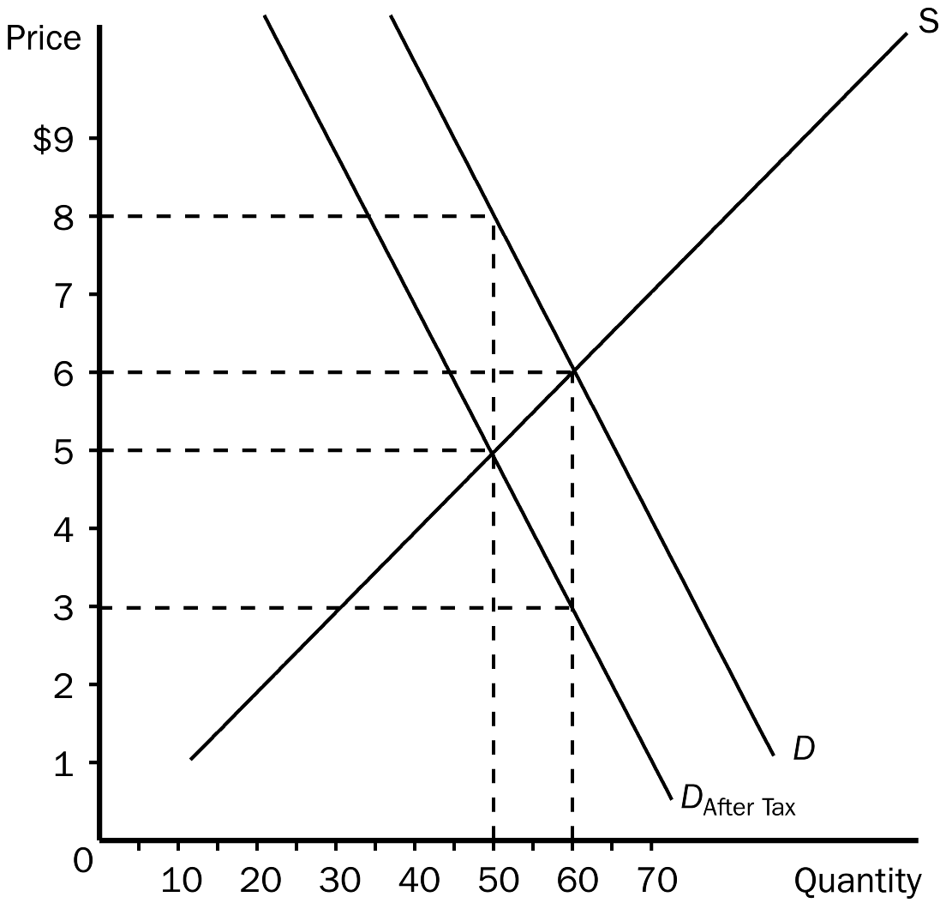
124. Refer to Figure 6-8. The equilibrium price in the market before the tax is imposed is
a. $8.
b. $6.
c. $5.
d. $3.
ANS: B PTS: 1 DIF: 1 REF: 6-2
TOP: Equilibrium price MSC: Applicative
125. Refer to Figure 6-8. As the figure is drawn, who sends the tax payments to the government?
a. the buyers
b. the sellers
c. A portion of the tax payments is sent by the buyers and the remaining portion is sent by the sellers.
d. The question of who sends the tax payments cannot be determined from the figure.
ANS: A PTS: 1 DIF: 2 REF: 6-2
TOP: Tax MSC: Applicative
126. Refer to Figure 6-8. The effective price that buyers pay after the tax is imposed is
a. $8.
b. $6.
c. $5.
d. $3.
ANS: A PTS: 1 DIF: 2 REF: 6-2
TOP: Tax | Equilibrium price MSC: Applicative
127. Refer to Figure 6-8. The price that sellers receive after the tax is imposed is
a. $8.
b. $6.
c. $5.
d. $3.
ANS: C PTS: 1 DIF: 2 REF: 6-2
TOP: Tax | Equilibrium price MSC: Applicative
128. Refer to Figure 6-8. The amount of the tax per unit is
a. $1.
b. $2.
c. $3.
d. $5.
ANS: C PTS: 1 DIF: 2 REF: 6-2
TOP: Tax MSC: Applicative
129. Refer to Figure 6-8. The burden of the tax on buyers is
a. $1.00 per unit.
b. $1.50 per unit.
c. $2.00 per unit.
d. $3.00 per unit.
ANS: C PTS: 1 DIF: 2 REF: 6-2
TOP: Tax burden MSC: Applicative
130. Refer to Figure 6-8. The burden of the tax on sellers is
a. $1.00 per unit.
b. $1.50 per unit.
c. $2.00 per unit.
d. $3.00 per unit.
ANS: A PTS: 1 DIF: 2 REF: 6-2
TOP: Tax burden MSC: Applicative
131. Refer to Figure 6-8. Suppose the same S and D curves apply, and a tax of the same amount per unit as shown here is imposed. Now, however, the sellers of the good, rather than the buyers, are required to pay the tax to the government. Now, relative to the case depicted in the figure,
a. the burden on buyers will be larger and the burden on sellers will be smaller.
b. the burden on buyers will be smaller and the burden on sellers will be larger.
c. the burden on buyers will be the same and the burden on sellers will be the same.
d. The relative burdens in the two cases cannot be determined without further information.
ANS: C PTS: 1 DIF: 3 REF: 6-2
TOP: Tax burden MSC: Applicative
Figure 6-9
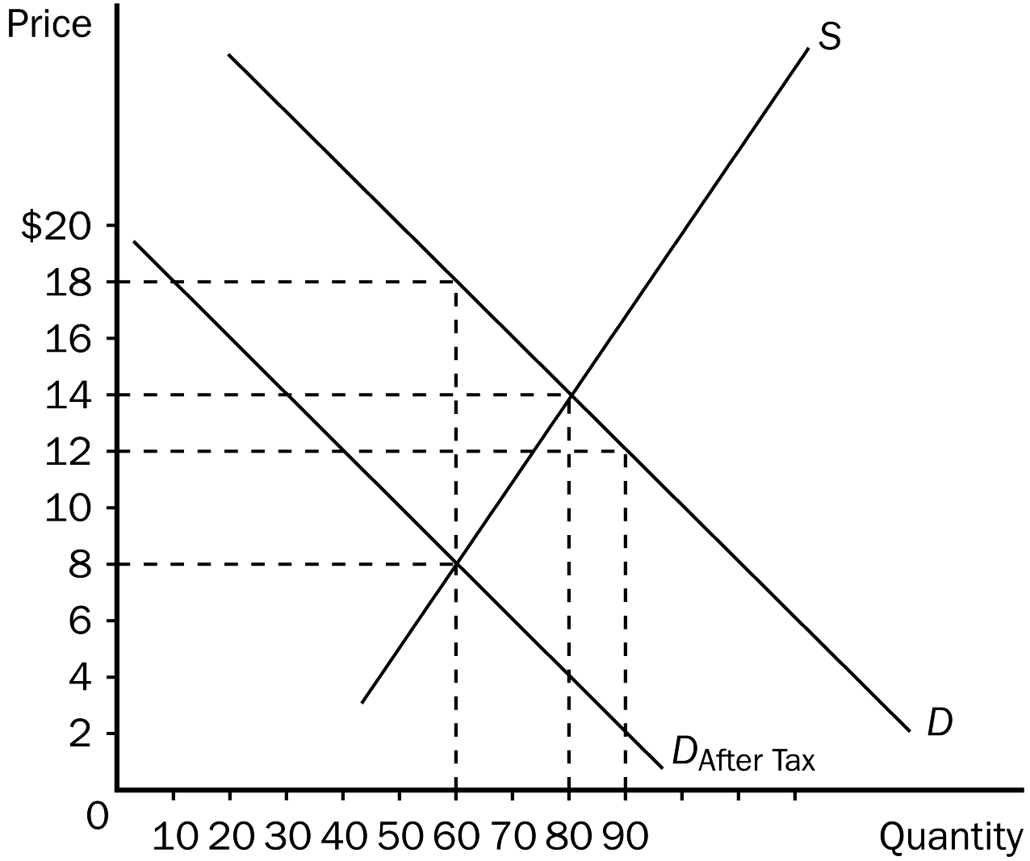
132. Refer to Figure 6-9. The effective price paid by buyers after the tax is imposed is
a. $18.
b. $14.
c. $12.
d. $8.
ANS: A PTS: 1 DIF: 2 REF: 6-1
TOP: Tax | Equilibrium price MSC: Applicative
133. Refer to Figure 6-9. The price received by sellers after the tax is imposed is
a. $18.
b. $14.
c. $12.
d. $8.
ANS: D PTS: 1 DIF: 2 REF: 6-2
TOP: Tax | Equilibrium price MSC: Applicative
134. Refer to Figure 6-9. The amount of the tax per unit is
a. $10.
b. $6.
c. $4.
d. $2.
ANS: A PTS: 1 DIF: 2 REF: 6-2
TOP: Tax MSC: Applicative
135. Refer to Figure 6-9. The per-unit burden of the tax is
a. $4 on buyers and $4 on sellers.
b. $5 on buyers and $5 on sellers.
c. $4 on buyers and $6 on sellers.
d. $6 on buyers and $4 on sellers.
ANS: C PTS: 1 DIF: 2 REF: 6-2
TOP: Tax burden MSC: Applicative
136. Refer to Figure 6-9. How much tax revenue does this tax produce for the government?
a. $480
b. $600
c. $800
d. $1,080
ANS: B PTS: 1 DIF: 2 REF: 6-2
TOP: Tax MSC: Applicative
137. If buyers are required to pay a $0.10 tax per bag on Hershey's kisses, the demand curve for kisses will shift
a. upward by $0.10 per bag.
b. upward by $0.05 per bag.
c. downward by $0.10 per bag.
d. downward by $0.05 per bag.
ANS: C PTS: 1 DIF: 2 REF: 6-2
TOP: Tax | Demand curve MSC: Interpretive
138. A tax on the buyers of popcorn
a. increases the size of the popcorn market.
b. reduces the size of the popcorn market.
c. has no effect on the size of the popcorn market.
d. may increase, decrease, or have no effect on the size of the popcorn market.
ANS: B PTS: 1 DIF: 2 REF: 6-2
TOP: Tax MSC: Interpretive
139. A tax on the buyers of coffee will
a. increase the effective price of coffee paid by buyers, increase the price of coffee received by sellers, and increase the equilibrium quantity of coffee.
b. decrease the effective price of coffee paid by buyers, increase the price of coffee received by sellers, and decrease the equilibrium quantity of coffee.
c. increase the effective price of coffee paid by buyers, decrease the price of coffee received by sellers, and decrease the equilibrium quantity of coffee.
d. increase the effective price of coffee paid by buyers, decrease the price of coffee received by sellers, and increase the equilibrium quantity of coffee.
ANS: C PTS: 1 DIF: 3 REF: 6-2
TOP: Tax | Equilibrium price | Equilibrium quantity MSC: Analytical
140. When a tax is imposed on tea and buyers of tea are required to send in the tax payments to the government,
a. buyers of tea and sellers of tea both are made worse off.
b. buyers of tea are made worse off and the well-being of sellers is unaffected.
c. buyers of tea are made worse off and sellers of tea are made better-off.
d. the well-being of both buyers of tea and sellers of tea is unaffected.
ANS: A PTS: 1 DIF: 2 REF: 6-2
TOP: Tax incidence MSC: Interpretive
141. Which is the most correct statement about the burden of a tax imposed on buyers of sugar?
a. Buyers bear the entire burden of the tax.
b. Sellers bear the entire burden of the tax.
c. Buyers and sellers share the burden of the tax.
d. The government bears the entire burden of the tax.
ANS: C PTS: 1 DIF: 2 REF: 6-2
TOP: Tax incidence MSC: Interpretive
142. Suppose a tax is imposed on the buyers of a good or service. The burden of the tax will fall
a. entirely on the buyers.
b. entirely on the sellers.
c. entirely on the government.
d. on both the buyers and the sellers.
ANS: D PTS: 1 DIF: 2 REF: 6-2
TOP: Tax incidence MSC: Interpretive
143. When a tax is placed on the buyers of milk, the
a. size of the milk market is reduced.
b. effective price of milk paid by buyers decreases.
c. supply of milk decreases.
d. price of milk received by sellers decreases, and the size of the milk market is unchanged.
ANS: A PTS: 1 DIF: 2 REF: 6-2
TOP: Tax MSC: Interpretive
144. When a tax is placed on the buyers of a product, a result is that, relative to the pre-tax situation,
a. buyers pay more and sellers receive more.
b. buyers pay more and sellers receive less.
c. buyers pay less and sellers receive more.
d. buyers pay less and sellers receive less.
ANS: B PTS: 1 DIF: 2 REF: 6-2
TOP: Tax | Equilibrium price MSC: Interpretive
145. The initial impact of a tax on the sellers of a product is
a. on the supply of the product.
b. on the demand for the product.
c. on both the supply of the product and the demand for the product.
d. more difficult to characterize than is the initial impact of a tax on the buyers of a product
ANS: A PTS: 1 DIF: 2 REF: 6-2
TOP: Tax | Supply MSC: Interpretive
146. If a tax is levied on the sellers of a product, the demand curve
a. will shift downward.
b. will shift upward.
c. will shift either upward or downward, depending on the amount of the tax.
d. will not shift.
ANS: D PTS: 1 DIF: 2 REF: 6-2
TOP: Tax | Demand curve MSC: Interpretive
147. A tax imposed on the sellers of a good will
a. raise the price paid by buyers and lower the equilibrium quantity.
b. raise the price paid by buyers and raise the equilibrium quantity.
c. raise the effective price received by sellers and raise the equilibrium quantity.
d. raise the effective price received by sellers and lower the equilibrium quantity.
ANS: A PTS: 1 DIF: 2 REF: 6-2
TOP: Tax | Equilibrium price MSC: Applicative
148. A tax imposed on the sellers of a good
a. raises both the price buyers pay and the effective price for sellers.
b. raises the price buyers pay and lowers the effective price for sellers.
c. lowers the price buyers pay and raises the effective price for sellers.
d. lowers both the price buyers pay and the effective price for sellers.
ANS: B PTS: 1 DIF: 2 REF: 6-2
TOP: Tax | Equilibrium price MSC: Applicative
149. When a tax is placed on the sellers of a product, the
a. size of the market is decreased.
b. effective price received by sellers decreases and the price paid by buyers increases.
c. supply of the product decreases.
d. All of the above are correct.
ANS: D PTS: 1 DIF: 2 REF: 6-2
TOP: Tax MSC: Applicative
Figure 6-10
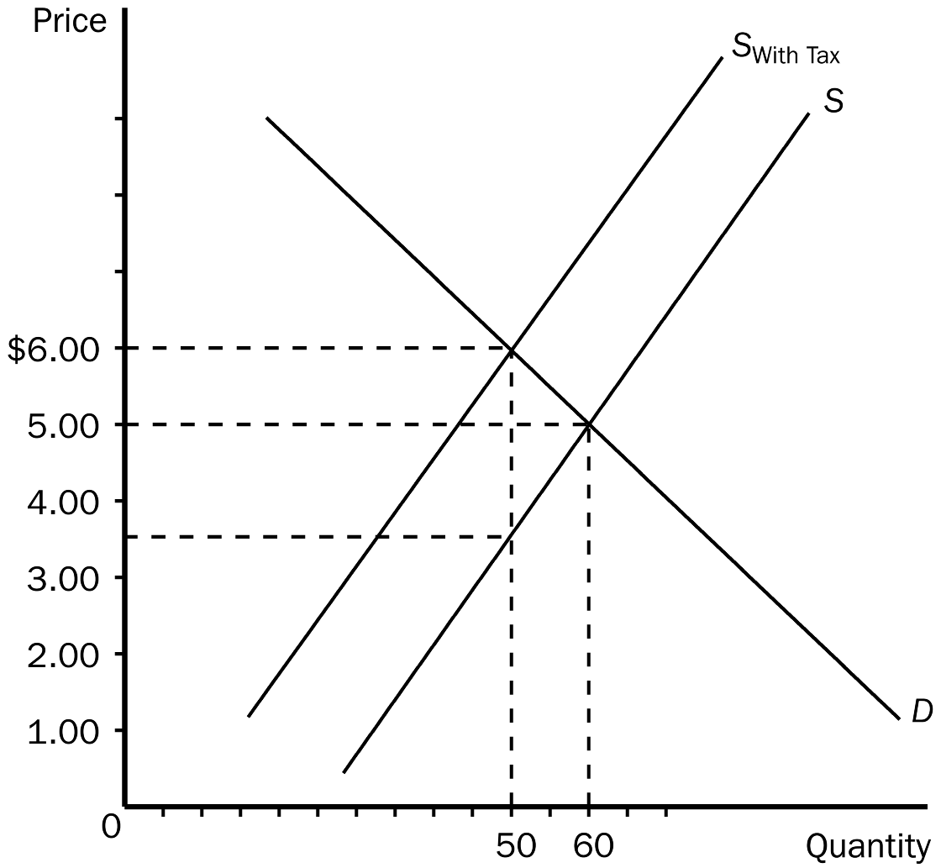
150. Refer to Figure 6-10. The equilibrium price in the market before the tax is imposed is
a. $1.00.
b. $3.50.
c. $5.00.
d. $6.00.
ANS: C PTS: 1 DIF: 1 REF: 6-2
TOP: Equilibrium price MSC: Applicative
151. Refer to Figure 6-10. The price paid by buyers after the tax is imposed is
a. $1.00.
b. $3.50.
c. $5.00.
d. $6.00.
ANS: D PTS: 1 DIF: 2 REF: 6-2
TOP: Tax | Equilibrium price MSC: Applicative
152. Refer to Figure 6-10. The effective price sellers receive after the tax is imposed is
a. $1.00.
b. $3.50.
c. $5.00.
d. $6.00.
ANS: B PTS: 1 DIF: 2 REF: 6-2
TOP: Tax | Equilibrium price MSC: Applicative
153. Refer to Figure 6-10. The amount of the tax per unit is
a. $1.00.
b. $1.50.
c. $2.50.
d. $3.50.
ANS: C PTS: 1 DIF: 2 REF: 6-2
TOP: Tax MSC: Applicative
154. Refer to Figure 6-10. From this tax the government will collect a total of
a. $125.00.
b. $175.00.
c. $200.00.
d. $250.00.
ANS: A PTS: 1 DIF: 2 REF: 6-2
TOP: Tax MSC: Applicative
155. Refer to Figure 6-10. Buyers effectively pay how much of the tax per unit?
a. $1.00.
b. $1.50.
c. $2.50.
d. $3.00.
ANS: A PTS: 1 DIF: 2 REF: 6-2
TOP: Tax incidence MSC: Applicative
156. Refer to Figure 6-10. Sellers effectively pay how much of the tax per unit?
a. $1.00.
b. $1.50.
c. $2.50.
d. $3.00.
ANS: B PTS: 1 DIF: 2 REF: 6-2
TOP: Tax incidence MSC: Applicative
157. Refer to Figure 6-10. Suppose the same S and D curves apply, and a tax of the same amount per unit as shown here is imposed. Now, however, the buyers of the good, rather than the sellers, are required to pay the tax to the government. Now,
a. the burden on buyers will be larger than in the case illustrated in Figure 6-10.
b. the burden on sellers will be smaller than in the case illustrated in Figure 6-10.
c. a downward shift of the demand curve replaces the upward shift of the supply curve.
d. All of the above are correct.
ANS: C PTS: 1 DIF: 3 REF: 6-2
TOP: Tax incidence MSC: Applicative
Figure 6-11. On the graph below, the shift of the supply curve from S₁ to S₂ represents the imposition of a tax on a good. On the axes, Q represents the quantity of the good and P represents the price.
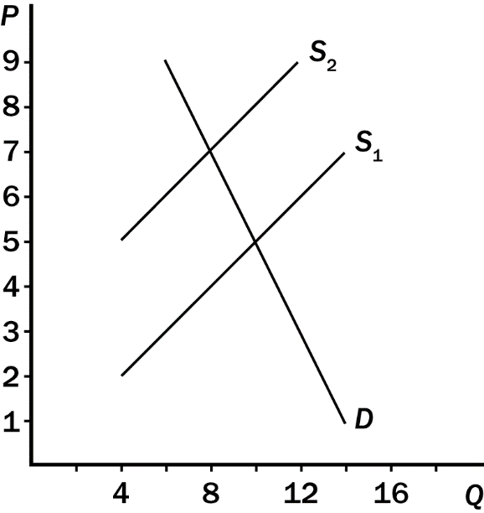
158. Consider Figure 6-11. Before the tax is imposed,
a. buyers pay $5 per unit.
b. sellers receive $5 per unit.
c. total revenue for sellers amounts to $50.
d. All of the above are correct.
ANS: D PTS: 1 DIF: 2 REF: 6-2
TOP: Tax MSC: Applicative
159. Consider Figure 6-11. The amount of the tax per unit is
a. $1.50.
b. $2.00.
c. $2.50.
d. $3.00.
ANS: D PTS: 1 DIF: 2 REF: 6-2
TOP: Tax MSC: Applicative
160. Consider Figure 6-11. From the appearance of the graph, it is apparent that, for every unit of the good that is sold,
a. sellers are required to send one dollar to the government and buyers are required to send two dollars to the government.
b. sellers are required to send two dollars to the government and buyers are required to send one dollar to the government.
c. sellers are required to send three dollars to the government and buyers are required to send nothing to the government.
d. sellers are required to send nothing to the government and buyers are required to send two dollars to the government.
ANS: C PTS: 1 DIF: 2 REF: 6-2
TOP: Tax MSC: Applicative
161. Consider Figure 6-11. As a result of the tax,
a. the price paid by buyers rises from $5 to $7.
b. the price received by sellers (after paying the tax) falls from $5 to $3.
c. the government collects $30 in tax revenue.
d. All of the above are correct.
ANS: A PTS: 1 DIF: 2 REF: 6-2
TOP: Tax MSC: Applicative
162. Consider Figure 6-11. Which of the following statements correctly characterizes the burden of the tax?
a. One-fourth of the burden falls on buyers and three-fourths of the burden falls on sellers.
b. One-third of the burden falls on buyers and two-thirds of the burden falls on sellers.
c. One-half of the burden falls on buyers and one-half of the burden falls on sellers.
d. Two-thirds of the burden falls on buyers and one-third of the burden falls on sellers.
ANS: D PTS: 1 DIF: 2 REF: 6-2
TOP: Tax burden MSC: Applicative
163. Consider Figure 6-11. Which of these statements about the effects of the tax is correct?
a. The tax is paid by sellers; sellers bear one-half of the burden of the tax; government collects $24 from the tax.
b. The tax is paid by sellers; sellers bear one-third of the burden of the tax; government collects $24 from the tax.
c. The tax is paid by sellers; sellers bear two-thirds of the burden of the tax; government collects $30 from the tax.
d. The tax is paid by buyers; buyers bear two-thirds of the burden of the tax; government collects $16 from the tax.
ANS: B PTS: 1 DIF: 3 REF: 6-2
TOP: Tax burden MSC: Applicative
164. Consider Figure 6-11. Suppose the demand curve is not the one drawn on the graph; instead, the demand curve is a vertical line passing through the point (Q = 10, P = 5). Using the two supply curves that are drawn, which of the following statements would describe the effects of the tax correctly?
a. The price paid by buyers would be $9.
b. The price received by sellers (after paying the tax) would be $6.50.
c. The government would collect $27 from the tax.
d. Buyers of the good would bear 100 percent of the burden of the tax.
ANS: D PTS: 1 DIF: 3 REF: 6-3
TOP: Tax burden MSC: Analytical
165. A tax on the sellers of TVs
a. leads sellers to supply a smaller quantity at every price.
b. leads buyers to demand a smaller quantity at every price.
c. leads sellers to supply a larger quantity at every price.
d. causes the supply curve to shift to the right.
ANS: A PTS: 1 DIF: 2 REF: 6-2
TOP: Tax | Quantity supplied MSC: Interpretive
166. A tax of $0.10 per Snickers bar on the sellers of Snickers will cause the
a. supply curve for Snickers to shift down by $0.10.
b. supply curve for Snickers to shift up by $0.10.
c. supply curve for Snickers to shift down by $0.05.
d. demand curve for Snickers to shift up by $0.10.
ANS: B PTS: 1 DIF: 2 REF: 6-2
TOP: Tax | Supply curve MSC: Interpretive
167. Suppose there is currently a tax of $50 per ticket on airline tickets. The supply curve for airline tickets slopes upward and the demand curve for airline tickets slopes downward. Sellers of tickets are required to pay the tax to the government. If the tax is reduced from $50 per ticket to $30 per ticket, then
a. the demand curve will shift upward by $20 and the price paid by buyers will decrease, but the decrease will be less than $20.
b. the demand curve will shift upward by more than $20 and the price paid by buyers will decrease by $20.
c. the supply curve will shift downward by $20 and the price paid by buyers will decrease, but the decrease will be less than $20.
d. the supply curve will shift downward by more than $20 and the effective price received by sellers will increase by $20.
ANS: C PTS: 1 DIF: 3 REF: 6-2
TOP: Tax | Supply curve | Tax incidence MSC: Analytical
168. A tax on the sellers of cell phones will
a. reduce the size of the cell phone market.
b. place a burden on the sellers of cell phones but not on the buyers of cell phones.
c. affect the price paid by buyers of cell phones, but not the size of the market.
d. affect the size of the market, but it will have no effect on the effective price received by sellers of cell phones.
ANS: A PTS: 1 DIF: 2 REF: 6-2
TOP: Tax incidence MSC: Applicative
169. A tax on the sellers of jewelry will
a. increase the price the buyers pay and increase the effective price the sellers receive.
b. increase the price the buyers pay and decrease the effective price the sellers receive.
c. decrease the price the buyers pay and increase the effective price the sellers receive.
d. decrease the price the buyers pay and decrease the effective price the sellers receive.
ANS: B PTS: 1 DIF: 2 REF: 6-2
TOP: Tax incidence MSC: Interpretive
170. Suppose the demand curve for motorcycles slopes downward and the supply curve for motorcycles slopes upward. If the government passes a law requiring buyers of motorcycles to send $500 to the government for every motorcycle they buy, then
a. the demand curve for motorcycles shifts downward by $500.
b. buyers of motorcycles pay $500 more per motorcycle than they were paying before the tax.
c. sellers of motorcycles are unaffected by the tax.
d. All of the above are correct.
ANS: A PTS: 1 DIF: 2 REF: 6-2
TOP: Tax | Demand curve MSC: Interpretive
171. Which of the following statements is correct concerning the burden of a tax imposed on candles?
a. Buyers bear the entire burden of the tax.
b. Sellers bear the entire burden of the tax.
c. Buyers and sellers share the burden of the tax.
d. We have to know whether it is the buyers or the sellers that are required to pay the tax to the government in order to make this determination.
ANS: C PTS: 1 DIF: 2 REF: 6-2
TOP: Tax incidence MSC: Applicative
172. A tax imposed on the sellers of blueberries
a. increases sellers’ costs, shifts the supply curve to the left (upward), and reduces profits.
b. increases sellers’ costs, shifts the supply curve to the right (downward), and reduces profits.
c. increases sellers’ costs, causes a movement upward and to the right along the supply curve, and reduces profits.
d. is passed on in full to the buyers of blueberries and profits remain unchanged.
ANS: A PTS: 1 DIF: 2 REF: 6-2
TOP: Tax | Supply curve MSC: Applicative
173. A $2.00 tax placed on the sellers of mailboxes will shift the supply curve
a. upward by exactly $2.00.
b. upward by less than $2.00.
c. downward by exactly $2.00.
d. downward by less than $2.00.
ANS: A PTS: 1 DIF: 2 REF: 6-2
TOP: Tax | Supply curve MSC: Interpretive
174. When a tax is placed on the sellers of lemonade,
a. the sellers bear the entire burden of the tax.
b. the buyers bear the entire burden of the tax.
c. the burden of the tax will be always be equally divided between the buyers and the sellers.
d. the burden of the tax will be shared by the buyers and the sellers, but the division of the burden is not always equal.
ANS: D PTS: 1 DIF: 2 REF: 6-2
TOP: Tax incidence MSC: Applicative
175. Revenue from the Federal Insurance Contribution Act (FICA) tax is used to
a. help retire the national debt.
b. cover crop insurance claims.
c. pay the salaries of members of Congress.
d. pay for Social Security and Medicare.
ANS: D PTS: 1 DIF: 1 REF: 6-2
TOP: FICA taxes MSC: Definitional
176. The Federal Insurance Contribution Act (FICA) tax is an example of
a. a payroll tax.
b. a sales tax.
c. a farm subsidy.
d. an income subsidy.
ANS: A PTS: 1 DIF: 1 REF: 6-2
TOP: FICA taxes MSC: Definitional
177. A payroll tax is a
a. fixed number of dollars that every firm must pay to the government for each worker that the firm hires.
b. tax that each firm must pay to the government before the firm can hire workers and operate its business.
c. tax on the wages that firms pay their workers.
d. tax on all wages above the minimum wage.
ANS: C PTS: 1 DIF: 2 REF: 6-2
TOP: Payroll taxes MSC: Definitional
178. Congress intended that
a. the entire FICA tax be paid by workers.
b. the entire FICA tax be paid by large firms.
c. the entire FICA tax be paid by small firms.
d. half the FICA tax be paid by workers, and half be paid by firms.
ANS: D PTS: 1 DIF: 2 REF: 6-2
TOP: FICA taxes MSC: Interpretive
179. Although lawmakers legislated a fifty-fifty division in the payment of the FICA tax,
a. the same outcome, in terms of tax incidence, would occur even if the entire tax had been levied on only the workers or only on the firms.
b. the employer now is required by law to pay more than 50 percent of the tax.
c. the employee now is required by law to pay more than 50 percent of the tax.
d. employers are no longer required by law to pay any portion of the tax.
ANS: A PTS: 1 DIF: 2 REF: 6-2
TOP: FICA taxes MSC: Interpretive
180. A key lesson from the payroll tax is that the
a. tax amounts to a tax solely on workers.
b. tax amounts to a tax solely on firms that hire workers.
c. eliminates any wedge that might exist between the wage that firms pay and the wage that workers receive.
d. true burden of a tax cannot be legislated.
ANS: D PTS: 1 DIF: 2 REF: 6-2
TOP: Payroll taxes MSC: Interpretive
181. When a payroll tax is enacted,
a. the wage received by workers falls and the wage paid by firms rises.
b. the wage received by workers falls and the wage paid by firms falls.
c. the wage received by workers rises and the wage paid by firms falls.
d. the wage received by workers rises and the wage paid by firms rises.
ANS: A PTS: 1 DIF: 2 REF: 6-2
TOP: Payroll taxes | Wages MSC: Interpretive
182. Most labor economists believe that the supply of labor is
a. less elastic than demand and, therefore, firms bear most of the burden of the payroll tax.
b. less elastic than demand and, therefore, workers bear most of the burden of the payroll tax.
c. more elastic than demand and, therefore, workers bear most of the burden of the payroll tax.
d. more elastic than demand and, therefore, firms bear most of the burden of the payroll tax.
ANS: B PTS: 1 DIF: 2 REF: 6-2
TOP: Labor supply | Payroll tax MSC: Applicative
183. Lawmakers designed the burden of the FICA payroll tax to be split evenly between workers and firms. Labor economists believe that
a. lawmakers may have actually achieved their goal, since statistics show that the tax burden is currently equally divided.
b. the tax raises too little revenue for the government and so it should be eliminated.
c. firms bear most of the burden of the tax.
d. workers bear most of the burden of the tax.
ANS: D PTS: 1 DIF: 2 REF: 6-2
TOP: FICA taxes MSC: Interpretive
184. In the final analysis, tax incidence
a. depends on the legislated burden.
b. is entirely random.
c. depends on the forces of supply and demand.
d. falls entirely on buyers or entirely on sellers.
ANS: C PTS: 1 DIF: 2 REF: 6-2
TOP: Tax incidence MSC: Interpretive
Figure 6-12
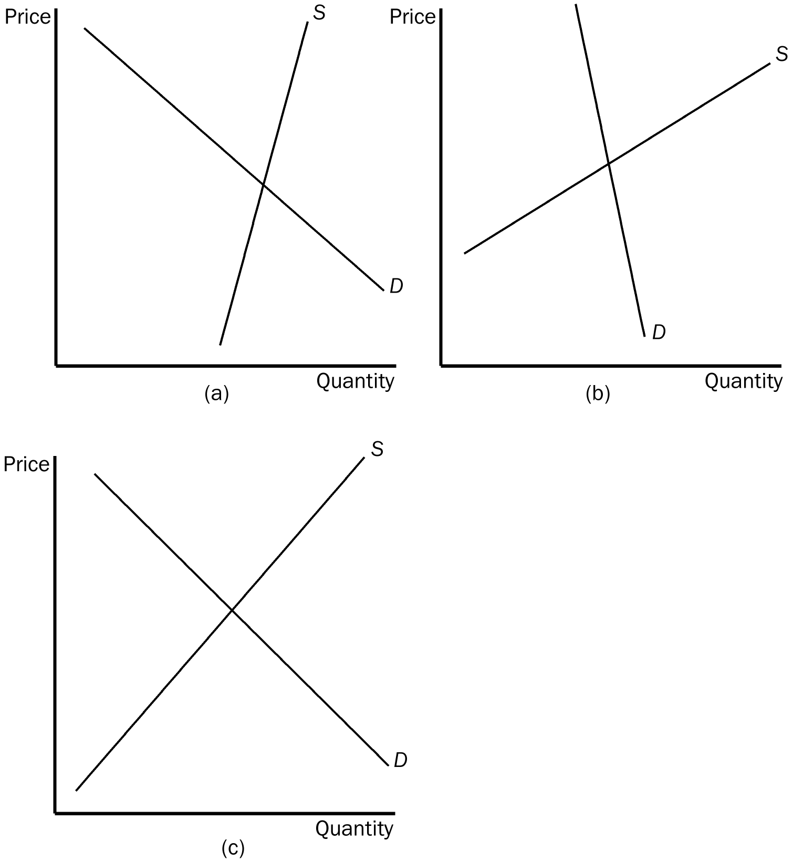
185. Refer to Figure 6-12. In which market will the majority of the tax burden fall on the buyer?
a. market (a)
b. market (b)
c. market (c)
d. All of the above are correct.
ANS: B PTS: 1 DIF: 2 REF: 6-2
TOP: Tax burden MSC: Applicative
186. Refer to Figure 6-12. In which market will the majority of the tax burden fall on the seller?
a. market (a)
b. market (b)
c. market (c)
d. All of the above are correct.
ANS: A PTS: 1 DIF: 2 REF: 6-2
TOP: Tax burden MSC: Applicative
187. Refer to Figure 6-12. In which market will the tax burden be most equally divided between the buyer and the seller?
a. market (a)
b. market (b)
c. market (c)
d. All of the above are correct.
ANS: C PTS: 1 DIF: 2 REF: 6-2
TOP: Tax burden MSC: Applicative
Figure 6-13
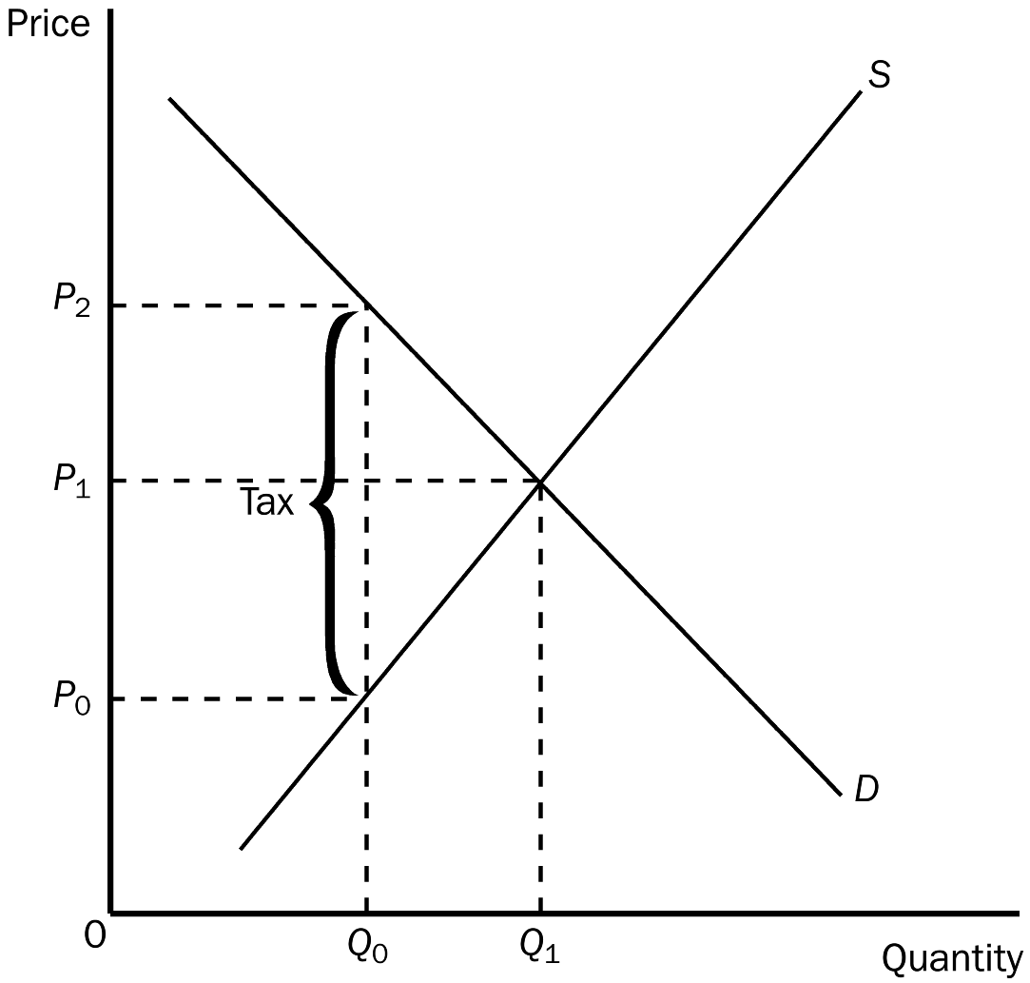
188. Refer to Figure 6-13. The equilibrium price before the tax is imposed is
a. P₀.
b. P₁.
c. P₂.
d. None of the above is correct.
ANS: B PTS: 1 DIF: 1 REF: 6-2
TOP: Tax | Equilibrium price MSC: Applicative
189. Refer to Figure 6-13. The effective price that will be paid by buyers after the tax is
a. P₀.
b. P₁.
c. P₂.
d. impossible to determine.
ANS: C PTS: 1 DIF: 2 REF: 6-2
TOP: Tax | Equilibrium price MSC: Applicative
190. Refer to Figure 6-13. The effective price that sellers receive after the tax is imposed is
a. P₀.
b. P₁.
c. P₂.
d. impossible to determine.
ANS: A PTS: 1 DIF: 2 REF: 6-2
TOP: Tax | Equilibrium price MSC: Applicative
191. Refer to Figure 6-13. The per-unit burden of the tax on buyers is
a. P₂ minus P₀.
b. P₂ minus P₁.
c. P₁ minus P₀.
d. Q₁ minus Q₀.
ANS: B PTS: 1 DIF: 2 REF: 6-2
TOP: Tax burden MSC: Applicative
192. Refer to Figure 6-13 The per-unit burden of the tax on sellers is
a. P₂ minus P₀.
b. P₂ minus P₁.
c. P₁ minus P₀.
d. Q₁ minus Q₀.
ANS: C PTS: 1 DIF: 2 REF: 6-2
TOP: Tax burden MSC: Applicative
193. Refer to Figure 6-13 The amount of the tax per unit is
a. P₂ minus P₀.
b. P₂ minus P₁.
c. P₁ minus P₀.
d. Q₁ minus Q₀.
ANS: A PTS: 1 DIF: 2 REF: 6-2
TOP: Tax MSC: Applicative
Figure 6-14.
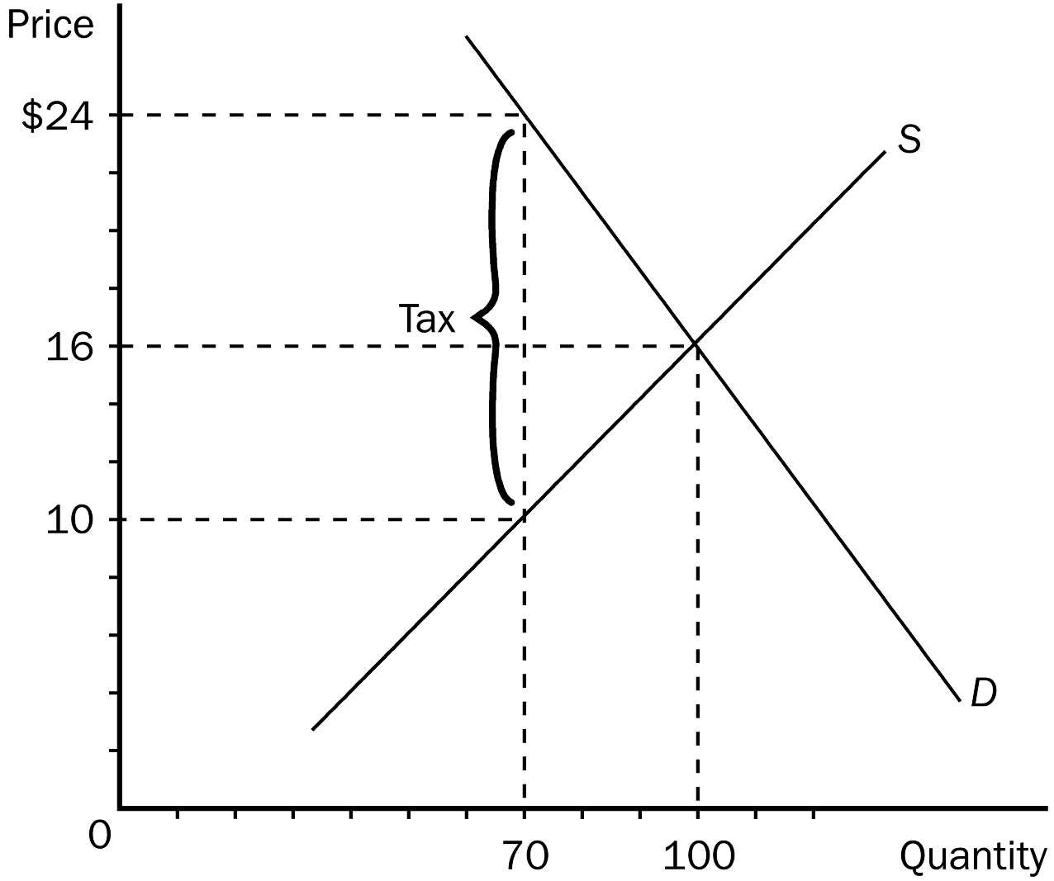
194. Refer to Figure 6-14. Before the tax is imposed, the equilibrium price is
a. $24.
b. $16.
c. $10.
d. $8.
ANS: B PTS: 1 DIF: 1 REF: 6-2
TOP: Equilibrium price MSC: Applicative
195. Refer to Figure 6-14. The effective price that buyers will pay after the tax is imposed is
a. $24.
b. $16.
c. $10.
d. $8.
ANS: A PTS: 1 DIF: 2 REF: 6-2
TOP: Tax | Equilibrium price MSC: Applicative
196. Refer to Figure 6-14. The effective price that sellers receive after the tax is imposed is
a. $24.
b. $14.
c. $10.
d. $8.
ANS: C PTS: 1 DIF: 2 REF: 6-2
TOP: Tax | Equilibrium price MSC: Applicative
197. Refer to Figure 6-14. The per-unit burden of the tax on buyers is
a. $16.
b. $14.
c. $8.
d. $6.
ANS: C PTS: 1 DIF: 2 REF: 6-2
TOP: Tax burden MSC: Applicative
198. Refer to Figure 6-14. The per-unit burden of the tax on sellers is
a. $16.
b. $14.
c. $8.
d. $6.
ANS: D PTS: 1 DIF: 2 REF: 6-2
TOP: Tax burden MSC: Applicative
199. Refer to Figure 6-14. The amount of the tax per unit is
a. $16.
b. $14.
c. $8.
d. $6.
ANS: B PTS: 1 DIF: 2 REF: 6-2
TOP: Tax MSC: Applicative
200. Refer to Figure 6-14. As the figure is drawn, who directly pays the tax to the government?
a. The buyers pay the full tax to the government.
b. The sellers pay the full tax to the government.
c. A portion of the tax is paid to the government by buyers and the remaining portion is paid to the government by sellers.
d. As the figure is drawn, any of the above is possible.
ANS: D PTS: 1 DIF: 3 REF: 6-2
TOP: Tax MSC: Applicative
201. If a tax is imposed on a market with inelastic demand and elastic supply,
a. buyers will bear most of the burden of the tax.
b. sellers will bear most of the burden of the tax.
c. the burden of the tax will be shared equally between buyers and sellers.
d. it is impossible to determine how the burden of the tax will be shared.
ANS: A PTS: 1 DIF: 3 REF: 6-2
TOP: Inelastic demand | Elastic supply | Tax incidence MSC: Applicative
202. Buyers of a good bear the larger share of the tax burden when a tax is placed on a product for which
a. the supply is more elastic than the demand.
b. the demand in more elastic than the supply.
c. the tax is placed on the sellers of the product.
d. the tax is placed on the buyers of the product.
ANS: A PTS: 1 DIF: 3 REF: 6-2
TOP: Elasticity | Tax incidence MSC: Applicative
203. If a tax is imposed on a market with elastic demand and inelastic supply,
a. buyers will bear most of the burden of the tax.
b. sellers will bear most of the burden of the tax.
c. the burden of the tax will be shared equally between buyers and sellers.
d. it is impossible to determine how the burden of the tax will be shared.
ANS: B PTS: 1 DIF: 3 REF: 6-2
TOP: Elastic demand | Inelastic supply | Tax incidence MSC: Applicative
204. Which of the following is the most correct statement about tax burdens?
a. A tax burden falls most heavily on the side of the market that is more elastic.
b. A tax burden falls most heavily on the side of the market that is less elastic.
c. A tax burden falls most heavily on the side of the market that is closer to unit elastic.
d. A tax burden is distributed independently of relative elasticities of supply and demand.
ANS: B PTS: 1 DIF: 2 REF: 6-2
TOP: Elasticity | Tax incidence MSC: Applicative
205. In general, a tax burden falls more heavily on the side of the market that
a. has a fewer number of participants.
b. is more elastic.
c. is unit elastic.
d. is less elastic.
ANS: D PTS: 1 DIF: 2 REF: 6-2
TOP: Elasticity | Tax incidence MSC: Applicative
206. Suppose that a tax is placed on DVDs. If the sellers end up bearing most of the tax burden, we know that the
a. demand is more inelastic than supply.
b. supply is more inelastic than demand.
c. government has required that buyers remit the tax payments.
d. government has required that sellers remit the tax payments.
ANS: B PTS: 1 DIF: 2 REF: 6-2
TOP: Tax | Elasticity MSC: Applicative
207. Suppose that a tax is placed on books. If the buyers pay the majority of the tax, we know that the
a. demand is more inelastic than the supply.
b. supply is more inelastic than the demand.
c. government has required that buyers remit the tax payments.
d. government has required that buyers remit the tax payments.
ANS: A PTS: 1 DIF: 2 REF: 6-2
TOP: Tax | Elasticity MSC: Applicative
208. In 1990, Congress passed a new luxury tax on items such as yachts, private airplanes, furs, jewelry, and expensive cars. The goal of the tax was to
a. raise revenue from the wealthy.
b. prevent wealthy people from buying luxuries.
c. force producers of luxury goods to reduce employment.
d. limit exports of luxury goods to other countries.
ANS: A PTS: 1 DIF: 1 REF: 6-2
TOP: Luxury tax MSC: Definitional
209. Which of the following was not a result of the luxury tax imposed by Congress in 1990?
a. The larger part of the tax burden fell on sellers.
b. The larger part of the tax burden fell more on the middle class than on the rich.
c. Even the wealthy demanded fewer luxury goods.
d. The tax was never repealed or even modified.
ANS: D PTS: 1 DIF: 2 REF: 6-2
TOP: Luxury tax MSC: Interpretive
210. The burden of a luxury tax falls
a. more on the rich than on the middle class.
b. more on the poor than on the middle class.
c. more on the middle class than on the rich.
d. equally on the rich, the middle class, and the poor.
ANS: C PTS: 1 DIF: 2 REF: 6-2
TOP: Luxury tax | Tax incidence MSC: Interpretive
211. Which of the following statements is true?
a. A tax levied on buyers will never be even partially paid by sellers.
b. Who actually pays a tax depends on the price elasticities of supply and demand.
c. Government can decide who actually pays a tax.
d. A tax levied on sellers always will be passed on completely to buyers.
ANS: B PTS: 1 DIF: 2 REF: 6-2
TOP: Tax | Elasticity MSC: Interpretive
212. Suppose the demand for picture frames is inelastic and the supply of picture frames is elastic. A tax of $1 per frame levied on buyers of picture frames will increase the equilibrium price paid by buyers of picture frames by
a. $1.
b. more than $0.50 but less than $1.00.
c. a positive amount but less than $0.50.
d. It is impossible to say without more information.
ANS: B PTS: 1 DIF: 3 REF: 6-2
TOP: Tax | Inelastic demand | Elastic supply MSC: Applicative
213. Suppose the demand curve for a good is very flat and the supply curve for the good is very steep. If the government taxes this good,
a. buyers and sellers will each share 50 percent of the burden, regardless of the slopes of the demand and supply curves.
b. sellers will bear a larger share of the tax burden and buyers will bear a smaller share of the burden.
c. the distribution of the burden will depend upon whether the buyers or the sellers are required to send the tax to the government.
d. the amount of tax revenue collected by the government will depend upon whether the buyers or the sellers are required to send the tax to the government.
ANS: B PTS: 1 DIF: 2 REF: 6-2
TOP: Tax burden | Tax revenue MSC: Applicative
214. Suppose the demand for picture frames is elastic and the supply of picture frames is inelastic. A tax of $1 per frame levied on buyers of picture frames will increase the equilibrium price paid by buyers of picture frames by
a. $1.
b. more than $0.50 but less than $1.00.
c. a positive amount but less than $0.50.
d. It is impossible to say without more information.
ANS: C PTS: 1 DIF: 3 REF: 6-2
TOP: Tax | Elastic demand | Inelastic supply MSC: Applicative
215. The demand for salt is inelastic and the supply of salt is elastic. The demand for caviar is elastic and the supply of caviar is inelastic. Suppose that a tax of $1 per pound is levied on the sellers of salt and a tax of $1 per pound is levied on the buyers of caviar. We would expect that most of the burden of these taxes will fall on
a. sellers of salt and the buyers of caviar.
b. sellers of salt and the sellers of caviar.
c. buyers of salt and the sellers of caviar.
d. buyers of salt and the buyers of caviar.
ANS: C PTS: 1 DIF: 3 REF: 6-2
TOP: Elasticity | Tax incidence MSC: Applicative
216. Suppose the demand for macaroni is inelastic and the supply of macaroni is elastic, and the demand for cigarettes is inelastic and the supply of cigarettes is elastic. If a tax were levied on the sellers of both of these commodities, we would expect that the
a. burden of both taxes would fall more heavily on the buyers than on the sellers.
b. burden of the macaroni tax would fall more heavily on the sellers than on the buyers, and the burden of the cigarette tax would fall more heavily on the buyers than on the sellers.
c. burden of the macaroni tax would fall more heavily on the buyers than on the sellers, and the burden of the cigarette tax would fall more heavily on the sellers than on the buyers.
d. burden of both taxes would fall more heavily on the sellers than on the buyers.
ANS: A PTS: 1 DIF: 3 REF: 6-2
TOP: Elasticity | Tax incidence MSC: Applicative
217. When the government passes a law requiring buyers of a good to send one dollar to the government for every unit of the good they buy,
a. the supply curve for the good shifts to the right.
b. the demand curve for the good shifts to the left.
c. more than 50 percent of the burden of the tax falls on buyers.
d. the government collects less tax revenue than it would collect if the sellers of the good were required to send one dollar to the government for every unit of the good they sell.
ANS: B PTS: 1 DIF: 2 REF: 6-2
TOP: Tax burden MSC: Interpretive
218. The federal government uses the revenue from the FICA (Federal Insurance Contribution Act) tax to pay for
a. unemployment compensation.
b. flood insurance.
c. Social Security and Medicare.
d. housing subsidies for low-income people.
ANS: C PTS: 1 DIF: 1 REF: 6-2
TOP: Federal Insurance Contribution Act (FICA) taxes MSC: Definitional
219. The term tax incidence refers to
a. the matter of whether buyers or sellers of a good are required to send tax payments to the government.
b. the matter of whether the demand curve or the supply curve shifts when the tax is imposed.
c. the distribution of the tax burden between buyers and sellers.
d. All of the above are correct.
ANS: C PTS: 1 DIF: 2 REF: 6-2
TOP: Tax incidence | Tax burden MSC: Definitional
220. Suppose sellers of liquor are required to send $1.00 to the government for every bottle of liquor they sell. Further, suppose this tax causes the price paid by buyers of liquor to rise by $0.80 per bottle. Which of the following statements is correct?
a. This tax causes the demand curve for liquor to shift downward by $0.80 at each quantity of liquor.
b. The incidence of the tax is summarized by the fact that sellers send the tax payments to the government.
c. Eighty percent of the burden of the tax falls on buyers.
d. All of the above are correct.
ANS: C PTS: 1 DIF: 2 REF: 6-2
TOP: Tax incidence | Tax burden MSC: Interpretive
221. In which of these cases will the tax burden fall most heavily on buyers of the good?
a. The demand curve is relatively steep and the supply curve is relatively flat.
b. The demand curve is relatively flat and the supply curve is relatively steep.
c. The demand curve and the supply curve are both relatively flat.
d. The demand curve and the supply curve are both relatively steep.
ANS: A PTS: 1 DIF: 2 REF: 6-2
TOP: Tax burden MSC: Interpretive
True/False
1. Economic policies often have effects that their architects did not intend or anticipate.
ANS: T PTS: 1 DIF: 1 REF: 6-0
TOP: Public Policy MSC: Interpretive
2. Policymakers use taxes both to raise revenue for public purposes and to influence market outcomes.
ANS: T PTS: 1 DIF: 1 REF: 6-0
TOP: Taxes MSC: Interpretive
3. A price ceiling is a legal minimum on the price of a good or service.
ANS: F PTS: 1 DIF: 1 REF: 6-1
TOP: Price ceilings MSC: Definitional
4. If a price ceiling of $2 per gallon is imposed on gasoline, and the market equilibrium price is $1.50, the price ceiling is a binding constraint on the market.
ANS: F PTS: 1 DIF: 2 REF: 6-1
TOP: Price ceilings MSC: Interpretive
5. If a price ceiling is not binding, it will have no effect on the market.
ANS: T PTS: 1 DIF: 2 REF: 6-1
TOP: Price ceilings MSC: Interpretive
6. If a price ceiling is below equilibrium price, the quantity demanded will exceed the quantity supplied.
ANS: T PTS: 1 DIF: 2 REF: 6-1
TOP: Price ceilings MSC: Interpretive
7. Binding price ceilings benefit consumers because they allow consumers to buy all the goods they demand at a lower price.
ANS: F PTS: 1 DIF: 2 REF: 6-1
TOP: Price ceilings MSC: Interpretive
8. When free markets ration goods with prices it is both efficient and impersonal.
ANS: T PTS: 1 DIF: 1 REF: 6-1
TOP: Market efficiency MSC: Interpretive
9. The housing shortages caused by rent controls are larger in the long run than in the short run because both the supply of housing and the demand for housing are more elastic in the long run.
ANS: T PTS: 1 DIF: 2 REF: 6-1
TOP: Rent control | Elasticity MSC: Interpretive
10. Rent control may lead to lower rents for those who find housing, but the quality of the housing may also be lower.
ANS: T PTS: 1 DIF: 2 REF: 6-1
TOP: Rent control MSC: Applicative
11. If the equilibrium wage rate is $4 per hour, and the minimum wage is $5.15 per hour, a shortage of labor will exist.
ANS: F PTS: 1 DIF: 2 REF: 6-1
TOP: Minimum wage MSC: Interpretive
12. A binding minimum wage in a competitive labor market creates unemployment.
ANS: T PTS: 1 DIF: 2 REF: 6-1
TOP: Minimum wage | Unemployment MSC: Interpretive
13. Most economists are in favor of price controls as a way of allocating resources in the economy.
ANS: F PTS: 1 DIF: 1 REF: 6-1
TOP: Economists | Price ceilings | Price Floors MSC: Definitional
14. Rent subsidies and wage subsidies are better than price controls at helping the poor because they have no costs associated with them.
ANS: F PTS: 1 DIF: 2 REF: 6-1
TOP: Price ceilings | Price floors MSC: Interpretive
15. Economists use the term tax incidence to refer to who is legally responsible for paying the tax.
ANS: F PTS: 1 DIF: 1 REF: 6-2
TOP: Tax incidence MSC: Definitional
16. If buyers of a product are required to pay a tax, the demand curve for the product will shift downward by exactly the size of the tax.
ANS: T PTS: 1 DIF: 2 REF: 6-2
TOP: Tax | Demand curve MSC: Interpretive
17. A government-imposed tax on a market shrinks the size of the market.
ANS: T PTS: 1 DIF: 2 REF: 6-2
TOP: Tax | Markets MSC: Interpretive
18. A tax on golf clubs will cause buyers of golf clubs to pay a higher price, and the equilibrium quantity will decrease.
ANS: T PTS: 1 DIF: 2 REF: 6-2
TOP: Tax | Equilibrium price | Equilibrium quantity MSC: Interpretive
19. If a tax is imposed on the buyers of a product, the tax burden will fall entirely on the buyers.
ANS: F PTS: 1 DIF: 2 REF: 6-2
TOP: Tax burden MSC: Interpretive
20. A tax on sellers shifts the supply curve upward by exactly the amount of the tax.
ANS: T PTS: 1 DIF: 2 REF: 6-2
TOP: Tax | Supply curve MSC: Interpretive
21. The incidence of a tax depends on whether the tax is levied on buyers or sellers.
ANS: F PTS: 1 DIF: 2 REF: 6-2
TOP: Tax incidence MSC: Interpretive
22. Since half of the FICA tax is paid by firms, and the other half is paid by workers, the burden of the tax must fall equally on firms and workers.
ANS: F PTS: 1 DIF: 2 REF: 6-2
TOP: FICA tax | Tax burden MSC: Applicative
23. Lawmakers can decide whether the buyers or the sellers must send a tax to the government, but they cannot legislate the true burden of a tax.
ANS: T PTS: 1 DIF: 2 REF: 6-2
TOP: Tax burden MSC: Applicative
24. Who bears the majority of a tax burden when a product is taxed depends on whether the tax is placed on the buyers or the sellers.
ANS: F PTS: 1 DIF: 2 REF: 6-2
TOP: Tax burden MSC: Interpretive
25. In general, a tax burden falls more heavily on the side of the market that is more inelastic.
ANS: T PTS: 1 DIF: 2 REF: 6-2
TOP: Tax burden | Elasticity MSC: Interpretive
26. Most of the burden of a luxury tax falls on the middle class workers who produce luxury goods rather than on the rich who buy them.
ANS: T PTS: 1 DIF: 2 REF: 6-2
TOP: Luxury tax | Tax burden MSC: Applicative
Short Answer
1. Using a supply-demand diagram, show a labor market with a binding minimum wage. Now, use the diagram to show those who are helped by the minimum wage, and those who are hurt by the minimum wage.
ANS:
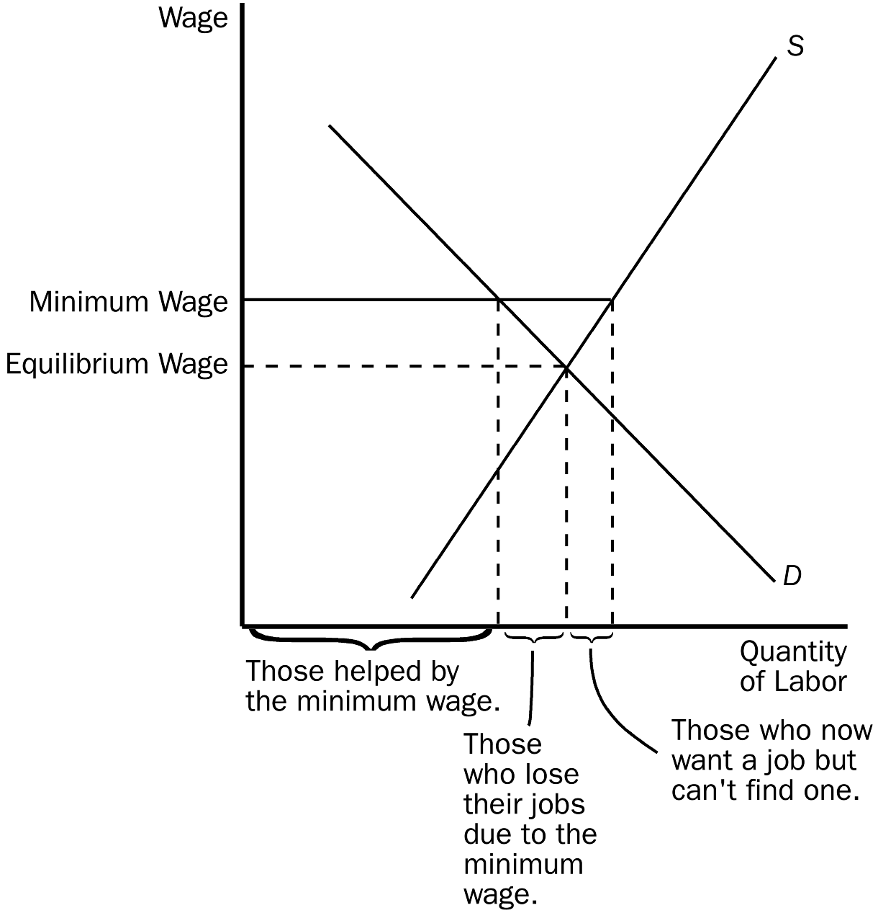
Those helped by the minimum wage are the workers who are still employed, but now receive the higher wage. In the diagram, those would be measured by the quantity of labor demanded at the minimum wage. Those who are hurt by the minimum wage are those who are now unemployed. These workers are measured as the difference between the quantity of labor supplied and the quantity demanded at the minimum wage. The perceptive student might note that the unemployed group can be divided into those who lose their jobs as a result of the minimum wage (the competitive equilibrium quantity of labor minus the quantity demanded at the minimum wage), and those who enter the market as a result of the higher wage, but cannot find employment (quantity of labor supplied at the minimum wage minus the competitive equilibrium quantity). The buyers of the labor (employers) are also worse off because they have to pay a higher wage for labor and, hence, hire a smaller quantity.
PTS: 1 DIF: 2 REF: 6-1
TOP: Minimum wage MSC: Applicative
2.
a. Using the graph shown, analyze the effect a $300 price ceiling would have on the market for ten-speed bicycles. Would this be a binding price ceiling?
b. Using the graph shown, analyze the effect a $700 price floor would have on this market. Would this be a binding price floor?
c. Why would policymakers choose to impose a price ceiling or price floor?
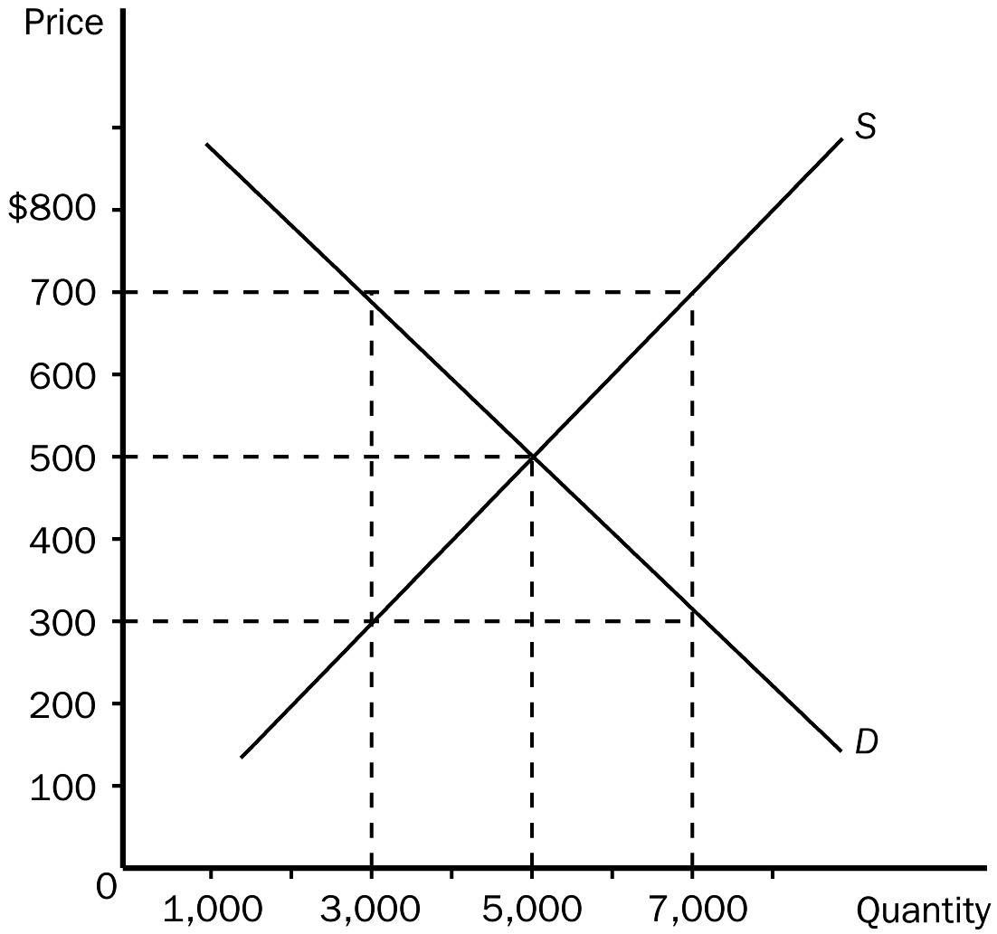
ANS:
a. For this example, a $300 price ceiling would cause a shortage of 4,000 bicycles. A price ceiling is binding if it is set at any price below equilibrium price. Since the equilibrium price in the market is $500, this would be a binding price ceiling.
b. For this example, a $700 price floor would cause a surplus of 4,000 bicycles. A price floor is binding if it is set at any price above equilibrium price. Since the equilibrium price in the market is $500, this would be a binding price floor.
c. More than one reason may exist for policymakers to impose a price ceiling or price floor in a market. Often this is done in an attempt to increase equity.
PTS: 1 DIF: 2 REF: 6-1
TOP: Price ceilings | Price Floors MSC: Applicative
3. Using the graph shown, answer the following questions.
a. What was the equilibrium price in this market before the tax?
b. What is the amount of the tax?
c. How much of the tax will the buyers pay?
d. How much of the tax will the sellers pay?
e. How much will the buyer pay for the product after the tax is imposed?
f. How much will the seller receive after the tax is imposed?
- As a result of the tax, what has happened to the level of market activity?

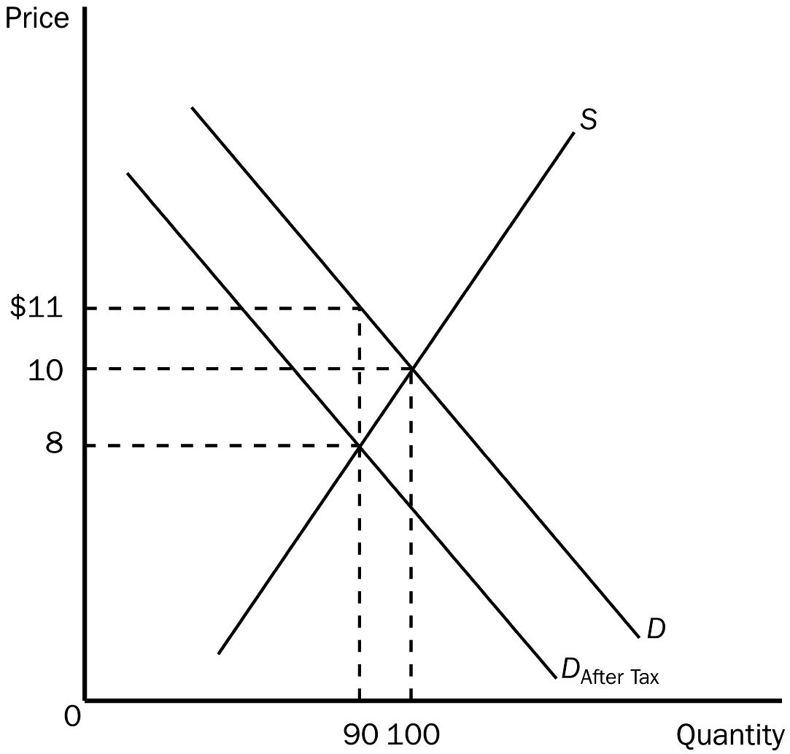
ANS:
a. $10
b. $3
c. $1
d. $2
e. $11
f. $8
g. As a result of the tax, the level of market activity has fallen, from 100 units being bought and sold to only 90 units being bought and sold.
PTS: 1 DIF: 2 REF: 6-2
TOP: Tax | Tax incidence MSC: Applicative
4. Using the graph shown, answer the following questions.
a. What was the equilibrium price in this market before the tax?
b. What is the amount of the tax?
c. How much of the tax will the buyers pay?
d. How much of the tax will the sellers pay?
e. How much will the buyer pay for the product after the tax is imposed?
f. How much will the seller receive after the tax is imposed?
- As a result of the tax, what has happened to the level of market activity?

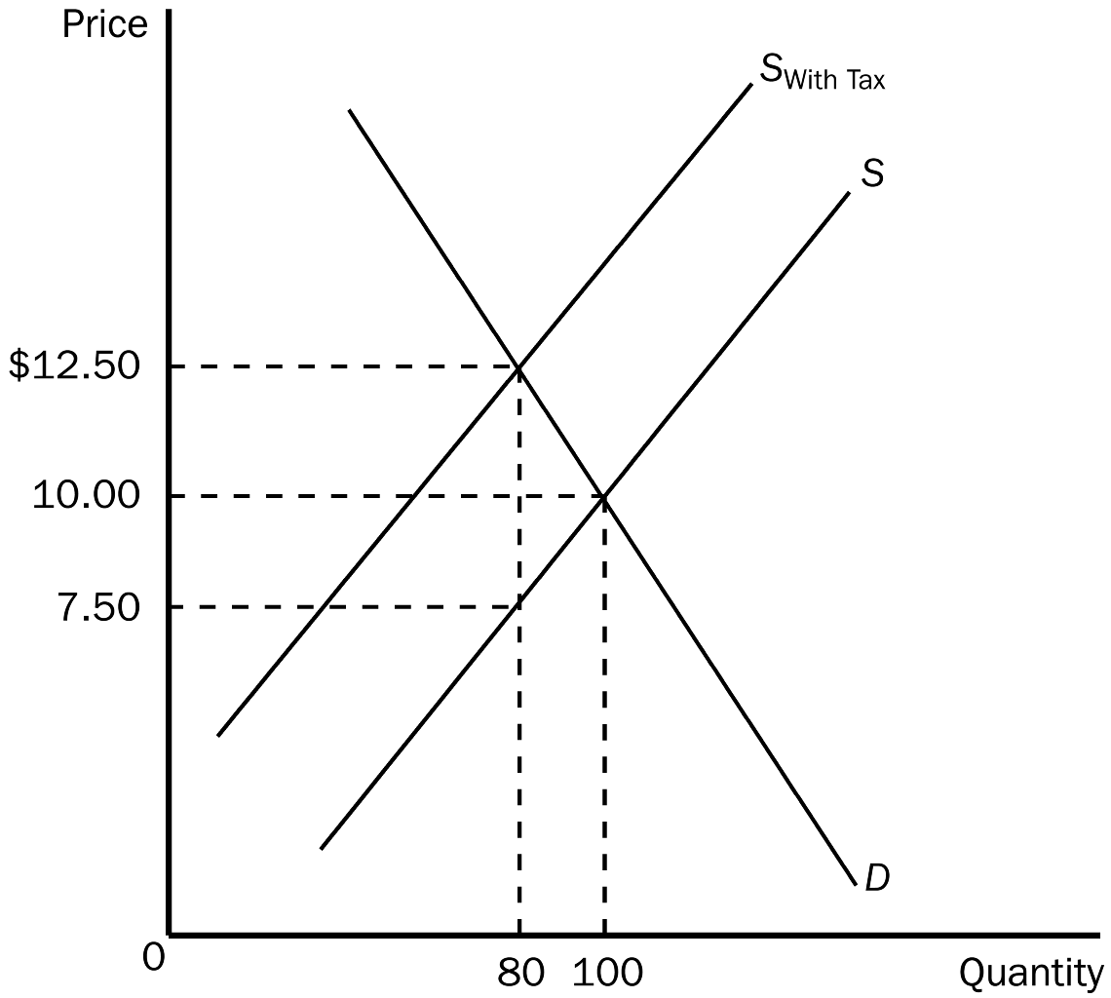
ANS:
a. $10.00
b. $5.00
c. $2.50
d. $2.50
e. $12.50
f. $7.50
g. As a result of the tax, the level of market activity has fallen, from 100 units being bought and sold to only 80 units being bought and sold.
PTS: 1 DIF: 2 REF: 6-2
TOP: Tax | Tax incidence MSC: Applicative
5. Using the graph shown, answer the following questions.
a. What was the equilibrium price and quantity in this market before the tax?
b. What is the amount of the tax?
c. How much of the tax will the buyers pay?
d. How much of the tax will the sellers pay?
e. How much will the buyer pay for the product after the tax is imposed?
f. How much will the seller receive after the tax is imposed?
- As a result of the tax, what has happened to the level of market activity?

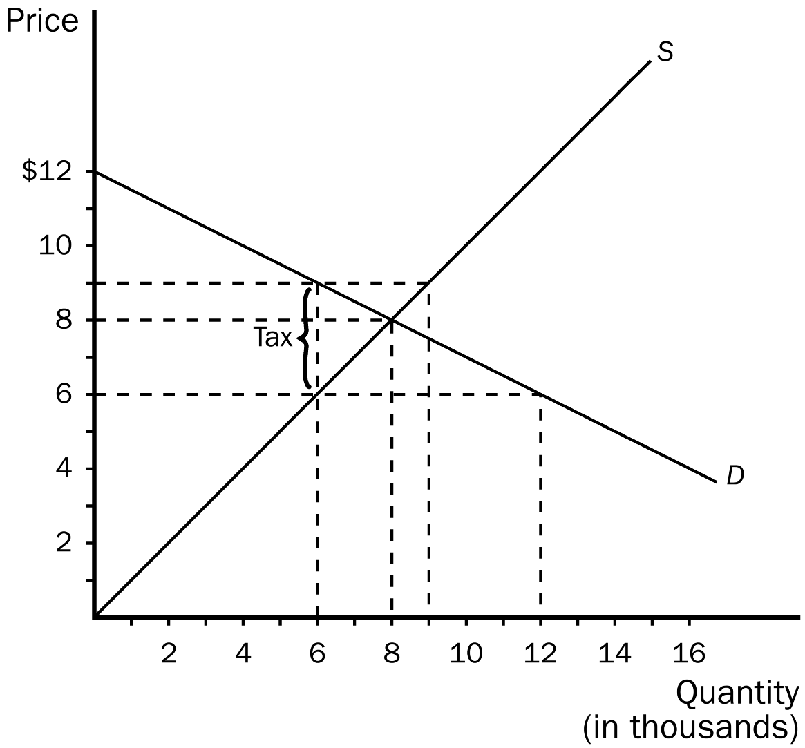
ANS:
a. Equilibrium price is $8 and equilibrium is 8,000 units.
b. The tax is $3.00.
c. Buyers will pay $1.00.
d. Sellers will pay $2.00.
e. $9.00
f. $6.00
g. Instead of 8,000 units being bought and sold, only 6,000 will be bought and sold.
PTS: 1 DIF: 2 REF: 6-2
TOP: Tax | Tax incidence MSC: Applicative
6. How does elasticity affect the burden of a tax? Justify your answer using supply and demand diagrams.
ANS:
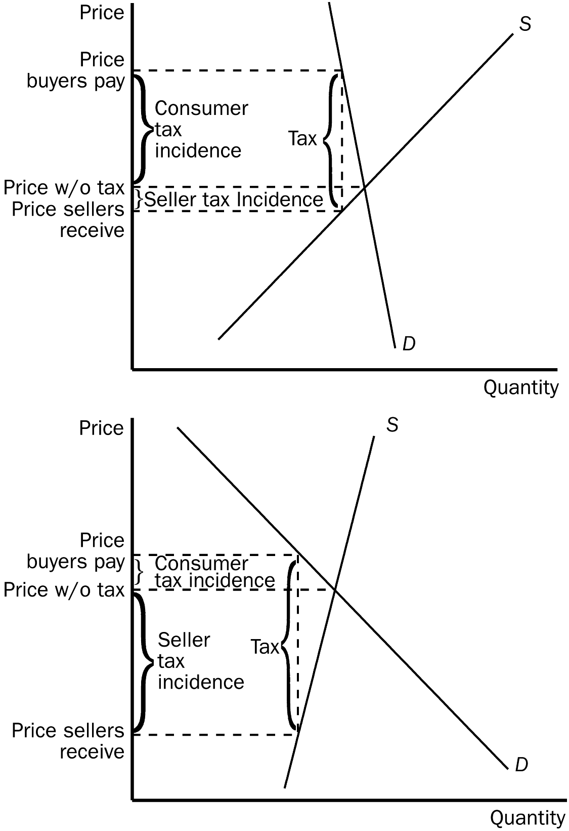
PTS: 1 DIF: 3 REF: 6-2
TOP: Tax incidence | Elasticity MSC: Analytical

