Chapter 8
Application: The Costs of Taxation
Multiple Choice
1. In 1776, the American Revolution was sparked by anger over
a. the extravagant lifestyle of British royalty.
b. the crimes of British soldiers stationed in the American colonies.
c. British taxes imposed on the American colonies.
d. the failure of the British to protect American colonists from attack by hostile Native Americans.
ANS: C PTS: 1 DIF: 1 REF: 8-0
TOP: Taxes MSC: Definitional
2. Anger over British taxes played a significant role in bringing about
a. the election of John Adams as the second American president.
b. the American Revolution.
c. the War of 1812.
d. the “no new taxes” clause in the U.S. Constitution.
ANS: B PTS: 1 DIF: 1 REF: 8-0
TOP: Taxes MSC: Definitional
3. When Ronald Reagan ran for the presidency in 1980, he pledged to bring about
a. large cuts in personal income taxes.
b. large cuts in payroll taxes.
c. large increases in personal income taxes.
d. large increases in payroll taxes.
ANS: A PTS: 1 DIF: 1 REF: 8-0
TOP: Taxes MSC: Definitional
4. Which U.S. president lost his bid for re-election, in part because he had broken an earlier campaign promise to refrain from imposing any new taxes?
a. Lyndon B. Johnson
b. Jimmy Carter
c. George H.W. Bush
d. Bill Clinton
ANS: C PTS: 1 DIF: 1 REF: 8-0
TOP: Taxes MSC: Definitional
5. During Ronald Reagan's presidency, the top tax rate on income fell from
a. 36 percent to 22 percent.
b. 50 percent to 22 percent.
c. 50 percent to 28 percent.
d. 70 percent to 28 percent.
ANS: D PTS: 1 DIF: 2 REF: 8-0
TOP: Tax rates MSC: Definitional
6. In recent decades, which of the following U.S. presidents promised tax cuts and subsequently delivered tax cuts?
a. Jimmy Carter and Ronald Reagan
b. Ronald Reagan and Bill Clinton
c. Gerald Ford and George W. Bush
d. Ronald Reagan and George W. Bush
ANS: D PTS: 1 DIF: 2 REF: 8-0
TOP: Taxes MSC: Definitional
7. Who once said that taxes are the price we pay for a civilized society?
a. Aristotle
b. George Washington
c. Oliver Wendell Holmes
d. Ronald Reagan
ANS: C PTS: 1 DIF: 1 REF: 8-0
TOP: Taxes MSC: Definitional
8. To fully understand how taxes affect economic well-being, we must
a. assume that economic well-being is not affected if all tax revenue is spent on goods and services for the people who are being taxed.
b. know the dollar amount of all taxes raised in the country each year.
c. compare the reduced welfare of buyers and sellers to the amount of revenue the government raises.
d. take into account the fact that almost all taxes reduce the welfare of buyers, increase the welfare of sellers, and raise revenue for the government.
ANS: C PTS: 1 DIF: 2 REF: 8-0
TOP: Taxes | Economic welfare MSC: Interpretive
9. Oliver Wendell Holmes once said taxes
a. are the price we pay for a civilized society.
b. are a fact of life.
c. cannot be escaped unless you are in jail.
d. can be avoided only by the rich.
ANS: A PTS: 1 DIF: 1 REF: 8-1
TOP: Taxes MSC: Definitional
10. When a tax is levied on a good, the buyers and sellers of the good share the burden,
a. provided the tax is levied on the sellers.
b. provided the tax is levied on the buyers.
c. provided a portion of the tax is levied on the buyers, with the remaining portion levied on the sellers.
d. regardless of how the tax is levied.
ANS: D PTS: 1 DIF: 2 REF: 8-1
TOP: Tax burden MSC: Interpretive
11. A tax on a good
a. raises the price that buyers effectively pay and raises the price that sellers effectively receive.
b. raises the price that buyers effectively pay and lowers the price that sellers effectively receive.
c. lowers the price that buyers effectively pay and raises the price that sellers effectively receive.
d. lowers the price that buyers effectively pay and lowers the price that sellers effectively receive.
ANS: B PTS: 1 DIF: 2 REF: 8-1
TOP: Tax | Prices MSC: Interpretive
12. When a good is taxed,
a. both buyers and sellers of the good are made worse off.
b. only buyers are made worse off, because they ultimately bear the burden of the tax.
c. only sellers are made worse off, because the government holds them responsible for sending in the tax payments.
d. neither buyers nor sellers are made worse off, since tax revenue is used to provide goods and services that would otherwise not be provided in a market economy.
ANS: A PTS: 1 DIF: 2 REF: 8-1
TOP: Taxes | Economic welfare MSC: Interpretive
13. To measure the gains and losses from a tax on a good, economists use the tools of
a. macroeconomics.
b. welfare economics.
c. international-trade theory.
d. circular-flow analysis.
ANS: B PTS: 1 DIF: 1 REF: 8-1
TOP: Taxes | Economic welfare MSC: Interpretive
14. When a tax is imposed on a good,
a. the supply curve for the good always shifts.
b. the demand curve for the good always shifts.
c. the amount of the good that buyers are willing to buy at each price always remains unchanged.
d. the equilibrium quantity of the good always decreases.
ANS: D PTS: 1 DIF: 2 REF: 8-1
TOP: Taxes | Equilibrium quantity MSC: Interpretive
15. A tax levied on the sellers of a good shifts the
a. supply curve upward (or to the left).
b. supply curve downward (or to the right).
c. demand curve upward (or to the right).
d. demand curve downward (or to the left).
ANS: A PTS: 1 DIF: 2 REF: 8-1
TOP: Tax | Supply curve MSC: Interpretive
16. A tax levied on the buyers of a good shifts the
a. supply curve upward (or to the left).
b. supply curve downward (or to the right).
c. demand curve downward (or to the left).
d. demand curve upward (or to the right).
ANS: C PTS: 1 DIF: 2 REF: 8-1
TOP: Tax | Demand curve MSC: Interpretive
17. When a tax is imposed on the buyers of a good, the demand curve shifts
a. downward by the amount of the tax.
b. upward by the amount of the tax.
c. downward by less than the amount of the tax.
d. upward by more than the amount of the tax.
ANS: A PTS: 1 DIF: 2 REF: 8-1
TOP: Tax | Demand curve MSC: Interpretive
18. When a tax is imposed on the sellers of a good,
a. the demand curve shifts downward by less than the amount of the tax.
b. the demand curve shifts downward by the amount of the tax.
c. the supply curve shifts upward by less than the amount of the tax.
d. the supply curve shifts upward by the amount of the tax.
ANS: D PTS: 1 DIF: 2 REF: 8-1
TOP: Tax | Supply curve MSC: Interpretive
19. A tax placed on buyers of tires shifts
a. the demand curve for tires downward, decreasing the price received by sellers of tires and causing the market for tires to expand.
b. the demand curve for tires downward, decreasing the price received by sellers of tires and causing the market for tires to shrink.
c. the supply curve for tires upward, decreasing the effective price paid by buyers of tires and causing the market for tires to expand.
d. the supply curve for tires upward, increasing the effective price paid by buyers of tires and causing the market for tires to shrink.
ANS: B PTS: 1 DIF: 3 REF: 8-1
TOP: Tax | Demand curve | Equilibrium quantity MSC: Applicative
20. Buyers of a product will bear the larger part of the tax burden, and sellers will bear a smaller part of the tax burden, when
a. the tax is placed on the sellers of the product.
b. the tax is placed on the buyers of the product.
c. the supply of the product is more elastic than the demand for the product.
d. the demand for the product is more elastic than the supply of the product.
ANS: C PTS: 1 DIF: 2 REF: 8-1
TOP: Tax incidence MSC: Applicative
21. Sellers of a product will bear the larger part of the tax burden, and buyers will bear a smaller part of the tax burden, when
a. the tax is placed on the sellers of the product.
b. the tax is placed on the buyers of the product.
c. the supply of the product is more elastic than the demand for the product.
d. the demand for the product is more elastic than the supply of the product.
ANS: D PTS: 1 DIF: 2 REF: 8-1
TOP: Tax incidence MSC: Applicative
22. When a tax is imposed on a good for which the supply is relatively elastic and the demand is relatively inelastic,
a. buyers of the good will bear most of the burden of the tax.
b. sellers of the good will bear most of the burden of the tax.
c. the effective price paid by buyers of the good will decrease.
d. the size of the market for the good will expand.
ANS: A PTS: 1 DIF: 2 REF: 8-1
TOP: Tax incidence MSC: Applicative
23. Suppose a tax is imposed on the buyers of fast-food hamburgers. The burden of the tax will
a. fall entirely on the buyers of fast-food hamburgers.
b. fall entirely on the sellers of fast-food hamburgers.
c. be shared equally by the buyers and sellers of fast-food hamburgers.
d. be shared by the buyers and sellers of fast-food hamburgers, but not necessarily equally.
ANS: D PTS: 1 DIF: 2 REF: 8-1
TOP: Tax incidence MSC: Interpretive
24. It does not matter whether a tax is levied on the buyers or the sellers of a good because
a. sellers always bear the full burden of the tax.
b. buyers always bear the full burden of the tax.
c. buyers and sellers will share the burden of the tax.
d. None of the above is correct; the incidence of the tax does depend on whether the buyers or the sellers are required to pay the tax.
ANS: C PTS: 1 DIF: 2 REF: 8-1
TOP: Tax incidence MSC: Interpretive
25. When a tax is imposed on a good for which demand is elastic and supply is elastic,
a. sellers effectively pay the majority of the tax.
b. buyers effectively pay the majority of the tax.
c. the tax burden is equally divided between buyers and sellers.
d. None of the above is correct; further information would be required to determine how the burden of the tax is distributed between buyers and sellers.
ANS: D PTS: 1 DIF: 2 REF: 8-1
TOP: Tax incidence MSC: Interpretive
26. When cigarettes are taxed and sellers of cigarettes are required to pay the tax to the government,
a. the size of the cigarette market is reduced.
b. the price paid by buyers of cigarettes decreases.
c. the demand for cigarettes decreases.
d. there is a movement downward and to the right along the demand curve for cigarettes.
ANS: A PTS: 1 DIF: 2 REF: 8-1
TOP: Tax | Equilibrium quantity MSC: Interpretive
27. One result of a tax, irrespective of whether the tax is placed on the buyers or the sellers, is that the
a. size of the market is unchanged.
b. price the seller effectively receives is higher.
c. supply curve for the good shifts upward by the amount of the tax.
d. tax reduces the welfare of both buyers and sellers.
ANS: D PTS: 1 DIF: 2 REF: 8-1
TOP: Tax | Economic welfare MSC: Interpretive
28. When a tax is placed on the buyers of a product, a result is that
a. buyers effectively pay less than before and sellers effectively receive less than before.
b. buyers effectively pay less than before and sellers effectively receive more than before.
c. buyers effectively pay more than before and sellers effectively receive less than before.
d. buyers effectively pay more than before and sellers effectively receive more than before.
ANS: C PTS: 1 DIF: 2 REF: 8-1
TOP: Tax | Equilibrium price MSC: Interpretive
29. When a tax is levied on a good,
a. neither buyers nor sellers are made worse off.
b. only sellers are made worse off.
c. only buyers are made worse off.
d. both buyers and sellers are made worse off.
ANS: D PTS: 1 DIF: 2 REF: 8-1
TOP: Tax | Economic welfare MSC: Interpretive
30. Which of the following statements is correct regarding the imposition of a tax on gasoline?
a. The incidence of the tax depends upon whether the buyers or the sellers are required to remit tax payments to the government.
b. The incidence of the tax depends upon the price elasticities of demand and supply.
c. The amount of tax revenue raised by the tax depends upon whether the buyers or the sellers are required to remit tax payments to the government.
d. The amount of tax revenue raised by the tax does not depend upon the amount of the tax per unit.
ANS: B PTS: 1 DIF: 3 REF: 8-1
TOP: Tax incidence MSC: Analytical
Figure 8-1
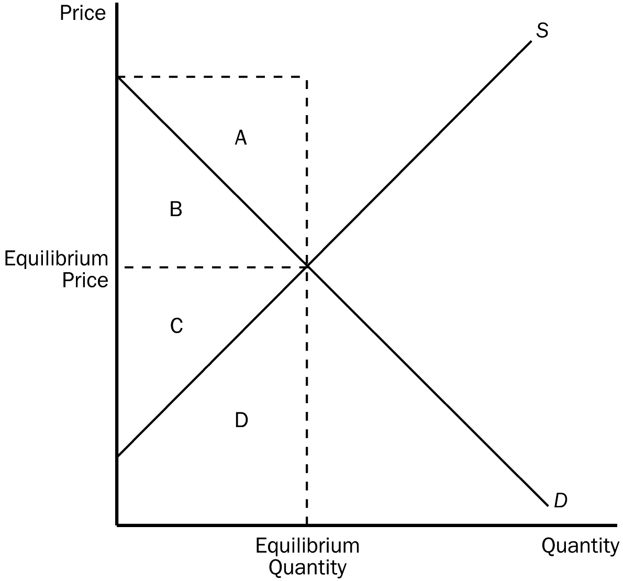
31. Refer to Figure 8-1. When the market is in equilibrium, consumer surplus is represented by area
a. A.
b. B.
c. C.
d. D.
ANS: B PTS: 1 DIF: 1 REF: 8-1
TOP: Consumer surplus MSC: Interpretive
32. Refer to Figure 8-1. When the market is in equilibrium, producer surplus is represented by area
a. A.
b. B.
c. C.
d. D.
ANS: C PTS: 1 DIF: 1 REF: 8-1
TOP: Producer surplus MSC: Interpretive
33. Refer to Figure 8-1. When the market is in equilibrium, total surplus is represented by area
a. A + B.
b. B + C.
c. C + D.
d. A + D.
ANS: B PTS: 1 DIF: 1 REF: 8-1
TOP: Total surplus MSC: Interpretive
34. Suppose a tax is levied on the buyers of a good;
a. then the supply curve shifts upward by the amount of the tax.
b. then the quantity supplied decreases for all conceivable prices of the good.
c. this means that the buyers of the good will send tax payments to the government.
d. this means that the buyers of the good will pay a higher effective price for the good, not that they will send tax payments to the government.
ANS: C PTS: 1 DIF: 2 REF: 8-1
TOP: Tax | Buyers MSC: Definitional
35. Suppose a tax is levied on the sellers of a good;
a. then the supply curve shifts upward by the amount of the tax.
b. then the quantity demanded decreases for all conceivable prices of the good.
c. this means that the sellers of the good will receive a lower price from buyers, not that the sellers are actually responsible for paying the tax to the government.
d. All of the above are correct.
ANS: A PTS: 1 DIF: 2 REF: 8-1
TOP: Tax | Sellers MSC: Interpretive
36. A $2.00 tax placed on the sellers of potting soil, for every bag of potting soil they sell, will shift the supply curve
a. downward by exactly $2.00.
b. downward by less than $2.00.
c. upward by exactly $2.00.
d. upward by less than $2.00.
ANS: C PTS: 1 DIF: 2 REF: 8-1
TOP: Tax | Supply curve MSC: Interpretive
37. When a good is taxed, the burden of the tax
a. falls more heavily on the side of the market that is more elastic.
b. falls more heavily on the side of the market that is more inelastic.
c. falls more heavily on the side of the market that is closer to unit elastic.
d. is distributed independently of relative elasticities of supply and demand.
ANS: B PTS: 1 DIF: 2 REF: 8-1
TOP: Tax incidence MSC: Applicative
38. When a tax on a good is enacted,
a. buyers and sellers share the burden of the tax regardless of whether the tax is levied on buyers or on sellers.
b. buyers always bear the full burden of the tax.
c. sellers always bear the full burden of the tax.
d. sellers bear the full burden of the tax if the tax is levied on them; buyers bear the full burden of the tax if the tax is levied on them.
ANS: A PTS: 1 DIF: 2 REF: 8-1
TOP: Tax incidence MSC: Interpretive
39. A tax placed on a good
a. causes the effective price to sellers to increase.
b. affects the welfare of buyers of the good, but not the welfare of sellers.
c. causes the size of the market for the good to shrink.
d. creates a burden that is usually borne entirely by the sellers of the good.
ANS: C PTS: 1 DIF: 2 REF: 8-1
TOP: Tax | Equilibrium price | Equilibrium quantity MSC: Interpretive
40. When a tax is levied on buyers of a good,
a. government collects too little revenue to justify the tax if the equilibrium quantity of the good decreases as a result of the tax.
b. there is an increase in the quantity of the good supplied.
c. a wedge is placed between the price buyers pay and the price sellers effectively receive.
d. the effective price to buyers decreases because the demand curve shifts leftward.
ANS: C PTS: 1 DIF: 2 REF: 8-1
TOP: Tax | Equilibrium price MSC: Applicative
41. The benefit to buyers of participating in a market is measured by
a. the price elasticity of demand.
b. consumer surplus.
c. the amount buyers are willing to pay for the good.
d. the equilibrium price.
ANS: B PTS: 1 DIF: 1 REF: 8-1
TOP: Consumer surplus MSC: Interpretive
42. The benefit that government receives from a tax is measured by
a. the change in the equilibrium quantity of the good.
b. the change in the equilibrium price of the good.
c. tax revenue.
d. total surplus.
ANS: C PTS: 1 DIF: 1 REF: 8-1
TOP: Tax | Government MSC: Interpretive
43. If T represents the size of the tax on a good and Q represents the quantity of the good that is sold, total tax revenue received by government can be expressed as
a. T/Q.
b. T + Q.
c. T x Q.
d. (T x Q)/Q.
ANS: C PTS: 1 DIF: 1 REF: 8-1
TOP: Tax | Government MSC: Interpretive
44. When a tax is levied on buyers,
a. the supply curves shifts upward by the amount of the tax.
b. the tax creates a wedge between the price buyers effectively pay and the price sellers receive.
c. the tax has no effect on the well-being of sellers.
d. All of the above are correct.
ANS: B PTS: 1 DIF: 1 REF: 8-1
TOP: Tax | Buyers MSC: Interpretive
45. For the purpose of analyzing the gains and losses from a tax on a good, we use tax revenue as a direct measure of
a. government's benefit from the tax.
b. government's loss from the tax.
c. the deadweight loss of the tax.
d. the overall net gain to society of the tax.
ANS: A PTS: 1 DIF: 1 REF: 8-1
TOP: Tax revenue MSC: Interpretive
46. The decrease in total surplus that results from a market distortion, such as a tax, is called a
a. wedge loss.
b. revenue loss.
c. deadweight loss.
d. shrinkage of consumer surplus.
ANS: C PTS: 1 DIF: 1 REF: 8-1
TOP: Deadweight losses MSC: Definitional
47. A tax on a good
a. gives buyers an incentive to buy more of the good than they otherwise would buy.
b. gives sellers an incentive to produce less of the good than they otherwise would produce.
c. creates a benefit to the government, the size of which exceeds the loss in surplus to buyers and sellers.
d. All of the above are correct.
ANS: B PTS: 1 DIF: 2 REF: 8-1
TOP: Tax | Producer surplus | Consumer surplus MSC: Interpretive
48. When the price of a good is measured in dollars, then the size of the deadweight loss that results from taxing that good is measured in
a. units of the good that is being taxed.
b. units of another good that is not being taxed.
c. dollars.
d. abstract units of measurement that reflect the well-being of the society.
ANS: C PTS: 1 DIF: 3 REF: 8-1
TOP: Deadweight losses MSC: Analytical
49. Suppose a tax of $4 per unit is imposed on a good, and the tax causes the equilibrium quantity of the good to decrease from 2,000 units to 1,700 units. The tax decreases consumer surplus by $3,000 and it decreases producer surplus by $4,400. The deadweight loss of the tax is
a. $200.
b. $400.
c. $600.
d. $1,200.
ANS: C PTS: 1 DIF: 2 REF: 8-1
TOP: Consumer surplus | Producer surplus | Deadweight losses MSC: Applicative
50. Suppose a tax of $3 per unit is imposed on a good. The supply curve and the demand curve are straight lines. The tax decreases consumer surplus by $3,900 and it decreases producer surplus by $3,000. The tax generates tax revenue of $6,000. From this information it follows that the tax decreased the equilibrium quantity of the good
a. from 2,000 to 1,500.
b. from 2,400 to 2,000.
c. from 2,600 to 2,000.
d. from 3,000 to 2,400.
ANS: C PTS: 1 DIF: 3 REF: 8-1
TOP: Consumer surplus | Producer surplus | Deadweight losses MSC: Analytical
51. Suppose a tax of $5 per unit is imposed on a good. The supply curve and the demand curve are straight lines. The tax decreases consumer surplus by $10,000 and it decreases producer surplus by $15,000. The deadweight loss of the tax is $2,500. From this information it follows that the tax decreased the equilibrium quantity of the good
a. from 6,500 to 5,500.
b. from 5,500 to 4,500.
c. from 5,000 to 3,000.
d. from 6,000 to 4,000.
ANS: B PTS: 1 DIF: 3 REF: 8-1
TOP: Consumer surplus | Producer surplus | Deadweight losses MSC: Analytical
52. A tax of $0.25 is imposed on each bag of potato chips that is sold. The tax
 • decreases producer surplus by $600 per day;
 • generates tax revenue of $1,220 per day;
 • decreases the equilibrium quantity of potato chips by 120 bags per day.
From this information, it follows that the tax
a. decreases consumer surplus by $645 per day.
b. decreases the equilibrium quantity from 6,000 bags per day to 5,880 bags per day.
c. decreases total surplus from $3,000 to $1,800 per day.
d. produces a deadweight loss of $15 per day.
ANS: D PTS: 1 DIF: 3 REF: 8-1
TOP: Consumer surplus | Producer surplus | Deadweight losses MSC: Analytical
53. The benefit to sellers of participating in a market is measured by
a. the amount of taxes collected on sales of the good.
b. producer surplus.
c. the amount sellers receive for their product.
d. the sellers' willingness to sell.
ANS: B PTS: 1 DIF: 1 REF: 8-1
TOP: Producer surplus MSC: Interpretive
54. When the government places a tax on a product,
a. the cost of the tax to buyers and sellers is less than the revenue raised from the tax by the government.
b. the cost of the tax to buyers and sellers is equal to the revenue raised from the tax by the government.
c. the cost of the tax to buyers and sellers exceeds the revenue raised from the tax by the government.
d. Without additional information, such as the elasticity of demand for this product, it is impossible to compare the cost of a tax to buyers and sellers with tax revenue.
ANS: C PTS: 1 DIF: 2 REF: 8-1
TOP: Tax | Economic welfare MSC: Applicative
55. Relative to a situation in which liquor is not taxed, the imposition of a tax on liquor causes
a. the equilibrium quantity of liquor demanded to decrease and the equilibrium quantity of liquor supplied to decrease.
b. the equilibrium quantity of liquor demanded to decrease and the equilibrium quantity of liquor supplied to increase.
c. the equilibrium quantity of liquor demanded to increase and the equilibrium quantity of liquor supplied to decrease.
d. the equilibrium quantity of liquor demanded to increase and the equilibrium quantity of liquor supplied to increase.
ANS: A PTS: 1 DIF: 2 REF: 8-1
TOP: Tax | Equilibrium quantity MSC: Interpretive
56. Which of the following quantities decrease in response to a tax on a good?
a. the size of the market for the good, the effective price of the good paid by buyers, and consumer surplus
b. the size of the market for the good, producer surplus, and the well-being of buyers of the good
c. the effective price received by sellers of the good, the wedge between the effective price paid by buyers and the effective price received by sellers, and consumer surplus
d. None of the above is necessarily correct unless we know whether the tax is levied on buyers or on sellers.
ANS: B PTS: 1 DIF: 3 REF: 8-1
TOP: Tax | Equilibrium | Economic welfare MSC: Applicative
57. For a good that is taxed, the area on the relevant supply-and-demand graph that represents government’s tax revenue is a
a. triangle.
b. rectangle.
c. trapezoid.
d. None of the above is correct; government’s tax revenue is the area between the supply and demand curves, above the horizontal axis, and below the effective price to buyers.
ANS: B PTS: 1 DIF: 2 REF: 8-1
TOP: Tax | Government MSC: Interpretive
58. For a good that is taxed, the area on the relevant supply-and-demand graph that represents government’s tax revenue is
a. smaller than the area that represents the loss of consumer surplus and producer surplus caused by the tax.
b. bounded by the supply curve, the demand curve, the effective price paid by buyers, and the effective price received by sellers.
c. a right triangle.
d. a triangle, but not necessarily a right triangle.
ANS: A PTS: 1 DIF: 3 REF: 8-1
TOP: Tax | Government MSC: Applicative
59. Total surplus with a tax is equal to
a. consumer surplus plus producer surplus.
b. consumer surplus minus producer surplus.
c. consumer surplus plus producer surplus minus tax revenue.
d. consumer surplus plus producer surplus plus tax revenue.
ANS: D PTS: 1 DIF: 2 REF: 8-1
TOP: Tax | Total surplus MSC: Interpretive
60. Taxes cause deadweight losses because they
a. lead to losses in surplus for consumers and for producers that, when taken together, exceed tax revenue collected by the government.
b. distort incentives to both buyers and sellers.
c. prevent buyers and sellers from realizing some of the gains from trade.
d. All of the above are correct.
ANS: D PTS: 1 DIF: 2 REF: 8-1
TOP: Deadweight losses MSC: Interpretive
61. Taxes cause deadweight losses because
a. taxes reduce the sum of producer and consumer surpluses by more than the amount of tax revenue.
b. taxes prevent buyers and sellers from realizing some of the gains from trade.
c. taxes cause marginal buyers and marginal sellers to leave the market, causing the quantity sold to fall.
d. All of the above are correct.
ANS: D PTS: 1 DIF: 2 REF: 8-1
TOP: Deadweight losses MSC: Interpretive
62. Deadweight loss measures the
a. loss in a market to buyers and sellers that is not offset by an increase in government revenue.
b. loss in revenue to the government when buyers choose to buy less of the product because of the tax.
c. loss of equity in a market due to government intervention.
d. loss of total revenue to business firms due to the price wedge caused by the tax.
ANS: A PTS: 1 DIF: 2 REF: 8-1
TOP: Deadweight losses MSC: Interpretive
63. The loss in total surplus resulting from a tax is called
a. a deficit.
b. economic loss.
c. deadweight loss.
d. inefficiency.
ANS: C PTS: 1 DIF: 1 REF: 8-1
TOP: Deadweight losses MSC: Definitional
64. Deadweight loss is the
a. decline in total surplus that results from a tax.
b. decline in government revenue when taxes are reduced in a market.
c. decline in consumer surplus when a tax is placed on buyers.
d. loss of profits to business firms when a tax is imposed.
ANS: A PTS: 1 DIF: 1 REF: 8-1
TOP: Deadweight losses MSC: Definitional
65. A deadweight loss is a consequence of a tax on a good because the tax
a. induces the government to increase its expenditures.
b. induces buyers to consume less, and sellers to produce less, of the good.
c. causes a disequilibrium in the market.
d. imposes a loss on buyers that is greater than the loss to sellers.
ANS: B PTS: 1 DIF: 2 REF: 8-1
TOP: Deadweight losses MSC: Interpretive
66. The supply curve and the demand curve for a good are straight lines. When the good is taxed, the area on the relevant supply-and-demand graph that represents the deadweight loss is
a. larger than the area that represents consumer surplus in the absence of the tax.
b. larger than the area that represents government’s tax revenue.
c. a triangle.
d. All of the above are correct.
ANS: C PTS: 1 DIF: 2 REF: 8-1
TOP: Deadweight losses MSC: Interpretive
67. Taxes
a. distort incentives and this distortion causes markets to allocate resources inefficiently.
b. distort incentives and this distortion results in an inequitable allocation of resources.
c. do not distort incentives, but they do cause markets to allocate resources inefficiently.
d. do not distort incentives, but they do result in an inequitable allocation of resources.
ANS: A PTS: 1 DIF: 2 REF: 8-1
TOP: Taxes | Inefficiency MSC: Interpretive
68. The supply curve and the demand curve for a good are straight lines. When the good is taxed, the area on the relevant supply-and-demand graph that represents
a. government’s tax revenue is a rectangle.
b. the deadweight loss of the tax is a triangle.
c. the loss of consumer surplus caused by the tax is neither a rectangle nor a triangle.
d. All of the above are correct.
ANS: D PTS: 1 DIF: 2 REF: 8-1
TOP: Deadweight losses MSC: Interpretive
69. A tax of $10 per unit is imposed on a certain good. The supply curve and the demand curve are straight lines. The tax reduces the equilibrium quantity in the market by 200 units. The deadweight loss from the tax is
a. $2,000.
b. $,1000.
c. $500.
d. $250.
ANS: B PTS: 1 DIF: 2 REF: 8-1
TOP: Deadweight losses MSC: Applicative
70. Suppose the equilibrium quantity in the market for widgets is 200 per month when there is no tax. Then a tax of $5 per widget is imposed. As a result, the government is able to raise $750 per month in tax revenue. We can conclude that the equilibrium quantity of widgets has fallen by
a. 25 per month.
b. 50 per month.
c. 75 per month.
d. 100 per month.
ANS: B PTS: 1 DIF: 3 REF: 8-1
TOP: Tax | Quantity demanded MSC: Applicative
71. The supply curve and the demand curve for widgets are straight lines. Suppose the equilibrium quantity in the market for widgets is 200 per month when there is no tax. Then a tax of $5 per widget is imposed. The price paid by buyers increases by $2 and the after-tax price received by sellers falls by $3. The government is able to raise $750 per month in revenue from the tax. The deadweight loss from the tax is
a. $250.
b. $125.
c. $75.
d. $50.
ANS: B PTS: 1 DIF: 3 REF: 8-1
TOP: Deadweight losses MSC: Applicative
72. The supply curve and the demand curve for cigars are straight lines. Suppose the equilibrium quantity in the market for cigars is 1,000 per month when there is no tax. Then a tax of $0.50 per cigar is imposed. The effective price paid by buyers increases from $1.50 to $1.90 and the effective price received by sellers falls from $1.50 to $1.40. The government’s tax revenue amounts to $475 per month. Which of the following statements is correct?
a. After the tax is imposed, the equilibrium quantity of cigars is 900 per month.
b. The demand for cigars is more elastic than the supply of cigars.
c. The deadweight loss of the tax is $12.50.
d. The tax causes a decrease in consumer surplus of $380.
ANS: C PTS: 1 DIF: 3 REF: 8-1
TOP: Deadweight losses | Elasticity MSC: Applicative
73. The supply curve and the demand curve for cigars are straight lines. Suppose the equilibrium quantity in the market for cigars is 1,000 per month when there is no tax. Then a tax of $0.50 per cigar is imposed. The effective price paid by buyers increases from $1.50 to $1.90 and the effective price received by sellers falls from $1.50 to $1.40. The government’s tax revenue amounts to $475 per month. Which of the following statements is correct?
a. The demand for cigars is less elastic than the supply of cigars.
b. The tax causes a decrease in consumer surplus of $390 and a decrease in producer surplus of $97.50.
c. The deadweight loss of the tax is $12.50.
d. All of the above are correct.
ANS: D PTS: 1 DIF: 3 REF: 8-1
TOP: Deadweight losses | Elasticity MSC: Applicative
Figure 8-2
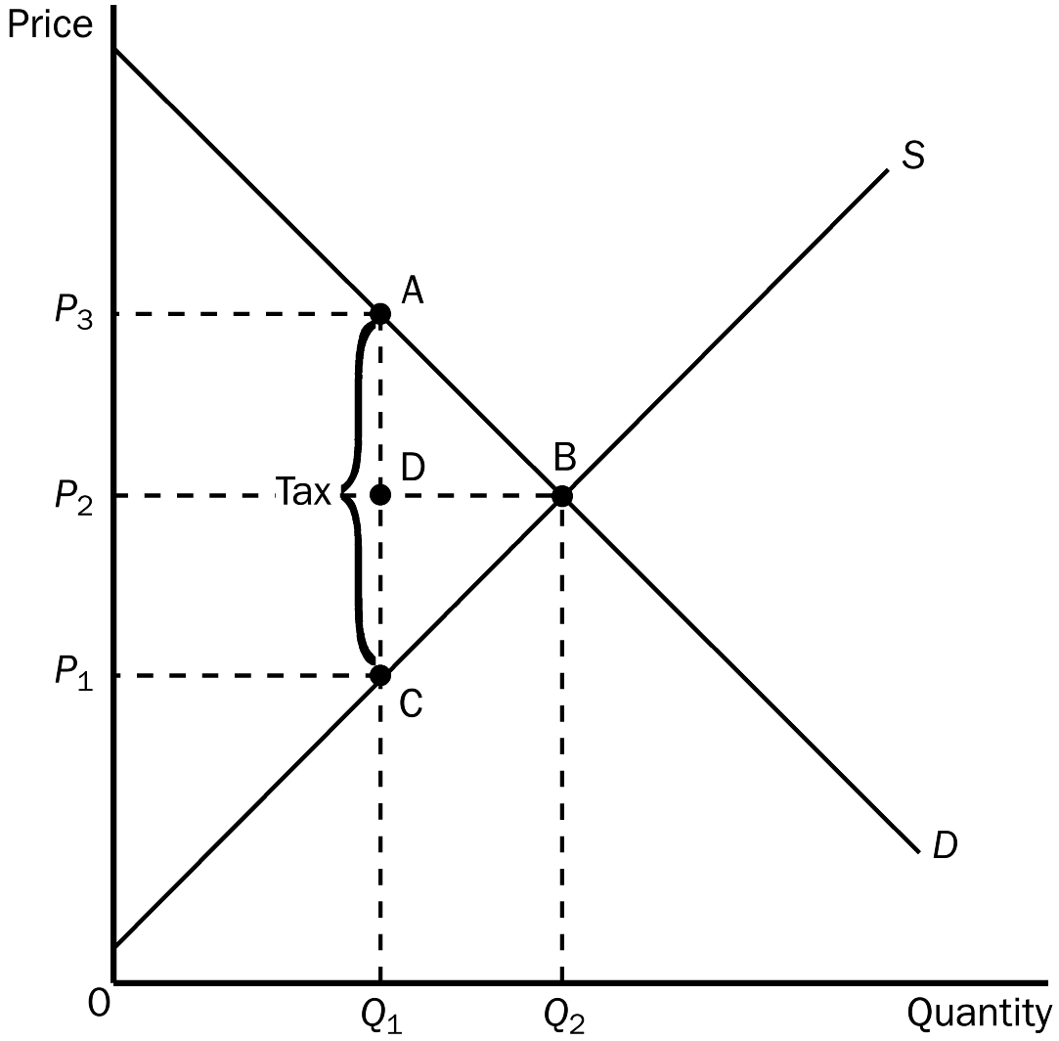
74. Refer to Figure 8-2. The equilibrium price before the tax is imposed is
a. P₁.
b. P₂.
c. P₃.
d. None of the above is correct.
ANS: B PTS: 1 DIF: 1 REF: 8-1
TOP: Equilibrium price MSC: Interpretive
75. Refer to Figure 8-2. The price that buyers effectively pay after the tax is imposed is
a. P₁.
b. P₂.
c. P₃.
d. impossible to determine from the figure.
ANS: C PTS: 1 DIF: 2 REF: 8-1
TOP: Tax | Equilibrium price MSC: Applicative
76. Refer to Figure 8-2. The price that sellers effectively receive after the tax is imposed is
a. P₁.
b. P₂.
c. P₃.
d. impossible to determine from the figure.
ANS: A PTS: 1 DIF: 2 REF: 8-1
TOP: Tax | Equilibrium price MSC: Applicative
77. Refer to Figure 8-2. The per unit burden of the tax on buyers is
a. P₃ - P₁.
b. P₃ - P₂.
c. P₂ - P₁.
d. Q₂ - Q₁.
ANS: B PTS: 1 DIF: 2 REF: 8-1
TOP: Tax burden MSC: Applicative
78. Refer to Figure 8-2. The per-unit burden of the tax on sellers is
a. P₃ - P₁.
b. P₃ - P₂.
c. P₂ - P₁.
d. Q₂ - Q₁.
ANS: C PTS: 1 DIF: 3 REF: 8-1
TOP: Tax burden MSC: Applicative
79. Refer to Figure 8-2. The amount of the tax on each unit of the good is
a. P₃ - P₁.
b. P₃ - P₂.
c. P₂ - P₁.
d. Q₂ - Q₁.
ANS: A PTS: 1 DIF: 1 REF: 8-1
TOP: Tax MSC: Applicative
80. Refer to Figure 8-2. The amount of tax revenue received by the government is equal to the area
a. P₃ A C P₁.
b. A B C.
c. P₂ D A P₃.
d. P₁ C D P₂.
ANS: A PTS: 1 DIF: 2 REF: 8-1
TOP: Tax | Government MSC: Applicative
81. Refer to Figure 8-2. The amount of deadweight loss associated with the tax is equal to
a. P₃ A C P₁.
b. A B C.
c. P₂ A D P₃.
d. P₁ D C P₂.
ANS: B PTS: 1 DIF: 2 REF: 8-1
TOP: Deadweight losses MSC: Applicative
82. Refer to Figure 8-2. Which of the following equations is valid for the loss in consumer surplus caused by the tax?
a. Loss of consumer surplus = (1/2)(P₃ - P₂)(Q₁ - Q₂).
b. Loss of consumer surplus = (1/2)(P₃ - P₂)(Q₁ + Q₂).
c. Loss of consumer surplus = (1/2)(P₃ + P₂)(Q₁ - Q₂).
d. Loss of consumer surplus = (1/2)(P₃ + P₂)(Q₁ + Q₂).
ANS: B PTS: 1 DIF: 3 REF: 8-1
TOP: Consumer surplus MSC: Analytical
83. Refer to Figure 8-2. Which of the following equations is valid for the loss in producer surplus caused by the tax?
a. Loss of producer surplus = (1/2)(P₂ + P₁)(Q₁ + Q₂).
b. Loss of producer surplus = (1/2)(P₂ + P₁)(Q₁ - Q₂).
c. Loss of producer surplus = (1/2)(P₂ - P₁)(Q₁ + Q₂).
d. Loss of producer surplus = (1/2)(P₂ - P₁)(Q₁ - Q₂).
ANS: C PTS: 1 DIF: 3 REF: 8-1
TOP: Producer surplus MSC: Analytical
84. Refer to Figure 8-2. Which of the following equations is valid for the tax revenue that the tax provides to the government?
a. Tax revenue = (P₂ - P₁)Q₁
b. Tax revenue = (P₃ - P₁)Q₁
c. Tax revenue = (P₃ - P₂)Q₁
d. Tax revenue = (P₃ - P₁)Q₂
ANS: B PTS: 1 DIF: 2 REF: 8-1
TOP: Tax | Government MSC: Applicative
85. Refer to Figure 8-2. Which of the following equations is valid for the deadweight loss of the tax?
a. Deadweight loss = (1/2)(P₂ - P₁)(Q₂ + Q₁)
b. Deadweight loss = (1/2)(P₃ - P₁)(Q₂ + Q₁)
c. Deadweight loss = (1/2)(P₃ - P₂)(Q₂ - Q₁)
d. Deadweight loss = (1/2)(P₃ - P₁)(Q₂ - Q₁)
ANS: D PTS: 1 DIF: 3 REF: 8-1
TOP: Deadweight losses MSC: Analytical
Figure 8-3
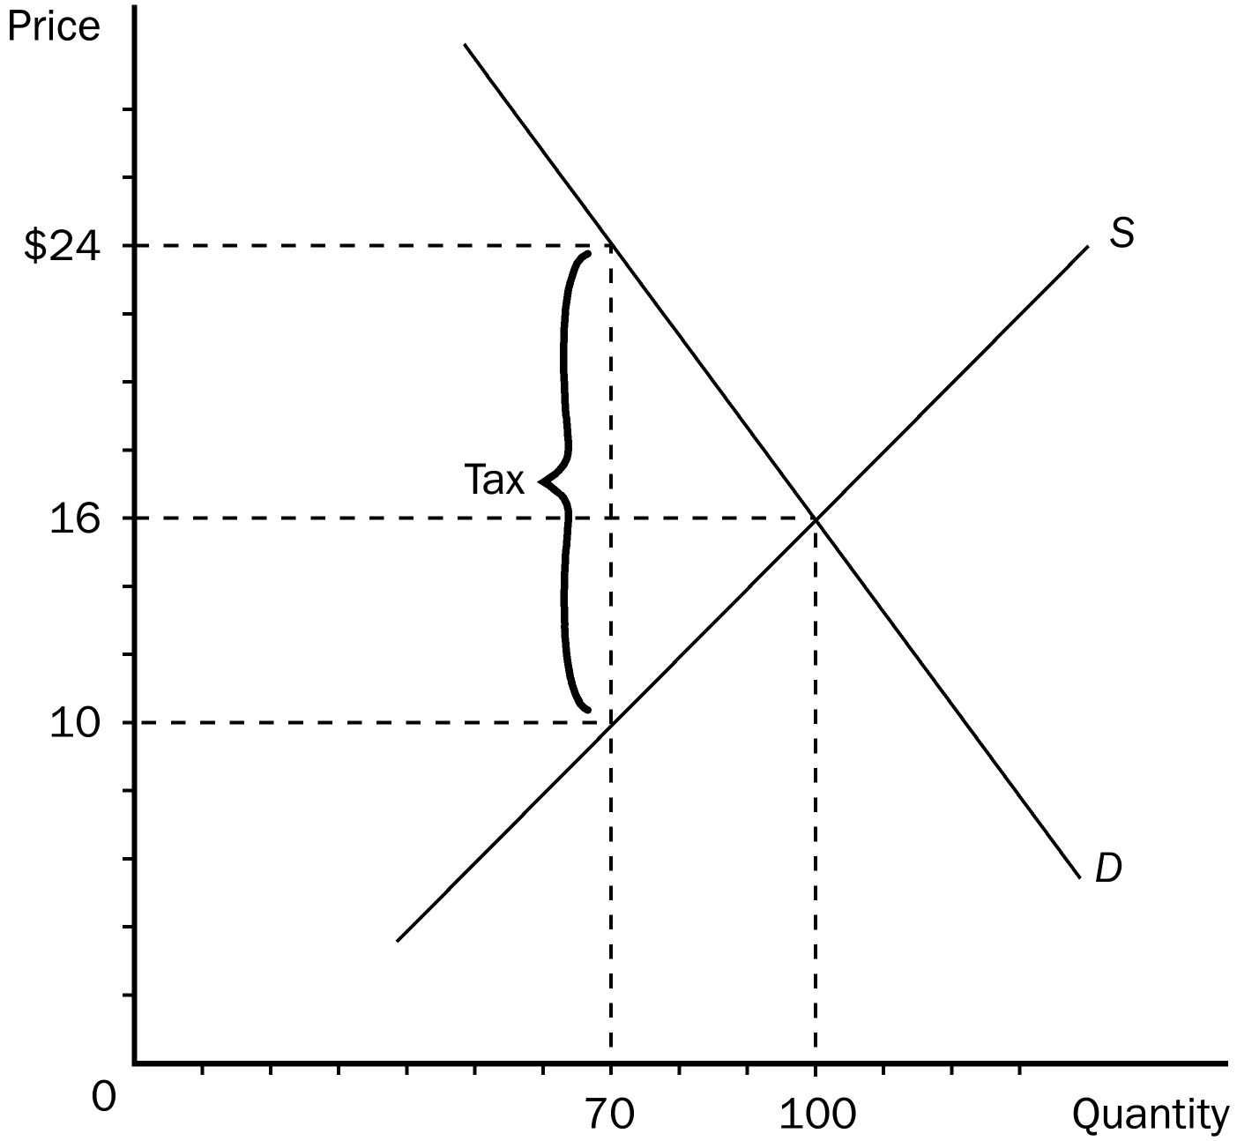
86. Refer to Figure 8-3. The equilibrium price before the tax is imposed is
a. $24 and the equilibrium quantity is 70.
b. $16 and the equilibrium quantity is 100.
c. $10 and the equilibrium quantity is 70.
d. $8 and the equilibrium quantity is 100.
ANS: B PTS: 1 DIF: 1 REF: 8-1
TOP: Equilibrium price | Equilibrium quantity MSC: Interpretive
87. Refer to Figure 8-3. The price that buyers effectively pay after the tax is imposed is
a. $24.
b. $16.
c. $10.
d. $8.
ANS: A PTS: 1 DIF: 2 REF: 8-1
TOP: Equilibrium price MSC: Applicative
88. Refer to Figure 8-3. The price that sellers effectively receive after the tax is imposed is
a. $24.
b. $14.
c. $10.
d. $8.
ANS: C PTS: 1 DIF: 2 REF: 8-1
TOP: Equilibrium price MSC: Applicative
89. Refer to Figure 8-3. The per-unit burden of the tax on buyers is
a. $16.
b. $14.
c. $8.
d. $6.
ANS: C PTS: 1 DIF: 2 REF: 8-1
TOP: Tax burden MSC: Applicative
90. Refer to Figure 8-3. The per-unit burden of the tax on sellers is
a. $16.
b. $14.
c. $8.
d. $6.
ANS: D PTS: 1 DIF: 2 REF: 8-1
TOP: Tax burden MSC: Applicative
91. Refer to Figure 8-3. The amount of the tax on each unit of the good is
a. $16.
b. $14.
c. $8.
d. $6.
ANS: B PTS: 1 DIF: 1 REF: 8-1
TOP: Tax MSC: Applicative
92. Refer to Figure 8-3. The amount of tax revenue received by the government is equal to
a. $210.
b. $420.
c. $560.
d. $980.
ANS: D PTS: 1 DIF: 2 REF: 8-1
TOP: Tax | Government MSC: Applicative
93. Refer to Figure 8-3. The amount of deadweight loss as a result of the tax is
a. $210.
b. $420.
c. $560.
d. $980.
ANS: A PTS: 1 DIF: 3 REF: 8-1
TOP: Deadweight losses MSC: Applicative
94. Refer to Figure 8-3. The tax results in a loss of consumer surplus that amounts to
a. $360.
b. $480.
c. $560.
d. $680.
ANS: D PTS: 1 DIF: 3 REF: 8-1
TOP: Consumer surplus MSC: Applicative
95. Refer to Figure 8-3. The tax results in a loss of producer surplus that amounts to
a. $210.
b. $510.
c. $600.
d. $660.
ANS: B PTS: 1 DIF: 3 REF: 8-1
TOP: Producer surplus MSC: Applicative
Figure 8-4
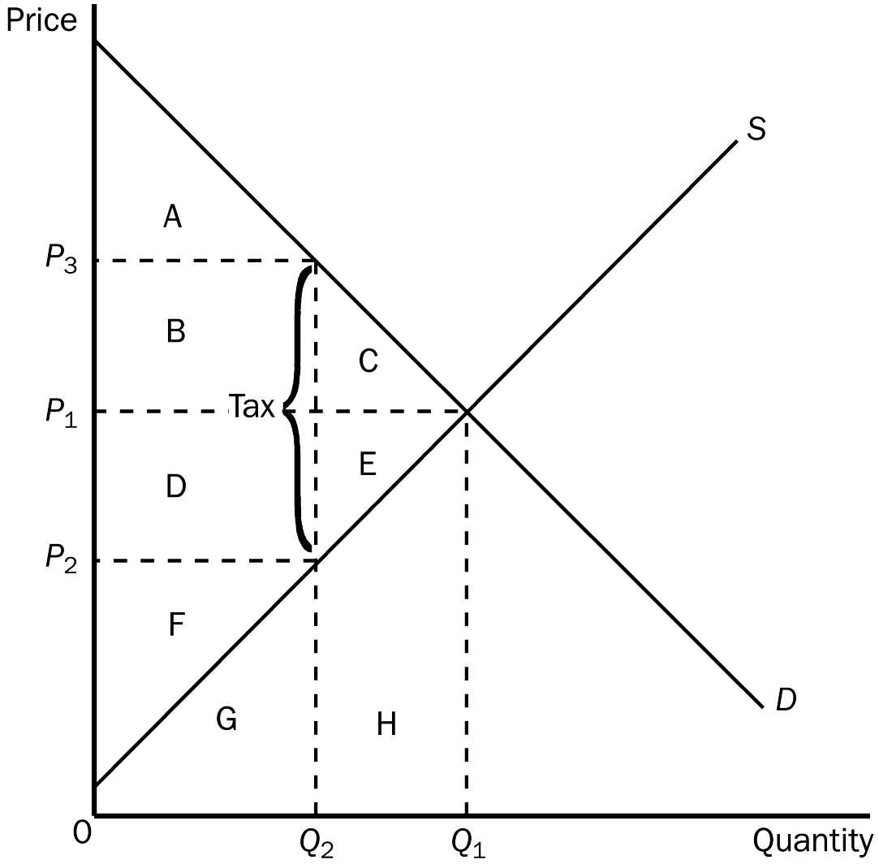
96. Refer to Figure 8-4. The equilibrium price before the tax is imposed is
a. P₁.
b. P₂.
c. P₃.
d. impossible to determine from the figure.
ANS: A PTS: 1 DIF: 1 REF: 8-1
TOP: Equilibrium price MSC: Interpretive
97. Refer to Figure 8-4. The price that buyers effectively pay after the tax is imposed is
a. P₁.
b. P₂.
c. P₃.
d. impossible to determine from the figure.
ANS: C PTS: 1 DIF: 2 REF: 8-1
TOP: Tax | Equilibrium price MSC: Applicative
98. Refer to Figure 8-4. The price that sellers effectively receive after the tax is imposed is
a. P₁.
b. P₂.
c. P₃.
d. impossible to determine from the figure.
ANS: B PTS: 1 DIF: 2 REF: 8-1
TOP: Tax | Equilibrium price MSC: Applicative
99. Refer to Figure 8-4. The tax is levied on
a. buyers only.
b. sellers only.
c. both buyers and sellers.
d. This is impossible to determine from the figure.
ANS: D PTS: 1 DIF: 2 REF: 8-1
TOP: Tax MSC: Interpretive
100. Refer to Figure 8-4. Consumer surplus before the tax was levied is represented by area
a. A.
b. A + B + C.
c. D + E + F.
d. F.
ANS: B PTS: 1 DIF: 2 REF: 8-1
TOP: Consumer surplus MSC: Interpretive
101. Refer to Figure 8-4. Producer surplus before the tax was levied is represented by area
a. A.
b. A + B + C.
c. D + E + F.
d. F.
ANS: C PTS: 1 DIF: 2 REF: 8-1
TOP: Producer surplus MSC: Interpretive
102. Refer to Figure 8-4. After the tax is levied, consumer surplus is represented by area
a. A.
b. A + B + C.
c. D + E + F.
d. F.
ANS: A PTS: 1 DIF: 2 REF: 8-1
TOP: Tax | Consumer surplus MSC: Applicative
103. Refer to Figure 8-4. After the tax is levied, producer surplus is represented by area
a. A.
b. A + B + C.
c. D + E + F.
d. F.
ANS: D PTS: 1 DIF: 2 REF: 8-1
TOP: Tax | Producer surplus MSC: Applicative
104. Refer to Figure 8-4. The tax causes a reduction in consumer surplus that is represented by area
a. A.
b. B + C.
c. D + E.
d. F.
ANS: B PTS: 1 DIF: 2 REF: 8-1
TOP: Tax | Consumer surplus MSC: Applicative
105. Refer to Figure 8-4. The tax causes a reduction in producer surplus that is represented by area
a. A.
b. B + C.
c. D + E.
d. F.
ANS: C PTS: 1 DIF: 2 REF: 8-1
TOP: Tax | Producer surplus MSC: Applicative
106. Refer to Figure 8-4. The benefit to the government is
a. measured by tax revenue and is represented by area A + B.
b. measured by tax revenue and is represented by area B + D.
c. measured by the net gain in total surplus and is represented by area B + D.
d. measured by the net gain in total surplus and is represented by area D + E.
ANS: B PTS: 1 DIF: 2 REF: 8-1
TOP: Tax | Government MSC: Applicative
107. Refer to Figure 8-4. The total surplus (consumer, producer, and government) with the tax is represented by area
a. C + E.
b. A + B + C.
c. D + E + F.
d. A + B + D + F.
ANS: D PTS: 1 DIF: 2 REF: 8-1
TOP: Total surplus MSC: Applicative
108. Refer to Figure 8-4. The loss in total welfare that results from the tax is represented by area
a. A + B + D + F.
b. A + B + C.
c. D + E + F.
d. C + E.
ANS: D PTS: 1 DIF: 2 REF: 8-1
TOP: Deadweight losses MSC: Applicative
Figure 8-5
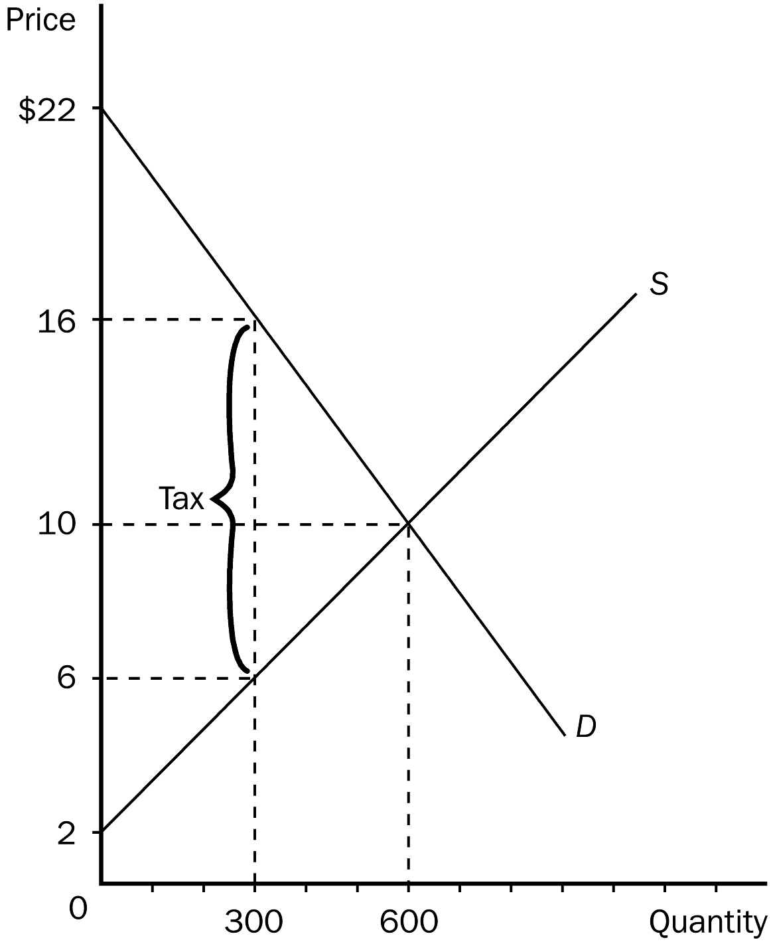
109. Refer to Figure 8-5. Without a tax, the equilibrium price and quantity are
a. $16 and 300.
b. $10 and 600.
c. $10 and 300.
d. $6 and 300.
ANS: B PTS: 1 DIF: 1 REF: 8-1
TOP: Equilibrium price | Equilibrium quantity MSC: Interpretive
110. Refer to Figure 8-5. Without a tax, consumer surplus in this market is
a. $1,500.
b. $2,400.
c. $3,000.
d. $3,600.
ANS: D PTS: 1 DIF: 2 REF: 8-1
TOP: Consumer surplus MSC: Interpretive
111. Refer to Figure 8-5. Without a tax, producer surplus in this market is
a. $1,500.
b. $2,400.
c. $3,000.
d. $3,600.
ANS: B PTS: 1 DIF: 2 REF: 8-1
TOP: Producer surplus MSC: Interpretive
112. Refer to Figure 8-5. Without a tax, total surplus in this market is
a. $3,000.
b. $4,800.
c. $6,000.
d. $7,200.
ANS: C PTS: 1 DIF: 2 REF: 8-1
TOP: Total surplus MSC: Interpretive
113. Refer to Figure 8-5. When a tax is imposed in this market, the price buyers effectively pay is
a. $10.
b. $16.
c. $22.
d. between $10 and $16.
ANS: B PTS: 1 DIF: 2 REF: 8-1
TOP: Tax | Equilibrium price MSC: Applicative
114. Refer to Figure 8-5. When a tax is imposed in this market, the price sellers effectively receive is
a. $6.
b. $10.
c. $16.
d. between $6 and $10.
ANS: A PTS: 1 DIF: 2 REF: 8-1
TOP: Tax | Equilibrium price MSC: Applicative
115. Refer to Figure 8-5. When a tax is imposed in this market, consumer surplus is
a. $600.
b. $900.
c. $1,500.
d. $3,000.
ANS: B PTS: 1 DIF: 2 REF: 8-1
TOP: Tax | Consumer surplus MSC: Applicative
116. Refer to Figure 8-5. When a tax is imposed in this market, producer surplus is
a. $450.
b. $600.
c. $900.
d. $1,500.
ANS: B PTS: 1 DIF: 2 REF: 8-1
TOP: Tax | Producer surplus MSC: Applicative
117. Refer to Figure 8-5. When a tax is placed on this good, the quantity sold
a. is 600 and buyers effectively pay $10.
b. is 300 and buyers effectively pay $10.
c. is 600 and buyers effectively pay $16.
d. is 300 and buyers effectively pay $16.
ANS: D PTS: 1 DIF: 2 REF: 8-1
TOP: Tax | Equilibrium price | Equilibrium quantity MSC: Applicative
118. Refer to Figure 8-5. When the government imposes a tax in this market, tax revenue is
a. $600.
b. $900.
c. $1,500.
d. $3,000.
ANS: D PTS: 1 DIF: 2 REF: 8-1
TOP: Tax | Government MSC: Applicative
119. Refer to Figure 8-5. The amount of the tax on each unit of the good is
a. $6.
b. $8.
c. $10.
d. $12.
ANS: C PTS: 1 DIF: 1 REF: 8-1
TOP: Tax MSC: Interpretive
120. Refer to Figure 8-5. Total surplus with the tax in place is
a. $1,500.
b. $3,600.
c. $4,500.
d. $6,000.
ANS: C PTS: 1 DIF: 2 REF: 8-1
TOP: Tax | Total surplus MSC: Applicative
121. Refer to Figure 8-5. What happens to consumer surplus when a tax is imposed in this market?
a. It falls by $3,600.
b. It falls by $2,700.
c. It falls by $1,800.
d. It falls by $900.
ANS: B PTS: 1 DIF: 3 REF: 8-1
TOP: Tax | Consumer surplus MSC: Applicative
122. Refer to Figure 8-5. What happens to producer surplus when a tax is imposed in this market?
a. It falls by $600.
b. It falls by $900.
c. It falls by $1,800.
d. It falls by $2,100.
ANS: C PTS: 1 DIF: 3 REF: 8-1
TOP: Tax | Producer surplus MSC: Applicative
123. Refer to Figure 8-5. What happens to total surplus in this market when a tax is imposed?
a. It increases by $1,500.
b. It increases by $3,000.
c. It decreases by $1,500.
d. It decreases by $,3000.
ANS: C PTS: 1 DIF: 3 REF: 8-1
TOP: Tax | Total surplus MSC: Applicative
124. Refer to Figure 8-5. The tax results in a deadweight loss that amounts to
a. $600.
b. $900.
c. $1,500.
d. $1,800.
ANS: C PTS: 1 DIF: 3 REF: 8-1
TOP: Deadweight losses MSC: Applicative
Figure 8-6
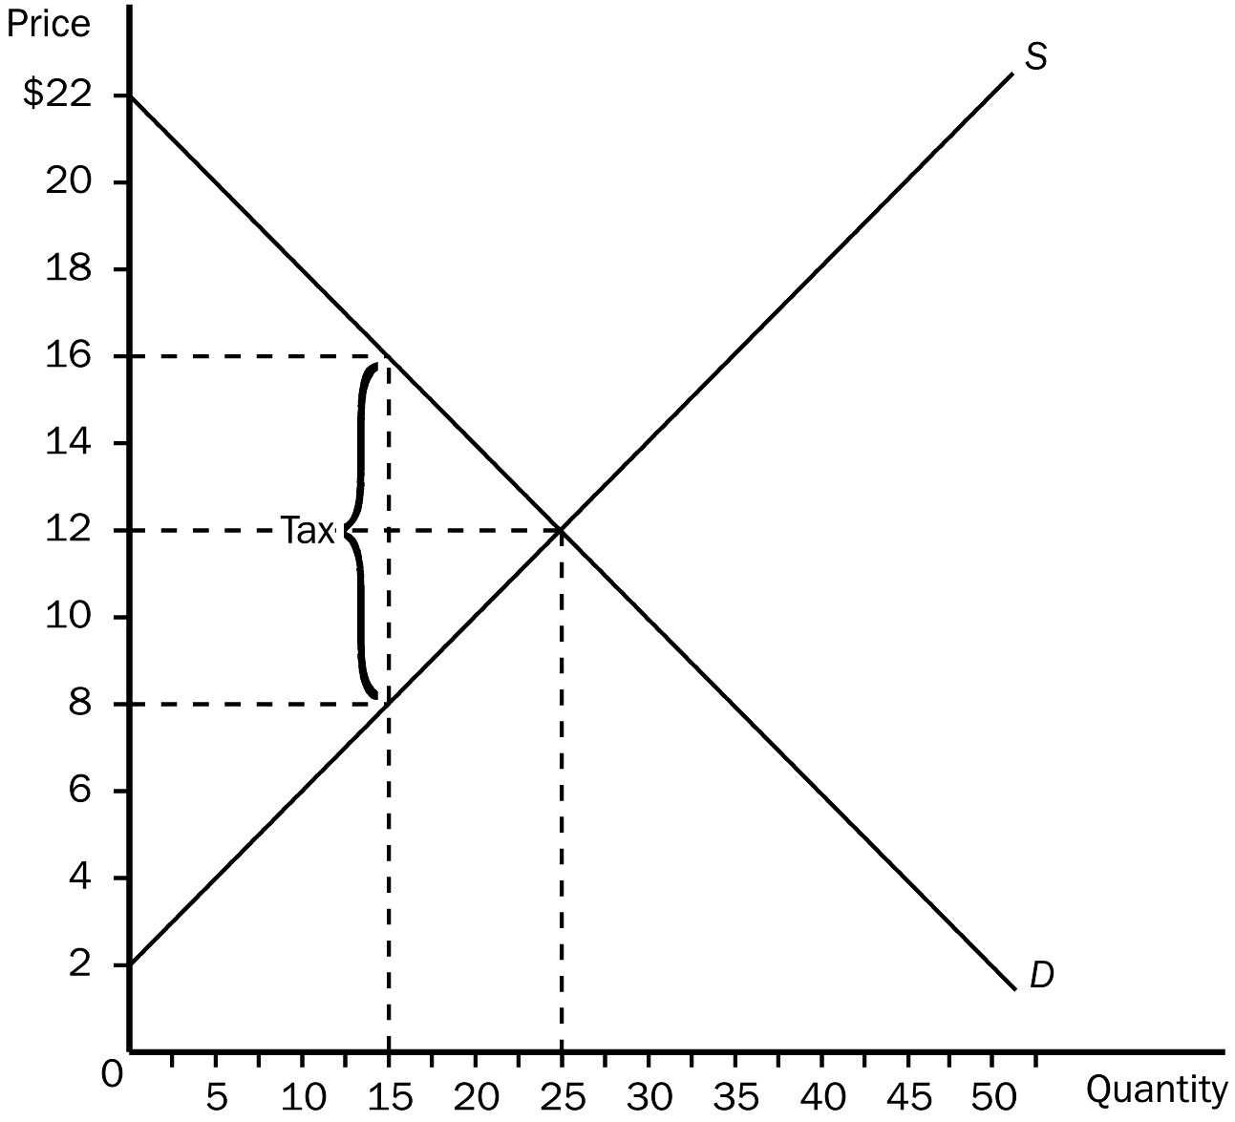
125. Refer to Figure 8-6. Before the tax is imposed,
a. the equilibrium price is $16 and the equilibrium quantity is 15.
b. the equilibrium price is $12 and the equilibrium quantity is 25.
c. the equilibrium price is $12 and the equilibrium quantity is 25.
d. the equilibrium price is $8 and the equilibrium quantity is 15.
ANS: B PTS: 1 DIF: 1 REF: 8-1
TOP: Equilibrium price | Equilibrium quantity MSC: Interpretive
126. Refer to Figure 8-6. As a result of the tax,
a. buyers effectively pay $16 for each unit of the good and sellers effectively receive $12 for each unit of the good.
b. buyers effectively pay $16 for each unit of the good and sellers effectively receive $8 for each unit of the good.
c. buyers effectively pay $12 for each unit of the good and sellers effectively receive $8 for each unit of the good.
d. buyers effectively pay $14 for each unit of the good and sellers effectively receive $10 for each unit of the good.
ANS: B PTS: 1 DIF: 2 REF: 8-1
TOP: Tax | Equilibrium price MSC: Applicative
127. Refer to Figure 8-6. Suppose a 20th unit of the good were sold by a seller to a buyer. Which of the following statements is correct?
a. On the 20th unit, the difference between the buyer’s value and the seller’s cost is less than the tax per unit.
b. On the 20th unit, the difference between the buyer’s value and the seller’s cost is greater than the tax per unit.
c. On the 20th unit, the difference between the buyer’s value and the seller’s cost is equal to the tax per unit.
d. It makes sense for the buyer to buy, and for the seller to sell, the 20th unit with or without the tax in place.
ANS: A PTS: 1 DIF: 2 REF: 8-1
TOP: Deadweight losses MSC: Applicative
128. Refer to Figure 8-6. Which of the following statements summarizes the incidence of the tax?
a. For each unit of the good that is sold, buyers bear one-half of the tax burden and sellers bear one-half of the tax burden.
b. For each unit of the good that is sold, buyers bear one-third of the tax burden and sellers bear two-thirds of the tax burden.
c. For each unit of the good that is sold, buyers bear one-fourth of the tax burden and sellers bear three-fourths of the tax burden.
d. For each unit of the good that is sold, buyers bear three-fourths of the tax burden and sellers bear one-fourth of the tax burden.
ANS: A PTS: 1 DIF: 2 REF: 8-1
TOP: Tax incidence MSC: Applicative
129. Refer to Figure 8-6. Which of the following statements is correct?
a. Total surplus before the tax was imposed amounted to $250.
b. After the tax is imposed, consumer surplus amounts to 36 percent of its pre-tax value.
c. After the tax is imposed, producer surplus amounts to 36 percent of its pre-tax value.
d. All of the above are correct.
ANS: D PTS: 1 DIF: 3 REF: 8-1
TOP: Consumer surplus | Producer surplus | Total surplus MSC: Applicative
130. Refer to Figure 8-6. Which of the following statements is correct?
a. Total surplus before the tax was imposed amounted to $225.
b. After the tax is imposed, consumer surplus amounts to 25 percent of its pre-tax value.
c. After the tax is imposed, the sum of producer surplus and consumer surplus amounts to 36 percent of its pre-tax value.
d. All of the above are correct.
ANS: C PTS: 1 DIF: 3 REF: 8-1
TOP: Consumer surplus | Producer surplus | Total surplus MSC: Applicative
131. Refer to Figure 8-6. As a result of the tax,
a. consumer surplus decreases from $150 to $60.
b. producer surplus decreases from $125 to $45.
c. the market experiences a deadweight loss of $45.
d. All of the above are correct.
ANS: B PTS: 1 DIF: 3 REF: 8-1
TOP: Consumer surplus | Producer surplus | Deadweight losses MSC: Applicative
132. Refer to Figure 8-6. As a result of the tax,
a. consumer surplus decreases by $65; producer surplus decreases by $85; tax revenue of $120 is generated; and the deadweight loss of the tax is $30.
b. consumer surplus decreases by $75; producer surplus decreases by $75; tax revenue of $120 is generated; and the deadweight loss of the tax is $30.
c. consumer surplus decreases by $80; producer surplus decreases by $80; tax revenue of $120 is generated; and the deadweight loss of the tax is $40.
d. consumer surplus decreases by $120; producer surplus decreases by $120; tax revenue of $200 is generated; and the deadweight loss of the tax is $40.
ANS: C PTS: 1 DIF: 3 REF: 8-1
TOP: Consumer surplus | Producer surplus | Deadweight losses MSC: Applicative
133. Refer to Figure 8-6. Which of the following statements is correct?
a. The loss of producer surplus that is associated with some sellers dropping out of the market as a result of the tax is $30.
b. The loss of consumer surplus for those buyers of the good who continue to buy it after the tax is imposed is $60.
c. The loss of consumer surplus caused by this tax exceeds the loss of producer surplus caused by this tax.
d. This tax produces $200 in tax revenue for the government.
ANS: B PTS: 1 DIF: 3 REF: 8-1
TOP: Consumer surplus | Producer surplus | Deadweight losses MSC: Applicative
134. Refer to Figure 8-6. The deadweight loss associated with this tax amounts to
a. $60, and this figure represents the amount by which tax revenue to the government exceeds the combined loss of producer and consumer surpluses.
b. $60, and this figure represents the surplus that is lost because the tax discourages mutually advantageous trades between buyers and sellers.
c. $40, and this figure represents the amount by which tax revenue to the government exceeds the combined loss of producer and consumer surpluses.
d. $40, and this figure represents the surplus that is lost because the tax discourages mutually advantageous trades between buyers and sellers.
ANS: D PTS: 1 DIF: 3 REF: 8-1
TOP: Deadweight losses MSC: Analytical
Figure 8-7 The graph below represents a $10 per unit tax on a good. On the graph, Q represents quantity and P represents price.
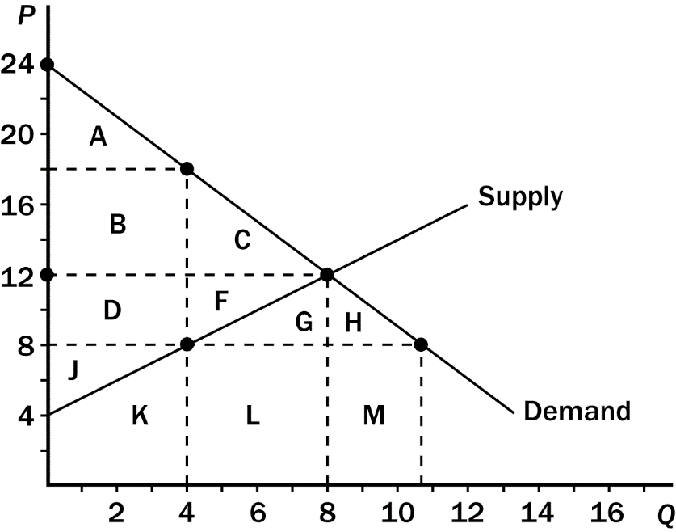
135. Refer to Figure 8-7. The tax causes consumer surplus to decrease by the area
a. A.
b. B + C.
c. A + B + C.
d. A + B + C+ D + F.
ANS: B PTS: 1 DIF: 2 REF: 8-1
TOP: Tax | Consumer surplus MSC: Interpretive
136. Refer to Figure 8-7. After the tax goes into effect, consumer surplus is the area
a. A.
b. B + C.
c. A + B + C.
d. A + B + D + J + K.
ANS: A PTS: 1 DIF: 2 REF: 8-1
TOP: Tax | Consumer surplus MSC: Interpretive
137. Refer to Figure 8-7. The tax causes producer surplus to decrease by the area
a. D + F.
b. D + F + G.
c. D + F + J.
d. D + F + G + H.
ANS: A PTS: 1 DIF: 2 REF: 8-1
TOP: Tax | Producer surplus MSC: Interpretive
138. Refer to Figure 8-7. After the tax goes into effect, producer surplus is the area
a. D + F + G + H + J.
b. D + F + G + H.
c. D + F + J.
d. J.
ANS: D PTS: 1 DIF: 2 REF: 8-1
TOP: Tax | Producer surplus MSC: Interpretive
139. Refer to Figure 8-7. The government collects tax revenue that is represented by the area
a. L.
b. B + D.
c. C + F.
d. F + G + L.
ANS: B PTS: 1 DIF: 2 REF: 8-1
TOP: Tax | Government MSC: Applicative
140. Refer to Figure 8-7. The decrease in consumer and producer surpluses that is not offset by tax revenue is the area
a. C.
b. F.
c. G.
d. C + F.
ANS: D PTS: 1 DIF: 2 REF: 8-1
TOP: Deadweight losses MSC: Applicative
141. Refer to Figure 8-7. The deadweight loss of the tax is represented by the area
a. B + D.
b. C + F.
c. A + C + F + J.
d. B + C + D + F.
ANS: B PTS: 1 DIF: 2 REF: 8-1
TOP: Deadweight losses MSC: Applicative
142. Refer to Figure 8-7. One effect of the tax is to
a. reduce consumer surplus from $60 to $24.
b. reduce producer surplus from $32 to $8.
c. create a deadweight loss of $24.
d. All of the above are correct.
ANS: B PTS: 1 DIF: 3 REF: 8-1
TOP: Consumer surplus | Producer surplus | Deadweight losses MSC: Applicative
143. Refer to Figure 8-7. One effect of the tax is to
a. reduce consumer surplus by $36.
b. reduce producer surplus by $24.
c. create a deadweight loss of $20.
d. All of the above are correct.
ANS: D PTS: 1 DIF: 3 REF: 8-1
TOP: Consumer surplus | Producer surplus | Deadweight losses MSC: Applicative
Scenario 8-1
Ryan would be willing to pay as much as $100 per week to have his house cleaned. Tammy's opportunity cost of cleaning Ryan’s house is $70 per week.
144. Refer to Scenario 8-1. If Ryan pays Tammy $80 to clean his house, Ryan’s consumer surplus is
a. $100.
b. $80.
c. $70.
d. $20.
ANS: D PTS: 1 DIF: 1 REF: 8-1
TOP: Consumer surplus MSC: Interpretive
145. Refer to Scenario 8-1. If Tammy cleans Ryan's house for $80, Tammy’s producer surplus is
a. $10.
b. $70.
c. $80.
d. $100.
ANS: A PTS: 1 DIF: 1 REF: 8-1
TOP: Producer surplus MSC: Interpretive
146. Refer to Scenario 8-1. Assume Ryan is required to pay a tax of $40 when he hires someone to clean his house for a week. Which of the following is correct?
a. Ryan will now clean his own house.
b. Tammy will continue to clean Ryan's house but her producer surplus will decline.
c. Total economic welfare (consumer surplus plus producer surplus plus tax revenue) will increase.
d. Ryan will continue to hire Tammy to clean his house but his consumer surplus will decline.
ANS: A PTS: 1 DIF: 2 REF: 8-1
TOP: Tax | Deadweight losses MSC: Applicative
147. Refer to Scenario 8-1. Assume Ryan is required to pay a tax of $15 when he hires someone to clean his house. Which of the following is true?
a. Ryan will continue to hire Tammy to clean his house but his consumer surplus will decline.
b. Tammy will continue to clean Ryan's house but her producer surplus will decline.
c. Total economic welfare (consumer surplus plus producer surplus plus tax revenue) will decrease.
d. All of the above are correct.
ANS: D PTS: 1 DIF: 2 REF: 8-1
TOP: Tax | Deadweight losses MSC: Applicative
Scenario 8-2
Tom mows Stephanie's lawn for $25. Tom’s opportunity cost of mowing Stephanie’s lawn is $20, and Stephanie's willingness to pay Tom to mow her lawn is $28.
148. Refer to Scenario 8-2. Stephanie's consumer surplus as a result of hiring Tom to mow her lawn is
a. $3.
b. $5.
c. $8.
d. $25.
ANS: A PTS: 1 DIF: 1 REF: 8-1
TOP: Consumer surplus MSC: Interpretive
149. Refer to Scenario 8-2. Tom’s producer surplus as a result of mowing Stephanie’s lawn is
a. $2.
b. $3.
c. $5.
d. $25.
ANS: C PTS: 1 DIF: 1 REF: 8-1
TOP: Producer surplus MSC: Interpretive
150. Refer to Scenario 8-2. Assume Ryan is required to pay a tax of $3 each time he mows a lawn. Which of the following results is most likely?
a. Stephanie now will decide to mow her own lawn, and Ryan will decide it is no longer in his interest to mow Stephanie’s lawn.
b. Stephanie still is willing to pay Ryan to mow her lawn, but Ryan will decline her offer.
c. Ryan still is willing to mow Stephanie’s lawn, but Stephanie will decide to mow her own lawn.
d. Ryan and Stephanie still can engage in a mutually agreeable trade.
ANS: D PTS: 1 DIF: 2 REF: 8-1
TOP: Tax | Deadweight losses MSC: Applicative
151. Refer to Scenario 8-2. Assume Ryan is required to pay a tax of $10 each time he mows a lawn. Which of the following results is most likely?
a. Stephanie now will decide to mow her own lawn, and Ryan will decide it is no longer in his interest to mow Stephanie’s lawn.
b. Stephanie still is willing to pay Ryan to mow her lawn, but Ryan will decline her offer.
c. Ryan still is willing to mow Stephanie’s lawn, but Stephanie will decide to mow her own lawn.
d. Ryan and Stephanie still can engage in a mutually agreeable trade.
ANS: A PTS: 1 DIF: 2 REF: 8-1
TOP: Tax | Deadweight losses MSC: Applicative
152. The deadweight loss from a tax
a. does not vary in amount when the price elasticity of demand changes.
b. does not vary in amount when the amount of the tax per unit changes.
c. is larger, the larger is the amount of the tax per unit.
d. is smaller, the larger is the amount of the tax per unit.
ANS: C PTS: 1 DIF: 2 REF: 8-2
TOP: Deadweight losses MSC: Interpretive
153. Which of the following statements is correct regarding a tax on a good and the resulting deadweight loss?
a. The greater are the price elasticities of supply and demand, the greater is the deadweight loss.
b. The greater is the price elasticity of supply and the smaller is the price elasticity of demand, the greater is the deadweight loss.
c. The smaller are the decreases in quantity demanded and quantity supplied, the greater the deadweight loss.
d. The smaller is the wedge between the effective price to sellers and the effective price to buyers, the greater is the deadweight loss.
ANS: A PTS: 1 DIF: 2 REF: 8-2
TOP: Elasticity | Deadweight losses MSC: Applicative
154. The amount of deadweight loss that results from a tax of a given size is determined by the
a. response of buyers to the tax.
b. number of buyers in the market relative to the number of sellers.
c. price elasticities of demand and supply.
d. ratio of the tax per unit to the effective price received by sellers.
ANS: C PTS: 1 DIF: 2 REF: 8-2
TOP: Elasticity | Deadweight losses MSC: Interpretive
155. The amount of deadweight loss from a tax depends upon
a. the price elasticity of demand.
b. the price elasticity of supply.
c. the amount of the tax per unit.
d. All of the above are correct.
ANS: D PTS: 1 DIF: 2 REF: 8-2
TOP: Deadweight losses MSC: Interpretive
156. Suppose a tax of $1 per unit is imposed on a good. The more elastic the supply of the good, other things equal,
a. the smaller is the response of quantity supplied to the tax.
b. the larger is the tax burden on sellers relative to the tax burden on buyers.
c. the larger is the deadweight loss of the tax.
d. All of the above are correct.
ANS: C PTS: 1 DIF: 3 REF: 8-2
TOP: Price elasticity of supply | Deadweight losses MSC: Applicative
157. Suppose a tax of $1 per unit is imposed on a good. The more elastic the demand for the good, other things equal,
a. the larger is the decrease in quantity demanded as a result of the tax.
b. the smaller is the tax burden on buyers relative to the tax burden on sellers.
c. the larger is the deadweight loss of the tax.
d. All of the above are correct.
ANS: D PTS: 1 DIF: 3 REF: 8-2
TOP: Price elasticity of demand | Deadweight losses MSC: Analytical
158. Quantitatively, which of the following taxes are the most important taxes in the U.S. economy?
a. taxes on investment
b. taxes on labor
c. sales taxes
d. property taxes
ANS: B PTS: 1 DIF: 1 REF: 8-2
TOP: Taxes | Labor MSC: Interpretive
159. Economists disagree on whether labor taxes cause small or large deadweight losses. This disagreement arises primarily because economists hold different views about
a. the size of labor taxes.
b. the importance of labor taxes imposed by the federal government relative to the importance of labor taxes imposed by the various states.
c. the elasticity of labor supply.
d. the elasticity of labor demand.
ANS: C PTS: 1 DIF: 2 REF: 8-2
TOP: Taxes | Labor | Elasticity | Deadweight losses MSC: Interpretive
160. Taxes on labor have the effect of encouraging
a. workers to work more hours.
b. the elderly to postpone retirement.
c. second earners within a family to take a job.
d. unscrupulous people to take part in the underground economy.
ANS: D PTS: 1 DIF: 2 REF: 8-2
TOP: Taxes | Labor MSC: Interpretive
161. The size of a tax and the deadweight loss that results from the tax are
a. positively related.
b. negatively related.
c. independent of each other.
d. equal to each other.
ANS: A PTS: 1 DIF: 1 REF: 8-2
TOP: Deadweight losses MSC: Interpretive
162. Suppose that policymakers are considering placing a tax on either of two markets. In Market A, the tax will have a significant effect on the price consumers pay, but it will not affect equilibrium quantity very much. In Market B, the same tax will have only a small effect on the price consumers pay, but it will have a large effect on the equilibrium quantity. Other factors are held constant. In which market will the tax have a larger deadweight loss?
a. Market A
b. Market B
c. The deadweight loss will be the same in both markets.
d. There is not enough information to answer the question.
ANS: B PTS: 1 DIF: 2 REF: 8-2
TOP: Deadweight losses MSC: Applicative
163. Consider a good to which a per-unit tax applies. The greater the price elasticities of demand and supply for the good, the
a. smaller the deadweight loss from the tax.
b. greater the deadweight loss from the tax.
c. more efficient is the tax.
d. more equitable is the distribution of the tax burden between buyers and sellers.
ANS: B PTS: 1 DIF: 2 REF: 8-2
TOP: Deadweight losses | Elasticity MSC: Interpretive
164. Consider a good to which a per-unit tax applies. The size of the deadweight that results from the tax is smaller, the
a. larger is the price elasticity of demand.
b. smaller is the price elasticity of supply.
c. larger is the amount of the tax.
d. All of the above are correct.
ANS: B PTS: 1 DIF: 2 REF: 8-2
TOP: Deadweight losses MSC: Interpretive
165. Consider a good to which a per-unit tax applies. The size of the deadweight that results from the tax is smaller, the
a. less elastic is the demand.for the good.
b. less elastic is the supply of the good.
c. smaller is the amount of the tax.
d. All of the above are correct.
ANS: D PTS: 1 DIF: 2 REF: 8-2
TOP: Deadweight losses MSC: Interpretive
166. Assume the price of gasoline is $2.00 per gallon and the equilibrium quantity of gasoline is 10 million gallons per day with no tax on gasoline. Starting from this initial situation, which of the following scenarios would result in the largest deadweight loss?
a. The price elasticity of demand for gasoline is 0.1; the price elasticity of supply for gasoline is 0.6; and the gasoline tax amounts to $0.20 per gallon.
b. The price elasticity of demand for gasoline is 0.1; the price elasticity of supply for gasoline is 0.4; and the gasoline tax amounts to $0.20 per gallon.
c. The price elasticity of demand for gasoline is 0.2; the price elasticity of supply for gasoline is 0.6; and the gasoline tax amounts to $0.30 per gallon.
d. There is insufficient information to make this determination.
ANS: C PTS: 1 DIF: 3 REF: 8-2
TOP: Deadweight losses MSC: Applicative
167. Assume the price of gasoline is $2.40 per gallon and the equilibrium quantity of gasoline is 12 million gallons per day with no tax on gasoline. Starting from this initial situation, which of the following scenarios would result in the largest deadweight loss?
a. A 10 percent increase in the price of gasoline reduces the quantity of gasoline demanded by 2 percent and it increases the quantity of gasoline supplied by 5 percent; and the tax on gasoline amounts to $0.40 per gallon.
b. A 10 percent increase in the price of gasoline reduces the quantity of gasoline demanded by 2 percent and it increases the quantity of gasoline supplied by 7 percent; and the tax on gasoline amounts to $0.40 per gallon.
c. A 10 percent increase in the price of gasoline reduces the quantity of gasoline demanded by 1 percent and it increases the quantity of gasoline supplied by 8 percent; and the tax on gasoline amounts to $0.35 per gallon.
d. There is insufficient information to make this determination.
ANS: D PTS: 1 DIF: 3 REF: 8-2
TOP: Deadweight losses MSC: Applicative
168. Other things equal, the deadweight loss of a tax
a. decreases as the size of the tax increases.
b. increases as the size of the tax increases, but the increase in the deadweight loss is less rapid than the increase in the size of the tax.
c. increases as the size of the tax increases, and the increase in the deadweight loss is more rapid than the increase in the size of the tax.
d. increases as the price elasticities of demand and/or supply increase, but the deadweight loss does not change as the size of the tax increases.
ANS: C PTS: 1 DIF: 3 REF: 8-2
TOP: Deadweight losses MSC: Applicative
169. Economists generally agree that the most important tax in the U.S. economy is
a. the income tax.
b. the tax on labor.
c. the inheritance or death tax.
d. corporate profit taxes.
ANS: B PTS: 1 DIF: 1 REF: 8-2
TOP: Taxes | Labor MSC: Interpretive
170. Concerning the labor market and taxes on labor, economists disagree about
a. the size of the tax on labor.
b. the size of the deadweight loss of the tax on labor.
c. whether or not a tax on labor places a wedge between the wage that firms pay and the wage that workers receive.
d. All of the above are correct.
ANS: B PTS: 1 DIF: 2 REF: 8-2
TOP: Economists | Taxes MSC: Interpretive
171. The Social Security tax is a tax on
a. capital.
b. labor.
c. consumption expenditures.
d. earnings during retirement.
ANS: B PTS: 1 DIF: 1 REF: 8-2
TOP: Tax | Social Security MSC: Interpretive
172. As more people become self-employed, which allows them to determine how many hours they work per week, we would expect the deadweight loss from the Social Security tax to
a. increase and the revenue generated from the tax to increase.
b. increase and the revenue generated from the tax to decrease.
c. decrease and the revenue generated from the tax to increase.
d. decrease and the revenue generated from the tax to decrease.
ANS: B PTS: 1 DIF: 2 REF: 8-2
TOP: Tax | Social Security MSC: Applicative
173. Which of the following taxes is, at least in large part, a tax on labor?
a. the Social Security tax
b. the Medicare tax
c. the federal income tax
d. All of the above are correct.
ANS: D PTS: 1 DIF: 2 REF: 8-2
TOP: Taxes | Labor MSC: Interpretive
174. If the labor supply curve is nearly vertical, a tax on labor
a. has a large deadweight loss.
b. raises a small amount of tax revenue.
c. has little impact on the amount of work that workers are willing to do.
d. results in a large tax burden on the firms that hire labor.
ANS: C PTS: 1 DIF: 2 REF: 8-2
TOP: Tax | Inelastic supply MSC: Applicative
175. The marginal tax rate on labor income for many workers in the United States is almost
a. 30 percent.
b. 40 percent.
c. 50 percent.
d. 65 percent.
ANS: C PTS: 1 DIF: 1 REF: 8-2
TOP: Taxes | Labor MSC: Definitional
176. The more mothers are pressured by society to be housekeepers and stay out of the labor force, the
a. more elastic the supply of labor will be.
b. less elastic the supply of labor will be.
c. flatter the labor supply curve will be.
d. greater is the decrease in employment that will result from a tax on labor.
ANS: B PTS: 1 DIF: 2 REF: 8-2
TOP: Elasticity | Labor MSC: Applicative
177. The more freedom people are given to choose the date of their retirement, the
a. more elastic is the supply of labor.
b. less elastic is the supply of labor.
c. steeper is the labor supply curve.
d. smaller is the decrease in employment that will result from a tax on labor.
ANS: A PTS: 1 DIF: 2 REF: 8-2
TOP: Elasticity | Labor MSC: Applicative
178. Taxes on labor encourage all of the following except
a. older workers to take early retirement from the labor force.
b. mothers to stay at home rather than work in the labor force.
c. workers to work overtime.
d. people to be paid “under the table.”
ANS: C PTS: 1 DIF: 2 REF: 8-2
TOP: Taxes | Labor MSC: Interpretive
179. Henry George argued that the government should raise
a. all of its revenue from a tax on land.
b. all of its revenue from taxes on labor.
c. most of its revenue from consumption taxes.
d. tax revenue from multiple and diverse taxes.
ANS: A PTS: 1 DIF: 1 REF: 8-2
TOP: Land tax MSC: Definitional
180. Since the amount of land is fixed, the total supply of land is
a. relatively elastic.
b. perfectly elastic.
c. perfectly inelastic.
d. relatively inelastic.
ANS: C PTS: 1 DIF: 1 REF: 8-2
TOP: Perfectly inelastic supply MSC: Interpretive
181. If the supply of land is fixed, the burden of a tax on land falls
a. partly on landowners and partly on users of land.
b. entirely on the renters or users of land.
c. entirely on workers.
d. entirely on landowners.
ANS: D PTS: 1 DIF: 2 REF: 8-2
TOP: Land tax MSC: Interpretive
182. A tax on raw land causes
a. a large deadweight loss.
b. no deadweight loss.
c. landlords to bear none of the burden of the tax.
d. the generation of such a large amount of tax revenue that all other taxes could be eliminated.
ANS: B PTS: 1 DIF: 2 REF: 8-2
TOP: Land tax | Deadweight losses MSC: Interpretive
183. Today's property tax
a. taxes only raw land.
b. is exactly the same as Henry George's single-tax proposal.
c. taxes land and the improvements to land.
d. has no deadweight loss since the amount of revenue going to the government equals the reduction in the landowners’ surplus.
ANS: C PTS: 1 DIF: 2 REF: 8-2
TOP: Land tax MSC: Definitional
184. For Henry George's single tax on land not to distort economic incentives, the tax would have to be on
a. improvements to land.
b. land used for commercial purposes.
c. land used for residential purposes.
d. raw land.
ANS: D PTS: 1 DIF: 2 REF: 8-2
TOP: Land tax MSC: Interpretive
185. For Henry George's land-tax argument to be valid, the land that is taxed must be
a. improved land.
b. productive land.
c. raw land.
d. urban land.
ANS: C PTS: 1 DIF: 2 REF: 8-2
TOP: Land tax MSC: Interpretive
186. Unlike the supply of raw land, the supply of improvements
a. is perfectly inelastic.
b. has an elasticity that is greater than zero.
c. cannot be taxed, even if an attempt were made to tax it.
d. is exempt from taxation under current law.
ANS: B PTS: 1 DIF: 2 REF: 8-2
TOP: Land tax MSC: Interpretive
187. One negative aspect of Henry George's single tax on land is that, if it were applied today,
a. the loss of surplus to landowners would be greater than the tax revenue raised.
b. the deadweight loss would be much larger than the deadweight loss of alternative taxes.
c. the tax would not raise enough revenue to pay for government spending.
d. it would result in enormous harm to users of land.
ANS: C PTS: 1 DIF: 2 REF: 8-2
TOP: Land tax MSC: Interpretive
188. According to the economist Milton Friedman, the "least bad" tax is a tax on
a. income received from profits and interest.
b. labor income.
c. the unimproved value of land.
d. the value of land including the improvements to the land.
ANS: C PTS: 1 DIF: 1 REF: 8-2
TOP: Land tax MSC: Definitional
189. Nobel Prize-winning economist Milton Friedman said that, "In my opinion, the least bad tax is the property tax on the unimproved value of land." Why?
a. Land owners can afford the tax better than other people.
b. A tax on unimproved land would be sufficient to fund government, so all other taxes could be abolished.
c. Such a tax could generate more government revenue than any tax on labor or capital.
d. A tax on unimproved land would have no deadweight loss.
ANS: D PTS: 1 DIF: 2 REF: 8-2
TOP: Land tax MSC: Interpretive
190. If the tax on a good is doubled, the deadweight loss of the tax
a. increases by 50 percent.
b. doubles.
c. triples.
d. quadruples.
ANS: D PTS: 1 DIF: 3 REF: 8-3
TOP: Deadweight losses MSC: Analytical
191. If the tax on a good is doubled, the deadweight loss of the tax
a. remains constant.
b. doubles.
c. quadruples.
d. decreases by a percentage that cannot be determined without further information.
ANS: C PTS: 1 DIF: 3 REF: 8-3
TOP: Deadweight losses MSC: Analytical
192. If the tax on a good is increased from $0.10 per unit to $0.40 per unit, the deadweight loss from the tax
a. remains constant.
b. increases by a factor of 4.
c. increases by a factor of 9.
d. increases by a factor of 16.
ANS: D PTS: 1 DIF: 3 REF: 8-3
TOP: Deadweight losses MSC: Analytical
193. In which of the following instances would the deadweight loss of the tax on airline tickets increase by a factor of 9?
a. The tax on airline tickets increases from $20 per ticket to $60 per ticket.
b. The tax on airline tickets increases from $20 per ticket to $90 per ticket.
c. The tax on airline tickets increases from $15 per ticket to $60 per ticket.
d. The tax on airline tickets increases from $15 per ticket to $135 per ticket.
ANS: A PTS: 1 DIF: 3 REF: 8-3
TOP: Deadweight losses MSC: Analytical
194. Which of the following events is consistent with an increase in the deadweight loss of the gasoline tax from $30 million to $120 million?
a. The tax on gasoline increases from $0.30 per gallon to $0.45 per gallon.
b. The tax on gasoline increases from $0.30 per gallon to $0.60 per gallon.
c. The tax on gasoline increases from $0.25 per gallon to $0.45 per gallon.
d. The tax on gasoline increases from $0.25 per gallon to $1.00 per gallon.
ANS: B PTS: 1 DIF: 3 REF: 8-3
TOP: Deadweight losses MSC: Analytical
195. The supply curve and the demand curve for a good are straight lines, and the good is taxed. When the tax is doubled,
a. the base of the triangle that represents the deadweight loss quadruples.
b. the height of the triangle that represents the deadweight loss doubles.
c. the deadweight loss of the tax doubles.
d. All of the above are correct.
ANS: B PTS: 1 DIF: 2 REF: 8-3
TOP: Deadweight losses MSC: Applicative
196. If the size of a tax increases, tax revenue
a. definitely increases.
b. definitely decreases.
c. definitely remains the same.
d. may increase, decrease, or remain the same.
ANS: D PTS: 1 DIF: 2 REF: 8-3
TOP: Taxes MSC: Interpretive
197. The Laffer curve relates
a. the tax rate to tax revenue raised by the tax.
b. the tax rate to the deadweight loss of the tax.
c. the price elasticity of supply to the deadweight loss of the tax.
d. government welfare payments to the birth rate.
ANS: A PTS: 1 DIF: 2 REF: 8-3
TOP: Laffer curve MSC: Definitional
198. Ronald Reagan believed that reducing income tax rates would
a. do little, if anything, to encourage hard work.
b. result in large increases in deadweight losses.
c. raise economic well-being and perhaps even tax revenue.
d. lower economic well-being, even though tax revenue could possibly increase.
ANS: C PTS: 1 DIF: 2 REF: 8-3
TOP: Economic welfare | Laffer curve MSC: Definitional
199. The view held by Arthur Laffer and Ronald Reagan—that cuts in tax rates would encourage people to increase the quantity of labor they supplied—became known as
a. California economics.
b. welfare economics.
c. supply-side economics.
d. elasticity economics.
ANS: C PTS: 1 DIF: 1 REF: 8-3
TOP: Supply-side economics MSC: Definitional
200. Which of the following scenarios is not consistent with the Laffer curve?
a. The tax rate is very low and tax revenue is very low.
b. The tax rate is very high and tax revenue is very low.
c. The tax rate is very high and tax revenue is very high.
d. The tax rate is moderate (between very high and very low) and tax revenue is relatively high.
ANS: C PTS: 1 DIF: 2 REF: 8-3
TOP: Laffer curve MSC: Interpretive
201. When a country is on the downward-sloping side of the Laffer curves, a cut in the tax rate will
a. decrease tax revenue and decrease the deadweight loss.
b. decrease tax revenue and increase the deadweight loss.
c. increase tax revenue and decrease the deadweight loss.
d. increase tax revenue and increase the deadweight loss.
ANS: C PTS: 1 DIF: 2 REF: 8-3
TOP: Laffer curve MSC: Applicative
202. Studies indicate that if income tax rates in Sweden had been reduced from their high 1980s levels, income tax collections would have
a. decreased moderately.
b. decreased significantly.
c. risen.
d. remained roughly constant.
ANS: C PTS: 1 DIF: 2 REF: 8-3
TOP: Tax rates MSC: Definitional
203. The argument that cutting income tax rates will increase tax revenues
a. clearly has merit for the United States but not for most other countries.
b. clearly has merit for all countries that have income taxes.
c. may not have merit for the United States but it has merit for most other countries.
d. is most likely to have merit for a country that has very high marginal tax rates.
ANS: D PTS: 1 DIF: 2 REF: 8-3
TOP: Tax rates MSC: Interpretive
204. The higher a country's tax rates, the more likely that country will be
a. at the top of the Laffer curve.
b. on the positively sloped part of the Laffer curve.
c. on the negatively sloped part of the Laffer curve.
d. experiencing small deadweight losses.
ANS: C PTS: 1 DIF: 2 REF: 8-3
TOP: Laffer curve MSC: Interpretive
205. Which of the following would likely have the smallest deadweight loss relative to the tax revenue?
a. a head tax (that is, a tax everyone must pay regardless of what one does or buys)
b. an income tax
c. a tax on compact discs
d. a tax on caviar
ANS: A PTS: 1 DIF: 3 REF: 8-3
TOP: Deadweight losses MSC: Analytical
206. Which of the following statements is true for markets in which the demand curve slopes downward and the supply curve slopes upward?
a. As the size of the tax increases, tax revenue continually rises and deadweight loss continually falls.
b. As the size of the tax increases, tax revenue and deadweight loss rise initially, but both eventually begin to fall.
c. As the size of the tax increases, tax revenue rises initially, but it eventually begins to fall; deadweight loss continually rises.
d. As the size of the tax increases, tax revenue rises initially, but it eventually begins to fall; deadweight loss falls initially, but eventually it begins to rise.
ANS: C PTS: 1 DIF: 2 REF: 8-3
TOP: Deadweight losses MSC: Applicative
207. Which of the following ideas is the most plausible?
a. Reducing a high tax rate is less likely to increase tax revenue than is reducing a low tax rate.
b. Reducing a high tax rate is more likely to increase tax revenue than is reducing a low tax rate.
c. Reducing a high tax rate will have the same effect on tax revenue as reducing a low tax rate.
d. Reducing a tax rate can never increase tax revenue.
ANS: B PTS: 1 DIF: 3 REF: 8-3
TOP: Tax rates | Laffer curve MSC: Applicative
208. Suppose the tax on gasoline is raised from $0.50 per gallon to $2.50 per gallon. As a result,
a. tax revenue necessarily increases.
b. the deadweight loss of the tax necessarily increases.
c. the supply curve for gasoline necessarily becomes steeper.
d. All of the above are correct.
ANS: B PTS: 1 DIF: 2 REF: 8-3
TOP: Deadweight losses MSC: Applicative
209. Suppose the tax on liquor is increased so that the tax goes from being a "medium" tax to being a "large" tax. As a result, it is likely that
a. tax revenue increases and the deadweight loss increases.
b. tax revenue increases and the deadweight loss decreases.
c. tax revenue decreases and the deadweight loss increases.
d. tax revenue decreases and the deadweight loss decreases.
ANS: C PTS: 1 DIF: 2 REF: 8-3
TOP: Deadweight losses MSC: Applicative
210. As the tax on a good increases from $1 per unit to $2 per unit to $3 per unit and so on,
a. the tax revenue increases at first, but it eventually peaks and then decreases.
b. the deadweight loss increases at first, but it eventually peaks and then decreases.
c. the tax revenue always increases and the deadweight loss always increases.
d. the tax revenue always decreases and the deadweight loss always increases.
ANS: A PTS: 1 DIF: 2 REF: 8-3
TOP: Deadweight losses MSC: Applicative
211. In which of the following cases is it most likely that an increase in the size of a tax will decrease tax revenue?
a. The price elasticity of demand is small and the price elasticity of supply is large.
b. The price elasticity of demand is large and the price elasticity of supply is small.
c. The price elasticity of demand and the price elasticity of supply are both small.
d. The price elasticity of demand and the price elasticity of supply are both large.
ANS: D PTS: 1 DIF: 3 REF: 8-3
TOP: Price elasticity of demand | Price elasticity of supply MSC: Analytical
212. Which of the following statements is correct?
a. According to the evidence from major industrial countries, there is no significant relationship between tax rates and the average number of hours worked per week.
b. In the early 1970s, the average French worker worked more hours per week than the average American worker; by the mid-1990s, the reverse was true.
c. Between the early 1970s and the mid-1990s, labor taxes in France decreased while labor taxes in the United States remained roughly constant.
d. All of the above are correct.
ANS: B PTS: 1 DIF: 2 REF: 8-3
TOP: Taxes | Labor MSC: Interpretive
213. Which of the following statements is correct?
a. In 2005, the combined Social Security-Medicare tax amounted to 15.3 percent of a worker’s income.
b. The White House budget office has asserted that Social Security and Medicare have promised to pay out $18 trillion more in benefits than they will receive in revenue in coming decades.
c. If payroll taxes are increased to maintain current levels of Social Security and Medicare benefits, an expected result would be fewer hours worked per week by the average American worker.
d. All of the above are correct.
ANS: D PTS: 1 DIF: 2 REF: 8-3
TOP: Taxes | Social Security | Medicare MSC: Interpretive
True/False
1. Normally, both buyers and sellers of a good become worse off when the good is taxed.
ANS: T PTS: 1 DIF: 2 REF: 8-1
TOP: Tax | Buyers | Sellers MSC: Interpretive
2. When a good is taxed, the tax revenue collected by the government equals the decrease in the welfare of buyers and sellers caused by the tax.
ANS: F PTS: 1 DIF: 2 REF: 8-1
TOP: Tax | Economic welfare MSC: Interpretive
3. A tax places a wedge between the price buyers pay and the price sellers receive.
ANS: T PTS: 1 DIF: 1 REF: 8-1
TOP: Tax | Equilibrium price MSC: Interpretive
4. A tax on a good causes the size of the market to increase.
ANS: F PTS: 1 DIF: 1 REF: 8-1
TOP: Tax | Equilibrium quantity MSC: Interpretive
5. A tax raises the price received by sellers and lowers the price paid by buyers.
ANS: F PTS: 1 DIF: 1 REF: 8-1
TOP: Tax | Equilibrium price MSC: Interpretive
6. When a tax is imposed, the loss of consumer surplus and producer surplus as a result of the tax exceeds the tax revenue collected by the government.
ANS: T PTS: 1 DIF: 2 REF: 8-1
TOP: Tax | Economic welfare MSC: Interpretive
7. Because taxes distort incentives, they cause markets to allocate resources inefficiently.
ANS: T PTS: 1 DIF: 2 REF: 8-1
TOP: Tax | Efficiency MSC: Interpretive
8. Taxes cause deadweight losses because they prevent buyers and sellers from realizing some of the gains from trade.
ANS: T PTS: 1 DIF: 2 REF: 8-1
TOP: Deadweight losses MSC: Interpretive
9. The more inelastic are demand and supply, the greater is the deadweight loss of a tax.
ANS: F PTS: 1 DIF: 2 REF: 8-2
TOP: Deadweight losses | Elasticity MSC: Applicative
10. If a tax did not induce buyers or sellers to change their behavior, it would not cause a deadweight loss.
ANS: T PTS: 1 DIF: 2 REF: 8-2
TOP: Deadweight losses MSC: Interpretive
11. The most important tax in the U.S. economy is the tax on corporations’ profits.
ANS: F PTS: 1 DIF: 1 REF: 8-2
TOP: Taxes MSC: Definitional
12. The Social Security tax, and to a large extent, the federal income tax, are labor taxes.
ANS: T PTS: 1 DIF: 1 REF: 8-2
TOP: Taxes | Labor MSC: Interpretive
13. Economists disagree on whether labor taxes have a small or large deadweight loss.
ANS: T PTS: 1 DIF: 1 REF: 8-2
TOP: Deadweight losses | Economists MSC: Definitional
14. A tax on unimproved land falls entirely on landowners, because the supply of land is perfectly inelastic.
ANS: T PTS: 1 DIF: 2 REF: 8-2
TOP: Land tax | Perfectly inelastic supply MSC: Interpretive
15. Because the supply of land is perfectly elastic, the deadweight loss of a tax on land is enormous.
ANS: F PTS: 1 DIF: 2 REF: 8-2
TOP: Land tax | Deadweight losses MSC: Interpretive
16. The demand for bread is less elastic than the demand for donuts; hence, a tax on bread will create a larger deadweight loss than will the same tax on donuts, other things equal.
ANS: F PTS: 1 DIF: 2 REF: 8-2
TOP: Deadweight losses | Elasticity MSC: Applicative
17. The larger the deadweight loss from taxation, the larger the cost of government programs.
ANS: T PTS: 1 DIF: 2 REF: 8-2
TOP: Deadweight losses | Government MSC: Interpretive
18. A tax on insulin is likely to cause a tremendous deadweight loss to society.
ANS: F PTS: 1 DIF: 2 REF: 8-2
TOP: Deadweight losses | Elasticity MSC: Applicative
19. The deadweight loss of a tax rises even more rapidly than the size of the tax.
ANS: T PTS: 1 DIF: 2 REF: 8-3
TOP: Deadweight losses MSC: Interpretive
20. As the size of a tax increases, the government's tax revenue rises, then falls.
ANS: T PTS: 1 DIF: 2 REF: 8-3
TOP: Laffer curve MSC: Interpretive
21. If the size of a tax doubles, the deadweight loss rises by a factor of six.
ANS: F PTS: 1 DIF: 3 REF: 8-3
TOP: Deadweight losses MSC: Applicative
22. Economist Arthur Laffer made the argument that tax rates in the United States were so high that reducing the rates would increase tax revenue.
ANS: T PTS: 1 DIF: 2 REF: 8-3
TOP: Laffer curve MSC: Definitional
23. The Laffer curve is the curve showing how tax revenue varies as the size of the tax varies.
ANS: T PTS: 1 DIF: 2 REF: 8-3
TOP: Laffer curve MSC: Definitional
24. The result of the large tax cuts in the first Reagan Administration demonstrated very convincingly that Arthur Laffer was correct when he asserted that cuts in tax rates would increase tax revenue.
ANS: F PTS: 1 DIF: 2 REF: 8-3
TOP: Tax rates | Laffer curve MSC: Interpretive
25. The more elastic are supply and demand in a market, the greater are the distortions caused by a tax on that market, and the more likely it is that a tax cut in that market will raise tax revenue.
ANS: T PTS: 1 DIF: 3 REF: 8-3
TOP: Tax | Elasticity | Deadweight losses MSC: Applicative
26. When the government imposes taxes on buyers and sellers of a good, society loses some of the benefits of market efficiency.
ANS: T PTS: 1 DIF: 1 REF: 8-4
TOP: Taxes | Efficiency MSC: Interpretive
Short Answer
1. Using the graph shown, determine the value of each of the following:
a. equilibrium price before the tax
b. consumer surplus before the tax
c. producer surplus before the tax
d. total surplus before the tax
e. consumer surplus after the tax
f. producer surplus after the tax
g. total tax revenue to the government
h. total surplus (consumer surplus + producer surplus + tax revenue) after the tax
i. deadweight loss
ANS:
a. $10
b. $3600
c. $2400
d. $6000
e. $900
f. $600
g. $3000
h. $4500
i. $1500
PTS: 1 DIF: 3 REF: 8-1
TOP: Tax | Economic welfare MSC: Applicative
2. John has been in the habit of mowing Willa's lawn each week for $20. John's opportunity cost is $15, and Willa would be willing to pay $25 to have her lawn mowed. What is the maximum tax the government can impose on lawn mowing without discouraging John and Willa from continuing their mutually beneficial arrangement?
ANS:
If the tax is less than $10, there will exist a price at which both John and Willa will still benefit from the lawn-mowing arrangement. If the tax is $10, a price can be set which will leave John and Willa neither better off nor worse off from the lawn-mowing arrangement. If the tax is greater than $10, all possible prices will leave at least one of the parties worse off from the lawn-mowing arrangement.
PTS: 1 DIF: 2 REF: 8-1
TOP: Tax | Gains from trade MSC: Applicative
3. Use the following graph shown to fill in the table that follows.
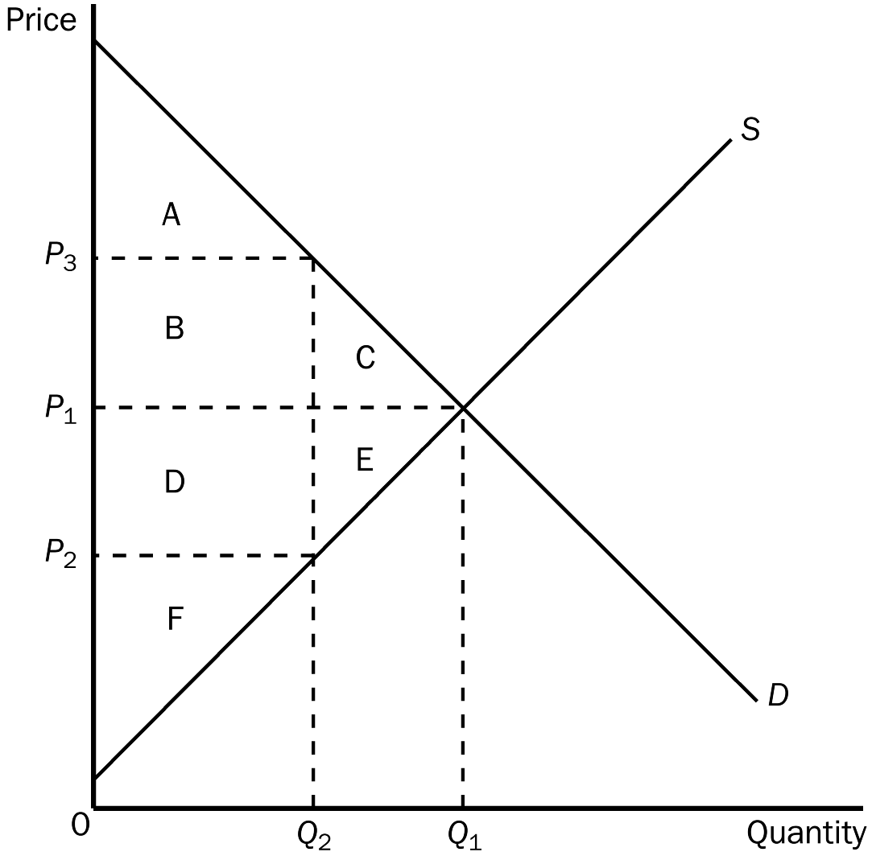

 | WITHOUT TAX | WITH TAX | CHANGE
Consumer surplus
Producer surplus
Tax revenue
Total surplus

ANS:
 | WITHOUT TAX | WITH TAX | CHANGE
Consumer surplus | A + B + C | A | –(B + C)
Producer surplus | D + E + F | F | –(D + E)
Tax revenue | None | B + D | (B + D)
Total surplus | A + B + C + D + E + F | A + B + D + F | –(C + E)

PTS: 1 DIF: 2 REF: 8-1
TOP: Tax | Economic welfare MSC: Applicative
4. Suppose that instead of a supply-demand diagram, you are given the following information:
Q_{s} = 100 + 3P
Q_{d} = 400 - 2P
From this information compute equilibrium price and quantity. Now suppose that a tax is placed on buyers so that
Q_{d} = 400 - (2P + T).
If T = 15, solve for the new equilibrium price and quantity. (Note: P is the price received by sellers and P + T is the price paid by buyers.) Compare these answers for equilibrium price and quantity with your first answers. What does this show you?
ANS:
Prior to the tax, the equilibrium price would be $60 and the equilibrium quantity would be 280. After the tax is imposed, P, the price received by sellers would be $57. The price paid by buyers would be $72. The quantity sold would be 271. The new answer shows three obvious facts. First, buyers pay more with a tax and second, sellers receive less with a tax. The third thing is that the size of the market shrinks when a tax is imposed on a product.
PTS: 1 DIF: 3 REF: 8-1
TOP: Tax | Equilibrium price | Equilibrium quantity MSC: Analytical
5. Using demand and supply diagrams, show the difference in deadweight loss between (a) a market with inelastic demand and supply and (b) a market with elastic demand and supply.
ANS:
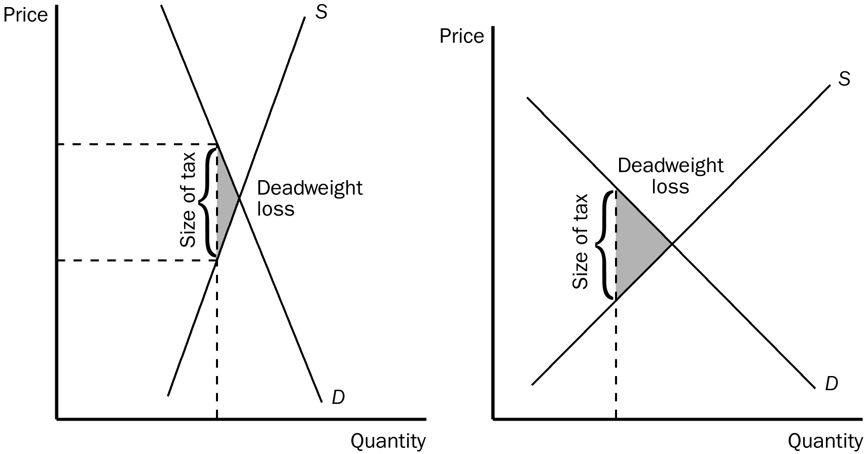
PTS: 1 DIF: 2 REF: 8-2
TOP: Deadweight losses | Elasticity MSC: Applicative
6. Illustrate on three demand-and-supply graphs how the size of a tax (small, medium and large) can alter total revenue and deadweight loss.
ANS:
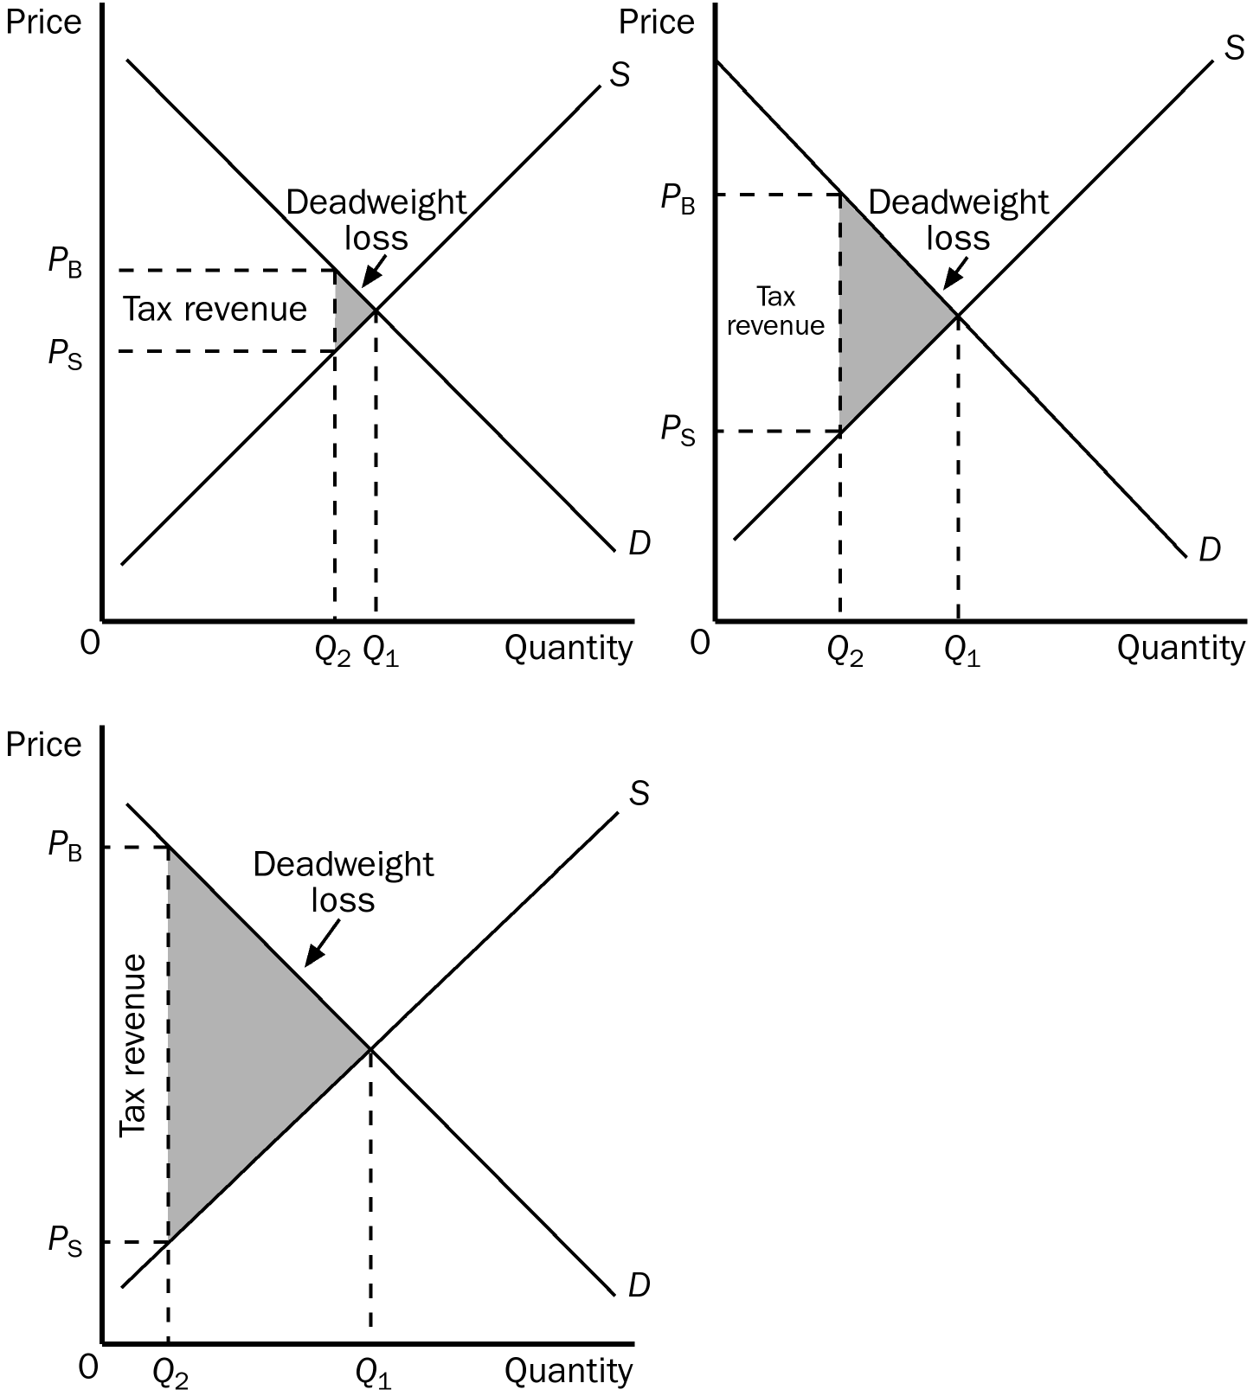
PTS: 1 DIF: 2 REF: 8-3
TOP: Tax | Deadweight losses | Government MSC: Applicative

