Chapter 10
Externalities
Multiple Choice
1. In a market economy, government intervention
a. will always improve market outcomes.
b. reduces efficiency in the presence of externalities.
c. may improve market outcomes in the presence of externalities.
d. is necessary to control individual greed.
ANS: C PTS: 1 DIF: 1 REF: 10-0
TOP: Externalities MSC: Applicative
2. In the absence of externalities, the "invisible hand" leads a market to maximize
a. producer profit from that market.
b. total benefit to society from that market.
c. both equity and efficiency in that market.
d. output of goods or services in that market.
ANS: B PTS: 1 DIF: 1 REF: 10-0
TOP: Externalities MSC: Applicative
3. One advantage market economies have over other types of economies is that market economies
a. provide an equal distribution of goods and services to consumers.
b. establish government economic control.
c. solve the problem of scarcity.
d. are more efficient.
ANS: D PTS: 1 DIF: 1 REF: 10-0
TOP: Externalities MSC: Applicative
4. The term market failure refers to
a. a market that fails to allocate resources efficiently.
b. an unsuccessful advertising campaign which reduces demand.
c. ruthless competition among firms.
d. a firm that is forced out of business because of losses.
ANS: A PTS: 1 DIF: 1 REF: 10-0
TOP: Externalities MSC: Definitional
5. Market failure can be caused by
a. too much competition.
b. externalities.
c. low consumer demand.
d. scarcity.
ANS: B PTS: 1 DIF: 1 REF: 10-0
TOP: Externalities MSC: Interpretive
6. An externality is the impact of
a. society's decisions on the well-being of society.
b. a person's actions on that person's well-being.
c. one person's actions on the well-being of a bystander.
d. society's decisions on the poorest person in the society.
ANS: C PTS: 1 DIF: 1 REF: 10-0
TOP: Externalities MSC: Definitional
7. The impact of one person's actions on the well-being of a bystander is called
a. an economic dilemma.
b. deadweight loss.
c. a multi-party problem.
d. an externality.
ANS: D PTS: 1 DIF: 1 REF: 10-0
TOP: Externalities MSC: Applicative
8. An externality
a. is a type of market failure.
b. causes markets to allocate resources efficiently.
c. strengthens the role of the “invisible hand” in the marketplace.
d. affects producers but not consumers.
ANS: A PTS: 1 DIF: 1 REF: 10-0
TOP: Externalities MSC: Interpretive
9. Dog owners do not bear the full cost of the noise their barking dogs create and often take too few precautions to prevent their dogs from barking. Local governments address this problem by
a. making it illegal to "disturb the peace."
b. having a well-funded animal control department.
c. subsidizing local animal shelters.
d. encouraging people to adopt cats.
ANS: A PTS: 1 DIF: 1 REF: 10-0
TOP: Externalities MSC: Applicative
10. An externality is
a. the costs that parties incur in the process of agreeing and following through on a bargain.
b. the uncompensated impact of one person's actions on the well-being of a bystander.
c. the proposition that private parties can bargain without cost over the allocation of resources.
d. a market equilibrium tax.
ANS: B PTS: 1 DIF: 1 REF: 10-0
TOP: Externalities MSC: Definitional
11. An externality is an example of
a. a corrective tax.
b. a tradable pollution permit.
c. a market failure.
d. Both a and b are correct.
ANS: C PTS: 1 DIF: 1 REF: 10-0
TOP: Externalities MSC: Applicative
12. An externality exists whenever
a. the economy can benefit from government intervention.
b. markets are not able to reach equilibrium.
c. a firm sells its product in a foreign market.
d. a person engages in an activity that influences the well-being of a bystander and yet neither pays nor receives payment for that effect.
ANS: D PTS: 1 DIF: 2 REF: 10-0
TOP: Externalities MSC: Definitional
13. When externalities are present in a market, the well-being of market participants
a. and market bystanders are both directly affected.
b. and market bystanders are both indirectly affected.
c. is directly affected, and market bystanders are indirectly affected.
d. is indirectly affected, and market bystanders are directly affected.
ANS: C PTS: 1 DIF: 2 REF: 10-0
TOP: Externalities MSC: Analytical
14. Which of the following statements about a well-maintained yard best conveys the general nature of the externality?
a. A well-maintained yard conveys a positive externality because it increases the home's market value.
b. A well-maintained yard conveys a negative externality because it increases the property tax liability of the owner.
c. A well-maintained yard conveys a positive externality because it increases the value of adjacent properties in the neighborhood.
d. A well-maintained yard cannot provide any type of externality.
ANS: C PTS: 1 DIF: 2 REF: 10-0
TOP: Externalities MSC: Applicative
15. Since restored historic buildings convey a positive externality, local governments may choose to
a. regulation the demolition of them.
b. provide tax breaks to owners who restore them.
c. increase property taxes in historic areas.
d. Both a and b are correct.
ANS: D PTS: 1 DIF: 2 REF: 10-0
TOP: Externalities MSC: Applicative
16. Externalities
a. cause markets to fail to allocate resources efficiently.
b. cause equilibrium prices to be too high.
c. benefit producers at the expense of consumers.
d. cause equilibrium prices to be too low.
ANS: A PTS: 1 DIF: 2 REF: 10-0
TOP: Externalities MSC: Applicative
17. When externalities exist, buyers and sellers
a. neglect the external effects of their actions, but the market equilibrium is still efficient.
b. do not neglect the external effects of their actions, and the market equilibrium is efficient.
c. neglect the external effects of their actions, and the market equilibrium is not efficient.
d. do not neglect the external effects of their actions, and the market equilibrium is not efficient.
ANS: C PTS: 1 DIF: 2 REF: 10-0
TOP: Externalities MSC: Applicative
18. Dioxin emission that results from the production of paper is a good example of a negative externality because
a. self-interested paper firms are generally unaware of environmental regulations.
b. there are fines for producing too much dioxin.
c. self-interested paper producers will not consider the full cost of the dioxin pollution they create.
d. toxic emissions are the best example of an externality.
ANS: C PTS: 1 DIF: 2 REF: 10-0
TOP: Externalities MSC: Applicative
19. If a paper manufacturer does not bear the entire cost of the dioxin it emits, it will
a. emit a lower level of dioxin than is socially efficient.
b. emit a higher level of dioxin than is socially efficient.
c. emit an acceptable level of dioxin.
d. not emit any dioxin in an attempt to avoid paying the entire cost.
ANS: B PTS: 1 DIF: 2 REF: 10-0
TOP: Externalities MSC: Applicative
20. One of the Ten Principles of Economics is that "markets are usually a good way to organize market behavior." This statement does not imply which of the following?
a. Some markets produce negative externalities.
b. The invisible hand of the marketplace does not always lead buyers and sellers to maximize total benefit to society.
c. Some markets are characterized by market failure.
d. Other types of economies are more efficient than market economies.
ANS: D PTS: 1 DIF: 2 REF: 10-0
TOP: Externalities MSC: Interpretive
21. Which of the following is an example of an externality?
a. cigarette smoke that permeates an entire restaurant
b. a flu shot that prevents a student from transmitting the virus to her roommate
c. a beautiful flower garden outside of the local post office
d. All of the above are correct.
ANS: D PTS: 1 DIF: 2 REF: 10-0
TOP: Externalities MSC: Applicative
22. Which of the following statements is not correct?
a. Government policies may improve the market's allocation of resources when negative externalities are present.
b. Government policies may improve the market's allocation of resources when positive externalities are present.
c. A positive externality is an example of a market failure.
d. Without government intervention, the market will tend to undersupply products that produce negative externalities.
ANS: D PTS: 1 DIF: 2 REF: 10-0
TOP: Externalities MSC: Interpretive
23. Which of the following represents a way that a government can help the private market to internalize an externality?
a. taxing goods that have negative externalities
b. subsidizing goods that have positive externalities
c. The government cannot improve upon the outcomes of private markets.
d. Both a and b are correct.
ANS: D PTS: 1 DIF: 2 REF: 10-0
TOP: Externalities MSC: Applicative
24. When externalities are present in a market,
a. the market equilibrium maximizes the total benefit to society as a whole.
b. participants lose some market benefits to bystanders.
c. firms produce too much output.
d. the market fails to allocate resources efficiently.
ANS: D PTS: 1 DIF: 2 REF: 10-0 | 10-1
TOP: Externalities MSC: Applicative
25. If an externality is present in a market, economic efficiency may be enhanced by
a. increased competition.
b. weakening property rights.
c. better informed market participants.
d. government intervention.
ANS: D PTS: 1 DIF: 1 REF: 10-1
TOP: Externalities MSC: Applicative
26. If a sawmill creates too much noise for local residents,
a. noise restrictions will force residents to move out of the area.
b. a sense of social responsibility will cause owners of the mill to reduce noise levels.
c. the government can raise economic well-being through noise-control regulations.
d. the government should avoid intervening because the market will allocate resources efficiently.
ANS: C PTS: 1 DIF: 2 REF: 10-1
TOP: Externalities MSC: Applicative
27. Private markets fail to account for externalities because
a. externalities don't occur in private markets.
b. sellers include costs associated with externalities in the price of their product.
c. decisionmakers in the market fail to include the costs of their behavior to third parties.
d. the government cannot easily estimate the optimal quantity of pollution.
ANS: C PTS: 1 DIF: 2 REF: 10-1
TOP: Externalities MSC: Applicative
28. When the government intervenes in markets with externalities, it does so in order to
a. increase production when negative externalities are present.
b. protect the interests of bystanders.
c. make certain all benefits are received by market participants.
d. reduce production when positive externalities are present.
ANS: B PTS: 1 DIF: 2 REF: 10-1
TOP: Externalities MSC: Applicative
29. Research into new technologies
a. provides positive externalities because it creates knowledge others can use.
b. results in negative externalities because government funding for research causes less government spending in other areas.
c. is protected by patent laws, which eliminates the need for government intervention.
d. should only be funded by the corporations that will receive the profits from the research.
ANS: A PTS: 1 DIF: 2 REF: 10-1
TOP: Externalities MSC: Applicative
30. At any given quantity, the willingness to pay in the market for gasoline is reflected in the
a. height of the demand curve at that quantity.
b. height of the supply curve at that quantity.
c. value to the producer of the last unit of gasoline sold.
d. total quantity of gasoline exchanged in the market.
ANS: A PTS: 1 DIF: 2 REF: 10-1
TOP: Externalities MSC: Applicative
31. The supply curve for a product reflects the
a. willingness to pay of the marginal buyer.
b. quantity buyers will ultimately purchase of the product.
c. cost to sellers of producing the product.
d. seller's profit from producing the product.
ANS: C PTS: 1 DIF: 2 REF: 10-1
TOP: Externalities MSC: Applicative
32. Without government intervention, the market equilibrium for oranges will
a. maximize the sum of producer and consumer surplus in the market.
b. be both efficient and equitable.
c. be equitable but not efficient.
d. be neither efficient nor equitable.
ANS: A PTS: 1 DIF: 2 REF: 10-1
TOP: Externalities MSC: Applicative
33. Since air pollution creates a negative externality,
a. social welfare will be enhanced when some, but not all air pollution is eliminated.
b. social welfare is optimal when all air pollution is eliminated.
c. governments should encourage private firms to consider only private costs.
d. the free market result maximizes social welfare.
ANS: A PTS: 1 DIF: 2 REF: 10-1
TOP: Externalities MSC: Applicative
34. The difference between social cost and private cost is a measure of the
a. loss in profit to the seller as the result of a negative externality.
b. cost of an externality.
c. cost reduction when the negative externality is eliminated.
d. cost incurred by the government when it intervenes in the market.
ANS: B PTS: 1 DIF: 2 REF: 10-1
TOP: Externalities MSC: Applicative
35. Which of the following statements is correct?
a. Government should tax goods with either positive or negative externalities.
b. Government should tax goods with negative externalities and subsidize goods with positive externalities.
c. Government should subsidize goods with either positive or negative externalities.
d. Government should tax goods with positive externalities and subsidize goods with negative externalities.
ANS: B PTS: 1 DIF: 2 REF: 10-1
TOP: Externalities MSC: Applicative
36. When a market is characterized by an externality, the government
a. can correct the market failure only in the case of positive externalities.
b. can correct the market failure only in the case of negative externalities.
c. can correct the market failure in the case of both positive and negative externalities by inducing market participants to internalize the externality.
d. cannot correct for externalities due to the existence of patents.
ANS: C PTS: 1 DIF: 2 REF: 10-1
TOP: Externalities MSC: Interpretive
Figure 10-1
37. Refer to Figure 10-1. This graph represents the tobacco industry. The industry creates
a. positive externalities.
b. negative externalities.
c. no externalities.
d. no equilibrium in the market.
ANS: B PTS: 1 DIF: 2 REF: 10-1
TOP: Externalities MSC: Applicative
38. Refer to Figure 10-1. This graph represents the tobacco industry. Without any government intervention, the equilibrium price and quantity are
a. $1.90 and 38 units, respectively.
b. $1.80 and 35 units, respectively.
c. $1.60 and 42 units, respectively.
d. $1.35 and 58 units, respectively.
ANS: C PTS: 1 DIF: 2 REF: 10-1
TOP: Externalities MSC: Applicative
39. Refer to Figure 10-1. This graph represents the tobacco industry. The socially optimal price and quantity are
a. $1.90 and 38 units, respectively.
b. $1.80 and 35 units, respectively.
c. $1.60 and 42 units, respectively.
d. $1.35 and 58 units, respectively.
ANS: B PTS: 1 DIF: 2 REF: 10-1
TOP: Externalities MSC: Applicative
40. Refer to Figure 10-1. This graph represents the tobacco industry. If the government uses a pollution tax, how much of a tax must be imposed on each unit of production?
a. $1.90
b. $1.80
c. $1.60
d. $0.30
ANS: D PTS: 1 DIF: 3 REF: 10-3
TOP: Corrective taxes MSC: Analytical
41. Refer to Figure 10-1. This graph represents the tobacco industry. If the government uses a pollution tax, how much tax revenue will the government receive?
a. $7.00
b. $10.50
c. $63.00
d. $67.20
ANS: B PTS: 1 DIF: 3 REF: 10-3
TOP: Corrective taxes MSC: Analytical
Figure 10-2
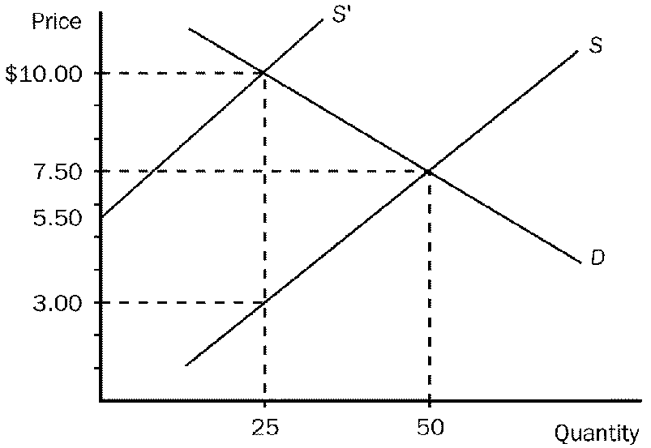
42. Refer to Figure 10-2. Suppose that the production of soccer balls creates a social cost which is depicted in the graph above. Without any government regulation, how many soccer balls will be produced?
a. 3
b. 10
c. 25
d. 50
ANS: D PTS: 1 DIF: 2 REF: 10-1
TOP: Negative externalities MSC: Analytical
43. Refer to Figure 10-2. Suppose that the production of soccer balls creates a social cost which is depicted in the graph above. Without any government regulation, what price will the firm charge per soccer ball?
a. $3
b. $5.50
c. $7.50
d. $10
ANS: C PTS: 1 DIF: 2 REF: 10-1
TOP: Negative externalities MSC: Analytical
44. Refer to Figure 10-2. Assume the production of the product shown by the graph imposes a cost on society of $7.00 per unit. If the free market equilibrium output is 50 units, the government should
a. impose a tax of $2.50 per unit.
b. increase the output of the firm by 25 units.
c. impose a lump-sum tax of $350 per period.
d. impose a tax of $7.00 per unit.
ANS: D PTS: 1 DIF: 2 REF: 10-3
TOP: Corrective taxes MSC: Analytical
45. Refer to Figure 10-2. Suppose that the production of soccer balls creates a social cost which is depicted in the graph above. If the government wanted to force the firm to internalize the cost of the externality, what action should it take?
a. Impose a tax of $7.50 per soccer ball.
b. Impose a tax of $7 per soccer ball.
c. Offer a subsidy of $3 per soccer ball.
d. Offer a subsidy of $2.50 per soccer ball.
ANS: B PTS: 1 DIF: 2 REF: 10-3
TOP: Corrective taxes MSC: Analytical
This figure reflects the market for outdoor concerts in a public park surrounded by residential neighborhoods.
Figure 10-3
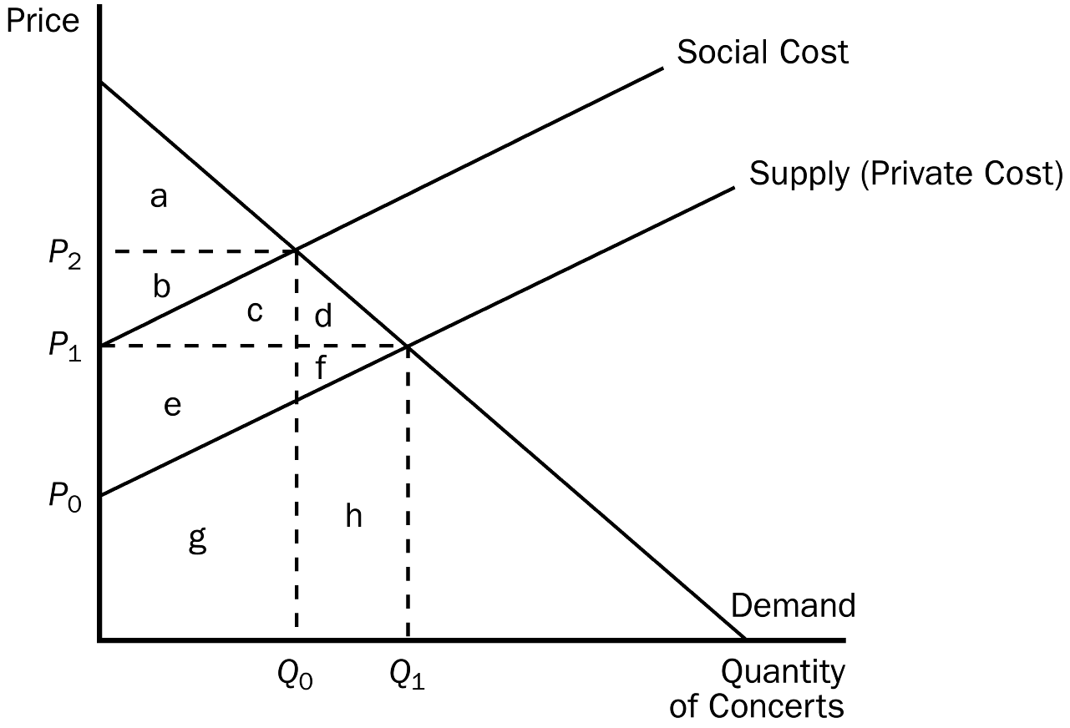
46. Refer to Figure 10-3. The social cost curve is above the supply curve because
a. it takes into account the external costs imposed on society by the concert.
b. it takes into account the effect of local noise restrictions on concerts in parks surrounded by residential neighborhoods.
c. concert tickets are likely to cost more than the concert actually costs the organizers.
d. residents in the surrounding neighborhoods get to listen to the concert for free.
ANS: A PTS: 1 DIF: 2 REF: 10-1
TOP: Negative externalities MSC: Analytical
47. Refer to Figure 10-3. The difference between the social cost curve and the supply curve reflects the
a. profit margin of each concert.
b. cost of spillover effects from the concert (e.g., noise and traffic).
c. value of concerts to society as a whole.
d. amount by which the city should subsidize the concert organizers.
ANS: B PTS: 1 DIF: 2 REF: 10-1
TOP: Negative externalities MSC: Analytical
48. Refer to Figure 10-3. At the private market outcome, the equilibrium price will be
a. P₀.
b. P₁.
c. P₂.
d. None of the above is correct.
ANS: B PTS: 1 DIF: 2 REF: 10-1
TOP: Negative externalities MSC: Analytical
49. Refer to Figure 10-3. What price and quantity combination best represents the optimum price and number of concerts that should be organized?
a. P₁, Q₁
b. P₂, Q₀
c. P₂, Q₁
d. The optimum quantity is zero concerts as long as residents in surrounding neighborhoods are adversely affected by noise and congestion.
ANS: B PTS: 1 DIF: 2 REF: 10-1
TOP: Negative externalities MSC: Analytical
50. Refer to Figure 10-3. Assume that the concert organizers must purchase a concert permit before organizing the concert and that the cost for the permit is included in the private cost curve. What criteria should the city use in determining whether or not to issue a permit?
a. The majority vote of the residents in surrounding neighborhoods should determine whether a permit is issued.
b. As long as the value to consumers of concerts exceeds the cost of concerts, including the external costs, the permit should be issued.
c. As long as concert organizers are willing to return the park to its original condition after the concert, the permit should be issued.
d. The permit should not be issued as long as there are identifiable external costs imposed on residents in surrounding neighborhoods.
ANS: B PTS: 1 DIF: 3 REF: 10-1
TOP: Negative externalities MSC: Interpretive
Figure 10-4
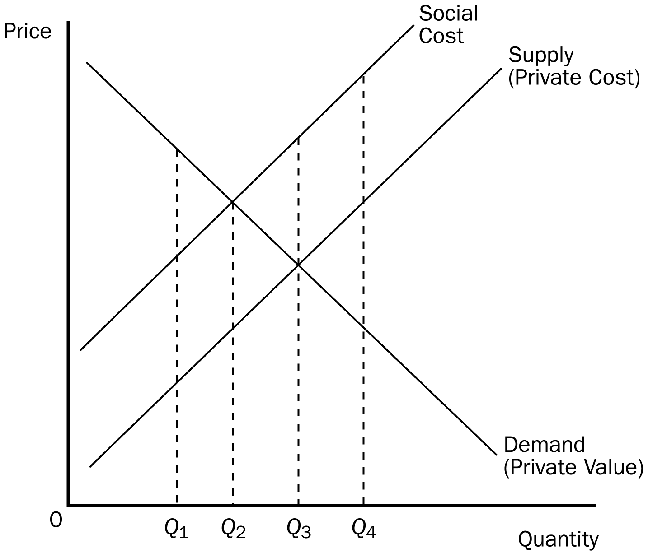
51. Refer to Figure 10-4. If this market is currently producing at Q₁, then total economic well-being would increase if output
a. increased to Q₂.
b. increased to Q_{3.}
c. increased to Q₄.
d. stayed at Q₁.
ANS: A PTS: 1 DIF: 1 REF: 10-1
TOP: Negative externalities MSC: Analytical
52. Refer to Figure 10-4. This market is characterized by
a. government intervention.
b. a positive externality.
c. a negative externality.
d. None of the above is correct.
ANS: C PTS: 1 DIF: 2 REF: 10-1
TOP: Negative externalities MSC: Analytical
53. Refer to Figure 10-4. Without government intervention, the equilibrium quantity would be
a. Q₁.
b. Q₂.
c. Q₃.
d. Q₄.
ANS: C PTS: 1 DIF: 2 REF: 10-1
TOP: Negative externalities MSC: Analytical
54. Refer to Figure 10-4. The socially optimal quantity would be
a. Q₁.
b. Q₂.
c. Q₃.
d. Q₄.
ANS: B PTS: 1 DIF: 2 REF: 10-1
TOP: Negative externalities MSC: Analytical
55. Refer to Figure 10-4. This market
a. has no need for government intervention.
b. would benefit from a tax on the product.
c. would benefit from a subsidy for the product.
d. would maximize total well-being at Q₃.
ANS: B PTS: 1 DIF: 2 REF: 10-1
TOP: Negative externalities MSC: Analytical
56. Refer to Figure 10-4. If this market is currently producing at Q₄, then total economic well-being would increase if output
a. increased beyond Q₄.
b. decreased to Q₂.
c. decreased to zero.
d. stayed at Q₄.
ANS: B PTS: 1 DIF: 2 REF: 10-1
TOP: Negative externalities MSC: Analytical
57. Refer to Figure 10-4. If all external costs were internalized, then the market’s equilibrium output would be
a. Q₁.
b. Q₂.
c. Q₃.
d. Q₄.
ANS: B PTS: 1 DIF: 2 REF: 10-1
TOP: Negative externalities MSC: Analytical
58. Refer to Figure 10-4. If this market currently produces Q₂, total economic well-being would be maximized if
a. production decreased to Q₁.
b. production increased to Q₃.
c. this product were no longer produced.
d. output stayed at Q₂.
ANS: D PTS: 1 DIF: 2 REF: 10-1
TOP: Negative externalities MSC: Analytical
59. Refer to Figure 10-4. Externalities in this market could be internalized if
a. there were a tax on the product.
b. there were a subsidy for the product.
c. production were stopped.
d. the Coase theorem failed.
ANS: A PTS: 1 DIF: 2 REF: 10-1
TOP: Negative externalities MSC: Analytical
60. Refer to Figure 10-4. At Q₃
a. the marginal consumer values this product less than the social cost of producing it.
b. every consumer values this product less than the social cost of producing it.
c. the cost to society is equal to the value to society.
d. the marginal consumer values this product more than the private cost.
ANS: A PTS: 1 DIF: 3 REF: 10-1
TOP: Negative externalities MSC: Analytical
61. Refer to Figure 10-4. If this market currently produces Q₃, total economic well-being would be increased if
a. production decreased to Q₂.
b. production increased to Q₄.
c. this product were no longer produced.
d. output stayed at Q₃.
ANS: A PTS: 1 DIF: 3 REF: 10-1
TOP: Negative externalities MSC: Analytical
Figure 10-5
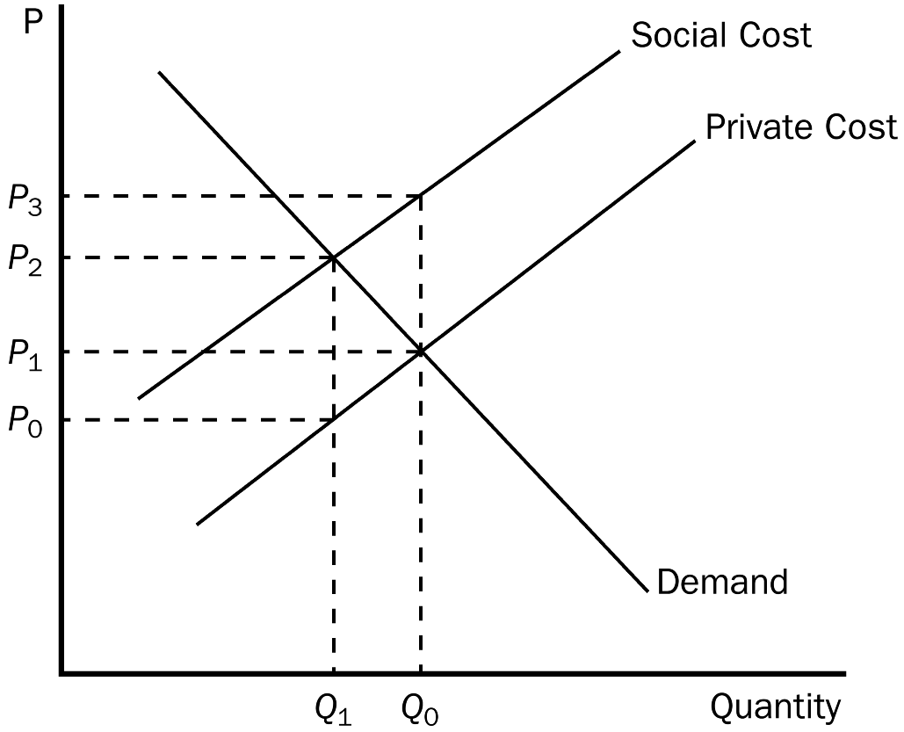
62. Refer to Figure 10-5. Which price and quantity combination represents the social optimum?
a. P₀ and Q₁.
b. P₂ and Q₁.
c. P₁ and Q₀.
d. P₂ and Q₀.
ANS: B PTS: 1 DIF: 2 REF: 10-1
TOP: Negative externalities MSC: Analytical
63. Refer to Figure 10-5. Which of the following statements is correct?
a. The marginal benefit of the positive externality is measured by P₃ - P₁.
b. The marginal cost of the negative externality is measured by P₃ - P₂.
c. The marginal cost of the negative externality is measured by P₃ - P₁.
d. The marginal cost of the negative externality is measured by P₃ - P₀.
ANS: C PTS: 1 DIF: 3 REF: 10-1
TOP: Negative externalities MSC: Analytical
64. Negative externalities occur when one person's actions
a. cause another person to lose money in a stock market transaction.
b. cause his or her employer to lose business.
c. reveal his or her preference for foreign-produced goods.
d. adversely affect the well-being of a bystander who is not party to the action.
ANS: D PTS: 1 DIF: 1 REF: 10-1
TOP: Negative externalities MSC: Definitional
65. A negative externality
a. is an adverse impact on a bystander.
b. causes the product in a market to be under-produced.
c. is an adverse impact on market participants.
d. is present in markets where the good or service is undesirable for society.
ANS: A PTS: 1 DIF: 1 REF: 10-1
TOP: Negative externalities MSC: Definitional
66. A positive externality
a. causes the product to be overproduced.
b. provides an additional benefit to market participants.
c. benefits consumers because it results in a lower equilibrium price.
d. is a benefit to a market bystander.
ANS: D PTS: 1 DIF: 1 REF: 10-1
TOP: Positive externalities MSC: Definitional
67. Which of the following illustrates the concept of a negative externality?
a. A college professor plays a vigorous game of racquet ball with the racquet he recently purchased.
b. A flood wipes out a farmer's corn crop.
c. A college student plays loud music on his new stereo system at 2:00 a.m.
d. A janitor eats a hamburger during his lunch break.
ANS: C PTS: 1 DIF: 2 REF: 10-1
TOP: Negative externalities MSC: Applicative
68. When a negative externality exists in a market, the cost to producers
a. is greater than the cost to society.
b. will be the same as the cost to society.
c. will be less than the cost to society.
d. will differ from the cost to society, regardless of whether an externality is present.
ANS: C PTS: 1 DIF: 2 REF: 10-1
TOP: Negative externalities MSC: Analytical
69. When negative externalities are present in a market
a. private costs will be greater than social costs.
b. social costs will be greater than private costs.
c. only government regulation will solve the problem.
d. the market will not be able to reach any equilibrium.
ANS: B PTS: 1 DIF: 2 REF: 10-1
TOP: Negative externalities MSC: Analytical
70. Suppose that large-scale pork production has the potential to create ground water pollution. Why might this type of pollution be considered an externality?
a. The groundwater pollution reduces the cost of large-scale pork production.
b. The economic impact of a large-scale pork production facility is localized in a small geographic area.
c. The pollution has the potential for creating a health risk for water users in the region surrounding the pork production facility.
d. Consumers will not reap the benefits of lower production cost from large-scale pork production.
ANS: C PTS: 1 DIF: 2 REF: 10-1
TOP: Negative externalities MSC: Analytical
71. Markets are often inefficient when negative externalities are present because
a. private costs exceed social costs at the private market solution.
b. externalities cannot be corrected without government regulation.
c. social costs exceed private costs at the private market solution.
d. production externalities lead to consumption externalities.
ANS: C PTS: 1 DIF: 2 REF: 10-1
TOP: Negative externalities MSC: Analytical
72. When the social cost curve is above a product's supply curve,
a. the government has intervened in the market.
b. a negative externality exists in the market.
c. a positive externality exists in the market.
d. the distribution of resources is unfair.
ANS: B PTS: 1 DIF: 2 REF: 10-1
TOP: Negative externalities MSC: Analytical
73. Suppose that a steel factory emits a certain amount of air pollution, which constitutes a negative externality. If the market does not internalize the externality,
a. the supply curve would adequately reflect the marginal social cost of production.
b. consumers will be required to pay a higher price for steel than they would have if the externality were internalized.
c. the market equilibrium quantity will not be the socially optimal quantity.
d. producers will produce less steel than they otherwise would if the externality were internalized.
ANS: C PTS: 1 DIF: 2 REF: 10-1
TOP: Negative externalities MSC: Applicative
74. When producers operate in a market characterized by negative externalities, a tax that forces them to internalize the externality will
a. give sellers the incentive to account for the external effects of their actions.
b. increase demand.
c. increase the amount of the commodity exchanged in market equilibrium.
d. restrict the producers' ability to take the costs of the externality into account when deciding how much to supply.
ANS: A PTS: 1 DIF: 2 REF: 10-1
TOP: Negative externalities MSC: Analytical
75. An optimal tax on pollution would result in which of the following?
a. Producers will choose not to produce any pollution.
b. Producers will internalize the cost of the pollution.
c. Producers will maximize production.
d. The value to consumers at market equilibrium will exceed the social cost of production.
ANS: B PTS: 1 DIF: 2 REF: 10-1
TOP: Negative externalities MSC: Applicative
76. Which of the following statements is correct?
a. Internalizing a negative externality will cause an industry to decrease the quantity it supplies to the market and decrease the price of the good produced.
b. Internalizing a negative externality will cause an industry to decrease the quantity it supplies to the market and increase the price of the good produced.
c. Internalizing a negative externality will cause an industry to increase the quantity it supplies to the market and decrease the price of the good produced.
d. Internalizing a negative externality will cause an industry to increase the quantity it supplies to the market and increase the price of the good produced.
ANS: B PTS: 1 DIF: 2 REF: 10-1
TOP: Negative externalities MSC: Analytical
77. A negative externality will cause a private market to produce
a. less than is socially desirable.
b. more than is socially desirable.
c. exactly the quantity that is socially desirable.
d. less than the same market would produce in the presence of a positive externality.
ANS: B PTS: 1 DIF: 2 REF: 10-1
TOP: Negative externalities MSC: Interpretive
78. Private markets fail to reach a socially optimal equilibrium when negative externalities are present because
a. social costs equal private costs at the private market solution.
b. private costs exceed social costs at the private market solution.
c. social costs exceed private costs at the private market solution.
d. they internalize externalities.
ANS: C PTS: 1 DIF: 2 REF: 10-1
TOP: Negative externalities MSC: Interpretive
79. When negative externalities are present in a market,
a. producers will be affected but consumers will not.
b. producers will supply too much of the product.
c. demand will be too high.
d. the market will still maximize total benefits.
ANS: B PTS: 1 DIF: 2 REF: 10-1
TOP: Negative externalities MSC: Applicative
80. Which of the following would not be considered a negative externality?
a. Smelter, Inc. creates steel and pollution.
b. Your friend buys a new puppy that barks every night.
c. You have an adverse reaction to a medication your doctor prescribed for you.
d. Your neighbor plays loud music that you dislike through stereo speakers set up on his deck.
ANS: C PTS: 1 DIF: 2 REF: 10-1
TOP: Negative externalities MSC: Applicative
81. Suppose that meat producers create a negative externality. What is the relationship between the equilibrium quantity and the socially optimal quantity of meat to be produced?
a. They are equal.
b. The equilibrium quantity is greater than the socially optimal quantity.
c. The equilibrium quantity is less than the socially optimal quantity.
d. There is not enough information to answer the question.
ANS: B PTS: 1 DIF: 2 REF: 10-1
TOP: Negative externalities MSC: Analytical
82. Suppose that electricity producers create a negative externality equal to $5 per unit. What is the relationship between the equilibrium quantity and the socially optimal quantity of electricity to be produced?
a. They are equal.
b. The equilibrium quantity is greater than the socially optimal quantity.
c. The equilibrium quantity is less than the socially optimal quantity.
d. There is not enough information to answer the question.
ANS: B PTS: 1 DIF: 2 REF: 10-1
TOP: Negative externalities MSC: Analytical
83. Suppose that smoking creates a negative externality. If the government does not interfere in the cigarette market, then
a. the equilibrium quantity of cigarettes smoked will equal the socially optimal quantity of cigarettes smoked.
b. the equilibrium quantity of cigarettes smoked will be greater than the socially optimal quantity of cigarettes smoked.
c. the equilibrium quantity of cigarettes smoked will be less than the socially optimal quantity of cigarettes smoked.
d. There is not enough information to answer the question.
ANS: B PTS: 1 DIF: 2 REF: 10-1
TOP: Negative externalities MSC: Analytical
84. Suppose that a firm produces electricity by burning coal. The production process creates a negative externality of air pollution. If the firm does not internalize the cost of the externality, it will produce where
a. the value of electricity to consumers equals the private cost of producing electricity.
b. the value of electricity to consumers equals the social cost of producing electricity.
c. the cost of the externality is maximized.
d. the transaction costs of private bargaining are minimized.
ANS: A PTS: 1 DIF: 2 REF: 10-1
TOP: Negative externalities MSC: Analytical
85. Suppose that a negative externality is created by the production of good X. Which of the following statements is correct?
a. The social cost of producing good X includes the private cost plus the cost to bystanders of the externality.
b. The increased social cost can be graphed as a decrease in demand.
c. The market equilibrium quantity will be the socially optimal quantity as long as the government does not interfere.
d. Both a and b are correct.
ANS: A PTS: 1 DIF: 2 REF: 10-1
TOP: Negative externalities MSC: Interpretive
86. A fertilizer plant emits a very foul odor during the production process. If the government forces the plant to internalize the negative externality, then the
a. supply curve for fertilizer would shift down.
b. supply curve for fertilizer would shift up.
c. demand curve for fertilizer would shift down.
d. demand curve for fertilizer would shift up.
ANS: B PTS: 1 DIF: 3 REF: 10-1
TOP: Negative externalities MSC: Analytical
87. When a market is in equilibrium and the marginal consumer values a commodity at less than the social cost of producing it, then
a. at market equilibrium the demand curve lies below the social cost curve.
b. reducing production to a level below the equilibrium level could possibly raise total economic well-being.
c. the equilibrium price is higher than necessary to insure maximum economic well-being.
d. Both a and b are correct.
ANS: D PTS: 1 DIF: 3 REF: 10-1
TOP: Negative externalities MSC: Analytical
88. Suppose that at present there are no laws to restrict pollution produced by the widget industry. Assume that the supply and demand curves are linear and that the market price of a widget is $20. If the government imposes a tax equal in value to the cost of the pollution, then firms would continue to produce widgets if
a. the cost imposed by the pollution is less than $20 per widget produced.
b. the private cost of producing a widget equals the cost of the pollution generated per widget.
c. $20 minus the private cost of producing a widget is greater than the cost of the pollution generated per widget.
d. $20 minus the private cost of producing a widget is less than the cost of the pollution generated per widget.
ANS: C PTS: 1 DIF: 3 REF: 10-1
TOP: Negative externalities MSC: Analytical
Figure 10-6
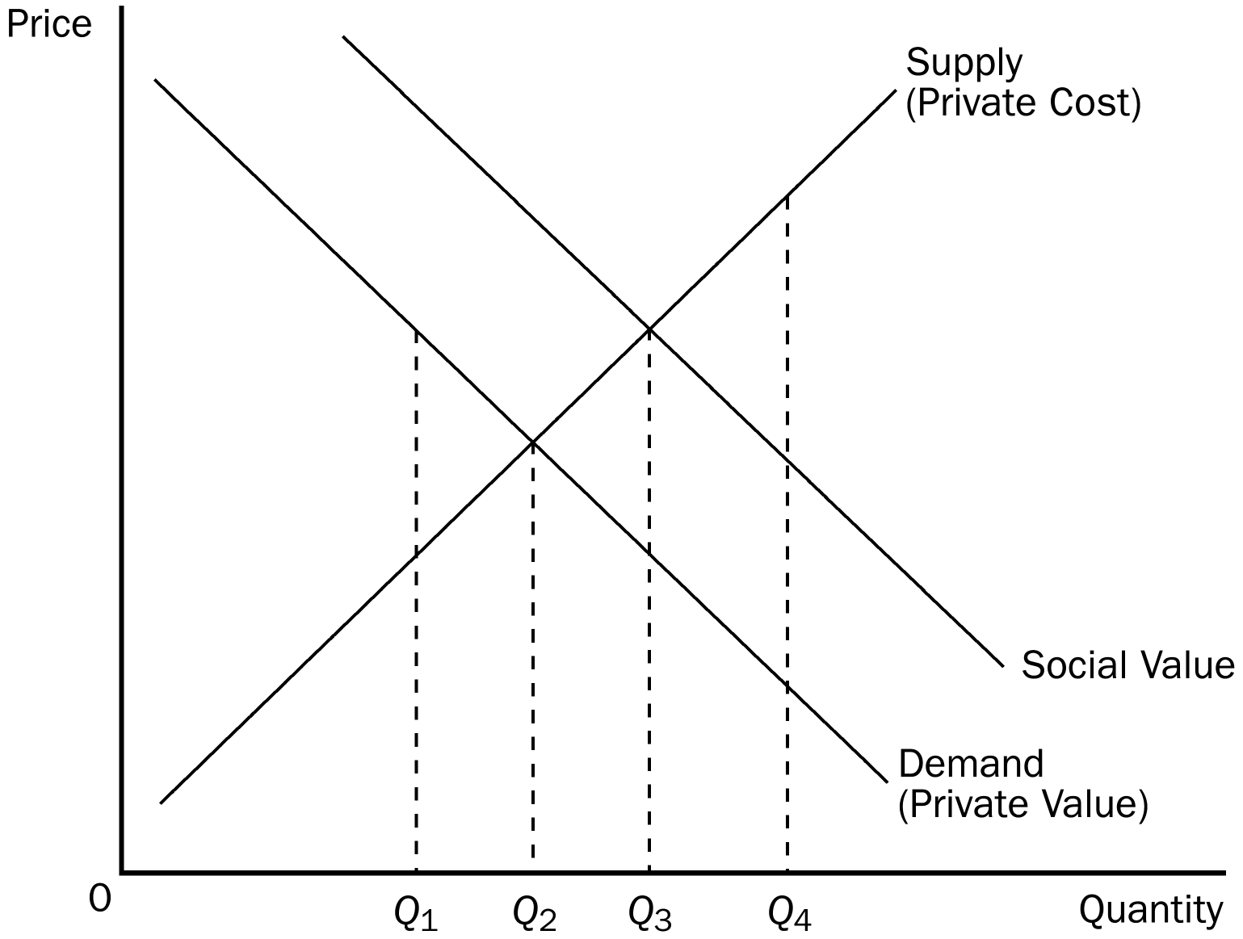
89. Refer to Figure 10-6. Which quantity represents the social optimum for this market?
a. Q_{1.}
b. Q₂.
c. Q_{3.}
d. Q_{4.}
ANS: C PTS: 1 DIF: 2 REF: 10-1
TOP: Positive externalities MSC: Analytical
90. Refer to Figure 10-6. To internalize the externality in this market, the government should
a. impose a tax on this product.
b. provide a subsidy for this product.
c. forbid production.
d. produce the product itself.
ANS: B PTS: 1 DIF: 2 REF: 10-1
TOP: Positive externalities MSC: Analytical
91. Which of the following is an example of a positive externality?
a. A college student buys a new car when she graduates.
b. The mayor of a small town plants flowers in the city park.
c. Local high school teachers have pizza delivered every Friday for lunch.
d. An avid fisherman buys new fishing gear for his next fishing trip.
ANS: B PTS: 1 DIF: 1 REF: 10-1
TOP: Positive externalities MSC: Applicative
92. Which of the following policies is the government most inclined to use when faced with a positive externality?
a. taxation
b. permits
c. subsidies
d. usage fees
ANS: C PTS: 1 DIF: 1 REF: 10-1
TOP: Positive externalities MSC: Applicative
93. Which of the following is an example of a positive externality?
a. air pollution
b. a person littering in a public park
c. a nice garden in front of your neighbor's house
d. the pollution of a stream
ANS: C PTS: 1 DIF: 1 REF: 10-1
TOP: Positive externalities MSC: Applicative
94. If education produces positive externalities, we would expect
a. the government to tax education.
b. the government to subsidize education.
c. people to realize the benefits, which would increase the demand for education.
d. colleges to relax admission requirements.
ANS: B PTS: 1 DIF: 2 REF: 10-1
TOP: Positive externalities MSC: Applicative
95. When a beekeeper places his hives of bees in an orchard so that the bees can gather nectar to produce honey, the bees pollinate the orchard, which increases the yield of fruit. This benefits
a. only the beekeeper.
b. the beekeeper, but it creates a negative externality because the bees are a hazard to the orchard owner.
c. only the owner of the orchard.
d. both the beekeeper and the orchard owner.
ANS: D PTS: 1 DIF: 2 REF: 10-1
TOP: Positive externalities MSC: Applicative
96. Internalizing a positive externality will cause the demand curve to
a. shift up.
b. shift down.
c. become more elastic.
d. remain unchanged.
ANS: A PTS: 1 DIF: 2 REF: 10-1
TOP: Positive externalities MSC: Analytical
97. If a market is characterized by a positive externality that is not the result of a technology spillover,
a. the socially optimal level of output is less than the equilibrium level of output, and the optimal price is greater than the equilibrium price.
b. the socially optimal level of output is greater than the equilibrium level of output, and the socially optimal price is less than the equilibrium price.
c. the socially optimal level of output is greater than the equilibrium level of output, and the socially optimal price is greater than the equilibrium price.
d. the socially optimal level of output is less than the equilibrium level of output, and the socially optimal price is less than the equilibrium price.
ANS: C PTS: 1 DIF: 2 REF: 10-1
TOP: Positive externalities MSC: Analytical
98. To enhance the well-being of society, a social planner will encourage firms to increase production when
a. the firms are producing basic goods.
b. there is a shortage in the market.
c. technology spillovers are associated with production.
d. negative externalities “spill over” into production.
ANS: C PTS: 1 DIF: 2 REF: 10-1
TOP: Positive externalities MSC: Analytical
99. A positive externality will cause a market to produce
a. more than is socially desirable.
b. less than is socially desirable.
c. the socially optimal equilibrium amount.
d. more than the same market would produce in the presence of a negative externality.
ANS: B PTS: 1 DIF: 2 REF: 10-1
TOP: Positive externalities MSC: Interpretive
100. A positive externality occurs when
a. Jack receives a benefit from John's consumption of a certain good.
b. Jack receives personal benefits from his own consumption of a certain good.
c. Jack's benefit exceeds John's benefit when they each consume the same good.
d. Jack's receives a loss from John’s consumption of a certain good.
ANS: A PTS: 1 DIF: 2 REF: 10-1
TOP: Positive externalities MSC: Interpretive
101. When a market experiences a positive externality,
a. the demand curve does not reflect the value to society of the good.
b. too much of the good is being produced.
c. the government can internalize the externality by imposing a tax on the product.
d. the private value is greater than the social value.
ANS: A PTS: 1 DIF: 2 REF: 10-1
TOP: Positive externalities MSC: Interpretive
102. Private markets fail to reach a socially optimal equilibrium when positive externalities are present because the
a. private benefit equals the social benefit at the private market solution.
b. private cost exceeds the private benefit at the private market solution.
c. social value exceeds the private value at the private market solution.
d. private cost exceeds the social benefit at the private market solution.
ANS: C PTS: 1 DIF: 2 REF: 10-1
TOP: Positive externalities MSC: Interpretive
103. Suppose that cookie producers create a positive externality equal to $2 per dozen. What is the relationship between the equilibrium quantity and the socially optimal quantity of cookies to be produced?
a. They are equal.
b. The equilibrium quantity is greater than the socially optimal quantity.
c. The equilibrium quantity is less than the socially optimal quantity.
d. There is not enough information to answer the question.
ANS: C PTS: 1 DIF: 2 REF: 10-1
TOP: Positive externalities MSC: Analytical
104. Suppose that flower gardens create a positive externality equal to $1 per plant. What is the relationship between the equilibrium quantity and the socially optimal quantity of plants grown?
a. They are equal.
b. The equilibrium quantity is greater than the socially optimal quantity.
c. The equilibrium quantity is less than the socially optimal quantity.
d. There is not enough information to answer the question.
ANS: C PTS: 1 DIF: 2 REF: 10-1
TOP: Positive externalities MSC: Analytical
105. Suppose that flu shots create a positive externality equal to $12 per shot. What is the relationship between the equilibrium quantity and the socially optimal quantity of flu shots produced?
a. They are equal.
b. The equilibrium quantity is greater than the socially optimal quantity.
c. The equilibrium quantity is less than the socially optimal quantity.
d. There is not enough information to answer the question.
ANS: C PTS: 1 DIF: 2 REF: 10-1
TOP: Positive externalities MSC: Analytical
106. Suppose that elementary education creates a positive externality. If the government does not subsidize education, then
a. the equilibrium quantity of education will be equal the socially optimal quantity of education.
b. the equilibrium quantity of education will be greater than the socially optimal quantity of education.
c. the equilibrium quantity of education will be less than the socially optimal quantity of education.
d. There is not enough information to answer the question.
ANS: C PTS: 1 DIF: 2 REF: 10-1
TOP: Positive externalities MSC: Analytical
107. University researchers create a positive externality because what they discover in their research labs can easily be learned by others who haven't contributed to the research costs. If there are no subsidies, what is the relationship between the equilibrium quantity of university research and the optimal quantity of university research produced?
a. They are equal.
b. The equilibrium quantity is greater than the socially optimal quantity.
c. The equilibrium quantity is less than the socially optimal quantity.
d. There is not enough information to answer the question.
ANS: C PTS: 1 DIF: 2 REF: 10-1
TOP: Positive externalities MSC: Analytical
108. Flu shots provide a positive externality. Suppose that the market for vaccinations is perfectly competitive. Without government intervention in the vaccination market, which of the following statements is correct?
a. At the current output level, the marginal social benefit exceeds the marginal private benefit.
b. The current output level is inefficiently low.
c. A per-shot subsidy could turn an inefficient situation into an efficient one.
d. All of the above are correct.
ANS: D PTS: 1 DIF: 2 REF: 10-1
TOP: Positive externalities MSC: Analytical
109. Because there are positive externalities from higher education,
a. private markets will under-supply college classes.
b. private markets will over-supply college classes.
c. the government should impose a tax on college students.
d. government intervention cannot improve the market for college classes.
ANS: A PTS: 1 DIF: 2 REF: 10-1
TOP: Positive externalities MSC: Analytical
110. Which of the following is true of markets characterized by positive externalities?
a. Social value exceeds private value, and market quantity exceeds the socially optimal quantity.
b. Social value is less than private value, and market quantity exceeds the socially optimal quantity.
c. Social value exceeds private value, and market quantity is less than the socially optimal quantity.
d. Social value seldom exceeds private value; therefore, social quantity is less than private quantity.
ANS: C PTS: 1 DIF: 3 REF: 10-1
TOP: Positive externalities MSC: Interpretive
111. In the case of a technology spillover, internalizing a positive externality will cause the supply curve of an industry to
a. shift down.
b. shift up.
c. become more elastic.
d. remain unchanged.
ANS: A PTS: 1 DIF: 2 REF: 10-1
TOP: Positive externalities | Technology spillovers MSC: Analytical
112. In the case of a technology spillover, the government can encourage firms to internalize a positive externality by
a. taxing production, which would decrease supply.
b. taxing production, which would increase supply.
c. subsidizing production, which would decrease supply.
d. subsidizing production, which would increase supply.
ANS: D PTS: 1 DIF: 2 REF: 10-1
TOP: Positive externalities | Technology spillovers MSC: Applicative
113. In the case of a technology spillover, internalizing a positive externality through a government subsidy will cause the industry's supply curve to
a. shift up by an amount equal to the subsidy.
b. shift down by an amount less than the subsidy.
c. shift down by an amount equal to the subsidy.
d. shift down by an amount greater than the subsidy.
ANS: C PTS: 1 DIF: 2 REF: 10-1
TOP: Positive externalities | Technology spillovers MSC: Applicative
114. Which of the following statements is not correct?
a. A patent is a way for the government to encourage the production of a good with technology spillovers.
b. A tax is a way for the government to reduce the production of a good with a negative externality.
c. A tax that accurately reflects social costs produces the socially optimal outcome.
d. Government policies cannot improve upon private market outcomes.
ANS: D PTS: 1 DIF: 2 REF: 10-1
TOP: Externalities | Technology spillovers MSC: Interpretive
115. Technology spillover is one type of
a. negative externality.
b. positive externality.
c. subsidy.
d. producer surplus.
ANS: B PTS: 1 DIF: 1 REF: 10-1
TOP: Technology spillovers MSC: Applicative
116. Which of the following best defines the situation where one firm's research yields knowledge that is used by society as a whole?
a. social cost
b. opportunity cost of technology
c. internalization of an externality
d. technology spillover
ANS: D PTS: 1 DIF: 1 REF: 10-1
TOP: Technology spillovers MSC: Definitional
117. Government intervention that aims to promote technology-enhancing industries is called
a. assisted technology.
b. intervention policy.
c. industrial technology assistance.
d. industrial policy.
ANS: D PTS: 1 DIF: 1 REF: 10-1
TOP: Technology spillovers MSC: Definitional
118. Technology spillover occurs when
a. a firm passes the high costs of technical research on to society through higher prices.
b. a firm's research yields technical knowledge that is used by society as a whole.
c. the government subsidizes firms engaged in high-tech research.
d. copyright laws prohibit firms from profiting from the research of others.
ANS: B PTS: 1 DIF: 2 REF: 10-1
TOP: Technology spillovers MSC: Definitional
119. When technology spillover occurs,
a. it is the government's responsibility to subsidize firms that are engaged in high-tech research.
b. a firm's research yields technological knowledge that can then be used by society as a whole.
c. those firms engaged in technology research should be taxed by the government.
d. when firms invest in the latest production technology, the cost of that technology "spills over" to the prices consumers must pay for the product.
ANS: B PTS: 1 DIF: 2 REF: 10-1
TOP: Technology spillovers MSC: Definitional
120. If the government wanted to ensure that the market reaches the socially optimal equilibrium in the presence of a technology spillover, it should
a. impose a corrective tax on any firm producing a technology spillover.
b. offer tax credits to consumers who are adversely affected by the new technology.
c. subsidize producers by an amount equal to the value of the technology spillover.
d. provide research grants to those firms not currently engaging in research to increase competition in the industry.
ANS: C PTS: 1 DIF: 2 REF: 10-1
TOP: Technology spillovers MSC: Applicative
121. To ensure the market reaches the socially optimal equilibrium in presence of a technology spillover, the government should subsidize producers by
a. imposing a corrective tax.
b. an amount equal to the value of the technology spillover
c. helping those companies that are adversely affected by the new technology.
d. transferring income to the poor by offering them free technology.
ANS: B PTS: 1 DIF: 2 REF: 10-1
TOP: Technology spillovers MSC: Applicative
122. When an industry is characterized by technology spillover, what should the government do to ensure that the market equilibrium equals the socially optimal equilibrium?
a. Impose a tax greater than the value of the technology spillover.
b. Not allow production of any product that causes a technology spillover.
c. Provide a subsidy equal to the value of the technology spillover.
d. Require producers to "clean up" any spillover that results from their production process.
ANS: C PTS: 1 DIF: 2 REF: 10-1
TOP: Technology spillovers MSC: Applicative
123. If the production of computer chips yields greater technology spillovers than the production of potato chips, the government should
a. encourage the production of computer chips with subsidies.
b. discourage the production of potato chips with taxes.
c. encourage the production of potato chips with subsidies.
d. discourage the production of computer chips with taxes.
ANS: A PTS: 1 DIF: 2 REF: 10-1
TOP: Technology spillovers MSC: Applicative
124. One drawback to industrial policy is that
a. technology spillovers are too expensive to control.
b. measuring the size of spillovers from different markets is difficult.
c. spillovers often occur in industries that produce undesirable products for society.
d. positive side effects are often outweighed by negative side effects.
ANS: B PTS: 1 DIF: 2 REF: 10-1
TOP: Technology spillovers MSC: Applicative
125. The goal of industrial policy should be that
a. industries yielding the largest positive externalities should receive the biggest subsidies.
b. any industry that produces negative externalities should be heavily taxed.
c. any production process that produces negative externalities should be shut down.
d. all industries that produce positive externalities should be equally subsidized.
ANS: A PTS: 1 DIF: 2 REF: 10-1
TOP: Technology spillovers MSC: Interpretive
126. Which of the following is the most effective way to internalize a technology spillover?
a. taxes
b. patents
c. government regulations
d. free markets
ANS: B PTS: 1 DIF: 2 REF: 10-1
TOP: Technology spillovers MSC: Applicative
127. A patent is used to
a. disseminate information.
b. offset the negative effects of taxes.
c. protect inventors for as long as they live.
d. assign property rights.
ANS: D PTS: 1 DIF: 2 REF: 10-1
TOP: Technology spillovers MSC: Applicative
128. Patents do not
a. provide firms an incentive to research.
b. assign property rights to inventors.
c. protect the rights of inventors for their lifetimes.
d. internalize externalities.
ANS: C PTS: 1 DIF: 2 REF: 10-1
TOP: Technology spillovers MSC: Applicative
129. Externalities tend to cause markets to be
a. inefficient.
b. inequitable.
c. unnecessary.
d. overwhelmed.
ANS: A PTS: 1 DIF: 1 REF: 10-2
TOP: Externalities MSC: Applicative
130. Externalities can be corrected by each of the following except
a. self-interest.
b. moral codes and social sanctions.
c. charity.
d. normal market adjustments.
ANS: D PTS: 1 DIF: 1 REF: 10-2
TOP: Externalities MSC: Interpretive
131. The Golden Rule can be used as a private solution for
a. subsidizing higher education.
b. internalizing externalities.
c. increasing production.
d. reducing scarcity.
ANS: B PTS: 1 DIF: 1 REF: 10-2
TOP: Externalities MSC: Applicative
132. Two types of private solutions to the problem of externalities are
a. charities and the Golden Rule.
b. charities and subsidies.
c. the Golden Rule and taxes.
d. taxes and subsidies.
ANS: A PTS: 1 DIF: 1 REF: 10-2
TOP: Externalities MSC: Applicative
133. When externalities cause markets to be inefficient,
a. government action is always needed to solve the problem.
b. private solutions can be developed to solve the problem.
c. given enough time, externalities can be solved through normal market adjustments.
d. there is no way to eliminate the problem of externalities in a market.
ANS: B PTS: 1 DIF: 1 REF: 10-1
TOP: Externalities MSC: Interpretive
134. Honey producers provide a positive externality to orchards because
a. the honey producers get more honey.
b. the orchard owner frequently gets stung by the honey producer's bees.
c. the orchard owner does not have to purchase bees to pollinate his flowers.
d. the honey producers have to rent access to the orchard grounds.
ANS: C PTS: 1 DIF: 1 REF: 10-2
TOP: Externalities MSC: Interpretive
135. All remedies for externalities share the goal of
a. moving the allocation of resources toward the market equilibrium.
b. moving the allocation of resources toward the socially optimal equilibrium.
c. increasing the allocation of resources.
d. decreasing the allocation of resources.
ANS: B PTS: 1 DIF: 2 REF: 10-2
TOP: Externalities MSC: Interpretive
136. Since externalities tend to keep markets from reaching a socially optimal equilibrium, government action
a. is always needed because private solutions can never be attained.
b. is needed when private solutions fail to arise.
c. will be needed only to correct for positive externalities.
d. will be needed only to correct for negative externalities.
ANS: B PTS: 1 DIF: 2 REF: 10-2
TOP: Externalities MSC: Interpretive
137. Firms that are involved in more than one type of business could be evidence of an attempt to
a. increase private profit at the expense of consumers.
b. internalize some forms of positive externalities.
c. reduce the impact of government regulations on their business.
d. increase the private marginal cost of production.
ANS: B PTS: 1 DIF: 2 REF: 10-2
TOP: Externalities MSC: Applicative
138. Private contracts between parties with mutual interests
a. will reduce the well-being of society.
b. will lead to market outcomes in which the public interest is sacrificed for personal gain.
c. can solve some inefficiencies associated with positive externalities.
d. will create negative externalities.
ANS: C PTS: 1 DIF: 2 REF: 10-2
TOP: Externalities MSC: Applicative
139. Suppose that an MBA degree creates no externality because the benefits of an MBA are internalized by the student in the form of higher wages. If there are no government subsidies for MBAs, then which of the following statements is correct?
a. The equilibrium quantity of MBAs will equal the socially optimal quantity of MBAs.
b. The equilibrium quantity of MBAs will be greater than the socially optimal quantity of MBAs.
c. The equilibrium quantity of MBAs will be less than the socially optimal quantity of MBAs.
d. There is not enough information to answer the question.
ANS: A PTS: 1 DIF: 3 REF: 10-1 | 10-3
TOP: Externalities MSC: Analytical
140. Suppose that an MBA degree creates no externality because the benefits of an MBA are internalized by the student in the form of higher wages. If the government offers subsidies for MBAs, then which of the following statements is correct?
a. The equilibrium quantity of MBAs will equal the socially optimal quantity of MBAs.
b. The equilibrium quantity of MBAs will be greater than the socially optimal quantity of MBAs.
c. The equilibrium quantity of MBAs will be less than the socially optimal quantity of MBAs.
d. There is not enough information to answer the question.
ANS: B PTS: 1 DIF: 3 REF: 10-1 | 10-3
TOP: Externalities MSC: Analytical
141. Which of the following statements is not correct?
a. Private markets tend to over-produce products with negative externalities.
b. Private markets tend to under-produce products with positive externalities.
c. Private parties can bargain to efficient outcomes even in the presence of externalities.
d. Private parties are usually more successful in achieving efficient outcomes than government policies.
ANS: D PTS: 1 DIF: 2 REF: 10-0 | 10-2
TOP: Externalities | Coase theorem MSC: Interpretive
142. Private solutions may not be possible due to the costs of negotiating and enforcing these solutions. Such costs are called
a. transaction costs.
b. opportunity costs.
c. deadweight loss.
d. corrective taxes.
ANS: A PTS: 1 DIF: 1 REF: 10-2
TOP: Coase theorem MSC: Definitional
143. Employing a lawyer to draft and enforce a private contract between parties wishing to solve an externality problem is an example of
a. an opportunity cost.
b. an implicit cost.
c. a sunk cost.
d. a transaction cost.
ANS: D PTS: 1 DIF: 1 REF: 10-2
TOP: Coase theorem MSC: Applicative
144. The proposition that if private parties can bargain without cost over the allocation of resources, they can solve the problem of externalities on their own, is called
a. the transaction cost theorem.
b. a corrective tax.
c. the externality theorem.
d. the Coase theorem.
ANS: D PTS: 1 DIF: 1 REF: 10-2
TOP: Coase theorem MSC: Definitional
145. Which of the following suggests that private markets can be effective in dealing with externalities?
a. the "invisible hand"
b. the law of diminishing social returns
c. the Coase theorem
d. technology policy
ANS: C PTS: 1 DIF: 2 REF: 10-2
TOP: Coase theorem MSC: Applicative
146. The Coase theorem suggests that private markets may not be able to solve the problem of externalities
a. if the government does not become involved in the process.
b. when the number of interested parties is large and bargaining costs are high.
c. if the firm in the market is a monopoly.
d. if some people benefit from the externality.
ANS: B PTS: 1 DIF: 2 REF: 10-2
TOP: Coase theorem MSC: Applicative
147. Transaction costs
a. can keep private parties from solving externality problems.
b. are incurred in the production process due to externalities.
c. increase when taxes are imposed to correct negative externalities.
d. are eliminated when the government intervenes in a market with externalities.
ANS: A PTS: 1 DIF: 2 REF: 10-2
TOP: Coase theorem MSC: Applicative
148. One reason that private solutions to externalities do not always work is that
a. government intervention negates the benefits of positive externalities.
b. some people benefit from externalities.
c. interested parties incur costs in the bargaining process.
d. charities are not well organized.
ANS: C PTS: 1 DIF: 2 REF: 10-2
TOP: Coase theorem MSC: Interpretive
149. When parties who are bargaining to eliminate an externality “hold out” for a better deal,
a. the inefficient outcome persists.
b. the eventual outcome will maximize total well-being.
c. transaction costs must be low.
d. one party will gain more than the other party.
ANS: A PTS: 1 DIF: 2 REF: 10-2
TOP: Coase theorem MSC: Applicative
150. Assuming transaction costs are small, the Coase theorem would predict that private parties could arrive at an efficient solution for which of the following problems?
a. One neighbor lets his dog run through another neighbor’s garden, damaging her flowers.
b. One neighbor doesn't mow her yard.
c. One neighbor deals drugs out of his house.
d. All of the above are correct.
ANS: D PTS: 1 DIF: 2 REF: 10-2
TOP: Coase theorem MSC: Applicative
151. If only a few people are affected by an externality, then it is likely that
a. corrective taxes will provide the most efficient solution to the externality.
b. command-and-control regulation will provide the most efficient solution to the externality.
c. a private solution to the inefficiency will occur.
d. a private solution will be very difficult to negotiate.
ANS: C PTS: 1 DIF: 2 REF: 10-2
TOP: Coase theorem MSC: Interpretive
152. Reaching an efficient bargain is difficult when the
a. externality is large.
b. number of interested parties is large.
c. externality is negative.
d. government becomes involved.
ANS: B PTS: 1 DIF: 2 REF: 10-2
TOP: Coase theorem MSC: Applicative
153. Which of the following is a problem that keeps people from privately solving externality problems?
a. Each party involved holds out for a better deal.
b. The externality is large.
c. Only problems with a sufficiently large number of parties can be solved.
d. There is a lack of government intervention.
ANS: A PTS: 1 DIF: 2 REF: 10-2
TOP: Coase theorem MSC: Applicative
154. In class action lawsuits interested parties to the lawsuit are not required to pay attorney fees directly. This is an example of an attempt to
a. maximize attorney fees.
b. reduce the incentive of attorneys to file class action lawsuits.
c. reduce the transaction costs of finding a private solution to an externality.
d. regulate attorney fees.
ANS: C PTS: 1 DIF: 2 REF: 10-2
TOP: Coase theorem MSC: Applicative
155. Nancy loves to landscape her yard, but her neighbor Lee places a low value on his landscaping. When Lee's grass is neglected and gets long, Nancy will mow it for Lee. This is an example of
a. a situation in which the Coase theorem fails to explain the lawn mowing arrangement.
b. an improper allocation of resources.
c. a private solution to a negative externality problem.
d. an exploitation of a common resource.
ANS: C PTS: 1 DIF: 2 REF: 10-2
TOP: Coase theorem MSC: Applicative
156. The Coase theorem suggests that private solutions to an externality problem
a. are effective under all conditions.
b. will always allocate resources efficiently if private parties can bargain without cost.
c. are only efficient when there are negative externalities.
d. may not be possible because of the distribution of property rights.
ANS: B PTS: 1 DIF: 2 REF: 10-2
TOP: Coase theorem MSC: Applicative
157. In which of the following cases is the Coase theorem most likely to solve the externality?
a. Richard is annoyed because his roommate smokes.
b. Chemicals from farms in the Mississippi Valley are polluting the Gulf of Mexico.
c. Car exhaust in a small town is making one of its residents ill.
d. Industrialization around the world is causing acid rain.
ANS: A PTS: 1 DIF: 2 REF: 10-2
TOP: Coase theorem MSC: Applicative
158. A local laundry advertises that the clothes it washes smell "sunshine fresh" because it line dries everything outside. Then a steel factory moves in next door and emits black smoke which stains the clothes drying at the laundry. According to the Coase theorem, granting the
a. steel factory the right to pollute would be efficient, but granting the laundry the right to clean air would be equitable.
b. laundry the right to clean air would be efficient, but granting the steel factory the right to pollute would be equitable.
c. steel factory the right to pollute has the same effect on equity as granting the laundry the right to clean air.
d. steel factory the right to pollute has the same effect on efficiency as granting the laundry the right to clean air.
ANS: D PTS: 1 DIF: 2 REF: 10-2
TOP: Coase theorem MSC: Interpretive
159. According to the Coase theorem, private parties can solve the problem of externalities if
a. the cost of bargaining is small.
b. the initial distribution of legal rights favors the person being adversely affected by the externality.
c. the number of parties involved is sufficiently large.
d. All of the above are correct.
ANS: A PTS: 1 DIF: 2 REF: 10-2
TOP: Coase theorem MSC: Applicative
160. According to the Coase theorem, private markets will solve externality problems and allocate resources efficiently as long as
a. the externalities that are present are positive, not negative.
b. government assigns property rights to the harmed party.
c. private parties can bargain with sufficiently low transaction costs.
d. businesses determine an appropriate level of production.
ANS: C PTS: 1 DIF: 2 REF: 10-2
TOP: Coase theorem MSC: Applicative
161. In many cases the Coase theorem does not work well because
a. there are too few parties at the negotiation table.
b. the government does not know about the Coase theorem.
c. transaction costs are too high.
d. transaction costs are too low.
ANS: C PTS: 1 DIF: 2 REF: 10-2
TOP: Coase theorem MSC: Interpretive
162. Why can't private individuals always internalize an externality without the help of government?
a. Legal restrictions prevent side payments between individuals.
b. Transactions costs may be too high.
c. Side payments between individuals are inefficient.
d. Side payments between individuals violate equity standards.
ANS: B PTS: 1 DIF: 2 REF: 10-2
TOP: Coase theorem MSC: Applicative
163. What economic argument suggests that if transactions costs are sufficiently low, the equilibrium is economically efficient regardless of how property rights are distributed?
a. the Coase theorem
b. the laws of supply and demand
c. the law of comparative advantage
d. the law of externalities
ANS: A PTS: 1 DIF: 2 REF: 10-2
TOP: Coase theorem MSC: Interpretive
164. The Coase theorem states that
a. taxes are an efficient way for governments to remedy negative externalities.
b. subsidies are an efficient way for governments to remedy positive externalities.
c. industrial policies encourage technology spillovers.
d. in the absence of transaction costs, private parties can solve the problem of externalities on their own.
ANS: D PTS: 1 DIF: 2 REF: 10-2
TOP: Coase theorem MSC: Applicative
165. Mike and Bob are both in the same enclosed hotel room. Mike assigns a $20 value to smoking his cigar. Bob values smoke-free air at $10. Which of the following scenarios is a successful example of the Coase theorem?
a. Bob offers Mike $15 not to smoke his cigar. Mike accepts and does not smoke.
b. Mike pays Bob $11 so that Mike can smoke his cigar.
c. Mike pays Bob $9 so that Mike can smoke his cigar.
d. Bob offers Mike $10 not to smoke his cigar. Mike accepts and does not smoke.
ANS: B PTS: 1 DIF: 3 REF: 10-2
TOP: Coase theorem MSC: Analytical
166. A dentist shares an office building with a radio station. The electrical current from the dentist's drill causes static in the radio broadcast, causing the radio station to lose $10,000 in profits. The radio station could put up a shield at a cost of $30,000; the dentist could buy a new drill that causes less interference for $6,000. Either would restore the radio station's lost profits. What is the economically efficient outcome?
a. The radio station puts up a shield, which it pays for.
b. The radio station puts up a shield, which the dentist pays for.
c. Neither the radio station nor the dentist purchase additional equipment.
d. The dentist gets a new drill; it does not matter who pays for it.
ANS: D PTS: 1 DIF: 3 REF: 10-2
TOP: Coase theorem MSC: Analytical
167. Dick owns a dog whose barking annoys Dick's neighbor Jane. Suppose that the benefit of owning the dog is worth $500 to Dick and that Jane bears a cost of $700 from the barking. Assuming Dick has the legal right to keep the dog, a possible private solution to this problem is that
a. Jane pays Dick $450 to give the dog to his parents who live on an isolated farm.
b. Dick pays Jane $650 for her inconvenience.
c. Jane pays Dick $650 to give the dog to his parents who live on an isolated farm.
d. There is no private transaction that would improve this situation.
ANS: C PTS: 1 DIF: 3 REF: 10-2
TOP: Coase theorem MSC: Analytical
168. Dick owns a dog whose barking annoys Dick's neighbor Jane. Suppose that the benefit of owning the dog is worth $700 to Dick and that Jane bears a cost of $500 from the barking. Assuming Dick has the legal right to keep the dog, a possible private solution to this problem is that
a. Dick pays Jane $600 for her inconvenience.
b. Jane pays Dick $650 to give the dog to his parents who live on an isolated farm.
c. Jane pays Dick $800 to give the dog to his parents who live on an isolated farm.
d. There is no private transaction that would improve this situation.
ANS: D PTS: 1 DIF: 3 REF: 10-2
TOP: Coase theorem MSC: Analytical
169. Dick owns a dog whose barking annoys Dick's neighbor Jane. Dick receives personal benefit from owning the dog, and Jane bears a cost of Dick's ownership of the dog. Assuming Jane has the legal right to peace and quiet, which of the following statements is correct?
a. If Dick's benefit exceeds Jane's cost, government intervention is necessary.
b. Dick will pay to keep his dog if his benefit exceeds Jane's cost.
c. If Jane's cost exceeds Dick's benefit, Dick will pay Jane to keep his dog.
d. If Jane has the legal right to peace and quiet, no further transactions will be mutually beneficial.
ANS: B PTS: 1 DIF: 3 REF: 10-2
TOP: Coase theorem MSC: Analytical
170. Chad's maple tree hangs over Amy's fence and drops leaves into her yard each autumn. The benefit to Chad of lower utility bills due to the tree’s shade in the summer is $300. The cost to Amy of having her lawn cleaned and reseeded is $350. Based on the Coase theorem,
a. Chad should pay Amy $400 so that he may keep the tree.
b. Chad should pay Amy $350 to have her lawn repaired and cleaned.
c. Amy should pay Chad $325 to cut down the tree.
d. Amy should build a fence.
ANS: C PTS: 1 DIF: 3 REF: 10-2
TOP: Coase theorem MSC: Analytical
171. According to the Coase theorem, in the presence of externalities
a. private parties can bargain to reach an efficient outcome.
b. government assistance is necessary to reach an efficient outcome.
c. the assignment of legal rights can prevent externalities.
d. the initial distribution of property rights will determine the efficient outcome.
ANS: A PTS: 1 DIF: 3 REF: 10-2
TOP: Coase theorem MSC: Analytical
172. Assume that your roommate is very messy. Suppose she gets a $100 benefit from being messy but imposes a $200 cost on you. The Coase theorem would suggest that an efficient solution would be for you to
a. pay your roommate at least $100 but no more than $200 to clean up after herself.
b. pay your roommate at least $201 to clean up after herself.
c. charge your roommate at least $100 to have you clean up after her.
d. charge your roommate at least $200 but no more than $300 to keep you from complaining about the mess.
ANS: A PTS: 1 DIF: 3 REF: 10-2
TOP: Coase theorem MSC: Analytical
173. Assume that your roommate is very messy. According to campus policy, you have a right to live in an uncluttered apartment. Suppose she gets a $200 benefit from being messy but imposes a $100 cost on you. The Coase theorem would suggest that an efficient solution would be for your roommate to
a. stop her messy habits or else move out.
b. pay you at least $100 but less than $200 to live with the clutter.
c. continue to be messy and force you to move out.
d. demand payment of at least $100 but no more than $200 to clean up after herself.
ANS: B PTS: 1 DIF: 3 REF: 10-2
TOP: Coase theorem MSC: Analytical
174. Anita enjoys growing flowers in her yard and has a lot of spare time, but she can't afford the $100 it costs to buy flower seeds, fertilizer and water. Sally, who has a good view of Anita's yard, would also enjoy Anita's flowers. Sally has plenty of money but has no time to plant flowers. According to the Coase theorem,
a. the city government should give Anita the $100 needed to grow flowers.
b. the city government should require Anita to grow flowers.
c. Sally and Anita could both be better off if Sally gave $100 to Anita to plant flowers.
d. Sally and Anita would both be better off if Sally gave $100 to Anita to plant flowers.
ANS: C PTS: 1 DIF: 3 REF: 10-2
TOP: Coase theorem MSC: Analytical
175. Suppose that Company A's railroad cars pass through Farmer B's corn fields. The railroad causes an externality to the farmer because the railroad cars emit sparks that cause $1,500 in damage to the farmer's crops. There is a special soy-based grease that the railroad could purchase that would eliminate the damaging sparks. The grease costs $1,200. Suppose that the farmer has the right to compensation for any damage that his crops suffer. Assume that there are no transaction costs. Which of the following characterizes the efficient outcome?
a. The railroad will continue to operate but will pay the farmer $1,500 in damages.
b. The railroad will purchase the grease for $1,200 and pay the farmer nothing because no crop damage will occur.
c. The farmer will incur $1,500 in damages to his crops.
d. The farmer will pay the railroad $1,200 to purchase the grease so that no crop damage will occur.
ANS: B PTS: 1 DIF: 3 REF: 10-2
TOP: Coase theorem MSC: Analytical
176. Suppose that Company A's railroad cars pass through Farmer B's corn fields. The railroad causes an externality to the farmer because the railroad cars emit sparks that cause $1,500 in damage to the farmer's crops. There is a special soy-based grease that the railroad could purchase that would eliminate the damaging sparks. The grease costs $1,200. Suppose that the railroad is not liable for any damage caused to the crops. Assume that there are no transaction costs. Which of the following characterizes the efficient outcome?
a. The railroad will continue to operate but will pay the farmer $1,500 in damages.
b. The railroad will purchase the grease for $1,200 and pay the farmer nothing because no crop damage will occur.
c. The farmer will incur $1,500 in damages to his crops.
d. The farmer will pay the railroad $1,200 to purchase the grease so that no crop damage will occur.
ANS: D PTS: 1 DIF: 3 REF: 10-2
TOP: Coase theorem MSC: Analytical
177. Suppose that Maria wants to dine at a fancy restaurant, but the only available table is in the smoking section. Maria dislikes the smell of cigarette smoke. She notices that only one person, John, is smoking in the smoking section. Maria values the absence of smoke at $25. John values the ability to smoke in the restaurant at $15. Which of the following represents an efficient solution in the absence of transaction costs?
a. John continues to smoke because he has a right to smoke in the smoking section.
b. Maria offers John between $15 and $25 not to smoke. John accepts, and both parties are better off.
c. Maria offers John between $15 and $25 not to smoke. John declines because he has a right to smoke in the smoking section.
d. Only a government policy banning smoking in restaurants will solve this problem.
ANS: B PTS: 1 DIF: 3 REF: 10-2
TOP: Coase theorem MSC: Analytical
178. Suppose that Maria wants to dine at a fancy restaurant, but the only available table is in the smoking section. Maria dislikes the smell of cigarette smoke. She notices that only one person, John, is smoking in the smoking section. Maria values the absence of smoke at $25. John values the ability to smoke in the restaurant at $20. In order for Maria to pay John not to smoke, she will need to tip the waiter $10 to facilitate the transaction. Which of the following represents an efficient solution?
a. John continues to smoke because the cost to Maria to pay him not to smoke is between $30 and $35, which exceeds the benefit to her of no smoking ($25).
b. Maria offers John between $20 and $25 not to smoke, and she pays the waiter $10. John accepts, and both parties are better off.
c. Maria offers John between $20 and $25 not to smoke, and she pays the waiter $10. John declines because he has a right to smoke in the smoking section.
d. Maria offers John $10 not to smoke, and she pays the waiter $10. John accepts, and both parties are better off.
ANS: A PTS: 1 DIF: 3 REF: 10-2
TOP: Coase theorem MSC: Analytical
179. When the government chooses a policy that aligns private incentives with social efficiency to solve an externality problem, it
a. provides incentives to private decisionmakers to induce them to solve the externality problem on their own.
b. typically uses command-and-control techniques.
c. uses taxes more often than subsidies.
d. uses subsidies more often than taxes.
ANS: A PTS: 1 DIF: 2 REF: 10-3
TOP: Externalities MSC: Interpretive
180. Since almost all forms of transportation produce some type of pollution,
a. the government should ban all transportation.
b. the government should ban all pollution.
c. society has to weigh the cost and benefits when deciding how much pollution to allow.
d. refrain from intervening because the market can best solve this problem.
ANS: B PTS: 1 DIF: 2 REF: 10-3
TOP: Externalities MSC: Interpretive
181. Some environmentalists argue that we should protect the environment as much as possible, regardless of cost. Which of the following is not a likely outcome of pursuing such a course of action?
a. lower levels of nutrition, health care, and housing
b. a lower standard of living
c. slowing or reversing technological advancement
d. the elimination of all pollution
ANS: D PTS: 1 DIF: 2 REF: 10-3
TOP: Externalities MSC: Applicative
182. The best remedy for market failure is often
a. properly redirected market forces.
b. central planning.
c. government regulations.
d. ignoring externalities.
ANS: A PTS: 1 DIF: 2 REF: 10-3
TOP: Externalities MSC: Interpretive
183. Which of the following statements is correct?
a. Because a clean environment is a public good, a feasible goal is to eliminate all pollution, regardless of the cost.
b. Rich countries usually have cleaner environments than poor countries because a clean environment is like other normal goods in that it has a positive income elasticity.
c. Clean water and clean air are priceless goods.
d. All of the above are correct.
ANS: B PTS: 1 DIF: 2 REF: 10-3
TOP: Externalities MSC: Interpretive
184. A command-and-control policy is another term for a
a. pollution permit.
b. government regulation.
c. corrective tax.
d. Both a and b are correct.
ANS: B PTS: 1 DIF: 1 REF: 10-3
TOP: Command-and-control policies MSC: Definitional
185. If the government were to limit the release of air-pollution produced by a steel mill to 75 parts per million, the policy would be considered a
a. regulation.
b. corrective tax.
c. subsidy.
d. market-based policy.
ANS: A PTS: 1 DIF: 1 REF: 10-3
TOP: Command-and-control policies MSC: Applicative
186. When the government uses a command-and-control policy to solve an externality, it
a. is usually the most effective policy option available.
b. creates policies that directly regulate behavior.
c. usually involves taxing the consumption of a commodity.
d. typically refers to the Coase theorem to structure the policy.
ANS: B PTS: 1 DIF: 2 REF: 10-3
TOP: Command-and-control policies MSC: Interpretive
187. A local cafe that allowed patrons to smoke was forced to stop serving customers because it did not comply with local clean air standards. This decision provides an example of
a. a direct regulation of an externality.
b. corrective taxes.
c. a Coase theorem solution to an externality.
d. the misuse of a subsidy.
ANS: A PTS: 1 DIF: 2 REF: 10-3
TOP: Command-and-control policies MSC: Applicative
188. Emission controls on automobiles are an example of a
a. corrective tax.
b. command-and-control policy to increase social efficiency.
c. policy that reduces pollution by allocating resources through market mechanisms.
d. policy to reduce congestion on urban freeways.
ANS: B PTS: 1 DIF: 2 REF: 10-3
TOP: Command-and-control policies MSC: Applicative
189. If it is illegal for a biochemical manufacturer to release its waste into a nearby stream, then this is an example of
a. a market-based policy.
b. a command-and-control policy.
c. tradable pollution permits.
d. transaction costs.
ANS: B PTS: 1 DIF: 2 REF: 10-3
TOP: Command-and-control policies MSC: Applicative
190. If the government were to impose a fine of $1,000 for each unit of air-pollution released by a steel mill, the policy would be considered
a. a subsidy.
b. a regulation.
c. a corrective tax.
d. an application of the Coase theorem.
ANS: C PTS: 1 DIF: 1 REF: 10-3
TOP: Corrective taxes MSC: Applicative
191. A gasoline tax is designed to correct each of the following problems except
a. traffic congestion.
b. traffic accidents.
c. air pollution.
d. EPA regulations.
ANS: D PTS: 1 DIF: 1 REF: 10-3
TOP: Corrective taxes MSC: Applicative
192. Which of the following statements is correct?
a. Gasoline taxes are an example of an EPA regulation.
b. Gasoline taxes are higher in many European countries than in the United States.
c. Gasoline taxes contribute to global warming.
d. Gasoline taxes are an example of a command-and-control policy.
ANS: B PTS: 1 DIF: 1 REF: 10-3
TOP: Corrective taxes MSC: Applicative
193. The tax on gasoline is an example of
a. a consumption tax.
b. a corrective tax.
c. an income tax.
d. a command-and-control policy.
ANS: B PTS: 1 DIF: 1 REF: 10-3
TOP: Corrective taxes MSC: Applicative
194. Which of the following statements is correct?
a. Automotive manufacturers prefer stricter fuel economy regulations to higher gasoline taxes.
b. Higher gasoline taxes have provided a market-based incentive for Europeans to buy more fuel-efficient vehicles.
c. Higher gasoline taxes have had no effect on the U.S. demand for gasoline because the demand for gasoline is perfectly inelastic.
d. Fuel efficiency regulations are more effective than gasoline taxes in reducing the demand for gasoline in the United States and Europe.
ANS: B PTS: 1 DIF: 2 REF: 10-3
TOP: Corrective taxes MSC: Applicative
195. Which of the following is not an advantage of corrective taxes?
a. They raise revenues for the government.
b. They enhance economic efficiency.
c. They subsidize the production of goods with positive externalities.
d. They move the allocation of resources closer to the social optimum.
ANS: C PTS: 1 DIF: 1 REF: 10-3
TOP: Corrective taxes MSC: Applicative
196. Which of the following statements is not correct?
a. Corrective taxes can be used to place a price on the right to pollute.
b. Corrective taxes allocate pollution to those producers who face the highest cost of reducing pollution.
c. Corrective taxes provide incentives to develop cleaner technologies.
d. Corrective taxes require the government to set a target level of pollution.
ANS: D PTS: 1 DIF: 2 REF: 10-3
TOP: Corrective taxes MSC: Interpretive
197. Most taxes distort incentives and move the allocation of resources away from the social optimum. Why do corrective taxes avoid the disadvantages of most other taxes?
a. Corrective taxes apply only to goods that are bad for people's health, such as cigarettes and alcohol.
b. Because corrective taxes correct for market externalities, they take into consideration the well-being of bystanders.
c. Corrective taxes provide incentives for the conservation of natural resources.
d. Corrective taxes do not affect deadweight loss.
ANS: B PTS: 1 DIF: 2 REF: 10-3
TOP: Corrective taxes MSC: Interpretive
198. Corrective taxes differ from most taxes in that corrective taxes
a. enhance economic efficiency.
b. do not raise revenue from the government.
c. cause deadweight loss.
d. cannot be divided between the buyer and seller.
ANS: A PTS: 1 DIF: 2 REF: 10-3
TOP: Corrective taxes MSC: Applicative
199. A corrective tax
a. allocates pollution to those factories that face the highest cost of reducing it.
b. is a form of regulation.
c. works well for all types of externalities.
d. is inferior to regulatory policy according to most economists.
ANS: A PTS: 1 DIF: 2 REF: 10-3
TOP: Corrective taxes MSC: Interpretive
200. Corrective taxes are unlike most other taxes because they
a. distort incentives.
b. move the allocation of resources away from the social optimum.
c. raise revenue for the government.
d. move the allocation of resources closer to the social optimum.
ANS: D PTS: 1 DIF: 2 REF: 10-3
TOP: Corrective taxes MSC: Interpretive
201. In Singapore, littering fines are strictly enforced. This is an example of a policy that
a. relies on moral codes to reduce the pollution externality.
b. relies on the Coase Theorem.
c. discriminates against foreigners.
d. relies on incentives to reduce the pollution externality.
ANS: D PTS: 1 DIF: 2 REF: 10-3
TOP: Corrective taxes MSC: Applicative
202. Corrective taxes are typically advocated to correct for the effects of
a. positive externalities.
b. negative externalities.
c. patents.
d. All of the above are correct.
ANS: B PTS: 1 DIF: 2 REF: 10-3
TOP: Corrective taxes MSC: Applicative
203. With a corrective tax, the supply curve for pollution is
a. perfectly inelastic.
b. perfectly elastic.
c. upward sloping.
d. downward sloping.
ANS: B PTS: 1 DIF: 2 REF: 10-3
TOP: Corrective taxes MSC: Analytical
204. Corrective taxes
a. encourage consumers to avoid sales taxes by shopping online.
b. are frequently used to discourage imports.
c. are less efficient than direct regulation.
d. give factory owners an economic incentive to reduce pollution.
ANS: D PTS: 1 DIF: 2 REF: 10-3
TOP: Corrective taxes MSC: Applicative
205. Suppose that meat producers create a negative externality. Further suppose that the government imposes a tax on the producers equal to the per-unit externality. What is the relationship between the equilibrium quantity and the socially optimal quantity of meat to be produced?
a. They are equal.
b. The equilibrium quantity is greater than the socially optimal quantity.
c. The equilibrium quantity is less than the socially optimal quantity.
d. There is not enough information to answer the question.
ANS: A PTS: 1 DIF: 2 REF: 10-3
TOP: Corrective taxes | Negative externalities MSC: Analytical
206. Suppose that smoking creates a negative externality. What can the government do to equate the equilibrium quantity of cigarettes and the socially optimal quantity of cigarettes smoked?
a. impose a tax on cigarettes that is equal to the per-unit externality
b. offer a subsidy on cigarettes that is equal to the per-unit externality
c. impose a regulation limiting the number of cigarettes that each consumer can purchase
d. nothing
ANS: A PTS: 1 DIF: 2 REF: 10-3
TOP: Corrective taxes | Negative externalities MSC: Analytical
207. Suppose that smoking creates a negative externality. If the government imposes a per-cigarette tax equal to the per-cigarette externality, then
a. the equilibrium quantity of cigarettes smoked will be less than the socially optimal quantity of cigarettes smoked.
b. the equilibrium quantity of cigarettes smoked will be greater than the socially optimal quantity of cigarettes smoked.
c. the equilibrium quantity of cigarettes smoked will equal the socially optimal quantity of cigarettes smoked.
d. There is not enough information to answer the question.
ANS: C PTS: 1 DIF: 2 REF: 10-3
TOP: Corrective taxes | Negative externalities MSC: Analytical
208. Suppose that electricity producers create a negative externality equal to $5 per unit. Further suppose that the government impose a $5 per-unit tax on the producers. What is the relationship between the equilibrium quantity and the socially optimal quantity of electricity to be produced?
a. They are equal.
b. The equilibrium quantity is greater than the socially optimal quantity.
c. The equilibrium quantity is less than the socially optimal quantity.
d. There is not enough information to answer the question.
ANS: A PTS: 1 DIF: 2 REF: 10-3
TOP: Corrective taxes | Negative externalities MSC: Analytical
209. Corrective taxes that are imposed upon the producer of a nasty smell can be successful in reducing that smell because the tax makes the producer
a. externalize the positive externality.
b. externalize the negative externality.
c. internalize the positive externality.
d. internalize the negative externality.
ANS: D PTS: 1 DIF: 2 REF: 10-3
TOP: Corrective taxes | Negative externalities MSC: Interpretive
210. Suppose that electricity producers create a negative externality equal to $5 per unit. Further suppose that the government gives a $5 per-unit subsidy to producers. What is the relationship between the equilibrium quantity and the socially optimal quantity of electricity to be produced?
a. They are equal.
b. The equilibrium quantity is greater than the socially optimal quantity.
c. The equilibrium quantity is less than the socially optimal quantity.
d. There is not enough information to answer the question.
ANS: B PTS: 1 DIF: 3 REF: 10-3
TOP: Corrective taxes | Negative externalities MSC: Analytical
211. Suppose that electricity producers create a negative externality equal to $5 per unit. Further suppose that the government imposes a $6 per-unit tax on the producers. What is the relationship between the equilibrium quantity and the socially optimal quantity of electricity to be produced?
a. They are equal.
b. The equilibrium quantity is greater than the socially optimal quantity.
c. The equilibrium quantity is less than the socially optimal quantity.
d. There is not enough information to answer the question.
ANS: C PTS: 1 DIF: 3 REF: 10-3
TOP: Corrective taxes | Negative externalities MSC: Analytical
212. Suppose that elementary education creates a positive externality. If the government subsidizes education by an amount equal to the per-unit externality it creates, then
a. the equilibrium quantity of education will equal the socially optimal quantity of education.
b. the equilibrium quantity of education will be greater than the socially optimal quantity of education.
c. the equilibrium quantity of education will be less than the socially optimal quantity of education.
d. There is not enough information to answer the question.
ANS: A PTS: 1 DIF: 2 REF: 10-3
TOP: Corrective taxes | Positive externalities MSC: Analytical
213. University researchers create a positive externality because what they discover in their research labs can easily be learned by others who haven't contributed to the research costs. What could the federal government do to equate the equilibrium quantity of university research and the socially optimal quantity of university research produced?
a. tax university researchers
b. offer grants to university researchers
c. eliminate subsidized student loans
d. nothing
ANS: B PTS: 1 DIF: 2 REF: 10-3
TOP: Corrective taxes | Positive externalities MSC: Analytical
214. University researchers create a positive externality because what they discover in their research labs can easily be learned by others who haven't contributed to the research costs. Suppose that the federal government gives grants to these researchers equal to the their per-unit production externality. What is the relationship between the equilibrium quantity of university research and the socially optimal quantity of university research produced?
a. The equilibrium quantity is greater than the socially optimal quantity.
b. They are equal.
c. The equilibrium quantity is less than the socially optimal quantity.
d. There is not enough information to answer the question.
ANS: B PTS: 1 DIF: 2 REF: 10-3
TOP: Corrective taxes | Positive externalities MSC: Analytical
215. Suppose that flower gardens create a positive externality equal to $1 per plant. Further suppose that the local government offers a $1 per-plant subsidy to growers. What is the relationship between the equilibrium quantity and the socially optimal quantity of plants grown?
a. The equilibrium quantity is less than the socially optimal quantity.
b. The equilibrium quantity is greater than the socially optimal quantity.
c. They are equal.
d. There is not enough information to answer the question.
ANS: C PTS: 1 DIF: 2 REF: 10-3
TOP: Corrective taxes | Positive externalities MSC: Analytical
216. Suppose that cookie producers create a positive externality equal to $2 per dozen. Further suppose that the government offers a $2 per-dozen subsidy to the producers. What is the relationship between the equilibrium quantity and the socially optimal quantity of cookies to be produced?
a. The equilibrium quantity is greater than the socially optimal quantity.
b. The equilibrium quantity is less than the socially optimal quantity.
c. They are equal.
d. There is not enough information to answer the question.
ANS: C PTS: 1 DIF: 2 REF: 10-3
TOP: Corrective taxes | Positive externalities MSC: Analytical
217. Suppose that flu shots create a positive externality equal to $12 per shot. Further suppose that the government offers a $12 per-shot subsidy to producers. What is the relationship between the equilibrium quantity and the socially optimal quantity of flu shots produced?
a. They are equal.
b. The equilibrium quantity is greater than the socially optimal quantity.
c. The equilibrium quantity is less than the socially optimal quantity.
d. There is not enough information to answer the question.
ANS: A PTS: 1 DIF: 2 REF: 10-3
TOP: Corrective taxes | Positive externalities MSC: Analytical
218. Suppose that flu shots create a positive externality equal to $12 per shot. Further suppose that the government offers a $5 per-shot subsidy to producers. What is the relationship between the equilibrium quantity and the socially optimal quantity of flu shots produced?
a. They are equal.
b. The equilibrium quantity is greater than the socially optimal quantity.
c. The equilibrium quantity is less than the socially optimal quantity.
d. There is not enough information to answer the question.
ANS: C PTS: 1 DIF: 3 REF: 10-3
TOP: Corrective taxes | Positive externalities MSC: Analytical
219. Suppose that flu shots create a positive externality equal to $12 per shot. Further suppose that the government offers a $15 per-shot subsidy to producers. What is the relationship between the equilibrium quantity and the socially optimal quantity of flu shots produced?
a. They are equal.
b. The equilibrium quantity is greater than the socially optimal quantity.
c. The equilibrium quantity is less than the socially optimal quantity.
d. There is not enough information to answer the question.
ANS: B PTS: 1 DIF: 3 REF: 10-3
TOP: Corrective taxes | Positive externalities MSC: Analytical
220. Which of the following statements is not correct?
a. Tradable pollution permits have an advantage over corrective taxes if the government is uncertain as to the optimal size of the tax necessary to reduce pollution to a specific level.
b. Both corrective taxes and tradable pollution permits provide market-based incentives for firms to reduce pollution.
c. Corrective taxes set the maximum quantity of pollution, whereas tradable pollution permits fix the price of pollution.
d. Both corrective taxes and tradable pollution permits reduce the cost of environmental protection and thus should increase the public's demand for a clean environment.
ANS: C PTS: 1 DIF: 3 REF: 10-3
TOP: Corrective taxes MSC: Interpretive
Figure 10-7
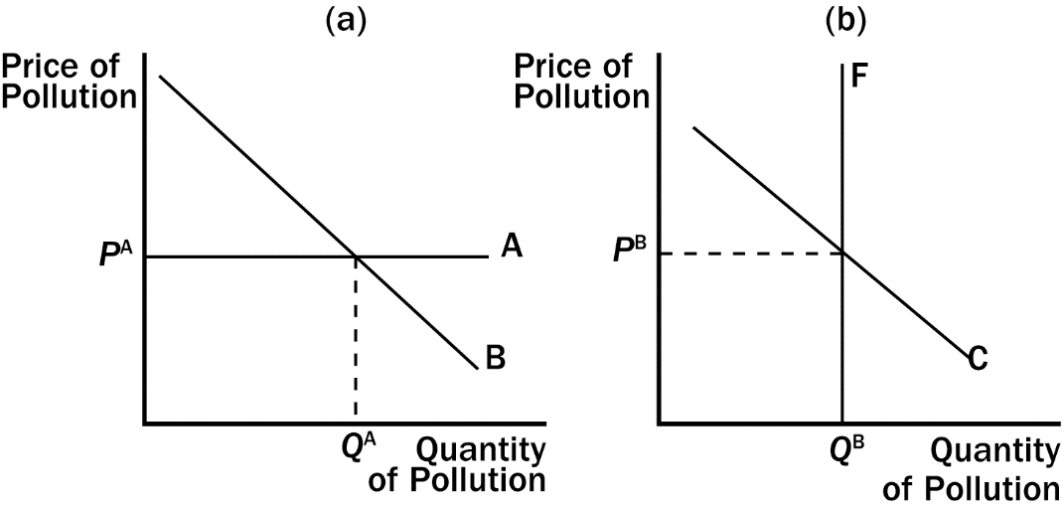
221. Refer to Figure 10-7. Which graph illustrates a regulation?
a. the left graph
b. the right graph
c. both graphs
d. neither graph
ANS: B PTS: 1 DIF: 2 REF: 10-3
TOP: Command-and-control policies MSC: Analytical
222. Refer to Figure 10-7. Which graph illustrates a corrective tax?
a. the left graph
b. the right graph
c. both graphs
d. neither graph
ANS: A PTS: 1 DIF: 2 REF: 10-3
TOP: Corrective taxes MSC: Analytical
223. Refer to Figure 10-7. Which of the following is not necessary in order for the corrective tax and pollution permit to have equivalent effects?
a. P^{B} must be equivalent to the corrective tax.
b. Q^{A} must be equivalent to the amount of pollution allowed to the pollution permit holders.
c. The equilibrium price and quantity of pollution must be the same in both graphs.
d. The amount of pollution emitted by each firm must be the same.
ANS: D PTS: 1 DIF: 3 REF: 10-3
TOP: Corrective taxes | Tradable pollution permits MSC: Analytical
224. Which of the following statements is correct?
a. Corrective taxes are often preferred over direct regulation because they typically reduce externalities at a lower cost.
b. Corrective taxes distort economic incentives.
c. Corrective taxes are often preferred over direct regulation because they typically reduce externalities at a faster rate.
d. Both a and b are correct.
ANS: A PTS: 1 DIF: 3 REF: 10-3
TOP: Corrective taxes | Command-and-control policies MSC: Analytical
225. Corrective taxes are preferred over regulations to deal with pollution because corrective taxes
a. reduce pollution at a lower cost to society.
b. raise revenue and reduce pollution simultaneously, although efficiency is reduced.
c. obtain faster results than regulations.
d. allow for an accurate monitoring of pollution levels.
ANS: A PTS: 1 DIF: 2 REF: 10-3
TOP: Corrective taxes | Command-and-control policies MSC: Interpretive
226. Regulations to reduce pollution
a. cause pollution levels to drop below the regulated amount.
b. are a less costly solution to society than a corrective tax.
c. cause each factory to reduce pollution to the same level (or less).
d. are a better solution for the environment than a corrective tax.
ANS: C PTS: 1 DIF: 2 REF: 10-3
TOP: Command-and-control policies | Corrective taxes MSC: Applicative
227. A corrective tax
a. causes each factory to reduce pollution by the same amount.
b. assigns a legal pollution limit for firms.
c. places a price on the right to pollute.
d. costs society more than pollution regulations.
ANS: C PTS: 1 DIF: 2 REF: 10-3
TOP: Corrective taxes | Command-and-control policies MSC: Applicative
228. Which of the following statements is correct?
a. Taxes are more difficult to administer than regulations.
b. Taxes provide incentives for firms to adopt new methods to reduce negative externalities.
c. Command-and-control policies provide incentives for private decisionmakers to solve their problems on their own.
d. Corrective taxes distort incentives.
ANS: B PTS: 1 DIF: 2 REF: 10-3
TOP: Corrective taxes | Command-and-control policies MSC: Interpretive
229. Which of the following is not an effective method to reduce negative externalities?
a. relying on voluntary compliance
b. taxing the output of industries that pollute
c. creating legal environmental standards
d. increasing public spending on cleanup and reduction of pollution
ANS: A PTS: 1 DIF: 2 REF: 10-3
TOP: Corrective taxes | Command-and-control policies MSC: Applicative
230. What is the difference between command-and-control policies and market-based policies toward externalities?
a. Command-and-control policies provide incentives for private decisionmakers to solve the problems on their own, whereas market-based policies regulate behavior directly.
b. Command-and-control policies rely on taxes, whereas market-based policies rely on quotas.
c. Command-and-control policies regulate behavior directly, whereas market-based policies provide incentives for private decisionmakers to change their behavior.
d. Command-and-control policies are efficient, whereas market-based policies are inefficient.
ANS: C PTS: 1 DIF: 1 REF: 10-3
TOP: Command-and-control policies MSC: Definitional
231. Which of the following statements is not correct?
a. Patents help internalize the externalities associated with technological advances.
b. Economists typically prefer regulations to corrective taxes because regulations provide more incentives for firms to seek continued reductions in pollution.
c. Allowing firms to trade pollution permits will lower the total cost of reducing pollution.
d. A big impediment to implementing the Coase theorem in many cases is high transactions costs.
ANS: B PTS: 1 DIF: 3 REF: 10-3
TOP: Command-and-control policies | Tradable pollution permits MSC: Analytical
232. In many cases selling pollution permits is a better method for reducing pollution than imposing a corrective tax because
a. it is hard to estimate the market demand curve and thus charge the "right" corrective tax.
b. selling pollution permits create a net increase in pollution.
c. Corrective taxes distort incentives.
d. Corrective taxes provide greater flexibility to firms that can reduce pollution at a low cost.
ANS: A PTS: 1 DIF: 2 REF: 10-3
TOP: Corrective taxes | Tradable pollution permits MSC: Interpretive
233. The difference between a corrective tax and a tradable pollution permit is that
a. a corrective tax sets the price of pollution and a permit sets the quantity of pollution.
b. a corrective tax creates a more efficient outcome than a permit.
c. a corrective tax sets the quantity of pollution and a permit sets the price of pollution.
d. a permit creates a more efficient outcome than a corrective tax.
ANS: A PTS: 1 DIF: 2 REF: 10-3
TOP: Corrective taxes | Tradable pollution permits MSC: Analytical
234. In some cases, tradable pollution permits may be better than a corrective tax because
a. pollution permits allow for a market solution while a corrective tax does not.
b. pollution permits generate more revenue for the government than a corrective tax.
c. pollution permits are never preferred over a corrective tax.
d. the government can set a maximum level of pollution using permits.
ANS: D PTS: 1 DIF: 2 REF: 10-3
TOP: Tradable pollution permits | Corrective taxes MSC: Interpretive
235. Which of the following helped reduce sulfur dioxide emissions, a leading cause of acid rain?
(i) corrective taxes
(ii) tradable pollution permits
(iii) amendments to the Clean Air Act

a. (i) only
b. both (i) and (ii)
c. (iii) only
d. both (ii) and (iii)
ANS: D PTS: 1 DIF: 3 REF: 10-3
TOP: Tradable pollution permits | Corrective taxes MSC: Applicative
236. With pollution permits, the supply curve for pollution rights is
a. perfectly elastic.
b. perfectly inelastic.
c. upward sloping.
d. downward sloping.
ANS: B PTS: 1 DIF: 2 REF: 10-3
TOP: Tradable pollution permits MSC: Analytical
237. Tradable pollution permits
a. are widely viewed as a cost-effective way to reduce pollution.
b. have helped reduce carbon emissions.
c. have helped reduce sulfur dioxide emissions.
d. All of the above are correct.
ANS: D PTS: 1 DIF: 2 REF: 10-3
TOP: Tradable pollution permits MSC: Applicative
238. Once tradable pollution permits have been allocated to firms,
a. the government controls the price of permits.
b. firms that can reduce pollution only at high cost will be willing to pay the most for the pollution permits.
c. the value of pollution-saving technology will be lower than the market value of a pollution permit.
d. the Coase theorem is no longer applicable as a solution to reducing pollution.
ANS: B PTS: 1 DIF: 2 REF: 10-3
TOP: Tradable pollution permits MSC: Interpretive
239. Tradable pollution permits
a. have prices that are set by the government.
b. will be more valuable to firms that can reduce pollution only at high costs.
c. are likely to create a higher level of total pollution.
d. are less desirable than corrective taxes in reducing pollution.
ANS: B PTS: 1 DIF: 2 REF: 10-3
TOP: Tradable pollution permits MSC: Analytical
240. Which of the following is not a characteristic of pollution permits?
a. Prices are set by supply and demand.
b. Allowing firms to trade their permits reduces the total quantity of pollution beyond the initial allocation.
c. Real-world markets for pollution permits include sulfur dioxide and carbon.
d. Firms for whom pollution reduction is very expensive are willing to pay more for permits than firms for whom pollution reduction is less expensive.
ANS: B PTS: 1 DIF: 3 REF: 10-3
TOP: Tradable pollution permits MSC: Analytical
241. When one firm sells its pollution permit to another firm,
a. both firms benefit.
b. the total amount of pollution remains the same.
c. the total amount of pollution decreases.
d. Both a and b are correct.
ANS: D PTS: 1 DIF: 3 REF: 10-3
TOP: Tradable pollution permits MSC: Analytical
242. Which of the following is an advantage of tradable pollution permits?
a. The government knows exactly how much each firm is allowed to pollute.
b. Revenue from the sale of permits is greater than revenue from a corrective tax.
c. The initial allocation of permits to firms does not affect the efficiency of the market.
d. Firms will engage in joint research efforts to reduce pollution.
ANS: C PTS: 1 DIF: 3 REF: 10-3
TOP: Tradable pollution permits MSC: Analytical
Figure 10-8
243. Refer to Figure 10-8. This graph shows the market for pollution when permits are issued to firms and traded in the marketplace. The equilibrium price of pollution is
a. $50
b. $500
c. $1,000
d. $2,000
ANS: C PTS: 1 DIF: 2 REF: 10-3
TOP: Tradable pollution permits MSC: Analytical
244. Refer to Figure 10-8. This graph shows the market for pollution when permits are issued to firms and traded in the marketplace. The equilibrium number of permits is
a. 50
b. 100
c. 1,000
d. 2,000
ANS: A PTS: 1 DIF: 2 REF: 10-3
TOP: Tradable pollution permits MSC: Analytical
245. Two firms, A and B, each currently dump 50 tons of chemicals into the local river. The government has decided to reduce the pollution and from now on will require a pollution permit for each ton of pollution dumped into the river. The government gives each firm 20 pollution permits, which it can either use or sell to the other firm. It costs Firm A $100 for each ton of pollution that it eliminates before it reaches the river, and it costs Firm B $50 for each ton of pollution that it eliminates before it reaches the river. After the two firms buy or sell pollution permits from each other, we would expect that Firm A will dump
a. 10 fewer tons of pollution into the river, and Firm B will dump 50 fewer tons of pollution into the river.
b. 50 fewer tons of pollution into the river, and Firm B will dump 10 fewer tons of pollution into the river.
c. 30 fewer tons of pollution into the river, and Firm B will dump 30 fewer tons of pollution into the river.
d. 10 more tons of pollution into the river, and Firm B will dump 50 fewer tons of pollution into the river.
ANS: A PTS: 1 DIF: 3 REF: 10-3
TOP: Tradable pollution permits MSC: Analytical
246. Two firms, A and B, each currently dump 50 tons of chemicals into the local river. The government has decided to reduce the pollution and from now on will require a pollution permit for each ton of pollution dumped into the river. The government gives each firm 20 pollution permits, which it can either use or sell to the other firm. It costs Firm A $100 for each ton of pollution that it eliminates before it reaches the river, and it costs Firm B $50 for each ton of pollution that it eliminates before it reaches the river. It is likely that
a. Firm A will buy all of Firm B's pollution permits. Each one will cost between $50 and $100.
b. Firm B will buy all of Firm A's pollution permits. Each one will cost between $50 and $100.
c. Both firms will use their own pollution permits.
d. Firm A will buy some of Firm B's pollution permits. Each one will cost less than $50.
ANS: A PTS: 1 DIF: 3 REF: 10-3
TOP: Tradable pollution permits MSC: Analytical
247. Two firms, A and B, each currently dump 50 tons of chemicals into the local river. The government has decided to reduce the pollution and from now on will require a pollution permit for each ton of pollution dumped into the river. It costs Firm A $100 for each ton of pollution that it eliminates before it reaches the river, and it costs Firm B $50 for each ton of pollution that it eliminates before it reaches the river. The government gives each firm 20 pollution permits. Government officials are not sure whether to allow the firms to buy or sell the pollution permits to each other. What is the total cost of reducing pollution if firms are not allowed to buy and sell pollution permits from each other? What is the total cost of reducing pollution if the firms are allowed to buy and sell permits from each other? You should assume that any firm that buys a permit pays the highest price for that permit.
a. $3,000; $1,500
b. $4,500; $3,500
c. $4,500; $4,000
d. $4,500; $2,500
ANS: B PTS: 1 DIF: 3 REF: 10-3
TOP: Tradable pollution permits MSC: Analytical
248. Two firms, A and B, each currently dump 20 tons of chemicals into the local river. The government has decided to reduce the pollution and from now on will require a pollution permit for each ton of pollution dumped into the river. The government gives each firm 10 pollution permits, which it can either use or sell to the other firm. It costs Firm A $100 for each ton of pollution that it eliminates before it reaches the river, and it costs Firm B $50 for each ton of pollution that it eliminates before it reaches the river. After the two firms buy or sell pollution permits from each other, we would expect that
a. Firm A will no longer pollute, and Firm B will not reduce its pollution at all.
b. Firm B will no longer pollute, and Firm A will not reduce its pollution at all.
c. Firm A will dump 10 tons of pollution into the river, and Firm B will dump 10 tons of pollution into the river.
d. Firm A will increase its pollution and Firm B will reduce its pollution.
ANS: B PTS: 1 DIF: 3 REF: 10-3
TOP: Tradable pollution permits MSC: Analytical
249. Two firms, A and B, each currently dump 50 tons of chemicals into the local river. The government has decided to reduce the pollution and from now on will require a pollution permit for each ton of pollution dumped into the river. The government will sell 40 pollution permits for $75 each. It costs Firm A $100 for each ton of pollution that it eliminates before it reaches the river, and it costs Firm B $50 for each ton of pollution that it eliminates before it reaches the river. It is likely that between the cost of permits and the cost of additional pollution abatement,
a. Firm B will spend $3,500.
b. Firm A will spend $4,000.
c. Firm A will spend $4,500.
d. Firm B will spend $3,000.
ANS: B PTS: 1 DIF: 3 REF: 10-3
TOP: Tradable pollution permits MSC: Analytical
250. Which of the following require firms to pay to pollute?
(i) corrective taxes
(ii) tradable pollution permits
(iii) pollution regulations

a. (i) only
b. both (i) and (ii)
c. (iii) only
d. both (ii) and (iii)
ANS: B PTS: 1 DIF: 2 REF: 10-3
TOP: Corrective taxes | Tradable pollution permits | Command-and-control policies MSC: Applicative
True/False
1. When a transaction between a buyer and seller directly affects a third party, the effect is called an externality.
ANS: T DIF: 1 REF: 10-0
TOP: Externalities MSC: Definitional
2. In a market characterized by externalities, the market equilibrium fails to maximize the total benefit to society as a whole.
ANS: T DIF: 1 REF: 10-0
TOP: Externalities MSC: Definitional
3. Barking dogs cannot be considered an externality because externalities must be associated with some form of market exchange.
ANS: F DIF: 1 REF: 10-0
TOP: Externalities MSC: Applicative
4. The social cost of pollution includes the private costs of the producers plus the costs to those bystanders adversely affected by the pollution.
ANS: T DIF: 1 REF: 10-1
TOP: Externalities MSC: Definitional
5. Organizers of an outdoor concert in a park surrounded by residential neighborhoods are likely to consider the noise and traffic cost to residential neighborhoods when they assess the financial viability of the concert venture.
ANS: F DIF: 1 REF: 10-1
TOP: Negative externalities MSC: Applicative
6. When firms internalize a negative externality, the market supply curve shifts to the left.
ANS: T DIF: 2 REF: 10-1
TOP: Negative externalities MSC: Analytical
7. Government subsidized scholarships are an example of a government policy aimed at correcting for negative externalities associated with education.
ANS: F DIF: 1 REF: 10-1
TOP: Positive externalities MSC: Applicative
8. Negative externalities lead markets to produce a smaller quantity of a good than is socially desirable, while positive externalities lead markets to produce a larger quantity of a good than is socially desirable.
ANS: F DIF: 2 REF: 10-1
TOP: Negative externalities, Positive externalities MSC: Interpretive
9. The government can “help” firms to internalize externalities by taxing goods that have negative externalities and subsidizing goods that have positive externalities.
ANS: T DIF: 2 REF: 10-1
TOP: Negative externalities, Positive externalities MSC: Applicative
10. If the social cost of producing robots is less than the private cost of producing robots, the private market produces too few robots.
ANS: T DIF: 2 REF: 10-1
TOP: Positive externalities, Technology spillovers MSC: Analytical
11. The patent system gives firms greater incentive to engage in research and other activities that advance technology.
ANS: T DIF: 2 REF: 10-1
TOP: Technology spillovers MSC: Applicative
12. A technology spillover is a type of negative externality.
ANS: F DIF: 2 REF: 10-1
TOP: Technology spillovers MSC: Interpretive
13. Government can be used to solve externality problems that are too costly for private parties to solve.
ANS: T DIF: 1 REF: 10-2
TOP: Externalities MSC: Interpretive
14. Government intervention is necessary to correct all externalities.
ANS: F DIF: 2 REF: 10-2
TOP: Externalities MSC: Applicative
15. According to the Coase theorem, if private parties can bargain without cost, then the private market will solve the problem of externalities.
ANS: T DIF: 1 REF: 10-2
TOP: Coase theorem MSC: Definitional
16. According to the Coase theorem, whatever the initial distribution of rights, the interested parties can bargain to an efficient outcome.
ANS: T DIF: 1 REF: 10-2
TOP: Coase theorem MSC: Definitional
17. According to the Coase theorem, the private market will need government intervention in order to reach an efficient outcome.
ANS: F DIF: 1 REF: 10-2
TOP: Coase theorem MSC: Definitional
18. Despite the appealing logic of the Coase theorem, private actors often fail to resolve on their own the problems caused by externalities.
ANS: T DIF: 1 REF: 10-2
TOP: Coase theorem MSC: Applicative
19. Private parties may choose not to solve an externality problem if the transaction costs are large enough.
ANS: T DIF: 2 REF: 10-2
TOP: Coase theorem MSC: Interpretive
20. Even if possible, it would be inefficient to prohibit all polluting activity.
ANS: T DIF: 2 REF: 10-3
TOP: Externalities MSC: Applicative
21. One advantage of regulation as a method for reducing pollution is that the government can determine the maximum quantity of pollution that is legally allowed.
ANS: T DIF: 2 REF: 10-3
TOP: Command-and-control policies MSC: Interpretive
22. When correcting for an externality, command-and-control policies are always preferable to market-based policies.
ANS: F DIF: 2 REF: 10-3
TOP: Command-and-control policies, Corrective taxes MSC: Interpretive
23. Corrective taxes enhance efficiency, but the cost to administer them exceeds the revenue they raise for the government.
ANS: F DIF: 1 REF: 10-3
TOP: Corrective taxes MSC: Interpretive
24. Most economists prefer regulation to taxation because regulation corrects market inefficiencies at a lower cost than taxation does.
ANS: F DIF: 2 REF: 10-3
TOP: Corrective taxes MSC: Applicative
25. A corrective tax places a price on the right to pollute.
ANS: T DIF: 2 REF: 10-3
TOP: Corrective taxes MSC: Interpretive
26. The least expensive way to clean up the environment is for all firms to reduce pollution by an equal percentage.
ANS: F DIF: 2 REF: 10-3
TOP: Corrective taxes MSC: Interpretive
27. Both pollution permits and corrective taxes are viewed as cost effective ways to keep the environment clean.
ANS: T DIF: 1 REF: 10-3
TOP: Corrective taxes, Tradable pollution permits MSC: Applicative
28. A market for pollution permits can efficiently allocate the right to pollute by the forces of supply and demand.
ANS: T DIF: 1 REF: 10-3
TOP: Tradable pollution permits MSC: Applicative
29. The Environmental Protection Agency (EPA) cannot reach a target level of pollution through the use of pollution permits.
ANS: F DIF: 1 REF: 10-3
TOP: Tradable pollution permits MSC: Applicative
30. Social welfare can be enhanced by allowing firms to trade their rights to pollute.
ANS: T DIF: 2 REF: 10-3
TOP: Tradable pollution permits MSC: Applicative
31. Firms that can reduce pollution easily would be willing to sell their pollution permits.
ANS: T DIF: 2 REF: 10-3
TOP: Tradable pollution permits MSC: Applicative
32. One example of a real-world market for tradable pollution permits is the market for carbon permits in Europe.
ANS: T DIF: 1 REF: 10-3
TOP: Tradable pollution permits MSC: Applicative
Short Answer
1. Using a supply and demand diagram, demonstrate how a negative externality leads to market inefficiency. How might the government help to eliminate this inefficiency?
ANS:
When a negative externality exists, the private cost (or supply curve) is less than the social cost. The market equilibrium quantity of Q₀ will be greater than the socially optimal quantity of Q₁. The government could help eliminate this inefficiency by taxing the product. In this example, the size of the per-unit tax would be P₃ - P₁
(or P₂ - P₀).
DIF: 2 REF: 10-2
TOP: Negative externalities MSC: Analytical
2. Using a supply and demand diagram, demonstrate how a positive externality leads to market inefficiency. How might the government help to eliminate this inefficiency?
ANS:
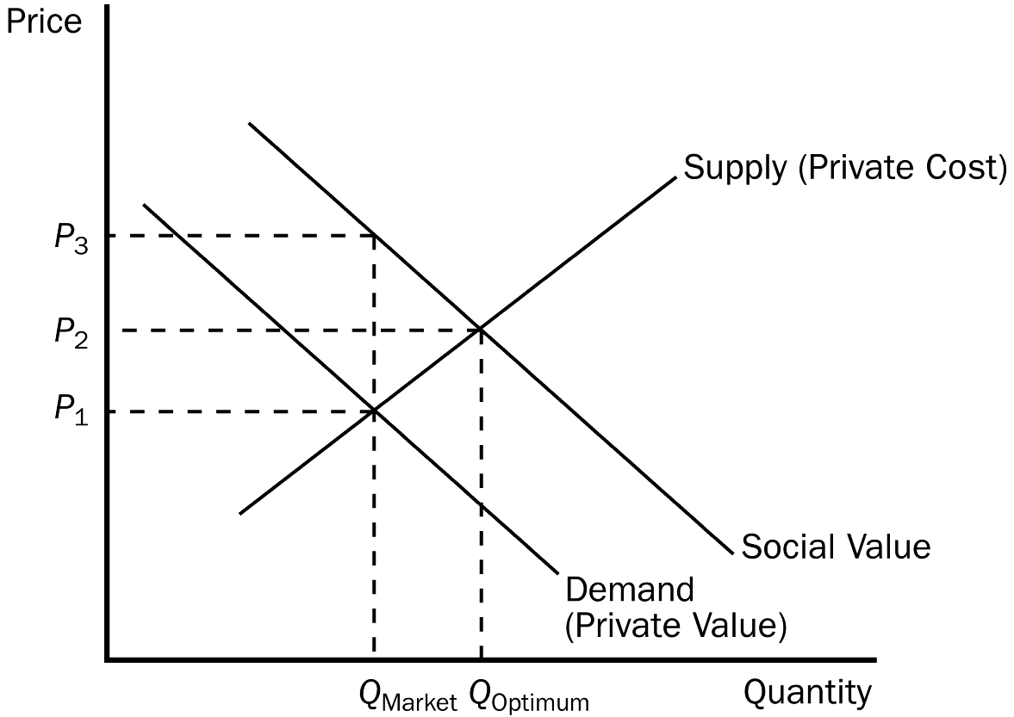
When a positive externality exists, the private value (or demand curve) is less than the social value. The market equilibrium quantity will be less than the socially optimal quantity. The government could help eliminate this inefficiency by subsidizing the product. In this example, the size of the per-unit subsidy would be P₃ - P₁.
DIF: 2 REF: 10-1
TOP: Positive externalities MSC: Analytical
3. To produce honey, beekeepers place hives of bees in the fields of farmers. As bees gather nectar, they pollinate the crops in the fields, which increases the yields of these fields at no additional cost to the farmer. What might be a reasonable private solution to this externality, and how might the solution be reached?
ANS:
One solution would be to have one person own both the farm fields and the beehives, in which case the externality is internalized. Another solution would be to have the farmer and beekeeper enter into a contract so that they can coordinate the number of bee hives and acres of crops to maintain an efficient outcome.
DIF: 1 REF: 10-2
TOP: Externalities MSC: Applicative
4. The Coase theorem suggests that efficient solutions to externalities can be determined through bargaining. Under what circumstances will private bargaining fail to produce a solution?
ANS:
Private parties may fail to bargain to an efficient solution under a variety of circumstances. First, the transaction costs of bargaining may be so high that one or both of the parties decides not to bargain. Second, the bargaining may not take place if one or both of the parties believes that the agreement cannot be enforced. Third, one or both of the parties may try to hold out for a better deal, in which case the bargaining process breaks down. Fourth, if there are a large number of parties taking part in the negotiations, the costs of coordination may be so great that the bargaining is not successful.
DIF: 1 REF: 10-2
TOP: Coase theorem MSC: Interpretive
5. Why are efficiency taxes preferred to regulatory policies as methods remedy externalities?
ANS:
Efficiency taxes allow markets to coordinate optimal resource allocation. In order for regulations to be efficient, the government needs detailed information about specific industries, including information about the alternative technologies that those industries could adopt. Thus, taxes are likely to reduce pollution at a lower cost to society.
DIF: 2 REF: 10-3
TOP: Command-and-control policies, Corrective taxes MSC: Applicative
6. Use a graph to illustrate the quantity of pollution that would be emitted (a) after a corrective tax has been imposed and (b) after tradable pollution permits have been imposed. Could these two quantities ever be equivalent?
ANS:
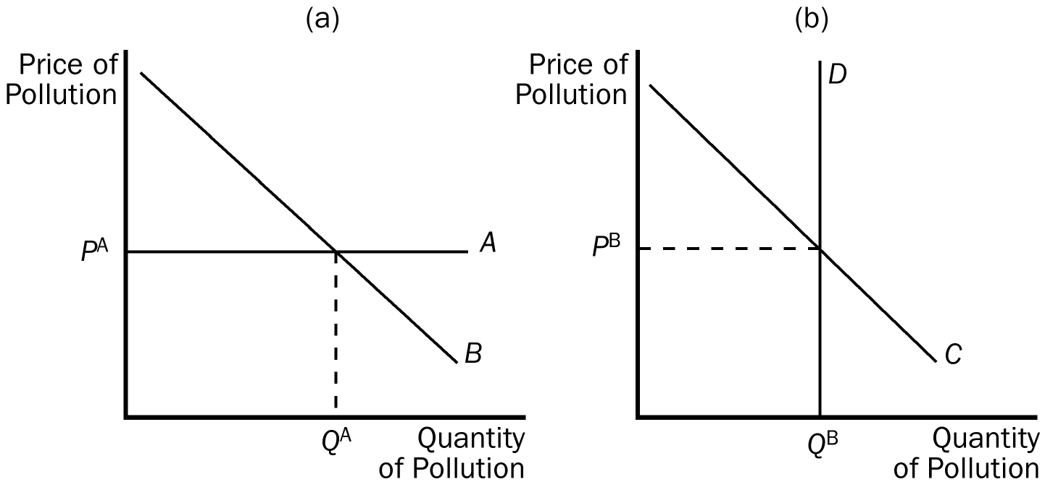

Yes, these two quantities could be equal. For example, P^{B} could be equal to the amount of the corrective tax.
DIF: 2 REF: 10-3
TOP: Corrective taxes, Tradable pollution permits MSC: Analytical

