Project Overview
This documentation describes the Python script pipeline developed to replicate the OUTPUT tab of the referenced spreadsheet. The pipeline is designed to process and integrate various data sources to produce a comprehensive and structured analytical output Excel file.

Project Structure
.
├── input_data
│ ├── CENSUS_MHI_STATE.csv -> median house income data
│ ├── CENSUS_POPULATION_STATE.tsv -> population data
│ ├── REDFIN_MEDIAN_SALE_PRICE.csv -> median sale price data
│ ├── KEYS.csv -> region names mapping file
│ ├── key_row.csv -> file that contains regions of interest
│ └── override_data.csv -> optional file for manual hardcoded fields in OUTPUT.xlsx file
├── output
│ └── OUTPUT.xlsx -> generted output file
└── src
├── generate_output.py -> command line script that generates OUTPUT.xlsx file
├── utils.py -> utility functions used by main generate_output.py script
└── visualization.ipynb -> visualizations script

input_data
This directory contains main provided 4 data sources that contain the data needed for generating OUTPUT.xlsx file in addition to two files which are:
- key_row.csv: This file contains the regions that will be retrieved in the OUTPUT.xlsx file which is displayed in the first column
- override_data.csv: This file contains optional feature for overriding or providing data for regions that is not present in main data sources, as observed in the OUTPUT.xlsx file, there are some values that are not mapped through formulas but are hardcoded values, to better organize this option this file is provided
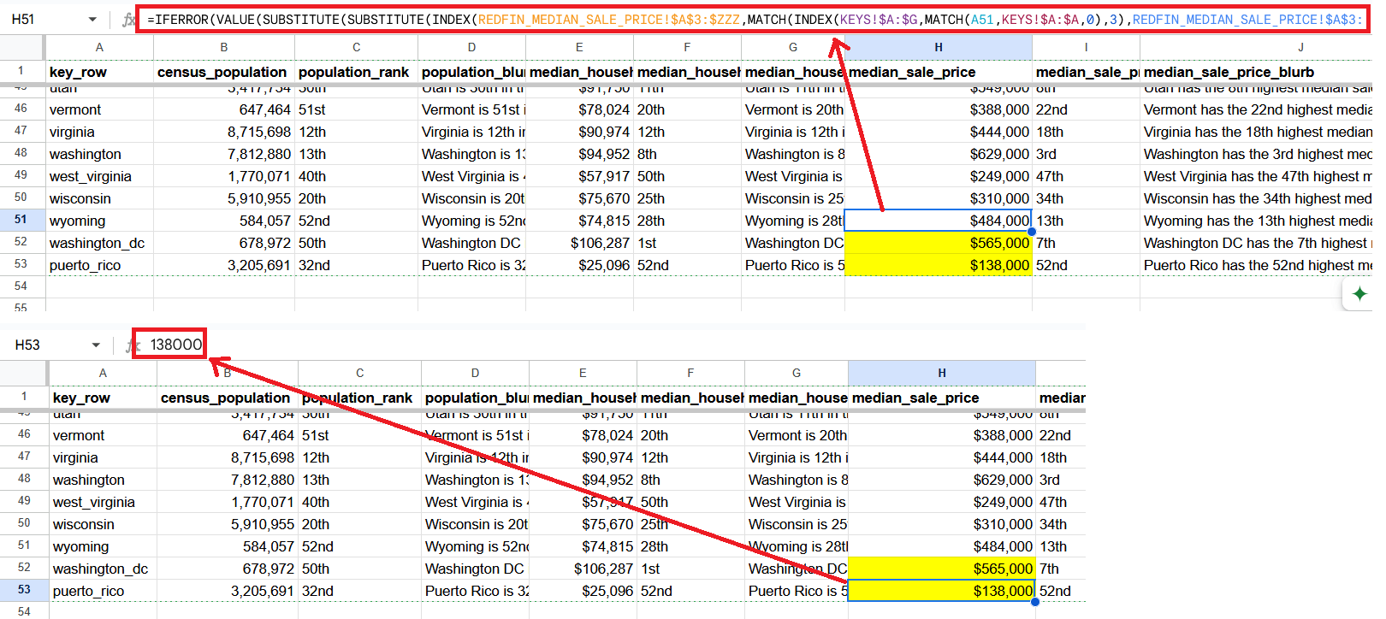

output
This directory contains the final generated OUTPUT.xlsx file.

src
This directory contains the core scripts responsible for data processing, output generation, and visualization.

Scripts Description
This section outlines the assumptions and core functionalities embedded within the Python scripts used to generate the final Excel output. The workflow centers around aggregating census and housing data, computing rankings & blurbs, and formatting the results into an exportable Excel sheet.

utils.py
This script serves as a utility module, providing reusable functions for data transformation, formatting, and output generation. Each function parameter’s are described in docstring of with the docstring, key functions are:

get_regions_mapping
Maps region identifiers from the key dataset (KEYS.csv) to standardized Zillow region names that are used to retrieve different metrics across datasets. It is worth noting that key_row field in the dataset may contain duplicate values. To mimic the behavior of Excel's MATCH function with match_type=0 (which returns the first exact match), duplicates are removed while retaining the first occurrence. This is handled in pandas using the following line: key_row_mapper.drop_duplicates(['key_row'], keep='first', inplace=True)

get_census_stats
Extracts specific labeled metrics (e.g., estimate of population or median of household income) for all regions from census datasets.
This function is tailored to work with census data for population and median household income (MHI), as both share the same structural format.

add_census_stat_with_blurb
A higher-order function that wraps get_census_stats , with the following functionalities:
- Joining the requested metric to the main output DataFrame
- Generating rankings for each region
- Producing descriptive blurbs based on the metric values
Like get_census_stats, this function only works with population and MHI census data.

get_median_sale_price
Extracts and cleans the most recent median home sale price data from median sale price datasets.

ordinal
Converts numeric ranks into their ordinal string equivalents (e.g., 1 → 1st), and in case of empty rank (the ranked numerical column is null) returns empty string.

get_rank
Assigns ordinal rankings to numeric columns with optional ascending control.

format_numbers
Cleans and converts number strings (with symbols like $ or ,) into Pandas numerical representation.

generate_blurb
Uses a provided template and placeholder mappings to generate human-readable summaries per region.

load_override_data
Loads optional override data (CSV format) for replacing or augmenting column values in the final output excel file.

save_formatted_xlsx
Saves the final DataFrame to an Excel file with formatted number and currency columns.

generate_output.py
This is the primary script responsible for orchestrating the full data pipeline. It performs the following steps:
- Argument Parsing
The script accepts command-line arguments for input paths, file names, and other configurations. Default values are provided for all arguments to enable out-of-the-box usage. A detailed explanation of all available arguments is provided in the "How to Run" section.
- Reading Data Sources
Reads all required input files.
- Data Gathering
This stage begins population the output DataFrame by first, mapping the row_key regions to Zillow regions, then retrieve and generate the main 3 columns (main metric column, calculating rank, and generating the blurb) for census population, census MHI, median sale price datasets, and the calculated house affordability ratio metric.
- Final Output
Cleans intermediate columns, apply formatting rules for numbers and currencies, and saves the final Excel file.

How to Run

Requirements
- This project is built using Python 3.10.11. Please make sure to use this version (or a compatible one) to avoid compatibility issues.
- Install requirements.txt from cmd with:
pip install -r requirements.txt

Running Script
The main script generate_output.py can be executed from the command line and accepts several configurable arguments to control input sources and output behavior.
Argument | Type | Default | Description
--population-fname | str | CENSUS_POPULATION_STATE.tsv | Filename of the census population data file inside --data-dir.
--mhi-fname | str | CENSUS_MHI_STATE.csv | Filename of the median household income CSV inside --data-dir.
--msp-fname | str | REDFIN_MEDIAN_SALE_PRICE.csv | Filename of the median sale price data file inside --data-dir.
--region-keys-fname | str | KEYS.csv | Filename of the region mapping keys file inside --data-dir.
--override-data-fname | str | (optional) | Filename of the override CSV file inside --data-dir.
--data-dir | str | input_data | Directory where the input files are located.
--output-dir | str | output | Directory where the output Excel file will be saved.
--output-fname | str | OUTPUT.xlsx | Name of the final generated Excel file.

Example
To run the script using default filenames and folder structure run the following on your command line from main project directory:
python ./src/generate_output.py
To generate identical Excel file as the referenced spreadsheet, use --override-data-fname
option:
python ./src/generate_output.py --override-data-fname override_data.csv

Bonus: Visualization
The following charts were created using Plotly to extract insights from the final output Excel file. For an interactive experience and higher resolution visuals, it’s recommended to explore them through the Jupyter notebook located at ./src/visualization.ipynb.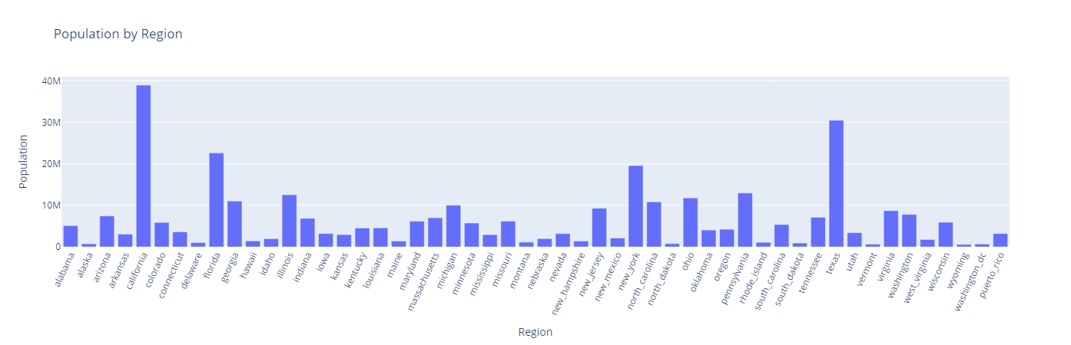
The plot highlights states like California, Florida, New York, and Texas are among the high-density regions. If these regions do not also have correspondingly high median household incomes, they tend to exhibit high home affordability ratio (indicating that housing is less affordable).

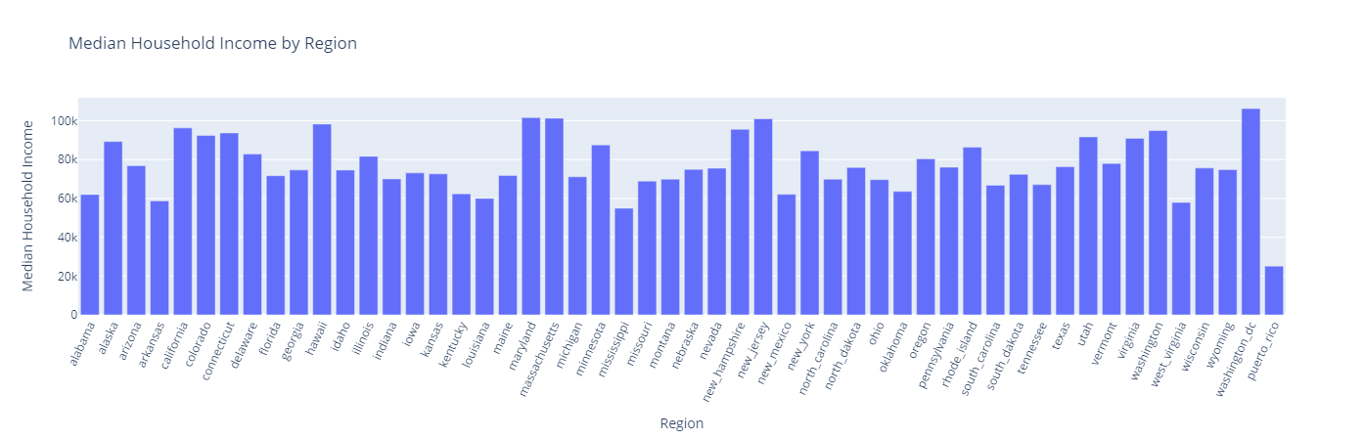
The plot indicates that no region stands out with exceptionally high median household income, while Puerto Rico notably has one of the lowest median household incomes among all regions.

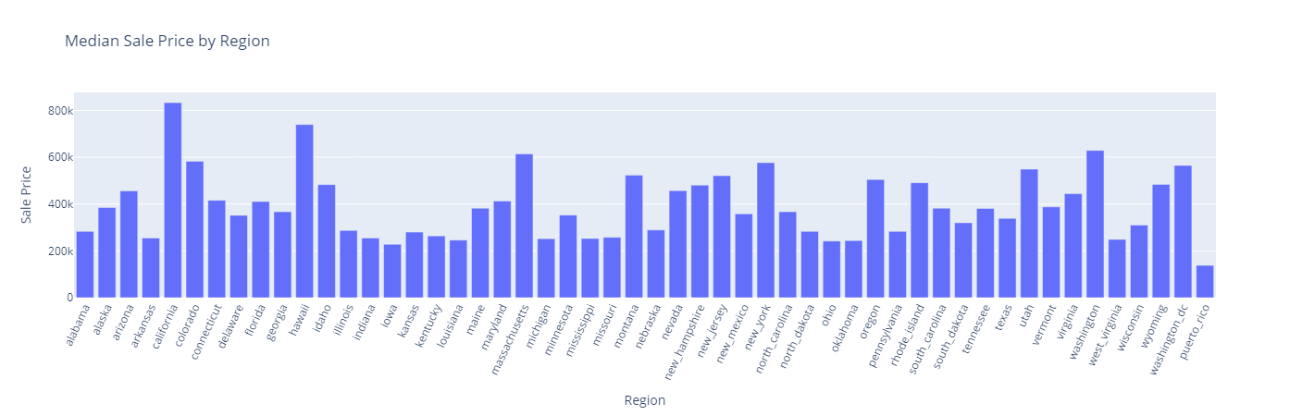
The plot shows that regions such as California, Hawaii, Massachusetts, and Washington have notably high median sale prices, with Hawaii standing out at the top after California. As observed in previous charts, Hawaii also has a low population, which is interesting insight that may reflect the impact of high housing costs and geographic constraints on population density.

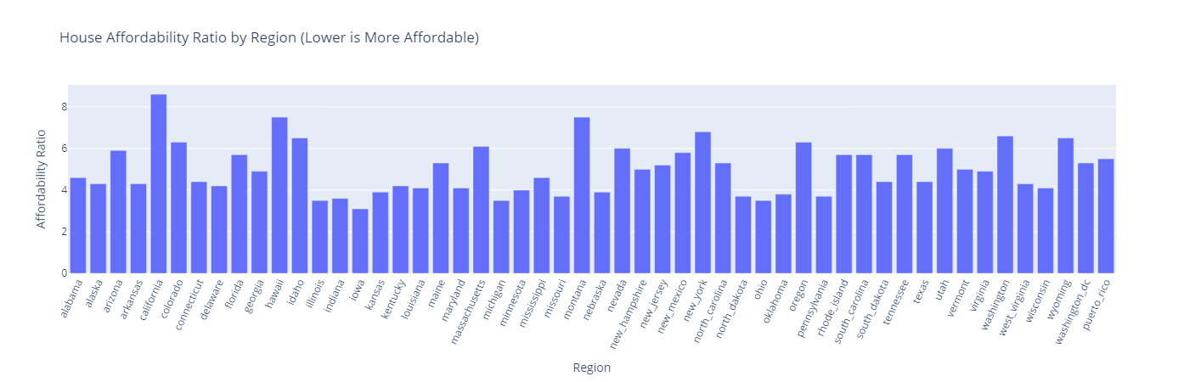
The chart indicates that regions such as California, Hawaii, Montana, New York, and Washington have high house affordability ratios, suggesting that homes in these areas are significantly less affordable relative to household income.

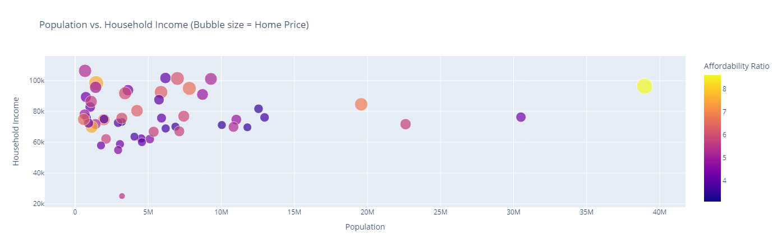
The chart reveals that there is a cluster of regions such as West Virginia, Mississippi, Arkansas, Oklahoma, Louisiana, Kentucky, Iowa, and Kansas tend to have both relatively low populations and lower household incomes, yet they achieve favorable housing affordability scores.

