JMETER RESULT ANALYSISn Report

HTML Report Dashboard is a huge step forward simplifying JMeter test result analysis.

**Report Summary**

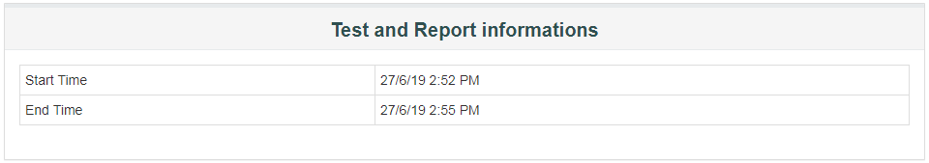

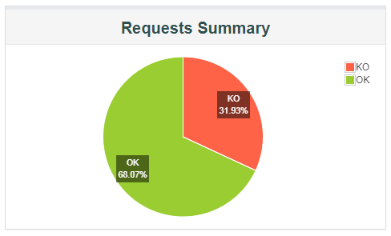

The Report Summary contains the following information:

* Test start time and end time,
* A pie chart named *Requests Summary* which gives the proportion of Successful / Failed samples.
  + **OK**: Total Number of samples executed successfully,
  + **KO**: Total Number of samples failed to execute,

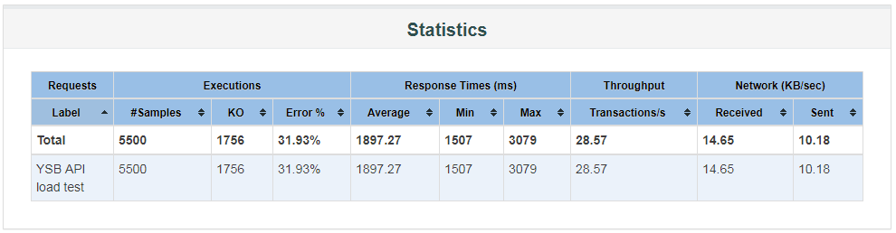

The **Statistics** table provides global test statistics for every single request which has been executed:

* **Executions**: Number of hits and errors,
  + **# Samples**: This indicates the number of virtual users per request,
  + **OK**: Total Number of samples executed successfully,
  + **KO**: Total Number of samples failed to execute,
  + **Errors %**: Percent of requests with errors,
* **Response Times (ms)**: Response times in milliseconds,
  + **Average**: The average response time for the request(s) executed,
  + **Min**: The lowest elapsed time for the samples with the same label,
  + **Max**: The longest elapsed time for the samples with the same label,
  + **Throughput**: Number of hits per second,
* **Network**: throughput in KB/sec

The throughput measured in Kilobytes per second

* + **Received**: KB received per second,
  + **Sent**: KB sent per second.

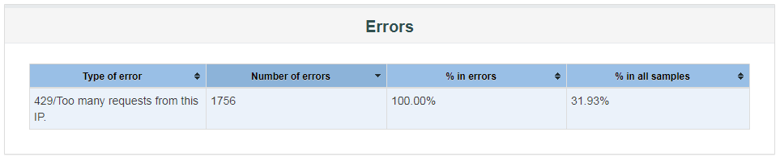

The errors table give more details about the errors encountered during the load test. For each type of error, you will see:

* **Number of errors**: how many errors occurred,
* **% in errors**: percentage of requests in error,
* **% in all samples**: Percentage of errors compared to total number of samples.

