

**IAR EW for 8051 Introduction and Installation**

https://zhuanlan.zhihu.com/p/535315364  
  
**Table of contents**

1. Introduction to IAR

2. Software Download

3. Installation steps

4. Software Registration

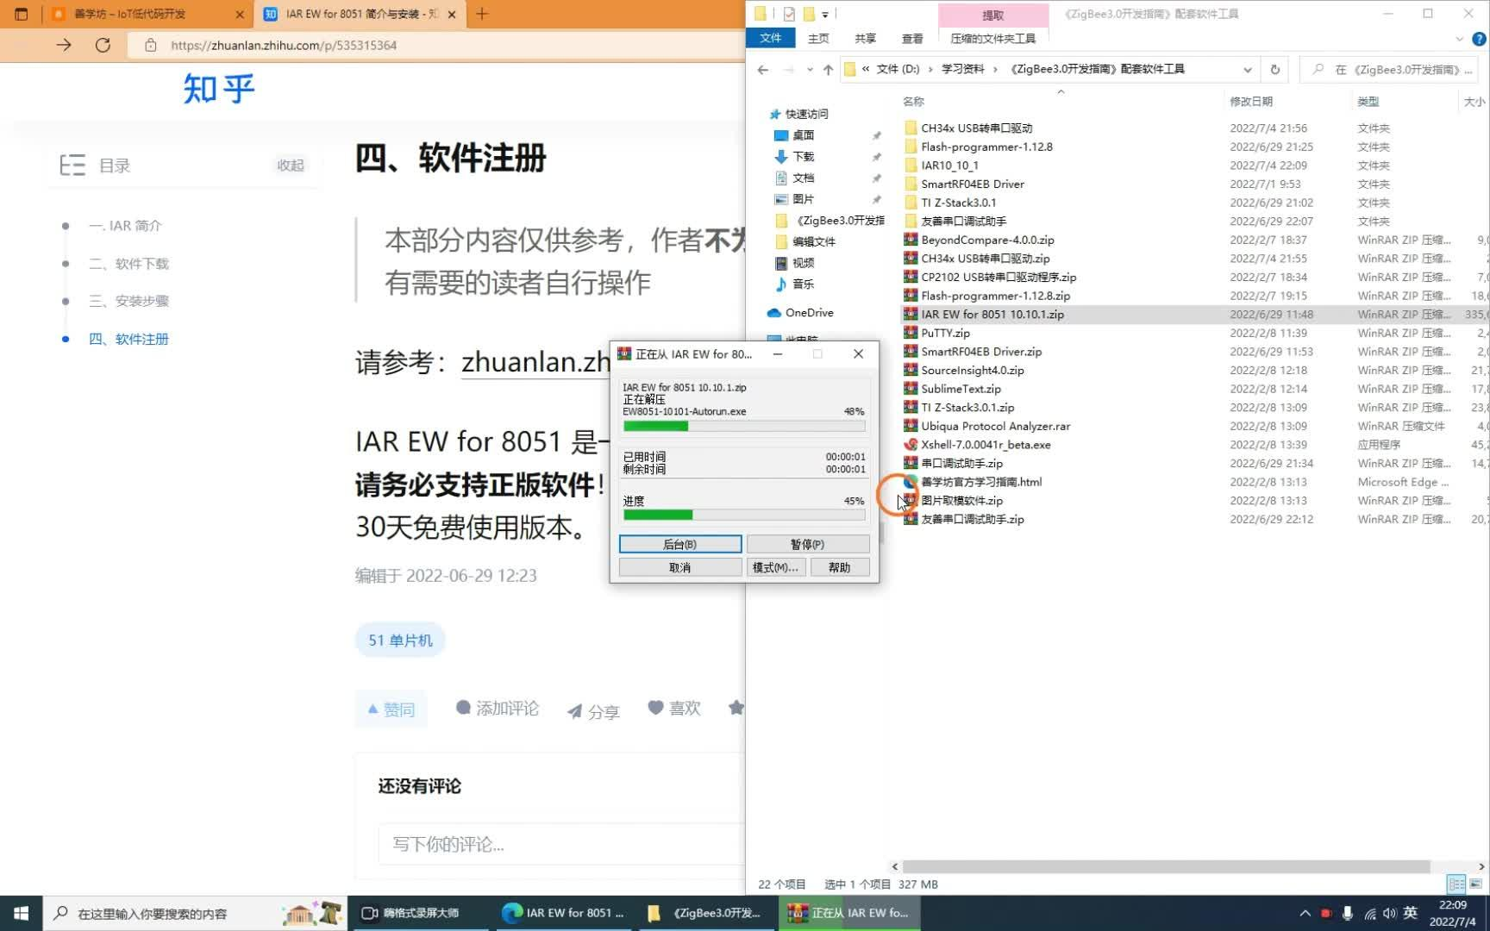

00:07 / 02:42

**1. Introduction to IAR**

IAR is a world-leading supplier of embedded system development tools and services. One of its most famous products is the C compiler IAR Embedded Workbench. IAR Embedded Workbench supports microprocessors from many well-known semiconductor companies. The currently supported microprocessors are shown in the figure (picture from IAR official website):

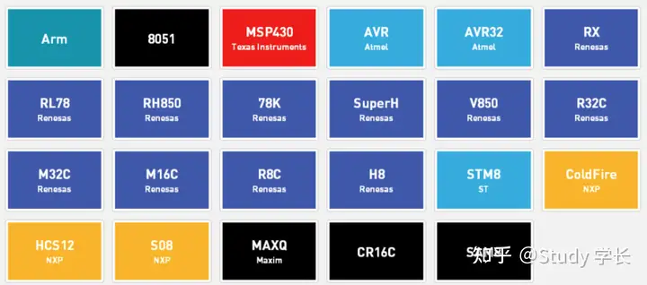

Since the ZigBee chip TI CC2530 is based on 8051, we choose IAR EW for 8051 as the development tool.

**2. Software Download**

(1) Course users can find a compressed file named “IAR EW for 8051 10.10.1.zip” in the supporting materials.

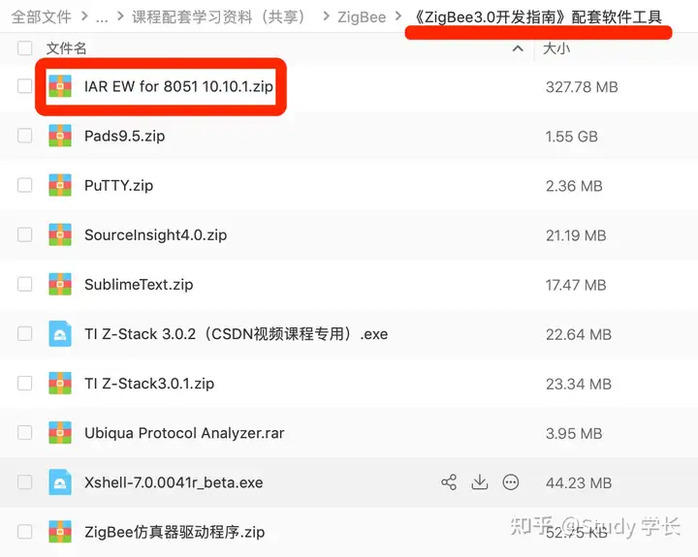

You can also download it from the official website [https://www.iar.com/products/archit ectures /iar-embedded-workbench-for-8051/](https://link.zhihu.com/?target=https%3A//www.iar.com/products/architectures/iar-embedded-workbench-for-8051/)

**3. Installation steps**

(1) After downloading the installation package, right-click the IAR installation package and select "Run as Administrator". After running, click Install IAR Embedded Workbench® for 8051, as shown in the figure.

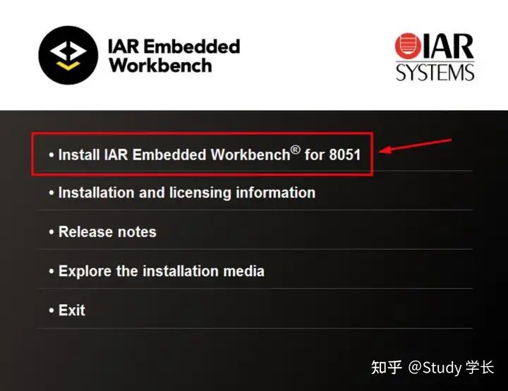

(2) In the pop-up dialog box, click the Next button, as shown in the figure.

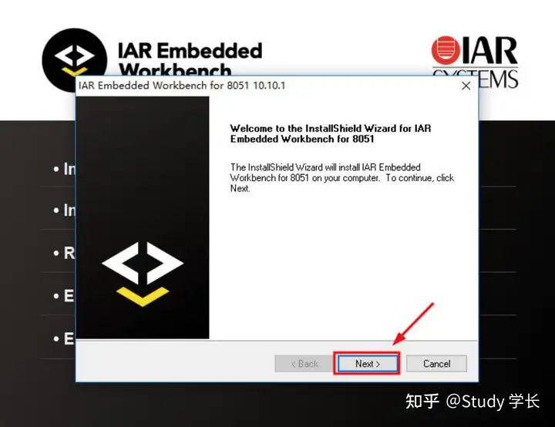

(3) After reading and agreeing to the license agreement, select I accept the terms of the license agreement, and then click the Next button, as shown in the figure.

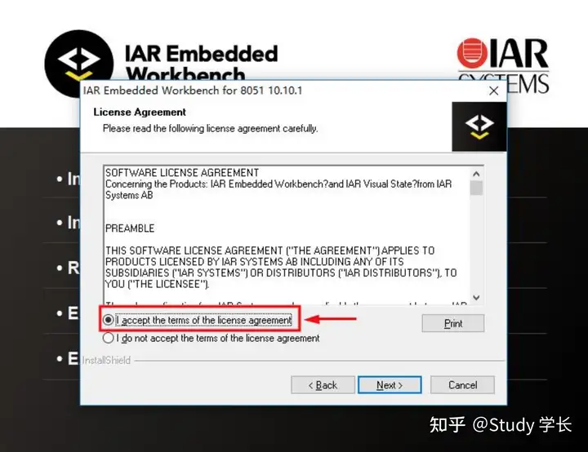

(4) Click the Change button to select the software installation directory, and then click the Next button, as shown in the figure.

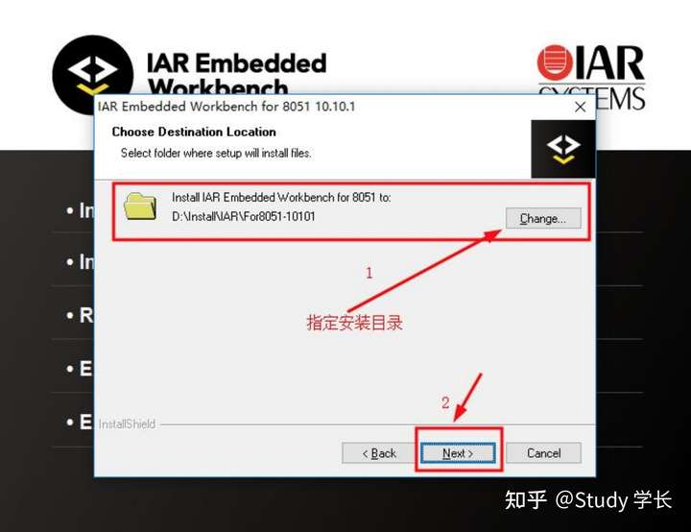

(5) Select Complete to install all components, and then click the Next button, as shown in the figure.

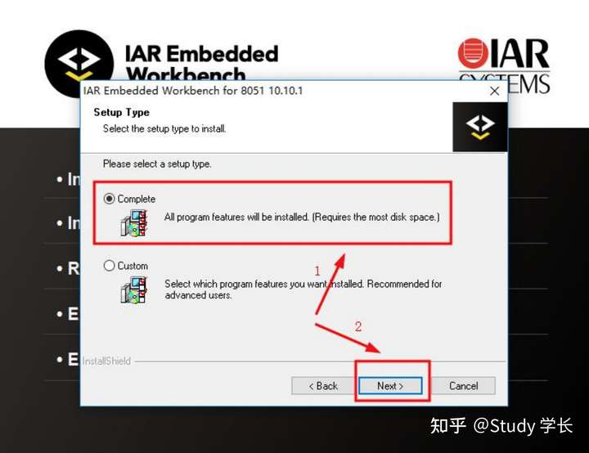

(6) Keep the default location of the program folder and click the Next button directly, as shown in the figure.

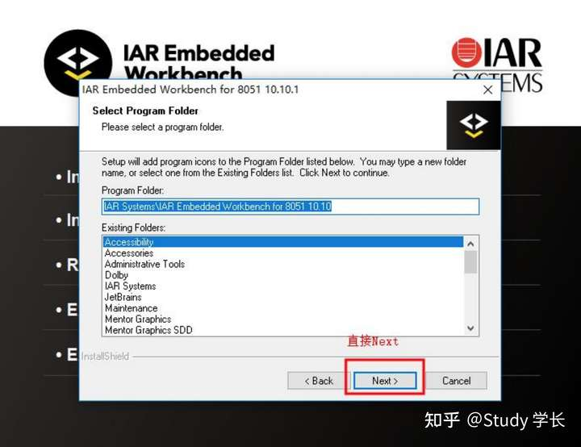

(7) Click the Install button, as shown in the figure.

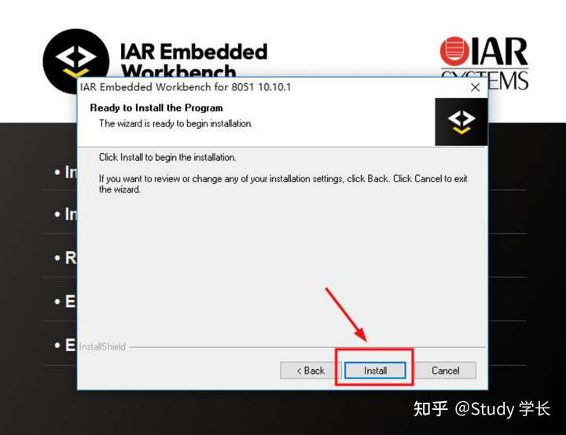

(8) Wait for the installation to complete, as shown in the figure.

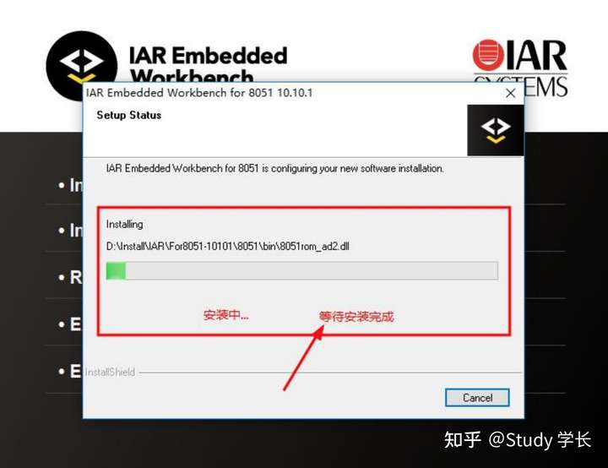

(9) IAR will pop up the following dialog box asking whether to install the Dongle driver. Since it is not used for the time being, click the "No" button, as shown in the figure.

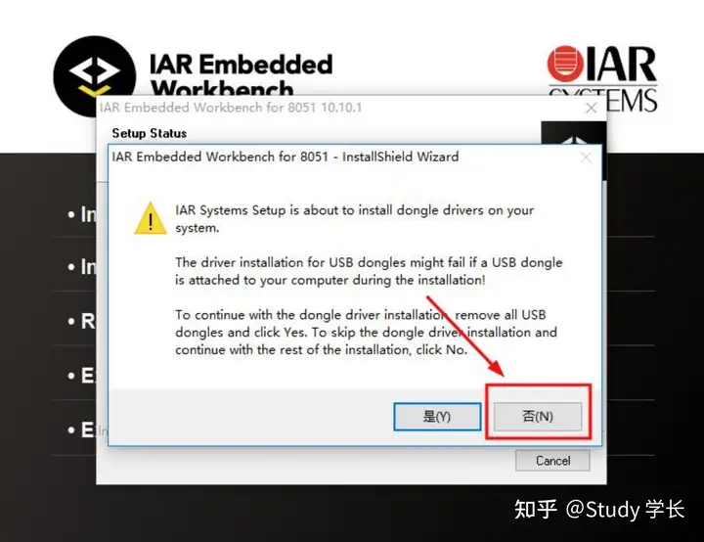

(10) Continue waiting for the installation to complete, as shown in the figure.

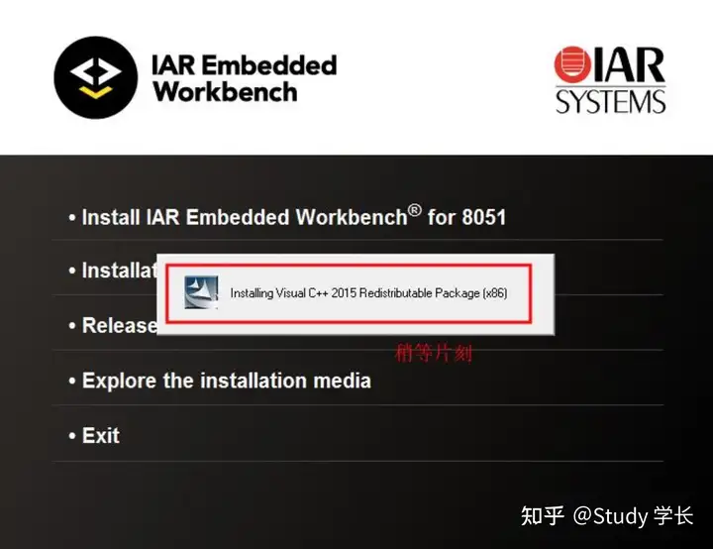

(11) Select Launch IAR Embedded Workbenchd, and then click the Finish button, as shown in the figure.

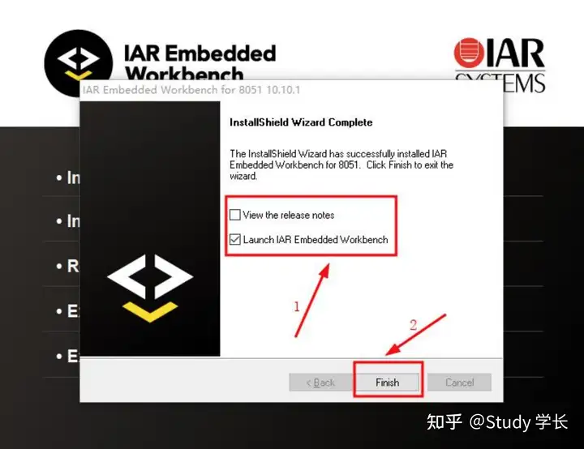

(12) If the following dialog box pops up, it means that another version of IAR has been installed. Check Don't remind me and click the Close button, as shown in the figure.

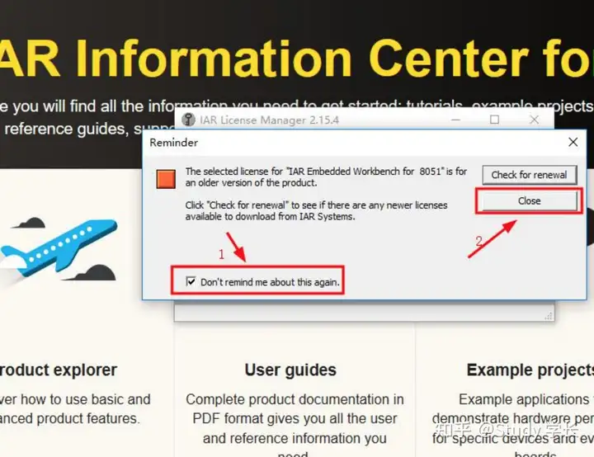

(13) If the following prompt box pops up, check Don't run the Wizard for this product at startup, and then click the "Cancel" button, as shown in the figure.

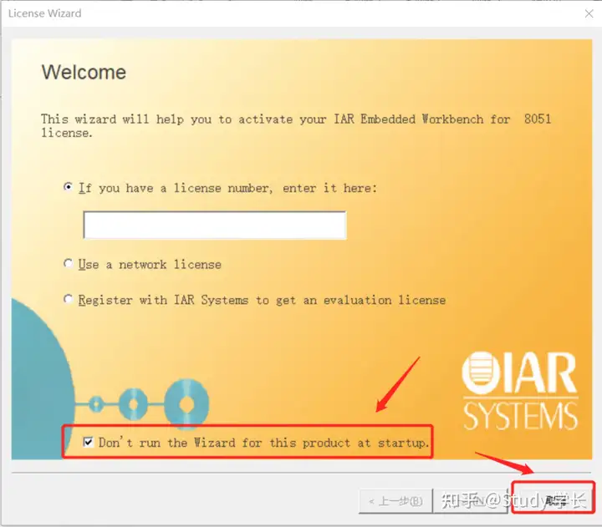

At this point, IAR EW for 8051 has been installed. If you need to register and activate, please continue reading below.

(14) Click Help, and then select Authorization Manager.

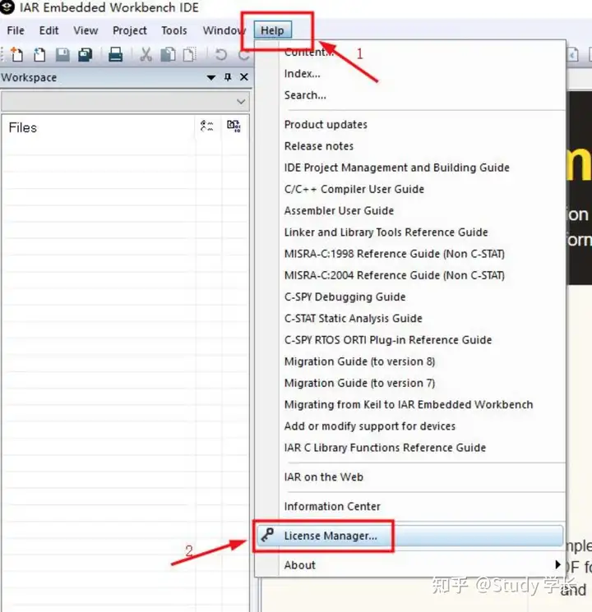

(15) Select Offline Activation in the License Manager.

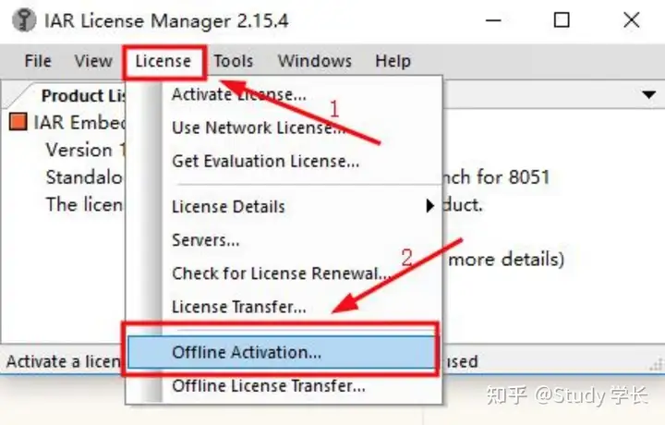

(16) Enter the registration code in the following dialog box. You can purchase the registration code on the IAR official website, or continue reading below.

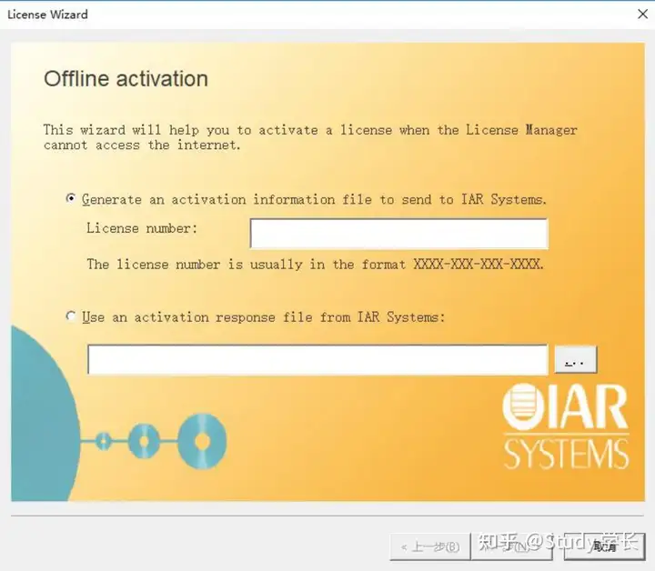

**4. Software Registration**

This section is for reference only. The author **does not provide technical support for this section**. Please operate it yourself if you need it.

Please refer to[:](https://zhuanlan.zhihu.com/p/535068284?)https://zhuanlan.zhihu.com/p/535068284

IAR EW for 8051 is a paid development software. **If you use it for commercial purposes, please be sure to support genuine software**! If you use it for personal learning, you can use the official 30-day free trial version.