**How to setup and work with OpenThread Border Router**  
https://docs.espressif.com/projects/esp-thread-br/en/latest/dev-guide/build_and_run.html  
https://openthread.io/guides/border-router/espressif-esp32  
https://openthread.io/codelabs/esp-openthread-hardware  
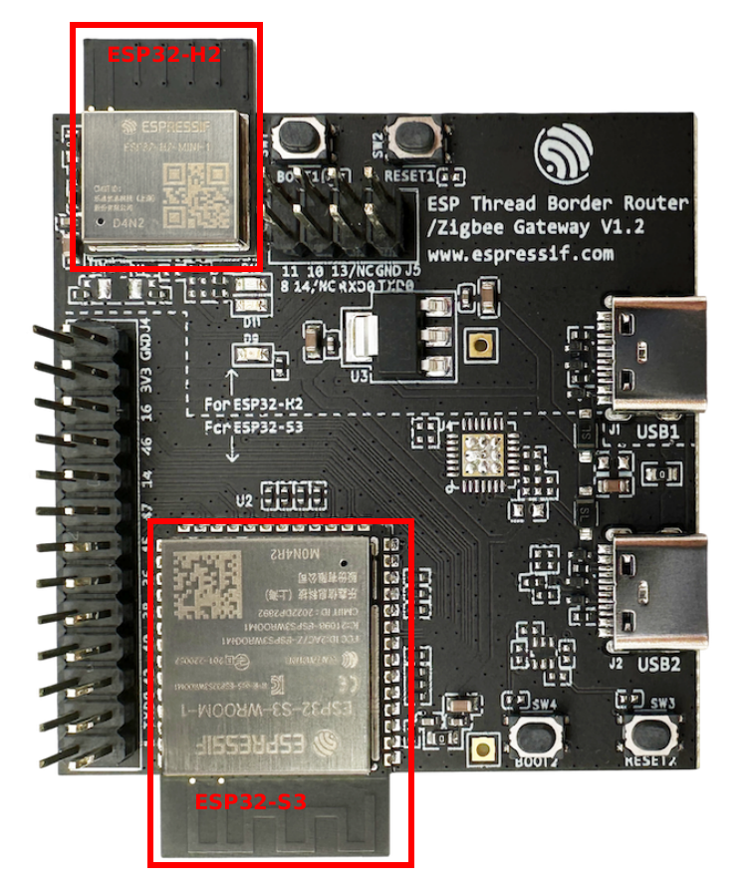  
esp-thread-border-router-board.png  
Note: Only the USB2 port on the ESP Thread Border Router Board needs to be connected to the host.  
  
~~~

D:

cd /Espressif/esp-idf  
./export.bat  
cd ..  
git clone --recursive https://github.com/espressif/esp-thread-br.git  
~~~  
  
Build the esp-idf/examples/openthread/ot_rcp example. The firmware doesn't need to be explicitly flashed to a device. It will be included in the Border Router firmware and flashed to the ESP32-H2 chip upon first boot (or the RCP firmware changed).  
~~~  
cd /Espressif/esp-idf/examples/openthread/ot_rcp

idf.py set-target esp32h2

idf.py build  
cd /Espressif/esp-thread-br\examples\basic_thread_border_router  
idf.py set-target esp32s3

idf.py menuconfig  
~~~  
  
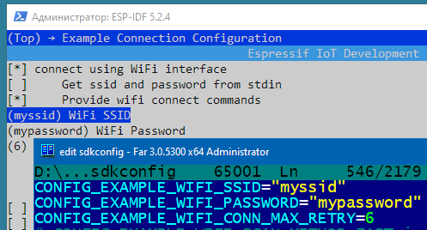  
esp_otbr_menuconfig_01.png  
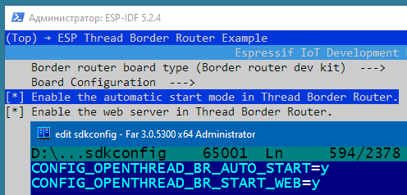  
esp_otbr_menuconfig_02.png  
  
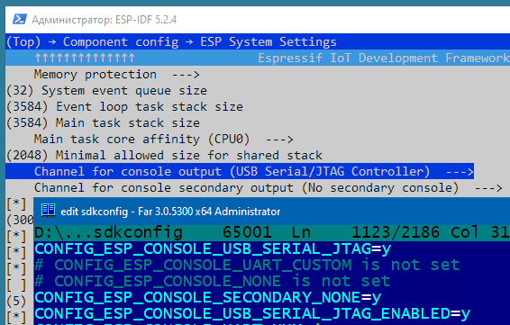  
esp_otbr_menuconfig_03.png  
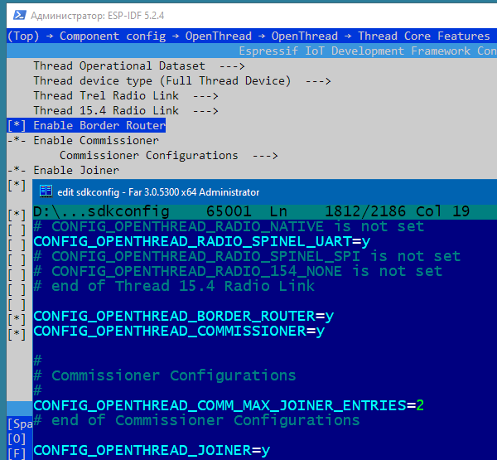  
esp_otbr_menuconfig_04.png  
  
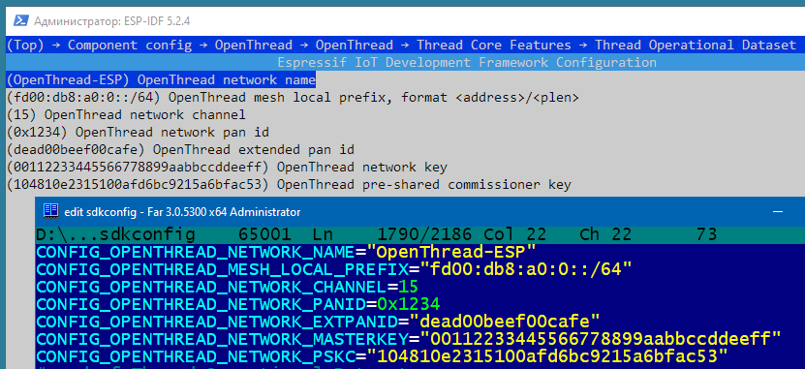  
esp_otbr_menuconfig_05.png  
  
~~~  
idf.py -p COM3 build flash monitor  
~~~  
  
Now we can form a Thread network using the OpenThread command line on ESP Thread Border Router Board (BR Commissioner):  
~~~  
dataset init new  
~~~

Done  
  
~~~  
dataset  
~~~  
Active Timestamp: 1

Channel: 21

Channel Mask: 0x07fff800

Ext PAN ID: 151975d11bea97b5

Mesh Local Prefix: fd6a:b54b:d6a3:b05a::/64

Network Key: 731ab6a60a64a0a0b14b259b86b2be01

Network Name: OpenThread-1444

PAN ID: 0x1444

PSKc: 54e7f18d2575014da94db09df29c5df0

Security Policy: 672 onrc 0

Done  
  
Commit this dataset as the active one:

~~~  
dataset commit active  
~~~

Done

Bring up the IPv6 interface:  
~~~  
ifconfig up  
~~~

I (59329) OPENTHREAD: Platform UDP bound to port 49153

Done

I (59329) OT_STATE: netif up

Start Thread protocol operation:  
~~~  
thread start  
~~~

I(61709) OPENTHREAD:[N] Mle-----------: Role disabled -> detached

Done

I(62469) OPENTHREAD:[N] Mle-----------: Attach attempt 1, AnyPartition reattaching with Active Dataset

I(69079) OPENTHREAD:[N] RouterTable---: Allocate router id 11

I(69079) OPENTHREAD:[N] Mle-----------: RLOC16 fffe -> 2c00

I(69089) OPENTHREAD:[N] Mle-----------: Role detached -> leader

I(69089) OPENTHREAD:[N] Mle-----------: Partition ID 0x28b518c6

I (69099) OPENTHREAD: Platform UDP bound to port 49154

After a moment, check the device state. It should be the Leader.  
~~~  
state  
~~~

leader

Done