**NAME\ MOHAMED HAZEM FAHMY AHMED**

2. What is the difference between cat and more command?

|  |  |
| --- | --- |
| ***cat*** | Outputs the entire contents of a file to the terminal at once. |
| **more** | Displays file contents one screen at a time, allowing navigation with the spacebar. |

**cat more**

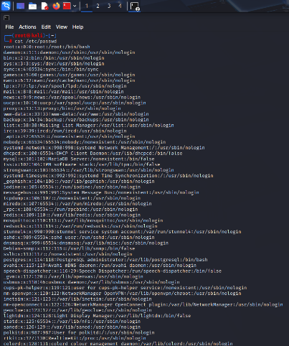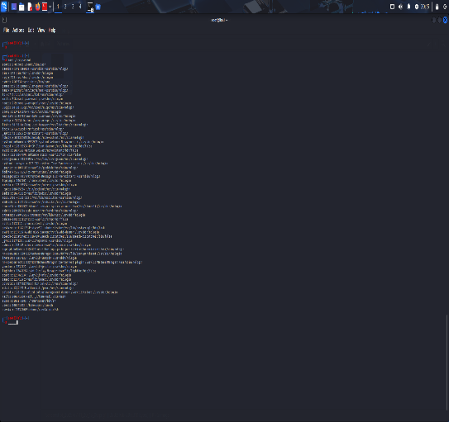

**3. What is the difference between rm and rmdir using man?**

**rmdir: Removes empty directories only.**

**rm: Removes files and, with the -r option, can remove non-empty directories recursively.**

**man rm**

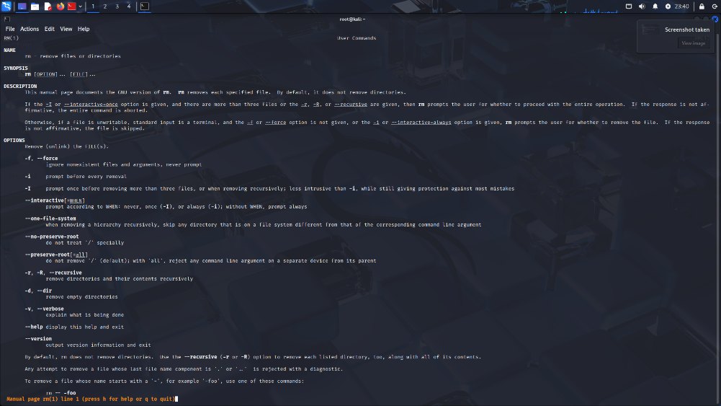

**man rmdir**

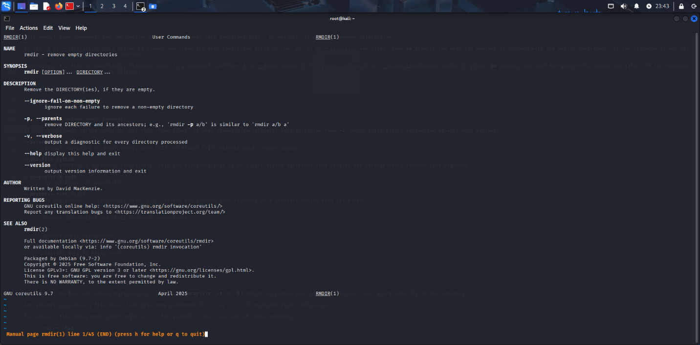

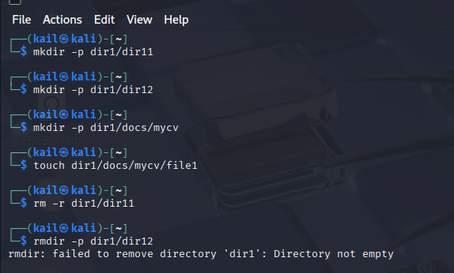**4. Create the following hierarchy under your home directory:**

**  
5. Copy the /etc/passwd file to your home directory making its name is mypasswd.**

**6. Rename this new file to be oldpasswd.**

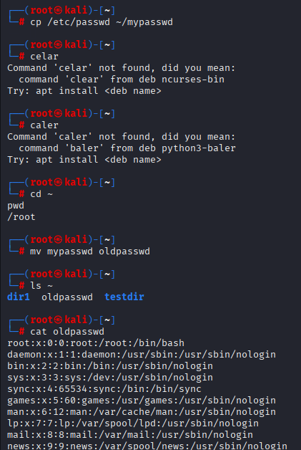

**7. You are in /usr/bin, list four ways to go to your home directory**

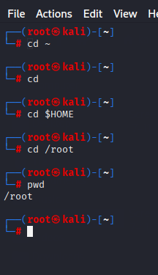

**8. List Linux commands in /usr/bin that start with letter w** 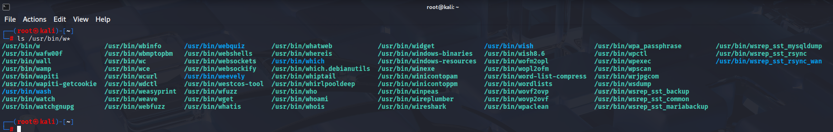

**9. Display the first 4 lines of /etc/passwd**

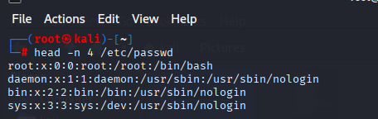

**10.Display the last 7 lines of /etc/passwd**

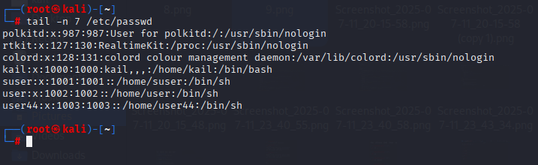

**11.Display the man pages of passwd the command and the file sequentially in one command.**

**man passwd ; man 5 passwd**

**12.Display the man page of the passwd file.**

**man 5 passwd**

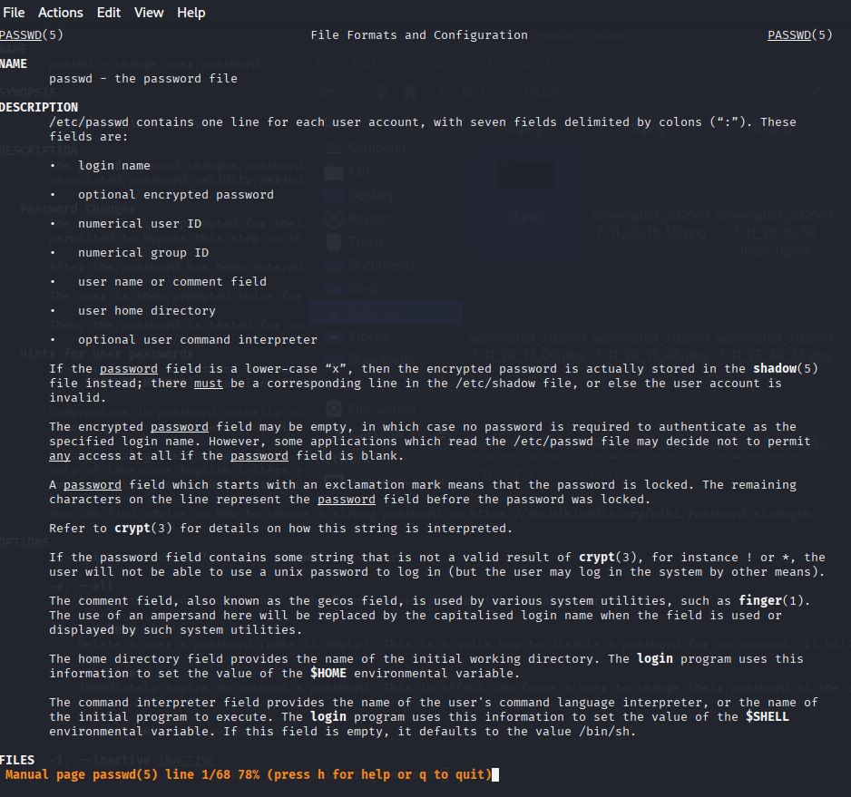

**13.Display a list of all the commands that contain the keyword passwd in their man page.**

