**به نام خدا**

**تمرین یک درس سنجی کاربردی**

**محسن حسینی، 403209902**

|  |  |  |  |  |  |
| --- | --- | --- | --- | --- | --- |
|  | **EducationLevel** | **ParticipationRate** | | **UnemploymentRate** | |
| **Gender** |  | **Female** | **Male** | **Female** | **Male** |
|  |  |  |  |  |  |
|  | Bachelor’s Degree | 33% | 69% | 24% | 11% |
|  | Below High School and High School | 9% | 74% | 11% | 8% |
|  | Master’s and Higher | 54% | 81% | 16% | 6% |
|  | Non-Literate | 9% | 61% | 1% | 5% |

**سوال یک**

**سوال دو**

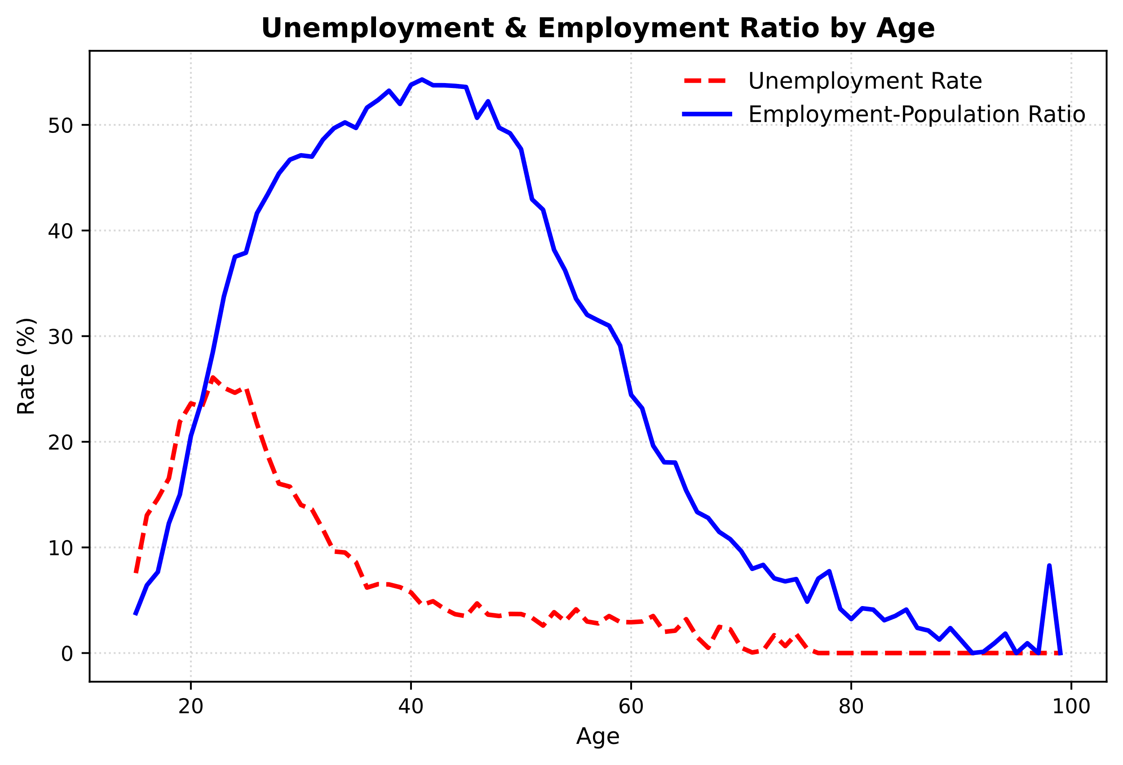

**سوال سه**

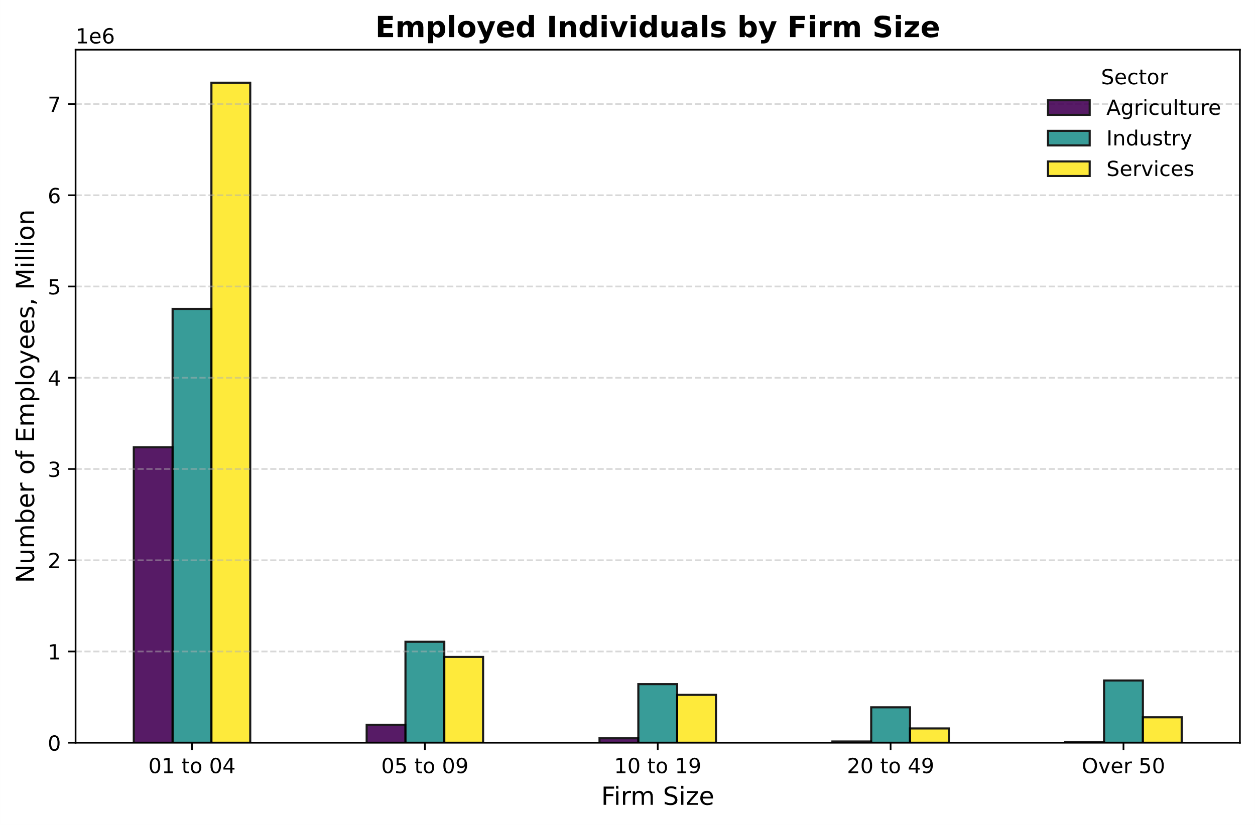

**سوال چهار**

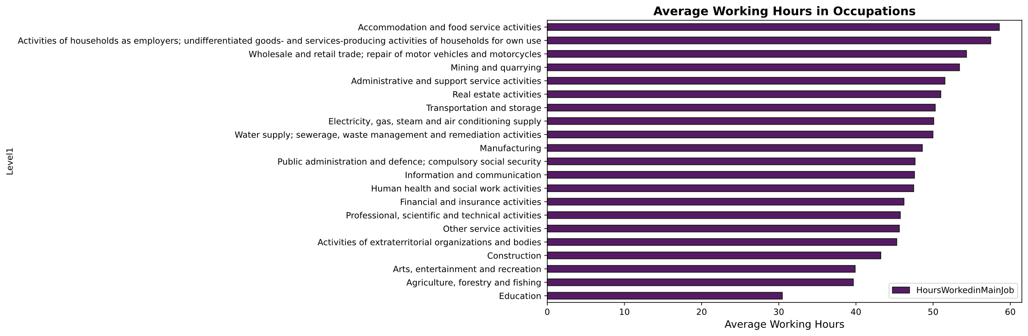

**سوال پنج**

**"جدول Q5-Part1"**

**سوال پنج**

**"جدول Q5-Part2"**

**سوال هفت**

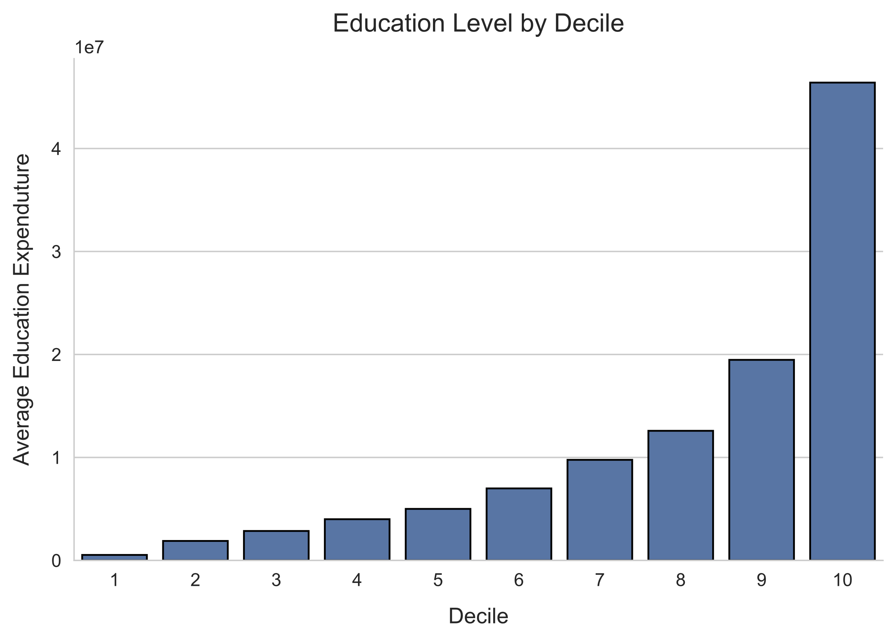

**سوال هشت**

