|  |  |  |  |
| --- | --- | --- | --- |
|  | **wage** | **educ** | **female** |
| **count** | 2000 | 2000 | 2000 |
| **mean** | 17.45092 | 13.7805 | 0.513 |
| **std** | 5.880851 | 3.643893 | 0.499956 |
| **min** | -1.21 | 8 | 0 |
| **25%** | 12.815 | 11 | 0 |
| **50%** | 16.785 | 14 | 1 |
| **75%** | 21.7475 | 17 | 1 |
| **max** | 34.26 | 20 | 1 |

|  |  |  |  |  |  |  |
| --- | --- | --- | --- | --- | --- | --- |
|  | **coef** | **std** | **t** | **P>|t|** | **[0.025** | **0.975]** |
| **const** | 17.4237 | 0.515 | 33.856 | 0 | 16.414 | 18.433 |
| **educ** | 0.002 | 0.036 | 0.055 | 0.956 | -0.069 | 0.073 |

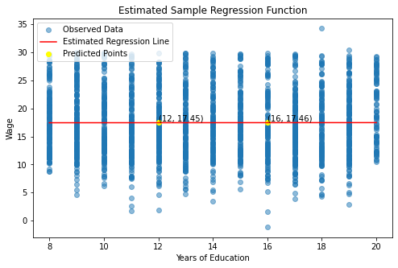

|  |  |  |  |  |  |  |  |  |  |  |  |
| --- | --- | --- | --- | --- | --- | --- | --- | --- | --- | --- | --- |
|  | **attend** | **termgpa** | **priGPA** | **ACT** | **final** | **atndrte** | **hwrte** | **frosh** | **soph** | **skipped** | **stndfnl** |
| **count** | 680 | 680 | 680 | 680 | 680 | 680 | 674 | 680 | 680 | 680 | 680 |
| **mean** | 26.14706 | 2.601 | 2.586775 | 22.51029 | 25.89118 | 81.70956 | 87.90801 | 0.232353 | 0.576471 | 5.852941 | 0.029659 |
| **std** | 5.455037 | 0.736586 | 0.544714 | 3.490768 | 4.709835 | 17.04699 | 19.26926 | 0.422644 | 0.494481 | 5.455037 | 0.989461 |
| **min** | 2 | 0 | 0.857 | 13 | 10 | 6.25 | 12.5 | 0 | 0 | 0 | -3.30882 |
| **25%** | 24 | 2.1375 | 2.19 | 20 | 22 | 75 | 87.5 | 0 | 0 | 2 | -0.78782 |
| **50%** | 28 | 2.67 | 2.56 | 22 | 26 | 87.5 | 100 | 0 | 1 | 4 | 0.052521 |
| **75%** | 30 | 3.12 | 2.9425 | 25 | 29 | 93.75 | 100 | 0 | 1 | 8 | 0.682773 |
| **max** | 32 | 4 | 3.93 | 32 | 39 | 100 | 100 | 1 | 1 | 30 | 2.783613 |

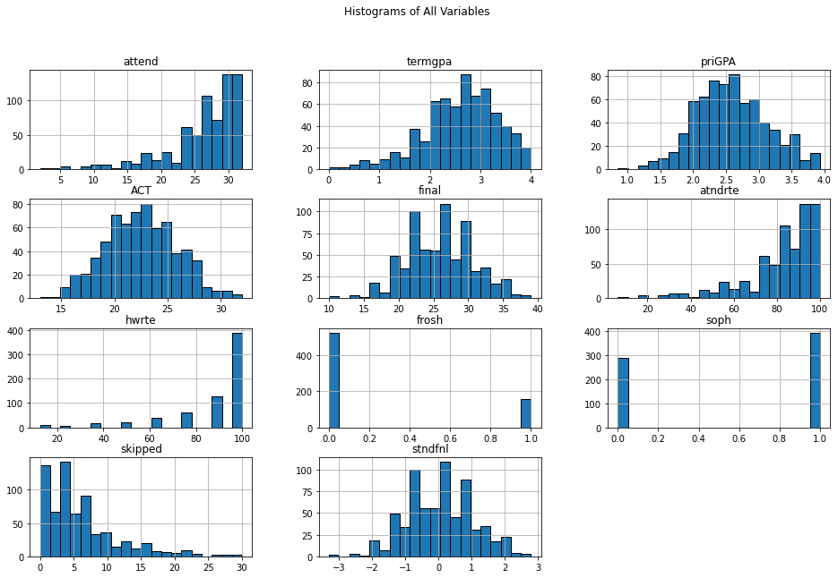

|  |  |  |  |  |  |  |
| --- | --- | --- | --- | --- | --- | --- |
|  | **coef** | **std** | **t** | **P>|t|** | **[0.025** | **0.975]** |
| **const** | -0.5017 | 0.196 | -2.556 | 0.011 | -0.887 | -0.116 |
| **atndrte** | 0.0082 | 0.002 | 3.705 | 0 | 0.004 | 0.012 |
| **frosh** | -0.2899 | 0.116 | -2.505 | 0.012 | -0.517 | -0.063 |
| **soph** | -0.1184 | 0.099 | -1.196 | 0.232 | -0.313 | 0.076 |

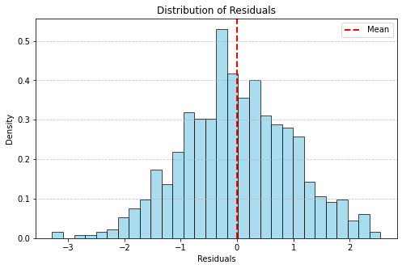

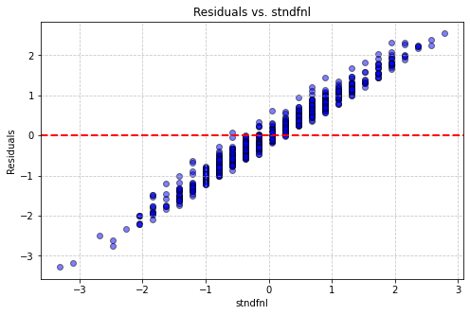

|  |  |  |  |  |  |  |
| --- | --- | --- | --- | --- | --- | --- |
|  | **coef** | **std** | **t** | **P>|t|** | **[0.025** | **0.975]** |
| **const** | -3.2973 | 0.309 | -10.677 | 0 | -3.904 | -2.691 |
| **atndrte** | 0.0052 | 0.002 | 2.191 | 0.029 | 0.001 | 0.01 |
| **frosh** | -0.0495 | 0.108 | -0.459 | 0.647 | -0.261 | 0.162 |
| **soph** | -0.1596 | 0.09 | -1.778 | 0.076 | -0.336 | 0.017 |
| **priGPA** | 0.4266 | 0.082 | 5.207 | 0 | 0.266 | 0.587 |
| **ACT** | 0.0844 | 0.011 | 7.559 | 0 | 0.062 | 0.106 |
|  |  |  |  |  |  |  |
|  | **coef** | **std** | **t** | **P>|t|** | **[0.025** | **0.975]** |
| **const** | 1.3848 | 1.239 | 1.117 | 0.264 | -1.049 | 3.818 |
| **atndrte** | 0.0062 | 0.002 | 2.642 | 0.008 | 0.002 | 0.011 |
| **frosh** | -0.1053 | 0.107 | -0.985 | 0.325 | -0.315 | 0.105 |
| **soph** | -0.1807 | 0.089 | -2.039 | 0.042 | -0.355 | -0.007 |
| **priGPA** | -1.5261 | 0.474 | -3.22 | 0.001 | -2.457 | -0.595 |
| **ACT** | -0.1124 | 0.098 | -1.145 | 0.253 | -0.305 | 0.08 |
| **priGPA2** | 0.3682 | 0.089 | 4.138 | 0 | 0.193 | 0.543 |
| **ACT2** | 0.0042 | 0.002 | 1.928 | 0.054 | -7.66E-05 | 0.008 |
|  |  |  |  |  |  |  |
|  | **coef** | **std** | **t** | **P>|t|** | **[0.025** | **0.975]** |
| **const** | 1.3943 | 1.267 | 1.1 | 0.272 | -1.094 | 3.882 |
| **atndrte** | 0.0058 | 0.011 | 0.535 | 0.593 | -0.016 | 0.027 |
| **frosh** | -0.1054 | 0.107 | -0.984 | 0.325 | -0.316 | 0.105 |
| **soph** | -0.1808 | 0.089 | -2.038 | 0.042 | -0.355 | -0.007 |
| **priGPA** | -1.5248 | 0.476 | -3.205 | 0.001 | -2.459 | -0.591 |
| **ACT** | -0.1123 | 0.098 | -1.143 | 0.253 | -0.305 | 0.081 |
| **priGPA2** | 0.3679 | 0.089 | 4.113 | 0 | 0.192 | 0.544 |
| **ACT2** | 0.0042 | 0.002 | 1.925 | 0.055 | -8.29E-05 | 0.008 |
| **atndrte2** | 2.87E-06 | 7.87E-05 | 0.036 | 0.971 | 0 | 0 |