**محسن حسینی، 403209902**

**تمرین سری 6**

**سوال یک**

**بخش سه:**

D year mean_dins

1 0 2013 [2013] 0.628

2 0 2014 [2014] 0.673

3 1 2013 [2013] 0.662

4 1 2014 [2014] 0.754

**بخش چهار**

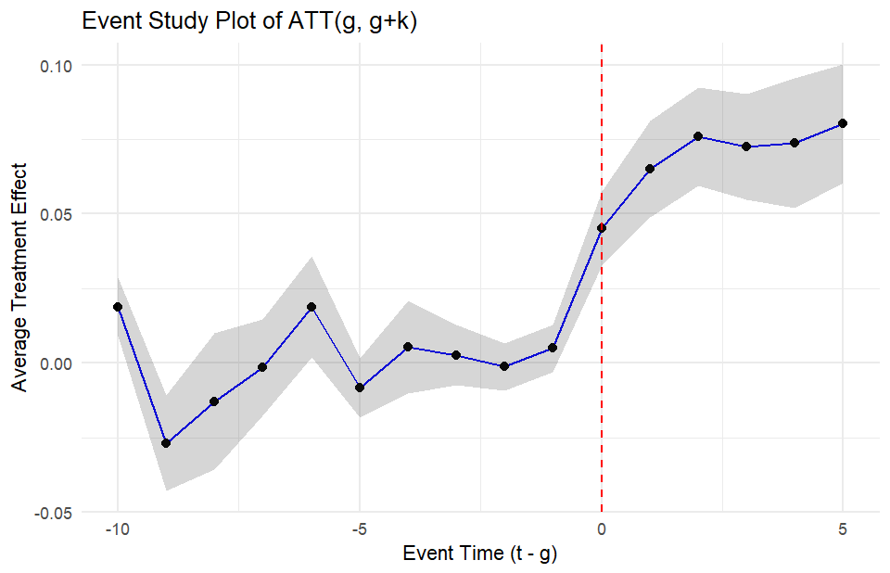

بخش پنج

OLS estimation, Dep. Var.: dins

Observations: 552

Fixed-effects: stfips: 46, year: 12

Standard-errors: Clustered (stfips)

Estimate Std. Error t value Pr(>|t|)

D 0.070321 0.007401 9.50152 2.5169e-12 ***

---

Signif. codes: 0 '***' 0.001 '**' 0.01 '*' 0.05 '.' 0.1 ' ' 1

RMSE: 0.021082 Adj. R2: 0.93835

Within R2: 0.426746

[1] "From Callaway:"

> mean(att$att)

[1] 0.0735354

> mean(att$se)

[1] 0.009346191

>

[1] "TWFE:"

> ols_result[["coefficients"]][["D"]]

[1] 0.07032067

> ols_result[["se"]

[1] 0.007400994

بخش شش

type weight avg_est

1 Earlier vs Later Treated 0.14911 0.06983

2 Later vs Earlier Treated 0.05827 0.04486

3 Treated vs Untreated 0.79262 0.07228

بخش هفت و هشت

[1] "From Callaway:"

> mean(att_treat$att)

[1] 0.07926593

> mean(att_treat$se)

[1] 0.01318506

>

[1] "TWFE:"

> ols_result_treated[["coefficients"]][["D"]]

[1] 0.06281731

> ols_result_treated[["se"]][["D"]]

[1] 0.00765281

type weight avg_est

1 Earlier vs Later Treated 0.71902 0.06983

2 Later vs Earlier Treated 0.28098 0.04486

بخش نه

[1] "From Callaway:"

> mean(att2$att)

[1] 0.1035354

> mean(att2$se)

[1] 0.009416247

[1] "TWFE:"

> ols_result2[["coefficients"]][["D"]]

[1] 0.08927005

> ols_result2[["se"]][["D"]]

[1] 0.007804685

type weight avg_est

1 Earlier vs Later Treated 0.14911 0.08196

2 Later vs Earlier Treated 0.05827 0.02751

3 Treated vs Untreated 0.79262 0.09518