**Cumulative Update Failure - Troubleshooting**

**Resolution Date:** July 20, 2023

**Microsoft Support Ticket:** TrackingID#2306260040007547

**Cumulative Update:** KB5028171



Resolution provide by: Shiva Rana (Microsoft support engineer)

Email address: [v-shivarana@microsoft.com](mailto:v-shivarana@microsoft.com)

Manager Email address: [v-rusi@microsoft.com](mailto:v-rusi@microsoft.com)

**Package State Descriptions**

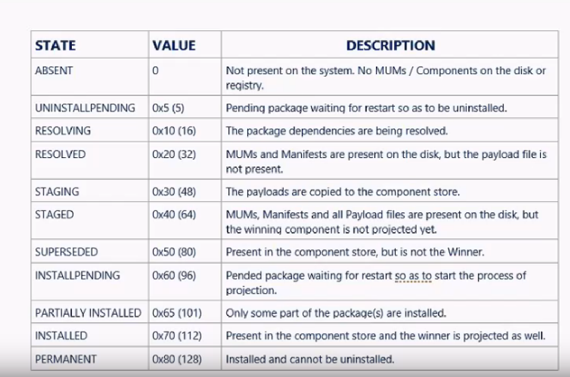

1. Login to the affected server with Admin privilege
2. Check the CBS logs (open last CBSpersist log with the latest date/time)

C:\Windows\Logs\CBS



1. Run the below command on the command prompt to identify how many packages are in stagged stage.

DISM /Online /Get-Packages /Format:Table >a.txt & a.txt

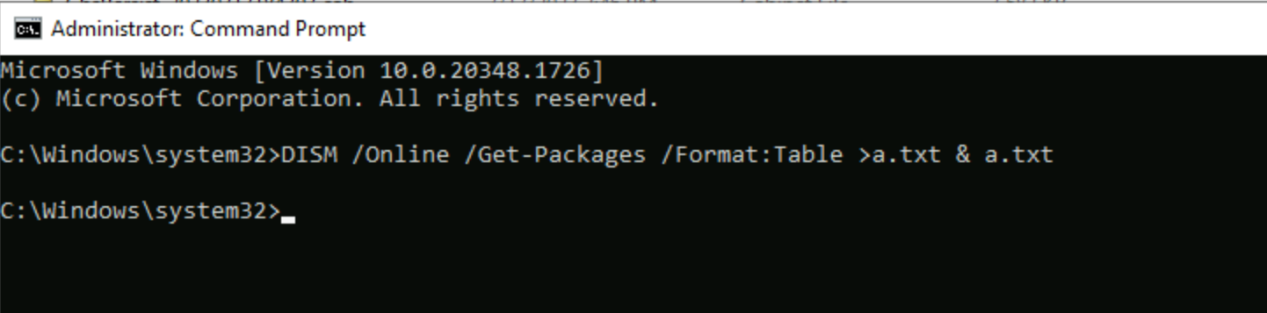

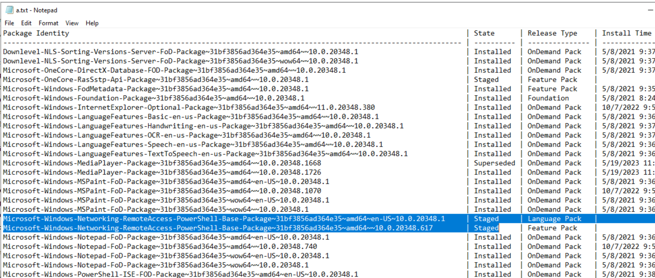

In this scenario we found 3 packages listed as Staged

Try to remove 3 staged packages using the below command

4) **Command**: Dism /online /remove-package /packagename: <Full Package name>

Trying to remove 1st package but Got an Error Access is denied.

Dism /online /remove-package /packagename:Microsoft-OneCore-RasSstp-Api-Package~31bf3856ad364e35~amd64~~10.0.20348.1

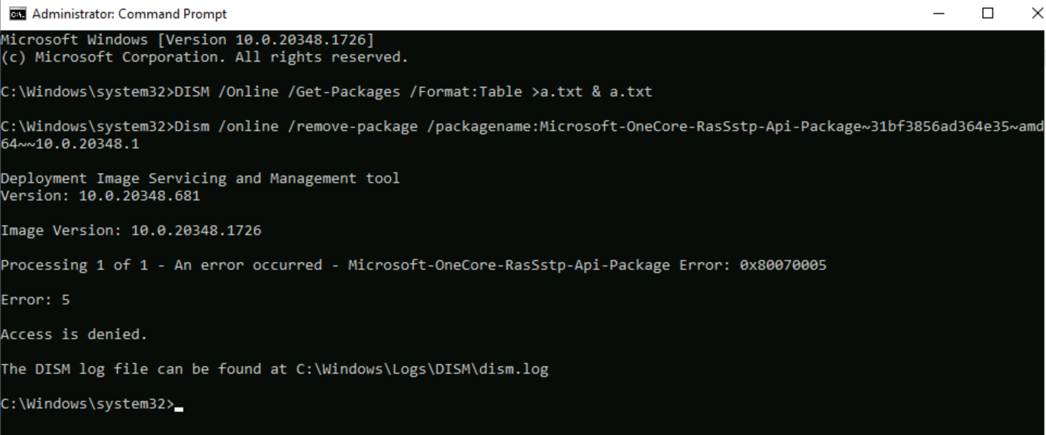

Microsoft Support engineer provided the below PowerShell script and suggested try with this approach

***********************************************************************************************

$name = 'CurrentState'

$check=(get-childitem -Path 'HKLM:\software\microsoft\windows\currentversion\component based servicing\packages' -Recurse).Name

foreach($check1 in $check)

{

$check2=$check1.replace("HKEY_LOCAL_MACHINE","HKLM:")

if((Get-ItemProperty -Path $check2).$name -eq 0x50 -or (Get-ItemProperty -Path $check2).$name -eq 0x40 )

{

write-host (Get-ItemProperty -Path $check2).PSChildName

Set-ItemProperty -Path $check2 -Name $name -Value 0

}

}

*****************************************************************************************

Copy the above script in the affected server, with any file name

Example: Staged_Powershell.ps1

Open PowerShell with Administrator

Navigate to the folder where the script has been copied

1. In this example below the script has copied in the “C:\Temp” with the name “Staged_Powershell.ps1”

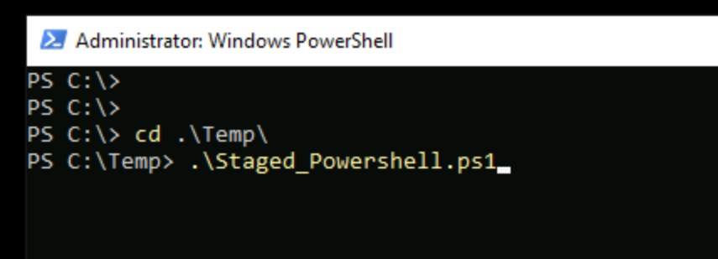

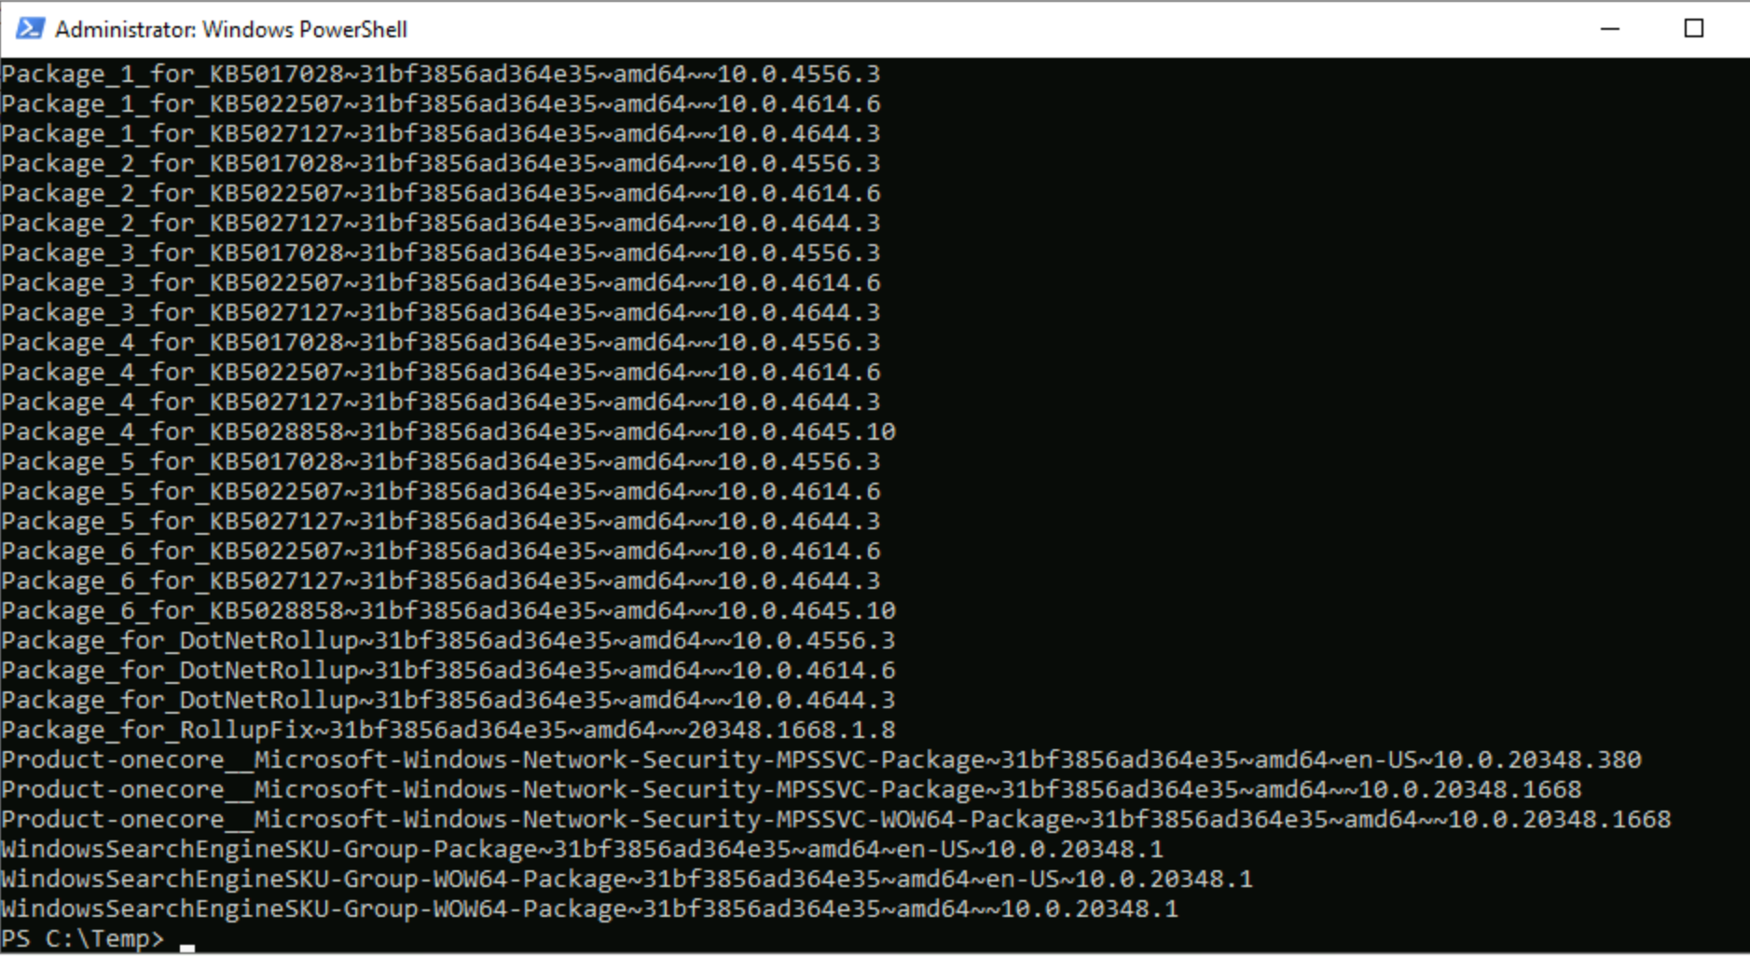

Once the script successfully completed, we need to run sfc/scannow

1. Sfc /scannow



1. Reboot the server

Downloaded the Cumulative update from Microsoft Catalogue below link

[Microsoft Update Catalog](https://www.catalog.update.microsoft.com/Search.aspx?q=KB5028171)

In this scenario July 2023 Cumulative update “KB5028171” having trouble to install on the Windows server 2022.

Copy the downloaded Cumulative update in the affected server. In this example copied under

1. C:\Temp\July-Update

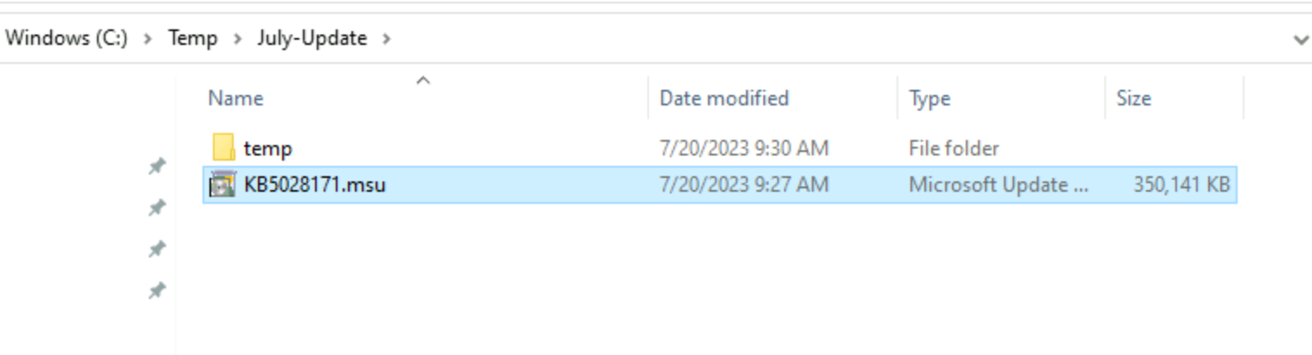

Now we need to extract the downloaded Cumulative update with the help of below commands

Create a Sub directory

Example: temp

Under C:\Temp\July-Update\temp

Run the below command

1. expand -f:* “C:\temp\July-update\KB5028171.msu” “C:\Temp\July-Update\temp”

After running the above command following below Output



Now we need to install the Cumulative update with the help of dsim command

1. dism /online /add-package /packagepath:”C\Temp\July-Update\temp\Windows10.0-KB5028171-x64.cab”

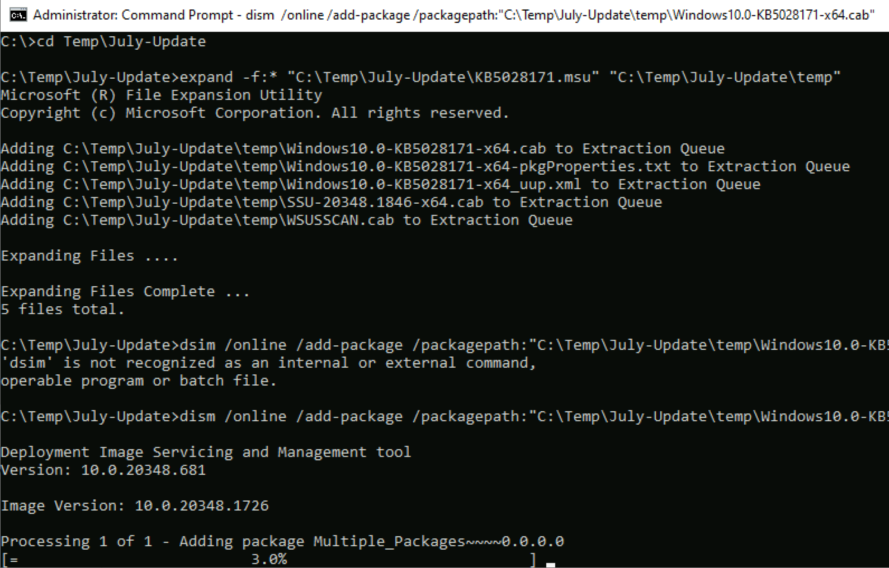

1. Type Y

Server will be reboot automatically

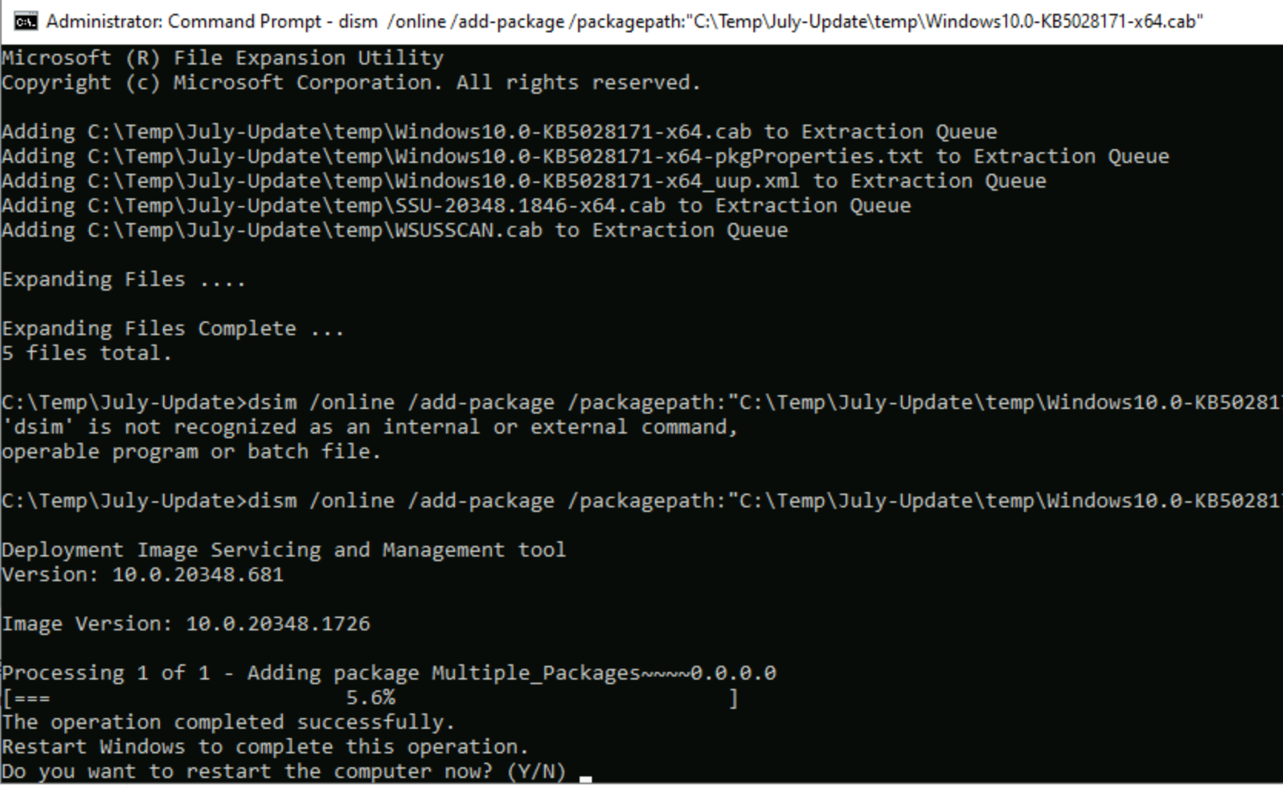

After server rebooted

1. Check the Cumulative update install

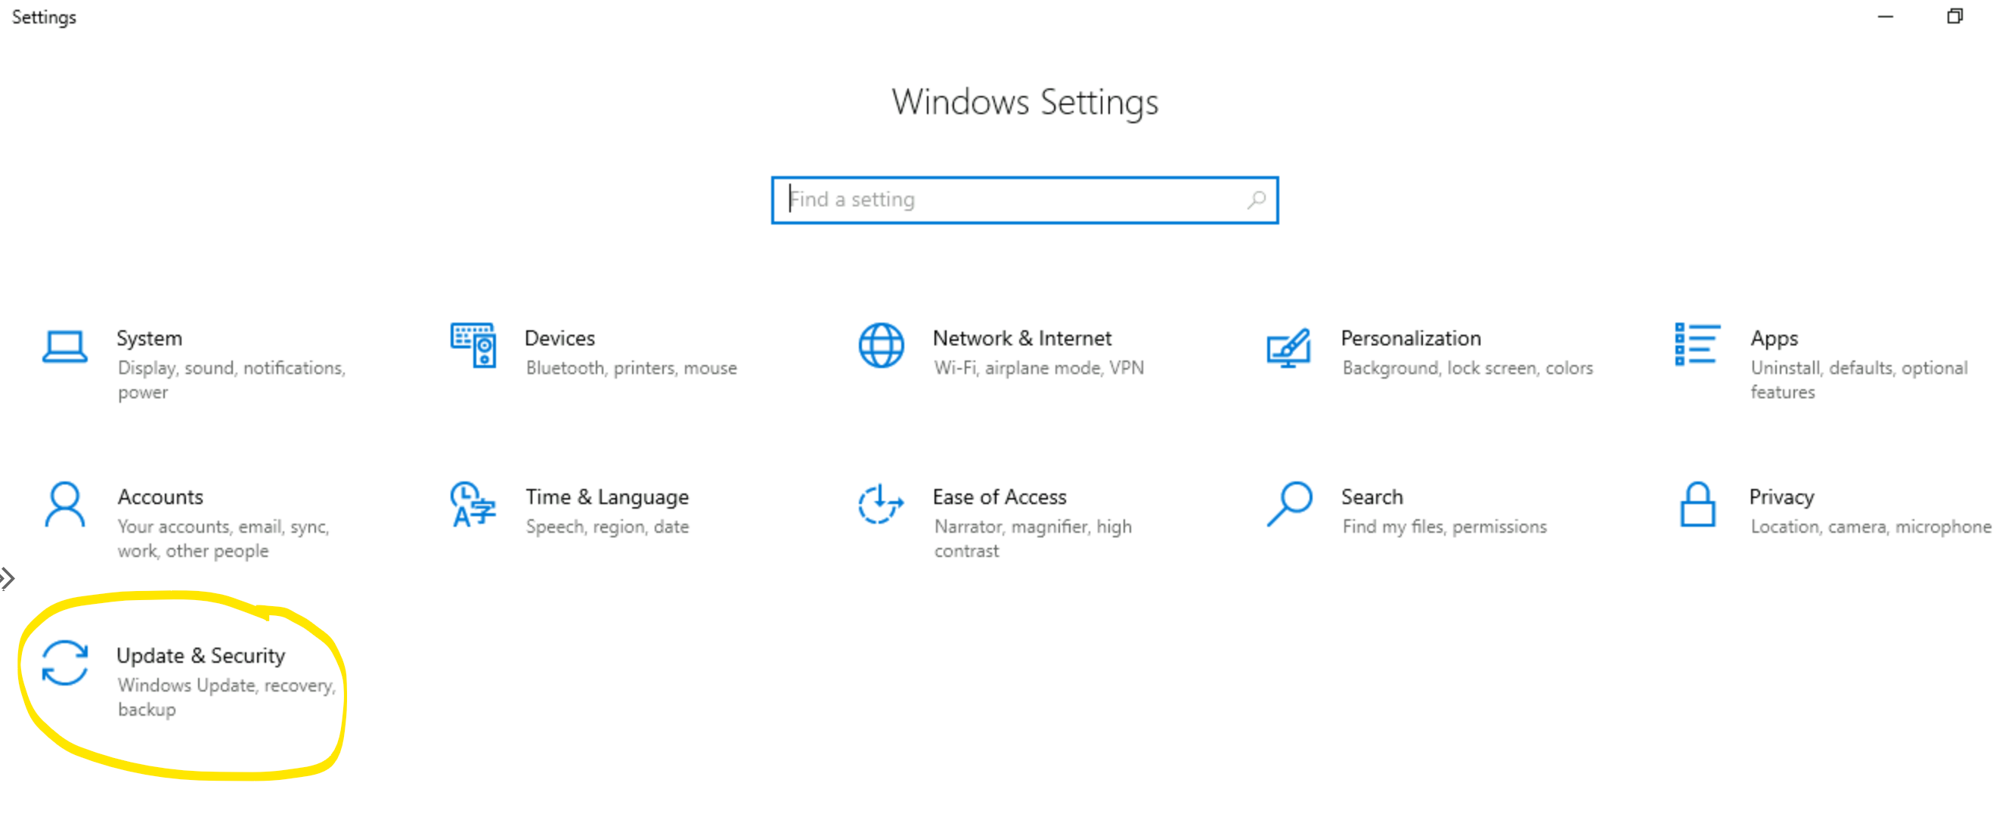

1. Click on View update history

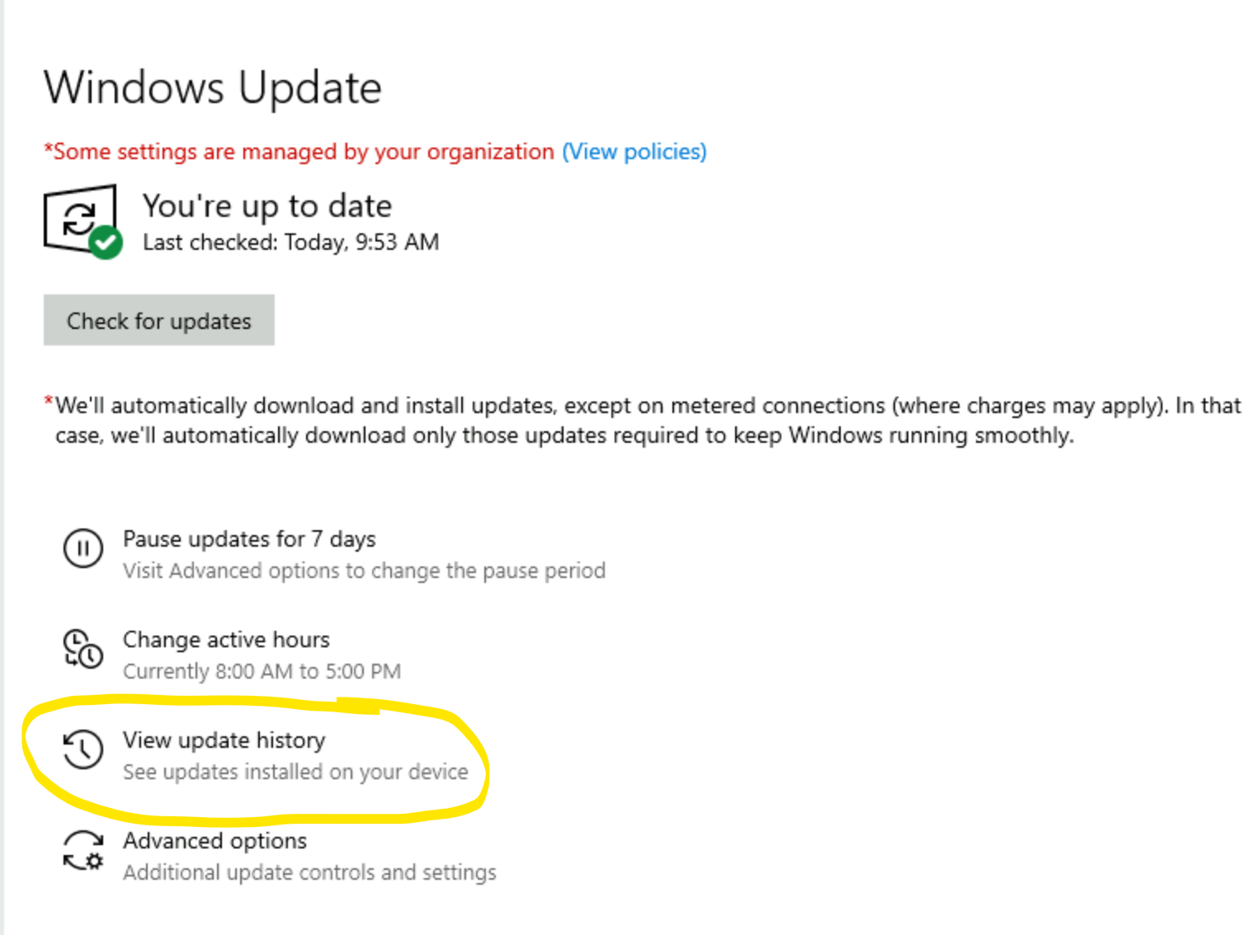

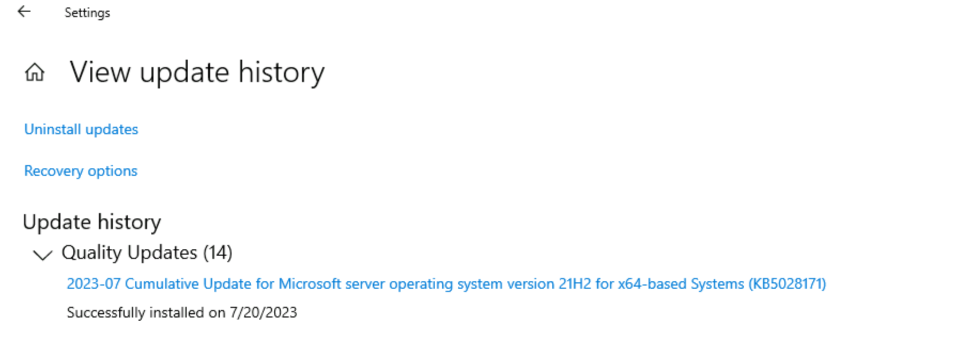

Another way to check with the following command

1. wmic qfe get Hotfixid /Format:Table >a.txt & a.txt

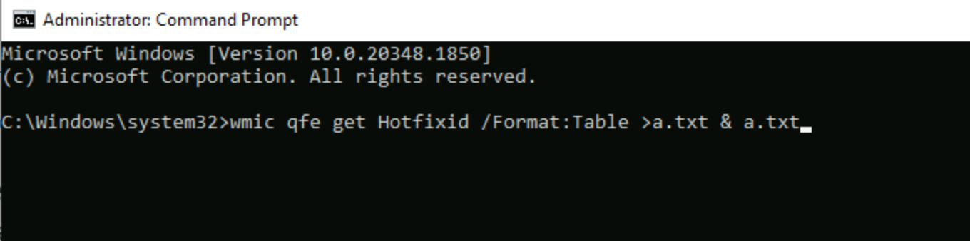

It will open a new Notepad window with list of Hotfixes installed on the server

