Issue with 2024-01 Security Update for Microsoft server operating system version 21H2 for x64-based Systems (KB5034439)

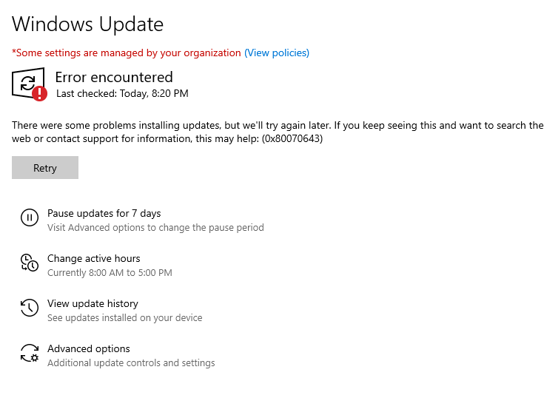

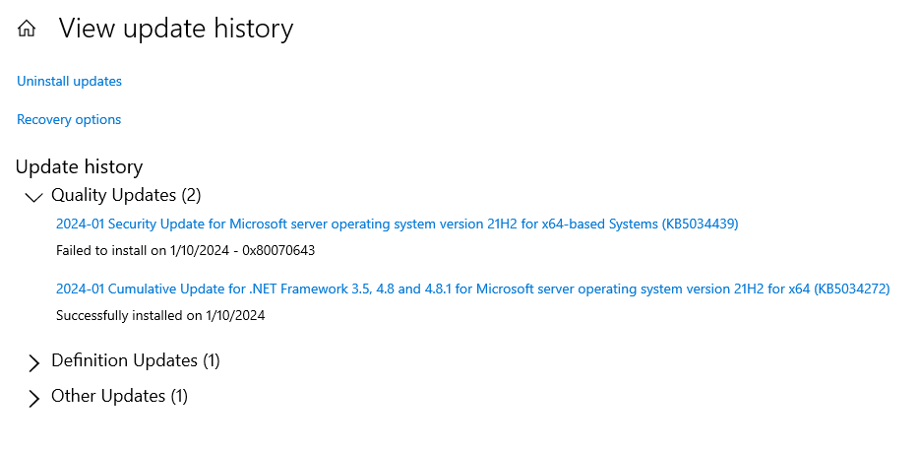

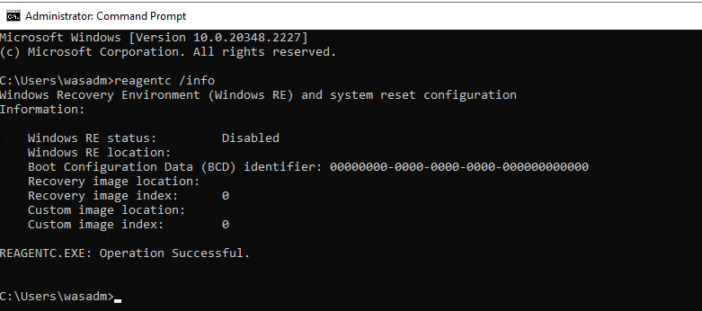

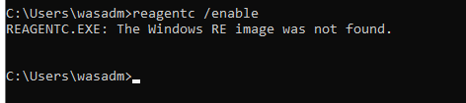

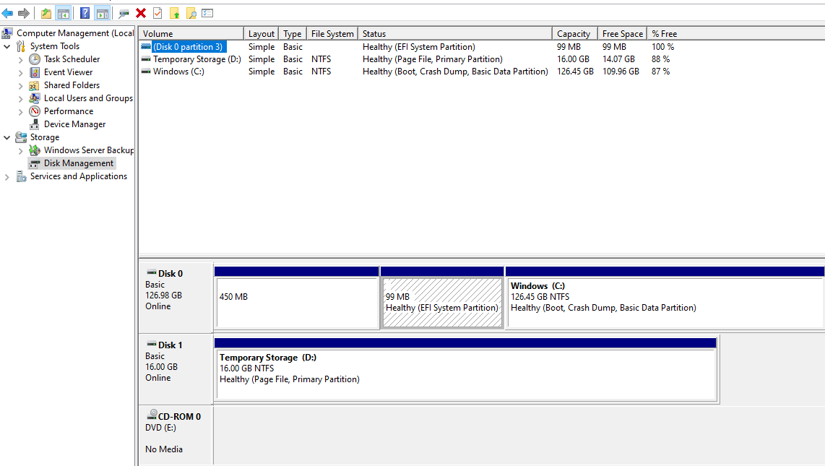

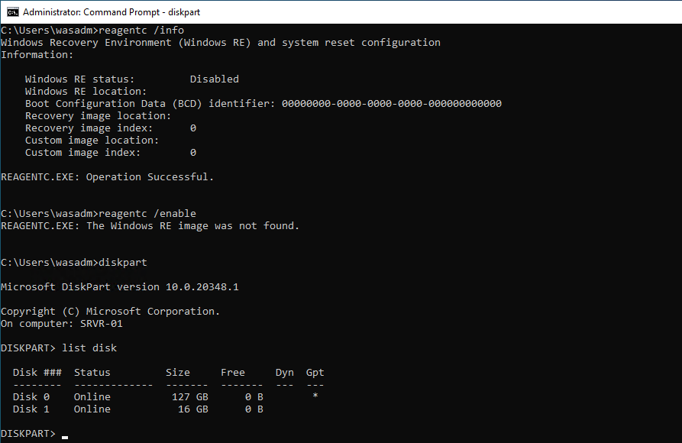

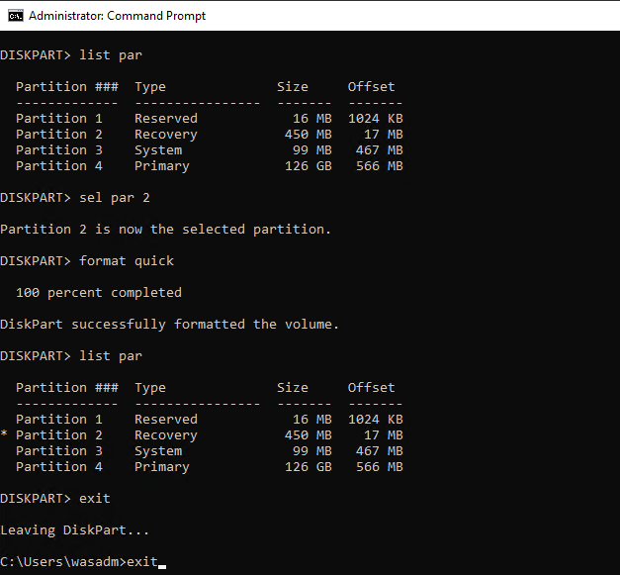

**Format recovery partition commands:**

reagentc /info

diskpart

list disk

sel disk 0

list disk

list par

sel par 2

list par

# del par

for quick

exit

exit

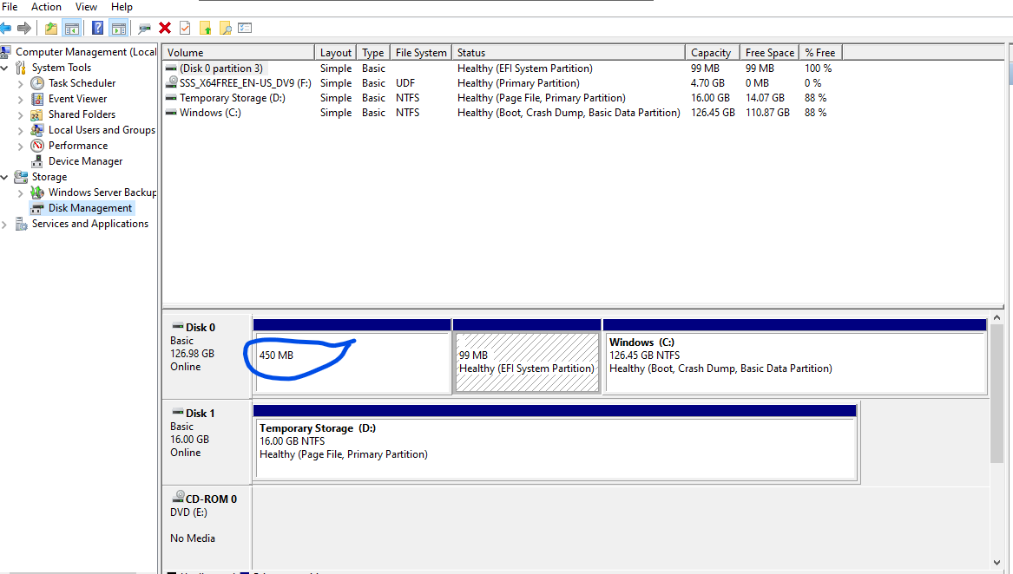

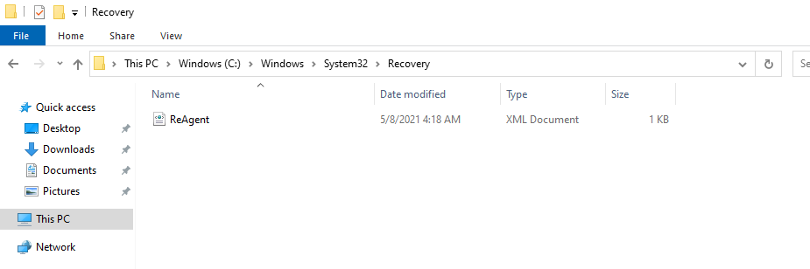

Download Windows server 2022 ISO media, on the server

[Windows Server 2022 | Microsoft Evaluation Center](https://www.microsoft.com/en-us/evalcenter/download-windows-server-2022)

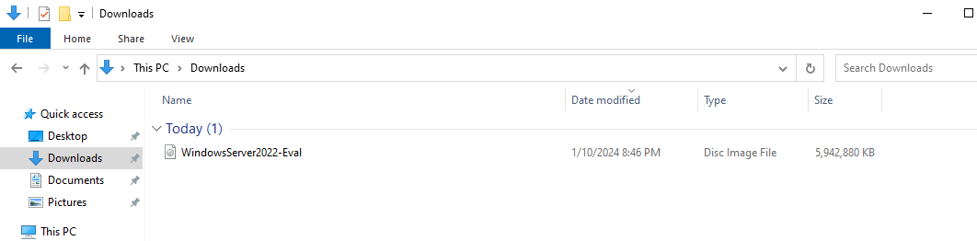

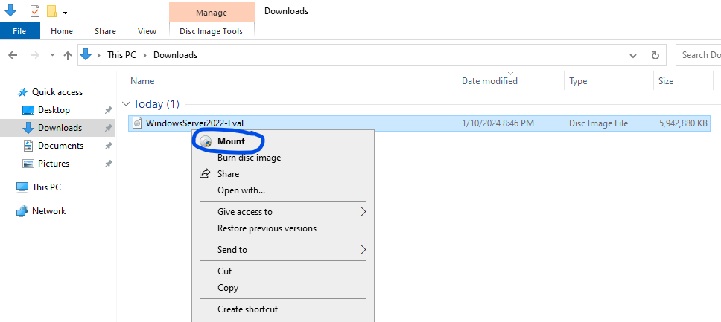

Create a Folder Mount under C:\

C:\Mount

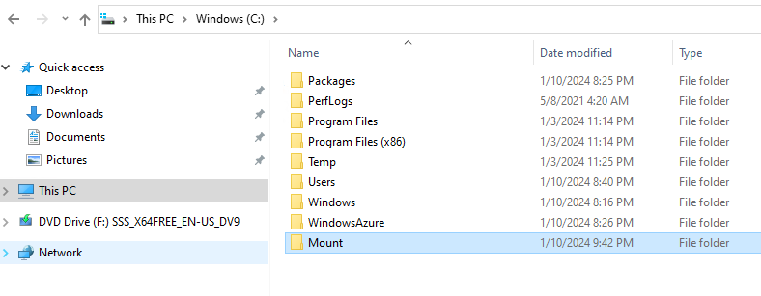

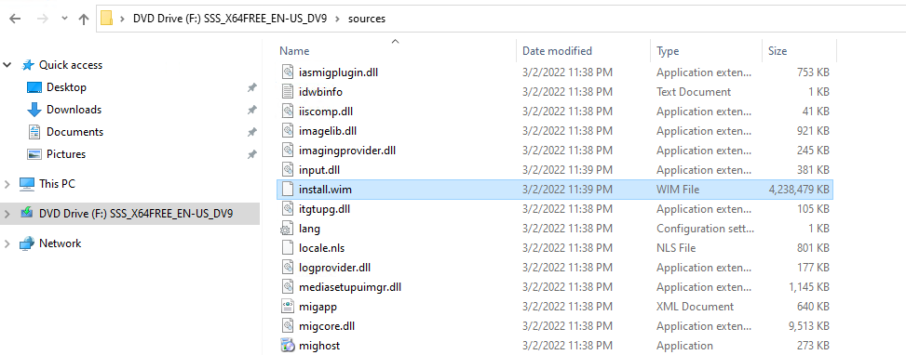

Open Command prompt as Administrator

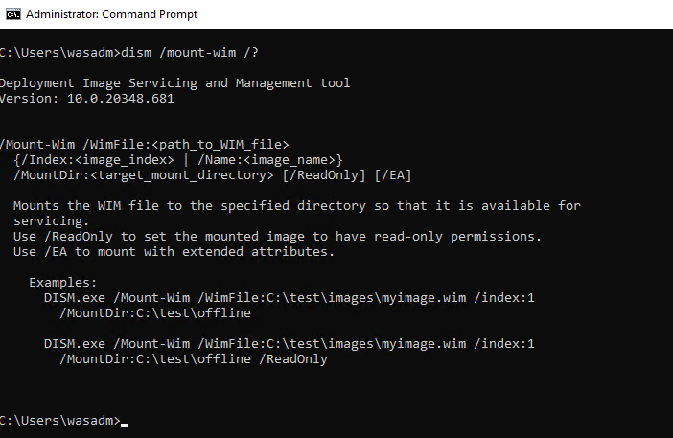

Dism.exe /Mount-Wim /WimFile:"F:\sources\install.wim" /index:1 /MountDir:C:\Mount /readonly

** Once the dism completes the mount we will see winre.wim file in the temporary mount location

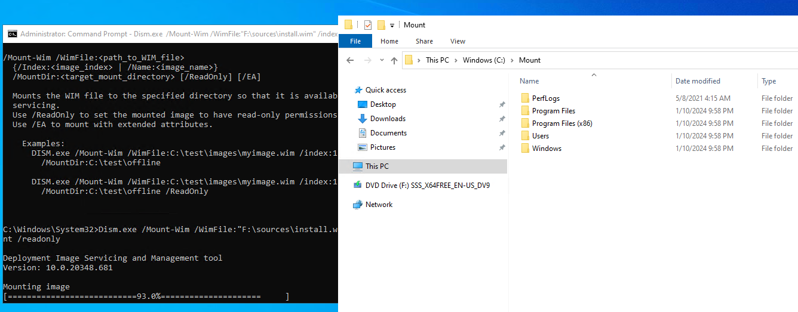

c:\mount\windows\system32\recovery\winre.wim

copy the above file to c:\windows\system32\recovery\

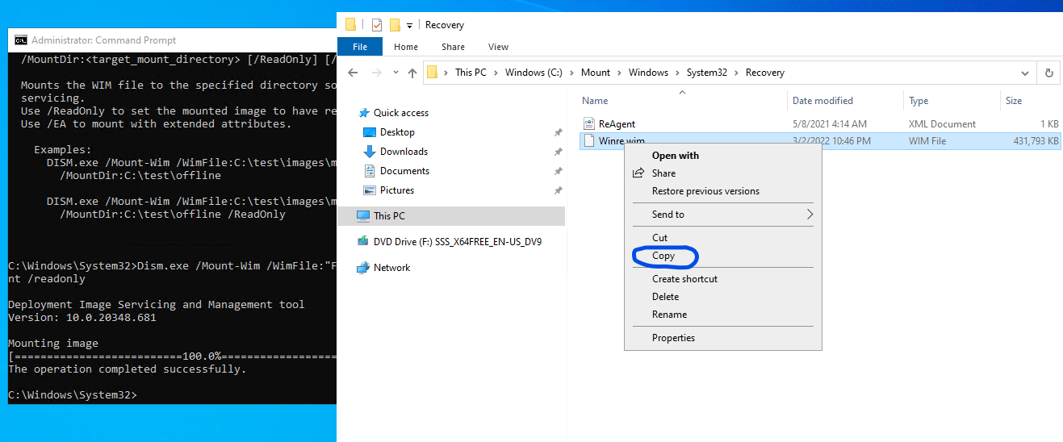

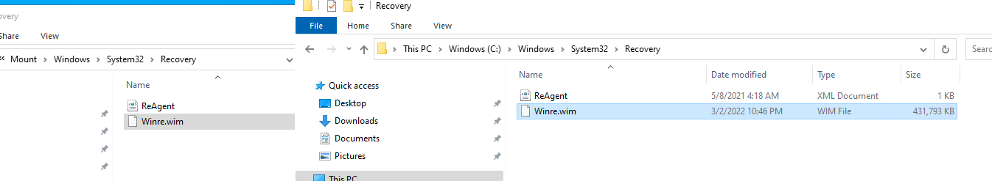

once the copy completed, we need to unmount the iso & temporary mount point

Dism /Unmount-image /MountDir:C:\Mount /Discard

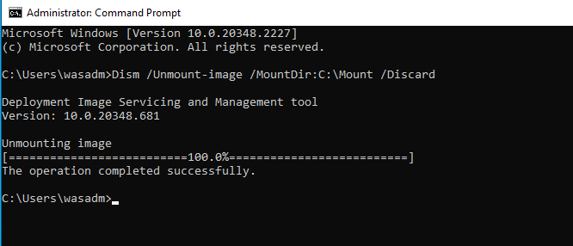

reagentc /info

reagentc /enable

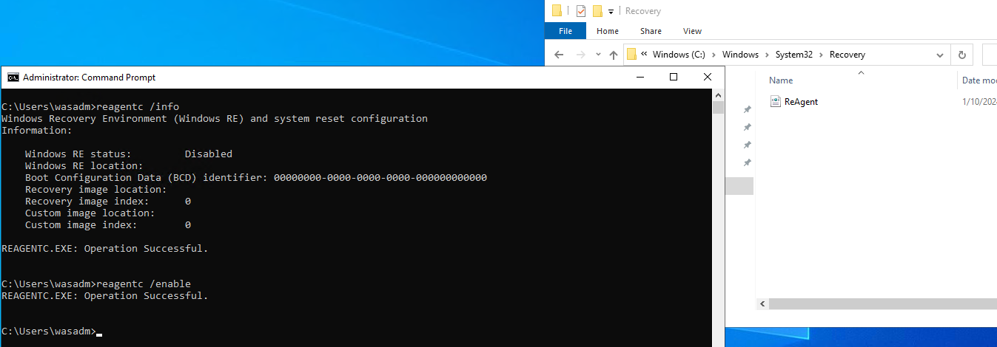

reagentc /info

Note: During the enabling process in progress winre.wim file will be taken away from c:\windows\system32\recovery

