GCP Landing Zone
Documentation

Table of Contents
1 Introduction 4
1.1 Background 4
1.2 How to Use 4
2 Accelerator Components 5
2.1.1 Contribution to Accelerator – PR raising process 5
2.2 GCP Foundation Landing Zone 6
2.2.1 Description 6
2.2.2 Folder Definitions 6
2.2.3 How to run Code 6
2.2.4 Troubleshooting 8
2.2.5 Release Notes- What are the use cases thought of and what has code covered as of today 8
2.2.6 Contribution to Accelerator – PR raising process 8
2.3 Organization Level Policy 9
2.3.1 Description 9
2.3.2 Use-Case 10
2.4 Identity and Access Management 10
2.4.1 Description 10
2.4.2 Use-Case 11
2.5 Logging 12
2.5.1 Description 12
2.5.2 Pre-Requisite 12
2.5.3 Use-Case 12
2.6 Network Landing Zone 13
2.6.1 Description 13
2.6.2 Troubleshooting 14
2.6.3 Use Cases 14
2.7 GCP Monitoring 21
2.7.1 Description 21
2.7.2 How to run Code 27
2.7.3 Troubleshooting 28
2.8 CI/CD Deployment of GCP Infrastructure 28
2.8.1 CICD Framework for IAC Deployment 28
2.8.2 Source Code Management & Branching Strategy 29
2.8.3 Environment variables 32
2.8.4 Secrets Management 33
2.8.5 CICD Best Practices 34
2.8.6 GCP – IAC Deployment using Cloud Build 44
3 Appendix 45
3.1 Monitoring APIs to Enable…………………………………………………………………………………………………………………….45

Introduction

Background
The purpose of the following document is to help guide the user in using the GCP Fabric Collection of Assets and Accelerators. The accelerators are designed with the intention that the end-user has a relatively straightforward experience when it comes to spinning up GCP infrastructure. Furthermore, they are designed with modularity in mind, where once the basic infrastructure is set in place (Landing Zone) the other modules can be leveraged as needed. This allows for greater flexibility when it comes to deployment and catering a solution more specifically for client needs.

How to Use
The document is split into the various sections denoting each of the accelerators; Resource Hierarchy, Google Compute Engine, Network Landing Zone, Monitoring and CICD on GCP. Each section will delve into what the accelerator accomplishes, where to find it, how to use it and some troubleshooting tips as well. There will be links for each accelerator to their respective repositories, where the code can be downloaded and leveraged based on the instructions provided.

Accelerator Components

High Level Overview

Below: 13 points Secure Foundation that we need to highlight and explain from accelerator perspective.
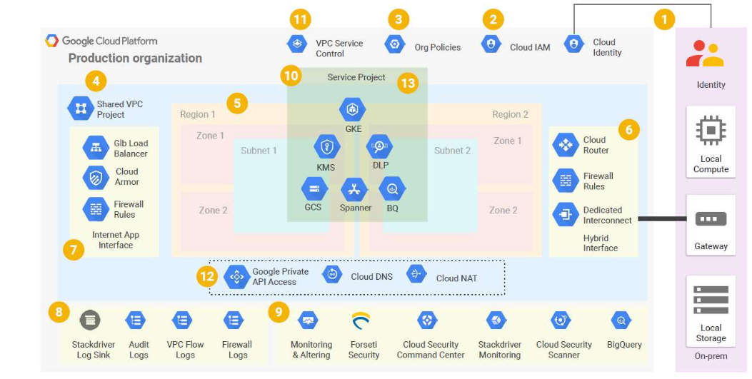w

Contribution to Accelerator – PR raising process

GCP Foundation Landing Zone

Description
The GCP foundation landing zone accelerator is designed with the intention of allowing the user a relatively quick and reliable way to spin up a GCP Landing Zone with its associated infrastructure. The solution is designed to be used out of the box with minimal to no coding enabling deployment of folder hierarchies, projects, and API access with just the configuration of YAML and variable files.

Folder Definitions
This consists of two subfolders as shown below:
0-bootstrap: The purpose of this module is to help bootstrap a GCP organization, creating all the required GCP resources & permissions to start using the Hierarchy
1-hierarchy: This code enables quick deployment of basic GCP resources, provisioning the foundational folder and project hierarchy in addition to Service Account creation and API enablement.

How to run Code
Clone the repository - git clone https://github.com/Deloitte-Default/deloitteca-gcplandingzone-accelerator.git (using main branch)
To setup Bootstrap:
- cd 0-bootstrap
- Update the variables file “variables.tf” as per the requirement
- “variables.tf” file break down
Required variables:
  - parent_folder: GCP parent folder ID in the form folders/{id}
  - org_id: GCP Organization ID
  - billing_account: The ID of the billing account to associate projects with
  - group_org_admins: Google Group for GCP Organization Administrators
  - group_billing_admins: Google Group for GCP Billing Administrators
  - default_region: Default region to create resources where applicable
- Use terraform init/plan/apply commands to execute the bootstrap main.tf file.

To setup Resource Hierarchy:
- cd 1-hierarchy
- A sample YAML file is created in “configs” folder. User can create/modify the YAML file as per the requirement. There can be one or more YAML files in the “configs” folder.
- An example of the sample YAML file
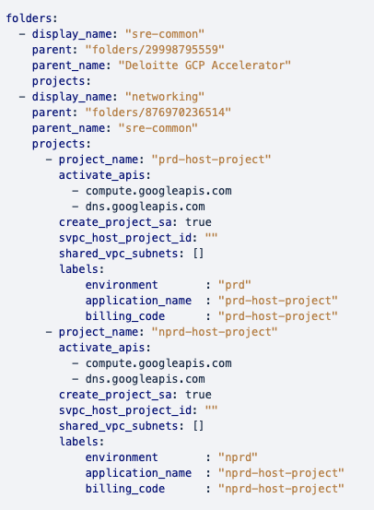

- Create folders and child projects through YAML config files with the following features:
  - Create one or multiple folders along with their child projects in one run providing that the parent folder id for each new folder gets specified
  - Create one or multiple projects below a specified folder
  - Attach Service projects to the Host project by providing Host project id (svpc_host_project_id) and fully qualified subnet addresses (shared_vpc_subnets) that the Host project would share with each Service project
  - Create an optional service account for each project
  - Enable the specified APIs (activate_apis) for each project.
  - Delete the default network for each project.
  - Add label(s) to each project.

- Update the variables file “variables.tf” as per the requirement. “variables.tf” file break down.
  - billing_account: Billing Account
  - organization_id: Organization ID

- Steps to create the Resource hierarchy

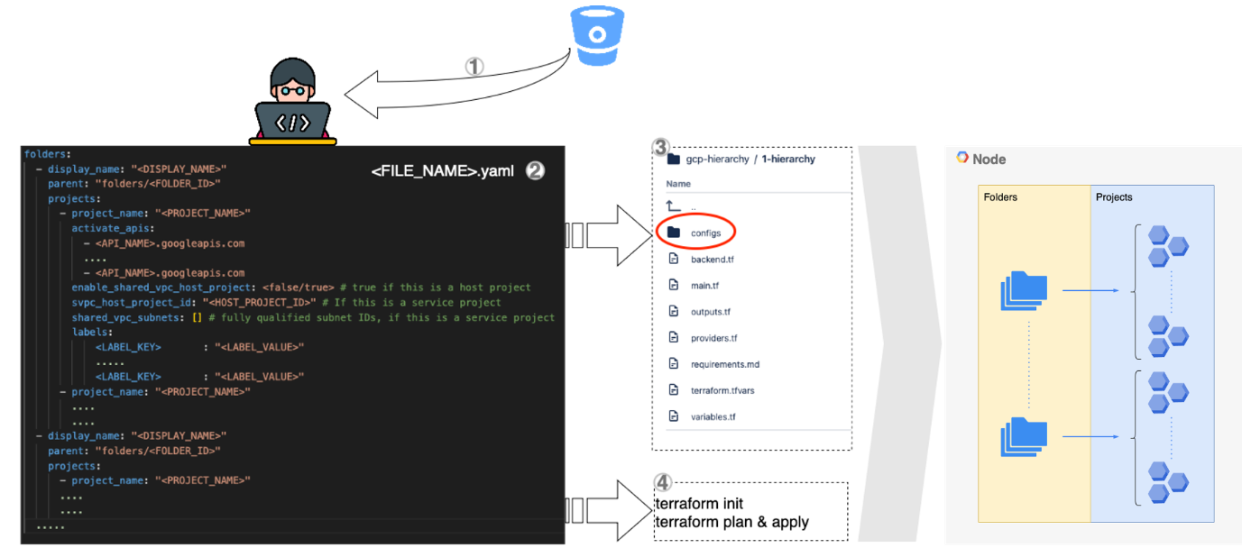

Troubleshooting
In case of errors encountered during terraform plan/apply, always check your input YAML file format and consider using terraform console command to check values of locals defined.

Release Notes- What are the use cases thought of and what has code covered as of today

Use Cases
- Creating one or multiple folders along with their child projects providing that the parent folder id for each new folder gets specified.
- Modifying each project through the config file.
- Modifying the hierarchy structure thorough the config file.

Contribution to Accelerator – PR raising process

Organization Level Policy

Description

The GCP Organizational Policy is a service provided by Google Cloud Platform that allows organizations to define and enforce policies across their cloud resources. It is a tool for establishing rules and guidelines for how resources are created and used within GCP projects, folders, and organizations. The Organizational Policy Service is the tool that enables organizations to define and manage these policies.
The Organizational Policy Service allows policies to be defined at the organization, folder, or project level, and apply to all resources within that scope. Custom policies can be created using the Policy Library, which contains pre-built policies for common use cases. This allows organizations to define policies that meet their specific needs and comply with regulatory requirements and industry standards.
Policies defined through the Organizational Policy Service can be enforced automatically, and violations can be logged or prevented. Compliance monitoring occurs in real-time, allowing organizations to identify and address policy violations promptly. The Organizational Policy Service integrates with other GCP services, such as Cloud Asset Inventory and Cloud Security Command Center, to provide a comprehensive solution for security and compliance.
In summary, the GCP Organizational Policy is the set of policies that are defined and enforced through the Organizational Policy Service. The service provides a centralized tool for managing policies across an organization's cloud resources, ensuring consistency in policy enforcement and helping to prevent issues related to compliance and security. By using the Organizational Policy Service to define and manage their policies, organizations can ensure that their cloud resources are being used in accordance with internal policies, regulatory requirements, and industry standards.
Organization policy administrators define organization policies and apply restrictions to their resources and child resources by setting them on organizations, folders, and projects.
Select Constraints to define your organization's policies. A constraint is a specific type of restriction on a Google Cloud service or group of Google Cloud services. Configure the constraints to match your desired restrictions.
Descendants of the target resource hierarchy node inherit the organization policy. Applying organization policies to the root organization node effectively allows you to apply organization policies and configure restrictions throughout the organization.
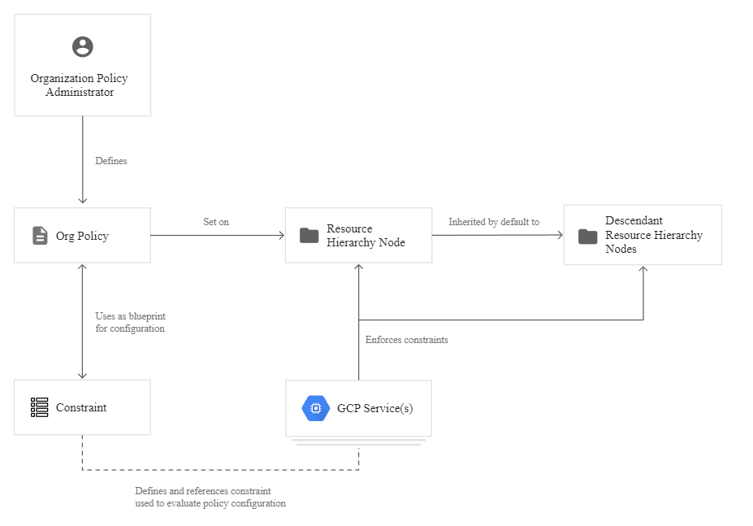

Use-Case

This module simplifies the creation and management of organization policies for your Google Cloud environment, particularly when you want to have exclusion rules. This module will allow you to set a top-level org policy and then disable it on individual projects or folders easily.

Identity and Access Management

Description

IAM (Identity and Access Management) is a service that helps you manage access to resources and services in your GCP project. IAM allows you to grant granular access to specific resources and services in your project, while controlling who has access to them and what actions they can perform. With IAM, you can create and manage roles, assign roles to users, groups, and service accounts, and set permissions on resources to control access to them.
A service account in GCP is an account that is used to represent a non-human entity or service that needs to authenticate with and access Google Cloud Platform resources. Unlike a user account, which is associated with a human, a service account is associated with an application or a virtual machine.
In GCP, authoritative roles are a set of predefined roles that grant broad permissions to manage GCP resources within a specific Google Cloud organization. These roles are intended for users who have administrative responsibilities within an organization and are authorized to make decisions about resource access and security policies. There are four authoritative roles in GCP:
- Organization Administrator: This role provides full access to all resources within the organization. It allows the user to manage all GCP resources, including projects, folders, and billing.
- Folder Administrator: This role provides full access to all resources within a specific folder and its subfolders. It allows the user to manage resources within the folder, create and delete projects, and assign roles to users.
- Project Creator: This role allows the user to create new projects within a specific folder or organization. It does not provide access to existing projects or their resources.
- Billing Account Administrator: This role provides full access to the billing account associated with the organization. It allows the user to view and manage billing information, create, and manage billing budgets, and link and unlink projects to the billing account.
Non-authoritative roles are a set of predefined roles that grant specific permissions to manage and access GCP resources within a project or organization. There are many non-authoritative roles in GCP, which can be broadly classified into three categories:
- Basic roles: These roles provide basic access to resources within a project or organization, such as the ability to view, create, or modify resources. Examples of basic roles include Viewer, Editor, and Owner.
- Service-specific roles: These roles provide access to specific GCP services, such as Compute Engine or Cloud Storage. They allow users to perform specific actions on resources within that service.
- Custom roles: These roles are user-defined roles that allow administrators to create roles with specific permissions tailored to the needs of their organization. Custom roles can be created by combining permissions from existing roles or by defining new permissions.

Use-Case

This module allows simplified creation and management of one service account and its IAM bindings. It supports:
- granting authoritative roles on the service accounts to other identities.
- granting non-authoritative roles to the service accounts on other resources.
- granting additive bindings on the service account.

Logging

Description

Log Sink is a mechanism that allows you to export logs from various GCP services to external destinations. A log sink enables you to export log data in real-time to different targets, such as Cloud Storage, BigQuery, Cloud Pub/Sub, and even external destinations via Cloud Logging's export feature.
To create a log sink, you need to define a sink configuration that specifies the source logs and the destination where you want to export the logs. You can create and manage log sinks using the Cloud Console, the gcloud command-line tool, or the Cloud Logging API.

Pre-Requisite
- Permissions: You need to have the necessary permissions to create and manage log sinks in the target project. This typically involves having the "Logs Configuration Writer" or "Logs Configuration Editor" role in the project.
- Log data: You need to have log data generated by the services you want to export logs from. This means you need to have the target services configured to generate logs, and you need to know the log format and log filter expressions that you want to use for exporting the logs.
- Destination: You need to have a destination where you want to export the logs. This could be a Cloud Storage bucket, a BigQuery dataset, a Cloud Pub/Sub topic, or an external destination using the export feature of Cloud Logging.
- Access control: If you are exporting logs to a destination outside of the GCP project, you need to ensure that the target destination is configured with appropriate access controls to allow the export of logs from your GCP project.

Use-Case

This module allows management of audit logging for a given service for a Google Cloud Platform Organization. It supports:
- creating a sink bucket in a project and sinking the audit logs to it.
- enabling audit logging for the specified services and grant one of these permissions: DATA_READ, DATA_WRITE, or ADMIN_READ
- exempting specified identities that do not cause logging for this type of permission. Each entry can have one of the following values:
  - user:{emailid}: An email address that represents a specific Google account. For example, alice@gmail.com or joe@example.com.
  - serviceAccount:{emailid}: An email address that represents a service account. For example, my-other-app@appspot.gserviceaccount.com.
  - group:{emailid}: An email address that represents a Google group. For example, admins@example.com.
  - domain:{domain}: A G Suite domain (primary, instead of alias) name that represents all the users of that domain. For example, google.com or example.com.

Network Landing Zone

Description

Virtual Private Cloud (VPC) overview
Virtual Private Cloud (VPC) provides networking functionality to Compute Engine virtual machine (VM) instances, Google Kubernetes Engine (GKE) clusters, and the App Engine flexible environment. VPC provides networking for your cloud-based resources and services that is global, scalable, and flexible.
A VPC network provides the following:
Provides connectivity for your Compute Engine virtual machine (VM) instances, including Google Kubernetes Engine (GKE) clusters, App Engine flexible environment instances, and other Google Cloud products built on Compute Engine VMs.
Offers built-in Internal TCP/UDP Load Balancing and proxy systems for Internal HTTP(S) Load Balancing.
Connects to on-premises networks using Cloud VPN tunnels and Cloud Interconnect attachments.
Distributes traffic from Google Cloud external load balancers to backends.

Firewall rules
Each VPC network implements a distributed virtual firewall that you can configure. Firewall rules allow you to control which packets are allowed to travel to which destinations. Every VPC network has two implied firewall rules that block all incoming connections and allow all outgoing connections.

Routes
Routes tell VM instances and the VPC network how to send traffic from an instance to a destination, either inside the network or outside of Google Cloud. Each VPC network comes with some system-generated routes to route traffic among its subnets and send traffic from eligible instances to the internet.

Forwarding rules
While routes govern traffic leaving an instance, forwarding rules direct traffic to a Google Cloud resource in a VPC network based on IP address, protocol, and port.

Troubleshooting
In case of errors encountered during terraform plan/apply always check your input yaml file format and consider using terraform console command to check values of locals defined.

Use Cases

VPC
This code facilitates creating new VPC Network(s) in one or multiple GCP projects by defining your network and subnet ranges in a concise syntax.
It supports creating:
- One or multiple Google Virtual Private Network (VPC)
- Subnets within the VPC
- Secondary ranges for the subnets (if applicable)
- It also makes the project a Shared VPC is_host via setting a flag in the configuration file.
How to run code:
- A few APIs (i.e. compute.googleapis.com) need to be enabled in the project. If "apply" fails due to a service not being enabled, click on the link in the error message to enable it for the project and then resume "apply"
- Clone repo from git clone https://github.com/Deloitte-Default/deloitteca-gcplandingzone-accelerator.git
- cd networking/net-vpc
- Update Provider.tf and Backend.tf for setting the following variables:
Provider.tf: define your credentials here for authentication with GCP
backend.tf: define cloud storage bucket to keep tfstate files
- Place YAML input files in “configs” folder
- Decoding YAML files
All YAML files should have object name “project-networks” to have list of VPC network configurations
Acceptable YAML format:
---
project-networks:
- project_id: "<PROJECT_ID>"
is_host: true/false
networks:
- network_name: "<NETWORK_NAME>"
subnets:
- name: "<SUBNET_NAME>"
subnet_private_access: true/false
region: "<SUBNET_REGION>"
ip_cidr_range: "<IP_CIDR_RANGE>"
secondary_ip_ranges:
- range_name: "<RANGE_NAME>"
ip_cidr_range: "<IP_CIDR_RANGE>"
- range_name: "<RANGE_NAME>"
ip_cidr_range: "<IP_CIDR_RANGE>"
- name: "<SUBNET_NAME>"
region: "<SUBNET_REGION>"
ip_cidr_range: "<IP_CIDR_RANGE>"
secondary_ip_ranges:
- project_id: "<PROJECT_ID>"
is_host: true/false
networks:
- network_name: "<NETWORK_NAME>"
subnets:
- name: "<SUBNET_NAME>"
subnet_private_access: true/false
region: "<SUBNET_REGION>"
ip_cidr_range: "<IP_CIDR_RANGE>"
secondary_ip_ranges:
- range_name: "<RANGE_NAME>"
ip_cidr_range: "<IP_CIDR_RANGE>"
- range_name: "<RANGE_NAME>"
ip_cidr_range: "<IP_CIDR_RANGE>"

Input Parameters Definition:
- project_id: Project id of VPC
- is_host: flag to be used for VPC sharing architecture
- networks: list of network configurations are defined here as :
  - network_name: VPC network Name
  - subnets: list of subnets under VPC network
    - name: Name of Subnet
    - subnet_private_access: Boolean value to define subnet private access
    - region: region of subnet
    - ip_cidr_range: cidr range of subnet
    - secondary_ip_ranges: list of Secondary cidr ranges of subnet
      - range_name: name of secondary cidr range
      - ip_cidr_range: cidr of secondary range
Hub and spoke VPC
- This code creates a Hub and Spoke setup, where the VPC network connects satellite locations (spokes) through a single intermediary location (hub) via VPC Peering.
Link to google documents for Hub and Spoke via VPC peering
https://cloud.google.com/architecture/deploy-hub-spoke-vpc-network-topology#peering

- Limitations
Some limitations need to be taken into account when using VPC Peering, mostly due to the lack of transitivity between peerings:
  - no mesh networking between the spokes
  - complex support for managed services hosted in tenant VPCs connected via peering (Cloud SQL, GKE, etc.)Version
  - the limit of 25 peerings in each peering group, which constrains the scalability of design

- Required cloud-foundation-fabric modules:
net-cloudnat
net-vpc-firewall
net-vpc-peering
net-vpc

google cloud-foundation-fabric repo link:
https://github.com/GoogleCloudPlatform/cloud-foundation-fabric.git
Operational considerations
- Hub and each spoke would either use a single project or use a separate project
- A few APIs (ie. compute.googleapis.com) need to be enabled in the project, if "apply" fails due to a service not being enabled just click on the link in the error message to enable it for the project, then resume "apply".
- The configurations consist in one or more YAML files in "configs" folder of this repository.

How to run code

- clone repo from
git clone https://github.com/Deloitte-Default/deloitteca-gcplandingzone-accelerator.git
- cd hub-and-spoke-peering
- update Provider.tf and Backend.tf for setting the following variables:
  - Provider.tf: define your credentials here for authentication with GCP
  - backend.tf: define cloud storage bucket to keep tfstate files

- place yaml input files in “configs” folder
- Decoding yaml files
All yaml files should have object name “hubs” to have list of hub and spoke configurations

Acceptable Yaml format:

hubs:
- hub_name: "hub-test1"
hub_project_id: "hub-project-a0f1"
hub_subnets:
- name: "hub-subnet11-test"
ip_cidr_range: "10.0.0.0/24"
region: "europe-west1"
secondary_ip_ranges:
pods: "172.16.0.0/20"
services: "192.168.0.0/24"
- name: "hub-subnet12-test"
ip_cidr_range: "10.1.0.0/24"
region: "asia-east1"
spokes:
- spoke_name: "spoke-nprd11-test"
spoke_project_id: "nprd-host-project-f592"
spoke_subnets:
- name: "spoke-nprd11-test"
ip_cidr_range: "10.0.16.0/24"
region: "europe-west1"
secondary_ip_ranges:
# pods_spoke_nprd = "172.32.0.0/20"
# services_spoke_nprd = "192.169.0.0/24"
- name: "spoke-nprd12-test"
ip_cidr_range: "10.1.16.0/24"
region: "asia-northeast1"
- spoke_name: "spoke-prd12-test"
spoke_project_id: "prd-host-project-ec94"
spoke_subnets:
- name: "spoke-prd12-test"
ip_cidr_range: "10.0.32.0/24"
region: "us-central1"
secondary_ip_ranges:
# pods_spoke_prd = "172.16.0.0/20"
# services_spoke_prd = "192.168.0.0/24"

Input Parameters Definition:

  - hub_name : Hub VPC network name
  - hub_project_id : Hub project id
  - hub_subnets: Hub subnet configuration
    - name: name of subnet
    - ip_cidr_range: ip range of subnet to be broadcasted as hub network
    - region: region of subnet
    - secondary_ip_ranges: Secondary Ip ranges in subnet
pods: cidr range for pods network
services: cidr range for services network
  - spokes: Specify spokes to be attached to above Hub network
  - spoke_name : Spoke VPC network name
  - spoke_project_id : Spoke project id
  - spoke_subnets: Spoke subnet configuration
    - name: name of subnet
    - ip_cidr_range: ip range of subnet to be broadcasted as spoke network
    - region: region of subnet
    - secondary_ip_ranges: Secondary Ip ranges in subnet
pods: cidr range for pods network
services: cidr range for services network

Cloud VPN
- This code is designed to create static Classic VPN between different VPC networks.
Google Documentation link :
Create a Classic VPN gateway using static routing | Google Cloud

- Required cloud-foundation-fabric modules:
net-vpn-static

google cloud-foundation-fabric repo link:
https://github.com/GoogleCloudPlatform/cloud-foundation-fabric.git

Operational considerations
  - This Code is designed to have VPN connectivity between multiple networks
  - Pre-requisite: VPC networks and Subnets should exists beforehand, code is designed to create VPN connection between pre-existing Networks only.

How to run code:

- Clone the repo from
git clone https://github.com/Deloitte-Default/deloitteca-gcplandingzone-accelerator.git
- cd networking/net-vpn/vpn
- input files are to be kept inside “yaml” folder
- update Provider.tf and Backend.tf for setting the following variables:
Provider.tf: define your credentials here for authentication with GCP
backend.tf: define cloud storage bucket to keep tfstate files
- To create VPN connectivity, yaml file Should have a block name vpn which can consist of list of elements each representing a new vpn gateway and tunnel configuration required for vpn.

Acceptable Yaml file format is show below:
---
vpn:
- gw_name: gw-vpc-env-vpc1
project_id : prj-env-proj1
region : region1
network : vpc-env-vpc1
remote_ranges : ["10.0.0.0/24"]
tunnels:
- name : tun-gw-vpc-env-vpc1-tunnel1
dest_range : "20.0.0.0/24"
peer_gw : gw-vpc-env-vpc2
local_traffic_selector : ["10.0.0.0/24"]
remote_traffic_selector : ["20.0.0.0/24"]
shared_secret : "secret_string"
#ike_version: 2
#priority: 1000
- gw_name: gw-vpc-env-vpc2
project_id : prj-env-proj2
region : region2
network : vpc-env-vpc2
remote_ranges : ["20.0.0.0/24"]
tunnels:
- name : tun-gw-vpc-env-vpc2-tunnel1
dest_range : "10.0.0.0/24"
peer_gw : gw-vpc-env-vpc1
local_traffic_selector : ["20.0.0.0/24"]
remote_traffic_selector : ["10.0.0.0/24"]
shared_secret : "secret_string"
#ike_version: 2
#priority: 1000

Input Parameters Definition:

  - name: VPN gateway name, and prefix used for dependent resources.
  - network: VPC used for the gateway and routes.
  - project_id: Project where resources will be created.
  - region: Region used for resources.
  - remote_ranges: Remote IP CIDR ranges.
  - tunnels: VPN tunnel configurations, including:
    - name: name of the tunnel
    - dest_range: CIDR range of destination network
    - peer_gw: destination gateway name
    - local_traffic_selector: defines the set of local IP ranges (CIDR blocks) from the perspective of the VPN gateway that emits the VPN tunnel
    - remote_traffic_selector: defines the set of remote IP ranges (CIDR blocks) from the perspective of the VPN gateway that emits the VPN tunnel
    - shared_secret: shared secret string for tunnel connectivity
    - ike_version: IKE version
    - priority: route priority .
Note: At least two cross referencing configurations are required to make VPN connection from both ends.

GCP Monitoring

Description

Google Cloud's operations suite is designed to monitor, troubleshoot, and improve cloud infrastructure, software, and application performance. It ingests the data and generates insights via dashboards, charts, and alerts.
Key features of Monitoring are:
- Proactive monitoring:

Cloud Monitoring allows you to create alerting policies to notify you when metrics, health check results, and uptime check results meet specified criteria. Integrated with a wide variety of notification channels, including Slack and PagerDuty.

- Custom visualization:

Cloud Monitoring provides default out-of-the-box dashboards and allows you to define custom dashboards with powerful visualization tools to suit your needs.

- Health check monitoring:

Cloud Monitoring provides uptime checks to web applications and other internet-accessible services running on your cloud environment. You can configure uptime checks associated with URLs, groups, or resources, such as instances and load balancers.

- Service monitoring:

Service Monitoring provides out-of-the-box telemetry and dashboards that allow troubleshooting in context through topology and context graphs, plus automation of health monitoring through SLOs and error budget management.

- Latency management :

Cloud Trace provides latency sampling and reporting for App Engine, including per-URL statistics and latency distributions.

- Performance and cost management:

Cloud Profiler provides continuous profiling of resource consumption in your production applications, helping you identify and eliminate potential performance issues.

- Security management :

Cloud Audit Logs provides near real-time user activity visibility across Google Cloud.

As part of this accelerator, we are creating Monitoring dashboard, alerts policies, monitoring groups and notification channels. The below diagram shows the high-level architecture for monitoring resources including the centralized monitoring and monitored projects.
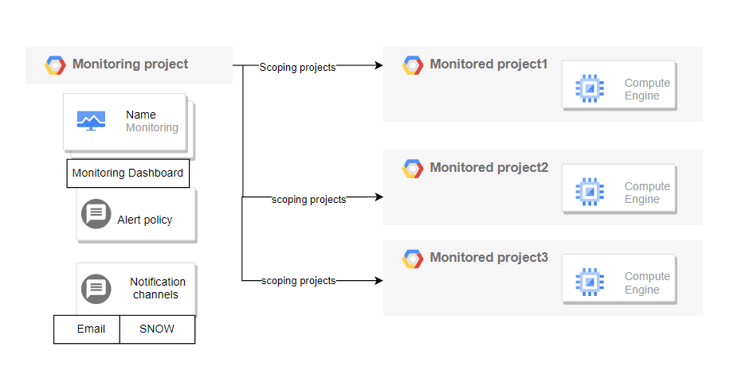
Monitoring project: Refers to centralized monitoring project which can monitor resources across different scoping projects.
Monitored project: Refers to different project with GCP resources to be monitored in centralized project.

Custom dashboards:
You create or install these dashboards. Custom dashboards let you define what data you want to view and how to view that data. For example, you can display metric data, alerting policies, and logs stored in your Google Cloud project. You can display time-series data on a chart, with a gauge or scorecard, or in tabular form. Dashboards also support text widgets. You can create a custom dashboard with the Dashboards API or with the Google Cloud console.
We have created customized Monitoring dashboards in GCP using the terraform scripts.

Alert Policy:
In Cloud Monitoring, an alerting policy describes the circumstances under which you want to be alerted and how you want to be notified. Alerting policies that are used to track metric data collected by Cloud Monitoring are called metric-based alerting policies.
We have created customized Monitoring dashboards in GCP based on requirement and SNOW incidents are getting thresholds added in alert Policies.

SNOW- Service Now Notification channel in detail:
We can integrate the Service now portal with GCP policies for monitoring and create the incidents if any of the metrics crosses the defined threshold value. This would help to monitor and maintain the system from any failure.
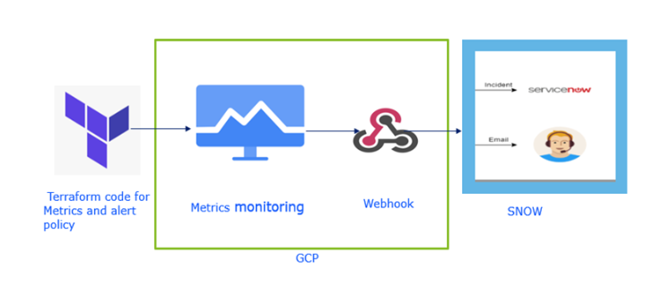
Figure 1- SNOW incident Notification

Code snippet for SNOW notification channel creation:
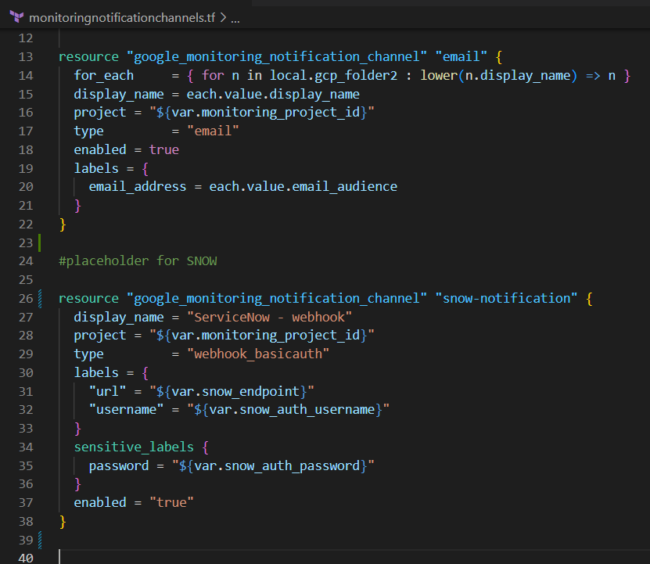

GitHub repo link: https://github.com/Deloitte-Default/deloitteca-gcplandingzone-accelerator.git

Bitbucket repo structure:
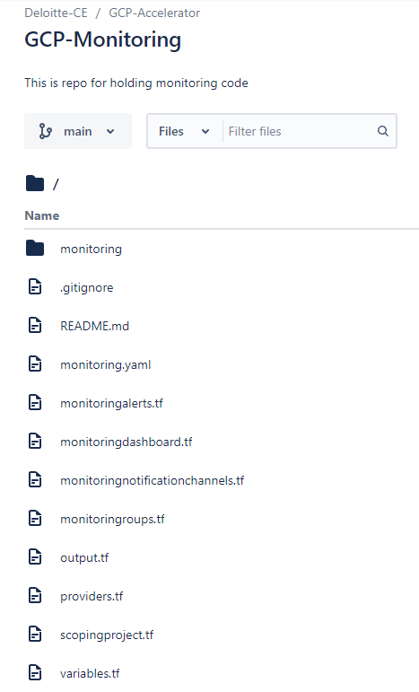
Figure 2 - Snippet showing monitoring code in bitbucket

Folder Definitions:
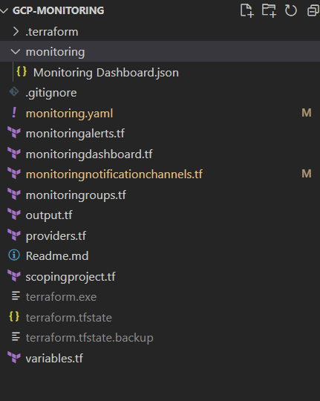
- monitoring- This folder contains json file for dashboard with layout with details for metrics to be added for monitoring.

- monitoringroups.tf - This file is used for creating monitoring groups.

- monitoringalerts.tf - This file holds the code for policies

- monitoringdashboard.tf- This file holds details for dashboard- project, name and team

- monitoringnotificationchannels.tf- This file creates the required email and SNOW notification channel

- scopingproject.tf - This file holds the name of scoping and monitored project

- monitoring.yaml - This file needs to be input to provide all inputs for groups, dashboard, policy and notification channel.

How to run Code

Prerequires:
Terraform v0.12 Terraform Provider for GCP plugin v2.0 Google Cloud SDK curl Service Account A service account with the following roles must be used to provision the resources of this module:
APIs: A project with the following APIs enabled must be used to host the resources of this module
Google Cloud Monitoring API: monitoring.googleapis.com

IAM roles required for Monitoring:
Additional dashboard
Additional notification channel
Additional policy

Steps to run the code:
- Enable Google Cloud Monitoring API in the required project.
- Clone the repository in your local workspace using below command : git clone https://github.com/Deloitte-Default/deloitteca-gcplandingzone-accelerator.git
- Change the directory to monitoring using command : cd gcp-monitoring
- Add you credentials file (eg creds.json) to all folders/subfolders you want to run and provide the following permissions to your Service Account : Appendix 3.1
- Set your files for the below variables:
- gcp_project: Project Name
- gcp_region: GCP Region like “us-east4”
- credentials :Name of Authentication file like “creds.json”
As per your requirement use the following input types in monitoring.yaml : (Click on each to review respective steps)
- Monitoring dashboard
- Notification channels
- Alert policies
- Monitoring Groups

Steps to follow to run monitoring.yaml and provision the resources are:
- provide input json- for creating dashboard with required metrics
- Create notification channels and output the id of notification channel created
- add scoping project- which holds resources to be tracked
- Create monitoring groups
- Create the monitoring dashboard
- Create alerts policies and add notifications channels to those policies

Troubleshooting
In case of errors encountered during terraform plan/apply always check your input yaml file format and consider using terraform console command to check values of locals defined.
- APIs are not enabled
  - Solution: Enabled right API
- Do not have correct permissions.
  - Solution: Fix the IAM

CI/CD Deployment of GCP Infrastructure

CICD Framework for IAC Deployment

A CI/CD Pipeline implementation is the backbone of the modern DevOps environment. Continuous Integration (CI) facilitates the automated integrating, building, and testing of software and infrastructure code within the development environment.

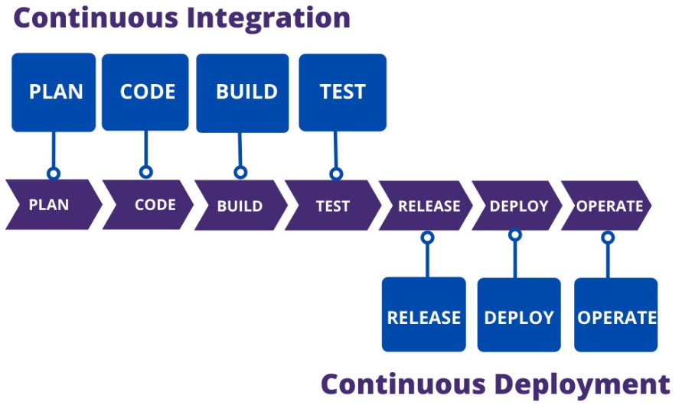
The accelerator manages infrastructure as code with Terraform and Cloud Build using the popular GitOps methodology. Gitflow Branching Strategy is followed in this accelerator to provision resources.
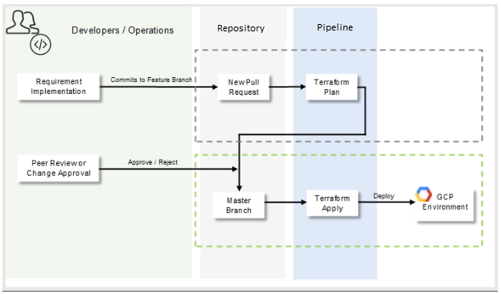
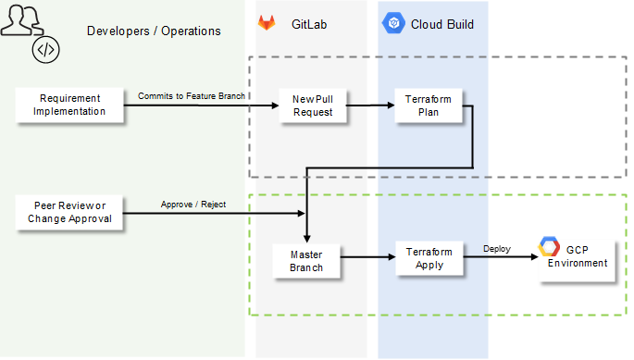
- Any change happens on feature/bug branches (which can be named feature/new-foo, bugfix/fix-bar, etc.) and when complete, a pull request (PR) or merge request (MR) can be opened targeting the development branch. This will trigger the CI/CD Pipeline to perform a plan and validate against all environments.
- After the code review is complete and changes are validated, this branch can be merged into development. This will trigger a CI/CD Pipeline that applies the latest changes in the development branch on the development environment.
- After validated in development, changes can be promoted to non-production by opening a PR or MR targeting the non-production branch and merging them. Similarly, changes can be promoted from non-production to production.

Source Code Management & Branching Strategy

Source Code Management:
A Source control system (or version control system) allows developers to collaborate on code and track changes. Use version control to save your work and coordinate code changes across your team. Source control is an essential tool for multi-developer projects.
The version control system saves a snapshot of your files (history) so that you can review and even roll back to any version of your code with ease. Also, it helps to resolve conflicts when merging contributions from multiple sources.
Some of the advantages of using source control are:
- Create workflows. Version control workflows prevent the chaos of everyone using their development process with different and incompatible tools. Version control systems provide process enforcement and permissions, so everyone stays on the same page.
- Work with versions. Every version has a description in the form of a comment. These descriptions help you follow changes in your code by version instead of by individual file changes. Code stored in versions can be viewed and restored from version control at any time as needed. It makes it easy to base new work on any version of code.
- Collaboration. Version control synchronizes versions and makes sure that your changes do not conflict with other changes from your team. Your team relies on version control to help resolve and prevent conflicts, even when people make changes simultaneously.
- Maintains history of changes. Version control keeps a record of changes as your team saves new versions of your code. This history can be reviewed to find out who, why, and when changes were made. The history gives you the confidence to experiment since you can roll back to a previous good version at any time. The history lets your base work from any code version, such as fixing a bug in an earlier release.
- Automate tasks. Version control automation features save your team time and generate consistent results. Automate testing, code analysis, and deployment when new versions are saved to version control.

Some of the Source Code management best practices are:
- Commit often. Commits are cheap and easy to make. They should be made frequently to capture updates to a code base. Each commit is a snapshot that the codebase can be reverted to if needed. Frequent commits give many opportunities to revert or undo work.
- Ensure you're working from latest version. SCM enables rapid updates from multiple developers. It’s easy to have a local copy of the codebase fall behind the global copy. Make sure to git pull or fetch the latest code before making updates. This will help avoid conflicts at merge time.
- Make detailed notes. Each commit has a corresponding log entry. At the time of commit creation, this log entry is populated with a message. It is important to leave descriptive explanatory commit log messages. These commit log messages should explain the “why” and “what” that encompass the commits content. These log messages become the canonical history of the project’s development and leave a trail for future contributors to review.
- Link code changes to work items. It will concretely link what was created to why it was created—or modified by providing traceability across requirements and code changes.
- Review changes before committing. SCM’s offer a ‘staging area’. The staging area can be used to collect a group of edits before writing them to a commit. The staging area can be used to manage and review changes before creating the commit snapshot. Utilizing the staging area in this manner provides a buffer area to help refine the contents of the commit.
- Use Branches. Branching is a powerful SCM mechanism that allows developers to create a separate line of development. Branches should be used frequently as they are quick and inexpensive. Branches enable multiple developers to work in parallel on separate lines of development. These lines of development are generally different product features. When development is complete on a branch it is then merged into the main line of development.
- Agree on a Workflow. By default SCMs offer very free form methods of contribution. It is important that teams establish shared patterns of collaboration. SCM workflows establish patterns and processes for merging branches. If a team doesn't agree on a shared workflow it can lead to inefficient communication overhead when it comes time to merge branches.

Branching strategy:
GitFlow is incompatible with Trunk-Based Development and has been the preferred model in a lot of enterprises, with heavy/centralized release processes and lack of componentization. It’s trade-off between isolating breaking changes from the Trunk for additional process.

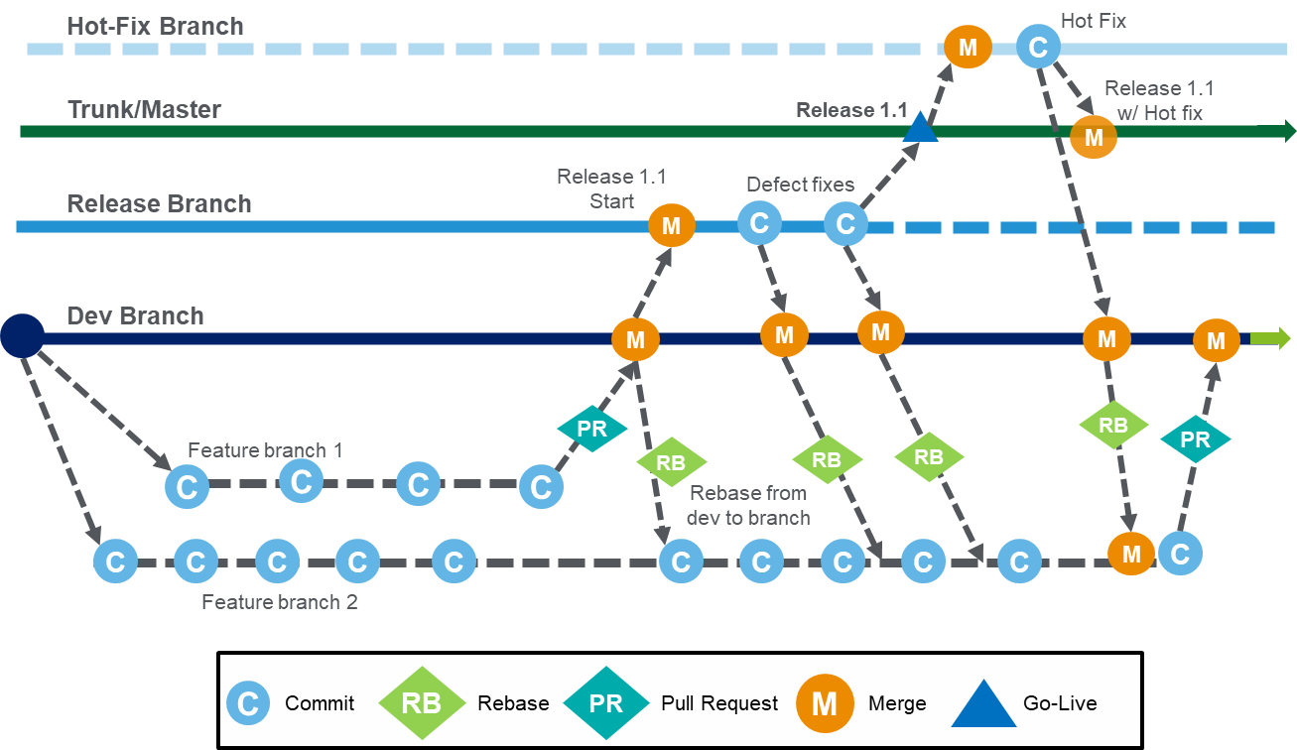

Branches and its purpose:
Branch | Type
Main/Master | This branch contains all release history, the only commits to it are from release branch and hotfixes branch
Release | Functions as the integration branch for features and bug fixes. When a feature is complete it is merged into the Release branch
Feature | Branched from the Main branch, the feature branch is used by developers to create specific functionality locally. When deemed acceptable the feature branch is merged back into the Main branch. These branches are usually short lived
Bugfix | A bug fix branch is used to resolve pre-production defects. It has the same behavior of a feature branch.
Hotfix | The hotfix branch is used by developers to create solutions for defects that arise in Production. It has the same behavior as a Feature branch.
Rollback | This branch is used by developers to remove unwanted functionality from a Main branch or master branch. It has the same behavior as a feature branch.

Environment variables

In Google Cloud Build, environment variables can be used to store configuration data and other sensitive information that your build scripts or build steps need access to. You can define environment variables for your builds in the Cloud Build configuration file. This could be for the entire build or for individual build steps. Once defined, the environment variables can be used in the build steps or build scripts.
Steps:
- name: 'gcr.io/cloud-builders/curl'
args: ['--header', 'Authorization: Bearer $API_KEY', 'https://api.example.com']
env:
- 'API_KEY=abc123'

In Cloud Build, environment variables are encrypted and stored securely. If you need to use sensitive data in your builds, such as API keys or passwords, you should store them as environment variables and protect them accordingly. One way to protect sensitive data is to use Secret Manager to store secrets, and then reference the secrets as environment variables in your Cloud Build configuration file. This enables you to keep sensitive data separate from your code and securely manage access to it.

Secrets Management

Secret Manager is a Google Cloud service that securely stores API keys, passwords, and other sensitive data. To include sensitive information in your builds, you can store the information in Secret Manager and then configure your build to access the information from Secret Manager.
Secret Manager can be integrated in the Cloud Build configuration file. After all the build steps, add an availableSecrets field to specify the secret version and environment variables to use for your secret. Secrets from scripts and processes can also be accessed using the Cloud Build config file.
Example:
steps:
- name: 'gcr.io/cloud-builders/docker'
entrypoint: 'bash'
args: ['-c', 'docker login --username=$$USERNAME --password=$$PASSWORD']
secretEnv: ['USERNAME', 'PASSWORD']
availableSecrets:
secretManager:
- versionName: projects/PROJECT_ID/secrets/DOCKER_PASSWORD_SECRET_NAME/versions/DOCKER_PASSWORD_SECRET_VERSION
env: 'PASSWORD'
- versionName: projects/PROJECT_ID/secrets/DOCKER_USERNAME_SECRET_NAME/versions/DOCKER_USERNAME_SECRET_VERSION
env: 'USERNAME'

The build can be configured to access sensitive information from Secret Manager for creating a GitHub pull request in response to build.

Steps:
- name: 'launcher.gcr.io/google/ubuntu1604'
id: Create GitHub pull request
entrypoint: bash
args:
- -c
- curl -X POST -H "Authorization:Bearer $$GH_TOKEN" -H 'Accept:application/vnd.github.v3+json' https://api.github.com/repos/GITHUB_USERNAME/REPO_NAME/pulls -d '{"head":"HEAD_BRANCH","base":"BASE_BRANCH", "title":"NEW_PR"}'
secretEnv: ['GH_TOKEN']
availableSecrets:
secretManager:
- versionName: projects/PROJECT_ID/secrets/GH_TOKEN_SECRET_NAME/versions/latest
env: GH_TOKEN

CICD Best Practices

- Commit early, commit often.
- Implement tracking and version control tools.
- Monitor and measure the pipeline.
- Test the container images.
- Establish security.
- Follow Naming Conventions.
- Manage Terraform State on a remote storage.
- Enable State file backup.
- Setup backend State locking.
- Implement version control on your code.
- Use a consistent file structure.

GCP – IAC Deployment using Cloud Build

Cloud Build is a service that executes your builds on Google Cloud infrastructure. Cloud Build can import source code from Cloud Storage, Cloud Source Repositories, GitHub, or Bitbucket, execute a build to your specifications, and produce artifacts such as Docker containers or Java archives. Cloud Build executes your build as a series of build steps, where each build step is run in a Docker container. A build step can do anything that can be done from a container irrespective of the environment.
HashiCorp Terraform is an infrastructure as code tool that lets you define both cloud and on-prem resources in human-readable configuration files that you can version, reuse, and share. You can then use a consistent workflow to provision and manage all of your infrastructure throughout its lifecycle.
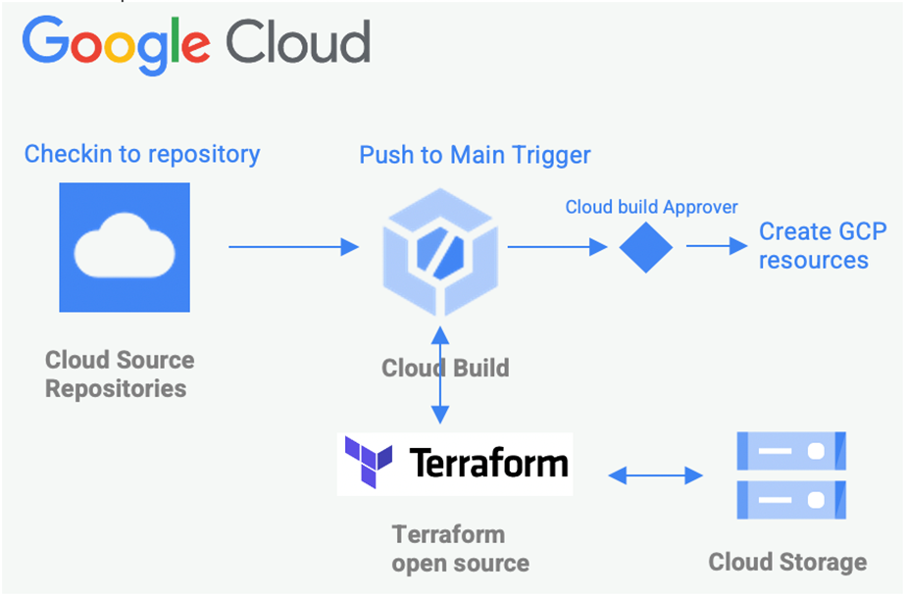
For the Google Landing Zone accelerator, Cloud Build is used to create a pipeline and to automate the deployment of infrastructure declared in Terraform code.
- Terraform and Cloud Build are integrated, so once the feature branch is merged to main branch in Cloud Source Repository, the deployment plan is evaluated, and (once an approval is provided for the deploy execution) Cloud Build pipeline deploys all the changes automatically.
- All the scripts written in Terraform can be modified easily to create a new product on GCP. In most scenarios Terraform code will not require any changes. The behavior can be influenced by customizing pipeline and terraform variables in the script.
- Jobs and Resources are configured together in a pipeline script and parameters used by them are defined separately in parameters file.

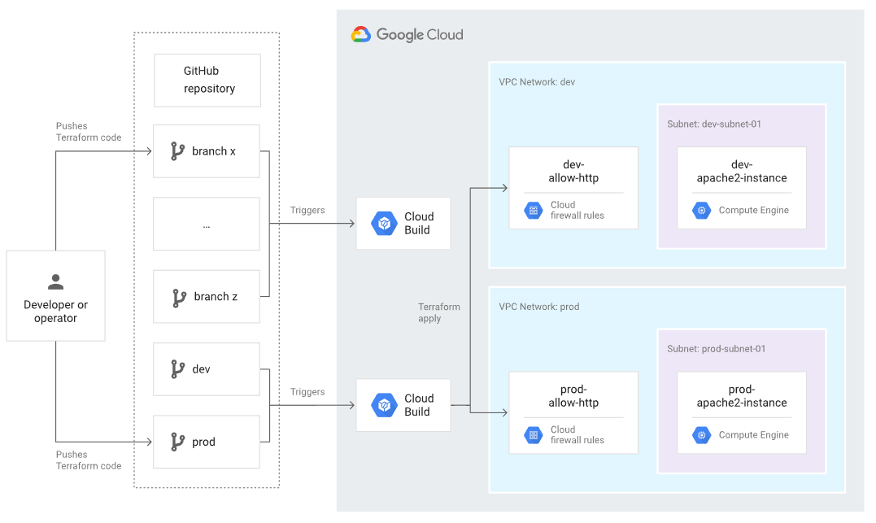

Cloud Build YAML – Plan:
A variable named _FOLDER_NAME can be passed to the Cloud build YAML, this refers to the path of the folder containing terraform code.If no value is passed, the execution assumes that the root of the repository contains terraform code.
When _FOLDER_NAME variable is updated with the path to the folder containing the terraform code, the cloud build trigger when it executes would perform the following steps in order
- change directory to the folder
- Run command terraform init
- Run command terraform plan
Note: The path to folder is relative to the root of the repository. Value test in the example refers to a folder named test at the root of the repository

Cloud Build YAML – Apply:
A variable named _FOLDER_NAME can be passed to the Cloud build YAML, this refers to the path of the folder containing terraform code.If no value is passed, the execution assumes that the root of the repository contains terraform code.
When _FOLDER_NAME variable is updated with the path to the folder containing the terraform code, the cloud build trigger when it executes would perform the following steps in order
- change directory to the folder
- Run command terraform init
- Run command terraform plan
- Run command terraform apply –auto-approve
Note: The path to folder is relative to the root of the repository. Value test in the example refers to a folder named test at the root of the repository.

Cloud Build Trigger Configuration:
Name: <Name of the trigger>
Region: global(non-regional)
Event: Push to branch (this runs the trigger every time there is a push to branch, either direct update to branch selected or a merge action to the branch selected
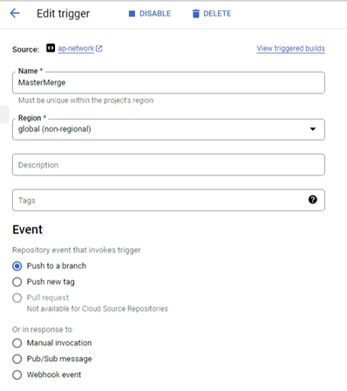

Repository: <select the name of the source repository from the list>
Branch: <enter the name of the branch>
Included files filter: <enter the details of the folders to watch, use the format <folder name>/*>
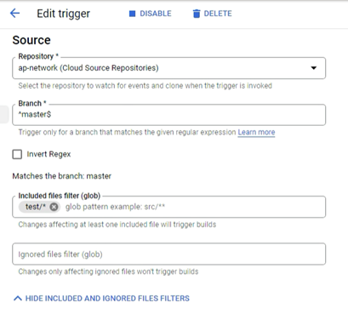

Type: Cloud Build configuration file (yaml or json)
Location: Repository
Cloud Build configuration file location*: /cloudbuildplan.yaml (for plan trigger) /cloudbuildbuildapply.yaml (for apply trigger)
Substitution variables: <enter _FOLDER_NAME for Variable 1 and value of the folder containing terraform script>
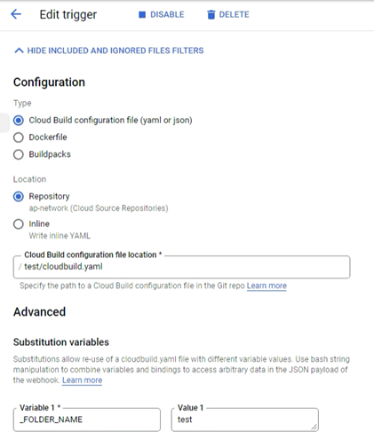

Approval: Require approval before build executes (only for apply trigger)
Service account: xyz@xyz.gserviceaccount.com
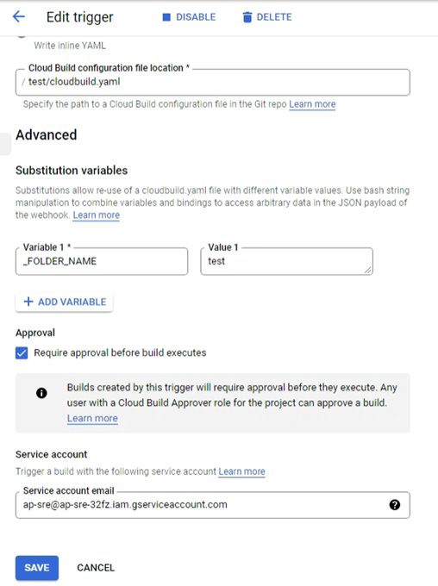

Approval:
A view of approval configuration and actions while using Cloud Build pipelines.
Approval: Require approval before build executes
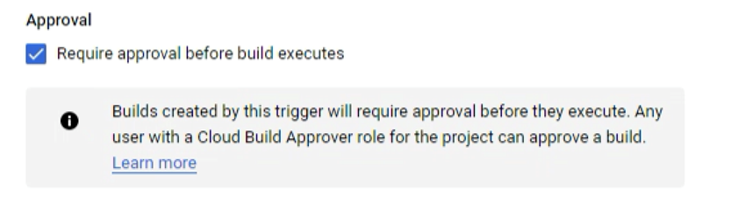
When Approval is enabled for a build trigger, the Build history displays the status of the build with  icon
The Build details displays an Awaiting approval message, which can be approved using the button.
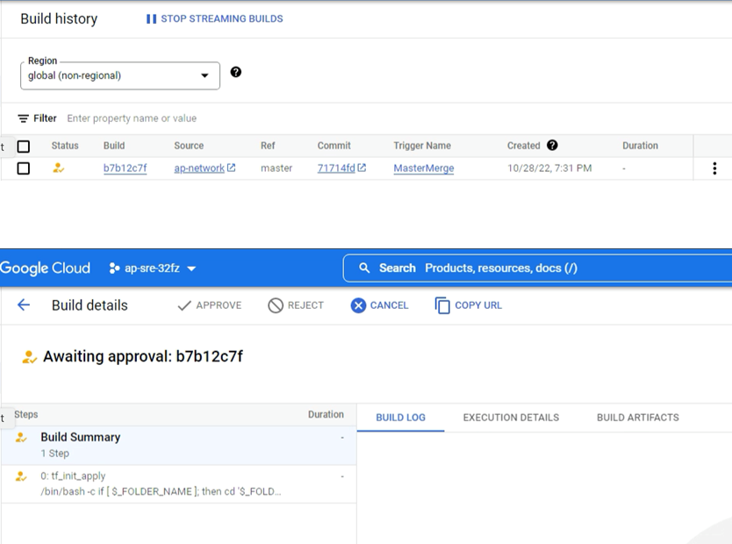

Terraform Deployment Flow:
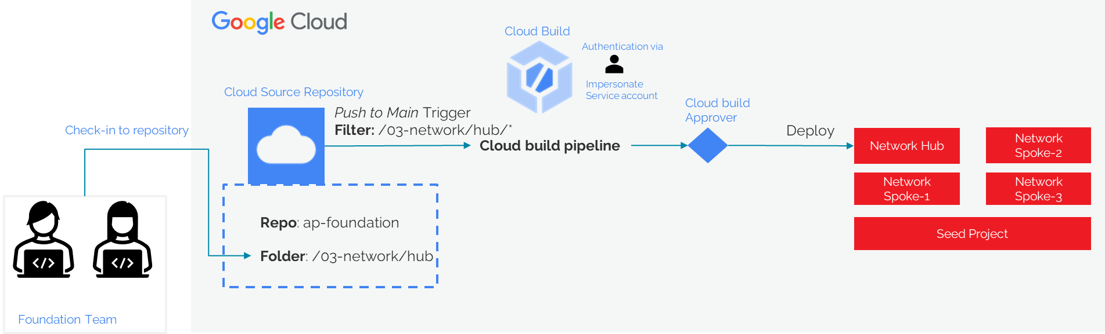
2.6.6.1 Pipeline Authentication
A Service Account is a special type of Google account that is associated with your GCP project, rather than tied to an individual user. Service Accounts can be used to authenticate and authorize access to GCP resources and APIs.
Cloud build triggers and terraform script make use of GCP Service account impersonation for authentication. Impersonation is a way to give a service account the ability to act as another identity, such as a user or another service account. This enables you to grant fine-grained permissions to your service accounts, while also keeping your credentials secure.
By default, Cloud Build uses a special service account to execute builds on your behalf. This service account is called the Cloud Build service account and it is created automatically when you enable the Cloud Build API in a Google Cloud project. This service account has a number of permissions by default such as the ability to update builds or write logs.
Instead of using the default Cloud Build service account, you can specify your own service account to execute builds on your behalf. You can specify any number of service accounts per project. Maintaining multiple service accounts enables you to grant different permissions to these service accounts depending on the tasks they perform. For example, you can use one service account for building and pushing images to the Container Registry and a different service account for building and pushing images to Artifact Registry.
This is a good practice to implement the concept of “least privilege”. The Principle of Least Privilege (PLOP) is an information security concept that effectively states that any user for a given system or resource should only be granted the minimum amount of permissions and access needed to successfully carry out a given task.

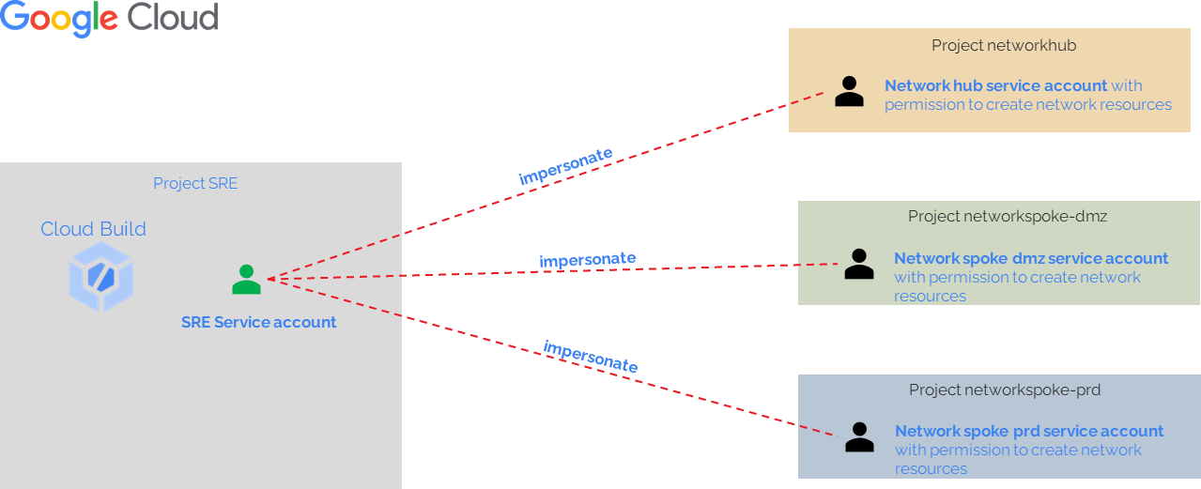

Placeholder for Project factory architecture:
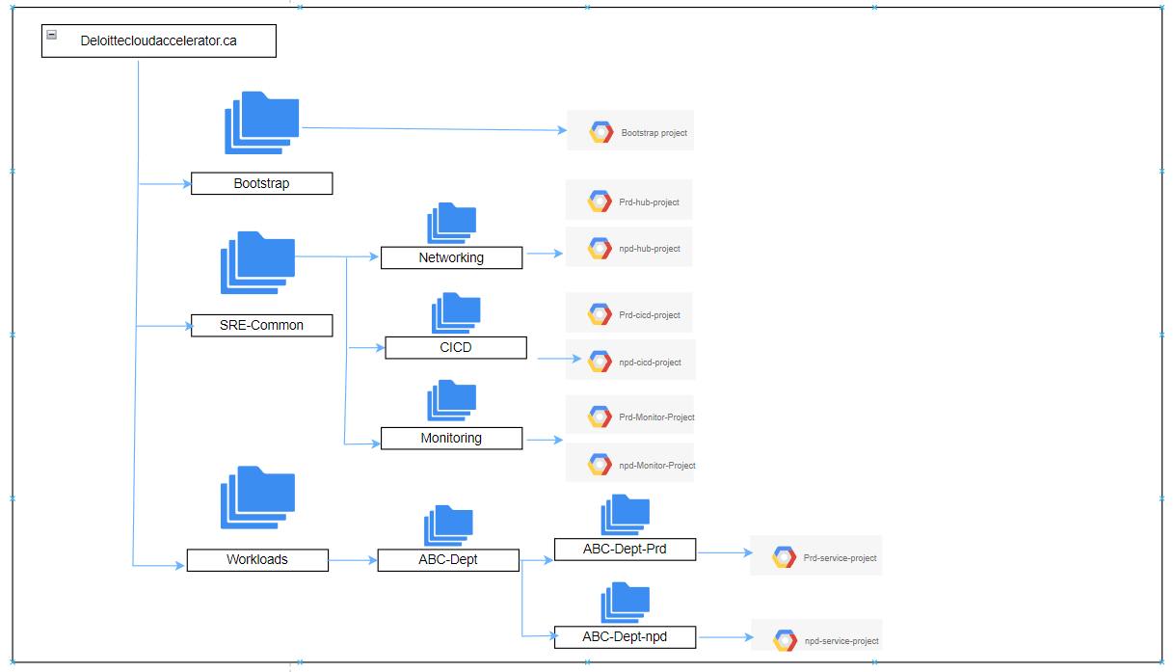

API list and SA permissions for Monitoring project:

Service Account
Logging Logs Writer: roles/logging.logWriter
Monitoring Metric Writer: roles/monitoring.metricWriter
OS Config GuestPolicy Admin: roles/osconfig.guestPolicyAdmin

APIs
Google Cloud Logging API: logging.googleapis.com
Google Cloud Monitoring API: monitoring.googleapis.com
Google Cloud OS Config API: osconfig.googleapis.com

Networking project:

Service Account
roles/compute.networkAdmin on the organization or folder
roles/compute.xpnAdmin on the organization
roles/dns.admin
roles/compute.networkAdmin on project

API's
Compute Engine API - compute.googleapis.com
Google Cloud DNS API: dns.googleapis.com
Google Cloud Compute Engine API: compute.googleapis.com

Appendix

Monitoring APIs to Enable

Link to Repo
compute.autoscalers.create, compute.autoscalers.delete, compute.autoscalers.get, compute.backendServices.create, compute.backendServices.delete, compute.backendServices.get, compute.disks.addResourcePolicies, compute.disks.create, compute.disks.delete, compute.disks.get, compute.disks.removeResourcePolicies, compute.disks.setLabels, compute.disks.use, compute.globalOperations.get, compute.healthChecks.create, compute.healthChecks.delete, compute.healthChecks.get, compute.healthChecks.use, compute.httpsHealthChecks.create, compute.httpsHealthChecks.delete, compute.httpsHealthChecks.get, compute.httpsHealthChecks.useReadOnly, compute.instanceGroupManagers.create, compute.instanceGroupManagers.delete, compute.instanceGroupManagers.get, compute.instanceGroupManagers.use, compute.instanceGroups.create, compute.instanceGroups.delete, compute.instanceGroups.get, compute.instanceGroups.update, compute.instanceGroups.use, compute.instanceTemplates.create, compute.instanceTemplates.delete, compute.instanceTemplates.get, compute.instanceTemplates.useReadOnly, compute.instances.attachDisk, compute.instances.create, compute.instances.delete, compute.instances.detachDisk, compute.instances.get, compute.instances.setLabels, compute.instances.setMetadata, compute.instances.setServiceAccount, compute.instances.setTags, compute.instances.use, compute.networks.get, compute.regionOperations.get, compute.resourcePolicies.create, compute.resourcePolicies.delete, compute.resourcePolicies.get, compute.resourcePolicies.use, compute.subnetworks.get, compute.subnetworks.use, compute.subnetworks.useExternalIp, compute.targetPools.create, compute.targetPools.delete, compute.targetPools.get, compute.zoneOperations.get, compute.zones.get, iam.serviceAccounts.actAs, logging.logEntries.create, compute.addresses.use

Assets | Technical Review | Business Review
Hierarchy | @Noparast, Katayoon | @Lai, Leandra
 |  | In-progress
Network | @Noparast, Katayoon | @Lai, Leandra
 |  | In-progress
IAM | @Noparast, Katayoon | @Lai, Leandra
 |  | Done
Logging | @Noparast, Katayoon | @Lai, Leandra
 |  | Done
Org Level Policy | @Noparast, Katayoon | @Lai, Leandra
 |  | Done
Monitoring | @Deshpande, Bhavika | @Lai, Leandra
 |  | Done
CICD | @Manyala, Ratna @Gnanam Prayen, Prashanth | @Lai, Leandra
 |  | Done

