Section 6 Rev 2: Network Security Design Options
  - Option A (existing Palo Alto Central Hub) and Option B (new Palo Alto hub in the AI Management Group)
Status: Draft for discussion. Revision 2, 15 October 2026. Supersedes the Rev 1 Section 6 update. Option A is the recommended path.

6.1 Purpose, scope and assumptions
This section sets out two network security design options, describes the target architecture for each, and evaluates them against security, manageability, scalability and alignment with the existing Azure environment. Both options must inspect all North-South and East-West traffic with a Palo Alto VM-Series firewall.
A Central Hub with a Palo Alto VM-Series firewall already exists (Option A). The assessment text that says no centralized firewall exists must be corrected.
Option B is a second Palo Alto VM-Series hub in a new hub subscription, placed in the AI Management Group as requested.
Eight existing subscriptions are the spokes. Each spoke peers to one hub only.
Canada Central is the primary region and Canada East is the DR region, for data residency. Both to be confirmed.
Throughput, VM sizing, licensing and cost are not yet known. No cost comparison is made here.

6.2 Design requirements (apply to both options)

6.2.1 Inspection requirements
Flow | Required path | Requirement
Internet to workload (inbound) | Public LB or Front Door/WAF, then firewall, then spoke | Approved services only. Threat profiles on every allow rule.
Workload to internet (outbound) | Spoke UDR 0.0.0.0/0 to internal LB, then firewall, then internet | URL/FQDN allow list, default deny, DNS Security.
On-premises to spoke and back | GatewaySubnet prefix routes to internal LB, then firewall, then spoke | Prefix routes only on GatewaySubnet. No 0.0.0.0/0.
Spoke to spoke (same hub) | Spoke UDR 0.0.0.0/0 to internal LB, then firewall, then destination spoke | Peering is non-transitive, so this path is set by the default route.
Subnet to subnet in one spoke | UDR for VNet address space or each other subnet, to internal LB | VNet system route is more specific than 0.0.0.0/0 and must be overridden.
Spoke to hub services (DNS, management, gateway) | UDR for hub prefixes to internal LB | Peering routes to hub subnets bypass the default route without this UDR.
Private Endpoint traffic | UDR for PE prefixes to internal LB, PE network policies enabled | Without PE network policies, UDRs do not apply.
Same subnet | Not routable through a UDR | Residual risk. Mitigate with small subnets and NSG micro-segmentation.
Cross-hub (Option B only) | Prohibited by default. If approved: source hub FW, then destination hub FW | Requires approval and symmetry testing.

6.2.2 Architecture principles
Every hub has two firewalls in different Availability Zones, active/active behind Standard load balancers.
Every spoke peers to exactly one hub. Dual-hub peering creates conflicting routes.
Panorama is the single source of policy. Hub-specific device groups inherit from a shared base.
Firewall, load balancer, route table and gateway resources carry CanNotDelete locks.
Firewall logs, VNet flow logs and Traffic Analytics go to the central Log Analytics workspace and Sentinel.
Azure health probes (168.63.129.16) are the only documented exclusion from inspection.

6.3 Option A: Use the existing Palo Alto Central Hub

6.3.1 Target state architecture
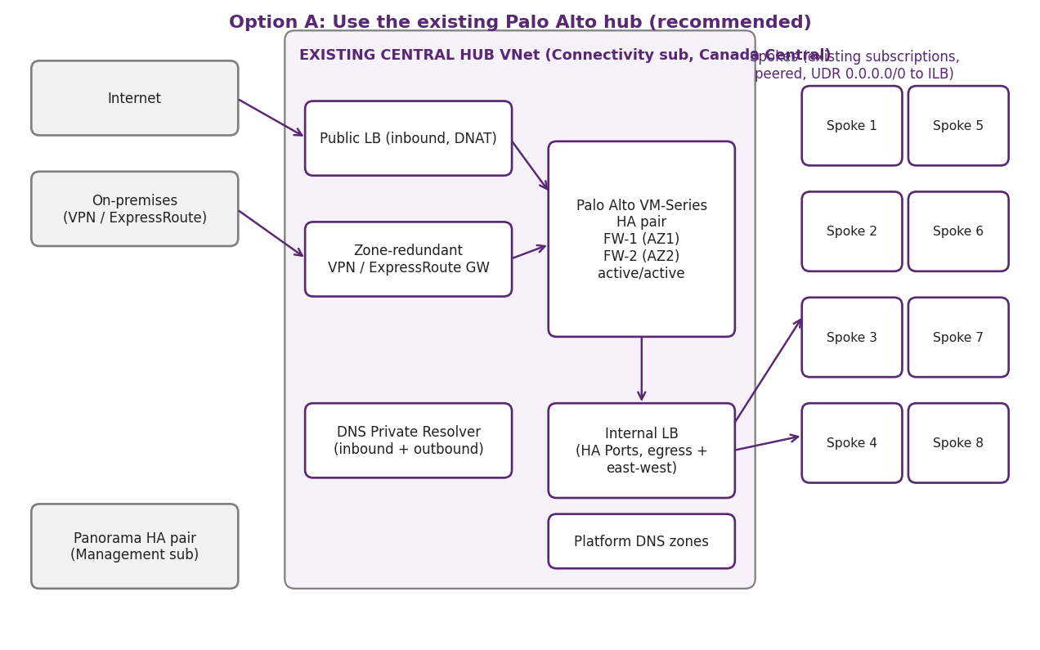
Figure 1. Option A target state. Traffic from the internet, on-premises and all spokes is inspected by the existing hub firewall pair.
How it works: inbound internet traffic enters through the public load balancer and is destination-NATed to the firewall. On-premises traffic enters through the zone-redundant gateway, which routes spoke prefixes to the internal load balancer. Spoke traffic to the internet, to other spokes and to hub services is sent by UDRs to the internal load balancer. The firewall applies zone-based policy, threat profiles and logging, then forwards the traffic to its destination.

6.3.2 Required configuration
Validate the existing hub: region, zone-redundant gateway, two firewalls in separate Availability Zones, PAN-OS version, licensing model and Panorama device group.
Peer each of the eight subscriptions to the hub. Enable gateway transit on the hub and use remote gateways on spokes. Disable BGP route propagation on spoke route tables.
Create or confirm UDRs per Section 6.2.1, including VNet-internal and hub-service prefixes.
Confirm firewall zones for untrust, trust, DMZ, Prod, Non-Prod, management and Private Endpoint traffic. Replace any any-to-any rules.
Confirm DNS Private Resolver in dedicated subnets of at least /28, with private DNS zones linked to the hub and all spokes.
Confirm that no spoke has a direct internet path (public IP, NAT Gateway or load balancer outbound rule).

6.3.3 Access to manage the Central Hub subscription
Role | Who | Scope | Method
Hub network administrator | Network / platform team | Hub resource group and hub VNet | Network Contributor, Entra group, PIM eligible
Subscription owner | Two named platform owners | Connectivity subscription | Owner via PIM with approval and time limit
Spoke owners | Each subscription owner | Their own VNets | Network Contributor (needed for peering), no hub permissions
Security operations | SecOps team | Hub network, firewall logs, Sentinel | Reader, Log Analytics Reader, Panorama role-based access
Firewall and Panorama admin | Security engineering | Panorama and PAN-OS | Role-based admin accounts, Entra SSO with MFA, source IP restrictions
Break-glass | Two named accounts | Subscription | Excluded from daily use, monitored, reviewed quarterly

Current access to the hub subscription must be confirmed before this table is used. Access should be granted through Entra groups, not to individual accounts.

6.3.4 Implementation considerations
Phase 0 (2 weeks): confirm the hub baseline and close the open decisions in 6.7.1.
Phase 1 (2 to 4 weeks): collect effective routes on every subnet of all eight subscriptions. Record bypass paths and gaps.
Phase 2 (4 to 6 weeks): remediate routes, PE network policies and bypass policy in Non-Prod. Turn on VNet flow logs and firewall log forwarding.
Phase 3 (6 to 8 weeks): deploy zone policy in log-only mode and pilot one Non-Prod spoke.
Phase 4 (8 to 12 weeks): move Prod spokes in waves, with a rollback step for each, then enforce URL and threat policy.

6.3.5 Advantages and disadvantages
Advantages | Disadvantages
Fastest route to full inspection. The hub already exists. | Depends on an unverified baseline. Gaps in the existing hub affect all spokes.
One Panorama device group and one policy set. Consistent East-West and North-South inspection. | Single hub limits regional scale and does not provide a DR hub yet.
Lowest cost. No second firewall pair or gateway. | A single hub concentrates admin access risk.
Matches the one-checkpoint goal in the assessment. | Existing hub may sit under policies that block required network changes.

6.3.6 Security and operational implications
Any missed route on one spoke is a bypass. The VNet flow log and firewall log comparison must run on every spoke.
Hub admin access is high value. Enforce PIM, MFA and logging of all role and firewall configuration changes to Sentinel.
Firewall capacity is shared. Throughput must be measured before spokes are added.
DR for Prod is not covered. A DR design must be added, either as a later hub or as an extension of this hub.

6.4 Option B: New Palo Alto hub in the AI Management Group

6.4.1 Target state architecture
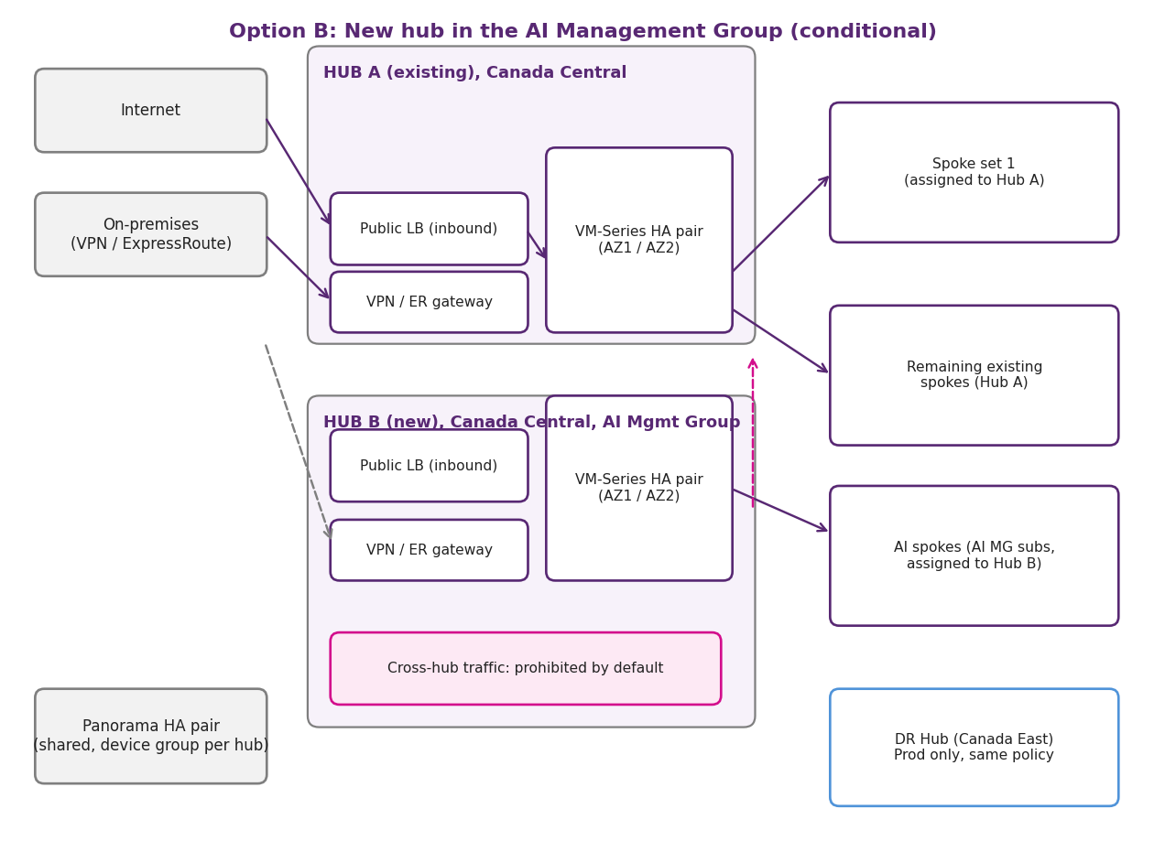
Figure 2. Option B target state. Two hubs, each with its own firewall pair, sharing one Panorama. Spokes are assigned to one hub only.
How it works: Hub B uses the same inspection pattern as Hub A and is placed in the AI Management Group. AI spokes peer to Hub B. The remaining existing spokes stay on Hub A, or move in waves according to an assignment rule. A DR hub in Canada East repeats the Hub B pattern for Prod. Cross-hub traffic is blocked by default.

6.4.2 Required configuration
Subscription: a new hub subscription (for example sub-hub-ai-prod-connectivity) under the AI Management Group. Review inherited policies (deny public IP, allowed regions, required tags) and add exemptions only for the hub.
Address plan: the hub range must not overlap any spoke or on-premises range. Suggested subnets: GatewaySubnet /27, firewall management /28, untrust /27, trust /27, DNS inbound and outbound /28 each.
Firewalls: two VM-Series in separate zones, three NICs each (management, untrust, trust). Same PAN-OS version and licensing model as Hub A.
Load balancing: Standard public LB (inbound DNAT) and internal LB with HA Ports (egress and east-west), with zone-redundant frontends and health probes.
Panorama: reuse the existing HA pair. Create a separate device group for Hub B that inherits from the shared base template.
Peering: each spoke peers to one hub only. Enable gateway transit on Hub B, and disable BGP propagation on spoke route tables.
Routing: the same UDR pattern as Option A. Cross-hub prefixes are blocked by route design, not only by policy.
DR hub: vnet-hub-dr-cae-001 in Canada East, for Prod only, with the same policy and routing. Failover routes must go through the DR firewall.

6.4.3 Access to manage the new hub subscription
Role | Who | Scope | Method
Hub network administrator | Network team | Hub B resource groups | Network Contributor, Entra group, PIM eligible
Subscription owner | Two named platform owners | Hub B subscription | Owner via PIM only
Spoke owners (AI MG) | Workload owners | Their own VNets | Network Contributor for peering only
AI MG administrators | AI platform team | AI Management Group | Must not hold hub permissions. Use a separate group.
Security operations | SecOps team | Hub B, logs, Sentinel | Reader, Log Analytics Reader, Panorama role access

6.4.4 Implementation considerations
Placement: the AI Management Group is the requested location. A Platform or Connectivity management group is cleaner for networking and is recommended if policy conflicts arise.
Spoke assignment: define a rule (by environment or business unit), record it in the IP plan, and move spokes in waves with rollback.
Each spoke move breaks connectivity briefly. Test DNS paths before and after each move.
Logs from Hub B go to the central workspace, tagged by hub.
Panorama device groups must stay in sync. Changes to the shared base are applied to both hubs and tested.

6.4.5 Advantages and disadvantages
Advantages | Disadvantages
Clear isolation of AI workloads, with a separate blast radius. | Two firewall pairs, load balancers and gateways. Roughly double the running cost (not estimated).
Supports regional scale and a DR hub for Prod. | Two policy sets and two sets of exceptions increase drift risk.
Clean greenfield design with no inherited misconfiguration. | Migration of existing spokes is high effort and risk.
Meets the AI MG placement requested in the brief. | AI MG inherited policies may block network changes.

6.4.6 Security and operational implications
Inspection is split across two hubs. Bypass checks must cover both hubs and any approved cross-hub path.
A spoke routed to the wrong hub becomes a blind spot. Assignment must be audited monthly.
Cross-hub traffic is a high-risk path. Keep it prohibited unless there is a documented business need and a tested design.
More privileged roles exist. PIM, MFA and change logging apply to both hubs.
Operating two Palo Alto estates needs more skills and runbooks for failover and upgrades.

6.5 Evaluation and comparison

6.5.1 Weighted scoring
Scores are on a 1 (weak) to 5 (strong) scale and are a judgement based on the requirements in this section. Revalidate them after the Phase 0 baseline is confirmed.
Criterion | Weight | Option A | Option B
Security (inspection coverage and blast radius) | 35% | 4 | 4
Manageability (operations and admin effort) | 20% | 4 | 2
Scalability and DR | 15% | 2 | 5
Alignment with the Azure environment and CAF | 15% | 4 | 3
Time to value | 10% | 5 | 2
Cost (indicative, relative only) | 5% | 5 | 2
Weighted score | 100% | 3.85 | 3.30

6.5.2 Summary comparison
Question | Option A: Existing hub | Option B: New hub (AI MG)
Is all N-S and E-W traffic inspected? | Yes, once the route audit and remediation succeed | Yes, per hub. Cross-hub paths must be blocked or separately inspected
How many places can a bypass occur? | One hub, all spokes | Two hubs, plus any cross-hub path
How many policy sets? | One | Two device groups from one base
Regional scale and DR | Needs a later DR design | Designed in: DR hub in Canada East
Time to first inspected spoke | Shortest | Longest, due to build and migration
Relative running cost | Lowest | Highest (second firewall pair and gateway)
Fit with AI MG placement | Not applicable (existing hub) | Requested placement. Networking fit is weaker than Platform

6.6 IP address overlap remediation (applies to both options)

6.6.1 Current position
Overlapping address spaces across the eight existing subscriptions block peering, VPN and ExpressRoute connectivity, and any hub-and-spoke design (Sections 6.8 and 7.3 of the assessment). Azure rejects peering between VNets with overlapping ranges, and a gateway cannot route to two networks that share a prefix. The overlap must be resolved before spokes are connected to either hub, so this work is a prerequisite for Option A and Option B alike.
The assessment does not yet list the overlapping ranges. Section 7.3 is still marked "To be completed". The inventory table below is a template, to be filled from an IP address scan of all VNets, subnets, gateways and on-premises routes.
VNet | Subscription | Region | Address space | Overlaps with | Treatment
[To be completed] | [Sub name] | [Region] | [CIDR] | [VNet or on-premises range] | Re-address / Keep isolated / Temporary NAT
[To be completed] | [Sub name] | [Region] | [CIDR] | [VNet or on-premises range] | [Treatment]

6.6.2 Recommended approach
Re-address overlapping networks into one hierarchical IP plan. Use NAT only as a temporary bridge for systems that cannot move within the change window. Decide the treatment for each overlap using the rules below:
Overlap type | Recommended treatment | Reason
Two spokes overlap, and both need hub connectivity | Re-address the spoke with fewer dependencies (usually the smaller or newer network) into the target plan | Keeps one authoritative plan and avoids long-term NAT
Spoke overlaps an on-premises range | Re-address the spoke. Change on-premises only if the spoke cannot move | On-premises changes affect more systems and are harder to reverse
Overlap between networks that never need connectivity (for example, sandbox or decommissioned) | Keep as is. Block peering with policy and record the exception | No change where no business need exists
Legacy workload that cannot move in the window | Temporary NAT at the gateway or firewall, with a named owner and expiry date | Allows progress without a forced outage. NAT must be removed by the expiry date

6.6.3 Target IP plan
Build the plan before any VNet is moved. The plan should be hierarchical, so that each environment, region and spoke has a known block of addresses:
One address supernet for Azure, separate from on-premises and from any partner or client ranges. Record each block in a single IP register (IPAM).
Hub blocks per region, sized for the gateway, firewall, load balancer, DNS and management subnets. Give the DR hub its own block, which must not overlap the primary hub.
Spoke blocks sized to growth, with about 30 to 40 percent of each block held in reserve.
Larger subnets for services that need them, such as Container Apps and AKS node pools. Check each service's minimum subnet size before sizing.
Avoid ranges that clash with common defaults, including 169.254.0.0/16, 168.63.129.16 (Azure platform), and default container bridge ranges such as 172.17.0.0/16.
Spoke blocks allocated per hub in Option B, so that each spoke's range is clearly tied to its assigned hub.

6.6.4 Implementation approach
Phase | Timing | Actions | Exit criteria
1. Discover | 2 to 3 weeks | Scan all VNets, subnets, gateways, NAT Gateways, Private Endpoints and on-premises routes. Record owners, dependencies and change windows. | Complete IPAM inventory with zero unknown ranges
2. Design | 2 to 3 weeks | Agree the target IP plan. Assign a treatment to each overlap. Produce a change list per workload. | Signed-off IP plan and change list
3. Pilot (Non-Prod) | 3 to 4 weeks | Re-address one Non-Prod spoke end to end. Test peering, DNS, routing, firewall policy and applications. | Pilot passes tests in Section 6.8
4. Prod waves | 6 to 10 weeks | Move Prod spokes in waves. Keep the old VNet until each wave is validated, then remove it. | Each wave passes tests before the next starts
5. Control | Ongoing | Require IPAM allocation before any VNet is created. Add a pipeline check for overlaps. Review the register monthly. | No new overlaps in the monthly scan

6.6.5 Key considerations
Re-addressing is more than a VNet change. A VNet address space cannot simply be replaced while resources are in use, so most workloads are rebuilt or moved. Plan for the following:
Resources: VM NICs get new private IPs, Private Endpoints are recreated, and gateways may need reconfiguration. Apps with hard-coded IPs need updates.
DNS: update Private DNS zone records and resolver rules for each moved service. Lower DNS TTLs before each wave, and test name resolution from spokes and on-premises.
Firewall: update Palo Alto address objects, security rules, NAT rules and zone mappings to the new ranges before cutover.
Routing and security: rewrite UDRs and NSGs for the new ranges, and confirm the GatewaySubnet routes cover the new spoke blocks.
External dependencies: partner, SaaS and on-premises allow lists that include old addresses must be updated before the change.
Downtime and rollback: agree a change window per workload, keep backups, and keep the original network until validation is complete.
Ownership: each spoke owner signs off on their move. The platform team owns the IP plan and the register.

6.6.6 Option-specific points
Option A: resolve overlaps before any spoke is peered to the existing hub, and use the existing hub's address space only where it fits the target plan.
Option B: allocate separate blocks to Hub B and the DR hub, and assign spoke blocks by hub. A spoke moved to Hub B must be re-addressed in the same change.

6.6.7 Validation
The overlap is closed when: the monthly IPAM scan shows zero overlaps, every spoke peers without error, effective routes show the expected next hop, DNS resolves for every moved service, and application tests pass. These checks are added to the validation list in Section 6.8.

6.7 Recommendation and decisions
Recommendation: adopt Option A as the primary design. It gives one inspection point, one policy set and the fastest path to full North-South and East-West inspection. Build Option B only when one of these triggers is confirmed:
A DR hub for Prod is needed and cannot be provided by extending Hub A.
A regulatory or data-residency boundary requires separate inspection for AI workloads.
Measured throughput exceeds what Hub A can deliver, after scale options are reviewed.
If Option B is approved, place it in a Platform or Connectivity management group rather than the AI Management Group, unless the AI MG policy review shows no conflicts.

6.7.1 Decisions required
Decision | Options | Owner
Confirm Hub A baseline (region, zones, HA, PAN-OS, licensing) | Confirm or rebuild | Network and security architects
Confirm whether Option B is required, and the trigger | Yes (with trigger) or no | Cloud architect and client
Hub B management group placement | AI MG (requested) or Platform/Connectivity (recommended) | Cloud architect
Spoke-to-hub assignment rule | By environment, by business unit, or other | Cloud architect and spoke owners
Cross-hub traffic | Prohibit (recommended) or approve with tested design | Security and network architects
Front Door Private Link origin path | Through firewall or documented exception | Network and application teams
TLS decryption scope | Full, selective or none | Security and compliance
Throughput, sizing and licensing | Measured data required | Client and procurement
IP overlap remediation approach (re-address or temporary NAT) | Re-address (recommended) or NAT as temporary bridge with expiry | Network architects and spoke owners
Overlap inventory and target IP plan | Complete IPAM scan and approve plan before any VNet change | Platform team and cloud architect

6.8 Validation tests (both options)
Test | Method | Pass condition
Next hop for 0.0.0.0/0 on every spoke subnet | Effective routes, Azure Resource Graph | Next hop is the internal LB
Outbound inspected | Allowed and blocked URLs from each spoke | Allowed logged, blocked denied and logged
Inbound inspected | Published service tested from outside | Session in firewall logs
On-premises inspected | Both directions for each spoke | Both directions in firewall logs
Spoke to spoke inspected | Both directions between two spokes | Both directions in firewall logs
Subnet to subnet inspected | Two subnets within one spoke | Traffic in firewall logs
Hub services inspected | Spoke to DNS and management endpoints | Traffic in firewall logs
Private Endpoint inspected | Access a PE-backed service from a spoke | Session in firewall logs
No bypass | VNet flow logs compared with firewall logs | Every flow matched, except documented exclusions
Symmetric return | Long-running sessions both ways | No dropped or one-way sessions
Cross-hub blocked (Option B) | Test from an AI spoke to a Hub A spoke | Denied by route or policy and logged
Failover | Stop one firewall in a test window | Traffic continues, alerts fire
Logs complete | Query each log type in Log Analytics | All types present within the agreed delay

Appendix A: Route and address plan (placeholders)
Replace these placeholders with the approved IP plan before implementation.
Item | Option A (Hub A) | Option B (Hub B and DR hub)
Hub VNet | vnet-hub-[env]-cac-001 (existing) | vnet-hub-prod-cac-001 and vnet-hub-dr-cae-001
Hub address space | [existing range] | [new range, no overlap with spokes or on-premises]
Spoke prefixes | [eight spoke ranges] | [assigned by rule, one hub each]
Route tables | rt-spoke-[env], rt-pe-[env], rt-gateway | Same, per hub
Default route | 0.0.0.0/0 to internal LB | 0.0.0.0/0 to internal LB

Appendix B: Source and next steps
Source: Assessment-Report.docx, Sections 4.2, 4.4, 5.5, 6, 7.3, 8 and 9. Palo Alto VM-Series on Azure reference architecture to be confirmed for active/active symmetry and routing.
Next step: review this revision with the client, close the decisions in 6.7.1, and confirm the Hub A baseline before the Phase 1 route audit.

