LASSO
Target Release | 1.0
Document status | In Development – Sprint 1
Document owner | Silvia Flores-Osuna, Frida Rodriguez-Flores, Ashley Cantu
Designer | Silvia Flores-Osuna, Frida Rodriguez-Flores, Ashley Cantu
Developers | Silvia Flores-Osuna, Frida Rodriguez-Flores, Ashley Cantu
Q&A contact | Students of UTRGV, Pedro Fonseca

Project Background
Lasso is a campus-only social app for UTRGV students that blends the customizable MySpace-style profile experience with smart matching for study partners, friendships, and clubs.

Requirements
# | User Story Title | User Story Description | Priority | Notes
1 | UTRGV Verification | As a user, I want to sign up using my UTRGV email so it can verify that I am a student and access a campus only network. | High | Mock SSO for demo
2 | Profile Creations | As a user, I want to create my own profile for other people to find me. | High | CRUD Feature
3 | Profile Customization | As a user, I want to design my own personal theme. | Low | Aesthetic
4 | Matching Toggles | As a user, I want to choose between study and friend modes to match with people. | High | Toggle-based matching
5 | Study Matching | As a user, I want to meet study partners. | High | Uses schedule info
6 | Group & Events | As a user, I want to find groups and events on campus that I might enjoy. It would help me meet other like-minded people. | High | CRUD Feature
7 | Chat/Request Connection | As a user, it would be nice to meet other people more easily. Sometimes it can be hard to approach others in-person. | Medium | Popup Chat
8 | Safety Controls | As a user, I want my info to be safe. I also want to be able to block other people I disagree with or report others. | High | Blocking/Reporting

Diagram flow for user interaction
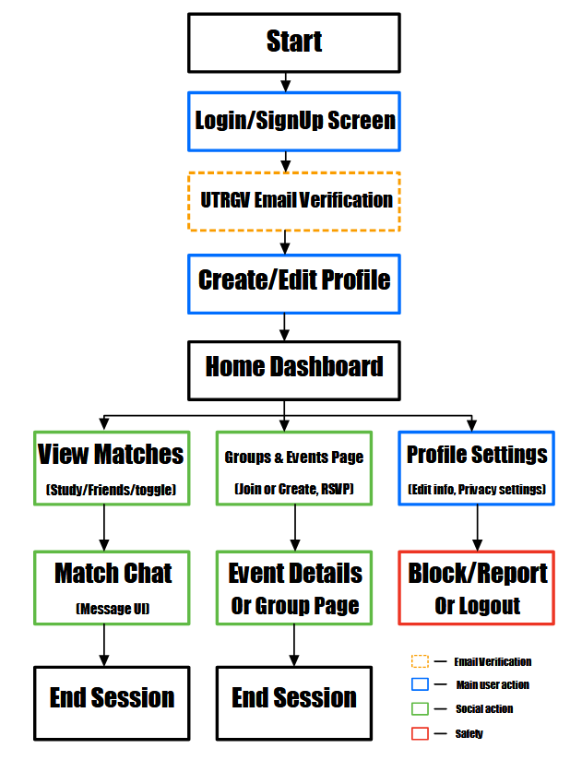

Questions
Below is a list of questions to be addressed as a result of reviewing this design document
Question | Outcome
How will the verification work for the demo? | For now, we’ll implement basic e-mail domain validation.
How will matching with other students work? | We’ll have a ‘suggested’ section for students on their profiles so they can find people easily. Alternatively, we are thinking of doing a ‘swiping’ mechanic, where the user swipes left or right on other students.
How can students track group meetings and events? | We’ll implement a calendar to handle this. On the calendar, users will be able to see events and meetings they have scheduled or signed up for.

Not doing
Below are the user stories, ideas, features, etc, that were considered but are not going to be done for this version or phase of the project.
Not Doing | Reason
Dating Mechanic | We didn’t think dating would be a good feature for a campus app.

Sprint number | Activities | Comments (issues, changes, etc)
One | -We prepared a PowerPoint to display our idea  -We set-up a repository, technical document, and other requirements for our preliminary delivery | We refined our idea; we got rid of only one feature that we had thought about in the brainstorming phase.
Two | -Setup the database  -Setup the front-end  -Make the basics functional | This is stuff we are currently planning on doing

