|  |  |
| --- | --- |
| Informatik und Mathematik  Systems Engineering for Vision and Cognition Goethe-Universität Frankfurt | C:\Users\Administrator1\AppData\Local\Microsoft\Windows\INetCacheContent.Word\GU-Logo-blau.jpg |

MLPR Group Project

**Ship Detection on satellite images using neural networks**

Kaggle Challenge: Airbus Ship Detection Challenge

Submission Date: October 2, 2018

|  |  |
| --- | --- |
| Team members | Supervised by: |
| Hesam Ghavami  Iurii Mozzhorin  Hevin Özmen | Prof. Dr. Visvanathan Ramesh  DBIS Goethe University Frankfurt |

Abstract

[Text]

Table of Contents

1 Introduction 1

2 Motivation 2

3 Use case: Forecasting and clustering demand for bicycle sharing system 3

3.1 Problem statement 3

3.1.1 Related work 3

3.2 Data Understanding 3

3.3 Methodology 3

3.4 Data Preparation 4

3.4.1 (Definition of Use Case Architecture ) 4

3.4.2 Data Loading 4

3.4.3 Data Preparation 4

3.5 Data Modelling 4

3.6 Data Visualization and Evaluation 4

3.7 Evaluation and Summary of the findings 4

4 Conclusion 5

5 References 6

6 Glossary (Optional) 1

7 Appendix 2

7.1 Code 2

7.2 Visualizations 1

7.2.1 Example image 2

7.2.2 CRISP-DM 3

List of Figures

Figure 2: Phases of the CRISP-DM reference model (Source: XXX) 8

Figure 2: [Text] 2

List of Tables

Table 1: Phases and Tasks of CRISP-DM reference model (own table) 8

List of Abbreviations

|  |  |
| --- | --- |
| ABK | BITTE ABKÜRZUNG BEI VERWENDUGN DIREKT REINSCHREIBEN: SORTIERUNG AM ENDE AUTOMATISCH!!! |
|  |  |
|  |  |
|  |  |
|  |  |
|  |  |
|  |  |
|  |  |
|  |  |
|  |  |
|  |  |
|  |  |
|  |  |
|  |  |
|  |  |
|  |  |
|  |  |
|  |  |
|  |  |

# Introduction

# Motivation

# Use case: Forecasting and clustering demand for bicycle sharing system

## Problem statement

In light of the increasing size and demand in the ship transport sector the need for maritime monitoring services becomes pressing. This ensures the reduction of ship accidents as well as the mitigation of illegal activities such as piracy, drug trafficking, illegal fishing and movement of illegal cargo. There are a myriad of stakeholders interested in functioning maritime monitoring, such as government authorities, insurance companies as well as environmental protection organizations.

One organization specializing in solutions for advancing maritime monitoring, threat anticipation and triggering and improving overall efficiency is Airbus. One of the attempted advances initiated by Kaggle is the automatic ship detection from satellite images. The objective here is dedicated improvement in the dimensions of speed and accuracy, as these remain challenging in automatic object extraction from satellite imagery. This problem is published as a challenge on the machine learning competition community platform Kaggle Inc.[1]

We have original satellite images and corresponding masks for each ship type. The data is provided in CSV-format

### Related work

General challenges with images: <https://sandbox.intelligence-airbusds.com/web/>

## Data Understanding

We have original images (around 100 k of them) and corresponding masks for each occuring ship (in .csv format, so we need to transform it into an image). So, make NN model, feed it with images and masks and get predictions.

Let's go step by step. (And yes, if you don't have GPU it's better not to try on this competition)

## Methodology

Text from E-Mail (Iurii to Ramesh: August 22, 2018)

We suggest to compare three different architectures:  
1) U-Net <https://arxiv.org/abs/1505.04597>, it was developed for the biomedical images but recently has shown good results for satellite images also.  
2) Mask R-CNN <https://arxiv.org/abs/1703.06870> (successor of Fast R-CNN and Faster R-CNN)  
3) a  combination of these two with more simple methods. The idea here is that only a small amount of images in the dataset display ships, so we can first scan all images with some not very deep network or some other fast ML method for selecting those with ships (pre-classifying). In a next step we can use the very deep and slow networks (U-Net or Mask R-CNN) for precise localization only for the preclassified smaller set. In the end, we can compare performance (runtime) and accuracy (score from the challenge) for all three solutions. In this case, it's easy to divide responsibilities for 3 persons: a) U-Net, b) Mask R-CNN, c) several methods for pre-classifying.

Definition of Use Case Architecture

## U-Net

### Data Preparation

### Data Modelling

### Data Visualization and Evaluation

## Mask R-CNN

### Data Preparation

### Data Modelling

### Data Visualization and Evaluation

## „Transfer Model“ for Classification + U-Net / Mask R-CNN

### Data Preparation

### Data Modelling

### Data Visualization and Evaluation

## Evaluation and Summary of the findings

In the end, we can compare performance (runtime) and accuracy (score from the challenge) for all three solutions

# Conclusion

# References

Example:

Breiman, Leo (2001): Random forests. In: *Machine Learning* 45 (1), S. 5–32.

# Glossary (Optional)

***Cross-industry standard process for data mining (CRISP-DM)*** is a widely used data process model and will be the basis for the use case implementation in section X. It was developed by a consortium originally comprised of the organizations SPSS, NCR and DailmerChrysler and OHRA. The CRISP-DM methodology views the data life cycle in data mining in six iterative but interdependent phases. Each phase is constituted of several tasks. The six phases as displayed in Figure 2 are as follows: (1) Business Understanding, (2) Data Understanding, (3) Data Preparation, (4) Modeling, (5) Evaluation and (6) Deployment.

The following table depicts the phases along with the respective tasks performed within the phases.

|  |  |  |  |  |  |  |
| --- | --- | --- | --- | --- | --- | --- |
| Phase | Business understanding | Data understanding | Data  preparation | Modeling | Evaluation | Deployment |
| Tasks | * determine business objectives * assess situation * determine data mining goals * produce project plan | * collect initial data * describe data * explore data * verify data quality | * select data * clean data * construct data * integrate data * format data | * select modeling technique * generate test design * build model * assess model | * evaluate results * review process * determine next steps | * plan deployment * plan monitoring and maintenance * produce final report * review project |

Table 1: Phases and Tasks of CRISP-DM reference model (own table)

# Appendix

## Code

## Visualizations

### Example image

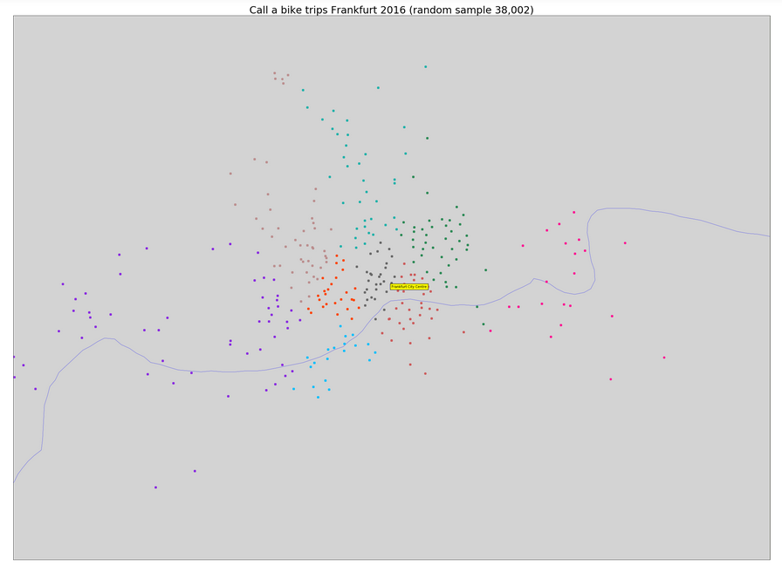

Figure 1: [Text]

### CRISP-DM

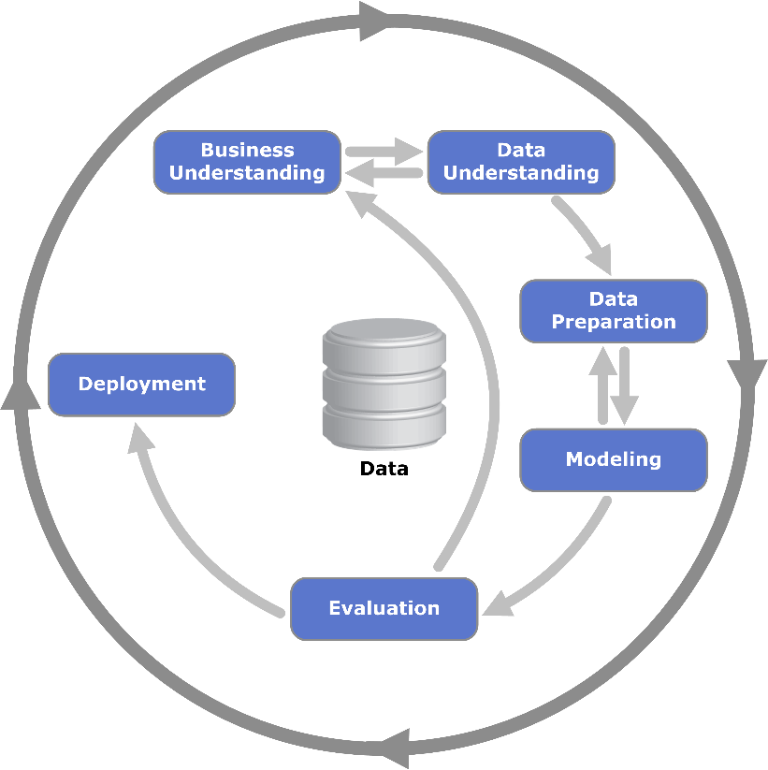

Figure 2: Phases of the CRISP-DM reference model (Source: XXX)

1. <https://www.kaggle.com/c/airbus-ship-detection#description>, Accessed: September 03, 2018