Animation App Functional and Non-Functional requirements

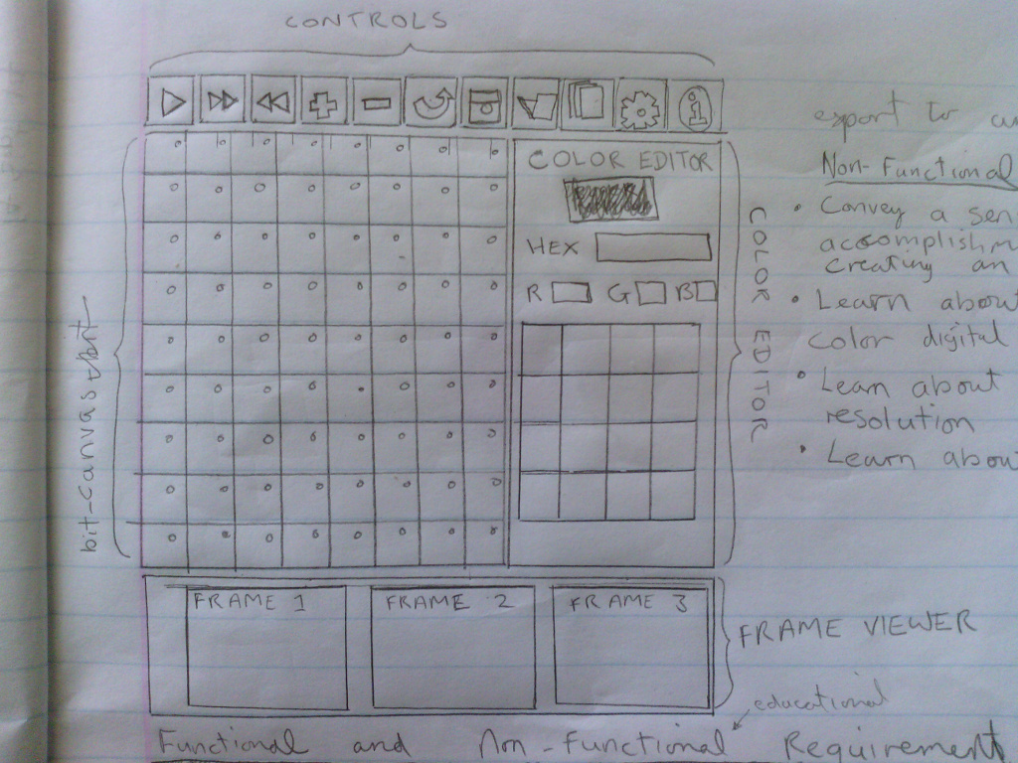

Functional requirements

    Pixel Canvas  
Allow user to draw colors to pixel canvas  
Select another color  
Edit selected color with RGB and Hex values  
Colors on pixel canvas should change when clicked or dragged

    Frame Preview  
Add a frame by duplicating selected frame and placing it after current frame  
Go to a frame by clicking it in the frame viewer  
Delete the currently selected frame  
View other frames by dragging frame viewer area to reveal frames off screen  
Preview a thumbnail of a frame

    Navigation  
Play/Stop animation  
Go to Next Frame/ Previous Frame

    Edit  
Undo previous stroke/click to pixel canvas

    File  
Save a working file  
Load a working file  
Export animated GIF, CSV File of Hex color values per frame

xport currentz afra,e as Seperate image file

Plus export in sprite format Mario Example

    Configure  
Change number of columns and rows

    Help  
Provide a live demo on using the app

Provide live demo of code interaction

    Social  
Share animated GIF, images and source via Bluetooth, Facebook, Email

Non-Functional

Must convey a sense of accomplishment by creating animation  
Learn about Color representation on computers via Hex and RGB  
Learn about resolution  
Learn about image sequencing  
Learn about file formats   
View code seeing the objects the the learner is interacting with.