Oceana Grill Prediction and Categorization of Customer Sentiment Within Yelp Reviews
BANA 472 Section 400
Data and Text Mining
Xueer Bai, Yung Ting Lin, Michael Panico
9 June 2024

Table of Contents
Oceana Grill Prediction and Categorization of Customer Sentiment Within Yelp Reviews 1
Table of Contents 2
Executive Summary 3
Introduction 5
Data Exploration 9
Oceana Grill Exploration 11
Data Preprocessing 17
Text Mining & Evaluation 22
Business Implications 26
Conclusion 29

Executive Summary
In today’s digital world, online reviews have become a critical source of information for consumers as well as business owners. Our report aims to leverage text mining techniques to analyze Yelp reviews and generate actionable insights. Understanding the dynamics of customer satisfaction and business performance through sophisticated data and text mining techniques.

This report will outline our comprehensive approach to designing, implementing, and evaluating text mining processes on Yelp review data, with a specific focus on the business of ‘Oceana Grill’.
To achieve our objectives, we began by focusing on text preprocessing and applied various text techniques such as our normalizing function which included lemmatization, stop word removal, TF-IDF vectorization to convert raw text into a structured term-document matrix, and more. Utilizing both VADER and FLAIR sentiment analyzers, we calculated compound sentiment scores and categorized them into either positive, neutral, or negative sentiments and this allowed us to utilize this as our target variable in our logistic regression model. We implemented logistic regression for classification and evaluated the models' performance using accuracy, precision, recall, f1-score, and cross-validation. Based on our findings we can propose information allowing the specific business of Oceana Grill to make actionable changes in order to more effectively satisfy their customers by tracking and actively remedying the sentiment of their customers found within their Yelp reviews.
The logistic regression model achieved a high accuracy in predicting sentiment categories, demonstrating the effectiveness of our preprocessing and classification techniques. Sentiment analysis also revealed that a significant portion of reviews were either negative or positive with little to no reviews being neutral and this allows the business to see that their customers are very emotional when leaving reviews. This also tells us that our model may be better trained on data with less biased and polarized sentiments. Positive reviews highlighted strengths such as service and ambiance and negative reviews often mentioned issues with staff or wait time or food expectations. This information can be utilized to implement operational improvements and with our model, these negative reviews can be tracked and explored based on trends and much more. This also allows Oceana Grill to implement an automated or manual sentiment-driven feedback process in order to promptly address these negative circumstances.
Moving forward recommendations for further enhancing this model could be made. Some enhancements toward the model seeing less biased data could potentially allow for better training on all categorization types. Additionally, another fix to this may be to use something to mitigate class imbalances within the model and this could be done by duplicating the minority class or even interpolating the minority class between one another to make more of them. Additionally adding ensemble models into the code can allow the model to train more efficiently and effectively. Ultimately without the need for any of these enhancements, the report demonstrates a practical application of text mining techniques in order to extract meaningful insights from unstructured data and effectively offer valuable recommendations and actions for business operational strategies.

Introduction
Online reviews are indispensable for businesses and the Yelp dataset contains loads of unstructured data that can offer significant insights into customer sentiment and business performance. Businesses can use this information to assess their customer satisfaction. Understanding and leveraging this data can lead to enhanced customer satisfaction, improved operational efficiency, improved service, and various other strategic business improvements. The data allows for various analyses, including, but not limited to, trend analysis, sentiment analysis, textual analysis, and the gathering of correlation matrices. The central problem we want to identify in the project pertains to what drives customer satisfaction and whether we can extract insights from textual data given by them. The primary objective of this report is to analyze customer reviews to extract actionable business insights for Oceana Grill. By utilizing advanced text mining and sentiment analysis techniques, we aim to make patterns and trends within the reviews pertaining to customer sentiment readily apparent and available in order to allow the business to make informed decisions. Specifically, we will apply various text preprocessing techniques to create our structured term-document matrix, then utilizing VADER and FLAIR we will compute sentiment scores and categorize them. Lastly, we will design and implement a logistic regression model that accurately utilizes both sentiment and our TF-IDF structured data as features and we will predict the sentiment categorization of new data. Our model is evaluated based on performance metrics of accuracy, cross-validation accuracy, precision, recall, and f1 score. By utilizing our predictive model, Oceana Grill can gain a comprehensive understanding of how various factors influence customer star ratings. Our model will enable them to discern what contributes to negative and positive star ratings, categorize and filter these ratings accordingly, make actionable decisions based on new categorizations, and ultimately provide valuable insights into customer satisfaction levels and preferences.
Expected Findings
From a business point of view, the star rating on platforms like Yelp is a critical indicator of how well a product or service meets customers' expectations. It significantly influences future management decisions and marketing strategies such as segmented and targeted marketing or engaging promotions. That being said, we want to focus on a single exemplary business. To begin, we will take a 5% random sample of the Yelp dataset to make our analysis processes much more manageable and efficient. We are then left with reviews related to 88609 unique business IDs. Analyzing trends within this dataset and looking out for any worrisome trends pertinent to the businesses present is critical. After developing insights into the data, we will narrow our scope by identifying the states with the highest number of reviews and then we will narrow it further by examining those states and targeting the most reviewed business within those top 3 states. Analyzing the top reviewed businesses will provide the best scope of the dataset as well as a large amount of text or sentiment data to analyze within it. After we determine our most prominent business within this sample dataset and explore and analyze it, in order to achieve a higher level of effectiveness within our logistic regression model, we will take a sample of 2000 reviews specific to this business, Oceana Grill, pre-process it, run sentiment analysis, vectorize it and create a matrix and then train our model. This provides a valuable opportunity for the specific business chosen to understand and propose actionable strategies to enhance the customers' experiences and improve business outcomes.

With data centered exclusively around one business, we are left with an easy-to-manage yet comprehensive view of customer text feedback. Analyzing review trends provides insights into how customer satisfaction has evolved, allowing the business to benchmark current performance against historical data, identify patterns, and provide itself a competitive edge by enabling quick adaptation to changing customer preferences and conditions. Therefore, understanding the factors that drive these star ratings is crucial for businesses aiming to enhance their customer satisfaction and loyalty. For example, calculating polarity scores for each review allows a business to gauge the overall sentiment expressed by customers, providing a clear picture of how they felt about their experiences. Classifying the reviews can provide actionable insights, enabling the restaurant to address specific issues or reinforce positive aspects proactively. Utilizing these insights can allow the business to allocate resources effectively to address and avoid issues, thus improving overall operational efficiency and increasing its customer engagement, retention, and satisfaction, consequently increasing its profits and revenues.
We expect to identify key drivers of customer satisfaction and dissatisfaction, such as excellent food quality and attentive service per say for positive reviews, long wait times, or low-quality food for negative reviews. Using VADER and FLAIR sentiment models we anticipate gaining a critical understanding of sentiment distribution and trend shifts over time, which can be extremely helpful in assessing operational changes relevant to the time. By applying logistic regression we aim to achieve high accuracy in sentiment prediction and provide a reliable monitoring tool for the business. The insights derived will lead to actionable recommendations for Oceana Grill in an attempt to enhance customer satisfaction, gear customer emotion toward positive emotion, and address concerns quickly whilst also leveraging positive feedback quickly and effectively.

Data Exploration
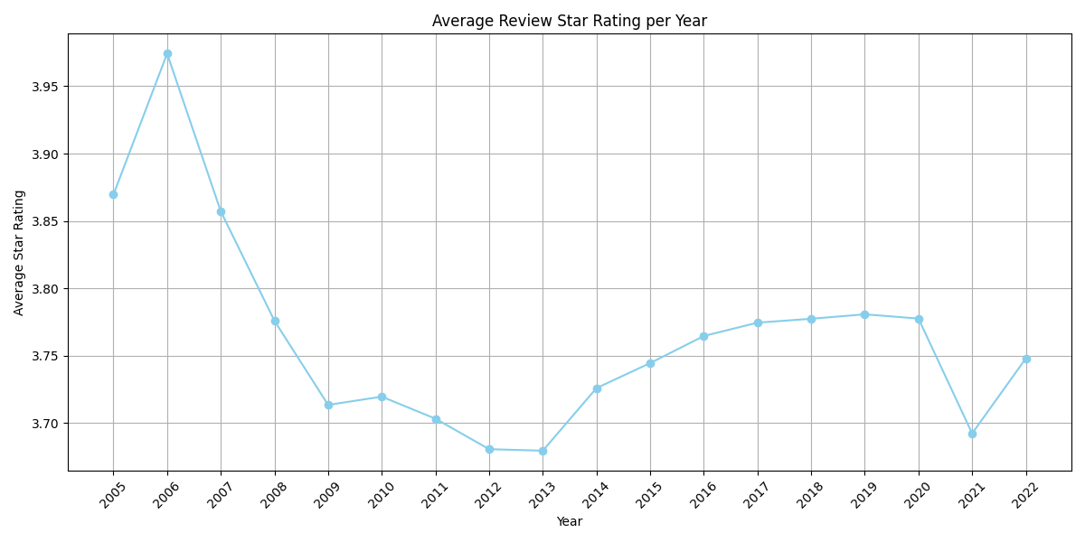
Taken from our sample data with over 88000 unique businesses, From 2005 until 2022, this graph illustrates the average annual star rating per year across the dataset. Initially, in 2005, ratings were approximately 4.0 stars, signifying strong consumer satisfaction. However, ratings fell steadily between 2006 and 2011, hitting a low of just over 3.7 stars. This period may signal problems such as a drop in overall service or business quality, changes in management, unfulfilled customers, or any other changes in customer expectations. Since 2011, ratings have been quite consistent, varying slightly between 3.7 and 3.8, with modest surges indicating that these businesses' star averages are consolidating below an average of four stars and therefore could benefit from insight into why their customers are not adequately satisfied. The significant decline in 2021 can be linked to external reasons such as the recent Covid-19, which heavily affected businesses. We want to discover what may be causing the steady decline of star ratings for businesses present in this dataset. We will focus on the most relevant business to accurately represent our sample data set.
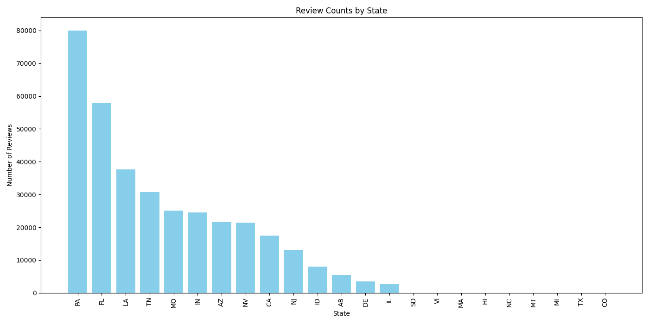
The number of reviews per state within our sample dataset is represented above. Pensallvia, Florida, and Louisiana have the highest number of reviews (chart shown above), indicating a considerable concentration of business activity and user engagement in these states. We then wish to reveal which specific businesses within these three states received the most reviews. We will be able to gain insights into a popular establishment within this subset of data as well as ensure a large amount of text data surrounding this specific business is available.
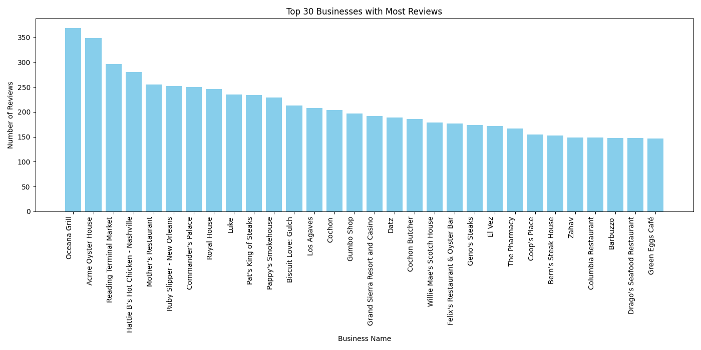
The visualization above displays the leading 30 businesses within the whole sample dataset, and as we analyzed further, Oceana Grill is indeed located in LA, one of our top 3 reviewed states, and possesses the highest count of reviews within the whole sample dataset. Therefore, Oceana Grill is identified as having the highest amount of feedback and interaction and will therefore be used for further analysis such as text sentiment within the reviews being directly related to the star rating given.

Oceana Grill Exploration
Throughout our analysis of Yelp reviews, for Oceana Grill particularly, spanning several years, we have observed a dynamic landscape of customer experiences and interactions, reflected through various data visualizations and statistical analyses. As you can tell we decided to filter the data, specific to the most reviewed restaurant within our 5% sample of the yelp_review data that we had been given. We are left with data only pertaining to Oceana Grill.
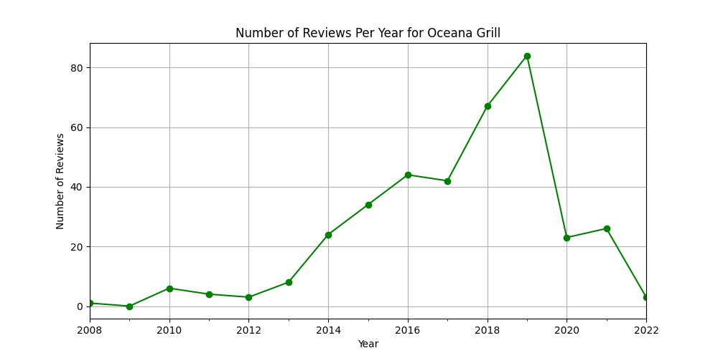
Visualized above is the number of reviews per year, which can provide additional context into the restaurant's popularity relevant to time as well as customer engagement levels. There was a notable increase in reviews over certain periods such as from 2012 to 2016. This may be linked to marketing campaigns, menu updates, restaurant updates, or even local events. By looking at this and cross-referencing it with the restaurant's history of events, updates, campaigns, etc, the restaurant can utilize this data to make similar changes that were seen as correlated with increased reviews or increased business to positively attribute to the future of the business. We notice that the number of reviews has decreased significantly in the past few years and this may be cause for concern because it could mean the customers are not engaging or even that there has been a decrease in the number of customers. The review text may give us insight into what operational needs customers are missing.
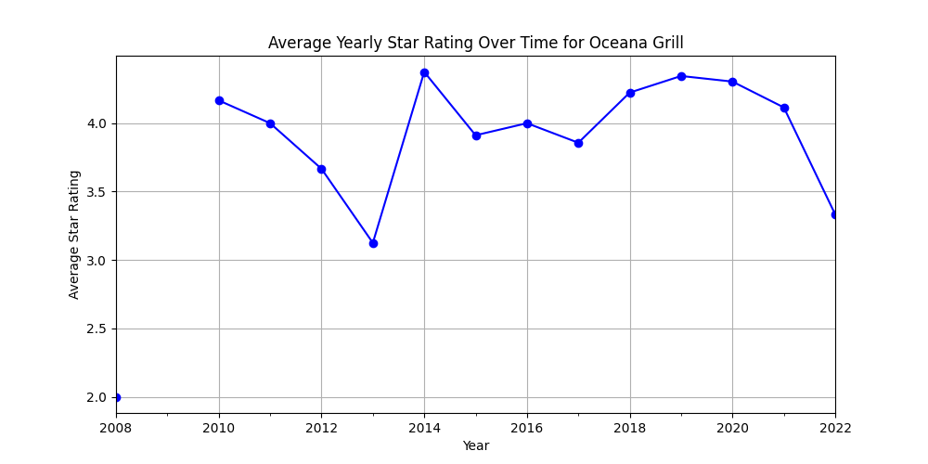
As visualized above, our investigation included extracting the average star rating for Oceana Grill with intervals of 1 year. This can reveal insights into customer satisfaction trends and correlations between timely promotions and star ratings. Initially, the ratings at Oceana Grill were remarkably high, on average exceeding 4 stars, highlighting a period of excellence for the restaurant. However, between the years 2010 and 2013, there was a subtle decline in the average of their star ratings. Nonetheless, from the year 2013 to 2014, the restaurant experienced a year of extreme growth in the average star rating of their restaurant. It continued to consolidate between about 3.8 and 4.5 up until the year 2019, when it began to decline, similar to how the number of reviews declined for Oceana Grill in the same year. These shifts could suggest a change in customer satisfaction or expectations in service quality, operational management, or food experience over time. It would be beneficial for the business to try to emulate what they were doing during high-star average rating times, and discover what may be causing their customer ratings to decline.
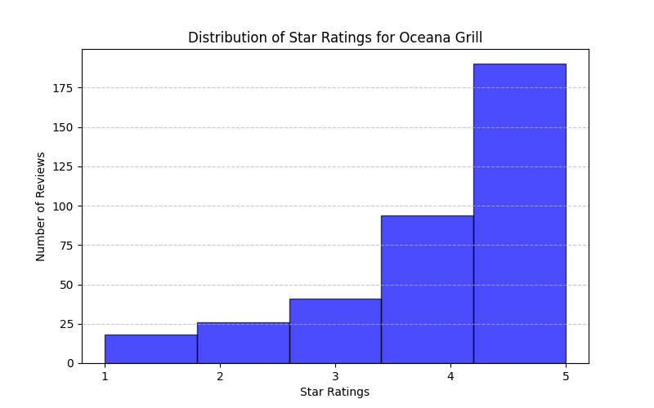
In addition to exploring the average of star ratings over time for Oceana Grill, we also explored the overall distribution of star ratings given to the business and represented in a histogram above. This histogram further illuminates the customer review data of Oceana Grill, where 5 stars remain the most frequently awarded rating, affirming an exceptional level of satisfaction among customers. 1-3 star reviews are very hard to come by which is something the business can be happy about. Only about 20% of reviews are left as 1-3 star reviews. However, the 1-3 star reviews especially indicate areas of improvement and the text within them can be utilized to determine solutions.
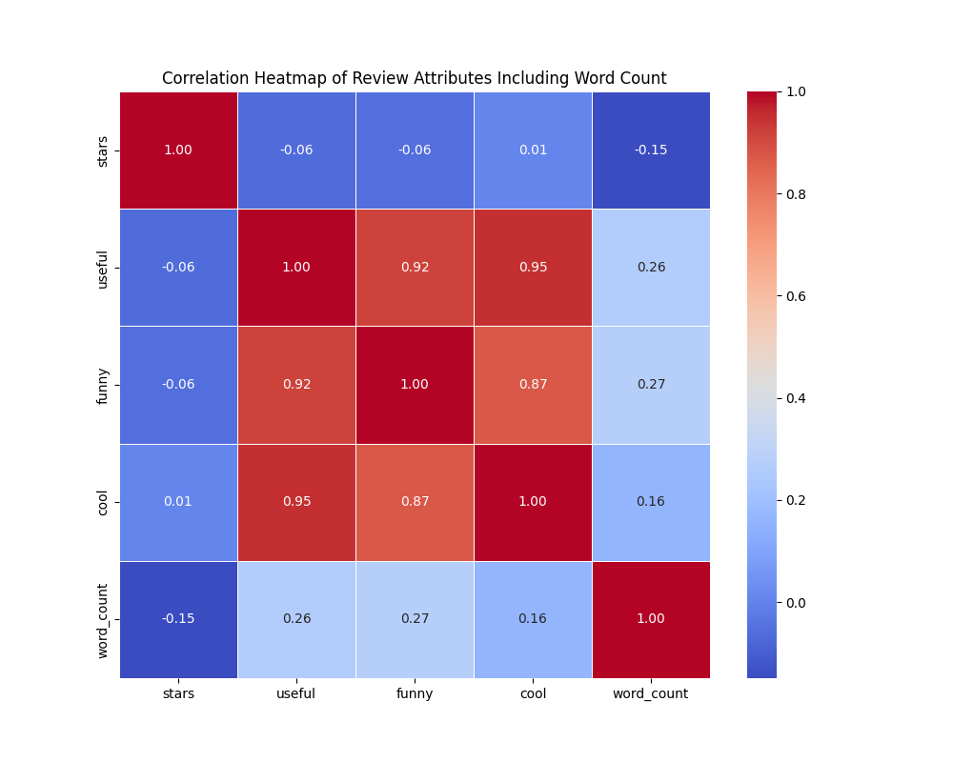
This correlation matrix heatmap includes metrics such as ‘stars’, ‘useful’, ‘funny’, ‘cool’, and ‘word count’, to provide insights into what attributes may be correlated with each other. Notably, ‘useful’, ‘funny’, and ‘cool’ ratings showed strong intercorrelations, suggesting that reviews that are found useful also tend to be rated as funny and cool. Interestingly, the word count showed a slight positive correlation with these attributes as well, hinting that longer reviews might be more engaging. However, there was minimal correlation between these metrics and the star ratings, and because of the strong correlation between the user tags, this suggests to us that because of multicollinearity these may not be applicable variables to use alongside subjectivity and polarity in our linear regression model.

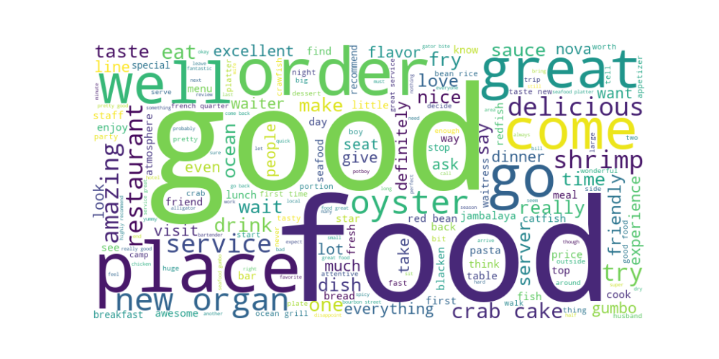
Lastly, we decided to utilize a word cloud specific to the attribute of ‘Text’. This vividly highlights the most frequently mentioned words and phrases, offering a direct insight into what stands out in customers' reviews the most. Terms like ‘good, ‘food’, ‘delicious’, ‘order’, ‘oyster’, and more were prominently featured as you can see above. These words can help highlight Oceana Grill’s strengths or weaknesses based on consistent word usage. After completing our sentiment analysis we will be able to display negative words present within reviews and display them similarly in a word cloud to get a better understanding of common customers' negative thoughts.

The data exploration, analysis, and visualization of Oceana Grill’s Yelp reviews reflect the restaurant's ability to maintain a generally high level of customer satisfaction and also highlight areas that can be improved. Strategic planning, targeted marketing, and other ways to enhance customer service and satisfaction can be expedited by utilizing information gathered from further text analysis.

Data Preprocessing
Text preprocessing is necessary to get the informative data we need from Yelp reviews, especially in the raw data that is full of colloquial and linguistically rich styles. It allows us to extract meaningful data from these customer reviews, making it a rich source for sentiment analysis and customer satisfaction research. It also improves the accuracy and efficiency of subsequent analyses, providing organizations with actionable insights about the factors that influence their ratings.

To begin with the data preprocessing step, we first needed to look into our original text (picture shown below). This step gives us a look at the dataset, which is important for planning the next preprocessing steps. As we can see these were the text results from the review dataset.
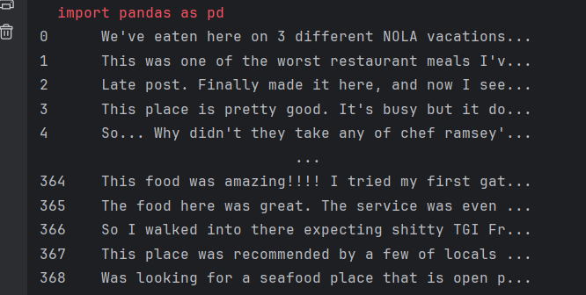
original text

Next, we use the text normalization step to involve multiple preprocessing techniques for cleaning and standardizing the text data. We imported the “normalize_corpus” function with various parameters to strip HTML tags, expand contractions, remove accented characters, convert text to lowercase, lemmatize words, remove special characters, and eliminate stopwords.

Our key parameters include:
- Strip HTML tags: HTML tags are often present in text data sourced from web pages. These tags do not contribute to the meaning of the text. By removing HTML tags, we can make sure that the text content is clean from unnecessary elements.
- Expand Contractions: Contractions are shortened forms of words or phrases. We will need to expand the contractions such as “don’t” to “do not” or “can’t” to “cannot” in order to make it to their full forms and the text can become more consistent and easier to analyze.
- Remove accented characters: Accented characters such as é in "café" contain characters that can confuse the analysis. So by changing accented characters to their plain character such as "café" to “cafe”, we standardize the text and it becomes simpler for the program to analyze.
- Convert text to lowercase: Convert all the text to lowercase since we wanted to make sure all the characters are in the same token which avoids any misunderstanding and keeps the consistency.
- Lemmatization: Lemmatization reduces the size of text data by combining similar words together. It improves the quality of the term-document matrix by combining different forms of the same word into a single word.
- Remove special characters: Special characters usually do not contain any meaning such as “!”, “@”, or “&”, so by removing those special characters, it helps to clean the text and reduce complexity.
- Eliminate stopwords: Stop words are common words that have little meaning and are usually removed to eliminate noise from the data. They are small words, prepositions, etc. such as “is”, “in”, “it”, etc. Removing the stop words allows us to find meaningful and contributing words on Oceana Grill reviews. This reduces the dimensionality of the text data and greatly improves the performance of the text mining algorithm. We use a standard list of known English stop words in NLTK to eliminate these common words.
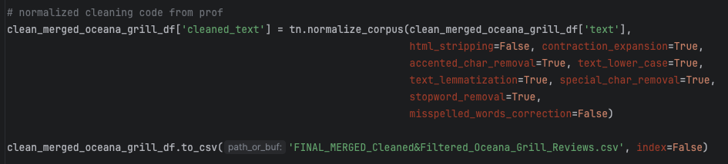

When we compare the original and cleaned text, we can see that all text has been converted to lowercase, and stopwords or other common words have been eliminated. After applying various text normalization techniques, the cleaned text appears to contain only meaningful words and phrases from the original text. This helps to standardize and clean up the raw text data for further analysis.
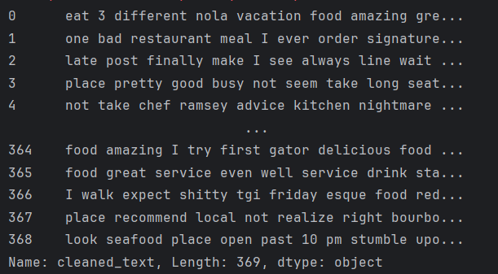
cleaned text

After cleaning the text, we used the TfidfVectorizer from scikit-learn to vectorize the normalized text and convert it into a term-document matrix.
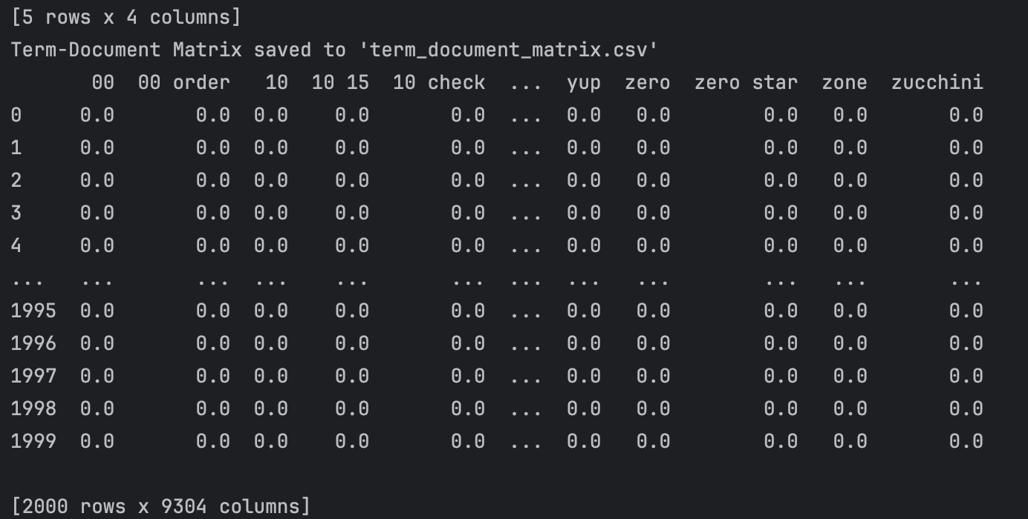

term-document matrix

The matrix organizes the text data and provides us with several contents that we can dive in. When we look at the resulting term-document matrix, we see that it has 2000 rows and 9304 columns which means we have 2000 reviews in our dataset and 9304 distinct terms after preprocessing. The values in the matrix are the TF-IDF scores which indicate that if the score is higher, the term is more important in the result; and if the score is lower, the term is less important in the result. We discovered that there are lots of values that contain zero, and this is common because every dataset contains only a small amount of possible terms. We can see that the column "yup", "zero", "zone", "zero star", and "zucchini" represent some unique terms found in the reviews, and the value “0.0” means it does not appear in those reviews or is not important in them.

The TF-IDF matrix is important for text mining because it can reduce the complexity of the text data which can highlight important terms and ignore less relevant ones, so it can help to manage large datasets more effectively. Additionally, the TF-IDF scoring highlights more relevant terms which improves the accuracy and efficiency of text analysis. The matrix format helps with tasks for our further sentiment analysis.

Text Mining & Evaluation
In this text mining and evaluation phase, we employed various techniques to extract meaningful insights from the Yelp reviews for Oceana Grill. We began with sentiment analysis using both VADER and FLAIR models. Each review was analyzed for its sentiment, which was then used to categorize the reviews into negative, neutral, and positive categories based on compound scores. The compound score of <= -.05 was recognized as negative and a score >= .05 was recognized as positive and anything else was neutral. This was to keep our categorizations as close to the FLAIR model which will be our target variable for our regression model. This categorization provided a structured way to interpret the sentiment expressed in the reviews.

Following sentiment analysis, we implemented TF-IDF vectorization to convert the raw text. We were left with a term-document matrix which we used as features for our regression model along with the compound sentiment scores. We chose n-grams ranging from unigrams to bi-grams, set stops words to English, and adjusted the max_df to 0.95 to ignore terms appearing in more than 95% of the documents, and min_df to 2 to ignore terms appearing in less than 2 documents. A class imbalance within our dataset was observed and this can be mitigated by utilizing class imbalancing techniques such as duplicating or interpolating minority classes.

The evaluation of our model was based on several metrics such as accuracy, precision, recall, and F-1 score. Cross-validation was utilized to ensure the model’s reliability. The logistic regression model demonstrated extremely high accuracy, with cross-validation scores consistently reaching 1.0. This indicated to us that our preprocessing steps were effective in predicting sentiment categories effectively and accurately. For further validation, we also processed a new CSV file with a new random 2000 sample specific to the Oceana grill and calculated the accuracy against the actual sentiment categories. This step confirmed the models' ability to be reliable and accurate with new data. The classification reports generated for both the training/testing phase and the new data predictions provided detailed insights into the model’s performance as well as the general classification of sentiments within the data.

Overall, the text mining and evaluation phase successfully transformed raw textual data into actionable insights, validating the effectiveness of our sentiment analysis and classification techniques. Now meaningful business insights can be drawn from the generated data.
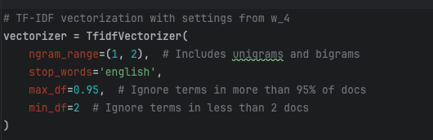
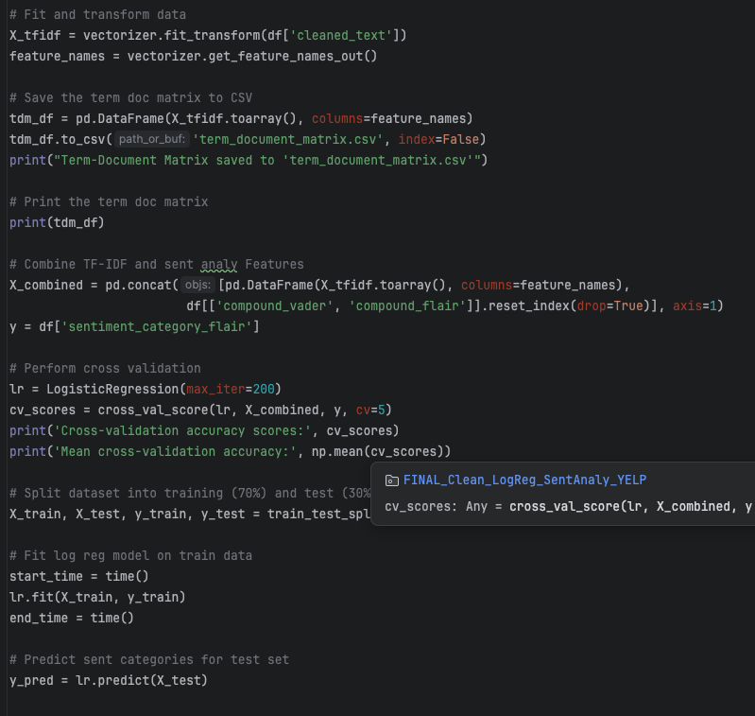
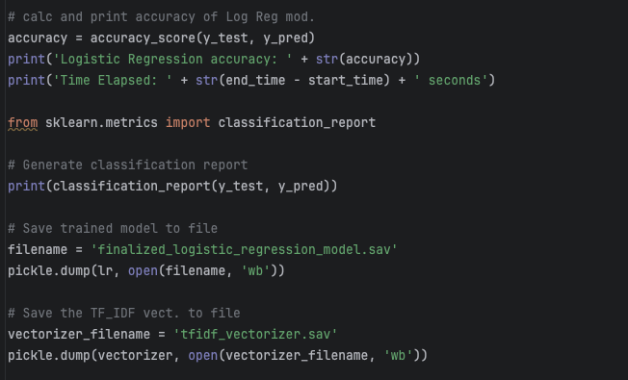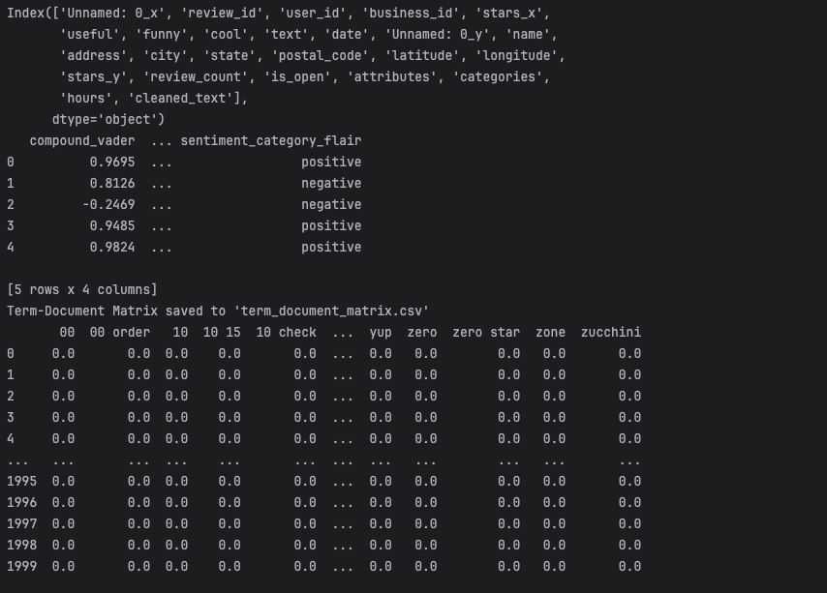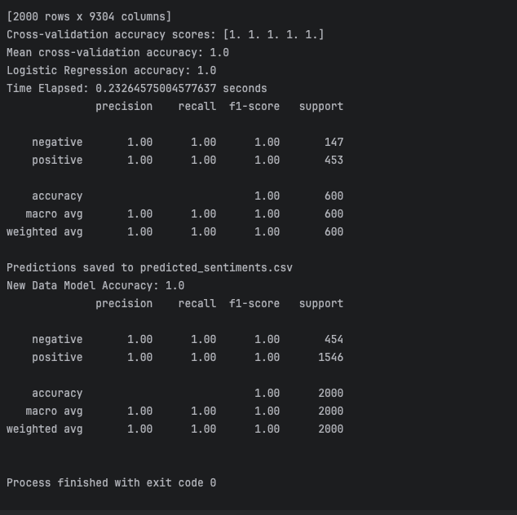

Business Implications
Our analysis of the Oceana Grill dataset uncovered key insights that are useful for businesses looking to improve Yelp's visibility and customer satisfaction. By employing sophisticated data mining techniques, we concluded that the close correlation between predicted sentiment and star ratings (.76) indicates that sentiment analysis can effectively serve as a metric for customer satisfaction. Typically, negative sentiment correlates with lower star ratings, while positive sentiment aligns with higher ratings. This relationship highlights the importance of monitoring sentiment alongside star ratings in order to obtain a comprehensive and full view of customer feedback within reviews.

In trend analysis, we observed that years with a higher count of positive reviews tend to have higher average star ratings as well. For instance, in years where positive reviews significantly outnumbered negative ones, such as 2018 and 2019, the average star ratings were also higher. This trend emphasizes the impact of positive customer experiences on overall ratings and highlights the need to implement a system to encourage more positive emotion and customer satisfaction.

By grouping our reviews by user tags and then further grouping them into negative and positive groups we were able to see that negative reviews tend to be perceived as more useful and funny by users, while reviews categorized as ‘cool’ by users tend to be split between positive and negative reviews. This insight suggests negative reviews can be more engaging and informative for the readers, and this may suggest that the users find the negative reviews useful and most likely cause them to take action to stay away from the business so it is imperative the business turn these negative reviews into positive ones.

Additionally, our analysis of reviews across different star ratings and sentiment ratings revealed to us that positive sentiment scores are very rare among lower star ratings of 1 and 2 and much more prevalent in ratings of 4 and 5. This distribution confirms the expected alignment between the sentiment categories and star ratings and further indicates that efforts to enhance customer satisfaction should focus on reducing the factors contributing to these negative sentiments present within the reviews. The analysis over time shows a steady increase in positive reviews until after 2019, after which there was a noticeable decline. This drop in positive reviews could be due to various factors, such as changes in management, societal changes, menu offerings, service quality, or many more. However, the restaurant can now utilize this and correlate it with the history they have documented in order to make better decisions for the future. Some changes that can be considered to capitalize on this would be things such as strengthening the positive aspects that were present during times of high positivity, promoting elements consistently praised in positive reviews, paying close attention to recurring issues present in negative reviews, and implementing changes to combat these, implement targeted improvements in these specific areas to help reduce the negative feedback, develop a system to respond to negative reviews promptly and effectively, use insights derived from the sentiment analysis categorization to train staff in the proper manner and use best practices by emphasizing importance of addressing common complaints and exemplifying the positive topics present in the reviews, and finally by continuously monitoring this data to establish an ongoing tracking and implementation process. This will allow Oceana Grill to abruptly respond to emerging trends whilst maintaining the high levels of operation that the customers appreciate. Oceana Grill can effectively enhance its operational efficiency, improve customer satisfaction, and ultimately drive their business growth higher!

Conclusion
In conclusion, our comprehensive analysis using sentiment analysis and text mining techniques on Yelp reviews for Oceana Grill has provided valuable insight into customer feedback and business performance for Oceana Grill. We accurately categorized customer sentiments and correlated them with the star ratings, thus revealing important trends and data metrics. Our findings highlighted the importance of monitoring both positive and negative sentiments to maintain and enhance customer satisfaction even further. The need to foster positive customer experiences is clearly exemplified by the positive reviews closely tied to higher star ratings. Conversely, negative reviews were the opposite and highlighted areas requiring immediate attention or improvement. The analysis also uncovered important trends such as a steady rise in positive reviews up until the end of 2019, suggesting potential operational inefficiencies were implemented.

Implementing targeted strategies based on these insights will significantly enhance Oceana Grill’s business and implementing our recommendations will allow for easy monitoring of our model and their business. Overall this project demonstrated the power of text mining and sentiment analysis in extracting meaningful business insights from unstructured data. By integrating this model into their business, Oceana Grill can make data-driven decisions in order to improve their Business as a whole.

