**Detailed Quality Assurance Report**

1) Scope and Objective of Testing

**Program Under Test:**

* **Module Name**: **SimpleFileManager** (from **fileUtils.py**)
* **Functionality**: This module is designed to handle basic file and directory management tasks. It includes functions for creating, deleting, renaming, copying, moving, and listing files and directories, as well as retrieving file properties.

**Specific Areas Covered:**

* **File Operations**:
  + Creating and deleting files.
  + Renaming, copying, and moving files.
  + Getting file size and timestamps (creation, modification, access).
* **Directory Operations**:
  + Creating and deleting directories.
  + Renaming, copying, and moving directories.
  + Listing files and subdirectories.
* **Listing and Filtering**:
  + Listing files in a directory (including recursive listing).
  + Filtering files by extension.

**Areas Not Covered:**

* **Exception Handling**: Tests do not thoroughly assess how the module handles edge cases, invalid inputs, or system-level errors.
* **Performance Testing**: The module's performance under high-load scenarios (e.g., large numbers of files) was not tested.
* **Security Testing**: The security aspects, like handling symbolic links or defending against path traversal vulnerabilities, were not part of the test suite.
* **Content Management**: Since the module does not include file content manipulation (reading/writing), these aspects were not tested.

2) Testing Methodology and Implementation

**Unit Testing with unittest:**

* **Setup**: Used Python's built-in **unittest** framework for creating and running test cases.
* **Test Cases**:
  + Each method in **SimpleFileManager** was paired with specific test cases designed to simulate normal use and edge case scenarios.
  + Temporary directories and files were used to ensure that tests did not affect the local file system state.
  + Tests included assertions to check whether the expected outcomes (e.g., file existence, directory contents) matched the actual results.
* **Representative Test Cases**:
  + *Test for File Creation and Deletion*: Ensured that files could be created and then removed without errors.
  + *Directory Operations*: Similar tests were conducted for directories.
  + *Renaming Tests*: Verified that files and directories could be renamed accurately.
  + *Copy and Move Operations*: Checked both files and directories for correct copying and moving functionality.
  + *Listing Functions*: Assessed various listing capabilities, including recursive listing and extension filtering.
  + *File Property Tests*: Retrieved and verified file size and timestamp information.

*Results*:  
Shared after coverage report, since coverage also ran unittests.

**Coverage and Mutation Testing:**

* **Tools Used**:
  + Coverage analysis was presumably done using a tool like **coverage.py**.
  + Mutation testing was conducted using **universalmutator**.
* **Coverage Report**:
  + The **fileUtils.py** module showed a 68% code coverage, indicating that some code paths were not exercised by the tests.
  + The test suite itself (**test_fileUtils.py**) had a high coverage of 99%.

*Results:*

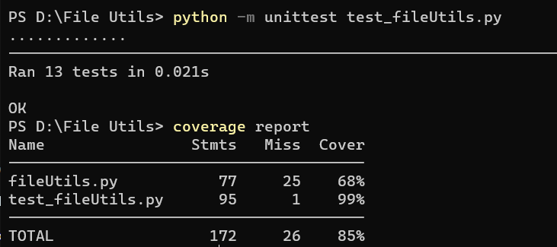

* **Mutation Testing**:
  + With 383 valid mutants generated, a mutation score of approximately 64% was achieved.
  + This score implies that while a significant portion of the tests can detect changes in the code, around 36% of the mutants survived, indicating potential weaknesses in the test suite.

*Results:  
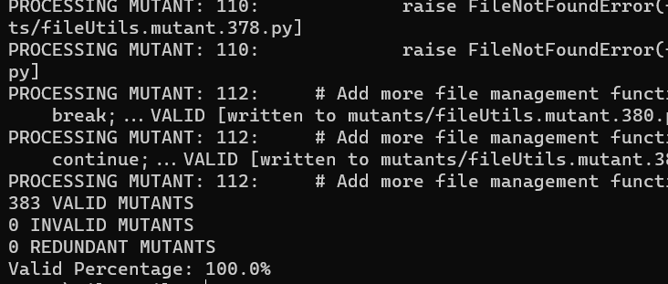*

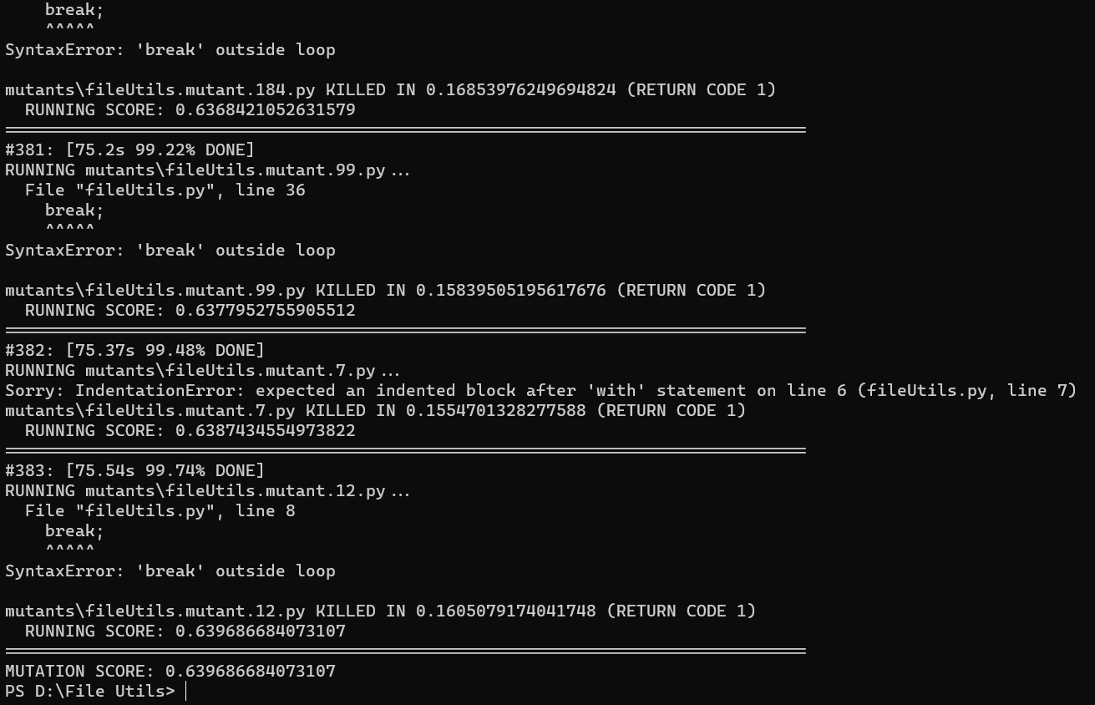

3) Evaluation of Test Effectiveness

**3a) Bugs and Anomalies:**

* No specific bugs or anomalies were reported from the unit tests. However, the lack of reported bugs does not necessarily imply the absence of bugs in the module.

**3b) Code Coverage Analysis:**

* The 68% coverage of **fileUtils.py** suggests that certain functions or branches within the module were not adequately tested. This leaves room for undetected bugs or unhandled scenarios in the untested code paths.

**3c) Mutation Testing Analysis:**

* A mutation score of 64% indicates a moderate level of test effectiveness.
* The survival of 36% of the mutants suggests that certain aspects of the code are not being rigorously tested, potentially leaving room for undetected errors or behavior inconsistencies.

Conclusion and Recommendations

The testing of **SimpleFileManager** was comprehensive in terms of unit testing, with a structured and systematic approach covering most of the module's functionality. However, the moderate code coverage and mutation score indicate areas for improvement.

* **Expand Test Coverage**: Additional tests should be designed to cover the untested portions of the code. This might include more complex scenarios or edge cases.
* **Enhance Exception Handling Tests**: Incorporate tests to handle exceptions and error conditions more robustly.
* **Include Performance and Security Testing**: Given the nature of file operations, adding tests for performance under high-load scenarios and security aspects (like path traversal) would be beneficial.
* **Continuous Monitoring and Improvement**: Regularly update the test suite in response to new features or changes in the module, ensuring that the testing remains comprehensive and up-to-date.

By addressing these recommendations, the robustness and reliability of the **SimpleFileManager** module can be significantly enhanced.