First, a user will create a graph under the session of choice.

The figure along with all its axes and attributes will be added to the fig_dict at this time

The user must check the save box if they wish to save the graph session in their workspace.

When the user plots a new session, the previous canvas is entirely overwritten and initialized with a new figure. The canvas will be updated with the new graph and the new graph will also be initialized in the figure dictionary (fig_dict)

Fig_dict:

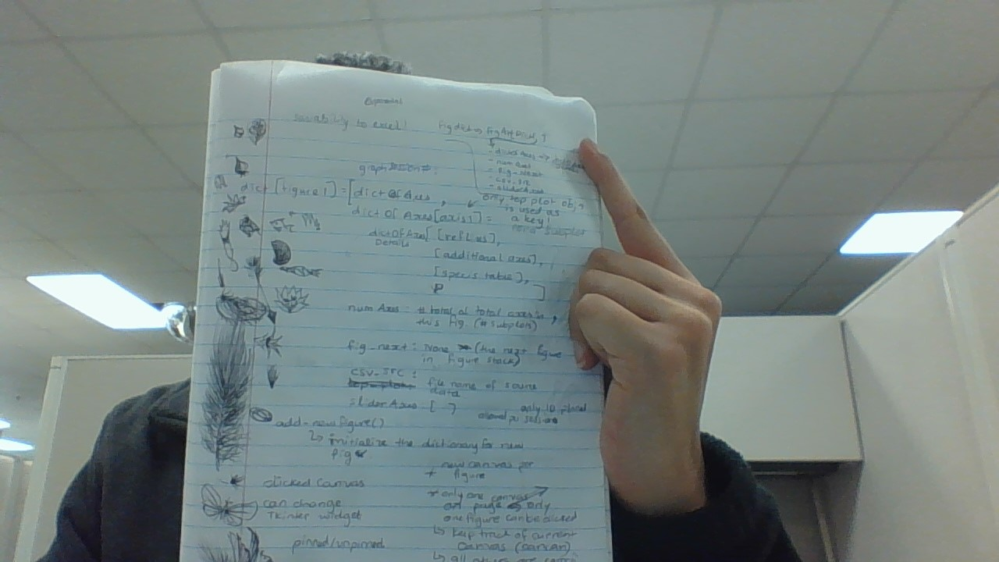

Saving A Workspace User Flow:

1. The new figure creation is triggered every time a session is switched (or on some sessions, if the New Plot button is clicked)
2. User can access the current workspace by clicking on the Workspace… => this workspace option. This gives the user access to all the figures they have saved so far in the current workspace.
   1. Note there is risk of having too many figures open if many workspaces have been opened in the program.
   2. Limit of workspaces open will be one at a time for now.
3. When user closes the application, Manitab will save the current workspace (fig_dict) in a pickle File. The user will be prompted to provide a name for the pickle file.
4. User can open up a workspace (pickle File) from the Workspace… => open workspace menu option. This gives the user access to their plots once again.
5. When a workspace is being opened, the program will acknowledge the event by adding the workspace dictionary to the current fig_dict.

Problems: