MVERIFY Users Guide
September 2002

Revised in April 2005

Revised in Arpil 2006

Revised in October 2007

- About Mverify

Mverify is an open source tool for verifying the accuracy of device model cards between ADS, HSpice and Spectre simulators. It requires the Design Kit Model Verification Tool provided with ADS installations.

  - Support

Mverify is a tool created to work with the Design Kit Model Verification Tool to efficiently test model cards between ADS, HSpice and Spectre simulators. It has not been rigorously tested and is NOT a supported product, however updates and bug fixes to Mverify may occur. There may be bugs in the code, use at your own risk.

  - Requirements

Mverify supports the following simulators:
ADS: 2006A and later
HSpice: 2006.09 and later
Spectre: 5.1.0 and later

Mverify requires the installation and configuration of the Design Kit Model Verification Tool, part of the ADS installation.

- Configuring Mverify

The following environment variables must be set:

DKITVERIFICATION = <path to the Model Verification Tool>
MVERIFY_DIR = <path to the mverify directory>

Additionally the PATH should include the following:

$DKITVERIFICATION/bin
$MVERIFY_DIR/bin

The following simulators should be available to run from the command line for mverify to run correctly:

ADS: hpeesofsim
HSpice: hspice
Spectre: spectre

Note: ADS requires the user to source “$HPEESOF_DIR/bin/eesofboot.sh” in Korn shell in order to run from the command line.

- Running Mverify

Mverify has the following usages:

mverify -h [template_name]
For help on mverify and usage. With a template name, provide a list of available settings for that particular template.

mverify –l
For listing available templates.

mverify [-aAcCdDlLnNoOpPrRsS] vsc_file
Runs the tests contained in the vsc_file. More information on the vsc file format is provided in chapter 4. The options control the files that remain from the test. Options with capital letters supercede all lower case options.

A | Delete all files regardless of pass/fail status (same as option -cdlnors)
A | Save all files
C | Delete all generated citifiles (.cti)
C | Save all citifiles (.cti)
D | Delete all generated datasets (.ds)
D | Save all datasets (.ds)
L | Delete all generated log files (.log)
L | Save all log files (.log)
N | Delete all generated netlist files (.ckt .hsp .scs)
N | Save all netlist files (.ckt .hsp .scs)
O | Delete files generated by hspice during simulation (.ic .st0)
O | Save files generated by hspice during simulation (.ic .st0)
P | Apply file delete options only when the simulation results comparison reports a PASS for all simulations. Does not delete any files if the simulation results do not meet tolerance, if a tolerence was not set, or if there was a simulation failure.
P | Unsets the –p option
R | Deletes all generated raw simulation results files (.rad .rhs .rsp/)
R | Saves all raw simulation results files (.rad .rhs .rsp/)
S | Deletes all generated statistics files (.stat)
S | Saves all statistics files (.stat)

3.1 Available templates

There were 62 templates as of April 2005. Many similar templates were merged into a single template with more options and enhanced features. As a result, there are only 23 templates by March 2006. The number may increase or decrease. For any templates not listed below, the name usually implies the purpose of the template.

    - Capacitor
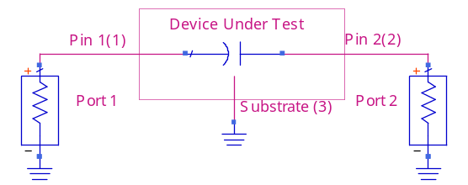
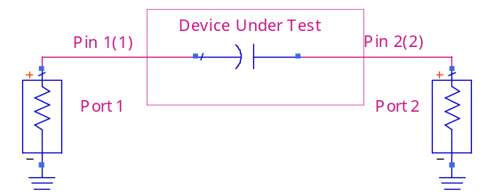
      - cap2_sparam – S-parameter test for two terminal native capacitor model card
      - cap2_subckt_sparam - S-parameter test for two terminal capacitor subcircuit
      - cap3_subckt_sparam - S-parameter test for three terminal capacitor subcircuit

These three templates are removed in 2006, but old tests using these templates will still work. They will invoke generic_sparam template with an appropriate –num_pins option.

    - Inductor

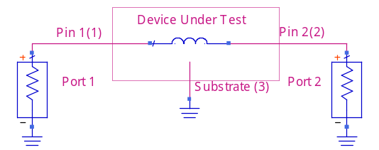
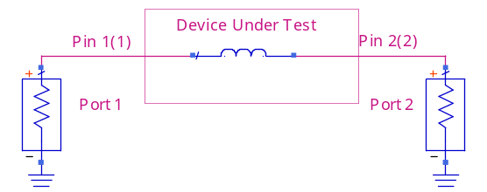
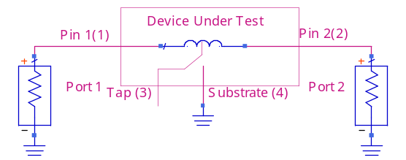
      - ind2_sparam - S-parameter test for two terminal native inductor model card
      - ind2_subckt_sparam - S-parameter test for two terminal inductor subcircuit
      - ind3_subckt_sparam - S-parameter test for three terminal inductor subcircuit
      - ind4_subckt_sparam - S-parameter test for four terminal inductor subcircuit. The tap pin (pin 3) is left floating in this test.

The above four templates are removed in 2006, but old tests using these templates will still work. They will invoke generic_sparam template with an appropriate –num_pins option.

    - Resistor
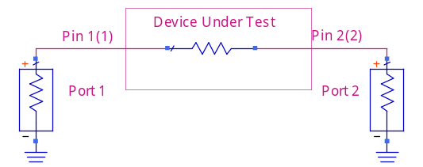
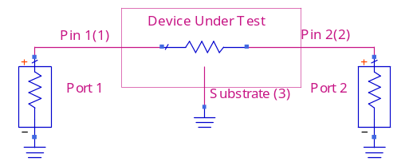

      - res2_sparam - S-parameter test for two terminal native resistor model card
      - res2_subckt_sparam - S-parameter test for two terminal resistor subcircuit
      - res3_subckt_sparam - S-parameter test for three terminal resistor subcircuit

The above three templates are removed in 2006, but old tests using these templates will still work. They will invoke generic_sparam template with an appropriate –num_pins option.

    - Diode

      - diode2_dc_iv – DC test for two terminal native diode model card
      - diode2_subckt_dc_iv – DC test for two terminal diode subcircuit
      - diode3_subckt_dc_iv – DC test for three terminal diode subcircuit
      - diode2_sparam - S-parameter test for two terminal native diode model card
      - diode2_subckt_sparam - S-parameter test for two terminal diode subcircuit
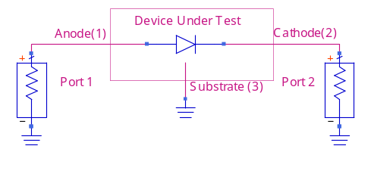
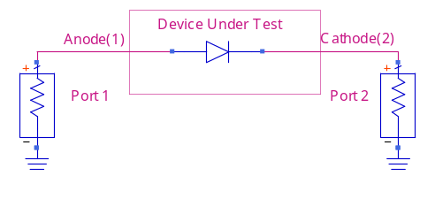
      - diode3_subckt_sparam - S-parameter test for three terminal diode subcircuit
      - esd1_subckt_sparam - S-parameter test for one terminal ESD diode subcircuit (internal ground).
The above templates are removed in 2006, but old tests using these templates will still work. The diode templates will invoke diode_dc_iv or diode_sparam template with appropriate –num_pins and –prefix options. The esd1_subckt_sparam will invoke generic_sparam with –num_pins=1.

    - Varactor

      - varactor2_dc_iv – DC test for two terminal native diode model card
      - varactor2_subckt_dc_iv – DC test for two terminal diode subcircuit
      - varactor3_subckt_dc_iv – DC test for three terminal diode subcircuit
      - varactor2_sparam – S-parameter test for two terminal native diode model card
      - varactor2_subckt_sparam – S-parameter test for two terminal diode subcircuit
      - varactor3_subckt_sparam – S-parameter test for three terminal diode subcircuit

The above varactor templates are removed in 2006, but old tests using these templates will still work. They will invoke varactor_dc_iv or varactor_sparam template with an appropriate –num_pins and –prefix options.

    - Bipolar

      - npn3_subckt_dc_iv – DC test for three terminal npn subcircuit
      - npn4_dc_iv – DC test for four terminal native npn model card
      - npn4_subckt_dc_iv – DC test for four terminal npn subcircuit
      - npn3_subckt_sparam – S-parameter test for three terminal npn subcircuit
      - npn4_sparam – S-parameter test for four terminal native npn model card
      - npn4_subckt_sparam – S-parameter test for four terminal npn subcircuit
      - pnp3_subckt_dc_iv – DC test for three terminal pnp subcircuit
      - pnp4_dc_iv – DC test for four terminal native pnp model card
      - pnp4_subckt_dc_iv – DC test for four terminal pnp subcircuit
      - pnp3_subckt_sparam – S-parameter test for three terminal pnp subcircuit
      - pnp4_sparam – S-parameter test for four terminal native pnp model card
      - pnp4_subckt_sparam – S-parameter test for four terminal pnp subcircuit

The above bjt templates are removed in 2006, but old tests using these templates will still work. They will invoke npn_dc_iv, npn_sparam, pnp_dc_iv, or pnp_sparam template with appropriate –num_pins and –prefix options.

    - MOSFET

      - nmos3_subckt_dc_iv – DC test for three terminal nmos subcircuit
      - nmos4_dc_iv – DC test for four terminal native nmos model card
      - nmos4_subckt_dc_iv – DC test for four terminal nmos subcircuit
      - nmos3_subckt_sparam – S-parameter test for three terminal nmos subcircuit
      - nmos4_sparam – S-parameter test for four terminal native nmos model card
      - nmos4_subckt_sparam – S-parameter test for four terminal nmos subcircuit
      - pmos3_subckt_dc_iv – DC test for three terminal pmos subcircuit
      - pmos4_dc_iv – DC test for four terminal native pmos model card
      - pmos4_subckt_dc_iv – DC test for four terminal pmos subcircuit
      - pmos3_subckt_sparam – S-parameter test for three terminal pmos subcircuit
      - pmos4_sparam – S-parameter test for four terminal native pmos model card
      - pmos4_subckt_sparam – S-parameter test for four terminal pmos subcircuit
      - mos_ring_osc (not fully functional) – Transient test for mos ring oscillator. You must specify the pmos and nmos model to use for this test. The number of stages may also be specified. Currently the output is not stored in the results HTML file. This is for native mos model cards.
      - mos_subckt_ring_osc (not fully functional) – Transient test for mos ring oscillator. You must specify the pmos and nmos model to use for this test. The number of stages may also be specified. Currently the output is not stored in the results HTML file. This is for native mos model cards.
      - nmos_dg5_subckt_dc_iv (not tested) – five pin dual-gate nmos subcircuit DC IV test.
      - pmos_dg5_subckt_dc_iv (not tested) – five pin dual-gate pmos subcircuit DC IV test.

Many pmos and nmos templates are removed in 2006, but old tests using these templates will still work. They will invoke generic nmos_dc_iv, nmos_sparam, pmos_dc_iv, or pmos_sparam template with appropriate –num_pins and –prefix options.

    - Any subcircuit

      - generic_sparam – S-Parameter test for any device with at least one pin and up to as many pins as the simulators would accept. Note that -num_pins option (the number of pins of the subcircuit) must be specified. Depending on the type of device, -prefix option may also need to be specified to avoid error in Hspice instance name.

- VSC file format

The VSC file format can contain an unlimited number of tests for different model cards and device types. The file is broken down into a series of tests. These tests run simulations based on the information listed in each test section.

  - VSC file specifications

The VSC file is an ASCII text file containing one or more test sections (defined below). All text should be in lower case letters, unless required for device model names or file names.

  - Test Section

A test section starts with “test:” and the name of the test, and ends with “end test;”. The name of the test is used to name the resulting files from the test. The test name should be unique, otherwise files may be overwritten.

Inside a test section the type of test, the test configuration and device models are defined. The test section is formatted as follows:

<parameter_name>: <parameter_value>

<parameter_name> matches the parameter names listed when you type “mverify –h template_name”, and <parameter_value> is the value assigned to that parameter. You may use single or double quotes for this value, or none at all. If you are assigning multiple <parameter_value>, you should use quotes or only the first value may be used. Multiple values are not valid for all parameters.

Parameters that must be included in the test section are:
- template_name – name of the template to use. Only one template is valid per test. For a list of templates type “mverify –l”.
- simulators – should be output as the list of simulators separated by commas. Use lower case letters only for the simulator names. The first simulator listed should be your reference simulator, or the simulator where the device models were extracted.
- device_name – list of models to test, separated by commas. You may also call the parameter model_name instead for all tests.
- ads_model_lib, hspice_model_lib, or spectre_model_lib- these define the files to include for the test. These are the model files that will be tested for the simulation. To define the section or library in the file to include add # followed by the section or library name.

Because ADS/RFDE 2005A simulator accepts sepctre netlist syntax, ads_model_lib is optional when verifying ADS 2005A and spectre. When ads_model_lib is left out in a test and spectre_model_lib is present, the latter will be included with the ADS simulation.
Other parameter names can be found by typing “mverify –h <template_name>”. These parameters set up tolerances, additional sweeps, sweep limits, bias points, scale option, gmin, etc. They depend specifically on the template that is used.

  - Instance Line Parameters

For most test templates, there are arguments for setting the instance line parameters of the device to be tested. These instance line parameters could set the length, width, or other parameter for the device to be tested. These instance line parameters are placed directly at the end of the instance line for the device under test, so they should be formatted exactly as the simulators expect the syntax of the line. They should be place in either single or double quotes.

- allparams – sets the instance line for all simulators
- adsparams – sets the instance line for the ADS simulator
- hspiceparams – sets the instance line for the HSpice simulator
- spectreparams – sets the instance line for the Spectre simulator

With ADS/RFDE 2005A, if ads_model_lib is missing and spectre_model_lib is given then the spectre model files will be included in the ADS test circuit netlist. In addition, if spectreparams is given and adsparams is left out, the instance line of the device to be tested will be netlisted in spectre format in the ADS test circuit netlist.

  - Tolerance settings

The tolerance settings in the VSC file set the threshold for the PASS / FAIL criteria. This parameter is given as a relative percent difference between the simulation results. S-parameter errors are given as the percent ratio of the magnitude of the error vector in the complex plane to the magnitude of the reference vector.

Relative tolerance settings:
- S-parameter tests: s11_tol, s21_tol, s12_tol, s22_tol
- Diode, varactor DC tests: i_tol
- Nmos, pmos DC tests: id_tol
- Npn, pnp DC tests: ic_tol

Absolute tolerance setting:
- All tests: abs_tol (It has a default of 1e-20. It is used to prevent considering 0 from one simulator and a very small number from another simulator as being not equal.)

If both the relative tolerance and absolute tolerance are exceeded at ay point in the test, the test is considered to have failed. If the relative tolerance is not set, 1% will be used as default. Note that unless the –P command line option is used all files are saved from the tests.

  - Comments

Comments start with #, which must be the first non-blank character on the line. Comments may not be appended to the end of lines.

  - Line Continuation Character "\"

You can add the back slash character ("\") at the end of the line to continue data (including comments) to the line below.

  - Changing the HTML Output file name

The html output file is by default set to results.html. This may be changed my setting the “results” parameter outside of a test section, followed by the full name of the results file include the .htm or .html extension. Note that the results are only output in html format.

  - Linking datasets to the data directory under an ADS project

The “dkit_dataset_dir” parameter allows you to create symbolic links of result dataset files to your desired directory. Linking dataset files to the data directory under an ADS project makes it convenient to display the datasets with the ADS Data Display.

  - Testing multiple Sections/Libraries

In order to test multiple sections or libraries of a model file a test section must be set up for each section, with a unique name given to each test section.

  - Example test scripts

4.10.1 Comparing ADS with ADS model, Spectre with Spectre model, and HSPICE with HSPICE model:

In this example, a four terminal nmos subcircuit will be tested using both the s-parameter test and dc IV test templates.

#Results saved to my_nmos_results.html
results: ’my_nmos_results.html’

#start of DC IV test
test: my_nmos_dc_TT
template: nmos4_subckt_dc_iv
id_tol: 0.1
abs_tol: 1e-14
reltol: 1e10
vabstol: 1e-12
iabstol: 1e-14
simulators: ads,hspice,spectre
device_name: ’my_nmos1,my_nmos2’
allparams: ’l=1e-6 w=1e-6 ad=0 as=0 pd=0 ps=0 nrd=0 nrs=0’
ads_model_lib:’my_models.net#TT’
hspice_model_lib:’my_models.l#TT’
spectre_model_lib:’my_models.scs#tt’
end test;
#end of DC IV test

#start of S-Parameter test
test: my_nmos_sp_TT
template: nmos4_subckt_sparam
s11_tol: 1.5
s12_tol: 1.5
s21_tol: 1.5
s22_tol: 1.5
abs_tol: 1e-16
reltol: 1e12
vabstol: 1e-16
iabstol: 1e-18
gmin: 1e-18
temp: 25
tnom: 25
simulators: ads,spectre
model_name: ’my_nmos1,my_nmos2’
allparams: ’l=1e-6 w=1e-6 ad=0 as=0 pd=0 ps=0 nrd=0 nrs=0’
ads_model_lib:’my_models.net#TT’
spectre_model_lib:’my_models.scs#tt’
end test;
#end of S-parameter test

4.10.2 Comparing ADS and Spectre; both simulators include the same Spectre model:

#############################################
# A 2-port S-parameter test for a 7-pin subcircuit ‘custom_ckt’.
# Port1 is connected to the first node (n1), and Port2 the fourth (n4).
# A DC source with 1-volt will be applied to the 7th pin (n7_bias).
# The spectre model files are to be included for ADS simulation as well
# because ads_model_lib is not given.
# The instance line of ‘custom_ckt’ in the ADS test circuit netlist will be
# in spectre format with “x=2 y=3” as its instance parameters because
# adsparams is not present.
# If the ‘scale’ argument is not commented out, it would apply to
# all simulators. The ads_scale overrides scale and will only apply
# to the ADS simulator as the Scale simulator option. Applying the scale
# option to ADS only may be necessary in the case that an included spectre
# model file contains a spectre scale option, which is not parsed by RFDE 2006A
# (This decision may or may not change after this writing).
#start of scale_test ########################################
test: scale_test
template: generic_subckt_sparam
s11_tol: 2
s12_tol: 2
s21_tol: 2
s22_tol: 2
abs_tol: 1e-17
simulators: ads,spectre
device_name: ’custom_ckt’
num_pins: 7
p1_conn: n1
p2_conn: n4
n7_bias: 1
# scale: 1e-6 # this line is commented out
ads_scale: 1e-6
spectreparams: ’x=2 y=3’
spectre_model_lib:’model1.scs#tt, model2.scs’
end test;
#end of scale_test ##########################################

# combined result dataset file (*.ds) will be saved in $ DKIT_DATASET_DIR
# DKIT_DATASET_DIR:/tmp/tmp_prj/data

# DIODE DC test
test:
template: diode2_dc_iv
plus_start:0.0
plus_stop:1.0
simulators: ads, spectre
device_name: dio
spectreparams: 'area=4e-13 pj=2.0e-06 m=1'
### include "apdk.scs" section=ff
spectre_model_lib: 'apdk.scs#ff'
end test;

# DIODE S-Param test
test:
template: diode2_sparam
plus_bias:0.75
simulators: ads, spectre
device_name: dio
spectreparams: 'area=4e-13 pj=2.0e-06 m=1'
spectre_model_lib: 'apdk.scs#ff'
end test;

# MOS DC test
test:
template: nmos4_dc_iv
vd_start:0.0
vd_stop:1.8
sweep_vg:yes
vg_pts:'0.5 1.0 1.5'
simulators: ads, spectre
device_name: nch
spectreparams: 'w=2u l=200n as=1.2p ad=1.2p ps=5.0u pd=5.0u'
spectre_model_lib: 'apdk.scs#tt'
end test;

# MOS S-Param test
test:
template: nmos4_sparam
# reltol, vabstol, and iabstol are simulator convergence tolerances
reltol: 1e-9
vabstol: 1e-10
iabstol: 1e-12
# abs_tol, id_tol, i_tol, ic_tol, s11_tol, etc., are mverify PASS/FAIL tolerances
abs_tol: 1e-14
gmin: 1e-14
drian_bias: 1.8
gate_bias: 1.8
simulators: ads, spectre
device_name: nch_rf
spectreparams: 'w=2u l=220n nf=1'
spectre_model_lib: 'apdk.scs#tt, mosrf.scs'
end test;

# BJT DC test
test:
template: npn3_dc_iv
vc_start:0.0
vc_stop:1.8
sweep_ib: yes
ib_pts:'1e-4 1e-5 1e-6'
simulators: ads, spectre
device_name: npn
spectreparams: 'm=1 '
spectre_model_lib: 'apdk.scs#ff'
end test;

# BJT S-Param test
test:
template: npn3_sparam
base_bias:0.8
collector_bias:1.2
simulators: ads, spectre
device_name: npn5_mis
spectreparams: 'm=1 '
spectre_model_lib: 'apdk.scs#ff'
end test;

# Generic 2-port S-Param test
test:
template: generic_sparam
simulators: ads, spectre
device_name: 'ind1, ind2'
spectreparams: ' '
num_pins:3
# port 1 is connected to node n1 - first pin of the device
p1_conn: n1
# port 2 is connected to node n3 - third pin of the device
p2_conn: n3
# a DC 0 volt is applied to the second pin of the device
n2_bias: 0
spectre_model_lib: 'apdk.scs#tt'
end test;

4.10.3 Comparing ADS and HSPICE; both simulators include the same HSPICE model:

# DIODE DC test
test:
template: diode2_dc_iv
plus_start:-1.0
plus_stop:1.0
simulators: ads, hspice
device_name: dio
hspiceparams: 'area=1e-10 pj=4e-05 m=1'
### .lib "models.spi" ff, .inc "params.lib"
hspice_model_lib: 'models.spi#ff, params.lib'
# element prefix=x for testing .subckt
# prefix:x
end test;

# DIODE S-Param test
test:
template: diode2_sparam
plus_bias:0.75
simulators: ads, hspice
device_name: dio
hspiceparams: 'area=1e-10 pj=4e-05 m=1'
hspice_model_lib: 'models.spi#ff, params.lib'
# prefix:x
end test;

# MOS DC test
test:
template: pmos4_dc_iv
vd_start:-1.8
vd_stop:0
sweep_vg:yes
simulators: ads, hspice
device_name: pch
hspiceparams: 'w=2u l=200n as=1.2p ad=1.2p ps=5.0u pd=5.0u m=1'
hspice_model_lib: 'models.spi#tt'
# prefix:x
end test;

# MOS S-Param test
test:
template: pmos4_sparam
# reltol, vabstol, and iabstol are simulator convergence tolerances
reltol: 1e-9
vabstol: 1e-10
iabstol: 1e-12
# abs_tol, id_tol, i_tol, ic_tol, s11_tol, etc., are mverify PASS/FAIL tolerances
abs_tol: 1e-14
gmin: 1e-14
drian_bias: -1.8
gate_bias: -1.8
simulators: ads, hspice
device_name: pch_rf
hspiceparams: 'w=2u l=220n nf=1'
hspice_model_lib: 'models.spi#tt, mosrf.scs'
# prefix:x
end test;

# BJT DC test
test:
template: pnp3_dc_iv
vc_start:-1.8
vc_stop:0.0
sweep_ib: yes
simulators: ads, hspice
device_name: pnp2
hspiceparams: 'm=1'
hspice_model_lib: 'models.spi#ff'
# prefix:x
end test;

# BJT S-Param test
test:
template: pnp3_sparam
base_bias:-0.8
collector_bias:-1.2
simulators: ads, hspice
device_name: pnp2
hspiceparams: 'm=1'
hspice_model_lib: 'models.spi#ff'
# prefix:x
end test;

# Generic 2-port S-Param test
test:
template: generic_sparam
simulators: ads, hspice
device_name: 'ind1, ind2'
hspiceparams: ' '
num_pins:5
# port 1 is connected to node n1 - first pin of the device
p1_conn: n1
# port 2 is connected to node n3 - third pin of the device
p2_conn: n3
# a DC 0 volt is applied to the 2nd, 4th, and 5th pin of the device
n2_bias: 0
n4_bias: 0
n5_bias: 0
hspice_model_lib: 'models.spi#tt'
# prefix:x
end test;

