Music Bee

* A guess the music type of game where in you will fill in the missing lyric of the song shown in the screen of your mobile device. The songs that will be questioned will be from Philippines or the OPM – Original Filipino Music.

Wireframe:

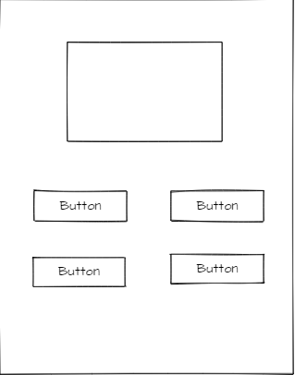

Mock-up:

* This is the example of the game app, it will show some lyric of the OPM song then there will be four buttons but there’s only one correct answer in it.

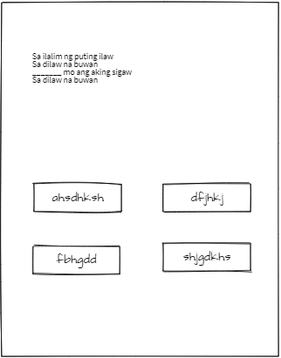

Prototype:

* This will be the output of the game. There will be a lyric then some part/s will leave a blank then you need to guess what lyric/s are missing below then click the correct answer.

