# N1

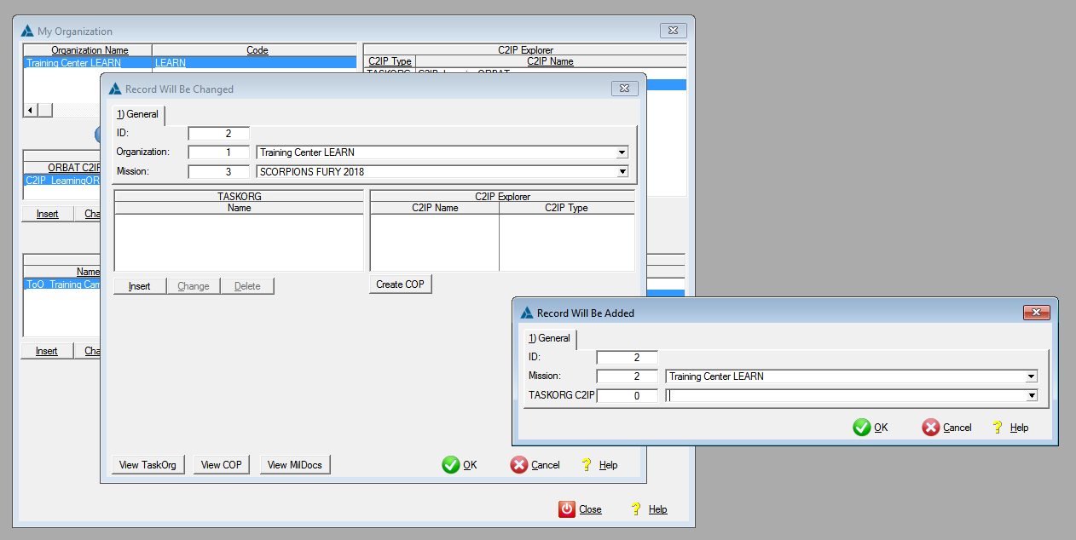

Defining a new TASKORG C2IP should automatically adding it to the current Mission C2IP Explorer

# N2

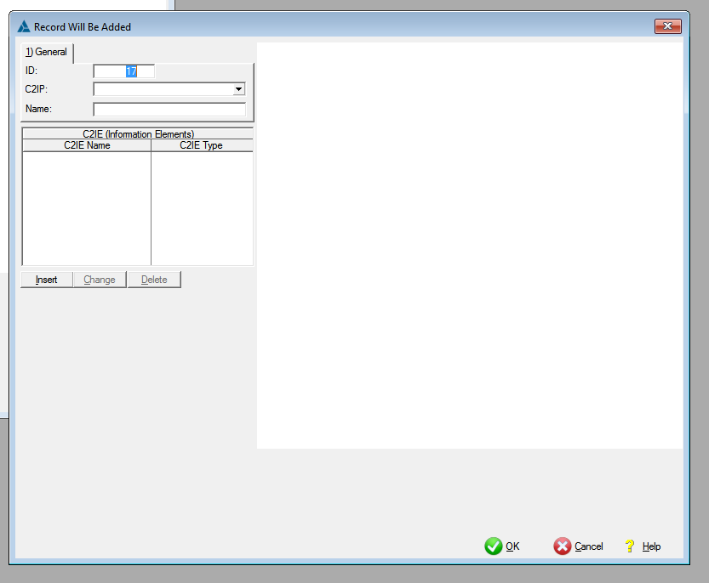

Defining a new C2IP should automaticaly generate and ADD a new C2IE of the same type

# N3

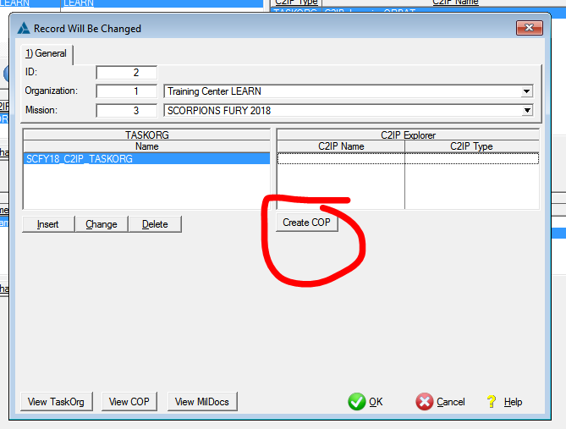

Creating a new C2IP from the C2IP Explorer of the Mission should automatically add the newly C2IP to the C2IP Explorer of the Mission.

# N4

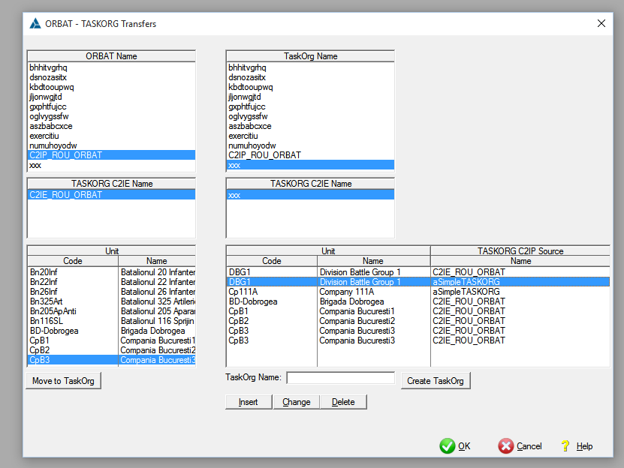

Adding a new BSO to a destination TASKORG C2IP duplicates the view with all C2IEs where the BSO is already part of

# Todo:N5

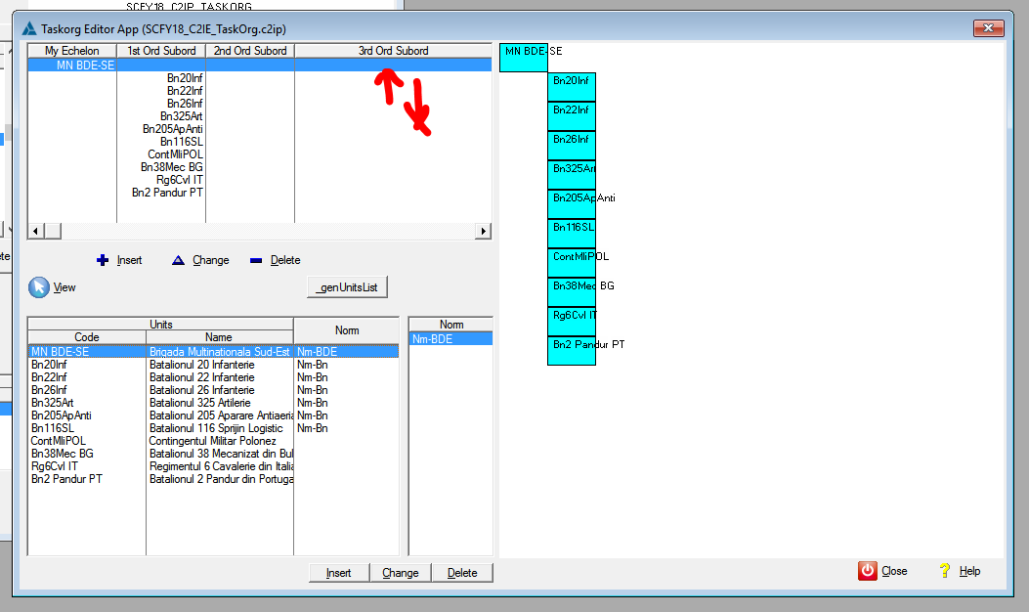

Implement the possibility to insert-modify-delete rows

# Todo:N6

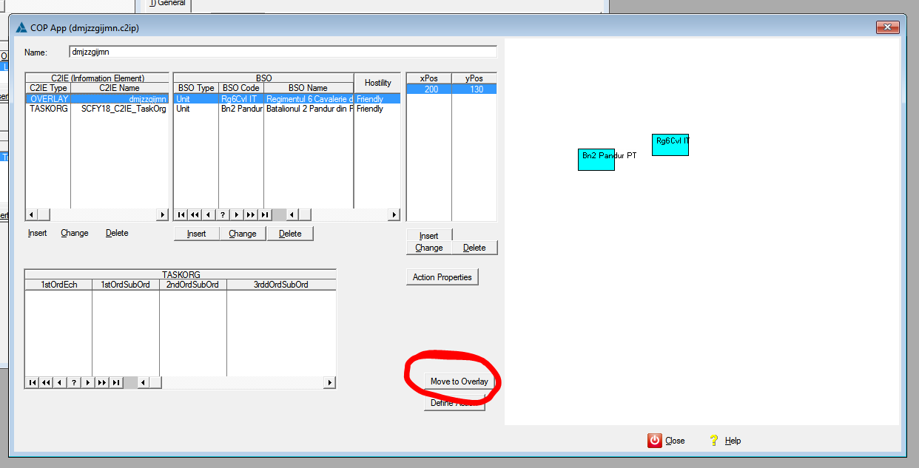

Move to overlay should automatically update thge OVERLAY C2IE.

Defining xPos and yPos should automatically redraw the BSO positions.

# Todo:N7 (SOLVED)

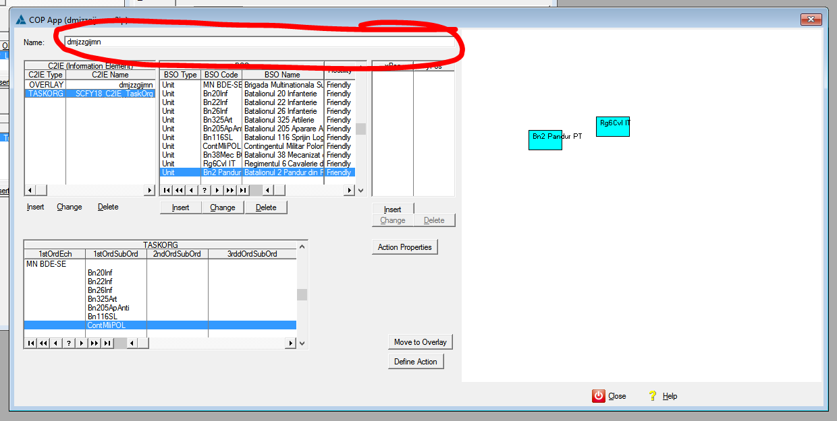

Change the name of C2IE and C2IP.

# Todo:N8

Visually manipulate objects on screen.

# N9

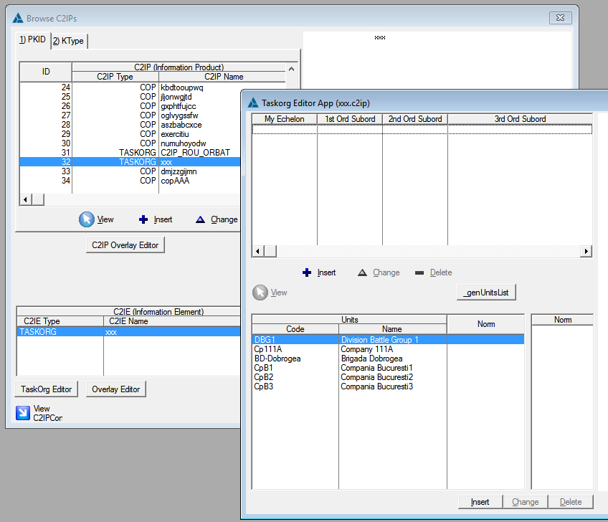

When a new TASKORG is created from another TASKORG. DO NOT FORGET to define not only the Units List, but also the TASKORG TREE VIEW.