|  |
| --- |
| Amantha Lott | Pallavi Murthy | Donggil Song |

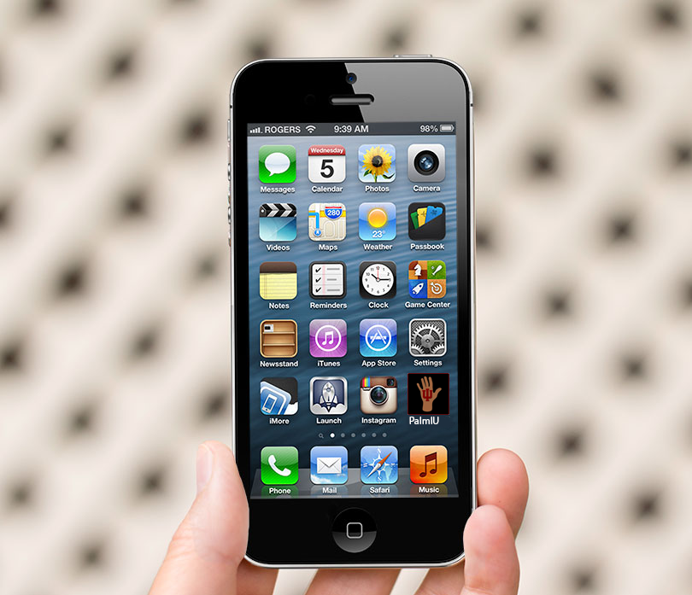

|  |  |
| --- | --- |
| Indiana University | PALMIU |

**I. AIM**

The aim of this project is to design an “app” that would appeal to the college population “based on our judgment of student needs and interests.” From this, our team selected the primary collegiate campus of Indiana University which encompasses nine different campuses. Our team brought very different and broad ideas together and ultimately decided on a final concept, “PalmIU”, in which we wanted to move forward with. Next, we created requirements, designs, and performed user testing.

“PalmIU” would benefit the lives of students, faculty, staff, and potentially other interested parties by bringing all relevant events and happenings into the *palm* of your hand through your personal preferences.

This report will more specifically discuss the necessary and vital process for which we successfully completed our project. Our report reflects our design iteration process as well as other vital suggestions that if given more time would have better improved our overall design.

**II. REQUIREMENTS**

1. General Requirements
   * + 1. This project mainly focuses on (1) how to gather event-related and time sensitive information; and (2) how to disseminate it for Indiana University members in a timely fashion.
2. Target Users
3. Our primary target users are Indiana University community members including undergraduate/graduate students, staff, and faculty.
4. Criteria for Design
   * + 1. Usability Goal
          1. Learnability: How easy is it for users to accomplish basic tasks the first time they encounter the design of PalmIU?
          2. Efficiency: Once users have learned the design of PalmIU, how quickly can they perform tasks?
          3. Memorability: When users return to the design of PalmIU after a period of not using it, how easily can they establish proficiency?
          4. Errors: How many errors do users make, how severe are these errors, and how easily can they recover from the errors?
          5. Satisfaction: How pleasant is it to use the design?
       2. User Experience Goal
     1. Utility: Do users perceive the functions in of PalmIU as useful and fit for the purpose?
     2. Usability: Do users feel that it is easy and efficient to get things done with of PalmIU?
     3. Aesthetics: Do users see the system as visually attractive? Does it feel pleasurable in hand?
     4. Identification: Can users identify themselves with of PalmIU? Do users look good when using it?
     5. Stimulation: Does of PalmIU give users inspiration?
     6. Value: Is of PalmIU important to users? What is its value for users?

To identify design principles and requirements, the project team created the needs assessment questionnaire including 7 questions (see Appendix A). Though the survey could not be conducted due to the limited time frame, general requirements and criteria for design could be refined through the development of the needs assessment. Specifically, “Errors, Memorability” of the usability goal and “Aesthetics, Identification, Stimulation” of the user experience goal were excluded in this design project because it is difficult to measure these items using a draft of the simple prototype.

**III. DESIGN SKETCHES**

**1. Design A.**

The main concept is taken from the continuous feed of Twitter, a social-networking app in which users can pre-select users, companies, and organizations to “follow”. Updates or “tweets” provided from selected users are shown in the form of a live “feed”. True for both designs, upon users opening their “Palm IU” application they would be prompted to “log in” per our campus Central Authentication System with their username and password and then directly select their preferences of which campus(s), college (i.e. Kelley School of Business, School of Informatics and Computing, etc.), and department. Design A is the simplest version of the app design.

**2. Design B.**

Design B is a more complex version of the app design. The main concept is taken from a common “home screen” layout style in which features icons of categories in which users can select at will to see comprehensive event and news information about their selected preferences. The previously mentioned login process is still valid.

**IV. EVALUATION**

We invented an evaluation questionnaire based on the previous studies (Computer System Usability Questionnaire in Lewis, 1995). We changed and optimized questions based on the context of the study. Finally, the evaluation includes 9 questions regarding the usability and user experience goals (Appendix B). The prototype design was evaluated by eleven (11) IU students as shown in Appendix C. Overall, 82% of the participants agreed that they were satisfied with PalmIU. 82% of the participants considered that PalmIU is simple to use, 72% of the participants agreed or strongly agreed the efficiency of the app. Regarding learnability, 45% of the participants strongly agreed and 36% strongly agreed. However, almost half of the participants (45%) responded as “neutral” to the questions that the interface of this system is pleasant.

**V. CONCLUSION**

The design prototype of PalmIU was presented and evaluated by the undergraduate/graduate students at Indiana University Bloomington. One of the participants asked a question about the difference between PalmIU and IU Mobile (which is the currently used official Indiana University mobile app). The biggest difference is that “PalmIU” brings all relevant events and happenings into the palm of your hand in one place while IU Mobile shows a wide range of information including Onestart, Oncourse, bus schedules, etc. In addition, PalmIU can be customized through users’ personal preferences while IU Mobile cannot be personalized. In the evaluation results, most participants showed positive opinions on the learnability and efficiency of the app. However, the evaluation results reveal that the initial prototype of PalmIU needs to be improved in terms of user experience. Thus, the iterative design and evaluation process is required for the future design and development.

Additionally, our team continued a thorough design process through initial planning, brainstorming, sketching, additional brainstorming, second and third iteration sketching, and finally live group testing. If allowed more time our team would have included detailed user testing through means of video of usability testing as well as more detailed mockup designs. PalmIU is a powerful concept because with the necessary tools our team possesses we would be able to *actually* plan and create this app through this iterative design process.

**Reference**

Lewis, J. R. (1995). IBM Computer Usability Satisfaction Questionnaires: Psychometric evaluation and instructions for use. *International Journal of Human-Computer Interaction. 7*(1), 57-78.

**Appendix A. Need Assessment Survey**

1. Which school(s) are you interested in? (For example, SoIC, Kelley…)

2. What is your Department or interest? If any…(For example, ILS, CS…)

3. Currently enrolled in?

   - Undergraduate

   - Graduate

   - PhD

   - Faculty

   - Staff

4. How do you find out about the events on campus that interests you?

   - Friends

   - Onestart

   - Specific Website of school/program

   - Other

5. Have you missed any events before by not being properly informed about it on time?

   - Most of the times

   - Sometimes

   - Never

6. Do you wish you could get alerts on the happening events on campus but not spam, just the ones you prefer to get updates about?

   - Yes

   - Maybe

   - No

7. Do you wish to customize the options instead of getting alerts about all events (which can be frustrating)?

   - Yes

   - No, I want all notifications

- Other (explain):

**Appendix B. Evaluation Survey**

(*5-point Likert type scale: Strongly disagree, Disagree, Neutral, Agree, Strongly agree)

1. It looks like simple to use this system

Strongly disagree Disagree Neutral Agree Strongly agree

1 2 3 4 5

2. I think I can effectively complete my task using this system

Strongly disagree Disagree Neutral Agree Strongly agree

1 2 3 4 5

3. I think I can complete my task quickly using this system

Strongly disagree Disagree Neutral Agree Strongly agree

1 2 3 4 5

4. I feel comfortable using this system

Strongly disagree Disagree Neutral Agree Strongly agree

1 2 3 4 5

5. I think it is easy to learn to use this system

Strongly disagree Disagree Neutral Agree Strongly agree

1 2 3 4 5

6. It looks like the information provided for the system is easy to understand

Strongly disagree Disagree Neutral Agree Strongly agree

1 2 3 4 5

7. It looks like the information provided with this system is clear

Strongly disagree Disagree Neutral Agree Strongly agree

1 2 3 4 5

8. The interface of this system is pleasant

Strongly disagree Disagree Neutral Agree Strongly agree

1 2 3 4 5

9. Overall, I am satisfied with this system

Strongly disagree Disagree Neutral Agree Strongly agree

1 2 3 4 5

Questions, comments, concerns:

**Appendix C. The Results of the Evaluation Survey**

