PROJECT DOCUMENTATION

CSE Store Website & Database Redesign

**Information Technology Project 2021**

Ben McIntyre – Mcin0287

Matthew Lyndon – Lynd0008

Justyn Keloth – Kelo0003

Susman Shrestha – Shre0282

Mohammed Chisti – Chis0060

Contents

Project Code: 1

Project Goals and Outcomes: 1

Database Schema and ERD: 1

Tables and Relationships: 1

stores: 1

users: 1

accounts: 1

allowedAccounts: 1

auditTrail: 1

categories: 1

detailedTransactions: 1

Items: 1

orders: 1

Projects: 1

userAccount: 1

storeManagers: 1

transactions: 1

orderTypes: 1

suppliers: 1

Table Updates: 1

ERD: 1

Website Implementation and Redesign: 1

Login: 1

Home Page: 1

Categories: 1

New Project: 1

New Supplier: 1

New User: 1

Edit Store Details: 1

Manage Account: 1

Manage Project: 1

Manage Suppliers: 1

Manage Users: 1

Start Shop Admin: 1

Start Shop Card: **Error! Bookmark not defined.**

Stock On Hand: 1

Use Account: **Error! Bookmark not defined.**

Create Item category: 1

Index: **Error! Bookmark not defined.**

User Logout: **Error! Bookmark not defined.**

List Loans: 1

# Project Code:

The project and website code can be found on github at:

https://github.com/mpalyndon/CSEDatabase

# Project Goals and Outcomes:

A full-scale implementation of a completely new database and website combined system for the CSE Store team would not be possible in the time that we had this semester. With this in mind we wanted to best spend our time on this project to be able to develop and make a meaningful impact on a new system for them and lay the groundwork for its implementation.

The goal of this project was to create a better database and web front and backend implementation than the already existing CSE store system. The existing system, as we were told, was also built by a student or was part of a student project over 10 years ago and as such has had little in the way of upgrades or maintenance at all during this time. We also heard of a failed project to add the ability to make orders online using your Flinders account. As we were told by Rapheal, this project failed after the project’s developer left the day after it was implemented. The implementation was also done without any proper testing and has been sitting, unused but functionally required and part of the CSE Store system wasting server space for many years.

The original CSE store database was written in an old version of Microsoft SQL Server sometime between 2008-2011. This database contained a large amount of unnecessary tables and relationships that were uncovered when creating an ERD of this database. We have been able to remove these unnecessary components when creating the new database that cleans up the cluttered components of the old one.

The new database is built on MYSQL, a robust and common commercially used database query language that will be effective for easy maintenance and future project work. Our implementation of this database for our development and testing has been done through hosting a MYSQL server on XAMPPs to also host our PHP website. This enables an easy basic connection that made testing and development easier for the project team. There is no reason why any other MYSQL server host could be substituted to host the database. Building off this system should be simple enough and will work with any MYSQL implementation.

# Database Schema and ERD:

## Tables and Relationships:

### stores:

|  |  |  |  |
| --- | --- | --- | --- |
| Attribute | Type | Null | Additional |
| id | bigint | NOT NULL | PK, auto_increment |
| descr | varchar | NOT NULL |  |
| contactName | varchar | NOT NULL |  |
| contactPhone | varchar | NOT NULL |  |
| location | varchar | NOT NULL |  |
| ohsPurchasing | bit | NOT NULL |  |
| storeManagerID | bigint | NOT NULL | FK storeManagers id |
| storeEditorID | bigint | NOT NULL | FK storeEditors id |
| domainServer | varchar | NOT NULL |  |
| allowOverBuying | bit | NOT NULL |  |
| allowOverBuying | varchar | NOT NULL |  |
| publicPurchasingComputer | varchar | NOT NULL |  |
| loansEnabled | bit | NOT NULL |  |
| ohsApproval | bit | NOT NULL |  |
| loanApproval | bit | NOT NULL |  |
| ordersEnabled | bit | NOT NULL |  |
| markup | decimal | NOT NULL | decimal(18,3) |
| confirmPurchases | bit | NOT NULL |  |
| confirmCancel | bit | NOT NULL |  |

### users:

|  |  |  |  |
| --- | --- | --- | --- |
| Attribute | Type | Null | Additional |
| id | bigint | NOT NULL | PK, auto_increment |
| storeID | bigint | NOT NULL | FK stores id |
| fname | varchar | NOT NULL |  |
| sname | varchar | NOT NULL |  |
| prefname | varchar | NOT NULL |  |
| username | varchar | NOT NULL |  |
| barcodes | varchar | NOT NULL |  |
| location | varchar | NOT NULL |  |
| type | varchar | NULL |  |
| startDate | datetime | NULL |  |
| finishDate | datetime | NULL |  |
| schoolArea | varchar | NULL |  |
| changeReminder | bit | NULL |  |
| notes | varchar | NULL |  |
| reminderDate | datetime | NULL |  |
| supervisor | varchar | NULL |  |
| password | varchar | NULL |  |
| isPasswordChanged | bit | NOT NULL |  |

### accounts:

|  |  |  |  |
| --- | --- | --- | --- |
| Attribute | Type | Null | Additional |
| id | bigint | NOT NULL | PK, auto_increment |
| storeID | bigint | NOT NULL | FK stores id |
| projectID | bigint | NOT NULL | FK projects id |
| accountNumber | varchar | NOT NULL |  |
| description | varchar | NULL |  |
| active | bit | NOT NULL |  |
| notes | varchar | NULL |  |

### allowedAccounts:

|  |  |  |  |
| --- | --- | --- | --- |
| Attribute | Type | Null | Additional |
| id | bigint | NOT NULL | PK, auto_increment |
| userID | bigint | NOT NULL |  |
| accountID | bigint | NOT NULL |  |

### auditTrail:

|  |  |  |  |
| --- | --- | --- | --- |
| Attribute | Type | Null | Additional |
| id | bigint | NOT NULL | auto_increment |
| storeID | bigint | NOT NULL | FK stores id |
| accountID | bigint | NOT NULL | FK accounts id |
| userID | bigint | NOT NULL | FK users id |
| objectid | bigint | NOT NULL |  |
| action | varchar | NOT NULL |  |
| description | varchar | NOT NULL |  |
| beforeQuantity | decimal | NOT NULL | decimal(18,4) |
| afterQuantity | decimal | NOT NULL | decimal(18,4) |
| beforeValue | varchar | NULL |  |
| afterValue | varchar | NULL |  |
| actionDate | datetime | NOT NULL |  |
| origionalDate | datetime | NOT NULL |  |

### categories:

|  |  |  |  |
| --- | --- | --- | --- |
| Attribute | Type | Null | Additional |
| id | bigint | NOT NULL | PK, auto_increment |
| storeID | bigint | NOT NULL | FK stores id |
| description | varchar | NOT NULL |  |
| disabled | bit | NOT NULL |  |

### detailedTransactions:

|  |  |  |  |
| --- | --- | --- | --- |
| Attribute | Type | Null | Additional |
| id | bigint | NOT NULL | PK, auto increment |
| storeID | bigint | NOT NULL | FK stores id |
| storeDescription | varchar | NOT NULL |  |
| accountNumber | varchar | NOT NULL |  |
| accountDescription | varchar | NOT NULL |  |
| username | varchar | NOT NULL |  |
| itemDescription | varchar | NOT NULL |  |
| itemBarcode | varchar | NOT NULL |  |
| quantity | decimal | NOT NULL |  |
| unitprice | decimal | NOT NULL |  |
| MSDSProduced | varchar | NOT NULL |  |
| riskAssesment | varchar | NOT NULL |  |
| approvedBy | varchar | NOT NULL |  |
| loanDueDate | date | NULL |  |
| loanDestination | varchar | NULL |  |
| loanEmergencyContact | varchar | NULL |  |
| purchaseDate | datetime | NOT NULL |  |
| stockOnHand | int | NULL |  |
| inventoryLevel | decimal | NOT NULL | decimal(18,4) |
| processed | bit | NOT NULL |  |
| returned | bit | NOT NULL |  |
| description | varchar | NULL |  |
| operatorName | varchar | NULL |  |

### Items:

|  |  |  |  |
| --- | --- | --- | --- |
| Attribute | Type | Null | Additional |
| id | bigint | NOT NULL | PK, auto increment |
| storeID | bigint | NOT NULL | FK stores id |
| description | varchar | NOT NULL |  |
| barcode | varchar | NOT NULL |  |
| categoryID | bigint | NOT NULL | FK categories id |
| unitsID | bigint | NOT NULL | FK units id |
| pricePerUnit | decimal | NOT NULL |  |
| purchaseDate | datetime | NOT NULL |  |
| inventoryLevelAlert | int | NOT NULL |  |
| supplierID | bigint | NOT NULL | FK supplier id |
| supplierNotes | varchar | NULL |  |
| supplierPartNumber | varchar | NULL |  |
| ohsorLoanitem | int | NULL |  |
| hazardusSubstance | bit | NOT NULL |  |
| dangerousGoodscategory1 | varchar | NULL |  |
| dangerousGoodscategory2 | varchar | NULL |  |
| dangerousGoodscategory3 | varchar | NULL |  |
| msdsRequired | bit | NULL |  |
| riskassesmentRequired | bit | NULL |  |
| photo | varchar | NULL |  |
| loansNotes | varchar | NULL |  |
| storeLocation | varchar | NULL |  |
| inventoryLevel1 | decimal | NOT NULL |  |
| inventoryLevel2 | decimal | NOT NULL |  |
| stockOrdered | bit | NOT NULL |  |
| enabled | bit | NOT NULL |  |

### orders:

|  |  |  |  |
| --- | --- | --- | --- |
| Attribute | Type | Null | Additional |
| id | bigint | NOT NULL | PK, auto increment |
| storeID | bigint | NOT NULL | FK stores id |
| accountID | bigint | NOT NULL | FK accounts id |
| userID | bigint | NOT NULL | FK users id |
| jobNumber | varchar | NOT NULL |  |
| description | varchar | NOT NULL |  |
| customer | varchar | NULL |  |
| email | varchar | NULL |  |
| orderTypeID | varchar | NULL |  |
| isExternal | bit | NULL |  |
| cost | decimal | NOT NULL | decimal(13,4) |
| isOpen | bit | NOT NULL |  |
| location | varchar | NULL |  |

### Projects:

|  |  |  |  |
| --- | --- | --- | --- |
| Attribute | Type | Null | Additional |
| id | bigint | NOT NULL | PK, auto increment |
| storeID | bigint | NOT NULL | FK stores id |
| code | varchar | NOT NULL |  |
| description | varchar | NOT NULL |  |
| manager | varchar | NOT NULL |  |

### userAccount:

|  |  |  |  |
| --- | --- | --- | --- |
| Attribute | Type | Null | Additional |
| id | bigint | NOT NULL | PK, auto increment |
| userID | bigint | NULL | FK users id |
| validAccCode | varchar | NULL |  |
| deleted | bit | NOT NULL |  |

### storeManagers:

|  |  |  |  |
| --- | --- | --- | --- |
| Attribute | Type | Null | Additional |
| id | bigint | NOT NULL | PK, auto increment |
| storeID | bigint | NOT NULL | FK stores id |
| userID | bigint | NOT NULL | FK users id |

### transactions:

|  |  |  |  |
| --- | --- | --- | --- |
| Attribute | Type | Null | Additional |
| id | bigint | NOT NULL | PK, auto increment |
| storeID | bigint | NOT NULL | FK stores id |
| userID | bigint | NOT NULL | FK users id |
| accountID | bigint | NOT NULL | FK accounts id |
| itemID | bigint | NOT NULL | FK items id |
| quantity | decimal | NOT NULL | decimal(18,4) |
| unitPrice | decimal | NOT NULL | decimal(13,4) |
| msdsProduced | bit | NULL |  |
| riskAssesment | varchar | NULL |  |
| approvedBy | bigint | NULL |  |
| loanDueDate | date | NULL |  |
| loanDestination | varchar | NULL |  |
| loanEmergencyContact | varchar | NULL |  |
| purchaseDate | datetime | NOT NULL |  |
| stockOnHand | int | NULL |  |
| inventoryLevel | decimal | NOT NULL | decimal(18,4) |
| processed | bit | NOT NULL |  |
| orderID | bigint | NOT NULL |  |
| returned | bit | NOT NULL |  |
| description | varchar | NULL |  |
| operatorName | varchar | NULL |  |

### orderTypes:

|  |  |  |  |
| --- | --- | --- | --- |
| Attribute | Type | Null | Additional |
| id | bigint | NOT NULL | PK, auto increment |
| storeID | bigint | NOT NULL | FK stores id |
| description | varchar | NOT NULL |  |

### suppliers:

|  |  |  |  |
| --- | --- | --- | --- |
| Attribute | Type | Null | Additional |
| id | bigint | NOT NULL | PK, auto increment |
| storeID | bigint | NOT NULL | FK stores id |
| name | varchar | NOT NULL |  |
| phoneNumber | varchar | NULL |  |
| mobileNumber | varchar | NULL |  |
| faxNumber | varchar | NULL |  |
| contactName | varchar | NULL |  |
| notes | varchar | NULL |  |
| emailAddress | varchar | NULL |  |
| website | varchar | NULL |  |

## Table Updates:

## CSE Database Entity Relationship Diagram:

Figure 1: CSE website Entity-Relationship Diagram

The team developed an entity relationship diagram for the website’s database component. This was not included in the original website. This provides a visual representation to give developers that plan to add updates to the website an understanding of how all the entities relate to each-other visually.

# Website Implementation and Redesign:

## 

## Home Page (index.php):

The homepage is labelled under ‘index.php’ which is a page where users can access all the website’s connected pages. All the pages are grouped together by pages by related pages, with a heading that describes what group of pages they are part of. For example, the ‘accounting’ section, contains ‘manage project’, ‘manage accounts’, and pages related the accounting side of the website. Other sections include ‘Inventory’, ‘Reporting’, and ‘loans.

When it came to the homepage, the goal was to implement the same design layout as to what the previous website design had looked like but with colours that would stand out to the user, which would make their experience feel modern to use and easy to navigate. Previously, the home page had colours that were blue for the outer background of the site, a white background for the second outer layer of the site and light blue for the buttons. The new colours now comes as a gold yellow, for the outer layer background off the, white for the second outer layer of the site and orange for the buttons. One of the reasons for choosing the new colours was how they represented Flinders University colour alongside the colours being bright and eye captioning to the user that makes it easier to locate.

Figure 2: index.php

## Index.php

## Figure 3: index.php

## 

## Figure 4: index.php

## Manage Item Categories (ManageItemCategories.php):

Manage item categories is a page that allows users to add categories to different stock items. ‘Stationary’, ‘electronics’, and ‘textbooks’ may be some item categories that can be added to the website. After the category has been added, users may edit and delete them after their addition to the website. In the designing of Manage Item Categories, one of the unique differences seen is previously the design of the manage category section was not in a box design layout that was showing the options of edit delete or disable a category. In a box layout as seen in Figure 5 below, this makes it look a lot more compacted in its design by grouping the buttons together under the actions Column in the box but also makes it feel spaced out better. Before it was cramped up in its design. The spacing makes it look easy for the user to view and click on the options they choose to click on.

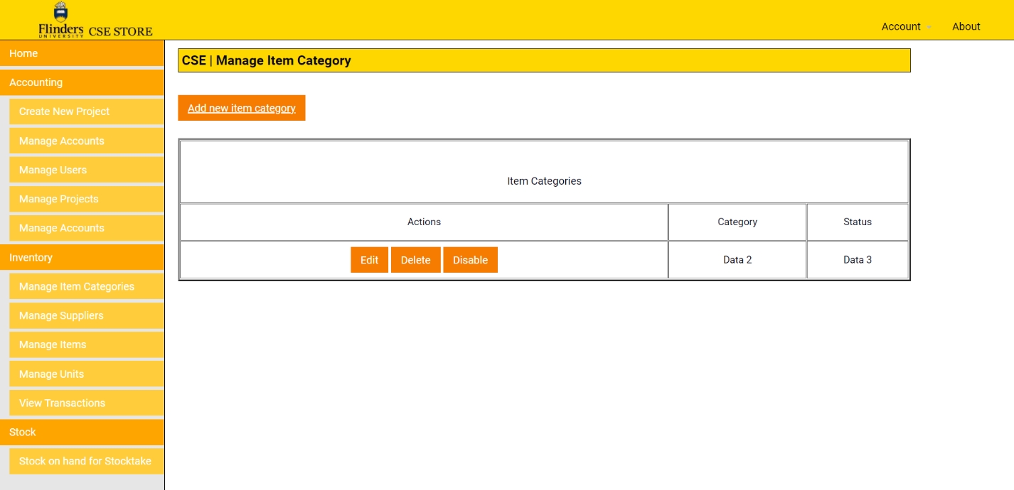

  Figure 5: ManageItemCategories.php

## Create Item Category (CreateItemCategory.php)

Adding an item category can be done via the ‘add new item category’ button. This page will allow users to provide a brief description on the category that they have added.

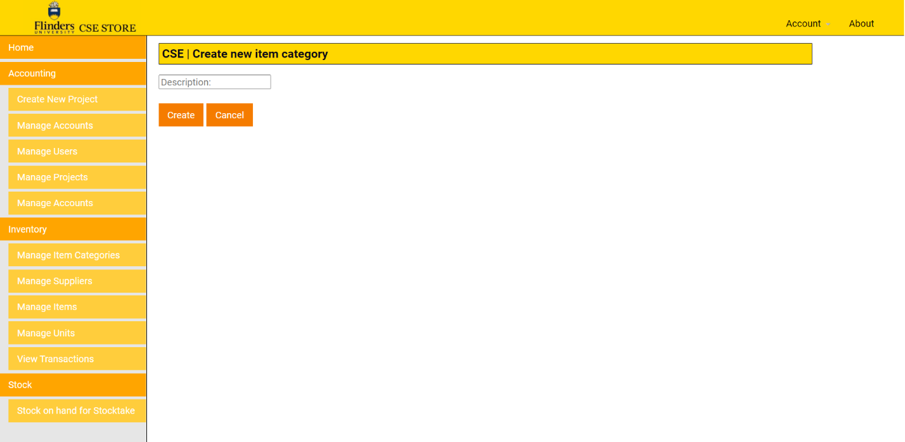

## 

## 

## Figure 6: CreateItemCategory.php

## Manage Project (ManageProject.php):

Manage Project is where users can delete/edit new projects related to stock in-take or organizing more stock deliveries. This page gives users the option to add a finance code, a description, and a manager to each ongoing project. Once a project is finished, users can delete it from the ‘delete’ button on the project table.

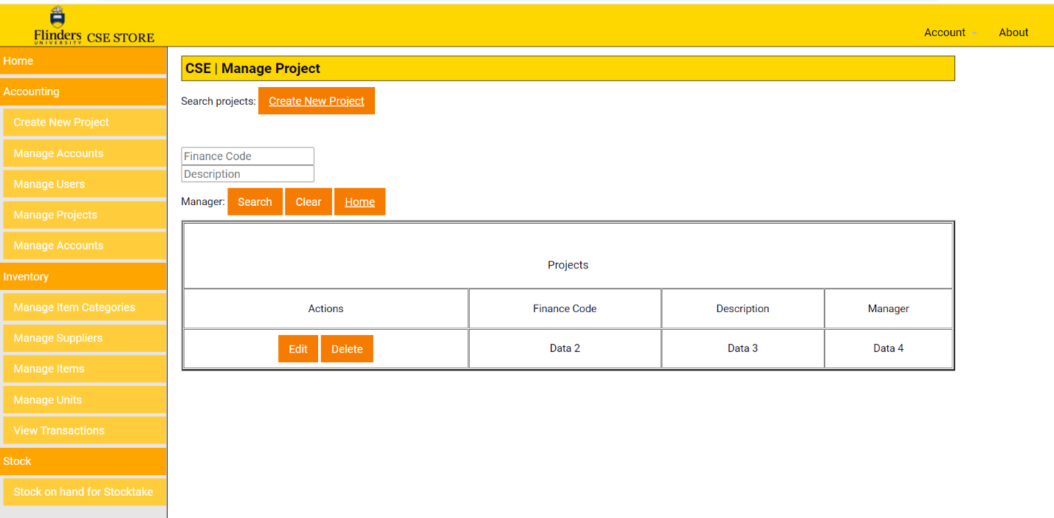

Figure 7: ManageProject.php

## New Project (CreateNewProject.php):

Create new project is a page that allows users to start a new project, to store in the manage project interface. Upon completing all the fields, they will be added in the ‘ManageProject.php’ page.

For the New Project page, the design remains the same, with the only difference being the colour different to what it was previously which was blue colours. What's also new is the way the layout of the buttons now has the title of the placeholder boxes embedded to the placeholders themselves, instead of them being outside. Functionality as explained would operate in the same manner as before which is creating a new project and adding the manger code, short description of the project and project management name.

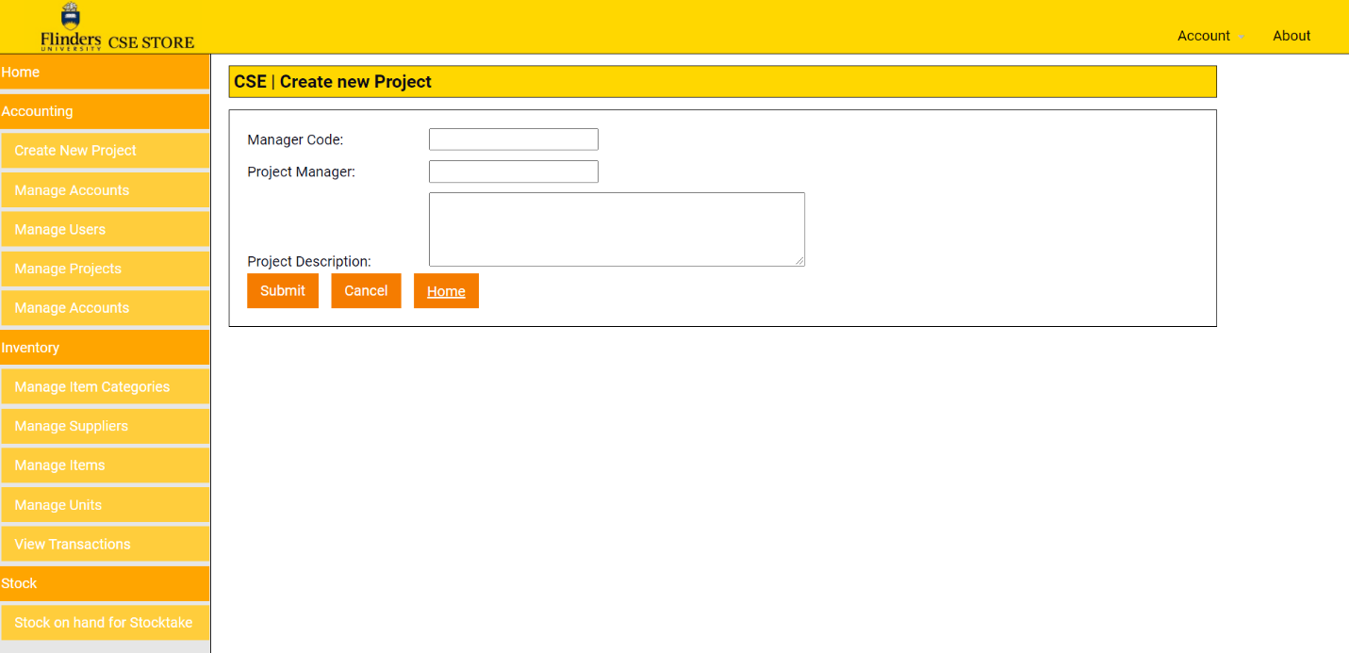

Figure 8: CreateNewProject.php

## 

## Manage Suppliers (ManageSuppliers.php):

 New Suppliers that provide stock are also accounted for on the website. This webpage will allow users to view the suppliers address, name, contact, phone, and mobile numbers. Any new additions can be changed via the ‘edit’ button, as well as deleted via the ‘delete’ button.

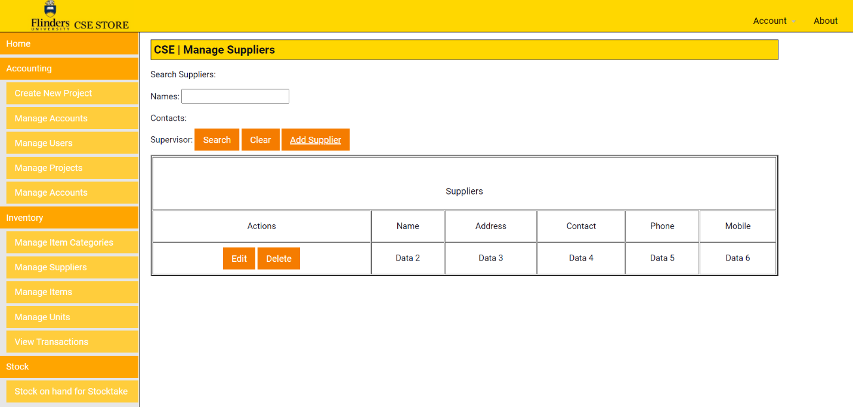

Figure 9: ManageSuppliers.php

## New Supplier (CreateNewSupplier.php):

Creating a new supplier can be done via the ‘CreateNewSupplier.php’ page. This is accessed via the ‘Add Supplier’ button on the Manage Suppliers page. It takes in the data fields of ‘name’, ‘address’, ‘contact number’, ‘phone number’, ‘mobile number’, ‘fax number’, ‘web address’, ‘email address’, and ‘notes’.

In the add supplier page, design of the placeholders options are listed in the same format with the only difference being that the new design features an additional button at the bottom on top  of the cancel button. This new button is the save button, that allows you to add what is imputed in the new supplier page so that new supplier new details entered can be added. There was previously only a cancel button before that did not make sense to have without a add button which therefore was why adding the add button made sensible sense for the site.

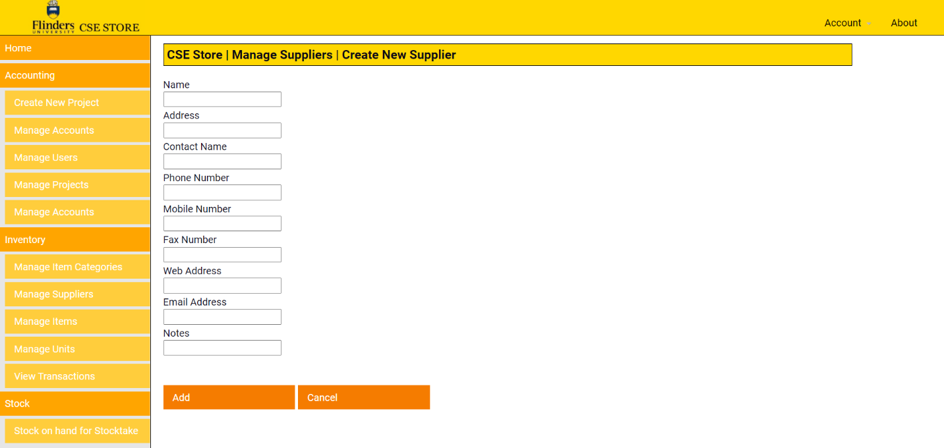

Figure 10: CreateNewSupplier.php

## 

## Manage Users (ManageUsers.php):

Manage users is a page where existing users can add other users to the database/website. It behaves similarly to the ‘ManageSuppliers.php’ page.

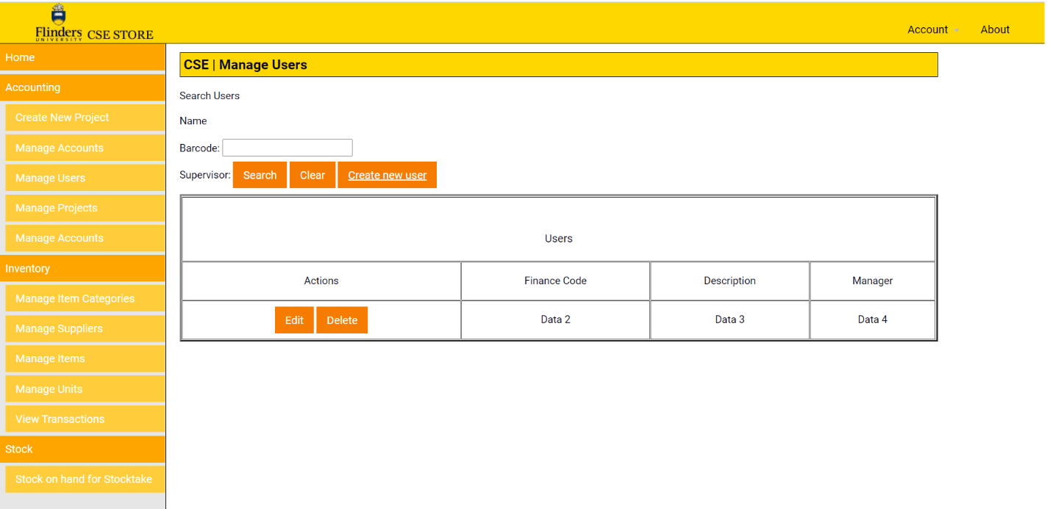

Figure 11: ManageUsers.php

## Create New User (CreateNewUser.php):

Create new user is the page where users can be inserted into the database/website. It takes in parameters of ‘barcode’ (provided on their student card), a reminder select button if they have ordered some stock awaiting pick up, a date indicating when the order was made, a first name, last name, details of the reminder that was set for them, a preferred name, FAN, supervision description, a lab indicating what area they are teaching/studying, type of student/staff placing the order, area of schooling, then a start-date/end-date representing how long the user will be affiliated with Flinders.

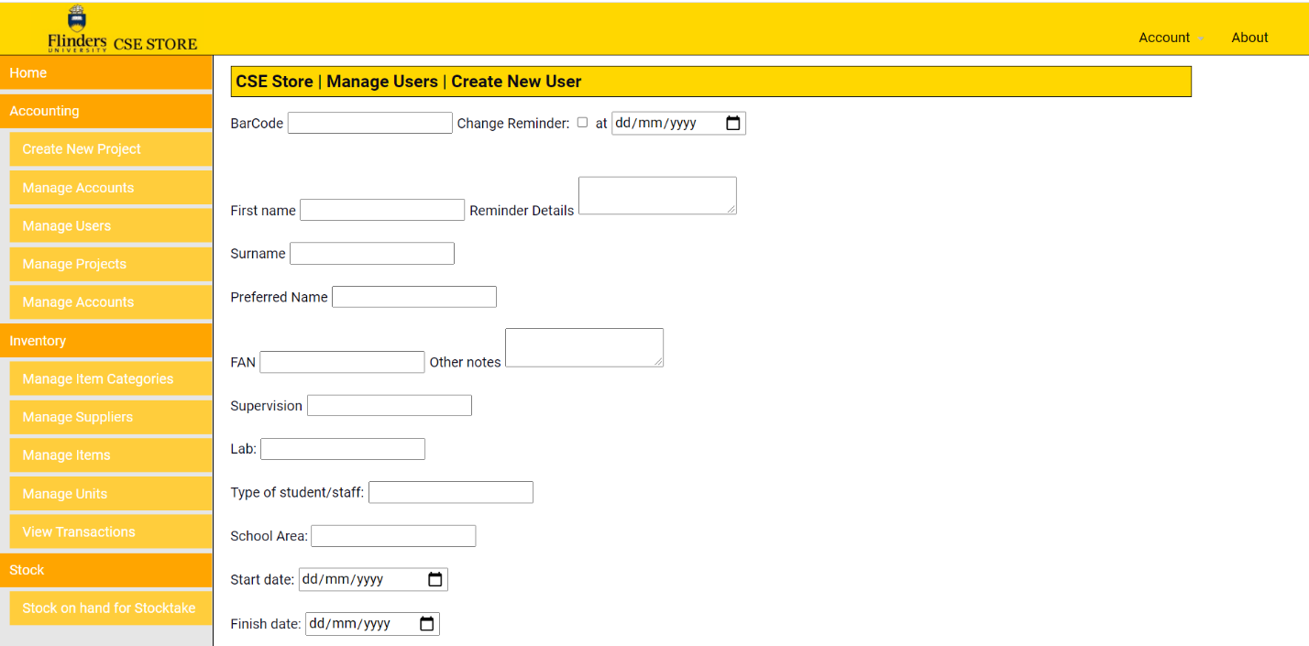

Figure 12: CreateNewUser.php (1)

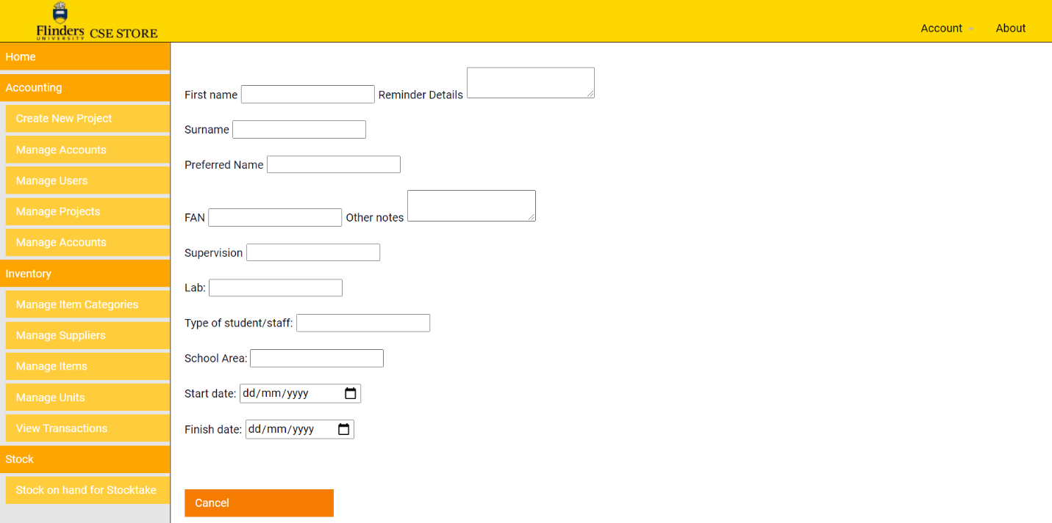

Figure 13: CreateNewUser.php

## Edit Store Details (EditStoreDetails.php):

The CSE store can edit its own details and update them through this page. This includes ‘name’, ‘contact phone’, ‘descriptions’ representing what each store operates in, ‘markup’ for pricing, and different dialog boxes. One of these boxes includes allowing ‘over-purchasing’ of certain products/stock, enabling loans at the store, OHS purchase warnings, and editing cancelling/purchasing dialog boxes. Much of how the store operates can be determined on this webpage.

­­­­­­­­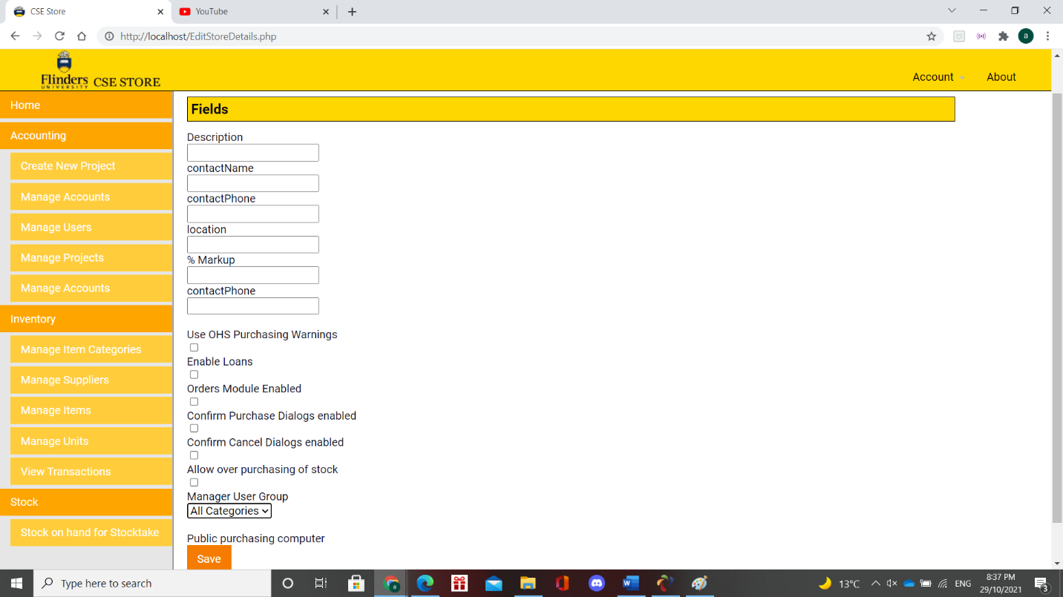

Figure 14: EditStoreDetails.php

## Manage Account (ManageAccount.php):

Manage accounts staff to make changes/edits to different accounts throughout the CSE store. As discussed in the manage users page, this can be staff members, and students of different types/fields. Accounts are directly attached to users, as users generally will have accounts.

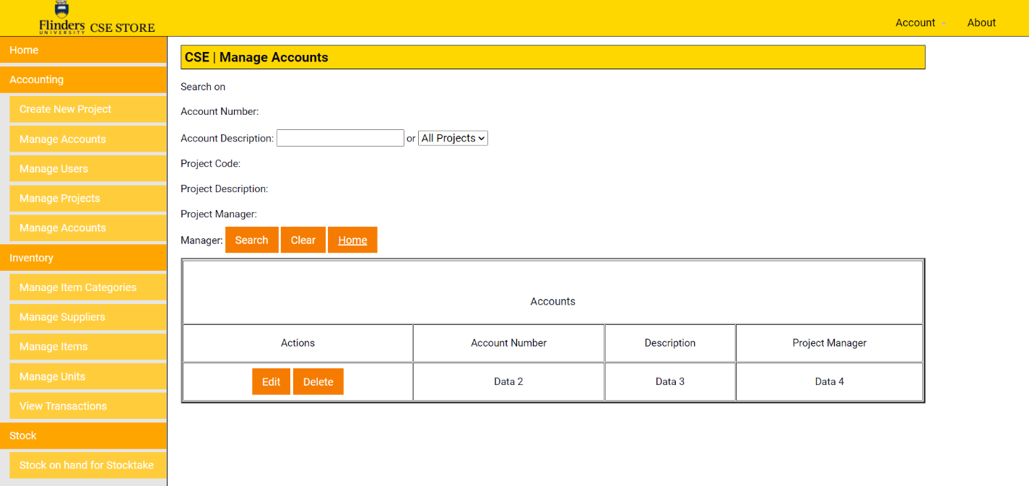

Figure 15: ManageAccounts.php

## 

## Start Shop Admin (StartShopAdmin.php):

Start shopping admin, provides staff members an option to shop at the CSE store including administrative privileges. The page takes the user to a list of accounts to charge, of the user’s choice. The design of this page is the same as original design layout. 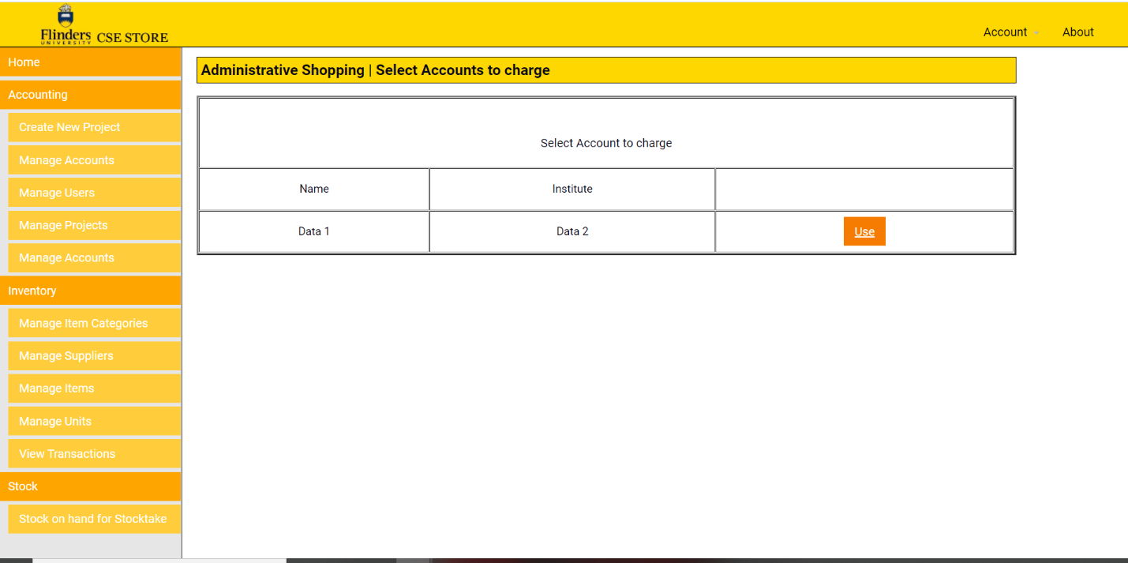

  Figure 16: StartShopAdmin.php

## Stock On Hand (StockOnHand.php):

A stock on hand report, is a page used for users to generate a stock take form in an excel format. Stock-taking is directly related to the physical in-take of quantities of different stock items. It verifies the condition of certain products at a sales distributor. The website supports this requirement. The design of this page is the same as original design layout.

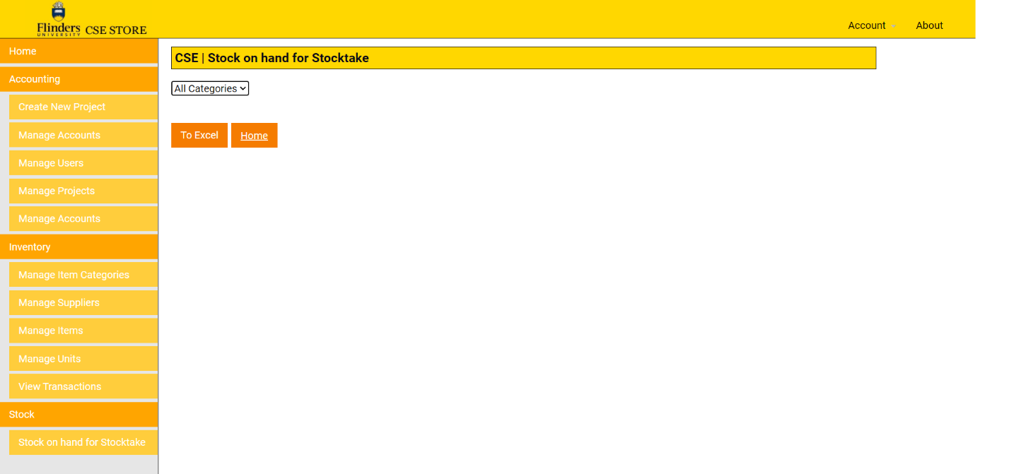

Figure 16: StockOnHand.php

## Create Item category (CreateItemCategory.php):

The create item category page allows users to create a new item category. This is then stored in the ‘Manage item categories page’. The design of this page is the same as original design layout with the difference being that the title of the placeholder being ‘Description’ is now located in the place holder box to make the page look simple and compacted while still keeping to that modern design style.

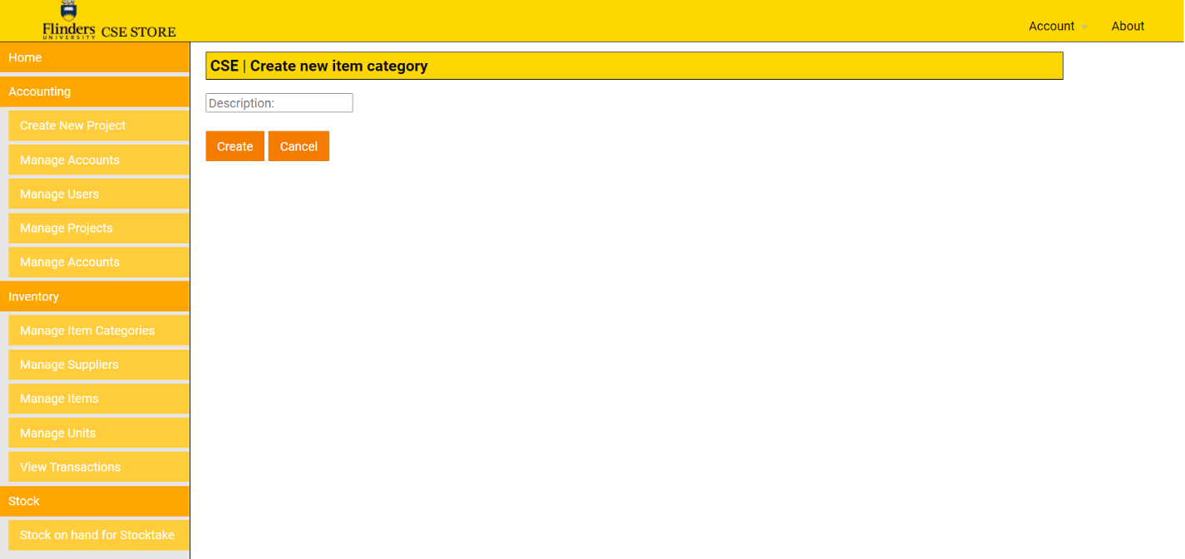

Figure 17: CreateItemCategory.php

## All Loans (ListLoans.php):

Users can add/display existing loans for different items. This includes a table for the user in question, their supervisor, the account, description detailing the loan’s circumstances, contact information, quantity, unit price, total price, and the date the loan was commissioned.

Figure 18: ListLoans.php

## Login (login.php):

Log In page is redesigned with the relevant/modern Flinders colors that is consistent with the rest of the website. Serves as an authentication system for authorized users to gain access to the website. Their username, and password is stored in the database file under users.

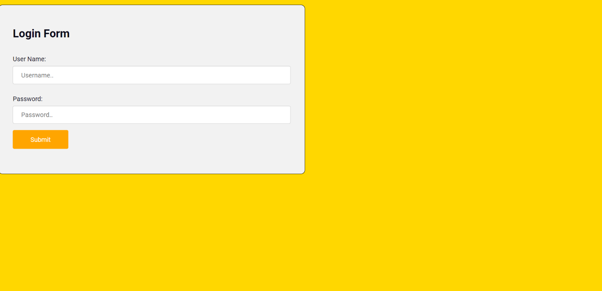

Figure 19: Login.php

## View Transactions (ViewTransactions.php)

View Transactions is a web page representing outstanding transactions on the website. Users can select the user affiliated with the transaction, the account, description of the transaction, quantity of the product, unit price of the product, the total price of the product, the stock on hand for the product, the date the purchase was made, and the operator overseeing the transaction of the product. Users can also select the start date, and end date separately above the table.

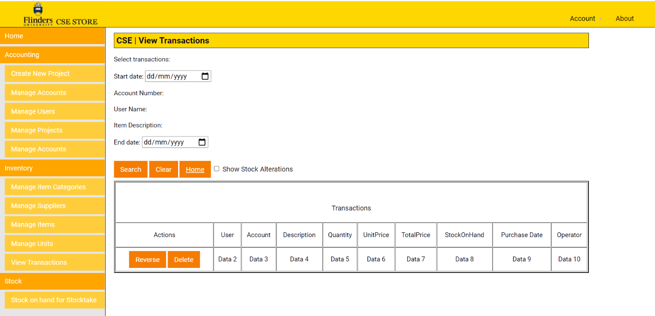

Figure 20: ViewTransactions.php

## Manage Units (MangeUnits.php)

In the Manage the units page, your able to perform task that are exact same as before however in a new modern look. Functions are exact same such as being able to add a new unit, along side editing deleting or disabling units that may exist in unit.

Figure 21: MangeUnits.php

Add New Unit (AddNewUnit.php)

For the Add New Unit Page, formatting of how the page looks is the same except as discussing before colours are the only change. Functionality would remain the same where you would when adding a new unit be entering the description of the new unit and you would then be able to click create or the user may want to cancel it if they decide they don’t want to add a new unit. You can refer to Figure 22 below for more detail.

Figure 22: AddNewUnit.php

Inventory Purchase History (InventoryPurchaseHistory.php)

In the Inventory Purchase History Page as shown in Figure 23 below, the inventory purchase design remains the same with the ability just like before to selecting a start and end date of the purchase. The search string option allows you as a user to input the search terms when it comes to searching for the purchase of items using search string. You could think about it as a search term option just like in a google search engine you can search by keyword.

Figure 23: InventoryPurchaseHistory.php

User Change Reminders (UserChangeReminders.php)

In the User change reminders page as shown in figure 24 below, your able to perform same functions as before such as being able to edit each user change reminders so that the user can be reminded to what the user needs to be reminded about.

Figure 24: UserChangeReminders.php

Items Below Stock Level (ItemsBelowStockLevel.php)

For the Items Below Stock Level Page as seen in Figure 25 below, shows the items below stock level. Same design format as before in the previous website design for CSE except your able to edit, or view by clicking the option on the left-hand side of the table and modify either the description, barcode stock on hand etc.

Figure 25: ItemsBelowStockLevel.php

Changing Journal Report (to Excel)

From accessing the option Changing Journal Report (to Excel) from the homepage, it downloads an excel spread sheet that will list the Journal type, account code, cost, and incident date for CSE Store Charges. Refer to Figure 26 below of this.

Figure 26: Changing Journal Report (to Excel) (NOTE Data is made up as test dummies due to not being able to show real-life data for data security reasons)

Changing Summary Report (to Excel)

Figure 27: Changing Summary Report (to Excel)

User Account Transaction

Under User Account Transactions option on home page, when you click on the option it downloads a excel file that showcases to the user’s transaction from the CSE system in what they have purchase, when and the type of item etc. Refer below to Figure 28 for an inside on what this looks like.

Figure 28:

Users in projects

When it comes to Users in projects option you can click on from the home page, which would then download an excel fille that will show case the users that are in projects. Refer to Figure 29 below to see the excel spreadsheet of this.

Figure 29:

Users List

In the User List option that you can head to from the home page, it will download a excel spreadsheet of the list of users that are able to have access to the CSE Store for being able to borrow and or purchase supplies. Below as you can refer to Figure 30 below to see what the excel spread sheet of this is like. It is seen in figure 30 that the excel spreadsheet contains each user details registered in the system with their username being students Fan ID, their first and last name along with a Barcode that is their unique identifier on the system.

Figure 30: UserList Excel Spreadsheet (NOTE Data is made up as test dummies due to not being able to show real-life user’s for data privacy reasons)

Overall Website Implementation Summary

Overall, the website design format stays the same as the previous design, with just a few modernizations in its design that was made along side a few extra added options including options that can be able to remove a user from the system where as previously, there was no option to do that. There are various other changes that has been discussed above however just highlighting one of the important changes that wasn’t avaible before now is. On top of this, there is the dashboard that is now included on the site, where before, you were only greeted to accessing different part of the CSE site on the home page. This complements it well for if a user decides to access the different part of the site, they can do so and click the options in the dashboard section.

## 