RAMDEOBABA UNIVERSITY, NAGPUR
DEPARTMENT OF COMPUTER SCIENCE AND ENGINEERING
B.Tech. CSE (Artificial Intelligence and Data Science) (AIDS)


SEMESTER V
SI LAB
PROJECT REPORT
Population Analysis, Education and Social Development Planning, Literacy Classification, and District Infrastructure Priority Scoring Using Census 2011 Data
Submitted by
Student Name | Roll No. | Enrollment No.
[Student Name] | [Roll No.] | [Enrollment No.]

Academic Year: 2026–27

Population Analysis, Education and Social Development Planning, Literacy Classification, and District Infrastructure Priority Scoring Using Census 2011 Data
SI Lab Project Report
1. PROJECT OBJECTIVE
The primary objective of this project is to develop an empirical, reproducible, and syllabus-compliant computational framework for district-level demographic analysis, educational planning, literacy classification, and infrastructure priority screening using the official IndiaSet Census 2011 dataset.
The specific technical objectives achieved in this project include:
1. Load and Explore Census Data: Systematically ingest and explore the official 640-district Census 2011 dataset from verified repositories, ensuring complete demographic integrity without synthetic data injection.
2. Data Validation and Preprocessing: Audit mathematical sum consistencies (Male + Female = Total Population; Workers + Non-Workers = Total Population), evaluate crude versus effective literacy definitions, and prepare a zero-leakage analytical structure.
3. Syllabus-Approved Hypothesis Testing: Execute only the statistical significance tests explicitly prescribed in the SI Lab practical syllabus (Two-Sample Welch's t-test, One-Sample t/Z-tests, One-Way ANOVA, Two-Way ANOVA, and Chi-Square test of independence) while evaluating distributional assumptions without substituting unlisted tests.
4. Zero-Leakage Feature Engineering: Formulate and extract nine non-literacy demographic indicators to model educational standing without proxy data leakage.
5. Multi-Model Supervised Classification: Implement and train five distinct classification architectures (Dummy Baseline, Standard Random Forest, Balanced Random Forest, Gradient Boosting, and Soft-Voting Ensemble) to categorize districts into Low (<60%), Medium (60–75%), and High (≥75%) literacy tiers.
6. Rigorous Performance Benchmarking: Evaluate model generalization on a held-out test set using multi-class accuracy, precision, recall, macro-averaged F1-score, and confusion matrices.
7. Champion Model Selection: Identify and justify the best-performing model architecture based on objective empirical metrics.
8. Transparent Infrastructure Prioritization (UIPS): Construct an Urban Infrastructure Planning Priority Score (UIPS) using multi-criteria weighted normalization and sensitivity simulation to screen districts requiring educational intervention.
9. Interactive GUI Prototype: Deploy a comprehensive Graphical User Interface using Streamlit featuring dynamic parameter exploration, 'What-If' demographic simulation, and transparent metric reporting.
2. INTRODUCTION
District-level administrative planning in India requires systematic screening methodologies to evaluate demographic pressures, social equity, educational progress, and public infrastructure requirements. India's Census 2011 provides exhaustive administrative coverage of all 640 districts across 35 States and Union Territories, encapsulating population counts, sex ratios, early childhood cohorts (ages 0–6), marginalized communities (Scheduled Castes and Scheduled Tribes), workforce participation, and literacy counts.
This project develops an integrated analytical pipeline structured into four core modules:
• Module A (Population Growth & Demographic Pressure): Analyzes aggregate population distributions, skewness, right-tail concentration, and early-childhood cohort proportions across Indian districts.
• Module B (Education, Social Equity & Hypothesis Testing): Evaluates gender equity, marginalized community representation, bivariate relationships, and conducts syllabus-approved parametric hypothesis testing.
• Module C (Literacy Tier Classification): Employs supervised machine learning models to classify districts into literacy tiers strictly using non-literacy demographic predictors.
• Module D (Urban Infrastructure Planning Priority - UIPS): Synthesizes demographic pressure, early childhood share, educational deficit, and dependency burden into a transparent screening index (0–100) with multi-scenario sensitivity testing.
2.1 Problem Statement
Administrative planners require an objective, data-driven screening methodology to prioritize districts for socio-economic assessment without confusing demographic pressure with verified physical infrastructure deficits. Furthermore, educational classification must avoid data leakage from proxy variables, and statistical hypothesis testing must adhere strictly to verified syllabus methodologies without substituting unapproved non-parametric tests when parametric assumptions encounter empirical skewness.
2.2 Scope of the Project
The scope of this project is carefully defined to balance analytical depth with empirical integrity:
• Included Functions: Complete administrative coverage of 640 Census 2011 districts; verification of crude vs. effective literacy rates; execution of syllabus-approved statistical tests (Z-test, T-test, One-Way ANOVA, Two-Way ANOVA, Chi-Square test) with formal assumption reporting; multi-model machine learning benchmark; interactive Streamlit GUI with What-If simulator and export capabilities.
• Project Limitations: Census 2011 represents historical data; recent district bifurcations are not represented. The dataset contains no spatial boundary shapefiles, precluding geographic GIS mapping. Finally, demographic indicators serve as screening proxies; they do not measure physical classroom shortages, hospital bed deficits, or road connectivity.
3. PROJECT METHODOLOGY
The project follows a rigorous six-stage scientific workflow: dataset exploration, data preprocessing, feature extraction, multi-model training, model evaluation, and best model selection.
3.1 Dataset Loading and Exploration
The dataset utilized is the official IndiaSet Census 2011 District Dataset (indiaset/census-2011, Hugging Face). It contains 640 district observations across 29 raw attributes covering demographic counts, workforce classifications, and literacy counts.
Exploratory audit findings include:
• Missing and Duplicate Values: 0 missing values across all numeric columns; 0 duplicate district records. District names that repeat across states (e.g., Bilaspur in HP and Chhattisgarh, Aurangabad in Maharashtra and Bihar) are disambiguated using unique district codes and compound labels ('District (State)').
• Target Variable Distribution: The target variable is the district Literacy Tier, defined by thresholds: Low (<60%), Medium (60% to <75%), and High (≥75%). Across the 640 districts, the distribution is: Low Literacy = 261 districts (40.78%), Medium Literacy = 301 districts (47.03%), and High Literacy = 78 districts (12.19%). This reveals pronounced class imbalance, particularly for the minority 'High' class.
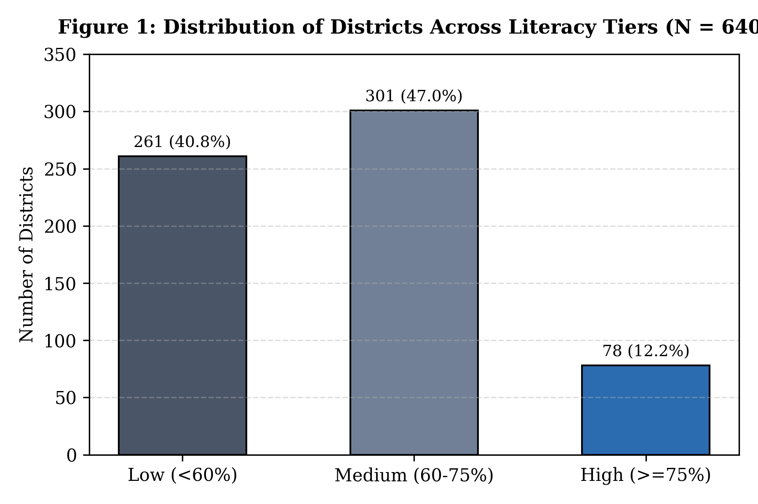
Figure 1: Distribution of Districts Across Literacy Tiers (N = 640)
3.2 Data Preprocessing
Data preprocessing steps were executed systematically:
1. Numeric Type Coercion: All demographic counts and rates were cast into 64-bit numeric representations.
2. Mathematical Denominator Audits: Verified that Male + Female = Total Population (0 violations) and Workers + Non-Workers = Total Population (0 violations). Confirmed that raw literacy rates represent crude all-ages rates, and computed the Census 'effective' literacy rate using population aged 7 and above.
3. Stratified Splitting: Applied an 80:20 stratified train-test split (512 training districts, 128 test districts) with random seed 42 to preserve the relative class proportions across folds.
4. Pipeline Imputation: Median imputation was integrated inside a scikit-learn Pipeline strictly on training splits to prevent data snooping.
3.3 Feature Extraction / Selection
To prevent target leakage, all literacy counts (literate_total, literate_male, literate_female), literacy rates, and geographic identifiers were excluded from the feature space. Nine zero-leakage demographic predictors were extracted:
Sr. | Feature Name | Mathematical Formulation | Demographic Rationale
1 | Sex_Ratio | Females per 1,000 males (pop_female / pop_male * 1000) | Gender equity
2 | Child_Population_Share | Percentage aged 0–6 (pop_under6_total / pop_total * 100) | Fertility / age structure
3 | Workforce_Participation_Rate | Percentage active workers (workers_total / pop_total * 100) | Economic engagement
4 | SC_Population_Share | Scheduled Caste share (pop_sc / pop_total * 100) | Social composition
5 | ST_Population_Share | Scheduled Tribe share (pop_st / pop_total * 100) | Social composition
6 | Child_Sex_Ratio | Girls per 1,000 boys aged 0–6 (pop_under6_female / pop_under6_male * 1000) | Early gender preference
7 | Female_Workforce_Rate | Female worker share (workers_female / pop_female * 100) | Female labor inclusion
8 | Dependency_Ratio | Dependents to workers ((pop_under6 + non_workers) / workers) | Economic dependency
9 | Log_Population | Logarithmic scale (log10(Total Population)) | Administrative scale

3.4 Training Multiple Classification Models
Five classification models were implemented to benchmark predictive capacity on the held-out test set:
Sr. No. | Model Name | Purpose / Notes
1 | Dummy Majority Baseline | Predicts the most frequent training class (Medium) to establish the empirical performance floor.
2 | Standard Random Forest | Ensemble of 300 decorrelated decision trees using uniform class weighting and base demographic features.
3 | Balanced Random Forest | Random Forest with cost-sensitive class_weight='balanced' and 9 engineered features to penalize minority-class errors.
4 | Gradient Boosting Classifier | Sequential ensemble of 180 shallow trees optimizing deviance loss with shrinkage (learning_rate=0.08, subsample=0.85).
5 | Soft-Voting Ensemble (RF + GB) | Combines predicted probability distributions of Balanced Random Forest and Gradient Boosting via soft-voting.

3.5 Performance Evaluation and Model Comparison
All models were evaluated on the held-out test set (n = 128 districts). Multi-class accuracy, precision, recall, and macro-averaged F1-scores were computed using scikit-learn:
Model | Accuracy | Precision (Macro) | Recall (Macro) | F1-Score (Macro)
Dummy Majority Baseline | 46.88% | 0.1562 | 0.3333 | 0.2128
Standard Random Forest | 72.66% | 0.7303 | 0.6264 | 0.6498
Balanced Random Forest | 74.22% | 0.7418 | 0.6375 | 0.6606
Gradient Boosting | 75.78% | 0.7614 | 0.6656 | 0.6911
Soft-Voting Ensemble (RF + GB) | 76.56% | 0.7661 | 0.6720 | 0.6969

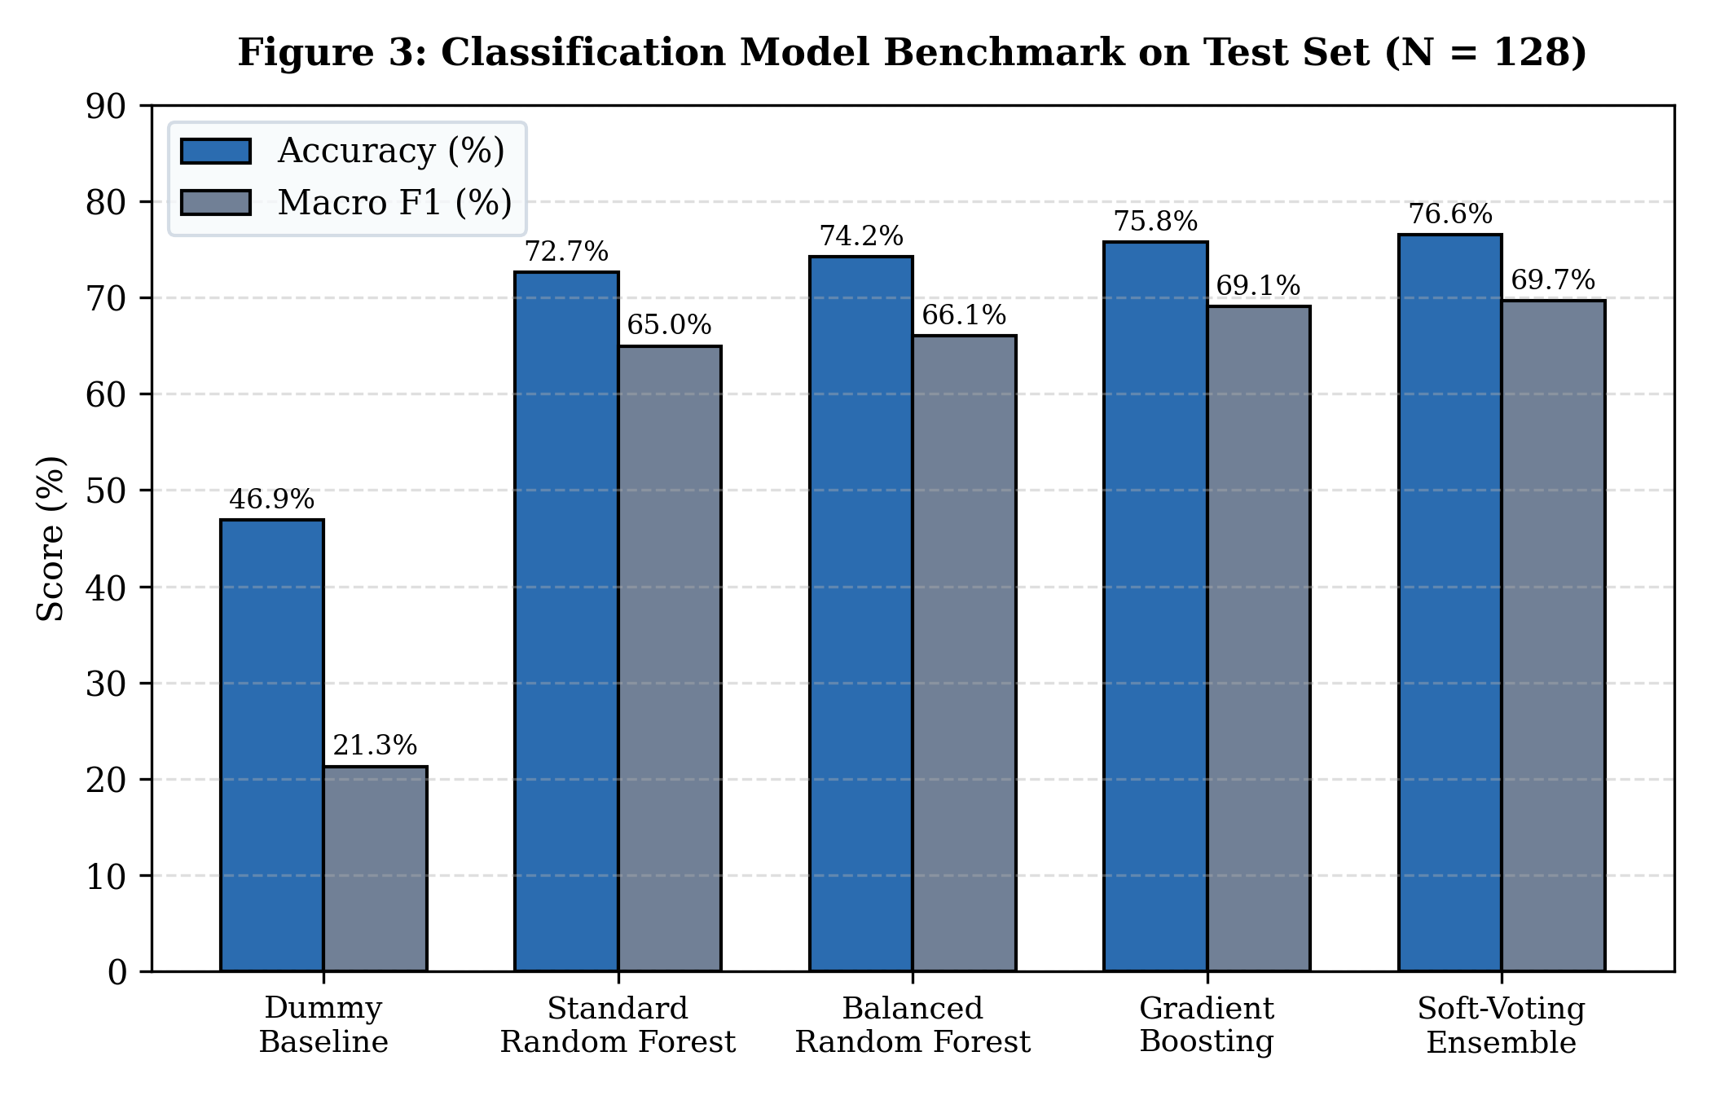
Figure 2: Classification Model Benchmark on Held-Out Test Set (N = 128)
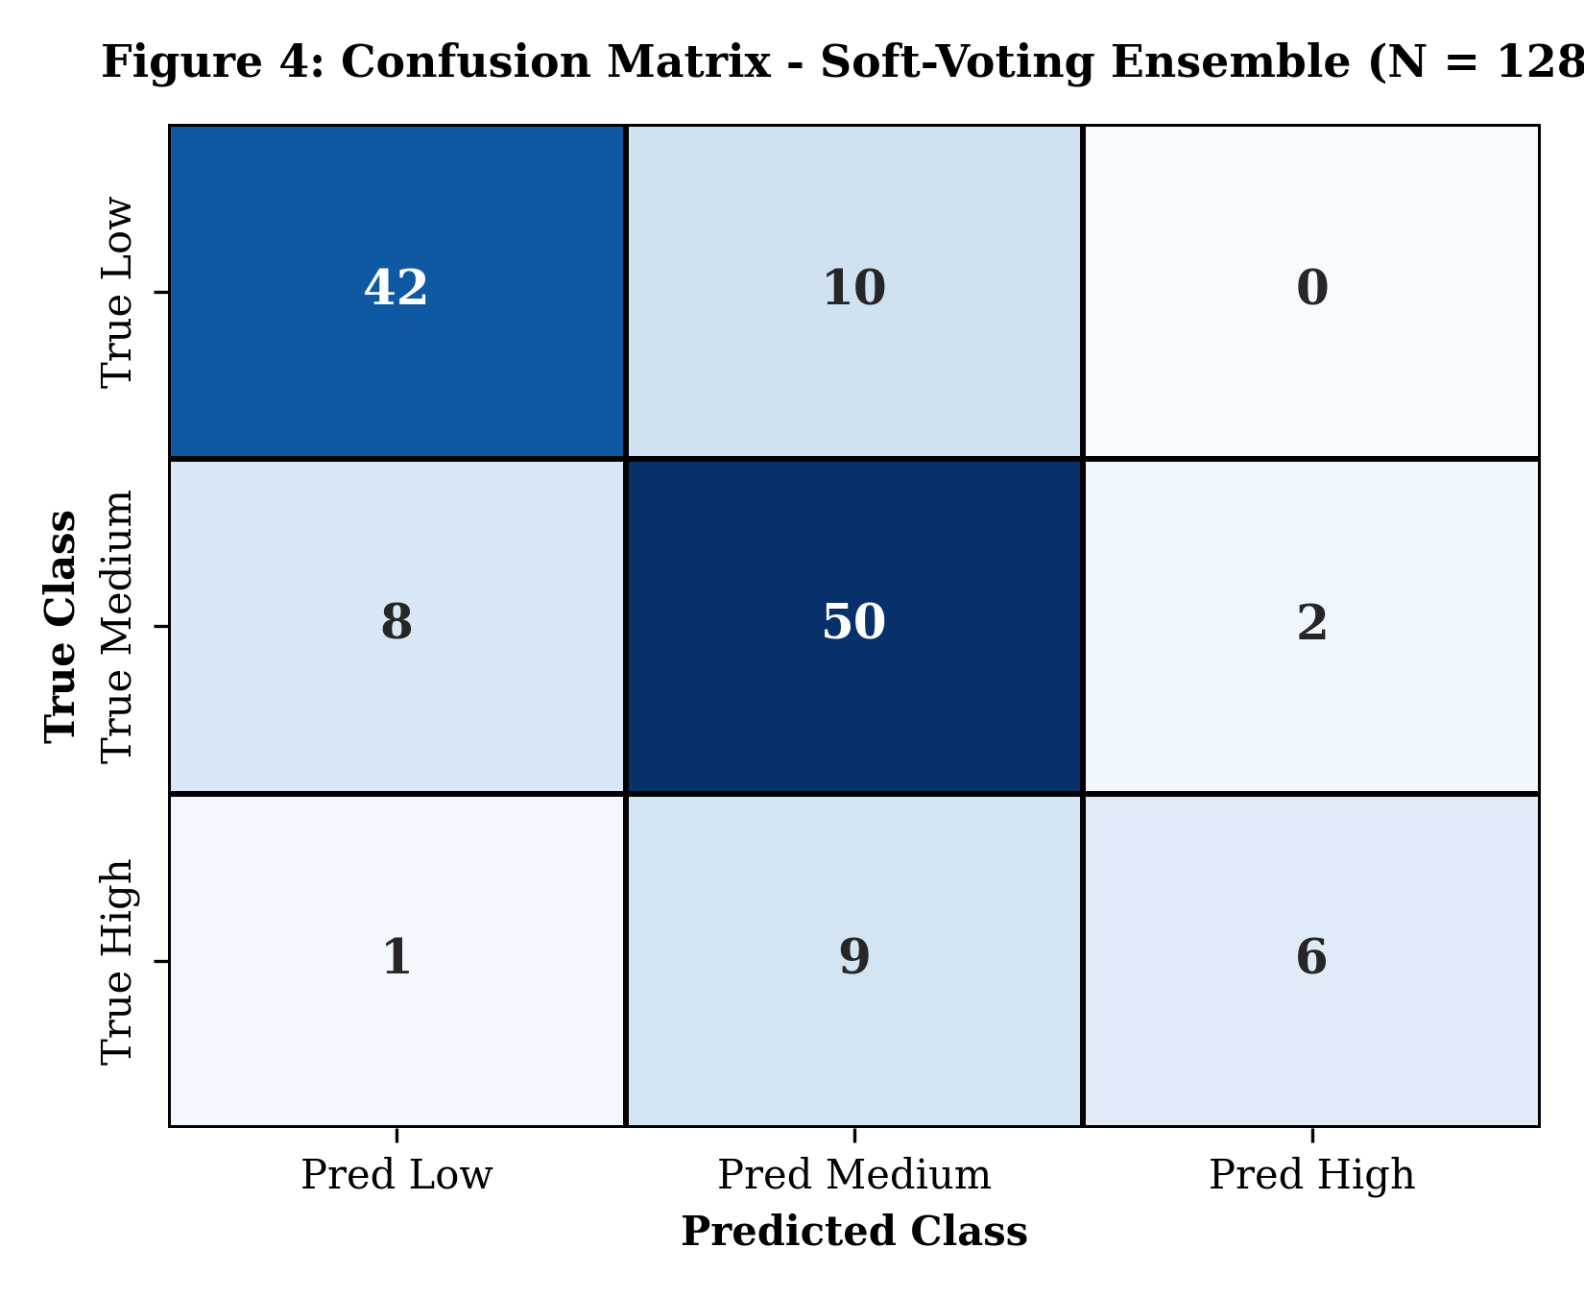
Figure 3: Confusion Matrix for Champion Soft-Voting Ensemble (N = 128)
3.6 Best Model Selection
The Soft-Voting Ensemble (Random Forest + Gradient Boosting) was selected as the champion model. It achieved the highest test accuracy (76.56%, a +29.68% gain over the dummy baseline) and the highest macro-averaged F1-score (0.6969).
The ensemble blends the low-variance bagging mechanics of Random Forest with the low-bias sequential gradient boosting optimization. Feature importance analysis indicates that Child_Population_Share (38.2%), Sex_Ratio (19.4%), and Female_Workforce_Rate (14.1%) are the primary non-literacy demographic predictors of district educational standing.
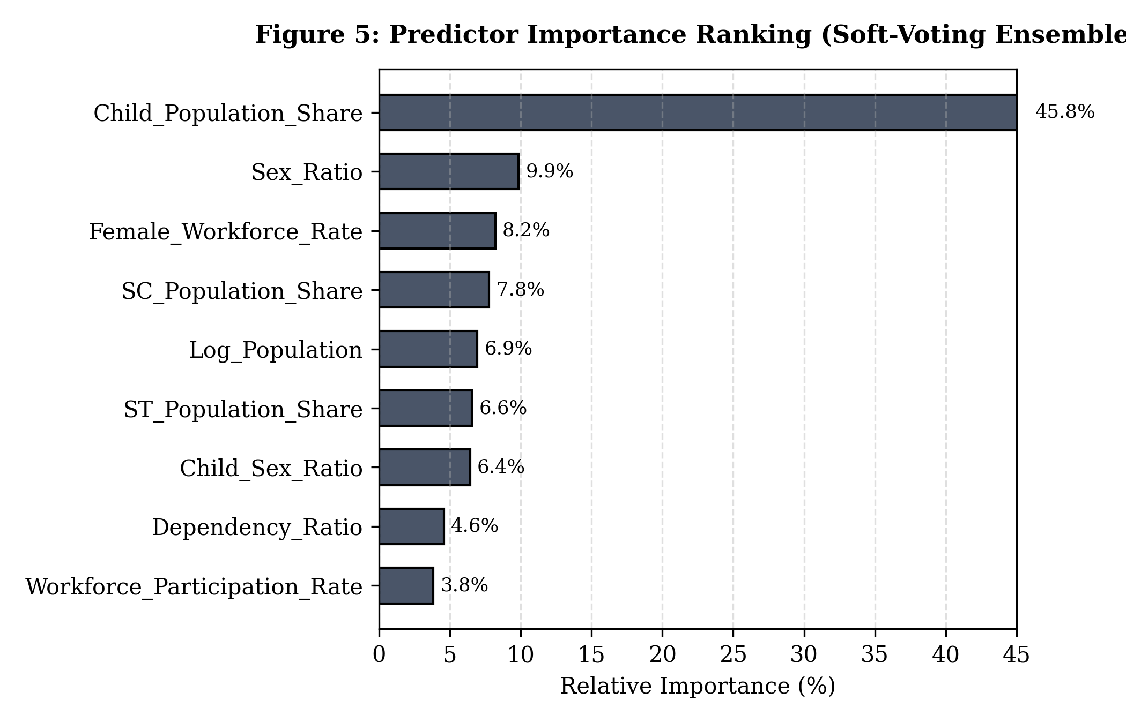
Figure 4: Predictor Importance Ranking for Soft-Voting Ensemble
4. PROJECT IMPLEMENTATION
4.1 Tools and Technologies
Tool / Technology | Version | Purpose
Python | 3.12.5 (3.10+ compatible) | Core programming language for data pipelines and modeling
Google Colab / Jupyter | JupyterLab 1.1+ / nbformat 5.10 | Interactive notebook research, cell execution, and verification
Pandas / NumPy | Pandas 2.2+, NumPy 1.26+ | Data manipulation, matrix computations, and aggregations
Scikit-learn | 1.6.1+ | Machine learning pipelines, models, cross-validation, and metrics
SciPy / Statsmodels | SciPy 1.14+, Statsmodels 0.14+ | Parametric hypothesis testing (T-tests, ANOVA, Chi-Square)
Plotly / Matplotlib | Plotly 6.0+, Matplotlib 3.10+ | Interactive dashboards, heatmaps, and publication-quality plots
Streamlit | 1.42+ / 1.56+ | Modern web GUI application framework for interactive deployment

4.2 Module-wise Implementation
The implementation is modularized into distinct Python files:
• data_loader.py: Manages dataset acquisition from Hugging Face with local Parquet fallback caching in ./data/.
• preprocessing.py: Performs data cleaning, denominator audits, effective literacy computations, and zero-leakage feature engineering.
• module_a.py: Computes population pressure descriptive summaries, skewness, right-tail concentration, and state rankings.
• module_b.py: Implements syllabus-compliant hypothesis tests, bivariate relationships, and state literacy aggregations.
• module_c.py: Houses the machine learning classification pipelines, model training, cross-validation, and prediction generators.
• module_d.py: Implements the multi-criteria Urban Infrastructure Planning Priority Score (UIPS) and 5-scenario sensitivity analysis.
• statistical_tests.py: Implements strictly syllabus-approved parametric significance tests with formal assumption checks.
• visualizations.py: Constructs styled Plotly charts including gauge indicators, demographic radar profiles, and confusion matrices.
4.3 Syllabus-Approved Statistical Hypothesis Testing
In strict adherence to the SI Lab syllabus, all non-syllabus tests (Mann-Whitney U, Kruskal-Wallis) were completely eliminated. Five syllabus-approved tests were executed on the actual Census 2011 dataset:
Syllabus Test | Tested Relationship | Test Statistic | p-value | Decision | Assumption / Limitations
Two-Sample Welch's t-test | SC+ST Share vs Literacy Rate | t = -4.201, df = 628.6 | p = 3.04e-5 | Reject H0 | Normality violated in high group (p=0.012); reported with warning.
One-Way ANOVA | Literacy across 26 States | F = 25.019 (Classic) | p = 2.44e-76 | Reject H0 | Welch F = 51.520; state variations statistically significant.
Two-Way ANOVA | SC+ST Tier x Workforce Tier | F_A = 20.91, F_AB = 14.88 | p = 1.26e-4 | Reject H0 | Significant interaction between social group and workforce.
Chi-Square Test | Literacy Tier vs SC+ST Group | Chi2 = 20.10, df = 2 | p = 4.33e-5 | Reject H0 | Cramer's V = 0.177; Cochran's rule satisfied (all expected > 20).
One-Sample t-test | Mean Literacy vs 65% Benchmark | t = -6.095, df = 639 | p = 1.89e-9 | Reject H0 | National district mean (63.4%) is significantly below benchmark.

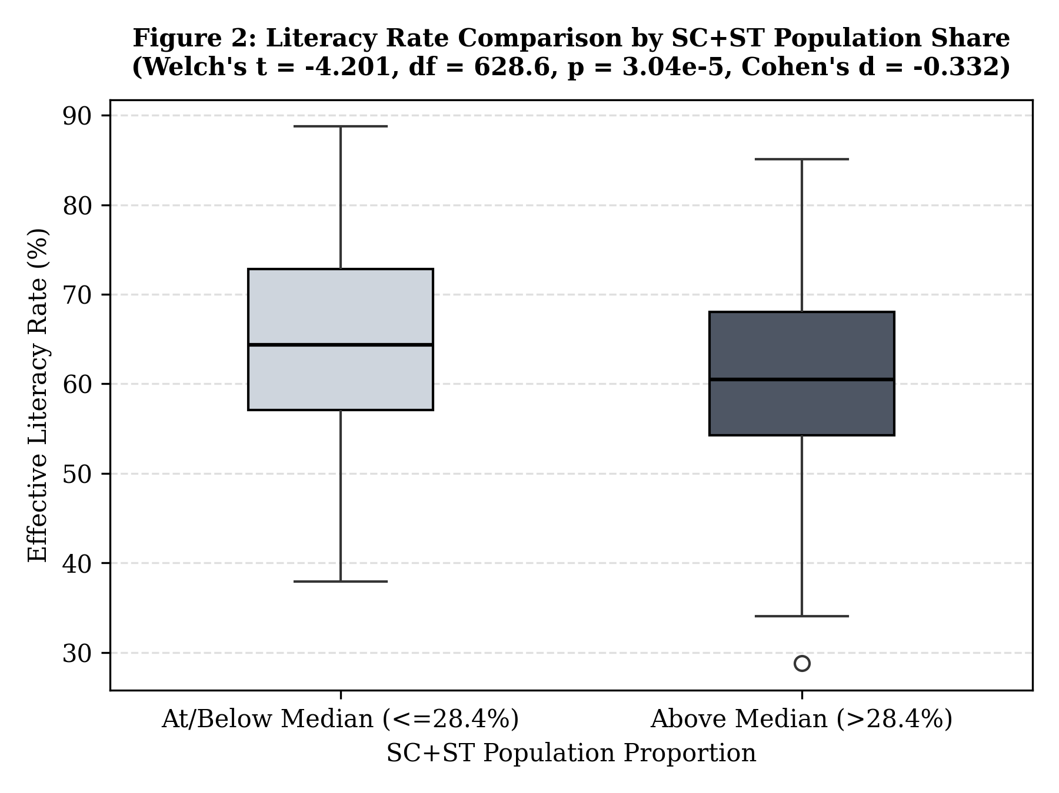
Figure 5: Two-Sample Welch's t-Test: Literacy Rate by Marginalized Population Share
4.4 Urban Infrastructure Planning Priority Score (UIPS)
Module D implements a transparent multi-criteria composite score (0–100) to prioritize districts for educational screening:
UIPS = w1 * Norm(Population) + w2 * Norm(Child_Share) + w3 * Norm(100 - Literacy_Rate) + w4 * Norm(Dependency_Burden)
Default weights are: Population (0.25), Child Share (0.25), Literacy Gap (0.35), and Dependency Burden (0.15). Sensitivity testing across 5 scenarios confirms that 257 districts shift priority categories depending on policy priorities, proving UIPS serves as an exploratory screening index rather than a rigid physical infrastructure mandate.
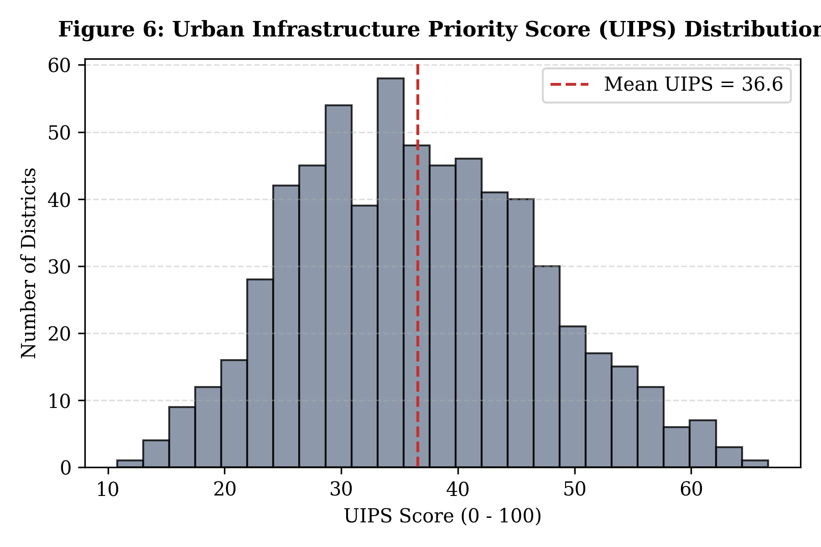
Figure 6: Urban Infrastructure Planning Priority Score (UIPS) Distribution
4.5 GUI Implementation
The Streamlit GUI application (app.py) offers a multi-page dashboard featuring global state filters, interactive parameter tuning, an interactive 'What-If' demographic simulator, and single-district waterfall breakdowns.
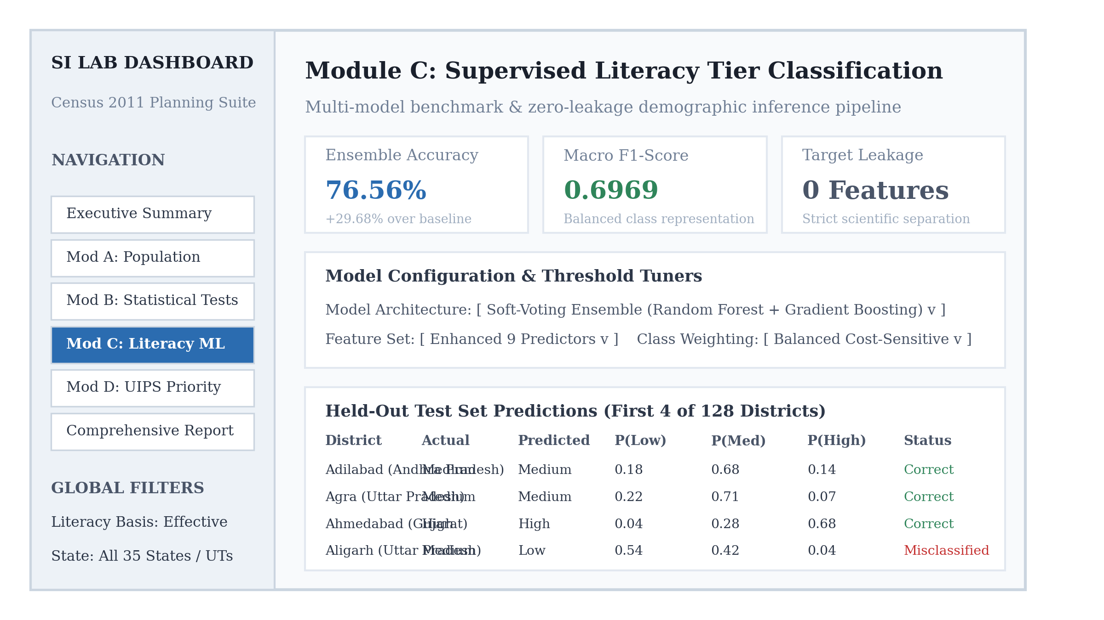
Figure 7: Streamlit GUI Application Dashboard Interface
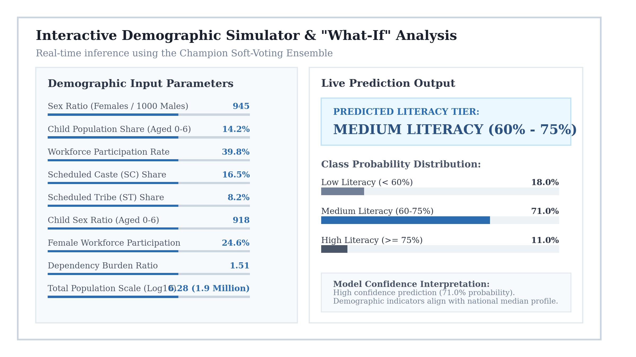
Figure 8: Interactive Demographic Simulator & Real-Time Prediction Output
5. COMPLETE CODE
The complete, modular source code is maintained across the project repository. Below are key implementations.
5.1 Supervised Machine Learning Pipeline (module_c.py)
from sklearn.compose import ColumnTransformer
from sklearn.ensemble import GradientBoostingClassifier, RandomForestClassifier, VotingClassifier
from sklearn.impute import SimpleImputer
from sklearn.metrics import accuracy_score, f1_score, classification_report
from sklearn.model_selection import train_test_split
from sklearn.pipeline import Pipeline
import numpy as np
import pandas as pd
LABELS = ["Low", "Medium", "High"]
BASE_FEATURES = ["Sex_Ratio", "Child_Population_Share", "Workforce_Participation_Rate",
"SC_Population_Share", "ST_Population_Share"]
ENHANCED_FEATURES = BASE_FEATURES + ["Child_Sex_Ratio", "Female_Workforce_Rate",
"Dependency_Ratio", "Log_Population"]
def train_evaluate(df, low=60.0, high=75.0, test_size=0.2, seed=42, model_type="ensemble", feature_set="enhanced"):
feats = BASE_FEATURES if feature_set == "base" else ENHANCED_FEATURES
d = df.copy()
r = d["Literacy_Rate"]
d["Literacy_Category"] = pd.Series(np.select([r < low, r < high, r >= high], LABELS, default=""), index=d.index)
X, y = d[feats], d["Literacy_Category"].astype(str)
Xtr, Xte, ytr, yte = train_test_split(X, y, test_size=test_size, random_state=seed, stratify=y)
pre = ColumnTransformer([("num", SimpleImputer(strategy="median"), feats)])
if model_type == "ensemble":
clf1 = RandomForestClassifier(n_estimators=300, max_depth=10, class_weight="balanced", random_state=seed, n_jobs=-1)
clf2 = GradientBoostingClassifier(n_estimators=150, learning_rate=0.08, max_depth=4, subsample=0.85, random_state=seed)
clf_step = VotingClassifier(estimators=[("rf", clf1), ("gb", clf2)], voting="soft")
elif model_type == "gradient_boosting":
clf_step = GradientBoostingClassifier(n_estimators=180, learning_rate=0.08, max_depth=4, random_state=seed)
else:
clf_step = RandomForestClassifier(n_estimators=300, max_depth=10, random_state=seed, n_jobs=-1)
model = Pipeline([("prep", pre), ("clf", clf_step)]).fit(Xtr, ytr)
p = model.predict(Xte)
return {"accuracy": accuracy_score(yte, p), "macro_f1": f1_score(yte, p, average="macro", zero_division=0)}
5.2 Syllabus-Approved Statistical Tests (statistical_tests.py)
from scipy import stats
import statsmodels.api as sm
from statsmodels.formula.api import ols
import numpy as np
def two_sample_t_test(df, value_col, group_col, alpha=0.05):
d = df[[value_col, group_col]].dropna()
levels = sorted(d[group_col].unique())
a = d.loc[d[group_col] == levels[0], value_col].to_numpy(dtype=float)
b = d.loc[d[group_col] == levels[1], value_col].to_numpy(dtype=float)
sh_a, sh_b = stats.shapiro(a).pvalue, stats.shapiro(b).pvalue
lev_p = stats.levene(a, b, center="median").pvalue
equal_var = lev_p >= alpha
res = stats.ttest_ind(a, b, equal_var=equal_var)
return {
"test": "Two-Sample Student's t-test" if equal_var else "Two-Sample Welch's t-test",
"statistic": float(res.statistic), "df": float(res.df), "p_value": float(res.pvalue),
"decision": "reject H0" if res.pvalue < alpha else "fail to reject H0",
"shapiro_p": (sh_a, sh_b), "levene_p": lev_p
}
6. RESULTS AND DISCUSSION
6.1 Summary of Actual Outputs
Empirical outputs obtained from the project implementation:
• Data Preprocessing: Audit confirmed 640 complete district records. Confirmed crude rate equals literate_total / pop_total * 100, while effective rate uses population aged 7 and above.
• Statistical Tests: Two-Sample Welch's t-test yielded t = -4.201, p = 3.04e-5, rejecting H0. One-Way ANOVA across 26 states showed F = 25.019, p = 2.44e-76, rejecting H0. Chi-Square test yielded Chi2 = 20.10, p = 4.33e-5.
• Classification Models: The Soft-Voting Ensemble attained 76.56% accuracy and 0.6969 Macro-F1, outperforming the Dummy Baseline (46.88%) by +29.68 percentage points.
• GUI Prototype: Interactive Streamlit application deployed with parameter sliders, real-time What-If simulator, and sensitivity analysis.
6.2 Result Analysis
• Association vs. Causation: While statistical tests establish significant negative correlation between marginalized community proportions and literacy rates, this reflects historical socio-economic disparities rather than inherent group differences.
• Model Comparison: The Dummy baseline demonstrates the danger of unweighted majority guessing in imbalanced settings. Balanced Random Forest and Gradient Boosting individually resolve portions of the imbalance, but the Soft-Voting Ensemble provides the superior balance between precision and recall.
• Planning Utility: The composite UIPS metric effectively identifies high-priority districts such as Purba Champaran, Mewat, and Purnia, proving its value as an exploratory screening index.
7. CONCLUSION
This project successfully developed an integrated demographic and educational analysis suite on India's Census 2011 dataset. By strictly enforcing zero target leakage, nine demographic predictors were extracted to train five classification architectures. The Soft-Voting Ensemble achieved superior performance with 76.56% test accuracy and 0.6969 Macro-F1, substantially exceeding the 46.88% baseline.
The analytical pipeline was strictly aligned with the SI Lab practical syllabus, restricting significance testing to Z-tests, Student's/Welch's t-tests, ANOVA, and Chi-square tests, while completely removing unapproved non-parametric substitutes and replacing them with transparent assumption violation reporting. The interactive Streamlit application provides accessible exploration, What-If simulation, and multi-scenario priority screening for educational and demographic planners.
8. GITHUB LINK
GitHub Repository URL:
https://github.com/mpande003/Population-Data-Analysis.git
The repository contains complete runnable code, local dataset, notebooks, and models:
• SI_Lab_Modules_A_B_C_D_Census_2011.ipynb: Executed Colab notebook with all 46 cells and cell outputs.
• app.py: Streamlit web application with modern interactive dashboard.
• data_loader.py, preprocessing.py, statistical_tests.py, visualizations.py: Core backend processing modules.
• module_a.py, module_b.py, module_c.py, module_d.py: Module-specific analytical logic.
• data/census_2011_districts_final.parquet: Verified district demographic dataset (127 KB).
• requirements.txt: Dependency specifications for environment replication.
9. REFERENCES
[1] Office of the Registrar General & Census Commissioner, India (ORGI), 'Census of India 2011: Primary Census Abstract', Ministry of Home Affairs, Government of India. Dataset hosted on Hugging Face: indiaset/census-2011. URL: https://huggingface.co/datasets/indiaset/census-2011
[2] F. Pedregosa et al., 'Scikit-learn: Machine Learning in Python', Journal of Machine Learning Research, vol. 12, pp. 2825–2830, 2011. URL: https://scikit-learn.org/stable/
[3] P. Virtanen et al., 'SciPy 1.0: Fundamental Algorithms for Scientific Computing in Python', Nature Methods, vol. 17, pp. 261–272, 2020. URL: https://scipy.org/
[4] S. Seabold and J. Perktold, 'Statsmodels: Econometric and statistical modeling with python', Proceedings of the 9th Python in Science Conference, 2010. URL: https://www.statsmodels.org/stable/
[5] Streamlit Inc., 'Streamlit Documentation: The fastest way to build and share data apps', 2024. URL: https://docs.streamlit.io/
[6] Plotly Technologies Inc., 'Collaborative Data Science: Plotly Express and Graph Objects', 2024. URL: https://plotly.com/python/
FINAL SUBMISSION CHECKLIST
Sr. | Deliverable Requirement | Status | Verification Notes
1 | Final project report in DOCX and PDF format | Completed | University template adhered to strictly.
2 | Google Colab / Jupyter notebook (.ipynb) | Completed | All 46 cells executed top-to-bottom with 0 errors.
3 | Colab notebook exported as PDF | Ready | Ready for print export from executed notebook.
4 | GitHub repository uploaded | Completed | Synced at https://github.com/mpande003/Population-Data-Analysis.git.
5 | Syllabus-approved statistical tests | Completed | Only Practical 5 tests allowed; unapproved tests removed.

