**Company Registration No.320160009989**

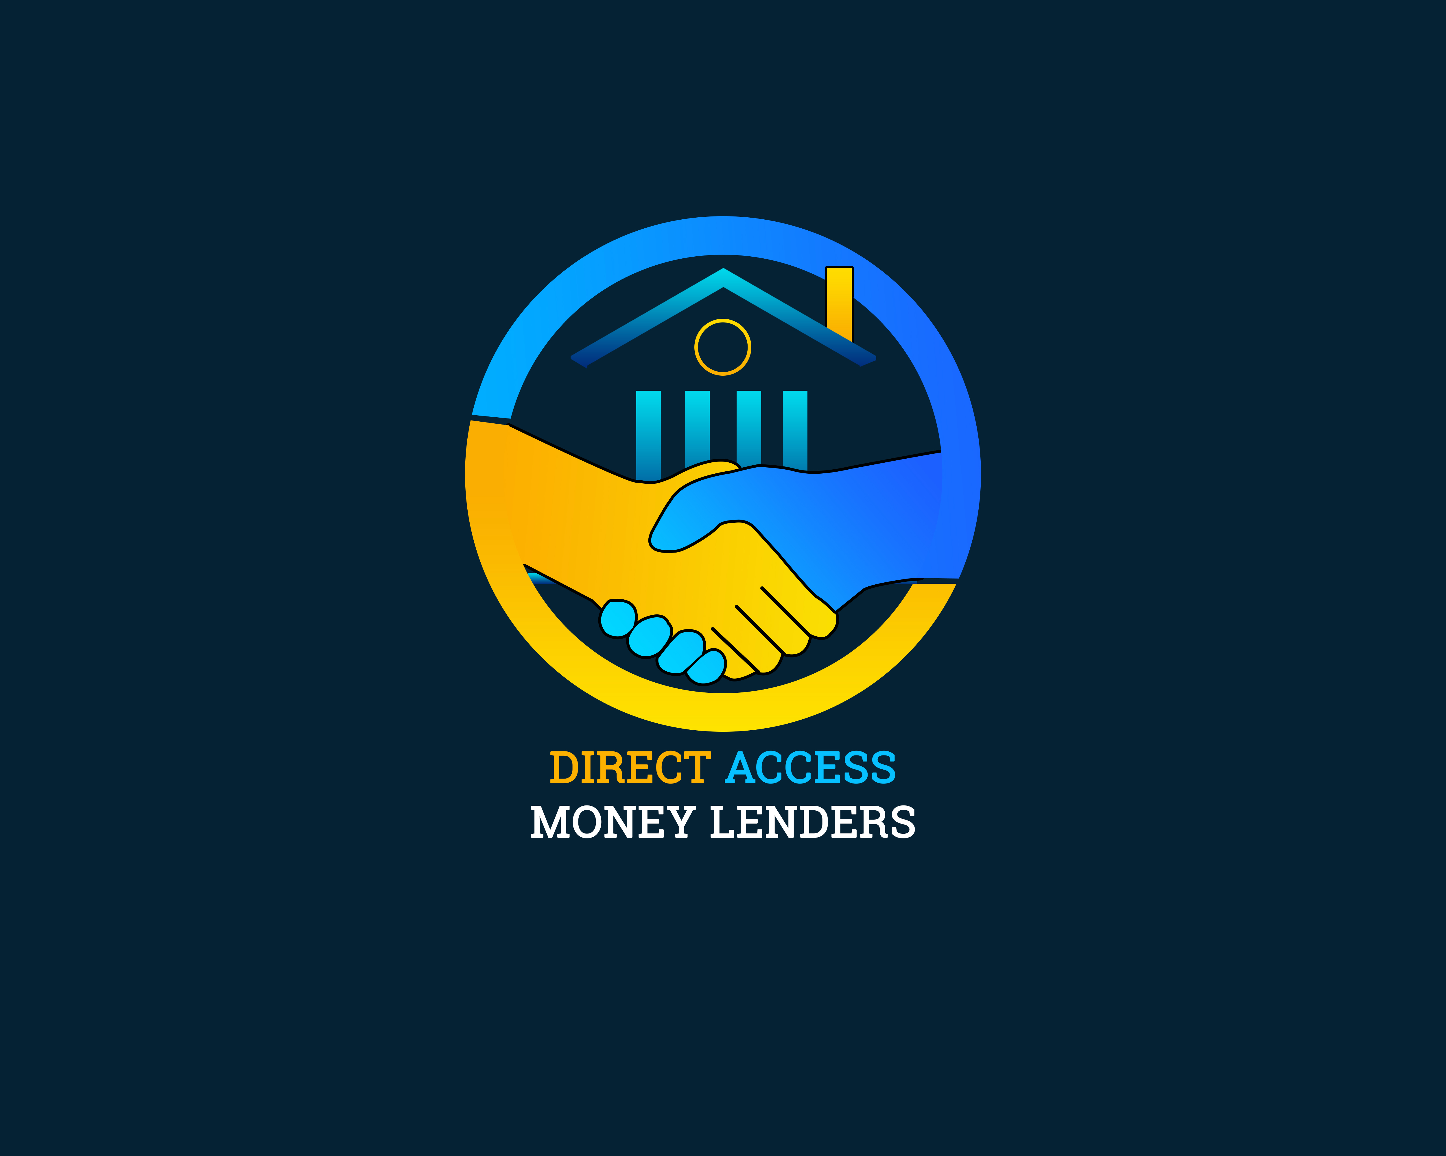

**TPIN: 1004797659**

**DIRECT ACCESS MONEY LENDING**

**Cell: +260971167499/+260777518123/+260776246770**

**Email: directaccessmoney@yahoo,com**

Has the customer given consent to pull out their CRB: NO YES

Marital Status: MARRIED SINGLE

Between **Direct Access** of Mazabuka and the borrower concluded at **Direct Access offices** on the following terms and conditions:

**CLIENT’S DETAILS**

Name………………………………… Male Female

NRC No……………………………………… Date of Birth…………………

Place of Birth……………………………… Mobile number +260……………………………

Physical address……………………...…… Residence type……………… (OWNER/TENANT)

Email Address……………………………… Postal address…………………………………

**NEXT OF KIN**

1. Name………………………………………………… 2. Name…………………………………………

Mobile number……………………………………… Mobile Number……………………………….

Home address………………………………………. Home address…………………………………

1. **EMPLOYMENT DETAILS 2.** **BANKING DETAILS**

Name of Employer…………..……………… The borrower’s bank is…………………………

Employer’s address……………………………… Account No……………………………………

Employee number………………………………… Branch name……………………………………

Department………………………………………………..

Supervisor's name…………………………………………..

Mobile number……………………………………………

The borrower acknowledges that the banking details are a critical element of this agreement and that changing the banking details without notifying **Direct Access** in writing within 7 days of such changes will constitute fraud.

1. **DETAILS OF THE LOAN ADVANCED AND MODE OF PAYMENT**

The borrower has received ZMW………………. loan at an interest rate of………% which is repayable on …………………….. By way of ……………………………………………….. (CASH/DIRECT BANK DEBIT/CashOut/Mobile Money).

1. **AUTHORISATION TO EMPLOYER**

Where **Direct Access** enters into a payroll agreement with the employer of the borrower, Direct **Access** will submit to the employer the instalment due by the borrower. If the borrower fails to honor any payment, the borrower by signing this agreement mandates **Direct Access** to instruct his/her employer to deduct such monies due to **Direct Access** from the salary of the borrower and remit such amounts directly to **Direct Access.**

1. **DIRECT DEBIT INSTRUCTIONS**
2. Where the borrower has mandated **Direct Access** to submit direct debits to his/her bank account, the mandate may be cancelled at any time after the borrower has given 15 day’s written notice of such cancellation to Direct Access.
3. Should the debit order bounce for whatever reason after **Direct Access institutes** such an order against the borrower's account, the borrower will be liable for the charges charged by the bank on his/her account and any other subsequent expenses incurred by **Direct Access.**
4. **DEFAULT AND BREACH OF CONTRACT**

1. The status of the borrower’s account will automatically change to default due to the following acts or omissions:

a If any of the details in clauses 1 to 3 above changes and the borrower fails to notify Direct Access in writing within 7 days of such change.

b If any installment is not paid by the borrower on the scheduled repayment dates. The borrower is responsible to ensure that **Direct Access** receives the installments due on the scheduled repayment dates, irrespective of any other alternatives which **Direct Access** may have to collect payments due by the borrower.

c. If the borrower fails to honor any repayments due on the installment date

2. Should the borrower be in default:

1. The total loan amount repayable plus any additional charges will become due and payable.
2. The borrower's name will be submitted to the Credit Bureau.
3. **Direct Access** may institute legal action to recover amounts that are in default. Legal actions will include obtaining a consent order and a garnishee order from the courts of law.
4. Legal costs and related fees will be borne by the borrower.

3. The grace period for making payments ends on the 5th of every month

1. **PENALTY INTEREST TO THE BORROWERS ACCOUNT**

Arrear interests will be charged by the rate equal to the interest rate applied to this agreement

1. **PENALTY FOR LATE PAYMENT**

Where the borrower fails to make payments on the scheduled repayment dates, the borrower will be penalized for such late repayment; the borrower will be charged a penalty fee calculated at the interest rate applied to this agreement in accordance with the Money Lenders Act.

1. **DECLARATION OF THE BORROWER**

I.................................................... (Borrower’s name) declare that the information recorded herein is true and correct and has been properly explained. I therefore understand and accept all terms and conditions.

……………………….. ……………. ……………………………………..

**Representative for Direct Access Money Lenders**

**Date**

**Signature of Borrower**