**STEP 6:**

1. **Volatility**

Volatility is always measured by variance or standard deviation. This means that, as higher the value of standard deviation or variance the more volatile are the returns or prices. According to the bellow formula shows that as correlation increase it will also increase variance which will lead to the high volatile of stock’s price and return.

**Variance**



**Standard deviation**



Wx= Weight of stock x

Wy = Weight of stock y

Covx,y = Covariance between stock x and y

**Volatility Swap**

A forward contract known as volatility swap bases its reward on the difference among gathered volatility strike and volatility.

**Volatility and correlation risk in S&P and VIX**

According to Gaurav (2018), in his paper shown how two stock market index (S&P 500 and VIX) may differ due to that they don’t have relationship between them. This also helped traders who invested in different stock where by one can go in loss and another be in profit.

1. **Chart analysis**

The chart below shows how S&P 500 and VIX are correlated in their daily returns. This scatter plot diagram illustrates that there is strong negative correlation between S&P 500 and VIX (r = -0.77). In addition, as the correlation increases it will also increase daily returns and prices where this chart also reveals how returns of VIX increased by 20 points while S&P 500 decreased by 10% of its daily returns.

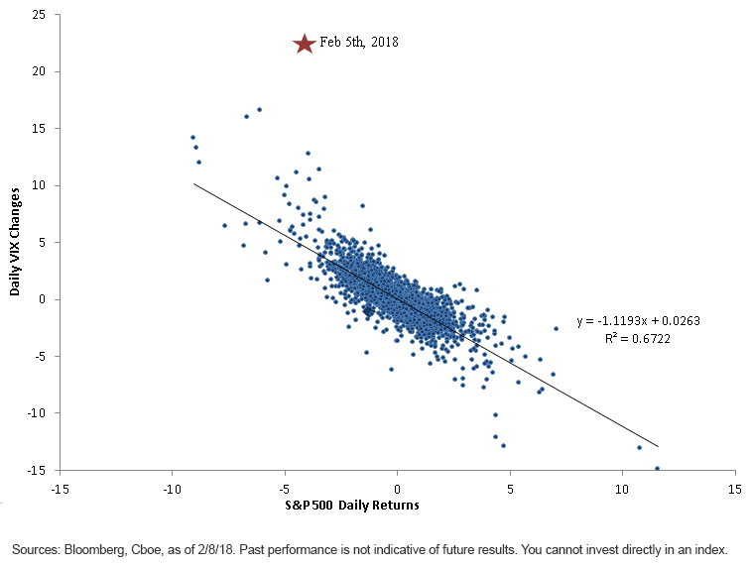

# References

Gaurav, S. (2018, 08 03). *Wisdom tree*. Retrieved from Wisdom tree: https://www.wisdomtree.com/~/link.aspx?_id=30BB440BCF364E4B80BFCB6FFF9515D8&_z=z