**STEP 3:**

**CORRELATION**

A correlation is a statistical indicator of the relationship among two different variables. In a scatterplot, the fit of the data can be shown graphically. We can typically evaluate the relationship between the variables and decide whether or not they are related using scatterplot. In addition, the correlation is measured in integer from -1 to +1 which shows if there is positive correlation or negative correlation.

**CORRELATION IN FINANCE CONCEPT**

Correlation plays a big role in sector of finance because helps in predicting future trends and also to manage risks in the portfolio. Additionally, correlation and other statistical models like variance and others are used in creating and setting price of derivatives.

Currently in sector of finance, the idea of correlation is used many times to prove whether a shares of the company will decrease or increase to modify interest rates or commodity prices. Similar to this, a portfolio manager may try to lower risk by making sure that any item in the portfolio is not too connected with others whereby he or she can take decision of diversifying.

**HOW COEFFICIENT CORRELATION IS MEASURED**

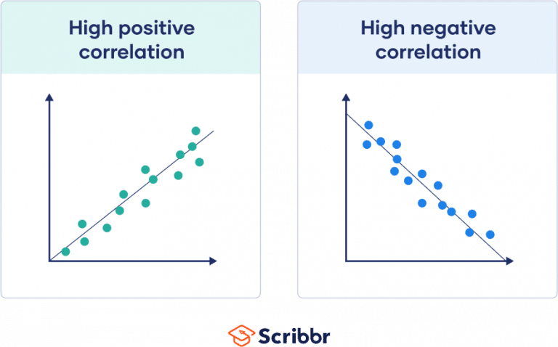

**NOTE:** +1, When the correlation tends to be +1 shows that there is strong positive relationship among the two variables (variables tend to move in same direction).



**NOTE:** 0, When the correlation tends to be 0 shows that there is no relationship among the two variables.

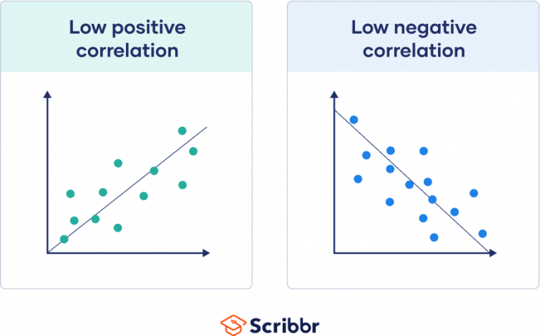

**NOTE:** -1, When the correlation tends to be -1 shows that there is negative relationship the two variables (variables tends to move in different directions).

**COEFFICIENT CORRELATION** **FORMULA**



rxy = Coefficient correlation of the relationship among x and y variables.

Cov (x, y): Covariance between x and y variables

δx = Standard deviation of variable x

δy = Standard deviation of variable y

xi = Values of variable x

 = Mean of all values for variable x

 = Mean of all values for variable y

yi = Values of variable y

# References