Activity – Module 1

Matthew Panuska

Rasmussen College

Author Note

This paper is being submitted on October 10, 2019, for Christopher Mattie’s CIS3801C Section 01 Fundamentals of Web Application Development course.

Azure URL:

<http://mpanuskacis3801c.centralus.cloudapp.azure.com>

URL for hello world page (using sample code, edited in atom):

<http://mpanuskacis3801c.centralus.cloudapp.azure.com/hello_world.html>

GitHub URL:

<https://github.com/mpanuska/CIS3801C_Fundamentals_Mobile_Web_App_Development>

Azure storage account:  
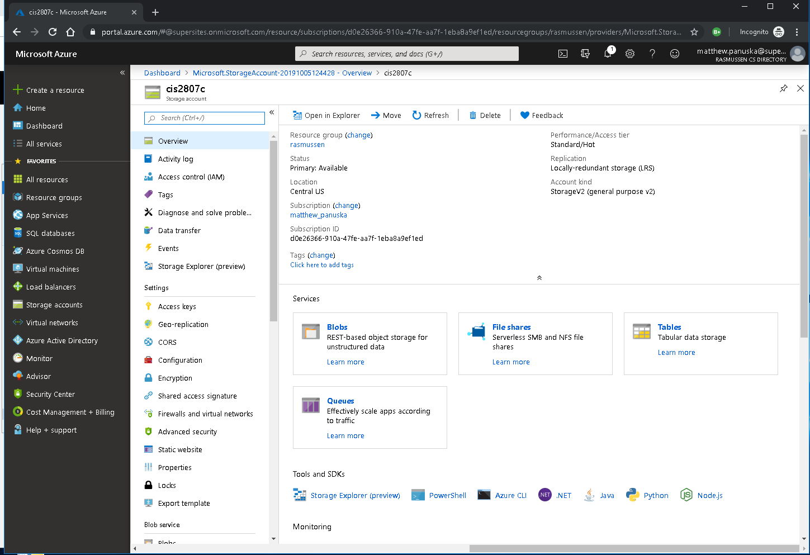

Azure LAMP virtual server:  
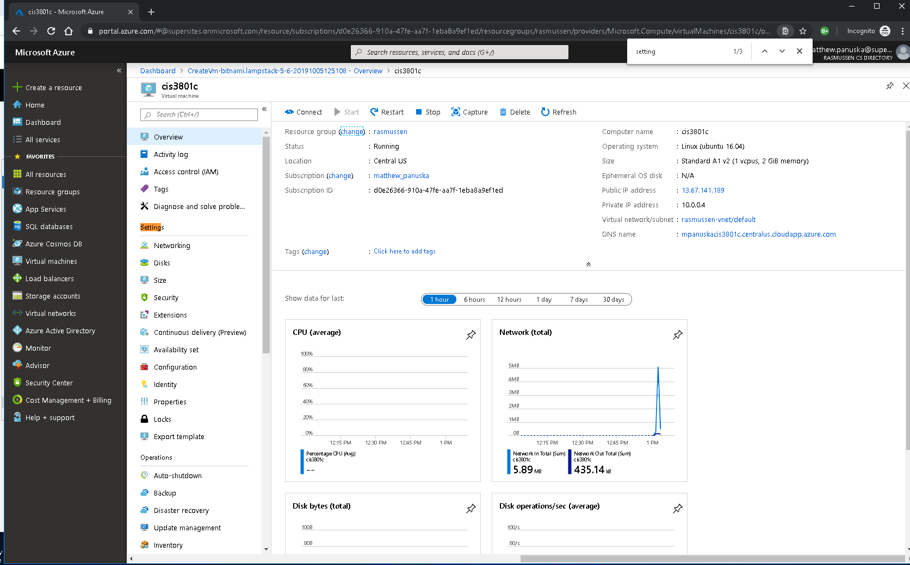

Putty:  
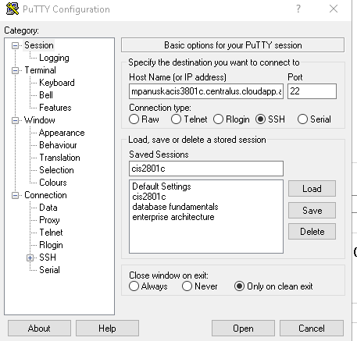

Bitnami Connection:  
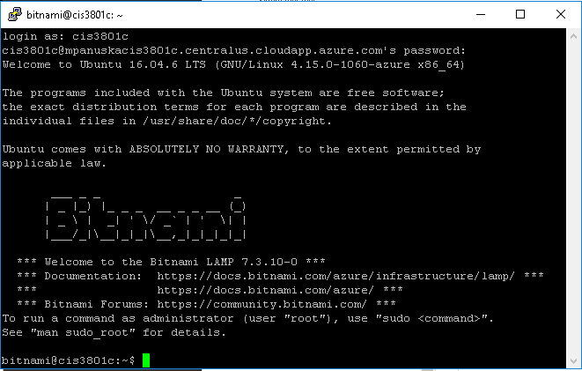

Filezilla  
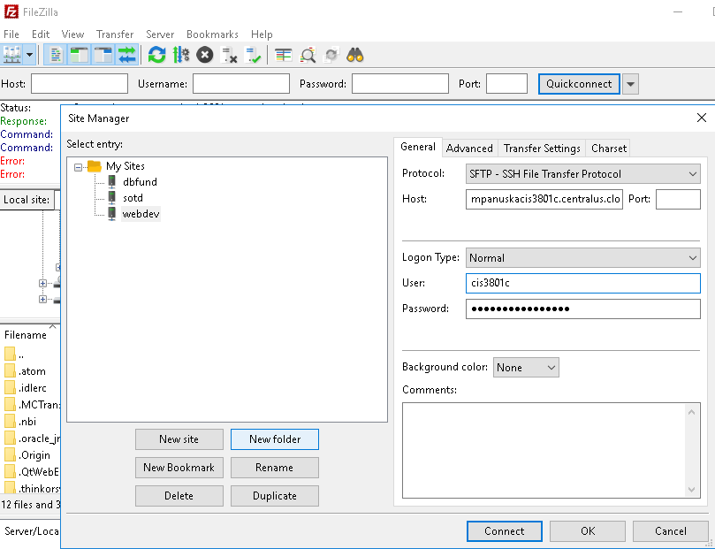

Successful filezilla connection & transfer of sample code to site:  
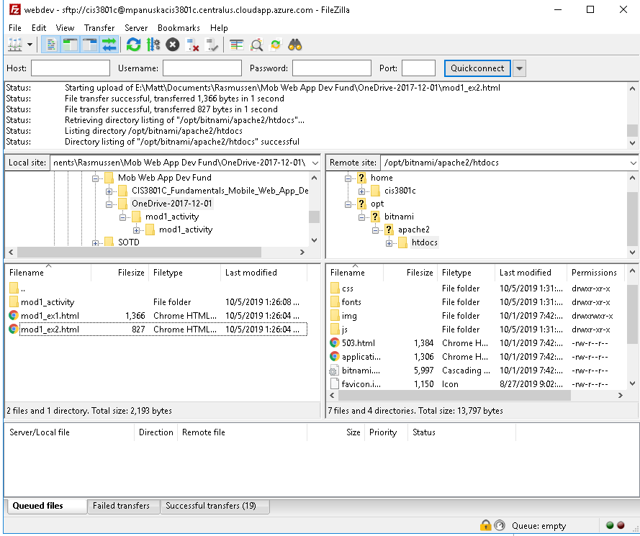

screenshot GitHub repository on GitHub.com:  
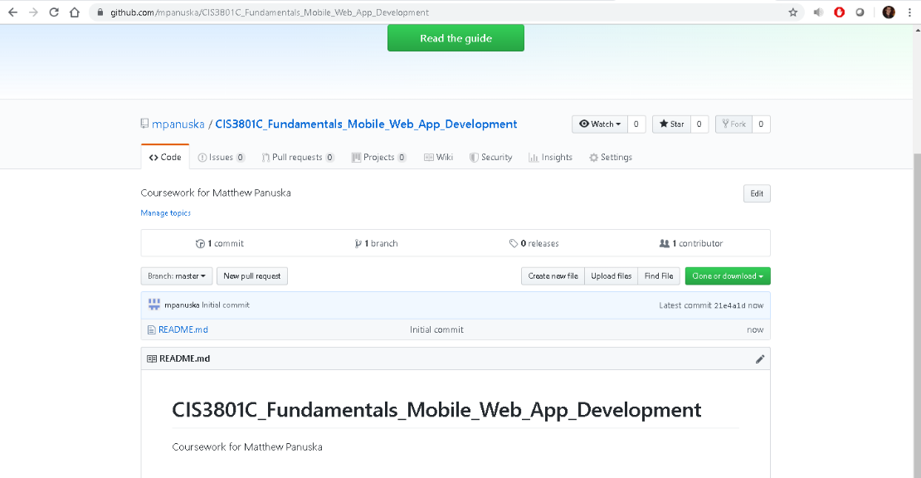

screenshot of local folder opened using Atom:  
