Course Project – Module 2

Matthew Panuska

Rasmussen College

Author Note

This paper is being submitted on October 13, 2019, for Christopher Mattie’s CIS3801C Section 01 Fundamentals of Web Application Development course.

Matts Cooking will be a site for discovering and discussing new recipes for casual cooks and hard core food enthusiasts alike.

Site URL:

<http://sotd.us/matthewpanuska/CIS3801C_Fundamentals_Mobile_Web_App_Development/Mod2/index.html>

GitHub URL:

<https://github.com/mpanuska/CIS3801C_Fundamentals_Mobile_Web_App_Development/blob/master/index.html>

Screen shot one (wide view):   
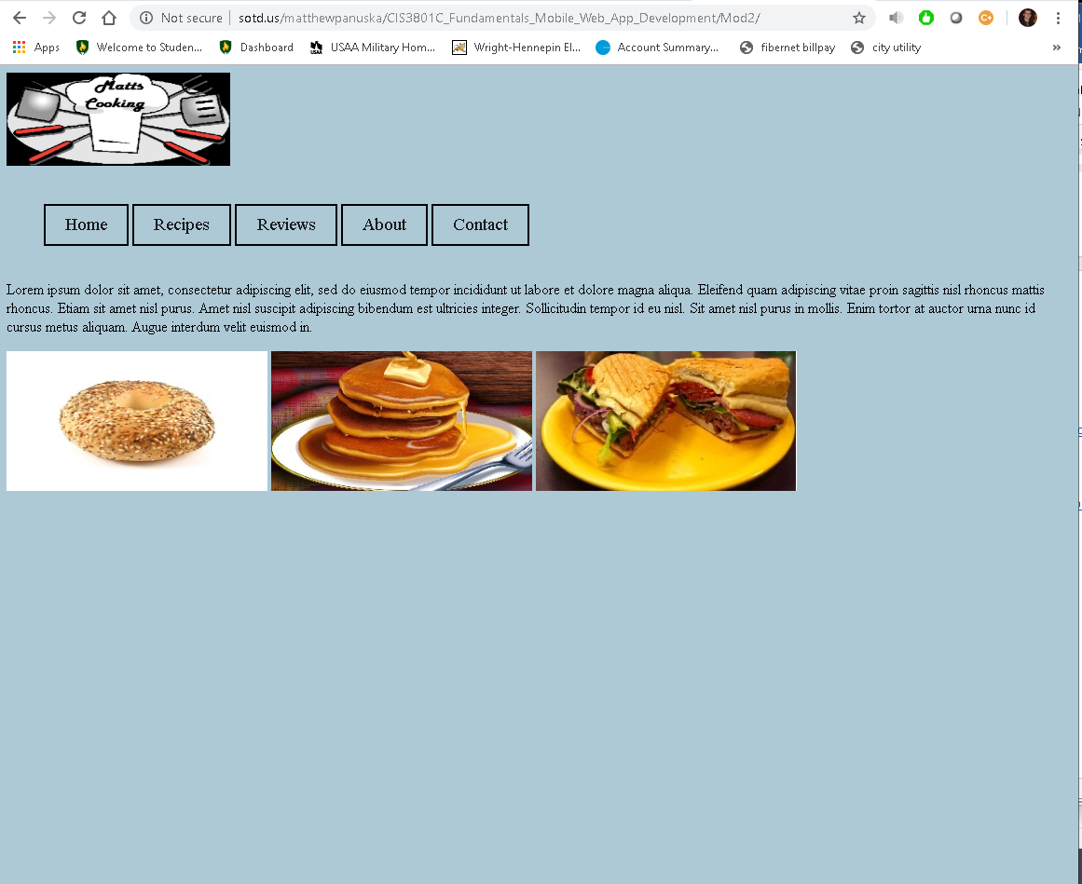

Screenshot two (text, navigation bar, and pictures automatically wrap / no horizontal scrolling required on narrow screen):  
