Course Project – Module 3

Matthew Panuska

Rasmussen College

Author Note

This paper is being submitted on October 20, 2019, for Christopher Mattie’s CIS3801C Section 01 Fundamentals of Web Application Development course.

Site URL:

[http://mpanuskacis3801c.centralus.cloudapp.azure.com/recipes.html](http://sotd.us/matthewpanuska/CIS3801C_Fundamentals_Mobile_Web_App_Development/Mod3/index.html)

GitHub URL:

<https://github.com/mpanuska/CIS3801C_Fundamentals_Mobile_Web_App_Development/blob/master/index.html>

Table (recipe) created in testdb database, with five columns, using the following SQL:  
  
DROP DATABASE IF EXISTS testdb;  
CREATE DATABASE testdb;

/*create recipes table*/  
DROP TABLE IF EXISTS recipe;  
CREATE TABLE recipe (  
recipeid mediumint,  
name varchar(255) default NULL,  
style varchar(255) default NULL,  
servings mediumint,  
minutes mediumint   
);  
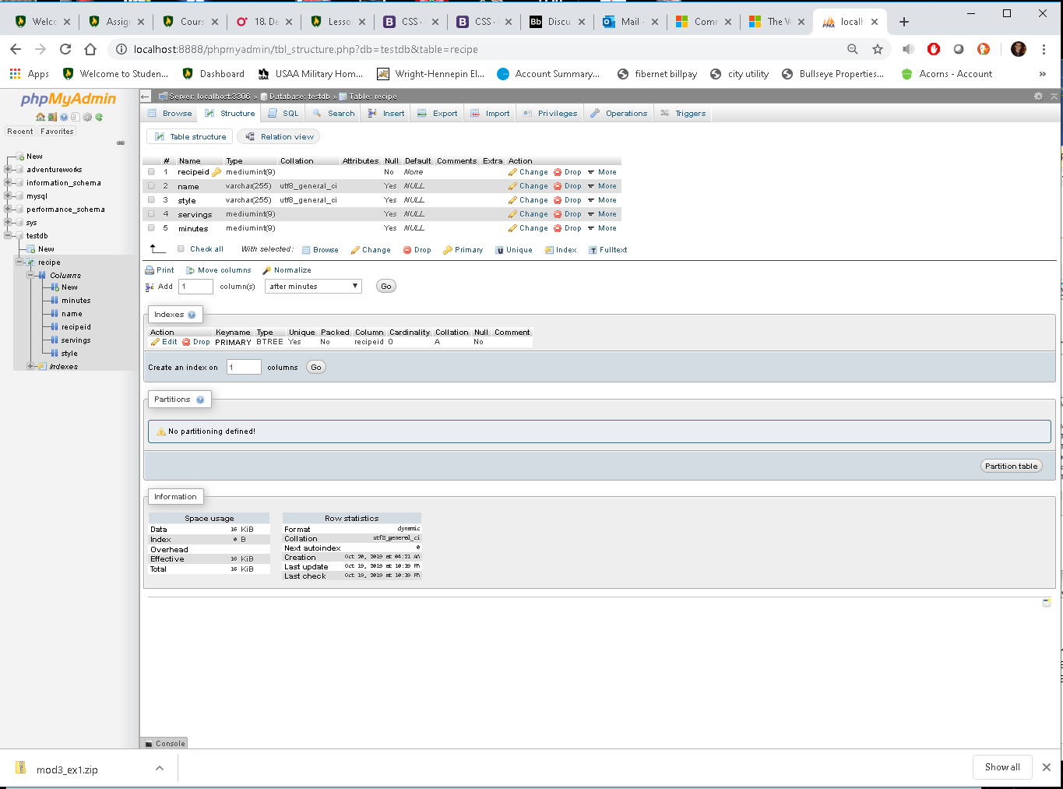

Primary key set to recipeid.

Table populated with data related to website:  
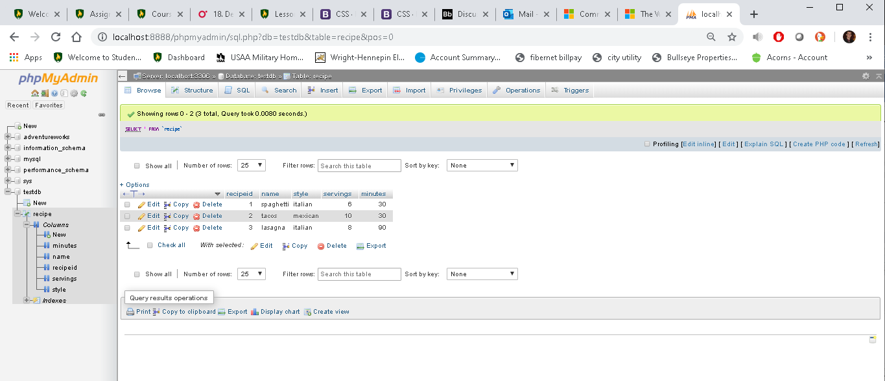

Screenshot of recipe page:  
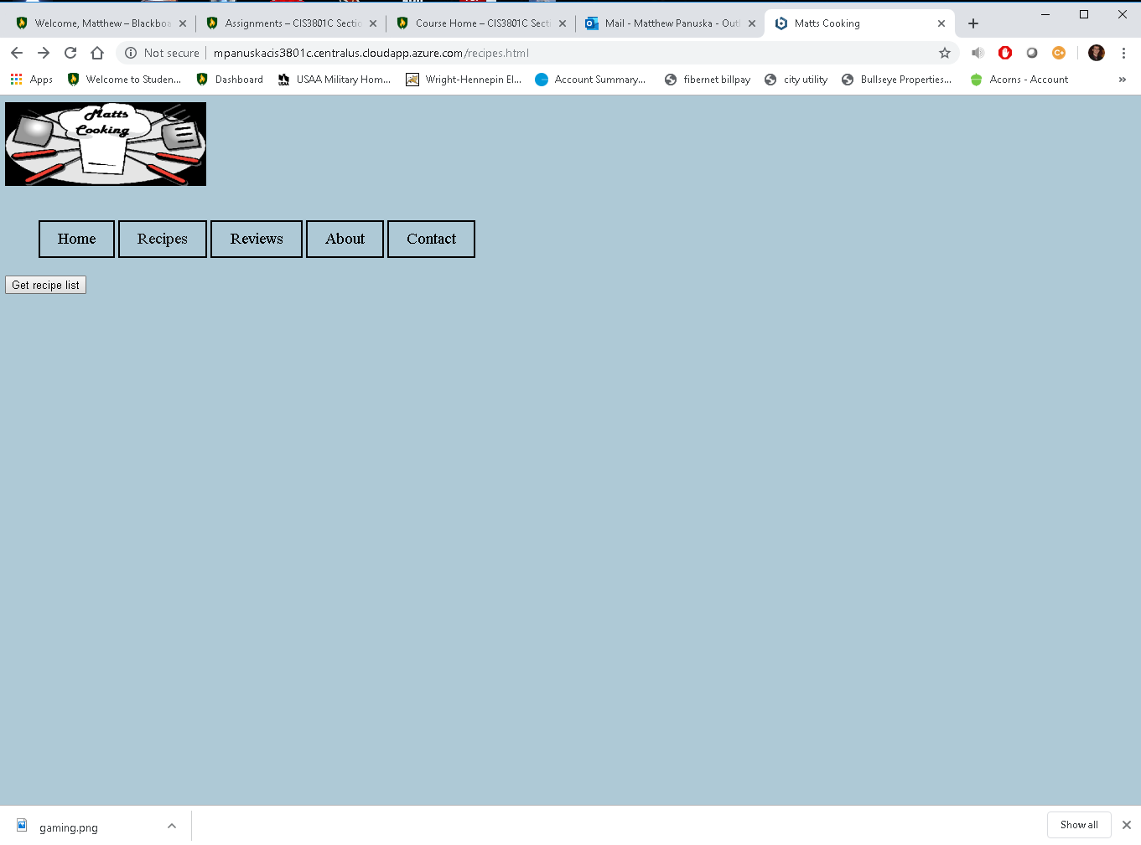

Clicking “Get Recipe List” (currently opens in blank page with no formatting)