Activity – Module 4

Matthew Panuska

Rasmussen College

Author Note

This paper is being submitted on October 27, 2019, for Christopher Mattie’s CIS3801C Section 01 Fundamentals of Web Application Development course.

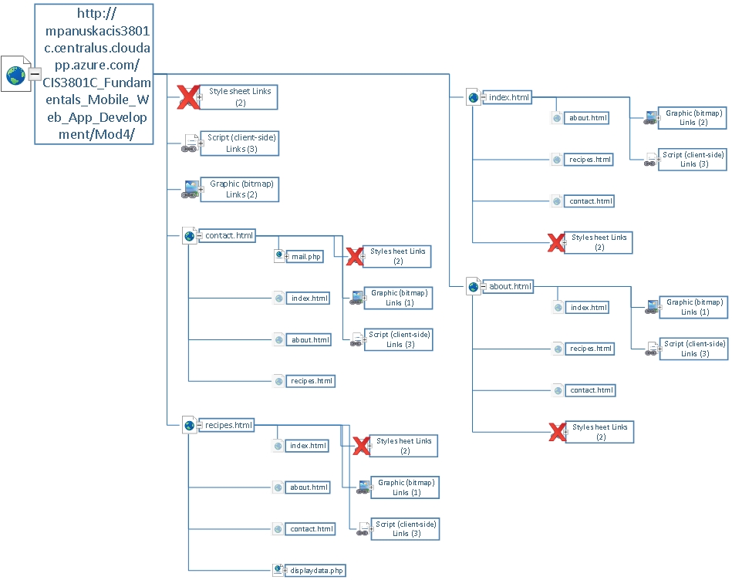

Sitemap