Course Project – Module 4

Matthew Panuska

Rasmussen College

Author Note

This paper is being submitted on October 27, 2019, for Christopher Mattie’s CIS3801C Section 01 Fundamentals of Web Application Development course.

Site URL:  
<http://mpanuskacis3801c.centralus.cloudapp.azure.com/CIS3801C_Fundamentals_Mobile_Web_App_Development/Mod4/>

GitHub URL:  
<https://github.com/mpanuska/CIS3801C_Fundamentals_Mobile_Web_App_Development>

Desktop view homepage:  
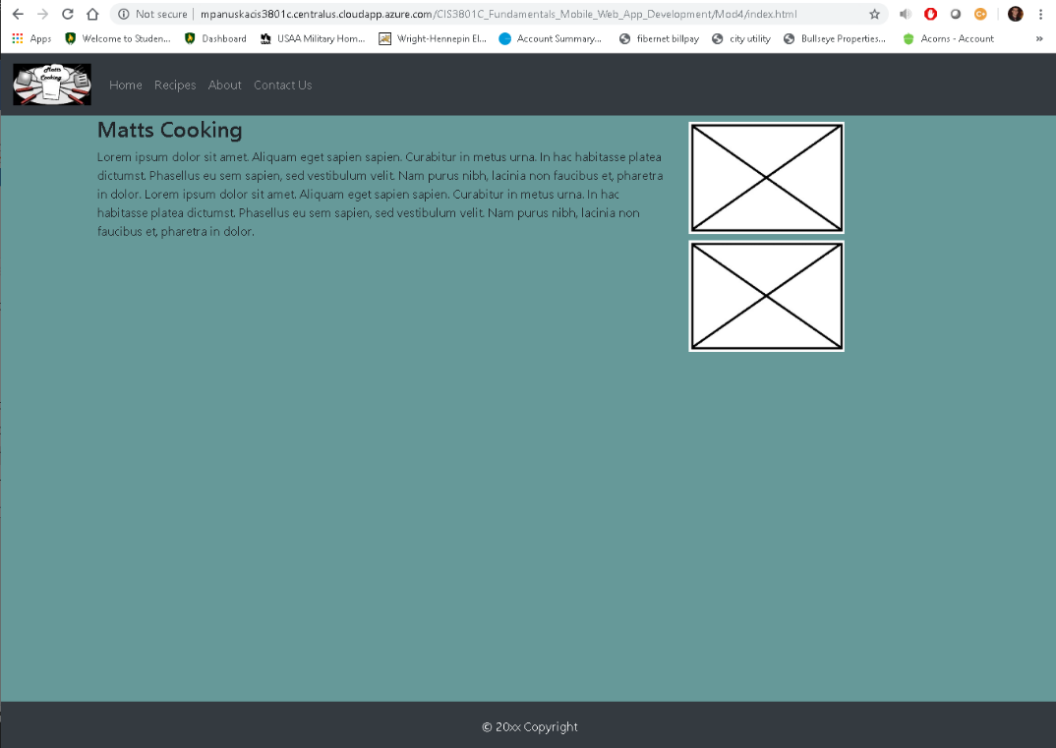

Mobile view of homepage:  
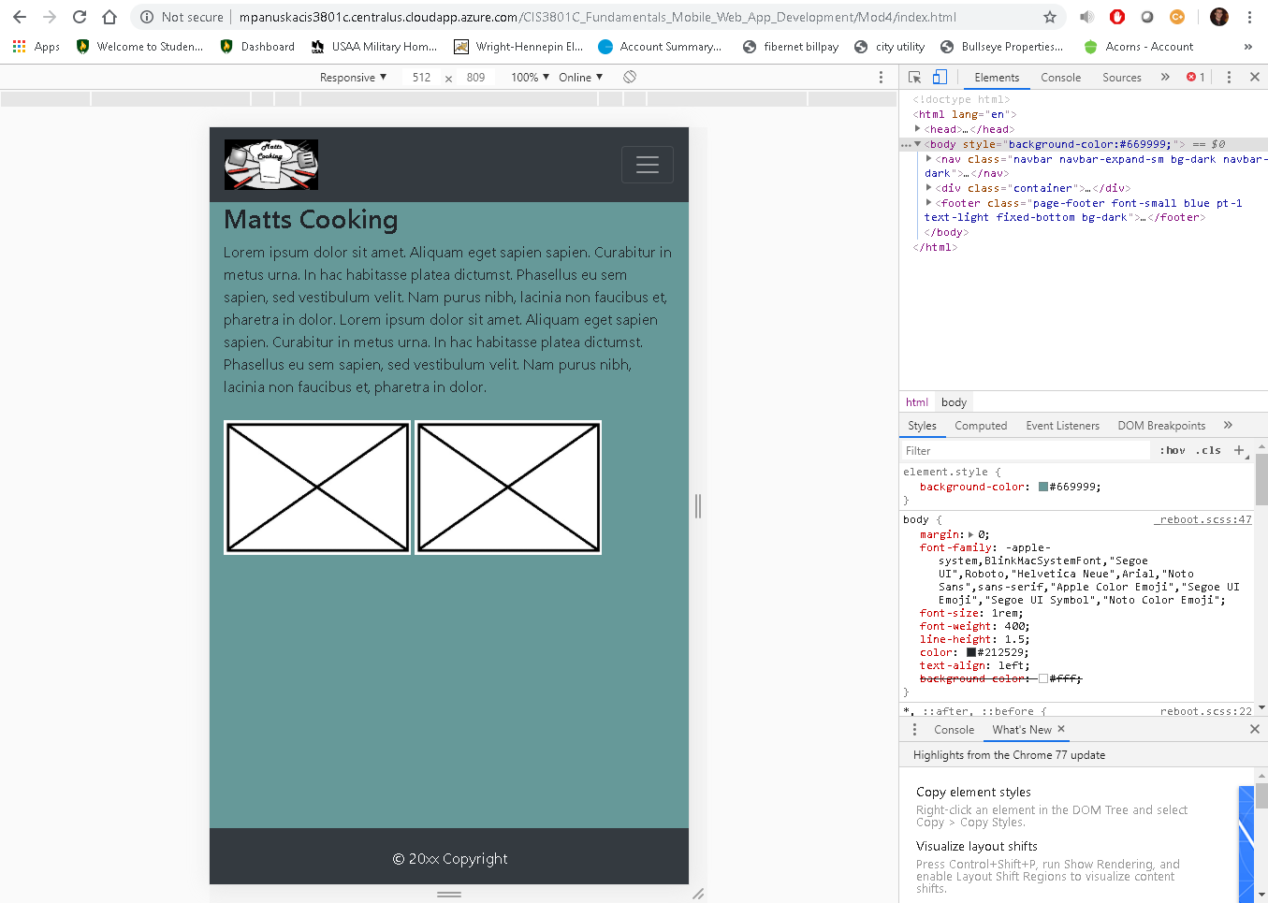

Contact Page desktop view:  
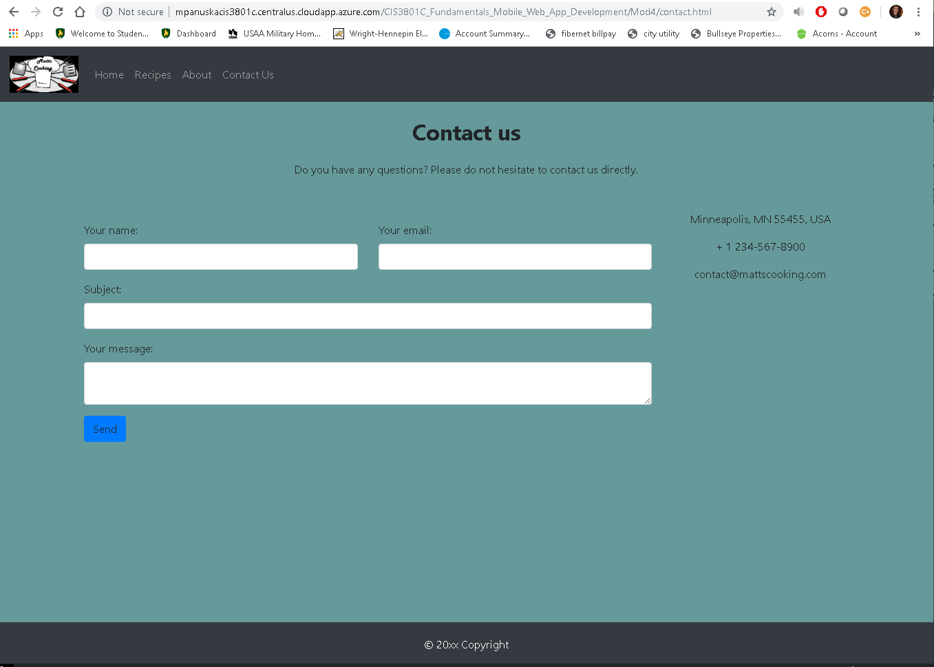

Contact Page mobile view:  
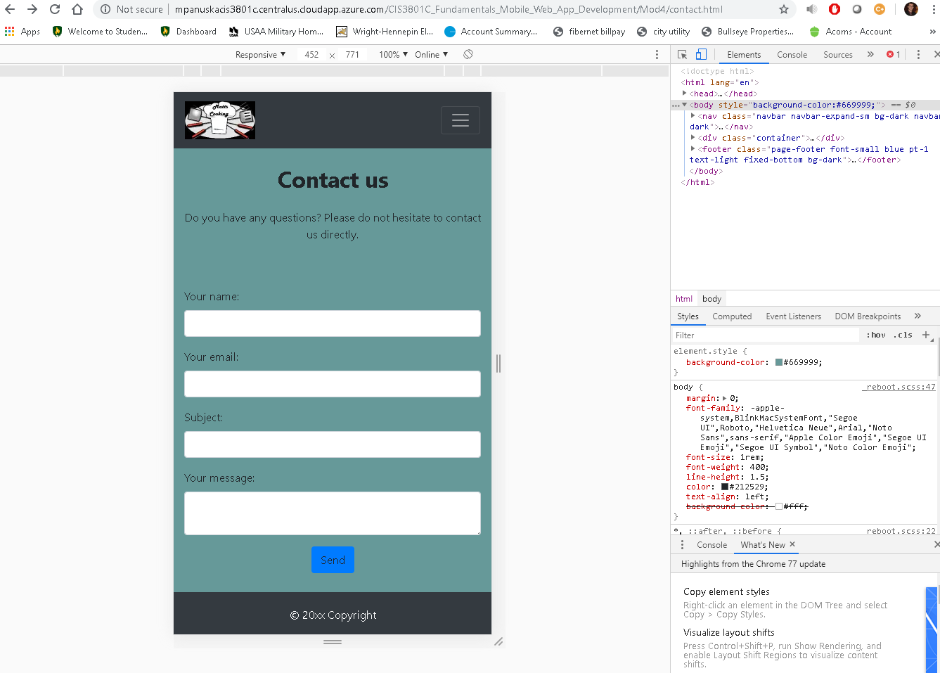

About Us desktop:  
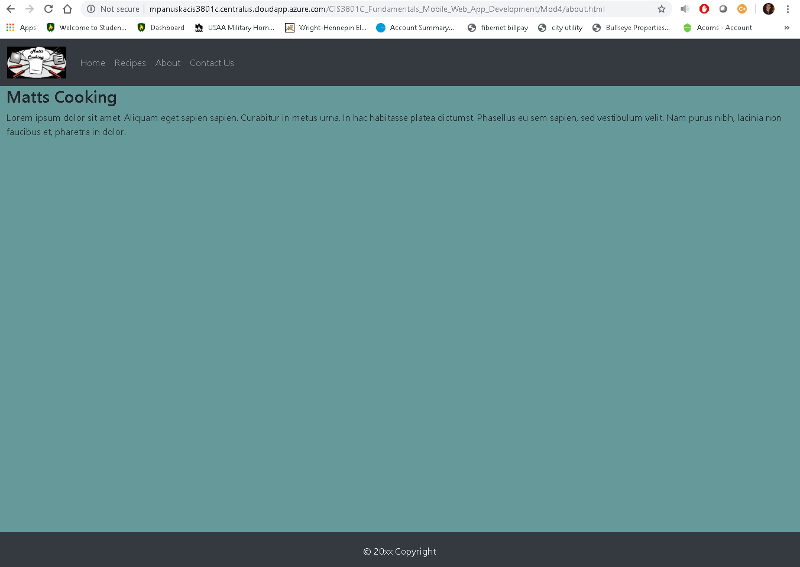

Recipes Page:  
