Activity – Module 5

Matthew Panuska

Rasmussen College

Author Note

This paper is being submitted on November 2, 2019, for Christopher Mattie’s CIS3801C Section 01 Fundamentals of Web Application Development course.

Activity 5

Used Chrome Dev tools to test page homepage and contact page on screens for desktop, iPhone (6/7/8), and Pixel 2 XL. In desktop view of contact page, things are not lined up perfectly – the form header is not centered relative to the form itself; the listed contact info is out of alignment. In the Pixel 2 XL view of the contact page, the footer obscures the email address in portrait mode and obscures the forms submit button in landscape. In the iPhone view of the home page, the footer obscures the bottom couple lines of text and part of the image.

Pixel 2XL landscape of contact page:  
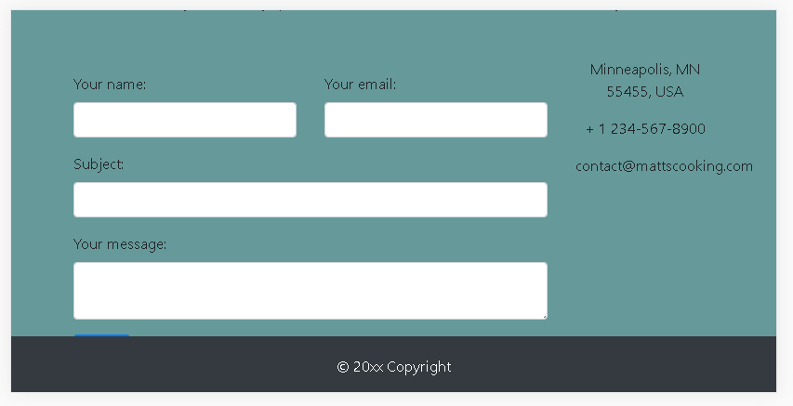

iPhone landscape of home page:

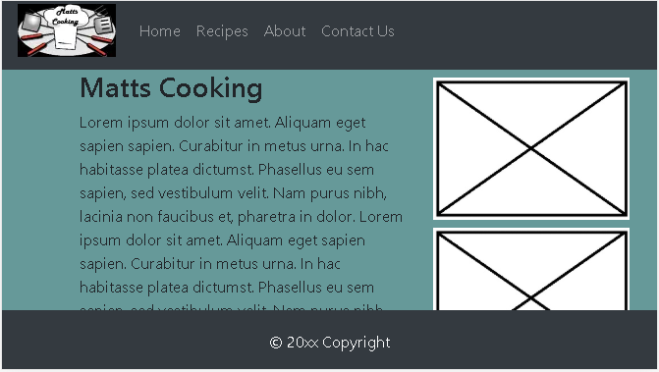

Pixel 2XL portrait of contact page:  
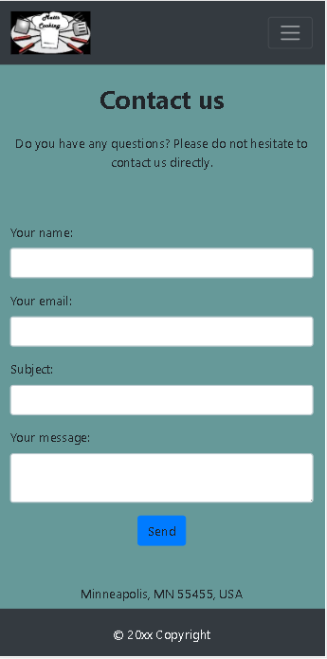

Desktop view of contact page

