Course Project – Module 5

Matthew Panuska

Rasmussen College

Author Note

This paper is being submitted on November 2, 2019, for Christopher Mattie’s CIS3801C Section 01 Fundamentals of Web Application Development course.

Site URL:  
<http://mpanuskacis3801c.centralus.cloudapp.azure.com/CIS3801C_Fundamentals_Mobile_Web_App_Development/Mod5/>

GitHub URL:  
<https://github.com/mpanuska/CIS3801C_Fundamentals_Mobile_Web_App_Development>

The first two changes tested below will be incorporated into the final site as they all significantly increase the usability of the site – primarily be making so all content is visible no matter what screen it is viewed on (prior to these changes, some content would be cut off or obscured when switching to mobile screens).

The last change will not be incorporated, as it was simply a test of changing background color using the dev tools, would detract from user experience if the background color were actually changed to the color shown.

.

1. Changed the footer position to absolute, which stuck it to the bottom of the page and it no longer obscures submit button on pixel 2XL landscape thus improving user experience:

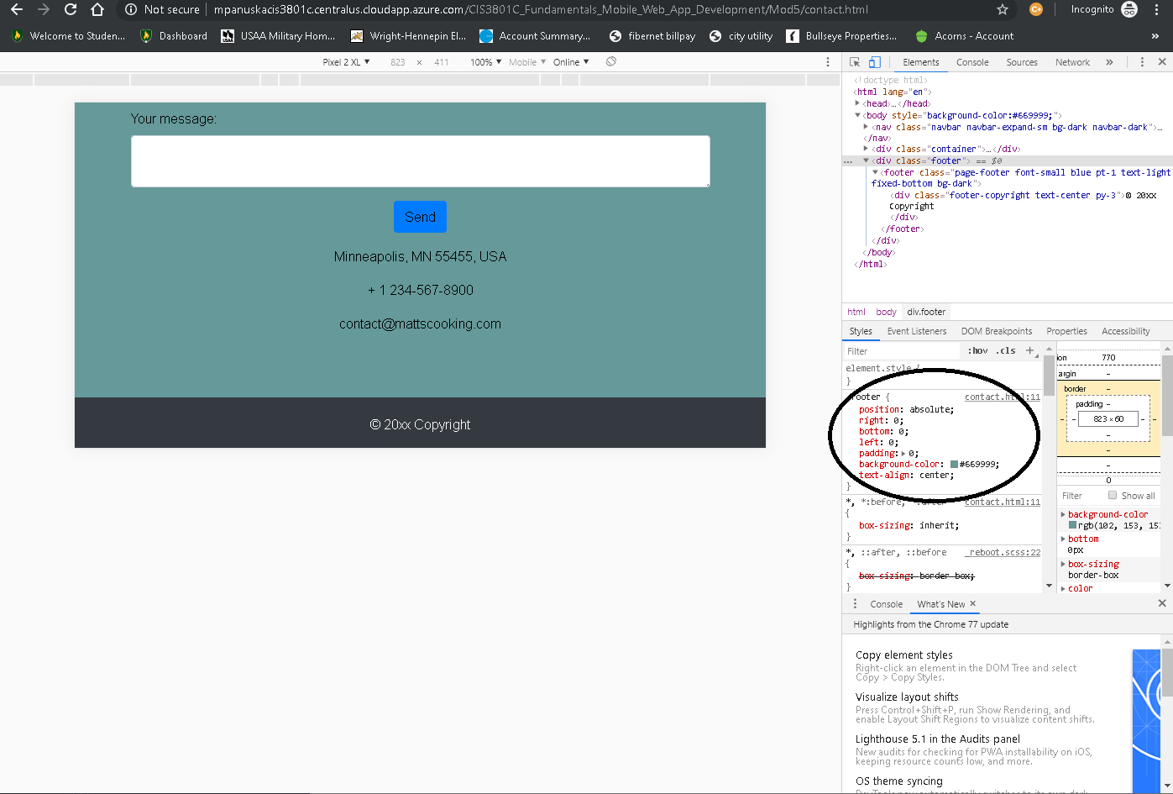

1. Added padding to body bottom so that the footer does not obscure email address in iPhone & Pixel2XL portrait, thus improving user experience: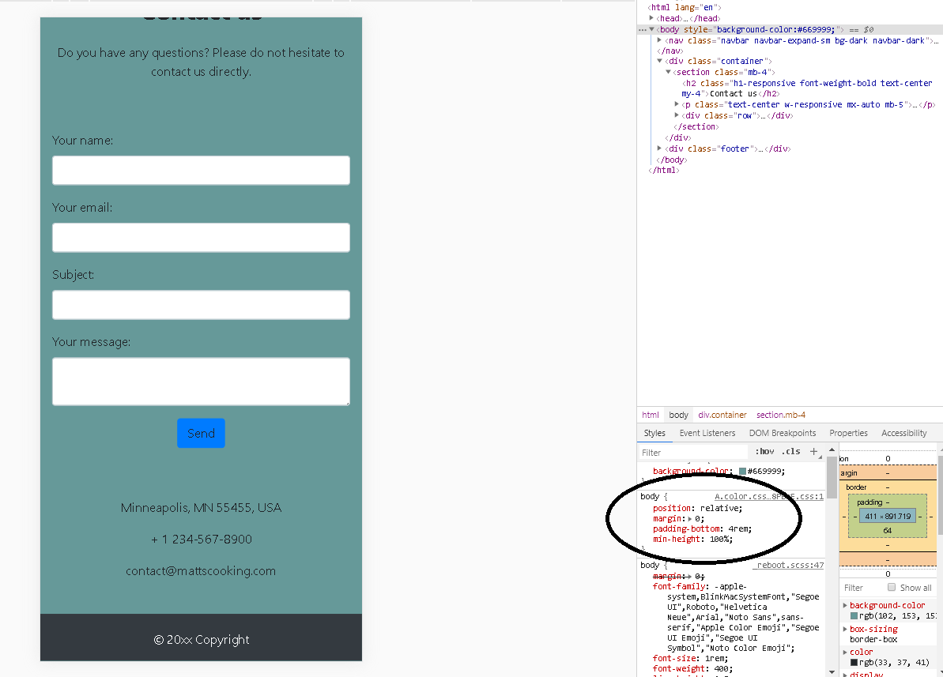
2. Changed the background color of body in the body’s element.style section. This change will not be incorporated as the original background color is more user friendly:

