Course Project – Module 6

Matthew Panuska

Rasmussen College

Author Note

This paper is being submitted on November 3, 2019, for Christopher Mattie’s CIS3801C Section 01 Fundamentals of Web Application Development course.

Site URL:  
[http://mpanuskacis3801c.centralus.cloudapp.azure.com/CIS3801C_Fundamentals_Mobile_Web_App_Development/](http://mpanuskacis3801c.centralus.cloudapp.azure.com/CIS3801C_Fundamentals_Mobile_Web_App_Development/Mod6/)

GitHub URL:  
<https://github.com/mpanuska/CIS3801C_Fundamentals_Mobile_Web_App_Development>

Project folder re-arranged to include project & activity folders in each module sub-folder:

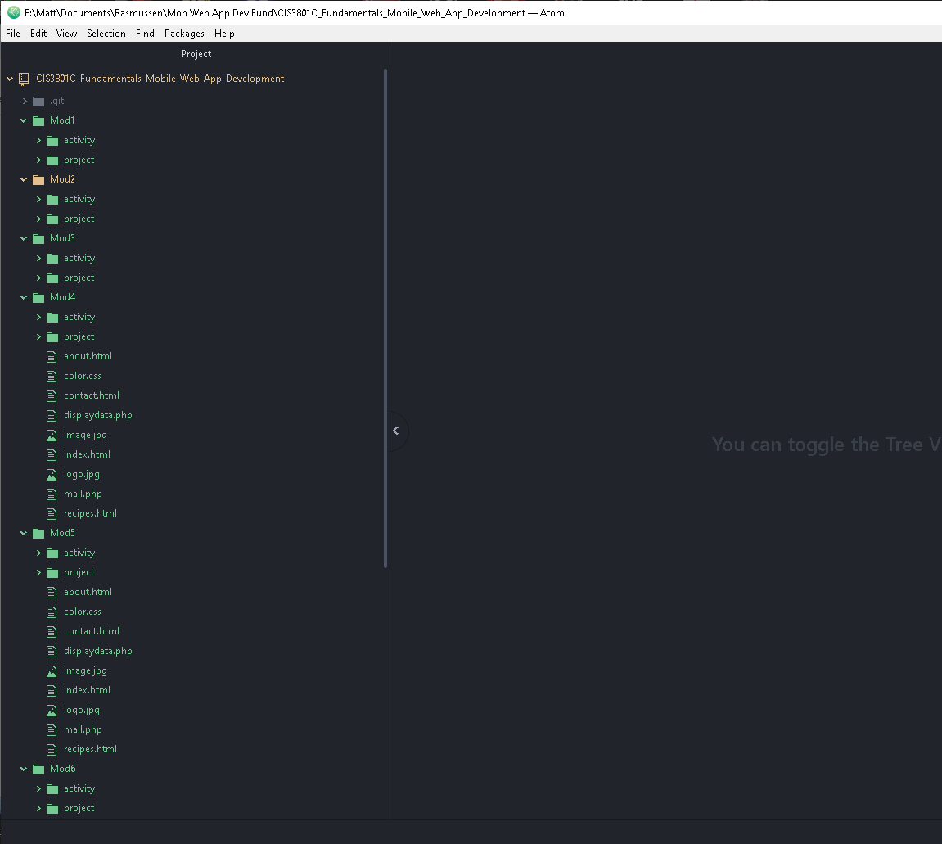

GitHub repository: